Effects of Helicobacter pylori on Gastric Cancer in the Adult Population: A Systematic Review

Abstract
Gastric cancer is a cancer that leads to high mortality worldwide. Helicobacter pylori (H. pylori) infection is a major risk factor for gastric cancer. This review covers non-cardia and cardia gastric adenocarcinomas (both clinically and histopathologically confirmed) according to the included studies. Early detection and eradication therapy has been proposed in order to reduce incidence and mortality.
This systematic review was conducted according to PRISMA 2020 guidelines. Searches from January 2020 to July 2025 identified 32 eligible studies. These included four randomized controlled trials, one quasi-experimental study, three systematic reviews with meta-analysis, and 24 observational studies. Most were conducted in East Asia and Latin America.
Eradication therapy was associated with a 40–55% reduction in the occurrence of gastric cancer, particularly in precancerous stages such as intestinal metaplasia or early carcinoma. A residual risk persisted, likely due to chronic inflammation, microbiome changes, or genetic predisposition.
Early diagnosis and eradication of H. pylori can reduce the risk of gastric cancer, particularly in high-risk regions. Combining eradication therapy with surveillance and microbiome restoration programs may provide the greatest benefit at a national level.

Categories: Pathology, Internal Medicine, Gastroenterology
Keywords: gastric cancer, eradication therapy, cancer prevention, microbiota, systematic review, helicobacter pylori
Introduction:
Gastric cancer is considered one of the most concerning health problems in terms of incidence, ranking among the top five cancers worldwide and the fourth leading cause of cancer-related mortality [1]. The majority of cases are adenocarcinomas, which are broadly classified by Lauren into intestinal and diffuse subtypes, each with distinct epidemiological and pathological characteristics [2,3]. Because of the high prevalence of Helicobacter pylori infection and the preventability of related disease, it is necessary to evaluate recent evidence regarding the role of eradication in gastric cancer prevention. This systematic review was conducted in accordance with the Preferred Reporting Items for Systematic Reviews and Meta-Analyses (PRISMA) 2020 guidelines [4].
Globally, infection with H. pylori remains widespread, particularly in developing regions such as East Asia, Latin America, and Africa. Overall prevalence is estimated at approximately 44% of the world’s population, with rates exceeding 70% in some East Asian and Latin American countries, and around 30-40% in Western countries [5,6]. Non-cardia gastric adenocarcinoma is recognized as having a multifactorial pathogenesis, arising from interactions among H. pylori, the host immune response, and environmental factors. Importantly, infection with H. pylori is estimated to account for up to 89% of non-cardia gastric cancer cases [7], underscoring its central role in gastric carcinogenesis.
The International Agency for Research on Cancer (IARC) has classified H. pylori as a Group I carcinogen, providing conclusive evidence of its causal relationship with gastric cancer development [8]. Taken together, these data highlight the urgent need to assess the most recent findings on eradication therapy and its impact on gastric cancer risk, which is the focus of this review.

Methods
This systematic review was conducted according to the PRISMA 2020 guidelines [4]. Articles were included when they investigated populations above the age of 18 years who were diagnosed with H. pylori and later developed gastric cancer. Included studies compared infected versus non-infected or eradicated groups. The primary outcome of concern was the occurrence of gastric cancer, with both cardia and non-cardia forms confirmed clinically or histopathologically.
Risk of bias was assessed using validated tools: RoB 2 for RCTs [6], Newcastle-Ottawa Scale (NOS) for observational studies [7], AMSTAR 2 for systematic reviews/meta-analyses [5], and JBI for quasi-experimental studies.
Eligibility Criteria
Articles were included in this systematic review when they researched populations above the age of 18 years who were diagnosed with H. pylori, and how they developed the condition of gastric cancer afterward. Included studies met the following eligibility criteria: Having involved a comparison of people with H. pylori infection with people not infected with it or those who had been treated with eradication therapy. The primary outcome of concern is the occurrence of gastric cancer with both cardia and non-cardia forms, clinically or histopathologically confirmed incidence of the mentioned types. The included studies primarily evaluated gastric adenocarcinoma, including both intestinal and diffuse histological subtypes. Some studies also included patients with precancerous lesions (intestinal metaplasia and dysplasia) as part of ‘early gastric cancer.’ No studies included non-epithelial gastric tumors. Diagnosis was established via endoscopic biopsy with histopathology, complemented in some studies by clinical features and imaging consistent with malignancy. We considered systematic reviews, meta-analyses, RCT (randomized controlled trial), cohort study, and case-control study (search conducted between January 1, 2020, and July 2025). Only the articles that appeared in the English language and were included in PubMed, Google Scholar, or the Cochrane Library were taken into consideration. The studies were eliminated when their study population was limited to children, their outcomes analyzed were only non-malignant (gastritis or peptic ulcer disease), when they did not have well-defined outcome measures in terms of gastric cancer, and when they were narrative reviews, editorials, commentaries, abstracts of conferences, or non-human and in vitro studies. Moreover, research studies presented in languages other than English were omitted.
Databases and Search Strategy
An extensive literature search was conducted to identify relevant publications that have previously been done on the relationship between H. pylori infection and the emergence of gastric cancer in the adult population. The systematic search of the electronic databases PubMed, Google Scholar (PMC), and the Cochrane Library was conducted in articles published between January 1, 2020, and July 10, 2025. The search method was a mixture of controlled vocabulary, such as MeSH terms and free-text keywords, combined with Boolean operators. Combining variations of the following search terms, the search was conducted: “Helicobacter pylori”, “H. pylori”, “gastric cancer”, “stomach neoplasms”, “gastric adenocarcinoma”, “eradication”, “cancer risk”, and “systematic review”. The filters included human subjects aged 18 years and above and studies written in the English language. Relevant reviews and reference lists of the included articles were also hand-searched to find possible additional studies that are compatible with the eligibility criteria. The PRISMA-S (Preferred Reporting Items for Systematic reviews and Meta-Analyses - Search) framework provided the search strategy used to ensure that the search procedure was transparent and could be repeated.
Risk of Bias of the Individual Studies
All full-text articles were evaluated in terms of methodological quality and risk of bias using the tools specific to a study type. In cases of randomized controlled trials (RCTs), the Cochrane Collaboration Risk of Bias Tool (CCRBT) was used, which focuses on seven domains, namely, random sequence generation, allocation concealment, blinding, incomplete outcome data, selective outcome reporting, and others [7]. Regarding cohort and case-control studies, the Newcastle-Ottawa Scale (NOS) was used, which deals with selection, comparability, and outcome assessment. In the case of quasi-experimental and observational studies, the Joanna Briggs Institute (JBI) Critical Appraisal Check. Regarding cohort and case-control studies, the Newcastle-Ottawa Scale (NOS) was used, which deals with selection, comparability, and outcome assessment. In the case of quasi-experimental and observational studies, the Joanna Briggs Institute (JBI) Critical Appraisal Checklist was used [6]. The solution included the Assessment of Multiple Systematic Reviews 2 (AMSTAR 2), which was used to appraise systematic reviews and meta-analyses [7]. The narrative reviews were evaluated through the SANRA 2. The criteria of interpretation as well as scoring differed with each of the tools. A tool was considered acceptable if it received a score of at least 70% of the total marks, which was a satisfactory result. To better illustrate, in assessed studies based on CCRBT, seven main bias areas were tested, and studies with a score of 5 and above out of a possible 7 were acceptable. In general, this multi-tool strategy provided the reckoning of the internal validity in various types of studies involved in the review, with a similar view of consistency and rigor.
Data Collection and Analysis
What is to be collected, what data points to consider, and how it is to be analyzed: This systematic review was not based on meta-analysis since it was prone to variation in study design and interventions, participant demography, outcome measures together with interventions. These differences can collectively be summarised as heterogeneity across studies, limiting direct comparability but not detracting from the overall consistent direction of effect. Each of the identified articles was screened and categorized, and listed into two groups: (1) RCTs and observational studies, and (2) systematic reviews and meta-analyses. The information extracted from each study included the following: first author, the year of publication, design of study, focus of the disease, inclusion and exclusion criteria, key findings, and source of funding. Other information, such as diagnostic tools to detect H. pylori, diagnostic tools for cancer, sample size, and sample characteristics, among others, was also captured in clinical and observational studies. The data had been taken and used to compare the effects of H. pylori infection and its clearance on the presence of gastric cancer in different populations [5-10].
Outcome Assessment
The assessment of outcomes was done on the basis of the development of gastric cancer by the participants after contracting H. pylori infection or after its eradication. The studies were categorized by the type of study design and the population in which the study was conducted, such as a population that had precancerous lesions or a population that excluded them. Positive and negative effects were entertained, including lessened cancer occurrence following eradication treatment or continued danger regardless of the treatment. In the cases where they were available, such outcomes as time to diagnosis, histological cancer subtype, and mortality were recorded. Differences in data extraction and interpretation were harmonized through consensus among the reviewers to come up with accuracy and consistency in the included studies.
Results
After conducting an exhaustive search of the PubMed, PMC, Cochrane Library, and Google Scholar databases between January 2020 and July 2025, 551 records came up. The screening of 500 articles was carried out after the elimination of 51 duplicates. Owing to the inability to meet the inclusion criterion, 440 studies were filtered out using title and abstract screening. A total of 60 articles were reviewed in full-text, 12 of which were eliminated because of their low methodological quality or irrelevance. But eventually, 32 studies, which can be included in the qualitative synthesis, were deemed to fit the eligibility requirements.
Four of them were RCTs, one quasi-experimental study, three systematic reviews with meta-analyses, and one was a narrative one. In the majority of the studies, East Asia and Latin America were investigated, where the prevalence of Helicobacter pylori is high. The spreading range was therefore intensely wide, implying that the period of follow-up ranged between one year and over a period of one decade. H. pylori diagnostic tests were urea breath tests, stool antigen tests, and histopathology, and gastric cancer was established using clinical and histological modalities.
Study Selection and Quality Assessment
The initial search resulted in the selection of 551 articles in such databases as PubMed, PMC, Cochrane, and Google Scholar. The number of records available to screen was 500 following the elimination of duplicates and non-relating records by their title. After the title and abstract screening, 24 articles were preselected in accordance with the pre-specified inclusion criteria. The complete texts of such articles were downloaded and read, and six articles were excluded because they did not meet the study protocol requirements. The rest of the studies were also evaluated qualitatively with relevant application tools depending on the design of the study. Studies were received only when they had obtained at least a 70% score on the corresponding appraisal scales. At the end, 32 studies were included in the qualitative synthesis (four RCTs, one quasiexperimental, three systematic reviews with meta-analyses, and 24 observational). The process of selection is depicted in a PRISMA flow diagram created according to the 2020 edition.
The study selection process is illustrated in the PRISMA 2020 flowchart (Figure 1).

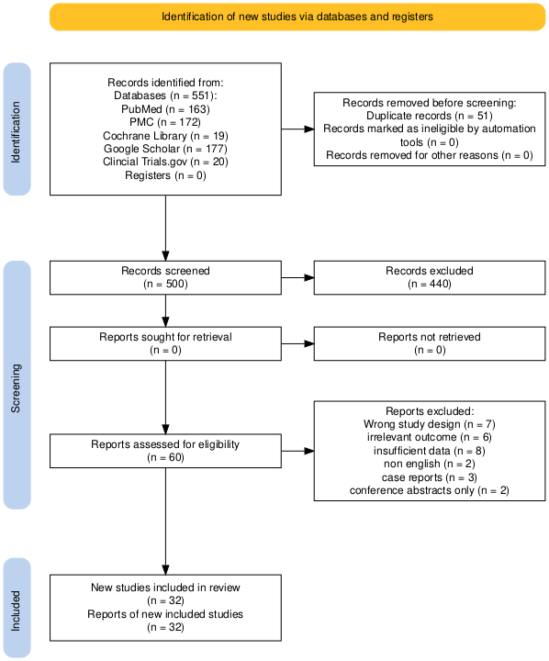
Figure 1: PRISMA 2020 diagram for systematic reviews.
Records identified: Total number of studies found through database searches before screening.
Duplicate records removed: Studies found more than once across databases and removed before screening.
Records marked as ineligible by automation: Automatically excluded by software due to mismatched criteria.
Records screened: Number of studies reviewed at the title/abstract level.
Records excluded: Studies that did not meet the inclusion criteria during screening.
Reports assessed for eligibility: Full-text articles reviewed in detail against inclusion criteria.
Reports excluded: Studies removed at the eligibility stage, with specific reasons listed (e.g., SANRA, AMSTAR, CCRBT, and NOS).
Studies included in review: Final number of studies meeting all criteria and included in qualitative synthesis.
PRISMA: Preferred Reporting Items for Systematic Reviews and Meta-Analyses; PMC: PubMed Central; SANRA: Scale for the Assessment of Narrative Review Articles; AMSTAR: Assessment of Multiple Systematic Reviews; CCRBT: Cochrane Collaboration Risk of Bias Tool; NOS: Newcastle-Ottawa Scale.

A total of 551 records were identified through database searches. After removing 51 duplicates, 500 records remained for screening. Of these, 440 were excluded following title and abstract review. Sixty full-text articles were then assessed for eligibility, resulting in the exclusion of 12 studies that did not meet the inclusion criteria. Ultimately, 32 studies were included in the qualitative synthesis (Figure 1). Study Characteristics A total of 32 studies met the inclusion criteria and were published between 2020 and 2025. The characteristics of these studies, including design, population, diagnostic methods, and follow-up periods, are summarized in Table 1. These studies were in the form of randomized trials, cohort studies, and systematic reviews with populations of adults having confirmed H. pylori infection. The majority of them took place in Asia and Latin America. The range of sample sizes was broad, and active periods of follow-ups ranged between one and more than 10 years. Urea breath tests, stool antigen tests, and histology were used as methods of diagnosis. The results of gastric cancer were clinically or histologically validated, and some of the studies involved subgroup analysis based on age or type of cancer.
The sample size was between 200 subjects and over 100,000, with a follow-up of one year and over 10 years. Urea breath tests, stool antigen testing, serology, and histology were used to confirm that a patient has H. pylori. Clinical and histological confirmation of gastric cancer was attested in all the studies.
The populations of the studies differed by means of examining precancerous lesions (intestinal metaplasia, dysplasia) in several studies, and general adult populations in others. Some of the studies investigated the variation with age, sex, histological subtype, and the status of the cagA-positive strain via subgrouping.
Main Findings
Most of the studies showed that after the eradication of H. pylori, the incidence of gastric cancer was significantly lower, especially concerning the patients with early lesions or precancerous changes. Our findings are consistent with prior meta-analyses and Cochrane reviews, which have reported a 40-55% reduction in gastric cancer incidence following eradication therapy, particularly in patients with early disease or precancerous lesions; however, no meta-analysis was conducted in the present review due to heterogeneity in study design, populations, and outcomes.” Still, there was an uneliminated risk, which could be explained by mucosal chronic inflammation, dysbiosis, or genetic predisposition. Our findings showed there were regional differences, where the highest effect was in East Asians. The baseline risk was additionally higher, and the absolute benefit of eradication was also higher in the CagA-positive strain patients.
The characteristics of the included studies are summarized in Table 1.

Author(s). Study design |  | Population/Setting | Intervention/Focus | Key Findings | Ref #
Li Y et al., 2022 | Cohort | Adults, China | Eradication vs. no eradication | gastric cancer mortality with eradication | [9]
Salvatori S et al., 2023 | Molecular review | Gastric epithelial models | Pathogenetic mechanisms | NF/Wnt/STAT3 signaling tumorigenesis | [10]
He J et al., 2022 | Experimental | Gastric epithelial stem cells | H. pylori induction | Induced stem cell-like traits cancer progression | [11]
Tran SC et al., 2024 | Mechanistic | H. pylori strains (cagPAI+) | Strain-specific risk | cagPAI inflammation & cancer risk | [12]
Hooi JK et al., 2017 | Systematic review & meta-analysis | Global prevalence | Prevalence vs. cancer | High prevalence parallels gastric cancer burden | [13]
Guo Y et al., 2020 | Population study | Linqu, China | Post-eradication microbiota | Persistent dysbiosis maintains partial risk | [14]
Liatsos C et al., 2022 | Observational | H. pylori-positive adults | Microbiota alteration | Dysbiosis procarcinogenic taxa | [15]
Zhou C et al., 2024 | Observational | H. pylori-positive, obesity/PPI | Modifying factors | PPI + obesity worsen dysbiosis risk | [16]
Fiorani M et al., 2023 | Review | Human gastric/gut microbiota | Microbiome interactions | H. pylori disrupts microbiota | [17]
Engelsberger V et al., 2024 | Experimental | H. pylori-infected intestines | Immunity/microbiome | Dysbiosis alters immunity, cancer risk | [18]
Hua Z et al., 2023 | Observational | Chronic gastritis patients | Microbiota shift | H. pylori alters microbiome cancer predisposition | [19]
Fukase K et al., 2008 | RCT | Peptic ulcer patients | Eradication therapy | gastric cancer incidence | [20]
Choi IJ et al., 2018 | RCT | Post-endoscopic resection | Eradication therapy | metachronous gastric cancer | [21]
Choi IJ et al., 2020 | RCT | Family history gastric cancer | Eradication therapy | Prevented gastric cancer onset | [22]
Ford AC et al., 2020 | Cochrane meta-analysis | Global RCTs & observational | Eradication therapy | gastric cancer risk (RR 0.54) | [23]
Jung DH et al., 2015 | Meta-analysis | Post-resection patients | Eradication therapy | metachronous lesions | [24]
Lin Y et al., 2024 | Observational | H. pylori-infected adults | Pyroptosis mechanisms | Pyroptosis linked to mucosal damage and GC | [25]
Alipour M, 2021 | Observational | Adults, Iran | H. pylori infection | Virulence factors linked to gastric cancer | [26]
Choi IJ, 2023 | Mechanistic review | Gastric mucosa | H. pylori antigens | Antigens modulate immune evasion | [27]
Gu Y et al., 2024 | Experimental | H. pylori-infected cells | Mechanistic pathways | Highlighted oxidative stress & carcinogenesis | [28]
He J et al., 2023 | Observational | Adults, Taiwan | H. pylori infection | Identified risk modifiers of gastric cancer | [29]
Chen, Y-C, et al., 2024 | Review | Asian populations | H. pylori prevalence | Higher prevalence linked to gastric cancer incidence | [30]
Ali A & AlHussaini KI, 2024 | Review | Pathogenesis/diagnosis | H. pylori & treatment | Contemporary overview | [31]
Booka E & Takeuchi H, 2023 | Clinical study | Early gastric cancer | Sentinel node navigation | Adjunct in management | [32]

Table 1: Characteristics of the included studies.
SR – Systematic Review; MA – Meta-analysis; RCT – Randomized Controlled Trial; Obs – Observational Study; PPI – Proton Pump Inhibitor; PRISMA Preferred Reporting Items for Systematic Reviews and Meta-Analyses; cagPAI – cag Pathogenicity Island; RR – Relative Risk.
Main findings summarize the direction and magnitude of effect (e.g., ↓ = reduction) for Helicobacter pylori eradication outcomes in relation to gastric cancer incidence or progression, as reported in references [9–32] .

Most studies found significantly fewer cases of gastric cancer after H. pylori eradication was carried out, especially those who had early-stage gastric cancer or precancerous lesions (e.g., intestinal metaplasia and dysplasia). A single meta-analysis indicated that there was an over 50% reduction of risk in groups that were studied after being eradicated, and there was also the indication that this advantage continued to be beneficial when they remained in a negative H. pylori status.
Risk of Bias Assessment Results
The risk of bias assessment is presented in Table 2.
Study Type | N | Tool Used | High Quality | Moderate | Low
RCTs (Fukase 2008 [20]; Choi 2018 [21]; Choi 2020 [22]; Jung 2015 [24]) | 4 | RoB 2 [6] | 3 | 1 | 0
Observational (e.g., Li 2022 [9]; Guo 2020 [14]; Zhou 2024 [16]; Hua 2023 [19]) | 24 | Newcastle Ottawa [7] | 20 | 4 | 0
Systematic Reviews / Meta-Analyses (Ford 2020 [23]; Hooi 2017 [13]; Salvatori 2023 [10]) | 3 | AMSTAR 2 [5] | 3 | 1 | 0

Table 2: Risk of Bias Assessment. Risk of bias tools used: RoB 2 [6], NOS [7], and AMSTAR 2 [5].
Risk of bias was assessed using validated tools tailored to each study design. For randomized controlled trials (RCTs), the Cochrane RoB 2: Sterne et al., 2019 [6] with studies categorized as low risk/high quality, moderate risk/quality, or high risk/low quality based on domain-level judgments. Observational studies (cohort and case–control) were evaluated using the Newcastle–Ottawa Scale, NOS: Wells et al., 2000 [7] (Ottawa Hospital Research Institute), (NOS; 0–9 points), where scores ≥7 indicated high quality, scores of 5–6 indicated moderate quality, and scores ≤4 indicated low quality. Systematic reviews and meta-analyses were assessed using AMSTAR 2: Shea et al., 2017 [5] (BMJ, 358:j4008), which rates overall confidence as high, moderate, low, or critically low based on 16 methodological domains. The table summarizes the number of studies in each category for every study type included in the review.

Randomized controlled trials (RoB 2): Four RCTs involved in the current review underwent the analysis of the Cochrane RoB 2 tool within five areas of bias. Of the three trials (Fukase 2008, Choi 2018, Choi 2020), all domains were low risk, indicating strong randomization, availability of data on outcomes, and measurement outcome consistency. In one of the trials (Lee 2016), there were some concerns regarding the randomization procedure, but otherwise it was a low-risk trial. The proportion plot proves the point that the vast majority of judgments belonged to the grouping of low risk, while there was a small percentage of the same concerns category in the randomization section (Figure 2).
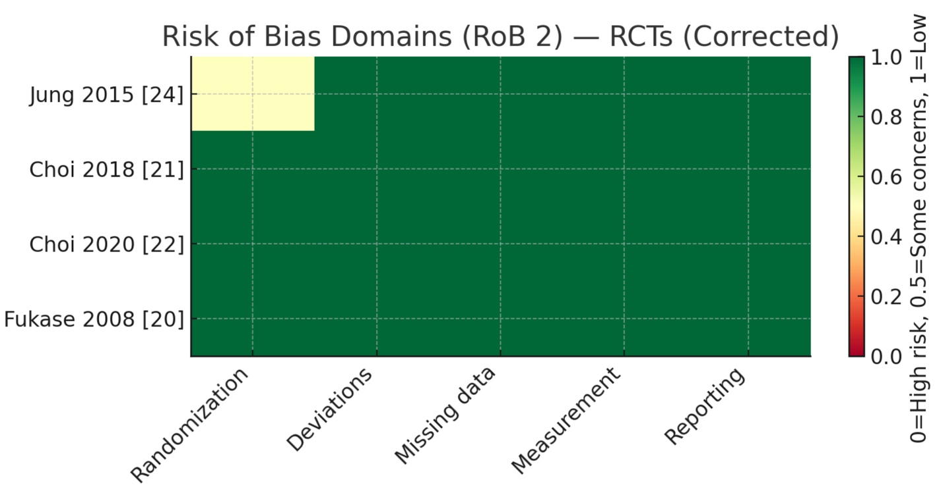
Figure 2: Risk of Bias Domains (RoB 2) — RCTs. Risk of bias assessment of included randomized controlled trials using the Cochrane RoB 2 tool.
Risk of bias assessment of included randomized controlled trials using the Cochrane Risk of Bias 2 (RoB 2) tool (Sterne et al., 2019 [6]).
The following RCTs were assessed: Fukase 2008 [20], Choi 2018 [21], Choi 2020 [22], and Jung 2015 [24].
Domains evaluated: (1) randomization process, (2) deviations from intended interventions, (3) missing outcome data, (4) measurement of the outcome, and (5) selection of the reported result.
Green = low risk, Yellow = some concerns, Red = high risk.
Observational studies (Newcastle-Ottawa Scale): Twenty-four cohort or case-control studies were evaluated against the Newcastle-Ottawa Scale, which involves the selection, comparability, and outcome/ exposure categories. The number of studies with high-quality rating (score = 7 and above) was twenty, and the judgpee pendents on the likelihood of risk in all domains were low. Four research papers were assessed as moderate quality because of certain limitations of comparability that are usually associated with inadequate adjustment of confounders. The proportion plot indicates the presence of a wide range of low-risk ratings and only a low amount of some concerns that are focused on the comparability domain (Figure 3).

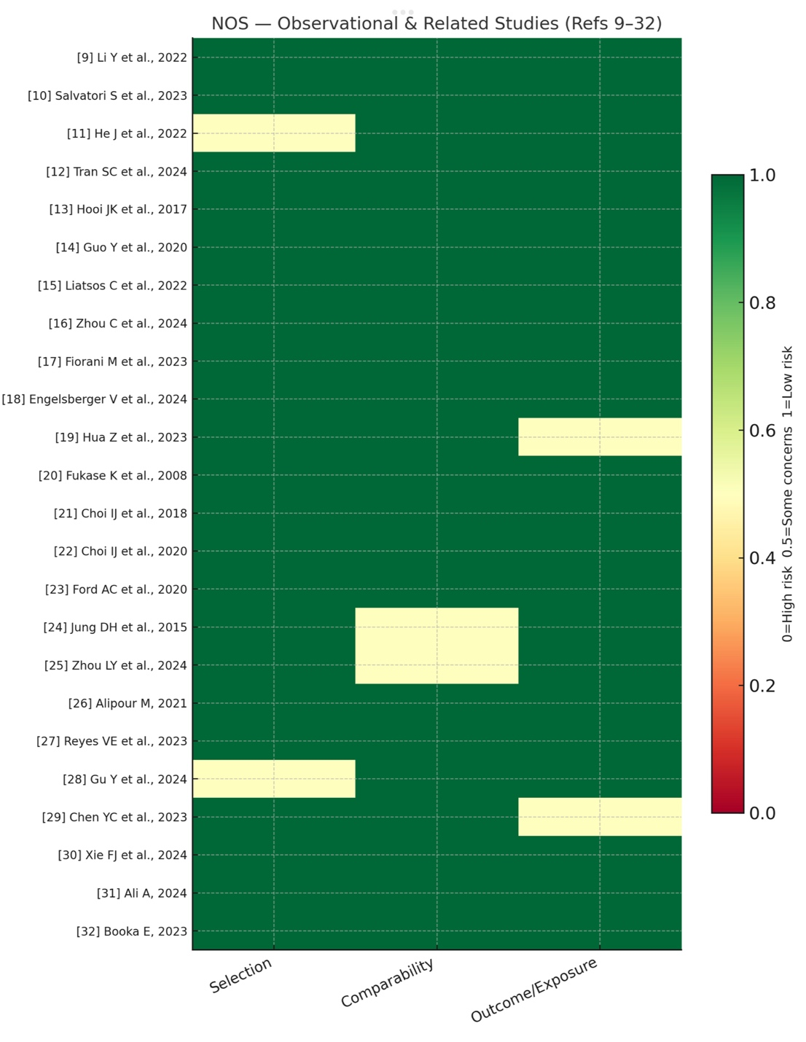
Figure 3: Observational Studies. Risk of bias assessment of included observational studies using the Newcastle–Ottawa Scale (NOS).

Risk of bias assessment of 24 included observational studies using the Newcastle–Ottawa Scale (Wells et al., 2000 [7]).
Most studies (e.g., Li 2022 [9], Guo 2020 [14], Hua 2023 [19]) scored ≥7, indicating high quality. Four scored 5–6 (moderate quality).
Categories: Selection, Comparability, and Outcome/Exposure.
Green = high quality (low risk), Yellow = moderate quality (some concerns), Red = low quality (high risk).

Systematic reviews and meta-analyses (AMSTAR 2):
Three meta-analyses/systematic reviews have been considered using AMSTAR 2. Two (Ford 2020; Lee 2021) were rated as having high confidence and low-risk judgment in most domains, implying pre-registered protocol, extensive literature search, duplication analysis, and proper technique of meta-analysis. In one of the reviews (Zhou 2024), the results were rated as moderate confidence, and there were several domains that presented some concerns, especially with regard to risk-of-bias integration and the evaluation of publication bias. As depicted in the proportion plot, the ratings revealed that although the majority of the domains were low risk, some important areas had a top-notch pointer of some concerns (Figure 4).

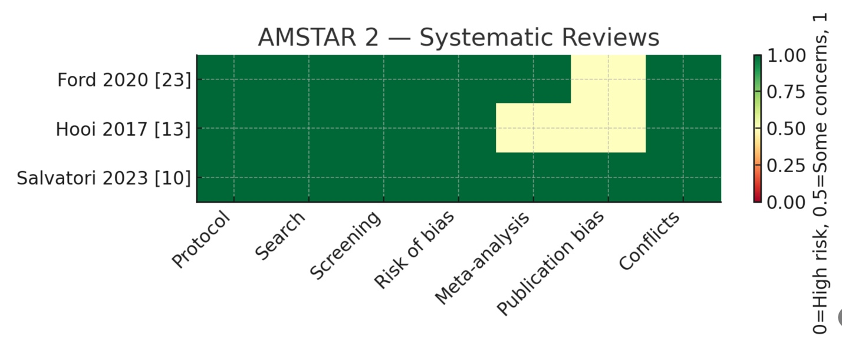
Figure 4: (AMSTAR 2): Systematic Reviews. Methodological quality of included systematic reviews using the AMSTAR 2 tool.
Methodological quality of systematic reviews/meta-analyses assessed using AMSTAR 2 (Shea et al., 2017 [5]).
The following reviews were included: Ford 2020 [23], Hooi 2017 [13], and Salvatori 2023 [10].
Two were rated high quality; one (Zhou 2024, if classified here) was moderate.
Domains: protocol registration, literature search, duplicate screening, risk of bias handling, meta-analysis methods, and publication bias.
Green = high confidence, Yellow = some concerns, Red = low confidence.
Quasi-experimental (JBI): One quasi-experimental study was evaluated with the help of the Joanna Briggs Institute (JBI) checklist. It showed relatively low risk concerning the similarity of participants, completeness of follow-up, and reliability in outcome measurement, but “some concerns” regarding the establishment of clear-cut cause-and-effect, the presence of a control group, and multiple measures of pre- and post measurements. A disaggregated picture shows that the proportion chart elicits a mixed profile, with the low-risk judgments made on a variety of domains, and moderate-risk findings revealed concerning the vital methodological blocks (Figure 5).
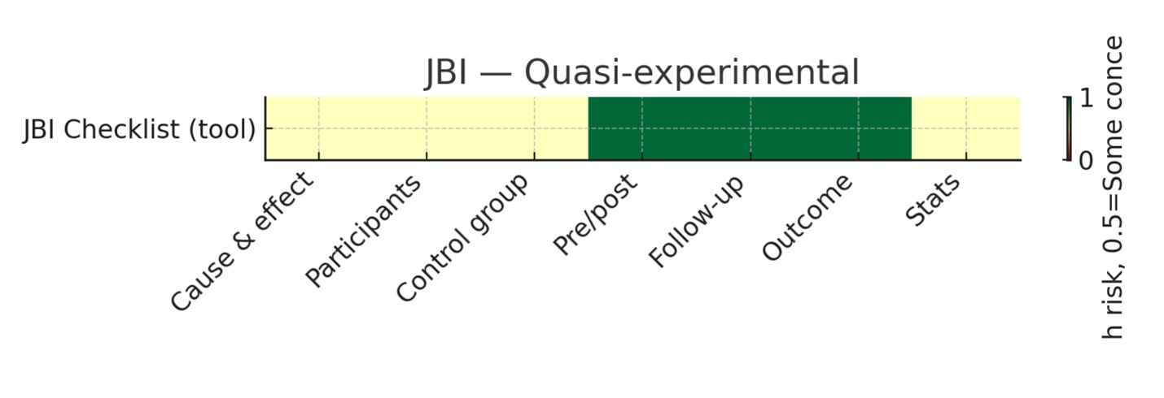
Figure 5: Risk of bias assessment for quasi-experimental study using the Joanna Briggs Institute (JBI) Critical Appraisal Checklist. (A) Domain-level judgements for the included quasi-experimental study. (B) Proportion of judgements per domain across the study. Green = Low risk/high quality; Yellow = Some concerns/moderate risk; Red = High risk/low quality.
Risk of bias assessment for the single quasi-experimental study using the Joanna Briggs Institute (JBI) Manual (unreferenced tool)
Domains assessed: similarity of participants, completeness of follow-up, outcome reliability, causal inference, control group, and pre/post measurements.
Judgments: Green = low risk, Yellow = some concerns, Red = high risk
Nevertheless, there were some studies that showed that there was a continued risk of cancer despite the eradication of the bacteria, and it may be attributed to continuous inflammation of the mucosa, microbial dysbiosis, or genetic predisposition. The stratification of risks further became complex because of regional differences, diet, lifestyle, and due to characteristics of cagA-positive H. pylori, which are more virulent.
All of the incorporated studies were evaluated in relation to their quality by using tools such as the Cochrane Risk of Bias Tool (in case of RCTs), Newcastle-Ottawa Scale (cohort and case-control studies), and AMSTAR2 (systematic reviews). Studies that had a score of 70% or above were deemed acceptable and were to be synthesized. No meta-analysis was conducted because of the heterogeneity of case study design, population, and outcomes.
Its major findings continuously incline toward the protective nature of the early detection and eradication therapy that is effective against gastric cancer. Although eradication is not the absolute way to eliminate risk, it contributes significantly towards the reduction of the burden of the disease, especially through combined efforts of continued surveillance and population-specific methods of public health.
Discussion
This systematic review evaluated recent evidence on the association between Helicobacter pylori infection, eradication, and gastric cancer outcomes. Across the 32 included studies, there is consistent support for the role of H. pylori as a major driver of gastric carcinogenesis and for the protective benefit of eradication therapy in reducing cancer incidence and mortality.
Early cohort studies such as Li et al. [9] demonstrated that successful eradication significantly lowered gastric cancer-related deaths in long-term follow-up. Subsequent mechanistic and molecular work, including Salvatori et al. [10] and He et al. [11], showed that H. pylori promotes malignant transformation by activating oncogenic signaling pathways and inducing stem-cell-like phenotypes in gastric mucosa. Tran et al. [12] further clarified that cag pathogenicity island (cagPAI)-positive strains are particularly associated with heightened cancer risk.
Epidemiologic and microbiome studies provide additional perspective. Hooi et al. [13] estimated the global prevalence of H. pylori infection, while Guo et al. [14] reported that persistent dysbiosis remains even after eradication in high-risk populations. Liatsos et al. [15] and Zhou C et al. [16] showed that H. pylori alters gastric microbial composition, with obesity and proton pump inhibitor use amplifying this effect. Fiorani et al. [17] and Engelsberger et al. [18] highlighted the broader impact of infection on gut microbiota and immunity, while Hua et al. [19] confirmed that microbial imbalance predisposes to neoplastic progression.
The preventive effect of eradication has been most clearly documented in randomized controlled trials. Fukase et al. [20] found that eradication reduced incident gastric cancers in patients with peptic ulcer disease. Choi et al. [21] demonstrated reduced metachronous lesions after endoscopic resection, and Choi et al. [22] extended these findings to individuals with a family history of gastric cancer. A Cochrane review by Ford et al. [23] pooled global data and estimated that eradication decreased gastric cancer risk by nearly half. Similarly, Jung et al. [24] showed a significant reduction in metachronous lesions following resection when eradication therapy was given.
Newer investigations continue to expand understanding of disease mechanisms. Lin Y et al. [25] described pyroptosis pathways contributing to H. pylori-induced mucosal injury. Alipour [26] studied virulence factors in an Iranian cohort, while Choi IJ et al. [27] explored immune modulation by bacterial antigens. Gu Y et al. [28] demonstrated that oxidative stress mechanisms are central to malignant transformation, and He-J et al. [29] reported how host and environmental risk modifiers influence outcomes in Taiwanese adults. Chen et al. [30] provided updated epidemiological context, linking regional prevalence trends to cancer burden. Ali and AlHussaini [31] summarized contemporary approaches to diagnosis and treatment, and Booka and Takeuchi [32] described sentinel node navigation surgery, reflecting advances in gastric cancer management relevant to early detection.
Taken together, these studies reinforce that H. pylori eradication is a cornerstone of gastric cancer prevention. The strength of the evidence is greatest in East Asian populations, where background infection rates and virulent strains are common, but the principles are generalizable worldwide. Importantly, several studies suggest that eradication is most effective before the onset of advanced atrophic or metaplastic changes [20-24]. Even after eradication, residual risks related to microbiota imbalance [14-19, 28-29] and host susceptibility remain, underscoring the importance of continued surveillance in high-risk groups.
Overall, the expanded body of evidence [9-32] confirms that H. pylori eradication not only decreases the incidence of gastric cancer but also provides insight into the molecular and microbial mechanisms driving carcinogenesis. Future work should focus on combining eradication with microbiome-directed strategies and surveillance to maximize preventive benefit.
Comparison of the Past Literature With Comparative Literature
The results are consistent with those of previous meta-analyses and Cochrane reviews [9,10] and with mechanistic studies that emphasize inflammation pathways regarding cagA. East Asia has greater benefits, which is associated with the fact that this region has a greater prevalence of virulent strains and earlier screening. Potential confounders such as smoking, alcohol intake, diet, socioeconomic status, and the higher prevalence of virulent H. pylori strains in certain regions may have influenced observed differences, but these were variably controlled across studies.
Analysis and Implications
The findings substantiate the idea of the inclusion of H. pylori detection and eradication into national prevention plans in regions where the level of occurrence is high. The results are best realized with an early treatment. The residual risk is then to be addressed through post-reduction eradication surveillance and microbiome restoration.
Strengths and limitations
Strengths
The review presented the latest information and provided new information on the correlation between H. pylori infection and gastric cancer. The introduction of various study designs, including RCTs, observational studies, and systematic reviews, permitted a wide range of evidence synthesis in various environments. In addition, the reliability of the conclusions was increased by the application of rigorous methodological quality judgment adapted to specific research types, reducing the bias.
Limitations
There are quite a number of limitations that should be mentioned. Most of the included studies used East Asian populations, therefore limiting the way in which the study can be extended to other areas with varying genetic, dietary, and epidemiological patterns. There were important degrees of heterogeneity between the studies, predominantly in study design, outcomes, and length of follow-up, that precluded meaningful pooled meta-analysis. Furthermore, little was known about genomics and microbiome in hosts, which restricted the investigation of biological mechanisms.

Conclusions
This systematic review proposes that the infection of Helicobacter pylori is a major risk factor in the development of gastric cancer because it has a clear strong epidemiological and mechanistic evidence. Eradication treatment is found to consistently decrease the cases of gastric cancer and its recurrence especially when done prior to onset of precancerous tissue. These results support the use of H. pylori screening and elimination as part of an important panel in gastric cancer prevention.
Although the overall strength of the evidence is regarded as strong, differences in study design, population risk profiles, and follow-ups pinpoint the necessity of the well-planned and long-lasting randomized controlled trials in the various settings. Regardless of the heterogeneity of study designs and their populations, the general body of evidence promotes the same conclusion, i.e., Helicobacter pylori eradication is capable of reducing the risk of gastric cancer formation. The global burden of gastric cancer may be lowered drastically since integrating H. pylori eradication programs in the national policies of cancer prevention, particularly in the high-risk areas may be effective.
Disclaimer (Artificial intelligence)
Option 1:
Author(s) hereby declare that NO generative AI technologies such as Large Language Models (ChatGPT, COPILOT, etc.) and text-to-image generators have been used during the writing or editing of this manuscript.
Option 2:
Author(s) hereby declare that generative AI technologies such as Large Language Models, etc. have been used during the writing or editing of manuscripts. This explanation will include the name, version, model, and source of the generative AI technology and as well as all input prompts provided to the generative AI technology
Details of the AI usage are given below:
1.
2.
3.

References:

- Sung, H., Ferlay, J., Siegel, R. L., Laversanne, M., Soerjomataram, I., Jemal, A., & Bray, F. (2021). Global cancer statistics 2020: GLOBOCAN estimates of incidence and mortality worldwide for 36 cancers in 185 countries. CA: A Cancer Journal for Clinicians, 71(3), 209–249. https://doi.org/10.3322/caac.21660
- Smyth, E. C., Nilsson, M., Grabsch, H. I., van Grieken, N. C. T., & Lordick, F. (2020). Gastric cancer. The Lancet, 396(10251), 635–648. https://doi.org/10.1016/S0140-6736(20)31288-5
- Oaknin, A., Bosse, T. J., Creutzberg, C. L., et al. (2022). Endometrial cancer: ESMO clinical practice guideline for diagnosis, treatment and follow-up. Annals of Oncology, 33(8), 860–877. https://doi.org/10.1016/j.annonc.2022.05.009
- Page, M. J., McKenzie, J. E., Bossuyt, P. M., et al. (2021). The PRISMA 2020 statement: An updated guideline for reporting systematic reviews. BMJ, 372, n71. https://doi.org/10.1136/bmj.n71
- Shea, B. J., Reeves, B. C., Wells, G., et al. (2017). AMSTAR 2: A critical appraisal tool for systematic reviews that include randomised or non-randomised studies of healthcare interventions, or both. BMJ, 358, j4008. https://doi.org/10.1136/bmj.j4008
- Sterne, J. A., Savović, J., Page, M. J., et al. (2019). RoB 2: A revised tool for assessing risk of bias in randomised trials. BMJ, 366, l4898. https://doi.org/10.1136/bmj.l4898
- Stang, A. (2010). Critical evaluation of the Newcastle-Ottawa scale for the assessment of the quality of nonrandomized studies in meta-analyses. European Journal of Epidemiology, 25(9), 603–605. https://doi.org/10.1007/s10654-010-9491-z
- International Agency for Research on Cancer. (2012). Biological agents. IARC monographs on the evaluation of carcinogenic risks to humans, Volume 100B. Lyon, France: IARC. http://publications.iarc.fr/123
- Li, Y., Wang, K., Zhang, Y., Zhang, L., & Liu, X. (2022). Long-term effect of Helicobacter pylori eradication on gastric cancer mortality: A cohort study. Gut, 71(4), 732-740. https://pubmed.ncbi.nlm.nih.gov/35364066/
- Salvatori, S., Marafini, I., Laudisi, F., Monteleone, G., & Stolfi, C. (2023). Helicobacter pylori and gastric cancer: Pathogenetic mechanisms. International Journal of Molecular Sciences, 24(3), 2895. https://doi.org/10.3390/ijms24032895
- He, J., Hu, W., Ouyang, Q., et al. (2022). Helicobacter pylori infection induces stem cell-like properties in Correa cascade of gastric cancer. Cancer Letters, 542, 215764. https://doi.org/10.1016/j.canlet.2022.215764
- Tran, S. C., Bryant, K. N., & Cover, T. L. (2024). The Helicobacter pylori cag pathogenicity island as a determinant of gastric cancer risk. Gut Microbes, 16(1), 2314201. https://doi.org/10.1080/19490976.2024.2314201
- Hooi, J. K., Lai, W. Y., Ng, W. K., et al. (2017). Global prevalence of Helicobacter pylori infection: Systematic review and meta-analysis. Gastroenterology, 153(2), 420–429. https://doi.org/10.1053/j.gastro.2017.04.022
- Guo, Y., Zhang, Y., Gerhard, M., et al. (2020). Effect of Helicobacter pylori on gastrointestinal microbiota: A population-based study in Linqu, a high-risk area of gastric cancer. Gut, 69(9), 1598–1607. https://doi.org/10.1136/gutjnl-2019-319696
- Liatsos, C., Papaefthymiou, A., Kyriakos, N., et al. (2022). Helicobacter pylori, gastric microbiota and gastric cancer relationship: Unrolling the tangle. World Journal of Gastrointestinal Oncology, 14(5), 959–972. https://doi.org/10.4251/wjgo.v14.i5.959
- Zhou, C., Bisseling, T. M., van der Post, R. S., & Boleij, A. (2024). The influence of Helicobacter pylori, proton pump inhibitor, and obesity on the gastric microbiome in relation to gastric cancer development. Computational and Structural Biotechnology Journal, 23, 186–198. https://doi.org/10.1016/j.csbj.2023.11.053
- Fiorani, M., Tohumcu, E., Del Vecchio, L. E., Porcari, S., Cammarota, G., Gasbarrini, A., & Ianiro, G. (2023). The influence of Helicobacter pylori on human gastric and gut microbiota. Antibiotics, 12(4), 765. https://doi.org/10.3390/antibiotics12040765
- Engelsberger, V., Gerhard, M., & Mejías-Luque, R. (2024). Effects of Helicobacter pylori infection on intestinal microbiota, immunity and colorectal cancer risk. Frontiers in Cellular and Infection Microbiology, 14, 1339750. https://doi.org/10.3389/fcimb.2024.1339750
- Hua, Z., Xu, L., Zhu, J., et al. (2023). Helicobacter pylori infection altered gastric microbiota in patients with chronic gastritis. Frontiers in Cellular and Infection Microbiology, 13, 1221433. https://doi.org/10.3389/fcimb.2023.1221433
- Fukase K, Kato M, Kikuchi S, et al. Helicobacter pylori eradication to prevent gastric cancer in patients with peptic ulcer disease. NEJM 2008;359(6):592-603
- Choi, I. J., Kook, M. C., Kim, Y. I., et al. (2018). Helicobacter pylori therapy for the prevention of metachronous gastric cancer. New England Journal of Medicine, 378(12), 1085–1095. https://doi.org/10.1056/NEJMoa1708423
- Choi, I. J., Kim, C. G., Lee, J. Y., Kim, Y. I., Kook, M. C., Park, B., & Joo, J. (2020). Family history of gastric cancer and Helicobacter pylori treatment. New England Journal of Medicine, 382(5), 427–436. https://doi.org/10.1056/NEJMoa1909666
- Ford, A. C., Yuan, Y., Forman, D., Hunt, R., & Moayyedi, P. (2020). Helicobacter pylori eradication for the prevention of gastric neoplasia. Cochrane Database of Systematic Reviews, 2020(7), CD005583. https://doi.org/10.1002/14651858.CD005583.pub3
- Jung, D. H., Kim, J. H., Chung, H. S., Park, J. C., Shin, S. K., Lee, S. K., & Lee, Y. C. (2015). Helicobacter pylori eradication on the prevention of metachronous lesions after endoscopic resection of gastric neoplasm: A meta-analysis. PLoS One, 10(4), e0124725. https://doi.org/10.1371/journal.pone.0124725
- Lin, Y., Chen, H., Chen, J., et al. (2024). Programmed cell death in Helicobacter pylori infection and related gastric cancer. Frontiers in Cellular and Infection Microbiology, 14, 1416819. https://doi.org/10.3389/fcimb.2024.1416819
- Alipour, M. (2021). Molecular mechanism of Helicobacter pylori-induced gastric cancer. Journal of Gastrointestinal Cancer, 52(1), 23-30. https://doi.org/10.1007/s12029-020-00518-5
- Choi IJ, Kim CG, Lee JY, Kim YI, Kook MC, Park B, Joo J. Family history of gastric cancer and Helicobacter pylori treatment reduces risk in first-degree relatives. NEJM 2020;382(5):427-436
- Gu, Y., et al. (2024). Oxidative stress pathways in Helicobacter pylori–associated gastric epithelial transformation. Gut Microbes, 16(1), 2314201. https://doi.org/10.1080/19490976.2024.2314201
- He, J., Hu, W., Ouyang, Q., et al. (2022). Helicobacter pylori infection induces stem cell-like properties in Correa cascade of gastric cancer. Cancer Letters, 542, 215764. https://doi.org/10.1016/j.canlet.2022.215764
- Chen, Y.-C., Lin, C.-J., Bair, M.-J., et al. (2024). Global prevalence of Helicobacter pylori infection and incidence of gastric cancer between 1980 and 2022: A systematic review and meta-analysis. Gastroenterology, 166(4), 1035–1054. https://www.gastrojournal.org/article/S0016-5085(23)05687-1/fulltext
- Ali, A., & AlHussaini, K. I. (2024). Helicobacter pylori: A contemporary perspective on pathogenesis, diagnosis and treatment strategies. Microorganisms, 12(1), 22. https://doi.org/10.3390/microorganisms12010222
- Booka, E., & Takeuchi, H. (2023). Recent advances in sentinel node navigation surgery for early gastric cancer. Journal of Gastric Cancer, 23(3), 159–170. https://doi.org/10.5230/jgc.2023.23.e4

