Traditional Cosmeceutical and Therapeutic Uses of Shea Butter (Vitellaria paradoxa) in the Maritime Region of Togo

.
ABSTRACT

Introduction : Shea butter (Vitellaria paradoxa), revered as "women's gold," is a vital socio-economic and cultural resource in Togo. However, the associated traditional knowledge, transmitted orally, is poorly documented and threatened by urbanization and ecological pressures. This study documents and analyzes the traditional cosmeceutical and therapeutic applications of shea butter in Togo's Maritime region to preserve this intangible heritage and explore its potential for sustainable development.
Materials and Methods An ethnobotanical survey was conducted from September to November 2024, involving semi-structured interviews with 210 women (resellers, users, beauticians) across eight prefectures. Data were analyzed using thematic analysis and citation frequency calculations. A targeted literature review was performed to identify articles that explain the therapeutic and cosmetological mechanisms of our research finding.
Results : Results highlight a dual function: cosmetic, dominated by skin hydration (92.9% of citations), and therapeutic, led by the relief of muscular and joint pain (85.6%). The investigation also documented the medicinal uses of the tree's bark, leaves, and roots, confirming a holistic ethnobotanical knowledge. By corroborating these traditional cosmetic and therapeutic practices with scientific literature, the study validates their biochemical basis, particularly the anti-inflammatory and regenerative properties of the butter's rich unsaponifiable fraction.
Conclusion : By comparing this traditional knowledge with scientific literature, the study validates the biochemical basis of these ancestral practices, particularly the anti-inflammatory and regenerative role of the butter's rich unsaponifiable fraction. While insightful, the study's qualitative design and snowball sampling limit the generalizability of the findings. The study underscores the necessity of preserving this threatened heritage and promoting its sustainable development through value chains that respect local knowledge.

Keywords: Vitellaria paradoxa, Shea butter, Cosmetic use, Ethnobotany, Togo
1. INTRODUCTION
Commonly known as "women's gold," the shea tree (Vitellaria paradoxa C.F. Gaertn.) is an emblematic oleaginous tree of the Sudanian savannas of Africa, with a distribution range that spans approximately twenty countries, forming the "shea belt" [Bup et al., 2014]. Beyond its fundamental ecological role in agroforestry parklands [Maanikuu et al., 2017], this tree constitutes a vital socio-economic and cultural resource for millions across the continent. In Togo, the shea sector is recognized as highly strategic, positioning the country as the 7th largest global producer and accounting for 5% of the West African export market.
The tree's poetic designation as "women's gold," embodies a profound socio-economic reality : the shea value chain, from the collection of nuts to the marketing of the butter, is predominantly controlled by women, who represent nearly 85% of the sector's stakeholders in Togo. Consequently, this sector serves as a key driver for their economic and social empowerment in rural areas [Lovett & Haq, 2000]. The fat extracted from the kernels, a vegetable butter rich in bioactive compounds, transcends its status as a mere agricultural product to become an intrinsic element of cultural heritage and a first-line remedy in community health practices [Atakpama et al., 2022]. Its applications are ubiquitous, ranging from infant care and ceremonial rites of passage to the treatment of various ailments.
This versatility is attributable to its unique biochemical composition, notably a high concentration of an unsaponifiable fraction rich in triterpenes, tocopherols, and phytosterols. These constituents impart remarkable anti-inflammatory, antioxidant, emollient, and wound-healing properties, which are increasingly being validated by scientific research [Akihisa et al., 2010]. However, despite its established importance, the ethnobotanical knowledge specific to the Togolese context remains insufficiently documented. Primarily transmitted orally from one generation to the next, this knowledge is threatened by urbanization dynamics that erode traditional practices [Kpegba et al., 2017]. This cultural threat is compounded by ecological pressure, including the degradation of shea parklands and unfavorable climate projections for the species' habitat. [Atakpama et al., 2022; Bidou et al., 2019]
Therefore, there is an imperative need to rigorously document these traditional uses before they potentially vanish. The present study is framed within this context. Its objective is to analyze the traditional knowledge and practices associated with shea butter in Togo, with a focus on its cosmetological and therapeutic applications. Specifically, this research aims to comprehensively inventory these uses among female vendors and users in the markets of the Maritime region and to corroborate this traditional knowledge with data from the scientific literature. This endeavor seeks to preserve this heritage and identify pathways for its sustainable valorization.
.]

2. material and methods
The study was conducted from September 2024 to November 2024, involving a cohort of 210 women. The research design integrated semi-structured interviews with a purposively selected participant sample and a targeted literature review focused on the biochemical constituents of shea butter that could substantiate its documented cosmetological and therapeutic properties.

2.1.Field survey
The investigation into cosmetological and therapeutic applications was carried out in marketplaces throughout the Maritime region. The respondent pool included women involved in the sale of medicinal plants, individuals who use shea butter for personal aesthetic or therapeutic purposes, and professional aestheticians and massage therapists who incorporate shea butter into their practice.

2.2.Sampling and Participants
A total of 210 women were interviewed using a semi-structured format. Participants were recruited using the snowball sampling technique to effectively identify key informants.

2.3.Data Collection Instrument
Semi-structured interviews were administered using a pre-designed questionnaire that functioned as a discussion guide. The open-ended nature of the questions facilitated in-depth responses and the collection of unanticipated information. The survey encompassed the following thematic areas:
- General information : age, primary activity related to shea, years of experience, and the mode of knowledge transmission.
- Cosmetological and therapeutic uses : application of shea butter for skin, hair, and body care, as well as its use in treating dermatological conditions or alleviating pain. The inquiry also extended to the utilization of other parts of the Vitellaria paradoxa tree (leaves, bark, roots) and their associated preparations, such as macerations and decoctions.
2.4.Targeted literature review
A targeted literature review was conducted to scientifically substantiate the ethnobotanical uses reported by the participants. The review focused on identifying peer-reviewed articles that elucidated the biochemical and pharmacological mechanisms underlying the observed cosmetological and therapeutic properties of shea butter (Vitellaria paradoxa). Key databases such as PubMed, Scopus, and Google Scholar were queried using terms including "shea butter," "Vitellaria paradoxa," "unsaponifiable fraction," "triterpenes," "anti-inflammatory properties," and "skin hydration." This process aimed to correlate traditional knowledge with established scientific evidence, particularly concerning the bioactivity of the butter's fatty acid profile and its rich unsaponifiable compounds.

2.5.Data Analysis
Qualitative data from the interviews were transcribed and subjected to a thematic analysis to identify recurrent uses. The citation frequency for each specific use was subsequently calculated and expressed as a percentage to quantify its prevalence within the study sample.
3. results and discussion

3.1. RESULTS
3.1.1. Study area
Togo (Fig 1.) is a West African nation that holds membership in both the Organisation Internationale de la Francophonie and the Commonwealth of Nations. This study is geographically situated within its Maritime Region (Fig 2), an area bounded approximately by latitudes 6.1° N and 6.9° N, and longitudes 0.8° E and 1.8° E, with a central point around 6.55° N, 1.35° E. The region encompasses eight prefectures or districts. While these districts are significantly engaged with modernity, they concurrently preserve deep-rooted traditional therapeutic and ethnopharmacological practices, notably the use of shea butter, which is the focus of this research
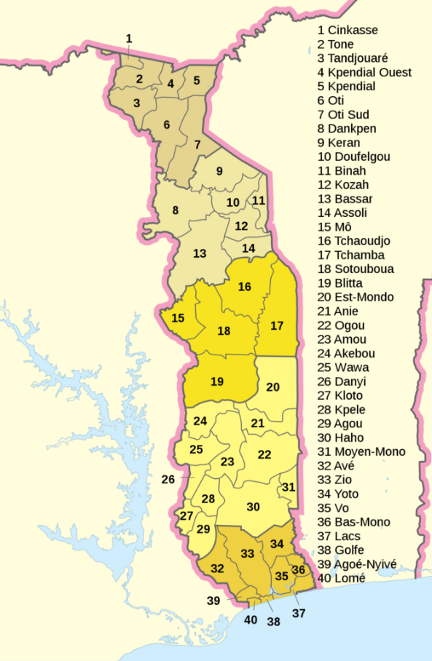 | 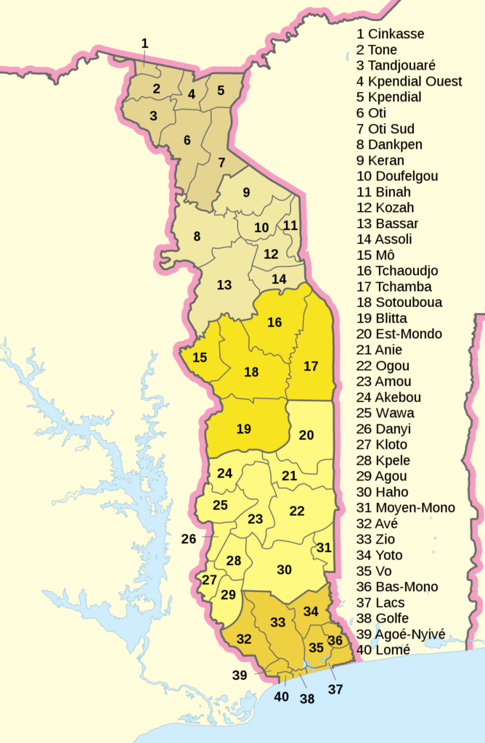  32-Kévé (District of Avé) : 6.42° N, 0.92° E  33-Tsévié (District of Zio) : 6.43° N, 1.21° E  34-Tabligbo (Préfecture de Yoto) : 6.58° N, 1.50° E  35-Vogan (District of Vo) : 6.33° N, 1.53° E  36-Afagnan (District of Bas-Mono) : 6.49° N, 1.63° E  37-Aného (District of Lacs) : 6.23° N, 1.60° E  39-Agoè-Nyivé (District of Agoè-Nyivé) : 6.22° N, 1.19° E  40-Lomé (District of Golfe, Akodessewa) : 6.13° N, 1.22° E
Figure 1 : Administrative map of Togo Republic  Source : https://gifex.com/fr | Figure 2 :Maritime region with District and their market
Geographically, the study was conducted across the eight prefectures of the Maritime region of Togo as shown in table 1.
Table 1: Distribution of the study population
Prefecture | Capital | Markets visited | Shea nutter resellers (n) | Medicinal plant resellers (n) | Women Using shea butter (n) | Beauticians, Masseurs (n) | Total number of People (n)
Agoè-Nyivé | Agoè-Nyivé | Agoè Légbassito Market | 3 | 8 | 4 | 3 | 18
Avé | Kévé | Kévé Market | 3 | 9 | 7 | 1 | 20
Bas-Mono | Afagnagan | Novissi Market of Afagnan | 4 | 8 | 12 | 2 | 26
Golfe | Lomé | Akodessewa Market (Fetish Market) | 12 | 9 | 5 | 6 | 32
Lacs | Aného | Lagbonou Market | 4 | 7 | 3 | 3 | 17
Vo | Vogan | The big Market of Vogan | 7 | 7 | 10 | 3 | 27
Yoto | Tabligbo | Tabligbo Market | 8 | 11 | 12 | 4 | 35
Zio | Tsévié | The big Market of Tsévié | 6 | 9 | 11 | 9 | 35
Total |  |  | 47 | 68 | 64 | 31 | 210
The geographical distribution of the sample across eight Districts of the Maritime region ensures a robust representation of practices within this area. The markets of Yoto (Tabligbo) and Zio (Tsévié) emerge as major hubs of the investigation, with the highest number of participants (35 each), suggesting a significant concentration of shea-related activities in these localities. The notable presence of shea butter resellers (12) at the Akodessewa market in Lomé, known as the "fetish market," indicates a profound integration of shea butter applications into traditional practices, including therapeutic and ritualistic uses.

3.1.2. Sociodemographic characteristics of participants
The survey data enabled the stratification of the study population based on several criteria as shown in table 2.
Table 2: Profile of women interviewed in the shea butter sector (N=210)

Feature | Category | Number of participants | Percentage
Activity category | Shea butter resellers | 47 | 22.38%
Activity category | Medicinal plant resellers | 68 | 32.38%
Activity category | Beauticians and/or masseuses | 31 | 14.76%
Activity category | Women using shea butter | 64 | 30.47%
Activity category | Total | 210 | 100.00%
Age group | Under 30 years | 15 | 7.1%
Age group | 30 to 50 years | 135 | 64.3%
Age group | Over 50 years | 60 | 28.6%
Years of experience | Less than 5 years | 24 | 11.4%
Years of experience | 5 to 15 years | 120 | 57.1%
Years of experience | More than 15 years | 66 | 31.4%
Table 2 outlines the sociodemographic profile of the 210 study participants and reveals that the sample is predominantly composed of experienced women, with a majority (64.3%) aged between 30 and 50 years and possessing significant experience in the field (57.1% with 5 to 15 years of experience). The diversity of profiles, which includes resellers of medicinal plants (32.38%) and direct users (30.47%), underscores that knowledge regarding shea butter is held and transmitted by a wide array of actors, spanning both commercial and private spheres. The maturity and diversity of the respondents lend considerable credibility to the data collected on traditional uses.

3.1.2. Documented therapeutic and cosmetological properties
The investigation successfully documented a wide variety of traditional uses for shea butter, confirming its central role in Togolese pharmacopoeia and skincare rituals.
3.1.2.1. Cosmetological uses
Shea butter is employed as a daily cutaneous moisturizer and protectant. Participants highlighted its application for preventing stretch marks, softening infants' skin, and shielding the epidermis from sun and wind exposure. It is also extensively used in hair care, particularly for moisturizing dry and brittle hair.
3.1.2.2. Therapeutic uses
Data analysis reveals that shea butter is traditionally utilized for the following purposes:
  - Alleviating muscular and articular pain, especially through massage.
  - Treating rheumatism and arthritis.
  - Soothing minor burns.
  - Promoting the healing of small wounds.
  - Mitigating the symptoms of certain dermatological conditions such as eczema and psoriasis.
Table 3 synthesizes the most frequently reported uses by the participants. These findings are derived from qualitative interview data and reflect the diverse applications of shea butter.
Table 3: Traditional cosmetological and therapeutic uses of shea butter
Type of use | Specific use | Citation frequency (N=210)
Cosmetic | Skin hydration | n=195 (92.9%)
Cosmetic | Sun protection | n=165 (78.6%)
Cosmetic | Stretch mark prevention | n=159 (75.71%)
Cosmetic | Hair care | n=132 (62.86%)
Therapeutic | Muscular and articular pain | n=180 (85.6%)
Therapeutic | Rheumatism | n=114 (54.28%)
Therapeutic | Burns | n=87 (41.42%)
Therapeutic | Wound healing | n=39 (18.57%)
Therapeutic | Dermatological afflictions (eczema, psoriasis) | n=27 (12.85%)
Table 3 quantifies the prevalence of the different uses and highlights the nearly equivalent dual function of shea butter as both a cosmetic and therapeutic agent. Skin hydration (92.9%) and the relief of muscular/articular pain (85.6%) emerge as the two most prominent applications, confirming its status as an essential daily care product. The high citation frequency for sun protection (78.6%) and stretch mark prevention (75.71%) reinforces its protective and restorative role for the epidermis. These data provide quantitative validation for the versatility of shea butter, which is deeply embedded in local practices.

3.1.3. Other uses of the shea plant
Table 4: Traditional uses of other parts of the shea tree
Preparation | Preparation Method | Reported Therapeutic Use | Citation Frequency
Barks | Decoction | Treatment of infections, stomach aches | n=102 (48.57%)
Leaves | Decoction, infusion | Digestive disorders (diarrhea, constipation) | n=93 (44.28%)
Roots | Decoction, maceration | Rheumatism, intestinal worms, female infertility | n=72 (34.28%)
Table 4 broadens the perspective, demonstrating that ethnobotanical knowledge is not confined to the butter but encompasses the entire Vitellaria paradoxa tree. The significant use of barks (48.57%) for infections and leaves (44.28%) for digestive ailments indicates a profound understanding of the medicinal properties of the plant's different parts. The use of roots for more complex conditions such as rheumatism or female infertility (34.28%) attests to the tree's central place in the traditional pharmacopoeia. These results underscore the importance of preserving a holistic view of the plant, beyond the singular economic valorization of its nuts.
The bark decoction for stomach aches, reported by 48.57% of participants, is typically prepared by boiling a handful of bark in one liter of water until the volume is reduced by half. The most frequently cited posology is one glass in the morning and evening for three days

3.2. DISCUSSION
This study aimed to document and analyze the traditional knowledge and practices associated with shea butter (Vitellaria paradoxa C.F. Gaertn.) in Togo, with a specific focus on its cosmeceutical and therapeutic applications. This investigation sought to elucidate the importance of the shea sector, its limitations, and to comprehensively catalog the associated ethnobotanical knowledge. By juxtaposing field data with current scientific literature, this discussion contextualizes our findings within existing research and identifies prospects for the sustainable valorization of this "women's gold" [Lovett, & Haq, 2000].
The therapeutic applications of shea butter, deeply embedded in the traditional Togolese pharmacopoeia, extend far beyond simple cutaneous hydration, positioning it as a cornerstone of community health and well-being. The ethnobotanical knowledge documented in this study reveals a sophisticated understanding of the plant's properties, wherein specific parts of Vitellaria paradoxa are utilized to treat a wide spectrum of ailments. These ancestral practices, far from being mere folklore, are substantiated by the butter's complex biochemical composition, which is increasingly validated by modern scientific research.
One of the most prevalent therapeutic uses in Togo is the topical application of shea butter as an analgesic for alleviating muscular and articular pain, including pathologies such as rheumatism and arthritis. This practice finds a plausible scientific explanation in the exceptionally high concentration of unsaponifiable compounds in shea butter, which can constitute up to 8% of its composition. This fraction is particularly rich in triterpene alcohols and their cinnamic esters, notably lupeol, alpha- and bêta-amyrin, and butyrospermol. These molecules are recognized for their potent anti-inflammatory properties [Akihisa et al., 2010]. Indeed, studies have demonstrated that triterpene cinnamates and acetates derived from shea fat exhibit significant anti-inflammatory and chemopreventive effects [Akihisa et al., 2010]. The capacity of these compounds to inhibit inflammatory pathways corroborates the traditional use of shea butter as an effective massage balm for soothing deep tissue pain. Furthermore, the presence of tocopherols (vitamin E), which also possess potent anti-inflammatory and antioxidant properties, complements this action by protecting tissues from the oxidative stress associated with inflammatory processes.
The use of shea butter to treat dermatological conditions and promote wound healing constitutes another essential pillar of traditional Togolese medicine. Informants widely reported its application for soothing minor burns and sunburns, healing small wounds and cuts, and mitigating the symptoms of chronic inflammatory skin conditions like eczema and psoriasis. This efficacy stems from a synergy between its saponifiable and unsaponifiable fractions. The rich fatty acid profile, particularly oleic acid (40-55%) and linoleic acid (3-8%), plays a crucial role in restoring the skin's lipid barrier, maintaining hydration, and promoting cellular renewal [Choungo et al, 2021]. Linoleic acid, an essential fatty acid, is a precursor to ceramides (vital components of the epidermal barrier) and its presence is critical for calming inflammatory reactions and facilitating the healing process. This lipid-mediated action is powerfully supported by the unsaponifiable fraction. Vitamins A, D, and E, along with phytosterols, contribute to the butter's regenerative and soothing virtues. Vitamin E, a potent antioxidant, protects cellular membranes from damage caused by free radicals generated during inflammatory responses or UV exposure, while phytosterols enhance skin elasticity and hydration. Consequently, shea butter acts not only as a protective and emollient film but also actively participates in the physiological processes of cutaneous repair.
Although this study focuses on shea butter, it is essential to recognize that traditional Togolese knowledge encompasses the Vitellaria paradoxa tree in its entirety, viewing it as a veritable "miracle tree". Ethnobotanical surveys revealed that other parts of the plant are regularly used for therapeutic purposes. Bark decoctions are employed against infections, while the roots are used to treat a range of conditions from intestinal worms to rheumatism and female infertility. The leaves, in turn, are indicated for digestive disorders such as constipation and diarrhea. While less scientifically documented than the butter, these uses highlight a holistic approach to the plant's resources. This underscores the necessity for more in-depth phytochemical and pharmacological investigations into these other parts of the tree, which could reveal novel bioactive compounds, validate their traditional applications, and thus open new avenues for valorization.
Our results suggest a correlation between the age of participants and the depth of their therapeutic knowledge. Indeed, the majority of complex applications, such as the use of roots to treat female infertility, were mentioned by women over 50, who constitute 28.6% of our sample. This highlights the crucial role of elders in the transmission of this heritage and underscores the urgency of its documentation.
The use of shea butter in beauty rituals in Togo, and more broadly across West Africa, transcends the mere application of a lipid; it is embedded within a cultural heritage and a holistic system of care. The cosmetic and aesthetic practices documented in this study, passed down from mother to daughter, reflect a profound empirical knowledge that is now finding scientific validation through the exceptional biochemical composition of Vitellaria paradoxa. [Israel;2014]
The most universal application of shea butter, confirmed by all participants, is its use as a moisturizing and protective agent for the skin and hair. This efficacy is predicated on its richness in fatty acids, notably oleic acid (omega-9, 40-55%) and stearic acid (35-50%) [Choungo et al, 2021]. These two compounds are major constituents of human sebum, which endows the butter with a remarkable affinity for the epidermis. By penetrating the upper layers of the skin, it restores the hydrolipidic film (the natural barrier that prevents transepidermal water loss and protects against external aggressors such as wind and sun) a widely acclaimed use in Togo. Palmitic acid (3-8%), also present, reinforces this action with its emollient properties that soften and smooth cutaneous tissues. [Hon et al ; 2015]. The application on infants' skin, an observed ancestral practice, thus finds its scientific justification in this capacity to form a gentle, non-occlusive protective shield. [Goreja ; 2004 ; Andersson, & Alander ; 2015]
Beyond hydration, shea butter is traditionally renowned for its regenerative and anti-aging virtues, which explains its use in the prevention and attenuation of striae (stretch marks) [Goreja ; 2004 ; Andersson, & Alander ; 2015)]. The key to this action lies in its exceptionally high unsaponifiable fraction (up to 8%), which concentrates a myriad of bioactive compounds. Among these, phytosterols and triterpene alcohols (such as alpha- and beta-amyrin) are known to stimulate the synthesis of collagen and elastin, thereby improving skin firmness and elasticity [Akihisa et al., 2010]. Concurrently, tocopherols (vitamin E), potent antioxidants, protect cells from free radical-induced damage, a primary factor in premature cutaneous aging. This synergy of active compounds confers upon shea butter a unique capacity to nourish, repair, and protect the skin in depth, justifying its status as a comprehensive, both preventive and restorative, skincare ingredient. [Kpegba et al., 2017 ; Ayanlowo et al, 2021]
Traditional Togolese knowledge accords a prominent place to shea butter in hair care, particularly for dry, brittle, or coily hair types. Its fatty acids penetrate the hair fiber to provide intense nourishment, while its unsaponifiable fraction forms a protective sheath that smooths the cuticles, limits breakage, and shields against external aggressions. Used as a mask, hot oil treatment, or daily application on the ends, it restores suppleness, luster, and vitality to even the most demanding hair.
The cosmetic uses of shea in Togo are not merely functional gestures ; they are integrated into cultural practices and rites of passage. The massaging of newborns, the anointing of brides and grooms, or postpartum care are all moments where shea butter acts as a "sacred balm," symbolizing protection, purity, and a connection to the earth. This aesthetic and ritualistic knowledge is a precious intangible heritage, transmitted orally from mother to daughter within communities. This transmission, which guarantees the continuity of these practices, is nevertheless threatened by modernization and urbanization, which tend to weaken intergenerational bonds and devalue traditional knowledge [Kpegba et al., 2017]. The documentation and valorization of these practices thus become a crucial endeavor, not only for the conservation of a cultural heritage but also for the future of an industry that draws its legitimacy and uniqueness from this ancestral wealth.

3.3. Limitations of the study
It should be noted that this study has some limitations. The qualitative approach and the use of snowball sampling, while appropriate for exploring traditional knowledge, do not permit the generalization of the findings to the entire Togolese population. Furthermore, the collected data are based on participant self-reports, which may introduce a social desirability bias. Complementary quantitative research would be necessary to confirm the prevalence of the documented uses on a larger scale.
4. Conclusion
This study has thoroughly documented the traditional cosmeceutical and therapeutic uses of shea butter in Togo, contextualizing them within current scientific knowledge and the socio-economic challenges of the sector. The findings confirm that shea, known as "women's gold," is far more than a simple agricultural commodity ; it is an essential component of the cultural heritage and community pharmacopoeia in Togo.
Although this study focused on uses, it is crucial to remember that the value of shea butter lies in its biochemical composition. Scientific literature indicates that traditional production practices are critical for preserving its rich unsaponifiable fraction. The valorization of knowledge about its uses must, therefore, be intrinsically linked to the preservation of these production know-hows. This fraction, rich in triterpenes, tocopherols, and phytosterols, scientifically justifies the ancestral uses of shea butter for its anti-inflammatory, soothing, and regenerative properties.
The most frequently reported uses for shea butter are skin hydration and the treatment of muscular and articular pain. These observations corroborate scientific data demonstrating that the triterpene cinnamates and acetates in the butter have significant anti-inflammatory effects, explaining its efficacy against pain and rheumatism. Similarly, its richness in essential fatty acids (oleic, stearic, linoleic) and vitamins (A, D, E) confirms its moisturizing, protective, and healing actions, validating its use for skin care, stretch mark prevention, and the repair of minor wounds
The study also highlighted the therapeutic use of other parts of the tree, such as the bark, leaves, and roots, to treat various ailments, underscoring a holistic and comprehensive approach to the plant in traditional Togolese medicine. This ethnobotanical knowledge, transmitted orally, is a precious yet endangered heritage, threatened by urbanization and modernization
Consent
All participants provided their free and informed consent prior to the start of the interview. they were first given a full explanation of the study's aims and objectives, after which they had the opportunity to ask questions until they were fully satisfied.

Disclaimer (Artificial intelligence)
Author(s) hereby declare that NO generative AI technologies such as Large Language Models (ChatGPT, manuscript.

References
Akihisa, T., Kojima, N., Kikuchi, T., Yasukawa, K., Tokuda, H., Masters, E. T., Manosroi, A., & Manosroi, J. (2010). Anti-inflammatory and chemopreventive effects of triterpene cinnamates and acetates from shea fat. Journal of Oleo Science, 59(6), 273–280. https://doi.org/10.5650/jos.59.273
Andersson, A. C., & Alander, J. (2015). Shea butter extract for bioactive skin care. Cosmet. Toilet, 130, 18-25.
Atakpama, W., Abalo-Sama, G. J., Egbelou, H., Gouwakinnou, G. N., Dimobe, K., Samarou, M., Batawila, K., & Akpagana, K. (2022). Aerial potentials of shea farming (Vitellaria paradoxa C.F Geartn spp paradoxa) in Togo. Review of Science and Technology, Synthesis, 28(2), 31-45.
Ayanlowo, O., Ebie, C., Cole‐Adeife, O., Ilomuanya, M., & Adegbulu, A. (2021). Shea butter as skin, scalp, and hair moisturizer in Nigerians. Dermatologic therapy, 34(2).
Bidou, J.-E., Koukpére, A., & Droy, I. (2019). The crisis of the shea tree park: an example of Djougou in Benin. In J. Sawmills & J.-M. Harmand (Eds.), Agroforestry and ecosystem services in the tropics (pp. 129-145). Editions Which.
Bup, D. N., Mohagir, A. M., & Nfor, M. E. (2014). Shea tree (Vitellaria paradoxa Gaertn. F.) conservation in Cameroon. International Journal of Biodiversity and Conservation, 6(3), 257-266. https://doi.org/10.5897/IJBC2013.0640
Bup, N., Djoukeng, E., & Toudou, H. (2014). Valuing shea (Vitellaria paradoxa): A source of income for rural Sahel populations.
Choungo Nguekeng, P. B., Hendre, P., Tchoundjeu, Z., Kalousová, M., Tchanou Tchapda, A. V., Kyereh, D., ... & Lojka, B. (2021). The current state of knowledge of shea butter tree (Vitellaria paradoxa cf gaertner.) for nutritional value and tree improvement in West and Central africa. Forests, 12(12), 1740.
Fok, M., & Assogba-Sodjinou, E. (2007). Shea in Benin: a hope for rural development. Cahiers Agricultures, 16(5), 455–460.
Gorey, W. G. (2004). Shea butter: the nourishing properties of Africa’s best-kept natural beauty secret. TNC International Inc.
Hon, K. L., Tsang, Y. C., Pong, N. H., Lee, V. W., Luk, N. M., Chow, C. M., & Leung, T. F. (2015). Patient acceptability, efficacy, and skin biophysiology of a cream and cleanser containing lipid complex with shea butter extract versus a ceramide product for eczema. Hong Kong Medical Journal, 21(5), 417.
Honfo, F. G., Akissoe, N., Linnemann, A. R., Soumanou, M., & Van Boekel, M. A. J. S. (2015). Production and Marketing of Shea Butter in Benin.
Honfo, F., Tovissodé, C., & Coulibaly, O. (2015). Economic Profitability Analysis of Shea Butter Production in Péhunco Municipality of Northern Benin. Annals of Agronomic Sciences, 19(1), 159-174.
Israel, M. O. (2014). Effects of topical and dietary use of shea butter on animals. Am J Life Sci, 2(5), 303.
Kpegba, K., Kpokan, S. A., Simalou, O., Novidzro, K. M., & Koumaglo, K. H. (2017). Evaluation of shea butter production techniques in Togo. International Journal of Biological and Chemical Sciences, 11(4), 1577-1591. http://dx.doi.org/10.4314/ijbcs.v11i4.14
Kpeglo, K., Koumoi, A., Folega, F., Kanda, M., Djiwa, O., & Batawila, K. (2024). Socio-Economic Importance of Nonlinear Forest Products in the Togo Savannah Region. Moroccan Review of Agronomic and Veterinary Sciences, 12(1), 46-53.
Lovett, P. N., & Haq, N. (2000). Evidence for anthropic selection of the sheanut tree (Vitellaria paradoxa). Agroforestry Systems, 48(3), 273-288.
Lovett, P. N., & Haq, N. (2000). Shea tree (shea tree) as a food crop and source of income in Ghana. Agroforestry Systems, 48(2), 177–187.
Mannicou, P. M. I., & Peker, K. (2017). Medicinal and nutritional benefits from the shea tree-(Vitellaria Paradoxa). Journal of Biology, Agriculture and Healthcare, 7(22), 51-57.

