Chemical composition and in vitro antioxidant studies on Annona muricata fruit

Abstract
The aim of the present study was to investigate the nutritional composition, proximate analysis, phytochemical constituents, and in vitro antioxidant activities of Annona muricata flesh, seed, and bark, with the goal of emphasizing their potential as alternative food sources. Phytochemical screening was conducted using both quantitative and qualitative techniques, in conjunction with the determination of proximate parameters through quantitative estimation. The scavenging effect of the Annona muricata flesh, seed, and bark was evaluated on 2,2-diphenyl-1-picrylhydrazyl (DPPH), ferric reducing potential, and nitric oxide scavenging radical. The quantitative phytochemical analysis identified the presence of cardiac glycosides, tannins, total phenols, saponins, and flavonoids. The proximate analysis of the flesh, seed, and bark indicated that the seed exhibited higher percentages of moisture content, protein, crude fat, ash content, crude fiber, and carbohydrates compared to the flesh. Considering phytochemicals, it has been demonstrated that the seed contains higher concentrations of antioxidants and flavonoid compounds compared to the flesh and bark. The study's findings demonstrate that soursop serves as a significant source of nutrition and various phytochemicals. The methanol fractions of the bark, flesh, and seed of Annona muricata were characterized using GC-MS, which revealed the presence of 134 phytochemicals. Consequently, the ethnobotanical perspective regarding the advantageous effects of Annona muricata flesh, seed, and bark may be substantiated, positioning it as a significant source of nutrition and medicinal value.
Keywords: Annona muricata (soursop), phytochemical constituents, in vitro antioxidant, proximate parameters, ferric reducing potential, nitric oxide scavenging radical.

INTRODUCTION
Modern scientific research has investigated fruit's nutraceutical qualities because of its high antioxidant content, absence of side effects, and viability from an economic standpoint [Manoharan R et al., 2025]. A vital component of the human diet for a long time has been fruits. They are widely acknowledged to be essential to their health and are also considered dietary supplements. Additionally, fruits are rich in organic, inorganic, and bioactive components, as well as moisture and carbohydrates [Ndife et al., 2014] [A. Zahid and R. Khedkar, 2022]. Since ancient times, herbal remedies have been essential to human health. Over the past century, pharmacological advancements have been greatly aided by plant phytochemicals. The importance of plant active ingredients in agriculture and medicine has sparked scientists' interest in the biological activities of plants in recent years [Kumari et al., 2021], [Moghadamtousi et al., 2015]. Because of its rich nutritional profile, soursop, also known as Annona muricata, has become quite popular [Chang et al., 2018], [Menezes et al., 2019]. The plant Annona muricata, also called soursop or custard apple, is a member of the Annonaceae family. Because of its bioactive components with nutraceutical qualities, this fruit is becoming more and more popular. In addition to being a fantastic source of fiber, soursop pulp has several interesting chemicals that, when taken in moderation, may have health benefits. For instance, the soursop plants contain epolyphenols, which are naturally occurring compounds with antioxidant properties that protect cells from harm caused by free radicals [Gonz´alez et al, 2017]. This plant contains around 200 distinct bioactive chemicals, most of which are acetogenins, phenols, and alkaloids [Gyesi et al., 2019]. Herbal medicine has traditionally made use of soursop phytochemicals. Medical disorders such bacterial or parasite infections, fever, hyperglycaemia, hypertension, inflammation, anxiety, and cancer can all be treated with them. In many scientific interventions, soursop extract has shown antibacterial, anti-protozoan, anti-inflammatory, antioxidant, and anticancer effects [Gyesi et al., 2019].
The aim of this research is to analyze the nutrient and bioactive compositions, along with the antioxidant properties, of the underutilized Annona muricata flesh, seed, and bark. This investigation will provide significant insights into the potential of Annona muricata as a natural source of antioxidants, mineral nutrients, and various other metabolites. The findings from this study will evaluate the possible applications of Annona muricata in nutraceutical and pharmaceutical formulations as dietary supplements for human consumption.

2.0 Materials and Methods

2.1 Collection of plant materials: Annona muricata samples (flesh, seed, and bark) were purchased from Sabo market Ibadan, Oyo state, Nigeria.

2.2 Preparation of the extract: 500g of sample was pulverized into powdery form and soaked in 250 ml of ethanol solvent. This was then placed in an amber bottle placed in a cupboard and allowed to stand for 72 hrs. The aqueous extract is then filtered and concentrated for further phytochemical use.

2.3 Phytochemical Screening (Qualitative): Preliminary phytochemical screening of crude ethanol extracts obtained was used as per standard procedure described by Harbone, (1991) and Ejikeme et al., (2014), for various phytochemicals such as alkaloid, steroids, terpenoids, tannins, phenolic compounds, flavonoids, carbohydrates, and amino acids.

2.3.1 Test for Alkaloid (Mayer Test):
10 ml of a mixture of ethanol and hydrochloric acid (50:50) was added to 1 ml of the ethanolic extract in a test-tube. The mixture was allowed to boil in a water bath for 10 minutes and thereafter filter. The filtrate was then treated with Mayer’s reagent (mixture of mercuric chloride (1.36 g) and of Potassium iodide (5.00 g) in 100 ml distilled water), and formation of a buff-white yellow precipitate indicates the presence of alkaloids.

2.3.2. Test for Saponin (Frothing Test):
10 ml of the ethanolic extract was diluted with 10 ml of water in a graduated measuring cylinder; it was shake vigorously and allowed to stand for 15 minutes. The formation of foam indicates the presence of Saponin, and the height of foam is measured: H₂-H₁.
Foam Height = H₂-H₁
Where H₂ = Final foam height, H₁ = Initial foam height
2.3.3. Test for Tannins:
0.30 g of the powder was weighed into a beaker; 30 ml of water was added and brought to a boil for 10 minutes in a water bath. The mixture was then filtered. To the filtrate, 5 ml of 1% ferric chloride solution was added, and a formation of brownish-green or a blue-black coloration showed a positive test for Tannins.

2.3.4. Test for Steroids / Terpenoids:
To 5 mg (0.005 g) of the powder sample was dissolved in 10 ml of hot water, 3 ml of chloroform/ diethyl ether was then added to it into test-tube. The test tube was then tited with the addition of 2 ml of concentrated sulphuric acid, slowly through the side of the test-tube; the presence of a brown-reddish colour at the chloroform phase indicates the presence of steroid / terpenoid.
    - Test for Phenol
1 ml of the extract was mixed with 2 ml of 1 % FeCl_{3,} the presence of blue-black (violet) or blue green coloration indicates the presence of phenol.
    - Test for Phlobatannin
0.30 g of powder sample was weighed into a beaker and 30 ml ^{of} distilled water was added. After 24 hours, 10 ml of the aqueous extract was boiled with 5 ml of 1% aqueous hydrochloric acid. The formation of deposit of red precipitate on the wall of the test-tube indicates presence of Phlobatannin.
2.3.7. Test for Flavonoids
0.30 g of powder sample was weighed into a beaker containing 30 ml of distilled water, and allowed to stand for 2 hours.10 ml of the filtrate was mixed with 5 ml of 1.0 M dilute ammonia solution followed by the addition of 5 ml of concentrated tetraoxosulphate (VI) acid. A yellow colour which disappeared on standing shows the presence of flavonoids.
2.3.8. Test for Reducing Sugars
To 2 ml of aqueous extract,1 ml of Fehling solution A and B are added to it in a test tube and boil for 10 min. Formation of a brick red precipitate indicates the presence of reducing sugar.
2.3.9. Test for Glycosides
2.00 g of the powder sample was added to 20 ml of water, it was then heated for 5 minutes on a water bath and filtered through filter paper (12.5 cm).15 ml of 1.0 M sulphuric acid was added to 2 ml of the aqueous extract and boil for 10 minutes, formation of red precipitate indicates the presence of glycosides.
2.4. Phytochemical Screening (Quantitative)
2.4.1. Test for Alkaloids
200 ml of 10% acetic acid in ethanol was added to each sample (2.50 g) in a 250 ml beaker and allowed to stand for 4 hours. The extract was then concentrated on a water bath to one-quarter of its original volume followed by addition of 15 drops of concentrated ammonium hydroxide dropwise to the extract until the precipitation was complete immediately after filtration. After 3 hours of mixture sedimentation, the supernatant was discarded, and the precipitates were washed with 20 ml of 0.1 M of ammonium hydroxide and then filtered. The residue was dried in an oven and the percentage of alkaloid.
% Alkaloid = Weight of alkaloid X 100
Weight of sample

2.4.2. Test for Saponin

100 ml of 20% aqueous ethanol was added to 5 grams of each powder sample in a 250 ml conical flask. The mixture was heated over a hot water bath for 4 hours with continuous stirring at a temperature of 55⁰C. The residue of the mixture was re- extracted with another 100 ml of 20% aqueous ethanol after filtration and heated for 4 hours at a constant temperature of 55∘ C with constant stirring. The combined extract was evaporated to 40 ml over water bath at 90∘ C. 20 cm³ of diethyl ether was added to the concentrate in a 250 separating funnel and vigorously agitated from which the aqueous layer was recovered while the ether layer was discarded. This purification process was repeated twice. 60 ml of n-butanol was added and extracted twice with 10 ml of 5 % sodium chloride. After discarding the sodium chloride layer, the remaining solution was heated in a water bath for 30 minutes, after which the solution was transferred into a crucible and was dried in an oven to a constant weight.
% Saponin = Weight of Saponin X 100
Weight of sample

2.4.3. Test for Tannins
50 g of sodium tungstate (Na₂WO₄) was dissolved in 37 ml of distilled water, Folin-Denis reagent was made. To the reagent prepared above, 10 g of phosphomolybdic acid (H₃PMo₁₂O₄₀) and 25 ml of orthophosphoric acid (H₃PO₄) were added. This was reflux for 2 hours, cooled, and diluted to 500 ml with distilled water. One gram of each (sample) in a conical flask was added to 100 ml of distilled water. This was boiled gently for 1 hour on an electric hot plate and filtered using 125 mm Whatman filter paper in a 100 ml volumetric flask. Addition of 5.0 ml Folin-Denis reagent and 10 ml of saturated Na₂CO₃ solution into 50 ml of distilled water and 10 ml of diluted extract (aliquot volume) was carried out after being pipetted into a 100 ml conical flask for colour development. The solution was allowed to stand for 30 minutes in a water bath at a temperature of 25∘C after thorough agitation. With the aid of UV/VIS spectrophotometer optical density was measured at 700 nm and compared on a standard tannic acid curve.
2.4.4. Preparation of Tannic acid for UV/VIS absorbance
0.20 g of tannic acid was dissolved in distilled water and dilution to 250 ml standard flask (1 mg/ ml) were used to obtain tannic standard curve. Varying concentrations (0.2–1.0 mg / ml) of the standard tannic acid solution were pipetted into five different test tubes to which Folin-Denis reagent (5 ml) and saturated Na₂CO₃ (10 ml) solution were added and made up to the 100 cm3 mark with distilled water. The solution was left to stand for 30 minutes in a water bath at 25⁰C. Optical density was ascertained at 700 nm with the aid of UV/VIS spectrophotometer. Optical density (absorbance) versus tannic acid concentration was plotted.
Tannic acid (mg /100 g) = 𝐶 × extract volume × 100
Aliquot volume × weight of sample

where 𝐶 is concentration of tannic acid read off the graph.

2.4.5. Test for Phenols

2 g powder sample was carried out for 2 hours in 100 ml of diethyl ether using a Soxhlet apparatus. The defatted sample (0.50 g) was boiled for 15 minutes with 50 ml of ether for the extraction of the phenolic components. Exactly 10 ml of distilled water, with 2 ml of 0.1 N ammonium hydroxide solution, and 5 ml of concentrated amyl alcohol were also added to 5 ml of the extract and left to react for 30 minutes for color development. The optical density was measured at 505 nm. 0.20 g of tannic acid was dissolving in distilled water and diluted to 250 ml mark (1 mg / ml) in preparation for phenol standard curve. Varying concentrations (0.2–1.0 mg/ml) of the standard tannic acid solution were pipetted into five different test tubes to which 2 cm3 of NH₃OH, 5 ml of amyl alcohol, and 10 ml of water were added. The solution was made up to 100 ml volume and left to react for 30 minutes for color development. The optical density was determined at 505 nm with UV/VIS TG 50 spectrophotometer.
Phenolic acid (mg /100 g) = 𝐶 × extract volume × 100
Aliquot volume × weight of sample

where 𝐶 is concentration of tannic acid read off the graph.

2.4.6. Test for Flavonoid

50 ml of 80 % aqueous methanol added was added to 2.50 g of sample in a 250 ml beaker, covered, and allowed to stand for 24 hours at room temperature. After discarding the supernatant, the residue was re-extracted (three times) with the same volume of ethanol. The solution was then filter and transferred into a crucible and then evaporated to dryness over a water bath. The content in the crucible was cooled in a desiccator and weighed until constant weight was obtained.
% Flavonoid = Weight of Saponin X 100
Weight of sample

2.4.7. Reducing Sugar
The reducing sugar content (RSC) can be determined using the 3,5-dinitrosalicylic acid (DNSA) method. The measurement was performed according to the procedure of Krivorotova and Sereikaite 2014
1 g of DNSA and 30 g of sodium-potassium tartaric acid were dissolved in 80 mL of 0.5 N NaOH at 45°C. After dissolution, the solution was allowed to cool to room temperature and diluted to 100 mL with distilled water. 2 mL of DNSA reagent was then pipetted into a test tube containing 1 mL of plant extract (1 mg/mL) and kept at 95°C for 5 min. After cooling, 7 mL of distilled water was added to the solution and the absorbance of the resulting solution was measured at 540 nm using a UV-VIS spectrophotometer (Shimadzu UV-1800). The reducing sugar content was calculated from the calibration curve of standard D-glucose (200-1000 mg/L), and the results were expressed as mg D-glucose equivalent (GE) per gram dry extract weight.
Reducing Sugar (mg /100 g) = 𝐶 × extract volume × 100
Aliquot volume × weight of sample

2.5. In vitro antioxidant test: Each sample was dissolved in distilled methanol to make a concentration of 25-100 µg/ml and then diluted to prepare the series concentrations for antioxidant assays. Reference Ascorbic acid was used for standard comparison in all assays.

2.5.1. Evaluation of antioxidant activity by DPPH radical scavenging method
Free radical scavenging activity of different extracts of Bark, flesh, and seed of Annona muricata. Plant was measured by 1, 1- diphenyl-2-picryl hydrazyl (DPPH). 0.1 mM solution of DPPH in ethanol was prepared. This solution (1 ml) was added to 3 ml. of different extracts in ethanol at different concentration (25, 50, 75, 100 µg/ml). Only extracts that dissolve in ethanol are employed here, and the dilution procedure was used to prepare the extracts in different quantities Vaidya Ratnam et al., (2002). After giving the mixture a good shake, it was let to stand at room temperature for thirty minutes. The absorbance was then calculated using a UV-VIS Shimadzu spectrophotometer at 517 nm. Ahmed et al., (2013). The experiment was conducted in triplicate using ascorbic acid as the reference standard component. Ihejieto et al., (2023). Using the log dosage inhibition curve, the sample's IC 50 value—the concentration of the sample needed to inhibit 50% of the DPPH free radical—was determined. A lower reaction mixture absorbance suggested a higher level of free radical activity. Koleva et al., (2002). The formula used to compute the percent DPPH scavenging effect was DPPH scavenging effect (%) or percent inhibition = A0 - A 1 / A0 × 100.
where A1 represented the absorbance while the test or standard sample was present, and A0 represented the absorbance of the control response. Achola et al,(1998).

2.5.2 Nitric Oxide Scavenging Activity (%Inhibition)

The amount of NO produced by sodium nitroprusside (SNP) was measured based on the methodology of Marcocci et al.(1994). To summarise, a visible polychromatic light source (a 25W tungsten lamp) was placed in front of the reaction mixture (5.0 ml) containing SNP (5 mM) in phosphate-buffered saline (pH 7.3), with or without the plant extract at varied concentrations, for 180 minutes at 25˚C. The nitrite ion (NO), which was measured at 30-minute intervals by combining 1.0 millilitre of the incubation mixture with an equivalent volume of Griess reagent (1% sulphanilamide in 5% phosphoric acid and 0.1% naphthylethylene-diaminedihydrochloride), was created when the NO radical thus formed interacted with oxygen. At 546 nm, the absorbance of the purple azo dye chromophore, which was created when nitrite ions were diazotized with succinyl amide and then coupled with naphthylethylene-diaminedihydrochloride, was measured. A standard curve based on solutions of sodium nitrite with known concentrations was used to determine the amount of nitrite produced in the presence or absence of the plant extract. Every experiment was conducted thrice or more, and the results were displayed as the mean of three separate analysis.

2.5.3 Lipid Peroxidation Scavenging Activity (%Inhibition)

A modified thiobarbituric acid-reactive species (TBARS) assay (Awah et al., 2010) was used to measure the lipid peroxide formed using homogenates of egg yolks as lipid-rich medium (Ruberto et al., 2000). Egg homogenate 500 µg of 10% and plant samples (at different concentration (25, 50, 75, 100 µg) were added to a test tube and made up to 1.0 ml with distilled water. Then, 50 µg of FeSO4 (0.075 M) and 20 µl Awah and Verla 2481 of L-ascorbic acid (0.1 M) were added and all were mixed and incubated for 1 h at 37 ˚C to induce lipid peroxidation. Thereafter, 0.2 ml of EDTA (0.1 M) and 1.5 ml of TBA reagent (3 g TBA, 120 g TCA and 10.4 ml 70% HClO4 in 800 ml of distilled water) were added in each sample and heated for 15 min at 100 ˚C. After cooling, samples were centrifuged for 10 min at 3,000 rpm and absorbance of supernatant was measured at 532 nm. Lipid peroxidation inhibition was calculated as per the equation:
% Inhibition = $( A0 - A s / A0)× 100\%$

2.5.4. Ferric Reducing Antioxidant Power (Frap)

The FRAP assay was conducted following the method described by Benzie et al.,(1996). Aliquots of 0.2 mL of methanolic extract (at four different concentrations 25, 50, 75, 100 µg/ml; two replicates per sample and concentration) had 3.8 mL of FRAP reagent added. Previously, 10 parts of 300 mM sodium acetate buffer solution at pH 3.6, 1 part of 10 mM TPZT, and 1 part of 20 mM FeCl3 hexahydrate were combined to create this reagent (Alfa Aesar, Kandel, Germany). The resultant mixture was incubated at 37 °C for 30 minutes. Using a UV-30 spectrophotometer (GIORGIO-BORMAC SRL, Carpi, Italy), the absorbance rise was observed at 593 nm. To make the blank, the same volume of diluted extract was replaced with methanol.

2.6. Proximate Analysis: For quantitative determination of proximate composition of leaves, flesh, and seed of Annona muricata samples, moisture was determined using hot air oven (Association of Official Analytical Chemists; AOAC 952.08, 2016), Crude protein was determined according to the Kjeldahl method (AOAC 992.23, 2016). Total nitrogen was multiplied by a protein factor of 6.25. Total fat was determined according to the acid hydrolysis method (AOAC 948.15, 2016), use a 60°C Soxhlet extractor till the weight remains unchanged. Using the enzymatic gravimetric technique (AOAC 985.29, 2016), dietary fiber was calculated, Alpha-amylase, protease, and amyl glucosidase were used to heat-digest samples at 60°C, respectively. Then, ethanol was applied to the samples to precipitate fiber. Gravimetric analysis was used to determine the amount of ash (AOAC 930.30, 2016), burned samples at 550°C until their weight remained constant. The difference approach was utilized to calculate the total amount of carbohydrates.

2.7. Preparation of the extract for Gas chromatography-mass spectrometry (GC-MS) analysis:
The mature fresh, back, flesh, and seed of Annona muricata were washed separately in fresh water thoroughly 2–3 times and once finally with sterile water to remove adhering dust. The three parts were dried on a sterile blotter under shade and then powdered in a mixture grinder. About 2g of the plant leaves and seeds extract was weighed separately into a tumble and placed inside a Soxhlet extractor. A mixture of n-hexane and methanol (50/50) v/v was placed within a round-bottom flask. The flask was attached to the main Soxhlet extractor, and the condenser was attached to the extractor, which was connected to a pipe where there was a continuous flow of water. The extractor was heated using a heating chamber for about 2–3 hrs. The solvent was run through the tumble containing the sample, and this trap all the possible extract into the solvent inside the round bottom flask, and the extract was then cleaned by passing it through a column packed with silica gel that had already been saturated with methanol. The extract was dried using hydrous sodium sulphate. The cleaned extract was then concentrated to about 1 ml using nitrogen concentration before being introduced into the GC-MS analyser.

2.8. Gas chromatography-mass spectrometry (GC-MS) analysis: The gas chromatography-mass spectrometry (GC-MS) analysis of the samples of Annona muricata was performed using a GC-MS (Modal; Agilent technologies 7890A) equipped with a VF – 5ms fused silica capillary column of 30m length, 0.25mm diameter and 0.25mm film thickness. For GC-MS detection, an electron ionization system with an ionization energy of 70eV was used. Helium gas (99.99%) was used as a carrier gas at a constant flow rate of 1 ml/min. Injection and mass transfer line temperatures were set at 200 and 240 °C respectively. The oven temperature was programmed from 80 °C to hold for 2 mins@ 10 °C/min to 240 °C to hold for 6 mins. 2 ml of water solution of the samples was manually inserted in the split less mode, with a split ratio of 1:40 and with a mass scan of 50–600amu. The total running time of the GC-MS was 35min. The relative percentage of each extract constituent was expressed as a percentage with peak area normalization. Interpretation of the mass spectrum of the plant extracts was conducted using the database of the National Institute of Standard and Technology (NIST) library, having more than 62,000 spectral patterns. The spectra of the compounds were compared with the spectra of the National Institute of Standard and Technology (NIST) library database (Figs. 1).
The samples of Annona muricata were analyzed using Gas Chromatography Mass Spectrometry. A GC-MS (Modal; Agilent technologies 7890A) equipped with a VF - 5ms fused silica capillary column of 30m length, 0.25mm diameter, and 0.25mm film thickness was used. An electron ionization system with ionization energy of 70eV was used for GC-MS detection. At a constant flow rate of 1 ml/min, helium gas (99.99%) was used as a carrier gas. The injection and mass transfer lines were set to 200 and 240 °C, respectively. The oven's temperature range was set to hold between 80 °C for 2 minutes at 10 °C/min and 240 °C for 6 minutes. Manually inserting 2 ml of water solution from the samples in split-less mode with a split ratio of 1:40 and a mass scan of 50-600amu. The GC-MS ran for 35 minutes in total. Peak area normalization was used to express each extract constituent's relative percentage as a percentage. The National Institute of Standard and Technology (NIST) library's database, which contains more than 62,000 spectral patterns, was used to interpret the mass spectra of the plant extracts. The compounds' spectra and those of the National Institute of Standard and Technology were compared (Figs 1, 2 and 3).

3.0. Results and discussion

Phytochemical screening of aqueous methanol fraction of Annona muricata leaf, flesh and seed revealed the presence of alkaloids, flavonoids, saponins, tannins, phenols, steroids, phlobatannins, cardiac glycosides, reducing sugar and terpenoids as shown in Table 1. Essential phytochemicals, a range of primary and secondary plant metabolites with known biological activities and effects such as anti-hyperglycaemic, anti-inflammatory, anti-diabetic, and anti-microbial properties, are abundant in medicinal plants and herbs Saiful et al.,(2014) and Seth et al., (2004). Aqueous methanol fraction of Annona muricata leaf, flesh and seed were subjected to the preliminary phytochemical screening to identify the presence of alkaloids, Saponins, Steroids, Cardiac glycosides,Terpenoid, tannins, phenolics, flavonoids, Phlobatannin and Reducing sugar as shown in table 1. These Phyto-compounds that have been documented to have antioxidant and other activities. It has been demonstrated that flavonoids are very effective scavengers of the majority of oxidizing molecules, including single oxygen and different free radicals Saeed N et al., (2012) linked to several illnesses. Flavonoids protect mucous membranes and have antioxidant properties Sharath SS et al., (2015) and Abebaw M et al., (2017). Vegetables high in flavonoids are popular functional foods because they can be utilized to treat heart conditions Stoclet JC et al., (2011). Due to their high bioavailability, flavonoids have been shown to provide pharmacologically meaningful plasma concentrations in humans when consumed consistently through diet Cao J et al., (2010). Furthermore, flavonoids may have cardioprotective properties against ischemia reperfusion, according to several studies Njoku UO et al., (2017) and Lecour S et al., (2011). While tannins lessen the mucosa's permeability to chemical irritation, saponins have the capacity to activate factors that protect mucous membranes. As a result, they lessen inflammation, protect, and astringe the stomach mucosa, and control excessive acidity. According to reports, terpenoids can relax cardiovascular smooth muscle by stimulating the production of nitric oxide (NO) and quenching reactive oxygen species (ROS) or by inhibiting Ca2+ influx in vascular smooth muscle Alves-Silva JM et al., (2016). These phytochemicals may reveal Annona muricata many therapeutic qualities, including its anti-inflammatory, anti-ulcer, and anti-oxidative qualities, as seen by their presence in the methanol fraction of the leaf, flesh and seed.
Antioxidants are added to food as food additives to stabilize foods whose composition would cause them to significantly degrade in the presence of oxygen and other reactive oxygen species. Examples of this include the development of rancidity from the oxidation of unsaturated fats, which results in off-odours and flavours, and discoloration from the oxidation of pigments or other food components. The bark, flesh, and seed of Annona muricata ethanolic extract showed similar range of antioxidant potential when compared to standard ascorbic acid by DPPH scavenging assay method. Using a UV visible spectrophotometer, the absorbance at 517 nm for standard ascorbic acid and alcoholic extract was determined to be 0.0390 and 0.0989, respectively. The IC 50 values obtained as shown in table 2. The TBARS method has been widely used to determine the degree of lipid oxidation which results from lipid peroxidation of polyunsaturated fatty acids shown in table 5. the values obtained by FRAP show that the lowest antioxidant activity was that of the Bark (0.360 at conc. 100µg/ml), and that the highest antioxidant activity was that of the Flesh (0.537 at conc. 100µg/ml), as shown in Table 4. The ferric reducing power of the extract at 100 μg/ml gave 0.398 μg/ml for seed, 0.537 μg/ml for flesh, 0.360 μg/ml for bark and 0.624 μg/ml for ascorbic at 100µg/ml extract and that of inhibition of lipid peroxidation (LPO) was 69.29 μg/ml for seed, 63.79 μg/ml for flesh, 76.20 μg/ml for bark and 82.81μg/ml for ascorbic at 100µg/ml extract respectively. The inhibition of TBARS a measure of the oxidative stress was high suggesting that Annona muricata is a good antioxidant source. Therefore, the radical scavenging assays in the cell-free systems for antioxidant studies are often considered by researchers before for their studies in cell lines and/or animal models J M et al., (2010). Our study suggested that the free radical scavenging capacity of extracts could contribute either moderately or strongly to their antiproliferative activity, which is supported by the fact that antioxidants known as “free radical scavengers” act by preventing and repairing damage caused by reactive oxygen species (ROS) and reactive nitrogen species (RNS), and thus can lower the risk of cancer Pham-Huy LA et al., (2008) and Valko M et al., (2009). Other authors have reported a positive linear relationship between antioxidant activity and anticancer effect of five herbal water extracts by comparing their percentage free radical scavenging capacity and percentage growth inhibition on A549 and MCF-7 cells Li W-Y et al., (2007).
Food and food substance quantitative estimation, including moisture, crude protein, total fat, total carbohydrate, and dietary fiber, is done using proximate analysis (Thangaraj P, 2016) and (Puwastien P et al., 2011). Proximate composition of Annona muricata leaf, flesh and seed samples are shown in Table 6. Sometimes the quality of food is estimated using the moisture content. However, because microorganisms like mold and fungus thrive in damp environments, moisture content is one of the most important elements in preservation. (Thangaraj P, 2016) and (Puwastien P et al., 2011). When fresh Annona muricata Bark, flesh and seed samples dried until constant weight, moisture content was found to be 8.4, 12.42, and 6.36 g/100 g sample. The quantity of total nitrogen multiplied by protein factors equals crude protein. Protein nitrogen and a few nonprotein nitrogen made up the total nitrogen. The protein content of different foods varied (Thangaraj P, 2016) and (Puwastien P et al., 2011). Fresh Annona muricata Bark, flesh and seed Nitrogen Content was found to be 2.54, 2.97, and 2.64 g/100 g sample. The amount of fat that includes fatty acids, oil-soluble colours, fat-soluble vitamins, and steroids is known as total fat, or ether extract (Thangaraj P, 2016) and (Puwastien P et al., 2011). Total fat of Annona muricata Bark, flesh and seed samples were found to be 6.47, 8.84, 12.64, g/100 g sample. Total carbohydrates are the quantity of carbohydrates, which are one of the primary building blocks of plant structural materials (Thangaraj P, 2016) and (Puwastien P et al., 2011). In this investigation, we determined that the total carbohydrate of Annona muricata Bark, flesh and seed samples were discovered to be based on difference approach, whereby Carbohydrate Content was found to be 60.4, 54.88, 59.69, g/100 g sample. Dietary fiber is the amount of total dietary fiber(Thangaraj P, 2016) and (Puwastien P et al., 2011). Dietary fiber of Annona muricata Bark, flesh and seed samples was found to be 5. 2, 1.6, 1.3g/100 g sample. The total quantity of mineral residue that remains after burning leaf samples to a consistent weight is known as the ash content (Thangaraj P, 2016) and (Puwastien P et al., 2011). Ash content of Annona muricata Bark, flesh and seed samples was found to be 1.04, 0.73, 0.87g/100 g sample. Carbohydrate, fat, and protein all contribute to the overall composition of energy.
The methanol fractions of the bark, flesh, and seed of Annona muricata were characterized using GC-MS, which revealed the presence of 134 phytochemicals.

Conclusion

In recent years, there has been a notable increase in global interest in soursop, attributed to its nutritional, functional, and therapeutic properties. The fruit's exceptional pulp extraction, diverse aromatic components, and rich viscosity have led to various studies suggesting its potential as a valuable raw material for the development of functional and value-added food products. Additionally, the bark, flesh, and seed of soursop are known to contain a variety of pharmacologically active compounds, such as alkaloids, coumarins, tannins, flavonoids, phenols, terpenoids, and saponins. Given its appealing aroma and flavor, soursop presents significant economic potential and opportunities for commercialization. In summary, both the soursop fruit and its components hold promise for application in the food and pharmaceutical industries, facilitating the creation of functional and high-value food products as well as medicinal formulations.

CONSENT

It is not applicable.

ETHICAL APPROVAL

Animal and human subject were not applicable for these research.

DISCLAIMER (ARTIFICIAL INTELLIGENCE)

Author(s) hereby declare that no generative ai technologies such as large language models (chatgpt, copilot, etc) and text-to-image

COMPETING INTERESTS DISCLAIMER:
Authors have declared that they have no known competing financial interests OR non-financial interests OR personal relationships that could have appeared to influence the work reported in this paper.

References

- KA, Manoharan R, Nair CS, Kandhan K, Alyafei MS, Jaleel A. Exploring the antioxidant potential of medicinal plants in the United Arab Emirates (UAE): Emphasizing their significance in novel drug development. Pharmacy Practice 2025 Jan-Marc;23(1):3113

- Ndife, P. J. Kwaya, and S. Bello, “Production and evaluationof storage changes in soursop-juice,” Asian Journal of Agri-culture and Food Sciences, vol. 2, no. 5, 2014.

- A. Zahid and R. Khedkar, “Valorisation of fruit & vegetablewastes: a review,” Current Nutrition & Food Science, vol. 18,no. 3, pp. 315–328, 2022.

- Kumari, H. Kaurav, and G. Chaudhary, “Punica granatumL.(Dadim) therapeutic importance of world’s most ancientfruit plant,” Journal of Drug Delivery and %erapeutics, vol. 11,no. 3, pp. 113–121, 2021.

- S. Z. Moghadamtousi, M. Fadaeinasab, S. Nikzad, G. Mohan,H. M. Ali, and H. Kadir, “Annona muricata (Annonaceae): areview of its traditional uses, isolated acetogenins and bio-logical activities,” International Journal of Molecular Sciences,vol. 16, no. 7, pp. 15625–15658, 2015.

- L. S. Chang, R. Karim, S. M. Abdulkarim, and H. M. Ghazali,“Production and characterization of enzyme-treated spray-dried soursop (Annona muricata L.) powder,” Journal of FoodProcess Engineering, vol. 41, no. 5, Article ID e12688, 2018.

- E. G. T. Menezes, E. R. Oliveira, G. R. Carvalho,I. C. Guimaraes, and F. Queiroz, “Assessment of chemical,nutritional and bioactive properties of Annona crassiﬂora andAnnona muricata wastes,” Food Science and Technology,vol. 39, pp. 662–672, 2019.

- E. M. Gonz´alez, A. E. L. Fern´andez, S. G. S´ayago-Ayerdi,R. M. V. Estrada, and L. G. Z. Vallejo, “In vitro antioxidantcapacity of crude extracts and acetogenin fraction of soursopfruit pulp,” Pharmaceutica Analytica Acta, vol. 8, pp. 1–7,2017.

- J. N. Gyesi, R. Opoku, and L. S. Borquaye, “Chemical com-position, total phenolic content, and antioxidant activities ofthe essential oils of the leaves and fruit pulp of Annonamuricata L.(Soursop) from Ghana,” Biochemistry ResearchInternational, vol. 2019, Article ID 4164576, 9 pages, 2019.

- Sofowara, Medicinal Plants and Traditional Medicine in Africa, Spectrum Books, sIbadan, Nigeria, 1993.

- J. B. Harborne, Phytochemical Methods: A Guide to Modern Techniques of Plant Analysis, Chapman and Hall, London, UK, 1973.

- AOAC, Official Methods of Analysis, Association of Official Analytical Chemists, Washington, DC, USA, 14th edition, 2015

- M. Ejikeme, C. S. Ezeonu, and A. N. Eboatu, “Determination of physical and phytochemical constituents of some tropical timbers indigenous to Niger Delta Area of Nigeria,” European Scientific Journal, vol. 10, no. 18, pp. 247–270, 2014.

- H. Hikino, Y. Kiso, H. Wagner, and M. Fiebig, “Antihepatotoxic actions of flavon olignans from Silybum marianum fruits,” Plant Sa Medica, vol. 50, no. 3, pp. 248–250, 1984.

- Vaidyaratnam, Varier, PS, Indian Medicinal Plants- A Compendium of 500 species, I, Orient longman publishing house, Kottakkal-India, 2002, 146.

- Ahmed, M, Saeed, F, et al, “Evaluation of Insecticidal and Antioxidant activity of selected Medicinal plants” Journal of Pharmacognosy & Phytochemistry, 2013, 2(3), 153-158.

- Ihejieto H. A., Ibegbulem C. O., Ujowundu C. O., & Ukairo D. I. (2023). Antioxidative Potentials of Annona muricata Pulp and Allium cepa Bulb Juices. International Journal of Biochemistry Research & Review, 32(8), 28–38. https://doi.org/10.9734/ijbcrr/2023/v32i8832.

- Koleva, I.I, Beek, T.A.V, et al, “Screening of Plant Extracts for Antioxidant Activity: a Comparative Study on Three Testing Methods” Phytochemical analysis, 2002, vol-13, 8-17.

- Achola, KJ, et al, "Bronchodilating and uterine activities of Ageratum conyzoides extract”, Pharmaceutical Biology, 36(2), 1998, 93-96.

- Marcocci L, Maguire JJ, Droy-Lefaix MT, Packer L (1994). The nitric oxide scavenging properties of Ginkgo biloba extract EGb761. Biochem. Biophys. Res. Commun., 201: 748-755.

- Awah FM, Uzoegwu PN, Oyugi JO, Rutherford J, Ifeonu P, Yao X, Fowke KR, Eze MO (2010). Free radical scavenging activity and immunomodulatory effect of Stachytarpheta angustifolia leaf extract. Food Chem., 119: 1409–1416.

- Ruberto G, Baratta MT, Deans SG, Dorman HJ (2000). Antioxidant and antimicrobial activity of Foeniculum vulgare and Crithmum maritimum essential oils. Planta Med., 66: 687–693.

- AOAC International. Official Methods of Analysis of AOAC International. 20th ed. Gaithersburg, MD, USA: AOAC International; 2016;p. 3172.

- Saeed N, Khan MR, Shabbir M (2012) Antioxidant activity, total phenolic and total flavonoid contents of whole plant extracts Torilis leptophylla L. BMC complement Altern. Med 12(1):221–232 .

- Sharath SS, Preethy J, Kumar GS (2015) Screening for anti-ulcer activity of Convolvulus pluricaulis using pyloric ligation method in Wistar rats. Int J Pharm Sci 6(1):89–99.

- Abebaw M, Mishra B, Gelayee DA (2017) Evaluation of anti-ulcer activity of the leaf extract of Osyris quadripartita Decne (Santalaceae) in rats. J Exp Pharmacol 9:1–11.

- Stoclet JC, Schini-Kerth V (2011) Dietary flavonoids and human health. Ann Pharmacother 69:78–90.

- Cao J, Zhang Y, Chen W, Zhao X (2010) The relationship between fasting plasma concentrations of selected flavonoids and their ordinary dietary intake. Br J Nutr 103(2):249–255.

- Lecour S, Lamont KT (2011) Natural polyphenols and cardioprotection. MiniRev Med Chem 11(14):1191–1199.

- Alves-Silva JM, Zuzarte M, Marques C, Ligia S, Girao H (2016) Protective effects of terpenes on the cardiovascular system: current advances and future perspectives. Curr Med Chem 23(40):1–42.

- Lu JM, Lin PH, Yao Q, Chen C. Chemical and molecular mechanisms of antioxidants: experimental approaches and model systems. J Cell Mol Med.2010;14(4):840–60.

- Pham-Huy LA, He H, Pham-Huy C. Free radicals, antioxidants in disease and health. Int J Biomed Sci. 2008;4(2):89–96.

- Valko M, Rhodes CJ, Moncol J, Izakovic M, Mazur M. Free radicals, metals and antioxidants in oxidative stress-induced cancer. Chem Biol Interact.2006;160(1):1–40.

- Li W-Y, Chan S-W, Guo D-J, Yu H-FP. Correlation between Antioxidative power and anticancer activity in herbs from traditional Chinese medicine formulae with anticancer therapeutic effect. Pharm Biol. 2007;45:541–6.

- Thangaraj P. Pharmacological assays of plant-based natural products. Rainsford KD, editor. Springer Nature 2016; 71:21-9.

- Puwastien P, Siong TE, Kantasubrata J, Craven G, Feliciano RR, Judprasong K. ASEAN Manual of Food Analysis. Institute of Nutrition, Mahidol University; 2011. DISCLAIMER

Table 1: Qualitative and Quantitative analysis of seed, flesh, and bark of Annona muricata

QUALITATIVE
CODE | Alkaloid | Tannin | Phlobatannin | Saponin | Phenol | Reducing Sugar | Steroid | Cardiac Glycoside | Terpenoid | Flavonoid
Seed | + | + | + | ++ | + | ++ | + | + | + | +
Flesh | + | + | + | ++ | + | ++ | + | + | + | +
Bark | + | + | + | ++ | + | ++ | + | + | + | +

Code
+ =Present ++ = Much Present ++ += Mostly Present -= Absent

QUANTITATIVE

CODE | Alkaloid mg/100g | Tannin mg/100g | Phlobatannin mg/100g | Saponin mg/100g | Phenol mg/100g | Reducing Sugar mg/100g | Steroid mg/100g | Cardiac Glycoside mg/100g | Terpenoid mg/100g | Flavonoid mg/100g
Seed | 32.57  32.68  32.56 | 30.87  30.68  30.78 | 22.45  22.50  22.56 | 35.50  35.48  35.46 | 24.68  24.32  24.38 | 50.14  50.98  50.12 | 43.88  43.90  43.88 | 45.78  45.68  45.72 | 30.36  30.24  30.32 | 41.25  41.34  41.34
Flesh | 32.52  33.76  33.76 | 29.34  28.63  28.64 | 22.08  22.12  22.18 | 40.13  40.07  40.07 | 28.96  28.96  28.98 | 53.92  53.89  53.92 | 44.36  44.34  44.36 | 40.98  40.80  40.82 | 35.86  35.68  35.70 | 40.12  40.12  40.10
Bark | 42.44  42.54  42.45 | 38.43  38.34  38.34 | 31.04  31.08  31.12 | 33.80  33.12  33.16 | 32.46  32.76  32.76 | 40.60  40.54  41.65 | 36.62  36.54  36.42 | 38.08  38.21  38.22 | 30.70  30.68  30.64 | 34.21  34.22  34.21

Table 2: DPPH Scavenging Activity (%Inhibition) of seed, flesh, and bark of Annona muricata

CODE | DPPH SCAVENGING ACTIVITY (%INHIBITION)
 | 25µg/ml | 50µg/ml | 75µg/ml | 100µg/ml
Seed | 44.49 | 50.95 | 61.03 | 74.52
Flesh | 48.10 | 37.07 | 53.61 | 70.91
Bark | 43.16 | 56.08 | 66.20 | 70.91
ASCORBIC ACID | 46.36 | 61.30 | 75.84 | 83.30

Table 3: Nitric Oxide Scavenging Activity (%Inhibition) of seed, flesh, and bark of Annona muricata
CODE | NITRIC OXIDE SCAVENGING ACTIVITY (%INHIBITION)
 | 25µg/ml | 50µg/ml | 75µg/ml | 100µg/ml
Seed | 35.85 | 41.53 | 50.96 | 61.80
Flesh | 35.40 | 50.00 | 56.60 | 58.02
Bark | 31.13 | 48.60 | 55.66 | 70.27
ASCORBIC ACID | 45.33 | 56.88 | 75.55 | 85.42

Table 4: Ferric Reducing Antioxidant Power (FRAP) of seed, flesh, and bark of Annona muricata
CODE | FERRIC REDUCING ANTIOXIDANT POWER (FRAP)
 | 25µg/ml | 50µg/ml | 75µg/ml | 100µg/ml
Seed | 0.120 | 0.182 | 0.239 | 0.398
Flesh | 0.147 | 0.236 | 0.312 | 0.537
Bark | 0.104 | 0.194 | 0.320 | 0.360
ASCORBIC ACID | 0.169 | 0.382 | 0.481 | 0.624

Table 5: Lipid Peroxidation Scavenging Activity (%Inhibition) of seed, flesh, and bark of Annona muricata
CODE | LIPID PEROXIDATION SCAVENGING ACTIVITY (%INHIBITION)
 | 25µg/ml | 50µg/ml | 75µg/ml | 100µg/ml
Seed | 37.93 | 43.75 | 54.16 | 69.29
Flesh | 41.97 | 27.85 | 45.44 | 63.79
Bark | 36.44 | 49.66 | 60.23 | 76.20
ASCORBIC ACID | 45.33 | 56.90 | 75.56 | 82.81

Table 6: Proximate analysis of seed, flesh, and bark of Annona muricata

PARAMETER | Bark | Flesh | Seed
Moisture (%) | 8.4 | 12.42 | 6.36
Ash Content (%) | 1.04 | 0.73 | 0.87
Total Fatty Acid (%) | 6.47 | 8.84 | 12.64
Nitrogen Content (%) | 2.54 | 2.97 | 2.64
Crude Protein (%) [% N X F (6.25)] | 15.88 | 18.56 | 16.50
Crude Fibre (%) | 5. 2 | 1.6 | 1.3
Carbohydrate Content (100 – X) | 60.47 | 54.88 | 59.69

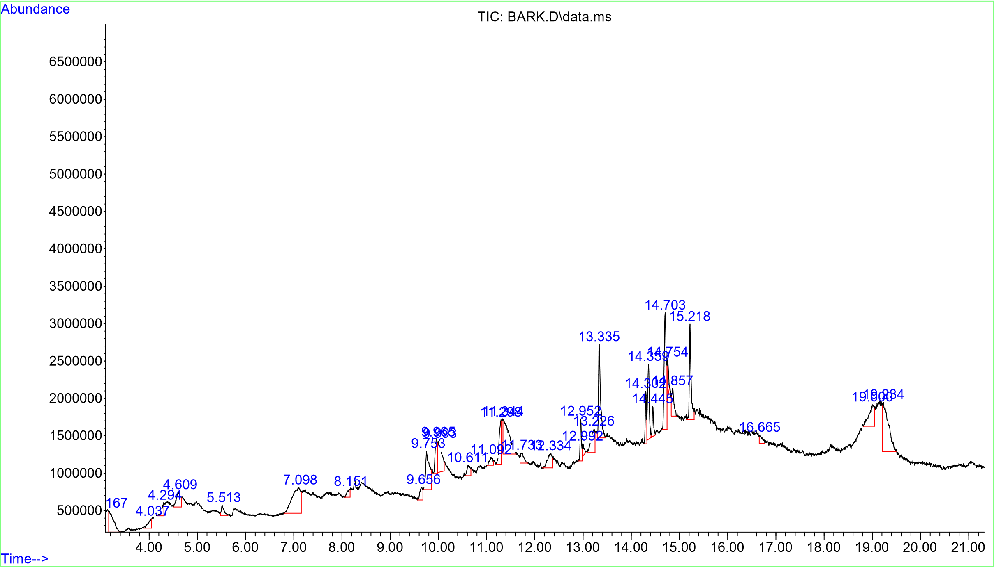

FIGURE 1: Graph showing the various peaks from the GC-MS analysis of Annona muricata bark

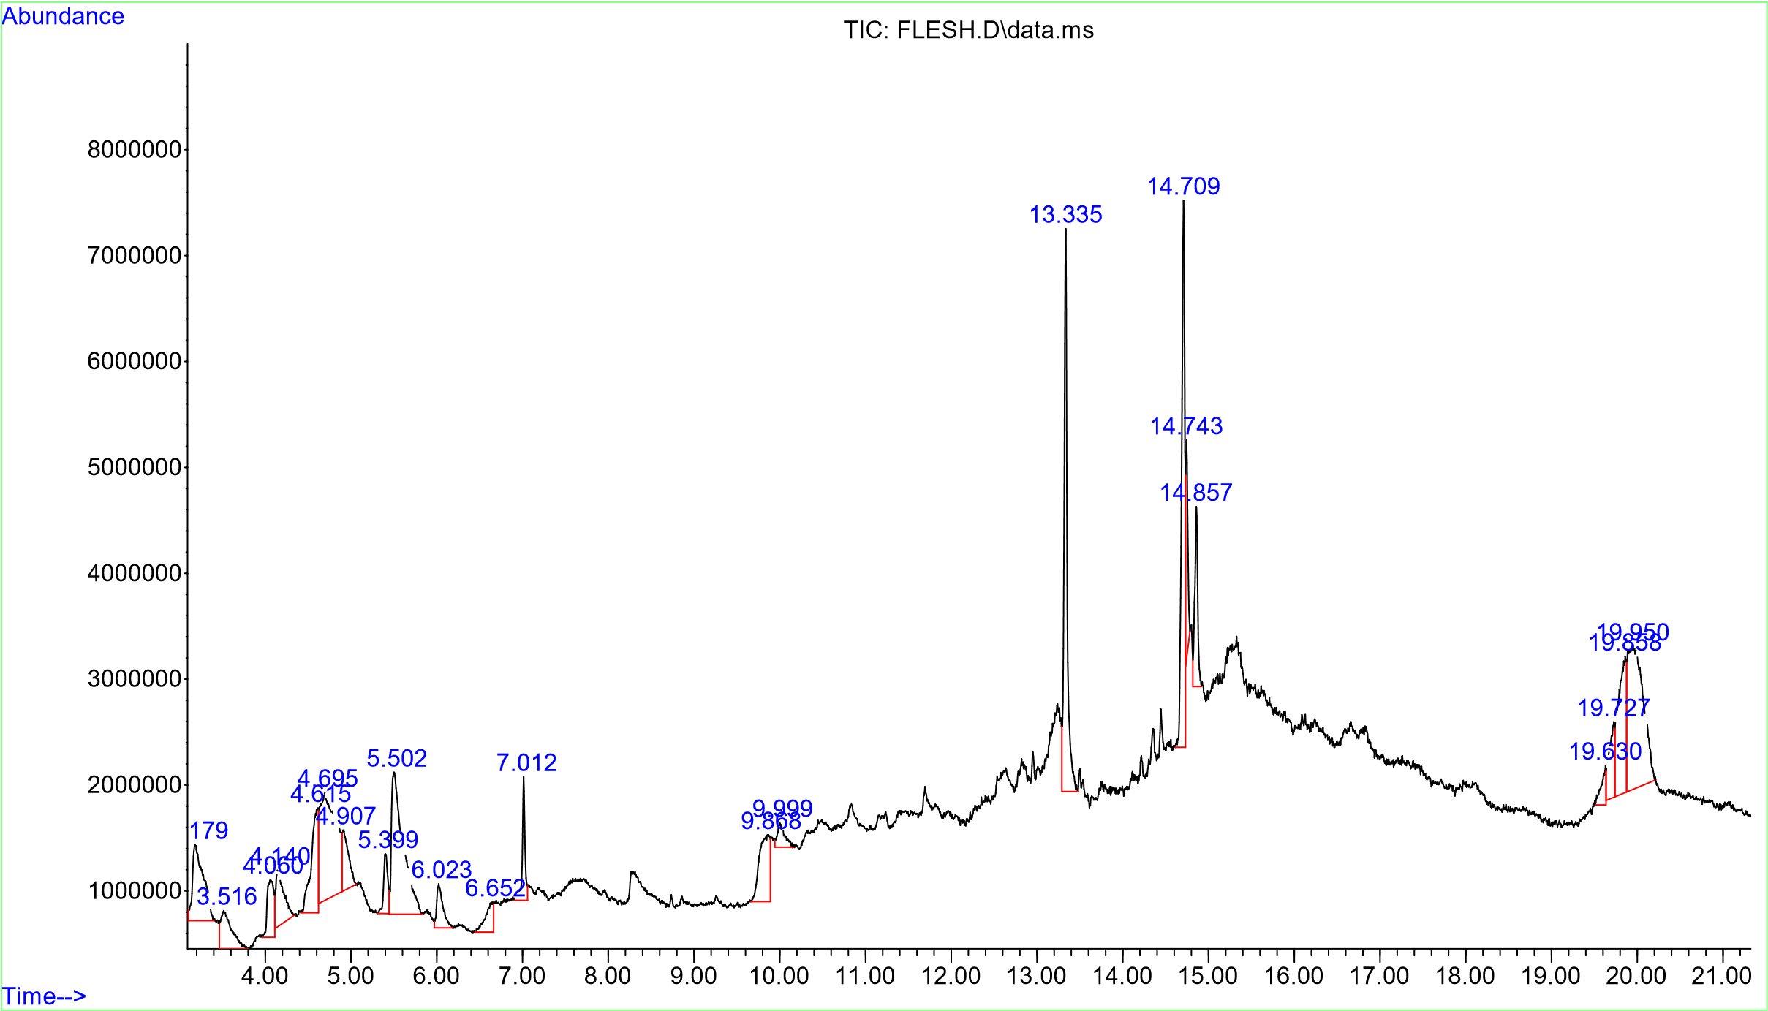

FIGURE 2: Graph showing the various peaks from the GC-MS analysis of Annona muricata flesh

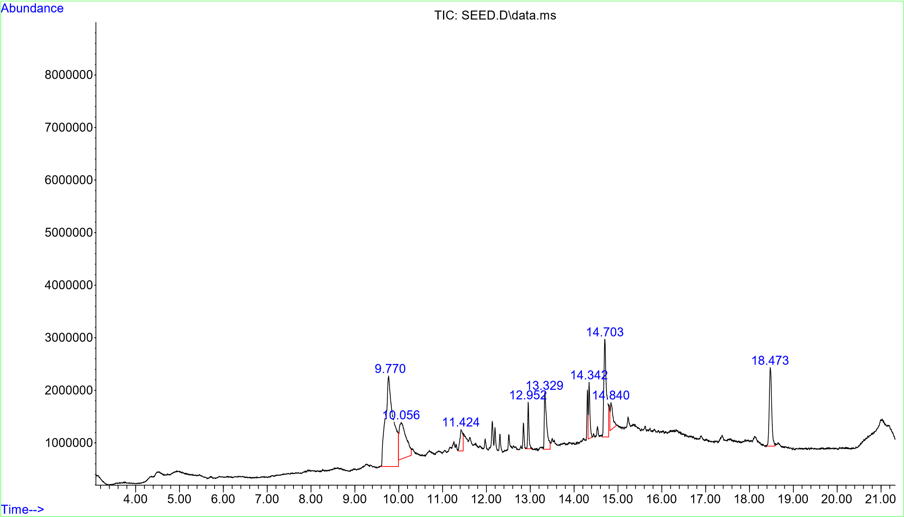

FIGURE 3: Graph showing the various peaks from the GC-MS analysis of Annona muricata seed

