Experimental Investigation Of Physical, Mechanical and Wear Index In Polymer Matrix Composites For potential Structural Applications

.
ABSTRACT
This study explores the utilization of granite stone dust, a quarry byproduct, as a reinforcement material in polymer matrix composites (PMCs) for structural applications. The influence of stone dust particles on the thermal, wear, mechanical, and physical properties of reinforced polymer matrix composites (PMCs) was evaluated. Epoxy resin served as the polymer matrix, while granite stone dust was hybridized with palm kernel shell ash at five weight fractions (2 wt.%, 4 wt.%, 6 wt.%, 8 wt.%, and 10 wt.%). Both granite dust and palm kernel shells were processed to a uniform particle size of 106 μm to ensure consistency in the fabrication of the composite. Test specimens were developed via hand lay-up techniques. The samples were subjected to mechanical, physical, and wear tests in accordance with standards (hardness test, wear test, flexural test, impact test, thermal test, tensile test, and density test). The stone dust + palm kernel shell ash had superior performance against the control. Results further showed that the five weight fractions compare better than the control across all the properties tested, indicating the effectiveness of the stone dust as a reinforced material for structural applications. These findings establish granite stone dust as a viable, eco-friendly reinforcement and hybrid synergy. Its adoption can reduce quarry waste, lower material costs, and improve the performance of components such as flooring panels, decking, and other wear-critical structural elements, thereby promoting sustainable engineering practices in automotive, construction, and infrastructure development.

Keywords: Granite stone dust, Palm kernel shell ash, Hybrid polymer composites, Wear index, Epoxy resin composites, Sustainable materials, Mechanical properties, Structural applications.

1. INTRODUCTION

Hybrid polymer composites are engineered by blending two or more types of reinforcements within a polymer matrix. This approach leverages the synergistic effects of different reinforcements to achieve a balance of properties that would be difficult to obtain using single-fibre composites for structural applications. Polymers have increasingly become key materials in engineering applications due to their remarkable versatility and an impressive set of properties that include low cost, low density, corrosion resistance, ease of processing, and environmental friendliness (Shagwira, 2024; Dholi et al., 2025).These attributes have led to their widespread use in the production of automotive parts, aerospace components, construction materials, consumer electronics, and various household appliances (C. Albano, 2009). The incorporation of polymers into composite systems by combining them with fillers or reinforcements has opened new avenues for developing high-performance materials that meet the demanding mechanical and thermal requirements of modern applications (Awasthi et al., 2024; Shagwira, 2024; Albano, 2009; Medjahed, 2019; Lamidi et al., 2025). Research advancement in hybrid polymer composites has emerged as a promising solution for addressing the limitations of conventional materials (Choi 2023; Shagwira 2024).
In the context of automotive manufacturing, where weight reduction, fuel efficiency, mechanical strength, and sustainability are critical considerations, polymer matrix composites (PMCs) offer a promising alternative to traditional metallic materials (Bilvatej et al., 2023; Aulin et al., 2024; Asotah and Adelike, 2017). The performance of these composites is largely influenced by the type of matrix, the nature and distribution of reinforcement, and the interfacial bonding between the constituents (Balaji et al., 2022; Arman et al., 2018; Tang, 2008; Kan, 2009). To this end, Oladele et al. (2022), Derraji (2022), Gobbato (2019), Li et al. (2025), and Kariduraganavar 2014 are some of the researchers who have been expanding research towards exploring natural and industrial waste materials as reinforcing agents or fillers in polymer matrices to improve performance while reducing environmental impact and production costs (Lamidi et al., 2025; Chandra et al., 2025).
One such promising waste material is granite stone dust (GSD), a byproduct of quarry activities (granite cutting and processing industries). Typically regarded as a waste with limited application, GSD is abundant, inert, and rich in silica (SiO₂) and other mineral constituents, making it a potential candidate for use as a reinforcing filler in polymer composites (Alam et al., 2023). The composition of GSD varies, and it is largely dependent on the local rock sources and the underlying conditions. The SiO₂ in GSD is typically in the form of quartz, thereby having a weathering resistance and hardness (H. Shagwira, 2024) (P. Nuaklong, 2023). Therefore, incorporating granite stone dust into a polymer matrix not only provides a value-added use for this waste material but also contributes to the global drive for sustainable, cost-effective, and environmentally friendly composite production (P. Nuaklong, 2023).
Wear-related degradation is one of the primary challenges faced by structural materials used in flooring, decking, bridge components, and other load-bearing systems. Excessive wear not only shortens the service life of structural elements but also increases maintenance costs and compromises safety. Consequently, investigating the wear index of novel composite systems is essential for predicting their long-term performance in real-world environments (Abdelbary, 2014). Granite stone dust, when incorporated into polymer matrices, has the potential to enhance abrasion resistance and load-bearing capacity, thereby extending the operational lifespan of structural components (Aigbodion et al., 2010). Recent studies have shown that mineral-based fillers such as stone dust can significantly enhance the mechanical properties, such as hardness, tensile strength, wear resistance, and thermal stability of polymer composites (Paula et al., 2022; Mamakos, 2019; Andrea et al., 2021). These properties are essential for components used in automotive applications, particularly under mechanical loading, thermal cycling, and abrasive conditions (Ammar et al. 2023; Khan 2025). However, comprehensive studies focused specifically on the characterisation of polymer composites reinforced with granite stone dust for automotive use remain limited in the existing literature.
Hybridizing granite dust with agro-industrial waste fillers such as palm kernel shell ash (PKSA) and coconut fibre offers additional advantages. PKSA, rich in silica and alumina, contributes to hardness and thermal stability, while coconut fibre improves impact resistance and energy absorption. Combining these reinforcements within a polymer matrix can create synergistic effects that outperform single-filler composites, particularly in structural applications where a balance of toughness, durability, and wear resistance is required (Dirisu et al., 2024).
By reinforcing epoxy resin with granite stone dust, PKSA, and coconut fibre at varying weight fractions, this study evaluates their wear index performance to determine their suitability for structural use. Understanding the influence of filler proportions on wear resistance will aid in optimizing composite formulations for flooring panels, decking, bridge components, and other structural systems subjected to abrasive environments. This research contributes to sustainable materials engineering by providing a pathway for converting quarry and agricultural wastes into high-performance structural composites. The outcomes align with global efforts to reduce construction waste, lower carbon footprints, and promote environmentally responsible engineering practices. The goal is to establish the potential of GSD-reinforced polymer composites as a viable and sustainable material for automotive parts such as brake components, panels, and other related structural applications.
By systematically analyzing the effects of granite stone dust on composite behavior, this work contributes to the broader field of green materials and sustainable engineering, offering insights that support waste-to-wealth initiatives, circular economy principles, and innovations in automotive materials science.

2. material and methods

2.1 Material Selection
Palm kernel shells were outsourced from the School of Agriculture and Agricultural Technology farmland, Federal University of Technology, Akure. Ondo State, Nigeria. Granite stone dusts were also obtained from the quarry mining site, Shasha, Benin Road, Akure, Ondo State, Nigeria. Other materials used were epoxy resin, hardener, sodium hydroxide (NaOH) and releasing agent, procured from Pascal Scientific Limited, Akure, Ondo State, Nigeria.
2.2 Preparation of materials.
Preparation of Palm Kernel Shell and Stone Dust
The palm kernel shells sourced were washed and oven-dried for 5 hours at 105°C to remove moisture and residual organic matter. Figure 1 shows the Carbonized ash gotten from the carbonation of palm kernel shells by burning in a muffle furnace at 700°C for 5 hours. The ashes were crushed, ground using a ball milling machine and sieved through a 106 µm mesh to ensure uniform particle size distribution. In a similar manner, the granite stone dust (GSD) shown in Figure 2 is a by-product of quarry activities typically causing air pollution and waste of productive land space. The granite stone was sun-dried for 2 days to remove all moist content present in it. The dried stone dust was sieved through a 106 µm mesh to remove oversized particles and ensure homogeneity.
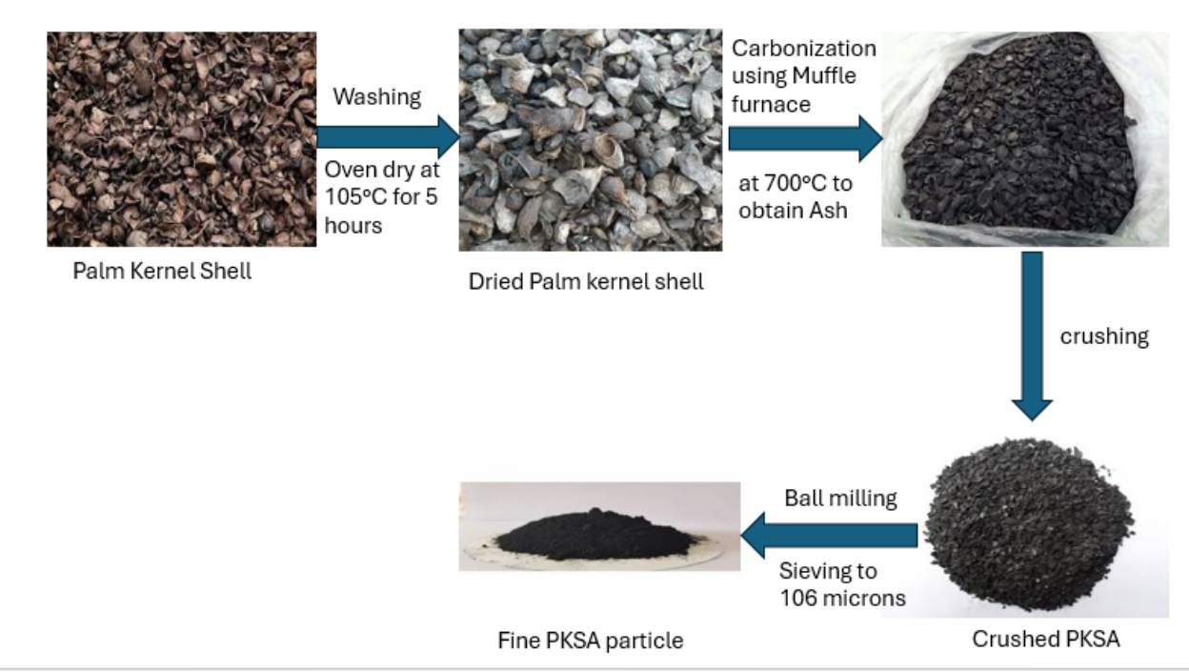
Figure 1: Preparation process of palm kernel shell ash

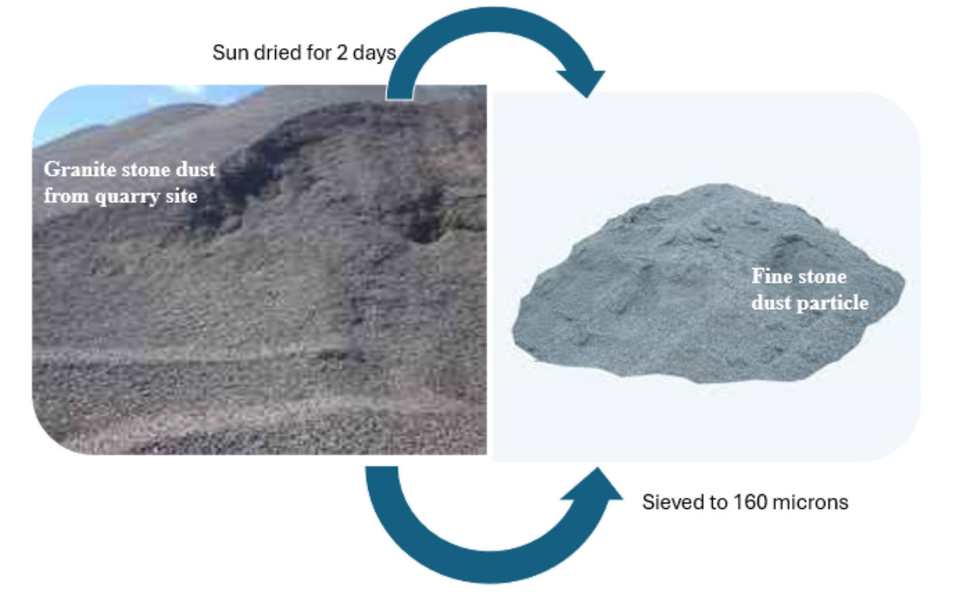
Figure 2: Preparation process of granite stone dust

2.3 Development of Test Specimens
The hand-layup technique was used for composite fabrication due to its low-cost tooling, simple processing, and high production rate. Tensile, impact, flexural, and wear moulds were prepared using releasing agents to enable easy removal of the specimens after fabrication, as seen in Figure 3. Epoxy and hardener were mixed in a 2:1 volume ratio, and weight fractions of resin, palm kernel shell ash and granite stone dust were determined and manually stirred together for 5 minutes to prevent agglomeration at an ambient temperature and relative humidity of below 65%. The composites were cured at room temperature for 6 hours. Mechanical, physical and wear tests were conducted according to ASTM standards. The hybrid composites were fabricated using the formulation table as seen in Table 1. Figure 4 shows the fabricated composite samples developed.

Table 1: Formulation table for the palm kernel shell ash-stone dust hybrid reinforced epoxy composite
Sample  (wt. %) | Polymer Matrix  (wt. %) | Palm Kernel shell ash  (wt. %) | Stone dust  (wt. %)
2 | 98 | 1 | 1
4 | 96 | 2 | 2
6 | 94 | 3 | 3
8 | 92 | 4 | 4
10 | 90 | 5 | 5
Control | 100 | 0 | 0

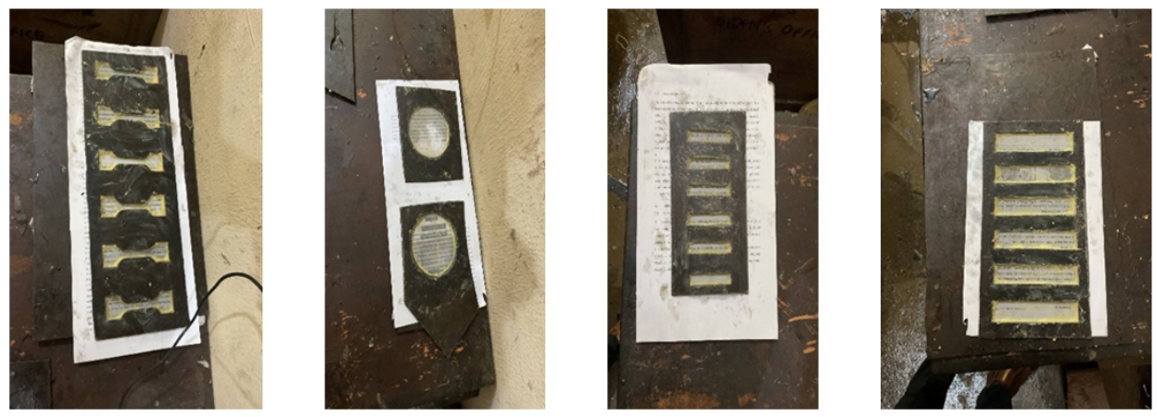
Figure 3: Different test molds preparation

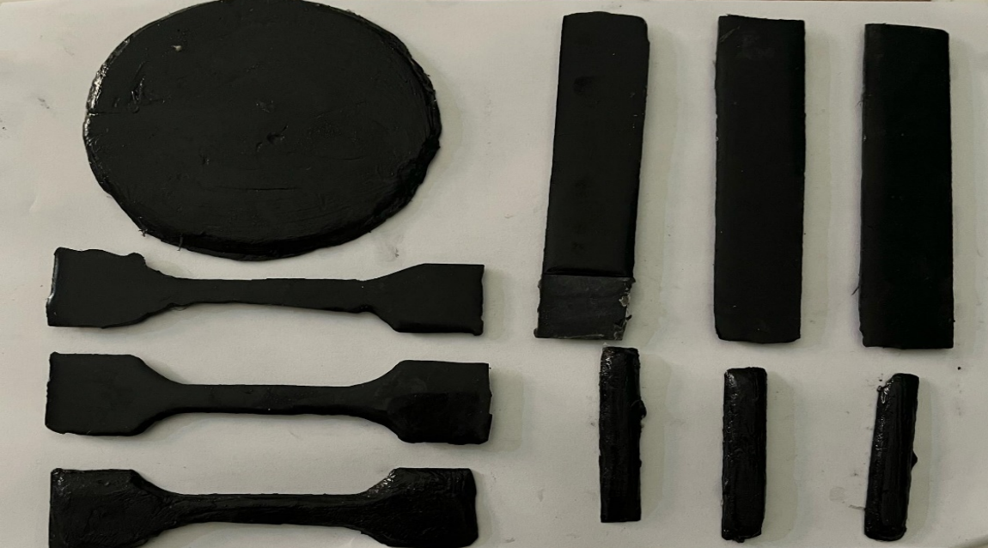
Figure 4: Developed palm kernel shell ash- stone dust hybrid polymer Composites for test specimens
2.4 Tests an Characterization
2.4.1 Wear Index Test
The wear test was carried out on the Taber Abrasion testing machine. This test was done to know the susceptibility of the material to abrasion. The initial weights of the samples were measured as W0, after which the samples were mounted on the machine one after the other and the machine was switched on. The machine was operated at 750 revolutions per minute (rpm). At the completion of each abrasion process, the final weights of the samples were measured on an electronic weighing machine as W1 and recorded. The wear resistance was calculated using equation (1).
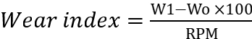 (1)
Where W₀ is the initial weight and W₁ is the final weight after
surface abrasion and rpm is revolutions per minutes.

2.4.2 Tensile tests
Tensile tests were conducted to determine the modulus of elasticity, ultimate tensile strength and elongation at break of the samples according to ASTM D 3039 standards relative to the work of Verma D (2012) and Singh T (2021). The Instron 5966 universal tester with a load cell of 10 kN at a crosshead speed was used. The samples were prepared using the hand layup technique and tested in tension mode at a strain rate of 5 mm/min at room temperature. The test piece of gauge length of 15 mm was fixed at the edges of the upper and lower grips of the machine, and the test was performed. A graph was automatically plotted, and data of tensile properties was generated as the test piece was extended. Three test samples were tested, and the average value reported. The tensile strength was computed using Equation (2).
Tensile strength =$\frac{applied load}{cross sectional area}$ (2)

2.4.3 Flexural Test
A three-point flexural bending test was used to evaluate the flexural strength and modulus of the fabricated composites using an Instron Universal Tester in accordance with ASTM D790-17 (2002) standards. Three test samples of each weight fraction were used, and the average value was reported. Flexural strength was determined using Equation (3).
Flexural strength = $\frac{3PL}{2bh^{3}}$ (3)
Where P is the maximum load applied, L is the length of the support span b is the width of the sample and h is the thickness of the sample. Flexural modulus was determined by Equation (4).
Flexural modulus = $\frac{L^{3}M}{4bh^{3}}$ (4)
Where L is the length of the support, b is the width of the composite, t is the thickness and M is the slope of the graph.$\frac{ΔF}{ΔY}$

2.4.4 Hardness Test
A hardness test was conducted on the sample using a Shore D hardness tester following ISO 868:2003 (868, 2003). The samples were placed on the flat surface of the tester stand and indented. Four values were obtained by indenting the samples in four different places, and the average value was used for analysis.
2.4.5 Impact Test
The impact test was performed on notched Izod samples using a household balance impact testing machine in accordance with the ASTM D256-10 standard. Specifically, notched samples were cantilevered, with the notched surface directly opposite the swinging pendulum. The testing machine’s pendulum was freely swung through 180 degrees to fracture the samples. Three repeatability tests were performed, and the average value was taken to ensure accuracy and reliability of the test results. Impact strength was calculated using equation (5).
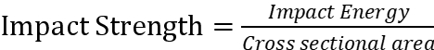 (5)

2.5 SEM/EDS
SEM/EDS was carried out to examine the surface morphology and microstructural features. The analysis was conducted using a Hitachi SU3500 SEM (Hitachi High-Tech Corporation, Tokyo, Japan). Prior to imaging, the samples were coated with a thin layer of gold to enhance conductivity and image quality. This coating was performed under vacuum conditions using a sputter coater with the Everhart-Thornley Detector (ETD) option to allow the best resolution for SEM imaging. Position the sample under the beam and wait until the SEM icon turns green, signifying a working vacuum in the chamber (pressure of less than 2.95e-2 Pascals (Pa)). EDS was integrated with SEM to obtain elemental composition and distribution across the sample surfaces.

2.6 XRF Analysis
The powdered ash (4 g) was mixed with wax binder (0.9 g) and pressed into 32 mm pellets at 20 tonnes pressure for 2 minutes. XRF analysis used a rhodium tube spectrometer (60 kV, 50 mA) with helium purge for light element detection. Certified reference materials calibrated major oxides and trace elements. Software performed automated peak identification and quantification with matrix correction algorithms.
3. results and discussionS
3.1 XRF analysis
The palm kernel shell ash burnt at 700°C for 5 hours shows a silica-dominated composition with SiO₂ at 68.47% as the primary component, as seen in Table 2(a), followed by alumina (Al₂O₃) at 12.82%. These values are distinctive for agricultural biomass ashes, where silica concentrations commonly range from 50-80% depending on the source material and processing conditions. The iron oxide (Fe₂O₃) content of 3.60% is moderate and within expected ranges for plant-derived materials. The calcium oxide (CaO) level at 3.30% and magnesium oxide (MgO) at 3.06% reflect the mineral content originally present in the palm kernel shells. Several characteristics distinguish this ash from other materials. The potassium oxide (K₂O) content at 4.14% is notably elevated, which is characteristic of palm-based biomass but higher than many mineral-based materials. These values indicate the material has undergone effective thermal processing, with the high silica content suggesting good potential for various applications, including ceramics, construction materials, or as a silica source, while the elevated alkali and phosphorus content, majorly due to impurities, may present both opportunities and challenges depending on the intended use, while the XRF result of granite stone dust shows an igneous rock composition with silica (SiO₂) at 68.4%, indicating high quartz and feldspar content as seen in Table 2(b). The alumina (Al₂O₃) content of 15.3% reflects significant feldspar mineral phases, primarily orthoclase and plagioclase. The combined alkali content of K₂O (3.6%) and Na₂O (4.1%), totalling 7.7%, confirms the presence of both potassium and sodium feldspars characteristic of granite mineralogy. The iron oxides present as Fe₂O₃ (3.2%) and FeO (2.1%) indicate mixed oxidation states typical of ferromagnesian minerals like biotite and hornblende. The low calcium oxide (CaO) content of 2.8% and minimal magnesium oxide (MgO) at 1.4% suggest limited mafic mineral content, consistent with granite's felsic nature. Titanium dioxide (TiO₂) at 0.6% likely originates from accessory minerals such as rutile or ilmenite. The loss on ignition (LOI) of 1.6% is relatively low, indicating minimal hydrated phases or organic matter.
Table 2(a): Chemical Composition of Palm Kernel Shell Ash
Oxide | Composition (%)
SiO₂ | 68.47
Al₂O₃ | 12.82
Fe₂O₃ | 3.60
CaO | 3.30
MgO | 3.06
K₂O | 4.14
P₂O₅ | 2.14
SO₃ | 2.12
TiO₂ | 0.22
MnO | 0.08
Na₂O | 0.04

Table 2(b): Chemical Composition of Palm Kernel Stone dust
Oxide | Composition (%)
SiO₂ | 68.4
Al₂O₃ | 15.3
K₂O | 3.6
Na₂O | 4.1
Fe₂O₃ | 3.2
FeO | 2.1
MgO | 1.4
CaO | 2.8
TiO₂ | 0.6
P₂O₅ | 0.3
MnO | 0.08
LOI | 1.6

3.2 SEM/EDS Analysis
Figure 5(a) reveals the morphological features of processed palm kernel shell ash. The particle feature is irregular and angular geometries which is consistent with biomass-derived ashes, Recent studies confirm that processed palm kernel shells display flaky, sub-angular and angular particle shapes (REF). The microstructural examination shows heterogeneous particle size distribution within the 106 microns, displaying both fine particulates and larger agglomerates. SEM morphology investigations indicate that pore network development varies significantly with processing conditions, with micropore structures becoming more pronounced at controlled activation temperatures. The thermal treatment at 700°C promotes surface texture modification through dehydration and organic matter removal, creating reactive surface sites essential for pozzolanic activity. The microstructure of stone dusts as seen in Figure 5(b) shows characteristics of brittle crystalline materials. these angular particles have high porosity compared to spherical equivalents. The surface texture provides multiple nucleation sites for interfacial bonding in composite systems. However, the high specific surface area will increase binder demand and affect rheological behavior through increased particle-particle friction and van der Waals interactions. EDS elemental composition confirms spatial distribution of major oxides consistent with XRF analysis, revealing silicon and aluminum-rich regions indicative of amorphous aluminosilicate phases. The EDS confirms the XRF composition with silicon (32.8 wt.%) and oxygen (45.6 wt.%) as dominant elements, consistent with silicate mineral phases. The aluminum content (8.2 wt.%) correlates with feldspar presence as reported in Table 3, while the potassium (4.1 wt.%) and sodium (2.8 wt.%) distributions reflect alkali feldspar and plagioclase phases respectively.
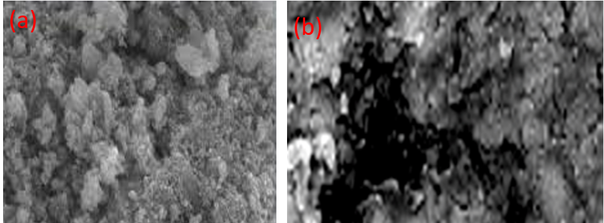
Figure 5: SEM micrograph of (a) Palm kernel shell Ash; (b) Stone dust
Table 3: Elemental composition (EDS) of Characterized particles
Palm kernel shell Ash |  |  | Stone Dust
Element | Weight % | Atomic % | Element | Weight % | Atomic %
O | 34.63 | 47.74 | Si | 32.8 | 32.1
Si | 62.67 | 50.30 | O | 45.6 | 78.4
K | 1.08 | 0.65 | Al | 8.2 | 8.4
Al | 0.57 | 0.49 | K | 4.1 | 2.9
Mg | 0.45 | 0.43 | Na | 2.8 | 3.3
Ca | 0.35 | 0.20 | Fe | 3.2 | 1.6
Fe | 0.25 | 0.10 | Ca | 2.1 | 1.4
- | - | - | Mg | 0.8 | 0.9
- | - | - | Ti | 0.4 | 0.2

3.3 Physical and Thermal Properties

3.1.1 Density Properties

Figure 6 shows the density variation with reinforcement content; the density of PHS increases from 0.916 g/cm³ at 2 wt.% to 0.961 g/cm³ at 10 wt.%, indicating dispersion and packing of the rigid reinforcement particles within the epoxy matrix. The carbonized palm kernel shell ash, with its porous carbon structure gotten from the pyrolysis of lignocellulosic components (Oladele and Okoro, 2016), reduces the composite density due to its inherent porosity. However, the further addition of stone dust, with its higher specific gravity (approximately 2.6-2.8 g/cm³), increased the composite density. The density progression in the PHS suggests minimal void formation and optimal particle distribution, consistent with findings by Oladele et al. (2022), who reported improved packing density in stone dust reinforced composites. The carbonized palm kernel shell ash acts as a complementary reinforcement, occupying interstitial spaces between larger stone dust particles, thereby enhancing overall packing efficiency. This phenomenon aligns with the binary packing theory, where the combination of particles with different size distributions can achieve higher packing densities than individual components (Rajput et al, 2021).

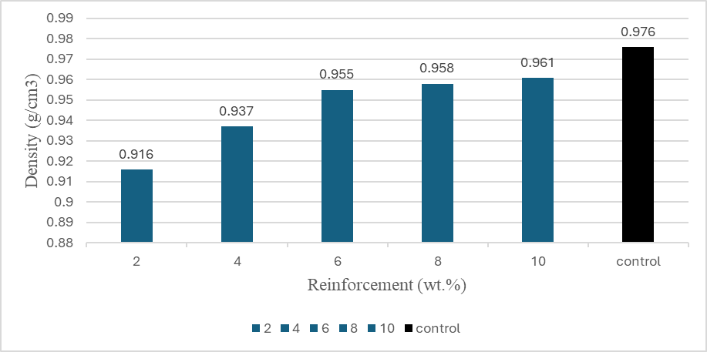
Figure 6: Variation of density properties of agro-mineral wastes reinforced hybrid composite

    - Thermal Properties

The PHS results show the highest thermal conductivity of 0.52 W/mK at a weight fraction of 10 wt. %, as illustrated in Figure 7, representing an improvement over the pure epoxy control, which has a thermal conductivity of 0.21 W/mK. This thermal performance can be attributed to the formation of thermally conductive pathways through the synergistic combination of carbon-rich palm kernel shell ash and mineral stone dust (Adetunji et al., 2022). The carbonized palm kernel shell ash contributes to thermal conductivity through its carbon content, which provides thermally conductive pathways similar to those found in carbon-based materials (Kate et al., 2025). The carbonization process creates a graphitic structure that facilitates heat transfer, while the stone dust particles provide additional thermal pathways through their mineral composition (alumina and silica). The PHS achieved 0.52 W/mK maximum thermal conductivity, signifying the effectiveness of the carbonized palm kernel shell ash and stone dust combination in creating thermally conductive networks.

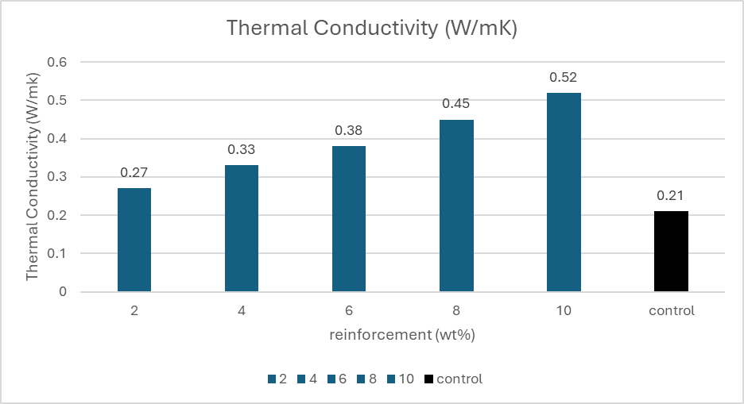
Figure 7: Variation of Thermal conductivity of agro-mineral wastes reinforced hybrid composite

  - Mechanical Properties

    - Hardness Properties

The PHS has the highest hardness values across all hybrid composites, reaching 60.5 BHN at 10 wt.% compared to 48 BHN for the control sample, as shown in Figure 4.2(a). This superior hardness enhancement can be attributed to the synergistic reinforcement effects of carbonized palm kernel shell ash and stone dust particles. The carbonized ash provides hard carbonaceous particles with graphitic characteristics that resist indentation (Oyedeji et al., 2022), while stone dust contributes mineral hardness through its crystalline structure. The attic hardness increases from 50 BHN at 2 wt.% to 60.5 BHN at 10 wt.%, indicating excellent dispersion and load transfer efficiency in the PHS. The rigid reinforcement particles create constraint zones within the epoxy matrix, restricting local deformation under applied loads. This behavior aligns with the Hall-Petch strengthening mechanism, where smaller reinforcement particles create more effective barriers to deformation. The findings are consistent with Rajput et al. (2021), who reported hardness improvements in epoxy composites filled with micro-sized stone dust particles. The carbonized palm kernel shell ash contributes to hardness enhancement through its unique microstructure developed during pyrolysis. The carbonization process removes volatile organic compounds while leaving behind a rigid carbon skeleton with graphitic characteristics, as documented by Oyedeji et al. (2022). This carbon structure provides hard reinforcement points that effectively resist indentation and contribute to overall surface hardness.
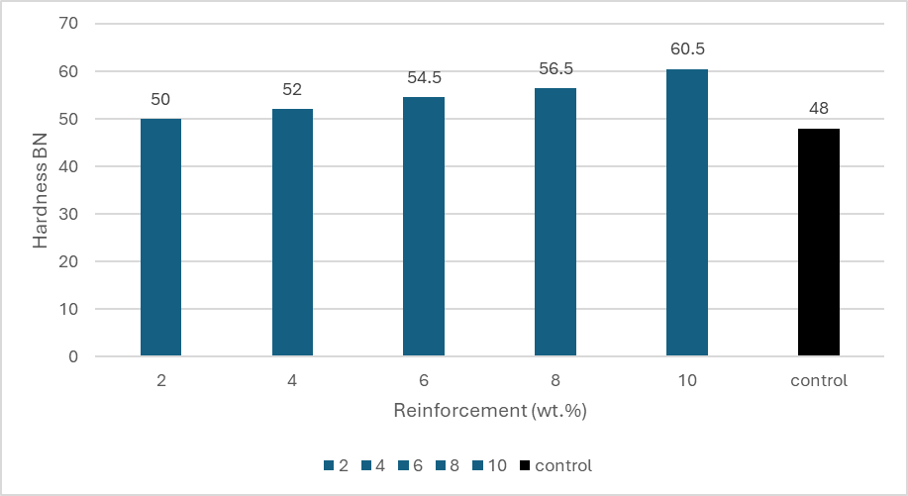
Figure 8: Variation of Hardness of agro-mineral wastes reinforced hybrid composite

    - Impact Strength

The PHS achieved the highest impact strength of 10.43 J/mm² at 10 wt. %. This exceptional performance can be attributed to the synergistic energy effect of the two composites. The hierarchical structure created by combining carbonized palm kernel shell ash particles and stone dust provides relatively good energy dissipation pathways during impact (da Silva Neto et al., 2025). The carbonized palm kernel shell ash particles provide crack deflection and particle-matrix debonding mechanisms that distribute impact energy over larger volumes. Stone dust particles contribute through their ability to arrest crack propagation and provide local reinforcement zones that enhance overall toughness. The presence of both rigid particles (carbonized ash and stone dust) ensures that the composite can absorb energy through elastic deformation (Joshi et al., 2023). This balanced approach prevents brittle failure modes while maintaining adequate stiffness for structural applications. The PHS showed good impact strength as a mechanical property, reaching 10.43 J/mm² at 10 wt. %, signifying that particle reinforcement composite can also provide meaningful impact resistance enhancement. The impact resistance mechanisms in the PHS composite rely primarily on particle-matrix interactions and crack deflection processes (Gupta et al., 2024). The energy absorption in the PHS occurs through several mechanisms unique to particle-reinforced composites. Carbonized palm kernel shell ash particles provide crack deflection and particle-matrix debonding mechanisms that distribute impact energy over larger volumes (Oyedeji et al., 2022). Stone dust particles contribute through their ability to arrest crack propagation and provide local stiffening that enhances overall toughness without sacrificing impact resistance. The consistent impact strength improvement in the PHS with increasing particles indicates effective reinforcement dispersion and good interfacial bonding. The rigid particle reinforcements create constraint zones within the epoxy matrix that enhance overall toughness through increased plastic deformation energy absorption (Rajput et al., 2021).

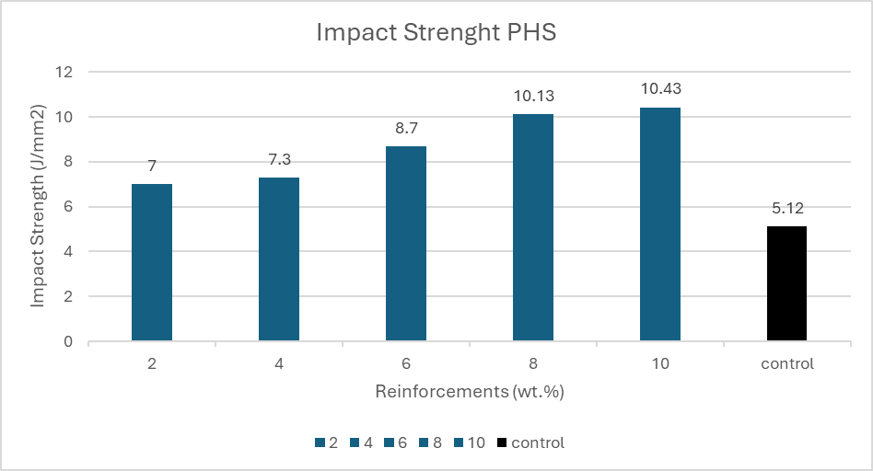
Figure 9: Variation of Impact strength of agro-mineral wastes reinforced hybrid composite

    - Tensile Properties

The PHS showed moderate tensile strength improvement, reaching 39.5 MPa at 6 wt. %. While this represents meaningful enhancement over the control sample, the performance is generally inferior to fibre-containing due to the absence of fibrous reinforcement mechanisms (Gupta et al., 2024). The particle reinforcement relies primarily on matrix constraint and particle-matrix load sharing for tensile enhancement. The tensile mechanism in the PHS composite involves load transfer between the epoxy matrix and rigid reinforcement particles through interfacial bonding mechanisms. Carbonized palm kernel shell ash particles provide matrix constraint and local stiffening effects, while stone dust particles contribute to overall composite stiffness and reduced thermal expansion (Rajput et al., 2021).

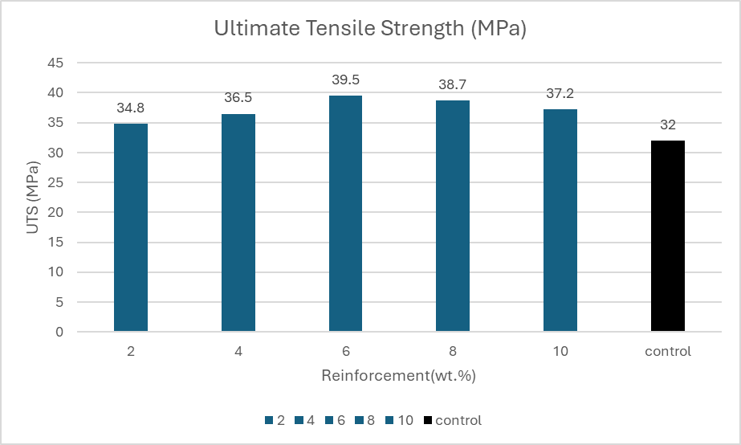
Figure 10: Variation of Tensile strength of agro-mineral wastes reinforced hybrid composite

    - Bending Properties

The flexural strength results show variations across the different weight fractions of the hybrid reinforcement composites of the palm kernel shell ash and stone dust. The highest flexural strength is 56.8 MPa at 2 wt. %, followed by 43.5 MPa at 4 wt. %, 37.5 MPa at 6 wt. %, 34.1 MPa at 8 wt. %, and 33.1 at 10 wt. %. The control sample exhibited only 15.33 MPa, as shown in Figure 8, which is the baseline for comparison. This clearly indicates that the reinforced composite performs far better than the control for over 200% across all the weight fractions. This superior performance can be attributed to the interlocking reinforcement mechanism that creates synergistic effects between carbonized palm kernel shell ash and stone dust. The carbonized ash provides a rigid particulate network that enhances load transfer efficiency, while stone dust contributes angular particles that create mechanical interlocking sites within the epoxy matrix. Research by Baffour-Awuah et al. (2021) supports this interpretation, noting that palm kernel shell-polymer composites benefit from the porous structure of carbonized ash, which provides an extensive matrix-particle interface area for stress transfer. Singh and Jha (2024) reported similar findings in polyester-stone dust composites, where particle hardness significantly influenced flexural performance, though they noted the need for additional reinforcement phases for optimal toughness. The flexural modulus results compare slightly better than the control across all five weighted fractions, with a trend of 2.6 GPa at 2 wt%, 2.8 GPa at 4 wt%, 3 GPa at 6 wt%, 3.1 GPa at 8 wt%, and 3 GPa at 10 wt%.These stiffness enhancements, with a peak achieved at 3.1 GPa at 8 wt%, as shown in Figure 9, reflect the effect of the two reinforcements in constraining matrix deformation. Carbonized palm kernel shell ash creates a rigid skeletal framework within the epoxy matrix, and stone dust provides discrete stiffening inclusions. This creates an effective constraint system that approaches theoretical rule-of-mixtures behaviour for composite stiffness. Rajput et al (2021) observed similar stiffness enhancement in stone dust-epoxy composites, attributing the improvements to effective particle-matrix stress transfer and constraints effects.

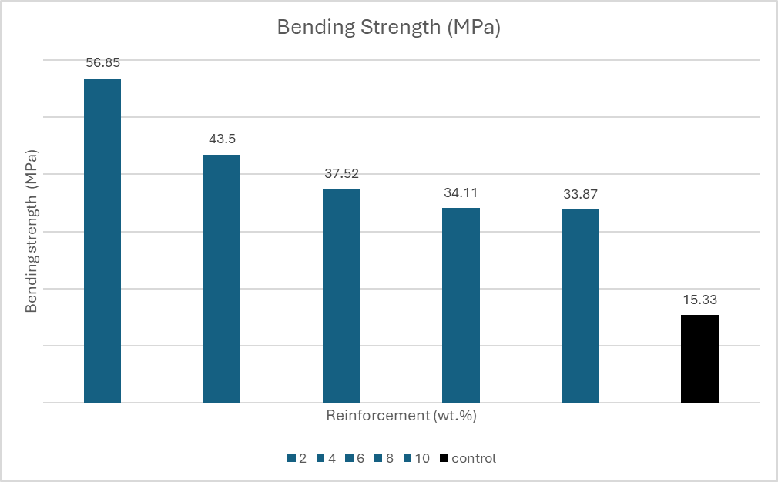
Figure 11: Variation of Bending strength conductivity of agro-mineral wastes reinforced hybrid composite

3.3 Tribological Properties

The wear index data show a clear inverse relationship between PHS loading and wear susceptibility, confirming that filler reinforcement progressively reduces material loss during tribological contact. At 4 wt.%, the composite achieves a wear index of 0.053 g (59% lower than the control at 0.13 g), reflecting partial dispersion of PKSA’s silica-rich phases and GSD’s angular particles, which disrupt cracks and improve load transfer—though limited network formation still allows localized wear. Increasing to 6 wt.%, wear declines further to 0.033 g (75% improvement), indicating optimal filler nucleation and synergistic interaction between PKSA and GSD that enhances interfacial bonding, lowers friction, and raises shear strength. The lowest wear occurs at 8 wt.% (0.027 g, 79% reduction), representing a percolation threshold where a quasi-continuous filler network distributes stress uniformly and suppresses subsurface fatigue. At 10 wt.%, wear remains similar (0.027 g), suggesting diminishing returns beyond 8 wt.% due to possible agglomeration or voids, though performance remains far superior to lower loading.
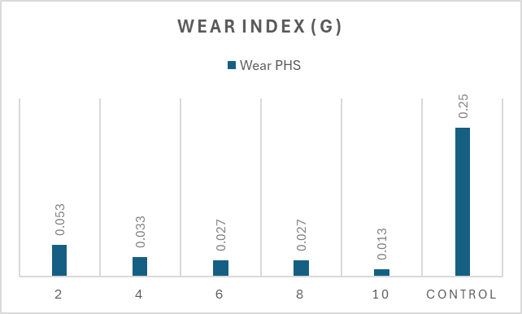
Figure 12: Variation wear index of agro-mineral wastes reinforced hybrid composite

- Conclusion
Overall, the study validates granite stone dust–based hybrid composites as a versatile, eco-friendly, and cost-efficient option for both automotive and structural applications. Their performance demonstrates the feasibility of replacing traditional materials without compromising functionality, advancing the development of green engineering solutions in the automotive and construction industries.

Disclaimer (Artificial intelligence)
Author(s) hereby declare that generative AI technologies such as Large Language Models, etc. have been used during the writing or editing of manuscripts. This explanation will include the name, version, model, and source of the generative AI technology and as well as all input prompts provided to the generative AI technology
Details of the AI usage are given below:
The authors declare that generative AI technology was used to assist in the preparation and editing of this manuscript. Specifically, OpenAI's GPT-4.5, accessed via the OpenAI platform, was employed to enhance clarity, grammar, and structural flow.
The AI assistance was limited to linguistic refinement and organization of content. All input prompts were carefully designed by the authors; below are the input prompts:
1. Rewrite the coconut fibre preparation process for journal-standard clarity.
2. Refine the grammar in the above text for the introduction section of a manuscript. Suggest some relevant literature too (hybrid polymer composites).
3. Summarize the influence of weight fractions on wear performance without losing meaning.”
All AI-generated outputs were critically reviewed, fact-checked, and edited by the authors to ensure accuracy, originality, and compliance with scientific standards. No part of the analysis, data interpretation, or scientific conclusions was generated by AI technologies. The authors take full responsibility for the content of this work.
Declaration
This research adopts an eco-friendly approach by using palm kernel shell ash and granite stone dust (agro-mineral wastes), materials that are otherwise environmental pollutants, as reinforcements in polymer composites. This sustainable utilization reduces landfill waste, mitigates quarry-related pollution, and provides greener alternatives to conventional non-degradable materials in structural and automotive applications.

References
Aigbodion, V. S., Hassan, S. B., and Agunsoye, J. O. (2010). Effects Of Bagasse Ash Reinforcement On The Wear Behavior Of Polymer Matrix Composites. Tribology International, 43(4), 55–62. Https://Doi.Org/10.1016/J.Triboint.2009.08.004.

Dirisu, J.O., Okokpujie, I.P., Apiafi, P.B. et al. (2024). Development of eco-friendly brake pads using industrial and agro-waste materials. J. Eng. Appl. Sci. 71, 55 https://doi.org/10.1186/s44147-023-00345-y
Pothan, L. A., Oommen, Z., and Thomas, S. (2006). Dynamic mechanical analysis of banana fiber reinforced polyester composites. Composites Science and Technology, 66(1), 85–91. https://doi.org/10.1016/j.compscitech.2005.01.006
L.Y. Barros, J.C. Poletto, G.S. Gehlen, G. Lasch, P.D. Neis, A. Ramalho, N.F. Ferreira (2023). Transition in wear regime during braking applications: An analysis of the debris and surfaces of the brake pad and disc, Tribology International, Volume 189,2023,108968, ISSN 0301 679X,https://doi.org/10.1016/j.triboint.2023.108968.
Abdelbary, A. (2014). 8–Prediction of wear in polymers and their composites. Wear of polymers and composites. Oxford: Woodhead, 185-217.
Dholi, A., Yadav, S., Agrawal, A., and Gupta, G. (2025). Development of epoxy/red stone dust composites and their characterization for light duty structural and automotive applications. Journal of Adhesion Science and Technology. https://www.semanticscholar.org/paper /bf1b7a1ea54d89f9d57c5d6bab800dc915fcb7b3

Alam, M. N., Kumar, V., Debnath, S. C., Jeong, T., & Park, S. S. (2023). Naturally abundant silica-kaolinite mixed minerals as an outstanding reinforcing filler for the advancement of natural rubber composites. Journal of Polymer Research, 30(2), 59.
Shuai Zhang, Na Zhang, Youpeng Zhang, Chong Ding, Yihe Zhang (2023). Modification of granite sawdust with aluminum ester coupling agent and its novel application in high-density polyethylene composite plate,Journal of Building Engineering,Volume 76,2023,107364,ISSN 23527102,https://doi.org/10.1016/j.jobe.2023.107364.
Chandra, P., Venkatarayappa, R., Chandrashekar, S. D., Raveendra, K., Bhaskararao, A. P., Bheemappa, S., Goudar, D. M., Kurhatti, R. V., Raju, K., and Pinto, D. G. (2025). Enhancing the Interfacial Adhesion and Mechanical Strength of Pultruded ECR–Glass Fiber Composites with Nanofiller-Infused Epoxy Resin. Journal of Composites Science, 9(7), 321. https://doi.org/10.3390/jcs9070321
J. Balaji, M.M. Nataraja, Achunala Rajesh (2022).Experimental investigation on mechanical properties of polymer composites reinforced with aluminium nitride and rice husk,Materials Today: Proceedings,Volume 52, Part 3,Pages 1781-1787,ISSN 2214-7853,
https://doi.org/10.1016/j.matpr.2021.11.445.
Isiaka Oluwole Oladele, Simbiat Olawunmi Aliu, Anuoluwapo Samuel Taiwo, Newton Itua Agbeboh (2022). Comparative investigation of the influence of stone-dust particles and bagasse fiber on the mechanical and physical properties of reinforced recycled high-density polyethylene bio-composites

A. Mamakos, M. A. (2019). Physical characterization of brake-wear particles in a PM10 dilution tunnel. Atmosphere, 10(11). doi:https://doi.org/ 10.3390/atmos10110639.
A. Paula Gomes Nogueira, G. d. (2022). Rice husk as a natural ingredient for brake friction material: A pin-on-disc investigation. Wear, 494–495. doi: https://doi.org/10.1016/j.wear.2022.204272.
Ammar, Z. I. (2023). Influenceof Natural Fiber Content on the Frictional Material of BrakePads – A Review. J. Compos. Sci., 72(2). doi: https://doi.org/10.3390/jcs7020072
Andreea-Catalina Cristescu, I. F. (2021). Studies and research on the tribological behavior of the braking systems of vehicles, Review. E3S Web of Conferences 286. doi: http://doi.org/10.1051/e3sconf/202128603021
Arman M, S. S. (2018). A review on material and wear analysis of automotive brake pad. Material Today Proceeding, 28305-28312.
Asotah W. and Adeleke, A. (2017). Development of Asbestos Free Brake Pads using Corn Husks. Leonardo Electronic Journal of Practices and Technologies, 31, 129-144.
Aulin, V. R. (2024). Revealing patterns of change in the tribological efficiency of composite materials for machine parts based on phenylone and polyamide reinforced with arimide-T and fullerene. Eastern-European Journal of Enterprise Technologies, 12(129), 6-19. doi: https:/doi.org/10.15587/1729-4061.2024.304719
B. Bilvatej, J. N. (2023). Progress in polymeric and metallic brake pads: A comprehensive review. Proc IMechE Part J J Engineering Tribology. doi: https://doi.org/0.1177/13506501231204655.
Sheriff Babatunde Lamidi, Oluwole A. Adesina, Kasali Aderinmoye Adedeji, Nurudeen Adekunle Raji (2025). Modeling and Development of Local Raw Materials for Automotive Brake Pad. International Journal of Latest Technology in Engineering, Management, and Applied Science. DOI: 10.51583/IJLTEMAS Volume XIV, Issue III.F. Khan, N. H. (2025). Advances of composite materials in automobile applications–a review. J. Eng. Res., 13(12), 1001-1023.
Sadiq Sius Lawal. (2025). Contribution of cashew nut shells as base material in the multi-response optimised automobile brake pad composites in the composition mix. Maejo International Journal of Energy and Environmental Communication, 7(1), 32–41. https://doi.org/10.54279/mijeec.v7i1.259004
Oladele, I. O., & Okoro, A. M. (2016). The effect of palm kernel shell ash on the mechanical properties of as-cast aluminium alloy matrix composites. Leonardo J. Sci, 28, 15-30.
Adetunji, O. R., Adedayo, A. M., Ismailia, S. O., Dairo, O. U., Okediran, I. K., & Adesusi, O. M. (2022). Effect of silica on the mechanical properties of palm kernel shell based automotive brake pad. Mechanical Engineering for Society and Industry, 2(1), 7-16.
Kate, N., Kulkarni, A., & Dama, Y. (2025). A comparative evaluation of friction and wear in alternative materials for brake friction composites. Obrabotka Metallov/Metal Working and Material Science, 27(2), 29-42.
Oyedeji, E. O., Dauda, M., Yaro, S. A., & Abdulwahab, M. (2022). The effect of palm kernel shell ash reinforcement on microstructure and mechanical properties of Al-Mg-Si metal-matrix composites. Proceedings of the institution of mechanical engineers, Part C: journal of mechanical engineering science, 236(3), 1666-1673.
da Silva Neto, J. T., Junior, P. S., Reis, E. D., Maciel, P. S., Gomes, P. C. C., Gouveia, A. M. C., & Bezerra, A. C. S. (2025). Synergistic effect of fiber type-length-distribution on mechanical behavior of high-strength synthetic fiber reinforced engineered cementitious composites. Journal of Building Engineering, 113337.
Baffour-Awuah, E., Akinlabi, S. A., Jen, T. C., Hassan, S., Okokpujie, I. P., & Ishola, F. (2021, April). Characteristics of palm kernel shell and palm kernel shell-polymer composites: a review. In IOP Conference Series: Materials Science and Engineering (Vol. 1107, No. 1, p. 012090). IOP Publishing.
Gupta, G., Rajput, V., Ayachit, B., Satpathy, M. P., Pati, P. R., Mishra, V., & Agrawal, A. (2024). Sliding wear behaviour of micro-sized Kota stone dust reinforced epoxy composites using Taguchi method and Grey Wolf optimisation algorithm. Proceedings of the Institution of Mechanical Engineers, Part C: Journal of Mechanical Engineering Science, 238(12), 5724-5738.

