Original Research Article
SANITATION, HOUSING, AND PUBLIC HEALTH IN URBAN NIGERIA: EVIDENCE FROM ABEOKUTA

ABSTRACT
This study assesses the relationship between sanitation infrastructure, housing quality, and public health outcomes in urban Nigeria. The objective is to identify existing challenges, analyse their socio-environmental and health implications, and propose evidence-based strategies for sustainable urban development. A mixed-methods case study design was utilised, combining quantitative data from field surveys with qualitative observations to offer a comprehensive understanding of the intricate urban health landscape. Data collection comprised reconnaissance surveys, direct observations, and the distribution of structured questionnaires to residents. The analysis included clear percentage interpretations of socio-economic characteristics and evaluations of housing and infrastructure quality, as well as qualitative observations of the observed environmental conditions. Findings indicate significantly low housing quality, extensive inadequacies in sanitary facilities (e.g., 50.5% reliance on pit latrines, 41.5% lack of toilet provision), and substandard waste disposal practices (e.g., 47.4% open space dumping). The conditions exhibit a significant correlation with elevated rates of communicable diseases, including malaria (27.6%), typhoid (23%), and diarrhoea (10.3%), which are intensified by inadequate water supply, unsanitary environments, and overcrowding. The research indicates that inadequate housing and sanitation conditions in urban areas of Nigeria present significant public health challenges and hinder sustainable urban development.

1. INTRODUCTION

Background on Urbanization, Housing, and Sanitation in Developing Countries
Urbanisation is a signature of modern global development, especially evident in developing countries where swift population growth in urban areas often exceeds the capabilities of current infrastructure, housing, and public services, resulting in numerous complex challenges. This fast, frequently unanticipated, urban growth leads to the emergence of substandard housing and insufficient sanitation services, particularly noticeable in informal settlements and older urban areas (Bako & Balogun, 2023). These circumstances are not only superficial or aesthetic issues; they are significant markers of underlying socio-economic dysfunctions and present substantial challenges to environmental sustainability and public health.

Adequate housing beyond just the provision of shelter; it fundamentally includes access to important services such as a reliable water supply, functional sanitation systems, and efficient waste management, all of which are vital for human well-being. The absence or inadequacy of these essential provisions creates conditions that facilitate disease transmission, environmental degradation, and a significant decline in residents' quality of life (Oluwagbayide et al., 2024). This issue is especially severe in metropolitan Nigerian settings, where a significant segment of the population lives in dire conditions, devoid of fundamental infrastructure and necessary services. The rapid urbanisation in Nigeria, although sometimes regarded as a marker of advancement, paradoxically compounds prevailing health and environmental concerns. This unfolds as the rate of urban expansion constantly surpasses the advancement and availability of essential infrastructure and services, resulting in a scenario where heightened population density fails to align with enhanced living standards. Conversely, these urban centres transform into "pressure cookers" where many mental health triggers emerge and the likelihood of disease transmission escalates, directly opposing the expected advantages of urban growth (Percudani et al., 2024). This highlights a systemic failing in which quantitative progress fails to provide qualitative enhancements in well-being for a substantial portion of the metropolitan populace.

2. LITERATURE REVIEW

2.1. Conceptualizing Environmental Health and Sanitation
Environmental health is a vital sector of public health that examines all elements of the natural and constructed environment that may influence human health. This subject involves the regulation of environmental elements that facilitate disease transmission, including thorough solid waste management, efficient water and wastewater treatment, and strict pollution control methods. The worldwide prevalence of illnesses linked to environmental hazards is significant. This cost is disproportionately taken on by low- and middle-income nations, especially in Sub-Saharan Africa, where household air pollution significantly contributes to acute and chronic respiratory disorders (Zerbo, 2022). Sanitation broadly encompasses the provision of facilities and services for the safe disposal of human urine and faeces, as well as the preservation of hygienic conditions (Kakam, 2020). Despite observable advancements in global sanitation, considerable issues remain, especially in quickly urbanising areas.

2.2. The Urban Housing Environment and Health
Housing is seen as a fundamental human necessity, second only to food, and its quality significantly impacts the health, productivity, social conduct, and overall well-being of a society. In addition to its physical protective role, housing acts as a crucial reference point for individual psychosocial and mental well-being, cultivating a feeling of place attachment and offering sanctuary from daily stressors. The World Health Organization (WHO) offers a comprehensive understanding of housing through a four-layer model, which considers various dimensions that impact health :
- Physical Structure of the Dwelling: This layer addresses factors such as indoor air quality, structural safety, noise levels, humidity, the presence of mould growth, and the existence of hazardous materials within the home environment.
- Meaning of Home: This dimension explores the psychological and social benefits derived from a dwelling that provides a sense of safety, privacy, and personal control, crucial for individual and family well-being.
- Immediate Housing Environment: This encompasses the quality of urban design, the availability and accessibility of public services, the presence of green spaces, and the suitability of areas for walking, all of which can either support or detract from residents' well-being.
- Community with Neighbors: This final layer considers the broader social fabric, including social cohesion, trust among residents, and collective efficacy, all of which are significantly influenced by the overall quality and characteristics of the neighborhood.
For at-risk populations, including the elderly and those with disabilities, housing accessibility and functionality are essential for sustaining independent living. In Europe, several elderly and disabled individuals live in residences with environmental obstacles, such as stairs and tight entrances, which impede their movement and independence. In the African context, informal settlements frequently provide considerable accessibility obstacles due to unpaved and narrow pathways, limited illumination, and deficient water and sanitation facilities, undermining freedom and quality of life for individuals with disabilities.

2.3. Health Impacts of Substandard Housing and Poor Sanitation
The pervasive nature of inadequate housing and poor sanitation leads to a multitude of adverse health outcomes, creating a significant burden on urban populations.
Waterborne Diseases: Inadequate sanitation and contaminated water sources are primary drivers of waterborne diseases globally, contributing to millions of deaths annually, disproportionately affecting children. In Nigeria, diarrheal diseases alone account for 16% of deaths among children under five, with a substantial portion of this burden directly linked to insufficient water, sanitation, and hygiene (WASH) practices (Jiwok et al., 2021). The compounding effects of poor housing and sanitation on health, particularly in children, create a cycle that perpetuates poverty and limits human capital development across generations. These chronic health issues in early life can significantly impact growth, cognitive development, and educational attainment. For instance, children may frequently miss school due to illness or be required to take on caregiving responsibilities for sick family members. This establishes a feedback loop where compromised environmental health in childhood constrains future economic opportunities, thereby entrenching the cycle of poverty and making it exceedingly difficult for subsequent generations to escape substandard living conditions. This highlights the critical need for interventions that view health not merely as a welfare issue but as a fundamental investment in human capital.
Respiratory Illnesses and Indoor Air Quality: Poor indoor air quality, often resulting from inadequate ventilation, persistent dampness, unchecked mould growth, and the prevalent use of solid fuels like firewood and charcoal for cooking, significantly contributes to the incidence of respiratory illnesses. In Sub-Saharan Africa, household air pollution is identified as a major factor driving acute and chronic respiratory diseases, particularly among children. A study conducted in Ibadan, Nigeria, explicitly found that residential dampness and exposure to mould were associated with a higher likelihood of severe lower respiratory tract infections in children (Fakunle et al., 2022).
Pest Infestations: Derelict structures and unmanaged waste accumulation create ideal breeding grounds for various disease vectors, including mosquitoes, rodents, and cockroaches. These infestations pose direct threats to public health through the transmission of diseases such as malaria and leptospirosis, and they can also induce significant psychological distress and impose considerable economic burdens on affected households. Overcrowding and the presence of waste in the immediate environment are significant contributors to rodent infestation, particularly in poor urban communities (Ifyalem & Jakada, 2023).
Home Safety and Accidents: Substandard housing conditions, which include poor structural integrity, a lack of consistent maintenance, and the presence of hazardous design features, substantially increase the risk of home accidents. In informal settlements across Sub-Saharan Africa, poorly constructed houses render residents vulnerable to various injuries, with falls and burns being frequently observed mechanisms of harm (Morakinyo et al., 2025).
Mental Health Impacts: The chronic stress associated with living in inadequate housing conditions, characterized by a pervasive lack of privacy, constant safety concerns, severe overcrowding, and continuous exposure to environmental pollution, can lead to significant mental health challenges (Ventriglio et al., 2021). These include heightened anxiety, clinical depression, and various stress-related disorders. Urbanization and rapid population growth in African cities are described as creating "pressure cookers" where multiple mental health triggers converge. These triggers include the constant threat of illness and pervasive financial strain, which can lead to feelings of helplessness and despair. While physical diseases are often measurable and thus prioritized in public health interventions, the pervasive mental health crisis in urban slums represents an often-unquantified burden. The psychological distress, social isolation, and erosion of dignity experienced by residents due to their living conditions are profound. This highlights that interventions must extend beyond purely physical infrastructure improvements to include psychosocial support and community-building initiatives aimed at addressing the holistic well-being of urban residents.

2.4. Governance, Policy, and Socio-Economic Factors in Urban Development
The widespread presence of abandoned housing estates in Nigeria is a clear manifestation of broader systemic issues, including insufficient project financing, inconsistencies in planning, bureaucratic delays, and inadequate regulatory oversight (Obakin et al., 2024). The pervasive nature of urban housing problems constitutes a formidable challenge to sustainable city growth and development.
Despite numerous policies formulated to improve sanitation and urban development in Nigeria, a persistent and significant gap exists between policy formulation and their effective implementation (Ezeudu, 2020). Key barriers to successful implementation include weak institutional frameworks, insufficient funding, a discernible lack of political will, prevalent corruption, bureaucratic inefficiencies, and inadequate community participation. This policy-practice disconnect is not merely a logistical problem but a fundamental governance failure. The consistent failure to translate well-intentioned policies into tangible improvements results in haphazard urban development, unmanaged waste accumulation, and the persistence of severe health challenges despite the existence of relevant policies. This indicates that the core issue is not a deficit of policy documents, but rather a systemic breakdown in governance structures, including issues of corruption, bureaucratic inefficiencies, and a lack of political commitment. Addressing this challenge requires not just the creation of new policies, but fundamental reforms in institutional capacity, transparency, and accountability, aligning with Institutional Theory's emphasis on "humanly devised rules to administer constraints".
Socio-Economic Disparities: Rapid urbanization in Nigeria has led to enormous disparities in access to basic social amenities, sanitary facilities, and decent, affordable housing. Poverty, high rates of unemployment, and the escalating costs of building materials contribute significantly to the non-affordability of quality housing for the majority of the population (Jiboye, et al., 2020). Furthermore, the low levels of formal education prevalent among many inhabitants often diminish their understanding of the critical importance of a healthy environment and proper housing conditions, hindering behavioral change and demand for improved services.
Waste Management Practices: Existing waste management systems in Nigerian urban centers are largely ineffective. Predominant practices include open burning and indiscriminate disposal in open spaces, rivers, and streams, which pose significant environmental and public health risks (Ichipi, 2023). This dire situation is further exacerbated by a general lack of public awareness regarding proper waste disposal methods and the severe inadequacy of formal waste management infrastructure.

3. METHODOLOGY: A Case Study Approach in Abeokuta

3.1. Study Area
The research was conducted in Abeokuta, the capital city of Ogun State, situated in southwestern Nigeria. Abeokuta is characterized as a medium-sized yet rapidly urbanizing city, presenting a unique blend of traditional settlement patterns and modern estate development, largely influenced by government housing policies. Its strategic proximity to Lagos, Nigeria's industrial capital, and its growing administrative significance have contributed to its considerable urban expansion in recent decades. While a broader study might encompass various housing estates, the specific focus of this paper, as detailed in the primary data source, centers on
Itoku, Olomore, and Isale-Ijeun and their immediate environs within Abeokuta. These areas were selected due to their representative characteristics as older, densely populated urban environments with documented challenges related to housing quality and sanitation.

3.2. Research Design and Data Collection
This study employed a mixed-methods case study design, integrating quantitative data collection through structured questionnaires with qualitative environmental assessments and direct field observations. This approach was chosen to provide a comprehensive understanding of the spatial distribution and environmental consequences of abandoned residential buildings, as well as the broader challenges related to housing conditions and sanitation. The research design was guided by the study's objectives to assess sanitary aspects, housing conditions, and their influence on the environment, health, and lifestyle of the residents.
Primary data sources for this study included:
- Field surveys: These involved direct observation of housing conditions, the state of sanitary facilities, and various indicators of environmental degradation such as overgrown vegetation, waste accumulation, and stagnant water.
- Questionnaire administration: A well-structured questionnaire, specifically tailored to address the study's objectives, was administered to residents within the selected study areas.
- Photographic documentation: Visual evidence of abandoned buildings, environmental conditions (e.g., effluent flow from bathrooms, open dump sites), and general infrastructure was captured to supplement qualitative observations.
Secondary data sources: The comprehensive literature review undertaken provided essential contextual understanding and supported the theoretical grounding of the research.

3.3. Sampling Technique
A purposive sampling strategy was implicitly adopted for this study by selecting Itoku, Olomore, and Isale-Ijeun as the specific study areas. These locations were chosen based on their known characteristics and relevance to the research objectives concerning housing and sanitation challenges in Abeokuta. Within these selected areas, questionnaires were administered primarily to adults aged 25 years and above, ensuring that the responses captured the perspectives of established residents. Out of a total of 400 questionnaires distributed, 370 were successfully retrieved and utilized for analysis, yielding a robust 93% response rate.

4. FINDINGS
This section presents the detailed findings derived from the study, encompassing the socio-economic characteristics of the residents, the quality of housing, the status of infrastructure facilities, and the environmental and health-related problems observed in the study areas of Abeokuta.

4.2. Assessment of Housing Quality
The overall quality of housing in the study area was found to be critically low. This was primarily attributed to poor planning standards, the use of low-quality materials during construction, inadequate building technology, and substandard maintenance practices for building components. A substantial majority of the buildings, over 80%, were aged 30 years or older, indicating a pervasive issue of aging housing stock. Only a small fraction, 8%, of the total housing units were of recent construction, being less than 20 years old.
In terms of construction materials, walling was predominantly made of mud or mud blocks, accounting for 84.5% of structures. While 60.5% of these walls were plastered or half-plastered, only 21.1% were both plastered and painted. Roofing materials primarily consisted of zinc-coated corrugated iron sheets (92.1%), with a significant proportion showing signs of disrepair: 19% were leaking, and 24.2% had been patched. The structural integrity of the buildings was also a major concern; only 12.5% were deemed physically sound, while 32.7% required minor repairs, 27% needed major repairs, and a substantial 20.8% were classified as dilapidated and old. This indicates that the building construction technology in the area remains crude and traditional, mirroring the low level of maintenance.
The data presented in Table 1 is essential for quantifying the physical state of housing in the study area. It provides concrete evidence of substandard housing conditions, characterized by old buildings, the use of poor-quality materials, and a significant lack of maintenance. These dilapidated structures directly contribute to various environmental hazards, such as dampness, inadequate ventilation, and easy entry points for pests, thereby directly impacting the health and safety of residents. The strong correlation between the age of buildings and their habitability further indicates a systemic issue of urban decay rather than isolated incidents of neglect. This table visually supports the broader argument that the built environment is a critical determinant of public health, highlighting the sheer scale of the physical housing challenge that must be addressed for any meaningful improvement in health outcomes.
Table 1: Building characteristics of houses in study area
Category | Sub-Category | Percentage (%)
Walling Material | Mud or mud blocks | 84.5
 | Cement blocks | 8.5
Roofing Material | Zinc/corrugated iron sheet | 92.1
 | Asbestos materials | 0.9
Condition of Walling | Plastered/half plastered | 60.5
 | Plastered and painted | 21.1
 | Not plastered | 7.4
 | Cracked | 4.0
Condition of Roofing | Good | 49.8
 | Leaking | 19.0
 | Patched | 24.2
Structural Condition | Physically sound | 12.5
 | Needs minor repairs | 32.7
 | Needs major repairs | 27.0
 | Dilapidated and old | 20.8
Age of Building | Below 10 years | 2.5
 | 10–19 years | 6.5
 | 20–29 years | 11.6
 | 30–39 years | 20.6
 | 40 years and above | 51.8
Source: Field Survey, 2024

4.3. Status of Infrastructure Facilities
The assessment of infrastructure facilities revealed significant deficiencies in both sanitary and general services within the study area.
Sewage Disposal (Toilet): Pit latrines were found to be the predominant sewage disposal method, utilized by 50.5% of households. Only a mere 1% of residents had access to modern water closets, while a substantial 41.5% had no toilet facilities whatsoever, resorting to mobile latrines, open bushes, dunghills, streams, or drainage channels for defecation. This critical lack of proper sanitation contributes immensely to the deplorable conditions of the area, rendering it unsightly, malodorous, and leading to widespread groundwater contamination and frequent outbreaks of diseases. Even among the few with modern toilets, many lacked adequate septic tanks or consistent water supply to their facilities.
Bathroom Facilities: The condition of bathroom facilities was equally concerning. Most bathrooms were described as substandard, inadequate, or inconveniently located, with 80.5% being outdoor open courtyards. Only 0.5% had self-contained indoor bathrooms, and 7.0% shared indoor facilities. A notable 5.0% of buildings lacked any bathroom provision.
Kitchen Facilities: The prevalent use of firewood and charcoal for cooking meant that many kitchens were located outdoors in open courtyards (79.3%), in backyards, or even inside living rooms, contributing to poor indoor air quality. Only 0.5% had self-contained indoor kitchens, and 5.0% shared indoor kitchens. About 8.2% of buildings had no kitchen facilities available.
Water Supply: The primary source of water supply was underground well water, accounting for 72.7% of households. Many of these wells were shallow, posing significant problems as the water was untreated before use and highly susceptible to contamination from surface runoff, including effluent flowing from bathrooms. Only a small proportion, 20.3%, had access to pipe-borne water, which was often irregular. This situation highlights that the existing water supply does not guarantee quality water, placing residents at a high risk of contracting acute waterborne diseases.
Waste Disposal Facilities: Despite government efforts, waste disposal practices were largely inadequate. Over 50% of residents disposed of their refuse indiscriminately, with 47.4% dumping in open spaces, and 14.1% burning waste within residential environments, causing air pollution. A further 31.5% disposed of waste at roadsides for government agencies to collect, though much of this waste often ended up in drainages. This indiscriminate disposal obstructs the free flow of runoff and creates comfortable breeding grounds for flies, mosquitoes, and other disease-carrying vectors.
Electricity Supply: The Power Holding Company of Nigeria (PHCN) was the main source of electricity for over 80% of the sampled buildings. About 3% used generating plants as supplements, and 10% relied solely on hurricane lamps (lanterns) and candles for lighting.
Household Facilities: A significant 52.3% of respondents indicated inadequacy of household facilities, considering the density ratio of the users. Only 8.4% found the provided facilities satisfactory, while 43.9% considered them fairly adequate.
Drainage Facility: The survey revealed a widespread absence of proper drainage facilities in some parts of the area. Where they were provided, they were frequently misused through the incessant dumping of refuse and human defecation without regular removal.
Road Accessibility: Only 29.5% of dwellings were accessible by road, with 20% of these roads being un-tarred. A majority, 53.5%, gained access to their dwellings solely by footpaths.
The data presented in Table 2 is critical for detailing the availability and quality of essential services, serving as a stark indicator of systemic underdevelopment in urban basic services. The high percentages of outdoor bathrooms, outdoor kitchens, and reliance on untreated well water, combined with the prevalence of unmotorable footpaths, point to a pervasive informal infrastructure. This "shadow" or "informal" infrastructure, while serving as a coping mechanism for residents in the absence of formal, planned systems, is inherently unsafe and contributes significantly to environmental degradation. For instance, effluent flowing from detached bathrooms can directly contaminate groundwater, and untreated water consumption increases the risk of waterborne diseases. This highlights a critical challenge for urban planning: not just to construct new infrastructure, but to acknowledge and integrate with existing informal systems, or to provide viable, accessible, and affordable alternatives. This underscores the need for context-specific solutions rather than simply imposing external models.
Table 2: Distribution of sanitary service and general service
Category | Sub-Category | Percentage (%)
Sewage Disposal (Toilet) | Pit latrine | 50.5
 | Water closet | 1.0
 | None (bucket latrine, bush, streams, etc.) | 41.5
Bathroom Facilities | Indoor – Self-contained | 0.5
 | Indoor – Shared | 7.0
 | Outdoor – Open courtyard | 80.5
 | Not available | 5.0
Kitchen Facilities | Indoor – Self-contained | 0.5
 | Indoor – Shared | 5.0
 | Outdoor – Open courtyard | 79.3
 | Not available | 8.2
Water Supply | Pipe-borne water | 20.3
 | Underground well water | 72.7
 | Surface stream | –
Waste Disposal Facilities | Free range – Roadside | 31.5
 | Free range – Open space | 47.4
 | Burning | 14.1
Electricity Supply | NEPA | 80.0
 | Self-generating plant | 3.0
 | Hurricane lamp and candle | 10.0
Road Accessibility | Available | 29.5
 | Not available | 63.5
Road Condition | Tarred | 19.5
 | Untarred | 20.0
 | Footpath | 53.5
Source: Field Survey, 2024
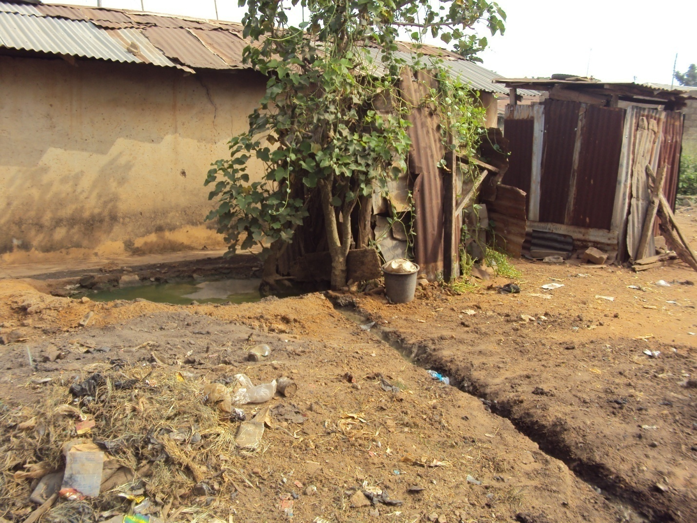
Stagnant effluent flowing from a detached bathroom
Lack of proper drainage system
Pit toilet
Figure 1: Stagnant effluent from a detached bathroom, beside is a pit toilet located around Isale-Ijeun . Source: Field survey

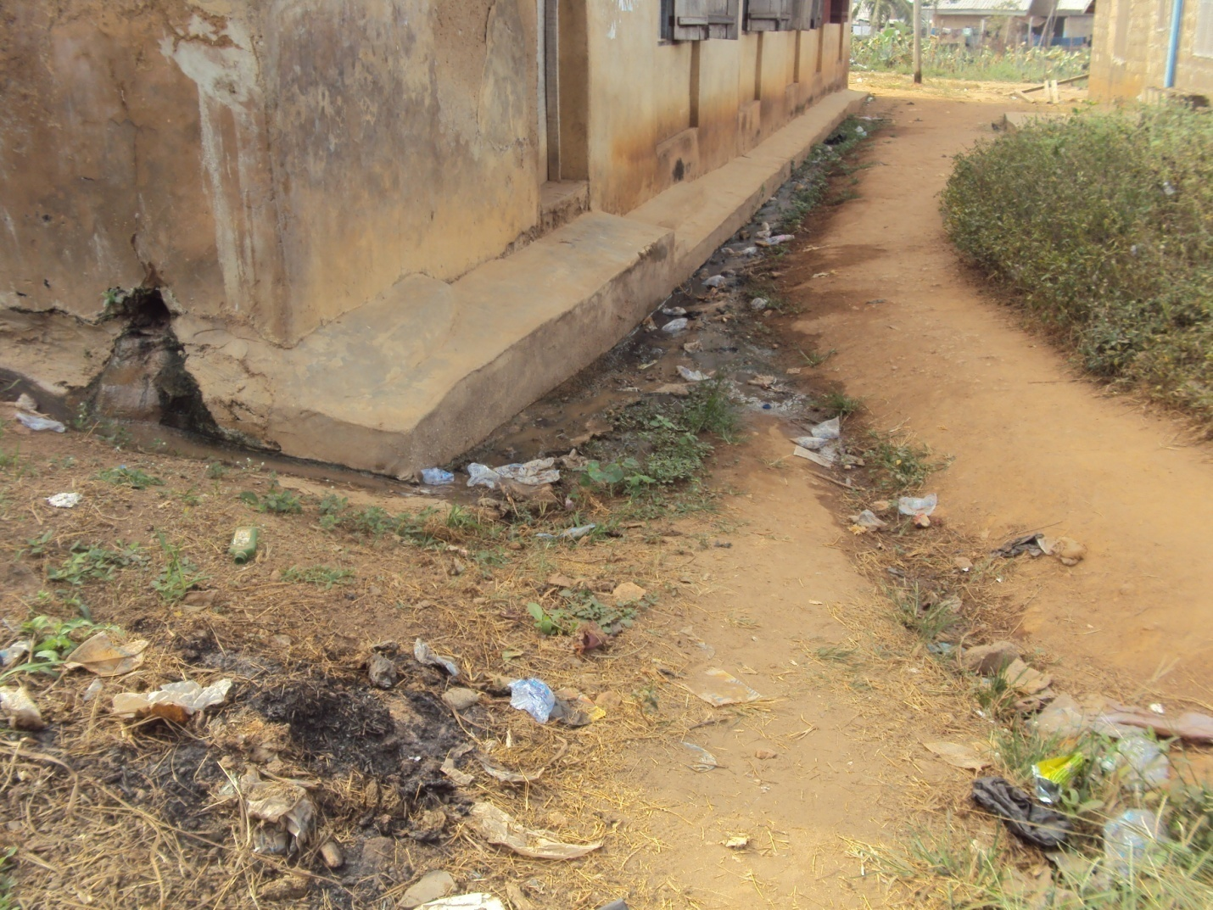
Lack of proper drainage system
Effluent flowing from a bathroom located inside a building
Figure 2: Effluent flowing from a bathroom located inside a building in Itoku

4.4. Environmental and Health-Related Problems
Findings indicate significant environmental challenges with direct health implications, as 62.6% of respondents acknowledged related problems. Malaria (27.6%), typhoid fever (23.0%), diarrhea (10.3%), cholera (8.1%), and flooding (19.0%) were the most frequently reported concerns. These align with national epidemiological patterns, where diarrheal and waterborne diseases remain prevalent due to inadequate sanitation and poor water quality. Reported causes included dirty environments (14.8%), poor water supply (14.7%), and overcrowding (12.2%), reflecting the effects of deficient basic facilities on housing quality and health.
The survey also revealed limited community engagement in environmental management, evidenced by indiscriminate waste disposal and general neglect. Such practices, shaped by environmental degradation and weak governance, foster uncontrolled dumping in the absence of formal collection systems. Within the Socio-Ecological Model, this represents systemic failure at both community and policy levels, where awareness campaigns alone are insufficient without infrastructure, enforcement, and local participation. Table 3 demonstrates the link between these conditions and reported health outcomes, providing empirical evidence of disease burden and the need for integrated interventions.
Table 3: Environmental related problems and likely causative factors
Category | Sub-Category | Percentage (%)
Possibility of Occurrence | Yes | 62.6
 | No | 30.4
Environmental Problems | Flooding | 19.0
 | Cholera | 8.1
 | Typhoid fever | 23.0
 | Malaria | 27.6
 | Diarrhea | 10.3
 | No response | 5.0
Likely Causative Factors | Poor drainage system | 0.9
 | Dirty environment | 14.8
 | Overcrowding | 12.2
 | Poor water supply | 14.7
 | No response | 50.4
Source: Field Survey, 2024

4.5. Qualitative Insights from Reconnaissance Survey
The reconnaissance survey provided qualitative insights that complemented the quantitative findings.
Indoor Housing Comfort: Approximately 75% of houses lacked adequate indoor quality, with poor ventilation and insufficient natural lighting. Over 80% lacked basic amenities such as sitting or dining areas, undermining household comfort.
Hygiene and Sanitation: More than 85% of houses exhibited poor hygiene, largely due to overcrowding and large household sizes. Litter, dirt, infant feces, and household waste were common both inside and around dwellings.
Pest Infestation: Rodent infestation was reported in over 90% of houses, linked to inadequate sanitation, unmanaged waste, and weak structural integrity.
Environmental Quality: Many bathrooms were detached from the main structures, discharging effluent into the environment with risks of groundwater contamination. Scattered open dump sites were observed, alongside poor road infrastructure where most access routes were unmotorable footpaths.
The prevalence of outdoor kitchens, reliance on well water, and unmotorable access roads reflect a pervasive informal infrastructure. While such systems provide coping mechanisms, they are unsafe and environmentally unsustainable. Effluent leakage and untreated water consumption increase exposure to waterborne diseases. These findings underscore the need for urban planning approaches that move beyond the imposition of generic models and instead provide context-specific, affordable, and integrative solutions that address existing informal systems.

5. DISCUSSION

5.1. The Nexus of Housing Quality, Sanitation, and Public Health
The results from Abeokuta clearly demonstrate a significant and obvious link between inferior housing, insufficient sanitation, and widespread public health issues. The significant incidence of aged, deteriorating structures built with inferior materials, as demonstrated by the study, encourages conditions that are naturally vulnerable to humidity, inadequate ventilation, and persistent pest infestations. These physical issues directly jeopardise the health and safety of people.
The heavy dependence on pit latrines, the considerable deficiency of adequate toilet facilities, and the concerning frequency of open defecation directly lead to substantial environmental pollution. This contamination is a primary factor contributing to the increased prevalence of waterborne illnesses, including malaria, typhoid, diarrhoea, and cholera, seen in the study area. This discovery consistently correlates with global evidence that clearly associates inadequate water, sanitation, and hygiene (WASH) practices with a significant illness burden. The qualitative observations of visible litter, infant faeces, and general refuse surrounding and within residences further emphasise the daily reality of poor hygiene and persistent exposure to pathogens, hence reinforcing the recognised F-Diagram of disease transmission (Budge, 2020). The interaction among physical housing deterioration, insufficient infrastructure, and socio-economic variables establishes a self-reinforcing feedback loop, wherein each issue intensifies the others, resulting in a decline in urban health and sustainability. Derelict residences, coupled with inadequate sanitation, directly contribute to environmental dangers (McGranahan et al., 2021). These concerns consequently result in elevated incidences of waterborne and respiratory infections, as well as pest infestations. The resultant ailments diminish productivity and earnings, hence exacerbating poverty. This poverty restricts households' capacity to sustain their housing or invest in enhanced sanitation, hence repeating the cycle. This illustrates that the concerns are not a series of separate issues but a systematic vicious loop. Consequently, effective interventions must be comprehensive, addressing several aspects of this cycle concurrently, rather than isolating difficulties. This underscores the imperative of a multi-tiered strategy, as proposed by the Socio-Ecological Model.

5.2. Socio-Economic and Governance Determinants
The socio-economic characteristics of residents, characterised by poor level of education, low income, and substantial household sizes, intensify housing and sanitation issues. These limitations diminish a household's ability to get suitable housing, preserve structures, or invest in sanitation services. These findings correspond with extensive literature that identifies poverty as a primary factor influencing inadequate urban living conditions. Failures in governance compound these issues. Insufficient institutional capability, ineffective policy execution, inadequate finance, and corruption limit efficient urban planning and service provision. The lack of dependable waste management, inconsistent water supply, and inadequate road infrastructure clearly illustrate these systemic deficiencies.
Resident indifference toward sanitation, described as a non-chalant attitude, reflects failures at community and policy levels, consistent with the Socio-Ecological Model. Without waste collection systems, accessible facilities, and enforcement mechanisms, individual behavioral change is unlikely. Widespread indiscriminate waste disposal and misuse of public spaces illustrate this breakdown of collective responsibility, reinforced by weak governance and limited community ownership of environmental resources. Reports that over half of households dispose of waste indiscriminately, often into drainage channels, underscore these challenges. This scenario exemplifies the tragedy of the commons, where individual convenience results in collective environmental degradation and public health risks. Addressing these issues requires stronger urban governance, clear enforcement mechanisms, and institutional reforms. Sustainable solutions should prioritize community engagement, including initiatives such as Community-Led Total Sanitation (CLTS), to foster shared responsibility and accountability for public spaces.

5.3. Implications for Urban Sustainability
The findings indicate that Nigeria's urban development path is unsustainable. The spread of urban decay is noticeable in Abeokuta, where neglect promotes disinvestment, environmental deterioration, and declining neighbourhood standards. Pollution, breeding grounds for vectors, and increasing disease burdens compromise public health, lower liveability, and reduce investment, thereby perpetuating cycles of poverty and decline. These conditions hinder advancement towards the Sustainable Development Goals, particularly SDG 3 (health) and SDG 11 (sustainable cities). Attaining universal access to safe water and sanitation necessitates accelerated progress beyond current trajectories. Tackling these issues requires integrated, context-specific strategies rather than generic models.
Promising solutions includes affordable sanitation technologies, demand-driven strategies like sanitation marketing and Community-Led Total Sanitation (CLTS), as well as private sector involvement via sustainable business models. Nonetheless, institutional fragility and budgetary limitations linger as significant obstacles to scalability and sustainability. Climate change adds to these difficulties. Respondents acknowledged flooding as a significant issue, aggravated by substantial precipitation and dilapidated buildings. Extensive evidence associates climate change with heightened flooding, water pollution, disease spread, and hazards of excessive heat. Informal settlements, characterised by insufficient infrastructure, are especially susceptible.
These findings emphasise the necessity for urban planning and sanitation policies that include climate resilience. Infrastructure must be engineered to endure severe weather conditions, while resilient early warning and response systems are crucial for safeguarding at-risk people. In the absence of such steps, urban health risks will intensify, jeopardising both developmental achievements and future sustainability.

6. CONCLUSION AND POLICY RECOMMENDATIONS

6.1. Conclusion
This research meticulously analyses the significant and interrelated issues arising from poor housing conditions and insufficient sanitation infrastructure in urban Nigeria, with Abeokuta serving as a relevant case study. The study presents strong empirical evidence indicating that deteriorating housing, poor waste management practices, and dependence on unsafe water sources are directly linked to a high incidence of communicable diseases and considerable environmental degradation. The findings highlight a dangerous interaction between urban neglect and ecological decline, a situation worsened by entrenched socio-economic inequalities and ongoing systemic governance failures. This study illustrates the practical application of mixed-methods approaches in urban diagnostics, providing a replicable model for other rapidly urbanising cities facing similar challenges. Abandoned properties and unsanitary living conditions are interconnected issues of neglect that have significant environmental, social, and public health consequences.

Large-scale investments in housing infrastructure, water supply, and basic sanitation must be given top priority in urban development strategies in order to solve the systemic problems ot study identifies. To stop environmental deterioration and hazards to public health, regulatory enforcement must be strengthened, especially in the areas of waste management and building safety. In order to lessen overcrowding and enhance living conditions, urban regeneration projects should focus on restoring vacant and abandoned buildings into secure, livable areas.
An integrated approach to policy is required, one that connects urban planning, housing, and public health. This includes setting up data-driven monitoring mechanisms and actively involving the community to make sure interventions are accountable and responsive. Equitable resource distribution to marginalized groups should be the main goal, and institutional capacity should be increased through interagency cooperation and workforce development. Both structural change and ongoing local involvement will be necessary for sustainable urban management.

6.3. Limitations and Suggestions for Further Research
This study provides significant insights; however, it is constrained by certain limitations. Data collection took place in the dry season (October–November 2024), potentially failing to capture seasonal variations in flooding and the prevalence of waterborne diseases during the rainy season. The limitations of site access and the lack of real-time satellite imagery constrained the comprehensiveness of spatial analysis.
Future research should concentrate on addressing these gaps by conducting time-series geospatial studies, longitudinal assessments of intervention outcomes, and qualitative investigations into the social and psychological effects of inadequate housing and sanitation. Comparative studies in urban and peri-urban contexts, as well as research on climate adaptation and resilient infrastructure, are essential for creating scalable, context-specific solutions to Nigeria's urban challenges.

Disclaimer (Artificial intelligence)
Author hereby declare that NO generative AI technologies such as Large Language Models (ChatGPT, manuscript.

References
BAKO, A. I. B., & BALOGUN, F. A. B. (2023). A review of emerging issues on urban land management policy in Nigeria. Urban and Regional Planning Review, 9(1), 37-44.
Oluwagbayide, S. D., Abulude, F. O., Akinnusotu, A., & Arifalo, K. M. (2024). The relationship between waste management practices and human health: new perspective and consequences. Indonesian Journal of Innovation and Applied Sciences (IJIAS), 4(1), 19-34.
Percudani, M., Porcellana, M., Di Bernardo, I., & Morganti, C. (2024). Urbanization and Mental Health. In Social Determinants of Mental Health (pp. 279-296). Cham: Springer Nature Switzerland.
Zerbo, A. (2022). Environmental risk factors associated to outbreaks of water and vector-borne diseases in urban areas of Sub-Saharan Africa (Doctoral dissertation).
Kakam, S. A. (2020). Ensuring environmental sanitation quality standards and its implication on students’ health (Doctoral dissertation, University of Education, Winneba).
Jiwok, J. C., Adebowale, A. S., Wilson, I., Kancherla, V., & Umeokonkwo, C. D. (2021). Patterns of diarrhoeal disease among under-five children in Plateau State, Nigeria, 2013–2017. BMC Public Health, 21(1), 2086.
Fakunle, A. G., Jafta, N., Smit, L. A., & Naidoo, R. N. (2022). Indoor bacterial and fungal aerosols as predictors of lower respiratory tract infections among under-five children in Ibadan, Nigeria. BMC Pulmonary Medicine, 22(1), 471.
Ifyalem, K. J., & Jakada, Z. A. (2023). The influence of housing and waste management facilities on public health. J. Mater. Environ. Sci., 14 (1), 62, 81.
Morakinyo, K. O., Taiwo, R. O., Oyediran, D. O., & Badejo, O. O. (2025). A Study of Housing Elements and Potential Home Injury Risks in Selected Public Housing Estates in Lagos State, Nigeria. Local Engineering, 3(1), 21-30.
Ventriglio, A., Bellomo, A., di Gioia, I., Di Sabatino, D., Favale, D., De Berardis, D., & Cianconi, P. (2021). Environmental pollution and mental health: a narrative review of literature. CNS spectrums, 26(1), 51-61.
Obakin, O. A., Afolami, S. K., & Akande, O. K. (2024). Causative factors of abandoned urban housing projects and strategies for revitalization in Ibadan, Nigeria. Journal of Contemporary Urban Affairs, 8(2), 582-602.
Ezeudu, O. B. (2020). Urban sanitation in Nigeria: the past, current and future status of access, policies and institutions. Reviews on environmental health, 35(2), 123-137.
Jiboye, A. D., Adebayo, J. A., & Obakin, O. A. (2020). Urban housing in Nigeria for sustainable development: Challenges and prospects. International Journal of Advanced Engineering Research and Science, 7(7), 478-491.
Ichipi, E. B. (2023). Assessing the Environmental and Health Impact of Illegal Dumping of Solid Waste in Lagos State. University of Johannesburg (South Africa).
Budge, S. (2020). Risk factors and transmission pathways to infection and malnutrition in infants in Ethiopia: implications for WASH programming.
McGranahan, G., Songsore, J., & Kjellén, M. (2021). Sustainability, poverty and urban environmental transitions. In The Earthscan reader in sustainable cities (pp. 107-133). Routledge.

