Geomorphic dynamism along the South Odisha Coast, India

Abstract:
Rivers emanating from Eastern Ghat Belt Hills(EGBH)and flowing east in Odisha are little studied, contrasting with the South Mahanadi Rivers and the Chilika Lagoon. The south Odisha Coast (SOC) has a coastal stretch of ≈200km between the Konark to the Bahuda River mouth, comprising an area of ≈10,000 Km². The present study addresses the under-researched rivers (the Rushikulya, the Salia, the Makara) along the South Odisha Coast, which has significant contribution, in contrast most prior works emphasizes the Mahanadi system and Chilika Lagoon. The integration of RS/GIS, field data, LULC, sedimentation, water quality, surface indices ( like NDVI, NDBI, NDMI and NDWI etc) and geomorphic proxies make the study interdisciplinary.and geomorphic proxies. The SOC rivers have not formed any delta in its tail reaches. During 21st century the meteorological, gromorphological and anthropogenic changes have shattered the SOC. The interventions like the Salia dam, Rare Earths Limited, surge in settlements, coastal erosion has threatened the people, the ecosystem and the vegetation of the area. Pertinent actions to be taken for satisfying SDG-15 (Life on Land) and SDG-6 (Clean Water and Sanitation).
Keywords: Anthropocene, Chilika, EGB Hills, GIS/RS, strandlines, LULC, SDG 15,
Introduction
The east coast shoreline shifts under geological and meteorological settings with coastal current dynamics, converging upon huge onshore energy, along Odisha’s micro-tidal coast of India. The paleo channels are distinct and housed along the coastal zone, and young coastal plains from the Pleistocene to the present day. The coastal stretch of south Odisha between the Rushikulya River mouth and to Kushabhadra River mouth) extends 200km. The South Mahanadi delta (SMD) ends up in the Chilika Lagoon. Before the start of Anthropocene (1950), the River Daya was taken as the southernmost river of the Mahanadi System, but presently. The Makara River, an anabranch of the Daya, carries the maximum share of the Mahanadi flow and is taken as the southern boundary of the Mahanadi system. Beyond Daya, three small, flat, serpentine ephemeral rivers are Makara, Salia, and Rushikulya, flow along the south Odisha coast (SOC). The tail river Bahuda emerges and debouches in Odisha, and has maximum spread flows in Andhra Pradesh (AP) (Fig. 1).
a.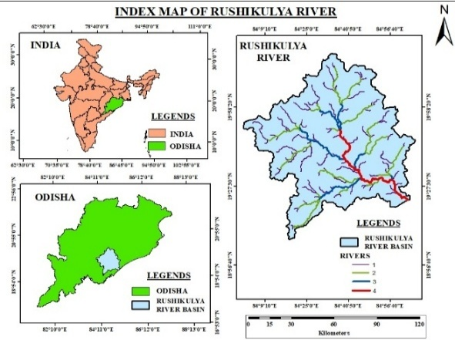b.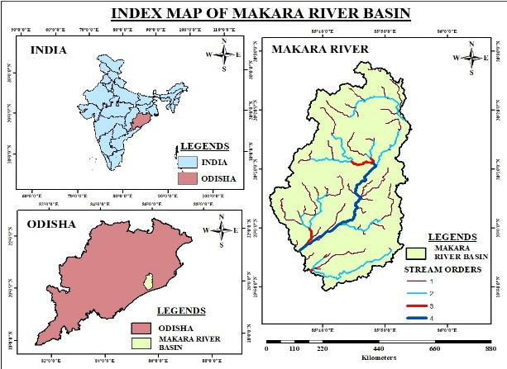
c.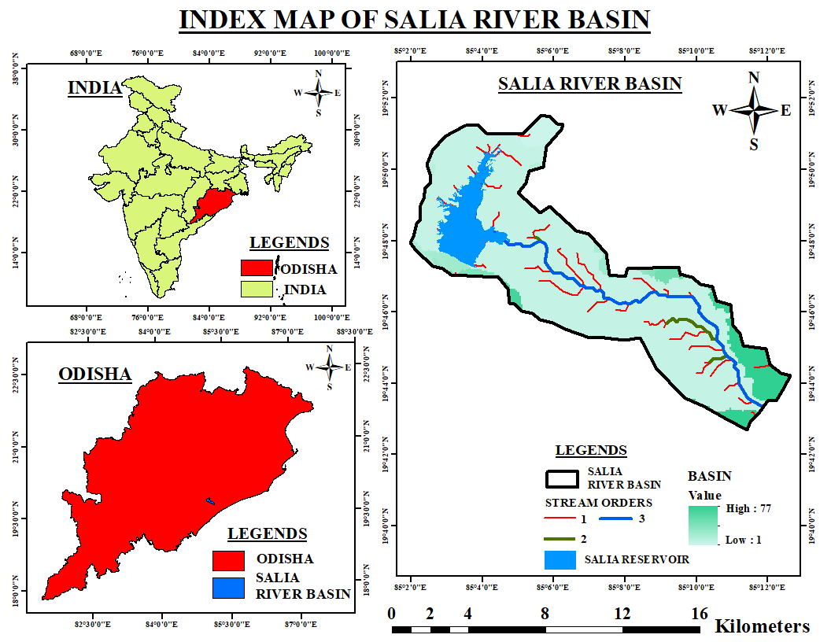d.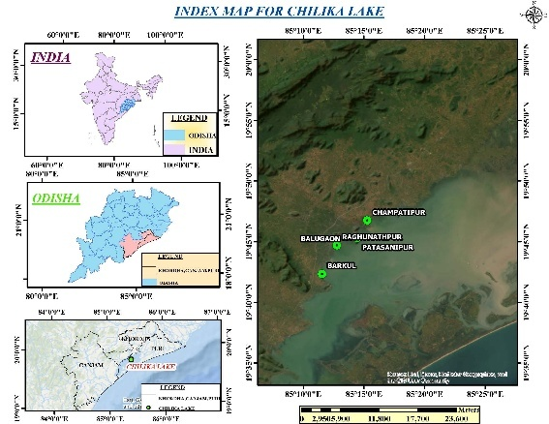
Fig 1(a-d): The basin’s index maps of (a) The Rushikulya River, (b) The Daya River, (c )The Salia River, (d)The greatest lagoon Chilika
The geographical formation of the rivers with comparatively small basins emerging from the Eastern Ghats Belt Hills (EGBH) and falling in the Chilika lagoon or Bay of Bengal is due to the reconstruction of past tectonic activities. The geo-morphology, geohydrology, hydrology, and ecology of the area have reformed significantly from the period of origin to the present under different geological settings. The Chilika and its surrounding south Odisha coast have confronted many deadly cyclonic storms along the SOC, especially during the last 30years, challenging the ecosystem, geological setting of the coast.
The Study area:
The major drainage channels (D/Cs) between the right of Daya and the Rushikulya River are the Makara, Kusumi nallah, Kansari Nallah, Salia, and Bada Sankha. Two lakes are accommodated within the SOC coast are the Chilika (brackish, and 64km long) and the Tampara (Lake) with a creek at Haripur within the research area. The Rushikulya R. has tributaries Badanadi, Ghodahado, Dhanei, Padma, Baghua, and Lohoara khandi, etc.
a.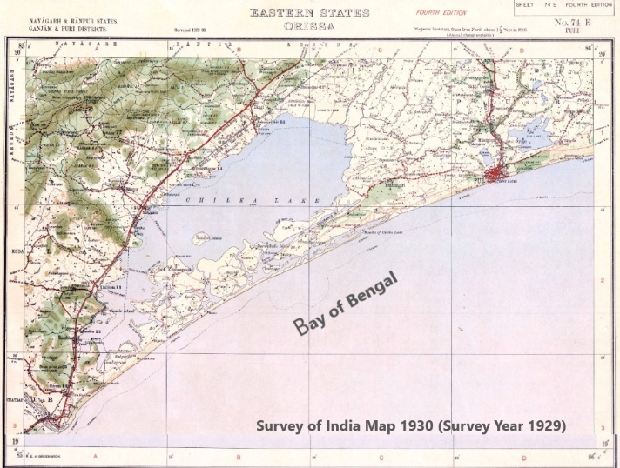b.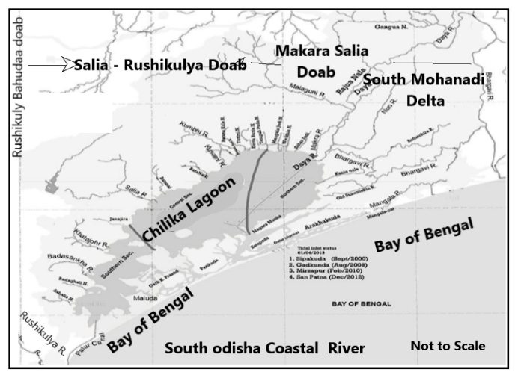
Fig 2: (a) The South Odisha Coast Topo map (SOI 1930) (b) the outfalling drains no delta around the Chilika
Literature review:
The Chilika Lagoon was once the busiest Indian Harbour/port during the past 400 years (Little Ice Age), later transformed shallow as degraded geo-ecologically, hydrologically choked and diminished from 1500 sq km to an average (av.) 1000 sq km presently. The diminishing lagoon’s size, water volume, coastal topography, is ascribed to BoB Cycloned, landforms, water bodies depth and stratification is attributable to a change in Climate, Regional Mean Sea Level (RMSL), anthropogenic interventions upstream (U/S), and overexploitation of resources (CDA Report (2011-13)^{[1]}, Mishra et al, 2019^{[2]} and 2024^{[3]}; Lemenkova, P., 2024^{[4]}; Ganesh et al, 2024^{[5]} ).
Many rivers (coast-parallel or perpendicular) are either dead, dysfunctional today. The abandonment of these Paleo channels, swamps and buried runnels is continuous in the Mahanadi lower delta (Feng et al, 2023^{[6]}). These geospatial shifts of the paleo-channels are the Pathar Buha, the Malini River, and Chandrabhaga, Dhanua rivers, Samang, SAR-LAKE, East Kania and Sunamunhi River, etc., due to a shift in the strandline and gentle sloping along the coast. (Mishra et al, 2021^{[7]}, Banerji et al., 2025^{[8]}, Sinha et al., 2025^{[9]}).
About the flora and fauna, the Chilika lies on the Central Asian Flyway, a regular flying route for migratory Avifaunal species from the Arctic and sub-Arctic and rookery (Locally called Arribada) for 641,000 nesting females by the 1st week of March 2025, harboured Olive Ridley Turtles for hatchlings between Rushikulya mouth at beach ridges near Gokhurkuda, Purunabandha, Kantiagada and Nuagaon, by NGO’s, Ganjam district, a part of SOC, Odisha, Hindusthan Times, Feb 23, 2025 05:26 am IST
The hydrologic study of the area started by Captain Harish after very high floods and severe droughts in the Mahanadi catchment area during the 19th century, but the Salia-Rushikulya doab is rarely studied (Mahalik, et al, 1996^{[10]}, Syvitski et al., 2009^{[11]}; Sethi et al, 2020)^{[12]}. The needs for research in the focused areas are, Deltaic Plain, Paleo-channels, Floodplains, Channel/ Islands, various Beach and Beach Ridges, various Lagoon, Mud/Tidal Flats, backwater, Dune, etc in the SOC (Kathiravan et al, 2018^{[13]}; Yu et al, 2025^{[14]}.
Loveson et al 2019^{[15]} reported that the east coast of India went through a reasonable rate of Mean Sea Level Rise (MSLR) (≈0.88m/100 years) during post post-Pleistocene period from 14,800 to 10,800 YBP (lower Holocene), but a sharp rise during the early Holocene 10,800 to 9,200 YBP @ 2.06m/100 years (Early Holocene). Later, the rise was sluggish during the post-Greenlandian period @ ≈ 0.82m/100years, and thereafter there was again a steep rise @ 2.22m/100 years. The Meghalayan period of the Holocene has experienced five small fluctuations to date. The coastal areas that were inundated along the Indian coast were 34906Km². East Coasts between 1987 and 2021. The RSLR at Paradip between 1987- 2021 was 0.717mm with an annual rise of 0.108cm. (Validya et al, 2017^{[16]}; Mishra SP. 2023^{[17]}, Das et al, 2024^{[18]}, Puthucherril 2025^{[19]}). The districts of Ganjam, Puri, Jagatsinghpur, Kendrapada, etc, have a potential threat to RSLR and shall be a menace to create risk of inundation even for the coming generations (FE&CC, GOO^{[20]}).
The Objectives:
The Objectives are
- The change detection evaluation of coastal landforms and shoreline positions using GIS/RS along the South Odisha Coast (SOC).
- The appraisal of the status of flow, land use and surface characteristic various drains inflowing the Makara, Salia and the Rushikulya basin.
- To assess thegeospatial changes of Land use and surficial various indices of the coastal reaches mainly concentrating on the Makara, Salia and the Rushikulya Rivers whose vegetation has changed in last 20years during the Anthropocene epoch.
Highlights:
- The rivers emerging from the Eastern Ghats Belt (EGBH) hills along south Odisha are small, low gradient, serpentine and have zero delta.
- The South Mahanadi delta (SMD) has extended southerly till the Makara River, but not the right bank of the Daya River.
- The terrain was made bald by people with erosional/depositional coast by the surging population, and Bay of Bengal (BoB) disturbances, shifting landward the resettlements.
- There exists regular transgression of the coasts, paucity of fish resources, have invited migration, marginalisation and societal transformations etc. alongwith present-day erosional SOC coastline and rarely depositional.
- The impacts of Anthropocene stresses along the coastal interface due to Indian Rare Earth Limited, the Gopalpur port, agglomeration of townships and widening of the NH16, etc.
Methodology:
About 52 drains (large or small) are draining to the ≈1000Km² water spread; the Chilika lagoon carries ≈8% of the total flow of the Mahanadi System. An attempt has been made to measure the local catchment area of the major drainage system (Ratnachira, Nuna and Makara) draining to the Chilika lagoon. (Table 1) Two cuts at Gabakund and Mangala are dredged to the BoB, which ameliorates the flood havoc of Puri. (Mishra SP., 2016^{[21]}, Patel et al, 2022^{[22]}).
The LULC Changes along the SOC and the stretch between Chilika lagoons deserve planning for strategic management, for conservation practices across the SOC. The strategic planning using GIS/RS can provide a sustainable and accurate solution to the satellite data. The present study uses GIS-based mapping and analysis of landscape dynamics for workflow, taking the Chilika Lagoon, the SMD, and the SOC (Lemenokova et al., 2024^{[23]}).
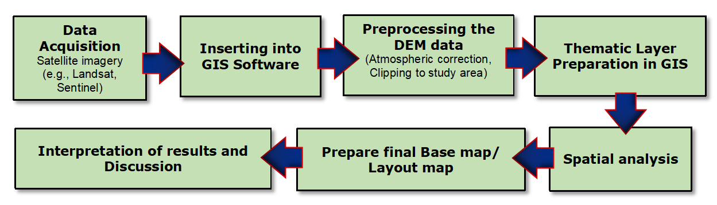
Fig 3: The GIS/RS-based study of the comand area between EDBH and SOC (Ayacut area)
Small river deltas can be analysed using GIS-based maps, reporting about the physical features by drainage density, curvature, slope, aspect ratio and sediment flow, etc. These morphologic signatures of the satellite imagery talk about the fluvial status, sinuosity, to have knowledge about their evolution and resilience, knowing the spatial patterns of the landforms (Mistika et al, 2023^{[24]}). The only sweet water lake, Tampara, exists along the Ganjam coast, whereas Samang and SAR lakes along the Puri Coast are dead and defunct due to past fluvial dynamics, tectonics and onshore activities (Mishra et al., 2015^{[25]}).
Results
Sedimentation from North EGB Hills:
The EGB Hills, a part of the Rayner complex of Antarctica, was shaped by tectonic processes linking the rifting, drifting, and Juxta Positioning, collision of continents from the Proterozoic Era, with key events of ≈ 1.6 to 1.5 Ga (billion years ago) and later during ≈ 1.0 to 0.9 Ga before due to series of primeval orogenies like magmatism, metamorphism and sedimentation.
The adjacent Mahanadi system contributes flow ≈61% and sediment ≈75% to the Chilika. The rest is donated by the western Rivers, Makara and the Salia, to Chilika. The major DCs, the Kusumi, Kansari and Salia had average flow 260.15MCum, 196.61 MCum, 122.16 MCum, and the corresponding sediment carried to the lagoon were 11539 MT, 23871MT and 6780.4MT respectively during 2001 to 2004. The Rushikulya is a separate river system that directly debouches into the BoB.
a.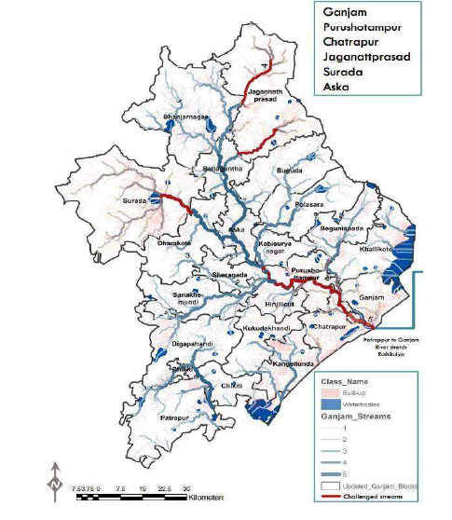b.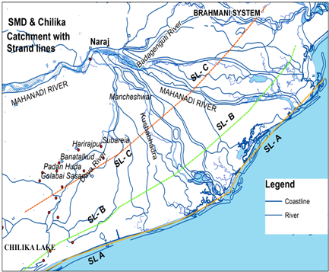
c.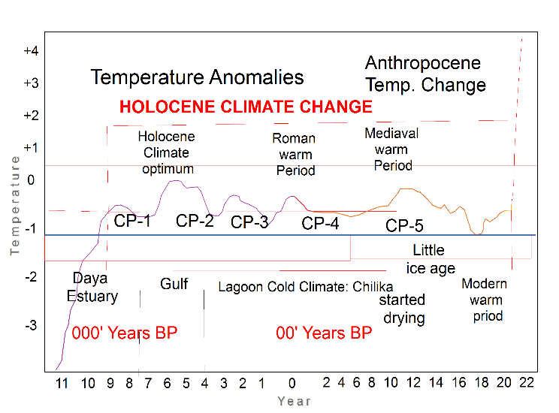d.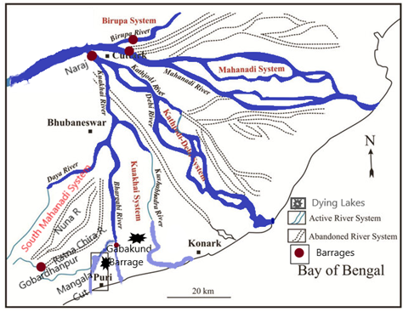
Fig 4(a-b): a. The Rushikulya R. Basin; b. The coastal shift and strandlines with ages along the SOC. (C )The Holocene climate change. (d) Paleochannels in the Mahanadi Delta
After 2008, i.e. after completion of six lanes of NH 16 from Tangi to Gopalpur, the sediment concentration has reduced (Mishra et al, 2013^{[26]}; Mishra et al., 2023^{[27]}). The east-flowing Peninsular rivers have an average sedimentation rate of 0.78mm/yr (CWC compendium 2020^{[28]}, Mishra et al., 2022^{[29]}). The sediment yield of the basin of the Rushikulya River is ≈18.51 MMT/yr, and the soil loss is 0 to 0.165 MT/ha/yr (Samal et al, 2024^{[30]})
Insignificant Deltas in South Odisha Coast
Along the East Coast of India, particularly in Odisha and Andhra Pradesh, many rivers that flow close to the Bay of Bengal are short, serpentine and cover a steep gradient of Eastern Ghat Belt Hills (EGBH). The proximity to the coast or the largest lagoon has a high flow rate but less sediment from the laterite-capped mountain ranges. The east-flowing Rushikulya River, falling in the Bay of Bengal (BoB) through a 5km long estuary along the SOC, is without a delta formation (Table 1).
Table 1: The Major drainage system of SOC from the Rushikulya to the west of Daya R.
Sl no | Name of river/ drains | Length (km) | Basin area (km²) | Sl no |  | Name of river/ drains |  | Length (km) |  | Basin  area (km²)
The Daya Right system |  |  |  |  | West of Daya-Salia DOAB (Contd)
1 | Daya and Rajua | 60 | 540 | 8. |  | Mangalajodi |  | 6.9 |  | 62.18
2 | Nuna drainage sys. | 26 | 445 | 9. |  | Tengulipada |  | 6.0 |  | 4.60
3 | Bhargavi R. system. | 85.5 | 646 | 10 |  | Patnakula |  |  |  | 4.03
4 | Ratnachira R. system | 22 | 145 | 11 |  | Kantabania |  |  |  | 6.28
 | Total to Chilika |  | 1777 | 12 |  | Chhamankantal bari |  |  |  | 144.19
West of Daya System |  |  |  |  | 13 |  | Badanai |  |  |  | 86.91
1. | Gangua (Join Daya) | 37.0 | 740.75 | 14 |  | Kansarinallah |  | 23.0 |  | 160.99
2. | Malaguni(Join Daya) | 22.5 | 289.01 |  |  | Sub-total (a) |  |  |  | 910.16
 |  |  | 1029.76 | Salia-Rushikulya DOAB
West of Daya-Salia |  |  |  |  | 15 |  | Salia |  | 36.0 |  | 454.82
3. | Kusumi | 8.2 | 141.19 | 16 |  | Janjira |  |  |  | 8.4
4. | Sahara Jodi | 10.5 | 13.50 | 17 |  | Badasankha (Kalajhar) |  | 15.0 |  | 128.45
5. | Weikhia | 16.0 | 14.05 | 19 |  | Badaghati drain |  | 11.0 |  | 179.53
6. | Tarimi | 7.8 | 86.56 | 19 |  | Sabulia (Manipalli) |  | 10.0 |  | 88.66
7. | Makara | 13.0 | 159.49 |  |  | Sub-total (b) |  |  |  | 859.86
 | Total local catchment SOC except Bahuda | 4577 Sq. Km. |  |  |  | Western catchment |  |  |  | 2800.2

In the southern fringe, Bahuda R.(tributaries Poichandia, Boginadi, Batruda Nalla) is of length 55km is emerges from the Parlakhemundi Hills, Gajapati district. After running for 17km, it enters the AP state and trails 6km, re-enters Odisha and debouches BoB at Sonapur, is neglected in the Present study (Mishra et al., 2015^{[31]}).
The climate:
The climate, environment and bionetwork of the area are administered by the El Niño Southerly Oscillation (ENSO), Indian summer monsoon (ISM), extreme meteorological events of the Bay of Bengal (BoB), and geomorphology of EGBH. The study area enjoys hot, humid weather, and the summer temperature is about 40 – 45^{0 °}C and receives an average rainfall of Purushottam 1326.2mm (2020 to 2024) annually at Purushottampur and is housed in the transition zone of SW-monsoon and NE monsoon. The 100km shoreline is almost stable and has low accretion towards 35 km south and slight erosion towards the north. The Rainfall maps in Fig. 5(a-b) do not include the Bahuda basin.
a.b.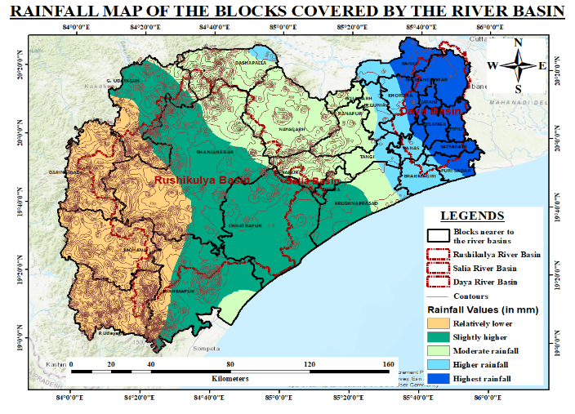
Fig 5 (a-b):(a)The Rainfall map of SOC (b) the Rainfall map of the study area (block data) The Existing Paleo channels in SMD:
During the field survey of SMD, it was observed that two dead and defunct paleochannels (past river courses), i.e. Chandrabhaga near Konark and Malini rivers bisecting Puri Town not exist, but Proxies were detected. A sedimented coast parallel river, the Sunamunhi has been renovated, but other coast parallel dying interfluves in the SMD are Kanchi system, East Kania, Nuanai, Choudadesh Puhani Jore, Balinai, etc., were the active channels in the past connecting the River Bhargavi and the Sunamunhi River, which run parallel to paleo-strandlines. Combined with remote sensing and geological data, helps researchers understand the delta's dynamic past and its response to both natural and tectonic forces (tectonic uplift and fault activity). The paleo-strandlines suggest the effect of the marine transgression (SLR) and regression (sea level drop) on the delta's morphology, associated with shifting paleo channels, meandering and braiding and anastomosis of drainage patterns.
Morphology of the onshore zone in South Odisha:
Delta progradation is due to paucity of sediment concentration, and shift of strand lines along the coastline from pre-Anthropocene (1950 onwards), based upon fluvial responses causing sea-level fluctuations. But climatic, geohydrology, salinity intrusion, anthropogenic stresses, and meteorological extremes, etc., may also transform the morphology of the Odisha coast ( Islam et al., ^{2022[32]}; Hazara et al., 2022^{[33]}; Acharyya et al., 2023^{[34]}). The estuarine area of the Odisha coast is maximum along the east coast of Odisha, 4.17 thousand hectares (Tha), followed by WB as 210THa. https://basu.org.in/wp-content/uploads/2020/10/esturies.pdf .The geomorphology SOC is contiguous with that of the 85⁰ E ridge. The geologic setting of SOC is given in Table 2.
Table 2: Past Geologic background of the Southern Mahanadi Delta, Chilika Lake and EGBH:
Sl | Geological phase | Years Before Present (BP) in (Ma) | Standing of the delta formation along with Coastal changes
1 | Late Creta-  ceous | 107-65 Ma | The Grenvillian collision in the Rayner complex of East Antarctica and the Rodania block formed the Chilika Gulf. Rajmahal Trap volcanic eruption over Crozet Hotspot deposited in the Mahanadi basin, and to the Chilika developed barrier spit from the southern fringe. Sediment uplifted the Basin and narrowed from the south as Rambha Hills, Rambha Soleri and Balugaon hills acted as spurs,Validiya K. S.(1993^{[35]}), .
2 | Early  Pleistocene | 65.5- 55.8  Ma | Carbonates (CO₃) deposits, extensions of the Mahanadi basin southward present in the Mahanadi offshore, but the inland is intact.
3 | Eocene | 55.8 - 33.9  Ma | Wide-spread transgression of the East Coast, formation up to the Mahanadi basin.Mahalik et al, 1996[36],
4 | Oligocene,  Miocene | 33.9-5.332  Ma | The margin of the Basin was formed by the Khordha and Bolagarh Formation (Study area). No Oligocene formation in both onshore and offshore, .Nayak et al, 2006^{[37]},
5 | Late Pleistocene - early Holocene | 5.332Ma to 11700 YBP | The lateritic tableland of fluvial origin skirted over the Pleistocene boulder conglomerate, Chatterjee N. (2008)^{[38]}, .
6 | Middle Holocene | 11700years to 7600 YBP | Sediment accretion in the Daltolah ridge in the Banki formation. The Chilika was a gulf in past associated with a Daya river estuary or delta with pure and associated Mangrove vegetation.Lal et al, 2009^{[39]};
7 | Late Holocene | 7600 YBPP0 YBP | Formation of the Chilika Lagoon as a gulf in the estuary between the southern distributaries of the Mahanadi and the Rambha Hills of EGB.
8 | Late Holocene to Present | 3000years  BP 75YBP | Spit formation of Chilika lagoon. The Lagoon diminished due to sedimentation. Ageing of the Bhargovi, Prachi. Ratnachira systems. The Chandrabhaga River and Sunamunhi River have become defunct, and sets of beach ridges have formed the Konark depression. The Kadua and Daya systems become active.Khandelwal, 2008^{[40]};
9 | Anthropocene Epoch | 75YBP -  till date | Anthropogenic intervention on nature, climate change and the active Crozet Hotspot, Mishra et al, 2024^{[41]}.

Topographic Characteristics of River Basins:
The maps showing the physical characteristics of the study area, such as curvature, aspect, slope, hill shade, Drainage and the drainage density maps are prepared for the three rivers: Daya (local catchment), Salia and Rushikulya rivers. As the Daya River is drying up at its tail reaches, the lion’s share is diverted to the Makara River. The physical characteristic maps of the Rushikulya river are constructed from satellite imagery,(Fig. 6 (a-f)). The Salia River basin flows through rugged mountains. The Rushikulya R. canopy, housed in tall reliefs and rocky mountains towards the west, transitioned by mildly rippling plains, structured hills, flood plains with active coast and estuaries running north.
Physical Characteristic: Aspect Map: This map depicts the direction that the slopes face across the basin. It reveals that the terrain has a mix of slope orientations. The slopes facing the sunlight influence soil moisture, vegetative growth, and erosion patterns. Commonly slopes of the multifaceted coast parallel hillocks face east or southeast. Falls within the North Eastern Ghat agro-climatic zone under a hot and subhumid climate. The Slope Map shows the gradient of the land across the basin. Steeper slopes are towards the erosion from west or northwest towards the central regions, contributing to fast water runoff. Flatter areas in the East are conducive to water retention, as slope knowledge contributes to soil conservation, farming, and infrastructure development (Fig 6).
a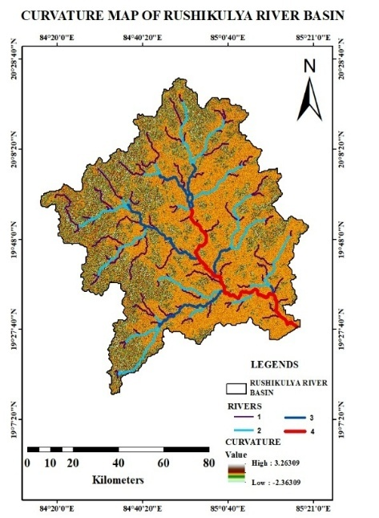b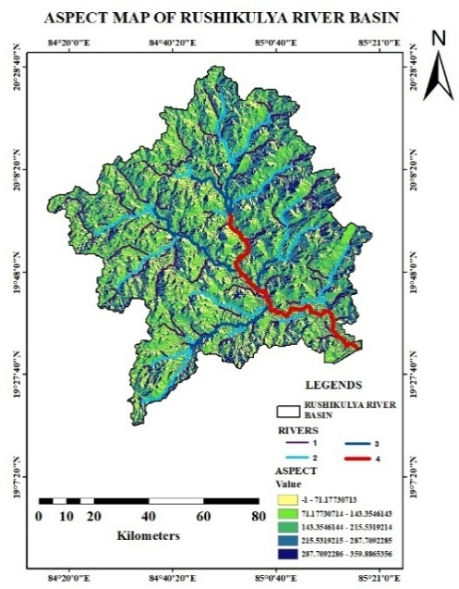c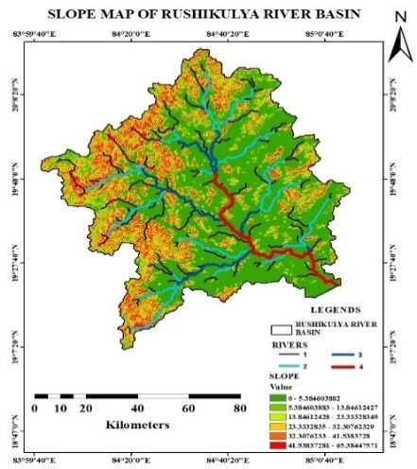 d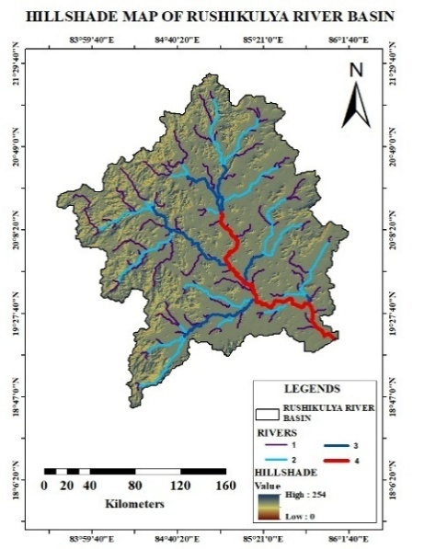e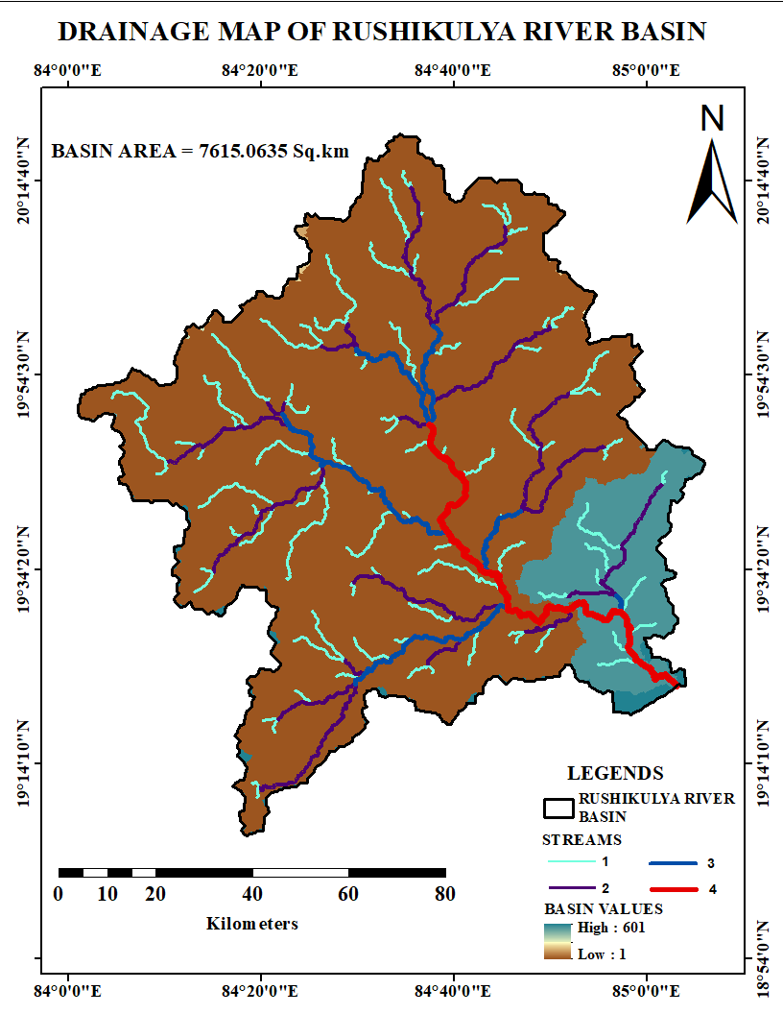f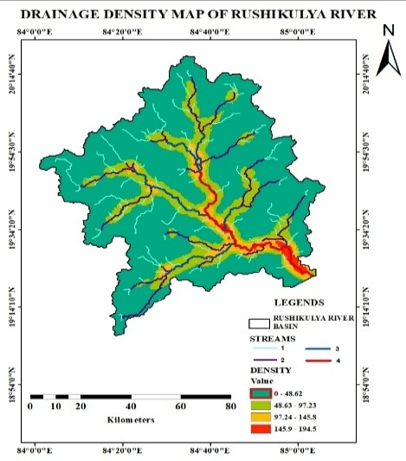
Fig6 (a-f): (a)The curvature, (b) Aspect, (c) Slope, (d) Hill shade, (e)drainage, and (f)drainage maps of the Rushikulya River basin

Curvature Map: The map highlights the curve or gradient of the land surface of the basin. Areas with high curvature are observed in the central and northern zones (around Rambha Hills), which may lead to fast flow and higher erosion (in field observation between Khalikote and Rambha) . In the southern fringe, the flat terrains are more suitable for farming or settlement.
The Drainage Density Map indicates the huge anastomosis of the drainage channels in the northern and central regions, indicating steep slopes and fast water movement within the basin (confirmed from field visit) . Low drainage density in the southern fringe with flatter terrain with slower runoff, which can be useful for water conservation and agriculture. Geological Map: The rocks found in the region are Charnockites, Khondalites, Migmatite, Basic Intrusive, and Alluvium (in low-lying areas). The soils are fertile, with better groundwater storage and land stability, which is important for agriculture and construction. Hill shade Map highlights the elevation of the terrain, which is a mix of high and lowlands, that identifies erosion-prone zones that guide watershed management.
The Drainage Map shows the distribution of drainage channels (DCs) across the basin. High drainage areas (dark brown) are in the northern and central zones, indicating steep terrain and fast water flow. Low drainage zones (light blue) in the south suggest flatter land and slower runoff, and ideal for farming and water retention. Watershed Map: This map divides the basin into 19 distinct watersheds (W1 to W19), each showing how water flows through different regions. It reveals that the basin has a complex drainage system, with multiple sub-watersheds feeding into the main river. This helps in planning water conservation, managing flood zones, and designing localised irrigation systems.
The geomorphology of the sea-facing slopes EGBH generate small serpentine, low gradient rivers and DCs, debouching either in the BoB or the lagoon. The basin houses dense forests, wild elephants, the runoff and agriculture. Along the coastline line The Haripur creek, Tampara lake, and Rookeries (Podampeta) are the coastal places of importance.
Topographic Characteristics of Salia River Basin:
a.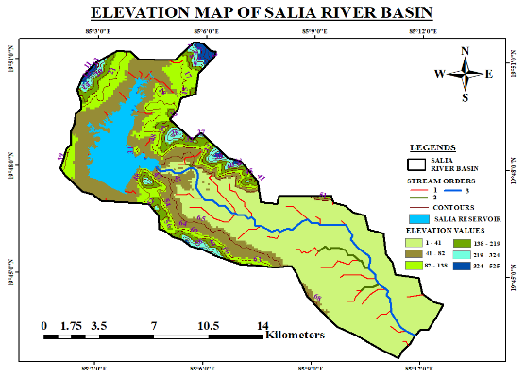 b.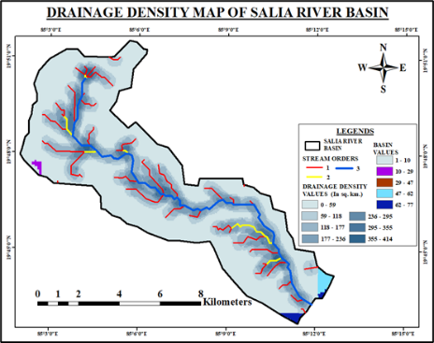 c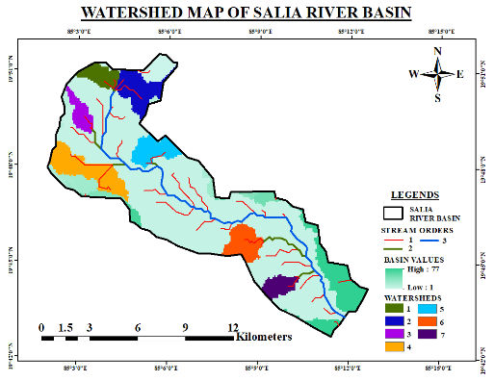
Fig 7 (a-c): (a) DEM, (b) Drainage density and ( c) watershed map of the Salia river basin

Physical Characteristics
The EGBH at Balugaon and at the upper reaches of the Salia River is housed within laterites, allowing the river Salia, drains like Kusumi, Janjira, Kalajhar, Badghati, etc, that carry flow /sediments through deep gullies and Ravines into the lagoon. Since the length of the river is 48km, other than DEM, Drainage density and watershed map, other imageries could not be prepared due to flat terrain.
The Drainage Density Map: The central and northern zones have high drainage density, the water flow is fast, and the reels, gulley erosion and low drainage density and erosion in is high erosion in the upper basin. Digital Elevation Map depicts the basin as a mix of high-yielding lowlands and highlands. The highest elevations are towards the northwest, and the lowest, adjacent to the Salia Reservoir, is in the southeast. This elevation gradient controls the flood-prone and erosion-sensitive areas of the basin. Watershed Map compartmentalises the basins into eight distinct watersheds, each with its own stream network and basin values. Watersheds with higher basin values are more active in terms of water flow, important for basin planning, irrigation, conservation, and flood control.
The hilly terrain tells about the dynamic hydrological health, the lightning-prone areas, the environment and ecosystem of the basin are the thickly populated low-lying plains near Balugaon, Banapur, Khalikote and Rambha townships of alluvial (recent and old) deposits. The topography is of stable landmass, limited relief, fertile high-yielding plains and a series of residual hills or ridges of EGBH. A dam constructed near Banapur, the Salia Dam has a catchment area of 245.00 km², av. rainfall 2137.17mm, av. Monsoon runoff of 259.22 Mm³ (WR Report, GOO, 2019^{[42]})
The Makara (part of Daya) basin:
The Makara basin is a recent formation during the Pre-Anthropocene Epoch period (1850s). During the early 18th century, some devastating floods associated with heavy rainfall in the south Mahanadi Delta had caused breeches in the river Daya in the U/s and downstream, generating two anabranches and later transformed to one loop river Rajua, and the other lower reaches of the Daya, was Makara. Both Rajua and the Daya system got sedimented, and the young channel Makara is carrying the lion’s share of SMD flow (CDA’s report 2012[1]). The Makara- Salia Doab (High land between two rivers) plays a vital role in the extension of SMD towards the Right.

a.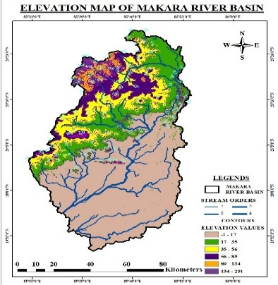 b.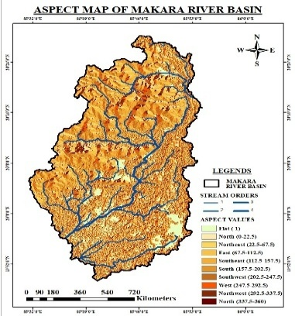 c.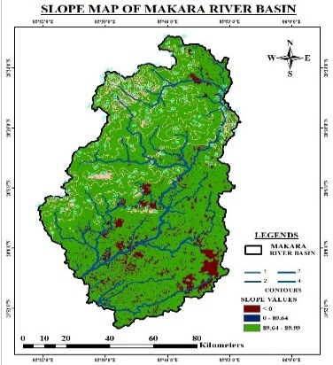
d.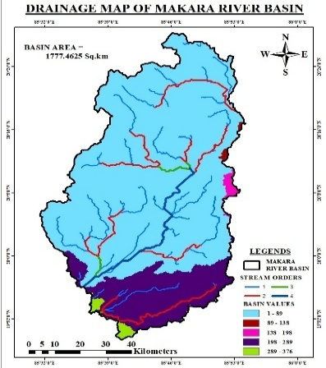 e.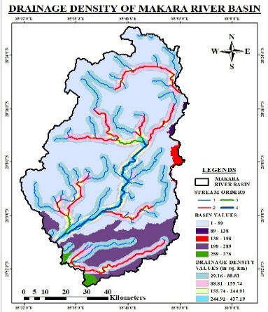 f.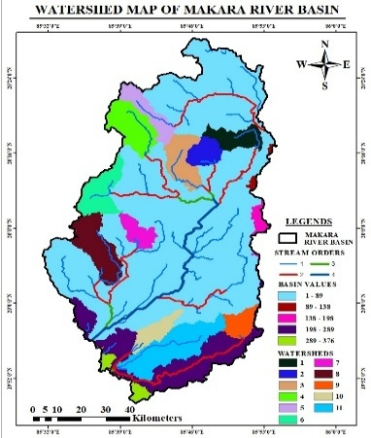
Fig 8: (a)The curvature, (b) Aspect, (c) Slope, (d) Hill shade, (e)drainage, and (f)drainage density map of the Makara River Basin

Since the Salia river basin is very close to the west bank of the Chilika Lagoon, the slope is flatter and the other topographic characteristics maps not except DEM/ contour, are in the figure 8

(a),Topographic and Hydro-morphology Characteristics
Land Surface features
NDVI tells about the health, greenness and density of vegetation. NDBI represents the settlements, urban infrastructures, impervious surfaces and human uses. NDWI signifies water in vegetation, swamps, water bodies and is used for strategic planning for irrigation, drought monitoring, etc.. NDVI, NDBI, NDWI. NWMI and Savi are the various spectral indices that are based on the application of remote sensing and GIS, calculated from the GIS/RS imageries given in Table 4
A. Rushikulya River Basin
a.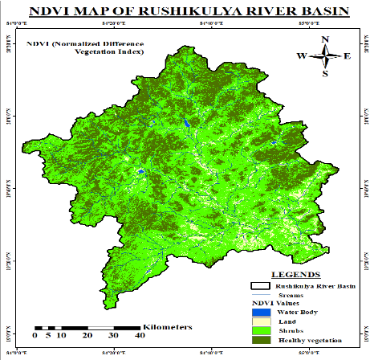 b.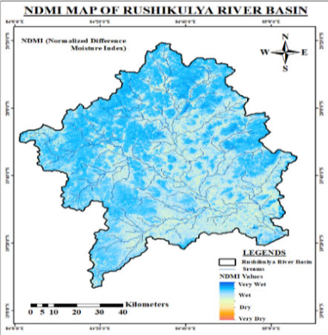c.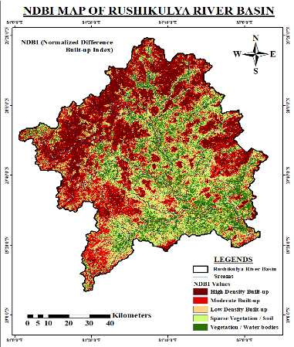
d.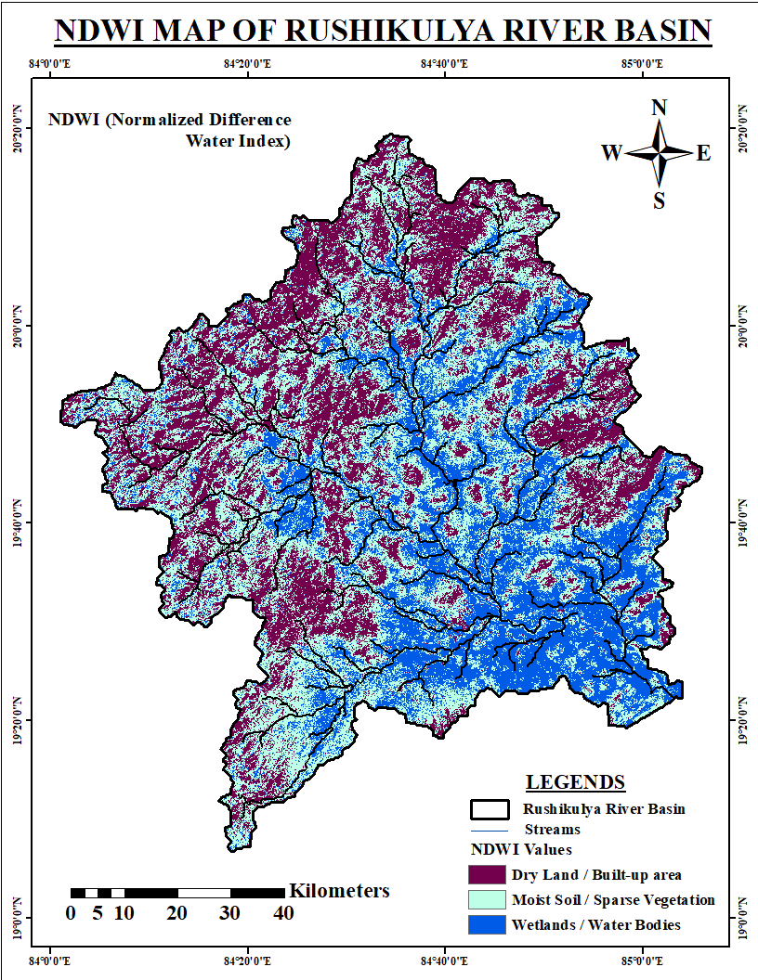e.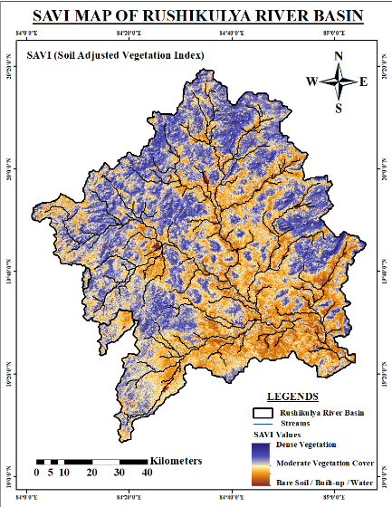f.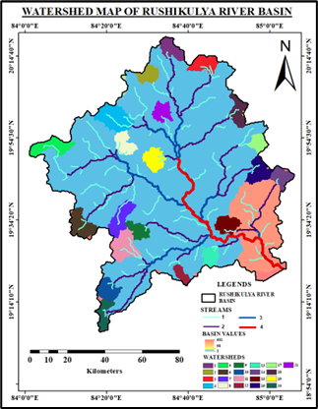
(B) The Salia River basin
a.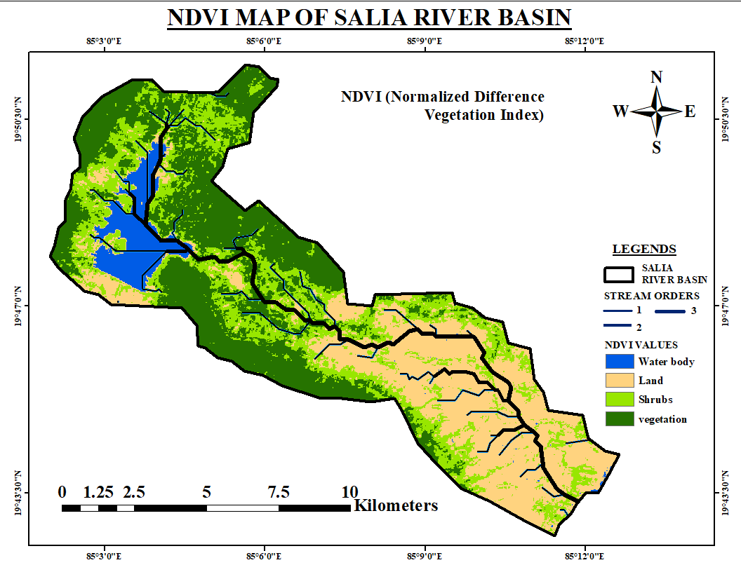 b. 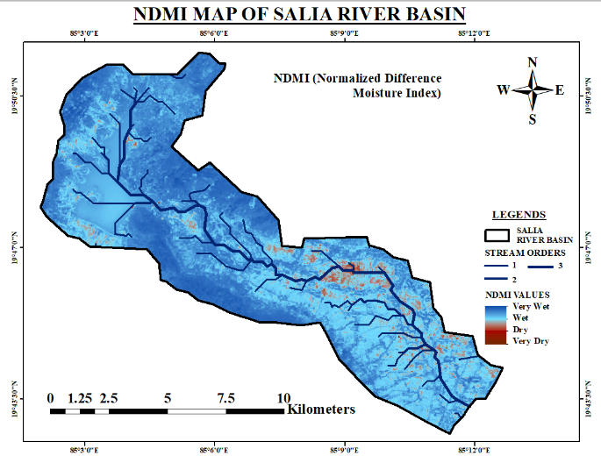
c.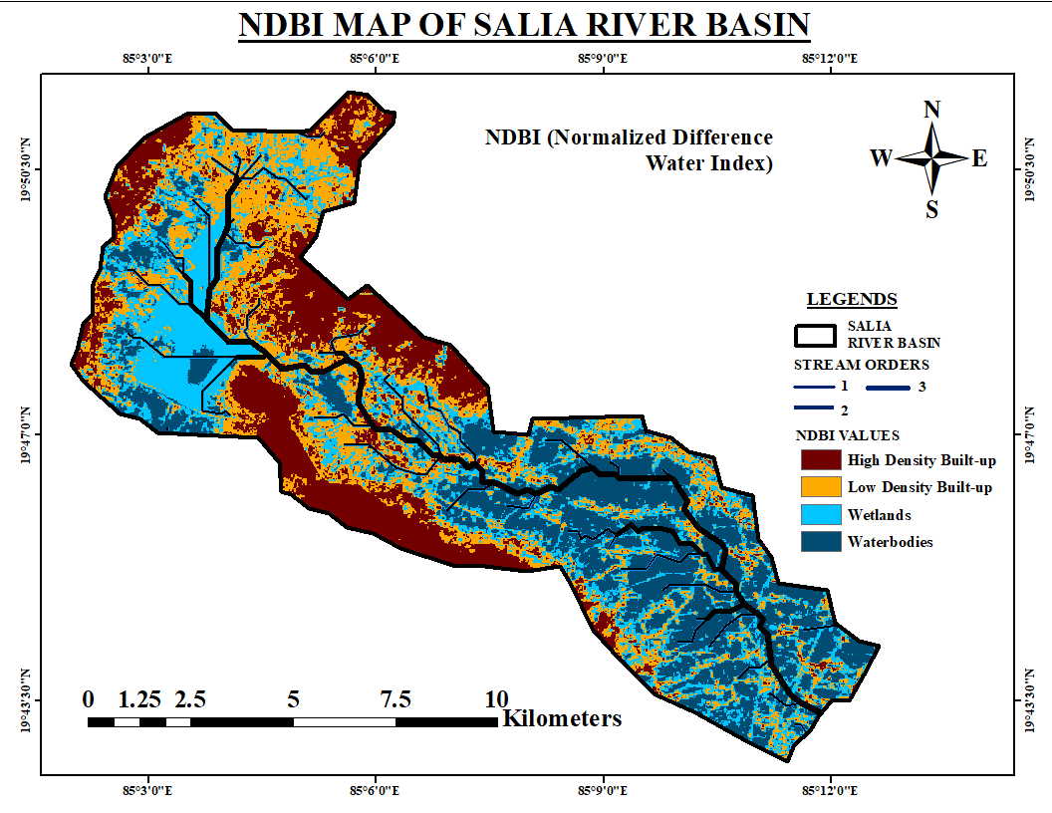 d. 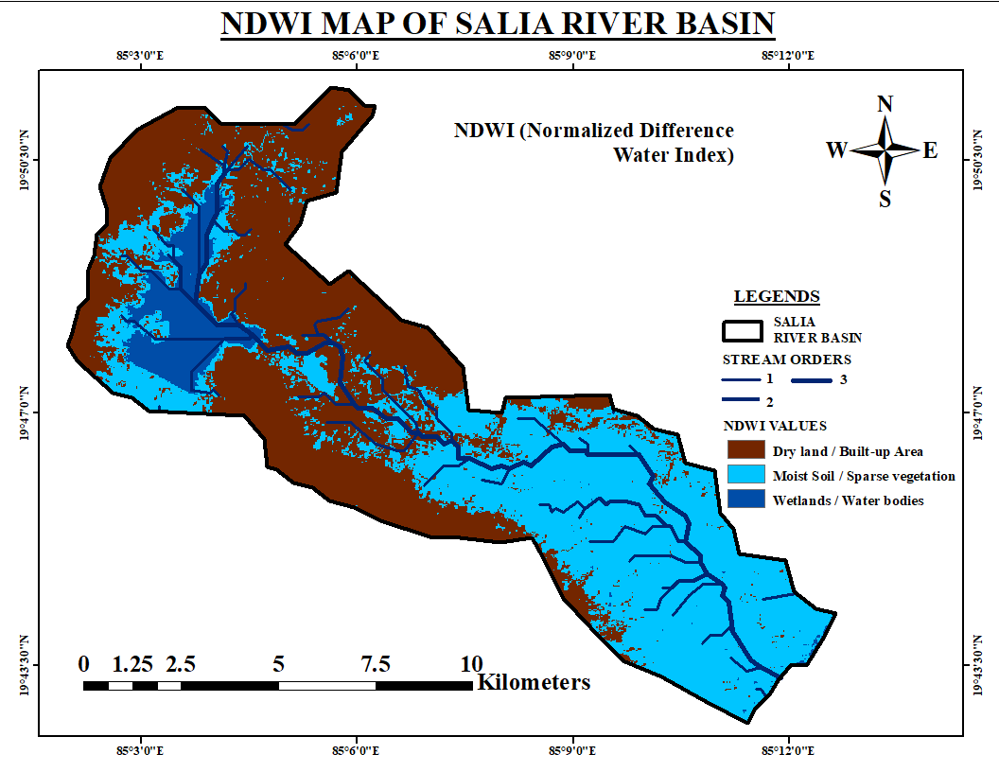
( C) Makara (Right of Daya River) Basin;
a.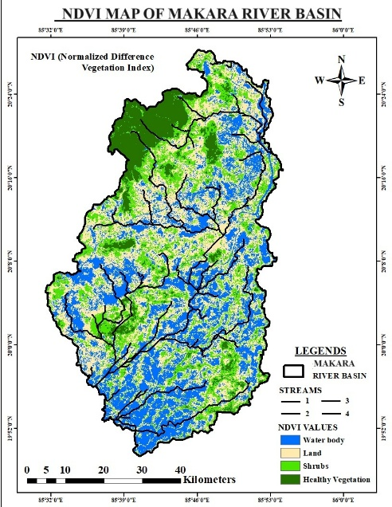 b. 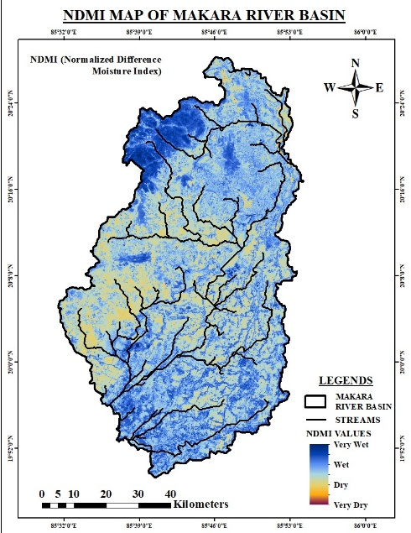
c.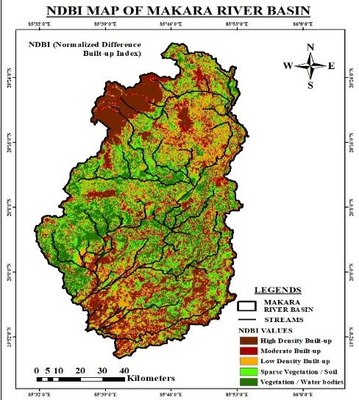d.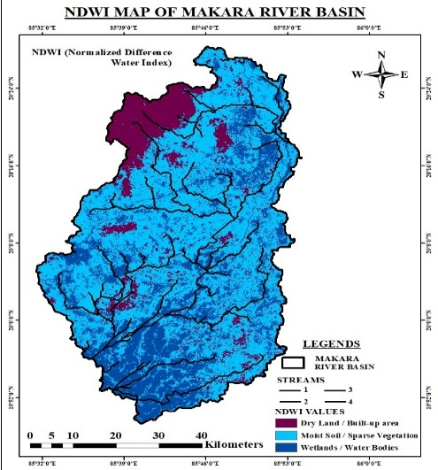
Fig 9 (A-C): The NDVI (b), The NDMI ( c), The NDBI (d), the NDWI ( e), SAVI and (f)the Watershed Map of the Rushikulya basin

The NDMI values imply spectral reflectance from satellites, indicating water stress in plants, fire risks in forests, drought and flood scenarios (Table 3).
Table 3: The design of various land surface features and their elucidations

Indices | The full form | The equations used | The spectral band used | Interpretations of values
NDVI | Normalised Difference Vegetation Index | (NIR - Red) / (NIR + Red) | NIR = near-infrared, Red = Red band.  SWIR shortwave infrared.  Green: green spectral band | High: dense, well-vegetated; Low = sparse vegetation
NDBI | Normalised difference Built-up Index | (SWIR - NIR) / (SWIR + NIR). |  | High: Urban areas  Low: Fewer settlements
NDWI | Normalised Dif. Water Index | (Green - NIR) / (Green + NIR) or (NIR - SWIR) / (NIR + SWIR) |  | High presence of water; Low vegetation
NWMI | Normalised Difference Moisture Index | (NIR - SWIR) / (NIR + SWIR) |  | Highly damp, Low moisture /dry stress condition
SAVI | Soil-Adjusted Vegetation Index | SAVI = ((NIR − RED) / (NIR + RED + L)) ∗ (1 + L) | Soil adjustment factor (L) | L = 0: vegetation high (≈ NDVI). L = 1: no green plants L = 0.5: modest cover,

Land use and land cover changes of the Salia-Rushikulya Doab .:
A doab is an upland between two rivers. Land cover (LC) refers to the land type (physical and biological features) on the surface of Earth, such as water, vegetation, or built structures. The land use reports humans’ intervention on natural soil (Mining, afforestation, agriculture, recreation, or residential areas, etc.). The land cover (LC) is what is the natural land, and land use (LU) is how land is used (Fig 10 (A,B,C).
Rushikulya River Basin.
A. The LULC map of the Rushikulya River in the Years 2004, 2014, and 2024.
a.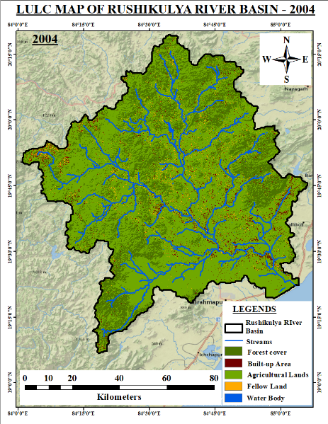b.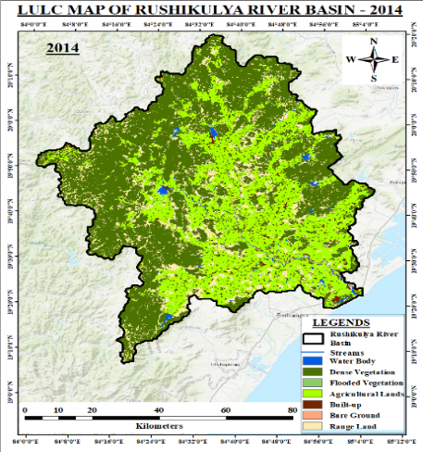c.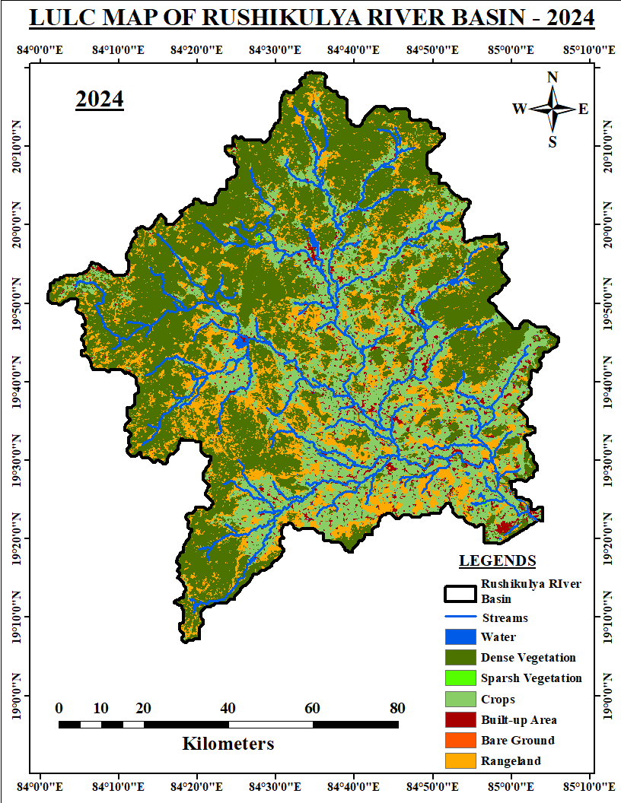
B. The LULC map of the Salia River basin in the years 2004, 2014, and 2024.
a.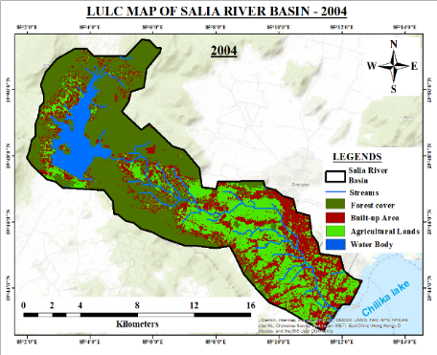b.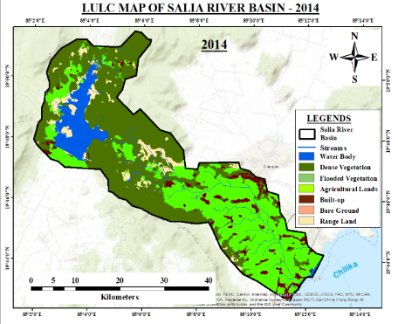c.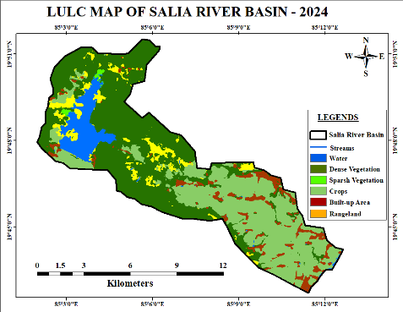
C. The LULC map of the Makara River in the years 2004, 2014, and 2024.
a.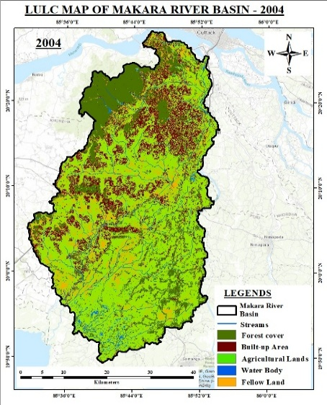b.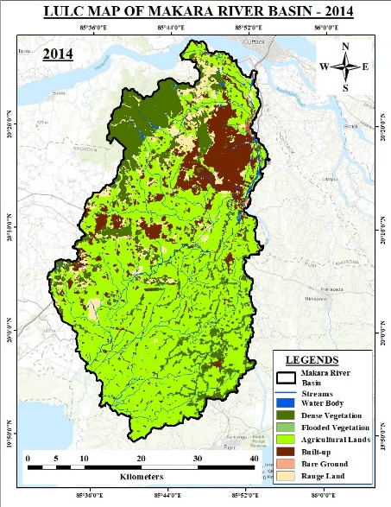c.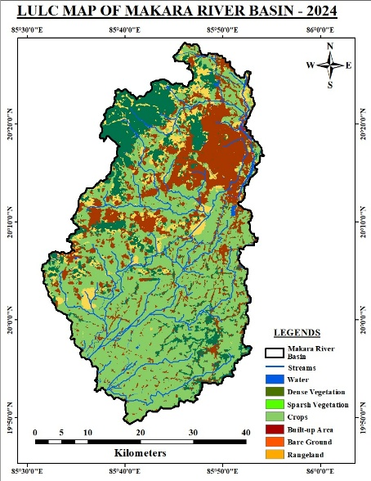
Figure 10 (A, B, C): The LULC map of the years 2004, 2014 and 2024 of the Rushikulya, the Salia and the Makara River Upper Basin
Salia Upper reaches of the Rushikulya R.; The Salia R. and the Makara River.
The land use and land Cover of the three major rivers flowing in the South Odisha coastline have been compared and given in Table 4(A), Table 4(B) and Table 4 ( C)
Table 4(A): The LU/LC status during 2004, 2014 and 2024 of the Rushikulya River basin
 | 2004 |  |  | 2014 |  | 2024
Class | Area(Sq.km) |  | % | Area(Sq.km) | % | Area(Sq.km) | %
Water body | 27.832 | 0.35 |  | 90.440 | 1.14 | 61.79 | 0.783
Forest cover | 1678.476 | 21.29 |  | 3973.770 | 50.40 | 3855.93 | 48.91
Fallow land | 168.326 | 2.13 |  | 10.109 | 0.12 | 2.794 | 0.035
Agriculture | 5699.956 | 72.30 |  | 2595.873 | 32.92 | 2306.64 | 29.26
Built-up | 309.066 | 3.92 |  | 204.737 | 2.59 | 266.06 | 3.374
 |  |  |  | 5.069 | 0.06 | 2.68 | 0.033
 |  |  |  | 1003.654 | 12.73 | 1387.72 | 17.60
TOTAL | 7615.65 | 100 |  | 7615.65 | 100 | 7615.65 | 100

Table 4(B): The LU/LC status during 2004, 2014 and 2024 of Makara River (Right of Daya)
 | 2004 |  | 2014 |  | 2024
Class | Area(km²) | % | Area (km²) | % | Area (km2) | %
Water body | 22.4235 | 1.261 | 25.4366 | 1.431 | 25.8259 | 1.452
Forest cover | 364.5936 | 20.511 | 307.9217 | 17.323 | 266.7693 | 15.008
Fallow land | 133.6554 | 7.519 | 0.986 | 0.055 | 0.1565 | 0.008
Agriculture | 1012.8222 | 56.980 | 1079.3254 | 60.722 | 994.194 | 55.933
Built-up | 243.9936 | 13.726 | 243.9114 | 13.722 | 355.7552 | 20.014
 |  |  | 3.7012 | 0.208 | 2.7122 | 0.152
 |  |  | 116.1799 | 6.536 | 132.0491 | 7.429
TOTAL | 1777.48 | 100 | 1777.48 | 100 | 1777.48 | 100

Table 4( C): The LU/LC status during 2004, 2014 and 2024 of the Salia River catchment.
 | 2004 |  | 2014 |  | 2024
Class | Area((km²)) | % | Area (km²) | % | Area((km²) | %
Water body | 7.3935 | 7.202 | 8.336 | 8.122 | 7.589 | 0.0007
Forest cover | 45.3942 | 44.223 | 46.227 | 45.036 | 46.832 | 0.0045
Agriculture | 27.4419 | 26.734 | 0.068 | 0.066 | 0.452 | 4.4045
Built-up | 22.4181 | 21.839 | 4.477 | 4.3621 | 35.164 | 0.0034
 |  |  | 0.005 | 0.0049 | 6.538 | 0.0006
 |  |  | 5.387 | 5.248 | 6.065 | 0.0005
 |  |  | 38.140 | 37.158 | 7.589 | 0.0007
TOTAL | 102.647 | 100 | 102.643 | 100 | 102.643 | 100

Water Quality along SOC
The small townships in the study area are Tangi, Balugaon,(Makara-Salia Doab), Rambha, Huma, and Gopalpur (Salia -Rushikulya doab), in South Odisha, which is influenced by the adjacent Chilika. The backwater and the Lagoon‘s brackish water influence the surface and the groundwater, along with freshwater habitats. The physical parameters of the Chilika’s periphery in the western catchment and Pottagada in the Rushikulya basin (Positions in Fig 10 and Table 5).
Table 5:Water Quality Analysis Report (West catchment of the Chilika) (Sampling date 05.04.25)
A | Parameters | Raghunathpur | Barkul | Prayagi | Patsahani  pur | Chilika | River  Salia | Limit
1 | pH | 7.47 | 8.36 | 7.60 | 7.92 | 7.32 | 7.56 | 6.5-8.5
2 | Cond  (mS) | 11.98 | 12.74 | 4.595 | 6.749 | 11.98 | 208.7 µS | *
3 | TDS (mg/l) | 6.255 | 6.607 | 2.365 | 3.454 | 6.193 | 107.7 | 500
4 | Turbidity  (NTU) | 205.8 | 42.5 | 6.2 | 386.4 | 438 | 4.7 | *
5 | PO₄³⁻  (mg/l) | 0.1225 | 0.0016 | 0.0159 | 0.3268 | 0.1196 | 0.0064 | 1
6 | NO⁻₂ (mg/l) | 0.0075 | 0.0213 | 0.0075 | 0.1599 | 0.0053 | 0.0086 | 3
7 | NH3 (mg/l) | 0.5540 | 0.2991 | 0.2717 | 7.0705 | 0.2526 | 0.3777 | 0.5
B | Place/River | Temp. | pH | DO(mg/l)/Ts (ml) | Conductivity | BOD | Nitrate | FC
Discharge at a point source |  | ⁰C |  | mg/l & MPN/100ml | mho/cm | mg/l | mg/l | MPN/100ml
Potagarh/R-Kulya |  | 26^{0C} | 7.9 | 7.2/1380 | 15050 | 17 | 0.52 | 460

The Water Quality of the Rushikulya River near Potagarh in the lower reaches Rushikulya River.
The water quality of the area is almost within the prescribed limit, except in some focused areas. Where the underground aquifers are influenced by nearby coastal intrusion. Further studies in detail are needed (Mishra et al, ^{2021 [43]}, Nair et al, 2024^{[44]})
Discussion:
The flat coastal rivers extend upstream (U/S) with regional sea level rise (RSLR). The Hydrology, geomorphology, and ecology serve as custodians of the prograde coast geographically, with intermittent hills extending the lagoon. They act as spurs and encourage deposits along the western bank. Along the Rushikulya river mouth, lateral channels with estuaries are formed moving north for 5Km. The sweet water Tampara lake receives the flow from EGBH and flows to BoB via the estuary.
The INCOIS have predicted extreme regional sea levels by 2100 for Indian east coast cities, which shall submerge parts of Paradip and Puri, Odisha. The sea level rise in India has been reported to cause inundation in Paradip and Puri. Other reports from 2025 and earlier indicate the sea level is rising along India's coasts, affecting areas like the Puri and Paradip regions, along with the Rejuvenation of these dead and defunct paleochannels (Puthicherimi et al, 2025^{[45}).
The Proxies along the Mahanadi Delta, the Chilika lagoon, the Tampara Lake, Haripur Creek, etc, indicate about geomorphic transition during the mid-Holocene transgression period to the Little Ice Age, i.e 7300 BP to 4000 BP. During the early Holocene period, there was a dry spell with a short warm period. Changes had occurred in the drainage system in the area due to changes in the mean sea level. The avulsion, Ana branching and anastomosing processes activated several reconstructions and reformations.
The reasons for transformations are due to geomorphological changes in the local catchment. As a result, the southern boundary of the delta has extended by 5 to 15km, engulfing a part of- Salia Doab. The high ridges and slopes, the vegetative cover, and the formation of new drainage channels over the last two hundred years indicate that the delta of the river Mahanadi is extending towards the south.
The Delta building process is a long-term term continuous natural activity. The Aeolian activity along the shore or barrier spit is more rapid, and the change of course of the river or drainage channel is a long-term process. The metamorphosis of the distributaries of the three rivers is in a process of reconstruction and abandonment with age. It is affected by submergence and emergence of coastal land, along with changes in local mean sea level.
For the last two centuries, the river systems in SOC have formed several anabranches, paleo drainage channels. Some of them are active, a few are sedimented, defunct, dead, covered with Ipomeas and water Hyacinth and abandoned today. Avulsion, anastomosis, meandering and bypassing are the fluvial processes that are connected to such fluvio-morphological changes (Rafique et al., 2025)^{[46]}.
Two coast-parallel discontinuous hill ranges exist with laterite coping of the Eastern Ghats hills along south Odisha. The less elevated, low gradient, serpentine and have no delta. The land between the western bank and a discontinuous series of Hillocks and anthropogenic intervention has shifted the South Mahanadi delta (SMD) from the right embankment of the Daya River to the southerly fringes of the Makara River, an anabranch of the Daya River.
During the pre-Holocene, the deforestation of Banapur Hills and the extension of Balugaon, Banapur and Chhatrapur have deteriorated the flood plains of the drains, and rivers have deteriorated the vegetation and geohydrology of the study area. Last three decades, the high waves and coastal erosion have damaged the coastal forests, the erosional coast, surging population have increased resettlement, resulting in transgression/retrogression of the coastline. The Anthropocene stresses have been observed in the area due to Indian Rare Earth Limited, Hotels/tourism, and Gopalpur port activities have deteriorated the ecosystem and environment.
The mapping and analysis of the changes in the LU and LC surrounding the Chilika lagoon, using RS/GIS, beyond the contribution of flow and sediment from the South Mahanadi deltaic branches. It is found that during the Golden Spike Period of Anthropocene Epoch (1980s), the slamming few high intensity cyclonic storms, Damming and deforestation, the agglomeration of townships (Balugaon, Berhampur, Gopalpur and Huma, Ganja and Chhatrapur, etc.), six lane development of the NH-16, within the inserted landscape between EGBH and the SOC.
Pertinent actions to be taken for satisfying SDG-15 (Life on Land) by complying with sustainable land degradation and soil management, and SDG-6 (Clean Water and Sanitation), responding to a sustainable water-related environment and the ecosystem.
Conclusion
The studied basins have no dams except Salia. The sediment ingress has increased because of CC, increased LU, deforestation, industrial developments accompanying the infrastructural input and anthropogenic interventions. Increased habitation, channelising of the rivers by raising and strengthening the embankments and damming have restricted the flood plain and hindered the process of delta development and hence reducing the fertility and yield of the soil.
As a result, both biotic and abiotic changes have occurred. The yield of marine products along SOC is decreasing or fluctuating. The traditional fishers community, (major stake holders) for want of adequate marine product has been affected. They are migrated or marginalised. The overall economy of the people in the area has been deteriorated. There is fall in traditional means of livelihood and also have impact on agriculture. The people in the area do not have adequate WASH facilities and civic amenities. The planning of the ayacut must be purpose specific, and actionable like priorotizing the the monitoring of the Makara-Salia doab. The buffer zone planning for Tampara Lake though partly done but an integrated tourist hub should be created within the study area. So a long-term well-judged planning of the water and other resources deployment is needed to flourish the people, land, agriculture and overall development to comply with SDG-6 and SDG-15.

COMPETING INTERESTS DISCLAIMER:
Authors have declared that they have no known competing financial interests OR non-financial interests OR personal relationships that could have appeared to influence the work reported in this paper.

Disclaimer (Artificial intelligence)
Option 1:
Author(s) hereby declare that NO generative AI technologies such as Large Language Models (ChatGPT, manuscript.
Option 2:
Author(s) hereby declare that generative AI technologies such as Large Language Models, etc. have been used during the writing or editing of manuscripts. This explanation will include the name, version, model, and source of the generative AI technology and as well as all input prompts provided to the generative AI technology
Details of the AI usage are given below:
1.
2.
3.

Reference:
- Chilika Annual Report (2011-13), Chilika Development Authority Annual Report 2011-12 and 2012-13. A Government of Odisha Agency, pp 1-50. https://www.chilika.com/documents/publication_1395326938.pdf
- Mishra S.P., (2019), Rejuvenation of lagoons along the east coast of India, management: Anthropocene approach, Int. J. Adv. Res. Vol: 7(1), pp-688-714, Article DOI:10.21474/IJAR01/8378
- Mishra SP., Mishra DP., Mishra S. (2024). Anthropocene response to the hydrodynamics of Chilika Lagoon, India. Journal of Computer Research and Development 24(7):397-422
- Lemenkova, P. (2024). Artificial Neural Networks for Mapping Coastal Lagoon of Chilika Lake, India, Using Earth Observation Data. Journal of Marine Science and Engineering, 12(5), 709. https://doi.org/10.3390/jmse12050709
- Ganesh, V., Goswami, S., & Nagendra, H. (2024). Long-Term Surface Water Variability in Chilika Lake Using Archival Remote Sensing Data. Environmental Sciences Proceedings, 29(1), 33. https://doi.org/10.3390/ECRS2023-16706
- Feng, X.; Zhu, C.; Liu, J.P.; Jia, Y. Sediment Dynamics in Coastaland Marine Environments: Scientific Advances. Water 2023, 15, 140
- Mishra SP., Sethi K. C., 2021, The imprints of Holocene climate and environmental changes in the South Mahanadi Delta and the Chilika lagoon, Odisha, India—An overview, In book: Holocene Climate Change and Environment, 457-482, https://doi.org/10.1016/ B978-0-323-90085-0.00015-2
- Baneerjee B., Mallick, M., Mohd Amir, AH., Ozelim, L., Kar, NR., et al. (2025). Holocene climate variability deciphered from Chilika Lagoon sediments: Implications for anthropogenic activity or paleocyclones?. Geosystems and Geo-environment, 4(3), 100390. https://doi.org/10.1016/j.geogeo.2025.100390.
- Sinha, P.N., Daga, M., Naik, P. (2025). Geomorphic Challenges and State of Natural Resource Regions of Coastal Odisha: A Diagnostic Overview. In: Chattopadhyay, S. (eds) Marine and Coastal Resources of India. Sustainable Development Goals Series. Springer, Cham. https://doi.org/10.1007/978-3-031-81276-7_11
- Mahalik N.K., Das C., Maejima W. (1996). Geomorphology and Evolution of the Mahanadi Delta, India. J. of louro. al of Geosciences, Osaka City Univ. 39(6), p.III-122
- Syvitski JPM, Kettner AJ, Overeem I, Hutton EWH, Hannon MT, Brakenridge GR, et al (2009). Sinking deltas due to human activities, Nature Geoscience. 6.
- Sethi BK, Mishra SP. (2020). Deltaic Expansions of the Mahanadi Tri-delta and the Chilika Lagoon: Geospatial Approach. CJAST. 39(34): 46-65,
- Kathiravan R., Kathiresan P., Kathiresan K., Ramesh Ku., Sudhakar Ch., (2018) Geospatial Technology Based Detailed Mapping of Coastal geo-morphological features and Certain Significant observations - Part of Puri District, Odisha, India. Int. J. of Recent Sci. Res., 9(4(A)}, 25550-25555.
- Yu, X., Dou, M., & Li, S. (2025). Establishing a Geological Knowledge Base for Braided River Deltas Using Google Earth. Applied Sciences, 15(11), 6186. https://doi.org/10.3390/app15116186
- Loveson, V.J., Nigam, R. (2019). Reconstruction of Late Pleistocene and Holocene Sea Level Curve for the East Coast of India. J Geol Soc India 93 (5), 507–514 https://doi.org/10.1007/s12594-019-1211-z
- Valdiya, K.S., Sanwal, J. (2017). Ch- 15 - Eastern Ghat Ranges and East Coast, Editor(s): ( 22),341-357, https://doi.org/10.1016/B978-0-444-63971-4.00015-3.
- Mishra SP. (2023). The Anthropocene Geology and Biodiversity of North North-Eastern Ghats mobile belt, Odisha, India. Acta Biology Forum, 2(1), 8-18
- Das A, Swain PK. (2024), Navigating the sea level rise: Exploring the interplay of climate change, sea level rise, and coastal communities in india. Environ Monit Assess. 2024 Oct 3;196(11):1010. doi: 10.1007/s10661-024-13191-z.
- Puthucherril TG (2025) Adapting to sea level rise: is India on- or off-track?. Front. Mar. Sci. 12:1516241.doi: 10.3389/fmars.2025.1516241
- Environment & Climate Change Department, Government of Odisha (FE&CC, GOO) and Odisha, Climate Change Action Plan 2021-30. Bhubaneswar: Forest,
- Mishra S. P., Dash Joykrishna, (2016). Hydro–morphology of cuts in coastal rivers debouching Chilika; South Mahanadi Delta, Odisha, India, IJAR, 4(5), 391-404
- Patel, N. K., & Pati, P. (2022). Mapping of the Buried Paleochannels on the Terminal Fans in the Western Ganga Plain: A Geomorphological and Ground Penetrating Radar-based Approach. Journal of Geological Society of India, 98(4), 525–537. https://doi.org/10.1007/s12594-022-2010-5
- Lemenkova, P. (2024). Artificial Neural Networks for Mapping Coastal Lagoon of Chilika Lake, India, Using Earth Observation Data. Journal of Marine Science and Engineering, 12(5), 709. https://doi.org/10.3390/jmse12050709
- Mitsika GS, Alexopoulos JD, Vassilakis E, Dilalos S, Poulos SE.(2025) Investigation of the physical-geographical characteristics of river delta with geophysical and satellite data. The case study of the Pineios River, Greece. MethodsX. Doi: 10.1016/j.mex.2023.102033.
- Mishra S. P. Jena J. G., (2015), “Morphological Reconstruction of Southern Mahanadi Delta and Chilika Lagoon, India – a critical study” Int. J. of Adv. Res, 3(5), , 691-702
- Mishra S.P. and Jena J. G (2013) “Characteristics of western catchment and their inflow contribution to Chilika Lagoon(India)” Int Journal of Lakes and Rivers, 6(2), 119-129
- Mishra SP, Mohapatra SK and Sethi KC (2023). The Values and Blue Carbon Ecosystem of the Chilika Lagoon through the Ages, India. Environ Sci Arch 2(2):164-184
- Central Water Commission. Compendium on Sedimentation of Reservoirs in India. Watershed & reservoir sedimentation Directorate, Environment Management Org., Water Planning and Projects Wing 2020:1-460
- Mishra SP., Mishra A. (2022). Chandan Ku., Mishra S., Sedimentation in East Coast Hilly Terrain Reservoirs; Balimela, Odisha. nternational Journal of Environment and Climate Change, 12(5): 15-30.
- Samal P., Swain PC., Samantray S. (2024). GIS-based RUSLE model for estimating soil erosion and sediment yield in Rushikulya River Basin of Odisha, India., J. Earth Syst. Sci. 133:242 Indian Academy of Sciences, https://doi.org/10.1007/s12040-024-02458-1
- Mishra S. P. Jena J G; 2015; Geophysical changes of Chilika lagoon in post-Naraj barrage period: Synopsis of the Thesis Submitted in partial fulfilment of the requirements for the degree; SOAA University; https://pdfs.semanticscholar.org/46eb/e5382
- Islam, M. S., Crawford, T. W. (2022). Assessment of Spatio-Temporal Empirical Forecasting Performance of Future Shoreline Positions. Remote Sensing, 14(24), 6364.
- Hazra, S., Ghosh, A., Ghosh, S., Pal, I., Ghosh, T. (2022). Assessing coastal vulnerability and governance in Mahanadi Delta, Odisha, India, Progress in Disaster Science,14, 100223, https://doi.org/10.1016/j.pdisas.2022.100223
- Acharyya, Rituparna, Anirban Mukhopadhyay, and Michał Habel. 2023. "Coupling of SWAT and DSAS Models for Assessment of Retrospective and Prospective Transformations of River Deltaic Estuaries" Remote Sensing 15, no. 4: 958. https://doi.org/10.3390/rs15040958
- Valdiya, K. S. (1993), Tertiary period in India, Current Science, Volume 64, No 11 & 12, Publisher: CurrentScience Association, Bangalore, Source Google.
- Mahalik N. K.(2006). A Study of the morphological features and borehole cuttings in understanding the evolution and geological processes in Mahanadi Delta in East Coast of India, J. of the Geological Soc. of India, 67(5):595-603
- Nayak G. K., Ch. Rama Rao, Rambabu H. V. (2006), Aeromagnetic evidence for the arcuate shape of Mahanadi delta, Earth Planet Space, 58, 1093-98.
- Chatterjee N., James L. Crowley, Mukherjee A. B. and Das S. ( 2008), Geochronology of 983-Ma Chilika Lake Anorthosite, Eastern Ghats Belt, India: Implications for Pre-Gondwana Tectonics, The Journal of Geology, 11(2),105-118
- Lal, N.K., Siawal, A., Kaul, A.K. (2009). Evolution of the East Coast of India – a plate tectonic reconstruction. J. Geological Society of India, Volume 73, pp 249-260
- Khandelwal, Asha and Mohanty, M (2007), Vegetation history and sea level variation during the last 13,500years inferred from a pollen record at Chilika Lake, Orissa, India, Veg Hist Archaeobot(2008) 17 335-344 DOI10. 1007/s00334-007-0127-5.
- Mishra S.P., Mishra D.P., Mishra S., 2024. Anthropocene response to the hydrodynamics of Chilika Lagoon, India. Computer Research and Development (ISSN NO:1000-1239) 24(7), 397 -422.
- Govt. of Odisha (2019). Operation & Maintenance (O&M) Manual of Salia Dam. Project ID Code: OR10MH0013, Dept. of Water Resources, 1-113.
- Mishra Siba Prasad: Georgics of Ground Water Quality and Its Geogenic Management in Coastal Odisha; India, Book Publisher International; April 2021, DOI: 10.9734/bpi/aaer/v4/7431D, In book: Advanced Aspects of Engineering Research V- 4, 86-106, Project: Anthropocene,
- Nair, N. V., Nayak, P. K. (2023). Exploring Water Quality as a Determinant of Small-Scale Fisheries Vulnerability. Sustainability, 15(17), 13238. https://doi.org/10.3390/su151713238
- Puthucherril TG (2025) Adapting to sea level rise: is India on- or off-track?Front. Mar. Sci. 12:1516241.doi: 10.3389/fmars.2025.1516241
- Rafique, M.K., Bharadwaj, A., George, M.E. et al. Paleo shoreline to Anthropocene Coast: assessing coastal stability and vulnerability in response to sea level changes. J. Disaster Sci. Manag. 1, 13 (2025). https://doi.org/10.1007/s44367-025-00013-3

