Review Article

Behaviorally Informed Urban Mobility Interventions for Congestion Management in Dehradun

Abstract
Dehradun, a fast-urbanising hill city, is witnessing critical levels of vehicular traffic congestion, particularly during peak school and office hours. This report presents a strategically layered, behaviourally informed urban mobility plan to reduce congestion sustainably. Drawing on globally validated behavioural models (Behavioural Urbanism, COM-B, EAST), criminological frameworks (CPTED, SCP, Defensible Space), and national-international precedents, this proposal leverages a hybrid of digital nudges, infrastructural adaptation, and social norm activation to drive sustainable modal transition.
Peak hour congestion is attempted to be solved from a Geographical perspective with the help of Transport Science, large scale network maps tying up with the previously mentioned Behaviour Science principles. Case studies of congestion hotspots are analysed with ground level solutions often involving changes in appearance of infrastructure and its presentation rather than changes in infrastructure capacity.
These solutions aim to be affordable, easy to implement and bring drastic change in how transportation is viewed in the hill city. Hotspot analysis is followed by a cost feasibility assessment, list of potential funding sources, implementation risk analysis and implementation roadmap. Lastly, areas for future research are specified.
Keywords
Behavioural urbanism, CPTED, SCP, defensible space, behavioural economics,
economical-tactical urbanism, sustainable congestion management
Introduction
The state of Uttaranchal (now Uttarakhand) separated from Uttar Pradesh in the year 2000 when three new states (Uttaranchal, Chhattisgarh and Jharkhand) were carved out based on the different cultures they had to their previous counterparts. With the Himalayan region separating from the Northern Plains, Uttaranchal gained Dehradun as its capital. A small town located on the foothills, Dehradun lies at a mere elevation of 450 metres compared to the mighty Himalayas which peak as high as 8 kilometres in Nepal and Tibet.
Since its inauguration as the state’s capital, the hill city has witnessed an urban area growth of nearly 200% increasing its urban land use (Figure 1) from 746 hectares to 1,463 hectares (Municipal Development and Development Authority, 2023). Much of this growth in urban land use and population has been haphazard, leading to congested roads, encroachment of footpaths, narrow alleyways with no room for vehicular movement and long traffic jams in the city’s central business district. The only arteries of the city are the State and National Highways which cut through the megalopolis and are crucial to movement within and through Dehradun.
A concoction of mismanagement, unplanned growth and large-scale immigration to the once calm and relaxed small town has led to a shift from pedestrian to vehicular transport. Dehradun presents a case of extremely high ownership of private transport means, most notably two-wheelers such as scooters and motorbikes. Most residences and commercial zones have developed without adequate parking spaces or consideration for vehicular storage contributing further to the crisis. A point of no return is coming, where traffic jams may stretch throughout the city corridors, in notable intersections like Ghantaghar and Rispana Pul leading to a complete standstill which can only be solved through targeted behavioural nudges, reform in the attitude towards public transport and realising that the impending disaster can be averted through simple interventions.
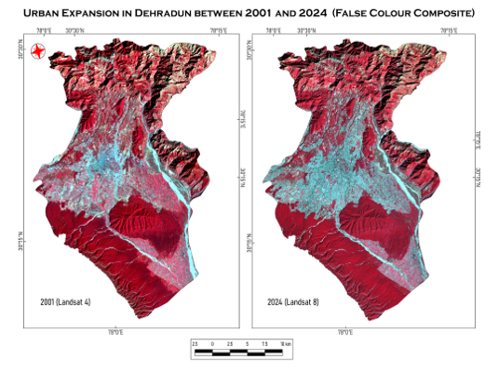
Figure (1): LULC Comparison Maps of Dehradun City (2001-2024)
This paper shall attempt to describe and then recommend strategies to solve said problems using popular and widely recognised theories of Spatial Criminology [such as Situational Crime Prevention, Crime Prevention through Environmental Design, Capability (C)-Opportunity (O)-Motivation (M) = Behaviour (B)], Behavioural Urbanism [such as Residential Density, New Urbanism], Behavioural Economics [such as Loss Aversion and Nudges] amongst others to approach urban planning through the lens of behaviour instead of infrastructure. It is an effort to look at modern planning in India through a multi-disciplinary approach.
The focus will be on identifying key areas of congestion complications, developing targeted solutions and also general frameworks that can be applied to any part of the city.
Literature Review
Designing behaviourally informed mobility interventions necessitates engagement with diverse scholarly traditions and applied studies. Rather than treating Dehradun’s congestion as a purely infrastructural concern, the literature foregrounds it as a systemic behavioural challenge, situated at the intersection of criminological frameworks, behavioural science, and context-specific urban assessments.
Criminological and Environmental Design Frameworks
The foundational insights of Clarke (1995) on Situational Crime Prevention (SCP) and Crowe (2000) on Crime Prevention Through Environmental Design (CPTED) establish the conceptual scaffolding for behaviour-oriented mobility planning. SCP emphasises regulating space and human behaviour through situational variables—such as access control, surveillance, and spatial structuring—thus enabling deterrence without reliance on intrinsic motivational change. Crowe’s CPTED complements this structural orientation by highlighting the role of environmental aesthetics, visibility, and territorial reinforcement in cultivating perceptions of safety and pro-social behaviour. Together, these frameworks validate low-cost interventions such as vendor zoning, tokenised auto systems, safe bus shelters, and pedestrian-friendly calm zones, where spatial cues nudge compliance and reshape commuting behaviour.
Behavioural Science Models
Beyond criminological theory, behavioural science provides diagnostic and design tools tailored for mobility behaviour. The COM-B model (Michie et al., 2011) dissects behaviour into three interrelated domains—Capability, Opportunity, and Motivation—enabling nuanced identification of barriers to modal shift. In Dehradun’s case, these range from limited transit literacy (capability), unsafe walking and waiting environments (opportunity), to entrenched cultural preferences for private vehicles (motivation). The EAST framework further complements COM-B by translating insights into actionable design principles—Easy, Attractive, Social, and Timely—offering practical levers for intervention. More broadly, Chataway’s Space, Time, Crime (2020) extends the application of criminological and behavioural frameworks to urban offences, including traffic indiscipline, reinforcing the salience of spatial criminology in mobility contexts.
Localised Urban Studies and Policy Documents
While global frameworks provide theoretical orientation, city-specific reports anchor interventions in Dehradun’s socio-spatial realities. The Dehradun Master Plan 2041 (MDDA, 2023) documents rapid vehicular growth, infrastructural deficits, and fragmented governance structures, offering a spatial and demographic baseline. Yet, the plan’s absence of behavioural analysis underscores the necessity of this report’s behaviour-first approach. The SDC Foundation’s (2023) Traffic Crisis Report adds granularity by detailing everyday commuter experiences, including pedestrian marginalisation, vendor encroachments, and traffic indiscipline, thereby contextualising interventions like car-free zones, Switch Day campaigns, and vendor compliance programmes. Complementing this, IIT Roorkee’s (2024) pilot study on child-friendly urban mobility in Dehradun demonstrates the practical feasibility of staggered school timings, demarcated drop-off zones, and ambient calm areas, providing empirical validation for the interventions advanced here. Adding to this is the study of road network analysis by Nijagunappa et al (2007) providing a base for identifying areas of importance in this paper as well as indicates areas for further research using spatial and quantitative data.
Behavioural Nudges and Case Studies
The basic theories of behavioural science used throughout the paper have been taken from Baddeley’s (2017) work on Behavioural Economics which connects with the Inter-Traffic Global Case Study (2024) and Dehradun’s challenges within a global urban learning framework documenting how cities like Mexico City, Perth, and Moscow have leveraged vending regulation, smart kiosks, and congestion dashboards to drive measurable efficiency gains. These cities’ success in behavioural design and participatory urbanism supports the feasibility and relevance of the proposed interventions.
New Urbanism, specified by Zali’s (2019) paper which makes us aware that planned mixed-use development with sustainable measures if applied to Dehradun can result in massive changes to its transportation problems and rising ownership of private vehicles. The Dehradun Air Action Plan (CPCB, 2022) serves as the environmental rationale for congestion reduction. While it does not engage with behavioural theory directly, its identification of transport as a major pollution source aligns with modal shift goals. The inclusion of AQI dashboards and pollution alerts echoes the salience and time-based nudges proposed in the EAST framework.
Taken together, this body of literature demonstrates that addressing Dehradun’s congestion requires more than infrastructural augmentation; it calls for the integration of criminological deterrence, behavioural diagnostics, and localised empirical insights. Criminological frameworks contribute the logic of spatial control, behavioural science models diagnose the psychological and social drivers of commuting choices, and city-level studies embed interventions within lived realities. This triangulated foundation provides a robust platform for behaviourally intelligent, equity-driven, and contextually feasible urban mobility reform in Dehradun.
Data Collection
To understand the crux of the problems daily commuters face during peak and off-peak hours in Dehradun, several telephonic interviews and questionnaires were used to collect primary data from the residents of the city. In total, 25 interviews and oral questionnaire surveys were conducted whose inputs have been used to determine the areas with the direst conditions and used to create targeted solutions for them (mentioned later).
The sample size was chosen at random by connecting with people who live or have lived in Dehradun for a significant portion of their lives. Due to the limitations of time and resources, only a limited number of people could be interviewed and mostly belonging to the age group of 18-35. The opinions of people beyond 35 were indirectly obtained from respondents by asking about the experiences of their parents, guardians and elders.

Geography of Dehradun
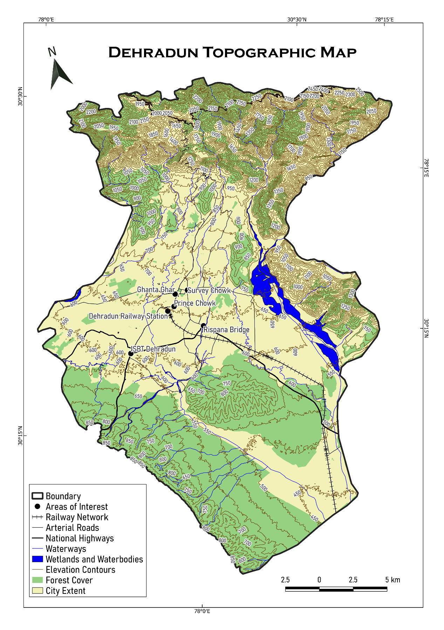
Figure (2): Topographic Map of Dehradun City
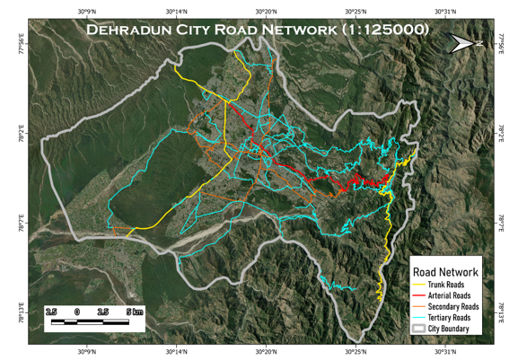
Figure (3): Dehradun’s road-network superimposed on its geographical landscape
Dehradun (also called as Dehra Doon) is a city with a population of 23.2 lakhs (2025 projection). It lies enveloped inside the Doon valley which itself is sandwiched between Himadri and Shivaliks of the Himalayan ranges. This valley also acts as a watershed between Yamuna and Ganga. The elevation of the hill city ranges from 410 metres in Clement Town in the South to about 700 metres (Figure 2 and 3) in Malsi in the North (Melbourne School of Design, 2024). The Langha Range, Ashkrodi, Nagal Jwalapur and Lachhiwala Range lie South to the city while Rajaji National Park is found to its South East. To the North lies Mussoorie and the Himadri Himalayan range and while to the east is the Song river. The city is found between latitudes 30°01' N and 31°2'N and longitudes 77°34' E and 78°18'E.
It is important to understand the circumstances and space in which the city has grown to such a size further emphasising the need for interventions, and behavioural interventions at that because of the constraints set by topography. Infrastructural changes would be hard to come by due to the presence of reserved and protected forest areas, hills, streams and extreme congestion in between.

Methodology and Theory Framework
This study employs the COM-B framework (Michie et al., 2011) to diagnose commuter behaviour in Dehradun’s mobility system. Capability deficits arise from inadequate transit literacy, inaccessible information, and limited exposure to shared mobility. Opportunity is constrained by infrastructural barriers such as sidewalk encroachments, the absence of bus shelters, and weak social reinforcement for shared commuting (Crowe, 2000; Clarke, 1995). Motivation remains tethered to comfort bias, the aspirational value of private vehicle ownership, and perceptions of insecurity in public transport (SDC Foundation, 2023; MDDA, 2023). Collectively, these constraints explain persistent resistance to modal shift and highlight the imperative for behaviourally informed interventions.
Complementing COM-B, the EAST framework developed by the UK Behavioural Insights Team (Michie et al., 2011; Thaler & Sunstein, 2008) operationalises behaviour change through four principles: Easy, Attractive, Social, and Timely. In Dehradun’s mobility context, ease is advanced through floating bus stops, QR-coded maps, and POP kiosks; attractiveness via art-based signage, colour-coded pedestrian zones, and vendor-linked rewards; social reinforcement through Commute Clubs, Eco-Traveller badges, and Green Vendor programs; and timeliness through real-time congestion dashboards and school-entry nudges. Collectively, EAST functions as a pragmatic design lens to embed sustainable mobility behaviours within the city’s socio-spatial rhythms.
In addition, this study draws on Behavioural Urbanism, a multidisciplinary field linking psychological urban planning and environmental studies (Lockton, 2011). Key principles include the role of residential and employment density in shaping traffic flow and public transport demand, and the influence of accessibility and neighbourhood design—such as walkability, road width, and proximity to amenities—on commuting behaviour. For instance, restrictions on four-wheeler access within certain neighbourhoods have been shown to reduce private vehicle dependence and encourage shifts toward public or non-motorised transport. These insights highlight how spatial configuration and design can function as behavioural levers for sustainable mobility.
Lastly, insights from Behavioural Economics (Behavioural Economics: A Very Short Introduction, 2017), which emphasise how choice environments can encourage or discourage specific behaviours are used. Tools include making unsustainable options uncomfortable (e.g., rumble strips or deprioritised lanes for private vehicles), leveraging default settings such as automatic inclusion of a transport maintenance cess in parking fees, and applying loss aversion, where commuters are nudged to avoid time or cost penalties (e.g., congestion delays). These mechanisms strategically reshape incentives to promote carpooling, walking, and public transport use.
The intervention strategy is anchored in nudge theory and choice architecture (Thaler & Sunstein, 2008), where subtle design modifications guide commuter behaviour without limiting autonomy. In Dehradun, defaults such as pre-assigned school drop-off times and carpool shuttles, salience cues like painted pedestrian trails and transit countdowns, and framing via congestion dashboards (e.g., “+12 minutes if you drive”) are deployed to shift commuter choices. Gamification through reward systems and commitment devices such as pledges and visual trackers further reinforce sustainable mobility. These principles are validated globally: Copenhagen’s car-free Strøget Street reduced traffic injuries by 35%, Shimla’s “One-Minute Pause” cut congestion by 18% (Shimla Municipal Corporation, 2019), Mexico City’s terminal redesign improved flow efficiency by 23%, and Seoul’s Smart Commute Zones lowered peak congestion by 21% (KOTI, 2021). Collectively, these precedents demonstrate the effectiveness of low-cost, non-coercive interventions in reshaping urban mobility.
Building on behavioural perspectives, the study also draws from Spatial Criminology, particularly Newman’s Defensible Space theory and Jeffery’s Crime Prevention Through Environmental Design (CPTED), both influenced by Jacobs’ work on urban form (Jacobs, 1961; Newman, 1972; Jeffery, 1971). These frameworks emphasise how poorly designed environments foster misuse and disorder, while strategic design can regulate behaviour. Key principles include territoriality (community ownership of space), access control (gates, pedestrian-priority and cycling zones), symbolic barriers (signage promoting public transport), natural surveillance (open-concept vehicles, lighting, safety mechanisms), image (upgraded streetscapes and transport facilities), and milieu (strengthened social infrastructure). Applied to mobility, these principles reframe congestion and encroachment as behavioural “offences” mitigated through environmental design and collective responsibility (Newman, 1972; Jeffery, 1971).
Jeffery’s Crime Prevention Through Environmental Design (CPTED) builds on Newman’s Defensible Space by adding measures such as target hardening, stricter vendor licensing, enforcement drives, improved sanitation, fines, and enhanced policing to reduce urban disorder (Newman, 1972; Jeffery, 1971; Chataway et al., 2020). Complementing this, Situational Crime Prevention (SCP), advanced by Clarke and Mayhew, reduces opportunities for offences by increasing effort, raising risks, and lowering rewards (Clarke, 1995; Lersch, 2007). Applied to mobility, this includes barriers, traffic cameras, parking restrictions, staggered timings, and congestion alerts to deter indiscipline and manage flow. Finally, Pigouvian taxation (Santora, 2017; Hu & Ley, 2025) offers an economic lever by imposing congestion charges in core areas, thereby internalising externalities and nudging commuters toward public and shared transport. Together, these criminological and economic tools reinforce behaviourally informed strategies for sustainable congestion management.
Results and Discussion
Traffic Crisis Quantification
With over 1.8 million registered vehicles for a population of one million (RTO Dehradun, 2023), Dehradun’s vehicle-per-capita rate surpasses national urban averages. Traffic delays in core nodes like Ghanta Ghar and Survey Chowk reach up to 30 minutes during peak hours (IIT-R, 2023). The Dehradun Master Plan 2041 identifies 65% of total traffic as private vehicle trips (MDDA, 2023), exacerbated by infrastructural bottlenecks (shown in Figure 4 below), vendor encroachments, and erratic traffic behaviour.
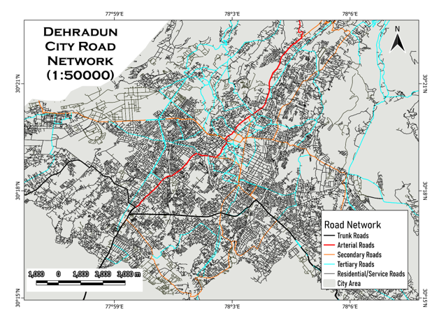
Figure (4): Dehradun’s Road network, showcasing the apparent lack of enough arterial and trunk roads needed for high intensity movement of vehicles
Despite the implementation of progressive infrastructural reforms—including the induction of electric bus fleets, interactive bus stop interfaces, and broader Smart Mobility initiatives—Dehradun’s commuters continue to exhibit a pronounced resistance toward public and shared transit systems. This behavioural inertia stems from a constellation of psychosocial factors: entrenched comfort biases, the habitual preference for personal convenience, status signalling associated with private vehicle ownership, and the absence of salient environmental safety cues. In response, this study proposes the strategic deployment of Safe, Smart, and Sustainable School Commute Zones (S³CZs), informed by the dual frameworks of Crime Prevention Through Environmental Design (CPTED) and Situational Crime Prevention (SCP). These S³CZs, situated around educational institutions and dense residential clusters, function as micro-urban mobility laboratories—designed to incubate and evaluate behaviourally intelligent interventions that recalibrate commuter norms, ease congestion, and embed long-term modal shifts within the everyday mobility culture of the city.
PROPOSED BEHAVIOURAL INTERVENTIONS FOR DEHRADUN’S URBAN MOBILITY
This multi-level intervention framework is designed to shift commuter behaviour by embedding principles of CPTED (Crime Prevention Through Environmental Design), SCP (Situational Crime Prevention), behavioural urbanism and behavioural economics into the everyday commute. The goal is to rewire commuting norms, reduce private vehicle reliance, and create safe, inclusive, and low-emission mobility ecosystems across Dehradun. At the core are Green Commute Zones and No-Honk, No-Pass Quiet Zones, spatially demarcated within 500-metre radii of schools and office clusters. These areas become motor-restricted during peak hours, encouraging modal shift toward walking, e-rickshaws, and public transit via strategically placed physical and symbolic deterrents—bollards, green signage, and painted curbs. Tactile design features such as planters, vertical gardens, and sound-absorbing murals contribute to ambient calm, while student-led peer enforcement (e.g., “Noise-Free Hero” tokens) reinforces civic participation and behavioural visibility. These spaces exemplify low-cost tactical urbanism layered with behavioural insight and community ownership.
In parallel, the “Switch Day” Mobility Campaign institutionalises weekly car-free days in educational and municipal institutions. Through the use of social proof, school gamification, peer pledging, and leaderboard displays (e.g., “Greenest Department of the Month”), the intervention generates sustained behavioural momentum while normalising low-emission commuting. The campaign’s incentive structure—badges, merchant discounts, and public recognition—taps into commitment devices and habit formation principles.
To complement habit-building with immediate behavioural reinforcement, the Eco-Travel Incentive Program (ETIP) introduces a QR-code-based rewards system. Commuters earn “Green Points” by walking, cycling, or using public transport, which are redeemable for tangible benefits like e-rickshaw rides and café discounts. Drawing on operant conditioning and present bias, ETIP offers visible, short-term gains that make sustainable behaviour both attractive and habitual.
Transforming spatial awareness into real-time decisions, Smart Congestion Visualisation Boards are proposed at critical junctions (e.g., Prince Chowk, Rajpur Road). These digital dashboards display real-time traffic status with behaviourally framed prompts such as “Take Rajpur Road now: Save 14 mins.” By leveraging salience and time-framing nudges, they redirect traffic flows and reduce bottlenecks, particularly during peak commuting windows.
Taking a page from Economics and the New York City case study, a potential way to shift people to public transport and walking is a Congestion Tax applied in the central areas of the city (ISBT, Railway Station, Clock Tower etc.) FAST-TAGS or a card-based system will be used to charge a fee to enter the CBD of the city during rush hours (07:00-11:00 and 16:00-20:00) much like how it is in lower Manhattan (Walker, 2018) for cars entering from Brooklyn and New Jersey City (Hu & Ley, 2025).
The physical transit environment itself undergoes a perceptual overhaul through Floating Transit Shelters—bus stops redesigned as inclusive, aesthetic, and functional micro-hubs. Drawing inspiration from Bogotá’s TransMilenio and Seoul’s Smart Shelter system, these shelters include ambient lighting, public art, and interactive elements, enhancing both usability and safety. The design aligns with the EAST framework—Easy, Attractive, Social, Timely—making public transport aspirational rather than utilitarian. Similarly, Interactive Passenger Orientation Pods (POPs) are deployed at high-footfall nodes like ISBT and Ghanta Ghar. These AI-lite kiosks provide icon-based directions, route planning, and grievance redressal in multiple languages, improving wayfinding confidence for first-time, low-literacy, or digitally underserved users.
Further, Calm Zones for Urban Mobility are introduced within 200 metres of sensitive areas such as schools and hospitals. Inspired by Zurich’s “Shared Space” design and Jaipur’s “Silent School Zones,” these environments integrate ambient soundscapes, silent-horn signages, LED-lit footpaths, and speed-calming measures to reduce aggressive driving and reinforce spatial respect. This creates an emotionally and behaviourally calibrated zone of safety, especially for children, women, and elderly commuters.
Moreover, the initiative includes Apps and Gamified Bus Stop Experiences, such as digital applications for coordinated school van pickups and community murals or puzzle installations at bus stops. These reduce the psychological burden of waiting and reposition public transport as a socially engaging and status-neutral mode of travel. Low-cost and community-designed, these spaces build affinity through interaction, especially among younger commuters.
To institutionalise visible behavioural signals, Walk Leaders—modelled after Australia’s walking school bus programs—guide younger students along clearly demarcated safe walking routes. Visual cues such as zebra art, colourful footprints, and reflective signage reinforce safety and build student-led authority bias. Recognition systems (e.g., “Safe Route Hero” walls) reward participation, ensuring continuity and pride in active commuting.
Finally, the initiative introduces Micro Traffic-Free Zones for Last-Mile Delivery in markets such as Paltan Bazaar and Astley Hall. By restricting motor vehicle entry during peak hours and promoting cargo cycles or e-trolleys, these zones address the behavioural inertia of delivery systems while displaying real-time emissions savings. Simultaneously, Rent-Free Ride & Return Cycles—city-branded bicycles borrowable by students—build early identification with sustainable transport while nudging intermodal habits through station placements at bus stops rather than school gates.
Together, this multi-layered behavioural strategy demonstrates a coherent integration of urban form, cognitive science, and social learning. It not only disrupts the habitual dominance of private motor vehicles but also reconstructs Dehradun’s mobility ecosystem into one that is inclusive, participatory, and future-ready.

HOTSPOT SPECIFIC INTERVENTIONS
Ghanta Ghar (Clock Tower) Intersection
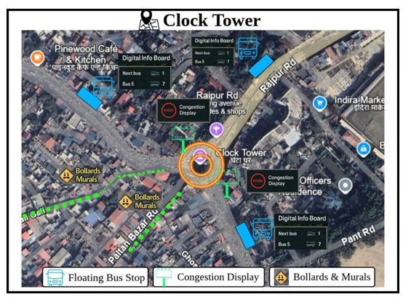
Figure (5): Clock Tower (Ghanta Ghar) interventions
Central Dehradun landmark—Ghanta Ghar is a radial convergence of six major roads (Paltan Bazaar, Rajpur Road, Chakrata Road, Ashley Hall, etc.). Surrounded by dense commercial markets (Paltan Bazaar, Kanwali Road), pedestrian traffic, street vendors, and public transport stops. Historically congested and highly pedestrianized yet dominated by private vehicles and two-wheelers. No clear zoning for pedestrians, deliveries, or autos to chaotic multimodal friction.
Challenges: The urban corridor experiences critical mobility dysfunction characterized by pedestrian spill over onto roadways due to inadequate sidewalk infrastructure and pervasive street obstructions. Systematic unauthorized parking, particularly of two-wheelers and delivery vehicles, compounds spatial constraints while heterogeneous traffic flows—encompassing auto-rickshaws, tempos, and private vehicles—operate without regulatory oversight. The absence of public transport incentivization mechanisms, coupled with pedestrian safety deficits, perpetuates car-centric mobility patterns and undermines sustainable urban transportation objectives (refer to Figure 5 and Table 1 for the corresponding visual and tabular syntheses of behaviourally informed interventions tailored to the Clock Tower node).
BEHAVIORALLY INFORMED INTERVENTIONS
Radial Pedestrian Priority Ring | A 150-meter radial pedestrian-priority zone around Clock Tower will restrict vehicle access during peak hours (9-11 AM, 5-8 PM) and incorporate CPTED elements including decorative bollards, string lighting, murals, ambient music, and plantings.
Digital Delivery Coordination Zone | Two delivery hubs near Ashley Hall and Paltan Bazaar will feature QR-coded lockers where riders must park and load/unload, eliminating mid-road halts through Situational Crime Prevention principles. Participating vendors receive "Smart Bazaar Vendor" badges and enhanced app visibility as behavioural incentives for compliance.
Smart Walking Trails with Social Nudges | Painted pedestrian trails will connect Ghanta Ghar to key landmarks including Paltan Bazaar, Gandhi Park, and Survey Chowk, incorporating directional arrows, temporal indicators ("4 min walk to Café Central"), and motivational signage. These wayfinding elements utilize temporal discounting and self-image nudges to encourage walking by reducing perceived travel time and reinforcing positive pedestrian identity.
Quite Core: Audio-Visual Campaign | Ambient interventions including calm music and LED displays ("Welcome to the Calm Clock Zone") will be deployed alongside real-time noise monitoring through volunteers or smart poles displaying daily "Noise Scores." Weekly rewards of free advertising banners for vendors during low-noise periods create compliance incentives, ensuring that calm environments enhance perceived order and reduce deviant behaviours.
Auto Ring with Token Entry | A circular loop system around Ghanta Ghar will limit auto-rickshaw presence through digital queue management, allowing only a fixed number of vehicles within the ring at any time. Entry tokens and real-time queue status displayed on digital boards at feeder roads (Rajpur Road, Chakrata Road) manage availability without complete bans, to control congestion while maintaining transport accessibility.
Table (1): Behaviourally Informed Interventions for Ghanta Ghar (Clock Tower) Intersection
Global Case Parallel: Copenhagen’s Strøget pedestrian mall reduced foot injuries and traffic incidents by 35% within 18 months.

ISBT Dehradun
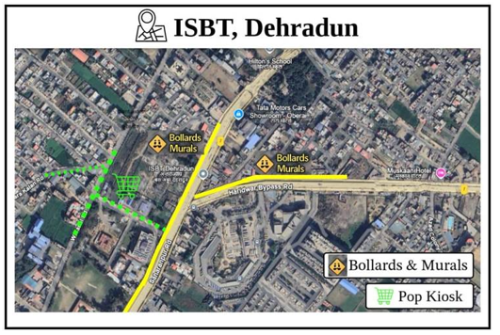
Figure (6): ISBT Dehradun interventions
Dehradun’s primary bus transit hub, connecting Uttarakhand to Delhi, Punjab, Himachal, and other states. Heavy footfall of interstate passengers, autos, taxis, private pick-up vehicles, and street vendors. Multiple entry-exit points; unregulated flow of shared autos and taxis causes severe traffic snarls. Surrounding areas have unplanned street layouts, leading to bottlenecks and confusion for first-time users.
Challenges: The transportation hub lacks designated pick-up and drop-off zones, resulting in chaotic traffic patterns as autos and taxis park haphazardly along roadsides, obstructing vehicular access. Inadequate wayfinding signage and orientation systems strand unfamiliar passengers, prompting informal boarding practices, while poor lighting and crowded conditions create safety concerns that particularly compromise nighttime accessibility and user confidence (refer to Figure 6 and Table 2 for the corresponding visual and tabular syntheses of behaviourally informed interventions tailored to ISBT Dehradun).
BEHAVIORALLY INFORMED INTERVENTIONS
Designated Pick-Up Bays | Colour-coded zones should be designated for taxis, e-rickshaws, and private cars, with each zone subject to digital timing limits to ensure efficient turnover and prevent prolonged occupancy.
Vendor Circle Regulation | Vending activities need to be formalized through licensed modular pods that incorporate integrated waste control systems to ensure organized commercial operations and environmental compliance.
Passenger Orientation Pods | Entry kiosk can be installed featuring a live city map, integrated booking portal, and comprehensive fare guidance system to assist passengers with navigation and transportation planning.
Auto Token Queue | Pre-authorized e-rickshaw orders will be displayed on LED screens positioned at the gate to provide real-time visibility of scheduled pickups.
Table (2): Behaviourally informed interventions for ISBT Dehradun
Parallel: Mexico City’s Terminal de Autobuses employs vending demarcation and real-time boarding alerts, improving efficiency by 23%.

Rispana Bridge Corridor
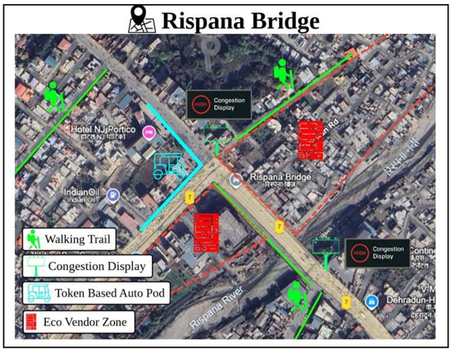
Figure (7): Rispana Bridge interventions
It is a critical junction connecting Haridwar Road with inner city areas like Nehru Colony and Dharampur. Key Landmarks: Proximity to Hotel JSR Continental and NJ Portico, indicating commercial activity. Traffic Patterns: High vehicular density due to mixed traffic—private vehicles, shared autos, buses, and pedestrians.
Challenges: The Rispana Bridge experiences capacity constraints due to its narrow width, creating peak-hour bottlenecks exacerbated by the absence of pedestrian infrastructure that intensifies vehicle-pedestrian conflicts. Street vendor encroachments and unauthorized parking further reduce available road space, while inadequate and poorly maintained public transport facilities discourage modal shift toward sustainable transportation options (refer to Figure 7 and Table 3 for the corresponding visual and tabular syntheses of behaviourally informed interventions tailored to the Rispana Bridge Corridor).

BEHAVIORALLY INFORMED INTERVENTIONS
Time segregated access zones | Peak-hour restrictions to be implemented for private vehicles, with access limited exclusively to school buses and e-bikes during specified high-traffic periods.
Floating Bus Platforms | Designated stopping points to be positioned near NJ Portico and JSR Continental to facilitate timed vehicle halts at these strategic locations.
Walk and Save Zones | A QR-coded sidewalk zone can be established to track and reward pedestrian movement through digital incentive systems.
Vendor Reallocation | A defined vending island can be established at a designated distance from the curb side to organize commercial activities and maintain traffic flow.
Table (3): Behaviourally informed interventions for Rispana Bridge Corridor
Parallel Model: Shimla’s “One-Minute Traffic Plan” introduced pause zones before choke points, easing downstream flow by 18%.

Dharampur and Survey Chowk Corridor
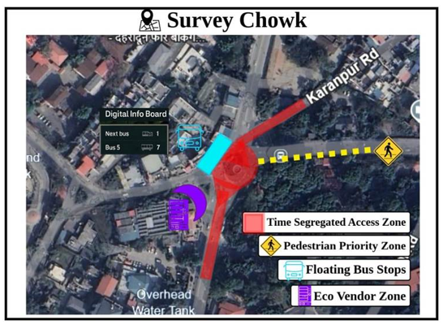
Figure (8): Survey Chowk interventions
Dharampur is one of Dehradun’s most saturated intersections—where Haridwar Road, EC Road, and Rajpur Road traffic converges. Surrounded by schools, hospitals (e.g., Drona Hospital), coaching centres, and residential zones, it experiences chaotic peak-hour movement. High density of autos, e-rickshaws, private two-wheelers, and informal roadside parking. Major feeder points to Survey Chowk and arterial road to ISBT.
Challenges: The area experiences traffic disruption from illegal U-turns and road-blocking drop-offs, while the absence of spatial separation between autos, vendors, and pedestrians creates operational chaos. Inadequate walkable infrastructure forces pedestrian spill over into vehicle lanes, and poor waiting conditions at transport facilities result in minimal public transport adoption (refer to Figure 8 and Table 4 for the corresponding visual and tabular syntheses of behaviourally informed interventions tailored to the Survey Chowk precinct).

BEHAVIORALLY INFORMED INTERVENTIONS
Auto Dispatch Pods | RFID-based queue stands will be implemented with rotational entry systems to manage orderly vehicle access and prevent congestion.
Staggered School Entry & Drop off System | Schools can be assigned different gate timings, with colour-coded entry boards installed to guide parents to appropriate pickup and drop-off zones based on their designated time slots.
Congestion Display Poles | Dynamic route time estimators can be installed to display real-time travel information alongside nudge messages such as "Take Rajpur Rd. = -7 mins" to encourage optimal route selection.
Vendor Compliance Badges | Monthly clean-vendor ratings can be implemented and linked to sales incentive coupons to reward vendors who maintain hygiene and cleanliness standards.
Green Points Transit Card | A Dharampur Pilot program can be launched where each bus ride, walk-to-school trip, or e-rickshaw journey tracked via QR codes earns "Green Points" that are redeemable at partner cafés, libraries, and tuition centres. This system encourages sustained behavioural shift toward sustainable transportation modes through gamified incentives.
Table (4): Behaviourally informed interventions for Dharampur and Survey Chowk Corridor
Benchmark: Seoul’s “Smart Commute Zones” synchronised school/office timings and reduced congestion by 21%.

Patel Nagar and Prince Chowk Intersection
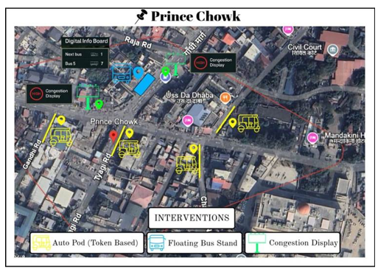
Figure (9): Prince Chowk interventions
It is a dense residential-commercial mixed-use area, lying adjacent to the Dehradun Railway Station and arterial roads like Haridwar Road and Prince Chowk. It acts as a key link between the inner city and ISBT/Railway Station, with significant through-traffic. Streets are narrow, choked with informal vending, roadside parking, and multiple small commercial shops. Low public transport uptake, with preference for personal two-wheelers and informal autos.
Challenges: The area suffers from excessive vehicular volume on constrained streets, compounded by random stops and encroachments that create persistent congestion. Residents avoid walking or cycling due to safety concerns, footpath encroachments, and environmental pollution, while local businesses resist vehicle restrictions fearing reduced visibility and customer access. The absence of real-time travel feedback leaves road users unaware of delays until they encounter traffic bottlenecks (refer to Figure 9 and Table 5 for the corresponding visual and tabular syntheses of behaviourally informed interventions tailored to the Patel Nagar and Prince Chowk intersection).
BEHAVIORALLY INFORMED INTERVENTIONS
Smart One-Way Loops | A circular flow system can be introduced to eliminate cross-directional halts and improve overall traffic movement efficiency.
Divider Wall Art by Local Schools | Behavioural nudges should be implemented to promote lane discipline and encourage walking among road users.
Live Entry Boards | Alert systems to be deployed to notify commuters to avoid entry during congestion periods, displaying messages such as "Next Window in 12 mins" to indicate optimal travel times.
Neighbourhood Guardian Groups | Residents and vendors must ensure rule compliance by displaying visible ID tags that indicate their participation in the traffic management system.
LOCAL GUARDIAN APP & FEEDBACK LOOP Residents and shopkeepers can report violations (e.g., illegal halts, honking) via a lightweight app. Monthly performance stats shown publicly: “Patel Nagar Quietest Street This Month: Street No. 6!”
Table (5): Behaviourally informed interventions for Patel Nagar and Prince Chowk Intersection
EQUITY AND INCLUSION COMMITMENTS
Equity and inclusion are central to effective urban mobility. In Dehradun, interventions go beyond traffic optimisation to ensure all commuters—regardless of age, gender, ability, or digital literacy—participate meaningfully in the city’s transport ecosystem. Embedding universal design within behavioural frameworks not only upholds ethical imperatives but strengthens intervention efficacy, positioning historically marginalised groups as active co-creators of sustainable mobility solutions.
Women’s mobility is enhanced through targeted safety measures, including well-lit floating bus stops, designated women-only ride options, “Calm Zones” near schools and commercial areas, and surveillance-enabled kiosks. These measures address both perceived and actual threats, increasing independent mobility while supporting broader traffic management goals.
School-age children benefit from safe walking trails, illustrated drop-off zones, and “Buddy Travel Groups,” complemented by QR-coded rewards and school recognition programmes. These interventions reduce congestion in school zones and embed positive travel behaviours early, fostering civic responsibility and ecological awareness.
Street vendors are integrated as legitimate spatial stakeholders via regulated vending pods, QR-enabled payments, and hygiene-focused “Clean Vendor” badges. Formalising their presence reduces informal congestion, supports livelihoods, and leverages vendors as visible agents of behavioural signalling.
Inclusive infrastructure for elderly citizens and persons with disabilities—tactile paving, high-contrast signage, icon-based kiosks, and rest benches—enables independent navigation, increasing system utilisation and modelling age- and disability-sensitive planning best practices. To address digital exclusion, multilingual signage, audio kiosks, and analogue rewards ensure equitable access to information and incentives.
Critical Note: Equity initiatives risk tokenism if unmonitored. Continuous assessment, participatory feedback, and adaptive design are essential to ensure inclusion translates into measurable outcomes.
By prioritising equity and inclusion, Dehradun’s mobility strategy affirms the right to move with dignity, safety, and agency, while enhancing behavioural intervention success and setting a precedent for globally relevant, participatory urban mobility design.
STAKEHOLDERS INVOLVED
Implementing behaviourally intelligent mobility interventions in Dehradun demands a coordinated, multi-stakeholder ecosystem. The Municipal Corporation of Dehradun (MCD) and Uttarakhand Transport Corporation (UTC) anchor policy, infrastructure, and operational oversight, while the Traffic Police enforce adaptive regulatory measures. Academic partners, notably IIT Roorkee, contribute empirical diagnostics, behavioural modelling, and spatial analytics. Private mobility operators and logistics providers drive technological deployment and service innovation. Civil society actors—including resident welfare associations, women’s collectives, vendor unions, and commuter advocacy groups—facilitate co-design, community buy-in, and sustained adoption. This interdependent governance model ensures interventions are technically sound, socially legitimate, and contextually embedded for long-term scalability (refer Figure 10 for stakeholder mapping).
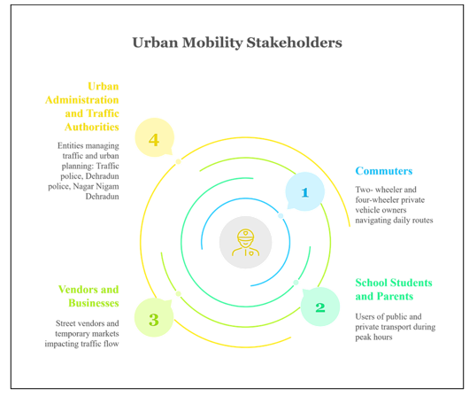
Figure (10): Stakeholders in Dehradun’s urban renewal
COST FEASIBILITY AND RISK MITIGATION
The proposed interventions prioritise cost-efficiency while maintaining high behavioural impact. The total implementation budget is estimated at ₹5 crores for one pilot project over a 12-month period, aligning with typical urban mobility innovation grants and Smart City funding frameworks. Costs are based on precedent from comparable urban mobility pilots in India and internationally—for instance, CPTED-compliant floating bus shelters in mid-sized Indian cities have been implemented at approximately ₹25–30 lakhs per unit, suggesting that the total allocation of ₹1.25 crores for multiple shelters across a zone is realistic (Source: Ministry of Housing and Urban Affairs, Smart Cities Mission Pilot Reports, 2022).
The modular design allows phased deployment, enabling iterative adjustments based on real-time feedback, thereby optimising resource utilisation. Table 6 summarises the estimated budget allocation:
ESTIMATED BUDGET BREAKDOWN (FOR PILOT PROJECT)
Components | Approx. Cost (in ₹)
Behavioural signage, murals, and painted pedestrian paths | 80 lakhs
POP kiosks and digital feedback dashboards | 1 crore
Floating bus shelters with CPTED-compliant upgrades | 1.25 crores
QR-based reward and gamification systems | 60 lakhs
Community workshops, outreach campaigns, school programs | 50 lakhs
Monitoring, evaluation, and third-party validation tools | 35 lakhs
Contingency and maintenance reserves | 50 lakhs
Table (6): Estimated Budget Breakdown
Scalability
The framework is designed for expansion beyond the pilot phase. Phased rollouts and adaptive monitoring mitigate implementation risks, while ongoing evaluation ensures cost-justified scaling across additional zones. Contingency reserves and community engagement strategies further reduce operational and behavioural adoption risks, providing a replicable model for other mid-sized urban contexts.
High Impact and Low-Cost Tools:
High-impact, low-cost interventions include community co-created murals to reduce visual clutter and define behavioural zones, solar-powered lighting and bollards for enhanced safety with minimal operational expenses, QR and SMS-based reward systems that bypass app download requirements, and vendor regulation through collapsible bamboo pods within designated painted boundaries.
Potential Funding Sources:
- Smart Cities Mission (MoHUA)
- 16th Finance Commission Urban Mobility Grants
- CSR contributions from logistics, e-mobility, and real estate sectors
- Academic partnerships for data collection and low-cost behavioural lab testing, e.g., IIT-R, NID (refer Figure 11 for sources of funds for pilot projects and implementation of initial behavioural reforms)
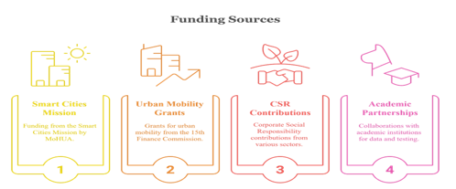
Figure (11): Sources of funds for pilot projects and implementation of initial behavioural reforms
IDENTIFIED RISKS AND MITIGATION STRATEGIES
RISK | IMPACT | MITIGATION STRATEGY
Digital Divide | Reduced participation in QR or app-based nudges | Provide paper-based reward cards and voice-enabled kiosks for non-smartphone users
Stakeholder Resistance | Lack of buy-in from auto unions or vendors | Incentivise participation through badge schemes, revenue assurance, and participation in governance boards
Maintenance and Vandalism | Damage to murals, signage, or kiosks | Use weatherproof paint, clear community ownership, and street guardian volunteer groups
Pilot Fatigue | Early enthusiasm drops off | Refresh campaigns quarterly with new reward themes and community events
Table (7): Identified Risks, Impacts and Mitigation Strategies
This financial model ensures that Dehradun’s congestion problem is addressed not through capital-intensive construction but through intelligent, behaviourally guided urban design—with long-term benefits outweighing initial deployment costs (Table 7 shows the identified risks, impacts and mitigation strategies).
IMPELEMENTATION ROADMAP
The success of behaviourally driven mobility reforms depends on a well-orchestrated and time-bound implementation roadmap that balances immediate interventions with long-term structural integration. This roadmap adopts a four-phase approach over a 12-month period—designed to pilot, validate, and scale sustainable mobility behaviours across Dehradun’s five most congested zones. Each phase involves key stakeholders such as municipal authorities, schools, civil society partners, local vendors, and transport unions to ensure deep-rooted behavioural adoption (see Table 8 for the Phased Implementation Roadmap and Figure 12 for its visual representation).
PHASE | MONTHS | MILESTONES & ACTIVITIES | LEAD STAKEHOLDERS
Planning | 1-3 | Surveys, community co-design, vendor mapping | Municipality, NGOs, Schools
Pilot | 4-6 | 2-zone deployment of floating stops, auto tokens, congestion boards | Municipality, Schools, Behavioural Consultants
Expansion | 7-9 | Scale to all 5 hotspots; launch app dashboard & kiosk network | Municipality, Civil Society, Local Vendors
Evaluation | 10-12 | Traffic volume tracking, AQI analytics, commuter feedback survey | Municipality, IIT-R, Behavioural Consultants, NGOs
Table (8): Phased Implementation Roadmap for Behavioural Mobility Interventions in Dehradun
- PHASE 1- Planning (1-3 Months): Engages commuters—especially women, students, and elderly—to co-design interventions that reflect real-world mobility needs.
B. PHASE 2- Piloting (4-6 Months): Tests prototypes in Rispana and ISBT zones, capturing behavioural and usage data to refine solutions.
C. PHASE 3- Expansion (7-9 Months): Scales validated solutions citywide, reinforced through pledges, gamification, and outreach campaigns.
D.PHASE 4- Evaluation (10-12 Months): Assesses performance via GIS, AQI monitoring, and surveys; informs integration into Dehradun’s Smart Mobility Policy and provides replicable insights for other cities.

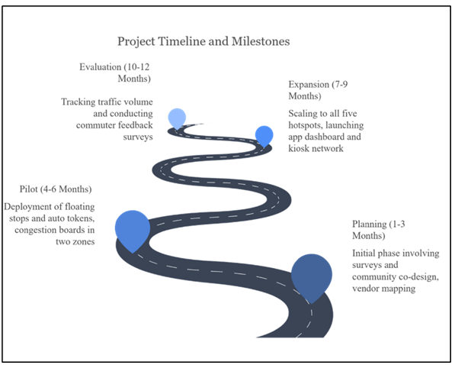
Figure (12): Implementation Road map
IMPACT AND EVALUATION METRICS
Measuring the success of behavioural interventions requires a robust, multidimensional framework that captures both direct and indirect impacts. This report adopts a hybrid evaluation approach combining quantitative indicators (traffic volume, AQI levels, transport mode share) with qualitative feedback mechanisms (surveys, interviews, perception audits). The goal is not only to assess modal shifts and congestion reduction but also to evaluate changes in commuter perception, safety, and stakeholder compliance.
Key metrics are drawn from comparable global case studies and adapted for Dehradun's context (refer Table 9). For instance, Copenhagen’s pedestrian reforms and Seoul’s time-staggering programs have shown success by measuring footfall shifts, modal elasticity, and safety perception—metrics mirrored here. Indicators will be collected through traffic sensors, GIS mapping, air quality monitors, and mobile app data.
Impact Metric | Target Outcome
Modal Shift (Public/Shared Transit) | Increase by 25% in targeted hotspots
Private Vehicle Use (School Hours) | Decrease by at least 30% through time-gated entry and nudges
Air Quality Index (AQI) | Improve by ≥10 points in pilot corridors
Women’s Safety Index | Enhance perceived safety by 40% (via surveys and feedback)
Vendor Compliance Index | 90% stall adherence to vending zones and cleanliness norms
Floating Bus Stop Usage | ≥15% increase in ridership within 6 months
Reward Program Participation | At least 5,000 active Green Commuter users by end of pilot
Community Satisfaction Score | Target 80%+ positive feedback in quarterly surveys
Table (9): Measurable Success Criteria for Dehradun’s Behavioural Urban Mobility Framework
Evaluation phases will be aligned with the implementation roadmap, enabling iterative refinement and public reporting. Key learnings will be disseminated through open data dashboards, allowing replicability in similar urban contexts such as Shimla and Nainital.

Conclusion
This study advances a nuanced and behaviourally informed framework to address Dehradun’s urban mobility challenges, integrating criminological design principles with contemporary behavioural science. Findings highlight that infrastructural upgrades alone are insufficient; interventions must engage commuter psychology, socio-cultural norms, and environmental cues. By combining city-wide behavioural nudges with hotspot-specific micro-interventions, strategically designed “pressure points” can shift mobility choices toward safer, lower-emission, and more inclusive modes.
The proposed initiatives—from Green Commute Zones to interactive transit nodes—are designed as scalable prototypes rather than isolated pilots. Integrating equity and inclusion safeguards ensures that marginalized groups, including schoolchildren, women, persons with disabilities, and street vendors, benefit from mobility improvements. The outlined evaluation metrics provide a replicable framework to measure shifts in travel patterns, congestion, and perceived safety, supporting continuous policy refinement.
Anchored in local context but validated against global precedents, this research contributes to human-centric urban transport policy. By synthesizing cost-effective tactical urbanism, participatory governance, and evidence-led behavioural design, it charts a pragmatic pathway for Dehradun to emerge as a benchmark in sustainable mobility. Ultimately, the study underscores that the future of urban transport lies not only in engineering infrastructure but in reshaping the cognitive, emotional, and social landscapes through which citizens navigate their cities.
Policy Implications
For policymakers, the evidence presented herein mandates an urgent shift from infrastructure-heavy, vehicle-centric planning to agile, behaviourally embedded interventions integrated into the Smart Mobility framework. Legislative provisions should enable tactical urbanism pilots, incentivise modal shifts through fiscal levers, and institutionalise participatory design processes that centre diverse commuter voices. If embedded within the city’s statutory transport policy, these interventions could not only mitigate congestion and emissions but also reframe Dehradun’s urban identity as a model of inclusive, sustainable mobility for emerging Indian cities.
Future Research Recommendations
The paper gravitates towards a more qualitative than quantitative/mixed-methods approach while investigating causes and possible solutions of traffic blockage. Case studies, qualitative theories and existing literature is used to advance the research and fill the gap of tackling vehicular traffic. However, quantitative approaches and data such as volume/capacity ratio of roads, road density, average speeds amongst others which can be used to provide a more empirical analysis of the problems in urban planning. At a more technical level, network analysis using a node-link model, topology and algorithms to find paths of least possible resistance such as by Dijkstra can be applied to identify new possible bus routes, cycling paths, plans for metro routes etc.
In an ideal case, more primary data from residents of Dehradun who travel every day, interaction with local bodies and quantitative data together would produce the most comprehensive and iron-clad measures to solve all urban planning issues the hill-city faces.

Disclaimer (Artificial intelligence)
Option 1:
Author(s) hereby declare that NO generative AI technologies such as Large Language Models (ChatGPT, manuscript.
Option 2:
Author(s) hereby declare that generative AI technologies such as Large Language Models, etc. have been used during the writing or editing of manuscripts. This explanation will include the name, version, model, and source of the generative AI technology and as well as all input prompts provided to the generative AI technology
Details of the AI usage are given below:
1.
2.
3.

References

- Clarke, R. V. (1995). Situational crime prevention. In M. Tonry & D. Farrington (Eds.), Building a safer society: Strategic approaches to crime prevention (Vol. 19, pp. 91–150). University of Chicago Press.
- Crowe, T. D. (2000). Crime prevention through environmental design: Applications of architectural design and space management concepts (2nd ed.). Butterworth-Heinemann.
- Intertraffic. (2024). Global case studies: Moscow, Perth, Mexico City. https://www.intertraffic.com/news/traffic-management/three-smart-cities-in-traffic-management-perth-mexico-city-moscow
- Michie, S., van Stralen, M. M., & West, R. (2011). The behaviour change wheel: A new method for characterising and designing behaviour change interventions. Implementation Science, 6(1), 42. https://doi.org/10.1186/1748-5908-6-42
- Municipal Development and Development Authority (MDDA). (2023). Dehradun Master Plan 2041. http://mddaonline.in/wp-content/uploads/2023/04/Dehradun-Master-Plan-2.0A.pdf
- SDC Foundation. (2023). Dehradun’s traffic crisis: A daily commute. https://www.sdcuk.in/dehraduns-traffic-crisis-a-daily-commute/
- Times of India. (2024, May 20). IIT-R completes study for safer, happier streets for Doon kids. https://timesofindia.indiatimes.com/city/dehradun/iit-r-completes-study-for-safer-happier-streets-for-doon-kids/articleshow/109658124.cms
- Central Pollution Control Board. (2022). Dehradun air action plan. https://cpcb.nic.in/Actionplan/Dehradun.pdf
- GeoFabrik. (2018). Geofabrik Download Server. Geofabrik Download Server. https://download.geofabrik.de/asia/india/central-zone.html
- Urban Behaviours Ideathon. (2025). Home | Cities Ideathon. Cities Ideathon. https://cityideathon.abcd.guide/
- Dehradun's Traffic Crisis: A Daily Commute - Social Development for Communities (SDC) Foundation. (2024, October 2). Social Development for Communities (SDC) Foundation. https://www.sdcuk.in/dehraduns-traffic-crisis-a-daily-commute/
- Doon Today. (n.d.). Vikrams Routes of Dehradun - Doon Today-All About Dehradun. Doon Today-All About Dehradun - Dehradun Directory. https://doontoday.com/transportation-in-dehradun/vikrams-routes-of-dehradun/
- Euttaranchal. (2025). Dehradun Electric Bus Service - Doon Electric Buses Timings Routes Schedule. eUttaranchal - Uttarakhand Tourism, Hotels, News, Culture of Uttarakhand. https://www.euttaranchal.com/tourism/electric-buses-dehradun.php
- Lockton, Dan. (2011). Architecture, urbanism, design and behaviour: a brief review.
- Viale R (2025) Behavioral city. Front. Built Environ. 10:1501853. doi:10.3389/fbuil.2024.1501853
- Mussoorie-Dehradun Development Authority. (2023). Dehradun Master Plan - 2041 (Draft). Town and Country Planning Department, Uttarakhand. http://mddaonline.in/wp-content/uploads/2023/04/Dehradun-Master-Plan-2.0A.pdf
- ZALI, N., ABIZADEH, S., & BAGHERINIA, A. (2019). New Urbanism and Urban Design, Tools for Changing Behavioral Patterns of the Citizens. International Journal of Natural and Engineering Sciences, 7(1), 31–36
- Nijagunappa, R & Shekhar, Sulochana & B, Gurugnanam & Raju, PLN & De, Prabir. (2007). Road network analysis of Dehradun City using high resolution satellite data and GIS. Journal of the Indian Society of Remote Sensing. 35. 267-274. 10.1007/BF03013494.
- Social Development for Communities Foundation. (2023). Public Transport in Dehradun. Social Development for Communities Foundation. https://www.sdcuk.in/wp-content/uploads/2024/01/SDC-Foundation-Report-on-Public-Transport-in-Dehradun.pdf
- Chataway, M., Hart, T., & Lersch, K. M. (2020). Space, Time, and Crime. Carolina Academic Press.
- Korea Transport Institute (KOTI). (2021). Smart commute zones in Seoul: Behavioural interventions for congestion control. KOTI Reports.
- Shimla Municipal Corporation. (2019). Urban transport initiatives: The ‘One-Minute Pause’ experiment. Urban Mobility Progress Reports.
- Thaler, R. H., & Sunstein, C. R. (2008). Nudge: Improving decisions about health, wealth, and happiness. Yale University Press.
- Melbourne School of Design. (2024). Dehradun | SDG Symposium | Melbourne School of Design. https://msd.unimelb.edu.au/sdg-cities/cities/dehradun-uttarakhand-india
- Baddeley, Michelle, 2017. "Behavioural Economics: A Very Short Introduction," OUP Catalogue, Oxford University Press, number 9780198754992, Decembrie
- Galvin, S. S. (2021). Becoming Organic: Nature and Agriculture in the Indian Himalaya. United Kingdom: Yale University Press.
- Melbourne School of Design. (n.d.). Dehradun | SDG Symposium | Melbourne School of Design. https://msd.unimelb.edu.au/sdg-cities/cities/dehradun-uttarakhand-india
- Singh, K. (2020). How 'City of Canals' lost its tag | Dehradun News - The Times of India. The Times of India. https://timesofindia.indiatimes.com/city/dehradun/how-city-of-canals-lost-its-tag/articleshow/74446926.cms
- Government of Uttarakhand. (2025). Climate. District Dehradun. https://dehradun.nic.in/climate/
- Hu, W., & Ley, A. (2025). Welcome to the Congestion Zone: New York Toll Program Is Set to Begin. The New York Times. https://www.nytimes.com/2025/01/04/nyregion/congestion-pricing-nyc.html
- The Economist. (2024). Congestion pricing in New York gets the go-ahead after all. Maybe. https://www.economist.com/united-states/2024/11/21/congestion-pricing-in-new-york-gets-the-go-ahead-after-all-maybe
- NYC congestion pricing start date set for June 30. See a map of the zone and how much it will cost. (2024). CBS News | Breaking news, top stories & today's latest headlines. https://www.cbsnews.com/newyork/news/nyc-congestion-pricing-start-date/
- Santora, M. (2017). Open-Road Tolls Could Pave the Way for Manhattan Congestion Pricing. The New York Times. https://www.nytimes.com/2017/08/25/nyregion/new-york-open-road-tolls-congestion-pricing.html
- Walker, A. (2018). New York drivers spent an average of 91 hours in traffic last year. Curbed NY. https://ny.curbed.com/2018/2/6/16979696/new-york-city-traffic-congestion-second-worst
- Hu, W., & Ley, A. (2025). New York City Welcomes Congestion Pricing With Fanfare and Complaints. The New York Times. https://www.nytimes.com/2025/01/05/nyregion/nyc-congestion-pricing-tolls.html
- Government of Uttarakhand. (2023). Routes. UTC Online. https://www.utconline.uk.gov.in/route.aspx
- ASRTU. (2024). Association of State Road Transport Undertakings. Association of State Road Transport Undertakings. https://www.asrtu.org/
- Ministry of Housing and Urban Affairs. (2022). Smart Cities Mission pilot reports. Government of India.

Appendix
Calculations for Impact and Evaluation Metrics:
Copenhagen’s pedestrian reforms and Seoul’s time-staggering programs have shown success by measuring footfall shifts, modal elasticity, and safety perception—metrics mirrored here. To estimate and track behavioural shifts, we propose the following calculations:
- Modal Shift Rate (%) = (post-intervention public/shared transit users − Baseline users) / Baseline users × 100
Example: If baseline public/shared use is 20%, and post-intervention it becomes 25%, the modal shift = (25−20)/20 × 100 = 25%
- Reduction in Private Vehicle Use (Peak Hours) = (Baseline vehicle count − post-intervention count) / Baseline count × 100
- AQI Improvement = (pre-AQI average − post-AQI average) points (target ≥10 points)
- Women’s Safety Index Improvement (%) = (post-survey safety score − Baseline score) / Baseline score × 100
Example: If baseline perception score is 50/100 and improves to 70/100 → (70−50)/50 × 100 = 40%
- Reward Program Engagement = Total unique app scans × average daily participation rate over pilot duration
- Vendor Compliance Rate (%) = (Number of vendors inside designated pods / Total active vendors) × 100
Additional calculation methods for key metrics include:
- Floating Bus Stop Usage Rate (%) = (Monthly post-intervention ridership at floating stops − Baseline ridership) / Baseline ridership × 100
Example: If baseline ridership is 1,000/month and post-intervention it is 1,150 → (1,150 − 1,000)/1,000 × 100 = 15% increase
- Reward Program Participation Growth (%) = (Final number of active users − Initial user base) / Initial user base × 100
Example: From 500 initial users to 5,000 by end of pilot → (5,000 − 500)/500 × 100 = 900% growth
- Community Satisfaction Score (%) = (Positive feedback responses / Total feedback responses) × 100
Example: 640 out of 800 respondents gave a positive rating → 640/800 × 100 = 80% satisfaction rate

