***Original Research Article***

**Paleoenvironment of the early Miocene Akyar Formation: insights from stable isotope analysis of benthic foraminifera**

**ABSTRACT**

We present new stable isotope data and discuss paleoenvironmental conditions of benthic foraminifera in the lower Miocene deposits (Akyar Formation) from the Yazıhan (N-NW Malatya) and Muşardağı (Baskil, SW Elazığ) areas located at the eastern part of the Taurus-Anatolian platform. The Akyar Formation is composed of limestone, mudstone, calcirudite, and calcarenite interlayers including rich foraminiferal assemblages. They show Aquitanian-Burdigalian in age. The foraminiferal assemblage, bivalve identified as *Hyotissa hyotis*, and the abundance of corals indicate a tropical to subtropical warm paleoenvironment from the inner shelf to the slope. δ18O values of foraminifera species have quite negative values between -7.99 and -0.27‰, and δ13C values are from -1.56 to +0.41‰. According to isotopic data and fossil content, paleosalinity is at the normal salinity levels. The obtained paleotemperature data from the δ18O values show that, the early Miocene the sea water temperature was extremely high. It is assumed that high temperatures were possibly related to the Yamadağ volcanism, starting from the late Cretaceous to the middle-late Miocene in the northern part of the area.

***Keywords: Benthic f****oraminifera, Isotopic data, Paleoenvironment, Early Miocene, Malatya basin*

**1. INTRODUCTION**

The study area is located northeast of the Malatya Basin and covers the eastern part of the Malatya-Ovacık Fault. The Malatya Basin, covering an area of about 1000 km² on the eastern Taurus-Anatolian platform, is a part of the southern branch of the Neotethys Sea, eastern Türkiye (Fig. 1). Geological studies in the Malatya Basin were started by Birand (1938). It was followed by several studies on stratigraphy, tectonics, paleontology, clay geology, sedimentology, isotope geochemistry and petroleum geology etc. (Asutay, 1988; Avşar, 1983; Ayan & Bulut, 1961; D’Onofrio et al., 2021; Gedik 2015; Giorgioni et al., 2019; Görmüş, 1992; Koral & Önal, 2007; Önal & Kaya, 2007; Örçen, 1986; Türkmen et al., 2007; Ural, 2013; Ural et al., 2015).

Due to the differences in the sequences outcropping in the north and south of the Malatya basin, the basin was divided into two sub-basins, namely the Hekimhan and Gündüzbey sub-basins (Ayyıldız et al., 2015; Önal & Gözübol, 1992). Our study area is located in the Hekimhan sub-basin.

Foraminiferal shell oxygen and carbon isotope analyses began to be used in paleoceanography after Emiliani (1955) used deep-sea core isotope records to interpret temperature cycles in the Pleistocene climate. Oxygen and carbon stable isotopes have been shown to be reliable for understanding the growth history and climate records of modern and fossil marine invertebrates such as corals, bivalves, gastropods, and foraminifers (Jones & Allmon, 1995; Zachos et al., 1992).

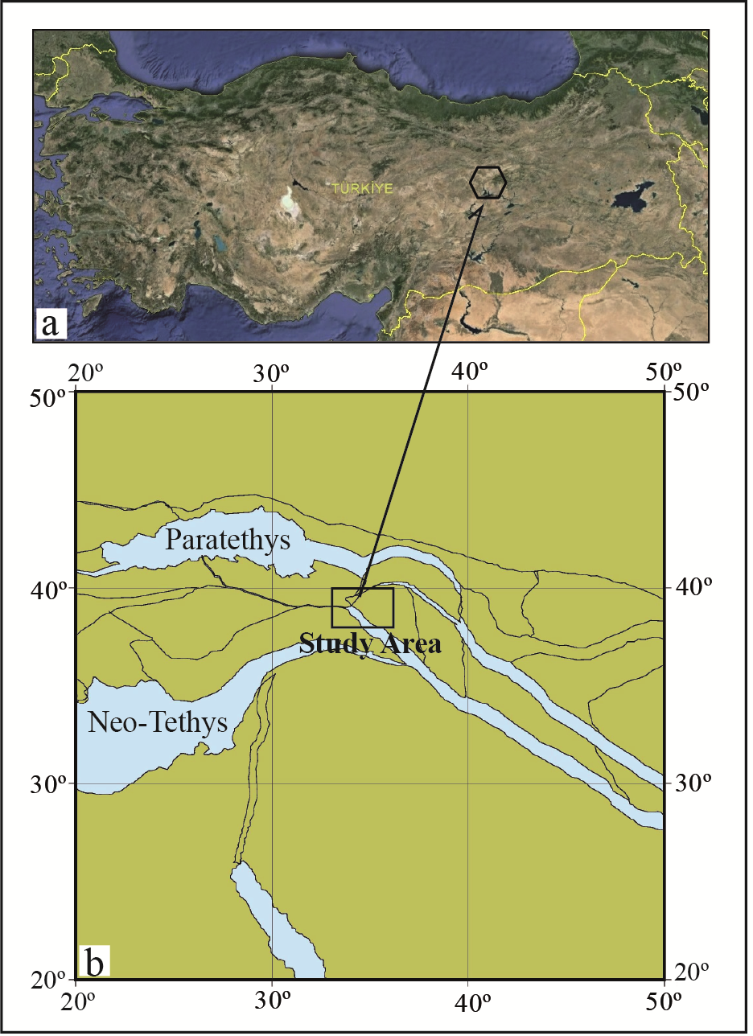

**Fig. 1(a). Location map of the study area (satellite photo from Google Earth), (b) The paleogeographic location of the area under study is depicted on a paleogeographic map of the eastern Neo-Tethys at 18 Ma** *http://www.odsn.de/odsn/services/paleomap/paleomap.html*

Stable isotope compositions of fossil taxa in the region had not been previously studied. Therefore, in this study, we attempted to acquire information on the deposition conditions of the early Miocene foraminiferal shells based on stable isotope analysis (δ18O and δ13C).

**2. MATERIALS AND METHODS**

The materials of the present study consist of 50 systematic samples collected from the Yazıhan (Malatya) and Muşardağı (Baskil-Elazığ) measured stratigraphic sections with a total thickness of 217 meters (Fig. 2). The Muşardağı section is on the K40 c2 and c3 sheets in the northwest of the Baskil district of Elazığ province, and the Yazıhan section is on the K40 d1 sheet in the northwest of Malatya province. Muşardağı section coordinates are as follows:

The section's beginning and ending coordinates are K40 c2 E 463750, N 748750, and K40 c3 E 462500, N 767500. The Yazıhan section has the following coordinates: E14 0000, N82 7000 begin and end at E14 6500, N84 5000 (Fig. 2a). Samples collected from sections included benthic and planktonic foraminifera, a bivalvia Hyotissa hyotis, bryozoa, ostracoda and corallinae. Soft rock samples were washed through a 63-µm sieve using a 17% hydrogen peroxide solution for 24 hours. The remaining fraction was oven-dried and dry-sieved at 63 µm, 125 µm, and 250 µm. At the end of micropaleontological examinations, benthic and planktonic species were described. Some representatives of each investigated species were examined with a scanning electron microscope (SEM).

δ18O and δ13C analyses for 20 samples of benthic foraminifera and 12 samples of planktonic foraminifera from the stratigraphic sections measured in the Akyar Formation were performed in the Iso-Analytical Laboratory (UK). Before being dried for 24 hours in a drying oven to eliminate moisture, samples were first weighed into clean Exetainer TM tubes (then crushed in situ). Septum caps were affixed to the tubes containing the samples. After being in an acidic environment for one night, the samples were heated at 60°C for two hours to make sure that all of the carbonate was turned into CO2. The tubes were subsequently purged with 99.995% helium. Continuous Flow-Isotope Ratio Mass Spectrometry (CF-IRMS) was subsequently employed to assess the CO2 gas emitted from the samples. A magnetic field separates various gas species based on their mass. They are then measured simultaneously using a collection array called a Faraday cup to determine the isotopomers of CO2 at m/z 44, 45, and 46. The carbon dioxide (CO2) was isolated using gas chromatography utilizing a packed column. The chromatographic peaks were then ionized and accelerated using the Europa Scientific 20-20 Isotope Ratio Mass Spectrometer (IRMS). Coplen et al. (1983) used phosphoric acid to digest samples for isotopic analysis and injected it through the septum into the vials.

The samples' isotope temperatures were determined using the following equation (Shackleton, 1974):

T (°C) = 16.9 – 4.38 (δ18Oc - δ18Ow) + 0.1 (δ18Oc - δ18Ow) 2. (1)

The water where the organism lives has a stable isotope ratio of δ18Ow, where “T” is the temperature (°C).

Craig and Gordon (1965) discovered a salinity-water isotope relationship because δ18Ow varies with salinity.

δ18Ow = 0.66 S − 23.5. (2)

The stable isotope ratio of the water the organism lived in is represented by δ18Ow, while the salinity level is represented by S. After this important study, many new ways and formulas have been developed to calculate paleosalinity (S) from the δ18Ow value, such as those established by Railsback and Anderson (1989). In this study, salinity values were calculated by taking into account these studies and formulas and fossils.

After the micropaleontological studies, species of benthic and planktonic organisms were named using the Ellis and Messina Catalogue of Micropaleontology (1940–present) and different foraminifera-focused studies (e.g.; Boersma, 1977; Bolli et al., 1994; Cahuzac & Poignant, 1997; Douglas, 1973; Hayward & Buzas, 1979; Iaccarino et al., 2007; Kender et al., 2008; Loeblich & Tappan, 1988; Miller et al., 1985; Nomura, 1986; Székely et al., 2017; Van Morkhoven et al., 1986; Woodruff, 1985).

**3. GEOLOGICAL SETTING AND STRATIGRAPHY**

The Malatya basin is located on the Eastern Taurus Platform and covers an area of approximately 1000 km2. It is a part of the southern branch of the Neo-Tethys Sea and is divided into two sub-basins, the Hekimhan and Gündüzbey basins, based on their sedimentological differences. The basement rocks in the study area consist of Paleozoic-Mesozoic metamorphics of the Malatya massif, as shown in “Figures 2 and 3”. The Hekimhan Formation lies unconformably over the basement rocks and comprises red-green conglomerate, sandstone, and claystone. Following it are limestone, sandstone, and marl interbeds containing rudist and other macrofossils. Sediments and Deveci Volcanics of the Campanian-Maastrichtian age are widely exposed in the Hekimhan and its surrounding area (Görmüş, 1992; Sarı et al., 2016). The Eocene Yıldıztepe Formation rests on the Hekimhan Formation with an angular unconformity. The formation starts with basal conglomerates and continues to the top with sandstone and mudstone interlayers. It consists of thick to very thick bedded claystone with macro- and microfossils. The Suludere, Yıldıztepe, and Gedik Formations are of Eocene age. The Oligocene Dumanlar Formation lies unconformably over the Eocene units and comprises conglomerate, sandstone, and mudstone. The lower Miocene Akyar Formation consists of conglomerate, sandstone, claystone, and reefal limestone. The middle-upper Miocene Karaca Formation lies unconformably over the Akyar Formation and consists of conglomerate, sandstone, shale, and lignite beds. The Karaca Formation is unconformably overlain by the Pliocene-aged Sultansuyu Formation, which consists of conglomerates, as shown in “Figures 2a and 3”.

**3.1. Akyar Formation**

In this study, we used the name Akyar as suggested by Önal (1988), because Akyar Formation is well exposed in the Akyar Valley to the northeast of Yazıhan (Fig. 2a). The Akyar Formation begins with light brown, medium-thick bedded sandstones. Towards the top, it passes into green, medium-thick bedded mudstones, marls and thick-bedded and massive limestones. The thickness of the formation is 250-500 meters in the north of the basin and 12-60 meters in the south and east, and is rich in foraminifera, *Hyotissa hyotis*, bryozoa, ostracoda and corallinae (Fig. 3 and 4). The Akyar Formation unconformably sets above the Dumanlar Formation and is overlain by the Karaca Formation with a disconformity. Yamadağ Volcanics, which are middle-upper Miocene in age and form a part of the Miocene volcanism widely distributed in Eastern Anatolia, overly the Akyar Formation (Bozkaya & Yalçın, 1991).

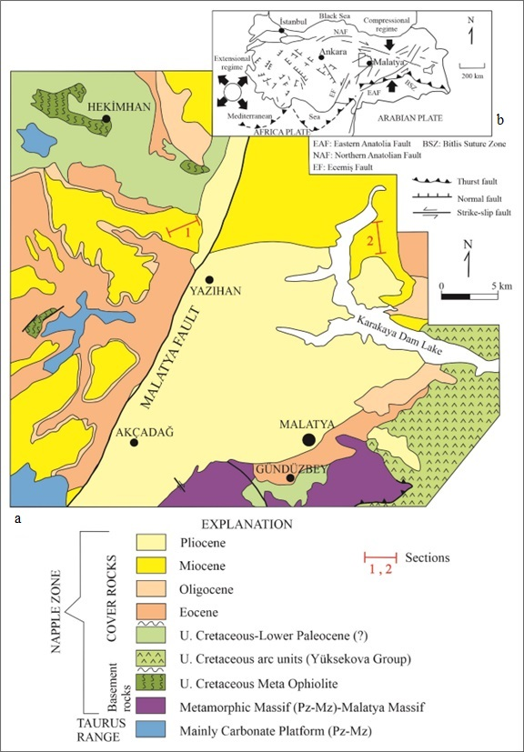

**Fig. 2(a). Geological map of the study area (after Önal, 2009), (b) Tectonic settings of Türkiye**

**(modified from Şengör & Yılmaz, 1983)**

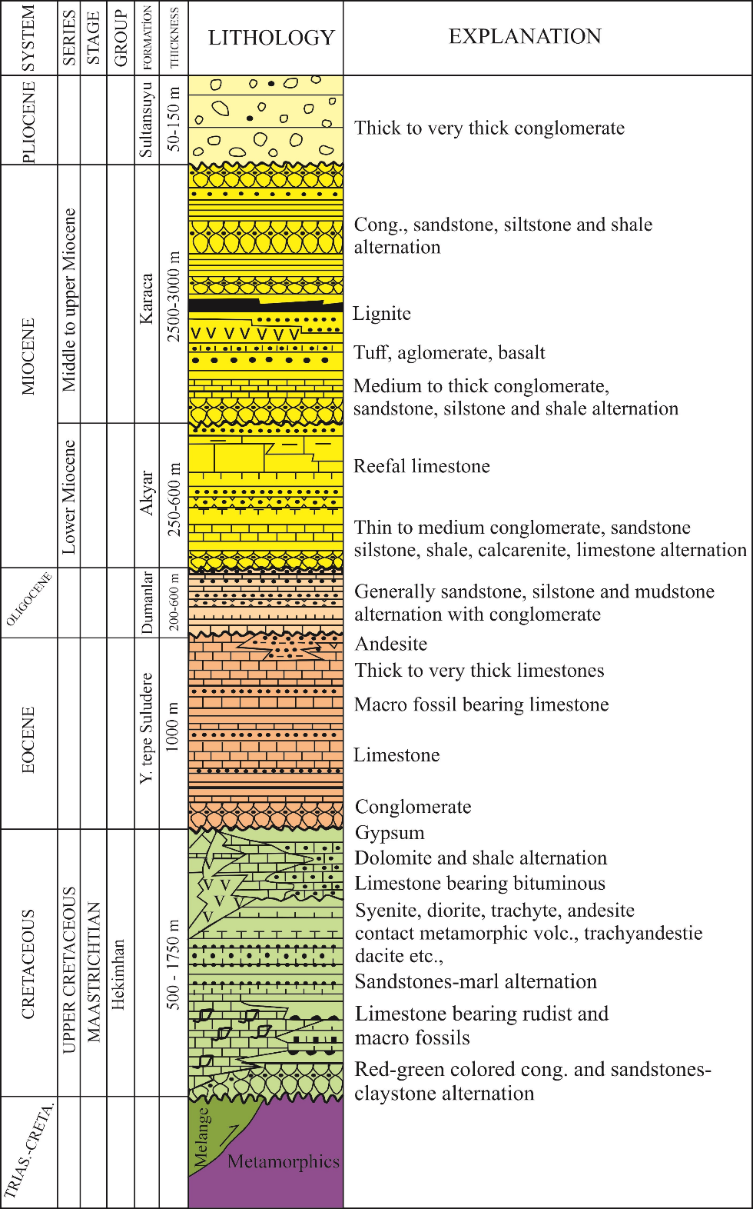

**Fig. 3. Stratigraphic columnar section of the Hekimhan sub-basin of the Malatya basin (modified from Önal, 1988)**

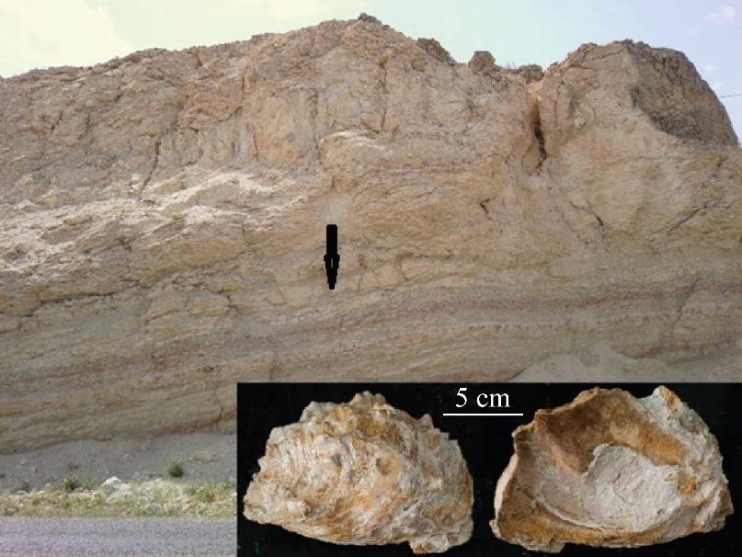

**Fig. 4. *Hyotissa hyotis* view and its location, Akyar Formation near Yazıhan**

The benthic foraminiferal assemblages of the Akyar Formation consist of 33 species belonging to 25 genera. These genera include *Anomalinoides*, *Astacolus, Cibicides, Cibicidoides, Dentalina, Elphidium*, *Globobulimina, Gypsina, Lagena,* *Lenticulina, Marginulina, Marginulinopsis*, *Miogypsina,* *Nodosaria,* *Osangularia*, *Planulina,* *Robulus, Saracenaria*, *Semivulvulina, Siphonina, Siphonodosaria*, *Spiroplectinella, Textularia, Uvigerina,* and *Vulvulina*. The benthic foraminiferal assemblages are categorized into SBZ 24 and SBZ 25 Zones (Figs. 5 and 6).

Planktonic foraminiferal genera belonging to the family Globigerinidae have also been identified: *Dentoglobigerina* spp.*, Globigerina* spp.*, Globoturborotalita* spp. and *Trilobatus* spp. (Determined by Deniz İBİLİOĞLU).

Foraminiferal assemblages suggest that the Akyar Formation was deposited during the early Miocene. In addition, the fossil records of *Hyotissa hyotis* in Western America date back from the early Miocene to the present (Cristín & Perriliat, 2013; Glenn, 1904).

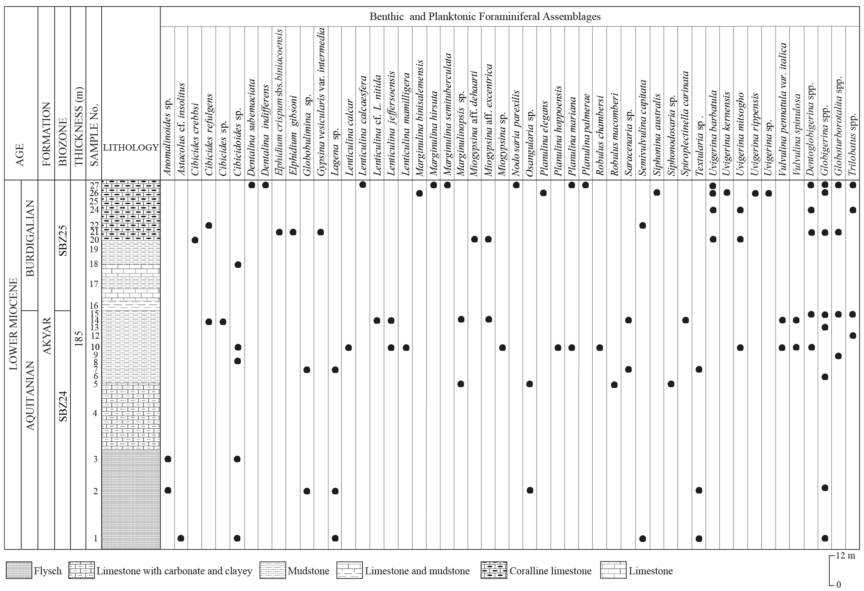

**Fig. 5. Benthic and planktonic foraminiferal assemblages of the Yazıhan Section**

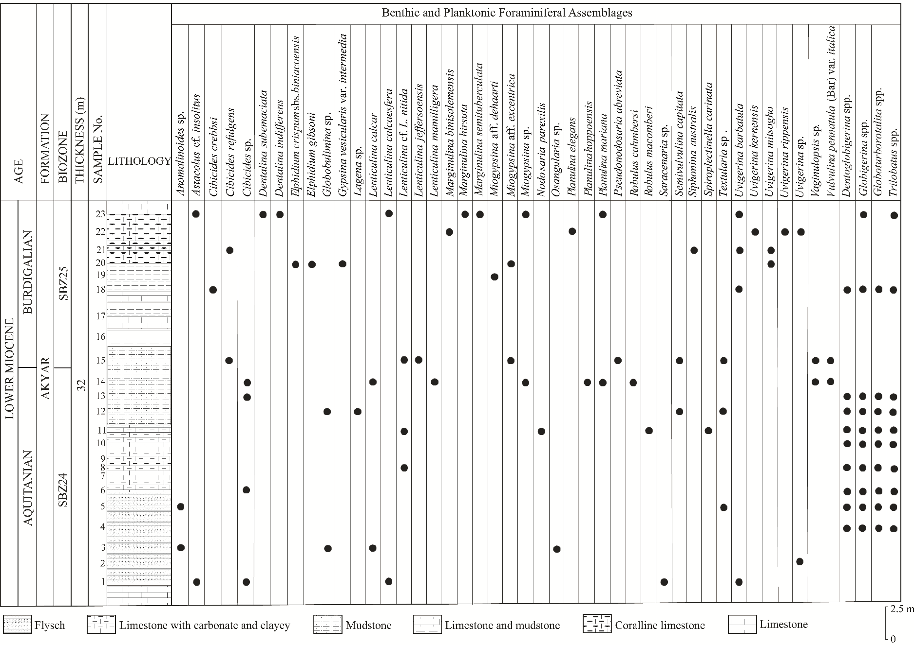

**Fig. 6. Benthic and planktonic foraminiferal assemblages of the Muşardağı Section**

**4. RESULTS AND DİSCUSSİON**

We examined the δ18O and δ13C isotopic records of foraminiferal shells from the Akyar Formation in the Hekimhan sub-basin of the Eastern Tethys region to ascertain the characteristics of the environment during the early Miocene. The foraminiferal assemblages found in the strata of the Akyar Formation are well-preserved, exhibit a high level of diversity, and are easily identifiable. The detailed stratigraphic temporal control of the analyzed sections, as well as the high sampling density, enabled us to reveal the paleoenvironmental conditions for the first time (Figs. 7 and 10-11).

**4.1. Foraminifera and other fossils**

Paleoenvironmental interpretations rely on a direct comparison between fossil foraminifera and their ecological environments, particularly because benthic foraminifera provide excellent paleoenvironmental indicators (e.g., Nebelsick et al., 2013). Benthic foraminifera are used in many studies about past climate and ocean changes because they are easy to find, very common, and quickly show how the environment has changed.

The benthic foraminiferal assemblages in the deposits of the Akyar Formation are well preserved. Hence, foraminifera considered autochthonous provide an excellent basis for thoughts about the paleoenvironment. Water temperature and other factors control the distribution patterns of shallow-water benthic foraminifera. It is known that many taxa prefer cold, temperate, or warm bottom water. The bottom water temperature is closely related to the water depth, and if the depth exceeds approximately 100 meters, temperate bottom waters are formed even in tropical regions (Murray, 2006). *Elphidium* assemblages typically favor cold temperate to tropical inner shelf environments, whereas *Lenticulina* prefers cold bottom waters and current marine assemblages. *Lenticulina* likes to live in outer shelf-bathyal areas at a depth of 20 meters, while *Uvigerina* spp. prefers deeper habitats between 100 and over 4500 meters and usually does not live shallower than 100 meters. However, the preferred depth range of Miocene *Lenticulina* species shifted toward the inner shelf area (Rögl & Spezzaferri, 2002). Furthermore, *Lenticulina calcar* is an upper bathyal form (Van Morkhoven et al., 1986). A foraminiferal assemblage dominated by *Elphidium* and *Cibicidoides* in the Miocene strata is characteristic of shallow marine environments with low water depths close to the coast. *Elphidium* assemblages live at a depth of 0-50 m, typically in cold-temperate and tropical inner shelf environments, whereas *Miogypsina* lives in shallow waters (up to 50-80 m), while *Siphonina australis* is usually found in mid-bathyal depth (⁓100 m water depth) (Drooger, 1993; Miller et al., 2008).

*Globigerina* and *Globoturborotalita* are surface dwellers, with the latter species also found in the Pacific and Indian Oceans, ranging from temperate to mid-latitudes. In contrast, *Trilobatus* is a deep-dwelling species that prefers depths greater than 50 meters (Spezzaferri et al., 2018).

The presence of shallow water forms (e.g., *Elphidium*) at various levels in both stratigraphic sections, along with the occurrence of *Hyotissa hyotis* and corals in the upper parts of the sections, indicates a shallow inner shelf (neritic) environment, especially given the scarcity or absence of deep-sea representatives. Additionally, the abundance of infaunal and planktonic taxa at certain levels suggests a middle-outer shelf environment, typically at depths of 50 to 100 meters.

The Akyar formation, as evidenced by the identified epifaunal and infaunal benthic foraminifers and planktonic foraminifers in the examined Yazıhan and Musardağı sections, was deposited from the inner shelf to the outer shelf (Fig. 7).

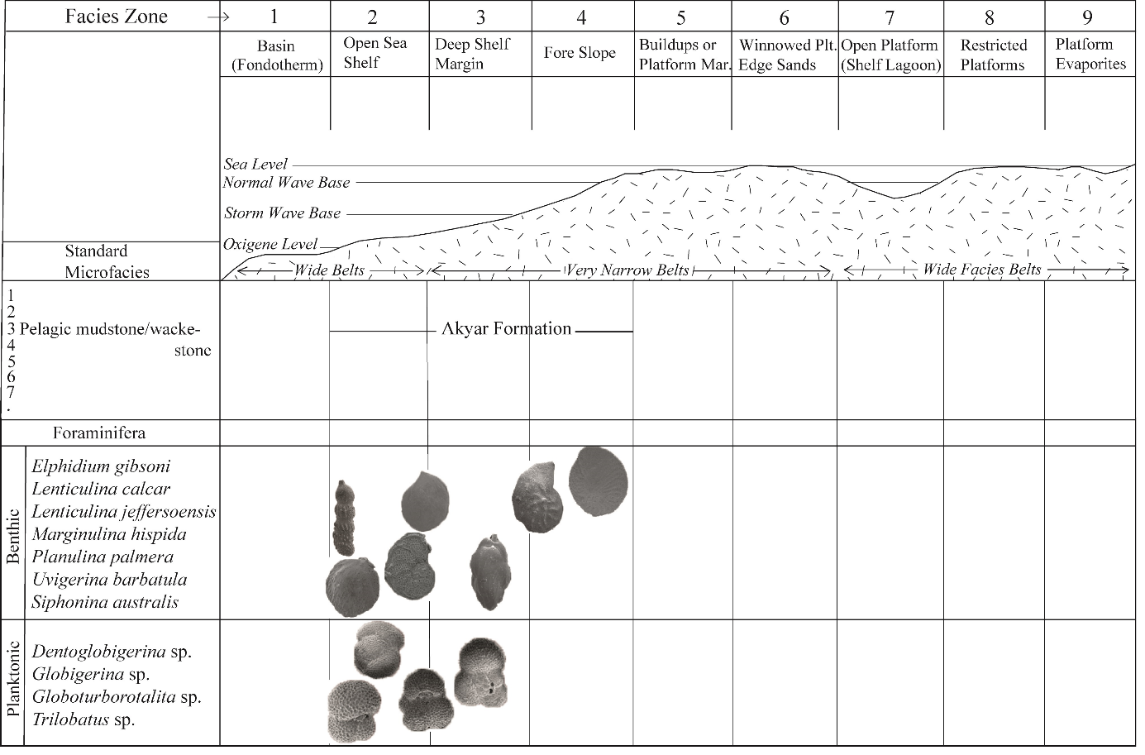

**Fig. 7. Depositional environments and facies of the Akyar Formation (arranged from Flugel, 2004; in accordance with Wilson, 1975)**

The *Hyotissa hyotis* species, detected in the uppermost levels of the Yazıhan and Muşardağı sections, has a maximum length of 14 cm, a width of 10 cm, and a height of 7.5 cm (Determination: İzzet HOŞGÖR). This oyster is found in tropical and subtropical waters and has spread from the Indo-Pacific to the eastern Pacific regions. Reports indicate that *Hyotissa hyotis* inhabits depths ranging from 0 to 50 meters, with a typical range of 0 to 5 meters in tropical environments. Recently, researchers discovered this species approximately 30 meters deep in Florida and on Jeju Island in Korea. These oysters thrive in water temperatures between 14.8 °C and 22.9 °C, with seawater salinity levels ranging from 24.7 to 31.2 PSU (Bieler et al., 2004). In the Yazıhan and Muşardağı sections, benthic foraminifera such as *Cibicidoides, Lenticulina,* and *Planulina* have been found in association with *Hyotissa hyotis*. Additionally, bryozoa, ostracoda, and corals were identified at these levels. The observed foraminiferal diversity indicates that salinity is within the normal range. It is widely accepted that the highest foraminiferal diversity occurs under standard sea conditions, with salinity rates ranging from 32 to 37 (Murray, 2006).

**4.2. Stable isotope**

The results of stable isotope compositions of samples collected from 20 benthic foraminifera and 12 planktonic foraminifera of the Yazıhan and Muşardağı sections indicate that δ18O has dramatically high negative values ranging from -7.99 to -0.27, and δ13C values range from -1.56 to +0.41 (Tables 1 and 2).

**Table 1. Stable isotope values ​​and seawater temperatures of foraminifera in the Yazıhan section**

|  |  |  |  |
| --- | --- | --- | --- |
| **Foraminifera** | **13CV-PDB** | **18OV-PDB** | **T(oC)** |
| *Cibicidoides* sp. | -0.02 | -4.06 | 31.2 |
| *Lenticulina calcaesfera* | -1.31 | -3.44 | 28.2 |
| *Cibicidoides* sp. | -0.19 | -5.11 | 36.6 |
| *Cibicidoides* sp. | -1.55 | -6.44 | 43.7 |
| *Lenticulina mamilligera* | -1.21 | -3.25 | 27.3 |
| *Miogypsina a*ff. *exentrica* | -1.38 | -6.69 | 45.1 |
| *Elphidium gibsoni* | -1.27 | -3.67 | 29.3 |
| *Uvigerina barbatula* | -0.53 | -0.80 | 16.0 |

**Table 2. Stable isotope values ​​and seawater temperatures of foraminifera in the Muşardağı Section**

|  |  |  |  |
| --- | --- | --- | --- |
| **Foraminifera** | **13CV-PDB** | **18OV-PDB** | **T(oC)** |
| *Uvigerina* sp. | -0.79 | -3.90 | 30.4 |
| *Lenticulina calcar* | 0.22 | -2.40 | 23.4 |
| *Textularia* sp. | -1.56 | -4.54 | 33.7 |
| *Cibicides* sp. | -0.21 | -4.27 | 32.3 |
| *Lenticulina* cf. *L. nitida* | -0.10 | -0.98 | 16.9 |
| *Cibicides crebbsi* | 0.17 | -2.04 | 21.6 |
| *Vaginulopsis* sp. | 0.07 | -0.30 | 13.9 |
| *Lenticulina* cf. *L. nitida* | -0.58 | -0.27 | 13.8 |
| *Pseudonodosaria abbreviata* | -0.69 | -6.11 | 41.9 |
| *Uvigerina barbatula* | -0.62 | -5.13 | 36.7 |
| *Uvigerina* sp. | 0.41 | -2.70 | 24.6 |
| *Astacolus* cf. *insolitus* | -1.32 | -7.99 | 52.4 |

In these sections, δ18O and δ13C values exhibit a slight positive correlation (R2 = 0.1088 and 0.4035) but are not strong enough to be considered significant (p> 0.05) (Figs. 8 and 9). Although this relationship implies a potential link between the two isotopic measurements, analyzing additional samples could further enhance our understanding of the early Miocene environment in the studied areas.

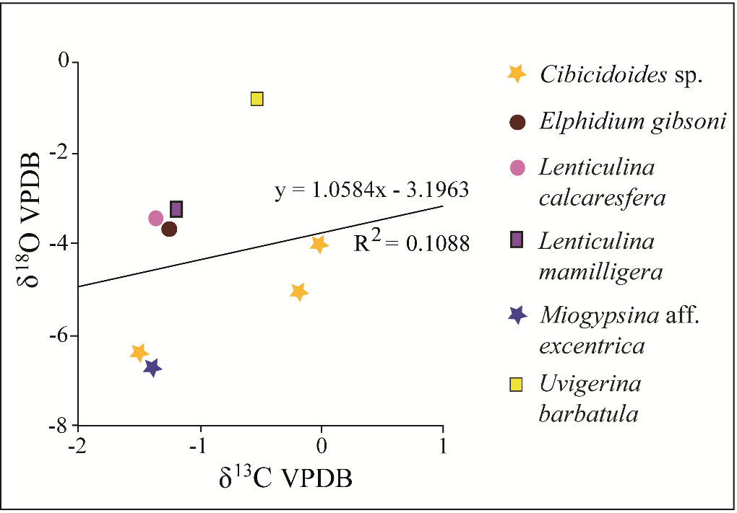

**Fig. 8. Cross plots and histograms of the covariance between δ 18O and δ 13C measured for foraminifera in the Yazıhan Section**

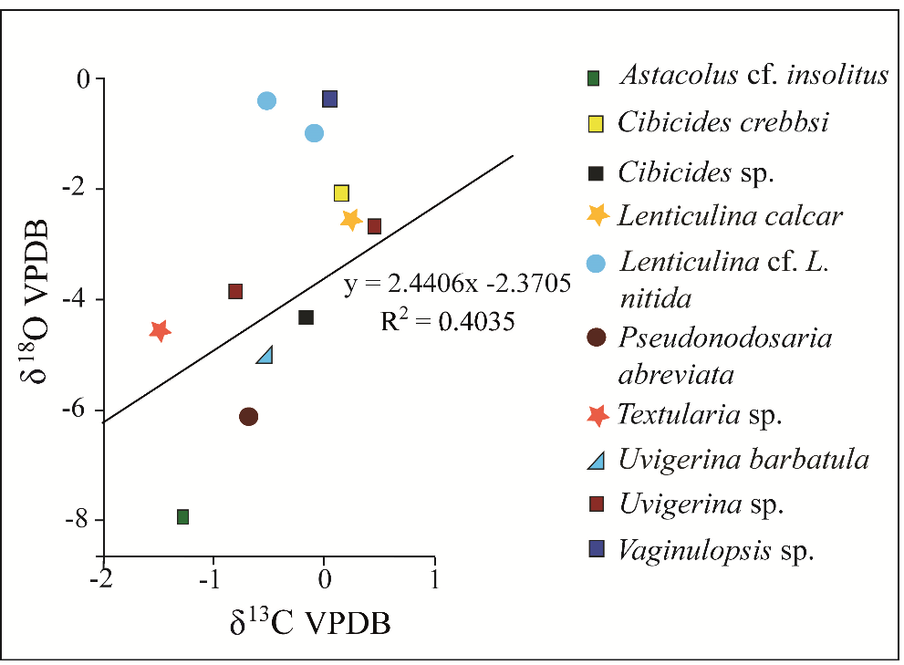

**Fig. 9. Covariance between δ18Ow and δ13C for the foraminifera in the Muşardağı Section, represented by cross plots and histograms**

Some of the isotopic deviations observed in the δ18O and δ13C curves in the Yazıhan and Musardağı sections are due to the degree of local climatic changes. However, these sections show a significant increase in seawater temperature at certain levels. Two warming phases were observed in the Yazıhan section, while one warming phases were observed in the Musardağı section during the early Miocene. Temperature estimates based on oxygen isotopes of foraminifera at these levels indicated a wide range of seawater temperatures between 13.8 °C and 52.4 °C. The temperature of 52.4 °C is also significantly high for species living in a tropical region (Tables 1 and 2, Figures 10 and 11).

Carbon isotope data from early Miocene samples show the degree of seawater level fluctuation. In addition, the carbon isotope curves indicate changes in ocean productivity and the loss of oxygen (Núñez-Useche et al., 2020). Furthermore, sea level is associated with δ18O values, and as δ18O values ​​become negative, sea level rises (Miller et al., 2008) (Figures 10 and 11).

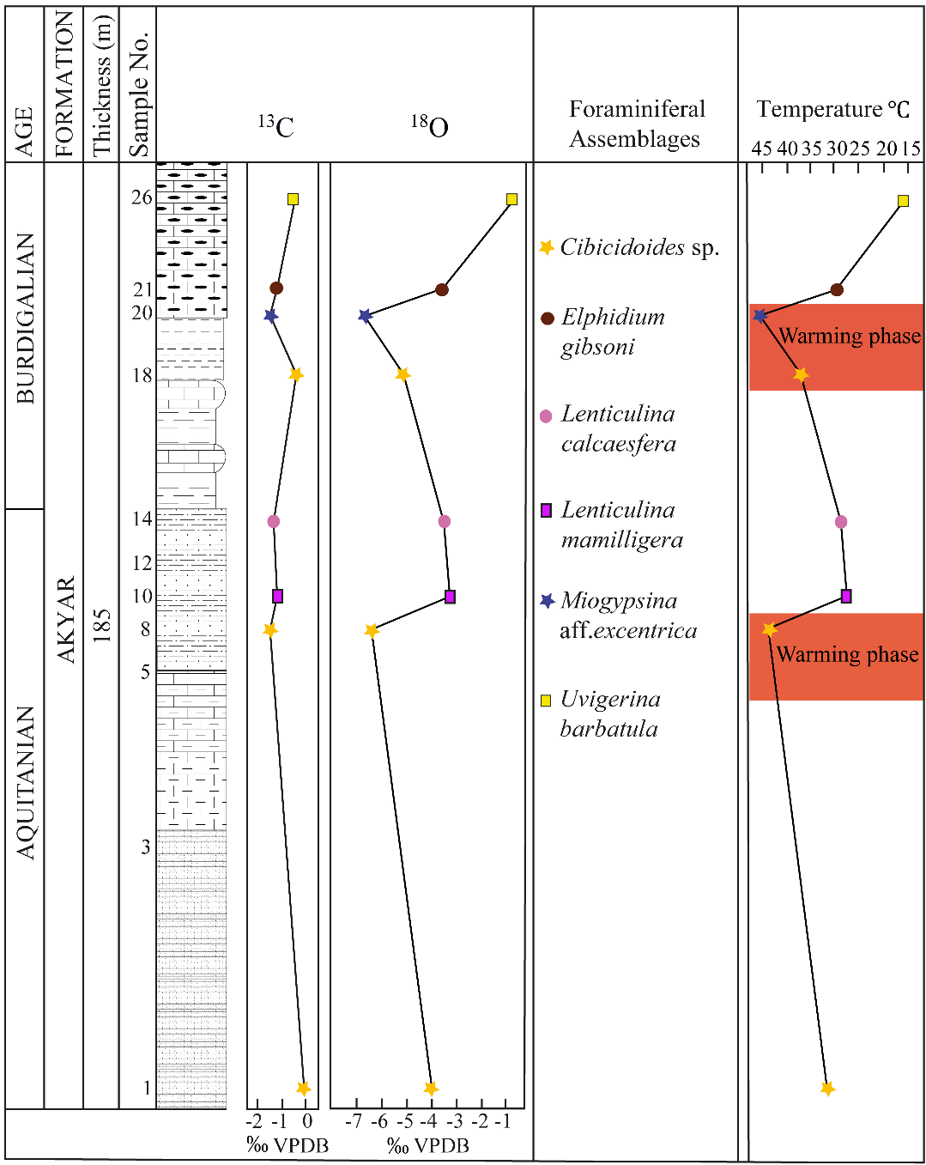

**Fig. 10. Paleotemperature (oC) and δ18Ow (PDB) oscillations in the Yazıhan Section during the early Miocene**

The signals from the most stable isotopes were analyzed and interpreted in terms of air temperature. However, Craig and Gordon (1965) established a salinity-water isotope relationship regarding paleosalinity. In the subsequent years, several other methods were developed to determine paleosalinity using δ18Osw (e.g.; Malaizé & Caley, 2009; Railsback & Anderson, 1989; Wolff et al., 1999). The application of these methods yielded paleosalinity values indicating that the paleosalinity was within the normal levels.

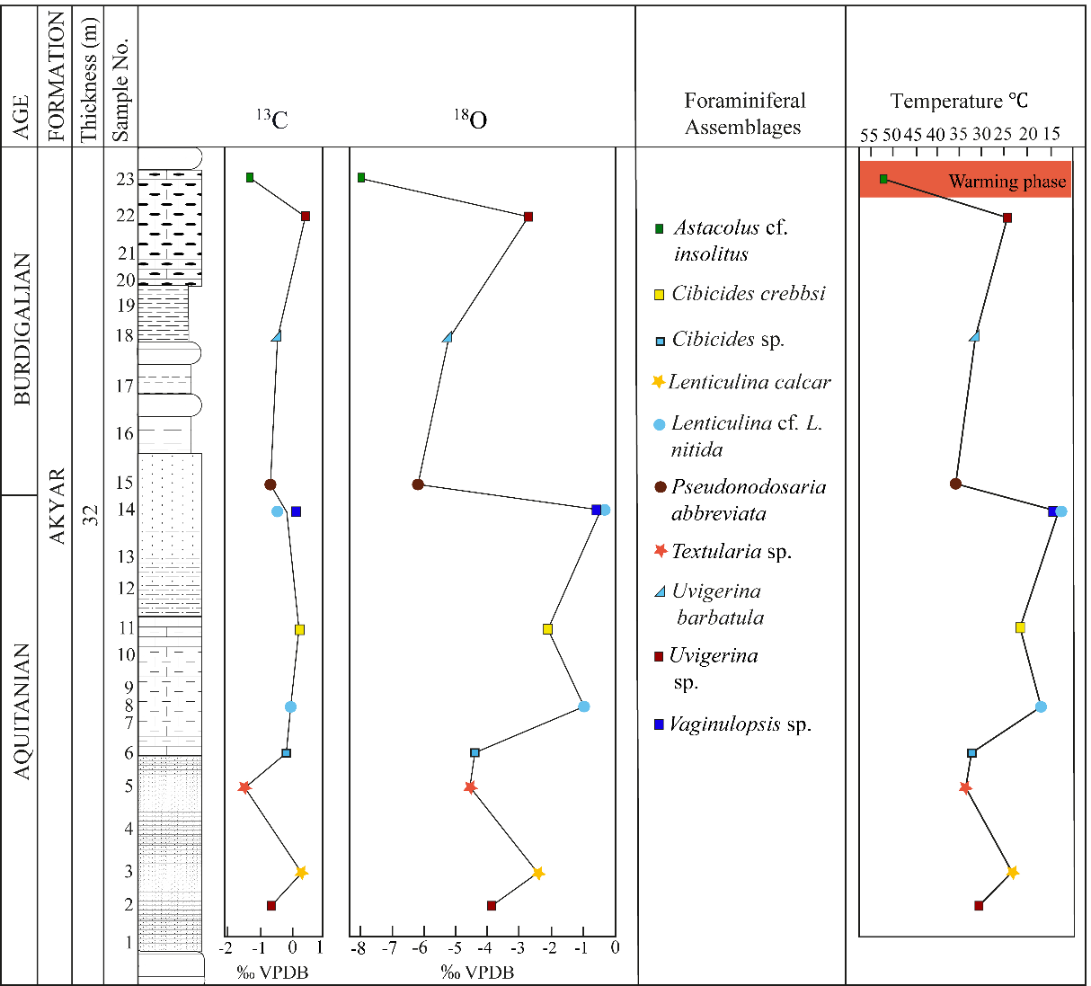

**Fig. 11. Paleotemperature (oC) and δ18Ow (PDB) oscillations in the Muşardağı Section during the early Miocene**

**4.3.** **Discussion**

Allan and Matthews (1982) proposed that δ18O readings in foraminifera typically range from -2 to +2‰. Our investigation indicates that the measured δ18O levels are markedly more negative. Contrary to the potential 1‰ variance in δ18O readings of *Lenticulina* species documented by Grossman (1987) and Dubicka et al. (2021), a discrepancy of -2.13‰ is observed in the Musardağı section.

Kennett (1977) argued that the sea surface temperatures of the Subantarctic and Antarctica were significantly warmer than they are today during the early Miocene. Savin et al. (1981) and Miller et al. (1987) suggested that δ18O values exhibited an increasing trend toward the end of the early Miocene. Anthonissen (2012) also noted that warming during the early Miocene occurred in the northeastern North Atlantic. Conversely, Shackleton and Kennett (1975) and Shackleton (1977) found that the warmest period in the early Miocene reached 10°C. They also reported that the δ¹⁸O values for the genus *Uvigerina* were positive, ranging from 0.71 to 4.11, while the δ¹³C values ranged from -0.46 to +1.27.

In our study, the δ¹⁸O values for the genus *Uvigerina* ranged from -3.90 to -0.80‰, indicating negative values, while the δ¹³C values varied from -0.79 to +0.59‰. Based on the δ¹⁸O values for the foraminifera in the Yazıhan section, the lowest and highest seawater temperatures were 16ºC and 45.1ºC, respectively (Table 1 and Fig. 10). The estimated seawater temperature for the Muşardağı section ranged from 13.8ºC to 52.4ºC (Table 2 and Fig. 11). This notable increase in temperature cannot be solely attributed to seasonal variations. Large-scale polar ice sheet formation, volcanic activity, and significant evaporation can all contribute to changes in the water isotope ratio (Hudson & Anderson, 1989). The studied area has documented considerable volcanic activity (Bozkaya & Yalçın, 1991; Ercan & Asutay, 1993; Gürer, 1992). Therefore, the shift in the water isotope ratio resulted in abnormal increases in seawater temperature.

Haq et al. (1988) and Zachos et al. (2001) indicated in their research that sea levels experienced a relative decline during the late Aquitanian. The results from the studied sections also suggest that the sea level decreased at the end of the Aquitanian.

Even though the δ18O values of the foraminiferal fauna found in this study are much more negative than those from similar studies in different regions of the world during the early Miocene, the δ13C values match those findings.

**5. CONCLUSION**

Based on the species of the benthic foraminiferal genera, SBZ24 and SBZ25 were zones determined in the early Miocene sediments from the Hekimhan sub-basin, eastern Türkiye. Foraminiferal assemblages and "*Hyotissa hyotis*" indicate the age of the Akyar Formation in the early Miocene (Aquitanian-Burdigalian).

The δ18O and δ13C analysis results of early Miocene foraminiferal species indicate short-term temperature decreases and overheating phases. In the early Miocene, δ18O values are between -7.99 and -0.27‰, and paleotemperatures range from 13.8ºC to 52.4ºC. We believe that the short-term, extreme increase in temperature likely originated from the Yamadağ Volcanism, located north of the study area, which dates from the late Cretaceous to the middle-late Miocene.

δ13C values ​​varying between -1.56 and +0.41‰ provide information on the sea-level changes. The stable isotope analysis results and fossil content indicate the sea-level changes during the early Miocene. According to the fossil coverage and results of calculations based on δ18O values, paleosalinity was at the normal level.

The biotic assemblages of the shallow marine part of the Akyar Formation demonstrate that deposition took place in a shallow marine environment in the warm waters of tropical and subtropical regions; a significant increase in the abundance of infaunal and planktonic taxa is an indicator of transition to a low-energy, middle-outer shelf environment.

**DISCLAIMER (ARTIFICIAL INTELLIGENCE)**

The author(s) hereby declare that no generative AI technologies such as Large Language Models (ChatGPT, COPILOT, etc.) or text-to-image generators were used in the creation or editing of this manuscript.

Competing interests

The authors have stated that no competing interests exist.

**REFERENCES**

[Allan](https://onlinelibrary.wiley.com/action/doSearch?ContribAuthorRaw=ALLAN%2C+JR), J.R., [& Matthews](https://onlinelibrary.wiley.com/action/doSearch?ContribAuthorRaw=MATTHEWS%2C+RK), R.K. (1982). Isotope signatures associated with early meteoric diagenesis. Sedimentology, 29(6), 797–817.

Anthonissen, E. (2012). A new Miocene biostratigraphy for the northeastern North Atlantic: an integrated foraminiferal, bolboformid, dinoflagellate and diatom zonation. Newsletters on Stratigraphy, 45(3), 281–307.

Asutay, H. J. (1988). Geological and petrographic investigation of the Baskil (Elazığ) surroundings. Bulletin of the Mineral Research and Exploration, 107, 47–63. in Turkish with English abstract.

Avşar, N. (1983). Stratigraphic and micropaleontological investigations in the near northwest of Elazığ. Ph.D. Thesis, University of Fırat, Elazığ, Türkiye, 84p. in Turkish with English summary.

Ayan, T., & Bulut, C. (1961). Detailed geology and petroleum potential of the Hekimhan-Ebreme region (north of Malatya). The Mineral Research and Exploration Report*,* 4186. in Turkish.

Ayyıldız, T., Varol B., Önal M., Tekin E., & Gündoğan, İ. (2015). Cretaceous-Tertiary (K-T) boundary evaporites in the Malatya Basin, Eastern Turkey. Carbonates Evaporites, 30, 461–476.

Bieler, R., Mikkelsen, P.M., Lee, T., & Foighil, D.Ó. (2004). Discovery of the Indo-Pacific oyster *Hyotissa hyotis* (Linnaeus, 1758) in the Florida Keys (Bivalvia: Gryphaeidae). Molluscan Research, 24, 149–159.

Birand, Ş.A. (1938). Geological observations around Malatya (Geologie Beobachtungen bei Malatya). Ankara Higher Institute of Agriculture Publication, 88. in Turkish.

Boersma, A. (1977). Eocene to Early Miocene Benthic Foraminifera, South Atlantic. Deep Sea Drilling Project Leg 39. Lamont-Doherty Geological Observatory (pp. 643–656). Palisades, New York. https://doi.org/10.2973/DSDP.PROC.39.129.1977

Bolli, H.M., Beckmann, J.P., & Saunders, J.B. (1994). Benthic Foraminiferal Biostratigraphy of the South Caribbean Region. (p. 265). Cambridge University Press.

Bozkaya, Ö., & Yalçın, H. (1991). Mineralogy and geochemistry of the Upper Cretaceous-Tertiary units in the eastern and southern parts of Hekimhan. 44th Bulletin of the Turkish Geological Congress, 6, 234–252. in Turkish with English abstract.

Cahuzac, B., & Poignant, A. (1997). Essai de biozonation de l’Oligo-Miocène dans les bassins européens à l’aide des grands foraminifères néritiques. Bulletin de la Société géologique de France, 168(2), 155–169.

Coplen, T.B., Hopple. J., & Kendall, C. (1983). Comparison of stable isotope reference samples. [Nature](https://www.nature.com/), 302, 236–238.

Craig, H., & Gordon, L. I. (1965). Deuterium and oxygen 18 variations in the ocean and the marine atmosphere, in Stable Isotopes in Oceanographic Studies and Paleotemperatures. In Proceedings of the Third Spoleto Conference, Spoleto- Italy, (pp. 9–122).

Cristín, A., & Perriliat, M.C. (2013). Revision of Late Cenozoic *Hyotissa* (Bivalvia: Pycnodonteinae) from Western North America. Revista Brasileira De Paleontologia, 16(3), 397–426.

D’Onofria, R., Zaky, A.S., Frontalini, F., Luciani V., Catanzariti R., Francescangeli, F., Giorgioni M., Coccioni, R., Özcan, E., & Jovane, L. (2021). Impact of the Middle Eocene Climatic Optimum (MECO) on Foraminiferal and Calcareous Nannofossil Assemblages in the Neo- Tethyan Baskil Section (Eastern Turkey): Paleoenvironmental and Paleoclimatic Reconstructions. Applied Sciences, 11(23), 11339. <https://doi.org/10.3390/app112311339>

Douglas, R.G. (1973). Benthonic foraminiferal biostratigraphy in the Central North Pacific, Leg 17, Deep Sea Drilling Project. In Winterer EL, Ewing JI, et al, Initial Reports of the Deep Sea Drilling Project, 17, (pp. 607–672). U.S. Government Printing Office Washington.

Drooger, C.W. (1993). Radial Foraminifera, morphometrics and evolution. Biology, 41, 1–242.

Dubicka, Z., Wierzbowski, H., & Pałczynska, A. (2021). Can oxygen and carbon isotope ratios of Jurassic foraminifera be used in palaeoenvironmental reconstructions? Palaeogeography, Palaeoclimatology, Palaeoecology, 577, 110554. <https://doi.org/10.1016/j.palaeo.2021.110554>

Ellis, B.F., & Messina, A. (1940). Catalogue of Foraminifera.Spec. Publisher: [The American Museum of Natural History](https://openlibrary.org/publishers/The_American_Museum_of_Natural_History" \o "Show other books from The American Museum of Natural History) New York.

Emiliani, C. (1955). Pleistocene temperatures. The Journal of Geology, 63(6), 538–578.

Ercan, T., & Asutay, H.J. (1993). Petrology of Neogene-Quaternary Volcanics in the Malatya-Elazığ-Tunceli-Bingöl-Diyarbakır Region. Proceedings of A. Suat Erk Geology Symposium 2-5 September 1991, Ankara, (pp. 291–302). in Turkish with English abstract.

Gedik, F. (2015). Benthic foraminiferal biostratigraphy of Malatya Oligo-Miocene succession (Eastern Taurids, Eastern Turkey). Bulletin of the Mineral Research Exploration, 150, 19–50.

Giorgioni, M., Jovane, L., Rego, E.S., Rodelli, D., Frontalini, F., Coccioni, R., Catanzariti, R., & Özcan, E. (2019). Carbon cycle instability and orbital forcing during the Middle Eocene Climatic Optimum. Scientific Reports, 9, 9357. https://doi.org/10.1038/s41598-019-45763-2

Glenn, L.C. (1904). Systematic paleontology of the Miocene deposits of Maryland: Pelecypoda. Baltimore- USA (pp. 274–401). Johns Hopkins Press.

Görmüş, M. (1992). Biostratigraphic investigation of the successions in the Hekimhan (NW-Malatya, Türkiye) region. Geological Bulletin of Turkey, 7, 179–191. in Turkish with English abstract.

Grossman, E.L. (1987). Stable isotopes in modern benthic foraminifera- a study of vital effect. Journal of Foraminiferal Research, 17(1), 48–61.

Gürer, Ö.F. (1992). Geological investigation of the Hekimhan-Hasançelebi (Malatya) area. PH. D. Thesis, Istanbul University, Institute of Science and Technology, 323p. in Turkish with English summary.

Haq, B.U., Hardenbol, J., & Vail, P.R. (1988). Mesozoic and Cenozoic chronostratigraphy and eustatic cycles. In: Wilgus CK, Kendall, CGStC Posamentier, HW Ross, CA Van Wagoner, JC (eds), Sea-level Changes: an Integrated Approach. SEPM special publication 42 (pp. 71–180). SEPM Society for Sedimentary Geology. <https://dx.doi.org/10.2110/pec.88.01.0071>

Hayward, B.W., & Buzas, M.A. (1979). Taxonomy and Paleoecology of Early Miocene Benthic Foraminifera of Northern New Zealand and the North Tasman Sea. Smithsonian Contributions to Paleobiology, Washington, (vol. 36). Smithsonian Institution Press.

Hudson, J.D., & Anderson, T.F. (1989). Ocean temperatures and isotopic compositions through time. Earth Sciences, 80, 183–192. https://doi.org/10.1017/S0263593300028625

Iaccarino, S.M., Premoli Silva, I., Biolzi, M., Foresi, M., Lirer, F., Turco, E., & Petrizzo, M.R. (2007). Practical Manual of Neogene Planktonic Foraminifera. International School on Planktonic Foraminifera, Universita degli Studi di Milano Dipartimento di Scienze della Terra, Perugia.

Jones, D.S., & Allmon, W. (1995). Records of upwelling, seasonality and growth in stable-isotope profiles of Pliocene mollusk shells fiom Florida. Lethaia An International Journal of Palaeontology and Stratigraphy, 28, 61–74.

Kender, S., Kaminski, M.A., & Jones, R.W. (2008). Early to middle Miocene foraminifera from the deep-sea Congo Fan, offshore Angola. Micropaleontology, 54(6), 477–568.

Kennett, J.P. (1977). Cenozoic evolution of Antarctic glaciation, the circum- Antarctic Ocean, and their impact on global paleoceanography. Journal of Geophysical Research, 82(27), 3843–3860.

Koral, H., & Önal, M. (2007). Episodic neotectonic escape in the eastern Taurids, SE Turkey: The Malatya Basin. International Geoscience Programmed 521-481 Joint Planary Meeting and Field Trip 8-15 September 2007, Gelendzhic Russia, p. 111.

Loeblich, A.R., & Tappan, H. (1988). Foraminiferal genera and their classification. New York.

Malaizé, B., & Caley, T. (2009). Sea surface salinity reconstruction as seen with foraminifera shells: Methods and cases studies, (pp. 177-188). The European Physical Journal Conferences, 1, <https://doi.org/10.1140/epjconf/e2009-00919-6>

Miller, K.G., Aubry, M.P., Khan, M.J., Melillo, A.J., Kent, D.V., & Berggren, W.A. (1985). Oligocene–Miocene biostratigraphy, magnetostratigraphy, and isotope stratigraphy of the western North Atlantic. Geology, 13(4), 257-261.

Miller, K.G., Fairbanks, R.G., & Mountain, G.S. (1987). Tertiary oxygen isotope synthesis, sea level history, and continental margin erosion. Paleoceanography, 2, 1-19.

Miller, K.G., Browning, J.V., Aubry, M.P., Wade, B.S., Katz, M.E., Kulpecz, A.A., & Wright, J.D. (2008). Eocene–Oligocene global climate and sea-level changes: St. Stephens Quarry, Alabama. GSA Bulletin, 120(1/2), 34-53. https://doi: 10.1130/B26105.1

Murray, J.W. (2006). Ecology and Applications of Benthic Foraminifera. Cambridge University Press.

Nebelsick, J.H., Kroh, A., & Roth-Nebelsick, A. (2013). The legacy of ocean climate and chemistry change in the echinoderm fossil record (pp. 11-22). London & New York.

Nomura, R. (1986). Geology of the central part in the Shimane Peninsula: Part 2: Biostratigraphy and paleoenvironment viewed from benthic foraminifera. Journal of the Geological Society of Japan, 92, 461-475.

Núñez-Useche, F., Barragán, R., Torres-Martínez, M.A., Lopez-Zúñiga, P.A., Moreno-Bedmar, J.A., Chávez-Cabello, G., Canet, C., & Chacon-Baca, E. (2020). Response of the western proto-North Atlantic margin to the early Aptian oceanic anoxic event (OAE) 1a: an example from the Cupido platform margin-Gulf of Mexico, NE Mexico. Cretaceous Research, 113, 1-37. https://doi.org/10.1016/j.cretres.2020.104488

Önal, M. (1988). Geology and hydrocarbon possibilities of the eastern part of the Malatya Basin (Muşardağı). Turkish Petroleum Corporation Exploration Group, 3863, p. 91. in Turkish.

Önal, M. (2009). Organic geochemical properties of marine Oligocene unit in the Malatya basin, east Anatolia, Turkey. Energy Sources, A31, 1406-1414.

Önal, M., & Gözübol, A.M. (1992). Stratigraphy, age, sedimentary facies, depositional environments, and tectonic evolution of the cover units overlying the Malatya metamorphics. Turkish Association of Petroleum Geologist Bulletin, 4, 119-127. in Turkish with English abstract.

Önal, M., & Kaya, M. (2007). Stratigraphy and tectono-sedimentary evolution of the Upper Cretaceous-Tertiary sequence in the southern part of the Malatya Basin, East Anatolia, Turkey. Journal of Asian Earth Sciences, 29, 878-890.

Örçen, S. (1986). Biostratigraphy and paleontology of the Medik-Ebreme (NW Malatya) area. Bulletin of the Mineral Research and Exploration, 105-106, 15-45.

Railsback, L.B., & Anderson, T.F. (1989). Paleoceanographic Modeling of Temperature-Salinity Profiles From Stable Isotopic Data, *Paleoceanography*, *4(5)*, 585–591.

Rögl, F., & Spezzaferri, S. (2002). Foraminiferal paleoecology and biostratigraphy of the Mühlbach section (Gaindorf Formation, Lower Badenian), Lower Austria. Annals of the Natural History Museum(pp. 23–75).Wien, Austria.

Sarı, B., Yıldız, A., Korkmaz, T., & Petrizzo, M.R. (2016). Planktonic foraminifera and calcareous nannofossils record in the upper Campanian-Maastrichtian pelagic deposits of the Malatya Basin in the Hekimhan area (NW Malatya, eastern Anatolia). Cretaceous Research, 61, 91–107.

Savin, S.M., Douglas, R.G., Keller, G., Killingley, J.S., Shaughnessy, L., Sommer Vincent E., & Woodruff, F. (1981). Miocene benthic foraminiferal isotope records: a synthesis. Marine Micropaleontology, 6, 423–450.

Shackleton, N.J. (1974). Attainment of Isotopic Equilibrium between Ocean Water and Benthonic Foraminifera Genus *Uvigerina;* Isotopic Changes in the Ocean During the Last Glacial. International conferences. National Center for Scientific Research (France), 219, 203–209.

Shackleton, N.J. (1977). Carbon-13 in *Uvigerina*: Tropical rainforest history and the Equatorial Pacific carbonate dissolution cycles, in The Fate of Fossil Fuel CO2 in the Oceans. Plenum Publishing Corporation 10, 401–428.

Shackleton, N.J., & Kennett, J.P. (1975). Paleotemperature history of the Cenozoic and the initiation of Antarctic glaciation: oxygen and carbon isotopic analyses in DSDP Sites 277, 279, and 281 (pp. 743–755). Washington.

Spezzaferri, S., Olsson, R.K., & Hemleben, C. (2018). Taxonomy, biostratigraphy, and phylogeny of Oligocene to Lower Miocene *Globigerinoides* and *Trilobatus.* In Cushman Foundation Special Publication, 46(9), 269–306.

Székely, S.F., Haitonic-Bindiu, R., Filipescu, S., & Bercea, R. (2017). Biostratigraphy and paleoenvironmental reconstruction of the marine lower Miocene Chechiș Formation in the Transylvanian Basin based on foraminiferal assemblages, Carnets de Geologie, 17(2), 1–27.

Şengör, A.M.C., & Yılmaz, Y. (1983). Evolution of Neo-Tethyan in Turkey. Turkish Geological Society Special Publication (Vol. 1, pp. 1–75).

Türkmen, İ., Aksoy, E., & Koç, C. (2007). Alluvial and lacustrine facies in an extensional basin: Miocene of the Malatya Basin, eastern Turkey. Journal of Asian Earth Sciences, 30, 181–198.

Ural, M. (2013).Morphologic and physical features of pillow basalts of the Yüksekova Complex around Elazığ (Eastern Anatolia, Turkey). Journal of Tethys, 2(1), 70–80.

Ural, M., Arslan, M., Göncüoğlu, M.C., Tekin, U.K., & Kürüm, S. (2015). Late Cretaceous arc and back-arc formation within the Southern Neotethys: whole-rock, trace element and Sr-Nd-Pb isotopic data from basaltic rocks of the Yüksekova Complex (Malatya–Elazığ, SE Turkey). Ofioliti, 40(1), 53–72.

Van Morkhoven, F.P.C.M., Berggren, W.A., & Edwards, A.S. (1986). Cenozoic Cosmopolitan Deep-Water Benthic Foraminifera. Bulletin of the Elf-Aquitaine Exploration-Production Research Centers. Memory, 11, 1–421.

Wolff, T., Grieger, B., Haie, W., Dürkoop, A., Mulitza, S., Pätzold, J., & Wefer, G. (1999). On the Reconstruction of Paleosalinities, Use of Proxies in Paleoceanography: Examples from the South Atlantic (pp. 207–228). Springer-Verlag Berlin Heidelberg.

Woodruff, F. (1985). Changes in Miocene deep-sea benthic foraminiferal distribution in the Pacific Ocean: relationship to paleoceanography. Geological Society of America Memoir, 163, 131–176.

Zachos, J.C., Berggren, W.A., Aubry, M.P., & Mackensen, A. (1992). Isotope and trace element geochemistry of Eocene and Oligocene foraminifers from site 748, Kergueten Plateau. In: Wise SW, Schlich R et al. (eds) Proceedings of the Ocean Drilling Program, Scientific Results, 12, 839–854.

Zachos, J.C., Pagani, M., Sloan, L., Thomas, E., & Billups, K. (2001). Trends, rhytms, and aberrations in global climate 65 Ma to present. Science, 292, 686–693.