Beyond the Haze: A Scientific Evaluation of Black Soot and Their Possible Impacts on Human Health

ABSTRACT
Black soot pollution has been a severe environmental and public health challenge in Port Harcourt, Nigeria. Port Harcourt is a metropolitan city in Nigeria and has experienced the hike of release of black soot (PM_{2.5} and PM_{10.0}) in recent years due the operations of illegal crude oil refining, gas flaring, and industrial emissions other oil exploration activities. There have been frantic efforts by the government and other concerned bodies over time to curb the hazards. Therefore, this study seeks to ascertain the current status of the concentration of black soot particulates in Port Harcourt, with a focus on the chemical composition and associated health risks to the local population. The Met One Aerocet 531S Particle Counter and High-Volume Air Sampler were employed to quantify particulate concentrations in different locations while subsequent laboratory analyses identified the presence of heavy metals and polycyclic aromatic hydrocarbons (PAHs) within the soot samples. The results shows that values of concentrations of particulate matter (PM_{2.5} and PM₁₀) in the sample locations ranged from 17.60µg/m³ to 46.23µg/m³ and 100.25µg/m³ to 282.32µg/m³ which exceeds the World Health Organization (WHO) safe limits of 15 µg/m³ for PM_{2.5} and 45 µg/m³ for PM₁₀ (WHO, 2021). Notably, specific areas near industrial zones and illegal oil refining sites exhibited PM₁₀ levels that were three times higher than the safe limits. The analysis of polycyclic aromatic hydrocarbons (PAHs) reveals the presence of Benzo(b)fluoranthene, Benzo(k)Flouranthene, Benzo(a)Pyrene, Indeno(1,2,3-c,d)pyrene and Dibenz(a,h)anthracene, with concentrations varying across different locations. However, the Incremental Lifetime Cancer Risk (ILCR) for both children and adults did not exceed the acceptable risk level of 1 in 1,000,000 mg/kg (10⁻⁶). The study concludes with a call for more regulatory measures to control emissions from industrial and vehicular sources, alongside public awareness campaigns to educate the community about the dangers of black soot pollution.

Keywords: Black Soot, Particulate Matter, Polycyclic Aromatic Hydrocarbons (PAHs), Incremental Lifetime Cancer Risk (ILCR)

- INTRODUCTION
Black soot or black carbon (BC), is a fine black or brown powder that can be slightly sticky, and is a byproduct of incomplete combustion of fossil fuels (coal, diesel, gasoline, etc.), biofuels (biodiesel, biogas, ethanol, etc.), and biomass (woods, shrubs, dry leaves, etc.) (EPA, 2012). In pollution terms, soot is a common word for a type of particle pollution known as PM_{2.5}—particulate matter with a diameter of 2.5 micrometers or less. These microscopic particles are even smaller than dust and mold particles, or around 1/30 the size of a human hair (Elem, 2021; American Public Health Association, 2020). The tiny particles in soot (PM_{2.5}) pose unique health challenges. When inhaled, the small particles’ size allows them to penetrate deep into bronchiolar tissue, producing oxidative stress, pulmonary inflammation, and potentially deoxyribonucleic acid damage (Valavanidis et al., 2013; Niranjan & Thakur, 2017; Whyte et al., 2020;).
Soot is released into the air as either very minute particles or liquid droplets. PM_{2.5} has been related to adverse impacts on ecosystems, visibility impairment, reduced agricultural production in some parts of the world, and materials soiling and degradation (EPA, 2012). A primary component of soot is black carbon which absorbs light more than any other particle matter. For example, black carbon may absorb a million times more energy than the same mass’s carbon dioxide (CO₂). Because of this energy absorption and interaction with clouds, black carbon is a significant source of concern for climate change. It is linked to rising temperatures, ice, and snow melting, especially in sensitive areas (EPA, 2012).
In recent years, Port Harcourt, Nigeria’s oil-rich city in the Niger Delta, has encountered a slew of environmental degradation, which constitutes a source of tension among different stakeholders (government, oil industries, community members, and civil societies). However, the most devastating of these is soot pollution (black carbon), affecting the city and its environs. Port Harcourt, one of the cities in Nigeria, is the heart of oil and gas exploration in the region is significantly affected by the immense oil exploration and production operations as well as the high population growth rate (Olowoporoku et al., 2021; Yakubu, 2017; Whyte et al., 2020).
Similarly, the usage of biomass fuels such as firewood, indiscriminate burning of plants and garbage, traffic and industrial pollutants, and gas flaring have all contributed to the air pollution in this region (Godson, 2011; Omisakin, 2022; Whyte et al., 2020).
Also, illicit (or artisanal) refineries built up in the bushes, has expanded in recent years in the oil-rich Niger Delta region environs (Ihesinachi et al., 2019, Ede & Edokpa, 2017).
This contributes to the spread of soot pollution, which consists of impure carbon particles generated from the incomplete combustion of hydrocarbons.
This study aims to provide a comprehensive analysis of the current level of black soot pollution and evaluate the potential health risk, thereby offering insights into the effectiveness of any measures taken to address this issue and the impact on public health over time.

2.0. MATERIALS AND METHOD
I Site Selection
Port Harcourt is the capital of Rivers State and a major metropolitan city in the Niger Delta, covering approximately 1,811.6 km² with a population of about 1.5 million. It serves as the state’s principal urban center and hosts one of the largest seaports in the region, making it a hub for administration, commerce, and industry. Geographically, the city lies between latitudes 4°45′N and 4°55′N and longitudes 6°55′E and 7°05′E (Figure 1), at the entrance of the Bonny River. Its mean elevation is about 18 m above sea level, situated between the Dockyard Creek/Bonny River and the Amadi Creek (Federal Republic of Nigeria [FRN], 2007).
Geographical location and topography of Port Harcourt is such that airborne pollutants travel fast and the farthest, as highlands are practically absent. Studies suggest that periodic plumes of pollutants from industrial discharges, a principal source of air pollution, constitutes a frequent occurrence in the city. Furthermore, occurrence of land breeze, as well as Harmattan, facilitate emission transfer into the city (Ayoade, 2004; Nwankwo &Egbule, 2011).
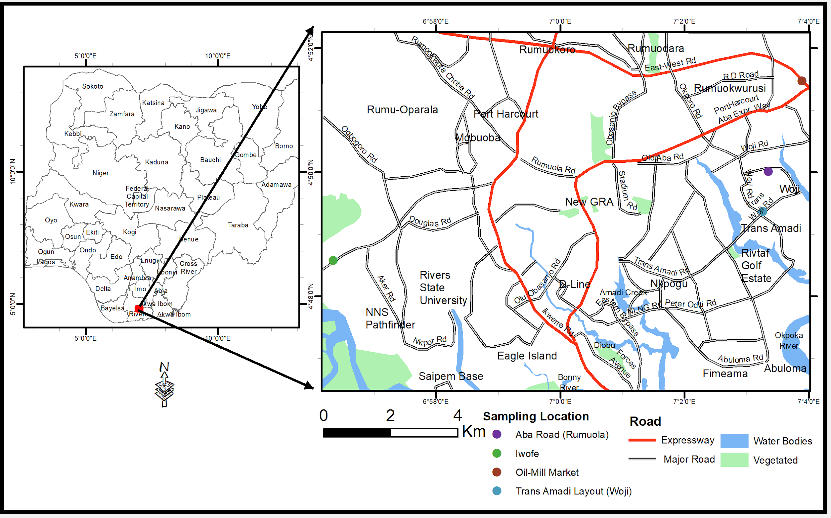
Figure 1: Location Map of the Study Area
II Data collection
High-Volume Air Sampler equipped with filters, designed to collect air samples over a continuous 8-hour period was used to collect the air samples from the study locations. The Met One Aerocet 531S Particle Counter, which is a portable device capable of detecting and counting particles in the air, was used in the measurement of the PM2.5 and PM 10.0. The Particle Counter was mounted on a platform about 1.8m high to measure the particulate matters within each of the study locations. The sampling techniques for the study were systematic and strategic to ensure that the data collected were representative of the various areas within the city. The sample locations included; Trans Amadi (Woji), Iwofe, Aba-road (Rumuola) and Oilmill (Eleme junction), based on geographic, demographic, and industrial criteria. Each of the mentioned locations represents a stratum with potentially different levels of black soot pollution due to varying sources and activities. The data were collected for the period of 3 months (June to August 2024).
The particle counter measured concentrations of different sizes of particulate matter, but the research is narrowed down to PM_{2.5} and PM₁₀ which represent the black soot. These measurements were taken at regular intervals throughout the day to capture variations in air quality. The data collected provided real-time readings of particulate matter concentrations, which was then recorded and averaged. The result of the measured data of the PM2.5 and Pm 10.0 at the study locations are presented in Table 1.

II Data Analysis
The health risk of the black soot concentration in the study areas were determined using the expression in equation 1, (EPA, 2011):
$R=\frac{C×IR×EF×ED}{BW×AT}$ (1)
where $R$ is the risk level or hazard quotient for a single pollutant,
$C$ is the concentration of the pollutant,
$IR$ is the inhalation rate,
$EF$ is the exposure frequency,
$ED$ is the exposure duration,
$BW$ is the body weight,
and $AT$ is the Averaging Time.
Using the assumptions and recommendations of the World Health Organization (WHO, 2005) and the United States Environmental Protection Agency (EPA, 2011) for inhalation exposure assessment, the values of these parameters are as follows:
$$IR=20 m^{3}/day$$
$$EF=350 days/year$$
$$ED=30 years$$
$$BW=70 kg$$
$$AT=30 years × 365 days/year$$
$C$ was obtained from the mean concentrations of the pollutants. The risk levels (R) were calculated for PM_{2.5} and PM₁₀, as well as for the heavy metals and PAHs. The unit of R is milligrams of contaminant per kilogram of body weight per day (mg/kg/day). It measures the amount of a contaminant that enters the body through breathing contaminated air.
III Concentration of Polycyclic Aromatic Hydrocarbons (PAHs)
The measured PAHs for the various location areas are presented in Table 2. The result showed varying levels of both Low Molecular Weight (LMW) and High Molecular Weight (HMW) PAHs. Table 3 (a) and 3 (b) also presents the carcinogenic risk analysis of selected PAHs for children and adults in the study area.
IV Heavy Metals in the Study
The measured concentration of heavy metals in the study area focused on Copper (Cu), Lead (Pb), Nickel (Ni), Chromium (Cr) and Cadmium (Cd) across the four locations, is presented in Table 4.

- RESULTS AND DISCUSSION
- Particulate Matter
The measured particulate matter (PM₁ – PM₁₀) for the various locations in the study area is presented in Table 1. The table also presents the WHO (2021) allowable standards for the particulate matter measured.

Table 1: Concentration of measured particulate matter at different locations
Study Location | Months | Concentration (µg/m³)
Study Location | Months | PM₁ | PM_{2.5} | PM₄ | PM₇ | PM₁₀
Iwofe | June | 5.25 | 18.85 | 48.70 | 95.85 | 130.30
Iwofe | July | 4.20 | 21.65 | 48.95 | 100.95 | 150.00
Iwofe | August | 3.30 | 30.25 | 66.30 | 116.85 | 151.30
Woji | June | 2.25 | 31.90 | 77.15 | 121.55 | 150.00
Woji | July | 4.25 | 24.00 | 52.40 | 99.80 | 128.80
Woji | August | 4.30 | 17.60 | 42.20 | 79.15 | 100.25
Aba Road | June | 6.50 | 44.25 | 125.30 | 213.85 | 240.15
Aba Road | July | 5.30 | 36.85 | 120.75 | 295.40 | 216.50
Aba Road | August | 5.00 | 34.40 | 68.75 | 120.15 | 271.20
Oil-Mill Market | June | 7.11 | 46.23 | 141.21 | 235.43 | 263.22
Oil-Mill Market | July | 6.32 | 39.15 | 146.34 | 254.23 | 282.32
Oil-Mill Market | August | 6.14 | 38.47 | 77.15 | 172.03 | 211.54
Range |  | 2.25 – 7.11 | 17.60 – 46.23 | 42.20 – 146.34 | 79.15 – 295.40 | 100.25 – 282.32
WHO |  | – | 15.00 | – | – | 45.00

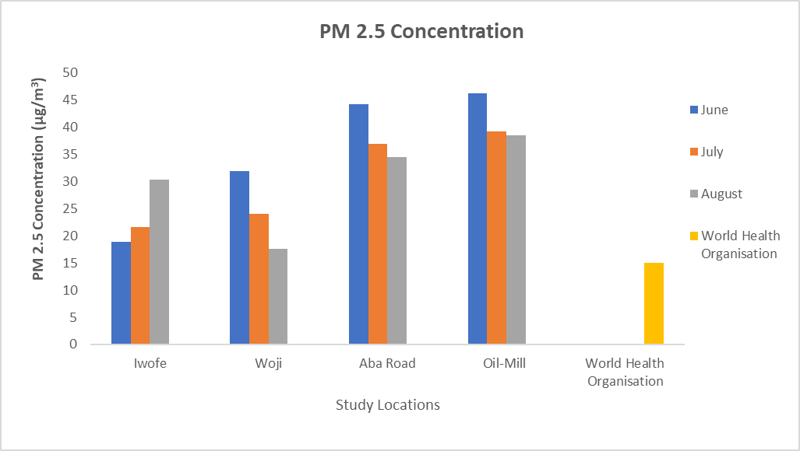
Figure 2: PM_{2.5} Measured in the Study Area
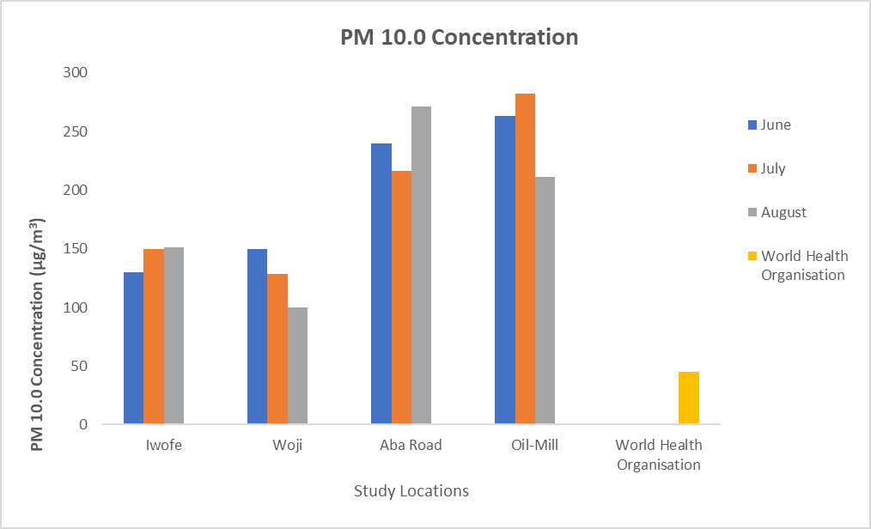
Figure 3: PM_{10.0} Measured in the Study Area
The analysis of particulate matter (PM) concentrations across different study locations and months reveals significant variations. At Iwofe, PM₁ concentrations ranged from 3.30 µg/m³ in August to 5.25 µg/m³ in June. PM_{2.5} levels were highest in August at 30.25 µg/m³, exceeding the WHO guideline of 15.00 µg/m³. PM₁₀ concentrations also showed an upward trend, peaking at 151.30 µg/m³ in August. In Woji, PM₁ levels were relatively low, with a minimum of 2.25 µg/m³ in June and a maximum of 4.30 µg/m³ in August. PM_{2.5} concentrations varied, with the highest value of 31.90 µg/m³ in June, again surpassing the WHO guideline. PM₁₀ levels were highest in June at 150.00 µg/m³ and lowest in August at 100.25 µg/m³.
Aba Road exhibited the highest particulate matter concentrations among all locations. PM₁ levels peaked at 6.50 µg/m³ in June, while PM_{2.5} concentrations reached a maximum of 44.25 µg/m³ in June, significantly exceeding the WHO guideline. PM₁₀ levels were particularly high, with a peak of 271.20 µg/m³ in August. Oil Mill also showed elevated particulate matter levels. PM₁ concentrations were highest in June at 7.11 µg/m³. PM_{2.5} levels peaked at 46.23 µg/m³ in June, far exceeding the WHO guideline. PM10 concentrations were highest in July at 282.32 µg/m³.
The concentrations of particulate matter (PM_{2.5} and PM₁₀) in Port Harcourt have been a significant concern due to their potential health impacts. In this study, the measured levels of PM_{2.5} and PM₁₀ were found to exceed international air quality standards, indicating a severe pollution problem. Specifically, the concentrations of PM_{2.5} and PM₁₀ were observed to be higher than the World Health Organization (WHO) guidelines, which set the 24-hour mean limits at 15 µg/m³ for PM_{2.5} and 45 µg/m³ for PM₁₀ (WHO, 2021).
Previous studies have also highlighted the high levels of particulate matter in Port Harcourt. For instance, Yakubu (2018) reported that the average PM_{2.5} concentrations in Port Harcourt often exceeded the WHO guidelines, with some areas recording levels as high as 159.23 µg/m³ for PM_{2.5} and 378.39 µg/m³ for PM₁₀. These findings are consistent with the results of this study, which also recorded elevated levels of particulate matter, particularly in areas with high traffic and industrial activities.
The health implications of these high particulate matter concentrations are profound. According to Obiweluozo et al. (2022), exposure to high levels of PM_{2.5} and PM₁₀ is associated with respiratory and cardiovascular diseases, as well as increased mortality rates. The study conducted by Obiweluozo et al. (2022) specifically noted that children and elderly populations are particularly vulnerable to the adverse health effects of particulate matter pollution. This is corroborated by the findings of this study, which identified significant health risks for residents in heavily polluted areas such as Aba Road.
Furthermore, the spatial distribution of particulate matter in Port Harcourt indicates that certain areas are more affected than others. The study by the Centre for Environment, Human Rights and Development (CEHRD) (2020) found that commercial and industrial zones and areas with heavy vehicular traffic had the highest concentrations of PM_{2.5} and PM₁₀. This pattern was also observed in the current study, where locations like Oil Mill showed the highest levels of particulate matter, suggesting localized sources of pollution such as industrial emissions, vehicular exhaust and illegal crude oil refineries.
In comparison to other regions, the particulate matter levels in Port Harcourt are significantly higher. For example, a study conducted in Lagos, another major city in Nigeria, reported lower average concentrations of PM_{2.5} and PM₁₀ (Akinfolarin et al., 2017). This disparity highlights the unique pollution challenges faced by Port Harcourt, likely due to its industrial activities and the prevalence of illegal refining operations, which contribute to the high levels of soot and particulate matter in the air.
The elevated concentrations of PM_{2.5} and PM₁₀ in Port Harcourt pose serious health risks to its residents. The findings of this study align with previous research and show the need for urgent policy interventions to mitigate particulate matter pollution.
The spatial distribution of black soot, as measured by particulate matter (PM) concentrations, varies significantly across the study locations: Iwofe, Woji, Aba Road, and Oil Mill. In Iwofe, PM_{2.5} levels ranged from 18.85 µg/m³ in June to 30.25 µg/m³ in August, with PM₁₀ levels peaking at 151.30 µg/m³ in August. This indicates a moderate presence of black soot, with higher concentrations observed during the rainy season.
Woji exhibited the highest PM_{2.5} concentration in June at 31.90 µg/m³, while PM₁₀ levels were highest in June at 150.00 µg/m³. This suggests that Woji experiences significant black soot pollution, particularly in the early rainy season, potentially due to industrial activities and vehicular emissions.
Aba Road recorded the highest PM_{2.5} levels in June at 44.25 µg/m³, with PM₁₀ concentrations peaking in July at 295.40 µg/m³. These values indicate severe black soot pollution, likely influenced by heavy traffic and commercial activities in the area. The consistently high levels of particulate matter throughout the study period highlight the need for urgent pollution control measures.
Oil-Mill Market showed the highest PM_{2.5} levels in June at 46.23 µg/m³, and PM₁₀ concentrations peaked in July at 282.32 µg/m³. This area appears to be the most polluted among the study locations, with substantial black soot presence likely due to market activities, nearby industrial emissions and illegal refineries. The elevated particulate matter levels across all months emphasize the critical need for effective environmental management strategies to mitigate health risks.
- Concentration Polycyclic Aromatic Hydrocarbons (PAHs)
The measured PAHs for the various location areas are presented in Table 2. The result showed varying levels of both Low Molecular Weight (LMW) and High Molecular Weight (HMW) PAHs. Table 2 (a) and 2(b) also presents the carcinogenic risk analysis of selected PAHs for children and adults in the study area.
The analysis of Polycyclic Aromatic Hydrocarbons (PAHs) in Table 4 reveals significant insights into the composition of black soot particulates in Port Harcourt. The study identified various PAHs, including benzo[a]pyrene, benzo[b]fluoranthene, and chrysene, with concentrations varying across different locations. The highest levels of PAHs were recorded at Aba Road, indicating a major pollution hotspot. These findings are consistent with previous studies that have highlighted the presence of high PAH concentrations in urban areas with significant industrial activities and vehicular emissions (Kalagbor et al., 2019).
The study measured the concentrations of both Low Molecular Weight (LMW) and High Molecular Weight (HMW) PAHs across four locations: Iwofe, Woji, Aba Road, and Oil Mill, over three months (June, July, and August). The results, as presented in Table 4, indicate significant spatial variations in PAH concentrations.
In Iwofe, the total PAH concentrations ranged from 7.2 mg/kg to 10.4 mg/kg, with a mean LMW/HMW ratio of 1.27. This suggests sources, which typically produce LMW PAHs that were more prevalent in June. Woji exhibited a different pattern, with total LMW PAHs ranging from 3.0 mg/kg in August to 4.2 mg/kg in June and July. The total HMW PAHs were relatively stable, ranging from 4.0 mg/kg in August to 4.9 mg/kg in July. The total PAH concentrations ranged from 7.0 mg/kg to 9.1 mg/kg, with a mean LMW/HMW ratio of 0.84, indicating a higher proportion of HMW PAHs.
Aba Road showed significant concentrations of PAHs, with total LMW PAHs peaking at 16.5 mg/kg in July and slightly decreasing to 16.0 mg/kg in August. The total HMW PAHs were lower, ranging from 4.1 mg/kg in July to 4.8 mg/kg in August. This location exhibited the highest PAH concentrations, ranging from 13.2 mg/kg to 20.8 mg/kg, with a mean LMW/HMW ratio of 3.17. The elevated levels of LMW PAHs suggest significant contributions from recent combustion sources.
Oil Mill exhibited the highest concentrations of PAHs. The total LMW PAHs ranged from 9.8 mg/kg in June to 18.0 mg/kg in July and 17.4 mg/kg in August. Total HMW PAHs ranged from 4.1 mg/kg in July to 5.0 mg/kg in August. The total PAH concentrations ranged from 14.2 mg/kg to 22.4 mg/kg, with a mean LMW/HMW ratio of 3.39, similar to Aba Road, indicating substantial soot pollution. The LMW/HMW ratios indicated higher proportions of LMW PAHs in Aba Road and Oil Mill compared to Iwofe and Woji. This suggests that these areas are more polluted with lighter PAHs, which are typically more volatile and can pose different health risks compared to HMW PAHs (Baali & Yahyaoui, 2020).
Soot, a major component of particulate matter (PM), is a significant source of PAHs in urban environments. It is primarily generated from vehicle emissions, industrial activities, illegal refineries and residential heating. The high concentrations of PAHs at Aba Road and Oil Mill suggest these areas are hotspots for soot pollution, likely due to heavy traffic and industrial activities (Tang et al., 2024). The findings of this study are consistent with other research on PAH pollution in urban areas. For instance, a study by Adeniji et al. (2017) reported similar PAH concentration ranges in regions with intense industrial activities. Additionally, the health risks associated with PAH exposure, particularly in areas with high soot pollution, have been well-documented in the literature (Agilent, 2021; Tang et al., 2024).
The presence of PAHs in black soot is primarily due to the incomplete combustion of organic materials, such as fossil fuels, biomass, and waste. In Port Harcourt, the illegal refining of crude oil and the burning of waste are major contributors to the high levels of PAHs. The presence of high levels of LMW PAHs, which are more volatile and can travel longer distances, indicates recent and ongoing combustion activities. In contrast, HMW PAHs, which are less volatile and more likely to adsorb onto particulate matter, suggest the accumulation of older soot particles.
The high concentrations of PAHs in black soot particulates have serious health implications. Long-term exposure to PAHs is associated with an increased risk of cancer, respiratory diseases, and cardiovascular problems. Studies have shown that PAHs can cause DNA damage, leading to mutations and cancer development (WHO, 2021). In Port Harcourt metropolis, the elevated levels of PAHs in the air are likely contributing to the high incidence of respiratory ailments and other health issues reported by residents (Oriasi et al., 2022).
Beyond human health, PAHs also have detrimental effects on the environment. They can persist in the environment for long periods, contaminating soil and water bodies. This can lead to bioaccumulation in the food chain, affecting wildlife and potentially entering human food sources. The study’s findings showed the need for stringent pollution control measures to reduce the emission of PAHs and mitigate their impact on both human health and the environment.

Table 2: PAHs concentration in the Study Area
S/N | PAHs | Type | Concentration (mg/kg)
S/N | PAHs | Type | Iwofe |  |  | Woji |  |  | Aba Road |  |  | Oil Mill
S/N | PAHs | Type | June | July | August | June | July | August | June | July | August | June | July | August
1 | Naphthalene | LMW | 0.2 | 1.1 | 0.9 | 0.1 | 0.3 | 0.1 | 1.5 | 3.4 | 3.1 | 1.6 | 3.7 | 3.4
2 | Acenaphthylene | LMW | 0.9 | 0.5 | 0.7 | 0.4 | 1.2 | 0.7 | 2.1 | 1.5 | 1.4 | 2.3 | 1.6 | 1.5
3 | Acenaphthene | LMW | 0.1 | 0.1 | 0.1 | 0.1 | 0.3 | 0.1 | 0.1 | 0.6 | 0.6 | 0.1 | 0.7 | 0.7
4 | Fluorene | LMW | 0.3 | 0.6 | 0.4 | 0.6 | 0.4 | 0.3 | 1.6 | 3.1 | 2.9 | 1.8 | 3.4 | 3.2
5 | Phenanthrene | LMW | 0.9 | 0.1 | 0.1 | 0.0 | 0.1 | 0.1 | 1.4 | 2.7 | 2.4 | 1.5 | 2.9 | 2.6
6 | Anthracene | LMW | 1.8 | 2.1 | 2.3 | 2.7 | 1.9 | 1.7 | 2.3 | 5.2 | 5.6 | 2.5 | 5.7 | 6.1
7 | Fluoranthene | HMW | 0.7 | 0.7 | 0.8 | 0.0 | 0.0 | 0.0 | 1.1 | 1.3 | 1.7 | 1.3 | 1.4 | 1.9
8 | Pyrene | HMW | 3.1 | 1.2 | 1.4 | 2.6 | 3.1 | 2.8 | 1.9 | 1.4 | 1.5 | 1.7 | 1.5 | 1.6
9 | Benzo(a)anthracene | HMW | 0.1 | 0.0 | 0.0 | 0.2 | 0.1 | 0.2 | 0.0 | 0.7 | 0.6 | 0.1 | 0.3 | 0.4
10 | Chrysene | HMW | 0.1 | 0.0 | 0.0 | 0.2 | 0.3 | 0.2 | 0.0 | 0.0 | 0.2 | 0.0 | 0.0 | 0.2
11 | Benzo(b)fluoranthene | HMW | 0.1 | 0.0 | 0.0 | 0.2 | 0.5 | 0.1 | 0.0 | 0.0 | 0.0 | 0.0 | 0.0 | 0.0
12 | Benzo(k)Flouranthene | HMW | 2.1 | 0.8 | 0.9 | 1.1 | 0.9 | 0.7 | 1.2 | 0.7 | 0.8 | 1.3 | 0.8 | 0.9
13 | Benzo(a)Pyrene | HMW | 0.0 | 0.0 | 0.0 | 0.0 | 0.0 | 0.0 | 0.0 | 0.0 | 0.0 | 0.0 | 0.0 | 0.0
14 | Indeno(1,2,3-c, d) pyrene | HMW | 0.0 | 0.0 | 0.0 | 0.0 | 0.0 | 0.0 | 0.0 | 0.0 | 0.0 | 0.0 | 0.0 | 0.0
15 | Dibenz(a,h)anthracene | HMW | 0.0 | 0.0 | 0.0 | 0.0 | 0.0 | 0.0 | 0.0 | 0.0 | 0.0 | 0.0 | 0.0 | 0.0
16 | Benzo(g,h,i)perylene | HMW | 0.0 | 0.0 | 0.0 | 0.0 | 0.0 | 0.0 | 0.0 | 0.0 | 0.0 | 0.0 | 0.0 | 0.0
17 | Total LMW PAHs |  | 4.2 | 4.5 | 4.5 | 3.9 | 4.2 | 3.0 | 9.0 | 16.5 | 16.0 | 9.8 | 18.0 | 17.4
18 | Total HMW PAHs |  | 6.2 | 2.7 | 3.1 | 4.3 | 4.9 | 4.0 | 4.2 | 4.1 | 4.8 | 4.4 | 4.1 | 5.0
19 | Total PAHs |  | 10.4 | 7.2 | 7.6 | 8.2 | 9.1 | 7.0 | 13.2 | 20.6 | 20.8 | 14.2 | 22.0 | 22.4
20 | LMW/HMW |  | 0.68 | 1.67 | 1.45 | 0.91 | 0.86 | 0.75 | 2.14 | 4.02 | 3.33 | 2.2 | 4.4 | 3.5
21 | Mean LMW/HMW |  | 1.27 |  |  | 0.84 |  |  | 3.17 |  |  | 3.39
22 | Range LMW/HMW |  | 0.68 – 1.67 |  |  | 0.75 – 0.91 |  |  | 2.14 – 4.02 |  |  | 2.23 - 4.44

Table 3(a): Carcinogenic Risk Analysis of Selected PAHs for Children in the Study Location
S/N | PAHs | Carcinogenic Risk
S/N | PAHs | Iwofe |  |  | Woji |  |  | Aba Road |  |  | Oil Mil
S/N | PAHs | June | July | August | June | July | August | June | July | August | June | July | August
1 | Benzo(b)fluoranthene | $$1.35×10^{-15}$$ | 0.0 | 0.0 | $$2.71×10^{-15}$$ | $$6.75×10^{-15}$$ | $$1.35×10^{-15}$$ | 0.0 | 0.0 | 0.0 | 0.0 | 0.0 | 0.0
2 | Benzo(k)Flouranthene | $$2.85×10^{-14}$$ | $$1.08×10^{-14}$$ | $$1.22×10^{-14}$$ | $$1.50×10^{-14}$$ | $$1.22×10^{-14}$$ | $$9.50×10^{-15}$$ | $$1.63×10^{-14}$$ | $$9.50×10^{-15}$$ | $$1.08×10^{-14}$$ | $$1.80×10^{-14}$$ | $$10.40×10^{-15}$$ | $$1.20×10^{-14}$$
3 | Benzo(a)Pyrene | 0.0 | 0.0 | 0.0 | 0.0 | 0.0 | 0.0 | 0.0 | 0.0 | 0.0 | 0.0 | 0.0 | 0.0
4 | Indeno(1,2,3-c, d)pyrene | 0.0 | 0.0 | 0.0 | 0.0 | 0.0 | 0.0 | 0.0 | 0.0 | 0.0 | 0.0 | 0.0 | 0.0
5 | Dibenz(a,h)anthracene | 0.0 | 0.0 | 0.0 | 0.0 | 0.0 | 0.0 | 0.0 | 0.0 | 0.0 | 0.0 | 0.0 | 0.0

Table 3(b):
S/N | PAHs | Carcinogenic Risk
S/N | PAHs | Iwofe |  |  | Woji |  |  | Aba Road |  |  | Oil Mill
S/N | PAHs | June | July | August | June | July | August | June | July | August | June | July | August
1 | Benzo(b)fluoranthene | $$5.41×10^{-15}$$ | 0.0 | 0.0 | $$1.08×10^{-14}$$ | $$2.71×10^{-14}$$ | $$5.41×10^{-15}$$ | 0.0 | 0.0 | 0.0 | 0.0 | 0.0 | 0.0
2 | Benzo(k)Flouranthene | $$1.14×10^{-13}$$ | $$4.33×10^{-14}$$ | $$4.88×10^{-14}$$ | $$5.98×10^{-14}$$ | $$4.88×10^{-14}$$ | $$3.81×10^{-14}$$ | $$6.51×10^{-14}$$ | $$3.81×10^{-15}$$ | $$4.33×10^{-14}$$ | $$7.10×10^{-14}$$ | $$4.20×10^{-15}$$ | $$4.7×10^{-14}$$
3 | Benzo(a)Pyrene | 0.0 | 0.0 | 0.0 | 0.0 | 0.0 | 0.0 | 0.0 | 0.0 | 0.0 | 0.0 | 0.0 | 0.0
4 | Indeno(1,2,3-c,d) pyrene | 0.0 | 0.0 | 0.0 | 0.0 | 0.0 | 0.0 | 0.0 | 0.0 | 0.0 | 0.0 | 0.0 | 0.0
5 | Dibenz(a,h)anthracene | 0.0 | 0.0 | 0.0 | 0.0 | 0.0 | 0.0 | 0.0 | 0.0 | 0.0 | 0.0 | 0.0 | 0.0

The risk analysis of polycyclic aromatic hydrocarbons (PAHs) presented in Tables 3(a) and 3(b) provides a detailed assessment of the carcinogenic risks associated with exposure to black soot particulates in Port Harcourt. The analysis reveals that the concentrations of several PAHs, including Benzo(b)fluoranthene, Benzo(k)Flouranthene, Benzo(a)Pyrene, Indeno(1,2,3-c,d)pyrene and Dibenz(a,h)anthracene, were measured across different locations. However, the incremental lifetime cancer risk (ILCR) for both children and adults did not exceed the acceptable risk level of 1 in 1,000,000 (10⁻⁶). This indicates that, despite the presence of these PAHs, the risk of developing cancer from lifetime exposure remains within safe limits. For instance, the ILCR for benzo[a]pyrene, a known potent carcinogen, was not found to be below the detection limit, suggesting no significant cancer risk for the exposed population.
The findings indicate that the ILCR values for the PAHs studied are within the acceptable risk levels, which is reassuring for public health. This suggests that, although PAHs are present in the environment, their concentrations are not high enough to pose a significant cancer risk over a lifetime of exposure. This aligns with findings from other studies that have reported similar risk levels in urban environments with industrial activities and vehicular emissions (Obiweluozo et al., 2021).
While the carcinogenic risk remains within acceptable limits, the presence of PAHs in black soot particulates still poses potential health concerns. Long-term exposure to PAHs, even at lower concentrations, can contribute to respiratory and cardiovascular issues. Therefore, continuous monitoring and regulation of PAH emissions are essential to ensure that their levels remain within safe limits and to protect public health.

- Heavy Metals Concentration
The measured concentration of heavy metals in the study area focused on Copper (Cu), Lead (Pb), Nickel (Ni), Chromium (Cr) and Cadmium (Cd) across the four locations, is presented in Table 4.

Table 4: Heavy Metals Found in the Study Area
S/N | Heavy Metals | Concentration (mg/kg)
S/N | Heavy Metals | Iwofe |  |  | Woji |  |  | Aba Road |  |  | Oil Mill
S/N | Heavy Metals | June | July | August | June | July | August | June | July | August | June | July | August
1 | Copper, Cu | <0.0001 | 0.0008 | 0.0007 | <0.0001 | <0.0001 | <0.0001 | 0.0087 | 0.0021 | 0.0068 | 0.0094 | 0.0023 | 0.0073
2 | Lead, Pb | <0.0001 | 0.0006 | 0.0006 | <0.0001 | <0.0001 | <0.0001 | <0.0001 | 0.0133 | 0.0129 | 0.0002 | 0.0144 | 0.0138
3 | Nickel, Ni | <0.0001 | 0.0007 | 0.0006 | <0.0001 | <0.0001 | <0.0001 | 0.0026 | 0.0175 | 0.0178 | 0.0028 | 0.0189 | 0.0192
4 | Chromium, Cr | <0.0001 | 0.0011 | 0.0009 | <0.0001 | <0.0001 | <0.0001 | 0.0007 | 0.0112 | 0.0116 | 0.0008 | 0.0121 | 0.0125
5 | Cadmium, Cd | <0.0001 | 0.0005 | 0.0004 | <0.0001 | <0.0001 | <0.0001 | 0.0025 | 0.0097 | 0.0113 | 0.0027 | 0.0105 | 0.0122
6 | Mean ± SD | <0.0001 | 0.00074± 0.00023 | 0.00064± 0.00018 | <0.0001 | <0.0001 | <0.0001 | 0.00363± 0.00349 | 0.01076± 0.00566 | 0.01208± 0.00394 | 0.00318± 0.00366 | 0.01164± 0.00611 | 0.01300± 0.00426

Table 5: One-Way Analysis of Variance
S/N | Metal |  | Sum of Squares | df | Mean Square | F | Significance Level
1 | Copper | Between-group | 0.0001033692 | 3 | 3.4456389e-05 | 5.5049 | 0.0240
2 | Copper | Within-group | 0.0000500733 | 8 | 6.2591667e-06 | 5.5049 | 0.0240
3 | Copper | Total | 0.0001534425 | 11 |  | 5.5049 | 0.0240
4 | Lead | Between-group | 0.0003818 | 3 | 0.0001273 | 7.8584 | 0.0091
5 | Lead | Within-group | 0.0001295 | 8 | 1.6193e-05 | 7.8584 | 0.0091
6 | Lead | Total | 0.0005113 | 11 |  | 7.8584 | 0.0091
7 | Chromium | Between-group | 0.0002391 | 3 | 7.9703e-05 | 6.4957 | 0.0155
8 | Chromium | Within-group | 0.0000982 | 8 | 1.2270e-05 | 6.4957 | 0.0155
9 | Chromium | Total | 0.0003373 | 11 |  | 6.4957 | 0.0155
10 | Cadmium | Between-group | 0.0001564 | 3 | 0.0000521 | 5.5143767 | 0.0239
11 | Cadmium | Within-group | 0.0000757 | 8 | 0.0000095 | 5.5143767 | 0.0239
12 | Cadmium | Total | 0.0002321 | 11 |  | 5.5143767 | 0.0239

Table 6: Pearson Correlation Matrix for the Heavy Metals in the Air Samples
S/N |  | Copper, Cu | Lead, Pb | Nickel, Ni | Chromium, Cr | Cadmium, Cd
1 | Copper, Cu | 1
2 | Lead, Pb | 0.270 | 1
3 | Nickel, Ni | 0.377 | 0.993** | 1
4 | Chromium, Cr | 0.315 | 0.998** | 0.996** | 1
5 | Cadmium, Cd | 0.469 | 0.976** | 0.994** | 0.985** | 1
** Correlation is significant at the 0.01 level. (2-tailed)

The analysis of heavy metals in black soot particulates, as shown in Table 4, reveals significant concentrations of various toxic metals, including copper (Cu), lead (Pb), nickel (Ni), chromium (Cr), and cadmium (Cd). These metals were detected at different levels across various locations in Port Harcourt, with some areas showing alarmingly high concentrations. For instance, lead concentrations ranged from below detection limits to 0.0144 mg/kg, while cadmium levels varied from below detection limits to 0.0122 mg/kg. Nickel, chromium, and copper also showed notable presence, with nickel concentrations peaking at 0.0192 mg/kg in Oil Mill during August.
The ANOVA analysis reveals substantial spatial variations in the concentrations of all four heavy metals. The p-values for each metal are below 0.05, indicating that the observed differences between locations are statistically significant and unlikely to be due to random chance. The variation in the concentrations of Copper, Lead, Chromium, and Cadmium across different locations was significantly greater than the variation within each individual location.
The correlation analysis results for heavy metals (Cu, Pb, Ni, Cr, and Cd) indicate different significant levels among the studied area metals. Copper (Cu) shows low to moderate positive correlations with various metals. It has a weak correlation with Lead (Pb) at (r = 0.270), a moderate correlation with Nickel (Ni) at (r = 0.377), a moderate correlation with Chromium (Cr) at (r = 0.315), and a slightly higher correlation with Cadmium (Cd) at (r = 0.469). These correlations suggest that Cu concentrations in the area are not strongly associated with the concentrations of the other metals analyzed. Lead (Pb) shows a high correlation with various metals, notably a very strong correlation with Nickel (Ni) at (r = 0.993), statistically significant at the 0.01 level, a very strong correlation with Chromium (Cr) at (r = 0.998), also significant, and a strong correlation with Cadmium (Cd) at (r = 0.976), which is significant as well.
This suggests a strong interrelationship among Pb, Ni, Cr, and Cd, possibly due to shared sources or similar geochemical behaviors. Nickel (Ni) exhibits a strong correlation with Chromium (Cr) and Cadmium (Cd), with a correlation coefficient of (r = 0.996) (significant) for Cr and (r = 0.994) (significant) for Cd. This supports the theory of common sources or analogous environmental pathways for Ni, Cr, and Cd. Chromium (Cr) exhibits strong correlations with other metals, notably a very high correlation with cadmium (Cd) at (r = 0.985), which is statistically significant. Cadmium (Cd), in turn, is strongly correlated with all other metals except for Cu, especially Pb, Ni, and Cr, suggesting similar environmental dynamics. The consistently high correlations between Pb, Ni, Cr, and Cd point to a likely shared origin or comparable environmental factors influencing their distributions.
The presence of these heavy metals in black soot is primarily attributed to industrial activities, vehicular emissions, and illegal oil refining operations prevalent in the study locations. The high levels of lead and cadmium are particularly concerning due to their well-documented health risks.
Lead (Pb) exposure is known to cause developmental and neurobehavioral effects in children, as well as cardiovascular issues in adults (Goswami & Neog, 2023). Cadmium (Cd), on the other hand, is classified as a group 1 carcinogen by the International Agency for Research on Cancer (IARC, 2012), with long term exposure increasing risk of lung and kidney cancer (National Toxicology Program [NTP], 2021; Nawrot et al., 2015) . Similarly, exposure to Chromium(Cr) has been associated with respiratory tract irritation and bronchitis, while exposure to Nickel (Ni) compounds has been linked to pulmonary fibrosis, dermatitis and cardiovascular diseases (IARC, 2012). Exposure to elevated Copper (Cu) levels can cause oxidative stress and liver toxicity when present in excessive concentrations.
The elevated concentrations of heavy metals in the air pose significant health risks to the residents of Port Harcourt metropolis. Long-term exposure to these metals can lead to serious health conditions, including respiratory and cardiovascular diseases, renal damage, and various forms of cancer. For example, studies have shown that inhalation of cadmium can result in chronic obstructive pulmonary disease (COPD) and emphysema (Goswami & Neog, 2023). Moreover, the presence of heavy metals in the environment can have detrimental effects on ecosystems. These metals can persist in the environment, leading to soil and water contamination. This can result in bioaccumulation in the food chain, affecting wildlife and potentially entering human food sources. The study’s findings highlight the need for stringent pollution control measures to reduce the emission of heavy metals and mitigate their impact on both human health and the environment.

5.0. CONCLUSION

The study on the current level of black soot in Port Harcourt Metropolis reveals significant environmental and health concerns. The findings indicate that black soot is prevalent across various parts of the metropolis, with higher concentrations in certain areas. This widespread presence of soot is primarily attributed to industrial activities, vehicular emissions, and illegal oil refining operations. The health implications are profound, as exposure to black soot is linked to respiratory issues, cardiovascular diseases, and other serious health conditions. The study highlights the urgent need for regulatory measures and public awareness campaigns to mitigate the sources of black soot and protect public health. It also highlights the importance of continuous monitoring and research to better understand the long-term impacts of black soot on the environment and human health. It is recommended that the government should implement stricter regulations to control industrial emissions, vehicular pollution, and illegal oil refining activities. This includes regular inspections and enforcement of environmental standards.

Disclaimer (Artificial intelligence)
Option 1:
Author(s) hereby declare that NO generative AI technologies such as Large Language Models (ChatGPT, COPILOT, etc.) and text-to-image generators have been used during the writing or editing of this manuscript.
Option 2:
Author(s) hereby declare that generative AI technologies such as Large Language Models, etc. have been used during the writing or editing of manuscripts. This explanation will include the name, version, model, and source of the generative AI technology and as well as all input prompts provided to the generative AI technology
Details of the AI usage are given below:
1.
2.
3.

REFERENCES

Adeniji, A. O., Okoh, O. O., & Okoh, A. I. (2017). Analytical methods for polycyclic
aromatic hydrocarbons and their global trend of distribution in water and sediment: A
review. In Recent Insights in Petroleum Science and Engineering (Chapter 19). IntechOpen. https://doi.org/10.5772/intechopen.71163
Akinfolarin, O. M., Boisa, N., & Obunwo, C. C. (2017). Assessment of particulate matter-based air quality index in Port Harcourt, Nigeria. Journal of Environmental Analytical Chemistry, 4(4), 1–4. https://doi.org/10.4172/2380-2391.1000224
Ayoade, J. O. (2004). Introduction to climatology for the tropics (2nd ed.). Ibadan, Nigeria: Spectrum Books Limited.
Baali, A., & Yahyaoui, A. (2020). Polycyclic aromatic hydrocarbons (PAHs) and their influence on some aquatic species. In Biochemical Toxicology – Heavy Metals and Nanomaterials (Chap. 12). IntechOpen. https://doi.org/10.5772/intechopen.90986
Ede, P. N., & Edokpa, D. O. (2017). Satellite determination of particulate load over Port Harcourt during black soot incidents. Journal of Atmospheric Pollution, 5(2), 55–61.
Elem, M. (2021). Black soot and public health of Rumuolumeni residents in Port Harcourt, Nigeria. Direct Research Journal of Social Science and Educational Studies, 8(2), 9–13. https://doi.org/10.26765/DRJSSES6753398261
Federal Republic of Nigeria. (2007, May 15). Legal notice on publication of the details of the breakdown of the national and state provisional totals of the 2006 population census (Official Gazette No. 24, Vol. 94). Lagos, Nigeria: Federal Government Printer.
Godson, R. R. A. (2011). Air Pollution in the Niger Delta Area: Scope, Challenges and Remedies. In M. Khallaf (Ed.), The Impact of Air Pollution on Health, Economy, Environment and Agricultural Sources (pp. 182–198). InTechOpen. https://doi.org/10.5772/16817.
Goswami, R., & Neog, N. (2023). Heavy metal pollution in the environment: impact on air quality and human health implications. In Heavy metal toxicity: Environmental concerns, remediation and opportunities (pp. 75-103). Singapore: Springer Nature Singapore.
Huang, Y.C. & Ghio, A.J., (2016). Vascular Effects of Ambient Pollutant Particles and Metals. Curr. Vasc. Pharmacol. 4, 199.
IARC. (2012). Arsenic, metals, fibres, and dusts: IARC monographs on the evaluation of carcinogenic risks to humans (Vol. 100C). Lyon, France: International Agency for Research on Cancer.
Ihesinachi, A. K., Dibofori-Orji, A. N., & Ekpete, O. A. (2019). Exposure to heavy metals in soot samples and cancer risk assessment in Port Harcourt, Nigeria. Journal of Health & Pollution, 9(24), Article 191211. https://doi.org/10.5696/2156-9614-9.24.191211
International Energy Agency (IEA). (2020). Energy and Climate Change.
Kalagbor, I.A., Orji, A.N., & Ekpete, O.A. (2019). Exposure to Heavy Metals in Soot Samples and Cancer Risk Assessment in Port Harcourt, Nigeria. Environmental Health Perspectives, 127(7), 77002.
National Toxicology Program. (2021). 15th Report on Carcinogens [Monograph]. NTP. https://doi.org/10.22427/NTP-OTHER-1003.
Nawrot, T. S., Martens, D. S., Hara, A., Plusquin, M., Vangronsveld, J., & Roels, H. A., & Staessen, J. A. (2015). Association of total cancer and lung cancer with environmental exposure to cadmium: Meta-analytical evidence. Cancer Causes & Control, 26(10), 1281–1288. https://doi.org/10.1007/s10552-015-0621-5.
Niranjan, R. & Thakur, A. (2017). The Toxicological Mechanisms of Environmental Soot (Black Carbon) and Carbon Black: Focus on Oxidative Stress and Inflammatory Pathways. Frontiers in Immunology, 8, (763), 1-20.
Nwankwo, D. I., &Egbule, C. L. (2011). Spatial Analysis of Air Pollution in Port Harcourt, Nigeria. Journal of Environmental Science and Health, Part C, 29(3), 157-171.
Obiweluozo, P. E., Onwurah, C. N., Uzodinma, U. E., Dike, I. C., & Onwurah, A. I. (2022). Particulate air-borne pollutants in Port Harcourt could contaminate recreational pools; toxicity evaluation and children’s health risk assessment. Environmental Science and Pollution Research, 29, 2342-2352.
Olowoporoku, A. O., Longhurst, J. W. S., & Barnes, J. H. (2021). Framing air pollution as a major health risk in Lagos, Nigeria. WIT Transactions on Ecology and the Environment, 157, 479–486. https://doi.org/10.2495/AIR210401
Omisakin, F. A. (2022). Soot pollution in Port Harcourt, Nigeria: A grand societal challenge (Master’s thesis). Malmö University, Sweden. Retrieved from https://www.diva-portal.org/smash/record.jsf?pid=diva2%3A1700975
Oriasi, M., Rowland, E.D., & Harry, A.A. (2022). Spatial Distribution of Black Soot and Its Health Effects in Port Harcourt Metropolis, Nigeria. Journal of Public Health in Africa, 13(1), 22-29.
Shell Petroleum Development Company (2017). Ambient Air Characterization of Selected Areas in Port Harcourt. Port Harcourt.
SPDC, (2017). Soot Report: Ambient Air Characterization of Selected Areas in Port Harcourt. Port Harcourt: Shell Petroleum Development Company of Nigeria.
United States Environmental Protection Agency. (2012). Provisional assessment of recent studies on health effects of particulate matter exposure (EPA/600/R-12/056F). U.S. EPA. Retrieved from https://www.epa.gov/sites/default/files/2015-08/documents/particulate-matter-health-effects.pdf
World Health Organization. (2021). Global air quality guidelines: Particulate matter (PM2.5 and PM10), ozone, nitrogen dioxide, sulfur dioxide, and carbon monoxide. Geneva, Switzerland: WHO.
Whyte, M., Numbere, T. W., & Sam, K. S. (2020). Residents’ perception of the effects of soot pollution in Rivers State, Nigeria. African Journal of Environmental Science and Technology, 14(12), 422–430..
Yakubu, O. H. (2018). Particle (soot) pollution in Port Harcourt, Rivers State, Nigeria—Double air pollution burden? Understanding and tackling potential environmental public health impacts. Environments, 5(1), Article 2. https://doi.org/10.3390/environments5010002

