Soil Moisture Index (SMI) Estimation using Raw Landsat-8 OLI data, NDVI and Land Surface Temperature for Agricultural Drought Assessment
ABSTRACT
This study outlines the procedure for calculating the Soil Moisture Index (SMI) using data from Landsat-8 OLI during the summer season, along with Land Surface Temperature (LST) and Normalized Difference Vegetation Index (NDVI), both obtained from analysis of thermal imagery from Landsat-8. The satellite data are sourced through the Earth Explorer platform. NDVI and LST serve as fundamental variables in determining SMI. To estimate LST, Band-10 from the Thermal Infrared Sensor (TIRS) is used, in combination with Bands 4 and 5 from the Operational Land Imager (OLI). SMI is computed by utilising both LST and NDVI values. NDVI scores fall within a range of -1 to 1. The QGIS software is used to calculate LST, NDVI and SMI. LST readings are measured in degrees Celsius. SMI is classified from no drought to extreme drought. Results show SMI values range between 0 to 0.3, suggesting significant water scarcity; therefore, it is observed that the selected study area is under drought conditions. Findings affirm that this technique is reliable for estimating SMI using Landsat data, providing an effective method for monitoring agricultural drought conditions.
Keywords: Soil Moisture Index (SMI), LST, Landsat-8 OLI, NDVI.

1. INTRODUCTION
Soil moisture index (SMI) is defined as the proportion of the difference between the current soil moisture and the permanent wilting point to the field capacity, as well as the residual soil moisture content [1]. Soil moisture is the main factor affecting various hydrological, ecological, and agricultural processes [2]. Remote sensing has proven to be an effective method for evaluating soil moisture (SM) across extensive spatial and temporal scales [3]. A variety of mathematical models have been created to estimate soil moisture (SM), utilising data from open-access satellite optical sensors, encompassing the Landsat and Sentinel datasets. These techniques provide practical and economical methods for monitoring soil moisture at regional and national scales [3]. There are three primary techniques for determining soil moisture: in situ measurements, hydrological modelling, and remote sensing [4]. Numerous studies have explored soil moisture assessment, employing two primary approaches: spaceborne remote sensing, which relies on the microwave portion of the electromagnetic spectrum, and thermal infrared observations. These methods depend on the type of imagery used, microwave, thermal, visible, or infrared, along with the radiometric behavior of infrared waves. They also utilise associations between surface temperature and fractional vegetation cover for estimating soil moisture [1,3].
Remote sensing techniques, particularly the application of Land Surface Temperature (LST), offer a promising alternative for estimating soil moisture on large scales [3]. Calculating soil moisture provides farmers with information about water stress, crop yield predictions, and the detection of drought or waterlogged conditions, guiding water management practices such as irrigation and drainage [5,6]. Soil moisture is important for knowing the carbon and nitrogen fluxes at the land surface.
Soil moisture is continuously assessed across large areas using remote sensing techniques. In recent years, advancements in these techniques have enhanced their effectiveness in determining SMI, along with related variables such as Land Surface Temperature (LST) and Normalised Difference Vegetation Index (NDVI). LST is obtained from thermal radiation, whereas NDVI is determined using specific wavelengths from the electromagnetic spectrum, primarily the red and near-infrared (NIR) surface reflectance. These approaches are classified as optical and thermal infrared remote sensing methods [4]. Landsat-8 imagery is employed to estimate SMI using both LST and NDVI values. LST is calculated using data from Band 10 of TIRS on Landsat-8, in conjunction with Bands 4 and 5 from OLI [2]. LST is the most important factor in the farming decision-making process during the growing seasons [10]. Generally speaking, people are familiar only with temperature and weather forecast information, which are usually obtained through electronic media and weather information provided by Meteorological Climatology and Geophysics Agencies (BMKG). However, Land Surface Temperature (LST) holds significant importance, as it is a key factor influencing global climate change [13].
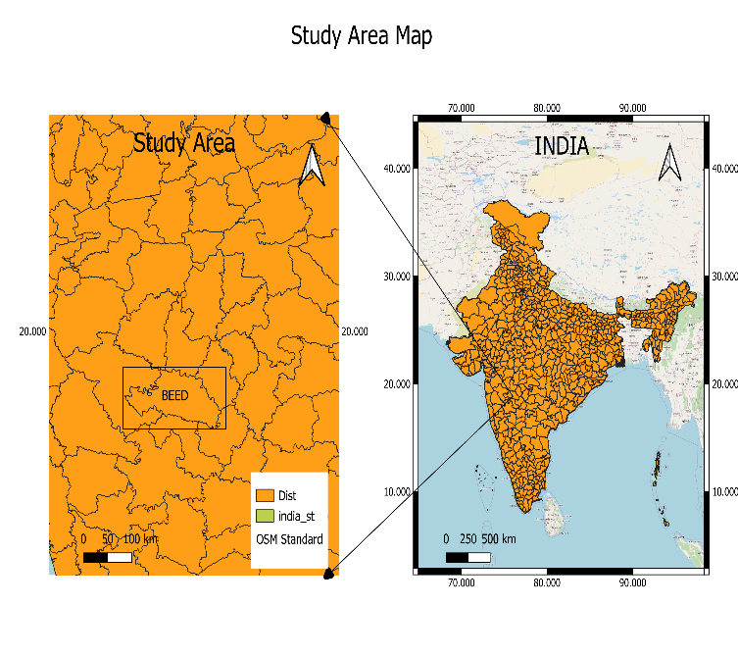Figure 1. Location map of the study area in Beed District, Maharashtra State.
In-situ soil moisture observations are conducted by collecting 40 surface soil samples to reflect moisture conditions within the study region. SMI is evaluated using thermal remote sensing data, specifically LST. This study primarily aims to determine SMI by utilising both LST and NDVI values.
Literature Review:
The soil moisture is put at an optimum level with frequent irrigations [21]. “The triangle method or surface temperature/ vegetation index method is defined as the combined application of optical and thermal infrared (TIR) bands” [22].
Nowadays, machine learning (ML) is a very popular method for analysing complex datasets and solving problems. A major complex task is drought analysis; it needs a huge amount of time and effort to interpret its characteristics. For drought forecasting, how machine learning can be used is shown in [Belayneh et.al (2013) and Adamowski et. al (2013)] [23]. Remote sensing has become a powerful tool for environmental monitoring, providing valuable insights into ecological dynamics (Agarwal et al., 2021; De Leeuw et al., 2010; R. Singh et al., 2024). Researchers can monitor shifts in vegetation cover, evaluate drought severity, and examine the influence of human activities on natural landscapes through the analysis of satellite-derived data (Agarwal et al., 2024; Mishra et al., 2024; Qin et al., 2021; Remya et al., 2024) [24].
About 80% of the agricultural sector is directly affected by drought conditions. It develops gradually and its impacts accumulate over an extended period before becoming visibly evident. Consequently, calculating the precise termination of a drought remains a significant challenge. Recently, satellite remote sensing data have become increasingly accessible, offering critical support for drought monitoring and assessment across spatial scales ranging from local to global. The synoptic coverage, high temporal frequency, and multispectral capabilities of satellite platforms enable continuous observation of key drought indicators, including vegetation condition, land surface temperature, and soil moisture. These attributes make remote sensing an indispensable tool for understanding the onset, severity, and spatial extent of drought events [25]. Remote sensing is widely used as an effective approach for monitoring soil moisture (SM) dynamics and assessing drought conditions. It enables the observation of key land surface parameters such as vegetation indices (VIs), and land surface temperature (LST). Various models used different optical bands of satellite data to calculate LST and VIs, which serve as critical inputs for drought monitoring and soil moisture estimation [26]. The Analytic Hierarchy Process (AHP) and fuzzy logic are advanced techniques commonly employed for drought assessment. AHP, is highly effective for mapping drought vulnerability, as it allows the integration of multiple drought types within a single framework. This method is widely accepted due to its efficiency, cost-effectiveness, and ability to save time while providing reliable results [27]. Several studies have indicated that integrating thermal and optical remote sensing data can significantly improve the accuracy of soil moisture assessment by providing complementary information. For instance, Janani et al. (2023) employed land surface temperature (LST) and the normalized difference vegetation index (NDVI) to evaluate soil moisture conditions [28]. Therefore, the current focus is on recent advances in retrieving soil moisture using the combination of optical and thermal bands of Landsat-8 OLT/TIRS methods.

2. EXPERIMENTAL METHODS
2.1 Study Area:
This investigation is performed at Rakshasbhuwan (Tamba) village in Taluka Shirur Kasar, District Beed, Maharashtra. The Beed district is situated in the centre of the Chhatrapati Sambhajinagar division of the state between 18⁰ 27̍ and 19⁰ 27̍ North latitude and 74⁰ 49̍ and 76⁰ 44̍ East longitude. From this region, Rakshasbhuwan Tamba is chosen for the current investigation. (Fig.1) whose latitude is 19.02207⁰ and longitude 75.428002⁰.
2.2 Remote Sensing Satellite Data Used:
Digital data from LANDSAT-8 OLI is acquired through the official website of the United States Geological Survey (USGS, a NASA platform). A NASA American Earth observation satellite called Landsat-8 ensures that the Landsat program will continue to be acquired and made available. It carries two sensor payloads, OLI and TIRS, which together capture data in nine shortwave spectral bands and two longwave thermal bands [2]. The USGS Earth Explorer website is utilised to obtain Landsat-8 imagery for the current study. SMI is derived from these images, and the SMI map is generated using QGIS version 3.28.2 (Fig.2).
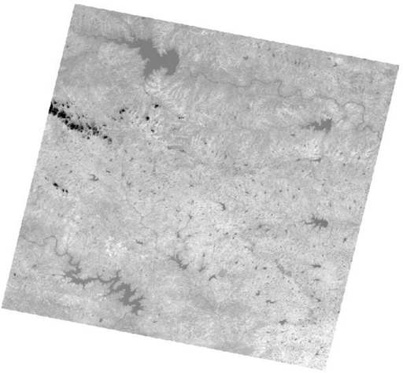
Figure 2. Landsat-8 OLI image covering study area

2.3 Soil Sample Collection:
Soil samples are obtained near-synchronously with the Landsat-8 acquisition date. Test fields are covered with maize vegetation, and there is no recorded rainfall in the study area during the sampling period. Soil samples are taken using a soil auger from a depth of 5cm, and they are then safely stored in airtight polythene bags. These samples are then transported to the laboratory and transferred into glass containers. A total of 40 soil samples were obtained from pre-determined sample points within the selected study area. In the laboratory, the samples are oven-dried to ensure consistency for further analysis.
2.4 Soil Moisture Determination using Field Data:
Various techniques are established for determining soil moisture (SM) content, which are categorised into two groups: direct and indirect techniques. While indirect methods use sensors and other factors that affect soil moisture to estimate moisture content, the accuracy of these approaches varies depending on the instrument. Direct methods determine soil moisture by measuring the weight difference of a soil sample before and after drying. Among these methods, the gravimetric method is considered the most accurate method for determining soil moisture [2]. In the current investigation, the gravimetric method is used to determine SM content.
This method involves taking soil samples from the field and weighing them afterwards. The samples are placed in a hot-air oven and dried at 105°C for 24 hours. Once fully dried, the samples are weighed again to evaluate their dry weight. SM content is then calculated by employing the following equation (1) [2].
$Soil Moisture=\frac{M_{w}}{M_{s}}*100 \%$ ----------(1)

Here, M_{w} denotes mass of water.
M_{s} represents the mass of dry soil.
M_{w} = (weight of wet soil + bowl) – (weight of oven dry soil + bowl)
M_{s} = (weight of oven dry soil + bowl)– (weight of bowl)
The average mean value of SM is calculated from all soil moisture samples.
2.5 Soil Moisture Index (SMI) Estimation:
SMI is evaluated by using LST values. Digital data from Landsat-8 OLI and TIRS are evaluated for estimating LST of the study area. Estimation utilises TIRS Band-10 data along with OLI Band-4 and Band-5 data. Characteristics of these bands are displayed in Table 1 [2].
Table-1. Spectral Band characteristics of LANDSAT-8
Band | Resolution(m) |  | Spectral Band | Wavelengths (µm)
4 | 30 | Red |  | 0.630-0.680
5 | 30 |  | Near Infrared | 0.845-0.885
10 | 100 |  | Longwave Infrared | 10.60-11.19

For the calculation of SMI, the steps followed in the current investigation are described by Sutariya et al. (2021) and Tajudin et al. (2021). Steps are given below:
- Download the Satellite image,
- Atmospheric correction of the image,
- Digital numbers (DN) are converted to top-of-the-atmosphere Spectral radiance values (TOA),
- TOA to at-sensor brightness temperature (BT) conversion,
- Evaluation of NDVI,
- Calculating Proportion of Vegetation (PV),
- By utilising empirical relationships based on NDVI to evaluate surface emissivity,
- Evaluating LST utilising a simplified version of Plank’s law,
- Calculate SMI using LST values,
Details of major steps are mentioned in the following sections:
2.5.1 Top of atmospheric Spectral radiance (TOA):
Selecting Band-10 from Landsat-8 OLI data is the first step in evaluating TOA spectral radiance:
𝐓𝐎𝐀 (𝐋) = 𝐌_{𝐋} ∗ 𝐐_{𝐜𝐚𝐥} + 𝐀_{𝐋} – 𝐐_{𝐢} ----------(2)
Where L denotes Top of Atmospheric Spectral Radiance, M_{L} denotes the band-specific multiplicative rescaling factor from metadata, Q_{cal} represents the Band 10 image, A_{L} represents the band-specific additive rescaling factor from metadata, and Qi denotes the correction for Band 10.
2.5.2 Conversion of TOA to at-sensor brightness temperature (BT):
Brightness temperature shows the temperature of Earth's surface as observed from space without any atmospheric interference [14]. BT is calculated using thermal constants from the Landsat-8 metadata:
$BT=\frac{K_{2}}{\ln\left(\frac{K_{1}}{L}\right)+1}-273.15$ ----------(3)
Here, K₁ and K₂ are band-specific thermal conversion constants from the metadata, and L is the TOA spectral radiance obtained in degrees Celsius; the radiant temperature is adjusted by adding absolute zero.
2.5.3 Calculation of the Normalized Difference Vegetation Index (NDVI):
The amount of vegetation is estimated using NDVI. Drought conditions are closely linked to the NDVI, which is generated with the help of remote sensing satellite data [9]. NDVI is crucial for calculating PV. Surface emissivity (𝜀) must be determined, as it is affected by PV.
$NDVI=\frac{NIR-RED}{NIR+RED}$ ----------(4)
Where NDVI represents the Normalized Difference Vegetation Index, NIR indicates the near-infrared band (Band 5), and RED indicates the Red band (Band 4)
2.5.4 Calculation of Proportion of Vegetation (P_{V}):
Proportion of vegetation (Vegetation Fraction) is defined as the percentage of vegetation occurring in the ground area in vertical projection [9]. It is closely related to NDVI values.

$P_{v}={\left[\frac{NDVI-NDVI_{min}}{NDVI_{max}-NDVI_{min}}\right]}^{2}$ ----------(5)

Where, P_{v} denotes the Proportion of vegetation, NDVI is the Normalized Difference Vegetation Index, NDVI_{min} represents the Minimum value of NDVI, and NDVI_{max} represents the Maximum value of NDVI.
2.5.5 Estimating the surface emissivity using an empirical relationship based on the NDVI:
To estimate LST, one needs to know the surface emissivity (E). Since the emissivity (E) is a proportionality factor that scales blackbody radiance (Planck’s law) to predict emitted radiance, it is the efficiency of transmitting thermal energy across the surface into the atmosphere [9].
The emissivity can be calculated as follows
𝐄 = 𝟎. 𝟎𝟎𝟒 ∗ 𝐏𝐯 + 𝟎. 𝟗𝟖𝟔 ----------(6)
Here, P_{v} denotes the “proportion of vegetation, 0.986 is the correction value for Landsat images.”
2.5.6 Calculating LST using the simplified Plank’s law:
LST is calculated by employing the following equation:
$LST=\frac{BT}{\left[1+\left[\frac{λ*BT}{ρ}\right]*ln\left(E\right)\right]}$ ----------(7)
Where LST denotes land surface temperature, BT represents Brightness temperature, E signifies Land surface emissivity, λ denotes wavelength of emitted radiance (10.895), ρ=1.4388*10⁻² m K
ρ =$\frac{h*c}{σ }$
where c = velocity of light = (2.998 × 10⁸ m/s),
σ = Boltzmann constant = (1.38 × 10⁻²³ J/K),
h = Planck’s constant = (6.626 × 10⁻³⁴ J s) [9].
2.5.7 Calculate Soil Moisture Index (SMI) using LST:
SMI is calculated by using LST values as follows:
$SMI=\frac{LST_{max}-LST}{LST_{max}-LST_{min}}$ ----------(8)
Here, SMI represents the soil moisture index, LST_{max} and LST_{min,} which are the maximum and minimum values of LST.
SMI was computed using the raster calculator tool within QGIS version 3.28.2. resulting SMI values range from 0-1, where a value of “0” signifies extremely “dry” conditions, while a value of “1” corresponds to extremely “wet” conditions.
3. RESULTS AND DISCUSSION
An algorithm developed in QGIS for evaluating LST by employing Landsat-8 OLI and TIRS data. Band-4 (RED) and Band-5 (NIR) are used to evaluate NDVI, while Band 10 is utilised to estimate BT. Estimation of NDVI and LST depends on useful data for assessing SMI.
NDVI values lie within the range of -1 to 1, with negative values demonstrating little to “no vegetation or sparse vegetative cover”, whereas positive values signify “dense and healthy vegetation”. The processed image of the Landsat-8 for the NDVI of the selected study is shown in Figure 3.
LST values are the land surface temperature of the selected study area, which is measured in ֠C. LST values vary between a minimum of 17.50 ֠C and a maximum of 35.96 ֠C as shown in Fig. 4.
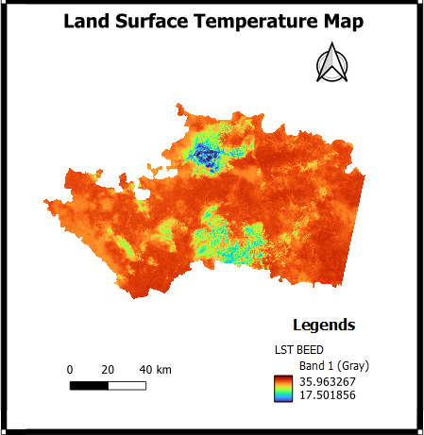
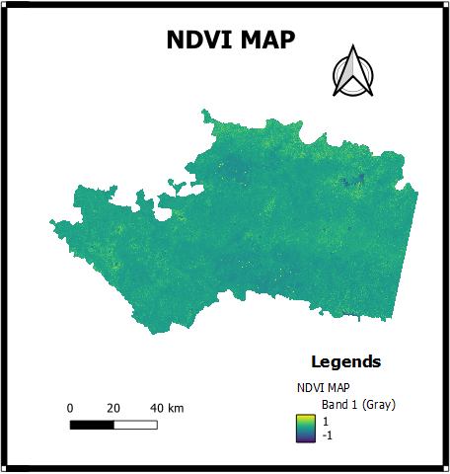
Figure 4. Land Surface Temperature Map

Figure 3. Normalized difference vegetation index (NDVI) map
The SMI map is divided into three categories: areas with SMI<0.3 are labelled as dry, values ranging from 0.3-0.5 represent moist regions, and those >0.5 are considered wet zones. Regions appearing blue and navy blue indicate dry conditions with SMI values close to 0.3, suggesting significant water scarcity. Aqua and lawn green colors denote zones with moderate moisture levels. Green lizard and maroon-colored regions, which reflect SMI values approaching 1, represent wet zones, typically including water bodies or forested lands, and possess the highest moisture levels compared to other land types, as shown in Figure 5.
Raster histogram for Soil Moisture Index (SMI) shows the frequency distribution of pixel values across the entire raster layer of SMI. Mostly the histogram peaks are between 0.1 and 0.3, which means most of the study area is under dry conditions, indicating possible agricultural drought shown in Figure 6. Based on this study, the selected area is affected by water deficit, which means it was a dry area. The range of soil moisture values calculated from gravimetric methods is between 10-16 vol% for the selected study area.

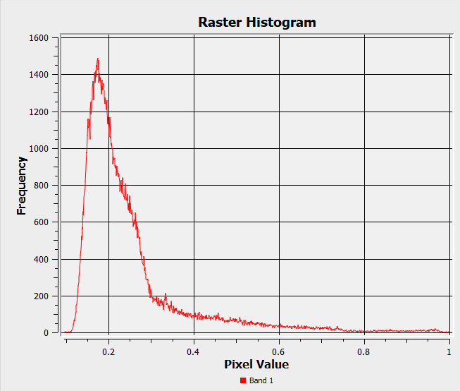
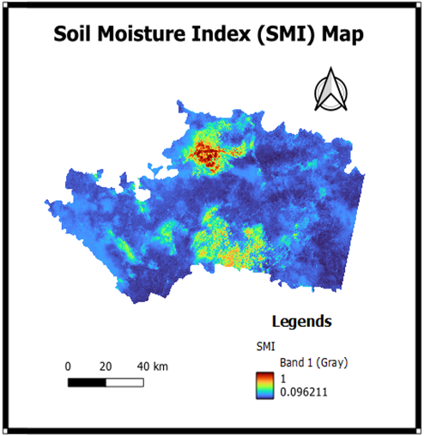
Figure 6. Graphical form of Soil Moisture Index
Figure 5. Soil Moisture Index Map

4. CONCLUSION:
The research objective was to analyse Landsat-8 OLI data for estimating soil moisture index content by employing LST and NDVI in the selected study area. Spatial variation of land surface temperature or SMI throughout the research region has been successfully shown via the use of remote sensing and GIS. Soil samples have been collected from designated sample points in Rakshasbhuwan (Tamba) village in Shirur Kasar Taluka almost simultaneously with the satellite acquisition date. The in-situ soil moisture content was calculated by using the gravimetric method. On the other hand, the study area’s soil moisture index (SMI) revealed that certain areas are experiencing flooding, while others are suffering from drought. Thermal data from Landsat-8 were used to assess LST. The Thermal infrared sensor bands Band-10, Band-4 and Band-5 have been utilised to assess LST. The results demonstrate that this approach provides a high level of accuracy in evaluating land surface characteristics. Research outcomes of the study area showed that it experienced normal drought conditions. To enhance agricultural productivity, it was deemed necessary to focus on SM conditions.
5. Limitations: Gravimetric method and in-situ sensors like tensiometers, time domain reflectometry (TDR), neutron probes & dielectric sensors are traditional methods to calculate soil moisture. While these techniques are highly accurate, they have limitations, such as being labour-intensive, time-consuming and often costly. Therefore, remote sensing is the best alternative to overcome these limitations. [28].
Acknowledgements:
The authors would like to thank Maharashtra Institute of Technology, Centre for Analytical Research and Studies (MIT-CARS), Chhatrapati Sambhajinagar, for their valuable support. We are also grateful to USGS for providing the Landsat-8 images.

Disclaimer (Artificial intelligence)
Author(s) hereby declares that NO generative AI technologies such as Large Language Models (ChatGPT, COPILOT, etc.) and text-to-image generators have been used during the writing or editing of this manuscript.
5. REFERENCES
[1] Saha, A., Patil, M., Goyal, V. C., & Rathore, D. S. (2012). Assessment and impact of soil moisture index in agricultural drought estimation using remote sensing and GIS techniques. In Proceedings , 7(1), 2. MDPI.
[2] Sutariya, S., Hirapara, A., Meherbanali, M., Tiwari, M. K., Sıngh, V., & Kalubarme, M. (2021). Soil moisture estimation using Sentinel-1 SAR data and land surface temperature in Panchmahal district, Gujarat State. International Journal of Environment and Geoinformatics, 8(1), 65-77.
[3] Acharya, U., Daigh, A. L., & Oduor, P. G. (2022). Soil moisture mapping with moisture-related indices, OPTRAM, and an integrated random forest-OPTRAM algorithm from Landsat 8 images. Remote Sensing, 14(15), 3801.
[4] Tajudin, N., Ya’acob, N., Ali, D. M., & Adnan, N. A. (2021). Soil moisture index estimation from Landsat 8 images for prediction and monitoring landslide occurrences in Ulu Kelang, Selangor, Malaysia. International Journal of Electrical and Computer Engineering, 11(3), 2101-2108.
[5] Peñuelas, J., Filella, I., Biel, C., Serrano, L., & Save, R. (1993). The reflectance at the 950–970 nm region as an indicator of plant water status. International journal of remote sensing, 14(10), 1887-1905.
[6] Tucker, C. J. (1980). Remote sensing of leaf water content in the near infrared. Remote sensing of Environment, 10(1), 23-32.
[7] Shafian, S., & Maas, S. J. (2015). Index of soil moisture using raw Landsat image digital count data in the Texas high plains. Remote Sensing, 7(3), 2352-2372.
[8] Li, B., Ti, C., Zhao, Y., & Yan, X. (2016). Estimating soil moisture with Landsat data and its application in extracting the spatial distribution of winter flooded paddies. Remote Sensing, 8(1), 38.
[9] Twumasi, Y. A., Merem, E. C., Namwamba, J. B., Mwakimi, O. S., Ayala-Silva, T., Frimpong, D. B., & Mosby, H. J. (2021). Estimation of land surface temperature from Landsat-8 OLI thermal infrared satellite data. A comparative analysis of two cities in Ghana. Advances in Remote Sensing, 10(4), 131-149.
[10] Lin, L., Di, L., Zhang, C., & Guo, L. (2023). The global land surface temperature change in the 21st century—A satellite remote sensing based assessment. IEEE Journal of Selected Topics in Applied Earth Observations and Remote Sensing, 17, 1756-1764.
[11] Esch, S., Korres, W., Reichenau, T. G., & Schneider, K. (2018). Soil moisture index from ERS-SAR and its application to the analysis of spatial patterns in agricultural areas. Journal of Applied Remote Sensing, 12(2), 022206-022206.
[12] Sobrino, J. A., Jiménez-Muñoz, J. C., & Paolini, L. (2004). Land surface temperature retrieval from LANDSAT TM 5. Remote Sensing of environment, 90(4), 434-440.
[13] Rahmahalim, M., Ramdani, F., & Rusydi, A. N. (2020). Design and development of land surface temperature calculation plugin of QGIS. In Proceedings of the 5th International Conference on Sustainable Information Engineering and Technology, 206-212.
[14] Kshetri, R., & Dahal, D. (2024). Estimation of Land Surface Temperature (LST) and Soil Moisture Index (SMI) using Satellite Image: A Case Study in Bharatpur Municipality, Chitwan, Nepal.
[15] Youssef, N. M., El Moustafa, A. M., Gad, M. A., & Elleithy, D. M. (2022). Soil moisture estimation using Land Surface Temperature in the Northwestern coast of Egypt. Int. Res. J. Eng. Technol, 9(12), 1560-1569.
[16] Jimenez-Munoz, J. C., Sobrino, J. A., Skoković, D., Mattar, C., & Cristobal, J. (2014). Land surface temperature retrieval methods from Landsat-8 thermal infrared sensor data. IEEE Geoscience and remote sensing letters, 11(10), 1840-1843.
[17] Jimenez-Munoz, J. C., Cristobal, J., Sobrino, J. A., Sòria, G., Ninyerola, M., & Pons, X. (2008). Revision of the single-channel algorithm for land surface temperature retrieval from Landsat thermal-infrared data. IEEE Transactions on geoscience and remote sensing, 47(1), 339-349.
[18] Amani, M., Parsian, S., MirMazloumi, S. M., & Aieneh, O. (2016). Two new soil moisture indices based on the NIR-red triangle space of Landsat-8 data. International Journal of Applied Earth Observation and Geoinformation, 50, 176-186.
[19] Zhang Feng, Z. F., Zhang LiWen, Z. L., Shi JingJing, S. J., & Huang JingFeng, H. J. (2014). Soil moisture monitoring based on land surface temperature-vegetation index space derived from MODIS data.
[20] Wagner, W., Lemoine, G., & Rott, H. (1999). A method for estimating soil moisture from ERS scatterometer and soil data. Remote sensing of environment, 70(2), 191-207.
[21] Selvaperumal, A., Sujitha, E., & Muthuchamy, I. (2019). Evaluation of uniformity coefficient and soil moisture distribution under drip irrigation system. Curr. J. Appl. Sci. Technol, 34(5), 1-9.
[22] Srivastava, S., & Dhanapriya, M. (2025). Remote Sensing Based Soil Moisture Estimation Using In-situ Probes in Varanasi District, India. International Journal of Environment and Climate Change, 15(5), 389-403.
[23] Paul, T., Mati, M. D., & Islam, M. M. (2024, December). Enhanced Drought Analysis in Bangladesh: A Machine Learning Approach for Severity Classification Using Satellite Data. In 2024 27th International Conference on Computer and Information Technology (ICCIT), 459-464, IEEE.
[24] Agarwal, V., Vishvendra Raj Singh, B., Marsh, S., Qin, Z., Sen, A., & Kulhari, K. (2025). Integrated Remote Sensing for Enhanced Drought Assessment: A Multi‐Index Approach in Rajasthan, India. Earth and Space Science, 12(2), e2024EA003639.
[25] Ha, T. V., Huth, J., Bachofer, F., & Kuenzer, C. (2022). A review of earth observation-based drought studies in Southeast Asia. Remote Sensing, 14(15), 3763.
[26] Tao, L., Di, Y., Wang, Y., & Ryu, D. (2023). Normalized temperature drought index (NTDI) for soil moisture monitoring using MODIS and Landsat-8 data. Remote Sensing, 15(11), 2830.
[27] Hodasová, K., Krčmář, D., & Ondrejková, I. (2025). Satellite-based drought assessment: integrating AHP method and fuzzy logic for comprehensive vulnerability and risk analysis. Natural Hazards, 1-24.
[28] Imtiaz, F., Farooque, A. A., Randhawa, G. S., Wang, X., Esau, T. J., Acharya, B., & Garmdareh, S. E. H. (2024). An inclusive approach to crop soil moisture estimation: Leveraging satellite thermal infrared bands and vegetation indices on Google Earth Engine. Agricultural Water Management, 306, 109172.

