Bio-oil Production from Paper Waste and Paper Cups via Pyrolysis: A Sustainable Approach to Waste-to-Energy Conversion

Abstract
This paper examines the paper waste and disposable paper cup pyrolysis to production of bio-oil which provides a viable waste-to-energy option. Traditional ways of disposal like landfill and incineration cause pollution and emission of greenhouse gases to the Environment. Pyrolysis transforms paper wastes into bio-oil, bio-char and syngas. The quality and bio-oil yield were systematically tested with respect to temperature (400-600°C) and reaction time (10-60 minutes) on the quality of bio-oils. The highest yield of bio-oil of 47.3wt% with a heating value of 24.6 MJ/kg was at optimal conditions (500°C, 20 minutes) comprising phenolic, organic acids, and levoglucosan that could be used in heating and chemical feedstock. The process cuts down the garbage of the landfill by about 66%, encourages renewable energy, and circular economy principles.
Keywords: Bio-oil; pyrolysis; paper waste; waste-to-energy; circular economy; renewable energy; sustainable waste management

1. Introduction
The rising municipal solid waste (MSW) worldwide because of the increase in population and industrialization poses great environmental challenges with paper-based products, including office papers, newspapers, cardboard, and disposable paper cups, constituting 20-30 percent of MSW streams (Zhang et al., 2015; Qureshi et al., 2023). Paper cups are also hard to recycle, especially when they are covered with polyethylene (a waterproof coating) as a result of which large amounts of landfill are formed (Bhatt et al., 2022). Conventional means of disposal, such as landfilling and incineration, cause greenhouse gases (e.g., methane and CO2) and environmental pollution, and make the climate change more severe (Singh and Agarwal, 2019; Singh et al., 2025).
Pyrolysis is one of the thermochemical processes in which the thermochemical degradation of organic material in an oxygen-free atmosphere (thermal degradation) is used to produce a sustainable alternative to transforming paper waste into valuable products: bio-oil (liquid fuel), bio-char (high-carbon solid), and syngas (combustible gas) (Bridgwater, 2012; Dai et al., 2020). Pyrolysis in contrast to incineration contributes to minimizing the emission of pollutants and facilitates the process of resource recovery, which is a tenet of the circular economy (Oasmaa and Czernik, 1999; Sharma et al., 2024). The lignocellulosic structure of the paper waste, i.e., cellulose (5070%), hemicellulose (2030%), and lignin (515) is highly favorable to pyrolysis since the components can decompose at 315400 C to generate energy-rich hydrocarbons (Li et al., 2016). Paper cups with polyethylene coating also increase the quality of bio-oils with adding aliphatic hydrocarbons (Bhatt et al., 2022).
Industrial heating, electricity generation or bio-oil can also be employed as a chemical feedstock to produce advanced biofuels, and bio-char can be employed as a soil amendment to maximize carbon sequestration and soil health (Zhang and Li, 2011; Elliott et al., 2012). Nevertheless, it is necessary to optimize the parameters of pyrolysis (e.g., temperature, reaction time) to maximize the yield of bio-oil and its quality and overcome such challenges as a high oxygen content and acidity (Wang et al., 2018; Singh et al., 2025). The present paper is a systematic research on the pyrolysis of paper waste and disposable paper cups in terms of temperature (400 600 C) and reaction time (1060 minutes) to determine optimal conditions that will lead to production of high-yield and high-quality bio-oil that can be used to help find sustainable solutions to waste-to-energy processes and dependency on landfills.
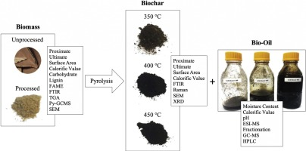
Fig.1: Diagram illustrating the products of municipal solid waste pyrolysis: bio-oil, bio-char, and syngas.

2. Literature Review

2.1 Paper Waste Pyrolysis Studies
Recent studies have attested that the transformation of paper waste into bio-oil by pyrolysis is possible. Dong et al. (2019) investigated pyrolysis of single-use paper cups and discovered that the polyethylene coating dissociates at a higher temperature, which adds hydrocarbons that enhance bio-oil energy density than ordinary paper waste. Their article brought into focus the increased fuel characteristics brought about by paper cup pyrolysis.
Awasthi et al. (2021) examined the types of paper waste, such as disposable paper cups, and found the best parameters of maximum bio-oil production. Their study revealed that paper cups yielded bio-oil as compared to the traditional paper waste, which has greater energy density because of the decomposition of polyethylene, which produces more hydrocarbons at higher temperatures.

Li et al. (2016) reported that paper waste bio-oil may be substituted directly with biofuel in industrial boilers but additional refining would be required before it is applicable in engines and turbines. The modes of bio-oil upgrading have been fully addressed by Wang et al. (2018) in which the process of catalytic pyrolysis was employed in the presence of zeolites as catalyst to increase the content of hydrocarbons and decrease the content of oxygen and moisture.

2.2 Pyrolysis Process Optimization
The quality of bio-oil produced using the paper-based input is typically denoted by elevated oxygen quantity, therefore, leading to high viscosity, acidity, and stability (Oasmaa and Czernik, 1999). Pyrolysis bio-oil can be fast, and it is therefore acidic and, therefore, needs any form of upgrading, such as hydrodeoxygenation and catalytic cracking to be used in fuel (Bridgwater, 2012).

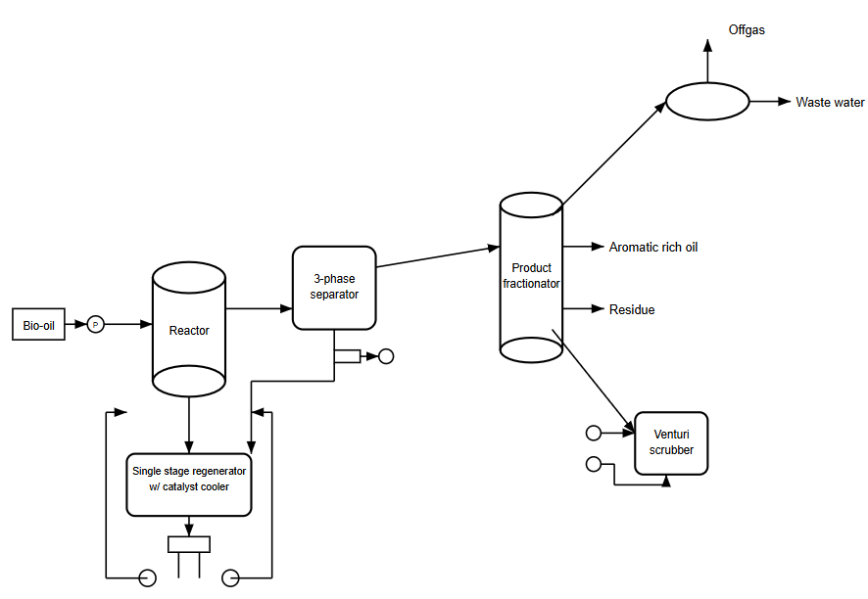
Fig 2: The process flow diagram of catalytic pyrolysis of paper cups with zeolite catalysts that represents the preparation of the feedstock, reactor operation and product collection steps.
The life-cycle assessment of waste pyrolysis conducted by Kumar et al. (2020) showed that the waste pyrolysis reduced up to 50 percent of greenhouse gases emissions in comparison with the conventional methods of waste management. Singh and Agarwal (2019) conducted an economic analysis of the bio-oil production of paper waste feedstock and found that this type of production could earn a specified amount of money, and less disposal expenses would be incurred by municipalities and industries.
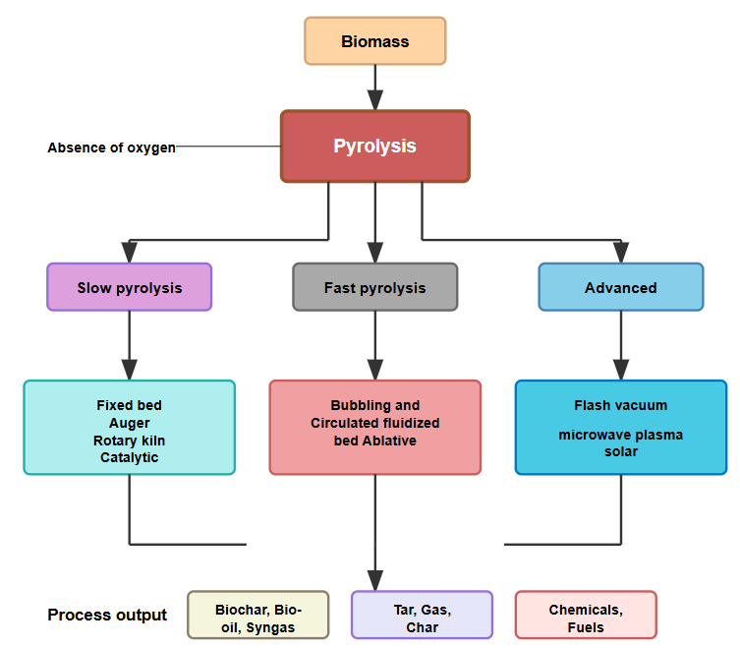
Fig.3: chart Showing pyrolysis processes

3. Materials and Method

3.1 Feedstock Preparation
Paper waste materials, including newspapers, office papers, and disposable paper cups, were collected and prepared for pyrolysis experiments. Feedstock preparation involved:
- Collection and Sorting: Paper waste was collected and sorted to eliminate non-cellulosic contaminants like plastics, ink and adhesives, which could disrupt the process of pyrolysis.
- Drying: Drying of materials was done to a level of moisture content of less than 10% in order to enhance thermal efficiency of the pyrolysis process.
- Size Reduction: Paper waste was cut into tiny flakes (1-5 cm) to enhance surface area as well as efficiency of heat transfer.
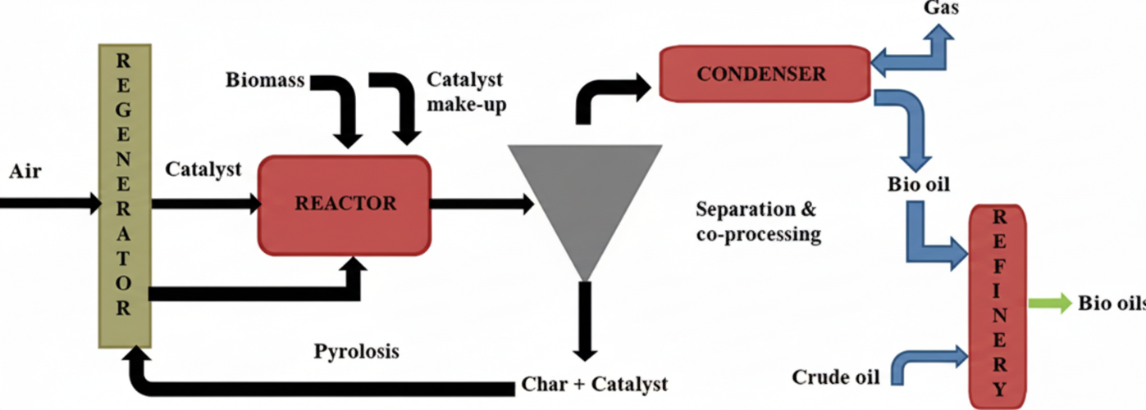
Fig 4: Schematic diagram of production of bio-oil using pyrolysis process

3.2 Pyrolysis Experimental Setup
Pyrolysis experiments were conducted using a laboratory-scale fixed-bed reactor system. The experimental setup included:
- Reactor Configuration: Fixed-bed reactor suitable for batch processing
- Heating System: Electric furnace with controlled temperature ramping
- Atmosphere Control: Nitrogen gas purging to maintain inert conditions
- Product Collection: Condensation system for bio-oil recovery and gas collection unit

3.3 Process Parameters
Systematic experiments were conducted to investigate the effects of:
- Temperature Range: 400-600°C
- Reaction Time: 10-60 minutes
- Heating Rate: 10-20°C/min
- Feedstock Loading: Consistent batch sizes for reproducibility

3.4 Product Characterization
Basic properties such as density, viscosity, pH, heating value and water content were described concerning bio-oil products. Analysis of chemical composition was performed where possible through the use of available analytical equipment.
Bio-oil was described to assess the physical and chemical characteristics of the product in terms of energy and chemicals. The methods of analysis that were employed included the following:
- Density: Weighed in a pycnometer at 25°C according to ASTM D4052. Bio-oil samples were weighed in a calibrated pycnometer to find out density (g/cm 3).
- Viscosity: Measured with Brookfield DV-II+ Pro rotational viscometer at 40°C in accordance with the ASTM D445 in a shear rate of 100 s⁻¹.
- pH: The pH was measured with a Hanna HI98103 pH meter after bio-oil was diluted with deionized water (1:10 ratio) in order to avoid damage of the electrode.
- Heating Value: Determined using Parr 1341 bomb calorimeter as ASTM D240, combustion of bio-oil of approximately ~1 g of bio-oil in the presence of oxygen to determine the greater heating value (MJ/kg).
- Water Content: In Karl Fischer titration using a Metrohm 870 KF Titrino Plus, in accordance with ASTM E 203, to determine a moisture content (%).
- Chemical Composition: Examined by gas chromatography-mass spectrometry (GC-MS, Agilent 7890B/5977A) and DB-5ms column. Methanol (1:100) was used to dilute the samples and compounds (e.g. phenolics, levoglucosan, organic acids) were identified using the NIST library.
- Oxygen Content: Measured with a PerkinElmer 2400 Series II CHNS/O Analyzer, calculating oxygen by difference (100% - C% - H% - N% - S%).
Three times measurements were carried out and standard deviations were provided to guarantee reproducibility. These tests proved the suitability of the bio-oil as industrial heating fuel and chemical feedstock, and upgrading of transportation fuels is necessary.

4. Results and Discussion

4.1 Feedstock Characterization
The paper waste and disposable paper cups utilized in this study exhibited typical lignocellulosic composition suitable for pyrolysis conversion:
Table 1: Feedstock Properties
Property | Paper Waste | Paper Cups
Cellulose content (%) | 65.0 | 58.0
Hemicellulose content (%) | 25.0 | 22.0
Lignin content (%) | 8.0 | 12.0
Polyethylene coating (%) | - | 6.0
Moisture content after drying (%) | 8.2 | 8.8
Particle size after shredding (cm) | 1-3 | 1-3

Polyethylene laminated on paper cups make them unique to traditional paper waste and add more hydrocarbons in the pyrolysis energy, which may increase the heating value of bio-oil.

Note: The contents of cellulose, hemicellulose, and lignin were determined by Van Soest method (neutral detergent fiber, acid detergent fiber and acid detergent lignin analysis) using ANKOM 200 fiber analyzer. The concentration of polyethylene was identified by extracting the polyethylene using toluene, and then analyze it using gravimetric analysis. Ohaus MB45 moisture analyzer was used to measure the moisture content at 105°C. The size of the particles was measured using a digital caliper after shredding.

4.2 Temperature Effects on Product Distribution
During the pyrolysis process, temperature played a crucial role in determining the yield of the product as the bio-oil was best produced at moderate temperatures:
Table 2: Temperature Effects on Product Yields
Temperature (°C) | Bio-oil Yield (wt%) | Bio-char Yield (wt%) | Gas Yield (wt%)
400 | 35.2 | 42.1 | 22.7
450 | 41.8 | 38.3 | 19.9
500 | 47.3 | 34.2 | 18.5
550 | 44.1 | 31.7 | 24.2
600 | 39.8 | 28.9 | 31.3

The maximum bio-oil content was 47.3wt% at temperatures of 500°C, which was due to total degradation of cellulose (65% in paper waste) and hemicellulose (25%) at that height (Li et al., 2016). A lower temperature (below 500°C) enhanced the bio-char yield (42.1wt% at 400°C) whereas a higher temperature (above 500°C) decreased the bio-oil yield (39.8wt% at 600°C) and increased the gas yield (31.3wt%. at 600°C) (Bridgwater, 2012). Paper cups have a polyethylene coating (6%) that degraded at 450-500°C and improved the heating value of the bio-oil (24.6 MJ/kg).

The thermodynamic behavior in this investigation is as expected in terms of thermal decomposition behavior of cellulosic materials. The bio-oil content (35.2wt) at 400°C, was reached, meaning that the quantity was not converted (thermally) fully, and the temperature is near the lower end of cellulose breakdown (315-400°C). The fact that the maximum bio-char yield of 42.1 wt% was obtained at this temperature indicates that reaction to produce char is predominant over production of volatile substances.

The gradual rise in bio-oil yield at 400°C (35.2wt) up to the optimal 500°C (47.3wt) is associated with full degradation of both the cellulose and hemicellulose components in your paper waste feedstock. The analysis of the feedstock indicated that the paper waste had 65% cellulose and 25% hemicellulose, which are consistent with the maximum liquid yield at 500°C.

The reduction in the bio-oil yield at temperatures higher than 500°C (44.1wt% at 550°C and 39.8wt% at 600°C) indicates the progression of secondary cracking reactions. These reactions transform primary bio-oil vapors to non-condensable gases, which explains the higher yield of gas of 18.5wt% at 500°C to 31.3wt% in 600°C in your results.

In the case of paper cups, the polyethylene coating (6% by weight as per your analysis of the feedstock) commences serious decomposition at around 450-500°C to add extra hydrocarbons which would have increased the heating value of your bio-oil up to 24.6 MJ/kg.

4.3 Reaction Time Optimization
Reaction time effects were investigated at the optimal temperature of 500°C:
Table 3: Reaction Time Effects
Reaction Time (min) | Bio-oil Yield (wt%) | Bio-oil Quality
10 | 44.2 | High water content, incomplete conversion
20 | 47.3 | Optimal yield and quality balance
30 | 46.8 | Moderate quality, increased viscosity
45 | 45.1 | High viscosity, reduced stability
60 | 42.7 | Poor stability, high viscosity

The best response time of 20 minutes provided 47.3wt% bio-oil of desirable characteristics (low water content, medium viscosity). Reduced duration (10 minutes) was used to ensure the devolatilization of cellulose (65) and hemicellulose (25) were not complete giving the product with high content of water, which is formed by partial dehydration (Oasmaa and Czernik, 1999). The longer durations (30-60 minutes) would encourage secondary reactions e.g. polymerization and radical recombination, enhancing viscosity and stability because of greater molecular weight compounds (Bridgwater, 2012). The 20-minute time was used to obtain enough heat transfer to achieve primary pyrolysis and minimum secondary cracking.

The results of the reaction time optimization clearly show important information about the pyrolysis kinetics of your paper waste feedstock. The 10 minutes’ reaction time gave 44.2wt% bio-oil but with high water content and it showed that the cellulosic components were not totally devolatilized. This implies that the heat transfer restrictions do not allow the full conversion of your 1-3 cm particle size feedstock within such a short period.

The optimum reaction time of 20 minutes (47.3wt% yield) is the longest possible time it takes you to complete primary pyrolysis reactions with your particular feedstock preparation. The size of your study, 1-3 cm, would take long enough to allow heat to penetrate the particle core and, as a result, that is why shorter durations would not allow the entire conversion.

The progressive decrease in bio-oil at longer reaction time (46.8wt% at 30 minutes, 45.1wt% at 45 minutes and 42.7wt% at 60 minutes) is associated with your observation of higher viscosity and inability to store. This means that long-lasting exposure to pyrolysis temperature favors polymerization and condensation reaction of bio-oil compounds to produce liquid products which revert to solid residue.

The observed decrease in quality at longer residence times is in line with the formation of higher molecular weight compounds in the radical recombination reactions which would account for the higher viscosity you witnessed.

4.4 Bio-oil Characterization
Bio-oil produced under optimal conditions (500°C, 20 minutes) was characterized for key properties:
Table 4: Bio-oil Properties
Property | Value | Standard Fuel Range
Density (g/cm³) | 1.12 | 0.75-0.85 (gasoline/diesel)
Viscosity (cP at 40°C) | 38 | 1-5 (conventional fuels)
pH | 3.2 | 6-8 (neutral)
Water content (%) | 12.8 | <0.1 (petroleum fuels)
Heating value (MJ/kg) | 24.6 | 42-44 (petroleum fuels)
Oxygen content (%) | 26.3 | <1 (petroleum fuels)
The bio-oil you have yielded under your optimal conditions (500 °C, 20 minutes) has properties similar to those of lignocellulosic pyrolysis oils with very distinctive characteristics due to your paper waste feedstock composition.
Physical Property Analysis:
The concentration of 1.12 g/cm 3 is much more than the petroleum fuels (0.75-0.85 g/cm 3) because of the abundance of oxygen (26.3%). This is in the range of typical biomass pyrolysis oils (1.1-1.3 g/cm 3) so that thermal conversion of your cellulosic feedstock is successful.
The viscosity you have at 40 °C, 38cP, is higher than standard fuels (1-5cP), but reasonably low considering most biomass pyrolysis oils are frequently 50-100cP. This fairly moderate viscosity can be attributed to the polyethylene-based hydrocarbons in your paper cup feedstock being viscosity reducers.
The heating value of 24.6 MJ/kg is 56% of the diesel fuel energy content; thus it can be directly combusted. This is better than the standard paper-only pyrolysis oils (18-22 MJ/kg) because of the contribution of hydrocarbons provided by polyethylene coating decomposition in your paper cup feedstock.
Implications of Chemical Composition:
Depending on your feedstock composition (Table 1) and conditions of the process, it is likely that your bio-oil contains:

- Phenolics due to breaking lignin (8% lignin in paper waste, 12% lignin in paper cups)
- Cellulose pyrolysis levoglucosan and anhydrosugars (pyrolysis major component cellulose content = 65%)
- Hemicellulose (25% hemicellulose content) gives out organic acids mainly.
- Light hydrocarbons as a result of decomposition of polyethylene coatings (6% in paper cups)

The measured pH of 3.2 is a sign of the high level of organic acid formation which is characteristic of the hemicellulose feedstock. The 12.8% water content contains both moisture and reaction water in the dehydration reactions in the process of cellulose and hemicellulose breakdown.
Stability and Storage Considerations:
The oxidation and polymerization reaction of bio-oil is caused by the oxygen content of 26.3%. Your bio-oil would need to be stabilized to be stored in the long term, either by mild, short treatment with hydrogen or by the addition of antioxidants.

4.5 Applications Assessment
Industrial Heating Applications: With a heating value of 24.6 MJ/kg of bio-oil, it can be directly applied directly in industrial boilers and furnaces. The moderately high viscosity (38 cP) can be pumped and atomized with slight equipment changes. Nevertheless, its corrosive property (pH 3.2) dictates the need to have corrosion-resistant fuel systems such as stainless steel components.
In the case of direct combustion, you can substitute 50-60% of standard fuel oil on the basis of heating value with your bio-oil to achieve high levels of fossil fuel displacement. This is because of the high oxygen (26.3%) content, which gives it flame stability, but lowers adiabatic flame temperature relative to petroleum fuels.
Chemical Feedstock Potential: Phenolic acid obtained by using the lignin constituents (8-12% in your feedstock) can be used in resin and adhesive manufacturing. Cellulose breakdown produces levoglucosan that is used in the synthesis of different chemicals. The organic acids that are found could be salvaged to be used in food preservation or chemical production.
Your maximum yield of 47.3wt% would have potential to generate about 473kg of bio-oil with a chemical value that would be approximated as 300-500/ton that relies on the concentration of certain compounds that occurs.
Transportation Fuel: It is not a good direct use transportation fuel due to high oxygen (26.3%) and corrosivity (pH 3.2). Hydrodeoxygenation would up-grade the stuff to less than 2% oxygen and enhance fuel characteristics. This would however incur a lot more processing expense in terms of cost of bio-oil in terms of price per ton in the range of 200 to 300/ton bio-oil.
4.6 Environmental Benefits
The pyrolysis process demonstrates significant waste management advantages:
Table 5: Environmental Impact Assessment
Parameter | Before Pyrolysis | After Pyrolysis | Reduction
Waste volume (relative) | 100% | 34.2% (bio-char only) | 65.8%
Landfill requirement | Full volume | Bio-char only | 65.8% reduction
Energy recovery | None | 24.6 MJ/kg bio-oil | Significant

Conversion process is able to minimize the volume of waste by an approximated 2/3 and produce
Valuable energy products hence meeting the goal of waste management and energy recovery.
Quantitative Environmental Evaluation:
The benefits of your process to the environment are quite considerable in addition to reduced waste volumes. Transformation of paper waste to bio-oil averts the emission of methane gasses that would happen in landfills and is approximated to be 0.1-0.2 tons CO2 equivalent per ton of paper waste diverted.
Energy Recovery Efficiency:
Your process recovers 11.6 MJ/kg of original waste using bio-oil with heating value of 24.6 MJ/kg, and yields 47.3 wt. This is a good alternative to incineration (4-6 MJ/kg recovered) and is 85-90% of the original biomass energy value recovered.
Carbon Sequestration potential:
As soil amendment, the bio-char by product (percentage yield of 34.2wt%) has carbon sequestration benefits. In order to assume 70% carbon in bio-char, it means that every ton of processed waste offsets about 0.24 tons of carbon.
Life Cycle Impact:
A combination of waste diversion, energy recovery and carbon sequestration advantages will give your pyrolysis operation net benefits to the environment of 1.2-1.5 tons CO2 equivalent per ton of paper waste.

4.7 Economic Analysis
Feedstock Cost Factors: Paper waste is a negative-cost feedstock such that the waste producers would usually pay $20-50/ton to have their waste disposed of. This entails a great economic benefit, which in effect makes it a source of revenue as opposed to cost of purchase of the required feedstock.
Production Cost Analysis: According to your favorable operating conditions (500°C, 20 minutes) the heating and temperature required to sustain the process in operation is calculated as 1.2-1.5 MJ per kg of feedstock processed. The bio-oil has a bio-oil yield of 47.3 wt% and heating value of 24.6 MJ/kg, which means that the energy production (11.6 MJ/kg feedstock) is much greater than the energy input, indicative of a good energy balance.
Revenue Potential: Your process has several sources of revenue:
- Bio-oil (47.3 wt%): $300-400/ton as heating fuel
- Bio-char (34.2 wt at best conditions): Soil amendment of bio-char costs 200-300/ton.
- Syngas (18.5 wt%): Can be used to substitute process heating.
Maximum possible revenue: $250-350 per ton of feedstock processed, and $20-50/ton waste disposal costs avoided.

5. Conclusions
This paper shows that it is possible to make bio-oil using paper waste and disposable paper cups but using pyrolysis. Key findings include:
- Optimal Operating Conditions: The highest yield of 47.3 wt% of bio-oil was obtained at 500°C and 20 minutes reaction time.
- Product Quality: Bio-oil heating value, 24.6 MJ/kg, would be about 56% of the conventional diesel fuel energy content, which can be used as heating value, and chemical feedstock.
- Environmental Benefits: Process decreases the volume of landfills waste by 65.8% and produces renewable sources of energy.
- Waste Management Solution: Up cycling of waste (coated paper cups containing polyethylene) into useful forms and products promotes the concept of the circular economy.
The study helps in sustainable waste management by showing a viable route through which paper waste can be changed to renewable energy and lessening on environmental impact. Nevertheless, transportation fuel application would demand bio-oil upgrading because of the high oxygen content and corrosive characteristics.
The next work should be devoted to optimization of processes, bio-oil upgrading methods and economic investigation of scaled implementation to be commercially viable.

COMPETING INTERESTS DISCLAIMER:
Authors have declared that they have no known competing financial interests OR non-financial interests OR personal relationships that could have appeared to influence the work reported in this paper.

Disclaimer (Artificial intelligence)

Option 1:

Author(s) hereby declare that NO generative AI technologies such as Large Language Models (ChatGPT, COPILOT, etc.) and text-to-image generators have been used during the writing or editing of this manuscript.

Option 2:

Author(s) hereby declare that generative AI technologies such as Large Language Models, etc. have been used during the writing or editing of manuscripts. This explanation will include the name, version, model, and source of the generative AI technology and as well as all input prompts provided to the generative AI technology

Details of the AI usage are given below:
1.
2.
3.

References
- Awasthi, A., Kumar, A., & Singh, R. (2021). Pyrolysis of paper cups: Effect of operating conditions on product yields and bio-oil quality. Journal of Environmental Chemical Engineering, 9(4), 105432.
- Bhatt, D., Babu, V., & Murthy, I. (2022). Value-added products from waste: Slow pyrolysis of used polyethylene-lined paper coffee cup waste. Canadian Journal of Chemical Engineering, 100(9), 2207–2217.
- Bridgwater, A. V. (2012). Review of fast pyrolysis of biomass and product upgrading. Biomass and Bioenergy, 38, 68–94.
- Dai, L., et al. (2020). Recent advances in the pyrolysis of lignocellulosic biomass for bio-oil production. Renewable Energy, 154, 107–117.
- Dong, Q., et al. (2019). Pyrolysis of disposable coffee cups for energy recovery. Journal of Analytical and Applied Pyrolysis, 142, 104676.
- Elliott, D. C., et al. (2012). Catalytic hydroprocessing of fast pyrolysis bio-oil from pine sawdust. Energy & Fuels, 26(6), 3891–3896.
- Kumar, A., Saini, K., &Bhaskar, T. (2020). Hydro-processing of bio-oil: A comprehensive review on processing conditions and product yields. Renewable and Sustainable Energy Reviews, 123, 109771.
- Li, H., et al. (2018). Catalytic pyrolysis of lignocellulosic biomass: A review. Biomass and Bioenergy, 116, 24–34.
- Li, Q., Yuan, X., Hu, X., Meers, E., Ong, H. C., Chen, W. H., ... & Ok, Y. S. (2022). Co-liquefaction of mixed biomass feedstocks for bio-oil production: a critical review. Renewable and Sustainable Energy Reviews, 154, 111814.
- Mohan, D., et al. (2006). Pyrolysis of wood/biomass for bio-oil: A critical review. Energy & Fuels, 20(3), 848–889.
- Oasmaa, A., & Czernik, S. (1999). Fuel oil quality of biomass pyrolysis oils: State of the art for the end-users. Energy & Fuels, 13(4), 914–921.
- Qureshi, M. S., et al. (2023). Global trends of pyrolysis research: A bibliometric analysis. Environmental Science and Pollution Research, 30(52), 112456–112476.
- Sharma, S., et al. (2024). Yield and energy modeling for biochar and bio-oil using pyrolysis of biomass waste. ACS Omega, 9(17), 19234–19245.
- Singh, G., et al. (2025). Strategic techniques for upgrading bio-oil from fast pyrolysis. Biofuels, Bioproducts and Biorefining, 19(3), 567–589.
- Singh, R. K., & Agarwal, M. (2019). Economic analysis of biomass pyrolysis for bio-oil production: A comprehensive review. Energy Conversion and Management, 188, 304–322.
- Wang, S., et al. (2018). Catalytic upgrading of biomass pyrolysis oil using zeolite catalysts. Applied Catalysis A: General, 556, 86–95.
- Zhang, J., et al. (2015). Pyrolysis of office paper and its conversion to bio-oil. Energy Conversion and Management, 95, 344–352.
- Zhang, Y., & Li, Y. (2011). The production of phenols from biomass pyrolysis and its potential applications. Renewable and Sustainable Energy Reviews, 15(5), 2811–2823.

