Original Research Article
Comparative Study of the Mechanical and Chemical Properties of Locally Produced Low-Carbon Steel Rebars on the Ghanaian Market

Abstract
Low-carbon steel reinforcement bars (rebars) are widely used in reinforced concrete construction in Ghana due to their relatively low cost and acceptable mechanical properties. However, most locally produced rebars are manufactured from recycled scrap metals, and limited data exist on their mechanical and chemical performance. This study investigates rebars produced by four leading Ghanaian manufacturers coded as AS, BS, CS, and DS, and compares them with Ghana Standards Authority (GSA) and British Standards (BS 4449). Tensile tests and spectrometer analysis were conducted to determine mechanical and chemical properties, respectively. Results showed that all rebars exceeded the GSA minimum yield strength (≥300 N/mm²) and ultimate tensile strength (≥400 N/mm²), with recorded values ranging from 380.02–499.69 N/mm² (yield) and 574.66–718.94 N/mm² (ultimate). Only BS rebars (Yield: 499.69 N/mm²; Ultimate: 718.94 N/mm²) fully satisfied the stricter BS 4449 thresholds (≥460 N/mm² yield; ≥600 N/mm² ultimate), while AS (452.7/667.1 N/mm²) and CS (432.16/604.95 N/mm²) were marginal, and DS (380.02/574.66 N/mm²) fell short. Elongation values (19.55–27.69%) exceeded the 14% requirement in both standards, confirming adequate ductility. Actual diameters were consistently lower than nominal, with 12 mm rebars measuring between 10.48 mm (CS) and 11.59 mm (BS). Chemical composition confirmed low-carbon steel (0.299–0.349% C), though phosphorus (0.049–0.054%) and sulfur (0.035–0.047%) levels in some samples approached the 0.05% limit. The findings provide essential data for engineers, designers, and regulators, underscoring the need for stricter quality control to ensure compliance with international benchmarks while supporting sustainable scrap-based steel production.
Keywords: Reinforcing steel, Mechanical properties, Chemical Composition, Standards
1. Introduction
Steel is an alloy primarily composed of iron and carbon, with minor additions of elements such as manganese, silicon, phosphorus, and sulfur, which influence its microstructure and mechanical performance (Chang et al., 2021). Low-carbon steel, also known as mild steel, typically contains between 0.05% and 0.25% carbon. This relatively low carbon content makes it malleable and ductile, allowing it to be shaped easily while retaining sufficient tensile strength for structural purposes. These characteristics make it the material of choice for reinforcement bars in concrete construction, where tensile stresses must be resisted. Reinforced concrete dominates construction in Ghana, constituting approximately 95% of urban building stock (Kankam & Adom-asamoah, 2002). The role of steel reinforcement extends far beyond tensile resistance; it is fundamental to achieving composite action between steel and concrete, where the inherent weakness of concrete in tension is compensated by the steel, enabling structures to withstand bending, shear, and dynamic loads (Lou et al., 2022), the synergy of steel and concrete underpins the durability, long-term resilience, and safety of modern structures. Reinforced concrete's strength and fire resistance, coupled with the structural flexibility afforded by steel reinforcement, have made it a globally preferred construction method for buildings, bridges, and infrastructure (Zhou, 2023). In the context of Ghana, maintaining quality and standard compliance of mild steel reinforcement is essential. The use of substandard or undersized rebars threatens building safety, reduces durability, and increases the risk of failure under adverse conditions such as earthquakes, high winds, or heavy loading (Adewuyi & Eric, 2024; Wang et al., 2024). Ensuring high-quality, standard-compliant steel reinforcement is, therefore, pivotal to the sustainability and safety of Ghana’s construction industry.
In Ghana, the majority of rebars are manufactured locally from recycled ferrous scrap metals, as opposed to imported versions produced from virgin iron ore through energy-intensive metallurgical processes. While locally manufactured rebars are more affordable and readily available, their structural performance and compliance with specification standards have been debated among practitioners and regulators (Adewuyi & Eric, 2024; Kalogeropoulos et al., 2024). The Ghana Standards Authority (GSA) stipulates reinforcement specifications, yet it remains unclear how consistently local producers adhere to them. This issue spans beyond structural safety, it is a matter of environmental and resource sustainability. Recycling steel for rebar production significantly reduces energy consumption and greenhouse gas emissions compared to processing virgin iron ore. For instance, a life cycle assessment conducted in Ethiopia showed that using efficient transport systems and renewable energy during scrap-based steel production can cut global warming potential by up to 50% per ton of rebar produced (Fente & Tsegaw, 2024). Globally, approximately 95% of scrap-based steel is recycled at end-of-life, creating net environmental benefits through reduced resource extraction and carbon footprint. Embracing such circular approaches in Ghana’s rebar industry could foster a more sustainable built environment conserving raw materials, reducing emissions, and minimizing industrial waste.
The lack of systematic and independently verified data on the mechanical and chemical properties of rebars in the Ghanaian market presents a critical gap in construction research and practice. Structural engineers and contractors often rely on the assumption that reinforcement bars available locally comply with prescribed nominal sizes and strength classes; however, without empirical evidence, such assumptions introduce risks to structural safety and long-term durability. This gap is particularly concerning given the centrality of reinforced concrete to Ghana’s urban infrastructure. To address this issue, the present study evaluates the mechanical and chemical properties of rebars from four major Ghanaian manufacturers, hereafter referred to as AS, BS, CS, and DS. The investigation benchmarks the sampled rebars against both the Ghana Standards Authority specifications and the more stringent British Standards) (British Standard, 2001). By generating robust performance data, the study provides a scientific basis for strengthening regulation, enforcing quality control, and guiding procurement decisions. Beyond safety, the findings have sustainability relevance: ensuring that rebars meet required standards minimizes premature structural deterioration, reduces the frequency of repairs or demolitions, and conserves both financial and natural resources. In this way, the research contributes not only to the immediate quality assurance of reinforcement materials but also to the broader agenda of sustainable construction in Ghana.
2. Materials and Method
Samples of locally manufactured low-carbon steel rebars were collected from four major producers within Ghana, coded as AS, BS, CS, and DS for anonymity. To ensure representativeness, rebars of 12 mm nominal diameter were obtained for BS, CS, and DS, while 14 mm nominal diameter bars were obtained from AS, reflecting availability on the open market. Each sample was procured in sufficient length to allow proper testing and verification of both physical and mechanical properties. Figure 1 shows the samples obtained from different sources. This study did not report the proportions or quantities of raw materials used in rebar manufacturing because such information is proprietary to steel producers and not publicly disclosed. Moreover, the majority of rebars manufactured in Ghana are produced through the electric arc furnace (EAF) route using recycled ferrous scrap as the primary input, supplemented with small quantities of ferroalloys (e.g., Fe-Mn, Fe-Si), fluxes (lime, dolomite), and deoxidizers (Al, Si, Ti) to adjust final composition. Since scrap quality and availability vary across batches, the exact input ratios are not constant and therefore cannot be reliably determined without direct process audits. Instead, spectrometric chemical analysis of the finished rebars was adopted as a proxy, providing an accurate reflection of the elemental composition (Fe >97%, C ≈0.30–0.35%, Mn ≈0.28–0.85%, Si ≈0.08–0.33%, etc.) and thereby indirectly indicating the types of input materials used.
The actual diameters of the rebars were first determined. Since manufacturers often under-roll diameters to reduce material usage, mass and length measurements were used to calculate actual diameters using the relation:
$$d=\sqrt{\frac{4×mass}{0.00785×π×length }}$$
where d is the actual diameter. Gauge lengths were marked as five times the measured diameter to ensure consistency during elongation testing. The physical properties which included the weight and lengths of the rebars are presented in Table 1.
Mechanical testing was conducted using a hydraulic universal testing machine in accordance with Metallic materials-Tensile testing Standard (ISO 6892-1:2019(E), 2003) as presented in Figure 2. Each specimen was loaded until fracture, and the yield load, ultimate load, and fractured lengths were recorded. Yield strength was calculated as the ratio of yield load to cross-sectional area, ultimate tensile strength as the ratio of maximum load to cross-sectional area, and elongation as the percentage increase in length after fracture relative to the original gauge length.
In addition to mechanical testing, spectrometric analysis was conducted to determine the chemical composition of the rebars. Samples approximately two inches in length were cut, ground, and polished before analysis with an Angstrom spectrometer. The elements measured included iron (Fe), carbon (C), manganese (Mn), silicon (Si), phosphorus (P), sulfur (S), copper (Cu), nickel (Ni), and chromium (Cr). The results were compared with permissible ranges defined by the Ghana Standards Authority and BS 4449, particularly focusing on carbon, manganese, and impurity levels of phosphorus and sulfur, which are known to influence weldability and toughness (Tanaka et al., 2019).
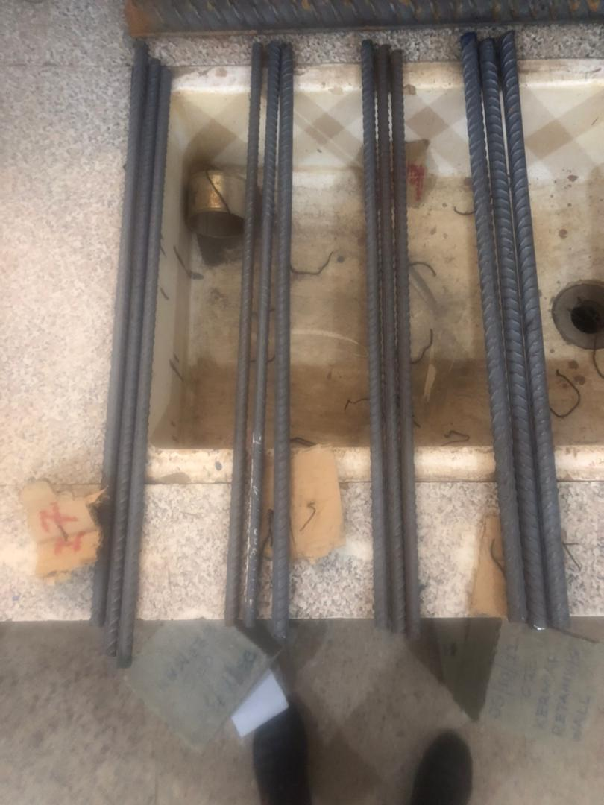
Figure 1. Steel reinforcing bars from four different sources.+
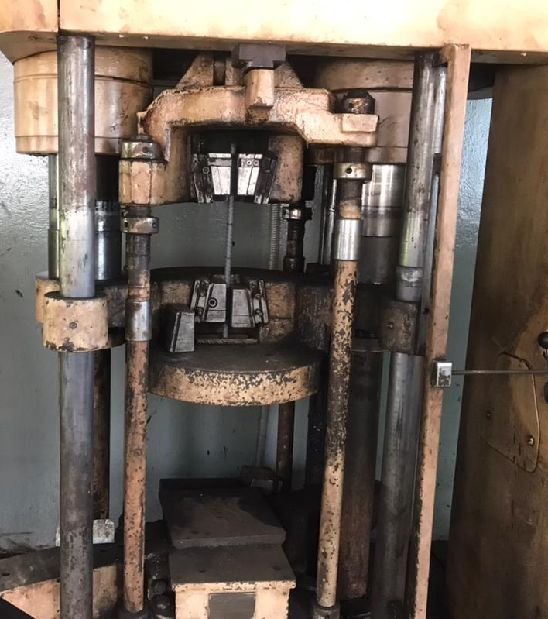
Figure 2. Reinforcing bar in Hydraulic Universal Testing Machine
Table 1: Physical Properties of Rebar Specimens
Specimen | Weight (g) | Length (mm)
AS1 | 755 | 605
AS2 | 755 | 605
AS3 | 745 | 605
BS1 | 505 | 605
BS2 | 500 | 605
BS3 | 500 | 605
CS1 | 410 | 605
CS2 | 415 | 605
CS3 | 410 | 605
DS1 | 425 | 620
DS2 | 420 | 612
DS3 | 415 | 605

3. Results and Discussion
Notably, the measured diameters of the rebars were consistently smaller than their nominal values as presented in Table 2. For example, rebars labeled as 12 mm often measured closer to 11 mm in actual diameter. This discrepancy directly reduces the cross-sectional area available to resist tensile loads and could lead to underperformance in reinforced concrete elements if not adequately accounted for in design. Such practices raise questions about compliance monitoring and suggest that stricter quality assurance procedures may be necessary to protect end-users.

Table 2: Diameters of Rebars
Specimen | Market Diameter (mm) | Actual Diameter (mm)
AS1 | 14 | 14.23
AS2 | 14 | 14.23
AS3 | 14 | 14.13
BS1 | 12 | 11.59
BS2 | 12 | 11.58
BS3 | 12 | 11.58
CS1 | 12 | 10.48
CS2 | 12 | 10.55
CS3 | 12 | 10.48
DS1 | 12 | 10.54
DS2 | 12 | 10.55
DS3 | 12 | 10.55

The results of the average tensile tests as presented in Table 3 indicated that the rebars produced by AS, BS, CS, and DS exhibited varying mechanical properties. In general, all samples exceeded the Ghana Standards Authority’s (GSA) minimum requirements of 300 N/mm² for yield strength and 400 N/mm² for ultimate tensile strength. However, when benchmarked against the more stringent BS 4449 requirements of 460 N/mm² and 600 N/mm², respectively, some rebars fell short. This discrepancy suggests that while the rebars may be suitable for local structural applications where GSA standards govern, they may not be competitive in markets where BS standards apply. This trend is consistent with earlier Ghanaian studies, which found that although locally produced rebars often satisfy GSA specifications, dimensional inconsistencies and batch-to-batch variability raise concerns about their reliability under international standards (Banini & Kankam, 2022; Kankam & Adom-asamoah, 2002) . Similar investigations in Nigeria revealed that locally manufactured rebars sometimes display acceptable strength values but fail to consistently meet BS 4449 requirements, largely due to irregular scrap composition and limited metallurgical process control (Abubakar & Abdulmajeed, 2023; Ocheri & Lo, 2017). Other researchers have highlighted that strength alone does not guarantee full compliance: residual impurities such as copper, tin, and nickel, prevalent in recycled steel, can alter weldability and toughness, thereby influencing long-term performance (Duan et al., 2021; Jin & Mishra, 2020). Recent cross-country analyses of rebar batches further indicate that non-trivial proportions of samples fail to meet grade specifications, particularly in lower-diameter bars, reinforcing the argument that variability in recycled steel-based production is a global concern rather than a uniquely Ghanaian one (Fente et al., 2024; Panasiuk et al., 2022). Comparable findings in other African contexts support these results. In Ethiopia, for instance, Fente et al., (2024) reported that many locally produced rebars satisfied national standards but would require stricter dimensional and compositional controls to compete internationally. Similarly, a Senegalese study by Sy et al., (2023) documented mechanical adequacy in local rebars but found deviations in linear mass and microstructural consistency when compared to imported alternatives. Collectively, these findings affirm that while Ghanaian rebars are adequate for domestic structural needs, improving process consistency and quality assurance is essential for meeting global standards and advancing sustainability goals in steel production.
Table 3: Mechanical Properties of Rebars from different sources
Specimen | Tensile Strength |  | Elongation
 | Yield Strength (N/mm2) | Ultimate Strength (N/mm2) | (%)
AS | 452.7 | 667.1 | 23.25
BS | 499.69 | 718.94 | 19.55
CS | 432.16 | 604.95 | 24
DS | 380.02 | 574.66 | 27.69

Elongation values (see Table 3) for all samples were above the 14% minimum requirement stipulated by both the GSA and BS 4449 standards, which confirms that the rebars possessed adequate ductility. Ductility is a critical property for reinforced concrete members as it enables redistribution of stresses and energy dissipation under overload conditions, thereby preventing sudden brittle failure (Dong et al., 2025). Adequate ductility also enhances seismic performance by allowing reinforced concrete members to undergo controlled deformations without catastrophic collapse, a particularly important consideration for developing countries where construction practices often vary (Cao et al., 2025; Li et al., 2024). The findings therefore indicate that despite occasional shortcomings in strength, the tested rebars are unlikely to pose brittleness-related structural risks. Similar results have been reported in studies of locally produced rebars across sub-Saharan Africa, where ductility values consistently met or exceeded minimum code requirements, even when yield strength and ultimate tensile strength varied (Banini & Kankam, 2022; Kankam & Adom-asamoah, 2002). Recent investigations in Ethiopia and Nigeria further emphasize that while recycled scrap-based rebars may show inconsistencies in strength, their elongation properties tend to remain within acceptable ranges, ensuring safety margins in reinforced concrete structures (Fente et al., 2024; Panasiuk et al., 2022). This highlights an important sustainability perspective: the reliance on recycled scrap metals, despite some compositional variability, continues to yield rebars with sufficient ductility for safe use in construction. This supports the argument that sustainable steel production through scrap recycling can be viable without compromising critical mechanical properties required for structural resilience (Duan et al., 2021; Jin & Mishra, 2020).
Chemical composition analysis confirmed that the rebars generally qualified as low-carbon steel as presented in Table 4. Carbon levels were within the range of 0.20–0.25%, which is consistent with the requirements for mild steel and ensures good weldability, ductility, and resistance to sudden brittle fracture (Chang et al., 2021). Maintaining low carbon content is particularly critical for reinforcement applications, since excessive carbon can increase hardness at the expense of ductility and weldability, both of which are vital for reinforced concrete structures where splicing and joint performance are important (Amran et al., 2023). Manganese and silicon levels were generally within the recommended ranges and contributed positively to strength and toughness through solid solution strengthening and improved deoxidation during steelmaking (Harsha et al., 2022). However, in some samples, their values approached the upper permissible limits, which could potentially influence strain hardening behavior and fatigue resistance if not carefully controlled (Xiong et al., 2020). Phosphorus and sulfur two undesirable residual elements were found to be within the 0.05% maximum limit prescribed by the GSA. While this suggests compliance, their concentrations in some samples were marginally close to the thresholds. Elevated phosphorus levels are known to reduce toughness and ductility, promoting cold-shortness in steel, whereas sulfur can form manganese sulfide inclusions that increase brittleness and impair weldability (Xing et al., 2022) marginally high presence of these impurities raises concerns about production consistency, especially considering that local rebar manufacturing in Ghana is heavily reliant on recycled scrap with variable metallurgical histories. From a sustainability standpoint, the findings reinforce both the benefits and challenges of scrap-based steel production. While recycling significantly reduces energy consumption and greenhouse gas emissions compared to primary steelmaking (Branca et al., 2020) inconsistent input materials can lead to variability in trace element concentrations that affect steel performance (Duan et al., 2021; Jin & Mishra, 2020). This highlights the need for stricter process monitoring, quality assurance, and the adoption of advanced refining technologies in Ghana’s steel industry to balance environmental sustainability with structural safety and reliability.

Table 4: Chemical Composition of Rebars from different sources
Chemical Composition | Specimen
(%) | AS | BS | CS | DS
Fe | 97.847 | 97.829 | 98.656 | 98.665
C | 0.299 | 0.344 | 0.349 | 0.338
Mn | 0.816 | 0.851 | 0.277 | 0.322
P | 0.05 | 0.049 | 0.042 | 0.054
S | 0.04 | 0.047 | 0.031 | 0.035
Si | 0.331 | 0.314 | 0.115 | 0.085
Cu | 0.291 | 0.233 | 0.193 | 0.229
Ni | 0.107 | 0.087 | 0.102 | 0.052
Cr | 0.228 | 0.256 | 0.231 | 0.225
V | 0.006 | 0.003 | 0 | 0
Mo | 0.085 | 0.083 | 0.08 | 0.087
Ti | 0.004 | 0.004 | 0.002 | 0.002
Al | 0.014 | 0.017 | 0.01 | 0.011
Nb | 0.006 | 0.004 | 0.001 | 0.001
Co | 0.012 | 0.011 | 0.007 | 0
Sn | 0.026 | 0.016 | 0.017 | 0.014
B | 0.002 | 0.006 | 0.003 | 0.002
Pb | 0.005 | 0.002 | 0 | 0

Overall, the study revealed that although the rebars met the basic national standards, they exhibited variability in both mechanical and chemical properties. The results highlight the need for more rigorous regulatory oversight, as well as improvements in manufacturing processes, to ensure that Ghanaian rebars can reliably meet international benchmarks.
4. Conclusion
This study investigated the mechanical and chemical properties of reinforcing steel bars (rebars) manufactured in Ghana by four coded producers (AS, BS, CS, and DS). The analysis highlighted both strengths and areas for improvement in terms of compliance with local and international standards. Key findings and implications are summarized below:
- All rebars met the Ghana Standards Authority (GSA) minimum requirements of ≥300 N/mm² yield strength, ≥400 N/mm² ultimate tensile strength, and ≥14% elongation, confirming suitability for domestic applications.
- Only some rebars achieved the stricter British Standard thresholds of ≥460 N/mm² yield strength and ≥600 N/mm² ultimate tensile strength.
- BS rebars recorded the highest performance (Yield: 499.69 N/mm²; Ultimate: 718.94 N/mm²).
- DS rebars showed the lowest performance (Yield: 380.02 N/mm²; Ultimate: 574.66 N/mm²).
- AS rebars achieved Yield: 452.7 N/mm²; Ultimate: 667.1 N/mm² (met GSA, but slightly below BS yield requirement).
- CS rebars achieved Yield: 432.16 N/mm²; Ultimate: 604.95 N/mm² (met GSA, borderline compliance with BS ultimate).
- Actual diameters were consistently lower than nominal values.
- 12 mm rebars measured between 10.48 mm (CS) and 11.59 mm (BS), reducing cross-sectional area and potentially affecting load capacity.
- All rebars qualified as low-carbon steel with carbon contents between 0.299–0.349%, ensuring good weldability and ductility.

Disclaimer (Artificial intelligence)

Option 1:

Author(s) hereby declare that NO generative AI technologies such as Large Language Models (ChatGPT, COPILOT, etc.) and text-to-image generators have been used during the writing or editing of this manuscript.

Option 2:

Author(s) hereby declare that generative AI technologies such as Large Language Models, etc. have been used during the writing or editing of manuscripts. This explanation will include the name, version, model, and source of the generative AI technology and as well as all input prompts provided to the generative AI technology

Details of the AI usage are given below:
1.
2.
3.

References
Abubakar, M., & Abdulmajeed, I. (2023). Characterization, Mechanical Properties and Probabilistic Failure Analysis of Reinforcement Bars Produced from Scraps in Southern and Northern Region of Nigeria. Journal of Failure Analysis and Prevention, 23, 1232–1241. https://doi.org/10.1007/s11668-023-01675-y
Adewuyi, A., & Eric, G. (2024). Flexural Behaviour of Concrete Beams Reinforced With Major Steel Bars under Normal and Corrosive Operational Conditions. Journal of Civil Engineering and Urbanism. https://doi.org/10.54203/jceu.2024.33
Amran, M., Murali, G., Makul, N., Tang, W., & Alluqmani, A. E. (2023). Sustainable development of eco-friendly ultra-high performance concrete (UHPC): Cost, carbon emission, and structural ductility. Construction and Building Materials. https://doi.org/10.1016/j.conbuildmat.2023.132477
Banini, E. K., & Kankam, C. K. (2022). Strength, Ductility and Chemical Properties of Reinforcing Steel Bars in Ghana’s Building Construction Industry. Original Research Article Banini and Kankam, 9(4), 1–18.
Branca, T., Colla, V., Algermissen, D., Granbom, H., Martini, U., Morillon, A., Pietruck, R., & Rosendahl, S. (2020). Reuse and Recycling of By-Products in the Steel Sector: Recent Achievements Paving the Way to Circular Economy and Industrial Symbiosis in Europe. Metals. https://doi.org/10.3390/met10030345
British Standard. (2001). BS4449:1997 Carbon steel bars for the reinforcement of concrete. October, 34.
Cao, Q., Ju, H., Wu, Z., & J., Z. (2025). Experimental study on seismic performance of GFRP and highly ductile stainless steel hybrid reinforced concrete columns. Engineering Structures. https://doi.org/10.1016/j.engstruct.2024.119130
Chang, Y., Haase, C., Szeliga, D., Madej, L., Hangen, U., Pietrzyk, M., & Bleck, W. (2021). Compositional heterogeneity in multiphase steels: Characterization and influence on local properties. Materials Science and Engineering: A, 827, 142078. https://doi.org/https://doi.org/10.1016/j.msea.2021.142078
Dong, S., Shi, F., Deng, E., & Chen, H.-T. (2025). Experimental Investigation on the Stress–Strain Behavior of Steel Fiber-Reinforced Rubberized Concrete Subjected to Cyclic Compressive Loading. Buildings. https://doi.org/10.3390/buildings15040584
Duan, J., Farrugia, D., Davis, C., & Li, Z. (2021). Effect of impurities on the microstructure and mechanical properties of a low carbon steel. Ironmaking & Steelmaking, 49, 140–146. https://doi.org/10.1080/03019233.2021.1972270
Fente, T. E., & Tsegaw, A. (2024). Environmental impact assessment of steel reinforcing bar manufacturing process from scrap materials using life cycle assessment method: a case study on the Ethiopian metal industries. Discover Applied Sciences. https://doi.org/10.1007/s42452-024-05709-4
Fente, T. E., Tsegaw, A., Abebe, A. T., & Admasu, B. (2024). Investigating the quality of ethiopian steel reinforcing bars through comprehensive analysis. Heliyon, 10. https://doi.org/10.1016/j.heliyon.2024.e31661
Harsha, B., Patnaik, A., Banerjee, M., & Kozeschnik, E. (2022). Physical, Mechanical, and Tribological Assessment of High Manganese-Silicon Steel Alloys. Silicon, 15, 3305–3322. https://doi.org/10.1007/s12633-022-02260-y
ISO 6892-1:2019(E). (2003). Metallic materials — Tensile testing. Iso 6892-1, 2003(March), 13.
Jin, H., & Mishra, B. (2020). Minimization of Copper Contamination in Steel Scrap. 357–364. https://doi.org/10.1007/978-3-030-36830-2_34
Kalogeropoulos, G., Tsonos, A.-D., & Iakovidis, P. (2024). Hysteresis Behavior of RC Beam–Column Joints of Existing Substandard RC Structures Subjected to Seismic Loading–Experimental and Analytical Investigation. Buildings. https://doi.org/10.3390/buildings14061609
Kankam, C. K., & Adom-asamoah, M. (2002). Strength and ductility characteristics of reinforcing steel bars milled from scrap metals Strength and ductility characteristics of reinforcing steel bars milled from scrap metals. 3069(September 2002). https://doi.org/10.1016/S0261-3069(02)00028-6
Li, Y., Wu, K., Pan, J., Zhao, C., Wang, F., Zhang, B., & Liu, Q. (2024). Experimental Investigation on Seismic Performance of Columns Enhanced by High-strength Steel Bars and Ultra-High-Performance fiber reinforced concrete. Case Studies in Construction Materials. https://doi.org/10.1016/j.cscm.2024.e03377
Lou, T., Wu, S., & Chen, B. (2022). Effect of reinforcement on the response of continuous steel-concrete composite beams. Case Studies in Construction Materials. https://doi.org/10.1016/j.cscm.2022.e00929
Ocheri, C., & Lo, I. (2017). Comparative Assessment of Locally Produced Reinforcing Steel Bars forStructural Purposes: 12 mm Steel Bars from Delta Steel Company (DSC),Warri-Nigeria as a Case Study. Journal of Powder Metallurgy and Mining, 6, 1–4. https://doi.org/10.4172/2168-9806.1000159
Panasiuk, D., Daigo, I., Hoshino, T., Hayashi, H., Yamasue, E., Tran, D.-H., Sprecher, B., Shi, F., & Shatokha, V. (2022). International comparison of impurities mixing and accumulation in steel scrap. Journal of Industrial Ecology, 26, 1040–1050. https://doi.org/10.1111/jiec.13246
Sy, E., Keinde, D., & Bodian, M. (2023). Comparative Evaluation of the Chemical Composition and Physical Properties of Reinforced Concrete Steel Bars Used in Construction in Senegal. Open Journal of Civil Engineering. https://doi.org/10.4236/ojce.2023.132022
Tanaka, Y., Pahlevani, F., Moon, S., Dippenaar, R., & Sahajwalla, V. (2019). In situ characterisation of MnS precipitation in high carbon steel. Scientific Reports, 9. https://doi.org/10.1038/s41598-019-46450-y
Wang, Q.-Y., Wang, Z., Li, C., Qiao, X., Guan, H., Zhou, Z., & Song, D. (2024). Research Progress in Corrosion Behavior and Anti-Corrosion Methods of Steel Rebar in Concrete. Metals. https://doi.org/10.3390/met14080862
Xing, L., Zhang, Z., & Bao, Y. (2022). Hot ductility behavior of medium carbon sulfur-containing alloy steel. Journal of Materials Research and Technology. https://doi.org/10.1016/j.jmrt.2022.05.143
Xiong, R., Liu, Y., Si, H., Peng, H., Wang, S., Sun, B., Chen, H., Kim, H.-S., & Wen, Y. (2020). Effects of Si on the Microstructure and Work Hardening Behavior of Fe‒17Mn‒1.1C‒xSi High Manganese Steels. Metals and Materials International, 27, 3891–3904. https://doi.org/10.1007/s12540-020-00846-y
Zhou, X. (2023). The application and development of reinforced concrete structure in building construction. Journal of Materials, Processing and Design. https://doi.org/10.23977/jmpd.2023.070302

