Research on the diagnosis of circulating current faults in the metal sheath of cross-linked XLPE cables under different working conditions

.

ABSTRACT

|  |
| --- |
| This article deeply analyzes the distribution characteristics and variation laws of metal sheath circulating current under various typical fault conditions when XLPE high-voltage single core cables are connected by cross interconnection at 110 kV level. By comparing the different distribution characteristics of circulating current under various working conditions, the fault mechanism is revealed and theoretical basis is provided for state monitoring and protection strategies. By establishing a theoretical model of a cross connected system and based on the principle of electromagnetic induction, five typical fault scenarios are theoretically derived and quantitatively estimated. This article uses PSCAD/EMTDC simulation software to simulate the current values of the sheath ring during normal operating conditions, single-phase grounding short circuit of A-phase core, two-phase short circuit of BC two-phase core, open circuit of A-phase metal sheath, and two-phase short circuit of AB two-phase metal sheath. Compared with theoretical calculation values, it is found that the short-circuit fault of the core will excite a huge sheath current of kA level, and the fault phase current is highly concentrated. The fault of the metal sheath itself will cause abnormal current of 10A level. Among them, the short-circuit between sheath phases significantly increases the fault phase current, while the open circuit of the sheath causes the fault phase current to drop sharply to zero and produce slight disturbance in the non fault phase. |

*Keywords: XLPE; induced current;* *metallic sheath; cross interconnection; fault*

1. INTRODUCTION

With the acceleration of urbanization in China, grounding high-voltage transmission lines has become an inevitable choice for the construction of power grids in large cities. XLPE cross-linked polyethylene insulated power cables are widely used in medium and high voltage lines of urban networks, power transmission and distribution, and industrial and mining enterprises due to their excellent electrical and mechanical properties [1]. In order to ensure the safe operation and prolong the service life of cables, metal sheaths serve as important electrical and mechanical shielding layers in cable structures, undertaking functions such as shielding electric fields, conducting fault currents, and grounding protection.

For XLPE high-voltage single core cables, when AC current passes through the core, a high induced voltage will be generated on its metal sheath [2]. If the sheath is grounded at both ends or multiple points, a closed circuit will be formed, resulting in significant sheath circulation. In practical engineering cases, we generally adopt a combination of direct grounding at both ends of the metal sheath and cross interconnection grounding in the middle, which can effectively suppress the current in the sheath.

When a core fault or sheath loop fault occurs in the XLPE cable cross interconnection grounding system, the current value of the sheath loop will be abnormal, and there are various factors that can cause circulation faults, including environmental changes, construction quality, equipment aging, etc [3]. These factors may lead to serious consequences such as potential short circuits, equipment damage, and even fires, and affect the stability of power system operation.

Therefore, it is necessary to calculate the circulation under various faults and analyze their circulation characteristics. The existing fault detection techniques mainly focus on the aging status of cables, insulation performance evaluation, and partial discharge detection. However, systematic research on metal sheath circulating current faults is still relatively insufficient. This article aims to explore in depth the causes and diagnostic techniques of metal sheath circulation in cross connected XLPE cables under different operating conditions. With the help of modern detection methods and theoretical analysis, an effective fault diagnosis model is established to provide more reliable technical support for the safe operation of power systems.

2. Calculation model of cross interconnected metal sheath circulation under different working conditions

The most common fault of XLPE cables during operation is that the insulation of the protective layer is damaged by external forces, causing multiple grounding points of the metal protective layer and generating protective layer circulation, resulting in increased protective layer loss. It may also cause local overheating of the insulation, accelerate insulation aging, and affect the service life of the main insulation. In addition, during cable operation, the core may also experience single-phase grounding short circuit and two-phase short circuit faults, and the resulting circulating current can also affect the stability of cable operation. Most domestic and foreign studies only analyze the operating status of cables under normal conditions, and rarely mention the operating status under different fault conditions.

**2.1 Under normal operating conditions**

This article employs a 110kV grade XLPE high-voltage single-core cable for power transmission. According to electromagnetic principles, the flow of current through the cable core will induce a certain voltage in the metallic sheath. Therefore, as shown in Figure 1, it is assumed that the metallic sheath P is a conductor parallel to the three-phase cores A, B, and C. The distances between the centers of these four conductors are expressed in ratios, where the center-to-center distances between cores AB, BC, and CA are denoted as S, mS, and nS, respectively; and the center-to-center distances between conductor P and cores A, B, and C are denoted as D, βD, and γD, respectively.

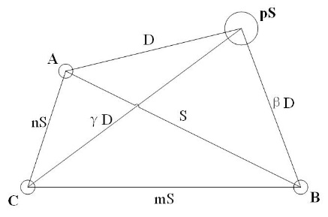

**Fig. 1. Ratio diagram of three-phase cable arrangement**

Assuming the currents in the three-phase cores A, B, and C are balanced, we have[4]:

$\begin{aligned}I_{A}=I \\ I_{A}=\left(-\frac{1}{2}-j\frac{\sqrt{3}}{2}\right)I \\ I_{A}=\left(+\frac{1}{2}-j\frac{\sqrt{3}}{2}\right)I\end{aligned}$ (1)

According to electromagnetic principles, the magnetic flux between conductor p and core current *IA*, , the magnetic flux between p and core current *IB*, , and the magnetic flux between p and core current IC, , are derived as follows[5]:

$φ_{pA}=2×{10}^{-4}I_{A}ln⁡\frac{D}{GMR_{P}}Wb/km$ (2)

$φ_{pB}=2×{10}^{-4}I_{B}ln⁡\frac{βD}{GMR_{P}}Wb/km$ (3)

$φ_{pC}=2×{10}^{-4}I_{C}ln⁡\frac{γD}{GMR_{P}}Wb/km$ (4)

The total magnetic flux $φ_{p}$ of the metal sheath p and the A, B, C three-phase cores can be expressed as[6]:

$φ_{p}=2×{10}^{-4}(I_{A}\ln{\frac{D}{GMR_{P}}}+I_{B}\ln{\frac{βD}{GMR_{P}}}+I_{C}ln⁡\frac{γD}{GMR_{P}})Wb/km$ (5)

In the formula, *GMRP* represents the geometric mean radius of conductor p, with the same unit as D.

When the conductor p is completely concentric with the A-phase core, it is the metal sheath of the A-phase core. At this point, there are βD=S and γD=nS, and because the geometric average distance between the circumference and any point within the circumference is the principle of its radius, D=*GMRP*=*GMRS*, where *GMRS* is the geometric average radius of the metal sheath. Substituting the above equation into equation (5) yields[7]:

$φ_{p}=2×{10}^{-4}\left(I_{B}\ln{\frac{S}{GMR_{S}}}+I_{B}\ln{\frac{nS}{GMR_{S}}}\right)$ (6)

Substituting equation (1) into equation (6) yields:

$\begin{aligned}φ_{p}&=2×{10}^{-4}\left(\begin{aligned}\left(-\frac{1}{2}-j\frac{\sqrt{3}}{2}\right)\operatorname{Iln}{\frac{S}{GMR_{S}}}+ \\ \left(-\frac{1}{2}+j\frac{\sqrt{3}}{2}\right)Iln⁡\frac{nS}{GMR_{S}}\end{aligned}\right) \\ =2×{10}^{-4}I\left(-\frac{1}{2}\ln{\frac{nS^{2}}{GMR_{s}}}-j\frac{1}{2}\ln{n}\right) \\ Wb/km\end{aligned}$ (7)

According to Faraday's law of electromagnetic induction, the induced electromotive force *USA* of the A-phase metal sheath can be obtained[8]

$U_{SA}=-jωφ_{P}=2ωI×{10}^{-4}(\frac{\sqrt{3}}{2}\ln{n}+ j\frac{1}{2}ln⁡\frac{nS^{2}}{GMR_{S}^{2}})V/km$ (8)

Where $ω$ is the electrical angular velocity of the three-phase current, with a magnitude of $2πf$ and $f$ being 50Hz.

Similarly, when the conductor p is completely concentric with the B-phase core

$U_{SB}=-jωφ_{P}=2ωI×{10}^{-4}\left(\frac{\sqrt{3}}{2}\ln{\frac{mS}{GMR_{S}}}- j\frac{1}{2}ln⁡\frac{S}{m×GMR_{S}^{2}}\right)V/km$ (9)

Similarly, when the conductor p is completely concentric with the C-phase core

$U_{SC}=-jωφ_{P}=2ωI×{10}^{-4}(-\frac{\sqrt{3}}{2}\ln{\frac{mS}{GMR_{S}}}- j\frac{1}{2}ln⁡\frac{n^{2}S}{m×GMR_{S}^{2}})V/km$ (10)

In summary, when the impedance per unit length of the metal sheath is known, its circulating current is also easy to calculate, and this article will not elaborate further.

**2.2 When a single-phase grounding short circuit occurs in conductor**

Compared to other short-circuit situations, the induced voltage under single-phase grounding short-circuit fault is the highest. The grounding current studied in this article is partially connected to the ground as the loop and partially connected to the sheath or return wire as the loop. When the metal sheath adopts cross interconnection grounding and the ground resistance near the line is small, the grounding resistance of the grounding body is also small. At this time, a part of the grounding current is looped around the ground and another part is looped around the metal sheath. In practice, this is usually the case where the induced voltage of the sheath is between two situations: when the grounding current is entirely in the earth circuit and when the grounding current is entirely in the cable metal sheath or return wire circuit.

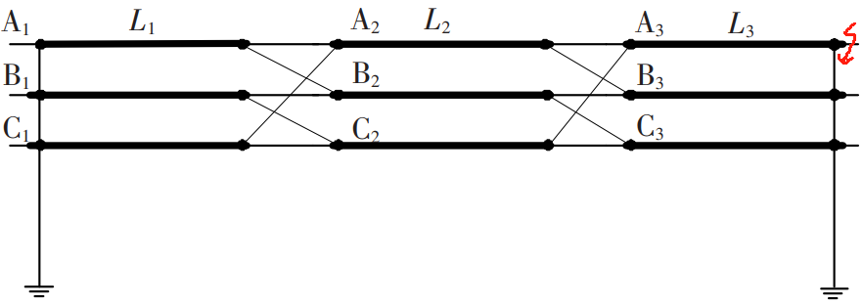

**Fig. 2. Schematic diagram of cross interconnection current of cable metal sheath during single-phase grounding short circuit of A-phase core**

$\begin{aligned}&Z_{ss}=r_{e}+r_{s}+j2ω×{10}^{-7}ln⁡\frac{D_{e}}{R_{av}} \\ &Z_{cs}=r_{e}+j2ω×{10}^{-7}ln⁡\frac{D_{e}}{R_{av}} \\ &Z_{ab}=r_{e}+j2ω×{10}^{-7}ln⁡\frac{D_{e}}{S_{ab}} \\ &Z_{ac}=r_{e}+j2ω×{10}^{-7}ln⁡\frac{D_{e}}{S_{ac}} \\ &Z_{bc}=r_{e}+j2ω×{10}^{-7}ln⁡\frac{D_{e}}{S_{bc}}\end{aligned}$ (11)

In equation (11), *Zss* is the self impedance per unit length of the metal sheath; *Zcs* is the mutual impedance per unit length between the same cable core and the metal sheath; *Zab*, *Zac*, *Zbc* are the mutual impedances per unit length of metal sheaths for AB phase, AC phase, and BC phase, respectively; *re* and *rs* are the resistance per unit length of the earth and metal sheath, respectively. Due to the large conducted and induced currents in the sheath circuit during a single-phase short circuit fault, which are much greater than the leakage current, the leakage current component can be ignored when calculating the circulating current of the short circuit fault. Taking the induced voltage on segment A1 in Figure 2 as an example, there are[9]:

$\left\{\begin{aligned}&E_{Al}=(Z_{cs}I_{f}+Z_{ab}I_{B}+Z_{ac}I_{C})L_{l} \\ &U_{Al}=(Z_{ab}I_{SB}+Z_{ac}I_{SC})L_{l} &&\end{aligned}\right.$ (12)

In equation (12), *EA1* is the induced voltage generated by the three-phase core current on the A1 section sheath; *UA1* is the induced voltage generated by other circulating currents on the A1 section sheath. The induced voltage of other segments can be obtained similarly. Write the KVL equation, which includes[10]:

$\left\{\begin{aligned}&Z_{s}I_{SA}-\left(R_{d1}+R_{d2}\right)\left(I_{f}-I_{SA}-I_{SB}-I_{SC}\right)=E_{SA}+U_{SA} \\ &Z_{s}I_{SB}-\left(R_{d1}+R_{d2}\right)\left(I_{f}-I_{SA}-I_{SB}-I_{SC}\right)=E_{SB}+U_{SB} \\ &Z_{s}I_{SC}-\left(R_{d1}+R_{d2}\right)\left(I_{f}-I_{SA}-I_{SB}-I_{SC}\right)=E_{SC}+U_{SC} &&\end{aligned}\right.$ (13)

In equation (13), *Zs* is the total impedance of the three metal sheaths; *ESA*=*EA1*+*EB2*+*EC3* is the total induced voltage generated by the three-phase core current in the sheath circuit 1; *USA*=*UA1*+*UB2*+*UC3* is the total induced voltage generated by the circulating current of other phase sheaths in sheath circuit 1; *ESB*, *USB*, *ESC*, and *USC* have similar meanings.

**2.3 When a two-phase short circuit occurs in conductor**

When there is a two-phase short circuit, the situation of edge phase and edge phase short circuit should be calculated. Because when the edge phase and edge phase are short circuited, the area enclosed by the circuit is larger than when the edge phase and middle phase are short circuited, so the induced potential is also larger. Due to the fact that the short-circuit current will no longer loop through the ground when two phases are short circuited, and no short-circuit current will flow through the grounding grid, the potential at point E of the protective layer is zero. The maximum potential of the A-phase cable metal sheath to ground is also the maximum induced potential of the metal sheath. The sheath circulation can be obtained from the following formula[11].

${\dot{U}}_{SA}=-j2ω{\dot{I}}_{SCA}\left(\ln{\frac{4S}{D_{s}}}\right)×{10}^{-7}$ (14)

${\dot{U^{'}}}_{SAE}={\dot{U}}_{SAE}=-j2ω{\dot{I}}_{SCA}l\left(\ln{\frac{4S}{D_{s}}}\right)×{10}^{-7}$ (15)

**2.4 When a single-phase open circuit occurs in the metal sheath**

The main danger of sheath open circuit fault is not circulation, but the abnormally high voltage generated at both ends of the open circuit point, which seriously threatens personal safety and equipment insulation.

The voltage at both ends of the open circuit point is mainly composed of two parts：1. The longitudinal induced electromotive force is generated by the electromagnetic induction of the current in the core of this phase. In a cross connected system, an induced electromotive force *V*=*IωML* is generated on the metal sheath of a cable, where *M* is the mutual inductance coefficient and *L* is the segment length. During normal operation, this electromotive force is short circuited, forming a circulating current. Once an open circuit occurs, this electromotive force cannot be cancelled out and is fully manifested at both ends of the open circuit point. For 110kV cables, the effective value of induced electromotive force of a standard length of sheath can reach tens to hundreds of volts under normal load. 2. Ground floating voltage is the voltage induced to ground by the core current of the other two phases passing through the entire isolated sheath section of the open circuit A phase. This voltage is superimposed on the longitudinal electromotive force, and its value is much greater than the longitudinal electromotive force, making it the main source of danger. The magnitude of this voltage is related to the core current and the operation mode of the power grid. In asymmetric situations such as single-phase grounding faults, the voltage will become extremely high. Even under normal balanced operation, its ground voltage value can easily reach hundreds or even thousands of volts.

The total voltage at both ends of the open circuit point is the vector sum of the two voltages mentioned above. This high voltage can cause: breakdown of air gaps, generation of arcs, continuous arcing at open circuit points (such as loose connections), burning of equipment, and possible fire hazards; Damaging the protective layer protector (SVL), continuous high voltage will cause the SVL to operate for a long time, flowing current far exceeding its energy absorption capacity, resulting in overheating and burning of the SVL; Personal safety is threatened, and maintenance personnel who come into contact with this open circuit protective sheath or related equipment will face the risk of electric shock.

When the cable joint is damaged by external forces, corroded by the environment, or installed improperly, it is easy for the grounding wire lead to become loose, resulting in an open circuit fault in the sheath circuit. At this time, due to the open circuit of phase A, there is no induced current component in sheath circuit 1, but there is still a leakage current component, so its impact on sheath circuits 2 and 3 still needs to be considered.

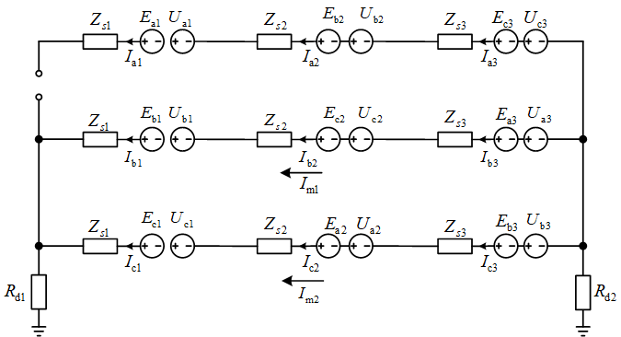

**Fig. 3.** **Schematic diagram of cross interconnection circulation of cable metal sheath when A-phase metal sheath is open circuit**

For an A-phase sheath open circuit and an equivalent circuit with only two sheath loops, the current equations for the loops $Z_{f2}$、 $U_{sf2}^{(t)}$, and the induced current components of each sheath segment are as follows[12]:

$Z_{f2}=\left[\begin{matrix}Z_{ss}L+R_{d1}+R_{d2} & R_{d1}+R_{d2} \\ R_{d1}+R_{d2} & Z_{ss}L+R_{d1}+R_{d2}\end{matrix}\right]$ (16)

$U_{sf2}^{(t)}=\left[\begin{aligned}U_{sbl}^{(t)}+U_{sc2}^{(t)}+U_{sa3}^{(t)} \\ U_{scl}^{(t)}+U_{sa2}^{(t)}+U_{sb3}^{(t)}\end{aligned}\right]$ (17)

$\begin{aligned}&I_{a1}^{(t)}=I_{a2}^{(t)}=I_{a3}^{(t)}=0 \\ &I_{b1}^{(t)}=I_{b2}^{(t)}=I_{b3}^{(t)}=I_{m1}^{(t)} \\ &I_{c1}^{(t)}=I_{c2}^{(t)}=I_{c3}^{(t)}=I_{m2}^{(t)}\end{aligned}$ (18)

After modifying the corresponding formula, the iterative method can be used to calculate the induced current component during A-phase open circuit fault, and then obtain the final sheath circulating current.

**2.5** **When a two-phase short circuit occurs in the metal sheath**

When the epoxy prefabricated component in the middle joint of the cable is punctured, there will be a short circuit between the two sheaths, and the original cross interconnection system will be destroyed. The newly added fault branch will increase the number of sheath circuits to four. Taking the AB two-phase short circuit as an example, when *Iai*、*Ibi*、*Ici*(i=1，2，3)are used as voltage sources, the induced current components of the i-th section of each sheath circuit are represented by *Rf* as the fault resistance, and *Im1*，*Im2*，*Im3* and *Im4* are the circuit currents of the four sheath circuits, respectively.

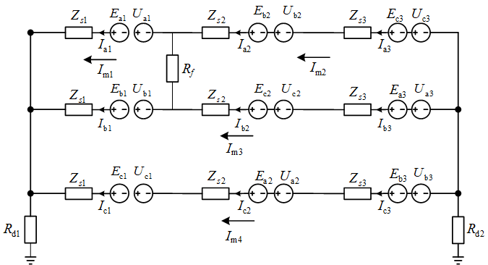

**Fig. 4. Schematic diagram of cross interconnection circulation of cable metal sheaths during two-phase short circuit of AB two-phase metal sheaths**

$\begin{aligned}&\left\{\begin{matrix}E_{ai}=(Z_{cs}I_{Lai}+Z_{ab}I_{Lbi}+Z_{ac}I_{Lci})L_{i} & \\ E_{bi}=\left(Z_{ab}I_{Lai}+Z_{cs}I_{Lbi}+Z_{bc}I_{Lci}\right)L_{i}⋯(i=1,2,3) & \\ E_{ci}=(Z_{ac}I_{Lai}+Z_{bc}I_{Lbi}+Z_{cs}I_{Lci})L_{i} & \end{matrix}\right.\end{aligned}$ (19)

$\left\{\begin{aligned}&U_{abc}=U_{abc}^{'}+U_{abc}^{''} \\ &U_{abc}^{'}=-Z_{m}I_{si(L)} \\ &U_{abc}^{''}=-Z_{m}I_{sv(L)} &&\end{aligned}\right.$ (20)

Among them[13], *Uabc* is the induced voltage matrix generated by the sheath circulating current; *U′abc* is the induced voltage matrix generated by the leakage current component of the sheath; *U′′abc* is the induced voltage matrix generated by the sheath induced current component; *Zm* is the mutual impedance matrix; *Isi(L)* is the leakage current component matrix, which does not change with the iteration process; *IsV(L)* is the matrix of induced current components, which will continuously change through iteration.[14]

$U_{abc}=\left[\begin{matrix}U_{a1} & U_{a2} & U_{a3} \\ U_{b1} & U_{b2} & U_{b3} \\ U_{c1} & U_{c2} & U_{c3}\end{matrix}\right]$ (21)

$Z_{m}=\left[\begin{matrix}0 & Z_{ab} & Z_{ac} \\ Z_{ab} & 0 & Z_{bc} \\ Z_{ac} & Z_{bc} & 0\end{matrix}\right]$ (22)

$I_{si(L)}=\left[\begin{matrix}I_{scal}L_{1} & I_{scc2}L_{2} & I_{scb3}L_{3} \\ I_{scbl}L_{1} & I_{sca2}L_{2} & I_{scc3}L_{3} \\ I_{sccl}L_{1} & I_{scb2}L_{2} & I_{sca3}L_{3}\end{matrix}\right]$ (23)

$I_{sv(L)}=\left[\begin{matrix}I_{al}L_{1} & I_{c2}L_{2} & I_{b3}L_{3} \\ I_{bl}L_{1} & I_{a2}L_{2} & I_{c3}L_{3} \\ I_{cl}L_{1} & I_{b2}L_{2} & I_{a3}L_{3}\end{matrix}\right]$ (24)

At the t-th iteration, the total induced voltage matrix of each section of the sheath is:

$U_{sabc}^{(t)}=\left[\begin{matrix}U_{sal}^{(t)} & U_{sa2}^{(t)} & U_{sa3}^{(t)} \\ U_{sb1}^{(t)} & U_{sb2}^{(t)} & U_{sb3}^{(t)} \\ U_{sc1}^{(t)} & U_{sc2}^{(t)} & U_{sc3}^{(t)}\end{matrix}\right]=\left[\begin{matrix}E_{al}+U_{al}^{(t)} & E_{a2}+U_{a2}^{(t)} & E_{a3}+U_{a3}^{(t)} \\ E_{bl}+U_{bl}^{(t)} & E_{b2}+U_{b2}^{(t)} & E_{b3}+U_{b3}^{(t)} \\ E_{cl}+U_{cl}^{(t)} & E_{c2}+U_{c2}^{(t)} & E_{c3}+U_{c3}^{(t)}\end{matrix}\right]$ (25)

The loop current matrix obtained from the loop current method is[15]:

$I_{m}^{(t)}={\left[\begin{matrix}I_{m1}^{(t)} & I_{m2}^{(t)} & I_{m3}^{(t)} & I_{m4}^{(t)}\end{matrix}\right]}^{T}=Z_{fl}^{-1}U_{sfl}^{(t)}$ (26)

among which:

$Z_{fl}=\left[\begin{matrix}2Z_{ss}L_{1}+R_{f} & -R_{f} & -Z_{ss}L_{1} & 0 \\ -R_{f} & 2(Z_{ss}L_{2}+Z_{ss}L_{3})+R_{f} & -Z_{ss}L_{2}-Z_{ss}L_{3} & 0 \\ -Z_{ss}L_{1} & -Z_{ss}L_{2}-Z_{ss}L_{3} & Z_{ss}L+R_{dl}+R_{d2} & R_{dl}+R_{d2} \\ 0 & 0 & R_{dl}+R_{d2} & Z_{ss}L+R_{dl}+R_{d2}\end{matrix}\right]$ (27)

$U_{sfl}^{(t)}=\left[\begin{aligned}U_{sal}^{(t)}-U_{sbl}^{(t)} \\ U_{sb2}^{(t)}+U_{sc3}^{(t)}-U_{sc2}^{(t)}-U_{sa3}^{(t)} \\ U_{sbl}^{(t)}+U_{sc2}^{(t)}+U_{sa3}^{(t)} \\ U_{scl}^{(t)}+U_{sa2}^{(t)}+U_{sb3}^{(t)}\end{aligned}\right]$ (28)

Calculate the t-th iteration value of the induced current component of each section of the sheath according to the following formula:

$\begin{aligned}&{ I}_{al}^{(t)}=I_{m1}^{(t)};I_{a2}^{(t)}=I_{a3}^{(t)}=I_{m2}^{(t)} \\ &{ I}_{b1}^{\left(t\right)}=-I_{m1}^{\left(t\right)}+I_{m3}^{\left(t\right)} \\ I_{b2}^{(t)}=I_{b3}^{(t)}=-I_{m2}^{(t)}+I_{m3}^{(t)} \\ &{ I}_{cl}^{(t)}=I_{c2}^{(t)}=I_{c3}^{(t)}=I_{m4}^{(t)}\end{aligned}$ (29)

Using iterative method to solve the circulation of each sheath.

3.Verification and analysis of simulation models under different operating conditions

PSCAD/EMTDC is an electromagnetic transient simulation software, which consists of two main components: PSACD and EMTDC. PSCAD is the front-end user interface of software, which provides an intuitive graphical operating environment. Users can build circuit models, set parameters, control simulation runs, and view results in real time by dragging and dropping components from the component library. EMTDC is the backend simulation engine for software, which is a powerful and time validated numerical calculation program responsible for solving the differential equations corresponding to the models established by users. The core of EMTDC is to use the algorithm proposed by Professor Dommel to equate power system components with resistors and current sources, and then solve them using trapezoidal integration method and node admittance matrix. This software has a powerful component library that allows users to use it directly without programming. It is adept at simulating fast dynamic processes ranging from microseconds to seconds, such as lightning overvoltage, operational overvoltage, short circuit faults, ferromagnetic resonance, and sub synchronous oscillation (SSR).This article uses PSCAD/EMTDC simulation software to simulate the circulating current values of the metal sheath of a cross connected XLPE high-voltage single core cable under different working conditions at 110kV level. When the core experiences single-phase grounding short circuit and two-phase short circuit faults, the circulating current value of the faulty phase sheath will also be particularly large due to the particularly high excitation source current, generally at the kA level. Due to the particularly large fault current in this situation, the fault current is measured by scaling it with a current transformer, and then a relay protection device is used to cut off the fault and a waveform recorder is used to record the waveform.The non fault phase sheath circulation is relatively small compared to the fault phase, but in actual operation, its sheath circulation value is also much larger than under normal conditions. Therefore, in these two situations, the relay protection should be activated, and manual troubleshooting and fault handling should be carried out. This section will not delve into it further. The following simulation study is only conducted on the operating system under normal operating conditions, when the A-phase metal sheath experiences an open circuit fault, and when the AB phase metal sheath experiences a short circuit fault, and compared with theoretical values to draw conclusions. The following lists the circulating current values under different load currents.

**Table 1 Comparison between theoretical and actual values of circulating current in each sheath under normal operating conditions**

|  |  |  |  |  |  |  |
| --- | --- | --- | --- | --- | --- | --- |
| load current (A) | *Isa*(A) | | *Isb*(A) | | *Isc*(A) | |
| theoretical value | Actual value | theoretical value | Actual value | theoretical value | Actual value |
| 200 | 1.425 | 1.046 | 1.425 | 1.044 | 1.425 | 1.046 |
| 250 | 2.033 | 2.541 | 2.033 | 2.510 | 2.033 | 2.501 |
| 300 | 2.567 | 2.789 | 2.567 | 2.788 | 2.567 | 2.701 |
| 350 | 3.020 | 3.235 | 3.020 | 3.235 | 3.020 | 3.235 |
| 400 | 3.699 | 3.854 | 3.699 | 3.856 | 3.699 | 3.850 |

**Table 2 Comparison between theoretical and actual values of circulating current in each sheath during open circuit of A-phase metal sheath**

|  |  |  |  |  |  |  |
| --- | --- | --- | --- | --- | --- | --- |
| load current (A) | *Isa*(A) | | *Isb*(A) | | *Isc*(A) | |
| theoretical value | Actual value | theoretical value | Actual value | theoretical value | Actual value |
| 200 | 0 | 0.332 | 5.265 | 5.623 | 5.265 | 5.621 |
| 250 | 0 | 0.254 | 6.989 | 6.761 | 6.989 | 6.754 |
| 300 | 0 | 0.245 | 8.033 | 8.515 | 8.033 | 8.527 |
| 350 | 0 | 0.159 | 9.281 | 9.710 | 9.281 | 9.719 |
| 400 | 0 | 0.112 | 11.004 | 12.815 | 11.004 | 12.810 |

**Table 3 Comparison between theoretical and actual values of circulating current in each sheath during two-phase short circuit of AB two-phase metal sheath**

|  |  |  |  |  |  |  |
| --- | --- | --- | --- | --- | --- | --- |
| load current (A) | *Isa*(A) | | *Isb*(A) | | *Isc*(A) | |
| theoretical value | Actual value | theoretical value | Actual value | theoretical value | Actual value |
| 200 | 50.877 | 52.694 | 50.877 | 52.663 | 3.426 | 3.955 |
| 250 | 54.198 | 57.322 | 54.198 | 57.152 | 4.011 | 5.289 |
| 300 | 58.184 | 60.962 | 58.184 | 60.910 | 4.956 | 5.936 |
| 350 | 62.154 | 65.519 | 62.154 | 65.429 | 5.648 | 7.005 |
| 400 | 70.095 | 75.442 | 70.095 | 75.561 | 6.626 | 8.010 |

According to Tables 1, 2, and 3, under normal operating conditions, the circulating current value of the sheath is generally less than 5A. When a single-phase open circuit fault occurs in the metal sheath, the circulating current of the faulty phase is close to 0, but a very high induced voltage will be generated at both ends of the open circuit, which will threaten personal safety, rather than the intact structure of the non faulty phase. Due to the single-phase open circuit, the current of the non faulty phase will slightly increase. When a two-phase short circuit occurs in the metal sheath, the fault phase current significantly increases, while the non fault phase current remains at normal values. Therefore, effective measures need to be taken to suppress the magnitude of the fault circulation. The simulation model diagram of the cable under normal and fault conditions is shown below：

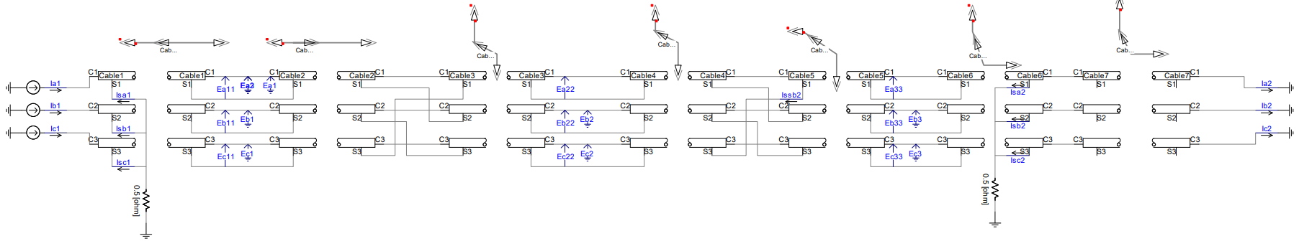

**Fig. 5.** **Cable simulation model under normal operating conditions**

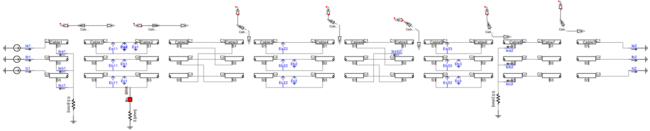

**Fig. 6** **Cable simulation model under fault conditions.**

**4 Conclusion**

This article focuses on the cross interconnection system of 110kV XLPE high-voltage single core cables, and deeply analyzes the size and distribution characteristics of the circulating current of the A, B, and C three-phase metal sheaths under four typical fault conditions. When there is a short circuit fault in conductor (A phase single-phase ground, BC two-phase short circuit), the sheath circulation is extremely large, reaching the kA level, and the distribution is highly concentrated. When there is a single-phase ground short circuit in phase A, the fault phase A has a huge circulating current in the sheath, reaching 10-18kA, while the non fault phases B and C have extremely small circulating currents; When the BC phase is short circuited, the non fault phase A phase sheath current is almost zero, while the fault phase B and C phase sheath current is huge, reaching 8-15kA. When the sheath is short circuited between phases (AB phase short circuit), a low impedance circuit will be formed between the fault phases A and B, producing significant phase to phase current of 30-80A, while the non fault phase C phase current remains normal. When the sheath has an open circuit fault (A-phase open circuit), the fault phase A-phase circulating current drops sharply to zero, but at the same time, it will generate dangerous high voltage at the open circuit point. The circulation of non faulty phases B and C will slightly increase due to the disruption of system balance, usually between 5-15A.

Under normal operating conditions, the cross interconnection system can effectively suppress the sheath circulation at an extremely low level (<5A). Any deviation from this benchmark value directly reflects the disruption of system balance and can be used for fault warning and localization. The sheath circulating current induced by the huge short-circuit current of conductor is kA level, which threatens the safety of the main equipment; The circulating current induced by normal load current and caused by changes in the sheath circuit structure is 10A, mainly leading to local overheating and insulation aging of the sheath.

This article clarifies the order of magnitude difference in circulating current between core short circuit and sheath fault. Based on this, differentiated protection strategies can be set: for kA level circulating current, the main fault should be immediately tripped and cut off; For abnormal increase in circulation of 10A level, an alarm can be issued to guide operation and maintenance personnel to search for defects such as insulation damage of the sheath or open circuit at the connection point, and achieve condition based maintenance. By monitoring the relative magnitude and distribution pattern of the circulating current values in the three-phase sheath, rather than just absolute values, it is possible to more accurately determine the nature and phase of the fault, greatly reducing the time for fault diagnosis.

COMPETING INTERESTS DISCLAIMER:

Authors have declared that they have no known competing financial interests OR non-financial interests OR personal relationships that could have appeared to influence the work reported in this paper.

Disclaimer (Artificial intelligence)

Option 1:

Author(s) hereby declare that NO generative AI technologies such as Large Language Models (ChatGPT, COPILOT, etc.) and text-to-image generators have been used during the writing or editing of this manuscript.

Option 2:

Author(s) hereby declare that generative AI technologies such as Large Language Models, etc. have been used during the writing or editing of manuscripts. This explanation will include the name, version, model, and source of the generative AI technology and as well as all input prompts provided to the generative AI technology

Details of the AI usage are given below:

1.

2.

3.

References

1. Wang Wenlong, Xu Wei. Analysis and Handling of Abnormal Grounding Current Fault in 220 kV Cable Outer Sheath [J]. Hebei Electric Power Technology, 2024, 43 (04): 75-79.
2. Fang Jun Operation Analysis and Circulating Current Suppression of High Voltage Cable Sheath Swapping Grounding System [D]. Shanghai Institute of Electrical Engineering, 2023.
3. Zhu Guangyue, Qi Mingze, Chen Xiangpeng, etc. The Influence of Phase Spacing and Loop Spacing on the Circulating Current of Metal Sheaths in Power Cables [J]. Journal of Northeast Electric Power University, 2021, 41 (02): 79-85.
4. Guo Wei, Ren Zhigang, Qi Weiqiang, et al. Study on the Impact of Mixed Laying of 10 kV and 110 kV Cable Lines on Circulating Current [J]. Electronic Measurement Technology, 2019, 42 (04): 135-140.
5. Chen Gen, Tang Yan, Wang Xinqiao Simulation of Multi point Grounding Fault of High Voltage Cable Metal Sheath Based on ATP [J]. High Voltage Apparatus, 2014, 50 (04): 49-53+60.
6. Ao Furong. Fault Analysis and Handling of 500 kV High Voltage Cable Outer Sheath Loop Current Online Monitoring Device [J]. Hydroelectric Power, 2017, 43 (04): 23-25.
7. Lu Xiaoyi, Xu Wei. Calculation Method of Circulating Current under Cross Interconnection of Multi-Circuit Cable Sheaths [J]. Power Grid and Clean Energy, 2017, 33 (06): 71-76.
8. Wang Enzhe, Chen Xiangrong, Zhang Tianyin, etc Fault circulating current calculation and grounding current optimization of tunnel cable system based on bilateral elimination method [J]. Chinese Journal of Electrical Engineering, 2025, 45 (03): 1160-1172.
9. Zhou Yuanxiang, Fu Xinya, Lv Weiwei, etc Simulation analysis of temperature and current carrying capacity of dual loop heterogeneous landing section submarine cable considering circulation [J]. High Voltage Technology, 2025, 51 (06): 2748-2758.
10. Wu R , Zou W , Yuan J , et al. Comparison of Methods for Suppressing Circulating Current in Metal Sheath of Cables Connected in Parallel [J]. Energies, 2023, 16 (11).
11. Peng L , Pengcheng G. Characteristic Analysis of the Outer Sheath Circulating Current in a Single-Core AC Submarine Cable System [J]. Symmetry, 2022, 14 (6): 1088-1088.
12. Nazrin, A., Kuan, T. M., Mansour, D. E. A., Farade, R. A., Ariffin, A. M., Abd Rahman, M. S., & Wahab, N. I. B. A. (2024). Innovative approaches for augmenting dielectric properties in cross-linked polyethylene (XLPE): A review. *Heliyon*, *10*(15).
13. Aljoumaa, K., & Allaf, A. W. (2021). Morphology, structure, properties and applications of XLPE. In *crosslinkable polyethylene: manufacture, properties, recycling, and applications* (pp. 125-166). Singapore: Springer Singapore.
14. Rafati, A., Mirshekali, H., Shaker, H. R., & Bayati, N. (2024). Power Grid Renovation: A Comprehensive Review of Technical Challenges and Innovations for Medium Voltage Cable Replacement. *Smart Cities*, *7*(6), 3727-3763.
15. Oluwafemi, I., Salau, A. O., & Laseinde, T. (2021). Causes of deterioration in XLPE MV cables: A review. *Recent Patents on Engineering*, *15*(2), 218-224.