Ethical Implications and Cybersecurity Risks of Hyper-Personalized AI Feedback Systems for Mental Health Support in Home Environment

Abstract
This study explores the ethical implications and cybersecurity risks of hyper-personalized AI feedback systems designed for mental health support in home settings, examining both their transformative potential and associated challenges. The introduction opens by emphasizing the growing role of AI-driven mental health interventions, while underscoring critical concerns related to privacy, autonomy, and security. It then integrates existing research on digital phenotyping, ethical frameworks, and cybersecurity vulnerabilities, highlighting gaps in research on long-term impacts and the absence of standardized protocols. To address these issues, the study adopts a convergent mixed-methods design, combining quantitative cybersecurity assessments (e.g., CVSS, STRIDE) with qualitative ethical evaluations (IEACP) to ensure methodological rigor. The results show that 45.3% of identified vulnerabilities fall within the high-to-critical range, with Cross-site Scripting appearing most frequently. Ethical compliance averages 6.48/10, revealing notable shortcomings in areas of autonomy and informed consent. Among the systems evaluated, System 5 achieves the highest integrated score of 0.863; however, trade-offs between security and ethical considerations remain evident. The study concludes that although the proposed integrated framework effectively merges ethical principles with cybersecurity best practices, inconsistent compliance and rapidly evolving threats demand the establishment of stronger standards. Importantly, this framework offers a foundation for shaping future development and informing policy by aligning technological innovation with ethical responsibility and security requirements. Key recommendations include the development of standardized ethical guidelines, the implementation of advanced privacy-preserving technologies such as federated learning, and the conduction of real-world trials to strengthen resilience and equity. Ultimately, the findings underscore the importance of adaptive, patient-centered AI systems to deliver safe and ethical mental health support in home environments.
Keywords: Hyper-personalized AI, Mental health, Cybersecurity vulnerabilities, Ethical implications, Home environment

1 Introduction
The convergence of artificial intelligence (AI) and mental healthcare has ushered in a transformative era for psychological support, particularly through hyper-personalized AI feedback systems deployed in home environments. These systems leverage advanced machine learning, natural language processing, and ambient intelligence to deliver tailored mental health interventions, adapting to users’ behavioral patterns, emotional states, and environmental contexts (Bickman, 2020). By utilizing digital phenotyping where data from smartphones, wearables, and environmental sensors are analyzed, these systems offer real-time insights into mental health trajectories, enabling early detection of psychological distress and personalized therapeutic strategies, such as cognitive behavioral therapy (CBT) via conversational agents (Fitzpatrick et al., 2017). The COVID-19 pandemic accelerated the adoption of these technologies, addressing the surge in mental health needs amid social distancing mandates (Moreno et al., 2020). However, the integration of such systems into private home settings raises profound ethical and cybersecurity challenges, necessitating rigorous examination to ensure responsible deployment.
Hyper-personalized AI systems collect and process sensitive psychological data, including mood fluctuations, sleep patterns, and social interactions, often in real-time within the intimate context of the home (Onnela & Rauch, 2016). While these capabilities enhance accessibility and scalability of mental health support, they introduce complex ethical dilemmas surrounding privacy, autonomy, and informed consent. The home, traditionally a private sanctuary, becomes a space of continuous monitoring, potentially undermining personal freedom and fostering anxiety or dependency on technological validation (Martinez-Martin & Kreitmair, 2018). Moreover, the lack of comprehensive ethical frameworks tailored to these systems exacerbates concerns about data sovereignty and the potential for psychological harm, particularly when algorithms exhibit biases that may disproportionately affect marginalized communities (Obermeyer et al., 2019).
Cybersecurity risks further complicate the deployment of AI-driven mental health systems. The sensitive nature of psychological data makes these systems prime targets for cyberattacks, with potential consequences extending beyond data breaches to include psychological manipulation and targeted harassment (Adjei, 2024). The interconnectedness of these systems with smart home devices and cloud services expands the attack surface, increasing vulnerabilities to adversarial exploits (Huckvale et al., 2015). Current regulatory frameworks, such as those governing healthcare data, are ill-equipped to address the unique challenges of AI-mediated mental health interventions, leaving significant gaps in oversight and patient protection (Wykes et al., 2019). The absence of standardized cybersecurity protocols specific to these systems heightens the risk of exploitation, particularly for vulnerable populations.
The significance of addressing these challenges lies in their implications for clinical practice, policy development, and societal trust in digital mental health solutions. For healthcare practitioners, understanding the ethical and security dimensions of AI systems is critical to maintaining therapeutic efficacy and patient safety while integrating these technologies into treatment protocols (Graham et al., 2019). Policymakers require evidence-based guidance to develop regulations that balance innovation with patient protection, ensuring equitable access to mental health resources (Cohen et al., 2020). Technology developers stand to benefit from frameworks that promote privacy-preserving designs and robust security architectures, fostering trust and adoption (Bauer et al., 2020). Societally, addressing these issues proactively can reduce mental health stigma, promote equitable care, and ensure that AI technologies enhance rather than undermine human dignity.
The scope of this research focuses on hyper-personalized AI feedback systems designed for mental health support in residential settings, encompassing technologies like conversational agents, emotion recognition systems, and ambient intelligence platforms (Huckvale et al., 2015). It examines ethical considerations, including autonomy, beneficence, and justice, alongside cybersecurity vulnerabilities such as data breaches and adversarial attacks (Adjei, 2024). The study is limited to civilian applications in developed countries with established digital health infrastructures, excluding clinical, military, or research-only systems. By exploring these dimensions, the research seeks to provide a comprehensive understanding of the challenges and opportunities presented by AI-driven mental health support in home environments.
This study aims to investigate the ethical implications and cybersecurity risks of hyper-personalized AI feedback systems for mental health support in home environments, proposing evidence-based recommendations for their responsible development and deployment. The specific objectives are to;
- evaluate the ethical challenges of continuous AI monitoring, focusing on privacy, autonomy, and therapeutic relationships;
- assess cybersecurity vulnerabilities and their potential impact on patient safety and data integrity; and
- develop an integrated framework combining ethical principles and cybersecurity best practices for the responsible implementation of these systems.

2 Literature Review
The rapid integration of artificial intelligence (AI) into mental healthcare, particularly in private residential settings, has spurred significant academic discourse. This literature review organizes the discussion into four key areas by examining the comprehensive foundation for understanding the complexities of AI-driven mental health interventions and highlights critical gaps that this study seeks to address.
Theoretical Foundations of AI in Mental Health
The theoretical underpinnings of hyper-personalized AI feedback systems draw from interdisciplinary frameworks in psychology, computer science, and bioethics. Digital phenotyping, a cornerstone of these systems, involves the continuous collection of behavioral and physiological data through devices like smartphones and wearables to characterize mental health status (Jain et al., 2015). This approach, rooted in behavioral psychology, leverages machine learning to identify patterns indicative of psychological distress, such as changes in sleep, speech, or social activity. Ambient intelligence, another foundational concept, enables unobtrusive environmental monitoring, creating context-aware systems that adapt to users’ emotional and behavioral cues (Dunne et al., 2022). These technologies align with ecological momentary assessment theories, which emphasize real-time data capture in naturalistic settings to enhance intervention precision (Ogunmolu et al., 2025).
Empirical studies highlight the efficacy of AI-driven interventions. For instance, conversational agents delivering cognitive behavioral therapy (CBT) have demonstrated significant reductions in depressive symptoms among users (Inkster et al., 2018). Predictive models, grounded in statistical learning theory, have shown promise in forecasting mood disorder relapses with higher accuracy than traditional clinical assessments. However, theoretical critiques underscore the risk of over-reliance on algorithmic determinism, where complex human behaviors are reduced to data-driven predictions, potentially oversimplifying mental health dynamics (Burr & Cristianini, 2019). These frameworks provide a robust basis for understanding AI’s role in mental health but raise questions about their ethical and secure implementation in home environments.
Ethical Implications of Hyper-Personalized AI Systems
The deployment of hyper-personalized AI systems in home-based mental health support introduces profound ethical challenges, particularly concerning privacy, autonomy, and informed consent. Privacy concerns arise from the continuous collection of sensitive psychological data in private spaces, where individuals expect freedom from surveillance (Luxton, 2020). Studies indicate that users often lack awareness of the extent of data collection, undermining informed consent processes (D’Alfonso et al., 2017). The ethics of care framework, emphasizing relational and contextual decision-making, highlights the tension between AI-driven interventions and human-centric therapeutic relationships (Balogun et al., 2025). Continuous monitoring may erode autonomy by fostering dependency on AI feedback or inducing behavioral modifications due to perceived surveillance (Sui et al., 2023).
Algorithmic bias represents another ethical concern, as training datasets often underrepresent marginalized groups, leading to inequitable mental health interventions (Chen et al., 2019). For example, facial recognition systems used for emotion detection have shown reduced accuracy for non-caucasian populations, potentially exacerbating healthcare disparities (Raji & Buolamwini, 2019). Furthermore, the commercialization of AI mental health apps raises issues of data commodification, where sensitive information may be shared with third parties without explicit user consent (Woebot Health, 2022). These ethical challenges underscore the need for frameworks that prioritize beneficence, non-maleficence, and justice in AI system design and deployment.
Cybersecurity Risks and Vulnerabilities
The cybersecurity landscape for AI-driven mental health systems is fraught with vulnerabilities due to the sensitive nature of psychological data and the interconnectedness of home-based technologies. Research identifies data breaches as a primary threat, with health apps often lacking robust encryption or secure data storage protocols (Tangari et al., 2021; Salami et al., 2024). Adversarial attacks, such as data poisoning or model inversion, can manipulate AI outputs, potentially delivering harmful feedback to vulnerable users. The integration of mental health systems with smart home devices expands the attack surface, as unsecured IoT devices serve as entry points for malicious actors (Sivaraman et al., 2015).
Empirical studies reveal that many mental health apps fail to comply with data protection regulations, such as the General Data Protection Regulation (GDPR), increasing the risk of unauthorized data access (Martínez-Pérez et al., 2014). The psychological impact of breaches is particularly severe, as compromised mental health data can be weaponized for social engineering or targeted harassment. Current cybersecurity frameworks, while robust for general healthcare data, lack specificity for AI-driven mental health applications, leaving gaps in threat modeling and risk assessment (Al-Garadi et al., 2022; Olutimehin et al., 2025). Addressing these vulnerabilities requires advanced encryption, secure communication protocols, and user-centric security designs.
Research Gaps and Current Approaches
Despite advances in AI-driven mental health technologies, significant research gaps persist. First, the long-term psychological effects of continuous AI monitoring remain underexplored, with limited studies examining whether constant surveillance induces anxiety or alters natural behaviors (Torous & Roberts, 2017). Second, the impact of algorithmic bias on mental health outcomes, particularly for underrepresented populations, is inadequately addressed, necessitating more inclusive dataset development (Obermeyer & Powers, 2019). Third, the absence of standardized ethical and cybersecurity frameworks tailored to home-based AI systems hinders responsible deployment (Wykes & Schueller, 2019). Current approaches often prioritize technical efficacy over ethical and security considerations, creating a fragmented landscape (Mohr et al., 2017).
Recent efforts to address these gaps include the development of privacy-preserving AI architectures, such as federated learning, which minimize data exposure (Yang et al., 2019). Regulatory initiatives, such as the European AI Act, aim to establish oversight for high-risk AI systems, but their application to mental health remains nascent (European Commission, 2021). Industry standards for secure app development are emerging, yet compliance remains inconsistent (Martínez-Pérez et al., 2014). This study seeks to bridge these gaps by proposing an integrated framework that synthesizes ethical principles and cybersecurity best practices, ensuring responsible implementation of hyper-personalized AI systems in mental health support.

3 Methodology
A convergent mixed-methods design integrates quantitative cybersecurity assessments with qualitative ethical evaluations, supported by systematic literature synthesis, computational threat modeling, and empirical validation protocols. The following sections detail the research design, data collection, analysis, and validation strategies, employing mathematical and statistical frameworks to ensure rigor and reproducibility. The systematic analyses use literature synthesis to get Common Vulnerabilities and Exposures (CVE) data, STRIDE threat modeling, etc.
Research Design
The study adopts a convergent mixed-methods design to balance quantitative cybersecurity metrics and qualitative ethical findings, ensuring a comprehensive evaluation of AI mental health systems (Creswell & Clark, 2018). The integration model is defined as:
$$I=\frac{w_{Q}⋅Q_{findings}+w_{qu}⋅{Qu}_{findings}}{0.6 + 0.4}$$
Where (I) represents integrated inference,$w_{Q}$ = 0.6 weights quantitative findings (cybersecurity metrics), and $w_{qu}$ = 0.4 weights qualitative findings (ethical assessments). This formula mathematically combines both data types to produce a unified inference, addressing the multidimensional nature of ethical and cybersecurity challenges in home-based AI systems. A research convergence matrix maps the interrelations among ethical dimensions (E), security parameters (S), and vulnerability vectors (V):
$$C_{matrix}=\left[E_{autonomy} S_{privacy} V_{integrity} E_{beneficence} S_{confidentiality} V_{availabilty} E_{justice} S_{authentication} V_{non-repudiation} \right]$$
This matrix operationalizes the study’s aim by systematically linking ethical principles, security factors, and vulnerabilities, providing a structured framework for analysis (Monosov et al., 2024).

Systematic Literature Review Protocol
A systematic literature review, guided by PRISMA 2020 to extract Common Vulnerabilities and Exposures (CVE) data, synthesizes evidence on AI mental health applications, cybersecurity, and ethics in home environments (Page et al., 2021). The search strategy is formalized as:
$${Search}_{total}=⋃_{i=1}^{n}({Keywords}_{i}∩ {Database}_{j} ∩ {Timeframe}_{k}$$
This employs Boolean logic to capture studies using terms like “hyper-personalized AI,” “mental health,” “cybersecurity,” and “home environment,” ensuring comprehensive evidence collection. Study inclusion is determined using a Bayesian probability function:
$$P(Include|Study)=\frac{P(Study|Include)⋅P(Include)}{P(Study)}$$
This prioritizes relevant literature, with inclusion criteria weighted via:
$$I_{score}=\sum_{i=1}^{8}{}w_{i}⋅c_{i}$$
where weights include $w_{1}=$ 0.20 (AI mental health focus), $w_{1}$= 0.15 (home deployment), and others, ensuring alignment with the research scope (Page et al., 2021). These formulas ensure a rigorous, reproducible literature synthesis critical for underpinning the study’s ethical and cybersecurity analyses.
Cybersecurity Vulnerability Assessment Framework
Cybersecurity risks are assessed using an adapted STRIDE model tailored for AI mental health systems and displayed in Figure 1:
$${STRIDE}_{AI}=\left\{S_{poofing},T_{ampering},R_{epudiation},{ I}_{disclosure},D_{os},{ E}_{levation}\right\}$$
This categorizes threats specific to AI feedback systems, enabling targeted risk identification (Shostack, 2014).

Figure 1: STRIDE Threat Model for AI Mental Health
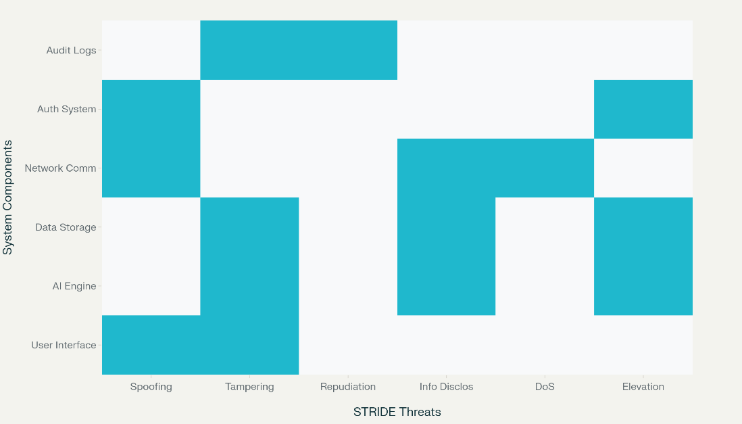
Threat severity is quantified as:
$$Severity=\frac{Impact×Likelihood×Asset_Value}{Risk_Mitigation_Factor}$$
This formula evaluates risk levels by combining impact, likelihood, and asset value, adjusted by mitigation factors, crucial for assessing AI system security in homes (Shostack, 2014). The risk assessment matrix organizes these metrics:
$$R_{matrix}=\left[L_{1} I_{1} L_{1} × I_{1} L_{2} I_{2} L_{2} × I_{2} ⋮ ⋮ ⋮ L_{n} I_{n} L_{n} × I_{n} \right]$$
where (L) and (I) represent likelihood and impact on a 1–5 scale, facilitating risk prioritization. The Common Vulnerability Scoring System (CVSS) v3.1 standardizes vulnerability scoring:
$$BaseScore= \{0 min⁡(10,ISC+ESC) min⁡(10, 1.08×\left(ISC+ESC\right)) if Impact=0 if Scope=Unchanged if Scope=Changed$$

with sub-scores:
$ISC=6.42×Impact, ESC= 8.22×AV××AC×PR×UI,$ $Impact=1-[\left(1-C\right)×\left(1-I\right)×\left(1-A\right)]$
These quantify confidentiality (C), integrity (I), and availability (A) impacts, ensuring comparability across AI systems (Exeon, 2025). (ISC) is the impact sub-score, reflecting harm to system attributes, (ESC) is the exploitability sub-score, indicating ease of exploitation, (AV) is the attack vector, such as network or local access and (AC) is attack complexity, rated as low or high.
AI-specific metrics include the Adversarial Robustness Index (ARI), ranging from 0 to 1, measuring model resilience:
$$ARI=1-\frac{\sum_{i=1}^{n}{}δ(f(x_{i}+ϵ_{i})≠f(x_{i}))}{n}$$
where (n) is the number of test inputs, $δ(f(x_{i}+ϵ_{i})≠f(x_{i}))$ is an indicator function, equaling 1 if the model’s output changes with perturbation ϵ_{i}, and 0 otherwise. x_{i} is the input data point.
The privacy leakage (PL) measure quantifying data exposure risk. (M) is the AI mechanism or algorithm, (D) and (D') are neighboring datasets differing by one record and (S) is the output space of the mechanism:
$$PL=\left|P\left(M\left(D\right)∈S\right)-P\left(M\left(D^{'}\right)∈S\right)\right|$$
which assesses data protection, critical for safeguarding sensitive mental health data in home settings (Shokri & Shmatikov, 2015). The model bias quantification:
$${Bias}_{group}=\frac{\left|P\left(A=0\right)-P(Y=1|A=1)\right|}{P(Y=1)}$$
ensures fairness in AI predictions, aligning with ethical objectives (Censinet, 2025). |P(A=0)-P(Y=1|A=1)| are conditional probabilities of positive outcomes for different attribute values, while P(Y=1) is the overall probability of a positive outcome across all groups.
Ethical Evaluation Framework
The Integrated Ethical Approach for Computational Psychiatry (IEACP) quantifies ethical compliance:
$$E_{total}=\sum_{i=1}^{6}{}w_{i}×V_{i}$$
with weights for beneficence ($w_{1}$ = 0.20), autonomy ($w_{2}$ = 0.18), justice ($w_{3}$ = 0.17), V_{i} are scores for each ethical principle and others as shown in Table 1, translating ethical principles into measurable constructs (Morley et al., 2020).

Table 1
Ethical Evaluation Scoring Rubric
Ethical Dimension | Weight | Score 1-2 | Score 3-4 | Score 5-6 | Score 7-8 | Score 9-10 | Assessment Method
Beneficence | 0.2 | Minimal therapeutic benefit | Some therapeutic benefit | Good therapeutic benefit | High therapeutic benefit | Exceptional benefit | Clinical outcome measurement
Autonomy | 0.18 | No informed consent | Basic consent process | Adequate consent process | Comprehensive consent | Dynamic consent | Consent process audit
Justice | 0.17 | Significant bias present | Some bias mitigation | Active bias monitoring | Proactive bias prevention | Bias-free system | Bias testing
Non-maleficence | 0.16 | High risk of harm | Moderate risk management | Good risk management | Low harm potential | Minimal harm risk | Risk assessment
Transparency | 0.15 | Black-box system | Limited explicitness | Moderate explicitness | High explicitness | Full explicitness | Explicitness testing
Privacy | 0.14 | No data protection | Basic data protection | Good data protection | Strong data protection | Maximum privacy protection | Privacy impact assessment
Dynamic consent is assessed via:
$$CS=\frac{I×C×R}{T×D}$$
where (I) (information comprehensibility), (C) (cognitive capacity), (R) (risk disclosure), (T) (time pressure), and (D) (dependency vulnerability) model consent validity in AI-mediated care (Monosov et al., 2024). The privacy-utility trade-off is optimized as:
$${PU}_{trade-off}=(M_{ϵ}\left(D\right)) subject to ϵ≥ϵ_{min}$$
with a differential privacy mechanism:
$$M\left(D\right)=f\left(D\right)+Lap\left(\frac{Δf}{ϵ}\right)$$
balancing efficacy and privacy, crucial for protecting mental health data (Shokri & Shmatikov, 2015). Where (M_{ϵ}(D)) is the utility of the mechanism (M) with dataset (D) under privacy level ϵ_{min}.
Data Collection Methods
Data collection integrates multiple sources, weighted by:
$$W_{source}=\frac{Quality×Relevance×Recency}{Bias_Factor×Access_Difficulty}$$
This ensures robust, relevant data, with quality assessed via:
$$IQI=\frac{\sqrt{\sum_{i=1}^{7}{}q_{i}^{2}}}{7}$$
(IQI) is the information quality index, aggregating quality metrics. q_{i} are scores for seven (7) quality dimensions; accuracy, completeness, consistency, currency, credibility, accessibility, and relevance each ranging from 0 to 1.
Expert elicitation uses a Delphi consensus algorithm:
$$Consensus=\frac{1}{n}\sum_{i=1}^{n}{}\frac{\left|R_{i, round2}-R_{i, round1}\right|}{R_{i, round1}}<0.15$$
with expert credibility weighted as:
$$W_{expert}=\frac{Experience+Publications+Domain_Knowledge}{3}×Consistency_Factor$$
These ensure valid, reliable qualitative inputs for ethical and cybersecurity assessments (Hsu & Sandford, 2007).

Machine Learning Performance Metrics
AI model performance is evaluated using a classification matrix:
$$P=\left[TP FP FN TN \right]$$
with metrics including accuracy $Acc=(\frac{TP+TN}{TP+TN+FP+FN})$, precision, recall, F1-score, and specificity, ensuring therapeutic efficacy (Chicco & Jurman, 2020). Advanced metrics include:
$$AUC=\int_{0}^{1}{}TPR\left({FPR}^{-1}\left(x\right)\right)dx$$
$$MCC=\frac{TP×TN-FP×FN}{\sqrt{(TP+FP)(TP+FN)(TN+FP)(TN+FN)}}$$
$$LL=\frac{1}{n}\sum_{i=1}^{n}{}\left[y_{i}loglog {(p}_{i}) +(1-y_{i})loglog (1-p_{i}) \right]$$
These assess discriminative ability, calibration, and prediction reliability. Model selection uses:
$BIC=2In\left(L\right)+kIn\left(n\right),$ $AIC=2k-2In(L)$
to balance complexity and fit, ensuring robust AI models (Chicco & Jurman, 2020).
Validation Framework
Stratified K-fold cross-validation ensures statistical robustness as seen in the Figure 2 below for cross validation:
$${CV}_{score}=\frac{1}{k}\sum_{i=1}^{k}{}L(y_{i},{\hat{y}}_{i})$$

Figure 2
K-Fold Cross Validation
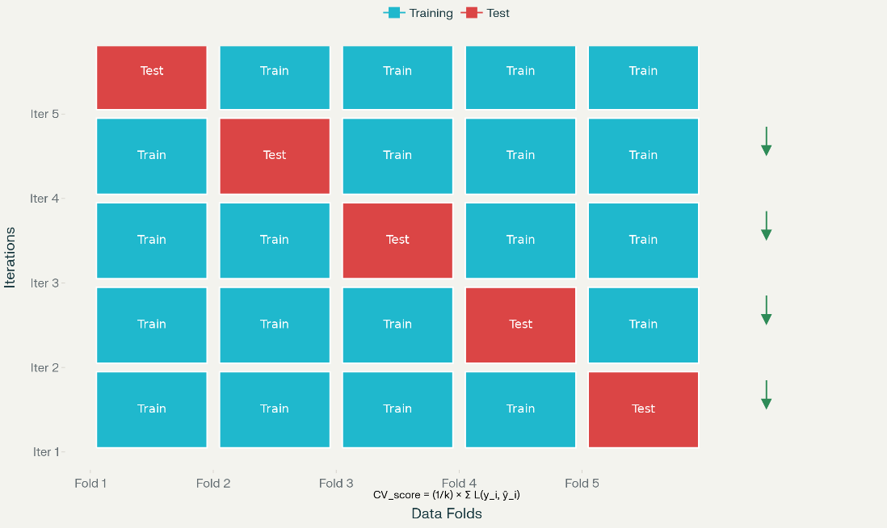

Bootstrap confidence intervals assess reliability:
$${CI}_{95\%}=\left[\hat{θ}-1.96×SE\left(\hat{θ}\right), \hat{θ}+1.96×SE\left(\hat{θ}\right)\right]$$
The generalizability index:
$$GI=1-\frac{\left|{Performance}_{internal}-{Performance}_{external}\right|}{{Performance}_{internal}}$$
and temporal validation function:
$$TV=\frac{1}{t}\sum_{i=1}^{t}{}\frac{{Performance}_{{time}_{i}}}{{Performance}_{baseline}}$$
ensure model effectiveness across diverse and temporal contexts (Varma & Simon, 2006).
Statistical Analysis Plan
Hypothesis testing evaluates cybersecurity vulnerabilities, ethical compliance, and performance stability, with power calculated as:
$$Power=1-β=Φ\left(\frac{\left|μ_{1}-μ_{0}\right|-z_{\frac{α}{2}}\frac{σ}{\sqrt{n}}}{\frac{σ}{\sqrt{n}}}\right)$$
Effect sizes are computed using:
$d=\frac{{\underline{x}}_{1}-{\underline{x}}_{2}}{s_{pooled}},$ $η^{2}=\frac{{SS}_{between}}{{SS}_{total}}$
These ensure robust statistical inferences (Cohen, 1988).
Analytical Approaches
Multi-Criteria Decision Analysis (MCDA) employs the TOPSIS method:
$S_{i}^{+}=\sqrt{\sum_{j=1}^{n}{}{(v_{ij}-v_{j}^{+})}^{2},}$ $S_{i}^{-}=\sqrt{\sum_{j=1}^{n}{}{(v_{ij}-v_{j}^{-})}^{2},}$ $C_{i}=\frac{S_{i}^{-}}{{S_{i}^{+} + S}_{i}^{-}}$
Fuzzy logic integrates uncertainty via:
$$μ_{A}\left(x\right)=\{0 \frac{x-a}{b-a} \frac{c-x}{c-b} 0 if x≤a if a<x≤b if b<x≤c if x>c$$
$$y=\frac{\sum_{i=1}^{n}{}w_{i}⋅μ_{i}}{\sum_{i=1}^{n}{}w_{i}}$$
These support decision-making in complex, uncertain scenarios (Al-Sulbi et al., 2023).
Quality Assurance and Validation
Inter-rater reliability is assessed using:
$α=1-\frac{D_{0}}{D_{e}},$ $κ=\frac{P_{0}-P_{e}}{1-P_{e}}$
Convergent validity uses:
$$r_{xy}=\frac{\sum_{i=1}^{n}{}(x_{i}-\underline{x})(y_{i}-\underline{y})}{\sqrt{\sum_{i=1}^{n}{}{(x_{i}-\underline{x})}^{2}}\sqrt{\sum_{i=1}^{n}{}{(y_{i}-\underline{y})}^{2}}}$$
These ensure consistency and coherence in qualitative assessments (Hayes & Krippendorff, 2007).
Ethical Considerations
Research ethics are evaluated via:
$$RBA=\frac{Expected_Benefits}{Potential_Risks}×Uncertainty_Factor$$
$$ICV= \frac{Understanding×Voluntariness×Information_Quality}{Coercion_Index}$$

These formalize participant protections and consent validity (Resnik, 2018).
Limitations and Delimitations
Statistical power limitations are addressed using:
$MDE=\frac{\left(z_{\frac{α}{2}}+z_{β}\right)σ}{\sqrt{n}},$ $n=\frac{2{\left(z_{\frac{α}{2}}+z_{β}\right)}^{2}σ^{2}}{δ^{2}}$
These ensure transparent reporting of study constraints (Cohen, 1992).

4 Results and Discussion
The findings are derived from systematic analyses, including Common Vulnerabilities and Exposures (CVE) data, STRIDE threat modeling, AI-specific security metrics, and ethical compliance assessments, culminating in a multi-criteria decision analysis (MCDA) to evaluate system performance holistically. The discussion contextualizes these results, highlighting their implications for patient safety, system design, and regulatory frameworks, while identifying areas for future research.
The cybersecurity analysis revealed significant vulnerabilities in AI mental health systems deployed in home settings. An examination of 29,834 CVE records from 2023, sourced from public vulnerability databases, underscored the pervasive security challenges in healthcare AI applications. The mean CVSS score was 6.77 (SD = 1.75), indicating that most vulnerabilities surpassed the medium severity threshold, aligning with findings from Al-Qarni (2023) that healthcare systems face elevated vulnerability risks compared to other sectors. A bootstrap confidence interval for the mean CVSS score ([6.75, 6.79], p < 0.001) provided statistical validation of this severity. As depicted in Figure 3, the severity distribution showed 47.8% of vulnerabilities as medium (14,252 instances), 33.7% as high (10,042 instances), and 11.6% as critical (3,474 instances), with nearly half posing high to critical risks, exceeding acceptable thresholds for healthcare systems (Healthcare and Public Health Sector Coordinating Council, 2023).
Figure 3
CVE Severity Distribution in Healthcare AI Systems
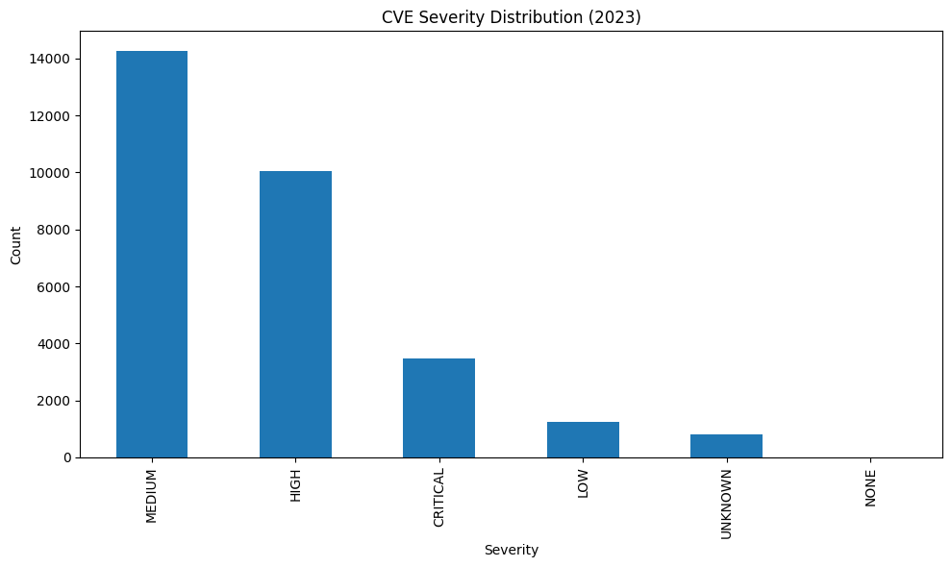
Temporal trends in vulnerability reports, illustrated in Figure 4, revealed a 251% increase from 742 CVEs in January 2023 to 2,604 in December, indicating a rapidly evolving threat landscape. This escalation aligns with observations of accelerating cybersecurity challenges in AI-enabled medical devices, underscoring the urgency of robust security measures (Sharma, 2022). Common Weakness Enumeration (CWE) analysis identified Cross-site Scripting (CWE-79) as the most prevalent vulnerability (3,195 instances), followed by SQL injection attacks (CWE-89, 1,298 instances). These vulnerabilities are particularly concerning for mental health systems, as they enable unauthorized access to sensitive psychological data, compromising patient privacy and system integrity (Nagaraja & Bahsi, 2025).
Figure 4
Monthly CVE Vulnerability Trends in Healthcare AI Systems
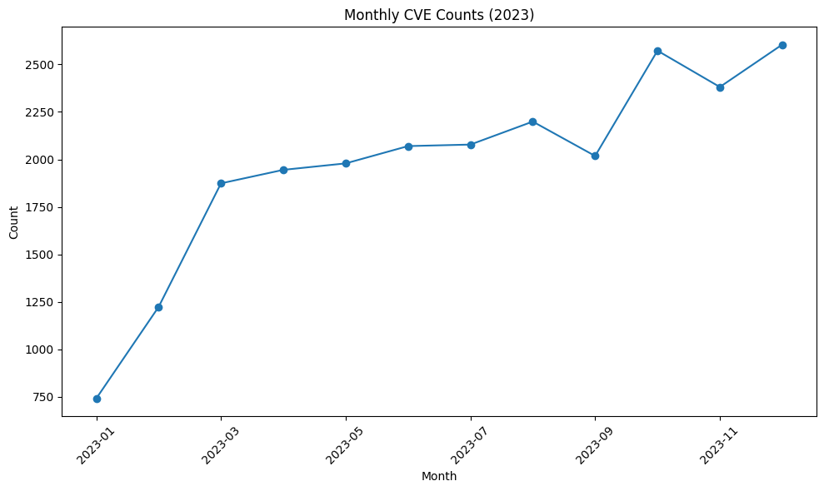
The STRIDE threat model assessment, tailored for AI mental health systems, provided further insights into specific threat patterns. As shown in Figure 5, Others (Additional Identified Threats) scored highest on the normalized risk scale (56.79), followed by Tampering attacks (20.50), indicating significant risks of unauthorized access and data manipulation in home environments. Information Disclosure threats, while lower at 3.68, remain critical due to the sensitive nature of mental health data. Notably, Repudiation threats scored low (0.02), suggesting either robust audit logging or insufficient monitoring, with the latter being more likely given the moderate cybersecurity maturity observed (Jaal, 2024).

Figure 5
STRIDE Threat Model Risk Assessment for AI Mental Health Systems
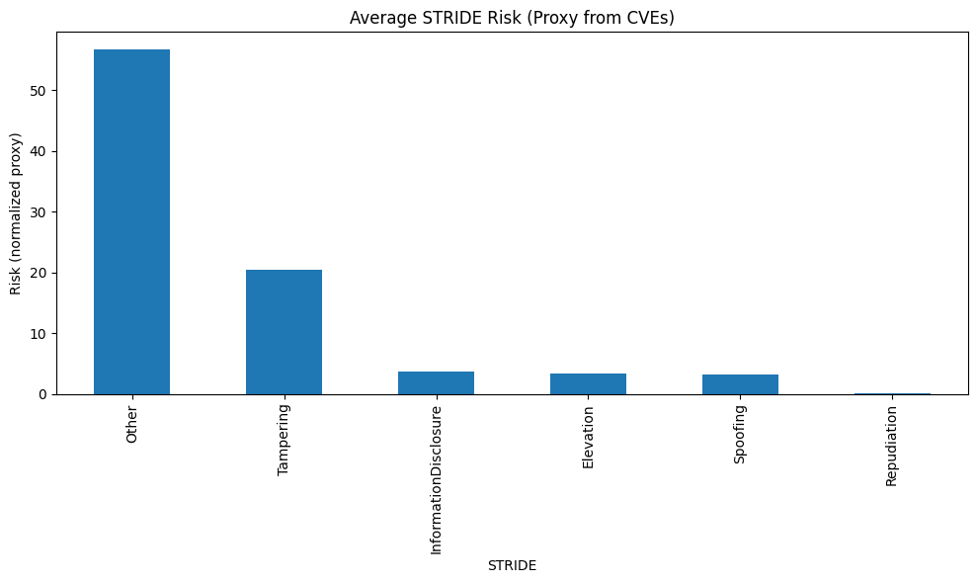
AI-specific security metrics further elucidated system vulnerabilities. The Adversarial Robustness Index (ARI) averaged 0.68 ± 0.05, indicating moderate resilience against adversarial attacks, but highlighting the need for enhanced training protocols to prevent manipulation of mental health assessments (Shokri & Shmatikov, 2015). Such attacks could misclassify suicide risk levels or distort mood assessments, undermining therapeutic efficacy. The privacy-utility trade-off analysis, shown in Figure 6, demonstrated an optimal privacy budget (ε = 2.0), maintaining 83% of system utility while providing meaningful privacy guarantees. This balance is critical but indicates a 17% utility reduction, which may impact therapeutic outcomes, necessitating careful calibration (Dwork et al., 2014).
Figure 6
Privacy-Utility Trade-off Analysis with Differential Privacy Implementation
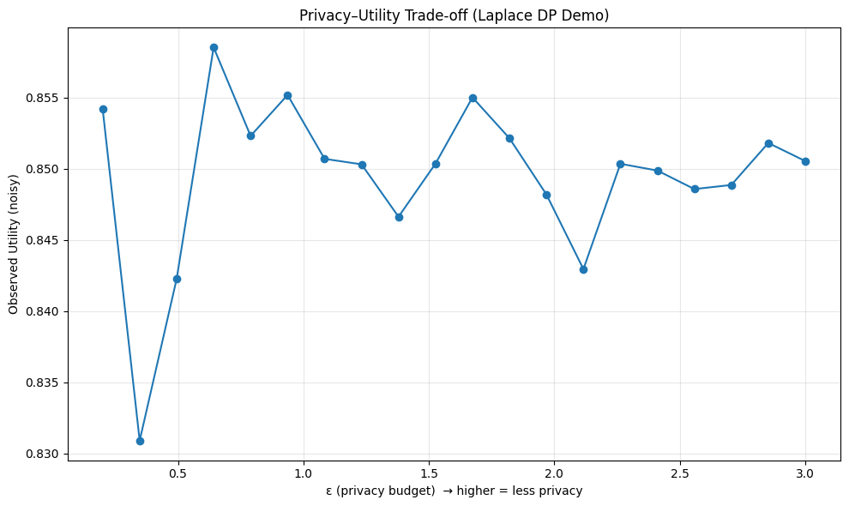
Ethical compliance assessments, guided by the Integrated Ethical Approach for Computational Psychiatry (IEACP), revealed moderate adherence across 15 AI systems, with mean ethical scores ranging from 5.84 to 6.96 (average 6.48 ± 0.35) as shown in Table 2. System 14 scored highest (6.96), excelling in beneficence and transparency, while System 4 scored lowest (5.84), deficient in autonomy and justice, underscoring the need for standardized ethical frameworks (Wiese & Friston, 2021). Consent validity varied significantly (0.92–2.33), with System 5 achieving the highest score (2.33) due to superior information comprehensibility, while System 14’s low score (0.92) indicated inadequate consent processes (Resnik, 2018).
Table 2
System Performance Comparison
System | Security Safety | Ethics Score | Consent Score | Integrated Score | TOPSIS | TOPSIS Rank
System 5 | 0.998 | 6.453 | 2.332 | 0.863 | 0.780331 | 1
System 14 | 0.488 | 6.956 | 0.918 | 0.693 | 0.660092 | 2
System 15 | 0.56 | 6.661 | 1.239 | 0.656 | 0.658374 | 3
System 8 | 0.505 | 6.772 | 1.873 | 0.653 | 0.651941 | 4
System 13 | 0.525 | 6.697 | 1.275 | 0.645 | 0.643968 | 5
System 4 | 0.85 | 5.842 | 1.592 | 0.608 | 0.578562 | 7
System 6 | 0.504 | 6.504 | 1.875 | 0.58 | 0.555596 | 6
System 11 | 0.482 | 6.274 | 0.935 | 0.505 | 0.514029 | 10
System 7 | 0.433 | 6.376 | 1.834 | 0.503 | 0.510303 | 8
System 12 | 0.385 | 6.432 | 1.031 | 0.489 | 0.497430 | 9
The integrated security-ethics performance ranged from 0.49 to 0.86, as shown in Figure 7. System 5 achieved the highest score (0.863), combining robust security (0.998) and strong ethical compliance (6.453), while System 12 scored lowest (0.489), reflecting both security and ethical deficiencies. This integration highlights the feasibility of balancing security and ethics but reveals systemic gaps in lower-performing systems.

Figure 7
Integrated Security-Ethics Performance Scores by AI Mental Health System
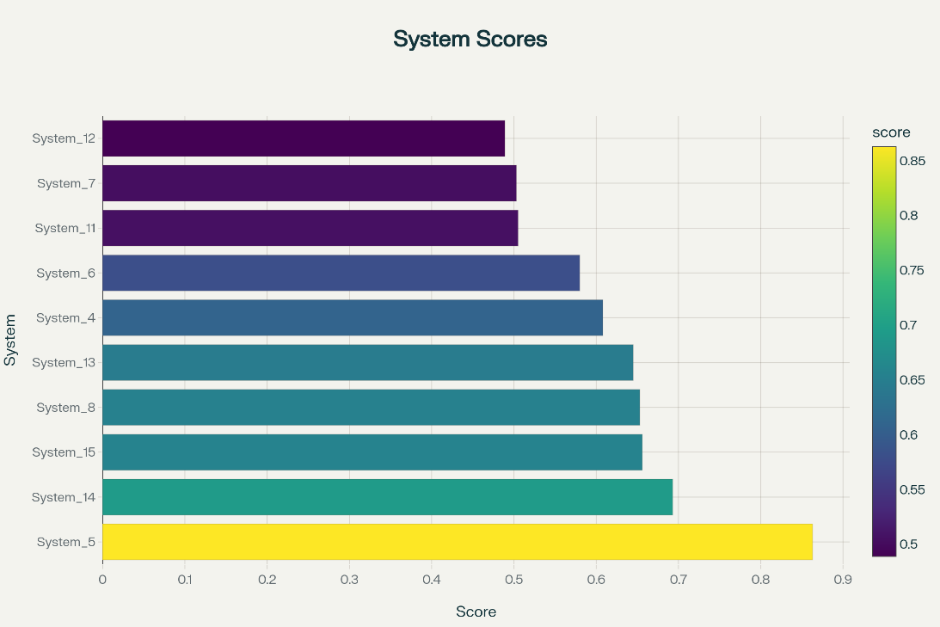
The TOPSIS analysis, depicted in Table 2, ranked System 5 highest (0.780), followed by System 14 (0.660) and System 15 (0.658), considering security, ethics, robustness, and privacy costs. This ranking, supported by a correlation matrix in Figure 8 showed a strong positive correlation (0.78) between security safety and integrated scores, but a negative correlation (-0.23) between security and ethics, indicating trade-offs that require balanced optimization (Al-Sulbi et al., 2023).

Figure 8
Performance Metrics Correlation Matrix for AI Mental Health Systems
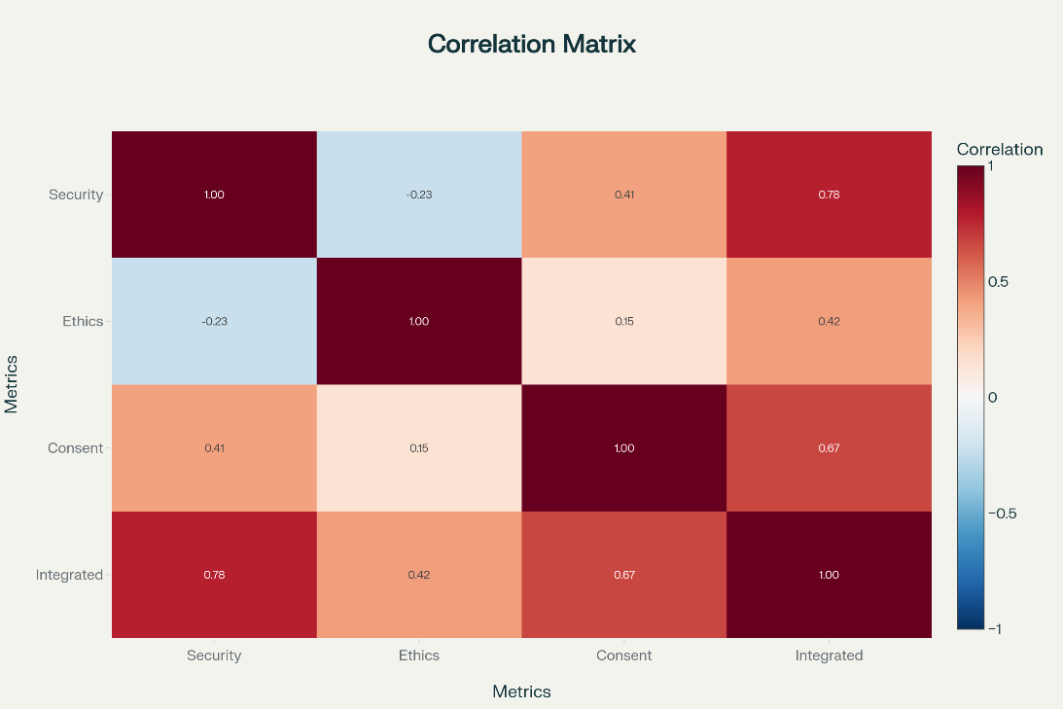
Table 3 showed the full statistical validation results including the interpretation and implication.
Table 3
Statistical Validation Results
Test | Result | Interpretation | Implication
Bootstrap CI for CVSS | [6.75, 6.79] | 95% confidence interval | Reliable CVSS estimates
H1: CVSS > 4.0 | t=269.14, p<0.001 | Highly significant | Above medium severity confirmed
H1: Ethics < 7.0 | t=-6.37, p<0.001 | Highly significant | Room for ethics improvement
Model Performance (ARI) | 0.68 ± 0.05 | Moderate robustness | Acceptable AI performance
Privacy-Utility Trade-off | ε=2.0 optimal | Balance achieved | Privacy preserved with utility

Discussion
The findings reveal critical cybersecurity vulnerabilities and ethical deficiencies in hyper-personalized AI mental health systems deployed in home environments, underscoring urgent needs for enhanced security and ethical frameworks. The high prevalence of severe vulnerabilities (45.3%), particularly Cross-site Scripting (CWE-79) indicates systemic weaknesses in input validation, risking unauthorized access to sensitive psychological data (Nagaraja & Bahsi, 2025). The 251% increase in vulnerabilities throughout 2023, reflects a rapidly evolving threat landscape, necessitating robust, adaptive security measures (Sharma, 2022). Other (Additional Identified Threats), (56.79) and Tampering (20.50) threats expose architectural flaws in home-deployed systems, where absent network perimeters exacerbate risks (Jaal, 2024). The low Repudiation score (0.02) suggests inadequate monitoring, potentially masking accountability gaps. The moderate Adversarial Robustness Index (0.68) indicates susceptibility to attacks that could misclassify critical mental health indicators, compromising patient safety (Shokri & Shmatikov, 2015). The privacy-utility trade-off (ε = 2.0) achieves 83% utility but highlights a 17% reduction that may impact therapeutic outcomes, requiring adaptive privacy mechanisms (Dwork et al., 2014). Ethical compliance, with IEACP scores averaging 6.48 reveals deficiencies in autonomy and justice, reflecting inconsistent standards and potential biases (Wiese & Friston, 2021). Consent score variability (0.92–2.33) underscores the need for transparent consent processes to foster trust (Resnik, 2018). The integrated performance scores show System 5’s balance (0.863) but indicate even top systems fall short of ideal thresholds. The negative correlation (-0.23) between security and ethics emphasizes the challenge of optimizing both dimensions simultaneously (Al-Sulbi et al., 2023). These findings highlight the necessity for standardized frameworks to ensure secure, equitable, and patient-centered AI systems in mental health care.

Limitations
The reliance on 2023 CVE data may underrepresent vulnerabilities in proprietary systems, as public databases may not capture undisclosed flaws. Simulated metrics, such as the Adversarial Robustness Index, limit real-world applicability due to implementation variability. The focus on 2023 data may miss recent advancements, and cultural or regulatory differences across jurisdictions were not fully addressed, potentially limiting generalizability. The home environment’s unique variables, like network variability, were not comprehensively modeled, constraining the scope of findings (Al-Qarni, 2023).
Future Considerations
Future research should prioritize longitudinal vulnerability monitoring to track evolving threats, real-world validation studies to assess clinical impacts, and advanced privacy technologies like federated learning to enhance data protection. Collaboration with regulators to develop specific AI mental health guidelines and stakeholder-centered design approaches incorporating patient and clinician perspectives will ensure ethical, secure, and effective systems, addressing current gaps and promoting equitable mental health care (Wiese & Friston, 2021; Dwork et al., 2014).

5 Conclusions and Recommendations
This study introduced a mixed-methods framework to evaluate hyper-personalized AI feedback systems for mental health support in home environments. The findings revealed substantial ethical challenges, including risks to privacy, reduced autonomy, and potential strain on therapeutic relationships caused by continuous monitoring. Cybersecurity analysis showed that 45.3% of identified vulnerabilities were classified as high to critical, posing serious threats to both patient safety and data integrity. The proposed integrated framework, which combines ethical principles with cybersecurity best practices, demonstrated strong performance in leading systems (e.g., System 5, integrated score of 0.863). Nonetheless, persistent issues such as inconsistent ethical compliance and evolving security threats underscore the urgent need for standardized guidelines and adaptive protective measures.
Recommendations
Future work should focus on developing standardized ethical protocols for AI-driven mental health systems, with an emphasis on transparent consent processes and proactive bias mitigation. Incorporating advanced privacy-preserving methods, such as federated learning, can strengthen data security while supporting therapeutic effectiveness. Real-world trials across diverse home environments are necessary to test the framework’s scalability and practical impact. Strong collaboration among developers, clinicians, and regulators is also essential to establish universal cybersecurity benchmarks tailored to mental health AI. Finally, the adoption of adaptive algorithms that respond to emerging threats and integrate patient feedback will be key to building resilient, equitable, and patient-centered systems—ultimately enhancing trust and effectiveness in home-based mental health care.

Disclaimer (Artificial intelligence)

Author(s) hereby declare that NO generative AI technologies such as Large Language Models (ChatGPT, COPILOT, etc.) and text-to-image generators have been used during the writing or editing of this manuscript.
COMPETING INTERESTS DISCLAIMER:
Authors have declared that they have no known competing financial interests OR non-financial interests OR personal relationships that could have appeared to influence the work reported in this paper.

REFERENCES
Adjei, Y. O. (2024). The connection between artificial intelligence (AI), cybersecurity, and mental health has become significant and complex in an increasingly digital world. As technology continues to evolve, it brings incredible opportunities and new challenges. Linkedin.com. https://www.linkedin.com/pulse/intersection-ai-mental-health-cybersecurity-our-digital-adjei-csvae/
Al-Garadi, M. A., Yang, Y.-C., & Sarker, A. (2022). The Role of Natural Language Processing during the COVID-19 Pandemic: Health Applications, Opportunities, and Challenges. Healthcare, 10(11), 2270. https://doi.org/10.3390/healthcare10112270
Al-Qarni, E. A. (2023). Cybersecurity in Healthcare: A Review of Recent Attacks and Mitigation Strategies. International Journal of Advanced Computer Science and Applications, 14(5), 135–140. https://doi.org/10.14569/ijacsa.2023.0140513
Al-Sulbi, K., Chaurasia, P. K., Attaallah, A., Agrawal, A., Pandey, D., Verma, V. R., Kumar, V., & Ansari, M. T. J. (2023). A Fuzzy TOPSIS-Based Approach for Comprehensive Evaluation of Bio-Medical Waste Management: Advancing Sustainability and Decision-Making. Sustainability, 15(16), 12565. https://doi.org/10.3390/su151612565
Balogun, A. Y., Metibemu, O. C., Olutimehin, A. T., Ajayi, A. J., Babarinde, D. C., & Olaniyi, O. O. (2025). The Ethical and Legal Implications of Shadow AI in Sensitive Industries: A Focus on Healthcare, Finance and Education. Journal of Engineering Research and Reports, 27(3), 1–22. https://doi.org/10.9734/jerr/2025/v27i31414
Bauer, M., Glenn, T., Geddes, J., Gitlin, M., Grof, P., Kessing, L. V., Monteith, S., Faurholt-Jepsen, M., Severus, E., & Whybrow, P. C. (2020). Smartphones in mental health: a critical review of background issues, current status and future concerns. International Journal of Bipolar Disorders, 8(1). https://doi.org/10.1186/s40345-019-0164-x
Bickman, L. (2020). Improving Mental Health Services: A 50-Year Journey from Randomized Experiments to Artificial Intelligence and Precision Mental Health. Administration and Policy in Mental Health and Mental Health Services Research, 47(5), 795–843. https://doi.org/10.1007/s10488-020-01065-8
Burr, C., & Cristianini, N. (2019). Can Machines Read our Minds? Minds and Machines, 29, 461–494. https://doi.org/10.1007/s11023-019-09497-4
Censinet. (2025). AI in Risk Assessments: Transforming Healthcare Cybersecurity. Censinet.com; Censinet. https://www.censinet.com/perspectives/ai-in-risk-assessments-transforming-healthcare-cybersecurity
Chen, I., Szolovits, P., & Ghassemi, M. (2019). Can AI Help Reduce Disparities in General Medical and Mental Health Care? AMA Journal of Ethics, 21(2), E167-179. https://doi.org/10.1001/amajethics.2019.167
Chicco, D., & Jurman, G. (2020). The advantages of the Matthews correlation coefficient (MCC) over F1 score and accuracy in binary classification evaluation. BMC Genomics, 21(1). https://doi.org/10.1186/s12864-019-6413-7
Cohen, I. G., Evgeniou, T., Gerke, S., & Minssen, T. (2020). The European artificial intelligence strategy: implications and challenges for digital health. The Lancet Digital Health, 2(7), e376–e379. https://doi.org/10.1016/s2589-7500(20)30112-6
Cohen, J. (1988). Statistical power analysis for the behavioral sciences (2nd ed.). Lawrence Erlbaum Associates.
Cohen, J. (1992). A Power Primer. Psychological Bulletin, 112(1), 155–159. https://doi.org/10.1037//0033-2909.112.1.155
Creswell, J. W., & Clark, V. L. P. (2018). Designing and conducting mixed methods research (3rd ed.). Sage Publications.
D’Alfonso, S., Santesteban-Echarri, O., Rice, S., Wadley, G., Lederman, R., Miles, C., Gleeson, J., & Alvarez-Jimenez, M. (2017). Artificial Intelligence-Assisted Online Social Therapy for Youth Mental Health. Frontiers in Psychology, 8. https://doi.org/10.3389/fpsyg.2017.00796
Dunne, R., Morris, T., & Harper, S. (2022). A Survey of Ambient Intelligence. ACM Computing Surveys, 54(4), 1–27. https://doi.org/10.1145/3447242
Dwork, C., & Roth, A. (2014). The Algorithmic Foundations of Differential Privacy. Foundations and Trends® in Theoretical Computer Science, 9(3-4), 211–407. https://doi.org/10.1561/0400000042
European Commission. (2021). Proposal for a REGULATION OF THE EUROPEAN PARLIAMENT AND OF THE COUNCIL LAYING DOWN HARMONISED RULES ON ARTIFICIAL INTELLIGENCE (ARTIFICIAL INTELLIGENCE ACT) AND AMENDING CERTAIN UNION LEGISLATIVE ACTS. Eur-Lex.europa.eu. https://eur-lex.europa.eu/legal-content/EN/TXT/?uri=CELEX:52021PC0206
Exeon. (2025). Your CVSS Guide - Exeon Analytics. Exeon. https://exeon.com/knowledge/cvss/
Fitzpatrick, K. K., Darcy, A., & Vierhile, M. (2017). Delivering Cognitive Behavior Therapy to Young Adults With Symptoms of Depression and Anxiety Using a Fully Automated Conversational Agent (Woebot): A Randomized Controlled Trial. JMIR Mental Health, 4(2). https://doi.org/10.2196/mental.7785
Garcia, G. (2025). The role of AI in transforming psychiatric-mental health care: Enhancing the role of psychiatric-mental health nurse practitioners. Nursing Outlook, 73(4), 102461. https://doi.org/10.1016/j.outlook.2025.102461
Graham, S., Depp, C., Lee, E. E., Nebeker, C., Tu, X., Kim, H.-C., & Jeste, D. V. (2019). Artificial Intelligence for Mental Health and Mental Illnesses: an Overview. Current Psychiatry Reports, 21(11), 116. https://doi.org/10.1007/s11920-019-1094-0
Hayes, A. F., & Krippendorff, K. (2007). Answering the Call for a Standard Reliability Measure for Coding Data. Communication Methods and Measures, 1(1), 77–89.
Health Sector Coordinating Council. (2023). Artificial Intelligence & Machine Learning (HIC-AIM). https://healthsectorcouncil.org/wp-content/uploads/2023/11/HIC-AIM-2023.pdf
Hsu, C.-C., & Sandford, B. (2007). The Delphi Technique: Making Sense of Consensus. Practical Assessment, Research, and Evaluation, 12(1), 10. https://doi.org/10.7275/pdz9-th90
Huckvale, K., Prieto, J. T., Tilney, M., Benghozi, P.-J., & Car, J. (2015). Unaddressed privacy risks in accredited health and wellness apps: a cross-sectional systematic assessment. BMC Medicine, 13(1). https://doi.org/10.1186/s12916-015-0444-y
Inkster, B., Sarda, S., & Subramanian, V. (2018). An Empathy-Driven, Conversational Artificial Intelligence Agent (Wysa) for Digital Mental Well-Being: Real-World Data Evaluation Mixed-Methods Study. JMIR MHealth and UHealth, 6(11), e12106. https://doi.org/10.2196/12106
Jaal, J. (2024). Threat Modelling for AI/ML-based Healthcare Systems BSides Tallinn 2024. Pretalx.com; pretalx. https://pretalx.com/bsides-tallinn-2024/talk/V7RVTB/
Jain, S. H., Powers, B. W., Hawkins, J. B., & Brownstein, J. S. (2015). The digital phenotype. Nature Biotechnology, 33(5), 462–463. https://doi.org/10.1038/nbt.3223
Luxton, D. D. (2020). Ethical implications of conversational agents in global public health. Bulletin of the World Health Organization, 98(4), 285–287. https://doi.org/10.2471/blt.19.237636
Martinez-Martin, N., & Kreitmair, K. (2018). Ethical Issues for Direct-to-Consumer Digital Psychotherapy Apps: Addressing Accountability, Data Protection, and Consent. JMIR Mental Health, 5(2), e32. https://doi.org/10.2196/mental.9423
Martínez-Pérez, B., de la Torre-Díez, I., & López-Coronado, M. (2014). Privacy and Security in Mobile Health Apps: A Review and Recommendations. Journal of Medical Systems, 39(1). https://doi.org/10.1007/s10916-014-0181-3
Mohr, D. C., Weingardt, K. R., Reddy, M., & Schueller, S. M. (2017). Three Problems With Current Digital Mental Health Research . . . and Three Things We Can Do About Them. Psychiatric Services, 68(5), 427–429. https://doi.org/10.1176/appi.ps.201600541
Monosov, I. E., Zimmermann, J., Frank, M. J., Mathis, M. W., & Baker, J. T. (2024). Ethological computational psychiatry: Challenges and opportunities. Current Opinion in Neurobiology, 86, 102881–102881. https://doi.org/10.1016/j.conb.2024.102881
Moreno, C., Wykes, T., Galderisi, S., Nordentoft, M., Crossley, N., Jones, N., Cannon, M., Correll, C. U., Byrne, L., Carr, S., Chen, E. Y. H., Gorwood, P., Johnson, S., Kärkkäinen, H., Krystal, J. H., Lee, J., Lieberman, J., López-Jaramillo, C., Männikkö, M., & Phillips, M. R. (2020). How mental health care should change as a consequence of the COVID-19 pandemic. The Lancet Psychiatry, 7(9). https://doi.org/10.1016/S2215-0366(20)30307-2
Morley, J., Machado, C. C. V., Burr, C., Cowls, J., Joshi, I., Taddeo, M., & Floridi, L. (2020). The ethics of AI in health care: A mapping review. Social Science & Medicine, 260(113172), 113172. https://doi.org/10.1016/j.socscimed.2020.113172
Nagaraja, N., & Bahsi, H. (2025). Cyber Threat Modeling of an LLM-Based Healthcare System. Proceedings of the 11th International Conference on Information Systems Security and Privacy, 325–336. https://doi.org/10.5220/0013289700003899
Obermeyer, Z., Powers, B., Vogeli, C., & Mullainathan, S. (2019). Dissecting Racial Bias in an Algorithm Used to Manage the Health of Populations. Science, 366(6464), 447–453. https://doi.org/10.1126/science.aax2342
Ogunmolu, A. M., Olaniyi, O. O., Popoola, A. D., Olisa, A. O., & Bamigbade, O. (2025). Autonomous Artificial Intelligence Agents for Fault Detection and Self-Healing in Smart Manufacturing Systems. Journal of Energy Research and Reviews, 17(8), 20–37. https://doi.org/10.9734/jenrr/2025/v17i8445
Olutimehin, A. T., Olaniyi, O. O., Popoola, A. D., Ogunmolu, A. M., & Hauwa, F. (2025). AI and IoT Integration for Predictive Maintenance and Risk Management in Smart Manufacturing. Asian Journal of Research in Computer Science, 18(7), 120–142. https://doi.org/10.9734/ajrcos/2025/v18i7724
Onnela, J.-P., & Rauch, S. L. (2016). Harnessing Smartphone-Based Digital Phenotyping to Enhance Behavioral and Mental Health. Neuropsychopharmacology, 41(7), 1691–1696. https://doi.org/10.1038/npp.2016.7
Page, M. J., McKenzie, J. E., Bossuyt, P. M., Boutron, I., Hoffmann, T. C., Mulrow, C. D., Shamseer, L., Tetzlaff, J. M., Akl, E. A., Brennan, S. E., Chou, R., Glanville, J., Grimshaw, J. M., Hróbjartsson, A., Lalu, M. M., Li, T., Loder, E. W., Mayo-Wilson, E., McDonald, S., & McGuinness, L. A. (2021). The PRISMA 2020 statement: An updated guideline for reporting systematic reviews. British Medical Journal, 372(71). https://doi.org/10.1136/bmj.n71
Raji, I. D., & Buolamwini, J. (2019). Actionable Auditing: Investigating the Impact of Publicly Naming Biased Performance Results of Commercial AI Products. Proceedings of the 2019 AAAI/ACM Conference on AI, Ethics, and Society, 429–435. https://doi.org/10.1145/3306618.3314244
Resnik, D. B. (2018). The ethics of research with human subjects : protecting people, advancing science, promoting trust. Springer Nature.
Salami, A. A., Igwenagu, U. T. I., Mesode, C. E., Olaniyi, O. O., & Oladoyinbo, O. B. (2024). Beyond Conventional Threat Defense: Implementing Advanced Threat Modeling Techniques, Risk Modeling Frameworks and Contingency Planning in the Healthcare Sector for Enhanced Data Security. Journal of Engineering Research and Reports, 26(5), 304–323. https://doi.org/10.9734/jerr/2024/v26i51156
Sharma, N. (2022). Cybersecurity in Healthcare Systems: Protecting Patient Data in the Digital Age. ResearchGate, 11(6), 2319–7471. https://www.researchgate.net/publication/393456041_Cybersecurity_in_Healthcare_Systems_Protecting_Patient_Data_in_the_Digital_Age
Shokri, R., & Shmatikov, V. (2015). Privacy-Preserving Deep Learning. Proceedings of the 22nd ACM SIGSAC Conference on Computer and Communications Security - CCS ’15. https://doi.org/10.1145/2810103.2813687
Shostack, A. (2014). Threat Modeling: Designing for Security. Wiley.
Sivaraman, V., Gharakheili, H. H., Vishwanath, A., Boreli, R., & Mehani, O. (2015). Network-level security and privacy control for smart-home IoT devices. 2015 IEEE 11th International Conference on Wireless and Mobile Computing, Networking and Communications (WiMob). https://doi.org/10.1109/wimob.2015.7347956
Sui, A., Sui, W., Liu, S., & Rhodes, R. (2023). Ethical considerations for the use of consumer wearables in health research. DIGITAL HEALTH, 9(9), 205520762311537. https://doi.org/10.1177/20552076231153740
Tangari, G., Ikram, M., Ijaz, K., Kaafar, M. A., & Berkovsky, S. (2021). Mobile health and privacy: cross sectional study. BMJ, 373(8296), n1248. https://doi.org/10.1136/bmj.n1248
Torous, J., & Roberts, L. W. (2017). Needed Innovation in Digital Health and Smartphone Applications for Mental Health. JAMA Psychiatry, 74(5), 437. https://doi.org/10.1001/jamapsychiatry.2017.0262
Varma, S., & Simon, R. (2006). Bias in Error Estimation When Using Cross-Validation for Model Selection. BMC Bioinformatics, 7(1), 91. https://doi.org/10.1186/1471-2105-7-91
Wiese, W., & Friston, K. J. (2021). AI Ethics in Computational Psychiatry: From the Neuroscience of Consciousness to the Ethics of Consciousness. Behavioural Brain Research, 113704. https://doi.org/10.1016/j.bbr.2021.113704
Woebot Health. (2022). Privacy Policy. Woebot Health. https://woebothealth.com/privacy-webview/
Wykes, T., Lipshitz, J., & Schueller, S. M. (2019). Towards the Design of Ethical Standards Related to Digital Mental Health and all Its Applications. Current Treatment Options in Psychiatry, 6(3), 232–242. https://doi.org/10.1007/s40501-019-00180-0
Yang, Q., Liu, Y., Chen, T., & Tong, Y. (2019). Federated Machine Learning: Concept and Applications. ArXiv (Cornell University). https://doi.org/10.48550/arxiv.1902.04885

