Method Article

Dynamic simulation analysis of wind power crane multi-body system

.
ABSTRACT

- As the wind power industry expands into low-wind-speed regions, traditional wind turbine installation equipment struggles to adapt to complex working conditions such as rugged terrain, weak ground-bearing foundations, and confined construction spaces. Developing new-type non-attached wind turbine cranes suitable for these special environments has become an urgent engineering challenge.
- A wind turbine crane is specialized equipment used for the loading and unloading of wind turbine components, as well as an indispensable piece of engineering machinery in the development of modern green energy. During hoisting operations, the wind turbine blade inevitably experiences pendulum motion due to influences such as inertial force and centrifugal force.Aiming at the special construction conditions of low-wind-speed wind farms and the hoisting requirements of high-tower wind power equipment, this paper focuses on the research of a wind turbine crane that is efficient, safe, non-attached, adaptable to weak ground-bearing foundations, and suitable for limited construction areas. Using co-simulation technology with ANSYS and ADAMS, a rigid-flexible coupled dynamics model of the truss structure and wire rope was established: the boom and wire rope were flexibly processed in ANSYS to generate modal neutral files, which were then imported into ADAMS to complete the multi-body system modeling and simulation analysis. Through dynamic response analysis under typical working conditions such as slewing, hoisting, and luffing, it was found that the maximum dynamic load on the boom is 520,000 N (during hoisting) and the maximum partial load is 26,000 N (during operation). Moreover, the displacement fluctuation of the load during slewing does not exceed 1 m, verifying the overall stability of the non-attached tower crane boom during hoisting operations. This study provides key technical references for the optimized design of new-type wind turbine cranes.

Keywords: Wind Turbine Crane; Dynamics Simulation; Rigid-Flexible Coupling; Stability Verification

- Introduction
- As a cornerstone for wind turbine installation, the wind turbine crane holds an irreplaceable position within the construction machinery sector. During the 13th Five-Year Plan period, the National Energy Administration issued the *Wind Power Development 13th Five-Year Plan*, which emphasized the need to continuously increase the proportion of wind power in the national energy mix, optimize the regional distribution of wind power facilities, and facilitate the transition to wind energy. In the 14th Five-Year Plan period, the administration further released the *Renewable Energy Development 14th Five-Year Plan* [1], highlighting the development of seven major onshore wind power bases in coastal, desert, and Gobi regions. According to GWEC's Global Wind Report 2023, China ranked first globally in newly installed wind power capacity in 2023. With the rapid growth of the wind power industry supported by national policies, the development of onshore wind turbine installation equipment (wind turbine cranes) has become one of the critical factors constraining the advancement of wind power.Wind turbine installation heights now exceed 100 meters, and installation sites have shifted from alluvial plains to mountainous and hilly areas. The harsh working conditions for installation and hoisting equipment make pendulum motion of wind turbine blades during lifting inevitable, significantly reducing operational efficiency and safety. To meet the rapidly growing demands of wind turbine installation, it is urgent to accelerate research on anti-sway technology for hoisting cranes. Against the backdrop of the global energy transition toward clean sources, the wind power industry is experiencing rapid expansion. As core equipment for wind farm construction and maintenance, wind turbine cranes must perform precision tasks at great heights and under heavy loads, making the structural safety and dynamic stability key concerns in the industry.Integrating multiple systems such as hydraulics, hoisting, and drive, wind turbine cranes are subjected to complex loads including self-weight, wind loads, and impact forces during operation. Traditional analysis methods focusing solely on single systems or rigid-body structures fail to comprehensively capture the dynamic structural responses under real working conditions, often leading to design inaccuracies and potential safety risks. Therefore, conducting rigid-flexible coupled multi-body dynamics simulation studies is of significant engineering importance.
- However, existing studies mostly focus on static analysis or single flexible body modeling, and systematic research on the rigid-flexible coupling characteristics and multi-condition dynamic responses of key components of wind power cranes (such as booms and steel wire ropes) still needs to be improved. The development of virtual prototype technology and multi-body system dynamics theory provides an effective means to solve the above problems [2] (He et al., 2023). Virtual prototype technology can simulate the complex movement process of equipment through software simulation, avoiding the high cost of repeated trial production of physical prototypes; multi-body system dynamics can accurately describe the coupled movement laws of rigid bodies and flexible bodies [3] (Simeone et al., 2022). Among them, the application of theories such as dynamic stiffening and modal superposition can significantly improve the calculation accuracy of the dynamic characteristics of flexible bodies. Based on this, this paper takes the wind power crane as the research object, adopts the co-simulation technology of ADAMS and ANSYS, constructs a truss-steel wire rope rigid-flexible coupling model, focuses on analyzing the structural dynamic response under typical working conditions such as slewing, lifting, and luffing, verifies the rationality of the structural design by comparing modal frequencies, load curves, and motion parameters, and aims to provide a theoretical basis and technical support for the optimal design and safe operation of wind power cranes.
1. Research Status of Simulation Analysis on Wind Power Cranes
- Wind power hoisting equipment is a complex engineering device integrating multiple disciplines, technologies, systems and fields. It consists of complex systems, including hydraulic, hoisting, cooling and drive systems. Studying and analyzing only one of these systems or structures cannot solve complex practical problems. Therefore, many scholars at home and abroad have conducted systematic simulation and analysis research on wind power crane equipment.
- Many scholars at home and abroad have achieved substantial research results in the simulation and analysis of cranes. In the field of virtual prototyping modeling, Chu[4] proposed a general high-level architecture for a VP framework comprising visualization, integration, and component layers based on WebGL. The system uses TCP/IP and WebSocket protocols to facilitate real-time bidirectional communication between the visualization and integration layers, enhancing interaction and information sharing. Based on this architecture, a virtual prototype model of an offshore knuckle-boom crane was developed, demonstrating the effectiveness of the prototype system in simulating complex multi-domain systems in the offshore crane industry.Hameed[5,6] replaced the APIO module and GA library with the MCOC module in MATLAB and proposed the CWO optimization algorithm, achieving optimized modeling of the virtual prototype for an offshore knuckle-boom crane. Yu Huan[7] from Northeastern University established a rigid-flexible coupled model of a crawler crane using PRO/E, ADAMS, and ANSYS. While considering the flexible boom, a flexible wire rope model was built using the bushing force method. This model was used to solve for transient impact vibrations of the boom as well as stress and displacement changes during hoisting operations.MILE M. Savkovic [8] conducted simulation-based optimization for single-girder overhead traveling cranes. Taking the box-section of the main girder as the research object, he set weight reduction as the objective function, and strength, stability, and stiffness as constraint functions. The firefly algorithm, bat algorithm, and cuckoo search algorithm were incorporated into the simulation optimization process. By comparing and analyzing the results, the correctness of the optimization method was verified.Ataei [9] et al. established a crane model using the finite element method and simplified it with equivalent 3D beam elements. They performed dynamic analysis under various environmental conditions and calculated the responses of the crane structure and water bridge under different working conditions. The study showed that during cooperative operations, the flexibility of the crane structure affects the relative motion between the floating rod buoy and the water turbine; the flexibility of the crane structure also has a significant impact on the rotation of the boom, and the response deviation between rigid and flexible cranes increases with the increase of excitation force.Yi Ming Lee [10] et al. studied the mechanism of a new type of multi-axis CNC machine tool and its characteristics during the development process. Basic motion commands were implemented via ADAMS, and multi-body dynamics simulation was conducted on the machine tool in a computer environment. This method is applied to the kinematic analysis of new CNC multi-axis machine tools, meeting the requirements of high-precision machine tools in the aerospace industry today.Garcia-vallejo [11] conducted further research on planar rigid-flexible multi-body systems using a hybrid approach of two methods: the natural coordinate method and the absolute nodal coordinate method.Kane [12] et al. first proposed the concept of dynamic stiffening when studying large-scale mechanical equipment, and the experimental simulation results were contrary to the traditional simulation results. Subsequently, Banerjee [13] also verified the phenomenon of dynamic stiffening in the simulation experiment of large-scale unloading equipment.In the flexible beam collision experiment, Rismantab-Sany [14] applied the momentum balance method to the flexible body system for the first time, laying a foundation for subsequent flexible body collision experiments.
2. Establishment and Process of Rigid-Flexible Coupling Model for Wind Power Cranes

- 2.1Division Principles of Rigid Bodies and Flexible Bodies
- In the design process of wind power cranes, to ensure the overall stability and safety of the tower body, it is essential to guarantee that the tower body, boom, tower sections, and trusses have sufficiently high strength and stiffness during the design phase.For some small components, their deformation is minimal, and the deformation magnitude is negligible relative to the overall model; these components can be modeled as rigid bodies.To meet the requirements of high-altitude operation radius, wind power cranes are often designed with a relatively long boom. Additionally, to effectively transmit forces, steel wire ropes are usually used for force transmission. During the force transmission process, both the steel wire ropes and the boom are subjected to large impact loads and undergo significant deformation during the lifting operation. Therefore, the steel wire ropes should be modeled as flexible bodies.
- (1) Rigid Body Modeling Method
- Due to the insufficiently powerful 3D functions and incomplete features of ADAMS, the efficiency of building 3D models in the ADAMS software is low, and the accuracy cannot be guaranteed. In this paper, a 3D model of the specific structure is first established; then, the specific model is transferred via data, and the rigid body model is constructed in ADAMS (input file format: x_t).
- (2) Flexible Body Modeling Methods
- Common flexible body modeling methods include the discrete flexible beam connection method, automatic flexibility processing, and the modal neutral file import method.
- ① Discrete flexible Beam Connection Method:
- The principle of the discrete flexible beam connection method is to divide the entire component into a limited number of small segments, which are flexibly connected by flexible beams. After discretization, different properties are assigned to each discrete segment, with each segment treated as an independent rigid part. However, no displacement occurs between the units, so the flexible body generated by this method is not a true flexible body. It is only suitable for simple flexibility analysis and not applicable to the analysis of crane truss structures.
- ② Automatic Flexibility Method:
- The automatic flexibility processing is conducted in the AutoFlex module of the ADAMS software. This method can be further divided into three approaches to create flexible bodies:The first approach is flexible body creation based on the extrusion method. Typically, a path plan is set in advance; the flexible body can be generated by performing extrusion and sweeping along this predefined path.The second approach involves flexibility processing according to the geometric features of the model.The third approach is to import a neutral file into ADAMS for automatic generation of the flexible body.
- ③ Modal Neutral File Import Method
- This method requires the use of finite element analysis software to discretize the flexible component. After conducting modal analysis on the model, the modal characteristics are extracted. Finally, the modal neutral file is imported into ADAMS to implement rigid-flexible coupling.

- 2.2Key Points and Generation of Flexible Body Modeling
- In ADAMS, there are generally two forms of flexible bodies: one is the modal form and the other is the discrete form. For the first form, the modal characteristics of the component are usually extracted in finite element software, and a suitable mesh and mesh generation method are selected to process the component. The flexible body of this method simulates the stress-induced deformation of the component through the linear superposition of modes.
- The following aspects need to be considered when extracting the Modal Neutral File (MNF) of a component in ANSYS software:
- (1) Unit System
- ADAMS can accept different unit settings. To ensure better recognition by ADAMS, the unit systems of the modal MNF file and the modal generated by ANSYS must be unified. Before executing the macro command, some data need to be set in advance, including the /units command and the unit systems of the component in the two simulation software, which should be set uniformly.
- (2) Selection of External Nodes
- Before executing the macro command, it is also necessary to select an external node of the component. This node is used for the processing of rigid regions to prevent voids at the connection of flexible bodies.
- (3) Interface Points
- Interface points are the points where flexible bodies connect to rigid bodies, and constraints or boundary conditions are usually applied at these points. An interface point generally has six degrees of freedom (DOFs), and each different DOF has its own constraint mode. To simplify the calculation, the number of interface points is usually set to a limited number. When applying boundary conditions to a flexible body in ADAMS, an interface point must be defined at the geometric location.
- (4) Constraints
- Constraints for flexible bodies are added in ADAMS software, and there is no need to add constraints during the process of generating modal information in finite element software.
- (5) Modal Extraction
- When importing the extracted modal information into ADAMS software, the rigid body modes need to be turned off, and the ADAMS/Flex program will automatically turn off the rigid body modes. Generally, the number of modes needs to be more than 5 orders, but not too many; otherwise, the calculation will become very complex.
- This method is adopted for the flexible body of the boom in this paper. In the ANSYS finite element software, the BEAM188 element mesh is used to establish the finite element model of the boom. The local finite element model of the boom is shown in Figure 1.
- 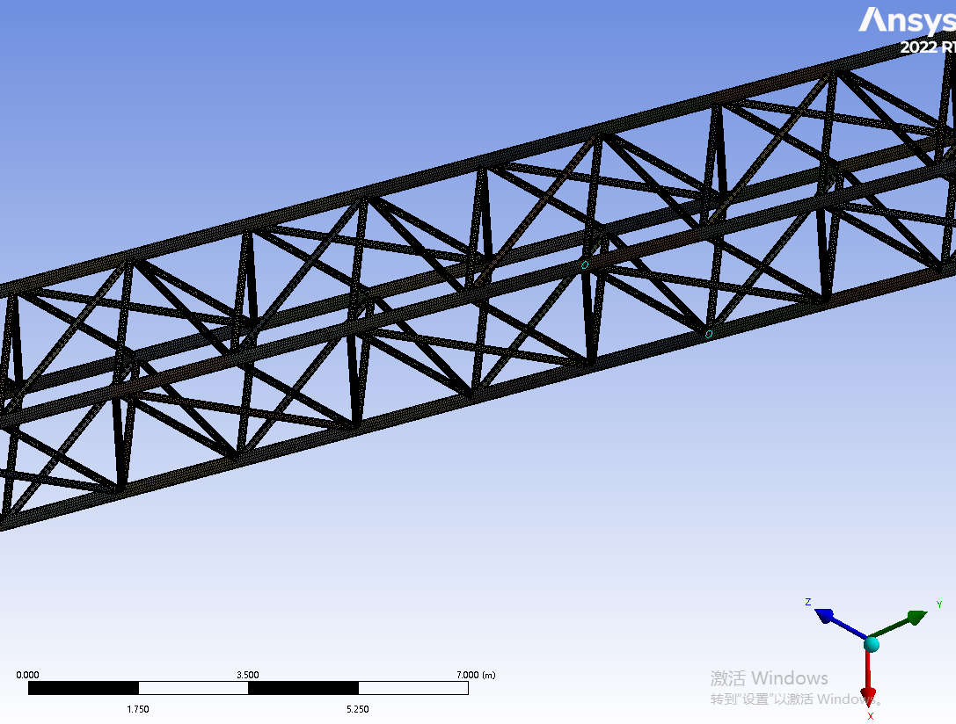

- Fig. 1 Local finite element model of boom

- Conduct a modal analysis on it and extract the eigenvalues. During actual operation, the frequency borne by the boom structure itself is not high. Therefore, it is sufficient to extract the low-order modal eigenvalues. The analysis shows that the first six orders of the boom are referred to as rigid body motion modes, whose natural frequencies are small and can be neglected. The calculated 7th to 11th order modes are presented in Table 1 below.
Table 1 Boom mode frequency
Order | Frequency/HZ | Vibration Mode Description
7 | 6.545 | Bending along the Y-axis
8 | 8.378 | Bending along the Z-axis
9 | 20.476 | Sinusoidal deformation along the Y-axis
10 | 45.783 | Sinusoidal deformation along the Z-axis
11 | 78.986 | Torsion along the X-axis

- 2.3Equivalent Modeling of Wire Ropes for Wind Power Cranes
- During the operation of the unit, due to the influence of some factors, alternating loads will be generated between the wire rope and the boom, leading to unstable system movement. Therefore, it is necessary to conduct simulation research on the wire rope. There are mainly the following methods for modeling wire ropes in ADAMS software [15].
- (1) Modal Neutral File modeling method. This method is the same as the flexible body modeling method mentioned earlier. The flexible model of the wire rope is generated into an MNF neutral file in finite element software and imported into ADAMS software through data transmission.
- (2) Discrete flexible body modeling method. The principle of the discrete flexible beam connection method is to divide the entire component into a limited number of small pieces, and each small piece is flexibly connected by a flexible beam. After discretization, different attributes are assigned to each discrete part, and each part is treated as a separate rigid component. This method can directly set model parameters to generate the real actual situation of the wire rope, but it does not solve the problems of friction and contact force.
- (3) Cable module modeling method. ADAMS/Cable is a module specially designed for simulating structures such as ropes and wire ropes, which can better reproduce the characteristics of wire ropes and pulleys. This method mainly divides the whole into many units and processes each unit separately. The Cable module has two main methods for establishing wire ropes: a simple model and a discrete model. The simple model mainly ignores factors such as the mass of the wire rope, only deals with the elastic deformation of the wire rope, and reflects the friction between itself and the slider by changing the magnitude and direction of the force, accurately reproducing the force situation of the pulley, and the simulation speed is greatly improved. The discrete model simulates the model through contact force, simulating the contact between the contact force and the pulley. During the calculation process, it can calculate the motion parameters and acting forces between itself and the pulley, and can also reflect the impact of vibration on the whole. However, the calculation speed is too slow, it is too affected by parameters, and the failure rate is very high.
- This paper uses the first method to model the wire rope. The eigenvalue of the wire rope is extracted in finite element software, imported into ADAMS, and dynamic simulation is carried out. The first few orders of modes of the wire rope are extracted, as shown in Figure 2 below:
- 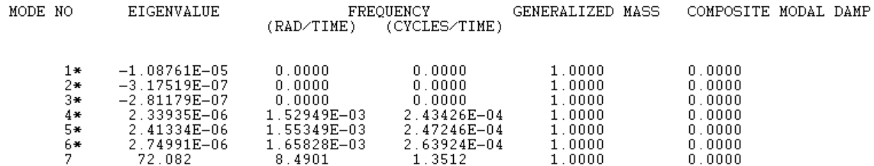
- Fig. 2 The value of the first seven modes of the rope

- 2.4Establishment and Verification of Rigid-Flexible Coupling Model via Rigid-Flexible Replacement of the Boom
- By generating the *.mnf file in the ANSYS finite element software, the specific information of this neutral file—such as natural frequency, units, and mass—can be viewed in the ADAMS/Flex toolbox to check whether the modal information is consistent. Load the AutoFlex module and replace the rigid body in ADAMS with the flexible body from the neutral file. Select the Build-Flexible Bodies-Rigid to Flex command, open the Rigid-to-Flex Replacement dialog box, select the rigid body to be replaced, and then perform the replacement. In the MNF File column, input the neutral file generated in the finite element software and its file path to complete the rigid-to-flex replacement. According to the connection method between components, adjust the centers of mass of the flexible body and the rigid body to make their centers of mass completely coincide. Use a sphere to simulate the lifted heavy object, as shown in Figures 3 and 4 below (the flexible body is colored green).
- Replace the flexible body generated above and import the modal analysis neutral file established above into ADAMS through the data interface. After replacement, it should be noted that the constraints between the original model parts in ADAMS are prone to errors, leading to simulation failure. Therefore, it is necessary to redefine and reapply the constraints between parts. At the same time, attention should be paid to applying the constraints in sequence. The constraint pairs of parts should be reasonably determined according to the actual situation and appropriate movement directions to reduce the probability of errors in ADAMS. Import the flexible body of the wind power crane into ADAMS, and compare the modal frequencies in the finite element analysis with those in ADAMS, as shown in Table 2 below. It can be found that the error between the two modal frequencies is small and they are basically the same, which indicates that the rigid-flexible replacement is completed and the rigid-flexible coupling model is established.
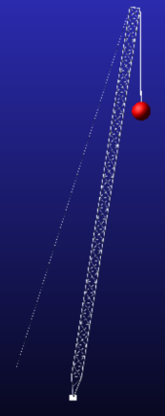
- Fig. 3 Flexible body model of boom system
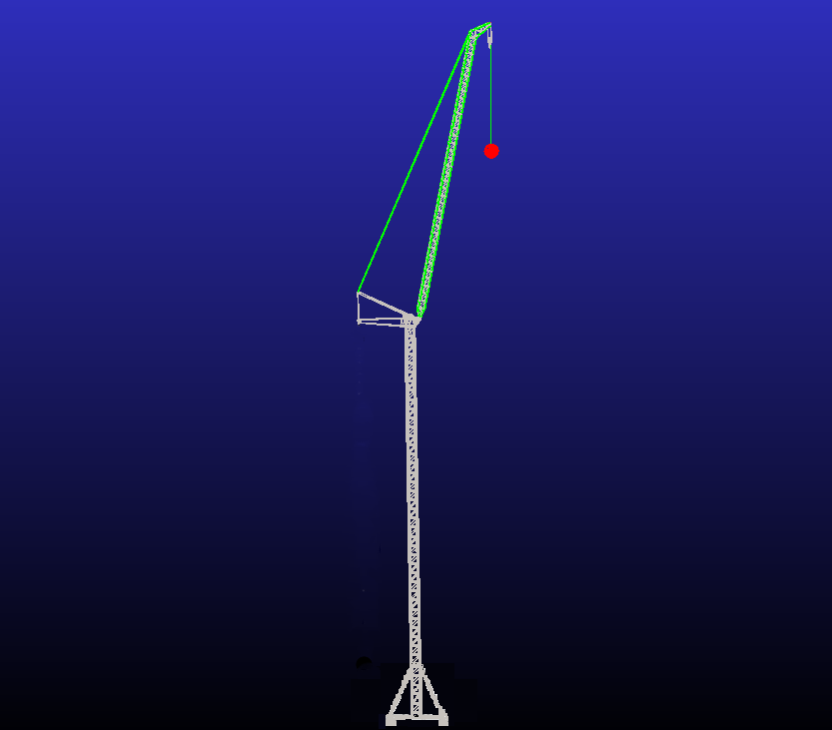
Fig. 4 Rigid-flexible coupling model of the whole system

Table 2 Natural frequency comparison between ADAMS and ANSYS
Modal Order | ANSYS（HZ） | ADAMS（HZ） | 误差
7 | 6.545 | 6.541 | 0.06%
8 | 8.378 | 8.324 | 0.64%
9 | 20.476 | 20.398 | 0.38%
10 | 45.783 | 45.771 | 0.02%
11 | 78.986 | 78.574 | 0.52%

- As shown in the above table, the error range of natural frequencies between ADAMS and ANSYS is 0.02% to 0.64%. Therefore, it can be considered that the establishment of the rigid-flexible coupling model is completed.

- 2.5Add Constraints
- After the rigid-flex coupling model is established, the components of the virtual prototype model should be connected to form a complete mechanical system. There are four common constraints in ADAMS, the first is the low second, the second is the basic second, the third is the drive, and the fourth is the high secondary. The low pair includes rotary pair, planar pair, cylindrical pair and slip pair. The main constraints added to the model are: the tower body and the earth are applied as fixed pairs; The tower body and the rotating system apply a rotating pair; Lifting arm, balance arm wire rope, herringbone frame, swing arm and main hoist wire rope are hinged with each other. Add a sliding pair between the wire rope and the small ball weight; Add a fixing pair between the drum, the hoisting system and the wire rope. When you are done adding constraints, check the degrees of freedom of the model.

- 2.6Add loads and drives
- The size and mode of load addition can be referenced from Chapter 3 and Chapter 4. A horizontal wind load of 1.589×${10}^{4}\text{N/}{\text{m}}^{\text{2}}$ was initially added to the middle of the boom.During the no-load, hoisting, luffing, and slewing processes of the equipment, it is affected by its own load and wind load. During the luffing process, it is affected by the luffing load; during the hoisting and unloading processes, it is affected by the impact load. The self-weight load mainly depends on the influence of gravitational acceleration, and the material settings are automatically added by the system.
- (1) Dynamic load when suddenly lifting a heavy object from the ground
- The overall structure of a wind power crane is a vibration system with multiple degrees of freedom, and simplified models are usually used for research and calculation. The hoisting system can be simplified into a dynamic model with three masses and two degrees of freedom. When calculating vibration, the wind power equipment can be simplified as shown in Figure 5 below:
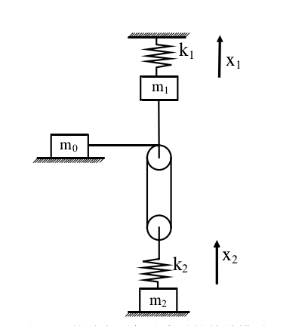
Fig. 5 Dynamic model of lifting weights off the ground

- ${\text{m}}_{\text{0}}$:represents the mass of the equipment's own moving parts and the mass transferred from the motor to the drum;；
- ${\text{m}}_{\text{1}}$:represents the mass transferred from the overall design to the boom head;；
- ${\text{m}}_{\text{2}}$:represents the lifting load mass;；
- ${\text{k}}_{\text{1}}$:represents the stiffness coefficient of the equipment equivalent to the boom head;；
- ${\text{k}}_{\text{2}}$:represents the stiffness coefficient of the hoisting wire rope at the heavy object suspension point;；
- ${\text{x}}_{\text{1}}$:represents the mass displacement;
- $\text{Y}$:represents the mass displacement
- Among the wind power equipment, the${ \text{m}}_{\text{0}}$ value is the largest, fixed on the turntable,${\text{m}}_{\text{1}}、{\text{m}}_{\text{2}}$, spring ${\text{k}}_{\text{1}}$、${\text{k}}_{\text{2}}$ are connected in series, and the rise speed of the wind turbine is set to ${\text{v}}_{\text{0}}$ two-degree-of-freedom system.
- The differential equation is expressed as:
$$\begin{aligned}{\text{m}}_{\text{1}}{\ddot{\text{x}}}_{\text{1}}\text{+}{\text{k}}_{\text{2}}\left({\text{x}}_{\text{1}}\text{-}{\text{x}}_{\text{2}}\right)\text{=}{\text{F}}_{\text{q}}\text{=}{\text{F}}_{{\text{s}}_{\text{1}}}\text{+Q}\#（\text{1}\text{-1}）\end{aligned}$$
$\begin{aligned}{\text{m}}_{\text{2}}{\ddot{\text{x}}}_{\text{2}}\text{-}{\text{k}}_{\text{2}}\left({\text{x}}_{\text{1}}\text{-}{\text{x}}_{\text{2}}\right)\text{=Q}\#（\text{1}\text{-}\text{2}）\end{aligned}$

- ${\text{F}}_{\text{q}}$ :expressed as the starting circumferential force;
${\text{F}}_{{\text{s}}_{\text{1}}}$:expressed as the residual acceleration force;
$\text{Q}$:expressed as a static load of heavy objects
- x=${\text{x}}_{\text{1}}$-${\text{x}}_{\text{2}}$ represents the elastic deformation of the spring, and there are the above two formulas:
$$\begin{aligned}\ddot{\text{x}}\text{+}{\text{ω}}^{\text{2}}\text{x=}\frac{{\text{F}}_{{\text{s}}_{\text{1}}}}{{\text{m}}_{\text{1}}}\text{+}\frac{{\text{m}}_{\text{1}}\text{+}{\text{m}}_{\text{2}}}{{\text{m}}_{\text{1}}{\text{m}}_{\text{2}}}\text{Q}\#（\text{1}\text{-}\text{3}）\end{aligned}$$
$$ω=\sqrt{{\text{k}}_{\text{2}}\left(\frac{{\text{m}}_{\text{1}}\text{+}{\text{m}}_{\text{2}}}{{\text{m}}_{\text{1}}{\text{m}}_{\text{2}}}\right)}$$
- Solving ($\text{1}\text{-}\text{3}$) obtains:
$$\begin{aligned}\text{x=}{\text{A}}_{\text{1}}\text{sin}{\text{ωt}}\text{+}{\text{B}}_{\text{1}}\text{cos}{\text{ωt}}\text{+}\frac{{\text{m}}_{\text{2}}{\text{F}}_{{\text{s}}_{\text{1}}}}{{\text{k}}_{\text{2}}\left({\text{m}}_{\text{1}}\text{+}{\text{m}}_{\text{2}}\right)}\text{+}\frac{\text{Q}}{{\text{k}}_{\text{2}}}\#（\text{1}\text{-}\text{4}）\end{aligned}$$
- $\begin{aligned}\dot{\text{x}}\text{=ω}{\text{A}}_{\text{1}}\text{cos}{\text{ωt}}\text{-}{{\text{ω}}_{\text{1}}\text{B}}_{\text{1}}\text{cos}{\text{ωt}}\#（\text{1}\text{-}\text{5}）\end{aligned}$
- The initial conditions are:$x\left(\text{0}\right)\text{=}\frac{\text{Q}}{{\text{k}}_{\text{2}}}$，$\dot{\text{x}}\left(\text{0}\right)\text{=}\text{v}$，Substitutions can be obtained:
$$\begin{aligned}{\text{A}}_{\text{1}}\text{=}\frac{\text{ν}}{\text{ω}}{\text{B}}_{\text{1}}\text{=}\frac{{\text{m}}_{\text{2}}{\text{F}}_{{\text{s}}_{\text{1}}}}{{\text{k}}_{\text{2}}\left({\text{m}}_{\text{1}}\text{+}{\text{m}}_{\text{2}}\right)}\#（\text{1}\text{-}\text{6}）\end{aligned}$$
- Substrain the values of $A_{1}$and$B_{1}$（$\text{1}\text{-}\text{4}$），（$\text{1}\text{-}\text{5}$）can be derived：
$$\begin{aligned}\text{x=}\frac{\text{ν}}{\text{ω}}\text{sin}{\text{ωt}}\text{+}\frac{{\text{m}}_{\text{2}}{\text{F}}_{{\text{s}}_{\text{1}}}}{{\text{k}}_{\text{2}}\left({\text{m}}_{\text{1}}\text{+}{\text{m}}_{\text{2}}\right)}\left(\text{1-}\text{cos}{\text{ωt}}\right)\text{+}\frac{\text{Q}}{{\text{k}}_{\text{2}}}\#（\text{1}\text{-}\text{7}）\end{aligned}$$
- The internal force of the wire rope can be expressed as:F=${\text{k}}_{\text{2}}\text{x}$，Bringing in can yield:
- $\begin{aligned}\text{F=}{\text{k}}_{\text{2}}\text{x=}\frac{{\text{k}}_{\text{2}}\text{ν}}{\text{ω}}\text{+}\frac{{\text{m}}_{\text{2}}{\text{F}}_{{\text{s}}_{\text{1}}}}{\left({\text{m}}_{\text{1}}\text{+}{\text{m}}_{\text{2}}\right)}\left(\text{1-}\text{cos}{\text{ωt}}\right)\text{+Q}\#（\text{1}\text{-}\text{8}）\end{aligned}$
- With the above formula, it can be seen that when lifting heavy objects, the wire rope is affected by static load, inertial load and impact load.
- (2) Determination of Dynamic Load When the Heavy Object Is Suspended in the Air
- ① During Hoisting Start-up
- The initial conditions are as follows:t=0时，$x\left(\text{0}\right)\text{=}\frac{\text{Q}}{{\text{k}}_{\text{2}}}$，$\dot{\text{x}}\left(\text{0}\right)\text{=0}$
$$\begin{aligned}{\text{A}}_{\text{2}}\text{=0}{\text{B}}_{\text{2}}\text{=}\frac{{\text{m}}_{\text{2}}{\text{F}}_{{\text{s}}_{\text{1}}}}{{\text{k}}_{\text{2}}\left({\text{m}}_{\text{1}}\text{+}{\text{m}}_{\text{2}}\right)}\#（\text{1}\text{-}\text{9}）\end{aligned}$$

- Substrain the values of $A_{1}$and$B_{1}$（$\text{1}\text{-}\text{4}$），（$\text{1}\text{-}\text{5}$）can be derived：
$$\begin{aligned}\text{x=}\frac{{\text{m}}_{\text{2}}{\text{F}}_{{\text{s}}_{\text{1}}}}{{\text{k}}_{\text{2}}\left({\text{m}}_{\text{1}}\text{+}{\text{m}}_{\text{2}}\right)}\left(\text{1-}\text{cos}{\text{ωt}}\right)\text{+}\frac{\text{Q}}{{\text{k}}_{\text{2}}}\#（\text{1}\text{-}\text{10}）\end{aligned}$$
- Internal force on the wire rope:
- $\begin{aligned}\text{F=}{\text{k}}_{\text{2}}\text{x=}\frac{{\text{m}}_{\text{2}}{\text{F}}_{{\text{s}}_{\text{1}}}}{\left({\text{m}}_{\text{1}}\text{+}{\text{m}}_{\text{2}}\right)}\left(\text{1-}\text{cos}{\text{ωt}}\right)\text{+Q}\#（\text{1}\text{-}\text{11}）\end{aligned}$

- ② Hoisting Braking
During braking, the wire rope will be affected by the braking force of the motor. The starting circumferential force${\text{F}}_{\text{q}}$ in the above formula will be replaced by the braking circumferential force ${\text{F}}_{\text{2}}$, which can be derived from the above formula:
$$\begin{aligned}\text{x=}{\text{A}}_{\text{1}}\text{sin}{\text{ωt}}\text{+}{\text{B}}_{\text{1}}\text{cos}{\text{ωt}}\text{+}\frac{\text{Q}{\text{m}}_{\text{1}}\text{-}{\text{m}}_{\text{2}}{\text{F}}_{{\text{s}}_{\text{2}}}}{{\text{k}}_{\text{2}}\left({\text{m}}_{\text{1}}\text{+}{\text{m}}_{\text{2}}\right)}\#（\text{1}\text{-}\text{12}）\end{aligned}$$
- Solving:${\text{B}}_{\text{3}}$=$\frac{{\text{m}}_{\text{2}}\left({\text{F}}_{{\text{s}}_{\text{2}}}\text{+Q}\right)}{{\text{k}}_{\text{2}}\left({\text{m}}_{\text{1}}\text{+}{\text{m}}_{\text{2}}\right)}$；
$$\begin{aligned}\text{F=}{\text{k}}_{\text{2}}\text{x=}\frac{{\text{F}}_{{\text{s}}_{\text{2}}}\left({\text{m}}_{\text{2}}\text{+Q}\right)}{\left({\text{m}}_{\text{1}}\text{+}{\text{m}}_{\text{2}}\right)}\left(\text{cos}{\text{ωt-1}}\right)\text{+Q}\#（\text{1}\text{-}\text{13}）\end{aligned}$$

- Simulation results and analysis of boom systems
- The jib and wire rope are analyzed as a dynamic model. Apply a rotational drive to the established model to rotate it 90° clockwise from the initial position, and record the centroid displacement curve and velocity curve of the spherical weight during this process to verify the stability of the equipment in the process of transporting the weight. As shown in Figure 6, it represents the initial position of the sphere from different perspectives. As shown in Figure 7, it represents the position of the sphere after rotating 90°.
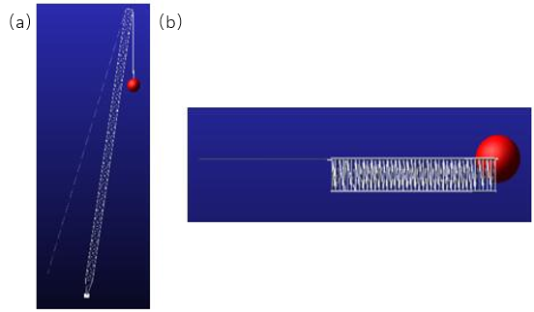
Fig. 6 Ball initial position(a) x perspective (b) z perspective

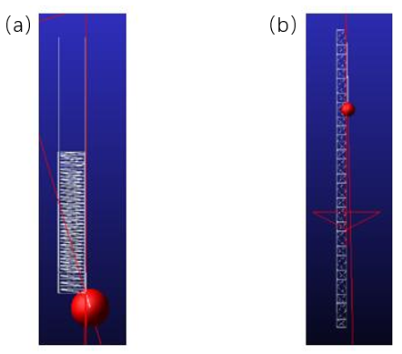
Fig. 7 The ball rotates 90° (a) x perspective (b) z perspective
- According to the modeling settings of the jib system, the positive direction of the X-axis is set to the clockwise moving direction of the heavy object, the Y-axis direction is set to the vertical direction (up and down), and the Z-axis direction is set to the lateral direction (left and right). A 90° rotational drive (as shown in Figure 8) is added, and the center of mass is set at the center of the sphere. The 25-second simulation results of the heavy object during the slewing stage are obtained: the amplitude motion curve of the sphere’s center of mass is shown in Figure 9; the velocity variation curve of the center of mass along the X-axis is shown in Figure 10; the displacement characteristic curves of the center of mass are shown in Figures 11, 12, and 13; and the total displacement characteristic curve of the center of mass is shown in Figure 14.
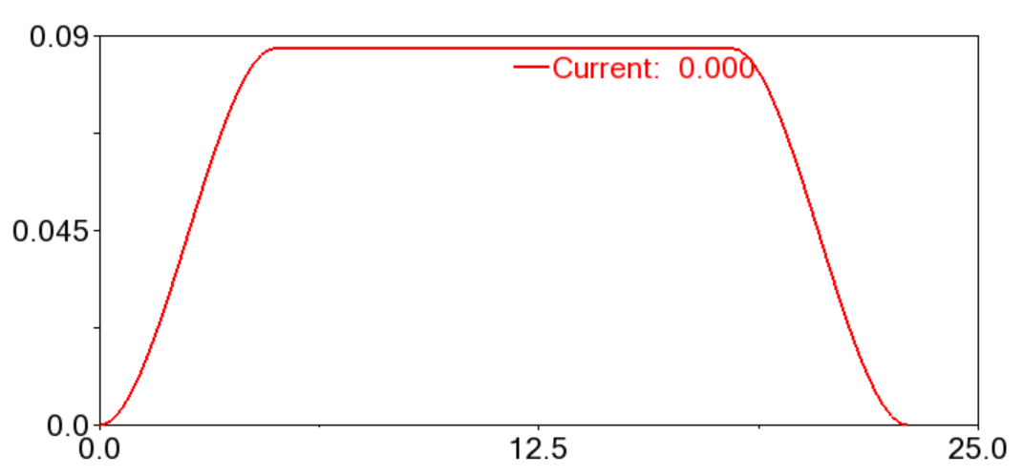
Fig. 8 Boom rotation drive curve
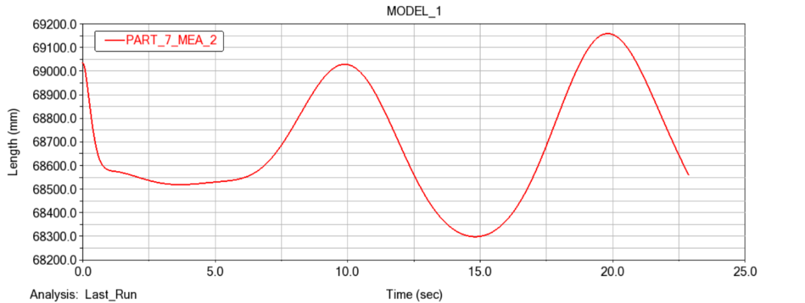
Fig. 9 Amplitude curve of ball centroid motion
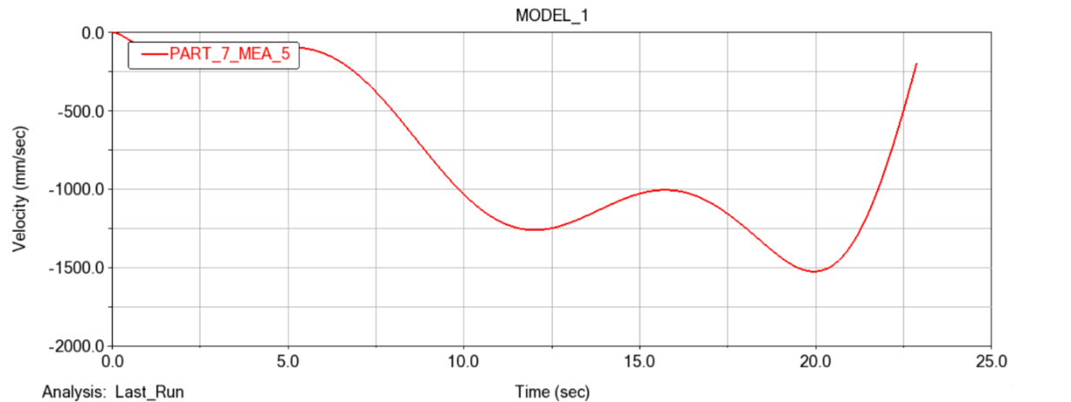
Fig. 10 Center of mass position x axis velocity curve
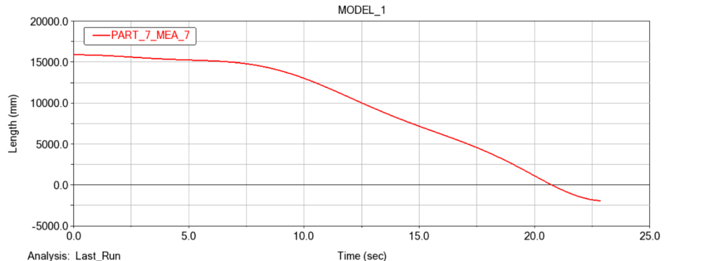
Fig. 11 Center of mass displacement curve in x axis
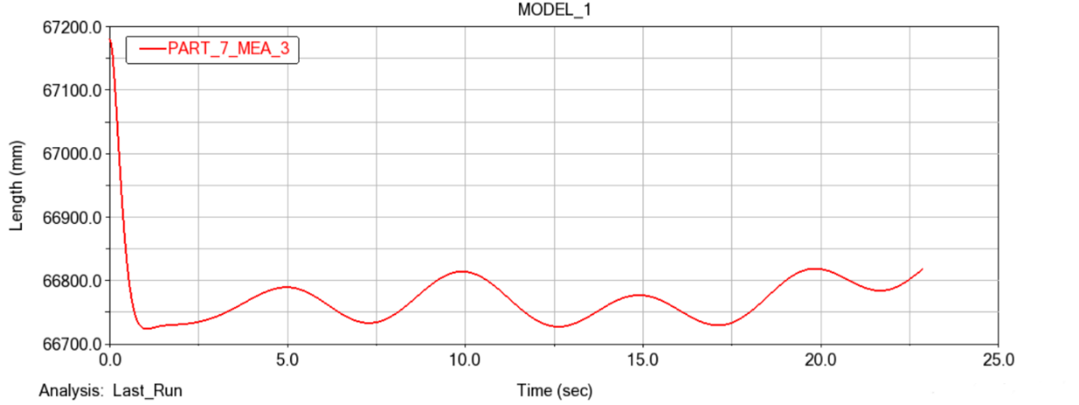
Fig. 12 Shift curve of the center of mass on the y axis
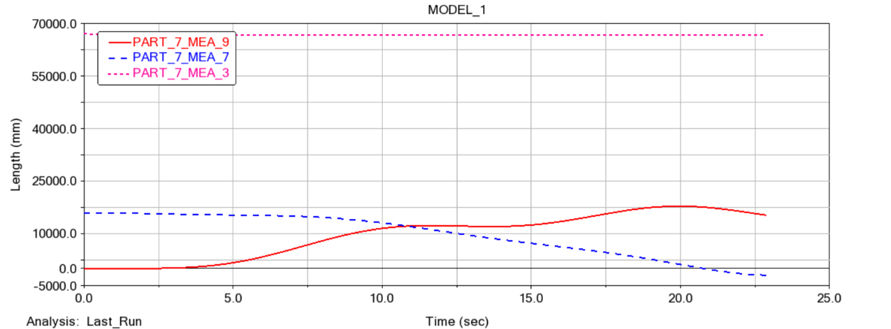
Fig. 13 Curve of displacement of the center of mass in the z axis
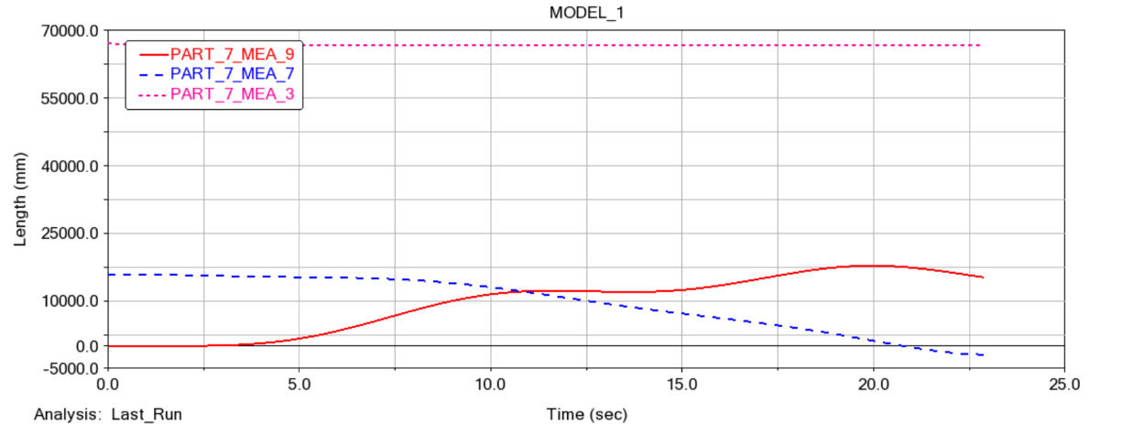
Fig. 14 Change curve of the total displacement of the center of mass position of the ball
- As shown in Figure 9, the curve changes smoothly, with luffing motion occurring between 69.05 m and 68.3 m. The movement amplitude of the sphere does not exceed 1 m; considering the influence of the elastic deformation of the wire rope, the movement amplitude of the sphere is negligible. It can also be seen that during the overall slewing process of the jib system, the heavy object can maintain a stable state.
- As shown in Figure 10, which presents the velocity variation curve of the sphere’s center of mass along the X-axis, it can be observed from the figure that the sphere’s velocity changes within the range of 0 to 1.5 m/s. At 20 seconds, the sphere’s velocity reaches its maximum value, and it is from this moment that the sphere begins to decelerate. The acceleration of the sphere during its movement is also within a reasonable range, and the curve changes stably. This indicates that the sphere’s velocity is controllable and its movement is stable during the slewing process.
- As shown in Figures 11 to 13, which are the displacement variation curves of the sphere along the X, Y, and Z axes respectively:From the X-axis displacement variation curve, the sphere moves in the first 7 seconds with almost no change in displacement, indicating that the jib starts stably in the early stage of slewing. After 7 seconds, the sphere shows a linear movement consistent with a linear function, which means the sphere moves smoothly along the X-axis during the slewing process.From the Y-axis displacement variation curve, it can be seen that the sphere’s displacement drops sharply in the first 2 seconds. This phenomenon occurs because the jib suddenly applies the load of the heavy object, and the wire rope undergoes elastic deformation under the influence of static load. However, after 2 seconds, the displacement of the sphere along the Y-axis shows a variation trend consistent with a sine function. During this movement process, the maximum displacement is 66.5 m and the minimum displacement is 66.6 m, with a difference of no more than 10 cm. For large-tonnage wind power equipment, coupled with the elastic deformation of the wire rope, this 10 cm displacement is negligible. Overall, it can be seen that the jib can maintain the stable lifting operation of the heavy object in the vertical direction during the slewing process.From the above data curves, it can be concluded that when the jib is slewing to lift goods, it can generally maintain stable operation without unstable phenomena such as jumping or swinging, which meets the design requirements.
4. Simulation results and analysis of rigid-flex coupling dynamics of wind power cranes
- The dynamic simulation of wind power cranes must be conducted by integrating its own load, luffing load, dynamic load, and other relevant loads. The material properties of the mechanism’s own load, as well as the magnitude and direction of gravitational acceleration, are automatically applied in the ADAMS software. For the inertial loads during equipment start-up and braking, a step function is input into the ADAMS/Solve solver, and the simulation process can then calculate and obtain the results .
- In accordance with the above steps, for the established rigid-flexible coupling model of the wind power crane, rigid-flexible coupling dynamic analysis is performed on the overall model during the operation, hoisting, and luffing processes respectively. Through the Solver module in the ADAMS software, the system’s motion dynamic equations for this process are automatically generated, and results such as kinematics and dynamics are solved.
- In the ADAMS software, the defined forces, expressions of kinematic pairs, functions, and other elements can be created using the function editor in the View interface. The function editor mainly exists in two forms: the first is the Expression mode, which is primarily used as a function editor for time-time relationships; the other is the Run-time mode, which is mainly used as a function editor for time-motion relationships. For this study, the hoisting mechanism mainly uses the function editor in Run-time mode to add drives.
- The STEP function is often used as an operation function. In this study, the STEP function is employed during the three motion processes. When the STEP function is used as an operation function, its format is as follows:
- The function format is$STEP \left(\text{x}\text{，}{\text{x}}_{\text{0}}\text{，}{\text{h}}_{\text{0}}\text{，}{\text{x}}_{\text{1}}\text{，}{\text{h}}_{\text{1}}\right)$
- x – Independent variable, which can be time or any function of time;
- ${\text{x}}_{\text{0}}$ – Start value of the STEP function for the independent variable, which can be a constant, a function expression, or a design variable;
- ${\text{x}}_{\text{1}}$ – End value of the STEP function for the independent variable, which can be a constant, a function expression, or a design variable;
- ${\text{h}}_{0}$– Initial value of the STEP function, which can be a constant, a design variable, or another function expression;
- ${\text{h}}_{\text{1}}$ – Final value of the STEP function, which can be a constant, a design variable, or another function expression.

- 4.1Simulation of equipment operation process dynamics
- The wind power crane equipment runs the motion simulation process, with a starting time of 7 s, a stable running time of 7 s, a stop time of 7 s, and a running speed of 1.5 m/s. Design a step function for this run, and run the driver step function as follows:
step（time，0，0，7，1500）+step（time，14，0，21，-1500）
- The driving function curve is shown in Figure 15 below, which is shown as a speed curve, and the overall simulation is performed after adding the driver.
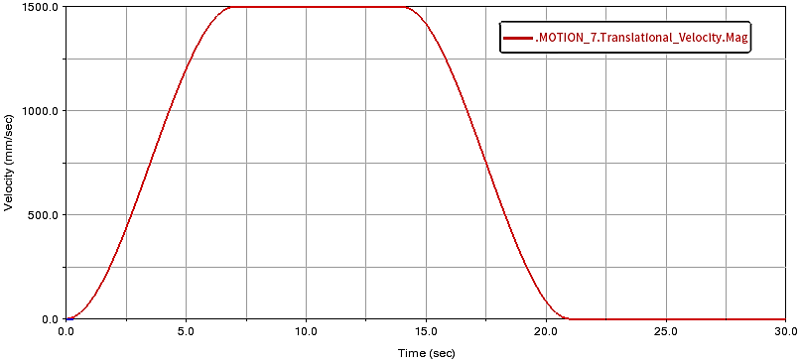
Fig. 15 Run process drive function curve
- The load data in the processor is extracted to form the corresponding unit deflection load curve, as shown in Fig. 16 below.
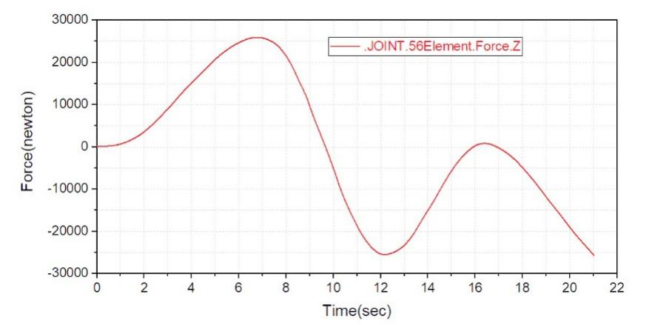
Fig. 16 Fan equipment yaw load curve
- Through the analysis of the above charts, it can be seen that in the overall operation of wind power lifting equipment, the maximum offset load appears in the acceleration stage of the unit, and the maximum offset load value is P=26000 N from the post-processor data. It can be seen from the curve diagram that in the process of movement of the wind power crane boom, a deformation curve similar to the sine function occurs in the vertical direction, resulting in an increase in the maximum yaw load of the equipment.

- 4.2Simulation of equipment lifting process dynamics
- In the simulation process of wind power crane equipment, the acceleration time is 5 s, the stable running time is 15 s, the deceleration time is 5 s, and the running speed is set to 130 mm/s. Design this runtime as a step function, and run the driver STEP function as follows:
step（time，0，0，5，130）+step（time，20，0，25，-130）
- The driving function curve of the lifting process is shown in Figure 17 below, which is shown as a speed curve, and the overall simulation is carried out after adding the drive.
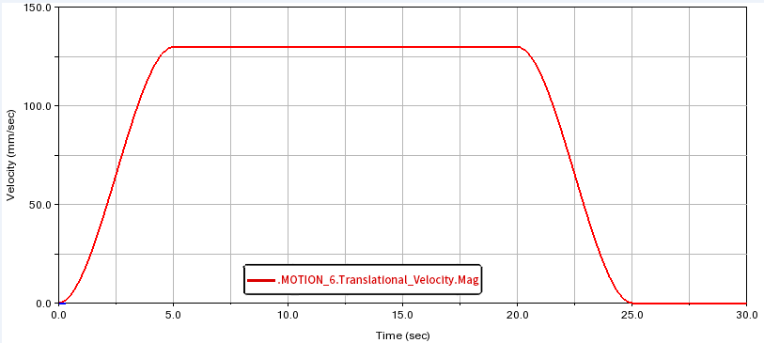
Fig. 17 Lifting process driving function curve

- The dynamic load curve of the lifting motion process of the unit is formed by extracting the load data in the processor, as shown in Fig. 18 below.
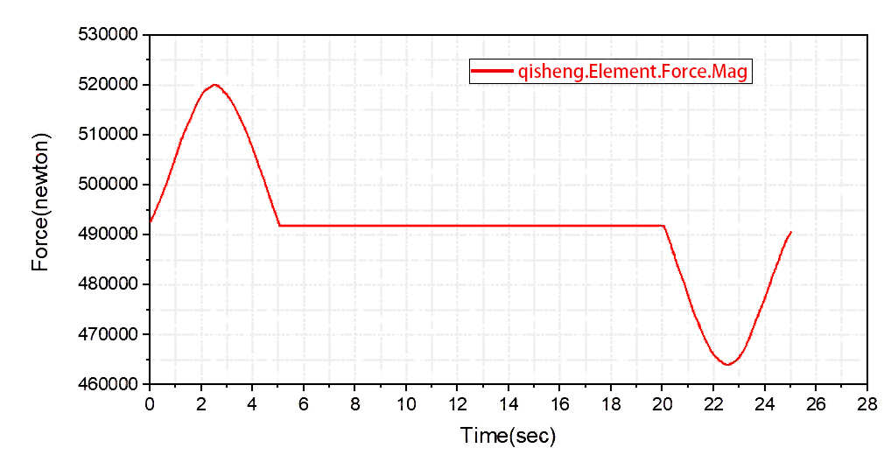
Fig. 18 Dynamic load curve during lifting

- From the above curve diagram, it can be seen that the maximum dynamic load of the whole equipment is 520000 N during the lifting and acceleration process of the equipment crane. In the process of lifting wind power equipment, the boom will bend and deform in the vertical direction, and the overall equipment is accelerating, so the dynamic load of the equipment increases.

- 4.3Simulation of equipment luffing process dynamics
- In the luffing motion simulation process of wind power crane equipment, the boom starts from 12.5 m to run the luffing action, after 15 seconds the luffing speed reaches 1.1 deg/s, maintains this speed for 65 s, then stops for 15 s, and maintains for 15 s, and drops to 12.5 m after 85 s. Design this runtime as a step function, and run the driver STEP function as follows:
step（time，0，0，15，15d）+step（time，80，0，95，-15d）+ step（time，110，0，125，15d）+step（time，210，0，225，-15d）
- The driving function curve of the luffing process is shown in Figure 19 below, which is shown as the driving curve of the luffing process, and the overall simulation is carried out after adding the driver.
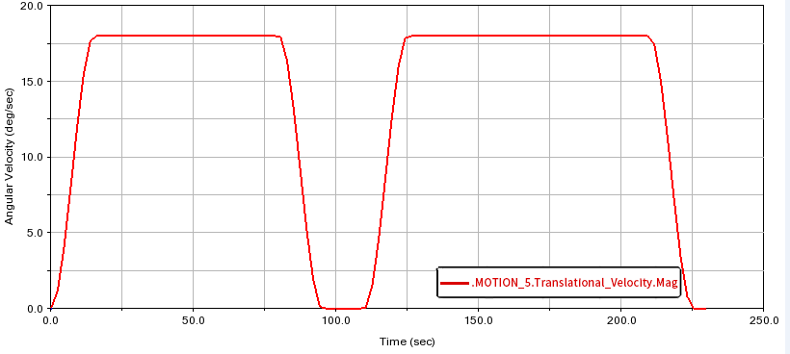
Fig. 19 Variable amplitude process driving function curve
- The load data in the post-processor is extracted to form the corresponding unit luffing process deflection load curve, as shown in Fig. 20 below.
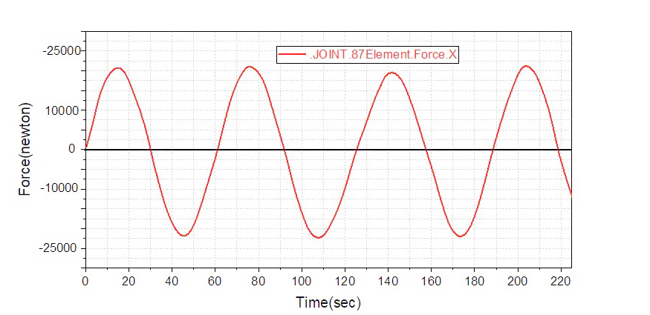
Fig. 20 Deflection load curve during amplitude variation

- From the above curve diagram, it can be seen that the values of the bias load at the beginning and end of the luffing movement are different, and the maximum deflection load appears when the equipment decelerates, and it can be seen that the maximum deflection load is 21040 N. In the luffing mechanism, the vertical deformation of the boom produces a deformation similar to a sinusoidal curve.

5. conclusion
- Aiming at the special construction environment of low-wind-speed wind farms and the hoisting requirements of high-tower wind power equipment, this study takes a non-attached wind turbine crane as the research object. Using co-simulation technology with ANSYS and ADAMS, a rigid-flexible coupled model of the truss structure and wire rope was established. Through dynamic simulation analysis under typical working conditions such as slewing, traveling, hoisting, and luffing, the following results were obtained: the displacement fluctuation of the load during slewing does not exceed 1 m, the maximum partial load during traveling is 26,000 N, the maximum dynamic load during hoisting is 520,000 N, and the maximum swing load during luffing is 21,040 N. These results verify the overall stability of the crane boom during operation and provide a theoretical basis and technical support for its structural optimization design.

- COMPETING INTERESTS DISCLAIMER:
- Authors have declared that they have no known competing financial interests OR non-financial interests OR personal relationships that could have appeared to influence the work reported in this paper.

Disclaimer (Artificial intelligence)

Author(s) hereby declare that NO generative AI technologies such as Large Language Models (ChatGPT, COPILOT, etc.) and text-to-image generators have been used during the writing or editing of this manuscript.

References

- National Development and Reform Commission, National Energy Administration. The 14th Five-Year Plan for Renewable Energy Development [EB/OL]. 2022. (year not match)
- He, H., Nie, S., Ji, H., Ma, Z., Yin, F., & Zhang, Z. (2023, August). Dynamic Analysis of Integrated-Slipper Seawater Hydraulic Axial Piston Pump (ISHAPP) Based on Virtual Prototype Technology. In 2023 9th International Conference on Fluid Power and Mechatronics (FPM) (pp. 1-9). IEEE.
- Simeone, A. L., Cools, R., Depuydt, S., Gomes, J. M., Goris, P., Grocott, J., ... & Gerling, K. (2022, April). Immersive speculative enactments: Bringing future scenarios and technology to life using virtual reality. In Proceedings of the 2022 CHI Conference on Human Factors in Computing Systems (pp. 1-20).
- Chu Y., Hatledal L. I., Zhang H., et al. Virtual prototyping for maritime crane design and operations[J]. Journal of marine science and technology, 2018, 23(4): 754-766.
- Hameed I., Bye R., Osen O., et al. Grey wolf optimizer (GWO) for automated offshore crane design[C]: Computational Intelligence, Athens, Greece. 2016: 6.
- Hameed I., Bye R., Osen O., et al. Intelligent computer-automated crane design using an online crane prototyping tool[C]: European Conference on Modelling and Simulation, Ostbayerische TH Regensburg, Regensburg, GERMANY. 2016: 564-573.
- Yu H. Static and Dynamic Analysis and Simulation of Crawler Crane Boom[D]. Northeastern University, 2011.
- Mile M S, RADOVAN R B, MILOM IR M G, et al. Optimization of the box section of the main girder of the single-girder bridge crane by applying biologically inspired algorithms[J]. Engineering Structures. 2017(148): 452-465.
- Ataei B, Yuan S, Ren Z, et al. Effects of structural flexibility on the dynamic responses of low-height lifting mechanism for offshore wind turbine installation[J]. Marine Structures, 2023(89): 103399.
- LEE Y M, SHU K, SHYUE H. Using ADAMS Application on Mechanism Simulation of New Multiaxis Machines[J]. Applied Mechanics and Materials, 2014.
- Garcia-Vallejo D, Escalona J L, Mayo J, et al. Describing rigid-flexible multibody systems using absolute coordinates[J]. Nonlinear Dynamics. 2003(34): 75-94.
- A. K. Banerjee, T. R. Kane. Dynamics of a Plate in Large Overall Motion[J]. ASME Journal of Applied Mechanics. 1989, 56(4): 887-892.
- T.R. Kane, R.R. Ryan, A.K. Banerjee. Dynamics of a Cantilever Beam Attached to a Moving Base[J]. Journal of Guidance Control and Dynamics. 1987, 10(2): 139-151.
- Rismantab-Sany J, Shabana A A. On the use of momentum balance in the impact analysis of constrained elastic system[J]. Journal of Vibration and Acoustics, 1990, 112(2): 119-126.
- Li Aiping, Jiang Chaoping, Liu Xuemei. Simulation Analysis of Dynamic Tension of Wire Rope Based on ADAMS Platform [J]. Modern Manufacturing Engineering, 2010 (01): 43-46.

