Improving Bridge Sustainability through Building Information Modelling: Experiences from the Barelang Bridge Project

.
ABSTRACT

This research explores integrating Building Information Modeling (BIM) technology for bridge sustainable design. It discusses the transitions from AutoCAD to BIM in the construction industry, with BIM recognized for increasing efficiency, sustainability, and accuracy in construction projects. Primary data was obtained by interviewing experienced and competent BIM user sources in carrying out bridge planning work to determine the factors that influence the efficiency of BIM-based planning with conventional methods. Secondary data used were obtained through the Barelang Bridge Project. In-depth interviews were conducted with BIM users with more than three years of experience to support the analysis. The study results show that bridge planning uses BIM more effectively than manual methods. The level of error can be minimized, and financing is more efficient. BIM and other digital planning methods can ensure sustainable bridge construction.

Keywords: Sustainable Infrastructure, BIM, BrIM, Digital Construction

1. INTRODUCTION

The advent of technology enables everyone to utilize potential resources to grow a country in various ways. Technology plays a crucial role in sustainable infrastructure by offering essential tools and support for the design and execution of building projects. The design of bridge structures often develops over time, as does the development of criteria and applied sciences created and sustainable with the rules listed (Yusuf, Hermawan, & F., 2024). Sustainable development refers to enhancing human life quality while remaining within the capacity of the supporting ecosystem (Abdullah & Ariffin, 2006). Structural engineers have been actively involved in extensive global research over the years to improve efficiency while taking strength, sustainability, and cost into account during the design process. Due to ongoing upgrades to seismic design codes and developments in engineering, existing bridges may become seismically weak. Bridge designs can differ depending on the intended use, the topography, funding sources, material accessibility, and sustainable practices.
Technological advancement is one of the challenges in the field of civil engineering. BIM (Building Information Modeling) is one example of technological advancement that can be used to implement bridge construction projects. The BIM application used is believed by various parties to be able to increase the efficiency and effectiveness of planning so that it is sustainable (Kaewunruen, Sresakoolchai, & Zhou, 2020). Building Information Modelling (BIM) represents both a procedural and technological transformation in the construction industry, offering significant improvements in project delivery (Omar & Mohd Fateh, 2023). The Autodesk Infraworks application can facilitate the placement of facility buildings by directly placing the buildings according to topographic conditions. Various applications such as Autodesk can be used to visualize the scheduling progress per the planning. Then, the Autodesk Revit application is used for 3D modeling to obtain the construction volume, reinforcement volume, and price of the construction project.
This paper uses the Autodesk Revit application to provide the output of working drawings and 3D modeling of bridge piers. This study aims to integrate BIM technology into the design and planning process of bridge piers while also promoting sustainable construction practices. This study enhances efficiency, accuracy, and resource optimization in the bridge pier design and planning procedure, reducing material waste and minimizing environmental impact. It also promotes cooperation and unity among the stakeholders engaged in the construction project. Hence, this study aims to discuss how to design a sustainable bridge pier using Autodesk Revit software based on BIM.
Characterized by its varied ecosystems and rapidly expanding urban areas, Indonesia encounters distinctive challenges and opportunities when adopting sustainable practices (Wirawan, 2015). Sustainability is now acknowledged as a crucial factor in civil engineering structures' design, construction, and ongoing maintenance. In the last decade, infrastructure development has been a top priority for the Indonesian government. Enhancing transportation network infrastructure is anticipated to boost national and international economic growth by linking various regions and improving access to public services and commodities (Saidi, Mani, Mefteh, Shahbaz, & Akhtar, 2020).
The number of bridge infrastructures is increasing significantly because of economic growth. Due to the complexity of bridge design, conventional design methods often lead to lengthy and labour-intensive construction processes (Ghosh & Karmakar, 2023). The traditional construction method, involving 2D drafting, is among the most complex techniques and needs a standardized data exchange platform, leading to frequent project delays, cost overruns, and excessive labour hours. Bridges often need higher rework rates due to their complexity. However, Building Information Modeling (BIM) presents an opportunity for the sustainability of development, lower project costs, enhanced productivity, improved project quality, and shortening project delivery times.

2. Literature review

2.1 Sustainable Infrastructure Design

Building Information Modeling (BIM) has been utilized in the construction of buildings for many years and is now being applied throughout the entire built environment (Liu, van Nederveen, Wu, & Hertogh, 2018). Sustainable designs increasingly rely on BIM as a foundation for conducting various performance analyses (Krygiel & Nies, 2008). BIM has the potential to aid in early sustainability assessments during the design phase. However, a significant challenge lies in the need for more clarity regarding the specific performance knowledge related to infrastructure that should be incorporated into BIM. Although BIM theoretically supports sustainability efforts by efficiently managing valuable data for assessing life cycle costs and conducting energy analyses, numerous practical challenges have emerged, including interoperability, regulations, and compliance issues.
Sustainable and green building design has emerged as a key focus to reduce the harmful environmental effects of the construction industry. The building sector accounts for approximately 40% of worldwide energy consumption and generates about one-third of annual greenhouse gas emissions (Numan, Saadat, & Farooq, 2024). As sustainability concerns come to the forefront, there is a paradigm shift in the architecture, engineering, and construction (AEC) industry towards holistic building life cycle assessment and integrating resource efficiency across design, construction, and operations (Attia, et al., 2017). Achieving sustainability goals in buildings is focused on data-driven decision-making during the preliminary design phase (de Wit & Augenbroe, 2002). These are also the phases when BIM can have more impact, enhancing its influence on building sustainability (Carvalho, Bragança, & Mateus, 2020).
In response to the demand for more efficient and sustainable buildings, designers actively seek methods to reduce structures' environmental impact and energy consumption (Wong & Zhou, 2015). As the demand to improve and more efficient construction projects grows, Building Information Modeling (BIM) has emerged as a valuable tool to assist designers in managing all project-related data (Broquetas, Bryde, & Volm, 2013). By enabling the integration of multi-disciplinary information into a single model, BIM provides the opportunity to incorporate and analyze sustainable measures at various stages of a project (Azhar, Carlton, Olsen, & Ahmad, 2011). Designers are supported with detailed information to compare and select the best solutions to their projects, allowing for the efficient development of sustainable and high-performance buildings (Soust-Verdaguer, Llatas, & García-Martínez, 2017).

2.2 Building Information Modeling (BIM)

Building Information Modeling (BIM) is a groundbreaking concept that transforms how information about construction projects is modeled and managed, encompassing all stages from design and implementation to building operation and maintenance (Gardzińska, 2023). A BIM model provides highly detailed and semantically meaningful information about a structure, encompassing its design, components, and functional attributes (Borkowski & To Duc, 2021). It advances design and construction via modeling technology, connecting many processes to create, share, and evaluate building models. BIM is a shared information source throughout the building life cycle that can be trusted to inform decisions to accomplish one or more objectives (Kreider & Messner, 2013).
Building information modeling (BIM), or virtual prototyping technology or n-D modeling, is a revolutionary technology rapidly changing the architecture, engineering, and construction (AEC) sector (Salman, Khalfan, & Maqsood, 2012). The concept, design, construction, and operation of buildings have all undergone rapid transformation due to the groundbreaking technology and technique known as Building Information Modeling (BIM). Even though this research on parametric modeling was carried out in Europe and the USA in the late 1970s and early 1908s, BIM's practical application in projects began in the mid-2000s in the Architecture, Engineering, and Construction (AEC) sector. BIM has evolved over the past seven years from a buzzword to the epicenter of AEC technology (Sacks, Eastman, Lee, & Teicholz).
BIM represents a new paradigm for construction sector workers that can promote collaboration among project stakeholders. The potential for improved harmony and efficiency between construction stakeholders exists with this integration (Salman A. , 2011). In Indonesia, the first article about building information modeling (BIM) was published in 2013, detailing the experience of implementing BIM in multiple construction projects in the country. In the Indonesian construction industry, the use of BIM was first documented and recorded in 2012, indicating that Indonesia's adoption of BIM has been trailing behind developed nations' use since 2000 (Pantiga & Soekiman, 2021).

2.3 Bridge Information Modeling (BrIM)

Building Information Modeling (BIM) has become prevalent in today’s construction industry, with numerous civil engineering projects benefiting from its diverse features (Basheer, Kirkpatrick, Rankin, Long, & Taylor, 2008). Many modern buildings and vertical structures have implemented BIM technology, yielding positive results in improved quality and faster completion times by reducing miscommunication and streamlining workflow (Franz & Messner, 2019). Over the years, BIM has evolved with several innovative applications. A newer concept known as Bridge Information Modeling (BrIM) has emerged, tailored explicitly for bridges, and is now being utilized in various projects worldwide (Zou & Zhou, 2014). In contrast to vertical structures, horizontal structures, such as bridges, have a non-linear geometry that must weave through obstacles, existing structures, and restrictions. Therefore, a very civil specialized BIM software is required to manage and adapt to these challenges. Almost all decisions are made during the design process, BIM is very important during the design stage. At this stage, BIM provides support for construction projects, site analysis, building orientation, building mass configuration, construction, cost analysis, and to achieve sustainable buildings and energy savings in building design. Using the BIM method means that resource requirements can be minimized. This is because conventional applications require more workers, but the BIM method allows each worker to do their own job. However, BIM has disadvantages, namely the need to master various disciplines to maximize the use of its applications.
Building information modeling (BIM) has transformed many aspects of engineering design in this era of information and technology, including the construction, maintenance, and management of infrastructure assets, especially bridges (Mohammadi, Rashidi, Yu, & Samali, 2023). Professionals in the field have shown keen interest in BIM, recognizing it as a transformative technological advancement in the construction industry. They think using this technology creatively and in various construction projects is essential. The idea behind Bridge Information Modeling (BrIM), which is like Building Information Modeling (BIM) but focuses only on bridges, was inspired by this sentiment (Mohamed, Khaled, & Abotaleb, 2023).
Like BIM, BrIM was created to make it easier for stakeholders to share information on bridge structures. It has been suggested that BrIM applications integrate data from design, engineering, construction, and operation (Yidong, Rucheng, Yang, & Law, 2019). Since BIM has demonstrated effectiveness in managing building design, construction, and long-term performance, it is anticipated to significantly contribute to providing viable design options for bridge construction, maintenance, and rehabilitation. BrIM enables designers to animate bridge geometries during the design phase by creating intelligent virtual 3D models containing comprehensive data and information about bridge components (Brendan, Rebecca, Caroline, & Mehmet, 2016).

2.4 Digital Construction

Digital construction refers to the application of advanced digital technologies, processes, and tools across all phases of a construction project—from planning and design to construction, operation, and maintenance. Its goal is to enhance efficiency, accuracy, collaboration, and sustainability within the construction industry. Digital construction is a strategic initiative aimed at tackling low productivity in the construction sector. It focuses on integrating processes across the entire lifecycle of a construction project using Building Information Modeling (BIM) systems (Arayici, 2008).
The construction industry represents a significant market for adopting new technologies, including advanced digital systems. Advanced technologies have been developed to provide solutions that enhance safety, productivity, and address the complex challenges faced by the modern construction industry. Previous research indicates that the adoption of new technologies significantly improves overall productivity, quality, and safety in construction. Despite its potential, the construction industry remains slow in embracing technological advancements, with evidence suggesting a general resistance to change (de Wit & Augenbroe, 2002).
Construction professionals have recognized the advantages of digital technologies in construction planning, including enhanced quality, improved record-keeping, and significant time savings. The construction industry plays a critical role in delivering essential buildings and supporting civil infrastructure. However, issues such as low productivity, inadequate planning, and poor coordination have hindered the industry from reaching its full potential. Implementing digital solutions for coordinating and planning construction activities can effectively address these challenges.

3. methodology

Primary data was obtained by interviewing experienced and competent BIM users with more than three years of experience. Secondary data used were obtained through the Barelang Bridge Project. The secondary data required are the RTA Drawing Document (PDF and CAD) and the Bridge Planning. The 3D modeling of pier designs is the methodology employed in this study, focusing on sustainable design practices. Using Autodesk Revit software, a 3D bridge pier model will be produced based on the data gathered. This model will include features and structural details specific to the bridge pier, emphasizing resource efficiency and minimizing environmental impact. The resulting 3D model will analyze and evaluate this process's accuracy, efficiency, and sustainability for designing and planning bridge piers. In-depth interviews were conducted with BIM users to support the analysis.

4. results and discussion

4.1 Bridge Design Spesifications

The bridge design specifications for this project encompass several critical elements to ensure structural integrity, safety, and functionality. When designing a bridge pier in Revit, you must consider and input various data points to model it accurately. The data required to design a bridge pier base, column, and pier head can be seen in Table 1.
Table 1. Structure Data
Section | Description | Specification
Pier Base | Thickness | 1000
 | Length | 4000
 | Width | 6000
Column | Height | 12000
 | Depth | 2000
 | Width | 3000
Pier Head | Bottom Length | 2000
 | Bottom Width | 3000
 | Height 1 | 1000
 | Top Length | 3500
 | Top Width | 1000
 | Height 2 | 4500

When designing a bridge pier, it’s crucial to detail the requirements and criteria to guide the entire design and construction process by compiling and utilizing this data. The author can effectively model and document the bridge pier in Revit, ensuring accuracy and compliance with project requirements and industry standards. Each aspect contributes to creating a comprehensive and reliable digital representation of the bridge pier within the author’s Revit project.
4.2 Bridge Design

Designing a bridge pier involves a structured process to ensure accuracy, compliance with standards, and integration with the overall bridge structure. Designing a bridge pier using Revit involves several steps to model and document the pier within the project accurately. With the BIM approach, Revit allows the creation of 3D models directly connected to project data and information. Users can design building elements such as floors, walls, roofs, doors, and windows in intelligent 3D objects equipped with customizable attributes and parameters, such as dimensions and materials. One of the main advantages of Revit is its ability to automatically update all views and documentation when model elements are changed. This provides complete visibility into the impact of changes to the overall project, including 3D visualizations, construction drawings, material schedules, and cost estimates. The initial view of the Revit Application can be seen in Figure 1.

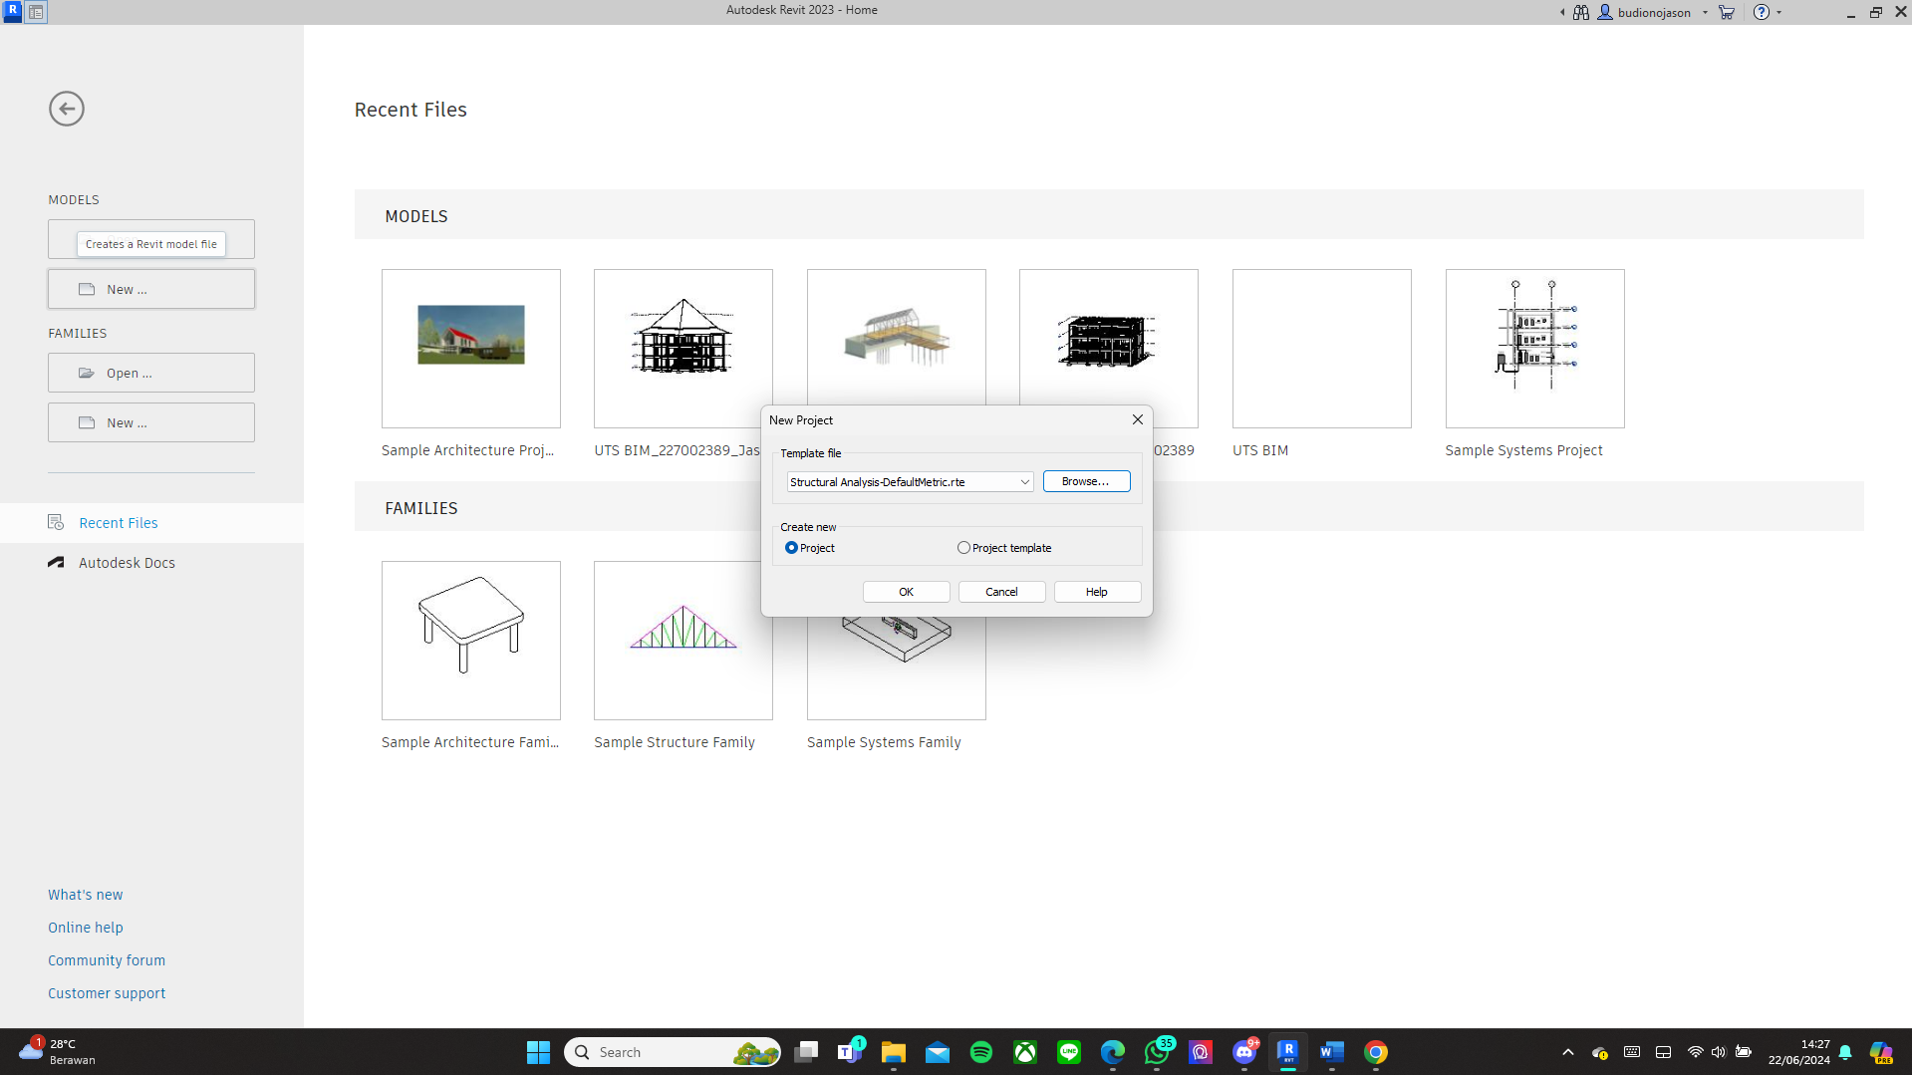
Fig 1. Revit Project Template

Autodesk Revit offers a variety of key functions that are crucial in the construction industry, making it an invaluable tool for professionals in the field. Here are some of the key features offered by Revit:
- Detailed 3D Modeling: Revit allows users to create three-dimensional (3D) models of construction projects with a very high level of accuracy and detail. These models include various building elements, such as the main structure, mechanical systems, electrical systems, and plumbing systems, allowing for a comprehensive and integrated visualization of all aspects of the project.
- Comprehensive Analysis and Simulation: Revit offers analysis and simulation features that allow users to evaluate the performance and reliability of the building model in depth. These features include structural, energy, and efficiency analysis, which helps ensure the design meets technical standards and functional requirements before construction begins.
- Accurate Technical Documentation: Revit provides various tools for producing complete and accurate technical documentation. This includes creating shop drawings, material schedules, and technical specifications required for construction. The documentation can be updated automatically as changes are made to the model, thus minimizing errors and ensuring consistency of information.
- Effective Collaboration: One of Revit’s strengths is its ability to support effective collaboration among project team members. The platform allows various professionals, such as architects, engineers, and contractors, to work on the same model simultaneously in real-time. This facilitates the rapid exchange of information and better alignment in project planning and execution.
- Integrated Project Management: Revit also has a project management feature that allows users to manage various aspects of a project efficiently. This includes managing project schedules, budgets, and resources, which helps plan and control each stage of the project more effectively.
Probabilistic seismic hazard analysis (PSHA) is a method of predicting the magnitude of future earthquakes using past earthquake data. To minimize deviations, PSHA considers seismic sources, frequency of occurrence, and data disaggregation. Based on the 2017 Earthquake Source and Hazard Map, there are user-friendly web-based applications: LINI Binamarga and Desain Spektra Indonesia. LINI Binamarga was developed by the Directorate General of Highways and was designed to obtain peak ground acceleration (PGA) values in bedrock with a probability of exceeding 7% in a period of 75 years or equivalent to 1000 years, specifically for bridges. The display of LINI running results for bridge planning in Batam City can be seen in Figure 2. Meanwhile, the Earthquake Study Center (PUSGEN) developed the Indonesian spectra design specifically for buildings and non-buildings using PGA values with a probability of exceeding 2% in 50 years or equivalent to a return period of 2500 years.

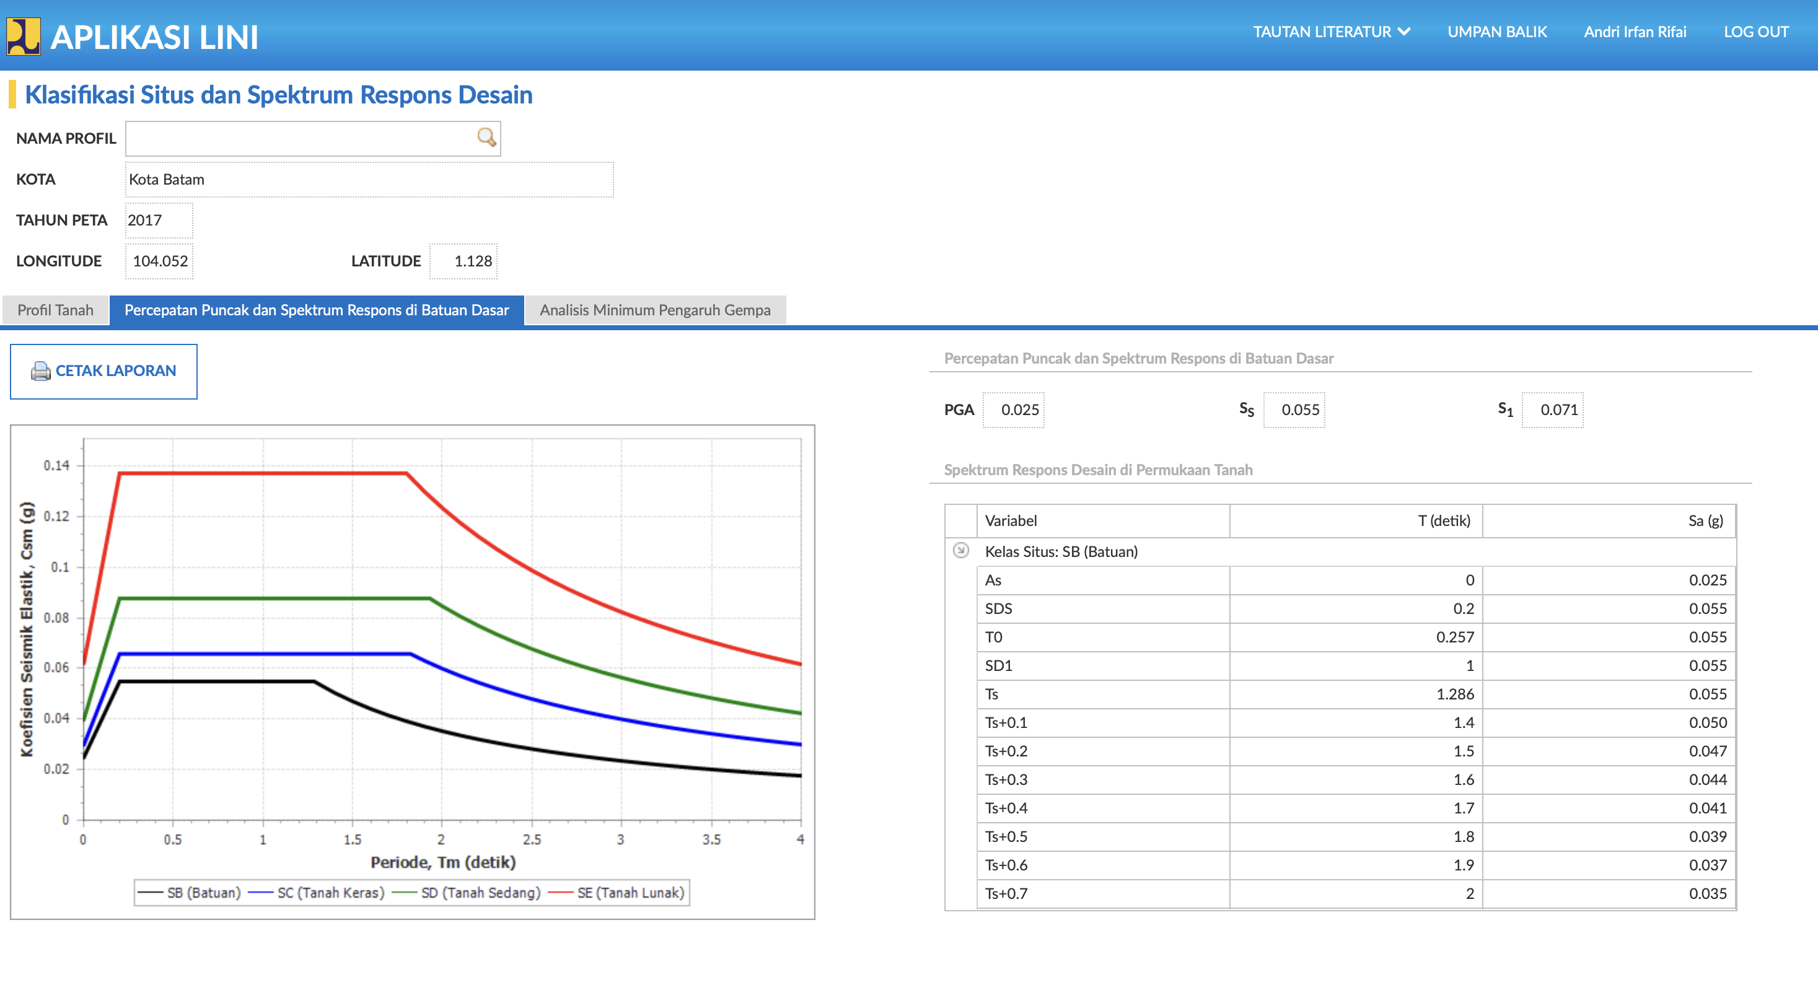
Fig 2. Dashboard of ‘LINI’ Applications

In this study, creating a typical bridge utilizes Autodesk Revit to model the structure and generate 3D images. Since Autodesk Revit software is designed for building construction, creating a 3D model of a typical bridge requires developing custom families for each planned element. For instance, a 3D model of a precast mini pile will reinforce the bridge abutment, beginning with creating a family in the metric generic model template file. For the abutment structure, a 3D model is developed using Autodesk Revit, starting with creating a family in the metric generic model template file, totaling two units based on the specified dimensions.
The bearing pad, made of natural rubber, is modeled in 3D through the family in the metric generic model template file, totaling four units, and will be placed between the girder beam and the abutment. The girder beam and bridge floor plate are created in a single family. This starts with establishing a reference line as a guideline and performing extrusion on the generate tab according to the planned dimensions. The handrail design incorporates 3-inch diameter galvanized pipe material, with retaining posts made of concrete. The sidewalk is designed with a thickness of 0.2 meters and a width of 0.4 meters. All are handled within the family on the metric generic model template file. Additionally, a void must be created on the create tab between the retaining pole and the galvanized pipe to minimize clash detection. For illustration, the results from Revit can be seen in Figure 3.

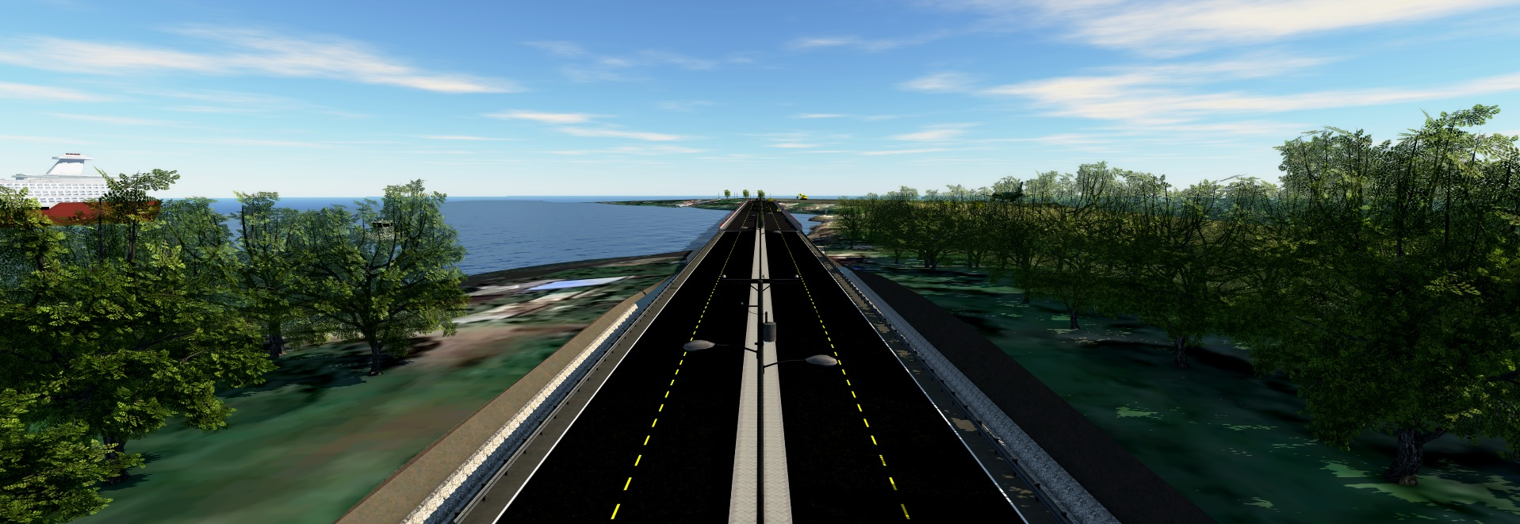
Fig 3. Visual design

4.3 Effectiveness of Using BIM Implementation

The bridge design specifications for this project encompass several critical elements to ensure structural integrity, safety, and functionality. When designing a bridge pier in Revit, you must consider and input various data points to model it accurately. When designing a bridge pier, it’s crucial to detail the requirements and criteria that will guide the entire design and construction process by compiling and utilizing this data. The author can effectively model and document the bridge pier in Revit, ensuring accuracy and compliance with project requirements and industry standards. Each aspect contributes to creating a comprehensive and reliable digital representation of the bridge pier within the author’s Revit project.
After the analysis, it turned out that there was a deviation in the work volume items. So, it is necessary to know what factors influence the deviation of the planning output by conducting interviews with BIM users. The following are the conclusions that can be drawn from the results of interviews with BIM users who have more than three years of experience in using BIM:
- BIM can speed up work, especially in planning, reduce errors, and calculate accurately. However, if the conventional method is used, many human errors will be experienced in design calculations.
- Human factors usually influence the deviation of BIM-based planning output from the Conventional Method. These factors include the person's knowledge of using BIM, understanding of reading references and work materials, and different assumptions related to the calculation concept model. In addition to human factors, errors can occur due to incorrect or other references, and conventional or manual methods cannot describe the actual process.
- Deviations in BIM calculations and the Conventional Method can occur in planning, although these deviations rarely occur significantly. Therefore, to anticipate these errors, it is necessary to conduct training, increase knowledge related to BIM and the planning process, and increase experience.
The Likert method calculation analysis concluded that some respondents still think making shop drawings using BIM is better and more manageable. However, some still use conventional methods because BIM is still a "new thing," so some people are not used to BIM, so there are still those who choose conventional methods, too. The existence of the BIM method has several other advantages during the shop drawing process, such as facilitating the stakeout process in the field because it makes it easier for the survey team to do their work, a higher level of efficiency and effectiveness when making drawings for bridge structure work and other work, producing accurate models. However, respondents often need help with several areas for improvement in the BIM method, namely frequent slowness.

5. Conclusion

The research findings substantiate that the integration of Building Information Modeling (BIM) in bridge planning significantly enhances both efficiency and effectiveness. The potential for inaccuracies in the planning phase can be substantially mitigated through the utilization of more comprehensive and structured data. However, insights derived from in-depth interviews indicate that errors remain an inherent possibility, predominantly attributable to human error.
Moreover, the progressive incorporation of sustainable design methodologies within the BIM framework underscores a paradigm shift toward minimizing environmental repercussions and fostering resource optimization across the entire lifecycle of the bridge. The primary determinants influencing the discrepancies between BIM-based planning outputs and those derived from conventional methodologies are predominantly human-centric. These encompass proficiency in BIM utilization, the ability to interpret technical references and project documentation, and divergences in conceptual assumptions pertaining to computational modeling. Beyond human-induced errors, deviations may also emerge from inaccuracies linked to erroneous or incompatible reference materials.

DISCLAIMER (ARTIFICIAL INTELLIGENCE)

Author(s) hereby declares that NO generative AI technologies such as Large Language Models (ChatGPT), COPILOT, etc.) and text-to-image generators have been used during the writing or editing of this manuscript.

COMPETING INTERESTS

Authors have declared that they have no known competing financial interests or non-financial interests or personal relationships that could have appeared to influence the work reported in this paper.

References

M. Yusuf, Hermawan and F., “Comparison Analysis of Existing Bridge Design Based on Bms 1992 and Sni 1725-2016,” International Journal on Livable Space, 2024.
S. Kaewunruen, J. Sresakoolchai and . Zhou, “Sustainability-Based Lifecycle Management for Bridge Infrastructure Using 6D BIM,” In Sustainability (Vol. 12, Issue 6), 2020.
Wirawan, “Laporan Praktek Magang Pada Usaha Pengasapan Jawa Timur,” pp. 55-64, 2015.
S. Saidi, V. Mani, H. Mefteh, M. Shahbaz and P. Akhtar, “Dynamic linkages between transport, logistics, foreign direct Investment, and economic growth: Empirical evidence from developing countries,” Transportation Research Part A: Policy and Practice, 141, pp. 277-293, 2020.
B. Ghosh and S. Karmakar, “The Conventional Construction Scenario and the Emergence of Advance Technologies in the Bridge Construction: Implementation, Impediments, and Case Study,” Journal of The Institution of Engineers (India): Series A, 104(3) , pp. 709-720, 2023.
Y. Liu, S. van Nederveen, C. Wu and M. Hertogh, “Sustainable Infrastructure Design Framework through Integration of Rating Systems and Building Information Modeling,” Advances in Civil Engineering, 2018.
E. Krygiel and . Nies, “Green BIM: successful sustainable design with building information modeling,” John Wiley & Sons, 2008.
M. Numan, E. U. Saadat and M. Farooq, “BIM and Sustainable Design: A Review of Strategies and Tools for Green Building Practices,” Journal of Engineering Research and Sciences, pp. 1-7, 2024.
S. Attia, P. Eleftheriou, F. Xeni, R. Morlot, C. Ménézo, V. Kostopoulos, M. Betsi, I. Kalaitzoglou, L. Pagliano, M. Cellura, M. Almeida, M. Ferreira, T. Baracu, V. Badescu, R. Crutescu and J. M. Hidalgo-Betanzos, “Overview and future challenges of nearly zero energy buildings (nZEB) design in Southern Europe,” Energy and Buildings, p. 439–458, 2017.
S. de Wit and . Augenbroe, “Analysis of uncertainty in building design evaluations and its implications,” Energy and Buildings, p. 951–958, 2002.
J. Carvalho, L. Bragança and . Mateus, “A Systematic Review of the Role of BIM in Building Sustainability Assessment Methods,” Applied Sciences, 10, 4444, 2020.
J. K. W. Wong and J. Zhou, “Enhancing environmental sustainability over building life cycles through green BIM: A review,” Automation in Construction, pp. 156-165, 2015.
M. Broquetas, D. Bryde and . Volm, “The project benefits of Building Information Modelling (BIM),” International Journal of Project Management, pp. 971-980, 2013.
S. Azhar, W. Carlton, D. Olsen and I. Ahmad, “Building information modeling for sustainable design and LEED (R) rating analysis,” Automation in Construction, p. 217–224, 2011.
B. Soust-Verdaguer, C. Llatas and . García-Martínez, “Critical review of bim-based LCA method to buildings,” Energy and Buildings, 2017.
A. Gardzińska, “Modeling of a Public Utility Facility from Total BIM Data,” Civil and Environmental Engineering Reports, pp. 135-144, 2023.
A. S. Borkowski and . To Duc, “Integration of BIM and GIS Data of a Heritage Building Using FME,” Civil and Environmental Engineering Reports, pp. 204-215, 2021.
R. G. Kreider and . Messner, “The uses of BIM: Classifying and selecting BIM uses. Computer integrated Construction Research Program,” 2013.
A. Salman, M. Khalfan and . Maqsood, “Building information modeling (BIM): Now and beyond,” Australasian Journal of Construction Economics and Building, 2012.
R. Sacks, C. Eastman, G. Lee and . Teicholz, “BIM Handbook: A Guide to Building Information Modeling for Owners, Designers, Engineers, Contractors, and Facility Managers”.
A. Salman, “Building Information Modeling (BIM): Trends, Benefits, Risks, and Challenges for the AEC Industry,” Leadership and Management in Engineering, pp. 241-252, 2011.
J. Pantiga and . Soekiman, “Kajian Implementasi Building Information Modeling (BIM) di Dunia Konstruksi Indonesia,” Rekayasa Sipil, pp. 104-110, 2021.
P. A. M. Basheer, J. Kirkpatrick, B. Rankin, A. Long and S. Taylor, “Sustainable bridge construction through innovative advances,” Proceedings of The Ice - Bridge Engineering, p. 183–188, 2008.
B. Franz and . Messner, “Evaluating the Impact of Building Information Modeling on Project Performance,” Journal of Computing in Civil Engineering, 2019.
Y. Zou and . Zhou, “A Model-Based BIM Framework for Bridge Engineering,” Applied Mechanics and Materials, p. 587–589, 2014.
M. Mohammadi, M. Rashidi, Y. Yu and . Samali, “Integration of TLS-derived Bridge Information Modeling (BrIM) with a Decision Support System (DSS) for digital twinning and asset management of bridge infrastructures,” Computers in Industry, 2023.
A. G. Mohamed, A. Khaled and . Abotaleb, “A Bridge Information Modeling (BrIM) Framework for Inspection and Maintenance Intervention in Reinforced Concrete Bridges,” In Buildings, 2023.
Q. Yidong, X. Rucheng, W. Yang and . Law, “A Bridge Information Modeling Framework for Model Interoperability,” Comput. Civ. Eng, pp. 447-454, 2019.
M. Brendan, A. Rebecca, C. Caroline and . Mehmet, “Bridge Information Modeling for Inspection and Evaluation,” Journal of Bridge Engineering, 21(4), 4015076, 2016.
S. M. &. Y. Arayici, “Digital Construction through BIM Systems will Drive the Re-engineering of Construction Business Practices.,” International Conference Visualisation, London, UK, pp. 29-34, 2008.
S. s. &. Davis, “Digital Construction Technology and Job-Site Equipment Demonstration: Modeling Relationship Strategies for Technologies Adoption.,” Buildings, 2019.
T. Abba, A. O. Afolabi and P. A. &. P. Olanrewaju, “Digital Technologies and Construction Planning,” International Conference on Engineering for Sustainable World, 2021.

