Research Article
Corrosion Prediction in Steel Bridge Structures Using Artificial Neural Networks in Archipelagic Environments

.
ABSTRACT

Corrosion in steel bridge structures remains a major concern that can endanger the reliability and safety as well as shorten the service life of infrastructure, especially in regions with extreme environmental conditions, such as archipelago. Corrosion also plays a main contribution to sustainability issues anymore with green construction practices, as it enhances the clear strain on resources or with energy, resulting in materials in the repairing and the maintenance structures, rendering there so generation event or in addition time struggle. This study aims to cast light on forecasting of Bridget corrosion based on incorporating sustainability in usage of ANNs. A dataset having ecological parameters was used to develop the ANN model. Other dataset entries comprised material properties and historical corrosion records. Data was obtained from the Riau Islands region to obtain a representation of dynamic environmental conditions. The proposed ANN model demonstrated strong predictive capability, achieving a coefficient of determination (R²) of 0.91 and a mean squared error (MSE) of 0.045. These results indicate the model’s robustness and reliability in forecasting corrosion progression in steel bridge structures exposed to harsh environmental conditions. Based on true ANN modeling results, the most considerable factor affecting the 10.6% corrosion rate was Chloride Ion Concentration. Also, there are 8.7% of Sulphur dioxide (SO₂), and 7.2% of Nitrogen oxide (NOₓ). Additionally, the study highlights the potential application of sustainable materials and maintenance practices derived from ANN predictions to mitigate environmental concerns and minimize long-term maintenance costs. ANN also supports a Life Cycle Assessment to assess the environmental impact of the different maintenance scenarios. This enables decisions to be made with a consideration of technical and environmental implications at once.

Keywords: [Bridge Construction, Corrosion, Archipelago, Maintainance, and Prediction

1. INTRODUCTION

Corrosion of bridge structures is one of the significant challenges in civil engineering, threatening structural integrity and significantly impacting sustainability and long-term maintenance costs. Predicting and reducing corrosion has become essential in the design and upkeep of sustainable infrastructure as the value of green construction techniques gains recognition [1]. Environmental factors like temperature, humidity, and chemical exposure can cause corrosion, an electrochemical process that weakens materials, reduces the lifespan of buildings, and increases the cost of replacement and repair. Therefore, developing an accurate and efficient method to predict the rate of bridge corrosion is essential.
Corrosion of bridge structures in island regions is a complex and multifaceted issue, mainly due to unique environmental conditions like high exposure to seawater, humidity, and extreme temperature fluctuations [2]. These elements increase corrosion, threatening the reliance and lifespan of the bridge structure. In islands, bridges are essential for integrating communities together, boosting local economies, and streamlining the distribution of goods. Therefore, to maintain infrastructure, save maintenance costs, and guarantee safety, it is crucial to comprehend and forecast the rate of corrosion of bridge structures in island environments.
Sustainable bridge construction in the Indonesian archipelago is starting to be widely implemented. Bridge construction with a longer design life and environmentally friendly design is necessary [3]. Studies have identified using local materials, eco-friendly design, and IoT-based monitoring systems as key to achieving sustainability. However, they have also revealed challenges such as budget constraints, lack of skilled manpower, and difficulty accessing advanced technology in remote areas.
ANN presents a viable method to forecast corrosion rates because of its capacity to recognize patterns in past data and make precise predictions. By utilizing data on environmental conditions, materials, and operational factors, ANN can provide more accurate and reliable predictions than traditional methods [4]. This helps plan more effective maintenance and aligns with green construction principles by reducing material and energy waste associated with unexpected repair situations.
Although ANN has proven effective in predicting various complex phenomena in civil engineering, including corrosion, significant research gaps remain regarding the use of ANN for predicting corrosion rates in bridges, particularly concerning sustainability and green construction [5]. First, without sufficiently addressing elements related to sustainable construction practices, most current studies concentrate on using ANN to predict corrosion under general conditions. Second, the integration of multidimensional data, such as environmental and material factors, sustainability indicators like carbon emissions, material life cycles, and social and economic effects of corrosion, is often disregarded in prior studies. The development of prediction models that correspond to the principles of green construction requires a comprehensive strategy. Third, the integration of ANN-based corrosion rate estimates into asset management systems for sustainable infrastructure has not received much attention. Preventive maintenance plans that increase bridge service life while reducing resource consumption and material waste, for instance, can be informed by these forecasts.
Additionally, many existing ANN models have not fully harnessed the potential of real-time data from sensors and the Internet of Things (IoT) to enhance prediction accuracy and responsiveness to changing environmental conditions [6]. Optimizing sustainable maintenance plans may require the integration of real-time data. Additionally, studies on using ANN to forecast bridge corrosion are frequently limited to locations with relatively stable environmental circumstances, which limits its relevance to areas with more dynamic ecological issues, like coastal or island regions, where corrosion is a more serious issue.
This study is especially significant for the scientific community because it fills the knowledge gap between sustainable infrastructure management in coastal and archipelagic zones and predictive modeling. Through the identification of nitrogen oxides (NOₓ), Sulphur dioxide (SO₂), and chloride ion concentration as the primary environmental elements impacting corrosion, the study offers practical insights that might improve steel bridge durability assessments and maintenance plans. Additionally, combining sustainability considerations with Artificial Neural Networks (ANN) advances resource-efficient and environmentally friendly construction methods, which benefit engineers and policymakers in the long run.
The findings of this study are expected to significantly contribute to extending the service life of bridges, reducing maintenance costs, and promoting more environmentally friendly construction methods. This study also opens doors for applying AI technology in sustainable infrastructure management, aligning with the global goal of minimizing the environmental impact of the construction sector.

2. LITERATURE REVIEW
Bridge construction in island regions faces unique challenges due to extreme geographic and environmental conditions, such as exposure to seawater, high humidity, and significant temperature fluctuations. These challenges affect bridge structures' durability and demand a sustainable and green construction approach. The following is a literature review of several reputable journals that discuss the sustainability and green construction aspects of bridge construction on islands.
Corrosion Science highlights that corrosion is a significant problem for bridge structures in coastal and inland areas. Exposure to salty seawater accelerates corrosion, resulting in decreased material strength and reduced structure service life [7]. This study emphasizes the importance of using corrosion-resistant materials and protective coatings to reduce environmental impacts and long-term maintenance costs. However, this study has not fully integrated green construction principles into selecting materials and construction methods.
Using environmentally friendly materials such as geopolymer concrete and corrosion-resistant steel (stainless steel) in bridge construction. Geopolymer concrete, made from industrial waste such as fly ash, not only reduces carbon emissions but also shows better resistance to corrosion than conventional concrete [8]. The study highlights the material's potential for application in island regions, where resilience to harsh environments is critical. However, the study also identifies challenges regarding material availability and higher production costs.
Bridge construction can also be done using a sustainability-based approach. The study emphasizes the importance of data-based preventive maintenance, including using sensors and the Internet of Things (IoT) to monitor bridge conditions in real-time [9] [10] [11]. This approach not only extends the service life of the bridge but also reduces the material and energy waste associated with major repairs. However, this research has not explicitly addressed its application in island areas, where access and logistics are often constraints.
Integrating advanced technologies such as Building Information Modelling (BIM) and Artificial Intelligence (AI) in sustainable bridge construction [12] [13] [14]. BIM enables more efficient project planning and management, while AI can predict structural failures and optimize maintenance schedules. The study shows that technology can support green construction by reducing material waste and increasing energy efficiency [15]. However, its application in island areas is still limited due to the lack of supporting infrastructure.
Recent developments in research on sustainable bridge construction discuss the importance of considering socio-economic and environmental impacts in bridge construction projects [16]. In the island region, bridges function as transportation infrastructure and social and economic links for local communities. Therefore, bridge construction must consider sustainability aspects such as reducing carbon emissions, using local resources, and empowering communities [17]. These studies continue to emphasize the need for a holistic approach that combines technical, environmental and social aspects.
In recent years, artificial intelligence, especially artificial neural networks (ANN), has shown significant potential for modelling complex phenomena across various fields, including civil engineering. A few studies, including [18], [19], [20] use the LCA with ANN approach to examine a bridge's lifetime. ANN and LCA integration have shown significant potential for increasing the effectiveness and precision of environmental impact assessments. ANN-based LCA approaches can be improved and made more dependable and broadly applicable in the domains of sustainability and environmental management by addressing the gaps in the development of accessible AI techniques for ANN-based LCA models.
Along with the development of AI, the use of ANN to predict corrosion rates in steel structures in marine environments is starting to develop [21]. The study collected data from various coastal and island locations, including salinity, temperature, humidity, and sea breeze exposure. The results showed that ANN could accurately predict corrosion rates under varying environmental conditions [22] [23]. This study also emphasizes the importance of data quality and quantity in training an effective ANN model.
Develop an ANN model that integrates environmental data (such as salinity, pH, and temperature) with material properties (chemical composition and coating thickness) to predict bridge corrosion in an island region [24]. The results showed that this model can predict corrosion rates with a relative error of less than 10%. This study also highlights the potential of ANN to be used in continuous preventive maintenance planning—integration of ANN in continuous bridge maintenance management systems. By accurately predicting corrosion rates, ANN can help optimize maintenance schedules, reduce costs, and extend the service life of bridges [25]. This study emphasizes that this approach is particularly relevant for island areas, where access and maintenance logistics are often challenging.
Data collection and selection involves review of extensive literature on bridge construction in island regions with a combined traditional and innovative perspective incorporating all aspects in achieving sustainability and green building. While some potential green materials, advanced technologies, and sustainable maintenance strategies have been identified in previous studies, they have yet to be applied in practice for island region buildings. There is a need for more research into the challenges with corrosion, resource constraints, and access to the right technology, but also using AI, and more specifically ANN, can help with these challenges. The approach the authors follow is to combine green construction with advanced technologies thus making it more sustainable, cost-effective and eco-friendly to construct the bridges on the islands.
3. METHOD
Predicting the corrosion rate of bridges is critical in infrastructure maintenance and public safety. This study uses an experimental and computational approach using Artificial Neural Networks (ANN). The following is the methodology used in this study.
  - Data Collection
Historical data on bridge corrosion rates from various locations were collected to build a comprehensive dataset. The input layer consists of 16 nodes corresponding to the collected variables:
- Humidity (X₁)
- Temperature (X₂)
- Salt Spray Exposure (X₃)
- Rainfall (X₄)
- Sulphur dioxide (SO₂) (X₅)
- Nitrogen oxide (NOₓ) (X₆)
- Metal Type (X₇)
- Protective Coating (X₈)
- Material Chemical Composition (X₉)
- Exposed Area (X₁₀)
- Water Retention (X₁₁)
- Joints and Gaps (X₁₂)
- Load and Stress (X₁₃)
- Erosion and Abrasion (X₁₄)
- Environmental pH (X₁₅)
- Chloride Ion Concentration (X₁₆)
Two hidden layers were incorporated into the model. Ten neurons make up the first hidden layer, and eight neurons make up the second. To deal with non-linear interactions between variables, the Rectified Linear Unit (ReLU) was used as an activation function. The output layer consists of a single output neuron that represents the anticipated rate of corrosion. Given that the prediction output is continuous, a linear activation function was employed.
The model was trained using the backpropagation algorithm with adaptive learning rate optimization and mean squared error (MSE) as the loss function.

  - Data Preprocessing
After the data is collected, the next step is to preprocess to ensure the data is ready to be used in training the ANN model. The preprocessing steps include Data cleaning, which removes missing or incomplete data; Data normalization, which changes the scale of the data to be consistent, thus facilitating the model training process; and Data encoding, which changes categorical data into a numeric format that the ANN model can process.
  - Data Division
The processed data is then divided into two sets. First Training Set: 70% of the data is used to train the ANN model. Second Test Set: 30% of the data is used to evaluate the model performance after training is complete.
  - ANN Model Development
The ANN model is built and configured to predict corrosion rate based on the data that has been collected and processed. The stages of model development include model architecture, which determines the number of layers and the number of neurons in each ANN layer and selects the appropriate activation function for each layer in the ANN. Training the model using the training set with a proper learning algorithm, such as backpropagation; Finally, evaluating the model performance using the test set, and adjusting if necessary.
  - Model Performance Evaluation
Relevant metrics such as Mean Squared Error (MSE), Mean Absolute Error (MAE), and coefficient of determination (R²) are utilized to evaluate the performance of the ANN model. Evaluate a model showing how accurate it is on predicting the corrosion rate on a bridge.
  - Life Cycle Cost Analysis
Choose from a variety of approach options to identify maintenance alternatives, including long-term maintenance schedule, ecologically friendly materials, and preventative versus corrective maintenance. The expenses associated with building a bridge and installing it initially are included in the original capital costs. Routine maintenance, inspection, and repair charges are included in maintenance and operating costs. The estimated expenses for significant repairs or the replacement of key components are referred to as replacement and rehabilitation costs. The bridge's recycling or demolition at the end of its useful life is covered by demolition and end-of-life charges. Applying present value and a suitable discount rate to all costs is the process of reducing.

4. results and discussion
Predicting bridge corrosion rates in island regions presents a complex challenge that requires advanced strategies to account for the variability of environmental and material conditions. This study employs ANN as the primary predictive tool due to its capacity to model nonlinear and intricate relationships among factors influencing corrosion. The following text provides a detailed discussion of the results and implications of utilizing ANN to forecast corrosion rates on bridges in island environments.
  - A Concept of Corroded Analysis with ANN
An Artificial Neural Network (ANN) is a synthetic representation of the neural network system of the human brain that continuously aims to replicate the brain's learning process. The term "synthetic" is used because the implemented neural network employs a computer program capable of executing several calculations during the learning phase. The effectiveness of ANN simulation and modelling heavily relies on the choice of variables. The chosen variables must significantly influence the target. The target output of this study is the rating factor. The details of the predicted output variables are as follows:
- Operating rating factor shear strength,
- Operating rating factor flexural strength,
- Inventory rating factor shear strength, and
- Inventory rating factor flexural strength.

The rating factor is a function of the capacity and internal forces due to loading. Therefore, input variables were selected to significantly impact changes in capacity and load values. In addition, the input variables used must be defined and measurable in the field. This is because the results of this study can be applied in the field. In this study, the input variables selected based on several references are a) Bridge span, b) Corrosion penetration depth, c) Concrete slab compressive strength, and d) Steel girder yield stress. These input variables were selected because they significantly impacted the rating factor value changes. The rating factor is a function of capacity and internal forces due to loading. These four variables greatly influence capacity and internal forces. Corrosion penetration depth, concrete slab compressive strength, and steel girder yield stress will affect the bridge capacity.
The load and the resulting internal forces will be greatly impacted by the bridge span. Three instantly usable datasets are created through a dataset construction procedure for learning, testing, and validation. There are two categories in the database. All previous road performance data is included in the first batch, except for the validation network. The road network data used for validation is the only data in the second dataset. To create the learning and test datasets, each dataset used for testing and learning is split into two subsets.
One subset contains 80% of the data for learning and 20% for testing. It includes data irrelevant to the datasets used for learning and testing, in accordance with the idea of separate datasets for validation. As a result, evaluating the corrosion model's performance using a different dataset acts as a control. The process of learning is carried out across 10,000 epochs. An ANN model with the ideal weight distribution between neurons is created through an iterative method.
After the learning stage is complete, the model development step is continued to the test stage to check the effectiveness of the learning process. The dataset used in the test stage is the input for corrosion data. The algorithm used in this stage uses a learning algorithm recorded during the learning process. The test process can calculate the level of error that occurs. If the error rate of the test stage is still within an acceptable level, then the data science model is considered reasonable. A comparison of the level of model accuracy is carried out by comparing the average MSE value during the test stage. Finally, the model with the lowest MSE error rate and the highest R² is selected. Finally, after the learning and test processes are complete. Furthermore, the model is verified and validated using the data prepared with the productivity prediction model of the learning and test results. Different dataset details are selected for model validation.
The corrosion prediction model can predict the next cycle time value of the bridge function deterioration. It is based on historical corrosion, natural environment conditions and performance records a long time ago. The way this prediction model works is general: historical data and identification of patterns. Mechanical Equipment Productivity Data Pattern: You query the historical data and tabulate the data in a database and prepare for a specific time interval.

  - Architecture ANN
In this study, the ANN architecture was designed 16-17, an artificial neural network model specifically designed to capture the complexity and variation in corrosion data. This model consists of several layers of interconnected neurons, processing information through synapses with specific weights.
The input layer consists of 16 neurons, each representing one attribute or feature from the dataset. These features can include environmental variables such as humidity, temperature, chloride concentration, and pH, as well as material characteristics such as steel type and others (X₁ to X₁₆). This data is needed to provide sufficient context for the model to make accurate predictions. Next, it has 17 hidden layers, where the number of neurons in each layer can vary depending on the data's complexity and the prediction's purpose. Typically, the first hidden layer may have 32 neurons, while the second hidden layer may have 16 neurons. To obtain the optimal configuration, the number of hidden layers and neurons is determined through trial, error, and cross-validation.
The output layer consists of a single neuron that generates a prediction of corrosion rate based on the given input. This outputs value results from an activation function applied to the weights and biases set in the training process. Common activation functions used in ANN architectures 16-17 are the ReLU (Rectified Linear Unit) function for the hidden layer and the sigmoid or linear function for the output layer. The ReLU function helps the model to capture non-linearities in the data. In contrast, the sigmoid or linear function generates the final estimate that can be interpreted as corrosion rate. The ANN training process 16-17 involves several essential steps, including data normalization, weight initialization, and optimization. The training data is split into subsets to train and test the model to avoid overfitting. Optimization algorithms such as Gradient Descent or Adam minimize the loss function and adjust the synapse weights. An illustration of the ANN architecture can be seen in Figure 1.
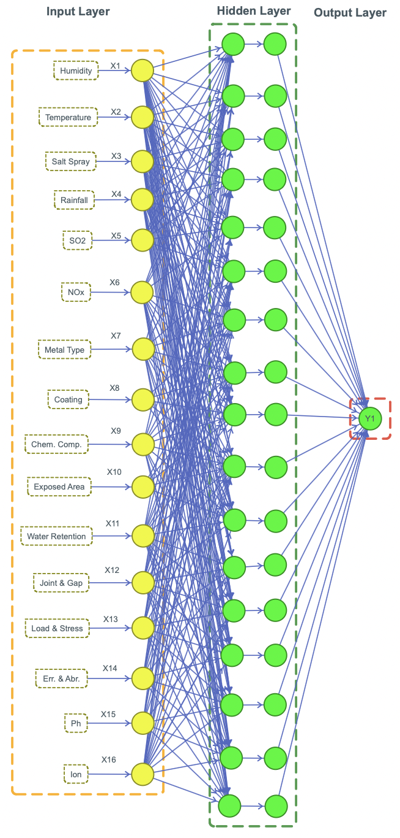
Figure 1 Architectural of ANN Model
The functioning of each neuron changes according to the layer it is in. There are three main types of layers which are discussed as follows: Input layer, hidden layer, and the output layer. The input layer accepts and processes raw data from outside the model through the input layer, which is passed on to the hidden layer. This layer's neurons will exhibit similar performance given that the data that are fed to them are of high quality and are representative of the task at hand. Most of the processing in an ANN takes place in the neurons of the hidden layer. They also implement weights, biases, and activation functions to convert and map out the input into a more abstract representation. The hidden layer neurons are used to learn features from the data, and their performance is critical. Gradient Descent or Adam are examples of optimization algorithms that can be used to update the synapse weights during the minimization of the loss function. This repeats iteratively until ‘convergence'' is reached, or other stopping criteria are satisfied. So, by tracking the loss function while training, the performance of each neuron can be monitored. Cross-validation is applied to evaluate the model and prevent overfitting. The training data is being split into multiple smaller subsets, and the model is trained and tested on Halves of these subsets in turn. During validation it is possible to measure how the neurons perform by using accuracy, precision, recall and other metrics.
  - Development of ANN Model
Developing the ANN architecture model means determining an optimal artificial neural network topology able to solve a specific problem. The ANN architecture contains defining how many layers there are, how many neurons in each layer, the activation functions to use, regularization, optimization techniques, etc. Developing an ANN model involves an iterative process and some of the steps need to be repeated to achieve the best performing model. Data preparation is an important element because data quality and representativeness will have a positive or negative impact on the performance of the ANN model developed.
Performance evaluation of ANN models is usually done at the overall output level. However, in some cases, it is important to evaluate performance at the individual neuron level to understand the contribution of each neuron to the final prediction. Here are the steps in applying R² to each neuron in an ANN. To calculate R² for each neuron, we first need to track the output of each neuron during the training and testing process. This output is then used to calculate the residual and total sum of squares. R², or the coefficient of determination, is a metric used to evaluate how well a statistical or predictive model explains the variation in the response data. This metric ranges from 0 to 1, with values closer to 1 indicating that the model explains most of the variability in the data.
The R² value for each neuron provides insight into which neurons contribute most to the model’s performance and which neurons may be less functional. Neurons with high R² values significantly contribute to the model’s predictions. The overall R² for the model reached 0.91. The R² values for each neuron and each stage can be seen in Figure 2.
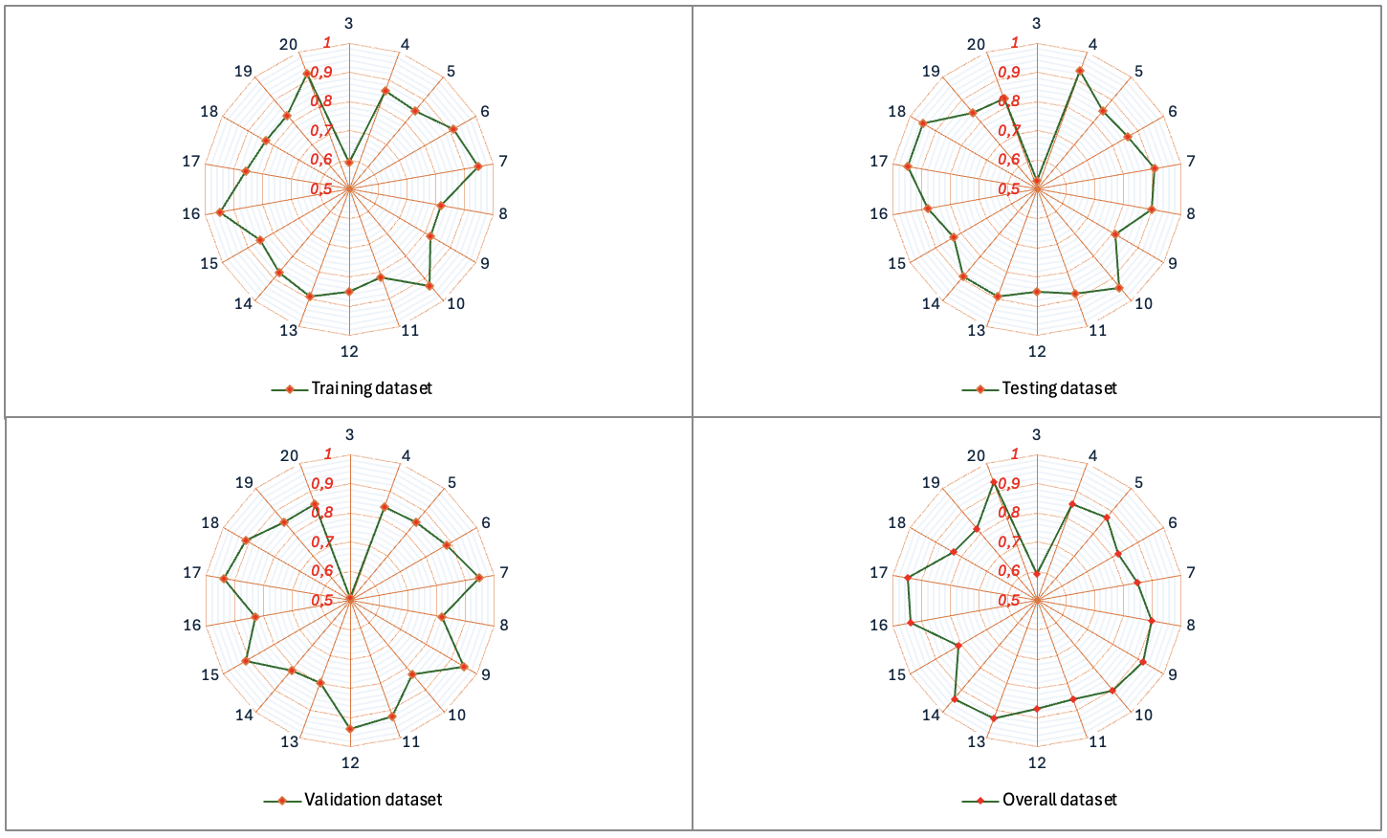
Figure 2 Value of R for each neuron
MSE is critical to ANN. For good performance of ANN model to predict the data, MSE value will become smaller. Most of the time, the mean-squared error (MSE) is used as the loss function while ANN is being trained. It helps in computing how far the model predictions are away from actual values. During the training, the ANN strives to minimize MSE for better predictive accuracy. If the MSE value reduces from one cycle to another one, then we can say that the ANN model is being learnt and that the ANN model is improving its performance. Through the comparison of various ANN architectures or configurations, MSE provides a mechanism for selecting the optimal model. Additionally, the MSE values can be obtained and can be employed to identify whether an ANN model is overfitting or not by mutual MSE opposing to train and test data.

MSE is one of the most used evaluation metrics in machine learning, including in ANN. MSE measures the average squared difference (error) between the predicted and actual values (ground truth). MSE is a loss function in ANN that measures how well the model predicts the desired output. During training, ANN tries to minimize the MSE value by adjusting the weights and bias through optimization algorithms such as Gradient Descent. MSE is an important metric in ANN training, especially for regression tasks. Despite drawbacks, such as sensitivity to outliers, MSE remains popular due to its simplicity and ability to provide a clear picture of model performance. The overall MSE value in this study was 0.045. Meanwhile, the details of the MSE for each neutron can be seen in Figure 3.
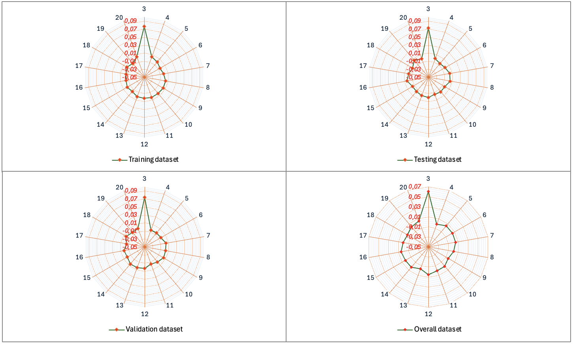
Figure 3 Values of MSE for each neuron
  - Relative Importance
Relative Importance (RI) in ANN measures the relative contribution of each input variable to the model output. In bridge corrosion, RI helps identify dominant factors that accelerate structural degradation. In addition, RI plays a critical role in understanding ANN performance by quantifying the relative contribution of input variables to model output. So, the function of RI can be said to open the "black box" of ANN by identifying dominant variables that affect predictions. In this study, the RI for each variable is shown in Figure 4.
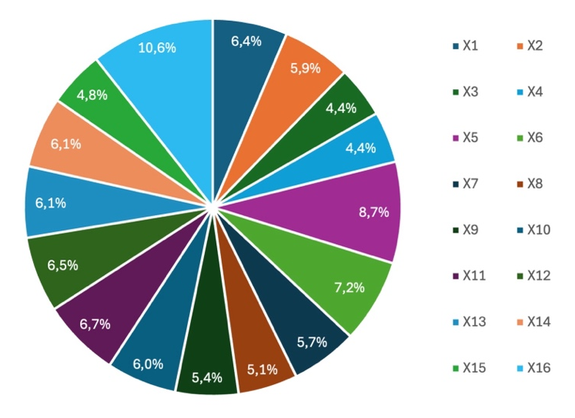
Figure 4 Influencing parameters
Looking at figure 4 as a visualization of the RI value, the Chloride Ion Concentration (X₁₆) variable is the most influential factor on the corrosion rate of 10.6%. Furthermore, the Sulphur dioxide (SO₂) (X₅) variable is 8.7% and Nitrogen oxide (NOₓ) (X₆) is 7.2%. Chemical conditions greatly influence the corrosion rate in the environment. At the same time, other variables have almost the same level of influence, ranging from 4-6%.
  - Life Cycle Assessment
Life Cycle Assessment (LCA) is necessary for assessing how building bridges will affect the environment over its life. The findings of several case studies on applying LCA in bridge engineering are covered in this study. Notably, it generates findings [26], [27], and [28] offers insights into the advantages, difficulties, and practical consequences of integrating LCA into bridge construction. There is potential for improving sustainability when the Life Cycle Assessment is incorporated into bridge construction procedures. The case studies researched demonstrate both the advantages and difficulties of life cycle assessment. Although there are obstacles to broad implementation, LCA has significant potential to support bridge design more ecologically concerned.
LCA in the context of bridge maintenance due to corrosion focuses on identifying life cycle stages, environmental impacts, and mitigation strategies. The analysis results show that using corrosion-resistant materials, effective coating techniques, and proactive maintenance strategies can significantly reduce environmental impacts and extend the life of bridges. LCA evaluates the environmental effects of various bridge maintenance strategies, from material production to demolition.
LCA considers the environmental impacts of alternative maintenance strategies to improve the applied maintenance strategy. Enables designers to assess more designs at early stage of project. LCA includes life cycle inventory (LCI), which gives tabulated values of materials and equipment involved in the construction and maintenance of the bridge. With LCA, designers can assess multiple designs at an early stage and select options with reduced environmental impacts. LCA also enables the analysis of multiple impact categories including GWP, ADP, and smog formation. Such information can aid in making more sustainable maintenance decisions environmentally and efficiently throughout the bridge's life cycle. Furthermore, an LCA may also complement the analysis of a Life Cycle Cost (LCC) to account for both economic and environmental perspectives on bridge maintenance. This enables infrastructure managers to maximize maintenance plans through considerations of costs and environmental effects of different alternatives.
The relationship that can be drawn between the use of ANN and LCA is that maintenance patterns can be done more precisely. Predictive data analysis: By utilizing artificial intelligence (AI) and machine learning (ML), the data collected can be analyzed to predict potential problems on the bridge. Using the LCA approach allows for proactive maintenance actions before significant damage occurs.
The data collected can be used to optimize the allocation of maintenance resources, ensuring that repairs are carried out at the right time and most efficiently. Integrating IoT technology, databases and machine learning into bridge maintenance management with the LCA method, infrastructure managers can improve operational efficiency, reduce costs, and extend the overall life of the bridge structure.
The integration of ANN and LCA empowers bridge infrastructure decision-makers to develop more sustainable bridge maintenance practices by considering technical factors as well as long-term sustainability. Using historical data that considers the failure of specific bridge components. ANN can predict the condition and damage of bridge components. The ANN predictions can be further converted into LCA input for sustainability assessment of these different maintenance alternatives. By using LCA, one can identify low-impact strategies for bridge maintenance across its life cycle.
4. Conclusion
Based on the research results, it can be concluded that the corrosion rate prediction in bridge construction in the archipelago can be done using the ANN approach. The literature review results obtained 16 main variables that affect the corrosion rate. The results of the ANN modeling show that chloride ion concentration (X₁₆) is the most influential factor in the corrosion rate of 10.6%. Furthermore, the Sulphur dioxide (SO₂) (X₅) variable is 8.7% and Nitrogen oxide (NOₓ) (X₆) is 7.2%. The correlation level of the ANN model indicated by R2 reaches 0.91. While the error value using MSE is 0.045. Based on the research of literature, it was found that ANN supports LCA in evaluating the environmental impact of each maintenance scenario. This integration allows decision making that considers technical and environmental aspects simultaneously.

COMPETING INTERESTS DISCLAIMER:
Authors have declared that they have no known competing financial interests OR non-financial interests OR personal relationships that could have appeared to influence the work reported in this paper.

DISCLAIMER (ARTIFICIAL INTELLIGENCE)
The authors hereby state that no generative AI tools, such as text-to-image generators or large language models (e.g., ChatGPT, Copilot), were utilized in the ideation, writing, or editing of this work.

REFERENCES
Al-Ali, A. R., Beheiry, S., Alnabulsi, A., Obaid, S., Mansoor, N., Odeh, N., & Mostafa, A. (2024). An IoT-based road bridge health monitoring and warning system. Sensors, 24(2), 469.
Alves, R., Lousada, S., Naranjo Gómez, J. M., & Cabezas, J. (2024). Maintenance challenges in maritime environments and the impact on urban mobility: Machico Stayed Bridge. Infrastructures, 9(10), 180.
Bender, R., Féron, D., Mills, D., Ritter, S., Bäßler, R., Bettge, D., & Zheludkevich, M. (2022). Corrosion challenges towards a sustainable society. Materials and corrosion, 73(11), 1730-1751.
Bianchi, S. &. (2022). Life-cycle assessment of deteriorating RC bridges using artificial neural networks. Journal of Infrastructure Systems, 28(2), 04022005.
Bianchi, S. M. (.2021). Life-cycle performance assessment of existing bridges based on artificial neural networks. Life-Cycle Sustainability and Innovations, 1081-1088.
Ek, K., Mathern, A., Rempling, R., Brinkhoff, P., Karlsson, M., & Norin, M. (2020). Life cycle sustainability performance assessment method for comparison of civil engineering works design concepts: case study of a bridge. International Journal of Environmental Research and Public Health, 17(21), 7909.
Haq, M. A., Ahmed, A., Khan, I., Gyani, J., Mohamed, A., Attia, E. A., & Pandi, D. (2022). Analysis of environmental factors using AI and ML methods. Scientific Reports, 12(1), 13267.
He, Z., Li, W., Salehi, H., Zhang, H., Zhou, H., & Jiao, P. (2022). Integrated structural health monitoring in bridge engineering. Automation in construction, 136, 104168.
Jalaei, F., Zhang, J., Mcneil-Ayuk, N., & McLeod, C. (2024). Environmental life cycle assessment (LCA) for design of climate-resilient bridges–a comprehensive review and a case study. International Journal of Construction Management, 1-16.
Jeon, D., Jung, J., Park, J., Min, J., Oh, J. E., Moon, J., & Yoon, S. (2022). Predicting airborne chloride deposition in marine bridge structures using an artificial neural network model. Construction and Building Materials, 337, 127623.
Kim, H., Moon, B., Hu, X., Lee, H., Ryu, G. S., Koh, K. T., & Keierleber, B. (2021). Construction and performance monitoring of innovative ultra-high-performance concrete bridge. Infrastructures, 6(9), 121.
Li, S., Zhang, Z., Lin, D., Zhang, T., & Han, L. (2023). Development of a BIM-based bridge maintenance system (BMS) for managing defect data. Scientific reports, 13(1), 846.
Li, X., Xiao, Y., Guo, H., & Zhang, J. (2022). A BIM based approach for structural health monitoring of bridges. KSCE Journal of Civil Engineering, 26(1), 155-165.
Luo, T., Xue, X., Tan, Y., Wang, Y., & Zhang, Y. (2021). Exploring a body of knowledge for promoting the sustainable transition to prefabricated construction. Engineering, Construction and Architectural Management, 28(9), 2637-2666.
Melchers, R. E. (2021). Experience-based physico-chemical models for long-term reinforcement corrosion. Corrosion and Materials Degradation, 2(1), 100-119.
O'Born, R. (2018). Life cycle assessment of large scale timber bridges: A case study from the world’s longest timber bridge design in Norway. Transportation research part D: transport and environment, 59, 301-312.
Panchenko, Y. M., Marshakov, A. I., Kudryavtseva, L. A., Kovtanyuk, V. V., & Nenasheva, T. A. (2024). A chloride deposition model for predicting the categories of atmospheric corrosivity in coastal areas. Corrosion Engineering, Science and Technology, 1478422X241298181.
Peng, Z., Li, J., & Hao, H. (2023). Development and experimental verification of an IoT sensing system for drive-by bridge health monitoring. Engineering Structures, 293, 116705.
Pierott, R. M., Garcia, S., Kropf, D., Figueiredo, K., da Costa, B. B., Amario, M., & Haddad, A. (2024 ). Predictive analysis of corrosion dynamics in prestressed concrete exposed to chloride environments. Infrastructures, 9(8), 133.
Pribadi, K. S., Abduh, M., Wirahadikusumah, R. D., Hanifa, N. R., Irsyam, M., Kusumaningrum, P., & Puri, E. (2021 ). Learning from past earthquake disasters: The need for knowledge management system to enhance infrastructure resilience in Indonesia. International Journal of Disaster Risk Reduction, 64, 102424.
Scianna, A., Gaglio, G. F., & La Guardia, M. (2022). Structure monitoring with BIM and IoT: The case study of a bridge beam model. ISPRS International Journal of Geo-Information, 11(3), 173.
Trach, R., Moshynskyi, V., Chernyshev, D., Borysyuk, O., Trach, Y., Striletskyi, P., & Tyvoniuk, V. (2022). Modeling the quantitative assessment of the condition of bridge components made of reinforced concrete using ANN. Sustainability, 14(23), 15779.
Tran, N. L., Nguyen, D. D., & Nguyen, T. H. (2022). Prediction of speed limit of cars moving on corroded steel girder bridges using artificial neural networks. Sādhanā, 47(3), 114.
Wani, A. K., Rahayu, F., Ben Amor, I., Quadir, M., Murianingrum, M., Parnidi, P., & Latifah, E. (2024 ). Environmental resilience through artificial intelligence: innovations in monitoring and management. Environmental Science and Pollution Research, 31(12), 18379-18395.
Willar, D., Waney, E. V., Pangemanan, D. D., & Mait, R. E. (2021 ). Sustainable construction practices in the execution of infrastructure projects: The extent of implementation. Smart and Sustainable Built Environment, 10(1), 106-124.
Winn, E. K. (2013). Development and validation of deterioration models for concrete bridge decks-phase 1: artificial intelligence models and bridge management system (No. RC-1587a). Dept. of Transportation.
Zhang, M., Sun, S., Liu, K., Li, T., & Yang, H. (2023 ). Research on the critical chloride content of reinforcement corrosion in marine concrete—a review. Journal of Building Engineering, 107838.
Zhang, P., Gao, Z., Wang, J., Guo, J., Hu, S., & Ling, Y. (2020). Properties of fresh and hardened fly ash/slag based geopolymer concrete: A review. Journal of Cleaner Production, 270, 122389.

