Original Research Article
Flanged Components for Design and Optimisation of Stamping Dies

.
ABSTRACT

This paper presents a comprehensive study on the stamping die design for a flange part. The development history and current status of stamping die technology at home and abroad are first reviewed, highlighting intelligence and automation as the key future directions. The research aims to provide theoretical guidance and practical references for die development of similar parts, while laying a foundation for promoting the intelligent upgrading of stamping dies. According to the structural features and technological requirements of the flange, 15 steel with 3 mm thickness, IT14 precision, and medium-to-large batch production are determined. Three alternative process plans—single-operation dies, compound dies, and progressive dies—are compared. Flange parts are typical non-flanged cylindrical deep-drawn components that are extensively employed in automotive pipelines, hydraulic elements, and household appliances. The optimal solution, a compound die for blanking, drawing and reverse drawing plus a separate piercing die, is selected. Critical parameters such as blank size, strip layout, material utilisation, punching forces, and die-cutting clearances are calculated, and a suitable press is chosen. Subsequently, the structural designs of the die components—die block, punches, compound punch–die, stripper plate, backup plates, and die set—are detailed, and standard elements are selected. Assembly drawings of the compound die and the piercing die are finally produced. The results show that the developed dies are compact, user-friendly, highly productive, and fully meet the accuracy requirements, offering strong engineering applicability. The two resulting die assembly drawings show compact structures with reliable positioning and safe operation, meeting the requirements of medium-to-large batch production at IT14 accuracy. Through this project, the authors not only consolidated their theoretical knowledge of stamping dies and proficiency in CAD/CAE tools, but also enhanced their ability to analyse and solve problems independently, laying a solid foundation for future work in die and related mechanical design.

Keywords: stamping die; flange; compound die; process calculation; structural design

1. INTRODUCTION

Sheet metal forming is the most important process used in the automotive industry. It is a manufacturing process where sheet metal is stretched, drawn, or bent under force to give it the desired shape. Formability is the ability of a sheet metal to deform without failure. Brass plays a key role in the forming process due to its properties like low melting point, resistance to corrosion, workability and formability and shows a wide application in hot working conditions (Bandhavi et al., 2022; Pereira et al., 2024). Sheet metal forming, as a highly efficient and precise metal-forming technology in modern manufacturing, is widely used in the automotive, home-appliance, electronics, and aerospace industries [1]. Among all factors, the design level of stamping dies directly determines product quality, production efficiency, and manufacturing cost, and it has become a key link in enhancing the core competitiveness of enterprises [2]. However, traditional die design has long relied on empirical knowledge, resulting in cumbersome calculations, long development cycles, and low automation, which can hardly meet the market demands of “high precision, short lead time, and low cost” [3]. With the rapid development of computer technology, artificial intelligence, and high-performance materials, stamping dies are moving toward integration, intelligence, and networking, yet relevant theoretical research and engineering applications are still in their infancy [4].
Flange parts are typical non-flanged cylindrical deep-drawn components that are extensively employed in automotive pipelines, hydraulic elements, and household appliances [5]. Flanges, with large cylindrical structure and the fitting relationship of hole and shaft, are commonly used slewing parts of aero-engines (Sun et al., 2021). Although their structure is relatively simple, the forming process involves multiple operations—blanking, drawing, reverse drawing, and piercing—which makes die structures complicated and imposes stringent requirements on process-parameter matching [6]. How to achieve efficient and stable mass production while guaranteeing IT14 accuracy has become a technical challenge in current engineering practice [7].
Therefore, this paper takes the flange part as the research object and systematically carries out the design and investigation of the stamping die[8]. First, the development history of stamping-die technology is reviewed, and the latest achievements and gaps in standardisation, informatisation, and intelligence at home and abroad are summarised [9]. Subsequently, according to the material properties, structural features, and batch requirements of the part, an optimised process scheme of “blanking–drawing–reverse-drawing compound die + piercing single-operation die” is proposed [10]. Furthermore, theoretical calculation and verification of key process parameters—blank size, layout optimisation, forming forces, and cutting-edge dimensions—are completed, and a J11-100 press is selected [11]. Finally, the overall die structure and detailed designs of critical components are performed, and complete assembly drawings are produced [12]. The research results aim to provide theoretical guidance and practical references for die development of similar parts, while laying a foundation for promoting the intelligent upgrading of stamping dies [13].
2. Design Scheme of the Die

2.1 Workpiece Specifications

The component designed in this project is a flange—a non-flanged, axis-symmetric deep-drawn part. It has a drawing diameter of φ96 mm, a drawing height of 11 mm, and corner radii of R3 mm; the sheet thickness is 3 mm, the material is 15 steel, the required precision is IT14, and the production volume is medium-to-large batch. Based on its geometric characteristics, it can be preliminarily determined that the part is well-suited to be formed by a deep-drawing die. Photographic and 2-D drawings of the part are shown in Figures 1 and 2, respectively. During die-structure design, both the specified accuracy and the demands of batch production must be taken into account.
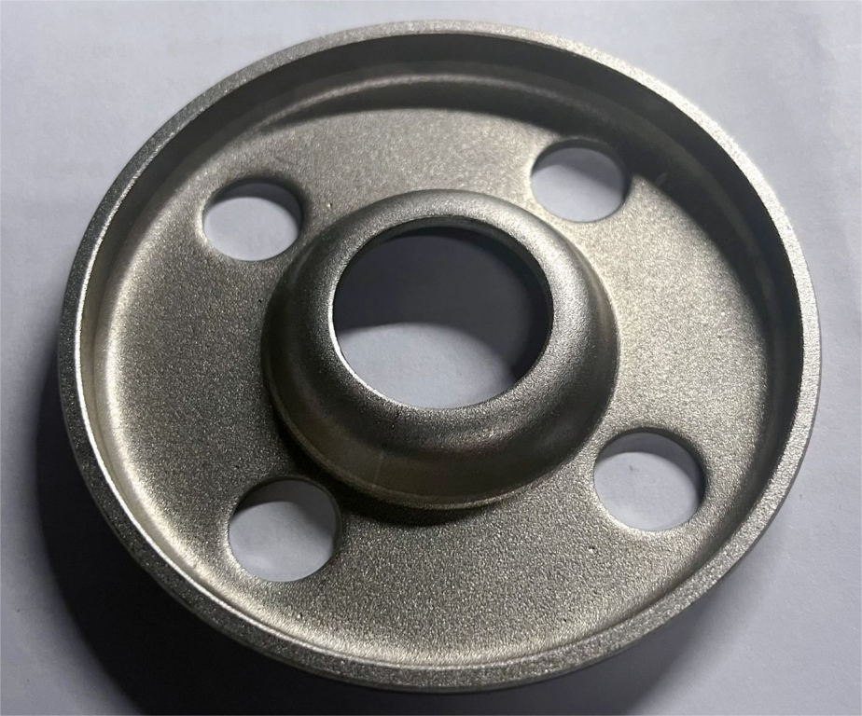
Fig. 1 Photograph of the Flange Part
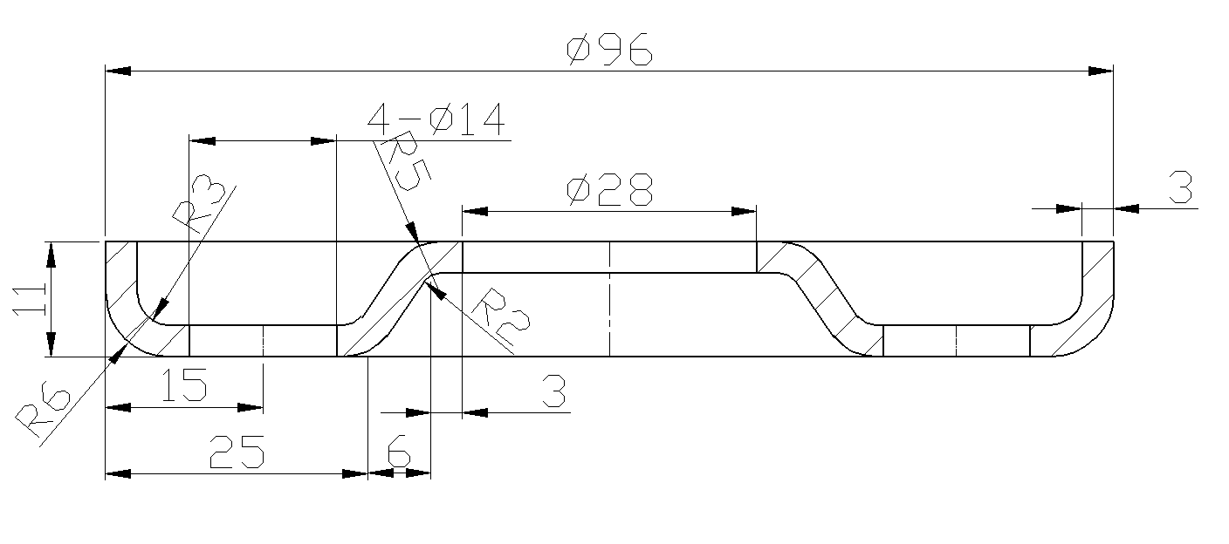
Fig. 2 Two-Dimensional Drawing of the Flange Part
2.2 Material Property Analysis

In this design, 15 steel is selected for the workpiece. This commonly used high-quality carbon structural steel offers moderate hardness and excellent formability, readily meeting the requirements of stamping-die design for blanking, piercing, and deep-drawing operations. It is widely employed in housing, electrical appliances, and general-purpose parts. Its mechanical properties are as follows: shear strength 270–380 MPa, tensile strength 340–480 MPa, and elongation 26 %.

2.3 Selection and Determination of the Process Plan

The flange requires four successive operations—blanking, drawing, reverse drawing, and piercing—which can be realized by three alternative die schemes: (1) four separate single-operation dies; (2) one compound die for blanking–drawing–reverse drawing plus one single-operation piercing die; and (3) one progressive die performing drawing–reverse drawing–piercing–blanking in sequence. Scheme 1 offers the lowest productivity and accuracy because of multiple setups and accumulated positioning errors. Scheme 3 provides the highest throughput, yet its progressive-step positioning is still less precise than that of a compound die. Scheme 2 strikes the best balance: it delivers moderate productivity with the highest accuracy, and its reduced number of tools results in the lowest manufacturing and maintenance costs. Consequently, scheme 2—a blanking–drawing–reverse-drawing compound die combined with a separate piercing die—is adopted for this design.

2.4 Preliminary Selection of Die Structure

Feeding and positioning: the blanking–drawing–reverse-drawing compound die employs manual strip feeding in the front-to-back direction, with the strip guided by pilot pins and positioned by stop pins; the piercing die uses the inner profile of the pre-drawn blank for direct positioning, eliminating the need for additional feeding mechanisms. For stripping: owing to the thin sheet thickness, the compound die adopts an elastic stripper, whereas the piercing die has no stripper because no strip is fed [14].
3. Process Dimension Calculations

3.1 Blank Size Calculation

The blank size formula for a non-flanged deep-drawn part is given as:
$D=\sqrt{4V/3.14T}$ （3.1）
where V is the volume of the drawn part and T is the sheet thickness.
$$D=\sqrt{28417.25×\frac{\frac{4}{3.14}}{3}}$$

$$D=109.8{mm}_{←}$$
3.1.1 Trimming Allowance

Due to metal flow and material anisotropy, the edge of a drawn blank becomes uneven. Consequently, a trimming operation is typically required after drawing. Therefore, the trimming allowance must be incorporated into the blank size calculation. Select the allowance from the table according to the relative height and the drawing height of the part:
$$h/d=11/93=0.12←$$
The edging allowance △h = 1.2mm is obtained from Table 1.
Table 1: Maximum relative height h/d of non-flanged cylindrical deep-drawn parts
Workpiece height | Relative height of the workpiece h/d
Workpiece height | ＞0.5～0.8 | ＞0.8～1.6 | ＞1.6～2.5 | ＞2.5～4.0
≤10 | 1.0 | 1.2 | 1.5 | 2.0
＞10～20 | 1.2 | 1.6 | 2.0 | 2.5
＞20～50 | 2 | 2.5 | 3.3 | 4.0
＞50～100 | 3 | 3.8 | 5.0 | 6.0
＞100～150 | 4 | 5.0 | 6.5 | 8.0
＞150～200 | 5 | 6.2 | 8.0 | 10.0
＞200～150 | 6 | 7.5 | 9.0 | 11.0
＞250 | 7 | 8.5 | 10.0 | 12.0

By using a machining allowance of 1.2mm, the blank size D = 109.8 + 1.2 + 1.2 = 112.2mm, and the finished size is 113mm.

3.2 Calculation of mould dimensions for blanking and deep drawing process

3.2.1 Patterning and Edge Alignment

The blank shape of this part is circular; hence, the layout method for this part is determined to be straight layout. When determining the overlap value, considering the part's shape is circular and manual feeding is used, it can be obtained from Table 2 in conjunction with the workpiece's size and thickness. The overlap values are: workpiece overlap a = 1.8mm, side overlap a1 = 2.2mm.

Table 2 Side Values
Material thickness | Round parts with a radius greater than 2t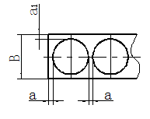 |  | The side length L of the rectangular piece is less than or equal to 50mm.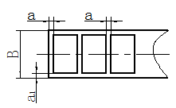 |  | The edge length L of the rectangular part is greater than 50mm or the corner radius r is less than or equal to 2t.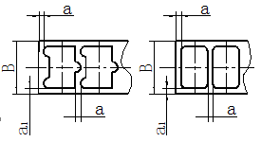
Material thickness | a | a1 | a | a1 | a | a1
≤0.25  0.25～0.5  0.5～0.8  0.8～1.2  1.2～1.6  1.6～2.0  2.0～2.5  2.5～3.0  3.0～3.5  3.5～4.0  4.0～5.0  5.0～12 | 1.8  1.2  1.0  0.8  1.0  1.2  1.5  1.8  2.2  2.5  3.0  0.6t | 2.0  1.5  1.2  1.0  1.2  1.5  1.8  2.2  2.5  2.8  3.5  0.7t | 2.2  1.8  1.5  1.2  1.5  1.8  2.0  2.2  2.5  2.5  3.5  0.7t | 2.5  2.0  1.8  1.5  1.8  2.5  2.2  2.5  2.8  3.2  4.0  0.8t | 2.8  2.2  1.8  1.5  1.8  2.0  2.2  2.5  2.8  3.2  4.0  0.8t | 3.0  2.5  2.0  1.8  2.0  2.2  2.5  2.8  3.2  3.5  4.5  0.9t

Based on the characteristics of the workpiece shape, while considering whether to improve the utilisation of the strips and whether it is compatible with the die cutting scheme, this design will directly adopt a single row format to complete the layout diagram. The layout diagram is shown in Figure 3 has been drawn.
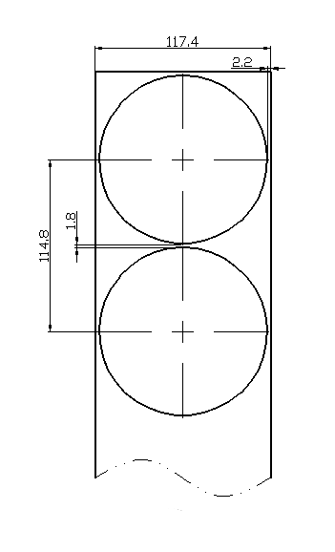
Figure.3 Layout Plan

3.2.2 Calculation of Material Utilization Rate

Improving material utilisation not only helps to reduce production costs, but also promotes environmental protection and reduces resource waste. Therefore, efforts should be made to improve material utilisation during the production process of stamping moulds.
The width of the strip is:
$B={\left(\begin{aligned}D+2a_{1}\end{aligned}\right)}_{-δ}$ (3.2)
Among them, B is the material width (mm), D is the maximum side length transverse to the material width direction (mm), a₁ is the side overlap value (mm), and δ is the allowable tolerance for the strip after shearing (mm).
The feed step is:
$H=C+a$ (3.3)
Among them, H is the feeding step distance (mm), C is the maximum edge length perpendicular to the material width direction (mm), and a is the overlap value between adjacent workpieces (mm).
Therefore, the material width and pitch of the mould are:
$$B=(D+2a_{1})_{-δ}$$
$$B=(\begin{aligned}113+2×2.2\end{aligned})_{-0.5}mm$$
$$B={117.4}_{-0.5}mm$$
$$H=C+a$$
$$H=113+1.8mm$$
$$\text{H = 114.8mm}$$
The material utilisation rate for a single step distance is:
$η_{1}=S/(B+H)×100\%$ (3.4) In the formula above, $η_{1}$ represents the material utilisation rate for a single step, and S is the area of the workpiece for a single step (including the punched area).
The area of the workpiece for a single feeding step can be directly measured using CAD software. By merging all the outlines and inner hole segments, the area S of a single feeding step can be directly measured using the CAD 'li' command:
$$S=10028.75{mm}^{2}$$
From this, the material utilisation rate is:
$$η_{1}=S/(B+H)×100\%$$
$$=10028.75/(117.4×114.8)×100\%$$
$$=74.41$$

3.3 Calculation of Cutting Force

Punching pressure is an important factor in the design and production of stamping moulds, significantly affecting the quality, efficiency, and cost of stamping. Punching pressure must be carefully considered and scientifically managed to ensure high quality and efficiency in stamping production [15].

3.3.1 Landing Force
$F_{\hat{Aa}}=KL_{1}tτ_{b}$ (3.5)
In the above formula, $F_{l}$ fall is the falling material force (kN); K is the coefficient, taken as 1.3; L₁ is the total perimeter of the falling material's outer contour (mm); T is the thickness of the sheet material (mm); $τ_{b }$is the shear strength of the material (MPa).
$$F_{l}=KL_{1}tτ_{b}=1.3×355×3×325=449.96KN$$

3.3.2 Unloading Force
$F_{\text{x}}=K_{\text{x}}×F_{\text{l}}$ (3.6)
In the above formula, $F_{\text{x}}$ is the unloading force (kN), and $K_{\text{x}}$ is the unloading force coefficient, which is obtained from Table 2 is 0.035.
$$F_{\text{x}}=K_{\text{x}}×F_{\text{l}}=0.035×449.96=15.75KN$$

3.3.3 Pulling Force

This design will directly use the formula to calculate the drawing force.
$F_{\hat{A-}}=πd_{1}tσ_{b}K_{1}$ (3.7)
$\begin{aligned}&=3.14×130mm×3mm×410×0.5 \\ &=251.04KN\end{aligned}$
In the formula: $σ_{b}$is the material's tensile strength, taken as 410 MPa; d₁ is the circumference of the deep drawing part (mm); K₁ is the coefficient, which is taken as 0.5 in this design; the values of $σ_{b}$ and K₁ are both referenced from the 'Stamping Manual'.
The deepened edge pressure is:
$F_{\text{y}1}=\frac{π}{4}(D^{2}-d^{2})p$ (3.8)
$=9.16KN$
In the formula, the unit edge pressing force p is taken as 2.5 MPa, and the top piece force is selected as 10% of the drawing force.
$F_{\text{d}}=0.1F_{\text{l}}=0.1×251.04=25.1KN$ (3.9)

3.4 Punching Die Cutting Force

3.4.1 Punching Force

$F_{\text{c}}=KL_{1}tτ_{b}$ (3.10)
In the above equation, Fc is the punching force (kN), K is the coefficient taken as 1.3, L₁ is the total perimeter of the punching shape (mm), t is the thickness of the sheet material (mm), and $τ_{b}$ is the shear strength of the material (MPa).
$$F_{\text{l}}=KL_{1}tτ_{b}=1.3×263.88×3×325=334.47KN$$

3.4.2 Unloading Force
$F_{\text{x}}=K_{\text{x}}×F_{\text{c}}$ (3.11)
In the above formula, $F_{\text{x}}$ represents the unloading force (kN); $K_{\text{x}}$ is the unloading force coefficient, taken as 0.035 from Table 2.
$$F_{\text{x}}=K_{\text{x}}×F_{\text{l}}=0.035×334.47=12.06KN$$
Table 3. Coefficients of Various Parts
thick material t/mm |  | K_{x} | K_{t} | K_{d}
Steel | ≤0.1  ＞0.1～0.5  ＞0.5～2.5  ＞2.5～6.5  ＞6.5 | 0.065～0.075  0.045～0.055  0.04～0.05  0.03～0.04  0.02～0.03 | 0.1  0.063  0.055  0.045  0.025 | 0.14  0.08  0.06  0.05  0.03
Aluminium, aluminium alloys  Pure copper, brass |  | 0.025～0.08  0.02～0.06 | 0.03～0.07  0.03～0.09

3.5 Selection of Press Machines

3.5.1 Nominal Force Check

The minimum engineering force required for the blanking and deep drawing composite die:
F = 1.3 × 751.01 = 976.31 KN ≤ 1000 KN.
The minimum engineering force required for the punching die:
F = 1.3 × 346.53 = 450.49 KN ≤ 1000 KN.
The nominal force of the press meets the verification requirements.

3.5.2 Closure Height Check

The formula for checking the die height of the press is:
$H_{max}-5⩾H_{m}⩾H_{min}+10$ (3.12)
Blanking deep drawing and reverse drawing composite die: 415≥250<345. Punching die: 415≥220<345. Therefore, the height of the mould is relatively low, and spacers need to be placed on the lower mould to increase the mould height.

3.5.3 Handle Hole Size Verification

The diameter of the mould handle is φ40x60, and the diameter and depth of the press slider handle hole are φ60x80. Therefore, only adding a handle sleeve is needed to meet the verification requirements.

3.5.4 Selection of the Press

Choosing a pressing machine is an important decision in the stamping production process. Selecting the right machine can improve production efficiency and ensure production quality. After comparing various parameters, the J11-100 model press was chosen.

3.6 Shearing Process Calculation

3.6.1 Cutting Gap

Generally, the cutting gap is set according to the properties of the stamping material and the processing technology. For soft materials, a larger cutting gap is typically required; for hard materials, a smaller cutting gap is usually needed. In actual operations, the settings must also consider factors such as stamping pressure and stamping speed. Using Table 4 in conjunction with the material and thickness of the part, the maximum and minimum cutting gaps between the punch and die for this design mould frame can be directly found to be: = 0.246mm, = 0.36mm.
Table 4: Initial Double-Sided Gap Value of the Shearing Die
Material thickness / | 08、10、20、35  09M2、30415steel-A |  | Q345 |  | 40、50 |  | 65
0.7 | 0.064 | 0.092 | 0.064 | 0.092 | 0.064 | 0.092 | 0.064 | 0.092
0.8 | 0.072 | 0.104 | 0.072 | 0.104 | 0.072 | 0.104 | 0.064 | 0.092
0.9 | 0.090 | 0.126 | 0.090 | 0.126 | 0.090 | 0.126 | 0.090 | 0.126
1.0 | 0.10 | 0.14 | 0.100 | 0.140 | 0.100 | 0.140 | 0.090 | 0.126
1.2 | 0.126 | 0.180 | 0.132 | 0.180 | 0.132 | 0.180
1.5 | 0.132 | 0.240 | 0.170 | 0.240 | 0.170 | 0.240
2.0 | 0.246 | 0.360 | 0.260 | 0.380 | 0.260 | 0.380

4 Die Structure Design and Selection

4.1 Design of the Concave Mould

4.1.1 Concave mould form

The structure of the die can be divided into three types based on its integrity: integral, embedded, and patchwork. The most commonly used types are the integral and embedded structures. In cases where the die's external dimensions are relatively small and the cutting edges are not too complex, integral dies are preferable as they are not only easier to process but also more convenient for maintenance later on. Therefore, this design will adopt the integral structure for all the moulds.

4.1.2 Concave Mould Materials

Since the concave die is an important component in the moulding process, the selection of concave die materials and heat treatment is crucial. The material for the concave die must not only have sufficient strength but also excellent machinability. It needs to be able to handle various complex cutting edges during processing. Common materials for forming parts include Cr12, T10A, SKD11, etc. In this design, considering that the processing of the cutting edge is not complicated and the overall size is not large, Cr12 material can be used to complete the processing of the concave die. After heat treatment, the hardness is 60-64 HRC. Additionally, the surface roughness of the concave die should reach Ra1.6, and the cutting edge should reach Ra0.8 or above. To meet production volume and mould life requirements, the parallelism and perpendicularity of the assembly surfaces and hole cavity surfaces must be controlled within 0.02mm.

4.1.3 Die Fixing Method

The fixing methods for mould components can be roughly divided into several categories, such as bosses, screws, resin, and rivets. Since the cavity mould is designed as an integral type, the best form of the cavity mould is screw fixation, which is accomplished through uniform screws in conjunction with pins to complete the assembly and fixation connection between the cavity mould and the upper or lower mould.

4.1.4 Concave mould size

The size of the cavity mould is calculated based on the maximum external dimensions of the workpiece.
$H=Kb$ (4.1)
In the formula, H is the height of the die, and to ensure the strength of the mould, it should be no less than 15 mm; K is the coefficient; B is the maximum outline length of the workpiece (mm).
The wall thickness of the cavity is:
$$C=(1.5∼2)H$$
After calculation:
$$\text{H=0.2x113=22.6mm}$$
Considering the processing convenience of the mould and the height of mould forming, the height of the cavity mould is appropriately increased to 25mm.
$$C=(1.5∼2)25=37.5∼50mm$$
Therefore, the size of the concave mould is:
$$L=B=2c+b=188mm∼223mm$$
Standard mould frame model with a value of 200mm. In summary, the drawing of the die part is shown in Figs 4. And 5.
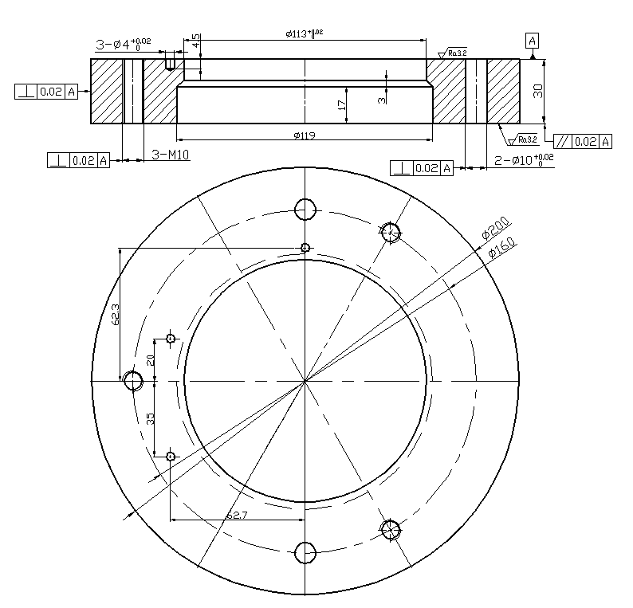
Fig. 4. Structure diagram of the blanking, deep drawing, and reverse drawing die
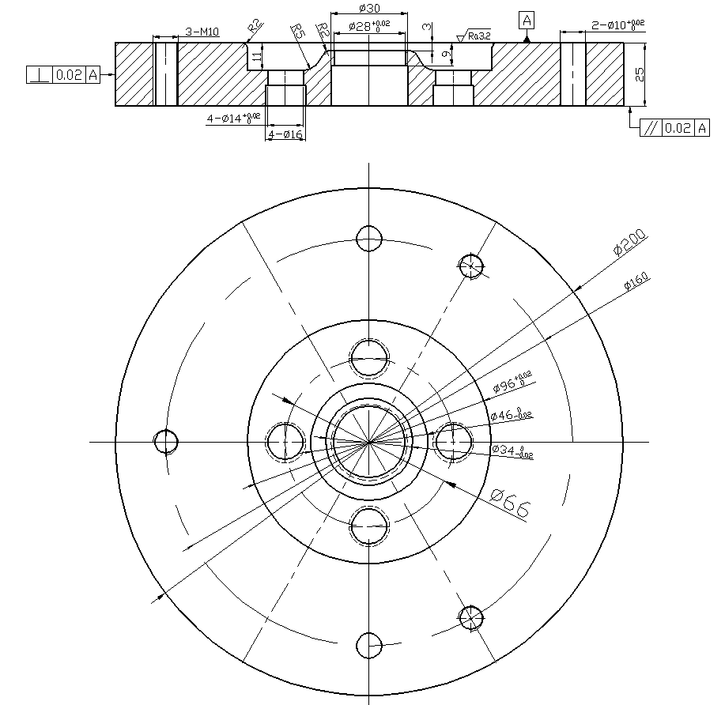
Fig. 5 Structure diagram of the punching die

4.2 Design of the Punch

4.2.1 Type of Punch
The structure of the punch has many varieties. Considering the dimensions of the punch parts in this design, a through-type structure was adopted from the perspective of ease of processing, ensuring structural strength while reducing processing difficulty.

4.2.2 Method of Fixing the Punch

The punch fixing method employs a boss structure. During the assembly process, the punch is placed within the fixing plate, and the rod portion of the punch is connected to the fixing plate using an H7/m6 transition fit. To consider the difficulty of assembly, disassembly, and maintenance, and to reduce wear on the punch, a clearance gap is set between the punch and the fixing plate. After the punch is assembled to the fixing plate, the excess part of the punch can be ground down to ensure flatness in assembly.

4.2.3 Material of the Punch

The material of the punch is the same as that of the die, using Cr12 material, which, after treatment, has a hardness of 58-62 HRC. This ensures that during the riveting production process, the cutting edge has sufficient strength for shearing, preventing edge chipping.

4.2.4 Calculation of Convex Mould Dimensions

Due to the use of a composite mould and an elastic unloading mechanism in this design, the length of the punch is:
$L=h_{1}+h_{2}$ (4.2)
Blanking and deep drawing composite mould: L=90mm； Punching mould: L=78mm.
The structure of the convex mould is shown in Figures 6 and 7.
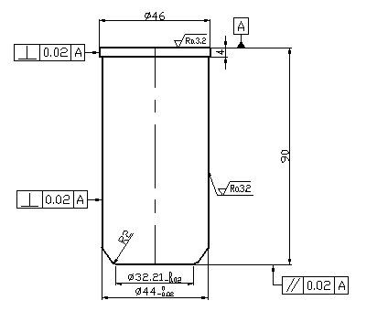
Fig. 6 Structure diagram of reverse deep-drawing convex mould
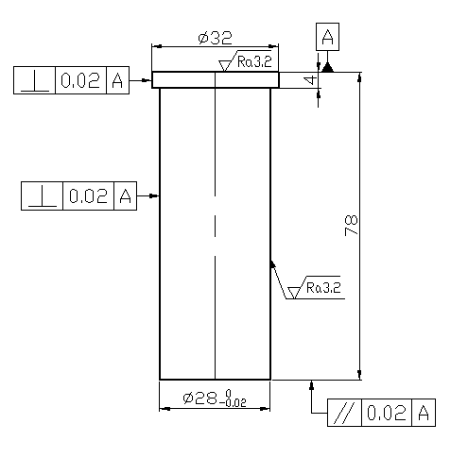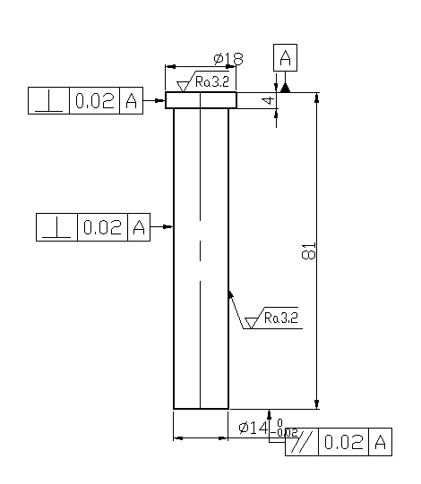
Fig. 7 Diagram of the punch die structure

4.3 Design of the Male and Female Moulds

Due to the small dimensions of the male and female moulds, the fixing method of the moulds is also chosen to be in the form of a boss. During the assembly process of the male and female moulds, a separate fixing plate is set up for the moulds, with an H7/m6 transition fit between the two. In terms of materials, Cr12 is chosen for the male and female moulds.
$L=h_{1}+h_{2}+h_{3}+h_{4}$ (4.3)
In the above equation, h1 is the thickness of the concave-convex mould fixing plate, h2 is the height of the spring, h3 is the thickness of the unloading plate, and h4 is the height required for moulding.
Blanking drawing depth of the mould height: L=79mm
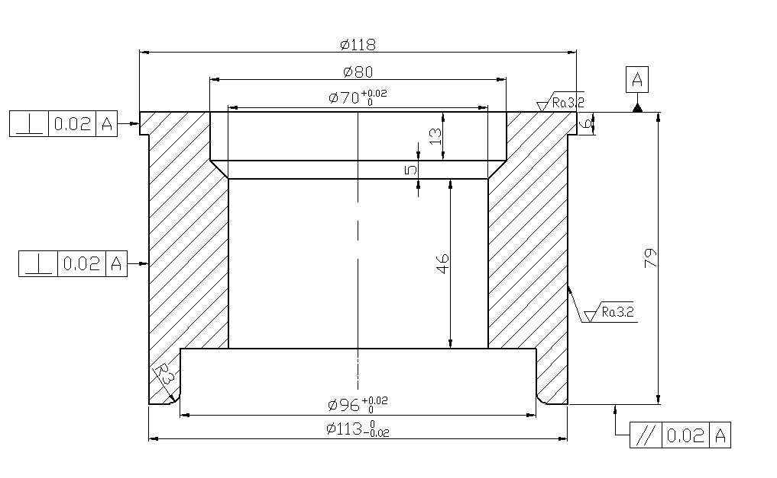
Fig. 8 Structure Diagram of the Concave-Convex Mould

4.4 Design of the Discharge Plate

From the preliminary design content of the unloading mechanism, it can be seen that the compound die for blanking, deep drawing, and reverse drawing in this design adopts an elastic unloading mechanism composed of an elastic unloading plate, springs, and unloading screws. The unloading plate does not directly participate in forming; instead, it compresses the material during the mould closing process and removes the strip during the mould opening process. Therefore, the hardness and processing requirements of the material are not high. Hence, the material selected for the unloading plate is 45 steel. The internal cavity of the unloading plate is in the form of a through hole, which has a male-female die passing through it. To ensure both the movement of the male-female die and the guiding function of the unloading plate, no clearance gap is set during the processing of the unloading plate’s internal through-hole structure. Instead, the male-female die and the unloading plate are controlled to slide fit at H7/h6. The outer dimensions of the unloading plate are the same as those of the die, which is 200x200 mm, with a height of 15 mm. Its dimensions and structure are shown in Figs.. 9 and 10.
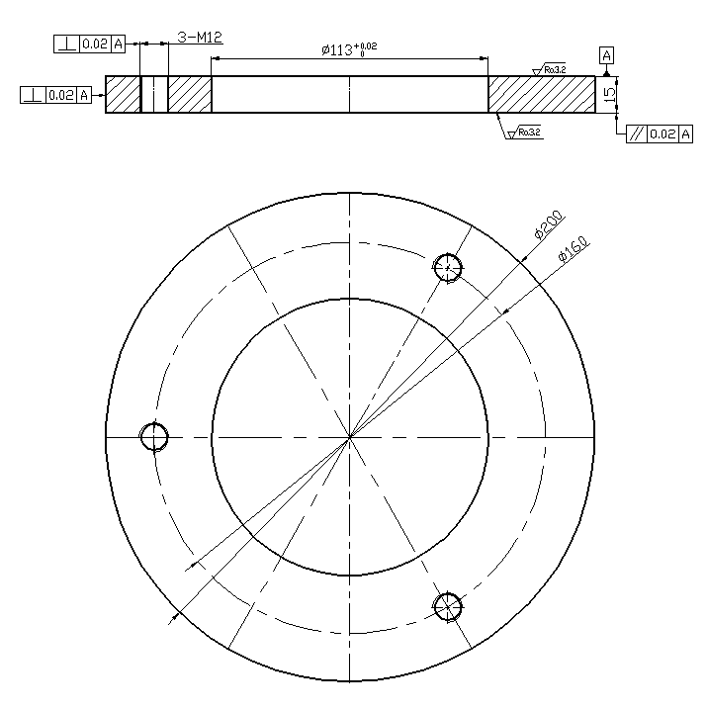
Fig 9 Structure diagram of the unloading plate for the compound die with blanking, deep drawing, and reverse deep drawing.
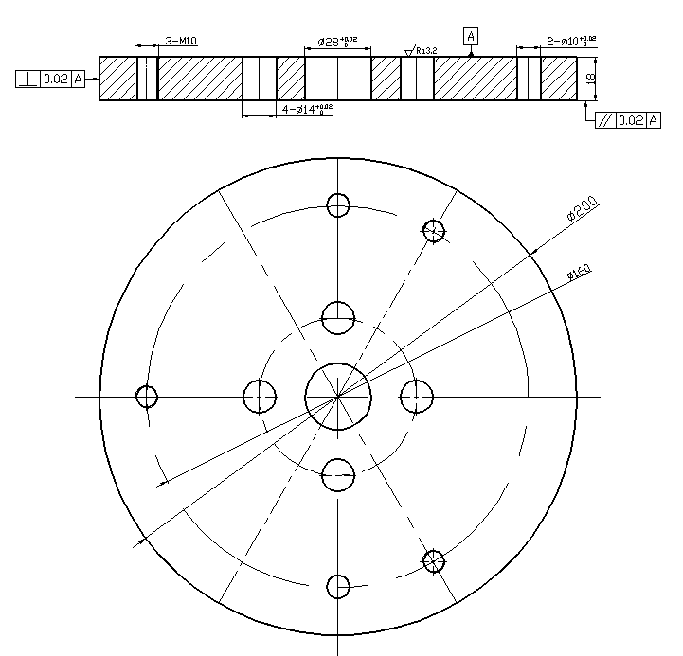
Fig. 10 Structure Diagram of the Punching Die Discharge Plate

4.5 Design of the fixed plate and pad plate

The fixing plate is a component used to secure parts in a mould. In this design, the fixing plate will be used to fix the punch and the die set, placing the punch and die set into the fixing plate to achieve assembly of the mould. The internal shape of the fixing plate corresponds to the internal shapes of the punch and die set, ensuring a transition fit of H7/m6 during assembly.
The backing plate is placed on the back of the fixed plate to prevent the punch or die from directly impacting the mould base, thereby reducing the wear of the mould and increasing its service life.
The materials for the fixed plate and the backing plate in the design are both 45 steel, with the same length and width dimensions as the die. The thickness of the fixed plate is set to be 0.6 to 0.8 times the thickness of the die, while the thickness of the backing plate is usually valued at 10 to 25 mm in special cases where the stroke of the top component is not controlled.
Therefore, an 18mm fixed plate is used in this design, and the thickness of the cushion plate is set to 10mm.
The fixed plate is shown in Figs. 11 and 12:
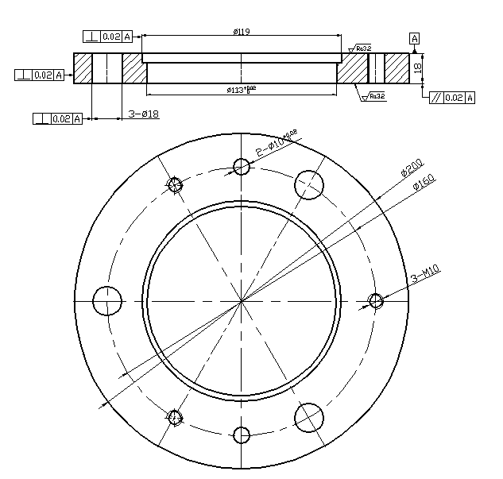
Fig. 11 Material Dropping Deep Drawing Male and Female Die Fixed Plate
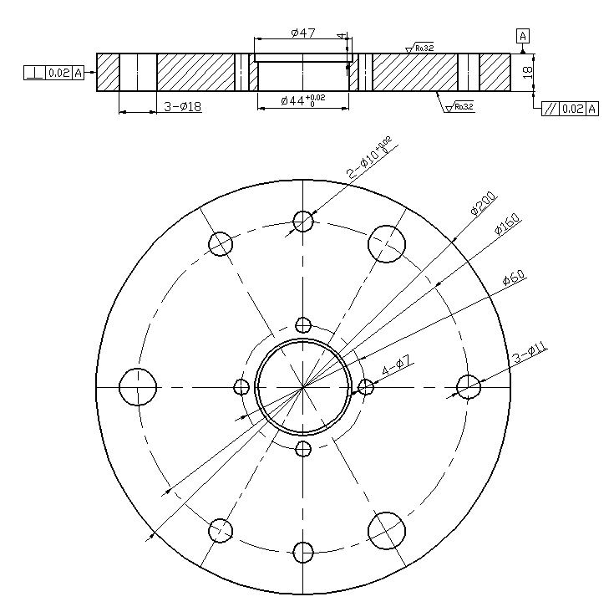
Fig. 12 Compound mould upper die fixing plate for blanking and deep drawing

4.6 Selection of Frame and Guide Pillar, and Guide Sleeve

The production accuracy of this design part is not high, and the dimensions are moderate. The rear guide pillar mould frame, and sliding guide pillar sleeve can be directly used.
Mould frame: GB/T2851.1-2851.2-2008 rear guide pillar mould frame
Guide pillar: GB/T2861.1-2008
Sleeve: GB/T2861.3-2008
The mould frame is shown in Fig. 13:
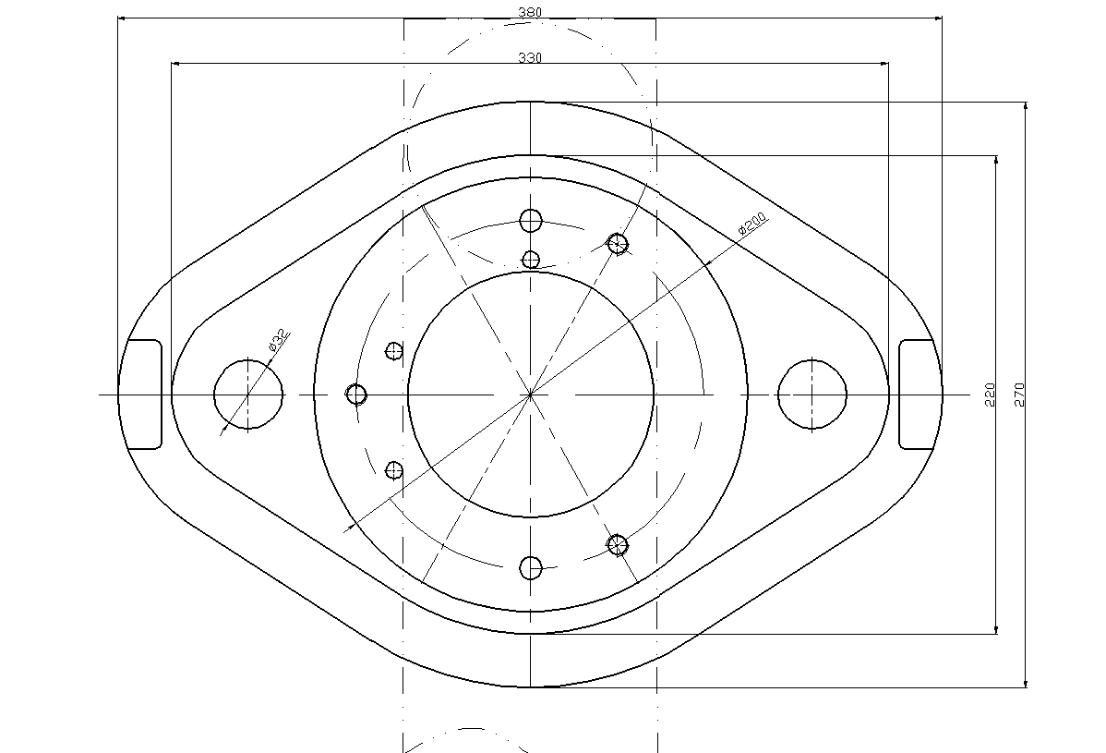
Figure 13 Middle circular guide post mould frame

4.7 Selection of screws, pins, and module handles

The template of the mould is fixed with screws, and the positioning assembly between the templates is achieved using dowel pins. The specifications are as follows:
Screws: M10x60, GB/T 7001-2000
Dowel pins: φ10x60, GB/T 117-2000
During the assembly process of the mould, a press-fitting handle is used. Since the mould size is relatively small, a press-fitting handle with good straightness is selected to ensure punching balance. The specification is as follows:
Handle: φ40x60, GB2862.1-1981

5 Draw the mould assembly drawing

5.1 Die assembly drawing for blanking, deep drawing, and reverse deep drawing composite mould

Figure 14 shows the assembly drawing of the drop forging, deep drawing, and reverse deep drawing composite mould.
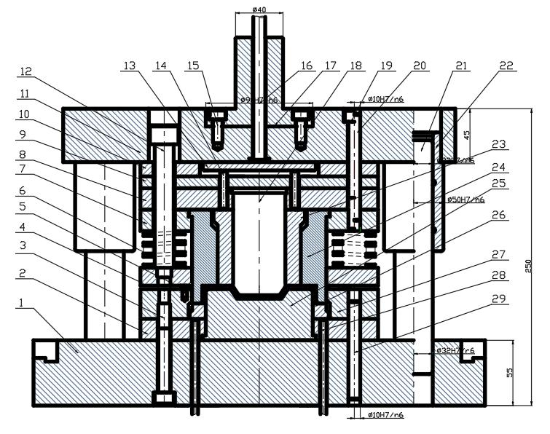
1. Lower die seat 2. Deep-drawing and reverse deep-drawing die fixing plate 3. Hexagonal screw with cylindrical head 4. Blank holder plate 5. Material stop/guide pin 6. Spring 7. Blank deep-drawing die fixing plate 8. Punch fixing plate 9. Upper cushion plate 10. Hollow cushion plate 11. Upper die seat 12. Cylindrical head unloading screw 13. Push plate 14. Push rod 15. Hexagonal screw with cylindrical head 16. Material punch rod 17. Die handle 18. Reverse deep-drawing punch 19. Hexagonal screw with cylindrical head 20. Round dowel pin 21. Guide post 22. Guide sleeve 23. Push block 24. Blank deep-drawing die 25. Deep-drawing and reverse deep-drawing die 26. Edge compression ring 27. Cavity die 28. Ejector pin 29. Round dowel pin
Fig. 14 Blanking, deep drawing, and reverse deep drawing composite die
Working principle: The strip material is fed in along the two guiding pins on the left side of the die, using a front-side stop pin for distance control. During operation, the upper die moves down, and the material is cut by the convex and concave dies, completing the blanking operation. Then, the deep-drawing convex and concave dies work together to complete the deep drawing, followed by reverse drawing performed by the reverse-drawing die with the deep-drawing dies, finishing the reverse drawing and completing the mould closing. When opening the mould, after the blanking is completed, the strip material will adhere to the blanking deep-drawing die, and the upper die moves up, releasing the pressure through the spring. The unloading mechanism, consisting of the unloading screw, spring, and unloading plate, removes the material strip, completing the unloading operation. The upper die continues moving up, the die rod contacts the horizontal bar of the press, which pushes the push plate; the push plate, in turn, pushes the push rod, which pushes the push block, ultimately pushing out the finished workpiece, completing the pushing operation. Meanwhile, due to the upward movement of the upper die, the lower die is driven upward by the pressure relief of the spring in the ejection mechanism. During the mould opening process, the ejection rod is pushed out by the ejection mechanism of the lower die, and finally, the workpiece is pushed out by the edge ring, completing the ejecting operation. The operations of blanking, forming, unloading, pushing, and ejecting are completed, preparing for the next working cycle.

5.2 Punching Die Assembly Diagram

Fig. 15 shows the assembly drawing of the punching die.

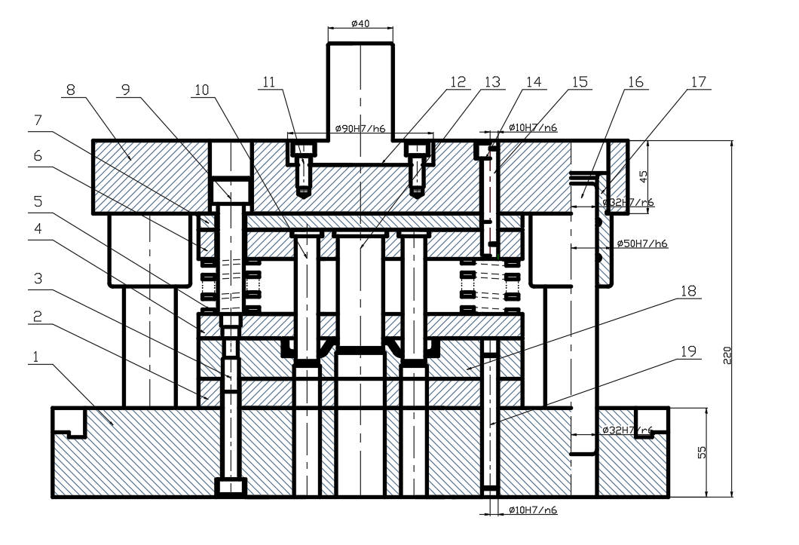
1. Lower mould base 2. Lower cushion plate 3. Hexagon socket screw with cylindrical head 4. Discharge plate 5. Spring 6. Punch fixing plate 7. Upper cushion plate 8. Upper mould base 9. Discharge screw with cylindrical head 10. Punching punch 11. Hexagon socket screw with cylindrical head 12. Mould handle 13. Punching punch 14. Hexagon socket screw with cylindrical head 15. Round pin 16. Guide pillar 17. Guide sleeve 18. Female mould 19. Round pin Figure
Fig.15 Punching mould

Working principle: Place the semi-finished product after deep drawing on the die of the punching mould, positioning it using the shape of the deep drawing. The work begins, the upper mould descends, and the punch and die complete the punching. The punching waste is directly discharged from the lower die, completing the cutting and forming. When opening the mould, the upper mould ascends, and the elastic unloading mechanism removes the workpiece stuck on the punch, completing all operations.

6. Conclusion

Centring on the “flange” part, this paper systematically completes the whole process from process analysis and calculation to die structure design. After comparing three feasible schemes, a two-die set combining a “blanking–drawing–reverse drawing compound die” with a separate piercing die was finally adopted, balancing accuracy, efficiency and cost. All key parameters—blank size, strip layout, material utilisation, blanking force, and die shut height—were thoroughly calculated, and the selection and structural design of the die block, punches, compound punch–die, stripper, bolster plates, backup plates, die set and standard components were accomplished. The two resulting die assembly drawings show compact structures with reliable positioning and safe operation, meeting the requirements of medium-to-large batch production at IT14 accuracy. Through this project, the authors not only consolidated their theoretical knowledge of stamping dies and proficiency in CAD/CAE tools, but also enhanced their ability to analyse and solve problems independently, laying a solid foundation for future work in die and related mechanical design.

Competing interests

Authors have declared that no competing interests exist.

Disclaimer (Artificial intelligence)

Option 1:

Author(s) hereby declare that NO generative AI technologies such as Large Language Models (ChatGPT, COPILOT, etc.) and text-to-image generators have been used during the writing or editing of this manuscript.

Option 2:

Author(s) hereby declare that generative AI technologies such as Large Language Models, etc. have been used during the writing or editing of manuscripts. This explanation will include the name, version, model, and source of the generative AI technology and as well as all input prompts provided to the generative AI technology

Details of the AI usage are given below:
1.
2.
3.

References
- [1]Deng L .Numerical study on local contact conditions on rough surface under press hardening[J].Proceedings of the Institution of Mechanical Engineers, Part B: Journal of Engineering Manufacture,2025,239(9):1338-1347.
- [1]Wang S ,Dou Z ,Yin Y , et al.Crack Failure Analysis of Hot-Stamping Die Insert for Manufacturing an Automobile A-Pillar[J].Materials,2025,18(13):3052-3052.
- [1]Deng C ,Chen W ,Zhu Y .Multifield modeling of coating profile and substrate stress distribution in laser cladding of hot stamping dies[J].Optics and Laser Technology,2025,190113220-113220.
- [1]Lei Y ,Chang Q .Optimization design of stamping die for large-size three-dimensional curved thick plate[J].Proceedings of the Institution of Mechanical Engineers,2025,239(7):2290-2305.
- [1]Macêdo G ,Pelcastre L ,Prakash B , et al.High temperature friction and wear of hot stamping tool materials produced by laser metal deposition[J].Wear,2025,568-569205682-205682.
- [1]Galkin V V ,Ivanov V S ,Galkin A S , et al.Wear Resistance of Stamping Tool in Hot Deformation[J].Russian Engineering Research,2025,44(12):1771-1774.
- [1]Grigoriev N S ,Volosova A M ,Korotkov A I , et al.Increasing the Wear Resistance of Stamping Tools for Coordinate Punching of Sheet Steel Using CrAlSiN and DLC:Si Coatings[J].Technologies,2025,13(1):30-30.
- [1]Lide I ,Alexander B ,Mats S , et al.Integrating Stamping Tool Temperature Effects into Early-Stage Process Design: Insights from an Industrial Benchmark[J].MATEC Web of Conferences,2025,40802002-02002.
- [1]Yu D ,Rachik M ,Blaise A , et al.Topology optimization designed twisted conformal cooling channel for additive-manufactured hot-stamping tool[J].Applied Thermal Engineering,2025,259124784-124784.
- [1]You H ,Lee S ,Baek C , et al.Enhancement of heat transfer in cooling channels for electronic devices using multi-directional graded triply periodic minimal surfaces (TPMS)[J].International Communications in Heat and Mass Transfer,2024,159(PC):108278-108278.
- [1]Zhang J ,Huang H ,Peng K , et al.18Ni300/AlSi10Mg interpenetrating phase composite: Lattice structure, mechanical and thermal performance, and application in forming die[J].Additive Manufacturing,2024,96104565-104565.
- [1]Ohashi T .Scrap Float Detection in a Blanking Die Set with Multiple Retrofit Accelerometers Using the Mahalanobis–Taguchi System:Special Issue on Recent Advanced Manufacturing Science and Technology[J].International Journal of Automation Technology,2024,18(4):537-543.
- [1]Mu Y .Using surfacing welding technology to manufacture economical molds[J].Frontiers in Mechanical Engineering,2024,101397767-1397767.
- [1]Weian D ,Chunxu L ,Xiaokui X , et al.Pallet Stamping Die Design[J].Journal of Physics: Conference Series,2022,2402(1):
- [1]Rahul B ,Prosanta B ,Ajay P , et al.Equal channel angular pressing die design through finite element analysis method for non-strain hardening material[J].Canadian Metallurgical Quarterly,2022,61(4):493-512.
- 16. Bandhavi, C., Srinath, E., Charan, I. R. G., Althaf, M., & Sai, V. S. B. (2022). Modelling and validation of sheet metal forming process of brass at elevated temperatures. Materials Today: Proceedings, 62, 3336-3343.
- 17. Sun, W., Zhang, Z., & Zhang, W. (2021). A coaxial alignment method for large flange parts assembly using multiple local images. IEEE Access, 9, 16716-16727.
18. Pereira, R., Peixinho, N., & Costa, S. L. (2024). A review of sheet metal forming evaluation of advanced high-strength steels (AHSS). Metals, 14(4), 394.

