Original Research Article

Prediction of Nanofluid Specific Heat Capacity Using Supervised Regression Models

.
ABSTRACT

The accurate prediction of the specific heat capacity (SHC) of nanofluids has become increasingly important for industrial and scientific applications. However, traditional experimental methods of determining SHC are often costly, labor-intensive, and subject to measurement uncertainties. Consequently, there is a need for reliable and efficient predictive models. The aim of this study is to develop and evaluate supervised machine learning regression models capable of predicting the SHC of nanofluids based on their key thermophysical features. A data set of 517 records containing the thermophysical features of nanofluids is collected and preprocessed. The dataset features include nanoparticle type, base fluid, base fluid temperature, and nanoparticle volume fraction. Supervised regression models such as Gradient Boosting, XGBoost, AdaBoost and Decision Tree Regressor, were applied and evaluated. The Gradient Boosting model showed the best performance with R² score of 99.60%, followed by XGBoost (97.43%), AdaBoost (97.07%) and the Decision Tree Regressor (86.73%). These findings demonstrate the capability of machine learning regression models in predicting SHC, offering a cost-effective and rapid alternative to experimental measurements. The results highlight the potential of such approaches to support the design and optimization of advanced thermal management and energy systems.

Keywords: Nanofluids; Specific Heat Capacity; Regression; Gradient Boosting; XGBoost

1. INTRODUCTION

In recent years, nanofluids engineered colloidal suspensions of nanoparticles in conventional base fluids have gained significant traction due to their enhanced thermophysical properties. These fluids offer remarkable improvements in heat transfer capabilities, primarily due to the inclusion of nanoparticles with high surface area and superior thermal conductivity. Such characteristics make nanofluids attractive for applications in energy systems, manufacturing processes, biomedical devices, and electronics cooling systems (Choi, 1998), (Borm et al., 2006). The ability to fine-tune their thermal properties as type, size, and volume fraction of nanoparticles has opened new avenues for designing highly efficient thermal systems (Colangelo et al., 2016). Among the critical thermophysical parameters influencing nanofluid performance is the specific heat capacity (SHC), which directly impacts the heat storage and transfer characteristics of the fluid. Accurately measuring of SHC is essential for selecting suitable nanofluids in engineering applications. However, conventional experimental techniques, such as differential scanning calorimetry, are labor-intensive, time-consuming, and often affected by measurement errors caused by particle agglomeration, sedimentation, or temperature sensitivity (O’Hanley et al., 2012), (Zhou et al., 2010). Furthermore, the complex and nonlinear behavior of nanofluids makes traditional predictive models insufficient.
In response to these challenges, machine learning (ML) has emerged as a powerful and efficient tool for predicting material properties, especially in cases involving large datasets and complex variable interactions. ML models have been successfully applied to estimate thermophysical properties such as thermal conductivity, viscosity, and antibacterial behavior of nanomaterials (Sarker, 2021), (Sharma et al., 2022). Recent advancements in this field have demonstrated that ML models not only complement but can also outperform traditional methods when accurate and rapid predictions are needed (Durgam & Kadam, 2021), (Zhu et al., 2024). More recently, Fasogbon et al. have emphasized the use of machine learning techniques to enhance energy system efficiency, demonstrating the growing usage of predictive models in contemporary thermal and energy systems (Fasogbon et al., 2025).
Different machine learning regression models were employed by Sharma et al. to predict the thermal conductivity of TiO₂-H2O nanofluids (Sharma et al., 2022). Their results showed that the gradient boosted model (GBR) had the highest accuracy, with an R² value of 0.99 and an MSE value of less than 0.0003. However, support vector regression (SVR) performed the worst of all models, with an R² value of 0.69 (Sharma et al., 2022). In contrast Alade et al. applied a hybrid Genetic Algorithm/Support Vector Regression (GA/SVR) model to predict the SHC of Al₂O₃/water nanofluids (Alade et al., 2019). Their model achieved a correlation coefficient of 99.998% with experimental data, and significantly outperformed traditional mixing and thermal equilibrium models, proving the potential of hybrid approaches for highly accurate SHC prediction. Similarly, Mathur et al. applied soft computing approaches for predicting the SHC of hybrid nanofluids, reporting high accuracy and further confirming the effectiveness of advanced machine learning models in modeling complex thermophysical behaviors (Mathur et al., 2024). In a separate study, Durgam and Kadam (Durgam & Kadam, 2021) applied Gaussian Process Regression with Matern and Squared Exponential kernels to predict the heat conductivity and viscosity of Al₂O₃-H₂O nanofluids, resulting in R² values of 0.99 and minimal Root Mean Square Error (RMSE) score. Also, Li et al. looked at six ways to use computers to work out how hot or cold EG-Al₂O₃ fluids would be. Their results showed that Gradient Boosting Decision Trees (GBDT) were the most accurate, with R² scores of 0.9974 (training) and 0.9958 (testing) (Zhu et al., 2024). A study of a much larger dataset confirmed the high prediction performance of Artificial Neural Networks (ANNs) across multiple types of nanofluid (Durgam & Kadam, 2021). Recently, Kanti et al investigated mono- and hybrid graphene oxide-based nanofluids and demonstrated that Random Forest had the best results (R² = 0.9575, MAPE = 1.04%), proving its effectiveness in predicting thermal properties. They used real data from five different nanofluids and showed that machine learning can be used to analyze many different nanofluid variables (Kanti et al., 2024). In addition to machine learning approaches, more recent studies have also investigated the thermophysical behavior of nanofluids in natural convection under magnetic fields and partial heating, highlighting the importance of accurate thermal property prediction in simulation and design processes (Marfouk et al., 2025).
All these researches demonstrate the effectiveness of several machine learning methods, especially those based on a set of models such as GBR and Random Forest (RF), in predicting the thermal properties of nanofluids with high accuracy. However, this study uses a set of supervised regression models to predict the thermal properties of nanofluids based on key input parameters: Nanoparticle type, base fluid type, temperature, average particle size, and volume fraction. The data was preprocessed using appropriate feature encoding and normalization techniques. Four regression models including Gradient boosted, XGBoost, AdaBoost, and decision tree, were trained, validated, and compared. The Gradient boosted model had the highest predictive value among all these models, achieving a prediction accuracy of 99.60%. The results encourage using of intelligent machine learning regression strategies for thermal management systems.
The objective of this study is to develop and evaluate supervised regression models for predicting the specific heat capacity (SHC) of nanofluids. The models are designed to utilize key thermophysical input parameters, including nanoparticle type, base fluid, nanoparticle volume fraction, and temperature, in order to provide an accurate, reliable, and cost-effective predictive tool for engineering and energy applications.

2. The proposed Model

Our proposed prediction model consists of five main steps. The first step is data collection. The second step is data extraction, where important features such as nanoparticle type, base fluid, temperature, and volume fraction are identified. The third step is data preprocessing, which includes coding univariate categorical variables and dividing the dataset into training and test sets. In the fourth step, the model is optimized using various regression models such as: Gradient boosting, AdaBoost, AdaBoost, Decision Trees, and XGBoost. The final step is model evaluation and validation. Fig. 1 shows the workflow.

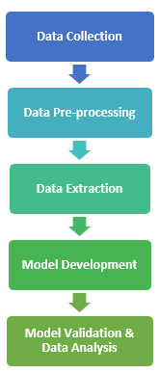
Fig. 1. Model development workflow

2.1 Nanofluid Dataset
The dataset has 517 records on the thermophysical properties of nanofluids. Every record contains four input properties: nanoparticle type, base fluid, nanoparticle volume fraction, and base fluid temperature, while the predicted output is the specific heat capacity (SHC) of the nanofluids (J/kg·K). The dataset was obtained from the Kaggle platform (KumarAugustya, 2024). Kaggle provides structured nanofluid data suitable for machine learning applications, but it does not rely on original experimental measurements. While the dataset is generally reliable and already preprocessed for modeling, some limitations should be considered, such as the restricted temperature range (293–363 K), possible missing values, and uneven sample distribution. Categorical features were processed using one-hot encoding to enable compatibility with machine learning regression models. Finally, the dataset was divided into 70% for training and 30% for testing. Table 1 shows a sample of the used dataset.
In this study, a variety of nanoparticles, including aluminum oxide (Al₂O₃), silicon dioxide (SiO₂), zinc oxide (ZnO), copper oxide (CuO), magnesium oxide (MgO), zirconium oxide (ZrO₂), aluminum nitride (AlN), and titanium dioxide (TiO₂), were employed. These nanoparticles were detached in different types of base liquids, such as water (H₂O), ethylene glycol (EG), and water-ethylene glycol mixtures. The concentrations of nanoparticles in the base liquids varied from 0.5% to 10% by weight, and the thermal properties of the resulting nanofluids were tested over a temperature range of 293 K to 363 K.
Table 1: Sample of the Nanofluid dataset
Nanoparticle | Base fluid | Nanoparticle volume fraction (%) | Base fluid Temperature (K) | SHC (J/kg.K)
Al₂O₃ | Water | 2 | 313 | 4181.89
ZrO₂ | Water + ethylene glycol | 5 | 243.15 | 3147.42
SiO₂ | Water/  Ethylene glycol (60:40) | 1 | 315 | 3141.04
ZnO | Water+  ethylene glycol (60:40) | 7 | 325 | 3146.75
MgO | Ethylene glycol | 0.16 | 343 | 2427.65

2.2 Data Pre-processing
The original dataset was obtained in tabular format and contained both categorical and numerical characteristics. Categorical variables such as nanoparticle type and base fluid were coded using both label coding and one-hot encoding techniques, depending on the stage of analysis. Numeric characteristics (such as volume fraction and temperature) were kept in the same original format, while descriptive statistics (such as mean, standard deviation, skewness, and kurtosis) were performed to detail the distribution of the data. Correlation analysis was also conducted to identify poorly correlated features that were subsequently removed and to remove high-impact features that led to overfitting.

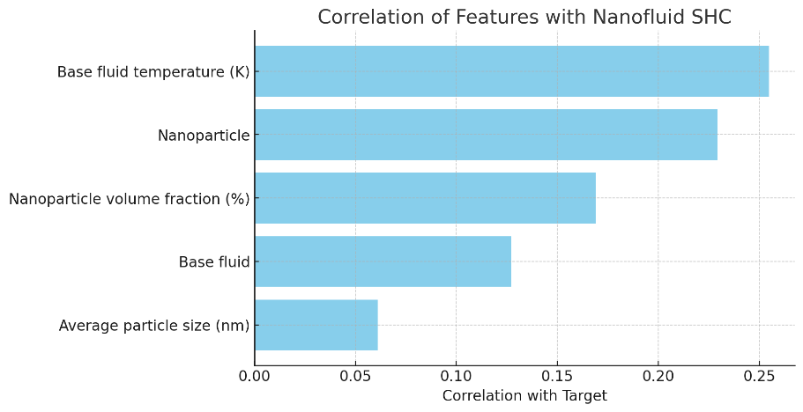
Fig. 2. Correlation coefficients of input features with nanofluid specific heat capacity

As shown in Fig. 2, the correlation coefficient analysis with the target variable (nanofluid specific heat capacity) revealed that base fluid temperature (0.25) and nanoparticle type (0.23) had the highest correlations, while average particle size (0.06) exhibited very weak correlation and was therefore excluded from further analysis. These preliminary preparatory stages ensured that the dataset was properly ordered and normalized before starting to train and evaluate the model.

2.3 Feature Extraction
Feature extraction was performed using structured tabular data to represent nanofluid samples. The input characteristics included the type of nanoparticle, the type of base fluid, the volume fraction and the temperature. The categorical attributes were also converted into numeric representations using single-point encoding to ensure compatibility with machine learning regression models. The numerical characteristics remained in the original form and an analysis of the statistical distribution and relationship with the target variable was performed. Attributes with high and low correlation were treated as redundant and removed to improve the effectiveness and performance of the model. This process ensured that the final set of attributes effectively demonstrated the key relationships relevant to the prediction of specific heat capacity.

2.4 Model Development
To model the specific heat capacity of nanofluids, four tree-based ensemble regression models were employed; Decision Tree, Gradient Boosting, AdaBoost, and XGBoost.
2.4.1 Decision Tree
It is a non-parametric supervised learning algorithm used for regression and classification tasks. The tree structure recursively splits the dataset into subsets based on feature thresholds, forming branches that lead to a prediction at the leaves. Although decision trees offer clear interpretability and fast computation, they are sensitive to small variations in the data and prone to overfitting when used individually. According to (Quinlan, 1986), decision tree models are effective for understanding key feature interactions, but ensemble strategies are often required for improved generalization.

2.4.2 Gradient Boosting
Gradiant boosting is based on the sequential construction of building models, with each subsequent model focusing on the modification and correction of errors in previous models. The loss function (e.g., MSE) is minimised by gradient boosting, resulting in a robust predictive model based on weak learners. It is demonstrated that gradient boosting is well-suited for structured or tabulated data, which typically yields a superior degree of prediction accuracy in comparison with single-model approaches (Friedman, 2001).

2.4.3 AdaBoost
Adaptive Boosting (AdaBoost) combines multiple weak learners (typically decision stumps) to form a strong learner by adjusting the weights of training samples. In each iteration, higher weights are assigned to previous cases that were incorrectly predicted, so the model is more focused on the harder cases. The study in (Chengsheng et al., 2017) shows that AdaBoost is efficient at minimizing bias and variance, making it a suitable algorithm for regression tasks.

2.4.4 XGBoost
Extreme Gradient Boosting (XGBoost) is an improved version of gradient boosting, which includes regularization parameters to control overfitting and parallel processing to improve performance. It also supports sparse algorithms and tree pruning strategies, making it particularly effective for large-scale regression. The use of XGBoost in civil engineering has been demonstrated for predicting the bearing capacity of piles (Amjad et al., 2022). The effectiveness and accuracy of XGBoost in modeling highly non-linear engineering datasets has also been confirmed.

2.5 Model Validation & Data Analysis
Equations (1) to (3) are employed to calculate the Mean Squared Error (MSE) (Hastie et al., 2009), Mean Absolute Error (MAE) (Willmott & Matsuura, 2005), and Coefficient of Determination (R²) (James et al., 2021), respectively. These metrics are crucial for evaluating the performance of the selected four tree-based ensemble algorithms. These evaluation measures are applied to both the training and testing datasets to assess model accuracy.

$MSE=\frac{1}{n}\sum_{i=1}^{n}{{(y_{i}-y_{i}^{^})}^{2} (1)}$

$MAE=\frac{1}{n}\sum_{i=1}^{n}{|}y_{i}-y_{i}^{^}| (2)$

$$R^{2}=1- \frac{\sum_{i=1}^{n}{{\left(y_{i}-y_{i}^{^}\right)}^{2}}}{\sum_{i=1}^{n}{{\left(y_{i}-y^{-}\right)}^{2}}} (3)$$
Where:
$n$ : Number of samples in the dataset.
$y_{i}$: Actual (true) value of the $i^{th}$observation.
$y_{i}^{^}$:​ Predicted value of the $i^{th}$observation.
$y^{-}$​: Mean (Avg) of the actual values $y_{i}$​.
∑: Summation symbol, used to sum over all samples from i=1 to$n$.

3. results and discussion

3.1 Results
The experiments started with data preprocessing, in which the categorical characteristics (nanoparticles and base fluid) were changed using monophasic coding. The data was then divided into two sets, training (70%) and testing (30%). After that, the four regression models were trained and evaluated. As shown in Table 2 and Table 3, Gradient Boosting and XGBoost obtained the highest accuracies in both the training and testing datasets, with Gradient Boosting showing its superiority in terms of generalization performance (R² = 0.996).

Table 2: Model Performance on Training Data
Model | MSE | MAE | R²
Gradient Boosting | 1137.68 | 19.09 | 0.9976
XGBoost | 6917.4 | 46.67 | 0.9855
AdaBoost | 9281.07 | 49.11 | 0.9805
Decision Tree | 37838.8 | 92.63 | 0.9204

Table 3: Model Performance on Testing Data
Model | MSE | MAE | R²
Gradient Boosting | 2189.93 | 27.53 | 0.996
XGBoost | 13895.6 | 68.93 | 0.9743
AdaBoost | 15820.5 | 68.45 | 0.9707
Decision Tree | 71768.1 | 141.50 | 0.8673

To demonstrate the practical utility of the trained models, several predictive scenarios were run in which the user provided key inputs, namely the type of nanoparticle, the base fluid, the nanoparticle volume fraction, and the fluid temperature. For example:
- Scenario 1: Nanoparticles: Al₂O₃; Base liquid: Water; Volume fraction at 2% Temperature of 313 K.
- Scenario 2: Nanoparticles: SiO₂; Base liquid: Water; Volume fraction at 10% Temperature of 363 K.
- Scenario 3: Nanoparticles: SiO₂; Base liquid: Water/Ethylene glycol (60:40); Volume fraction at 1% Temperature of 315 K.
- Scenario 4: Nanoparticles: MgO; Base liquid: Ethylene glycol; Volume fraction at 0.16% Temperature of 343 K.
The models then generated predictions of the specific heat capacity (SHC). As shown in Table 4, the predicted SHC values closely matched the corresponding values in the dataset. This strong agreement demonstrates not only the accuracy but also the practical applicability and generalizability of the proposed models.

Table 4: Predicted SHC Values and Comparison with Original Data
Scenario |  | XGBoost | Gradient Boosting | Decision Tree | AdaBoost
  Original SHC (J/kg·K)
1 | 4181.89 | 4181.9 | 4181.15 | 4181.94 | 4182.61
2 | 4188.45 | 4188.45 | 4187.75 | 4188.45 | 4184.42
3 | 3141.04 | 3141.14 | 3141.47 | 3141.09 | 3066.58
4 | 2427.65 | 2427.6 | 2427.48 | 2427.59 | 2430.31

To confirm these findings on the full dataset, Fig. 3 compares actual and predicted SHC values for all records. The plots visually confirm that Gradient Boosting and XGBoost achieve the closest agreement with the ideal line, while AdaBoost and Decision Tree show relatively larger deviations.

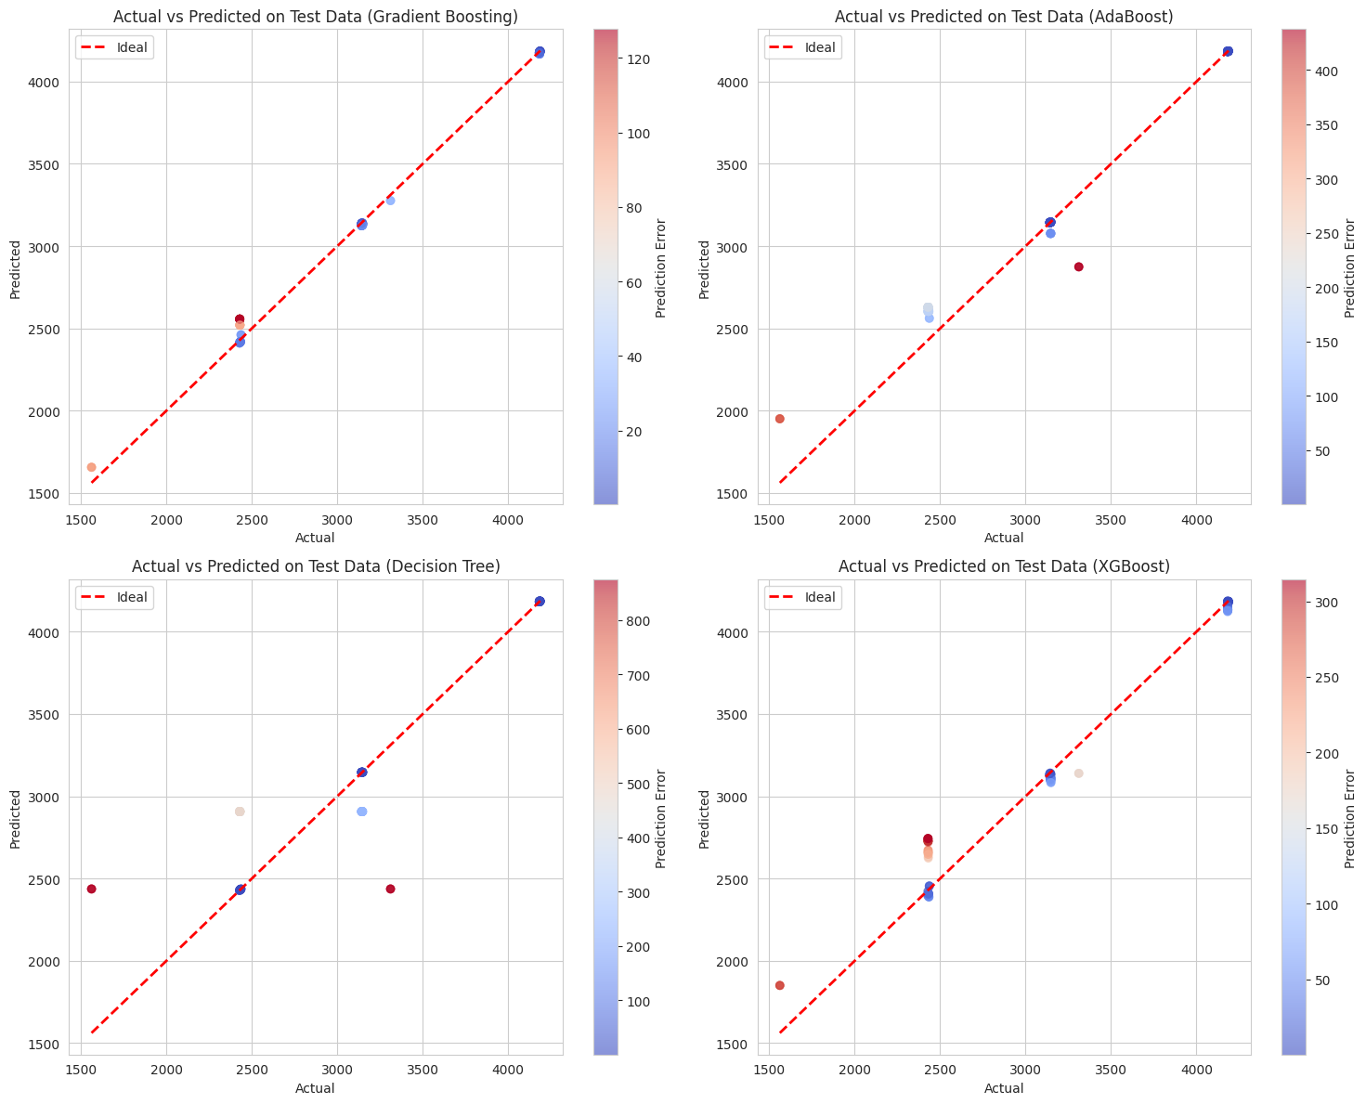
Fig. 3. Actual vs predicted SHC for the four models. The red dashed line represents the ideal prediction. Gradient Boosting and XGBoost align closely with the ideal line, while AdaBoost and Decision Tree show larger deviations.

To further validate the robustness of the predicting models and to avoid overfitting, a 5-fold cross-validation was conducted using four independent features (Nanoparticle type, Base fluid, Base fluid temperature, and Nanoparticle volume fraction). Table 5 presents the mean and standard deviation of MSE, MEA, and R² values for the 5-fold validation. The bar chart in Fig. 3 shows also the mean values of the 5-fold cross-validation performance for MAE, MSE, and R² across models. The consistency across folds confirms robustness for Gradient Boosting, XGBoost, and Decision Tree, while AdaBoost showed higher variance. The consistency across folds confirms the robustness of the models. Gradient Boosting, XGBoost, and Decision Tree achieved stable high accuracy, while AdaBoost showed higher variance.

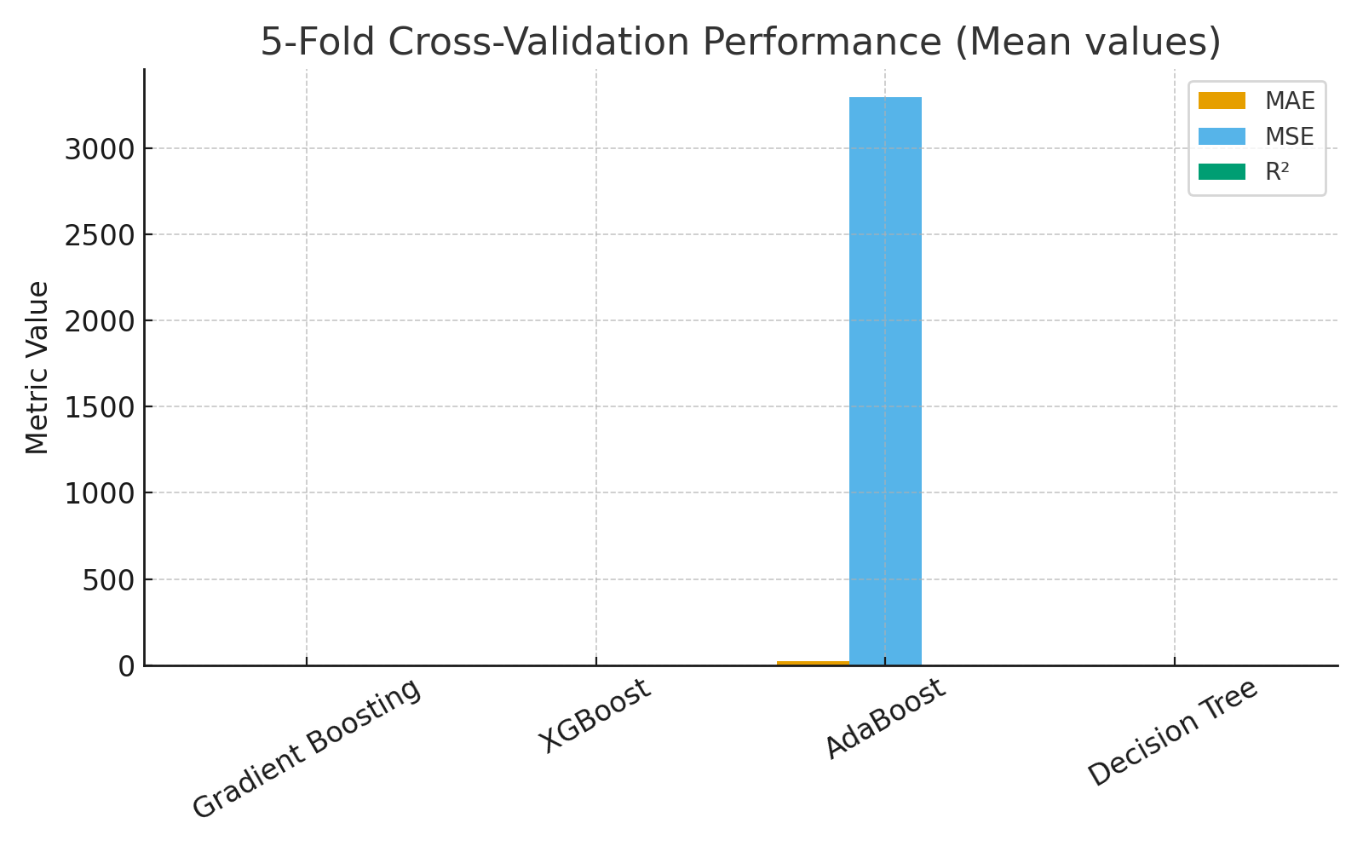
Fig. 4. 5-fold cross-validation performance (mean values)

Table 5: Results of 5-fold cross-validation (mean ± std).
Model | MSE (Mean ± Std) | MAE (Mean ± Std) | R² (Mean ± Std)
Gradient Boosting | 818.24 ± 566.85 | 17.24 ± 5.29 | 0.998 ± 9.8e-04
XGBoost | 0.011 ± 0.012 | 0.057 ± 0.011 | 1.00 ± 2.07e-08
AdaBoost | 10646.29 ± 1890.33 | 53.49 ± 8.88 | 0.978 ± 5.12e-03
Decision Tree | 0.005 ± 0.002 | 0.06 ± 0.006 | 1.00 ± 3.78e-09

3.2 Discussion
Accurate prediction of the specific heat capacity (SHC) of nanofluids is important for the design of heat exchangers, refrigeration units, and renewable energy systems. Experimental measurements of SHC are usually time-consuming and expensive. Machine learning models provide a fast and reliable alternative that allows the study of different nanofluid compositions and operating conditions. These results emphasize the role of predictive modeling in improving next-generation thermal management and cooling technologies. The results demonstrated that the Gradient Boosting model has the best performance with R² score of 99.60%, followed by XGBoost (97.43%), AdaBoost (97.07%) and the Decision Tree Regressor (86.73%). These results are consistent with the results obtained by (Mathur et al., 2024) which demonstrated the effectiveness of gradient boosting in modeling and predicting complex properties of nanofluids, including specific heat capacity (SHC). Similarly, Alade et al. reported that a hybrid GA/SVR model provided highly accurate predictions of SHC for Al₂O₃/water nanofluids, significantly outperforming traditional models (Alade et al., 2019). The preprocessing using one-hot encoding and correlation-based feature filtering, improved the model's accuracy by eliminating irrelevant or redundant variables. The result are consistent with (Ullah et al., 2023) which support the ability of supervised regression models to capture the nonlinear and multivariable thermal behaviors of nanofluids. In addition, 5-fold cross-validation and predicted vs actual SHC plots confirmed the robustness and reliability of the Gradient Boosting model across the dataset.

4. CONCLUSION
The objective of this study was to construct supervised regression models to predict the specific heat capacity (SHC) of nanofluids. Four ensemble regression models were trained and validated on a dataset of 517 records demonstrating the effectiveness of Gradient Boosting in achieving superior prediction accuracy. The four regression models; Gradient Boosting, XGBoost, AdaBoost and Decision Tree Regressor are employed to estimate the specific heat capacity (SHC) of nanofluids. The features include nanoparticle type, base fluid, base fluid temperature, and nanoparticle volume fraction. The input properties of nanoparticle were preprocessed using one-hot encoding and correlation-based feature filtering.
The Gradient Boosting model showed the best performance with R² score of 99.60%, followed by XGBoost (97.43%), AdaBoost (97.07%), and the Decision Tree Regressor (86.73%). Similar to (Amjad et al., 2022), the results of our experiments demonstrated that the XGBoost model has shown efficiency and accuracy in predicting the thermophysical properties of nanofluids. Similarly, Gradiant Boosting showed high accuracy in predicting SHC, which is consistent with the results demonstrated by (Friedman, 2001).
The use of explainable artificial intelligence (XAI) methods, such as SHAP or LIME, is recommended for the future, as they improve interpretability and provide insights into the importance of features and decision-making within the model (Lundberg & Lee, 2017).

Competing interests

Authors state no conflict of interest.

COMPETING INTERESTS DISCLAIMER:
Authors have declared that they have no known competing financial interests OR non-financial interests OR personal relationships that could have appeared to influence the work reported in this paper.

Disclaimer (Artificial intelligence)

Author(s) hereby declare that generative AI technologies have been used during the editing of this manuscript. The technology used was ChatGPT (GPT-5, OpenAI, 2025) for language polishing and formatting suggestions only. All scientific content, analysis, and interpretation were prepared entirely by the authors.

Details of the AI usage are given below:
1. Language refinement and grammar improvement.
2. Formatting assistance for references

References

Alade, I. O., Abd Rahman, M. A., & Saleh, T. A. (2019). Modeling and prediction of the specific heat capacity of Al2 O3/water nanofluids using hybrid genetic algorithm/support vector regression model. Nano-Structures & Nano-Objects, 17, 103–111.
Amjad, M., Ahmad, I., Ahmad, M., Wróblewski, P., Kamiński, P., & Amjad, U. (2022). Prediction of pile bearing capacity using XGBoost algorithm: modeling and performance evaluation. Applied Sciences, 12(4), 2126.
Borm, P. J. A., Robbins, D., Haubold, S., Kuhlbusch, T., Fissan, H., Donaldson, K., Schins, R., Stone, V., Kreyling, W., & Lademann, J. (2006). The potential risks of nanomaterials: a review carried out for ECETOC. Particle and Fibre Toxicology, 3, 1–35.
Chengsheng, T., Huacheng, L., & Bing, X. (2017). AdaBoost typical Algorithm and its application research. MATEC Web of Conferences, 139, 222.
Choi, S. U.-S. (1998). Nanofluid technology: current status and future research. Argonne National Lab.(ANL), Argonne, IL (United States).
Colangelo, G., Favale, E., Miglietta, P., Milanese, M., & de Risi, A. (2016). Thermal conductivity, viscosity and stability of Al2O3-diathermic oil nanofluids for solar energy systems. Energy, 95, 124–136.
Durgam, S., & Kadam, G. (2021). Investigation on thermal conductivity and viscosity of nanofluids using analytical and machine learning models. ArXiv Preprint ArXiv:2102.12120.
Fasogbon, S. K., Fetuga, I. A., Oyeniran, A. T., Shaibu, S. A., Afolabi, S., Ndokwu, T. A., Oluwadare, S. R., Onafowokan, J. T., Eso, O. S., & Bassey, V. B. (2025). Optimization of energy grid efficiency with machine learning: A comprehensive review of challenges and opportunities. Renewable and Sustainable Energy Reviews, 223, 115980.
Friedman, J. H. (2001). Greedy function approximation: a gradient boosting machine. Annals of Statistics, 1189–1232.
Hastie, T., Tibshirani, R., & Friedman, J. (2009). The elements of statistical learning. Springer series in statistics New-York.
James, G., Witten, D., Hastie, T., & Tibshirani, R. (2021). An introduction to statistical learning with applications in R (2nd ed.). Springer. https://doi.org/doi.org/10.1007/978-1-0716-1418-1
Kanti, P. K., Paramasivam, P., Wanatasanappan, V. V., Dhanasekaran, S., & Sharma, P. (2024). Experimental and explainable machine learning approach on thermal conductivity and viscosity of water based graphene oxide based mono and hybrid nanofluids. Scientific Reports, 14(1), 30967.
KumarAugustya. (2024). NanoFluid Dynamics. https://www.kaggle.com/datasets/kumaraugustya/nanoparticle-basefluid
Lundberg, S. M., & Lee, S.-I. (2017). A unified approach to interpreting model predictions. Advances in Neural Information Processing Systems, 30.
Marfouk, A., Mansour, A., Hasnaoui, A., Amahmid, A., & Hasnaoui, M. (2025). MHD Free Convection in an Enclosure Loaded with Nanofluid and Partially Cross-heated. Journal of Applied Fluid Mechanics, 18(7), 1720–1734.
Mathur, P., Gupta, A. K., Panwar, D., & Sharma, T. K. (2024). Soft computing approaches for prediction of specific heat capacity of hybrid nanofluids. Expert Systems, 41(1), e13471.
O’Hanley, H., Buongiorno, J., McKrell, T., & Hu, L. (2012). Measurement and model validation of nanofluid specific heat capacity with differential scanning calorimetry. Advances in Mechanical Engineering, 4, 181079.
Quinlan, J. R. (1986). Induction of decision trees. Machine Learning, 1, 81–106.
Sarker, I. H. (2021). Machine learning: Algorithms, real-world applications and research directions. SN Computer Science, 2(3), 160.
Sharma, P., Ramesh, K., Parameshwaran, R., & Deshmukh, S. S. (2022). Thermal conductivity prediction of titania-water nanofluid: A case study using different machine learning algorithms. Case Studies in Thermal Engineering, 30, 101658.
Ullah, A., Kilic, M., Habib, G., Sahin, M., Khalid, R. Z., & Sanaullah, K. (2023). Reliable prediction of thermophysical properties of nanofluids for enhanced heat transfer in process industry: a perspective on bridging the gap between experiments, CFD and machine learning. Journal of Thermal Analysis and Calorimetry, 148(12), 5859–5881.
Willmott, C. J., & Matsuura, K. (2005). Advantages of the mean absolute error (MAE) over the root mean square error (RMSE) in assessing average model performance. Climate Research, 30(1), 79–82.
Zhou, L.-P., Wang, B.-X., Peng, X.-F., Du, X.-Z., & Yang, Y.-P. (2010). On the specific heat capacity of CuO nanofluid. Advances in Mechanical Engineering, 2, 172085.
Zhu, T., Mei, X., Zhang, J., & Li, C. (2024). Prediction of thermal conductivity of EG–Al2O3 nanofluids using six supervised machine learning models. Applied Sciences, 14(14), 6264.
Kanti, P. K., Paramasivam, P., Wanatasanappan, V. V., Dhanasekaran, S., & Sharma, P. (2024). Experimental and explainable machine learning approach on thermal conductivity and viscosity of water based graphene oxide based mono and hybrid nanofluids. Scientific Reports, 14(1), 30967.

