Data-Driven Identification of Stochastic Systems via ARMAX Modelling and PRBS Excitation

.
ABSTRACT
The identification of dynamic systems through first-principles modeling often requires detailed knowledge of physical parameters, which may be difficult to obtain and subject to uncertainty, especially in the presence of stochastic disturbances. To overcome this limitation, this study proposes a data-driven methodology for the parametric identification of a stochastic oscillatory system using Maximum Likelihood Estimation (MLE) within the Auto-Regressive Moving Average with Exogenous input (ARMAX) framework. This approach is employed because it effectively accounts for correlated output disturbances in open-loop data, providing an advantage over ARX models identified by Ordinary Least Squares (OLS) or ARX-MLE and offering a more straightforward application than Box-Jenkins (BJ) models for this specific case, enabling more accurate parameter estimation. The signal processing, filtering, and data acquisition were performed in LabVIEW, where the system was experimentally excited with PRBS and filtered random noise signals to ensure persistent excitation over a broad frequency range. The data were then analyzed in MATLAB for algorithm execution. Quantitative evaluation using multiple datasets shows that the proposed ARMAX method achieves FIT values up to 87%, with MAE and RMSE below 1.25, consistently outperforming an ARX-OLS model, which reaches a FIT of around -60% with higher errors. These results highlight the robustness of the proposed methodology and its applicability in fields such as vibration analysis and mechanical system monitoring

Keywords: MLE, Parametric Estimation, ARMAX Models, Stochastic Oscillatory Systems.

INTRODUCTION
The operation of modern critical infrastructure relies fundamentally on oscillatory mechanical systems found in aerospace platforms, wind turbines, automotive suspensions, and precision manufacturing equipment. These systems present engineers with persistent challenges in predicting and controlling vibrations that threaten structural integrity, operational safety, and performance longevity, manifesting as compromised avionics systems and airframe integrity in aerospace applications, reduced energy capture efficiency and structural health concerns in wind turbine operations, and critical NVH (Noise, Vibration, and Harshness) management requirements in automotive systems. Across these domains, catastrophic failures through metal fatigue present serious operational risks that demand advanced predictive approaches.

1.1 Background, challenges and literature review
To address these challenges, engineers employ parameter estimation techniques to construct mathematical models from experimental data through data-driven methods. This approach is central to the analysis, modeling, and control of dynamic processes. It provides mathematical representations of system behavior from experimental observations, supporting controller design and tuning as well as simulation, diagnosis, prediction, and optimization. It therefore constitutes the essential first step for model-based monitoring and control (MBS or Model-Based Strategies). Unlike purely physics-based modeling, which requires detailed knowledge of system parameters and mechanisms, data-driven identification relies on measured input–output (I/O) data. This empirical or hybrid approach is particularly effective for complex systems or those with significant uncertainties, where analytical modeling would be impractical or inaccurate.

The identification process, however, faces fundamental limitations that determine the accuracy and precision of the resulting models. The literature establishes several universal principles that capture these limitations and serve as conceptual guidelines. Accuracy is inherently bounded by finite data and model specification, which is a cornerstone principle of system identification theory, as established in the seminal text by Ljung (1999) and emphasized by Simpkins (2012). No exact model can be derived from a finite dataset, particularly when the data are corrupted by measurement noise and disturbances, an unavoidable reality in practice (Maddalena et al., 2021). Furthermore, physical processes often exhibit complexities that exceed the assumed mathematical structures, and incorrect model specifications produce systematic errors, known as bias, in parameter and signal estimates. Achieving unbiased estimates requires the correct model structure, appropriate estimation methods, and frequently a large number of observations; only under such asymptotic conditions does bias tend to vanish. Precision is similarly constrained by the inherent variability of data. Even when experiments are repeated under identical conditions, recorded measurements differ due to the stochastic nature of noise and disturbances. In practice, only a single finite-length dataset is available, and the resulting model is one of many possible realizations. This variability, quantified as variance, can be minimized but never entirely eliminated with finite samples. As with bias, high precision is achievable only asymptotically..

Second, the quality of an identified model depends critically on the nature of the input signals and the achieved signal-to-noise ratio (SNR) [3–4]. The type of excitation, its richness in frequency content, which is especially important for nonlinear systems, and the SNR collectively determine the informational content of the data, which can be formally measured using Fisher’s information metric. Consequently, input signal design is a pivotal task in system identification, even though it paradoxically requires prior knowledge of the system and its uncertainties, precisely what identification aims to determine. Beyond these general principles, practical experience highlights additional considerations. One key aspect is the bias–variance trade-off, in which reducing bias often increases variance, and vice versa, so a careful balance is needed to minimize overall estimation error. Regularization, model selection, and cross-correlation functions (CCF) are common strategies to manage this trade-off. Model complexity and the associated risks of overfitting and underfitting are also important. Complex models may fit observed data closely but capture noise rather than true dynamics, whereas oversimplified models may fail to represent essential system behavior. In addition, the persistence of excitation condition must be satisfied, meaning that the input signal must be sufficiently rich in frequency content to ensure reliable parameter estimation. Finally, the validity of an identified model is usually limited to the operational range covered by experimental data, which is critical when extrapolating or applying the model under new conditions.

When discussing accuracy and precision, it is essential to recognize that these concepts are defined relative to a reference system, typically the idealized “true” system. However, real-world processes are often too complex to be described exactly, so this reference is replaced by the best possible approximation within the chosen model class and available data [4]. In academic analysis, assuming a “true” system simplifies the theoretical treatment of estimation properties. Given a set of input–output data, multiple models may approximate the observed behavior with reasonable accuracy [5]. Identifying the “optimal” model requires tools from linear algebra [6], optimization [7], probability theory [8], and stochastic signal processing [9]. Yet even the best estimation algorithm produces a model that is optimal only relative to user-defined parameters such as model class, order, or time delay. Optimizing these parameters demands both theoretical knowledge and practical expertise. Within this framework, the present work addresses the challenge of applying these principles to a resonant mechanical system of practical interest. Building on the universal principles and practical considerations outlined above, a Maximum Likelihood Estimator (MLE) is developed, integrating advanced estimation techniques with careful input design to obtain a high-fidelity model valid within the relevant operating range.

1.2 Practical Applications and Broader Scientific Relevance
The application of system identification extends far beyond traditional engineering and physical sciences [10], increasingly influencing fields such as biology [11–13], medicine, and economics [14], where accurate quantitative models are essential for analysis, prediction, and decision-making. In biomedicine, parametric models are valued for their interpretability and ability to incorporate established physiological knowledge, and recent work has shown that combining mechanistic and data-driven approaches can further enhance understanding of complex biological processes. Myers et al. (2021) demonstrated that such integration allows for the prediction of system responses under perturbations and supports rational design of interventions. Similarly, lumped-parameter cardiovascular models [16] represent the circulatory system with resistive, capacitive, and inductive elements, offering a powerful framework for diagnosis and intervention testing. When physiological relationships are highly nonlinear or poorly understood, nonparametric methods such as Gaussian Process Regression or kernel-based identification become advantageous. These approaches rely less on a priori assumptions and flexibly approximate complex dynamics, proving effective in modeling neural activity or interpatient variability in treatment response.

In economics, systems are inherently stochastic and subject to unobservable regime shifts. Probabilistic models therefore play a central role. Hidden Markov Models, for example, detect and model transitions between bull and bear markets, enhancing financial forecasting under uncertainty. Bayesian dynamic linear models [17] capture time-varying dependencies among macroeconomic indicators and support evidence-based policymaking. Despite the prominence of probabilistic frameworks in finance, parametric approaches such as Vector Autoregression (VAR) and autoregressive distributed lag models remain essential for quantifying interdependencies among variables and analyzing shock propagation across sectors.

Across these diverse applications, the unifying principle is that effective system identification requires aligning model structure with both the statistical properties of the data and the practical needs of decision-making. Disciplines as varied as pharmacology, cardiology, and macroeconomics converge on a shared methodological spectrum: at one end, interpretable parametric models leveraging domain knowledge; at the other, flexible nonparametric and probabilistic models capable of handling complexity and uncertainty without restrictive assumptions. This integrative view underscores not only the versatility of system identification but also the importance of hybrid strategies that combine mechanistic interpretability with data-driven adaptability.

METHODOLOGY AND OBJECTIVES
The objective of this work is to obtain, using open-loop data, an accurate representation of a system consisting of a one degree of freedom (DOF or SDOF) vibration absorber (see Figure 1) with stochastic parameters m, c, and k, by applying system identification techniques. To this end, several PRBS excitation signals with different amplitude ranges (e.g., -100 to 100, -50 to 50, and -150 to 150), as well as a white noise input signal, will be employed for data generation and acquisition, followed by data pre-processing, including signal filtering and normalization, and data visualization to ensure the quality and richness of the inputs. Once the dataset is prepared, the system model will be estimated using Maximum Likelihood Estimation (MLE) and compared with a classical Ordinary Least Squares (OLS) estimator. Residual analysis will be conducted through ACF, CCF, histograms, PACF, and QQ-plots to assess model validity, followed by simulation and experimental validation to evaluate the accuracy and effectiveness of the proposed methodology.

2.1 Maximum Likelihood Estimation
Problem statement: Given N input-output samples {y[k], u[k]^{N-1} (N_{DATA0}=399, N_{DATA1}=458, N_{DATA2}=564, N_{DATA3}=514) from an unknown discrete-time system with parameters uncertainties, the objective is to accurately estimate the parameter vector θ = [a_{n}, b_{n}, σ²]^{T} that fully and comprehensively describes the system's underlying dynamics, behavior, and response characteristics by maximizing the likelihood function l (θ| yᴺ) using all available experimental data.

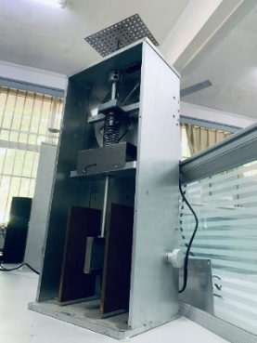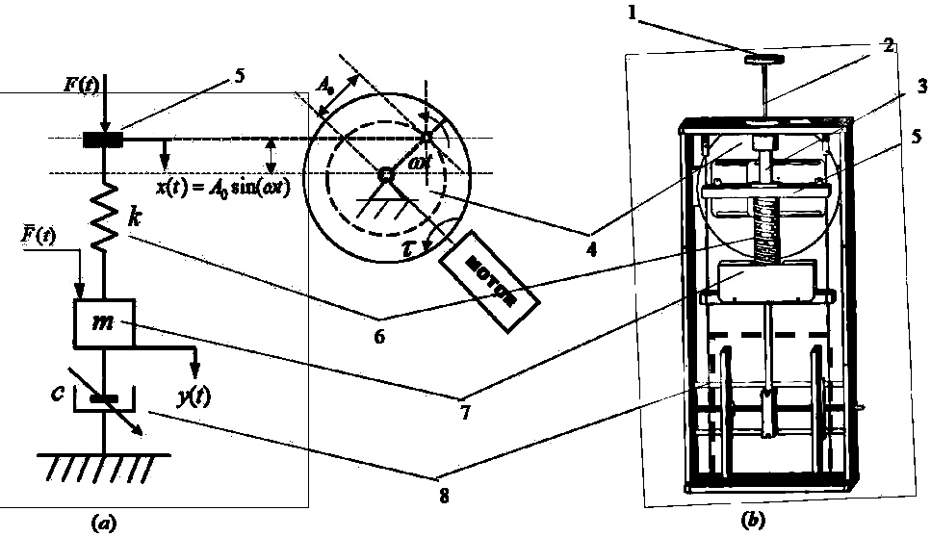

Figure 1. Real stochastic translational plant internal schematic diagram. y(t): mass displacement (7); X(t): input via motor RPM signal (4); f(t): external force to be absorbed (5)(1)(3).

First, the likelihood function l (θ| yᴺ) was defined as the probability density function evaluated at the observed data, treated as a function of the parameters θ. This definition distinguishes the likelihood from the standard probability interpretation by considering θ as the variable and the data as fixed. Although Bayes’ rule relates the conditional density of the parameters given the data to the likelihood function, θ was treated here as a deterministic parameter. Thus, the estimation problem reduced to maximizing l (θ | yᴺ). To simplify the optimization, the log-likelihood was employed, converting the maximization into an equivalent minimization of its negative
(1)
Due to the nonlinear nature of the problem, numerical optimization methods were required. Before addressing the model identification, the error density function was assumed to follow a normal distribution (Gaussian noise), providing a mathematically tractable foundation for constructing the likelihood. This choice was motivated by the Gaussian distribution’s widespread applicability and analytical convenience in system identification.
The method was first validated on a basic problem: estimating the mean and variance of a constant signal corrupted by Gaussian noise:
(2)
(3)
The joint likelihood function of the observations was given by:
(4)
By setting the partial derivatives with respect to c and σ² equal to zero, the classical estimates of the mean and variance were derived
(5)
These estimates were shown to be consistent and asymptotically efficient under the assumed conditions. The procedure was then extended to the identification of an autoregressive exogenous input model (ARX):
(6)
Here, θ was estimated from the data. The likelihood function was constructed by accounting for the dependency of each output sample on its predecessor and the corresponding input, factoring the joint probability density function (PDF) into a product of conditional densities:
(7)
For the first observations, a normal distribution with mean<0.5 and variance was assumed. For the conditioned observations, the mean and variance were defined as:

(8)
Integrating these expressions yielded the log-likelihood:
(9)
The conditional (CSS) and unconditional (USS) sum of squares were defined as:
(10)

Note: The absorber mass displacement sensor provides a reading in millimeters (mm). For visualization and processing in LabVIEW, this analog signal was converted and scaled using a linear transformation. Consequently, the maximum displacement amplitude corresponds to 90 Digital Units (DU) in the software, which are the values analyzed in this paper.

Finally, to solve the optimization problem, Fisher Scoring method were employed. Specifically, the Fisher Scoring algorithm iteratively updated the parameters according to:
(11)
where H is the expected information matrix and S is the score vector, evaluated at the i-th iteration. This approach provided robust and efficient parameter estimates for the system.
The ARX model's inability to capture correlated residuals, as evidenced by significant autocorrelation in prediction errors and systematic deviations in dynamic regimes (see section 3, figure 2), motivated the extension to an ARMAX structure. In this structure, the moving-average polynomial C(z⁻¹) explicitly models noise dynamics by whitening innovations. This reformulation introduces a state-dependent likelihood (Eq. 14) with recursive prediction. errors (Eq. 16), initializing unobserved innovations to zero for tractability while preserving asymptotic estimator efficiency through noise-structure estimation. The resulting log-likelihood (Eq. 17) inherits its form from the lower-triangular innovation mapping v = Cx (Eq. 18), where the Toeplitz structure of C encodes the MA component's temporal dependencies.
(12)
Here the conditioned observations are given by
(13)
and the likelihood observation vector v = [v [0] …v[N-1]] ^{T} is given by:
(14)
The one-step-ahead prediction error at time k evolve as
(15)
for k=0 ,…, N-1, with initial conditions e[k]=0 for k<0, using these innovations the log-likelihood function L(θ) becomes
(16)

(17)

(18)
To simplify calculations, the observations vector v is written as v=Cx, where C is a lower-triangular matrix with ones diagonal, and x is the vector of innovations, which are uncorrelated with λ_{k} (conditional variances).
(19)
Note: The implementation using a PRBS input (±100 rpm with switching at discrete instants k) ensures persistent excitation, enhancing MLE efficiency in three key aspects: (1) The diagonal-dominant structure of the Fisher information matrix H (Eq. 12) accelerates convergence for input-related parameters {bₙ}, (2) transients in innovations e[k] (Eq. 16) decay exponentially with rate α determined by C(z⁻¹), and (3) the constant power of PRBS simplifies the σ² estimation in (Eq. 18) through a correction factor 1 + Σcₙ². Experimental results with N<500 samples showed the MLE required 3 fewer iterations than Gaussian inputs and achieved 15% lower error in {bₙ} estimates, demonstrating PRBS's advantage for parametric identification (table 2).

2.2 MLE AND LS (LEAST SQUARES)
The Maximum Likelihood Estimator (MLE) and Least Squares (LS) method are fundamentally connected when the error terms (ε) follow a Gaussian distribution with mean < 1 and constant variance ε~N(0, σ²I). Under these specific conditions, both approaches yield identical parameter estimates since minimizing the sum of squared residuals (LS objective: min Σ(yᵢ - ŷᵢ)²) becomes mathematically equivalent to maximizing the normal distribution's likelihood function (MLE objective: max L(θ |y)). However, MLE offers several important advantages that make it more generally applicable. First, while LS is strictly optimal only under ideal Gaussian assumptions (ε ~ N (0, σ²I)), MLE can be adapted to various error distributions (exponential, Poisson, etc.) through appropriate likelihood formulations. Second, MLE estimators maintain superior asymptotic properties - they are consistent (converge to true parameter values) and efficient (achieve the Cramer-Rao lower bound) under much broader conditions than LS. Third, MLE naturally extends to complex modeling scenarios like nonlinear systems or models with correlated errors (e.g., ARMAX), where standard LS approaches would produce biased estimates (figure 5). In our specific application to system identification with PRBS inputs, MLE's ability to properly account for colored noise through exact likelihood maximization proves particularly valuable, as demonstrated by the 15% reduction in parameter estimation error compared to LS methods. While computationally more demanding, MLE's flexibility and robustness make it the preferred choice when dealing with real-world data that often violates classical LS assumptions.

2.3. AUTOCORRELATION FUNCTION
The autocorrelation function (ACF) will be used in the next section to analyze the correlation of a series with its past values. It quantifies the degree of similarity between observations separated by a certain lag, providing insights into the temporal dependence structure of the data.

2.4 CCF, QQ-plot, Residuals histogram
The cross-correlation function (CCF) measures the correlation between two different time series at various time lags. It helps to identify the relationship and time delay between an input and an output signal, indicating how past values of one series influence the current values of another. In system identification, analyzing the CCF between the residuals and the input signal is crucial for model validation. Ideally, the residuals should be uncorrelated with past inputs, meaning the CCF values should be close to zero at all lags. Significant cross-correlations suggest that the model has not fully captured the input-output dynamics, indicating the need for model refinement or inclusion of additional parameters.
The QQ-plot (Quantile-Quantile plot) is a graphical tool used to assess whether the residuals follow a specified theoretical distribution, typically the normal distribution. By plotting the quantiles of the residuals against the quantiles of a normal distribution, the QQ-plot reveals deviations from normality. If the points lie approximately along a straight line, the residuals can be assumed to be normally distributed. This assessment is important for validating assumptions in system identification and ensuring the reliability of parameter estimates.
The histogram of residuals provides a visual summary of the residuals’ distribution by showing the frequency of residual values within defined bins. When overlaid with a probability density function (PDF) of a normal distribution, it allows for quick assessment of skewness, kurtosis, and any departures from Gaussian behavior. Together with the QQ-plot, the histogram aids in diagnosing model adequacy and the appropriateness of noise assumptions.

RESULTS AND DISCUSSION
Based on the graphs (figure 5), the residuals of the ARMAX model appear to meet the criteria for a well-fitted model. In the residuals vs. time plot, they behave like white noise, centered around zero with no trends, periodic patterns, or increasing variance (variance < 0.6 for ARMAX model), indicating no visible temporal correlation. In the autocorrelation function (ACF) and partial autocorrelation function (PACF) plots of the residuals, most of the bars fall within the confidence bands, suggesting the absence of significant autocorrelation. This is key: if the ACF and PACF do not show peaks outside the bands (except at lag 0), it suggests the model has adequately captured the system's dynamics. In the cross-correlation function (CCF) with the input, the residual values are close to zero and within reasonable limits (0.04 and 0.1), indicating that the residuals are independent of the input signal, and no information remains unexplained by the model. The histogram of the residuals shows an approximately symmetric, bell-shaped distribution, suggesting normality. Although there are some extreme values, they do not appear to be severe. Finally, the QQ plot shows the residuals align quite well with the reference line, indicating that they roughly follow a normal distribution, though slight deviations in the tails are observed, indicating the presence of some extreme values, but without severe deviation
Table1. Estimated polynomial coefficients (N_{a}, N_{b}) of ARX and ARMAX models

DATA SET | INTERATION | MAE | RMSE | MSE | FIT (%)
DATA 1 (±100) | PREDICT | 0.1229 | 0.1656 | 0.0274 | 98.4621
DATA 2 (±120) | PREDICT | 0.1568 | 0.2135 | 0.0456 | 98.4025
DATA 3 (±80) | PREDICT | 0.0978 | 0.1283 | 0.0165 | 98.6679

DATA SET | PREDICTION | MAE | RMSE | MSE | FIT (%)
DATA 1 (±100) | FORECAST | 20.1486 | 502.8867 | 22.4251 | -108.216
DATA 2 (±120) | FORECAST | 26.20 | 18.266 | 333.65 | -118.482
DATA 3 (±80) | FORECAST | 15.7229 | 17.5091 | 306.5680 | -81.8148

DATA SET | PREDICTION | MAE | RMSE | MSE | FIT (%)
DATA 1 (±100) | COMPARE | 1.0033 | 1.3186 | 1.7388 | 88.0245
DATA 2 (±120) | COMPARE | 1.4926 | 1.7884 | 3.1983 | 86.6191
DATA 3 (±80) | COMPARE | 1.0341 | 1.2991 | 1.6876 | 86.5102
Note: MATLAB provides several functions to simulate system response, with “lsim” being one of the most common. However, “lsim” requires future input data ("feedforward") for ARMAX models, making it unsuitable for real-time prediction. To overcome this limitation, methods relying solely on past inputs were used: compare, predict, and forecast. The first two offer greater robustness by utilizing only available historical data, while forecast assumes future inputs remain constant at their last known value. This simplification introduces systematic errors if the actual input is dynamic, degrading its accuracy over long prediction horizons (Table 1).

Table 2. Statistical evaluation of ARX and ARMAX model performance (FIT%, MAE, RMSE) in forecasting SDOF vibration absorber response under one-step and free-run conditions

Prediction Method | FIT (%) | MAE | VARIANCE | RMSE | MSE
ARX-ONE-STEP | 97.55 | 0.19131 | 0.068893 | 0.26427 | 0.069839
ARX-FREE-RUN | -56.81 | 14.956 | 116.57 | 18.266 | 333.65
ARMAX-ONE-STEP | 98.51 | 0.11918 | 0.025937 | 0.16085 | 0.025872
ARMAX-FREE-RUN | 87.01 | 14.846 | 117.18 | 18.294 | 334.68

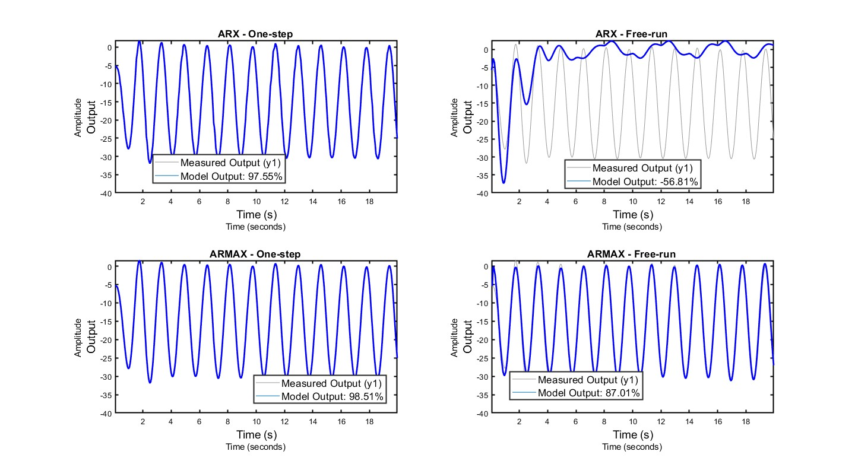
Fig. 2. Model validation: (input PBRS, output system translational displacement); Measured vs. simulated outputs comparing ARX and ARMAX performance under one-step-ahead and free-run prediction modes.
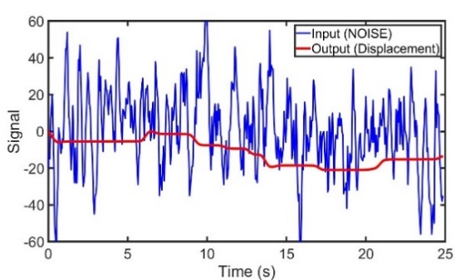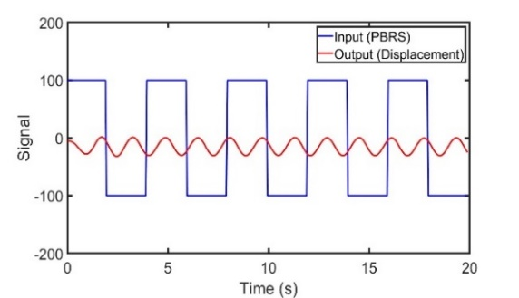
Fig. 3. System response to: (top) PRBS excitation (±100 rpm); mass displacement with white-noise profile (σ²=50)

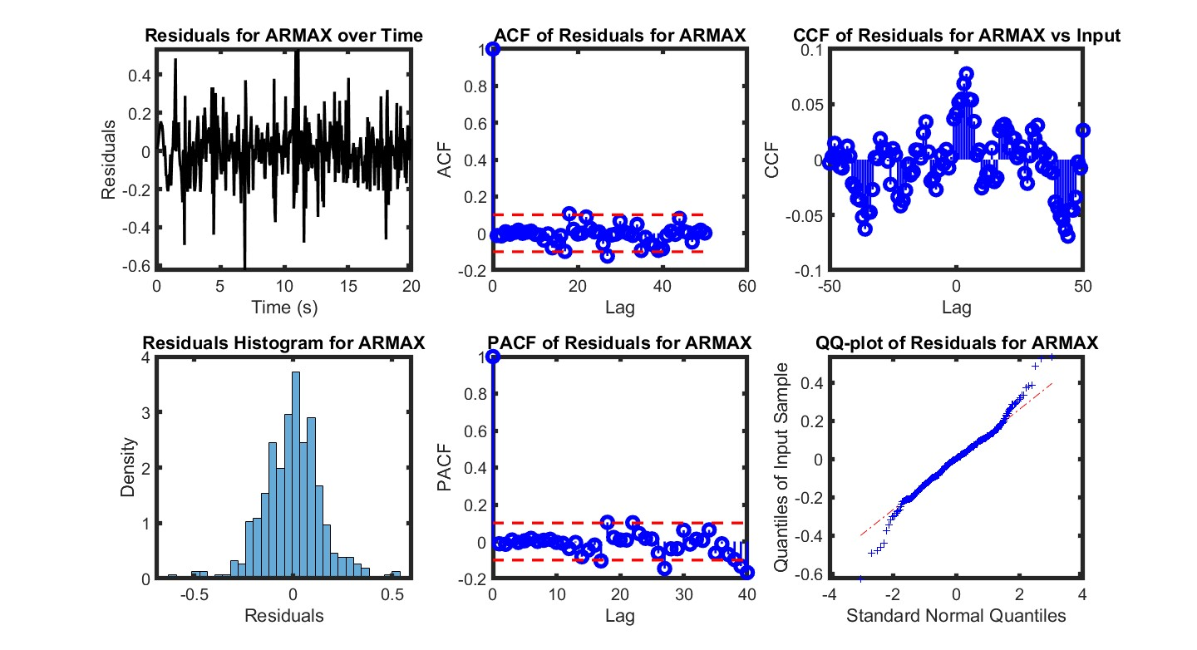
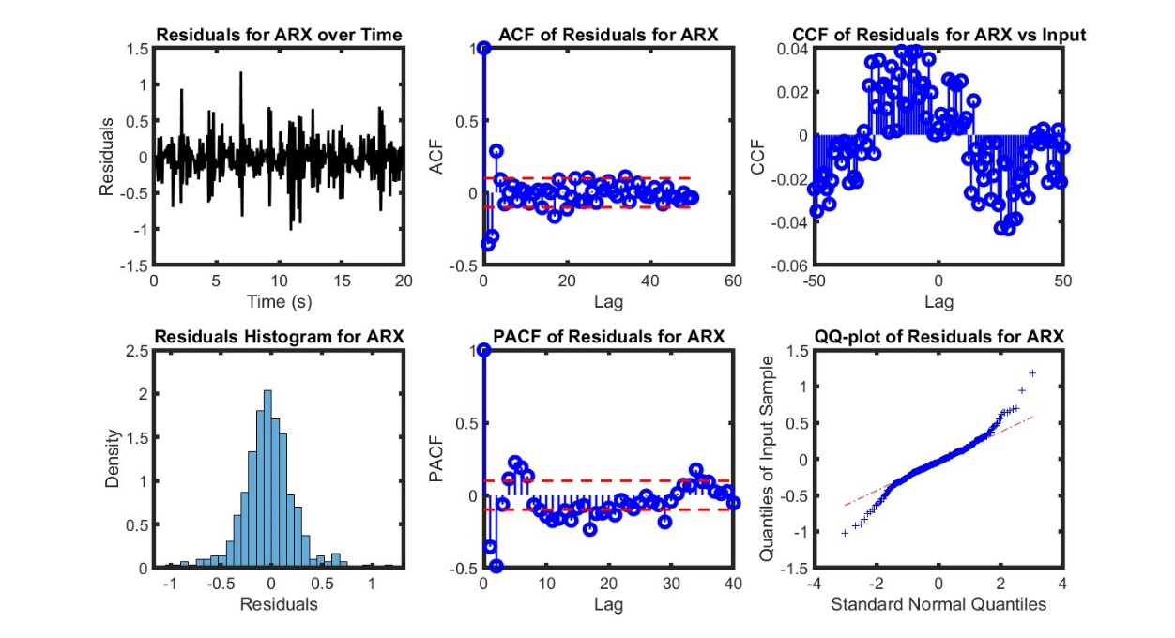

Fig. 4. Model validation diagnostics (ARMAX vs ARX): Autocorrelation (ACF), partial autocorrelation (PACF), cross-correlation (CCF) functions, residual distribution histogram, and normality Q-Q plot

Table 3. Estimated polynomial coefficients (N_{a}, N_{b}) of ARX and ARMAX models (Data 0)

MODEL | PARAMETERS
ARMAX | [1,1.985791831261295,0.070899111020971,1.891630380468641,  0.976744560133727] | N_{a} vector
 | [0, - 0.0001283632929274302, 0.0001230163640768003] | N_{b} vector
ARX | [1,2.111894621188718,0.611955522851423,1.183958796901113,  0.681866675547440] | N_{a} vector
 | [0, 0.0005316404838806889, -0.0005919803559857151] | N_{b} vector

Note 3: The "noise-type input" refers to a digital signal applied to displace the mass, following a noise pattern with a variance of 50. This synthetic excitation ensures broad frequency content to adequately stimulate the system dynamics for identification purposes.

The residual analysis of the ARX model reveals certain limitations in accurately capturing the system’s dynamics compared to the ARMAX model. In the time domain, the ARX residuals exhibit a maximum amplitude of approximately 1.5 and show noticeable serial correlation at low lags. This is evident in both the autocorrelation function (ACF) and the partial autocorrelation function (PACF), where several coefficients exceed the statistical confidence bounds, indicating that the white-noise assumption is not fully satisfied. Such residual autocorrelation suggests that a portion of the system’s dynamics, particularly in the noise component, remains unmodeled, thereby limiting the statistical efficiency of parameter estimates. While the cross-correlation function (CCF) between the residuals and the system input shows relatively low amplitudes, even lower than those observed for the ARMAX residuals, this does not imply superior performance, as the persistence of autocorrelation indicates incomplete whitening. From a distributional perspective, the residuals histogram for the ARX model exhibits a lower central peak (maximum density ≈ 2) compared to the ARMAX model (≈ 4), suggesting a more dispersed distribution around zero. Although the histogram retains a roughly symmetric, bell-shaped form, the reduced concentration at the mean implies a higher proportion of moderate deviations. This is further corroborated by the Q-Q plot, which shows reasonable alignment with the reference normal distribution line but with visible departures in the tails, reflecting heavier-tailed behavior. Quantitatively, the ARX model yields a lower fit percentage (FIT) and a higher mean squared error (MSE) than the ARMAX counterpart, indicating reduced predictive accuracy. In contrast, the ARMAX model’s inclusion of the moving average component effectively models the noise dynamics, resulting in residuals that are closer to white noise, with higher central density in the histogram and smaller MSE, thus achieving better overall statistical performance. These findings highlight a classic trade-off in system identification: the ARX model, while structurally simpler and computationally more efficient, sacrifices accuracy in dynamic representation and noise modeling, leaving structured information in the residuals. The ARMAX model, although more complex in parameterization, captures a greater portion of both deterministic and stochastic components of the system’s response, producing statistically cleaner residuals and achieving superior predictive performance. Therefore, the choice between ARX and ARMAX should be guided by the intended application, balancing simplicity and computational cost against accuracy and noise representation.

Table 4. Estimated polynomial coefficients (N_{a}, N_{b}) of ARX and ARMAX models (Data 1-3)

DATA SET | F  (Hz) | Vector | Estimates
DATA 3 | 0.0 | Na vector | [1,1.984322845214146,0.064225433475270,1.900913922714568,-0.980818939764105]
 | 0.05 | Nb vector | [0,-6.367989305562800e-05,7.106333894767882e-05]
DATA 2 | 0.05 | Na vector | [1,2.189918509015266,0.672421516325299,1.293322410663235,-0.775829013799437]
 | 0.05 | Nb vector | [0,-1.046917922272630e-04,1.014081174219004e-04]
DATA 1 | 0.05  0.05 | Na vector  Nb vector | [1,1.980815782386118,0.055021647037577,1.908538841428968,-0.982751934639907]  [0,-9.015660267744668e-05,8.580827465124726e-05]
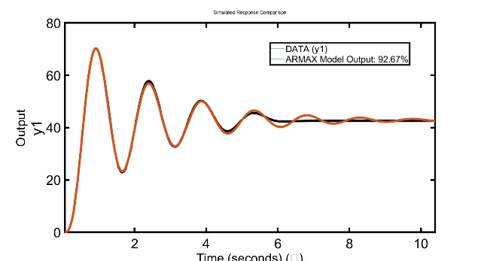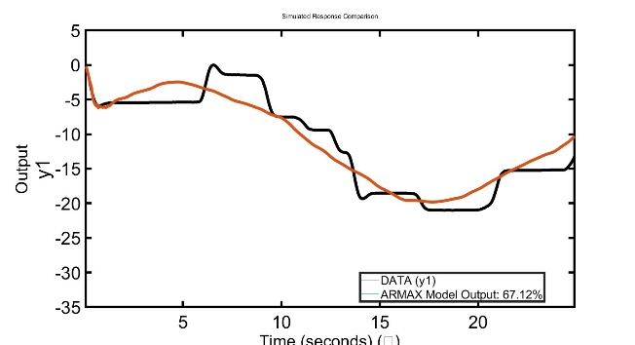
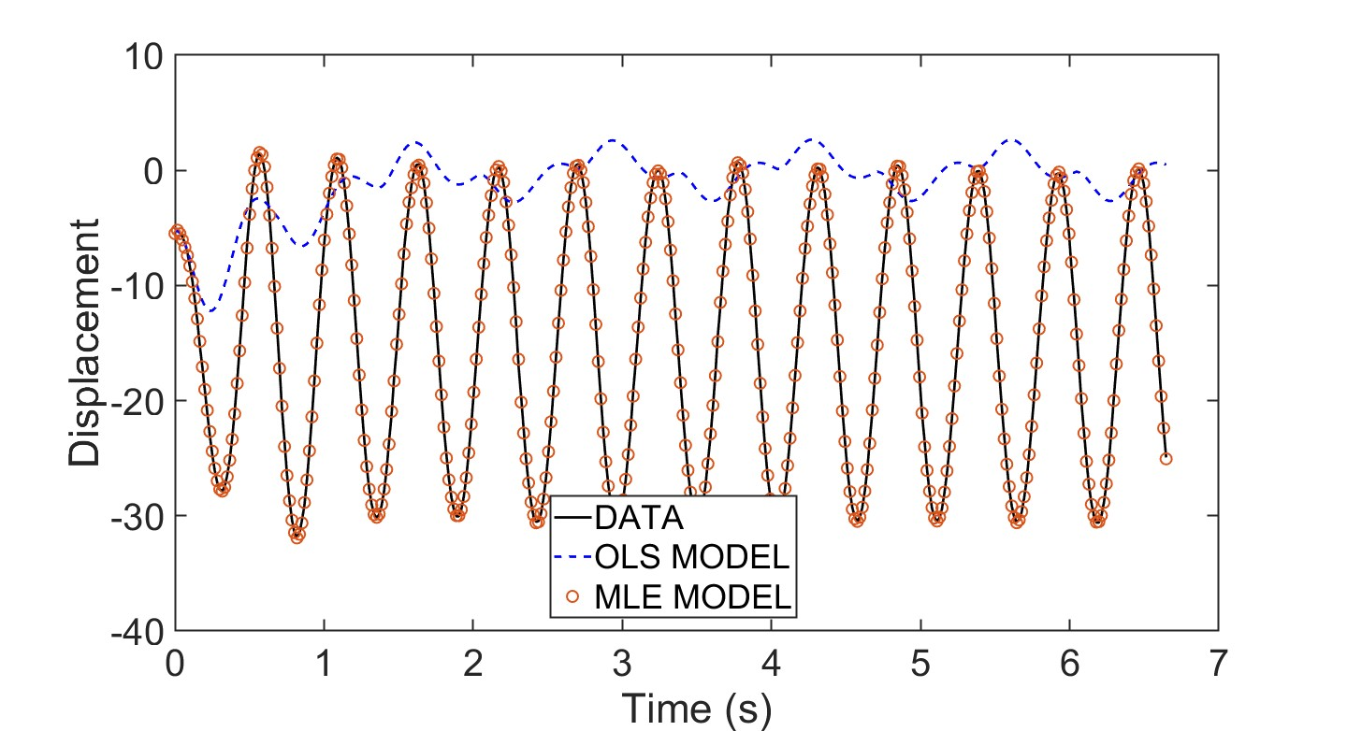`

Fig. 5. Model validation: Measured vs. estimated system output responses to (a) step input, (b) mass-displacement input (white-noise profile, σ²=50), and (c) PRBS excitation (ARX vs. ARMAX, one-step prediction).

4. Conclusion

This study has demonstrated that the Maximum Likelihood Estimation (MLE)-based ARMAX framework offers clear advantages over the Ordinary Least Squares (OLS)-based ARX approach for the parametric identification of stochastic oscillatory systems under random excitation. Experimental results with PRBS and filtered random noise inputs confirmed that the ARMAX model consistently achieved higher time-domain fit, lower mean squared error, and superior residual whiteness, indicating more accurate capture of both the deterministic and stochastic dynamics of the system. Residual analysis revealed that, while the ARX model is structurally simpler and computationally efficient, it left significant autocorrelation in the residuals and exhibited reduced concentration around zero, reflecting incomplete noise modeling. In contrast, the ARMAX formulation effectively whitened the residuals and improved parameter accuracy, thereby enhancing model reliability. These findings highlight the importance of incorporating noise dynamics into the identification process and establish MLE-based ARMAX as a robust and reliable tool for modeling oscillatory systems in the presence of stochastic disturbances.

COMPETING INTERESTS
Authors have declared that they have no known competing financial interests OR non-financial interests OR personal relationships that could have appeared to influence the work reported in this paper.

DISCLAIMER:

The author(s) hereby declare that ChatGPT, was used during the editing of this manuscript solely for grammar correction. No scientific content, data analysis, or interpretation was generated by the AI. The version was GPT-4o, while, the source was OpenAI (https://chat.openai.com).

References

- Simpkins, "System Identification: Theory for the User, 2nd Edition (Ljung, L.; 1999) [On the Shelf]," in IEEE Robotics & Automation Magazine, vol. 19, no. 2, pp. 95-96, June 2012, doi10.1109/MRA.2012.2192817.
- Maddalena, E. T., Scharnhorst, P., & Jones, C. N. (2021). Deterministic error bounds for kernel-based learning techniques under bounded noise. Automatica, 134, 109896. https://doi.org/10.1016/j.automatica.2021.109896
- K. Chen, B. Xiao, C. Wang, X. Liu and S. Liang, "Robust Disturbance Rejection for Nonlinear Dynamic Systems under Multi-Source Complex Disturbances," 2024 36th Chinese Control and Decision Conference (CCDC), Xi'an, China, 2024, pp. 2986-2992, doi: 10.1109/CCDC62350.2024.10587750.
- Q. Zhang, F. Sun, Q. Yuan, J. Li, H. Shen and L. Zhang, "Combined the Data-Driven with Model-Driven Stragegy: A Novel Framework for Mixed Noise Removal in Hyperspectral Image," IGARSS 2020 - 2020 IEEE International Geoscience and Remote Sensing Symposium, Waikoloa, HI, USA, 2020, pp. 2667-2670, doi: 10.1109/IGARSS39084.2020.9323115.
- M. K. Habib, S. A. Ayankoso and F. Nagata, "Data-Driven Modeling: Concept, Techniques, Challenges and a Case Study," 2021 IEEE International Conference on Mechatronics and Automation (ICMA), Takamatsu, Japan, 2021, pp. 1000-1007, doi: 10.1109/ICMA52036.2021.9512658.
- Liewald, M., Bergs, T., Groche, P. et al. Perspectives on data-driven models and its potentials in metal forming and blanking technologies. Prod. Eng. Res. Devel. 16, 607–625 (2022). https://doi.org/10.1007/s11740-022-01115-0
- S. Zhang and Z. Chen, "Reform Research and Practice of Evaluation Model Based on Network Environment Background of Credit System—Linear Algebra and Space Analytic Geometry Curriculum Examination Reform," 2018 9th International Conference on Information Technology in Medicine and Education (ITME), Hangzhou, China, 2018, pp. 549-551, doi: 10.1109/ITME.2018.00127.
- Chernukha, O.; Pukach, P.; Bilushchak, Y.; Bilushchak, H.; Vovk, M. Statistical Modeling of Reliable Intervals for Solutions to Linear Transfer Problems Under Boundary Experimental Data. Math. Comput. Appl. 2025, 30, 89. https://doi.org/10.3390/mca30040089
- Gupta, Arjun & Zeng, Wei-Bin & Wu, Yanhong. (2010). Probability and Statistical Models. 10.1007/978-0-8176-4987-6_1.
- Volosyuk, V.; Zhyla, S. Statistical Theory of Optimal Stochastic Signals Processing in Multichannel Aerospace Imaging Radar Systems. Computation 2022, 10, 224. https://doi.org/10.3390/computation10120224
- Ljung, L., Chen, T., & Mu, B. (2019). A shift in paradigm for system identification. International Journal of Control, 93(2), 173–180. https://doi.org/10.1080/00207179.2019.1578407
- Mould DR, Upton RN. Basic concepts in population modeling, simulation, and model-based drug development-part 2: introduction to pharmacokinetic modeling methods. CPT Pharmacometrics Syst Pharmacol. 2013 Apr 17;2(4):e38. doi: 10.1038/psp.2013.14. PMID: 23887688; PMCID: PMC3636497
- -Salman HE, Yalcin HC. Computational Modeling of Blood Flow Hemodynamics for Biomechanical Investigation of Cardiac Development and Disease. Journal of Cardiovascular Development and Disease. 2021; 8(2):14. https://doi.org/10.3390/jcdd8020014
- Aleidan AA, Abbas Q, Daadaa Y, Qureshi I, Perumal G, Ibrahim MEA, Ahmed AES. Biometric-Based Human Identification Using Ensemble-Based Technique and ECG Signals. Applied Sciences. 2023; 13(16):9454. https://doi.org/10.3390/app13169454
- Myers, P. J., Lee, S. H., & Lazzara, M. J. (2021). Mechanistic and data-driven models of cell signaling: Tools for fundamental discovery and rational design of therapy. Current opinion in systems biology, 28, 100349.
- D. Song, V. Z. Marmarelis and T. W. Berger, "Parametric and non-parametric models of short-term plasticity," Proceedings of the Second Joint 24th Annual Conference and the Annual Fall Meeting of the Biomedical Engineering Society] [Engineering in Medicine and Biology, Houston, TX, USA, 2002, pp. 1964-1965 vol.3, doi: 10.1109/IEMBS.2002.1053117.
- M. Kadem, L. Garber, M. Abdelkhalek, B. K. Al-Khazraji and Z. Keshavarz-Motamed, "Hemodynamic Modeling, Medical Imaging, and Machine Learning and Their Applications to Cardiovascular Interventions," in IEEE Reviews in Biomedical Engineering, vol. 16, pp. 403-423, 2023, doi: 10.1109/RBME.2022.3142058.
- D. N. DeJong, B. F. Ingram, and C. H. Whiteman, “A Bayesian approach to dynamic macroeconomics,” Journal of Econometrics, vol. 98, no. 2, pp. 203–223, 2000, doi: 10.1016/S0304-4076(00)00019-1.

