**Co-Pyrolysis of Beverage Waste for Green Hydrogen Production**

***Abstract—*** *Energy demand continues to increase both in Türkiye and globally, driven by factors such as population growth and industrialisation.* *In Türkiye, the accumulation of organic solid waste further exacerbates ecological challenges, increasing greenhouse gas (GHG) emissions. This study investigates the production of hydrogen-rich syngas as a sustainable alternative to conventional fossil-based energy sources. Among thermochemical conversion methods, pyrolysis was selected due to its relatively lower energy demand and reduced GHG emissions. Waste tea bags and spent coffee grounds were identified as feedstocks based on their high volatile matter content and widespread consumption in Türkiye. Following collection and drying, proximate analyses were conducted to determine the fuel characteristics of the samples. At high temperatures, the coffee and tea bag wastes were pyrolysed individually, and then these wastes were pyrolysed together at a 1:1 ratio. When the pyrolysis data were analysed, it was observed that the co-pyrolysis of the wastes had the highest hydrogen yield, and the higher heating value (HHV) of the synthesis gas (syngas) obtained was greater than that obtained by the individual pyrolysis of the two wastes. As per the proximate analysis results, on a dry basis, tea bags contained 81.62% volatile matter, 3.77% ash, and 14.62% fixed carbon, while coffee grounds contained 95.60% volatile matter, 0.00% ash, and 4.40% fixed carbon. The high volatile matter content observed in both materials is consistent with previous reports on lignocellulosic feedstocks. As a result of co-pyrolysis, the biochar ratio was 22.8%, the tar ratio was 31.6% and the syngas ratio was 45.6%. The highest hydrogen content during the pyrolysis period was measured as 26.30%, and it was observed that the hydrogen ratio, which was low at the beginning, increased with the decrease in the ratio of other gases. the co-pyrolysis process consistently produces a higher proportion of hydrogen compared to the individual pyrolysis of tea bags and coffee grounds: 35.59%, 32.44% and 39.13% for coffee waste, tea bag waste and coffee and tea bag waste, respectively.*

***Keywords—****Coffee Grounds, Energy, Hydrogen, Pyrolysis, Tea Bag Waste*

# Introduction

The reduction in GHG emissions and the replacement of fossil fuels with renewable energy sources are the most important challenges in the development of the economies of all countries in the world. The transition from fossil fuels towards renewable energy sources across countries is possible due to a high level of environmental investment (Wolniak & Skotnicka-Zasadzień, 2022). The primary objective of this project is to develop an alternative to fossil fuels, which are widely utilised for energy production and are major contributors to greenhouse gas (GHG) emissions. To address this, the study focuses on the generation of hydrogen-rich syngas, a clean energy carrier with high energy density and low environmental impact. Additionally, the project aims to mitigate the environmental burden of organic solid waste, which contributes to GHG through degradation processes (Okorafor et al., 2025). In this context, waste tea bags and spent coffee grounds—two biomass residues with high volatile matter content and high consumption rates in Türkiye—were selected as feedstocks. Pyrolysis was employed as the thermochemical conversion technique due to its efficiency in producing hydrogen-rich syngas from biomass. Pyrolysis consists of heating the waste to a certain temperature so that the pyrolysis reaction occurs; the large molecular chains are broken into small molecular chains, and finally, different types of pyrolysis products are obtained (Han et al., 2023). The study further investigates whether co-pyrolysis of the selected wastes enhances hydrogen yield and syngas quality compared to the individual pyrolysis of each feedstock.

Energy plays a central role in economic and social development. Ensuring a sustainable, economical, and secure energy supply directly affects the economic, social, and political agendas of nations (Tunçbilek, 190). Consequently, every country primarily aims to meet its energy needs by utilising its domestic natural resources in the most efficient way (Tunçbilek, 190). However, fossil fuels account for more than 80 per cent of global energy production ("Renewable Energy"). Many countries have begun searching for alternatives to reduce their dependence on petroleum. Alternatives to fossil fuels are renewable energy sources such as hydroelectric, nuclear, solar, wind, geothermal, wave, and tidal energy (Rosen and Koohi-Fayegh 12). One of the primary drivers behind the push for a green economy is the need to decarbonise various sectors. Currently, industries such as steel, chemicals, and refining heavily rely on fossil fuels, contributing to a substantial portion of global greenhouse gas emissions. Replacing fossil fuels with renewable energy, these industries can significantly reduce carbon footprint and play a crucial role in achieving climate goals (Hassan et al., 2025; Sahin et al., 2020). Despite challenges such as infrastructure deficiencies, energy storage issues, and high initial costs in expanding the use of renewable energy, some experts believe that renewable sources could meet all human energy needs in the medium term (Yue et al. 17; T.C Ticaret Bakanlığı).

In Türkiye, 63.12% of energy production comes from thermal power plants, whereas 36.88% is generated from renewable energy sources (İnanç). This distribution highlights the country’s continued dependence on fossil-based energy systems and underscores the need for a more sustainable and diversified energy portfolio. The declining availability of fossil fuel reserves and increasing energy costs have further intensified the shift toward low-carbon energy alternatives. Additionally, Türkiye’s total GHG emissions in 2021 increased by 7.7% compared to 2020, reaching 564.4 million tons of CO2 equivalent (Mt CO2-eq) (*Greenhouse Gas Emissions*). Of these emissions, 71.3% originated from energy-related sources, while the remaining emissions were distributed as follows: 13.3% from industrial processes and product use, 12.8% from agriculture, and 2.6% from the waste sector (*Greenhouse Gas Emissions*). Owing to the high proportion of carbon emissions from the energy sector, transitioning to sustainable energy sources has become a critical need.

Among the proposed solutions for ensuring a sustainable energy supply, hydrogen energy stands out. The European Union aims to increase hydrogen's share in energy consumption to 13-14% by 2050, while Türkiye has developed the "Türkiye National Energy Plan" in line with its 2053 net-zero emission target. Within this plan, the use of hydrogen in the industrial, transportation, and energy sectors is expected to generate economic benefits and reduce carbon emissions ("TÜİK Ulusal"). Hydrogen has a wide range of applications, including industrial processes, rocket fuels, fuel cells, and electricity generation ("Hydrogen Explained"). One of the main reasons for this is its high calorific value. Among known fuels, hydrogen has the highest calorific value per unit mass, approximately 142.80 megajoules per kilogram (MJ/kg), which is significantly higher than that of other fuels (for example, natural gas has a calorific value of 50.00 MJ/kg) (Roldán). Additionally, 9.5 kg of hydrogen can replace 25 kg of gasoline (Nguyen et al. 129). As an important energy carrier, hydrogen is not only storable, transportable, and directly usable as a fuel, but it can also be converted into electricity through fuel cells. Its environmental advantages make it a promising energy solution for the future (Yue et al. 1).

In addition to energy concerns, the waste problem is another critical issue that must be addressed for a sustainable future. Globally, approximately 2.01 billion tons of municipal solid waste are produced annually, and this amount is expected to rise to 3.40 billion tons by 2050 ("Trends in Solid"). Of the waste generated, 19% is composted or recycled, while 31% is sent to landfills ("Trends in Solid"). In Türkiye, an average of 32,324,472 tons of municipal waste is generated annually (Efe 2405). The impact of waste on GHG emissions can be seen in the fact that 19.6% of methane gas emissions in 2022 were caused by waste (*Greenhouse Gas Emissions*).

With technological advancements, various methods have been developed for waste recovery. Thermal processes are one of such methods, and they include incineration, gasification, and pyrolysis. Incineration occurs at combustion chambers at around 850℃ (Jhonke 457). It results in climate-relevant emissions such as CO2, NO2, and NOx (Jhonke 455). Moreover, for every mg of waste, 3,500-5,500 m3 of waste gas is produced (Jhonke 457). Gasification is the thermochemical process that converts biomass into a gas mixture and a solid byproduct fraction under high temperature and with controlled amounts of oxidising agent without combustion (Agapova et al. 12). However, these processes are shown to be less efficient compared to pyrolysis in reducing emissions and meeting energy requirements (Al-Rumaihi et al. 2). Additionally, compared to energy-intensive methods like gasification, pyrolysis requires less energy, facilitates scaling up more easily, and includes portable reactors, making it a preferable option (Seah et al. 2). Pyrolysis is a complex mechanism that thermally disintegrates organic matter into oil, char, and gases (mainly carbonaceous gases, hydrogen, and methane) under

varying temperatures (Al-Rumaihi et al. 2-3). The temperature goes as high as 1000℃ in order to fully break down organic material into its components (Al-Rumaihi et al. 2-3).

To initiate a locally grounded solution, a consumption analysis was conducted at Robert College, Istanbul, Türkiye, focusing on the daily habits of students. Our observations revealed that coffee grounds and tea bags/loose tea were among the most frequently consumed items. In evaluating the suitability of these biomass residues as feedstocks for pyrolysis, two key parameters were considered: volatile matter content and ash content. According to Gao et al ( 2023), an increase in the volatile matter content enhances the syngas yield. Additionally, as cited in the same study, Chan et al. () report that biomass with elevated ash content interferes with catalytic gasification reactions by causing pore blockage and reducing surface reactivity, ultimately lowering the overall syngas yield. Therefore, waste selection prioritises materials with a high volatile matter content and a low ash content.

Türkiye reports a significant level of coffee consumption, with an annual total of 102,660,000 kilograms and an average per capita intake of 1.2 kilograms ("Coffee Consumption"). Spent coffee grounds, a byproduct of this widespread consumption, may pose environmental concerns due to the presence of bioactive compounds such as caffeine and tannins, which can affect soil and aquatic ecosystems if not properly managed (Boğa and Dertli, p. 116). Additionally, when coffee grounds decompose naturally, they release methane gas, which contributes to global warming ("Waste No More"). Moreover, Fernández-Ferreras et al. reported that coffee grounds have a moisture content of 10.5%, a volatile matter content of 76.7%, a fixed carbon content of 20.9%, and an ash content of 2.4% (7). Thus, the high production of coffee waste and its favourable volatile matter and ash content values make coffee grounds a suitable biomass waste for this project.

The total tea consumption of an average Turkish citizen is approximately equivalent to consuming 1,580 tea bags per year, and tea bags are most commonly made from food-grade nylon or polyethylene terephthalate (PET) ("İMÜ Sürdürülebilirlik"). Specifically, the degradation of these polymer-based materials results in the formation of microplastic particles, contributing to the growing issue of microplastic contamination in terrestrial and aquatic environments. Therefore, effective recovery and management strategies for tea bag waste are essential to prevent polymer fragmentation and environmental dispersion. In a study by Lee et al. (2022), proximate analysis of waste tea bags revealed the following characteristics: the tea leaf residue contained 4.2% moisture, 76.6% volatile matter, 18.7% fixed carbon, and 0.5% ash; the polymer bag component exhibited 1.8% moisture, 96.5% volatile matter, 0.6% fixed carbon, and 1.1% ash (p. 3). These physicochemical properties suggest that tea bag waste constitutes a viable biomass feedstock for thermochemical conversion processes in this project.

The co-pyrolysis method was selected as the thermochemical conversion technique for this study due to the use of two distinct waste feedstocks. Co-pyrolysis refers to the simultaneous pyrolysis of biomass and plastic feedstocks (Al-Rumaihi et al. 2). Therefore, this method has the potential to increase the convenience of pyrolysis, improve the efficiency of valuable products, and reduce waste formation (Al-Rumaihi et al. 7). Considering the high consumption rates of tea bags and coffee grounds in Türkiye and the presence of trace plastics in tea bags, a 1:1 ratio co-pyrolysis of these wastes was conducted to investigate possible synergistic effects on syngas yield. Previous studies have indicated synergistic interactions during co-pyrolysis that can positively affect gas composition and energy recovery, though these effects require empirical validation in the context of these specific feedstocks.

Based on this rationale, batch pyrolysis experiments were carried out under elevated temperature conditions at the Istanbul Technical University Synthetic Fuels & Chemicals Technology Centre Laboratories. Literature reviews indicate that co-pyrolysis has been investigated for several types of waste materials. However, there is a gap in the research regarding the co-pyrolysis of waste tea bags and coffee grounds. Through exploring an under-investigated combination of feedstock, this project addresses the mentioned gap by experimentally evaluating the co-pyrolysis behaviour of these two biomass wastes prevalent in Türkiye.

# Methodology

In the methodology section of the project, the collection and drying of raw materials will be explained. Then, characterisation, processes and pyrolysis processes will be discussed.

## Materials and Raw Material Characterisation

Coffee grounds in powdered form, obtained from the industrial coffee machine in Robert College's canteen and from various coffee shops across Istanbul, were used. Similarly, waste tea bags were collected from Robert College. For the characterisation studies, coffee grounds were used as received, while tea bags were cut into pieces smaller than 0.25 mm to ensure homogeneity. Before pyrolysis, the weight of a certain amount of waste was measured on a precision balance to determine the moisture content of the waste. Then, drying was carried out in a Nüve FN 500P oven at 103-105℃ for 60 minutes. The weight of the dried waste was measured, and the moisture percentage of the waste was calculated using equation (1). The proximate analysis of tea bag and coffee waste was carried out in accordance with ASTM D7582 standards in LECO TGA 701 to determine moisture, volatile matter, ash and fixed carbon. The ultimate analysis of carbon, hydrogen, and nitrogen was conducted using an Elementar Vario Macro instrument in accordance with ASTM D5373. Oxygen content was determined by difference based on the elemental composition. The higher heating value (HHV) was measured using a LECO AC-600 instrument following the ASTM D4809 standard.

$$Moisture content, wMMMM=\frac{mass of moisture}{mass of dry soil}×100\%$$

$$=\frac{\left(mass of container+wet soil\right)-\left(mass of container+dry soil\right)}{\left(mass of container+dry soil\right)-\left(mass of container\right)}×100\%$$

## Pyrolysis Tests

In the study, 500 grams of coffee grounds and 250 grams of tea bag waste were pyrolysed separately in a batch pyrolysis system, which was operated as described by Babayigit et al. (2024). A total of 500 grams of the coffee ground and tea bag waste mixture, prepared in a 1:1 ratio by weight, was pyrolysed. The block diagram and the photo of the batch pyrolysis unit are presented in Figures 1 and 2, respectively. The cylindrical flanged tube reactor used in the system was stirred continuously at a rotational speed of 10 Hz (this is units of speed) with blades built on a rotating shaft. The rotation speed of the reactor is set remotely via a control program.

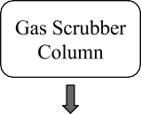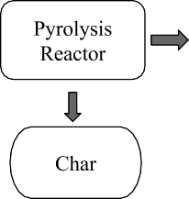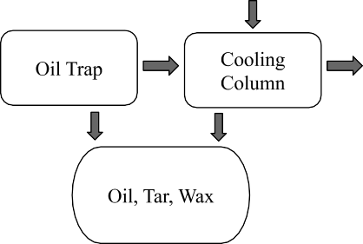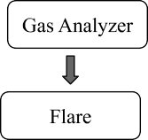

**Figure 1. Block Diagram of Batch Pyrolysis Unit**

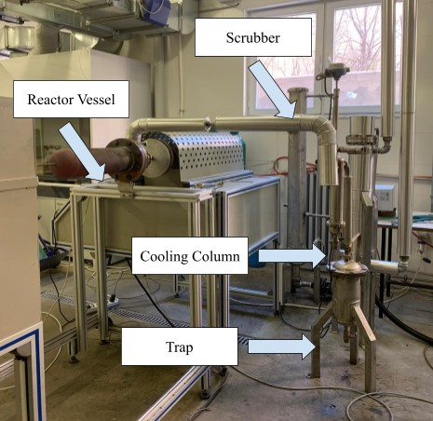

**Figure 2. Batch Pyrolysis Unit**

A purge line positioned on one side of the reactor enables the pyrolysis process to be carried out under either inert or reactive gas conditions. The temperature of the reactor was controlled from the outer surface of the reactor via thermocouples placed inside the furnace. The system also includes a wax/oil trap, a cooling column and an open spray type scrubber. The experiments were conducted over a period of approximately 2 hours, during each of which O2%, CO2%, CO%, H2% and CH4% values were recorded every 5 minutes using the online syngas analyser (MRU SWG 200) shown in Figure 3 and these data were used for graphing. This process has provided important data by monitoring the evolution of gas components over time during the pyrolysis process.

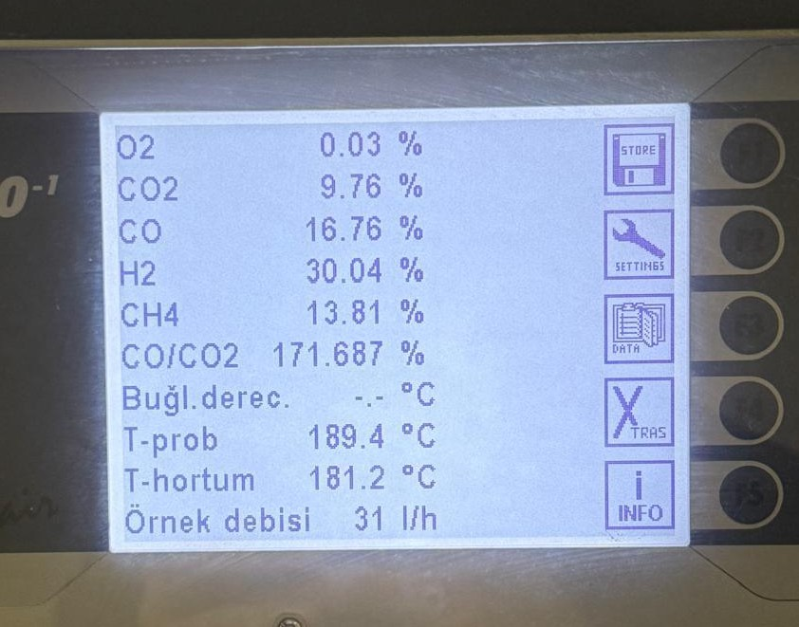

**Figure 3. MRU SWG 20 Syngas Analyser Main Panel**

At the end of the experiments, the reactor was cooled down to ambient temperature under a nitrogen gas atmosphere. The biochar was then removed from the reactor and weighed. Wax, oil and aqueous products were collected from traps and containers under the scrubber and cooling columns, respectively. The gas yield was calculated by subtracting the collected biochar and wax/liquid products from the weight of feedstock fed into the pyrolysis reactor for that batch. All pyrolysis processes were carried out at a temperature of 850 °C and a nitrogen gas flow of 1 L/min. This process represents an important parameter to optimise pyrolysis conditions and increase gas efficiency.

## HHV Calculation of the Syngas

The calorific value of the gas was determined based on its composition, following the ISO 6976 standard. The heating values of H₂, CH₄, CO, CO₂, and N₂ gases employed in the calculations are presented in Table 1 (T. Waldheim, L. Nilsson, 2001).

**Table 1. Syngas Standard Density and HHV Values**

|  |  |  |
| --- | --- | --- |
| **Syngas** | **Density (kg/m3)** | **HHV (MJ/m3)** |
| Hydrogen (H2) | 0.0837 | 12.76 |
| Methane (CH4) | 0.657 | 39.76 |
| Carbon Monoxide (CO) | 1.14 | 12.63 |
| Carbon Dioxide (CO2) | 1.85 | 0 |
| Nitrogen (N2) | 1.25 | 0 |

In the following, only an example calculation of coffee grounds pyrolysis is made, and this calculation is repeated after the other two pyrolysis processes to find the calorific value of the syngas.

* + 1. First, the proportion of each gas in the total syngas mass is multiplied by the standard densities given in Table 1 and these values are summed to obtain the density of the syngas:

|  |  |  |  |  |  |  |  |  |  |  |
| --- | --- | --- | --- | --- | --- | --- | --- | --- | --- | --- |
| *CO2* |  | *CO* |  | *H2* |  | *CH4* |  | *N2* |  | Sum |
| 12.43%  ×  1.87 𝑘𝑔  3  𝑚 | + | 11.37%  ×  1.14  𝑘𝑔  3  𝑚 | + | 19.68% | + | 11.83% | + | 44.56%  ×  1.25 𝑘𝑔  3  𝑚 | = | 1.01 𝑘𝑔  3  𝑚 |
|  |  | × |  | × |  |  |
|  |  | 0.08375 |  | 0.657 |  |  |
|  |  | 𝑘𝑔 |  | 𝑘𝑔 |  |  |
|  |  | 3 |  | 3 |  |  |
|  |  | 𝑚 |  | 𝑚 |  |  |

* + 1. The total syngas is then divided by the gas density to give

0.278 𝑘𝑔

𝑘𝑔

3

### = 0. 27𝑚

1.01 3

𝑚

* + 1. For *CO, H2,* and *CH4* gasesthe percentage value of the gas is multiplied by the previous volume value to give the following:

|  |  |  |
| --- | --- | --- |
| *CO* | *H2* | *CH4* |
| 11.37%×0.27 𝑚3 = 0.031  𝑚3 | 19.68%×0.27 𝑚3 = 0.054  𝑚3 | 11.83%×0.27 𝑚3 = 0.032 𝑚3 |

* + 1. *CO, H2,* and *CH4*’s standard HHV, as given in Table 1, are multiplied by the respective values found in the previous step and then added one by one:

|  |  |  |  |  |  |  |
| --- | --- | --- | --- | --- | --- | --- |
| *CO* |  | *H2* |  | *CH4* |  | Sum |
| 12.63 𝑀𝐽 × 0.031 3  3 𝑚  𝑚 | + | 12.76 𝑀𝐽 ×0.05 3  3 𝑚  𝑚 | + | 39.76  𝑀𝐽 ×0.032 3  3 𝑚  𝑚 | = | 2.37 𝑀𝐽 |

* + 1. The sum value obtained in the previous step is divided by the mass of the syngas obtained from pyrolysis:

2.37 = 8. 52

0.278 𝑘𝑔 𝑘𝑔

* + 1. To convert the value found in the previous step from  𝑀𝐽 to  𝑘𝑐𝑎𝑙 , it will be multiplied

by the constant 239.

### 8. 52 × 239 = 2037. 228 𝑙

𝑘𝑔

𝑘𝑔

𝑘𝑔 𝑘𝑔

The values found through these calculations are provided in Table 3.

# Results and Discussion

# Feedstock characterisation

The moisture content was found to be 10.81% in tea bags and 48.45% in coffee grounds. However, prior to the pyrolysis process, the coffee grounds were left in the open air, reducing their moisture content to 30%. This is within the expected range for raw coffee materials, which typically exhibit moisture contents between 62% and 68% depending on the variety and post-harvest treatment (Zainol et al., 2019).

Proximate analysis results are shown in Table 2. On a dry basis, tea bags contained 81.62% volatile matter, 3.77% ash, and 14.62% fixed carbon, while coffee grounds contained 95.60% volatile matter, 0.00% ash, and 4.40% fixed carbon. The high volatile matter content observed in both materials is consistent with previous reports on lignocellulosic feedstocks. For example, d’Andrés et al. (2021) found that spent coffee grounds, depending on whether they are fresh or spent, may vary in composition—spent coffee grounds, for instance, generally exhibit lower volatile matter (around 64%) and higher fixed carbon due to prior thermal exposure.

The absence of ash in the coffee sample is somewhat lower than the 0.3–0.6% range reported for both raw and roasted coffee (Zainol et al., 2019), but this may be attributed to differences in sample processing, source blend, or limitations in measurement sensitivity. Furthermore, the **ash content in our tea bag sample (3.77%)** is slightly higher thanliterature values, which were **0.5% for biomass** and **1.1% for non-biomass** components, likely due to sample variability or the presence of additives (Kim et al., 2021).

# Product yield distribution

The pyrolysis product distribution at 850 °C has been given for waste coffee grounds, waste tea bags and their 1:1 mixture in Figure 4.

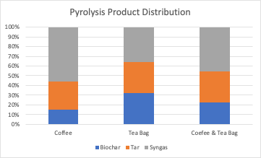

**Figure 4. Coffee Grounds & Tea Bag Wastes Pyrolysis Product Distribution**

According to Figure 4, the biochar obtained as a result of pyrolysis of coffee grounds was 14.8%, tar was 29.6% and syngas was 55.6%. In the case of tea bags, the biochar ratio was calculated as 32.0%, tar ratio as 32.0% and syngas ratio as 36.0%. As a result of co-pyrolysis, the biochar ratio was 22.8%, the tar ratio was 31.6% and the syngas ratio was 45.6%. Figure 5 represents the biochar and bio-oil samples obtained after pyrolysis.

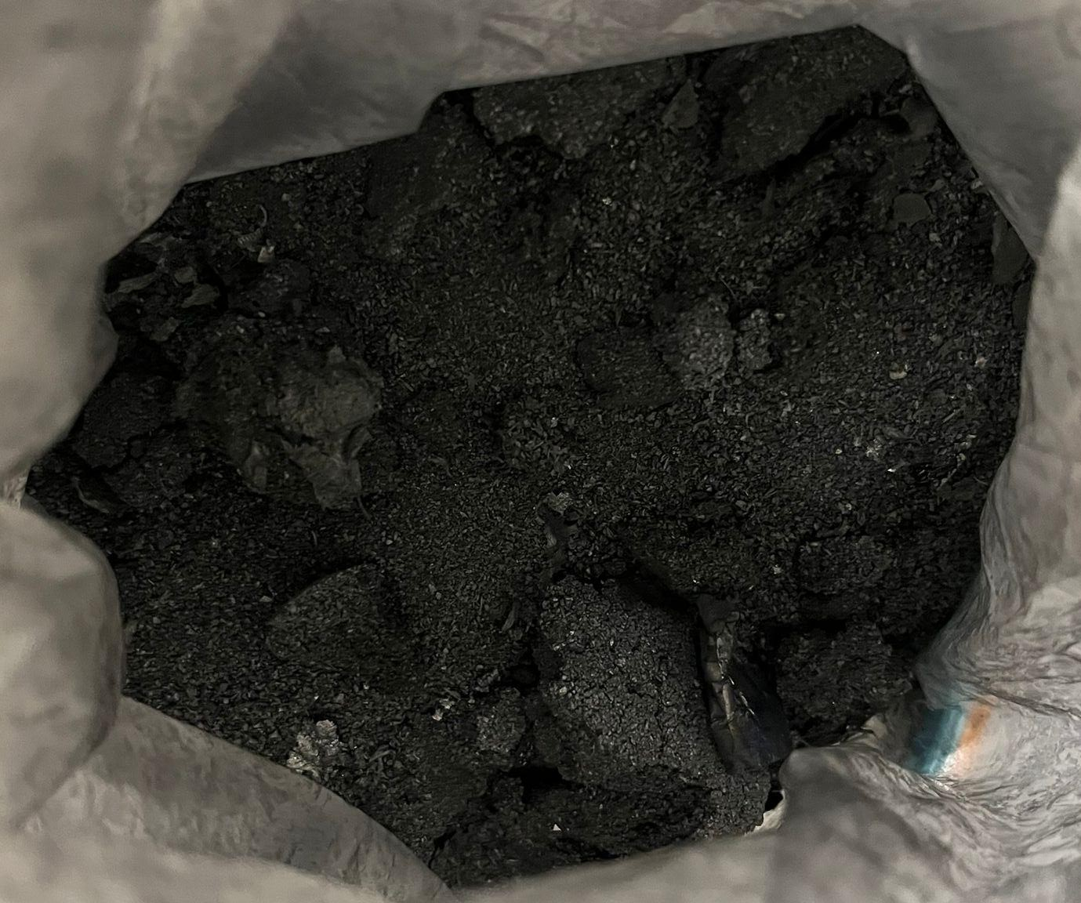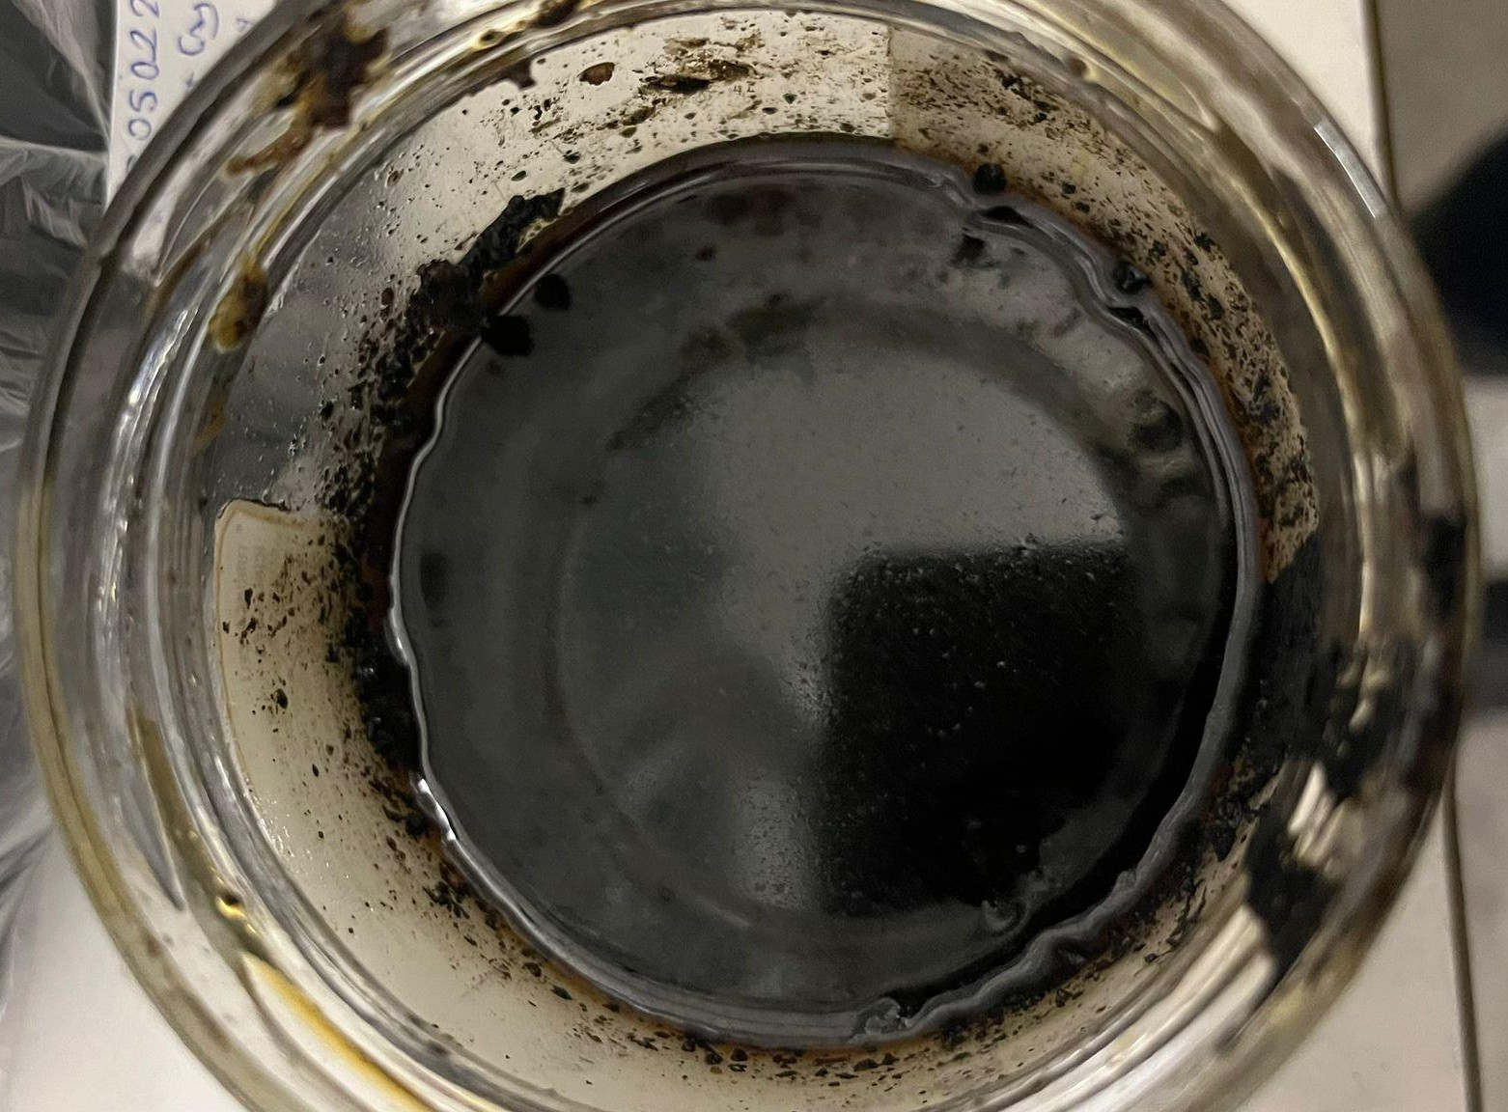

**Figure 5. Biochar (left) and Tar (right) Examples Obtained after Pyrolysis**

The composition of the biomass affects the pyrolysis product yield. Especially, higher ash and fixed carbon values lead to lower hydrogen generation (Garcia et al., 2024, p. 10). In addition, secondary cracking reactions of volatile matter result in higher hydrogen yield (Al & Bayrakdar Ateş, 2022, p. 21). Furthermore, moisture content is an important factor that even subtle changes in it can lead to different outcomes. In order to shift the CO towards H2 with the water gas shift reaction, steam is required. “However, if the moisture content is high, the gasifier will consume more feedstock to generate energy, resulting in CO2 (and hence no H2)” (Lundgren et al., 2025, p. 16).

Considering these factors, the data in Table 2 reveal that coffee grounds—characterised by a high volatile matter content (95.60%) and no ash (0.00%)—produced a higher syngas ratio compared to tea bags, which had lower volatile content (81.62%) and higher ash content (3.77%). Similarly, the higher fixed carbon content in tea bags (14.62%) corresponds to a greater biochar yield than that of coffee grounds, which had only 4.40% fixed carbon. Moisture contents of both feedstocks were within acceptable limits (10.81% for tea bags and 30% for coffee), yet the notably higher volatile matter in coffee appears to have played a dominant role in enhancing gas production.

When tea and coffee were co-pyrolysed, the combination benefited from the complementary properties of both materials. As illustrated in Figure 10, this synergy resulted in a higher syngas ratio than when either material was used alone, suggesting that feedstock blending can be an effective strategy for optimising gas yield in biomass pyrolysis.

# 3.3 Syngas composition

The variation of the distribution of the percentage of syngas obtained as a result of the three pyrolysis processes in units of %Volume with nitrogen with respect to time is given in Figures 5, 6, and 7.

**Figure 6. Gas yield trends of spent coffee grounds over time (with N2)**

During the pyrolysis, hydrogen is produced through the initial “cracking of organic matter to produce non-condensable gases” and through the secondary reaction in which “volatile small-molecule gases form hydrogen-containing compounds” (Zhang et al., 2024). In our case, secondary pyrolysis reactions were prominent. In one-stage pyrolysis, hydrogen-rich syngas can be produced through the cracking of hemicellulose, cellulose, and lignin in the feedstock (Zhang et al., 2024). However, the tar cracking or steam reforming of the products from the one-stage pyrolysis results in more hydrogen generation since heavy hydrocarbons decompose and release hydrogen (Xu et al., 2022, p. 11). According to Figure 6, the highest hydrogen content during the pyrolysis period was measured as 26.30%, and it was observed that the hydrogen ratio, which was low at the beginning, increased with the decrease in the ratio of other gases. Keeping the pyrolysis reaction mechanisms in mind, the mentioned observation can be attributed to the secondary pyrolysis reactions that occurred under the influence of high temperatures. Afterwards, it was observed that the sample was completely pyrolysed and there was a decrease in hydrogen and other gases due to the end of the pyrolysis reactions.

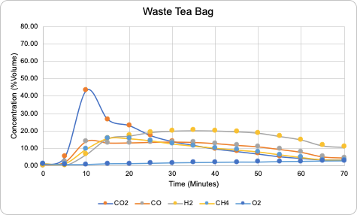

**Figure 7. Gas yield trends of waste tea bag over time (with N2)**

In Figure 7, which shows the composition of the syngas formed as a result of pyrolysis of tea bag waste during the pyrolysis process, the highest hydrogen ratio was recorded as 20.11%. Similar to coffee waste, the hydrogen ratio, which was low at the beginning, increased with the decrease in the ratios of other gases and then decreased after reaching the highest level.

**Figure 8. Gas yield trends of waste tea bag and spent coffee grounds mixture (1:1) over time (with N2)**

The amount of hydrogen produced from co-pyrolysis of coffee and tea bag wastes, shown in Figure 8, increased over time, like in Figures 5 and 6 and then decreased after hitting its peak. According to Figure 8, the highest hydrogen level was 30.32%. This is 4.02% higher than the maximum pyrolysis result of coffee grounds only and 10.21% higher than the maximum pyrolysis result of tea bags only. This increase can be attributed to the synergistic effect of the pyrolysis process between the tea bag and coffee grounds that resulted in an increased hydrogen yield.

**Figure 9. Spent coffee grounds pyrolysis gas product composition (N2-free)**

**Figure 10. Waste tea bags pyrolysis gas product composition (N2-free)**

**Figure 11. Spent coffee grounds & waste tea bags co-pyrolysis gas product composition (N2-free)**

When the syngas compositions measured at 5 intervals in Figures 6,7, and 8 are averaged for each of the three pyrolysis processes, the resulting data are presented in Figures 9, 10 and 11, respectively. A comparison and analysis of these graphs reveals that the co-pyrolysis process consistently produces a higher proportion of hydrogen compared to the individual pyrolysis of tea bags and coffee grounds: 35.59%, 32.44% and 39.13% for coffee waste, tea bag waste and coffee and tea bag waste, respectively.

**Table 3. HHV of the gas products of coffee grounds, tea bags, and their mixture (1:1)**

|  |  |
| --- | --- |
| *Sample* | *Calorific value of Syngas (N2-free, kcal/kg)* |
| *Spent coffee grounds* | *4532* |
| *Waste tea bags* | *3781* |
| *Waste coffee grounds: Waste tea bags (1:1)* | *4568* |

Finally, Table 3 shows that the calorific value of the gaseous product obtained as a result of co-pyrolysis is the highest at 4568 kcal/kg, which clearly shows the positive effect of co-pyrolysis on syngas production.

# Conclusion

In today's world, where energy demand is rapidly increasing, the intensive use of non-renewable energy sources contributes to climate change through GHG emissions while also causing environmental problems. This ongoing trend highlights the pressing need for the development and implementation of sustainable and renewable energy alternatives. At the same time, waste accumulation has become a major environmental concern, both globally and in Türkiye, as improper waste disposal leads to emissions, soil and water contamination, and microplastic formation—environmental impacts that parallel those of fossil fuel consumption. Within this context, the present project explores the application of the pyrolysis method as a thermochemical approach for converting biomass waste into hydrogen-rich syngas. Utilising biomass residues for energy recovery not only supports environmental sustainability by reducing waste volume and associated emissions but also contributes to energy diversification and supply resilience.

Given the significant volume of these wastes directed to landfills and their favourable proximate analysis values for hydrogen generation, three separate pyrolysis experiments were conducted: (1) pyrolysis of tea bag waste as a single feedstock, (2) pyrolysis of coffee grounds as a single feedstock, and (3) co-pyrolysis of both tea bags and coffee grounds at a 1:1 ratio. Analysis of the gas composition revealed that the average hydrogen content obtained from tea bag pyrolysis. When the experimental results were examined, the average hydrogen content in the gas composition obtained from pyrolysis with only tea bags was 32.44% and with only coffee grounds it was 35.59%, and with the pyrolysis of both tea bags and coffee grounds together, it was 39.13%. Similarly, the calorific value of the syngas obtained from the pyrolysis of coffee grounds and tea bag waste was calculated to be 4568 kcal/kg, which is higher than the calorific values of both coffee grounds (4532 kcal/kg) and tea bag waste (3781 kcal/kg). In fact, the co-pyrolysis of the two wastes yielded a hydrogen gas efficiency that reached a much higher level (39.13%) than the theoretical value due to the synergistic effect during the pyrolysis process.

Due to the limited number of studies focusing on the high-temperature co-pyrolysis of tea bag and coffee biomass waste, this research addresses a gap in the literature by conducting co-pyrolysis experiments using a 1:1 ratio of these two feedstocks. The findings demonstrate that hydrogen yield is significantly enhanced through the co-pyrolysis process. The experimental results indicate that the potential of biomass waste in Türkiye to contribute to reducing dependence on fossil-based energy sources. In the future, developing and spreading pyrolysis processes for different biomass wastes in

Türkiye will provide significant contributions to both the environment and the economy by offering local and sustainable solutions for energy transformation.

The study not only addresses both energy and waste issues but also offers solutions to several of the 17 Sustainable Development Goals (SDGs) set by the United Nations, particularly focusing on Goals 9, 11, 12, and most notably, Goals 7 and

13. Hydrogen produced through pyrolysis can serve as a relatively cleaner energy alternative compared to fossil fuels, increasing energy security and reducing carbon emissions (SDG 7). Furthermore, this method provides low-carbon energy for the steel, chemical, and transportation sectors and contributes to the sustainability of Türkiye’s energy infrastructure (SDG 9). The project supports the creation of sustainable infrastructure in cities through the conversion of biomass waste into energy (SDG 11) and promotes the circular economy approach (SDG 12). Finally, hydrogen production reduces fossil fuel consumption, lowering GHG emissions and contributing to the fight against climate change (SDG 13) ("The 17 Goals").

The strengths of the project include environmental sustainability, high-efficiency hydrogen production, evaluation of existing waste, the advantages of the pyrolysis method over other thermal processes, economic potential, and alignment with sustainable development goals. In terms of economic potential, it is predicted that the use of hydrogen in the steel, petrochemical, and transportation sectors will provide significant economic gains. Additionally, evaluating local biomass waste will reduce foreign energy import dependency.

**COMPETING INTERESTS DISCLAIMER:**

Authors have declared that they have no known competing financial interests OR non-financial interests OR personal relationships that could have appeared to influence the work reported in this paper.

Disclaimer (Artificial intelligence)

Option 1:

Author(s) hereby declare that NO generative AI technologies such as Large Language Models (ChatGPT, COPILOT, etc.) and text-to-image generators have been used during the writing or editing of this manuscript.

Option 2:

Author(s) hereby declare that generative AI technologies such as Large Language Models, etc. have been used during the writing or editing of manuscripts. This explanation will include the name, version, model, and source of the generative AI technology and as well as all input prompts provided to the generative AI technology

Details of the AI usage are given below:

1.

2.

3.

**References**

Agapova, A., Dr., Cancian, G., Sever, L., Decorte, M., & Dekker, H. (2024, December). *Gasification: Diversification of biomass processing and waste utilization*. European Biogas Association. https://www.europeanbiogas.eu/

Al, K., & Bayrakdar Ate, E. (2022). Sürdürülebilir hidrojen üretim teknolojileri: Biyokütle temelli yaklaşımlar. *Bartın University International Journal of Natural and Applied Sciences, 5*(1), 18?37. https://doi.org/10.55930/jonas.1101384

Al-Rumaihi, A., Shahbaz, M., Mckay, G., Mackey, H., & Al-Ansari, T. (2022). A review of pyrolysis technologies and feedstock: A blending approach for plastic and biomass towards optimum biochar yield. *Renewable and Sustainable Energy Reviews*, *167*, 1-16. https://doi.org/10.1016/j.rser.2022.112715

Babayiğit, E., Alper, D., Çokgör, E., Okutan, H. C., & Sarıoğlan, A. (2024). High temperature pyrolysis of sewage sludge: Synergistic effects of co-pyrolysis with rice straw and composite plastics wastes. *Heliyon, 10*(21), e39737. https://doi.org/10.1016/j.heliyon.2024.e39737

Boğa, T., & Dertli, E. (2021). Kullanılmış kahve telvesinin lif kaynağı olarak değerlendirilme potansiyeli. *Avrupa Bilim ve Teknoloji Dergisi*, (31), 114-120. https://doi.org/10.31590/ejosat.909736)

*Coffee consumption by country 2024: Lifetime data and statistics*. (2024). Cafely. Retrieved September 14, 2024, from https://cafely.com/blogs/research/which-country-consumes-the-most-coffee?srsltid=AfmBOoqyY_qo3xiTDe05FSoNlBfVaCu86X30GEpMWyX9h76twjR1degi

Efe, Ş. (2022). Günümüzün sürdürülebilir enerjisi kentsel katı atıklar ve türkiye potansiyeli. *Iğdır Üniversitesi Fen Bilimleri Enstitüsü Dergisi*, *12*(4), 2396-2407. https://doi.org/10.21597/jist.1138329

Fernández-Ferreras, J., Llano, T., Kochaniec, M. K., & Coz, A. (2023). Slow pyrolysis of specialty coffee residues towards the circular economy in rural areas. *Energies*, *16*(5), 2300. https://doi.org/10.3390/en16052300

Gao, Y., Wang, M., Raheem, A., Wang, F., Wei, J., Xu, D., Song, X., Bao, W., Huang, A., Zhang, S., & Zhang, H. (2023). Syngas production from biomass gasification: Influences of feedstock properties, reactor type, and reaction parameters. *ACS Omega*, *8*(35), 31568-32221. https://doi.org/10.1021/acsomega.3c03050

Garcia, I., Lopez, G., Santamaria, L., Fernandez, E., Bilbao, J., Olazar, M., Artetxe, M., & Amutio, M. (2024). Biomass source influence on hydrogen production through pyrolysis and in-line oxidative steam reforming. *ChemSusChem, 17*(20), e202400325. https://doi.org/10.1002/cssc.202400325

*Greenhouse gas emissions statistics, 1990-2022*. (2024, June 5). Retrieved August 8, 2024, from https://data.tuik.gov.tr/Bulten/Indexİp=Greenhouse-Gas-Emissions-Statistics-1990-2022-53701&dil=2

*Hydrogen explained: Use of hydrogen*. (2024, June 21). U.S. Energy Information Administration. Retrieved November 10, 2024, from https://www.eia.gov/energyexplained/hydrogen/use-of-hydrogen.php#:~:text=Hydrogen%20has%20many%20actual%20and,or%20replacement%20for%20natural%20gas

*İMÜ sürdürülebilirlik topluluğu çay poşetlerindeki plastik tehlikesine dikkat çekti ve sürdürülebilir çay hediye etti*. (2024, July 3). İMÜ SKA. Retrieved December 14, 2024, from https://sdg.medeniyet.edu.tr/

İnanç, S. (2025, February 3). *Türkiye'nin elektrik üretimi (Ocak-2025)*. Enerji Ajansı. Retrieved February 7, 2025, from https://enerjiajansi.com.tr/turkiyenin-elektrik-uretimi/?utm_source=chatgpt.com#2025_Ocak_Ayi_Turkiyenin_Elektrik_Uretimi_Verileri

Johnke, B. (n.d.). Emissions from waste incineration. *Good practice guidance and uncertainty management in national greenhouse gas inventories*, 455-468.

Kim, S., Lee, N., Lee, S. W., Kim, Y. T., & Lee, J. (2021). *Upcycling of waste teabags via catalytic pyrolysis in carbon dioxide over hzsm-11* [Data set]. https://doi.org/10.1016/j.cej.2021.128626

Lee, N., Kim, S., & Lee, J. (2021). Valorization of waste tea bags via co2-assisted pyrolysis. *Journal of CO2 Utilization*, *44*, 101414. https://doi.org/10.1016/j.jcou.2020.101414

Lundgren, J., Vreugdenhil, B., Ganjkhanlou, Y., & Baldwin, R. (2025, February). *Biomass gasification for hydrogen production*. https://www.ieabioenergy.com/wp-content/uploads/2025/03/IEA-Bioenergy_T33_Bio-H2_Final_v2.pdf

Nguyen, Van G., Nguyen-Thi, T. X., Nguyen, P. Q. P., Tran, V. D., Ağbulut, Ü., Nguyen, L. H., Balasubramanian, D., Tarelko, W., Bandh, S. A., & Pham, N. D. K. (2024). Recent advances in hydrogen production from biomass waste with a focus on pyrolysis and gasification. *International Journal of Hydrogen Energy*, *54*, 127-160. https://doi.org/10.1016/j.ijhydene.2023.05.049

Pujol d'Andrés, R., Montané, D., & Farriol, X. (2021). Comprehensive characterization of spent coffee grounds as a valuable feedstock for biofuels and chemicals. Sustainable Chemistry and Pharmacy, 23, 100515. https://doi.org/10.1016/j.scp.2021.100515

*Renewable energy powering a safer future*. (n.d.). United Nations. Retrieved April 6, 2025, from https://www.un.org/en/climatechange/raising-ambition/renewable-energy

Roldán, J. A. (n.d.). *The calorific power of hydrogen: Unlocking the secret behind its energy*. Juan A. Roldán. Entrepreneur Chemical Engineer. Retrieved November 13, 2024, from https://www.ingenieroemprendedor.com/english/

Rosen, M. A., & Koohi-Fayegh, S. (2016). The prospects for hydrogen as an energy carrier: An overview of hydrogen energy and hydrogen energy systems. *Energy, Ecology and Environment*, *1*(1), 10-29. https://doi.org/10.1007/s40974-016-0005-z

Seah, C. C., Tan, C. H., Arifin, N. A., Hafriz, R., Salmiaton, A., Nomanbhay, S., & Shamsuddin, A. H. (2023). Co-pyrolysis of biomass and plastic: Circularity of wastes and comprehensive review of synergistic mechanism. *Results in Engineering*, *17*. https://doi.org/10.1016/j.rineng.2023.100989

*The 17 goals*. (n.d.). United Nations. Retrieved April 6, 2025, from https://sdgs.un.org/goals

T.C. Ticaret Bakanlığı. (2024, July 19). IEA, küresel elektrik talebinin 2024 yılında yaklaşık %4 artacağını öngörmektedir. *Sektör haberleri*. https://ticaret.gov.tr/

*TÜİK ulusal sera gazı emisyon envanteri yayınlandı*. (2023, March). T.C. Çevre ve şehircilik Ve iklim Değişikliği Bakanlığı. Retrieved February 13, 2025, from https://iklim.gov.tr/tuik-ulusal-sera-gazi-emisyon-envanteri-yayinlandi-haber-1122

*Trends in solid waste management*. (n.d.). The World Bank. Retrieved February 14, 2025, from https://datatopics.worldbank.org/what-a-waste/trends_in_solid_waste_management.html#:~:text=The%20world%20generates%202.01%20billion,from%200.11%20to%204.54%20kilograms.

Tunçbilek, Ö. F. (2024). Hidrojen enerjisi çevresel etkileri üzerine değerlendirmeler [Abstract from DergiPark]. *Ankara Üniversitesi Sosyal Bilimler Dergisi*, 189-197.

Waldheim, T., & Nilsson, L. (2001). *Heating value of gases from biomass gasification*. IEA Bioenergy. http://www.ieatask33.org/app/webroot/files/file/publications/HeatingValue.pdf (Accessed July 4, 2025)

*Waste no more coffee grounds!* (2023, January 18). European Commision. Retrieved December 8, 2024, from https://commission.europa.eu/index_en

Xu, T., Zheng, X., Xu, J., & Wu, Y. (2022). Hydrogen-rich gas production from two-stage catalytic pyrolysis of pine sawdust with nano-NiO/AlO catalyst. *Catalysts, 12*(3), 256. https://doi.org/10.3390/catal12030256

Yue, M., Lambert, H., Pahon, E., Roche, R., Jemei, S., & Hissel, D. (2021). Hydrogen energy systems: A critical review of technologies, applications, trends and challenges. *Renewable and Sustainable Energy Reviews*, *146*. https://doi.org/10.1016/j.rser.2021.111180

Zainol, Z., Anwar, F., Latip, R. A., & Suberu, M. Y. (2019). Characterization and physicochemical properties of coffee beans and ground coffee. Malaysian Food Research Journal, 26(3), 358-365. https://www.myfoodresearch.com/uploads/8/4/8/5/84855864/_10__fr-2019-358_zainol_1.pdf

Zhang, X., Huo, L., Yao, Z., Xie, T., Jia, J., Sun, Y., Zhao, Y., & Zhao, L. (2024). Pyrolysis characteristics and hydrogen production mechanism of biomass impregnated with transition metals. *Journal of Cleaner Production, 474,* Article 143572. <https://doi.org/10.1016/j.jclepro.2024.143572>

Wolniak, R., & Skotnicka-Zasadzień, B. (2022). Development of Photovoltaic Energy in EU Countries as an Alternative to Fossil Fuels. *Energies*, *15*(2), 662.

Han, W., Han, D., & Chen, H. (2023). Pyrolysis of Waste Tires: A Review. *Polymers*, *15*(7), 1604.

Hassan, Q., Al-Jiboory, A. K., Sameen, A. Z., Barakat, M., Abdalrahman, K. Y. M., & Algburi, S. (2025). Transitioning to sustainable economic resilience through renewable energy and green hydrogen: The case of Iraq. *Unconventional Resources*, *5*, 100124.

Okorafor, O. O., Nwakuba, N. R., Chikwue, M. I., Anyanwu, V. K., & Ukaoha, C. U. (2025). Renewable energy development in Nigeria: Prospects, problems and solutions. *Journal of Energy Research and Reviews, 17*(6), 88–101.

Sahin, H. H., Yelmen, B., & Kurt, C. (2020). Management of renewable energy sources and technologies for Turkey. *Asian Journal of Advanced Research and Reports, 11*(3), 26–36.