Opinion Article

Research on the Method of Magnetic Liquid Tilt Sensor
ABSTRACT

This study focuses on the second-order buoyancy mechanism of magnetic liquids and proposes and implements a new type of miniaturized tilt sensor (with a tube length of 80 mm and an inner diameter of 5.5 mm). The paper first systematically reviews the theoretical models and research progress of the first-order and second-order buoyancy of magnetic liquids, pointing out that the second-order buoyancy can achieve the suspension and recovery of permanent magnets without an external magnetic field, providing a new idea for simplifying the structure and reducing the cost of sensors. Subsequently, the expression of the second-order buoyancy of the permanent magnet in the magnetic liquid was derived by using the "double mirror method", and a finite element model was established through COMSOL Multiphysics to simulate and optimize the magnetic field gradient and magnetic stiffness of the restoring magnet. The simulation results show that within the gap range of 0-1 cm, the restoring force rapidly decays from -150 N to -30 N, and the average magnetic stiffness reaches 1.2×10⁴ N/m, verifying the rationality of the magnetic circuit design. The experimental section established a full-range static test platform from 0° to ±40°, which was calibrated based on coal-based magnetic liquid samples. The results show that the output voltage of the sensor is in good linearity with the inclination Angle (fitting curve 0.007x² - 1.12x + 1.9), the hysteresis and repeatability errors are both 2.08%, the comprehensive accuracy is 0.3°, and the size is reduced by more than 20% compared with the traditional structure. This research provides a feasible technical route for the miniaturization and high-precision of magnetic liquid inertial devices.

Keywords: Magnetic liquid; Tilt sensor; Hall element Magnetic field

1. INTRODUCTION

Magnetic liquid, also known as magnetic fluid or ferromagnetic fluid, is a new type of functional material composed of nano-scale magnetic particles (usually Fe3O4 powder particles) highly dispersed in a base carrier liquid. It can remain stable for a long time under the influence of external gravitational fields, electric fields and magnetic fields. Its main components include nano-sized magnetic particles (with an average particle size of about 10 nanometers), base carrier liquid and surfactant. Due to the small volume of the magnetic particles, the magnetic liquid exhibits superparamagnetization. Under the action of a non-uniform magnetic field, the magnetic liquid will be rapidly magnetized and gather in the area with a stronger magnetic field. At the same time, its surface will present a shape similar to spines. The height and shape of the spines are related to the distribution and intensity of the magnetic field (as shown in Figure 1). When the external magnetic field is removed, the magnetic liquid will quickly return to its natural state without hysteresis. ^{[1-3}]At present, magnetic liquid sensing technology has extensive research and broad application prospects in fields such as inertial sensors, power shock absorbers, micro-pumps, and micro-differential pressure sensors.
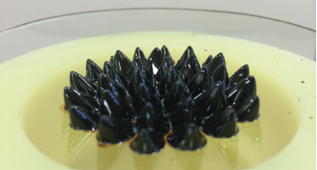
Fig 1.The response of magnetic liquids to magnetic fields
The magnetic liquid tilt sensor is a new type of tilt sensor. Its working principle is that the inertial mass deviates from the equilibrium position and generates a certain displacement under the action of the tilt Angle and the restoring force. The displacement of the inertial mass is converted into an electrical signal by the sensitive element, thereby achieving the measurement of the tilt Angle. Its inertial mass can be classified as: objects containing permanent magnets, non-magnetic objects and magnetic liquids.
Compared with common solid magnetic materials or general liquids, the hydrodynamic properties of magnetic liquids show significant changes under the action of an external magnetic field. According to Archimedes' principle of buoyancy, only objects with a density lower than that of the liquid can remain stably suspended in the liquid. However, under the influence of an external non-uniform magnetic field, objects with a density greater than that of magnetic liquids can still remain stably suspended. This phenomenon can be classified as the "first-order buoyancy principle of magnetic liquids" ^{[4]}. Yao Jie et al. ^{[5]} designed a magnetic liquid tilt/acceleration sensor with a non-magnetic aluminum housing and a non-magnetic copper rod as the inertial mass by taking advantage of the first-order buoyancy characteristics of magnetic liquids. The non-magnetic copper rod is suspended in the magnetic liquid. When the sensor tilts or accelerates, the movement of the non-magnetic copper rod causes the inductance of the inductive coil to change, and the cylindrical magnet provides a restoring force, thereby achieving the measurement of the tilt Angle or acceleration. The non-magnetic copper rod in the shape of a dumbbell can further enhance the linearity and stability of the sensor compared to the cylindrical one. Based on this, Qian Leping et al. ^{[6]} extended this principle and proposed a two-dimensional magnetic liquid acceleration sensor, as shown in Figure 2. Four short rectangular permanent magnets generate a magnetic field, allowing the magnetic liquid to suspend non-magnetic inertial mass. When the sensor moves, it generates acceleration. The movement of the non-magnetic inertial mass causes the inductance of the disc-shaped inductive coil to change, and the four long rectangular permanent magnets provide the restoring force, thereby achieving the measurement of acceleration. This sensor can measure acceleration in two directions and has broader application prospects.
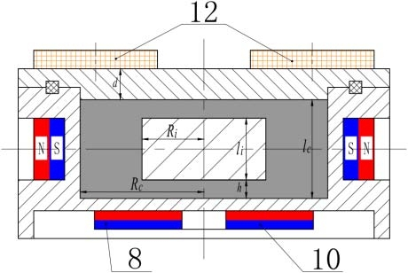
Figure 2 Schematic diagram of a two-dimensional magnetic liquid inertial sensor based on first-order buoyancy characteristics
The second-order buoyancy of a magnetic liquid refers to the additional force generated by the magnetization of nanoscale magnetic particles within the liquid in a non-uniform magnetic field. This causes the buoyancy to change not only with the conventional Archimedes force but also with the variation of the magnetic field intensity and its gradient. In such a magnetic field environment, particles in the magnetic liquid tend to gather in areas with higher magnetic field intensity, thereby exerting an additional push or pull force on the entire liquid, the magnitude of which is proportional to the magnetic susceptibility and the square of the magnetic field intensity ^{[7]-[8]}. Yu Jun et al. ^{[9]} proposed and established a model of a magnetic liquid acceleration sensor that reaches equilibrium under the combined action of magnetic and gravitational fields based on the second-order buoyancy characteristics of magnetic liquids, as shown in Figure 3. When the magnetic liquid is in a static equilibrium state under the interaction of the two field forces, the researchers first established an equilibrium differential equation and then respectively adopted the equilibrium differential equation Three calculation methods, namely the surface area integration method, the magnetic force method and the equivalent magnetic force method, were adopted to derive the second-order buoyancy expression of magnetic liquids and measure it through experiments. Research shows that the calculation results are highly consistent with the experimental results, and the calculation error is less than 7% compared with the numerical range of second-order buoyancy. At the same time, the study also found that as the axial distance between the bottom of the permanent magnet and the container decreases, the second-order buoyancy will increase significantly. This rule lays a solid foundation for more in-depth theoretical analysis and optimization design of the second-order buoyancy characteristics of magnetic liquids in the future. Meanwhile, Yao Jie et al. designed a new type of magnetic liquid tilt sensor based on the second-order buoyancy characteristics of magnetic liquids, as shown in Figure 4. Two rectangular permanent magnets are fixed at the two ends of a non-magnetic connector with opposite polpolarity. These two rectangular magnets will generate a non-uniform magnetic field. A Hall element is fixed on the inner wall of the container at the center of the two magnets. The movement of the magnetic fluid as an inertial mass block around the magnets will change the magnetic field at the Hall element. The Hall element will detect the change in the magnetic field and output a signal. Through theoretical calculation and experimental measurement, satisfactory linearity and high sensitivity were obtained, fully verifying the feasibility of the tilt sensor based on the second-order buoyancy characteristics of magnetic liquids.
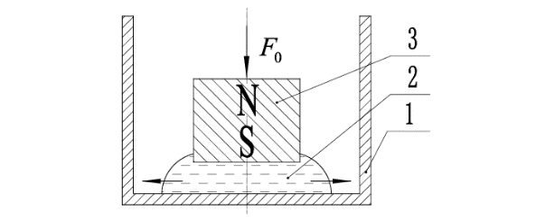
Figure 3 Schematic diagram of the magnetic liquid acceleration sensor based on second-order buoyancy characteristics
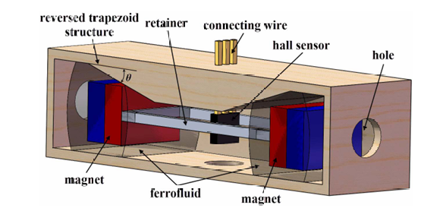
Figure 4 Schematic diagram of the magnetic liquid tilt sensor based on second-order buoyancy characteristics
Based on the above research, this study proposes and designs a new type of magnetic liquid tilt sensor. The restoring force characteristic parameters of the sensor were optimized through simulation analysis, and good linearity and repeatability measurement results were obtained through experimental measurement. This sensor is made of environmentally friendly materials, has a compact structure, low manufacturing cost and high practical value.

2. The second-order buoyancy principle of magnetic liquids
The principle of second-order buoyancy in magnetic liquids specifically refers to the fact that a permanent magnet with a density greater than that of the magnetic liquid can be stably suspended in the magnetic liquid, and when the permanent magnet leaves the center of the magnetic liquid region, a force will be generated that prompts the permanent magnet to return to its initial position. Unlike the principle of first-order buoyancy, since permanent magnets themselves can generate magnetic fields, there is no need to provide an additional external magnetic field.
The principle of second-order buoyancy in magnetic liquids specifically refers to the fact that a permanent magnet with a density greater than that of the magnetic liquid can be stably suspended in the magnetic liquid, and when the permanent magnet leaves the center of the magnetic liquid region, a force will be generated that prompts the permanent magnet to return to its initial position. Unlike the principle of first-order buoyancy, since permanent magnets themselves can generate magnetic fields, there is no need to provide an additional external magnetic field. The calculation of second-order buoyancy is similar to the principle of first-order buoyancy. Since the internal magnetic field of the permanent magnet is saturated, no induced magnetic field will be generated.
Under the premise of ignoring the body force of the permanent magnet, the sensor model is simplified to Figure 5, and its coordinates are shown in the figure. The rectangle in the center of the figure represents a cylindrical permanent magnet with a radius of R and a length of lm. The distance from the bottom boundary of the magnetic liquid, that is, the suspension height, is d. The gray area represents the magnetic liquid, and its length in the axial direction of the permanent magnet is l_{f}. Assuming that the magnetic liquid is uniformly magnetized, its relative magnetic permeability is constant. The other side of the B1 interface is composed of non-magnetic substances such as air.
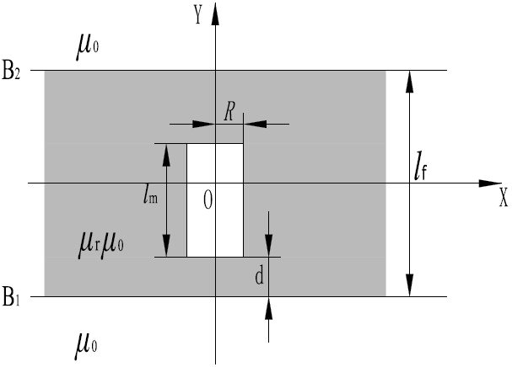
Figure 5 Coordinates for second-order buoyancy calculation
Assuming that the magnetic liquid is infinitely long in the X-axis direction, the mirror current can be obtained by using the mirror method at both ends of the B1 interface.
(2-1)
Figure 6 shows the calculation model of the force between the original energized coil and the mirror coil. The mirror current element below interface B1 is represented by I1dl1, and the original current element above interface B1 is represented by I2dl2, which can be written as
(2-2)
(2-3)
In the formula, dy1 represents the length of the mirror current element along the Y-axis, dy2 represents the length of the original current element along the Y-axis, and R is the radius of the current-carrying coil, that is, the radius of the cylindrical permanent magnet.

The Angle between the mirror current element and the X-axis is θ1, and the Angle between the original current element and the X-axis is θ2. According to the geometric relationship, the distance between the original current element and the mirror current element is
(2-4)
(2-5)

According to the Biot-Savart law, the magnetic field generated by the mirror current element I1dl1 is
(2-6)
Figure 6 Calculation model of the force acting between two coils
Therefore, according to Ampere's rule, the interaction force between current-carrying coils can be obtained
(2-7)
In the formula, represents the unit vector vertically upward.
It is noted that the force obtained is the force of the current-carrying coil at both ends of the interface B1 by applying the mirror image method. Similarly, the mirror image method can be used at both ends of the interface B2 to obtain it
According to the superposition principle, the magnitude of the second-order buoyant force acting on a permanent magnet immersed in a magnetic liquid can be obtained
(2-8)

This method for calculating the magnitude of the second-order buoyancy of magnetic liquids is named the double mirror method.
3. Recovery force simulation

Since the restoring force parameter of the sensor directly determines the range and size of the sensor, this section conducts a simulation study on the restoring force of the magnetic liquid tilt sensor. By establishing a finite element model, a 6* 6-sized return magnet and two permanent magnets in the middle with a size of 4*6mm were adopted. The restoring force composed of two restoring magnets at both ends (200mT) and a permanent magnet in the middle (300mT) was numerically simulated, with the magnet being rubidium magnet N52. Its model diagram and grid division diagram are shown in the figure.

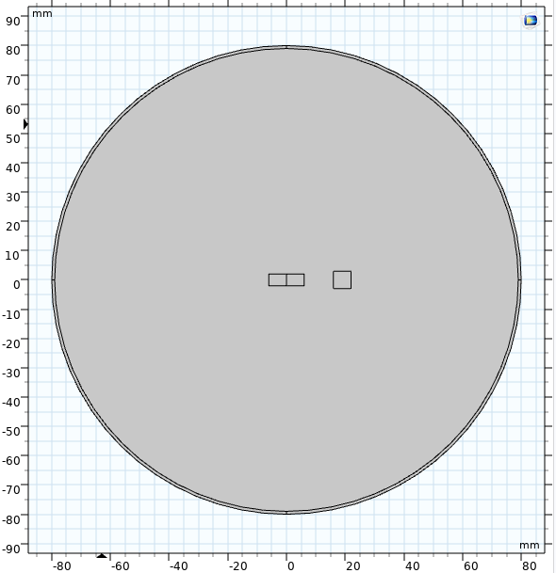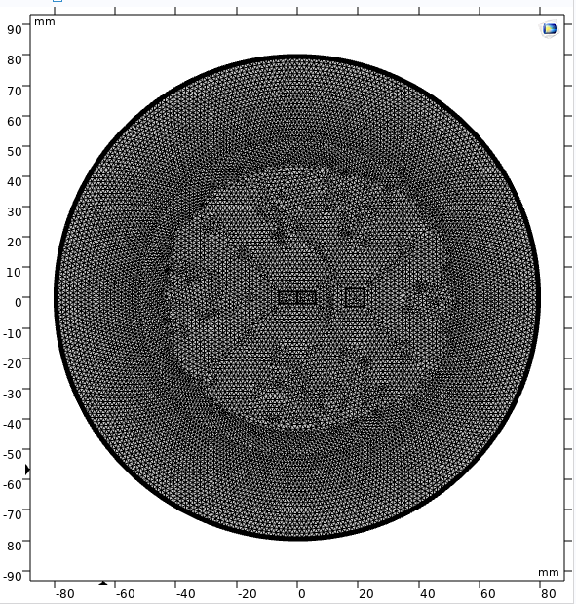

Figure 7 the calculation model diagram of the sensor's restoring force and the grid division diagram

The simulation results are shown in the following figure. Two relatively polar permanent magnets form a distinct dipole-coupled magnetic field within the circular boundary. The magnetic flux density reaches its maximum (approximately 1.17T) near the end faces of the magnets and is concentrated along the space between the two magnets, forming a high-intensity magnetic flux path. However, the magnetic field in the area far from the magnet rapidly decays (< 0.2T), presenting an overall closed loop shape, which conforms to the typical dipole field characteristics and verifies the rationality of the sensor's magnetic circuit design.
The simulation results show that in the designed 85mm long transparent acrylic tube structure, the recovery magnet with a diameter of 6mm and a thickness of 4.5mm and the permanent magnet with a diameter of 4mm and a thickness of 6mm in the middle form a typical magnetic field gradient distribution. The obtained magnetic flux density mode image clearly shows the gradient variation characteristics of the axial magnetic field intensity, while the magnetic scale potential distribution intuitively reflects the attenuation law of magnetic potential energy in space. It is particularly worth noting that the symmetrical magnetic field generated by the centered arrangement of the permanent magnet and the reverse magnetic field formed by the returning magnets at both ends produce a specific gradient in the middle area of the acrylic tube. This magnetic field configuration provides the necessary field strength gradient conditions for the displacement detection of the magnetic liquid under the action of acceleration. The simulation results verified the rationality of the sensor's magnetic circuit design, providing a theoretical basis for the subsequent research on the dynamic characteristics of magnetic liquids.The simulation results show that in the designed 85mm long transparent acrylic tube structure, the recovery magnet with a diameter of 6mm and a thickness of 4.5mm and the permanent magnet with a diameter of 4mm and a thickness of 6mm in the middle form a typical magnetic field gradient distribution. The obtained magnetic flux density mode image clearly shows the gradient variation characteristics of the axial magnetic field intensity, while the magnetic scale potential distribution intuitively reflects the attenuation law of magnetic potential energy in space. It is particularly worth noting that the symmetrical magnetic field generated by the centered arrangement of the permanent magnet and the reverse magnetic field formed by the returning magnets at both ends produce a specific gradient in the middle area of the acrylic tube. This magnetic field configuration provides the necessary field strength gradient conditions for the displacement detection of the magnetic liquid under the action of acceleration. The simulation results verified the rationality of the sensor's magnetic circuit design, providing a theoretical basis for the subsequent research on the dynamic characteristics of magnetic liquids.
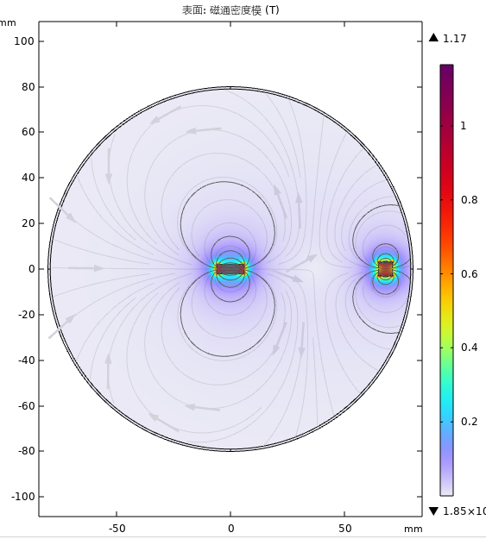
Figure 8 Schematic diagram of the magnetic flux density mode of permanent magnets

According to the comsol simulation result data, as shown in the relationship diagram 9 of its conductive force, when two permanent magnets approach each other, they generate a significant attractive force (negative values indicate the direction of attraction), with a maximum of approximately 150 N. As the gap increases, the force decays rapidly and almost drops to zero at 0.05m, demonstrating typical short-range strong coupling characteristics. During the gap variation from 0 m to 0.01 m, the attractive force decreases from -150 N to approximately -30 N, with a variation of about 120 N. The corresponding average magnetic stiffness is approximately 1.2×10⁴ N/m, indicating that the system is extremely sensitive to the change in spacing. The overall curve shows a monotonically rapid attenuation trend, which is more in line with the power-law or exponential attenuation law rather than nonlinear attenuation.
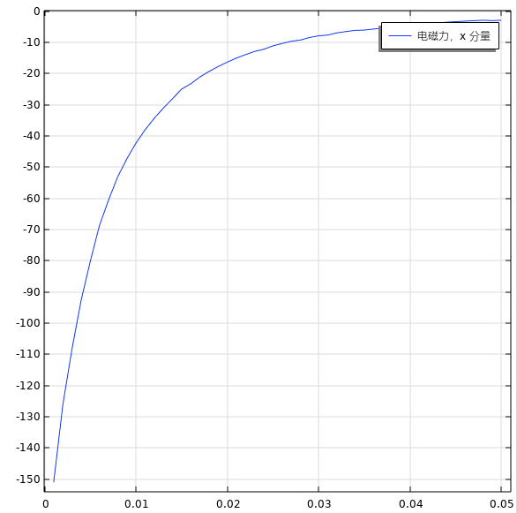
Figure 9 Simulation schematic diagram of the sensor's restoring force and restoring distance
- Static experiment of magnetic liquid tilt sensor
  - Experimental Platform Construction
In this study, the design of the sensor is based on the second-order buoyancy principle of magnetic liquids. This design method fully takes into account the static response and stability issues that sensors encounter during actual operation, and also utilizes the unique physical properties of magnetic liquids to achieve high-precision Angle measurement. The overall structural design of the sensor has been meticulously planned and optimized to ensure it maintains excellent performance under various working conditions.
The specific structure of the sensor model is shown in Figure 10. The parameters are presented in detail in table form in the text. The determination of these parameters is based on an in-depth understanding of the working principle of the sensor and a comprehensive consideration of the actual application requirements. By precisely setting these parameters, the sensor can achieve the best measurement effect within a specific working range, while ensuring its adaptability and reliability under different environmental conditions. Compared with the previous research on magnetic liquid tilt sensors, the length was basically over 100mm and the inner diameter was over 25mm. Therefore, this study has been very successful in miniaturizing the tilt sensor.
The measurement principle of the sensor is the core of its design and also the key to achieving tilt Angle measurement. In this study, the sensor utilizes the second-order buoyancy principle of magnetic liquids to indirectly obtain the magnitude of the inclination Angle by measuring the displacement of the inertial mass. When the sensor is subjected to external acceleration, the inertial mass will produce a corresponding displacement, and this displacement can be precisely measured by specific detection methods. By converting the displacement signal into an electrical signal and combining it with the static model of the sensor for data processing, an accurate tilt Angle measurement result can ultimately be obtained.
This sensor design based on the principle of second-order buoyancy is not only innovative in theory but also demonstrates excellent performance in practical applications. Through precise structural design and reasonable parameter configuration, the sensor can operate stably in complex dynamic environments, providing a brand-new, efficient and reliable solution for acceleration measurement.
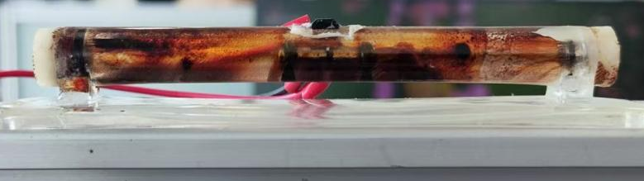
Figure 10 the specific structure of the sensor model
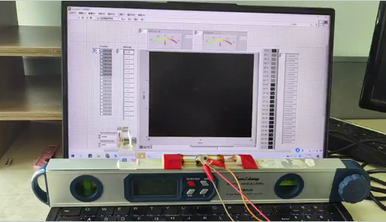
Figure 11 Sensor model diagram and experimental platform
Table 1 Sensor Structure Parameters
Pipe chief  mm | Inner diameter of the pipe  mm | Outer diameter of the pipe  mm | The base is long  mm | Base width  mm
80 | 5.5 | 9 | 100 | 20
  - Static performance indicators of magnetic liquid tilt sensors
The static performance of magnetic liquid tilt sensors is an important basis for evaluating their measurement accuracy and reliability, mainly including key indicators such as linearity, hysteresis, repeatability, resolution and threshold. These indicators comprehensively reflect the working characteristics of the sensor under steady-state conditions and serve as the foundation for optimizing sensor design and verifying its performance.
Linearity characterizes the degree of linear relationship between the output and input tilt angles of a sensor, defined as the percentage of the maximum deviation between the actual characteristic curve and the fitted straight line to the full-scale output. For magnetic liquid tilt sensors, their linearity is mainly affected by the rheological properties of the magnetic liquid and the uniformity of the magnetic field distribution. Experiments show that optimizing the concentration of magnetic particles and the ratio of surfactants can significantly improve linearity.
Hysteresis is the non-coincidence of the forward and reverse strokes of a sensor, reflecting the inconsistency of the output signal of the sensor during the forward and reverse strokes. It is caused by factors such as the viscoelasticity of magnetic liquids and the friction of sealing structures. When calculating, take the percentage of the maximum difference between the forward and reverse strokes to the full scale. By improving the thixotropy of magnetic liquids and reducing the friction of moving parts, this error can be effectively reduced. The formula is as follows.
$γ_{H}=±\left(1/2\right)\left(Δ_{H_{max}}/y_{FS}\right)×100\%$ （4-1）
Repeatability refers to the degree of inconsistency in the output of a sensor when it is input multiple times. It describes the consistency of the output when the sensor measures the same acceleration multiple times under the same conditions and is evaluated through the degree of dispersion of multiple test data. The repeatability error of magnetic liquid sensors mainly stems from particle sedimentation and temperature fluctuations, and the formula is as follows.
$γ_{R}=±\left(Δ_{R_{max}}/y_{FS}\right)×100\%$ （4-2）
Resolution refers to the smallest input increment that a sensor can detect. Resolution is expressed in absolute terms. When expressed as a percentage of the full scale, it is called resolution. The resolution near the zero point of the sensor input is called the threshold.
These static performance indicators are interrelated and jointly determine the comprehensive accuracy of the sensor. By combining theoretical calculation with experimental testing, the static characteristics of magnetic liquid tilt sensors can be systematically evaluated, providing an important basis for subsequent performance research and engineering applications.
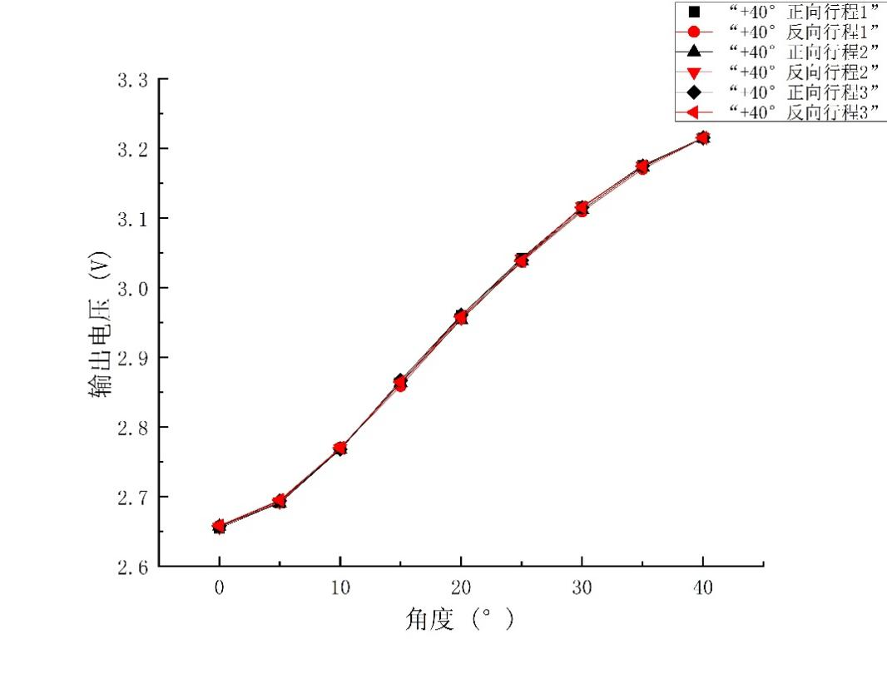
Figure 12 Schematic diagram of the sensor's variation from 0° to 40°
Figure 12 shows the relationship between the sensor's output voltage and the Angle. The horizontal axis represents the Angle (from 0° to 40°), and the vertical axis represents the output voltage (from 2.6V to 3.3V). The figure contains six sets of data, each represented by different marks and colors, which may represent measurement results under different conditions. All datasets show a trend that the output voltage increases with the increase of the Angle, indicating that the output voltage of the sensor is positively correlated with the Angle. At 0° C, the voltage value is approximately between 2.6V and 2.7V, while at 40° C, it is approximately between 3.2V and 3.3V, with the voltage increasing by approximately 0.6V. The voltage variation trends of these datasets are similar, but the specific voltage values may vary slightly, which might be due to the differences in sensor sensitivity at different positions or under different conditions.
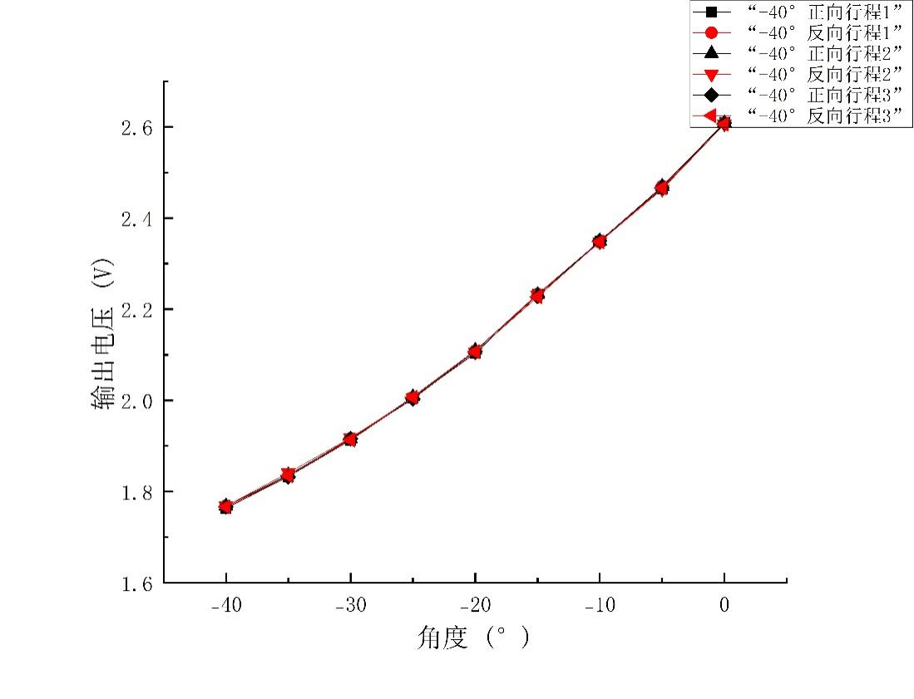
Figure 13 Schematic diagram of the sensor's variation from -40° to 0°
Figure 13 shows the linear relationship between the sensor output voltage and the Angle, where the horizontal axis represents the Angle (from -40° to 0°), and the vertical axis represents the output voltage (from 1.6V to 2.6V). The figure contains six sets of data, each represented by different markers and colors, which may represent different test conditions or sensor configurations. All datasets show a trend of linear increase in output voltage as the Angle increases, indicating a stable linear relationship between the sensor's output voltage and the Angle. At -40° C, the voltage value is approximately between 1.7V and 1.8V, while at 0° C, it is approximately between 2.5V and 2.6V, with the voltage increasing by approximately 0.8V to 0.9V.
By integrating the information from the two charts, we can determine the measurement range of the sensor. The sensor can measure an Angle range from -40° to 40°, covering a total of 80°. Within this angular range, the voltage output range of the sensor is from 1.6V to 3.3V, which means that the voltage range of the sensor is 1.7V.
According to the formula calculation, the performance parameters of the coal-based sensor can be known. Among them, the fitting curve is 0.007x² - 1.12x + 1.9, the hysteresis and repeatability are both 2.08%, the accuracy is 0.3°, and the single-sided range is 40 degrees. These parameters jointly describe the accuracy and reliability of the sensor experiment during the measurement process.
5.Summary & CONCLUSION
Theoretical level: The physical essence of the second-order buoyancy of magnetic liquids has been clarified, namely the synergistic effect of "self-field of permanent magnets + liquid magnetization gradient". The proposed double mirror method has a calculation error of less than 7%, laying a theoretical foundation for the subsequent design of high-precision sensors.
Simulation level: For the combination of magnets with a pipe length of 85 mm and a diameter of 6 mm, a dipole coupling magnetic field with high gradient and low leakage flux was obtained. The short-range and strongly coupled characteristics of the restoring force provide sufficient rigidity for the ±40° range.
Experimental level: The miniaturization (80mm × 20mm × 9mm) and batch production potential of the sensor have been achieved. The key static indicators (linearity, hysteresis, and repeatability) all meet the requirements of industrial-grade MEMS tilt sensors.
Application prospects: In the future, the resolution can be further enhanced to within 0.05° through means such as temperature compensation, digital closed-loop processing, and 3D printing integrated packaging, and it can be extended to scenarios such as vibration monitoring, unmanned aerial vehicle attitude control, and structural health inspection.

Disclaimer (Artificial intelligence)
Option 1:
Author(s) hereby declare that NO generative AI technologies such as Large Language Models (ChatGPT, COPILOT, etc.) and text-to-image generators have been used during the writing or editing of this manuscript.
Option 2:
Author(s) hereby declare that generative AI technologies such as Large Language Models, etc. have been used during the writing or editing of manuscripts. This explanation will include the name, version, model, and source of the generative AI technology and as well as all input prompts provided to the generative AI technology
Details of the AI usage are given below:
1.
2.
3.

References

- Felicia L J , Vinod S , Philip J .Recent Advances in Magnetorheology of Ferrofluids (Magnetic Nanofluids)—A Critical Review[J].Journal of Nanofluids, 2016, 5(1):1-47.DOI:info:doi/10.1166/jon.2016.1203.
- Sousa,A,C,et al.Hybrid nanofluids preparation, thermal properties, heat transfer and friction factor - A review[J].Renewable & sustainable energy reviews, 2017, 68(Feb. Pt.1):185-198.
- Ahmad S H A, Saidur R, Mahbubul I M, et al. Optical properties of various nanofluids used in solar collector: A review[J]. Renewable and Sustainable Energy Reviews, 2017, 73: 1014-1030.
- Li Decai, Hao Du. Research Progress on Key Issues of Magnetic Liquid Rotary Seal [J]. Journal of Vacuum Science and Technology, 2018, 38(7): 564-574.Yao J, Huang C, Li D. Research on a novel ferrofluid inertial sensor with levitating nonmagnetic rod[J]. IEEE Sensors Journal, 2015, 16(5): 1130-1135.
- Qian L, Li D, Yu J. The theoretical and experimental study of a novel two-dimensional magnetic fluid accelerometer[J]. IEEE Sensors Journal, 2016, 16(23): 8412-8419.
- Yu J, Hao D, Li D. A novel method for calculating and measuring the second-order buoyancy experienced by a magnet immersed in magnetic fluid[J]. Journal of Physics D: Applied Physics, 2017, 51(1): 015002.
- Yu J, He X, Li D, et al. Boundary interface condition of magnetic fluid determines the magnetic levitation force experienced by a permanent magnet suspended in the magnetic fluid[J]. Physics of Fluids, 2018, 30(9).
- Yu J, He X, Li D, et al. Effective and practical methods to calculate the second-order buoyancy in magnetic fluid acceleration sensor[J]. IEEE Sensors Journal, 2018, 18(6): 2278-2284.

