AI-Enabled Design Simplification through Functional Part Clustering and Consolidation

ABSTRACT
This paper presents a novel approach to product design optimisation through the integration of artificial intelligence techniques for part clustering and consolidation. In today’s competitive industrial environment, there is a growing demand for products that are cost-effective, efficient to manufacture, and easy to assemble. This study aims to design simplification through AI-enabled part clustering and consolidation. Traditional design methods often result in assemblies with a high number of discrete components, leading to increased manufacturing complexity, cost, and assembly time. To address this, we propose a framework that leverages unsupervised learning algorithms such as K-means clustering to group similar components based on functional, material, and geometrical attributes. In addition, convolutional neural networks (CNNs) are explored for pattern recognition in 3D models to identify consolidation opportunities. A legacy mechanical product is selected as a case study to demonstrate the practical application of the method. The results reveal a reduction in part count, improved modularity, and enhanced manufacturability, validating the effectiveness of AI-assisted design simplification. This approach offers a promising direction for next-generation engineering design practices, particularly in contexts where light weighting, cost-efficiency, and sustainability are critical. Overall, the analysis reflects a design philosophy that prioritizes prioritises low-cost production, efficient assembly, and functional minimalism, making the product well-suited for high-volume manufacturing and consumer use.

KeyWords

Part Consolidation, K-means Clustering, Convolutional
Neural Networks (CNN), Artificial Intelligence, Product Reengineering, Modular Design.

INTRODUCTION

In today’s competitive industrial environment, there is a growing demand for products that are cost-effective, efficient to manufacture, and easy to assemble. To meet these demands, manufacturers are adopting strategies like part consolidation, which involves merging multiple components into fewer, multifunctional parts. This practice not only reduces production and assembly costs but also minimises material waste and enhances overall product performance and sustainability [1]. Historically, part consolidation has been guided by expert judgment and manual analysis. However, these traditional methods can be time-consuming and error-prone, especially in large assemblies. The integration of Artificial Intelligence (AI) and data-driven techniques offers a scalable and systematic alternative. Artificial Intelligence (AI) refers to the ability of machines to mimic human intelligence and perform tasks that typically require human intelligence, such as learning, problem-solving, decision-making, and natural language understanding. Depicts AI technologies including machine learning, natural language processing, robotics, and computer vision (Aldoseri et al., 2023; Yella & Kondam, 2023). Clustering algorithms and deep learning methods can be employed to automatically identify similar or redundant components based on various features such as function, material, and joining method [2]. This paper focuses on using K-means clustering and Convolutional Neural Networks (CNNs) to identify consolidation opportunities in mechanical assemblies. A case study involving a table fan assembly is used to demonstrate how AI tools can streamline part analysis, helping designers create modular, efficient, and manufacturable products [3]. Forming part families is essential for modular design and efficient manufacturing. Grouping components with similar geometry, material, or function simplifies production planning and supports part consolidation. Clustering is the process of grouping the data based on their similar properties. Meanwhile, it is the categorisation of a set of data into similar groups (clusters), and the elements in each cluster share similarities, where the similarity between elements in the same cluster must be smaller enough to the similarity between elements of different clusters. Hence, this similarity can be considered as a distance measure. One of the most popular clustering algorithms is K-means, where distance is measured between every point of the dataset and the centroids of clusters to find similar data objects and assign them to the nearest cluster (Ghazal, 2021). Clustering algorithms, especially K-means, have emerged as effective tools for this purpose. Gupta et al. [4] proposed a two-stage K-means method to identify part families in reconfigurable systems, showing improved grouping efficiency. Chattopadhyay et al. [5] applied self-organising maps (SOM) for machine-part clustering, allowing for visual interpretation of complex data. Sengupta et al. [6] combined fuzzy ART with K-means in a hybrid framework, enhancing clustering accuracy. To address K-means limitations like poor initialisation,
Xia et al. [7] explored convex clustering for better stability in large datasets. Additionally, Zhang et al. [8] used CAD-based feature vectors with improved K-means++ to guide consolidation in aerospace assemblies. Design for Manufacturing and Assembly (DFMA) plays a central role in reducing part count and simplifying designs. The methodology, pioneered by [9], proposed a decision-support system that uses CAD data to flag complex regions for redesign. Similarly, Rahmani and Arezoo [10] demonstrated that combining DFMA metrics with clustering can significantly reduce assembly effort and improve modularity. AI and Neural Networks in Part Analysis. AI techniques, especially neural networks, are increasingly used to automate part recognition and analysis. CNNs have proven effective for identifying geometric and functional similarities in components, thus facilitating clustering and simplification [11]. An autoencoder is an unsupervised learning model which can automatically learn data features from a large number of samples and can act as a dimensionality reduction method. With the development of deep learning technology, the autoencoder has attracted the attention of many scholars. Researchers have proposed several improved versions of autoencoders based on different application fields (Li et al., 2023). Autoencoders and deep feature extractors learn part representations from CAD models, helping to uncover redundancy across complex assemblies [12]. Integrating these models into DFMA workflows reduces manual intervention, speeds up the analysis process, and leads to better design decisions early in product development. Industry Applications of Clustering for Consolidation. Clustering has been adopted across various industries to reduce part complexity and improve product modularity. In the automotive sector, it supports platform standardisation and reduces tooling requirements [13]. Aerospace manufacturers use clustering to detect redundant fasteners and brackets, which simplifies maintenance and lowers inventory [14]. Consumer electronics firms consolidate internal components through clustering, maintaining performance while simplifying structure [15]. In additive manufacturing, clustering results enable the design of integrated parts that replace multi-part assemblies. Additive Manufacturing (AM) uses the technique of joining materials, usually layer upon layer, to make objects, as opposed to subtractive manufacturing (SM) or conventional manufacturing (CM) where an object is made by removing material processes such as turning, drilling, and milling. AM has many advantages over traditional manufacturing (Khalid & Peng, 2021; Struzziero et al., 2021). Overall, clustering supports continuous product optimisation, offering economic and sustainability benefits throughout the product lifecycle [15].

METHODOLOGY

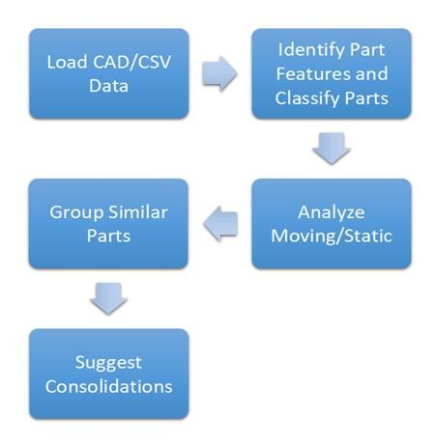
Figure 1:Methodology of Part Clustering and
Consolidation

The AI-enabled DFMA methodology applied to the table fan design followed a structured, data-driven process focused on reducing part count and improving manufacturability. The process began by loading the part-level data from either CAD models or structured CSV files containing relevant attributes such as function, material, joining method, and whether the part is moving or static. Once the data was loaded, each component was classified based on its role (e.g., support, protect, rotate), material composition, and assembly method. A key step in this analysis involved distinguishing between moving and static parts, as static components are typically more suitable for consolidation. Based on this classification, parts with similar function, material, and joining characteristics were grouped to identify redundancy. These groups were then analysed for consolidation potential, and suggestions were made to combine parts where feasible—streamlining the design and enhancing manufacturing efficiency. The overall methodology used in this project is visually summarised in Fig. 1, which illustrates the sequence of steps involved in the DFMA-based consolidation workflow (see Fig. 1).

DESIGN OVERVIEW

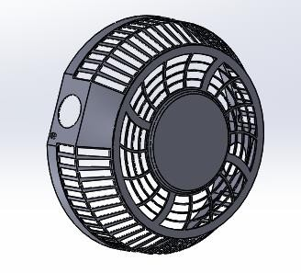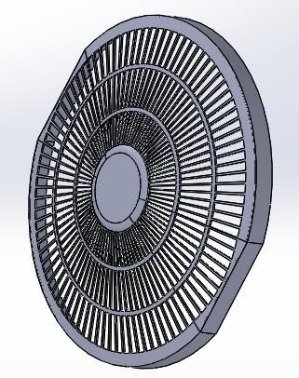The product under investigation for DFMA (Design for Manufacturing and Assembly) evaluation is a compact electric table fan. The entire fan has been digitally modelled using computer-aided design (CAD) software to enable structural and functional analysis. The assembly consists of multiple components, each fulfilling a distinct function in the overall operation and user interaction. The major components of the design are

Figure 2 (a): Front Grills (b): Rear Grills

These covers serve as protective barriers for the rotating fan blades. They are radially patterned for airflow and safety, and they represent a significant portion of the plastic volume in the product. Due to their symmetry and repetitive geometry, they are prime candidates for part consolidation or mould optimisation.

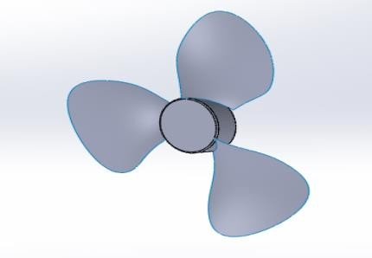

Figure3: Fan
The component shown in Fig. 4 is the motor enclosure, which serves as a critical static part in the table fan assembly. It houses the internal motor and provides mounting support for the fan blades. Designed with vertical rib-like structures, this enclosure ensures mechanical stability and proper alignment of the motor
with the rest of the assembly. These structural ribs also aid in heat dissipation and increase the part’s
stiffness. Given its symmetry, repetitive geometry, and material uniformity, this part presents a strong

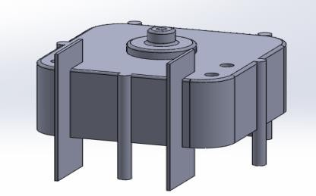Figure 4: Motor and Housing
candidate for design optimisation or consolidation with adjoining support elements to reduce part count and simplify manufacturing processes (see Fig. 4).

The component shown in Fig. 5 is the base support bracket, which functions as the foundational structural element of the table fan assembly. It anchors the entire fan system to a surface and provides support for the motor housing and shaft. The bracket is typically made of rigid plastic or metal to endure vibration and loading conditions during fan operation. Its design often includes mounting holes and guide slots to align with the motor housing and vertical stand.

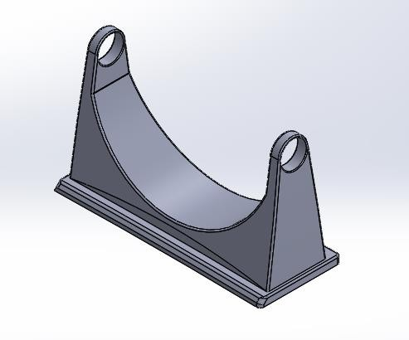

Figure 5: Base Support
Bracket:

A small, ergonomically contoured dial (fig:6) serves as the user interface for adjusting fan speed or switching the unit on/off. This part demands minimal assembly effort but must be robust under repeated usage.

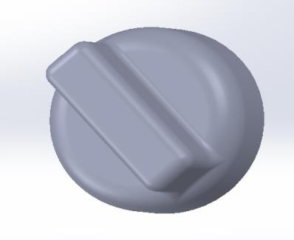

Figure 6: Control Knob

Figure 7 illustrates the electrical coil and wire routing assembly within the fan motor housing. The electrical coil is responsible for generating the electromagnetic field that drives the rotor and, subsequently, the fan blades. Proper routing of the coil wires is crucial to prevent electrical interference, overheating, and mechanical entanglement with rotating parts. The wires are typically secured using slots or clamps within the motor housing to maintain their position during operation. From a DFMA (Design for Manufacture and Assembly) perspective, optimising the coil placement and routing reduces the risk of assembly errors and enhances overall electrical reliability.

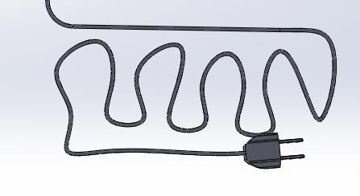

Figure 7: Electrical Coil and Wire Routing

Figure 8 shows the complete assembly of the table fan, integrating all key subcomponents, including the motor housing, impeller, protective covers, support brackets, and electrical wiring. This holistic view helps in analysing the interrelationships between parts and identifying redundancy or complexity in design. By visually mapping the assembly, DFMA principles can be effectively applied to evaluate the potential for part reduction, and improved manufacturability. For instance, aligning material usage across components and assessing joining methods aids in reducing assembly time and cost.

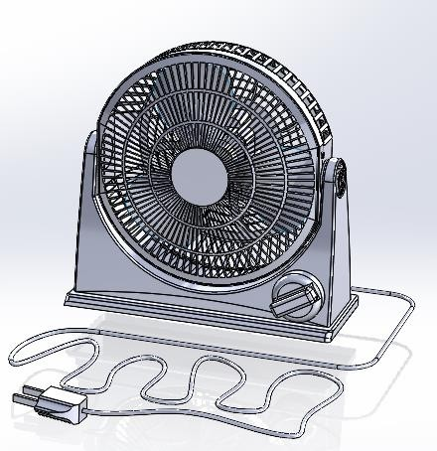

Figure 8: Table fan assembly

Part Name | Function | Joining  Method | Material | Is Moving | Quantity | Manufacturing  Process
Fan Blade | rotate | press-fit | plastic | Yes | 1 | injection molding
Front Guard | protect | snap-fit | plastic | No | 1 | injection  molding
Rear-guard | protect | snap-fit | plastic | No | 1 | injection  molding
Motor Mount | support | screw | metal | No | 1 | die casting
Motor Housing | cover | screw | plastic | No | 1 | injection  molding
Oscillation Link | transmit | press-fit | metal | Yes | 1 | stamping

Base Stand | support | screw | plastic | No | 1 | injection  molding
Control Knob | input | snap-fit | plastic | Yes | 1 | injection  molding
Power Cord | electrical | glue | rubber | No | 1 | extrusion

Table 1:Table Fan Bill of Materials

The table fan consists of 11 parts, each analysed based on function, joining method, material, motion, and manufacturing process. Key rotating parts like the Fan Blade use press-fit joints and are injection moulded in plastic. Protective components, such as the Front and Rear Guards, employ snap-fits for ease of assembly. Structural parts like the Motor Mount and Base Stand are secured with screws, made from metal or plastic, and manufactured through die casting or injection moulding. The Oscillation Link, made of stamped metal, transmits motion and is one of the two moving parts. Control elements such as the Knob and Wire Cover are plastic, joined via snap-fit, while the Power Cord is glued and extruded from rubber. This part breakdown highlights opportunities for DFMA-driven improvements like part consolidation, reduced fastener use, and material unification. Overall, the analysis supports design optimisation to enhance manufacturability and assembly efficiency in table fan production (see Table 1)

DFMA Analysis of Part Clustering and Consolidation

A DFMA-based evaluation of the table fan assembly was performed to identify opportunities for design simplification through part consolidation. The product comprises 10 components, with detailed classification across functional, material, and manufacturing attributes. A clustering approach revealed that out of the 10 parts, 3 were moving and excluded from consolidation. The remaining 7 static parts were analysed further, and a cluster of two protective plastic components (front and rear guards) with snap-fit joining was identified as a viable consolidation group. This indicates the potential for reducing part count and improving manufacturing efficiency in TABLE (2).

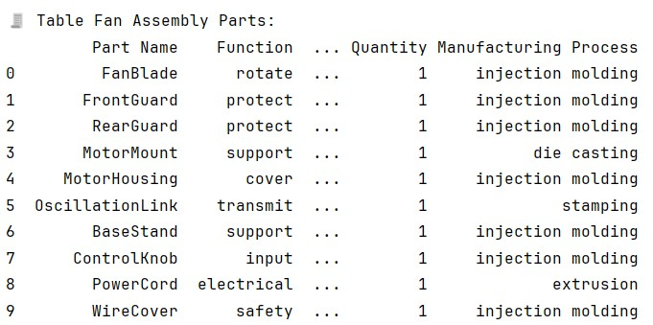

TABLE 2: Part Clustering
The table fan consists of 10 components, each classified by function, joining method, material, mobility, and manufacturing process. The most common material is plastic, and the dominant joining method is snap-fit. Fig 9
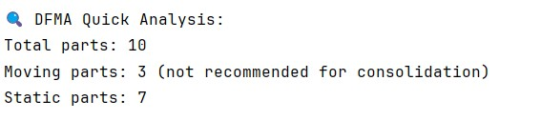

Figure 9: DFMA Quick Analysis

Out of the 10 components, 3 were identified as moving parts, essential to product operation and excluded from consolidation. The remaining 7 static parts were evaluated for potential merging based on material, function, and joining method.

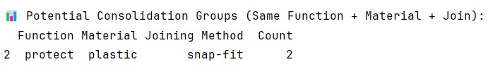
Figure 10: Potential Consolidation

Through AI-assisted clustering based on function, material, and joining method, potential consolidation was identified among the front and rear guards. Both perform a protective function, are manufactured from plastic, and assembled using snap-fit, making them suitable candidates for integration into a single part.

Results and Discussion

The table fan assembly includes ten individual components, each analysed based on their function, material, manufacturing method, mobility, and joining technique. A majority of the parts are made from plastic and assembled using snap-fit joints. [12] This uniformity in material and joining method helps identify potential areas for simplification and part consolidation.

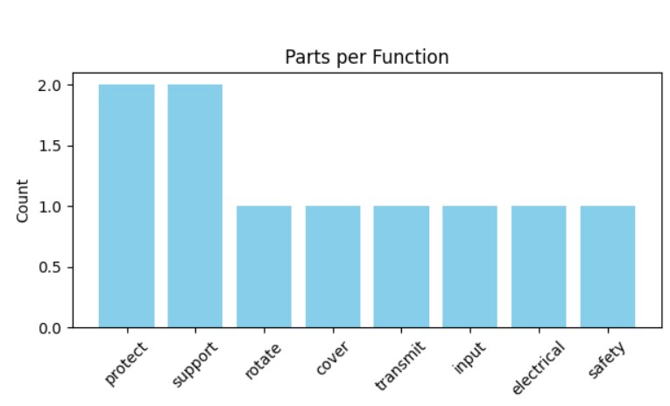

Figure 11: Parts Per Function
This chart shows the number of components in the table fan assembly based on their function. The functions "protect" and "support" have the highest count, with two parts each. This suggests that safety and structural support are key priorities in the design Fig. 12. Other functions, such as rotation, cover, transmission, input, electrical connection, and safety, each correspond to one part, indicating a diverse set of roles handled by individual components.

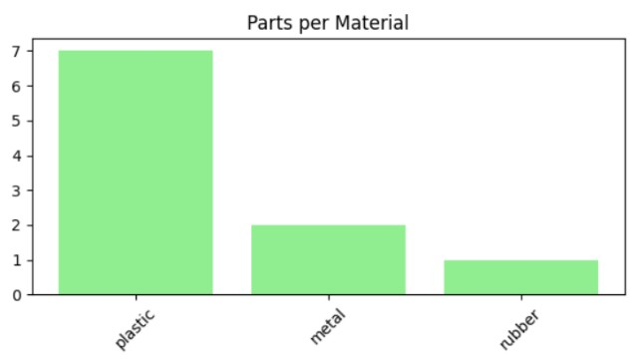
Figure 12: Parts per material

This graph represents the distribution of materials used across the parts. Plastic dominates with seven parts made from it, which reflects its widespread use due to properties like lightweight, moldability, and cost-effectiveness. Metal appears in two parts, likely for mechanical strength or electrical purposes, while rubber is used in one component, possibly for insulation or vibration damping.
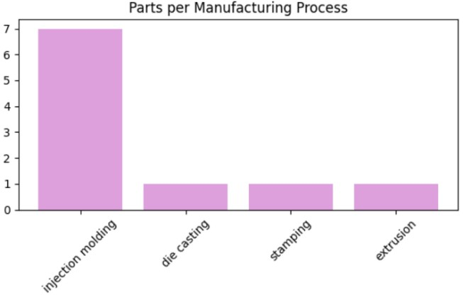

Figure 13: Parts Per Manufacturing Process

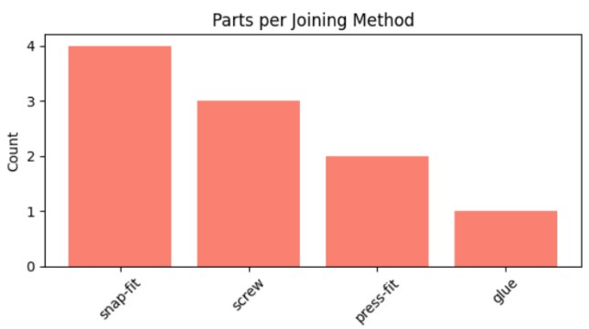

Figure 14: Parts Per joining Method

This chart breaks down how each component is manufactured. Injection moulding is the most frequently used process, applied to seven parts, indicating a preference for plastic parts and high-volume production. Other methods, such as die casting, stamping, and extrusion, are used less frequently, each associated with one part. This reflects a mix of processes chosen based on material and design requirements.

This graph shows how parts are assembled. Snap-fit is the most common joining technique, used in four parts, likely due to its simplicity and ease of assembly without tools. Screws are used in three parts, providing secure but removable connections. Press-fit and glue are used less often, possibly for parts that don’t require frequent disassembly. This distribution highlights a design approach that balances ease of manufacturing with structural integrity.

Conclusion

The visual data analysis provides specific insights into the design and manufacturing strategy of the product. From the "Parts per Function" graph, it is evident that the majority of components serve protective and supportive roles, each with a count of two. This suggests that the product’s design places significant importance on shielding internal components and maintaining structural integrity. Functional categories like rotation, cover, transmission, input, electrical, and safety are each represented by only one part, indicating a highly focused and efficient use of components for secondary functions. In the "Parts per Material" chart, plastic overwhelmingly dominates with seven parts, while metal and rubber account for only two and one part s) respectively. This points to a deliberate choice to rely on plastic materials for the bulk of the structure, likely due to its low cost, ease of moulding, lightweight nature, and suitability for mass production. Metal and rubber are likely reserved for parts requiring mechanical strength or flexibility. The "Parts per Manufacturing Process" graph highlights that injection moulding is the most frequently used manufacturing method, with seven parts produced using this technique. This aligns with the material distribution, as plastics are typically formed through injection moulding. Other processes, such as die casting, stamping, and extrusion, are used for a single part each, suggesting their limited role, likely associated with non-plastic components. The "Parts per Joining Method" graph reveals that snap-fit joints are the most common (4 parts), followed by screws (3 parts), press-fit (2 parts), and glue (1 part). This distribution implies a design emphasis on quick, tool-less assembly (snap-fit), and secure fastening (screws), with minimal reliance on permanent bonding methods like glue. This approach supports modularity and ease of repair or disassembly. Overall, the analysis reflects a design philosophy that prioritises low-cost production, efficient assembly, and functional minimalism, making the product well-suited for high-volume manufacturing and consumer use.

COMPETING INTERESTS DISCLAIMER:
Authors have declared that they have no known competing financial interests OR non-financial interests OR personal relationships that could have appeared to influence the work reported in this paper.

Disclaimer (Artificial intelligence)

Option 1:

Author(s) hereby declare that NO generative AI technologies such as Large Language Models (ChatGPT, COPILOT, etc.) and text-to-image generators have been used during the writing or editing of this manuscript.

Option 2:

Author(s) hereby declare that generative AI technologies such as Large Language Models, etc. have been used during the writing or editing of manuscripts. This explanation will include the name, version, model, and source of the generative AI technology and as well as all input prompts provided to the generative AI technology

Details of the AI usage are given below:
1.
2.
3.

References

1. Boothroyd, G., Dewhurst, P., & Knight, W. A. (2010). Product Design for Manufacture and Assembly.
CRC Press.

2. Boothroyd, G. (1994). Product design for manufacture and assembly. Computer-Aided Design,
26(7), 505–520.
3. Eastman, C. M. (Ed.). (2012). Design for X: concurrent engineering imperatives. Springer Science & Business Media.
4. Bralla, J. G. (1999). Design for Manufacturability Handbook. McGraw-Hill.

5. Kuo, T. C., Huang, S. H., & Zhang, H. C. (2001). Design for manufacture and design for 'X': Concepts, applications, and perspectives. Computers & Industrial Engineering, 41(3), 241–260.

6. Szykman, S., et al. (2000). A foundation for interoperability in next-generation product development systems. NIST.

7. Anderson, D. M. (2004). Design for Manufacturability and Concurrent Engineering. CIM Press.

8. Pahl, G., Beitz, W., Feldhusen, J., & Grote, K. H. (2007). Engineering Design: A Systematic
Approach. Springer.

9. ISO 9001:2015 – Quality Management Systems – Requirements.

10. Gupta, S. K., & Nau, D. S. (1995). Systematic approach to analysing the manufacturability of machined parts. Computer-Aided Design, 27(5), 323-342..

11. Lu, W., Tan, T., Xu, J., Wang, J., Chen, K., Gao, S., & Xue, F. (2021). Design for manufacture and assembly (DfMA) in construction: The old and the new. Architectural Engineering and Design Management, 17(1-2), 77-91.

12. Yang, S., Tang, Y., & Zhao, Y. F. (2015). A new part consolidation method to embrace the design freedom of additive manufacturing. Journal of Manufacturing Processes, 20, 444-449.

13. Boothroyd, G. (2002). Assembly automation and product design. CRC Press.

14. Charter, M., & Tischner, U. (Eds.). (2017). Sustainable solutions: developing products and services for the future. Routledge.

15. Vezzoli, C., Macrì, L., Takacs, B., & Yang, D. (2022). System design for sustainability in practice. methods, tools and guidelines to design sustainable product-service systems applied to distributed economies. POLITECNICA, 1-276.
16. Khalid, M., & Peng, Q. (2021). Sustainability and environmental impact of additive manufacturing: A literature review. Computer-Aided Design and Applications, 18(6), 1210-1232.

17. Struzziero, G., Barbezat, M., & Skordos, A. A. (2021). Consolidation of continuous fibre reinforced composites in additive processes: A review. Additive Manufacturing, 48, 102458.

18. Aldoseri, A., Al-Khalifa, K. N., & Hamouda, A. M. (2023). Re-thinking data strategy and integration for artificial intelligence: concepts, opportunities, and challenges. Applied Sciences, 13(12), 7082.

19. Yella, A., & Kondam, A. (2023). Integrating AI with Big Data: Strategies for Optimizing Data-Driven Insights. Innovative Engineering Sciences Journal, 9(1).

20. Li, P., Pei, Y., & Li, J. (2023). A comprehensive survey on design and application of autoencoder in deep learning. Applied Soft Computing, 138, 110176.

21. Ghazal, T. M. (2021). Performances of k-means clustering algorithm with different distance metrics. Intelligent Automation & Soft Computing, 30(2), 735-742.

Appendix

Step 1: Load and Display the Data import pandas as pd
# Load the Excel file
df = pd.read_excel("table_fan_parts.xlsx") # file is in project root
This code imports the pandas library and loads the table fan parts data from an Excel file into a Data
Frame called df.

# Print the full table
print("\n🧾 Table Fan Assembly Parts:")
print(df)
Displays the full parts list of the table fan for reference in the terminal.

Step 2: Count and Classify Parts
# Part counts total_parts = len(df) print(df.columns)
Counts the total number of parts and prints all the column names in the DataFrame. moving_parts = df[df["Is Moving"].str.lower() == "yes"]
static_parts = df[df["Is Moving"].str.lower() == "no"]
Filters the parts into two categories: moving and static parts based on the “Is Moving” column.

Step 3: Identify Potential Consolidation Groups
# Grouping static parts for consolidation
grouped = static_parts.groupby(["Function", "Material", "Joining
Method"]).size().reset_index(name='Count')
Groups static parts that share the same Function, Material, and Joining Method. Useful for identifying opportunities to consolidate parts to reduce complexity.

Step 4: Output Summary of Analysis
# Output
print("\n DFMA Quick Analysis:")
print(f"Total parts: {total_parts}")
print(f"Moving parts: {len(moving_parts)} (not recommended for consolidation)")
print(f"Static parts: {len(static_parts)}")
Prints summary information about how many parts are moving vs static. print("\n Potential Consolidation Groups (Same Function + Material + Join):") print(grouped[grouped['Count'] > 1])
Shows only groups of static parts with more than one instance (i.e., potential candidates for consolidation).

Step 5: Plotting Bar Charts for Visual Analysis import matplotlib.pyplot as plt
Imports the Matplotlib library for data visualization.
# Group and count parts by different categories function_counts = df["Function"].value_counts()
material_counts = df["Material"].value_counts() joining_counts = df["Joining Method"].value_counts() process_counts = df["Manufacturing Process"].value_counts()
Computes how many parts fall into each category for Function, Material, Joining Method, and
Manufacturing Process.
# Create subplots
fig, axs = plt.subplots(2, 2, figsize=(12, 8)) fig.suptitle("DFMA Part Distribution Charts", fontsize=16) Sets up a 2×2 grid of charts and a main title for all of them.

Plot 1: Function Distribution
# Function plot
axs[0, 0].bar(function_counts.index, function_counts.values, color='skyblue')
axs[0, 0].set_title("Parts per Function")
axs[0, 0].set_ylabel("Count")
axs[0, 0].tick_params(axis='x', rotation=45)
Displays how many parts perform each function (e.g., protect, support, rotate).

Plot 2: Material Distribution
# Material plot
axs[0, 1].bar(material_counts.index, material_counts.values, color='lightgreen')
axs[0, 1].set_title("Parts per Material") axs[0, 1].tick_params(axis='x', rotation=45) Shows what materials are used and how often. Plot 3: Joining Method Distribution
# Joining Method plot
axs[1, 0].bar(joining_counts.index, joining_counts.values, color='salmon')
axs[1, 0].set_title("Parts per Joining Method")
axs[1, 0].set_ylabel("Count")
axs[1, 0].tick_params(axis='x', rotation=45)
Illustrates which joining methods are used (e.g., snap-fit, screws).

Plot 4: Manufacturing Process Distribution
# Manufacturing Process plot
axs[1, 1].bar(process_counts.index, process_counts.values, color='plum')
axs[1, 1].set_title("Parts per Manufacturing Process")
axs[1, 1].tick_params(axis='x', rotation=45)
Shows the distribution of different manufacturing processes used.
Step 6: Display the Charts
plt.tight_layout(rect=[0, 0, 1, 0.95]) # Adjust layout to fit title plt.show()
Adjusts spacing and displays the plots in a window.

