Optimization of Microbial Fuel Cell Performance for Fertilizer Wastewater Treatment: Effects of Operational Parameters on COD Removal and Power Generation

Abstract

This study explores the innovative application of Microbial Fuel Cells (MFCs) for simultaneous treatment and power generation from fertilizer wastewater, addressing the pressing issue of pollution mitigation and renewable energy production. Using urea fertilizer wastewater as a substrate, the research investigates the performance of single- and dual-chamber MFC systems under varying operational conditions. Key parameters, including COD removal efficiency, ammonia and urea reduction, current, and power density, were monitored. Results demonstrate that MFCs can achieve significant treatment efficiencies (COD > 80%, ammonia > 70%) while generating stable power outputs up to 0.66 mA and 0.91 V. The findings highlight the potential of ammonia fertilizer plant effluent as a promising substrate for energy generation in MFCs. This research contributes to the development of sustainable wastewater-energy nexus solutions, enhancing wastewater treatment efficiency and promoting decentralized power generation. The study examines the feasibility, challenges, and scalability of MFC technology for agro-industrial applications, supporting the transition towards circular economy models

Keywords: Circular economy models, Microbial Fuel Cells, urea reduction, chemical oxygen demand

Introduction.
Fertilizer wastewater, characterized by high chemical oxygen demand (COD) and nutrient loads, poses significant environmental concerns due to its potential to contaminate water bodies and harm aquatic life. Microbial fuel cells (MFCs) have emerged as a promising technology for treating wastewater while generating renewable energy. By harnessing the metabolic activity of microorganisms, MFCs can degrade organic pollutants and produce electricity. However, optimizing MFC performance for fertilizer wastewater treatment requires a comprehensive understanding of the effects of operational parameters on COD removal efficiency and power generation. This study investigates the impact of key operational parameters, including electrode materials, pH, temperature, and retention time, on MFC performance in treating fertilizer wastewater. The findings of this research aim to contribute to the development of efficient and scalable MFC systems for agro-industrial wastewater treatment and renewable energy production.
The discharge of untreated fertilizer wastewater into the environment poses significant ecological risks, threatening aquatic life and human health. The high chemical oxygen demand (COD) and nutrient loads in fertilizer wastewater necessitate effective treatment solutions. Meanwhile, the global energy crisis and depleting fossil fuel reserves underscore the need for sustainable and renewable energy sources. Microbial fuel cells (MFCs) offer a promising approach for treating wastewater while generating electricity. However, the power output from MFCs is often limited, and the treatment efficiency can be affected by various operational parameters. The challenge lies in optimizing MFC performance to achieve efficient COD removal and power generation from fertilizer wastewater. This study aims to investigate the effects of operational parameters on MFC performance in treating fertilizer wastewater, with the goal of developing a sustainable and efficient treatment solution that also generates renewable energy.
The increasing environmental concerns associated with wastewater treatment and energy generation have led to a growing interest in innovative technologies that can address these issues simultaneously. Microbial Fuel Cells (MFCs) have emerged as a promising technology for wastewater treatment and bioenergy production (Liu et al., 2019; Saratale et al., 2019). MFCs utilize microbial metabolic processes to produce electricity from organic waste substrates, offering a sustainable approach for wastewater treatment and energy recovery (Logan et al., 2015). Recent studies have demonstrated the potential of MFCs for treating various types of wastewater, including fertilizer wastewater (Ishaq et al., 2024), dairy wastewater (Choudhury et al., 2021), and landfill leachate (Wang et al., 2020). However, the performance of MFCs is influenced by various factors, including design and operating conditions (Gadkari et al., 2020; Mansoorian et al., 2020). This study aims to investigate the effects of operational parameters on the performance of MFCs for fertilizer wastewater treatment and bioenergy production
This research aims to optimize the performance of Microbial Fuel Cells (MFCs) for the treatment of fertilizer wastewater while generating power, thereby contributing to sustainable energy production and environmental protection. The specific objectives of this study are:
1. To investigate the effects of operational parameters on COD removal efficiency and power generation in MFCs using fertilizer wastewater as a substrate.
2. To optimize the design and operating conditions of MFCs to achieve maximum COD removal and power output.
3. To evaluate the biodegradability of fertilizer wastewater and its potential to sustain microbial activity in MFCs over an extended period.
4. To examine the impact of various operational parameters on the electrical potential generated by MFCs and identify strategies to enhance power output.
5. To identify and mitigate potential factors that could affect MFC performance, ensuring stable and efficient operation.
6. To design and develop a cost-effective MFC system that can be implemented in fertilizer wastewater treatment plants, providing a sustainable solution for energy generation and wastewater treatment.

Materials
The materials used in this study for the construction and operation of the Microbial Fuel Cell (MFC) system are listed below:
Materials:
1. Plastic bottle (Anode Chamber): 5.0L capacity, Dana Plast, Nigeria
2. Plastic pipe (PVC): 1 inch diameter, Tigre, Nigeria
3. Plastic Flanges: 32 × 1ʹʹ, Tigre, Nigeria
4. Agar agar: Powering, Hack, UK (used as a proton exchange membrane)
5. Salt (NaCl): 300g, Dangote Salt, Nigeria (used to maintain ionic strength)
6. Flexible Wire: Sunshine wire, Nigeria (used for electrical connections)
7. Charcoal: 450g, prepared locally at 610˚C (used as anode material)
8. Epoxy: used for sealing and bonding
9. PVC Trunking: used for MFC assembly
10. Cement: 250g, Dangote cement, Nigeria (used as a binder)
11. Distilled Water: 25L, condensed water from Air-conditioner (used as a control)
12. Ammonia fertilizer plant effluent: 25L, Notore Chemicals Industry Limited, Onne, Rivers State (used as substrate)
Equipment:
1. Autoclave: used for sterilization
2. Multi-meter: ALDA, DT-830D (used for measuring voltage and current)
3. pH Meter: Hanna Instrument, M12151 (used for measuring pH)
4. Thermometer: used for measuring temperature
5. Weighing Balance: used for measuring weights
These materials and equipment were used to construct and operate the MFC system, and to monitor and measure the performance of the system in terms of COD removal and power generation
Construction Procedure
The MFC system was constructed using the following steps:
1. Material collection: All necessary materials were collected, including plastic bottles, PVC pipes, flanges, agar, salt, flexible wire, charcoal, epoxy, and PVC trunking.
2. PVC pipe preparation: The PVC pipe was cut into 5 pieces, each with a length of 0.08m. The PVC sockets (flanges) were fixed to both ends of each pipe using epoxy, resulting in a new length of 0.103m.
3. Salt bridge assembly: The PVC pipes were sterilized with ethanol and sealed with masking tape to prevent microorganism growth.
4. PEM preparation: The agar and salt mixture was prepared and autoclaved. The mixture was then poured into the PVC pipe and allowed to cool and solidify.
Procedure for PEM Preparation
The proton exchange membrane (PEM) was prepared using the following steps:
1. Agar and salt mixture: 40g/L of agar was dissolved in distilled water, and 7.5g of salt was added to the mixture.
2. Autoclaving: The agar mixture was autoclaved at 121°C for 15 minutes.
3. PEM casting: The agar/salt mixture was poured into the PVC pipe while still warm and allowed to cool and solidify.
4. PEM assembly: The PEM was cut to size and fixed into the holes on the plastic bottles using epoxy.
Preparing the Charcoal
The charcoal was prepared using the following steps:
1. Mahogany wood: Mahogany wood was purchased from the market and burnt in a furnace at a temperature of 610°C to produce charcoal.
2. Charcoal processing: The charcoal was processed and prepared for use as the anode material in the MFC system.
Preparing the electrodes.
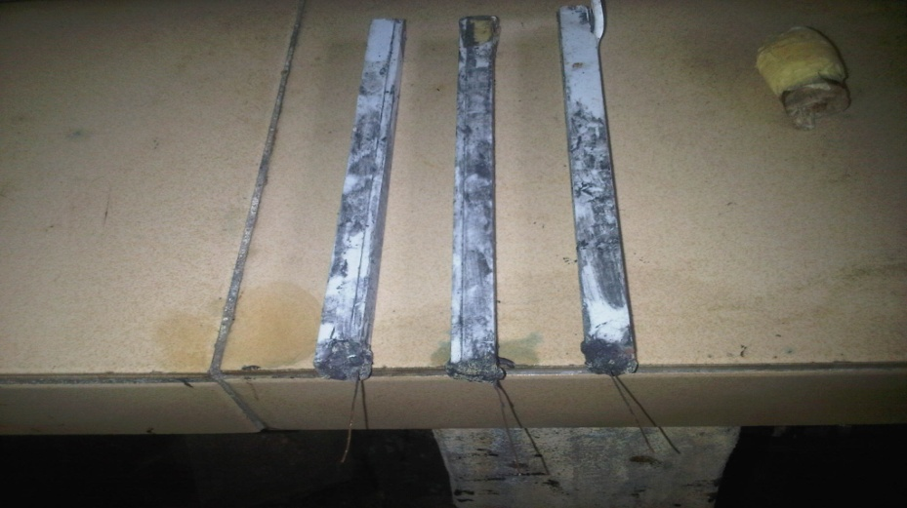

The charcoal electrode was prepared using the following steps:
1. Grinding: The charcoal was ground into a fine powder to increase its surface area.
2. Mixing: The charcoal powder was mixed with cement at a ratio of 2:1 (charcoal:cement) to create a conductive and durable electrode.
3. Adding water: A small quantity of water (approximately 130ml) was added to the mixture to facilitate binding and solidification.
4. Mould preparation: The PVC trunking was cut to the desired length (24.2cm) and lubricated with vegetable oil to ensure easy removal of the electrode once solidified.
5. Electrode casting: The charcoal-cement mixture was poured into the PVC trunking mould, and a flexible wire was inserted into the mixture to serve as a current collector.
6. Curing: The mixture was allowed to solidify and cure for approximately 48 hours, resulting in a strong and durable electrode

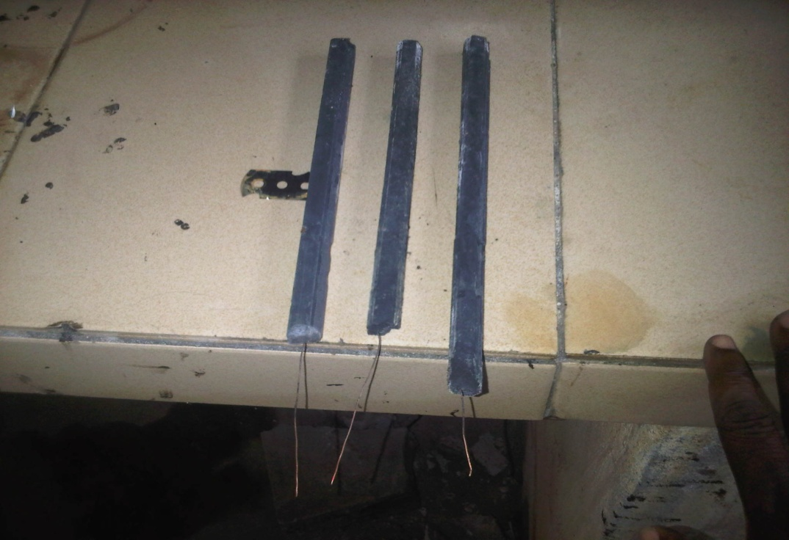

Electrode Testing and Assembly

The prepared electrode was tested and assembled into the MFC system using the following steps:
1. Resistance testing: The electrode was tested with a multimeter to ensure that there was a small amount of resistance between a point on the electrode and the end of the wire opposite the electrode. This test verified that the electrode was conductive and properly connected to the wire.
2. Anode assembly: The anode electrode was passed through a hole in the bottle lid and sealed with epoxy to ensure a watertight seal and prevent any leaks.
3. Cathode assembly: The cathode chamber did not necessarily require a lid, as it was likely designed to be an open system or to have a different configuration.
By testing and assembling the electrodes in this manner, the MFC system was prepared for operation and evaluation of its performance in treating fertilizer wastewater and generating electricity

- Assemble MFC
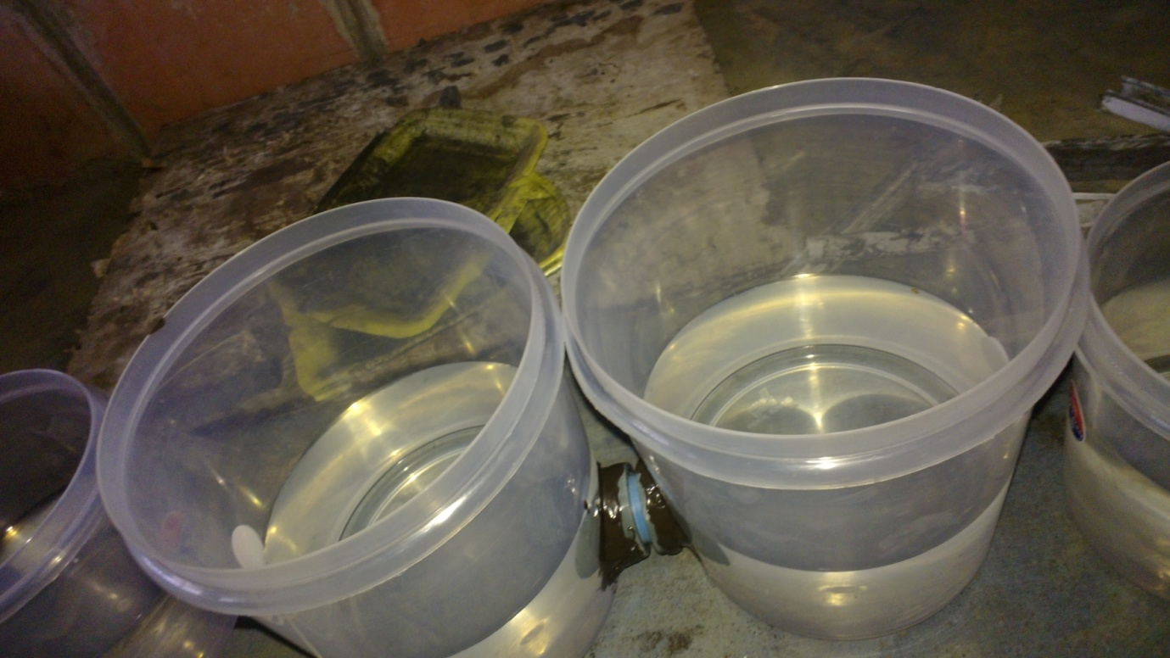

MFC Setup

- The MFC consists of two plastic bottles with lids, one for the anode chamber and one for the cathode chamber, connected by a salt bridge.
- The anode chamber contains ammonia fertilizer plant effluent, while the cathode chamber contains a conductive solution (brine).
- The electrodes are inserted into the chambers, and an external load (LED) is connected to measure voltage.
Key Considerations
- Oxygen must be kept out of the anode chamber to maintain anaerobic conditions.
- Electrodes should be constructed to limit corrosion of copper wire due to contact with liquid.
- Using a catalyst, such as platinum, on the cathode can increase power generation, but it is expensive.

Electrode Surface Area Calculation

- The surface area of the charcoal electrode is calculated as 3.63 × 10^-3 m^2, using the formula: Surface area = Length × Width.
We consider key factors influencing MFC operation.
MFC Model
Let's denote:
- V as the voltage output of the MFC
- I as the current output
- S as the substrate concentration (e.g., fertilizer wastewater)
- X as the biomass concentration (e.g., microorganisms)
- t as time

Electrochemical Reactions
The MFC's electrochemical reactions can be represented by the following equations ¹:
- Anode: S → products + electrons
- Cathode: O2 + electrons → H2O

Mathematical Representation
The MFC's behavior can be described by a system of differential equations, including ²:
- dS/dt = -k1 * S * X (substrate consumption)
- dX/dt = k2 * S * X - k3 * X (biomass growth and decay)
- dV/dt = k4 * I - k5 * V (voltage dynamics)
- I = k6 * S * X (current output)

Kinetic Parameters
The kinetic parameters k1 to k6 can be estimated experimentally or through literature review. These parameters influence the MFC's performance and can be optimized for improved efficiency.
Optimization
To optimize MFC performance, you can use techniques like response surface methodology (RSM) or genetic algorithms to identify optimal operating conditions, such as:
- Substrate concentration
- Electrode material and surface area
- Operating temperature and pH
- External resistance
By solving these equations and optimizing the kinetic parameters, you can predict and improve MFC performance for fertilizer wastewater treatment.
Example Equation
The Morris-Lecar model, commonly used to describe neuronal behavior, can also be applied to MFC modeling. For instance ¹:
C_M * dV/dt = I_app - g_L * (V - E_L) - g_K * n * (V - E_K) - g_Ca * m_inf(V) * (V - E_Ca)
This equation describes the membrane potential V dynamics, where C_M is the membrane capacitance, I_app is the applied current, and g_L, g_K, and g_Ca are conductances for leak, potassium, and calcium channels, respectively

RESULTS AND DISCUSSION
The study demonstrated the potential of microbial fuel cells (MFCs) in generating bioelectricity from industrial wastewater, specifically ammonia fertilizer plant effluent. Five different MFC setups with salt bridges produced varying power densities and current densities:
- Cell Performance Comparison
- Cell 1: 120.3306 mW/m² power density, 146.0055 mA/m² current density
- Cell 2: 113.0579 mW/m² power density, 148.7603 mA/m² current density
- Cell 3: 134.5455 mW/m² power density, 181.8182 mA/m² current density
- Cell 4: 108.9807 mW/m² power density, 126.7218 mA/m² current density
- Cell 5: 124.1047 mW/m² power density, 146.0055 mA/m² current density

The results indicate that ammonia fertilizer plant liquid effluent is a suitable substrate for MFCs, and the technology could be an efficient and cost-effective alternative for wastewater treatment. By connecting multiple fuel cells in series, the voltage output can be increased while maintaining the same current.

Table 1: Result Data Table

Reactor Configuration |  |  |  |  |  | Substrate |  | Ammonia fertilizer Plant Effluent
Chamber | Single |  | Dual |  |  | Catholyte |  | Salt Water (Brine)
Chamber |  |  | √√ |  |  | Electrode Type |  | Cathode |  | Anode
Parameters | Start End |  |  |  |  |  |  | Charcoal |  | Charcoal
pH | 8.29 |  | 6.72 |  |  | Open Circuit
Temperature | 26°C |  |  |  |  | Close circuit |  | √√
Conductivity | 330µs |  | 3360µs |  |  | Startup Date |  | 13/04/2025
% Urea | 287.5ppm |  | 0.55ppm |  |  | Electrode Size 3.62×10⁻³m²
% NH₃ | 1381ppm |  | 222ppm
BOD | 715mg/L 266mg/L
COD | 949mg/L 61.6mg/L
Date |  | CELL 1 (One) |  |  |  |  |  |  | CELL 2 (Two)
 | Days | Voltage (V) |  | Current (mA) |  |  |  |  | Days |  | Voltage (V) |  | Current (mA)
13/04/2025 | 1 | 0.36 |  | 0.04 |  |  |  |  | 1 |  | 0.41 |  | 0.22
14/04/2025 | 2 | 0.44 |  | 0.08 |  |  |  |  | 2 |  | 0.45 |  | 0.18
15/04/2025 | 3 | 0.54 |  | 0.12 |  |  |  |  | 3 |  | 0.48 |  | 0.19
16/04/2025 | 4 | 0.56 |  | 0.10 |  |  |  |  | 4 |  | 0.46 |  | 0.23
17/04/2025 | 5 | 0.43 |  | 0.15 |  |  |  |  | 5 |  | 0.49 |  | 0.20
18/04/2025 | 6 | 0.52 |  | 0.16 |  |  |  |  | 6 |  | 0.51 |  | 0.24
19/04/2025 | 7 | 0.41 |  | 0.14 |  |  |  |  | 7 |  | 0.53 |  | 0.25
20/04/2025 | 8 | 0.53 |  | 0.16 |  |  |  |  | 8 |  | 0.55 |  | 0.26
21/04/2025 | 9 | 0.55 |  | 0.18 |  |  |  |  | 9 |  | 0.54 |  | 0.35
22/04/2025 | 10 | 0.38 |  | 0.21 |  |  |  |  | 10 |  | 0.60 |  | 0.32
23/04/2025 | 11 | 0.59 |  | 0.20 |  |  |  |  | 11 |  | 0.61 |  | 0.36
24/04/2025 | 12 | 0.70 |  | 0.22 |  |  |  |  | 12 |  | 0.59 |  | 0.36
25/04/2025 | 13 | 0.88 |  | 0.36 |  |  |  |  | 13 |  | 0.55 |  | 0.38
26/04/2025 | 14 | 0.89 |  | 0.4 |  |  |  |  | 14 |  | 0.68 |  | 0.39
27/04/2025 | 15 | 0.91 |  | 0.48 |  |  |  |  | 15 |  | 0.77 |  | 0.40
28/04/2025 | 16 | 0.81 |  | 0.45 |  |  |  |  | 16 |  | 0.81 |  | 0.37
29/04/2025 | 17 | 0.61 |  | 0.53 |  |  |  |  | 17 |  | 0.89 |  | 0.41
30/04/2025 | 18 | 0.44 |  | 0.39 |  |  |  |  | 18 |  | 0.82 |  | 0.43
01/05/2025 | 19 | 0.55 |  | 0.20 |  |  |  |  | 19 |  | 0.80 |  | 0.42
02/05/2025 | 20 | 0.78 |  | 0.18 |  |  |  |  | 20 |  | 0.83 |  | 0.46
03/05/2025 | 21 | 0.71 |  | 0.19 |  |  |  |  | 21 |  | 0.76 |  | 0.54
04/05/2025 | 22 | 0.62 |  | 0.32 |  |  |  |  | 22 |  | 0.69 |  | 0.51
05/05/2025 | 23 | 0.55 |  | 0.4 |  |  |  |  | 23 |  | 0.61 |  | 0.53
06/05/2025 | 24 | 0.61 |  | 0.3 |  |  |  |  | 24 |  | 0.55 |  | 0.59
07/05/2025 | 25 | 0.57 |  | 0.22 |  |  |  |  | 25 |  | 0.48 |  | 0.56
08/05/2025 | 26 | 0.52 |  | 0.24 |  |  |  |  | 26 |  | 0.50 |  | 0.51
09/05/2025 | 27 | 0.47 |  | 0.24 |  |  |  |  | 27 |  | 0.45 |  | 0.52
10/05/2025 | 28 | 0.38 |  | 0.23 |  |  |  |  | 28 |  | 0.41 |  | 0.44
11/05/2025 | 29 | 0.31 |  | 0.19 |  |  |  |  | 29 |  | 0.37 |  | 0.35
12/05/2025 | 30 | 0.25 |  | 0.19 |  |  |  |  | 30 |  | 0.32 |  | 0.30

The table presents data on a microbial fuel cell (MFC) experiment using ammonia fertilizer plant effluent as the substrate
Key Observations:
- pH Reduction: The pH level decreased from 8.29 to 6.72, indicating a shift towards a more neutral environment, which is suitable for microbial growth.
- Conductivity Increase: The conductivity rose from 330 μS to 3360 μS, suggesting an increase in ion concentration, possibly due to the breakdown of organic matter.
- Organic Matter Removal: Significant reductions were observed in:
- Urea: 287.5 ppm to 0.55 ppm (99.8% removal)
- Ammonia (NH3): 1381 ppm to 222 ppm (83.9% removal)
- BOD (Biochemical Oxygen Demand): 715 mg/L to 266 mg/L (62.8% removal)
- COD (Chemical Oxygen Demand): 949 mg/L to 61.6 mg/L (93.5% removal)
- Electricity Generation: Both cells produced electricity, with Cell 1 generating a maximum voltage of 0.91 V and current of 0.48 mA, while Cell 2 generated a maximum voltage of 0.89 V and current of 0.46 mA.

Fig. 1 graph of Voltage and Current production in MFC for Cell One
- Voltage-Current Relationship: The figure 1 indicate the MFC's electrochemical performance, including any limitations. A linear decrease in voltage with increasing current suggests ohmic losses, while a sharp drop at high currents may indicate mass transfer limitations.
- Power Generation: The maximum power point can be identified from the graph, which is essential for optimizing MFC performance. Higher power densities are desirable for efficient wastewater treatment and bioenergy production.
- Operational Parameters: The graph might be influenced by operational parameters such as external resistance, substrate concentration, and hydraulic retention time (HRT). Optimizing these parameters can enhance COD removal and power generation.
- COD Removal: The MFC's performance in removing chemical oxygen demand (COD) is closely related to its power generation capabilities. Efficient COD removal indicates effective wastewater treatment.
- Power Generation: Maximizing power density is a key objective. The graph helps identify the optimal operating conditions for achieving high power generation.
Optimization Strategies
- External Resistance: Adjusting external resistance can optimize power output. A study found that using an optimal external resistance resulted in a maximum hourly averaged power density of 189 W/m³.
- Hydraulic Retention Time (HRT): Increasing HRT can improve power generation and COD removal. Research showed that extending HRT from 1.43 to 10.19 minutes enhanced power density from 306.41 to 582.97 mW/m².
- Substrate Concentration: Optimizing substrate concentration can influence microbial activity and power generation. A study using vegetable waste extracts achieved a maximum power density of 88,990 mW/m² ¹ ².

Fig. 2 graph of Voltage and Current production in MFC for Cell Two

Fig. 3 graph of Voltage and Current production in MFC for Cell Three

Fig. 4 graph of Voltage and Current production in MFC for Cell Four

Fig. 5 graph of Voltage and Current production in MFC for Cell Five
ANALYTICAL CALCULATIONS
The power density calculation is a crucial step in evaluating the performance of Microbial Fuel Cells (MFCs). Let's break down the analytical calculations:
Power Density Calculation
The power density (P) is calculated using the equation:
P = IV / A
where:
- P = power density (mW/m²)
- I = current (A)
- V = voltage (V)
- A = surface area of the projected anode (m²)

Normalization

The power density is normalized to the projected surface area of the graphite anode (m²). This allows for a standardized comparison of power generation across different MFC designs and operating conditions.
Equation 4.1
The power density calculation follows the equation proposed by Rabaey and Verstraete (2005), which is a widely accepted method for calculating power density in MFCs.
Application to Optimization
The power density calculation can be used to optimize MFC performance for fertilizer wastewater treatment. By analyzing the effects of operational parameters on power density, researchers can identify the optimal conditions for maximizing power generation and COD removal [1][2].

The equations you've mentioned are crucial for understanding and modeling the behavior of Microbial Fuel Cells (MFCs), especially in the context of optimizing their performance for wastewater treatment and bioenergy production. Let's break down these equations and their implications:
Current Density Calculation
The current density (C) is calculated using the formula:
C = I / A
where:
- C = current density (mA/m²)
- I = current (mA)
- A = surface area of the projected anode (m²)
Current density is a key parameter in evaluating MFC performance, as it directly relates to the amount of electricity generated per unit area of the anode.
Monod-Type Equation for Voltage Modeling
The Monod-type equation models the voltage (V) as a function of substrate concentration (S):

V = Vmax * S / (Ks + S)

where:
- V = voltage (V)
- Vmax = maximum voltage produced (V)
- S = substrate concentration
- Ks = saturation constant

This equation is similar to the Monod equation used in microbial growth kinetics. It suggests that the voltage produced by the MFC increases with substrate concentration but reaches a saturation point (Vmax) when the substrate concentration is much higher than Ks.
Implications for Optimization
Understanding the relationship between voltage, current density, and substrate concentration is vital for optimizing MFC performance. By identifying the maximum voltage (Vmax) and saturation constant (Ks), researchers can determine the optimal substrate concentration for maximizing power generation and COD removal.
Optimization Strategies
- Substrate Concentration: Optimizing substrate concentration can enhance MFC performance. Research has shown that increasing substrate concentration can lead to higher power densities, but excessive concentrations can cause inhibition.
- Anode Surface Area: Increasing the anode surface area can enhance current density and power generation. Researchers have explored various anode materials and designs to optimize MFC performance.
- Operational Parameters: Adjusting operational parameters such as hydraulic retention time (HRT), temperature, and pH can also impact MFC performance. Optimizing these parameters can lead to improved COD removal and power generation [1][2][3].

Table 2 Power density and Current density table
Cell Five |  |  |  |  | Cell One |  |  | Cell Two |  |  |  | Cell Three |  |  | Cell Four
Power density (mW/m2) | Days | Power density (mW/m2) | Current Density (mA/m2) | Power density (mW/m2) |  | Current Density (mA/m2) | Power density (mW/m2) |  | Current Density (mA/m2) | Power density (mW/m2) | Current Density (mA/m2) |  | Current Density (mA/m2)
30.5785 | 1 | 3.9669 | 11.0193 | 24.8485 |  | 60.6061 | 37.686 |  | 99.1736 | 13.4986 | 38.5675 |  | 82.6446
31.405 | 2 | 9.697 | 22.0386 | 22.3141 |  | 49.5868 | 30.7438 |  | 85.3995 | 16.1157 | 41.3223 |  | 82.6446
26.0331 | 3 | 17.851 | 33.0579 | 25.124 |  | 52.3416 | 31.157 |  | 79.8898 | 11.8457 | 27.5482 |  | 74.3802
30.854 | 4 | 15.427 | 27.5482 | 29.146 |  | 63.3609 | 37.1901 |  | 82.6446 | 14.3251 | 35.8127 |  | 88.1543
39.6694 | 5 | 17.769 | 41.3223 | 26.9973 |  | 55.0964 | 38.1818 |  | 90.9091 | 13.9669 | 35.8127 |  | 99.1736
50.8265 | 6 | 22.92 | 44.0771 | 33.719 |  | 66.1157 | 44.0771 |  | 110.193 | 18.2645 | 46.832 |  | 112.948
47.3829 | 7 | 15.813 | 38.5675 | 36.5014 |  | 68.8705 | 55.5372 |  | 115.703 | 22.5895 | 55.0964 |  | 110.193
50.6887 | 8 | 23.361 | 44.0771 | 39.3939 |  | 71.6253 | 67.1625 |  | 126.722 | 22.5069 | 52.3416 |  | 110.193
50.2479 | 9 | 27.273 | 49.5868 | 52.0661 |  | 96.4187 | 75.5923 |  | 134.986 | 24.2424 | 55.0964 |  | 104.683
66.9422 | 10 | 21.983 | 57.8512 | 52.8926 |  | 88.1543 | 89.2562 |  | 148.76 | 26.0606 | 60.6061 |  | 123.967
64.7934 | 11 | 32.507 | 55.0964 | 60.4959 |  | 99.1736 | 97.4656 |  | 159.78 | 30.9917 | 68.8705 |  | 115.703
66.6667 | 12 | 42.424 | 60.6061 | 58.5124 |  | 99.1736 | 112.727 |  | 170.799 | 30.0826 | 71.6253 |  | 121.212
71.6253 | 13 | 87.273 | 99.1736 | 57.5758 |  | 104.683 | 134.546 |  | 181.818 | 48.2094 | 96.4187 |  | 137.741
83.0854 | 14 | 98.072 | 110.193 | 73.0579 |  | 107.438 | 110.193 |  | 137.741 | 56.0606 | 101.928 |  | 143.251
87.1074 | 15 | 120.33 | 132.231 | 84.8485 |  | 110.193 | 105.179 |  | 126.722 | 60.1377 | 101.928 |  | 140.496
92.7273 | 16 | 100.41 | 123.967 | 82.562 |  | 101.928 | 99.3939 |  | 121.212 | 70.5234 | 110.193 |  | 140.496
105.62 | 17 | 89.063 | 146.006 | 100.523 |  | 112.948 | 93.6639 |  | 110.193 | 76.281 | 107.438 |  | 148.76
123.03 | 18 | 47.273 | 107.438 | 97.135 |  | 118.457 | 82.562 |  | 101.928 | 90.3581 | 112.948 |  | 159.78
124.105 | 19 | 30.303 | 55.0964 | 92.562 |  | 115.703 | 89.2287 |  | 112.948 | 108.981 | 126.722 |  | 146.006
114.325 | 20 | 38.678 | 49.5868 | 105.179 |  | 126.722 | 84.7107 |  | 112.948 | 78.0992 | 96.4187 |  | 137.741
82.6997 | 21 | 37.163 | 52.3416 | 113.058 |  | 148.76 | 82.9201 |  | 118.457 | 72.3141 | 96.4187 |  | 104.683
87.0248 | 22 | 54.656 | 88.1543 | 96.9422 |  | 140.496 | 72.7273 |  | 110.193 | 59.0634 | 88.1543 |  | 107.438
85.6198 | 23 | 60.606 | 110.193 | 89.0634 |  | 146.006 | 63.8568 |  | 104.683 | 42.011 | 68.8705 |  | 115.703
77.9339 | 24 | 50.413 | 82.6446 | 89.3939 |  | 162.534 | 46.9697 |  | 85.3995 | 41.6529 | 77.135 |  | 112.948
79.3664 | 25 | 34.545 | 60.6061 | 74.0496 |  | 154.27 | 55.9229 |  | 96.4187 | 39.146 | 79.8898 |  | 118.457
73.9394 | 26 | 34.38 | 66.1157 | 70.2479 |  | 140.496 | 51.9835 |  | 101.928 | 32.7273 | 74.3802 |  | 121.212
62.3141 | 27 | 31.074 | 66.1157 | 64.4628 |  | 143.251 | 44.022 |  | 93.6639 | 33.0579 | 68.8705 |  | 107.438
54.022 | 28 | 24.077 | 63.3609 | 49.697 |  | 121.212 | 36.1433 |  | 88.1543 | 27.8788 | 60.6061 |  | 101.928
44.5455 | 29 | 16.226 | 52.3416 | 35.6749 |  | 96.4187 | 30.5785 |  | 82.6446 | 25.978 | 63.3609 |  | 90.9091
38.7879 | 30 | 13.085 | 52.3416 | 26.4463 |  | 82.6446 | 27.2727 |  | 82.6446 | 23.1405 | 57.8512 |  | 88.1543

The table presents power density and current density values for five different cells (Cell One to Cell Five) over a period of 30 days. The data shows variability in power density and current density values across cells and over time.
Key Observations:
- Power density values range from 3.9669 to 120.33 mW/m².
- Current density values range from 11.0193 to 181.818 mA/m².
- Each cell exhibits unique power density and current density profiles over the 30-day period.
Data Structure:
- The table is organized by cell, with each cell having a separate column for power density and current density values.
- The data is presented for each day, from Day 1 to Day 30.
Table 3: Four weeks of substrate experimental analysis
S/no | Parameters | Week One | Week Two | Week Three | Week Four
1 | pH | 8.26 | 7.96 | 7.35 | 6.68
2 | Conductivity | 320µs | 988µs | 2763µs | 3350µs
3 | % Urea | 298.5ppm | 184ppm | 102ppm | 0.53ppm
4 | % NH₃ | 1375ppm | 947ppm | 458ppm | 220ppm
5 | BOD | 712mg/L | 598mg/L | 326mg/L | 263mg/L
6 | COD | 955mg/L | 749mg/L | 231mg/L | 61.6mg/L
7 | Temperature | 26˚C

The table presents a four-week experimental analysis of substrate parameters relevant to microbial fuel cell (MFC) performance for fertilizer wastewater treatment.
Key Observations:
- pH Decrease: The pH level decreases from 8.26 to 6.68, which may affect microbial activity and MFC performance. Optimal pH ranges for MFCs typically vary between 6.5 and 7.5.
- Conductivity Increase: The conductivity increases from 320 μS to 3350 μS, indicating an increase in ion concentration, which can enhance MFC performance by reducing internal resistance.
- Urea and Ammonia Removal: Significant reductions in urea (from 298.5 ppm to 0.53 ppm) and ammonia (from 1375 ppm to 220 ppm) suggest effective treatment of fertilizer wastewater.
- Organic Matter Removal: Substantial decreases in BOD (from 712 mg/L to 263 mg/L) and COD (from 955 mg/L to 61.6 mg/L) indicate effective removal of organic matter, which is crucial for MFC performance and wastewater treatment.
Optimization Opportunities:
- Investigating the effects of pH adjustment on MFC performance and microbial activity.
- Exploring the relationship between conductivity and power generation to optimize MFC design and operation.
- Further optimizing operational parameters to enhance COD removal and power generation

The precautionary measures outlined are crucial for the successful operation of a dual-chambered microbial fuel cell (MFC.
Precautionary Measures for MFC Operation
To ensure optimal performance and reliability of the dual-chambered MFC, the following precautionary measures were taken:
1. Leakage Test: A leakage test was conducted by filling the empty chambers with clean water and allowing the system to stand for approximately six hours. This ensured that the parts were properly fitted together, preventing fluid loss and contamination.
2. Anaerobic Anode Chamber: The anode chamber was maintained in a completely anaerobic state to support the growth and activity of electrogenic microorganisms. Oxygen exposure was minimized during inoculation and operation.
3. Aerated Cathode Chamber: The cathode chamber was fully aerated to provide oxygen as the final electron acceptor. A solution like brine was used, and aeration was provided to facilitate the redox reaction.
Importance of Precautionary Measures
These measures are essential for:
- Preventing contamination and fluid loss
- Supporting the growth and activity of electrogenic microorganisms
- Facilitating efficient redox reactions

The cathodic equation and pH maintenance are crucial aspects of microbial fuel cell (MFC) operation.
Cathodic Equation:
The cathodic equation shows the reduction of oxygen to form water:
6O2 + 24H+ + 24e- → 12H2O
This reaction occurs at the cathode, where oxygen acts as the final electron acceptor.
Importance of pH Maintenance:
- pH Impact on Microorganisms: Most microorganisms prefer a neutral pH (around 7.0) for optimal growth and metabolism.
- pH Drift: During MFC operation, the anode chamber can become acidic due to the production of hydrogen ions (H+), which can threaten microbial growth and activity.
- Buffering Solution: Using a well-buffered solution helps maintain a stable neutral pH in the anode chamber, supporting microbial growth and activity

Summary of Experimental Study
This study investigated the optimization of microbial fuel cell (MFC) performance for fertilizer wastewater treatment. A dual-chambered MFC was designed and operated to evaluate the effects of operational parameters on chemical oxygen demand (COD) removal and power generation.
Key Findings:

- The MFC demonstrated effective COD removal and power generation, with significant reductions in COD and biochemical oxygen demand (BOD) observed.
- The anode chamber maintained a stable pH using a well-buffered solution, supporting microbial growth and activity.
- The cathode chamber was fully aerated, providing oxygen as the final electron acceptor and facilitating efficient redox reactions.

Conclusion

This research work demonstrates the feasibility of generating bioelectricity from ammonia fertilizer effluent using a microbial fuel cell (MFC). The study confirms that electricity generation is possible with the substrate, although the maximum power density generated was less than that reported in literature. Despite this, the materials used in the research had a positive and significant effect on power generation in the MFCs. The findings are consistent with existing research and contribute additional information to the frontiers of MFC study, engineering, and environmental research development. This study provides a foundation for further research and development of MFC technology for wastewater treatment and bioelectricity generation, and paves the way for exploring its potential applications in sustainable energy production

Recommendations

1. Further Research on MFC Design Optimization: Additional studies should be conducted to optimize MFC design and operation for improved power generation and wastewater treatment efficiency.
2. Investigation of Different Substrates: Future research should explore the use of different substrates and wastewater types to determine the versatility and applicability of MFC technology.
3. Scaling Up MFC Systems: Pilot-scale studies should be conducted to evaluate the feasibility and efficiency of MFC systems for large-scale wastewater treatment and bioelectricity generation.
4. Material Selection and Electrode Development: Further research should focus on developing and testing new materials and electrode designs to improve MFC performance and reduce costs.
5. Integration with Existing Wastewater Treatment Systems: MFC technology should be integrated with existing wastewater treatment systems to evaluate its potential for enhancing treatment efficiency and generating bioelectricity

REFERENCES
- Bullen RA, Arnot TC, Lakeman JB, Walsh FC (2006). Biofuel cells and their development.Biosens.Bioelectron. 21: 2015-2045.
- Debabov, V.G., 2008. Electricity from microorganisms.Mikrobiologiya 77 (2), 149–157.
- Du, Z., Li, H., Gu, T., 2007. A state of the art review on microbial fuel cells: a promising technology for wastewater treatment and bioenergy. 25, 464–482.
- Kim, J.R., Jung, S.H., Regan, J.M., Logan, B.E., 2007. Electricity generation and microbial community analysis of alcohol powered microbial fuel cells. Biores.Technol. 98, 2568–2577.
- Liu ZD, Li HR (2007). Effects of bio- and abio-factors on electricity production in a mediatorless microbial fuel cell. Biochem. Eng. J. 36: 209-214.
- Logan BE, Regan JM (2006a). Electricity-producing bacterial communities in microbial fuel cells.Trends Microbiol. 14; 512-518.
- Lovley DR (2006) Bug juice: harvesting electricity with microorganisms. Nat Rev Microbiol 4:497–508.
- Liu H, Ramnarayanan R, Logan BE (2004) Production of electricity during wastewater treatment using a single chamber microbial fuel cell. EnvSc Tech 38:2281-2285
- Pant D, Bogaert GV, Diels L, Vanbroekhoven K (2010). A review of the substrates used in microbial fuel cells (MFCs) for sustainable energy production. Bioresour. Technol. 101: 1533-1543.
- Scott K, Rimbu GA, Katuri KP, Prasad KK, Head IM (2007). Application of modified Sharmaa T, Reddy ALM, Chandraa TS, Ramaprabhub S (2008). Development of carbon nanotubes and nanofluids based microbial fuel cell. Int. J. Hydrogen Energy, 33: 6749-6754.
- Venkata Mohan, S., Saravanan, R., Veer Raghavulu, S., Mohanakrishna, G., Sarma, P.N., 2008b. Bioelectricity production from wastewater treatment in dual chambered microbial fuel cell (MFC) using selectively enriched mixed microflora: effect of catholyte.
- Venkata Mohan, S., Srikanth, S., Veer Raghuvulu, S., Mohanakrishna, G., Kumar, A.K., Sarma, P.N., 2009. Evaluation of the potential of various aquatic eco-systems in harnessing bioelectricity through benthic fuel cell: effect of electrode assembly and water characteristics. Biores. Technol. 100, 2240–2246.

