Purification of Biogas Using Low-Cost Locally Available Materials for Off-Grid Power Applications.
Abstract
Upgrading biogas is essential to increase its calorific value and expand its applications, primarily in power and rural electrification uses. Raw biogas is typically 50–70 % methane (CH₄), with some carbon dioxide (CsO₂), hydrogen sulfide (H₂S), and water vapour that lowers energy efficiency and leads to system parts corrosion. Although efficient, conventional purification methods such as water scrubbing, chemical adsorption, and pressure swing adsorption remain costly and technically demanding for small-scale or rural use. Five cheap locally available materials that could be used for biogas purification were screened in this study: zeolite, iron ore, charcoal, potash, and clay. The materials were tested individually and in mixtures, and commercial-grade adsorbent (soda lime and silica gel) served as control. Portable biogas analyzer was utilized in determining the composition of gas before and after purification to determine CO₂, H₂S, and H₂O removal efficiency. The findings confirmed the efficiency of zeolite and potash in CO₂ removal, with maximum efficiency being 6.72 % for potash. Iron ore eliminated over 80 % of H₂S, confirming its high desulfurizing capacity. Charcoal adsorbed CO₂ and H₂S at the same time, concentrating methane to 76.2 %. Clay was ineffective alone but worked synergistically in mixed-material systems. With all five materials together, methane concentration increased from 69 % to 82.37 %, very close to the industrial control value of 88.46 %. These results reaffirm that indigenous adsorbents offer a practical, low-cost alternative to industrial purifiers and hold great promise for decentralized biogas upgrading, rural electrification, clean waste management, and climate-resilient access to energy.
Keywords: Biogas purification; Low-cost adsorbents; Zeolite; Iron ore; Sustainable waste-to-energy

1.0 Introduction
Biogas, produced by the anaerobic breakdown of organic wastes, is increasingly regarded as a clean energy that has the potential to both bridge rural energy shortages and address agricultural waste disposal issues. This aligns with global projections that biogas can play a pivotal role in sustainable energy transitions, particularly in rural and developing regions (IRENA, 2022; IEA, 2023). Raw biogas is typically composed of 50–70 % methane (CH₄), 30–50 % carbon dioxide (CO₂), and trace amounts of hydrogen sulfide (H₂S), water, and other impurities (Appels et al., 2008). While it may be directly combusted for heat and cooking, its comparatively low calorific value and corrosive nature of CO₂, H₂S, and water vapour restrict its broader use in power generation and off-grid electricity systems (Werkneh, 2022). For enhanced energy efficiency, raw biogas must be upgraded to have a higher methane concentration than 90 % through the selective removal of impurities (Bragança et al., 2020). There are conventional upgrading technologies, including water scrubbing, chemical absorption, and pressure swing adsorption that are efficient but remain costly, technologically sophisticated, and unsuitable for smallholder and rural communities in developing nations (Galloni & Marcoberardino, 2024). This is a problem that requires cheap, uncomplicated, and locally implementable purification methods. There are many abundant, cheap materials, such as natural zeolite, iron ore, charcoal, potash, and clay, that have intrinsic properties with potential for adsorption application in biogas upgrading (Kainth et al., 2024). Experimental findings from our studies indicated that potash exhibited the highest CO₂ removal efficiency by 6.72 %, whereas zeolite and charcoal were highly effective in decreasing both CO₂ and H₂O contents. Iron ore was the most effective in desorbing H₂S, while charcoal contributed significantly to methane enrichment by its porous adsorption (Nwokolo et al, 2020).
Clay, though less effective on its own, contributed synergistically when mixed with other materials. Mixing all five materials enhanced methane concentration from approximately 69 % in raw biogas to 82.37 %, close to the industrial control value of 88.46 %. (Qian et al., 2025). Despite these promising results, there is scant comparative data on the effectiveness of such cheap, readily available materials for cleaning biogas. Most of the existing literature has dealt with industrial adsorbents in the absence of developing flexible, multi-component purification technologies suitable for rural electrification (Atelge et al., 2021). This effort, therefore, investigates purification of biogas with zeolite, iron ore, charcoal, potash, clay, and mixtures thereof, against an industrial benchmark (Liu, et al., 2020). The objective is to quantify their efficiency in removing CO₂, H₂S, and H₂O, enriching methane content, and assessing their feasibility as low-cost, eco-friendly purification agents for decentralised power applications. The novelty of using blended, low-cost natural materials in this study complements recent advances in multi-component purification technologies for biogas upgrading (Niesner et al., 2013; Abatzoglou & Boivin, 2009). The findings are expected to provide evidence-based recommendations on scaling up biogas use as a sustainable energy source for rural communities.
2.0 Materials and Methods
2.1 Study Area and Biogas Source
Purification experiments were conducted at the Soil and Water Laboratory, Department of Agricultural and Environmental Engineering, Federal University of Technology, Akure, Nigeria (7°15′N, 5°12′E). The location falls within the humid tropical rainforest belt, characterised by mean annual temperatures of 28–34 °C, which are ideal for mesophilic digestion conditions. Raw biogas was obtained from the anaerobic co-digestion of cow dung with yam peel, cassava peel, and maize husk, as discussed in earlier experiments (Appels et al., 2008). After seven weeks of digestion, gas was collected and led into purification units for upgrading experiments.
2.2 Selection and Preparation of Purification Materials
Five low-cost, locally available materials, including zeolite, iron ore, charcoal, potash, and clay, were employed as adsorbents owing to their availability, affordability, and physicochemical properties of interest for gas purification. Zeolite is a crystalline aluminosilicate with high surface area and cation-exchange capacity that has been widely reported to adsorb CO₂ (Ren et al., 2020). Iron oxide-rich iron ore reacts with hydrogen sulfide (H₂S) to produce stable iron sulfides that reduce corrosive effects (Kumar et al., 2024). Charcoal consists of a highly developed pore structure that promotes higher adsorption of CO₂ and water vapour (Mochizuki et al., 2025). Potash, derived from ash of plants, consists of alkalinity properties that neutralize acidic gases such as CO₂ and H₂S, enhancing methane concentration (Liu et al., 2009). Clay minerals are less effective on their own but contribute to structural strength and can be synergistic when blended with other adsorbents (Pan et al., 2024). The adsorbents were all sun dried, milled, and 1 mm sieved to optimize surface area. Each was weighed individually at 100 g for single-material experiments. For combined-material treatment, an equal proportion of all five adsorbents was blended to obtain a total of 100 g.
2.3 Experimental Setup for Purification
The purification unit contained 500 mL glass vessels with rubber stoppers that were airtight and with inlet–outlet tubing. Biogas from the digesters was passed through the adsorbent-packed vessels. For single-material tests, one vessel contained 100 g of the selected material. For combined-material trials, equal amounts of zeolite, iron ore, charcoal, potash, and clay were blended. A commercial adsorbent (mixture of soda lime and silica gel) was utilized as the control according to conventional biogas upgrading technology (Werkneh, 2022). The airtight condition was maintained by utilizing silicone sealant and parafilm.
2.4 Gas Composition Analysis
The composition of biogas before and after purification was analysed with a portable biogas analyser (GA5000, Geotechnical Instruments, UK). Concentrations of CH₄, CO₂, H₂S, O₂, and water vapour were recorded following standard protocols (APHA, 1998). Removal efficiency (RE) was calculated using the equation:

$RE=\frac{Cin-Cout}{Cin}$ 100
where 𝐶 in​ and C out ​ are inlet and outlet concentrations, respectively. Methane enrichment was expressed as the percentage increase in CH₄ relative to the raw biogas.
2.5 Experimental Design and Data Analysis
Seven treatments were investigated, five single-material adsorbents (zeolite, iron ore, charcoal, potash, clay), one combined-material trial, and one industrial control. Each treatment was replicated three times, and mean values were computed. Statistical analysis was conducted using one-way Analysis of Variance (ANOVA) in SPSS (version 16.0). At p < 0.05 significance was claimed, and treatment performances contrasted through post-hoc tests.

3.0 Results and Discussion
3.1 Biogas Composition Before Purification
The raw biogas from the digesters contained approximately 69 % CH₄, 28 % CO₂, 2 % H₂S, and traces of H₂O vapour and O₂. This is consistent with published figures of untreated biogas, ranging between 50–70 % CH₄ and 30–50 % CO₂ (Appels et al., 2008). Such a gas is not suitable for immediate utilization in engines or in power generation due to its low calorific value and corrosive action of H₂S and steam.
3.2 Performance of Individual Adsorbents
The efficiencies of the five low-cost purifying agents—zeolite, iron ore, charcoal, potash, and clay, varied with regard to each impurity individually, as attested to by the outcomes in Figures 1 to 6. Zeolite proved to be very effective in the removal of carbon dioxide (CO₂) and water vapour (H₂O) together, with a significant enrichment of methane (CH₄) from 69 % up to 75.4 % (Fig. 1a–d). This performance is attributed to zeolite's microporous aluminosilicate structure and high cation-exchange capacity, which facilitate selective adsorption of acidic gases such as CO₂ and polar molecules such as H₂O. This performance is consistent with literature reports that zeolite is a good CO₂ adsorbent (Ganiyu, 2025). Iron ore (hematite) was particularly effective in the removal of hydrogen sulfide (H₂S), reducing its concentration by more than 80 % of inlet concentration (Fig. 2c). This is in line with well-known redox reactions whereby iron oxides react with H₂S to form stable iron sulfides (Poulton et al., 2002). Methane concentration rose modestly to 72.8 %, as the purification was aimed at sulphur-based impurities and not at CO₂. Charcoal demonstrated the ability to adsorb both CO₂ and some H₂S simultaneously, leading to enrichment of methane to 76.2 % as shown in Fig. 3c; Fig. 4b. It's high surface area and porous nature facilitated the removal of a wide spectrum of impurities, in line with its documented activity as an inexpensive adsorbent (Ortiz Cancino & Santos Santos, 2025). Notably, Seka et al. (2025) demonstrated the successful application of activated carbon derived from rubber tree branches to reduce carbon monoxide in biogas, reinforcing the broader potential of charcoal-based materials in multi-component gas purification, particularly in resource-constrained regions. Charcoal's two-pronged action makes it a suitable material for utilization in small-scale biogas upgrading units. Potash, a plant ash product, was the most effective individual material for CO₂ removal, with a 6.72 % decrease in average (Fig. 8a). This was equivalent to 77.1 % enrichment of methane. The alkalinity of potash enhances neutralisation of acidic gases like CO₂ and H₂S, which enhances gas quality and digestate stability (krzypczak et al., 2009). Clay, by contrast, performed the worst in purification. It decreased CO₂ and H₂O only slightly (Fig. 5a–d) and had a negligible effect on H₂S (Fig. 5c). Consequently, the methane concentration increased to 71.3 %. Clay, however, may play a supporting role in composite mixtures by aiding in adsorption surface area and structure stability, as suggested in past research (Altaf et al., 2025). Briefly, the single adsorbents manifested diverse purification profiles, some more efficient and selective (e.g., potash for CO₂, iron ore for H₂S), while others, such as charcoal, provided multi-component removal capability. These performance trends are the foundation for evaluating the synergistic behaviour of these materials when used in combination, as discussed in the next section.
3.3 Synergistic Effect of Combined Adsorbents
With all five inexpensive adsorbents (zeolite, iron ore, charcoal, potash, and clay) combined in equal proportions, a synergistic purification effect was observed. The study was the first to demonstrate the synergistic action of zeolite, iron ore, charcoal, potash, and clay in a composite adsorption system. The formulation facilitated multi-pollutant removal while achieving substantial methane enrichment at 82.37 %, comparable to the efficiency of industrial-grade purification systems. This establishes the trailblazing contribution of the research towards developing multi-component, low-cost purification technology suitable for decentralized power applications. Methane (CH₄) concentration was considerably increased from 69 % in raw biogas to 82.37 %, closely approaching the industrial control performance of 88.46 %, as shown in Figures 7–9. The mixed combination led to the removal of more than 70 % hydrogen sulfide (H₂S), approximately 60 % carbon dioxide (CO₂), and near-total elimination of water vapour (Mutegoa & Sahini, 2023). This enhanced performance can be attributed to the complementary interactions among the adsorbents: potash and zeolite exhibited high CO₂ adsorption capacity; iron ore was effective in removing H₂S due to redox reactions forming iron sulfides; charcoal contributed to the simultaneous removal of CO₂ and H₂O due to its porous structure; while clay, although weak when used alone, enhanced the system by providing additional adsorption support and structural integrity to the adsorbent matrix. These synergistic effects align with recent studies highlighting the value of multi-component adsorbent systems in low-cost biogas upgrading technologies (Hidalgo & Martín-Marroquín, 2025).
3.4 Comparison with Industrial Control
Industrial control-including silica gel and soda lime-registered the highest purification efficiency, raising concentration of methane from 69 % to 88.46 %, with removal of nearly all content of carbon dioxide (CO₂), hydrogen sulfide (H₂S), and water vapour effectively, as seen in Figures 7–9. This finding illustrates the capability of high performance by commercial-grade purification systems. For context, the domestic adsorbent blend (zeolite, iron ore, charcoal, potash, and clay) yielded a methane purity of 82.37 %, which was only a modest short-fall from the industrial standard (Vogelsang & Umar, 2023). Nevertheless, the gas purity obtained using locally available materials is still within specifications for electricity generation, gas engines, and other off-grid power applications. Above all, the local adsorbents have a very much cost-effective ratio. Compared to the industrial control with high procurement, processing, and transportation costs, the five materials experimented with are readily available, low in costs, and environmental friendly. This makes them very much suitable for rural and decentralised energy systems, particularly in developing regions where affordability, accessibility, and ease of implementation are overriding constraints (Fajardo et al., 2025).
3.5 Implications for Rural Electrification and Sustainability
The findings of this study unequivocally validate the possibility of using indigenous and readily affordable materials for effective biogas upgrading. With methane levels over 80% after purification with a mixture of zeolite, iron ore, charcoal, potash, and clay, the generated biogas can be of acceptable quality for use in electricity generators, cooking stoves, and possibly utilized for compressed biomethane applications such as fuel for automobiles (Jameel et al 2025). Successful scaling of similar low-cost biogas upgrading solutions has been reported in Europe using region-specific materials and infrastructure adaptations (Thrän et al., 2025). Valorisation of these natural adsorbents eliminates the need for expensive industrial purification technology, thus making biogas upgrading universally available to rural communities. Such a localised approach directly benefits rural electrification, decentralised energy access, waste valorisation, and climate resilience, especially in developing regions where energy poverty is still prevalent (Olaniyan et al., 2024). The approach also substantially contributes to the attainment of Sustainable Development Goals (SDGs), specifically SDG 7 (Affordable and Clean Energy) and SDG 13 (Climate Action). Among individual adsorbents tested, potash gave the highest carbon dioxide removal of 6.72 %, which was followed by zeolite, both having major roles in methane enrichment. Iron ore was found to be the best material to remove hydrogen sulfide, removing it by more than 80% of its inlet value (Mambetova et al., 2024). Charcoal exhibited double purification effect, efficiently adsorbing both CO₂ and H₂S, and enriching methane content to 76.2 %. While clay alone exhibited only a limited capacity for removal, it played a valuable support and synergistic role as part of the adsorbent combination. Notably, synergistic use of all five materials raised methane concentration to 82.37 %, which is just a hair away from the 88.46 % achieved by the industrial control. This indicates that careful pairing of natural materials can produce purification capabilities similar to commercial systems, at a tenth the cost and complexity (Gamage et al., 2023). Overall, indigenous material application for biogas upgrading presents an inexpensive, eco-friendly, and locally acceptable method for enhancing access to clean energy, reducing environmental pollution from uncontrolled organic wastes, and improving circular economy strategies in peri-urban and rural areas.
4.0 Conclusion
This study critically evaluated the purification performance of five inexpensive, locally available materials—zeolite, iron ore, charcoal, potash, and clay, for upgrading raw biogas through selective removal of CO₂, H₂S, and H₂O. The results demonstrated that the local materials possess excellent potential as cost-effective alternatives to industrial-grade adsorbents, particularly for decentralised utilisation in rural and off-grid scenarios. Among the individual adsorbents, the highest CO₂ adsorbing efficiency of 6.72% was exhibited by potash, followed closely by zeolite and both contributing significantly towards methane enrichment. Iron ore was the most effective when removal of H₂S was considered, with over 80% removal, while charcoal exhibited dual functional capacity in adsorbing both CO₂ and H₂S, with a raise in the concentration of methane to 76.2%. Although clay was not very effective alone, it provided structural and synergistic assistance when blended with other adsorbents. The maximum result was obtained with the integrated application of all five materials, raising methane concentration from 69% to 82.37%, which was very close to the 88.46% with the use of the industrial control (soda lime + silica gel). The composite system also removed more than 70% of H₂S, 60% of CO₂, and nearly all water vapour, demonstrating the effectiveness of integrating complementary materials to achieve broad-spectrum purification. These outcomes clearly favour the utilisation of material available locally to build low-cost, accessible, and efficient biogas purification systems, particularly for smallholder farmers and rural communities. The low-cost approach enhances the economics of decentralised renewable energy systems and reduces the dependency on expensive industrial adsorbents and sophisticated technologies. To proceed from these results, future research needs to explore the optimal mixing proportions of the materials in multi-adsorbent systems. Adsorption capacity and regeneration value for each material over multiple purification cycles, and scalability of these systems to the use in continuous-flow or large-volume digesters. Parallel to this, policy support is required. Governments and development institutions must promote the increased deployment of local purification methods by developing technical guidelines, enabling rural energy schemes, and providing incentives for biogas facilities. Through this, not only would waste-to-energy conversion be improved, but making progress in Sustainable Development Goals (SDGs)—specifically SDG 7 (Affordable and Clean Energy) and SDG 13 (Climate Action), would be accelerated. While the outcome is encouraging, this study was at the laboratory scale. Pilot-scale verification, especially under continuous-flow or field-scale configuration, should be the focus of future work to confirm performance in actual usage conditions. In-depth study of the best mixtures and the regeneration capacity of the adsorbent for multicycle use is needed to ensure long-term and sustainable implementation. This would facilitate the shift of research from experimental feasibility to actual application in off-grid and rural energy usage. To conclude, this study provides a scalable, practical, and context-specific solution to biogas upgrading through natural adsorbents. It paves the way for subsequent innovations that can potentially transform local materials into instrumental facilitators of sustainable energy access, waste valorisation, and climate resilience in developing nations.

DISCLAIMER (ARTIFICIAL INTELLIGENCE)
Author (s) hereby declare that NO generative AI technologies such as Large Language Models (ChatGPT, COPILOT, etc.) and text-to-image generators have been used during the writing or editing of this manuscript.
COMPETING INTERESTS
Authors have declared that no competing interests exist.

References
Abatzoglou, N., & Boivin, S. (2009). A review of biogas purification processes. Biofuels, Bioproducts and Biorefining, 3(1), 42–71. https://doi.org/10.1002/bbb.117

Altaf, F., Ahmed, S., Ali, S., Mansha, M., Kouser, T., & Khan, S. A. (2025). Transforming natural resources into advanced solutions: The contribution of clay-based adsorbents to carbon dioxide (CO₂) adsorption. Transactions of Tianjin University, 31, 74–130. https://doi.org/10.1007/s12209-025-00429-1
APHA, AWWA, & WEF. (1998). Standard methods for the examination of water and wastewater (19th ed.). American Public Health Association.
Appels, L., Baeyens, J., Degrève, J., & Dewil, R. (2008). Principles and potential of the anaerobic digestion of waste‐activated sludge. Progress in Energy and Combustion Science, 34(6), 755–781. https://doi.org/10.1016/j.pecs.2008.06.002
Atelge, M. R., Senol, H., Djaafri, M., Hansu, T. A., Krisa, D., Atabani, A., Eskicioglu, C., Muratçobanoğlu, H., Unalan, S., Kalloum, S., Azbar, N., & Kıvrak, H. D. (2021). A critical overview of the state-of-the-art methods for biogas purification and utilization processes. Sustainability, 13(20), 11515. https://doi.org/10.3390/su132011515
Bragança, I., Sánchez-Soberón, F., Pantuzza, G. F., Alves, A., & Ratola, N. (2020). Impurities in biogas: Analytical strategies, occurrence, effects and removal technologies. Biomass and Bioenergy, 143, 105878. https://doi.org/10.1016/j.biombioe.2020.105878.
Fajardo, A., Baker, L. H., Sesan, T., Bhattacharyya, S., Kerr, D., Katyega, M., & Barnett, A. (2025). Business models and access to finance for mini grid development in sub-Saharan Africa. Energy for Sustainable Development, 85, 101666.
https://doi.org/10.1016/j.esd.2025.101666.

Galloni, M., & Di Marcoberardino, G. (2024). Biogas upgrading technology: Conventional processes and emerging solutions analysis. Energies, 17(12), 2907. https://doi.org/10.3390/en17122907
Gamage, A., Gangahagedara, R., Gamage, J., Jayasinghe, N., Kodikara, N., Suraweera, P., & Merah, O. (2023). Role of organic farming for achieving sustainability in agriculture. Farming System, 1(1), 100005. https://doi.org/10.1016/j.farsys.2023.100005.
Ganiyu, S. A. (2025). Review of zeolitic-based sorbents for CO₂ capture: Insights into functional modifications, economic feasibility and machine learning-enhanced strategies. Chemical Engineering Journal Advances, 23, 100818.
https://doi.org/10.1016/j.ceja.2025.100818.

Hidalgo, D., & Martín-Marroquín, J. M. (2025). Cryogenic technologies for biogas upgrading: A critical review of processes, performance, and prospects. Technologies, 13(8), 364. https://doi.org/10.3390/technologies13080364
International Energy Agency (IEA). (2023). World Energy Outlook 2023 – Biogas and Biomethane Section. https://www.iea.org/reports/world-energy-outlook-2023
International Renewable Energy Agency (IRENA). (2022). Outlook on Biogas for Sustainable Development. https://www.irena.org/publications/2022
Jameel, M. K., Mustafa, M. A., Ahmed, H. S., Mohammed, A. J., Ghazy, H., Shakir, M. N., Lawas, A. M., Mohammed, S. K., Idan, A. H., Mahmoud, Z. H., Sayadi, H., & Kianfar, E. (2024). Biogas: Production, properties, applications, economic and challenges: A review. Results in Chemistry, 7, 101549.
https://doi.org/10.1016/j.rechem.2024.101549.

Kainth, S., Sharma, P., & Pandey, O. P. (2024). Green sorbents from agricultural wastes: A review of sustainable adsorption materials. Applied Surface Science Advances, 19, 100562. https://doi.org/10.1016/j.apsadv.2023.100562
Kumar, S., Jawdekar, T. A., Cheng, Z., Akulwar, F., Hu, J., Trout, A. H., & Fan, L.-S. (2024). Enhanced decomposition of H₂S to H₂ via iron sulfide nanoparticles: A comprehensive experimental and theoretical evaluation. Chemical Engineering Journal, 499, 156117. https://doi.org/10.1016/j.cej.2024.156117
Liu, J., Chen, Q., & Qi, P. (2020). Upgrading of biogas to methane based on adsorption. Processes, 8(8), 941. https://doi.org/10.3390/pr8080941
Liu, Y., Yin, K., Wu, J., Mei, D., Konttinen, J., Joronen, T., Hu, Z., & He, C. (2023). Ash chemistry in chemical looping process for biomass valorization: A review. Chemical Engineering Journal, 478, 147429. https://doi.org/10.1016/j.cej.2023.147429
Mambetova, M., Dossumov, K., Baikhamurova, M., & Yergaziyeva, G. (2024). Sorbents based on natural zeolites for carbon dioxide capture and removal of heavy metals from wastewater: Current progress and future opportunities. Processes, 12(10), 2071. https://doi.org/10.3390/pr12102071
Mochizuki, Y., Bud, J., Byambajav, E., & Tsubouchi, N. (2025). Pore properties and CO₂ adsorption performance of activated carbon prepared from various carbonaceous materials. Carbon Resources Conversion, 8(1), 100237.
https://doi.org/10.1016/j.crcon.2024.100237.

Mutegoa, E., & Sahini, M. G. (2023). Approaches to mitigation of hydrogen sulfide during anaerobic digestion process – A review. Heliyon, 9(9), e19768.
https://doi.org/10.1016/j.heliyon.2023.e19768

Niesner, J., Jecha, D., & Stehlik, P. (2013). Biogas upgrading techniques: State of art review in European region. Chemical Engineering Transactions, 35, 517–522. https://doi.org/10.3303/CET1335086

Nwokolo, N., Mukumba, P., Obileke, K., & Enebe, M. (2020). Waste to energy: A focus on the impact of substrate type in biogas production. Processes, 8(10), 1224. https://doi.org/10.3390/pr8101224
Olaniyan, A., Caux, S., & Maussion, P. (2024). Rural electrification in Nigeria: A review of impacts and effects of frugal energy generation based on some of e-waste components. Heliyon, 10(11), e31300. https://doi.org/10.1016/j.heliyon.2024.e31300
Ortiz Cancino, O. P., & Santos Santos, N. (2025). Experimental adsorption study of pure CH₄ and CO₂ on organic-rich shales from the Cesar-Ranchería Basin, Colombia. Processes, 13(7), 2108. https://doi.org/10.3390/pr13072108
Panzer, M., Scherb, S., Beuntner, N., & Thienel, K.-C. (2024). An approach to estimate the strength contribution of calcined clays in blended cements. Construction and Building Materials, 447, 137800. https://doi.org/10.1016/j.conbuildmat.2024.137800
Poulton, S. W., Krom, M. D., Van Rijn, J., & Raiswell, R. (2002). The use of hydrous iron (III) oxides for the removal of hydrogen sulphide in aqueous systems. Water Research, 36(4), 825–834. https://doi.org/10.1016/s0043-1354(01)00314-1
Qian, S., Chen, L., Xu, S., Zeng, C., Lian, X., Xia, Z., & Zou, J. (2025). Research on methane-rich biogas production technology by anaerobic digestion under carbon neutrality: A review. Sustainability, 17(4), 1425. https://doi.org/10.3390/su17041425
Ren, X., Qu, R., Liu, S., Zhao, H., Wu, W., Song, H., Zheng, C., Wu, X., & Gao, X. (2020). Synthesis of zeolites from coal fly ash for removal of harmful gaseous pollutants: A review. Aerosol and Air Quality Research, 20(5), 1127–1144.
https://doi.org/10.4209/aaqr.2019.12.0651

Seka, O. C., Kouakou, A. R., Kouadio, M. C., Djama, A. G., & Abolle, A. (2025). Reduction of carbon monoxide in biogas using an activated carbon filter produced from rubber tree branches. Asian Journal of Chemical Sciences, 15(5), 31–49.
https://doi.org/10.9734/ajocs/2025/v15i5389

Skrzypczak, D., Pstrowska, K., Niciejewska, A., Mazur-Nowacka, A., Wilk, Ł., & Chojnacka, K. (2025). Catalytic innovations in fertilizer production from agricultural waste: Enhancing soil health and sustainability. Applied Catalysis O: Open, 206, 207064. https://doi.org/10.1016/j.apcato.2025.207064
Thrän, D., Adetona, A., Borchers, M., Cyffka, K.-F., Daniel-Gromke, J., & Oehmichen, K. (2025). Potential contribution of biogas to net zero energy systems – A comparative study of Canada and Germany. Biomass and Bioenergy, 193, 107561. https://doi.org/10.1016/j.biombioe.2024.107561
Vogelsang, C., & Umar, M. (2023). Municipal solid waste fly ash-derived zeolites as adsorbents for the recovery of nutrients and heavy metals—A review. Water, 15(21), 3817. https://doi.org/10.3390/w15213817
Werkneh, A. A. (2022). Biogas impurities: Environmental and health implications, removal technologies and future perspectives. Heliyon, 8(10), e10929.
https://doi.org/10.1016/j.heliyon.2022.e10929.

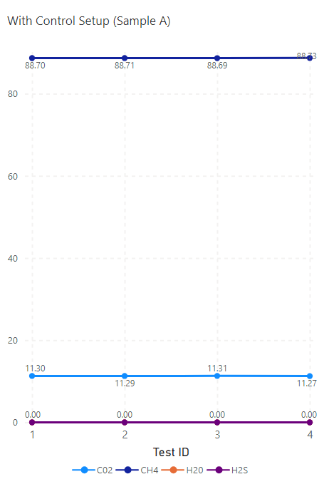
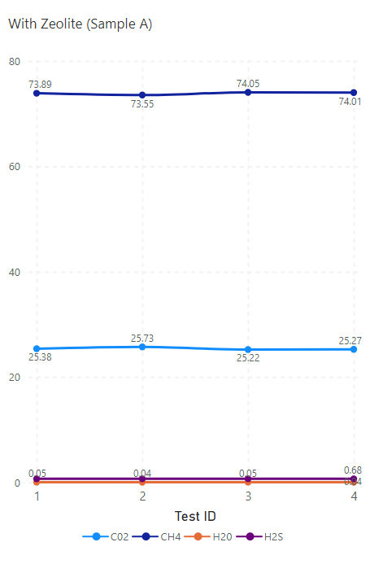
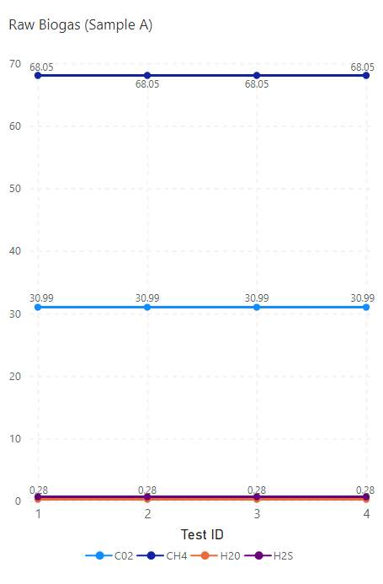

Figure 1. Biogas composition before and after purification using zeolite: (a) methane (CH₄), (b) carbon dioxide (CO₂), (c) hydrogen sulfide (H₂S), and (d) water vapour (H₂O).

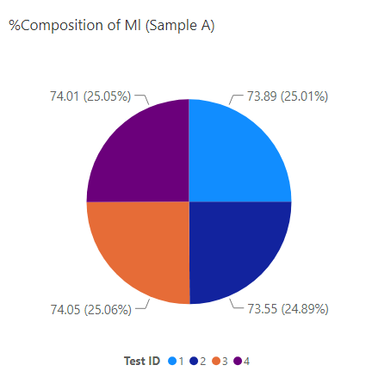
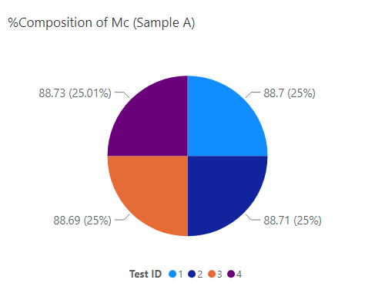

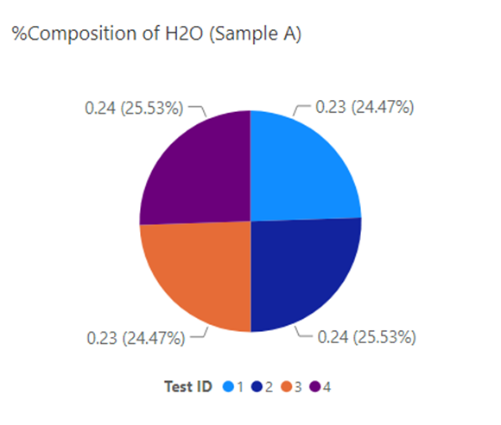
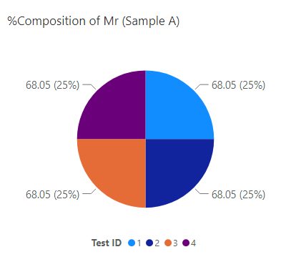

Figure 2. Biogas composition before and after purification using iron ore: (a) methane (CH₄), (b) carbon dioxide (CO₂), (c) hydrogen sulfide (H₂S), and (d) water vapour (H₂O).
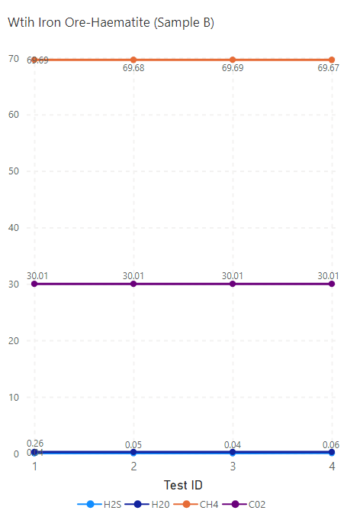
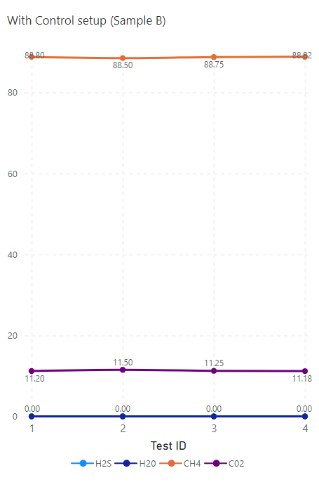
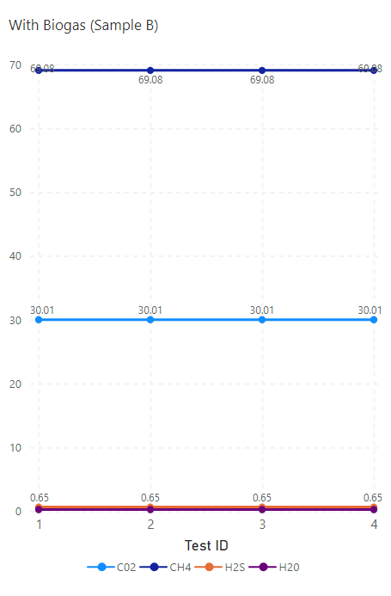

Figure 3. Biogas composition (CH₄, CO₂, H₂S, H₂O) across Tests 1–4: (a) raw biogas, (b) purified with industrial control (MC), and (c) purified with iron ore (hematite).

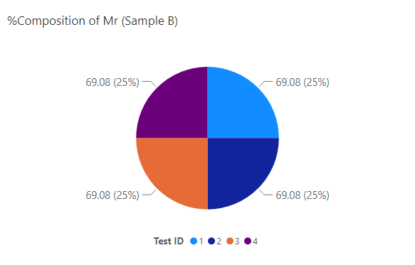
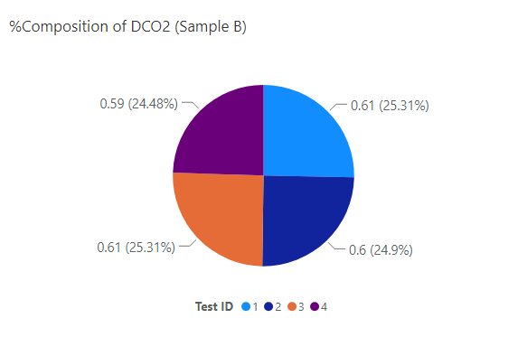
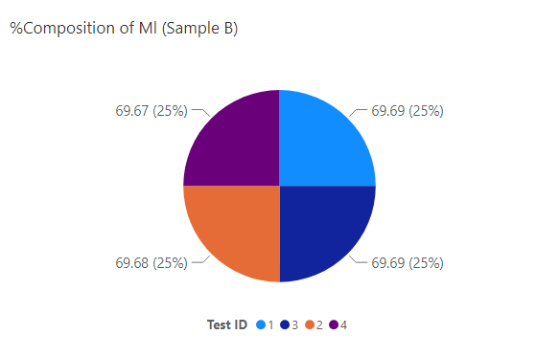

a b c
Figure 4. Biogas quantities across Tests 1–4: (a) raw biogas (MR), and (b) purified with local materials (ML), (c) purified with industrial control (MC).

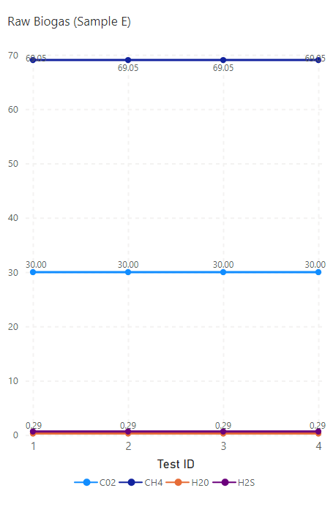
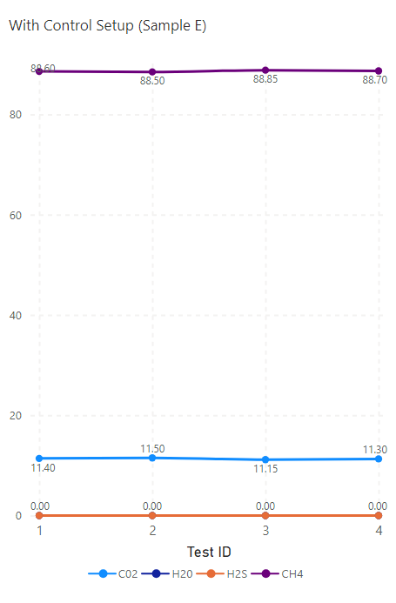
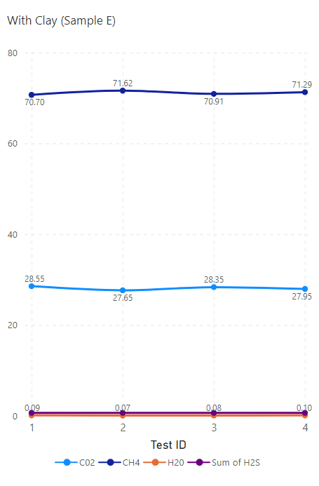

Figure 5. Biogas composition (CH₄, CO₂, H₂S, H₂O) across Tests 1–4: (a) raw biogas, (b) purified with industrial control, and (c) purified with clay.

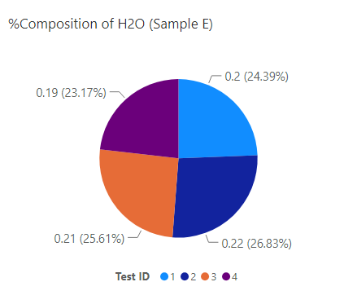
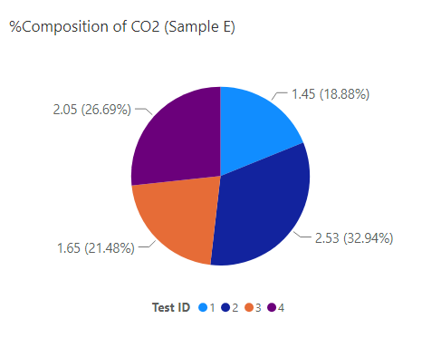

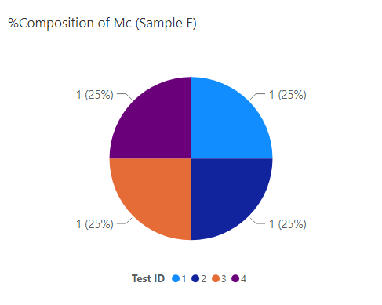
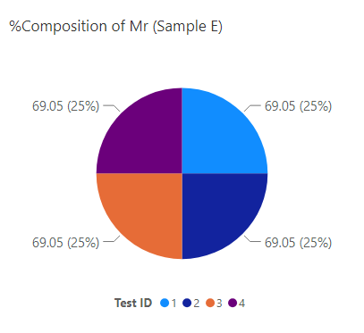
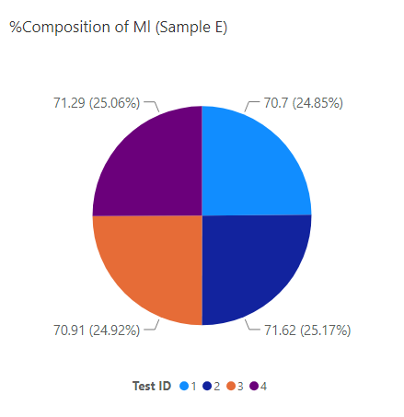
a

b
Figure 6. Biogas purification efficiencies across Tests 1–4: (a) removal of CO₂ and H₂O, (b) locally purified (ML), and control-purified (MC) biogas.
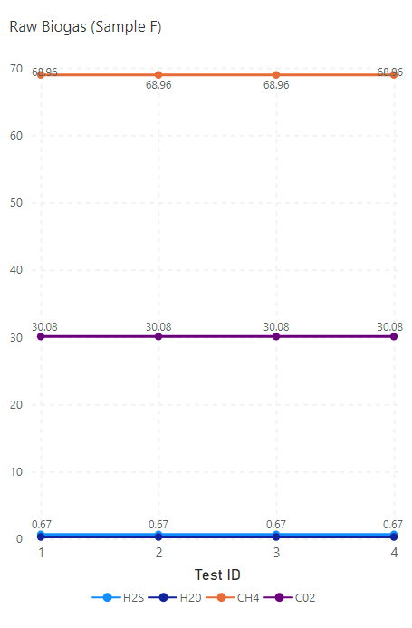
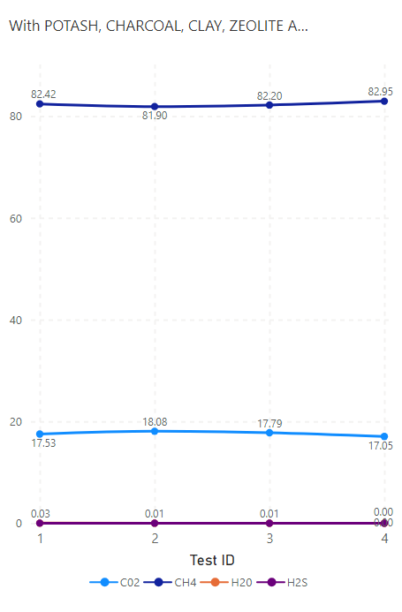
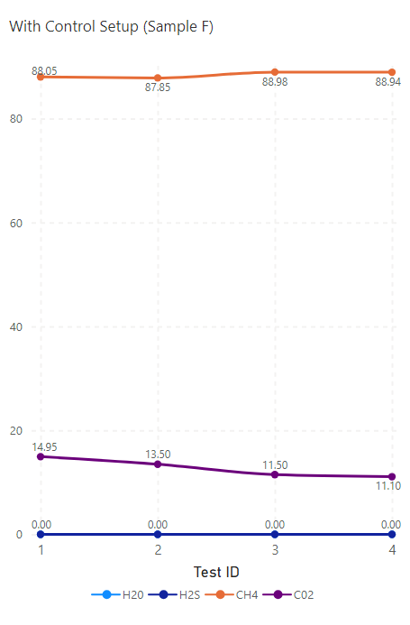

a b c
Figure 7: Biogas composition across Tests 1–4: (a) raw biogas, (b) purified with industrial control, (c) purified with local adsorbents (potash, charcoal, clay, zeolite, and iron ore).

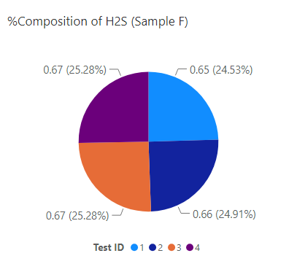
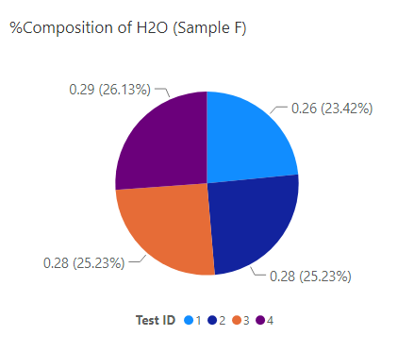
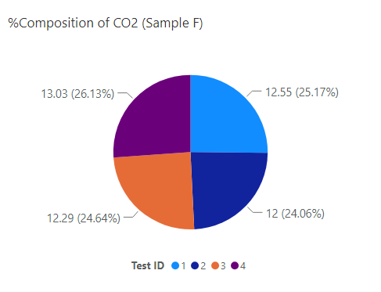

a b c
Figure 8. Removal efficiencies of (a) carbon dioxide (CO₂), (b) water vapour (H₂O), and (c) hydrogen sulfide (H₂S) across Tests 1–4 for different adsorbents compared with industrial control.

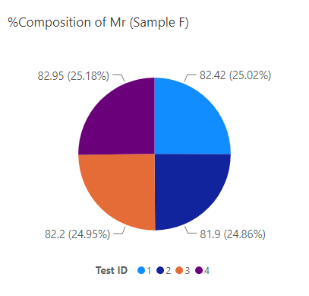
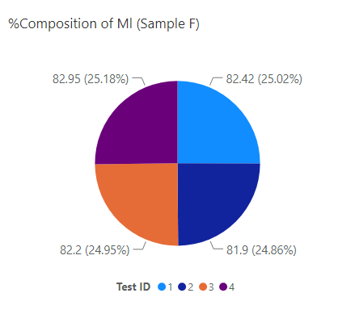
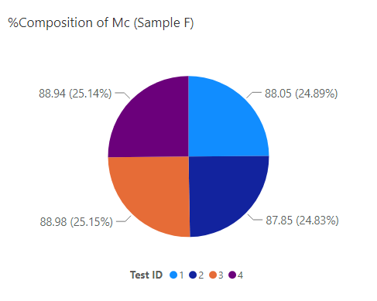

Figure 9. Comparative purification performance across Tests 1–4: (d) raw biogas, (e) biogas purified with industrial control, and (f) biogas purified with local adsorbents (zeolite, iron ore, charcoal, potash, and clay).

