Measuring the Efficiency of Solar Energy Systems: Technological, Economic, and Environmental Perspectives

Abstract
Solar energy plays a pivotal role in the global shift toward sustainable energy systems, driven by declining costs, technological innovation, and environmental benefits. This paper assesses the efficiency of solar energy systems from technological, economic, and environmental perspectives. Technologically, advances in photovoltaic (PV) systems—such as bifacial modules and perovskite-silicon tandem cells—have pushed conversion efficiencies beyond 23%, enhancing energy yield and economic competitiveness (Junker et al., 2023). Integration with energy storage and smart grid technologies improves reliability and enables real-time performance optimization. Economically, solar PV deployment generates higher employment multipliers compared to fossil-based sources, supporting new industries and job creation (Wei, Patadia & Kammen, 2010). Environmentally, solar energy contributes to significant reductions in greenhouse gas emissions, supporting national and global climate goals. Regional trends reveal rapid adoption in Asia and Europe, driven by policy incentives and market growth. Emerging technologies, including hybrid PV systems, building-integrated photovoltaics, and floating solar installations, further expand applicability and efficiency. By evaluating these dimensions, this study provides a comprehensive understanding of solar energy efficiency and highlights its crucial role in advancing energy security, sustainable development, and climate change mitigation worldwide.
Keywords: solar energy, photovoltaic systems, efficiency, renewable energy, bifacial solar cells, perovskite technology, energy storage, sustainability

1.Introduction
Solar energy has emerged as one of the most promising renewable sources in the global transition to sustainable energy. With steadily declining costs, improved efficiency, and wide availability, it plays a critical role in reducing dependence on fossil fuels and mitigating climate change. This paper examines solar energy efficiency from technological, economic, and environmental perspectives, highlighting its potential to shape the future of global energy systems. Technological advancements in photovoltaic (PV) systems—such as bifacial modules and perovskite-silicon tandems—have pushed conversion efficiencies to unprecedented levels, enhancing energy yield and economic competitiveness. Recent studies report bifacial perovskite solar cells achieving conversion efficiencies exceeding 23% and bifaciality above 91% (Junker et al., 2023). Complementing these advances, the integration of storage solutions and smart grid systems further strengthens solar’s reliability as a mainstream energy option. From an economic standpoint, investments in solar PV generate substantially higher employment multipliers than fossil-based sources, reflecting the labor-intensive nature of the sector and its capacity for job creation (Wei, Patadia & Kammen, 2010). Environmentally, solar energy contributes significantly to greenhouse gas reduction, supporting sustainability targets set by the Paris Agreement and national energy strategies. Hence, a comprehensive assessment of solar efficiency is essential for understanding both its current performance and future role in global energy security and climate resilience. This study applies a systematic review methodology. The literature was retrieved from Scopus and Web of Science databases, covering the period 2010–2025, using keywords such as ‘solar energy efficiency’, ‘photovoltaic systems’, ‘LCOE’, and ‘EPBT’. Articles were selected based on relevance, peer-reviewed status, and direct focus on technological, economic, or environmental aspects of solar energy efficiency.”

2. Technological Aspects of Solar Energy Efficiency
The efficiency of solar systems is largely determined by the technology employed. Global deployment of solar PV has accelerated over the past decade, as illustrated in Figure 1.

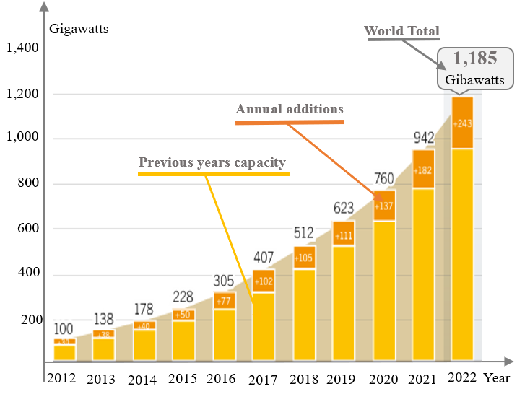
Source: Renewable 2024 Global Status Report
Figure 1.Trends of Solar PV Capacity Globally
Figure 1 shows the increasing global installed capacity of solar PV systems from 2010 to 2025, highlighting the rapid adoption in key regions. A regional perspective of installed solar PV capacity is presented in Figure 2, highlighting Asia and Europe as leading markets. Advancements in solar cell materials, including high-efficiency monocrystalline and bifacial technologies, continue to improve overall system performance. Integration of smart inverters and energy management systems further enhances the utilization of generated electricity, reducing losses and increasing reliability. Emerging innovations such as tandem cells and perovskite-based modules offer the potential for even higher efficiencies in the near future. Additionally, improvements in tracking systems and hybrid installations allow solar arrays to capture more sunlight throughout the day, optimizing energy output. As these technological developments progress, solar energy systems are becoming not only more efficient but also more adaptable to diverse environmental and grid conditions.

Regional breakdown in Figure 2 illustrates the dominant growth in Asia and Europe compared to other regions. Photovoltaic (PV) systems remain the dominant form, based on monocrystalline and polycrystalline silicon. Monocrystalline PV modules reach efficiencies of 18–22%, while polycrystalline achieve 15–17% (Aslam et.al., 2022).
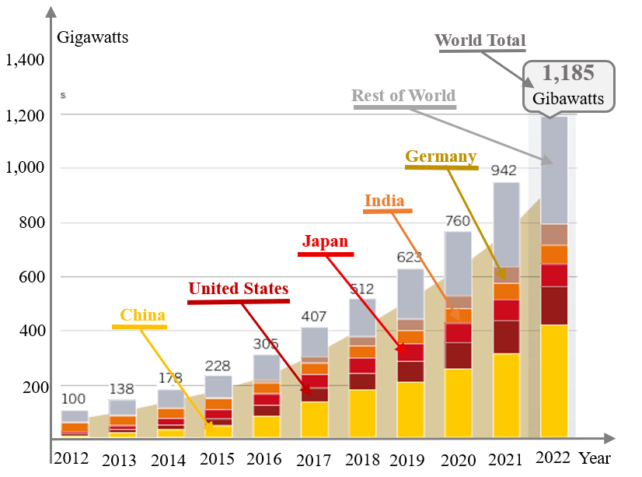
Source: Renewable 2024 Global Status Report
Figure 2. Regional Trends of Solar PV Capacity Globally
Recent research on perovskite materials demonstrates efficiency rates above 25%, providing a promising alternative to silicon (Green et al., 2022). Hybrid systems, floating PV, and building-integrated photovoltaics (BIPV) further enhance applicability. Solar thermal systems, particularly flat-plate and evacuated tube collectors, remain widely applied in residential and industrial heating (Evangelisti et al., 2019). Innovations such as smart solar systems connected to IoT technologies increase adaptability and allow real-time performance optimization.Furthermore, the integration of energy storage solutions, such as lithium-ion and emerging solid-state batteries, significantly enhances the capacity of solar systems to provide stable and dispatchable power. Policy incentives and declining module costs have accelerated deployment in emerging markets, broadening access to clean energy. Research into tandem PV cells and novel perovskite-silicon architectures is expected to further push conversion efficiencies, potentially exceeding 30% in commercial applications. Additionally, combining solar with other renewable sources, such as wind or hydro, through hybrid microgrids improves overall system reliability and resilience. Finally, advances in predictive maintenance and real-time monitoring allow operators to maximize energy yield and extend the operational lifespan of solar installations. Recent reviews highlight that bifacial perovskite and silicon heterojunction (SHJ) solar cells are among the most promising architectures, with laboratory efficiencies above 33% (Iturralde et al., 2025). Moreover, advanced thermal management strategies, including passive cooling and hybrid PV–thermoelectric generator (TEG) systems, are increasingly being investigated to mitigate heat-induced efficiency losses (Parthiban, 2022). Floating photovoltaic (FPV) systems, particularly in Asia and Europe, demonstrate higher yield due to natural cooling from water surfaces, while also reducing land-use conflicts (Nazir et al., 2023). These innovations not only expand the technological scope of solar applications but also enhance energy yield and operational stability.
3. Economic Viability and Sustainability Indicators
Economic aspects represent a critical factor in solar energy deployment. While the cost of PV modules has dropped by more than 80% in the last decade, installation and storage costs remain significant (Haegel et al., 2019). The Levelized Cost of Energy (LCOE) is a key benchmark. In many regions, solar LCOE has reached values below conventional fossil fuels, often in the range of 20–40 USD/MWh (Branker et al., 2011). Figure 3 presents a comparison of LCOE values across major energy sources, illustrating the strong cost competitiveness of solar PV.
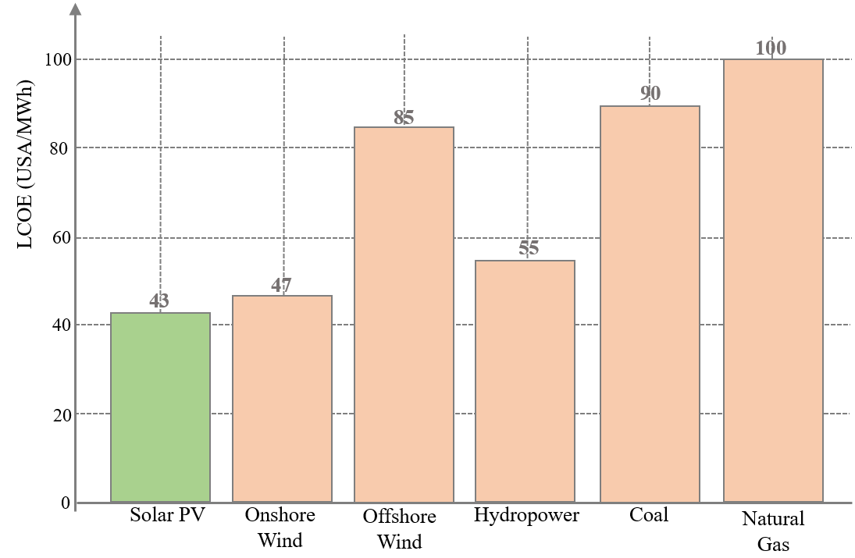
Source: IRENA (2024/2025).
Figure 3. LCOE Comparison of Solar PV vs. Other Energy Sources
Energy Payback Time (EPBT), which measures the time required for a system to produce the energy spent during its production, is currently 1–4 years depending on technology (Muteri et al., 2020). Additionally, solar energy creates millions of new jobs worldwide, with global PV employment reaching over 7 million in 2023 (IRENA, 2023). Figure 4 illustrates the strong correlation between investment flows in solar PV and employment growth, underscoring the sector’s role as both an economic driver and a sustainability enabler. Moreover, the long-term economic viability of solar energy is reinforced by decreasing operational and maintenance costs, as well as improving efficiency of PV technologies. Grid parity in many regions further enhances the attractiveness of solar investments, making them increasingly resilient to fluctuations in fossil fuel prices. Solar energy also contributes to energy security by reducing dependence on imported fuels and mitigating exposure to global market volatility. From a sustainability perspective, the low carbon footprint of PV systems compared to conventional energy sources provides significant environmental benefits. The combination of rapid cost declines, job creation, and environmental advantages positions solar energy as a cornerstone of both economic development and climate change mitigation strategies. As technology continues to advance and scale, the integration of solar energy into national energy portfolios is expected to accelerate, supporting broader goals of sustainable growth and decarbonization.
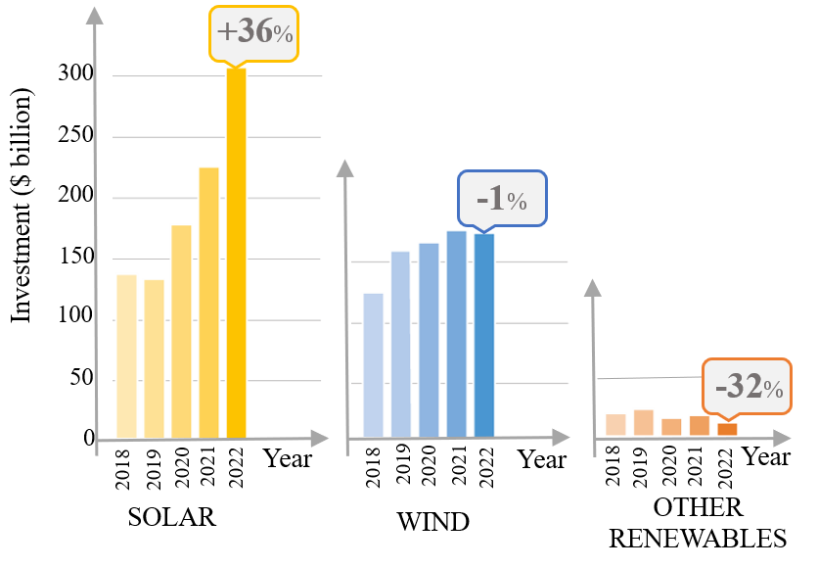
Source:Renewable 2024 Global Status Report; IRENA 2023; FS-UNEP Centre & BloombergNEF 2023
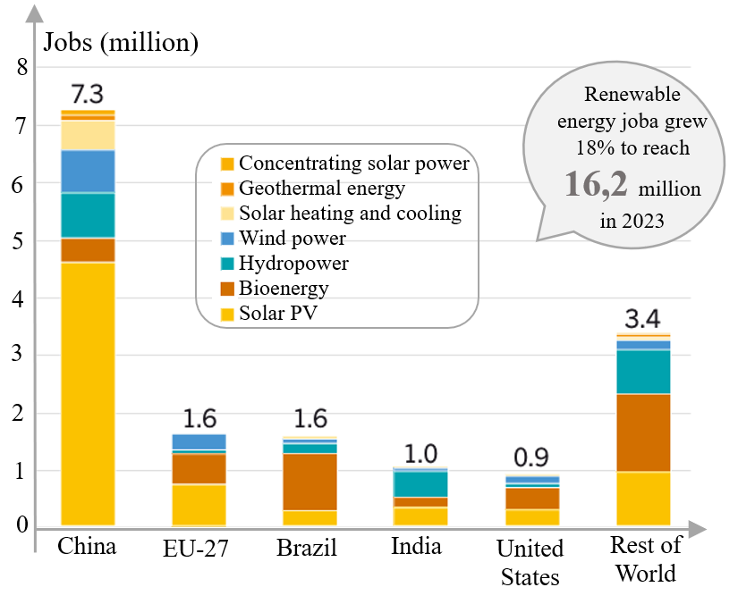
Source:Renewable 2024 Global Status Report; IRENA 2023; FS-UNEP Centre & BloombergNEF 2023
Figure 3. Investments and Employment
Figure 4 depicts the correlation between investments in solar PV and job creation, indicating significant employment opportunities in renewable energy sectors. These economic benefits reinforce solar energy’s competitiveness and sustainability. Recent data indicate that the levelized cost of energy (LCOE) for solar PV has reached record lows in 2023, dropping below 20 USD/MWh in some regions such as the Middle East and Latin America (IRENA, 2024). Innovative business models, including power purchase agreements (PPAs) and community-based solar projects, further accelerate adoption by lowering upfront costs for consumers and industries. According to Dada (2023), emerging PV materials such as organic–inorganic hybrids could reduce production costs while maintaining high conversion efficiencies. Additionally, large-scale deployment of floating solar projects, like those in Singapore and China, illustrate how economic and geographic constraints can be overcome through innovative design and financing. Such trends reinforce the role of solar energy as not only an environmental solution but also an economically dominant force in global energy markets.

4. Environmental and Social Benefits

From an ecological standpoint, solar energy significantly reduces greenhouse gas emissions and contributes to environmental preservation. Compared to fossil fuels, PV systems emit negligible amounts of CO₂ during operation, which makes them vital in achieving the targets of the Paris Agreement (Creutzig et al., 2017). Life Cycle Assessment (LCA) studies also show that modern solar modules have lower environmental footprints thanks to advances in recycling technologies (Cucchiella et al., 2015). Furthermore, decentralized solar applications enhance energy equity by providing access to clean energy in rural and off-grid regions. Life cycle assessment (LCA) studies conducted in 2023 confirm that recycling strategies for end-of-life PV panels significantly reduce their environmental footprint (Nazir et al., 2023; Cucchiella et al., 2015). The integration of nanomaterials, such as graphene and carbon nanotubes, not only improves panel performance but also facilitates sustainable recycling pathways (Nazir et al., 2023). Furthermore, the development of lightweight printed solar cells has achieved record efficiencies of up to 15.5% (CSIRO, 2024), offering scalable and recyclable alternatives for flexible and portable applications. These advancements align with circular economy principles, ensuring that solar PV deployment contributes to long-term environmental sustainability beyond its operational phase.

5. Measuring Efficiency and Comparative Analysis
Efficiency can be evaluated using several key indicators: installed capacity, capacity factor, LCOE, and EPBT. Capacity factor for solar typically ranges between 15–25%, while wind reaches 30–50% and hydro over 90% (Jacobson et al., 2015). Despite a lower capacity factor, solar offers unique advantages such as scalability, integration into buildings, and declining costs. Monocrystalline PV modules reach efficiencies of 18–22%, while polycrystalline achieve 15–17% (Shao & Xu, 2018). To enable a clearer comparison, Table 1 summarizes the efficiency ranges, advantages, and limitations of the main PV technologies, including silicon-based, bifacial, and emerging perovskite–silicon tandem cells.

Table 1. Comparative Efficiency of Photovoltaic (PV) Technologies
Technology Type | Typical Efficiency (%) | Key Advantages | Limitations | Sources
Monocrystalline Silicon | 18–22 | High efficiency, long lifespan | Higher cost | Shao & Xu, 2018
Polycrystalline Silicon | 15–17 | Lower cost, easier manufacturing | Lower efficiency, larger area needed | Shao & Xu, 2018
Perovskite (single-junction) | 22–25+ | High potential, low-cost materials | Stability and durability issues | Green et al., 2022
Bifacial Modules | 20–23 (front + rear) | Higher yield, better ground reflection | Requires optimal installation | Junker et al., 2023
Tandem (Perovskite–Silicon) | 28–30 (lab-scale) | Potential for record efficiencies | Still in R&D, limited scalability | Haegel et al., 2019

As shown in Table 1, perovskite and tandem PV technologies achieve significantly higher efficiencies than traditional silicon-based modules, but their commercial scalability remains limited. These trends confirm the need for continued research into stability, cost reduction, and industrial integration. Successful projects, such as Morocco’s Noor Solar Complex and Germany’s Energiewende program, demonstrate solar’s cost-effectiveness and societal benefits (IEA, 2023). Recent technological advances, particularly in bifacial and perovskite PV cells, as well as the application of artificial intelligence and machine learning for predictive maintenance and grid optimization, further enhance efficiency and reliability (Xu et al., 2025). Moreover, the development of hybrid energy systems that integrate solar with wind, hydrogen, or storage technologies provides additional resilience to climate variability and fluctuating demand (Iturralde et al., 2025). In addition to case studies, quantitative indicators such as Levelized Cost of Energy (LCOE) and Energy Payback Time (EPBT) are essential for cross-technology evaluation. Table 2 provides a comparative overview of LCOE and EPBT values across major renewable energy sources.

Table 2. Comparative LCOE and EPBT of Renewable Technologies
Technology | LCOE Range (USD/MWh) | EPBT (years) | Notes on Competitiveness | Sources
Solar PV | 20–40 | 1–4 | Competitive in most markets, rapid cost decline | Branker et al., 2011; Bhandari et al., 2015
Wind | 30–50 | 0.5–1.5 | Stronger capacity factor, site-dependent | Jacobson et al., 2015
Hydro | 40–80 | 1–2 | Very high capacity factor, but location-limited | Jacobson et al., 2015
Solar Thermal (CSP) | 50–100 | 2–5 | Storage potential, higher cost | Zhang & Yang, 2019
As illustrated in Table 2, solar PV demonstrates a competitive LCOE in most regions, with EPBT values among the lowest of renewable sources. While wind and hydro show advantages in terms of capacity factor and stability, solar’s scalability and declining costs make it one of the fastest-growing renewable options.These case studies, technological innovations, and comparative indicators confirm that efficiency goes beyond technical performance and includes economic and social contributions.

6. Conclusion
Solar energy is a cornerstone of the green transition, combining technological advancements, economic sustainability, and ecological benefits. Its efficiency is determined not only by technological progress but also by supportive economic, regulatory, and policy frameworks. By applying performance indicators such as LCOE, EPBT, and capacity factor, solar energy demonstrates increasing competitiveness against both conventional fossil-based and alternative renewable sources. Technological innovations, particularly in bifacial and perovskite PV cells, energy storage systems, and decentralized or hybrid installations, continue to improve energy yield and system reliability. Despite significant progress, challenges remain in areas such as energy storage integration, grid infrastructure, regulatory harmonization, and lifecycle management of solar modules. Addressing these issues through targeted research, investment, and policy incentives is crucial for unlocking the full potential of solar energy. Additionally, regional adoption patterns indicate that tailored strategies considering local resources, market dynamics, and socio-economic conditions are essential to maximize impact.
- Policy Implications and Future Directions
Beyond its technical and economic dimensions, solar energy serves as a catalyst for sustainable development, creating employment opportunities, fostering industrial innovation, and supporting climate resilience. To realize its full potential, several policy and research directions should be emphasized:
- Policy recommendations: Harmonized regulatory frameworks, incentives for recycling and lifecycle management of PV modules, and targeted support for storage integration and smart grid development.
- Research priorities: Advanced perovskite–silicon tandem architectures, floating PV applications, and the application of artificial intelligence for predictive maintenance, grid optimization, and resource forecasting.
- Practical contributions: Strengthening local supply chains, creating employment in installation and maintenance, and promoting energy equity through decentralized solar solutions in rural and underserved regions.
In the context of global energy security and decarbonization targets, solar power offers a scalable and versatile solution adaptable across diverse geographic and socio-economic settings. Continued interdisciplinary efforts combining technology, policy, and finance will be essential for ensuring the long-term sustainability and competitiveness of solar energy in the global transition.

Disclaimer (Artificial intelligence)
As the author Isak Karabegović, i declare that i did NOT use generative AI technologies such as large language models (ChatGPT, COPILOT, etc.) and text-to-image generators during the writing or editing of this manuscript.

References:
- Junker, A. et al. (2023). Highly efficient bifacial single-junction perovskite solar cells. Joule, 7(7), 1543–1555. https://doi.org/10.1016/j.joule.2023.06.001
- Wei, M., Patadia, S., & Kammen, D. M. (2010). Putting renewables and energy efficiency to work: How many jobs can the clean energy industry generate in the US? Energy Policy. https://doi.org/10.1016/j.enpol.2009.10.069
- Muteri, V., Cellura, M., Curto, D., Franzitta, V., Longo, S., Mistretta, M., & Parisi, M. L. (2020). Review on life cycle assessment of solar photovoltaic panels. Energies, 13(1), 252. https://doi.org/10.3390/en13010252
- Branker, K., Pathak, M. J. M., & Pearce, J. M. (2011). A review of solar photovoltaic levelized cost of electricity. Renewable and Sustainable Energy Reviews, 15(9), 4470–4482. https://doi.org/10.1016/j.rser.2011.07.104
- Creutzig, F., et al. (2017). The underestimated potential of solar energy in combating climate change. Nature Energy, 2(9), 17140. https://doi.org/10.1038/nenergy.2017.140
- Green, M. A., et al. (2022). Solar cell efficiency tables (version 60). Progress in Photovoltaics: Research and Applications, 30(7), 687–701. https://doi.org/10.1002/pip.3544
- Haegel, N. M., et al. (2019). Terawatt-scale photovoltaics: Trajectories and challenges. Science, 364(6443), 836–838. https://doi.org/10.1126/science.aaw1845
- IEA – International Energy Agency. (2023). World Energy Outlook 2023. https://www.iea.org/reports/world-energy-outlook-2023
- IRENA. (2023). Renewable Energy and Jobs: Annual Review 2023. International Renewable Energy Agency. https://www.irena.org
- Jacobson, M. Z., et al. (2015). 100% Clean and Renewable Wind, Water, and Sunlight (WWS) All-Sector Energy Roadmaps for 139 Countries. Joule, 1(1), 108–121.
https://doi.org/10.1016/j.joule.2017.07.005
- Cucchiella, F., D’Adamo, I., Koh, S. C. L., & Rosa, P. (2015). Recycling of WEEE: An economic assessment of present and future e-waste streams. Renewable and Sustainable Energy Reviews, 51, 263–272. https://doi.org/10.1016/j.rser.2015.06.010
- Commonwealth Scientific and Industrial Research Organisation (CSIRO). (2024, 12. ožujka). Record efficiency for lightweight printed solar cells. The Guardian. https://www.theguardian.com/australia-news/2024/mar/12/csiro-claims-new-record-for-energy-efficiency-in-lightweight-printed-solar-cells
- Aslam, A., Ahmed, N., Qureshi, S. A., Assadi, M., & Ahmed, N. (2022). Advances in solar PV systems; A comprehensive review of PV performance, influencing factors, and mitigation techniques. Energies, 15(20), 7595. https://doi.org/10.3390/en15207595
- Evangelisti, L., De Lieto Vollaro, R., & Asdrubali, F. (2019). Latest advances on solar thermal collectors: A comprehensive review. Renewable and Sustainable Energy Reviews, 114, 109318. https://doi.org/10.1016/j.rser.2019.109318
- J. M., Castillo-Alvarez, Y., & Rodríguez-Reséndiz, J. (2025). Efficiency and Sustainability in Solar Photovoltaic Systems: A Review of Key Factors and Innovative Technologies. Eng, 6(3), 50. https://doi.org/10.3390/eng6030050
- Parthiban, R., & Ponnambalam, P. (2022). An enhancement of the solar panel efficiency: A comprehensive review. Frontiers in Energy Research, 10, 937155.
https://doi.org/10.3389/fenrg.2022.937155
- Nazir, S., Ali, A., Aftab, A., Muqeet, H. A., Mirsaeidi, S., & Zhang, J. M. (2023). Techno-Economic and Environmental Perspectives of Solar Cell Technologies: A Comprehensive Review. Energies, 16(13), 4959. https://doi.org/10.3390/en16134959
- Dada, M., & Popoola, P. (2023). Recent advances in solar photovoltaic materials and systems for energy storage applications: A review. Beni-Suef University Journal of Basic and Applied Sciences, 12, 66. https://doi.org/10.1186/s43088-023-00405-5
- Xu, T., Wei, R., Singh, S. C., & Guo, C. L. (2025). 15-fold increase in solar thermoelectric generator performance through femtosecond-laser spectral engineering and thermal management. Light: Science & Applications, 14(1), Article 192.
https://doi.org/10.1038/s41377-025-01916-9

