Original Research Article

Effect of Co-digestion in the Anaerobic Digestion of Sugarcane Effluents

Abstract : This study focused on the optimal conditions for the biodigestion of sugarcane effluents from Sucrivoire Zuenoula located in the southwest of Côte d’Ivoire. Thus, four experimental digesters were fed as follows: 1) sugarcane effluent ; 2) effluent + bagasse ash; 3) effluent + cow dung; 4) effluent + ash + cow dung. The results showed that the digesters operated in a mesophilic manner with temperatures ranging from 28.83 to 29.37 °C and an alkaline pH varying from 6.93 to 7.70. Regarding COD, it decreased in all digesters from 665.7 to 590.9 mg/L for D1; D2: 670.7 to 580.4 mg/L; D3: 2188.9 to 801.3 mg/L; D4: 1551.9 to 890.9 mg/L. As for TKN, it slightly decreased in all digesters (D1 : 79.17 to 60.45 mg/L D2: 670.7 to 580.4 mg/L; D3: 2188.9 to 801.3 mg/L; D4: 1551.9 to 890.9 mg/L). As for TKN, it slightly decreased across all digesters (D1: 79.17 to 60.45 mg/L; D2: 77.98 to 57.7 mg/L; D3: 558 to 220.1 mg/L; D4: 260.12 to 190.45 mg/L). For the volume of gas produced, it is significantly higher in digesters 2, 3, and 4 (0.018; 0.013; 0.058 m³) than in digester 1 (0.0062 m³). The flammability test of the produced gas is positive after 7 days in digester 2, after 6 days in digester 3, and after 4 days of operation in digester 4; the flammability test is negative in digester 1. Overall, the results of the study show that the co-digestion of sugarcane effluents with bagasse ash and cow dung is necessary for optimizing the biomethanization process.

Keywords : Zuenoula, sugarcane effluent, biodigestion, co-digestion, optimization

Introduction
The agri-food industry, particularly the sugar industry, produces enormous waste. This waste consists of a large amount of water. Indeed, a study conducted on the integrated agricultural unit of Sucrivoire Zuenoula revealed that 8,932.56 m³ of effluents are discharged daily. These discharged effluents are rich in easily biodegradable organic substances (Die Grace and Kpata-Konan 2024; Smith et al., 2020). To effectively and efficiently manage this waste produced, anaerobic digestion is an adequate solution. It is a key technology for the circular economy, including sustainable waste management, green energy production, and environmental preservation. Anaerobic digestion, also known as methanization, is a biological treatment process for organic waste. which allows for the production of digestate and biogas (ADEME 2011). It enables the transformation of organic matter mainly into methane (CH4), water (H2O), and carbon dioxide (CO2) through a complex microbial ecosystem operating in the absence of oxygen (Kalloum et al., 2007, Murphy et al., 2013). The produced biogas can be used to generate energy in the form of steam, heat, electricity, and domestic gas (Bougrier, 2005; Saidi et al., 2007). Additionally, it helps in environmental terms to reduce carbon dioxide (CO2) emissions (Wu et al., 2009). The produced digestate is a liquid fertilizer rich in nutrients usable in agriculture, odorless, reduced in the number of pathogenic microorganisms and in

trace metallic elements (Bougrier, 2005; Ossepe et al., 2024). Several parameters such as pH, temperature, and substrate composition govern the proper functioning of an anaerobic digester (Bouallagui et al., 2009; Fountoulakis et al., 2010). The anaerobic digestion process generally involves four successive phases (Héteu and Martin, 2003; Cresson, 2006): hydrolysis and acidogenesis, which result in the formation of volatile fatty acids, acetogenesis, responsible for the formation of acetic acid, hydrogen, and carbon dioxide, and finally methanogenesis, which converts acetate into methane (CH4). This last phase requires very specific conditions for its initiation. The present work aims to determine the optimal conditions for the biodigestion of effluents from sugar refineries through anaerobic processes by monitoring pH, temperature, chemical oxygen demand (COD), total Kjeldahl nitrogen (TKN), the COD/TKN ratio, and biogas production.
Materials and methods
  - Materials
The raw material used in this study is the effluent from Sucrivoire of Zuénoula, a city in the central-western part of Côte d’Ivoire, located in the Marahoué region. This effluent, with a pH ranging from 4.25 to 6.65, consists of water used for washing sugar cane. Bagasse ash and cow dung, with a pH between 9 and 12, were respectively used for inoculation and neutralization of the reaction medium. This bagasse ash also comes from the integrated agricultural unit of Sucrivoire Zuénoula. The cow dung comes from the municipal slaughterhouse of Daloa. The temperature and pH of the reaction medium were measured using a HANNA type pH meter model HI 8010. A commercial scale type CAP.20 kg/GRAD.50 g was used for weighing the cow manure. The experimental setup consists of four digesters, each made up of two metal barrels with capacities of 27 L and 20 L, each open on one side (Figure 1). The larger barrel contains the reaction medium. The smaller barrel is submerged in the larger one until it touches the bottom. The smaller barrel acts as a gasometer where the produced biogas is stored. A mixer and a valve are mounted on this barrel. The valve allows for the burning of the produced biogas as fermentation proceeds. As for the mixer, it is used to homogenize the reaction medium to prevent sedimentation.

  - Methods
The trials were launched on July 5, 2023. The four digesters set up were fed as follows:
• Digester 1: sugarcane effluent (E);
• Digester 2: sugarcane effluent + bagasse ash (E+C);
• Digester 3: sugarcane effluent + cow dung (E+B);
• Digester 4: sugarcane effluent + bagasse ash + cow dung (E+C+B)
For digesters 2 and 4, the reaction media were buffered to pH 7 using bagasse ash. All the digesters, exposed to sunlight, operate discontinuously. The COD and TKN are determined in the laboratory and were obtained according to the AFNOR methods NF T 90-015 and NF TNF T90-101. The volume (V) of the biogas produced was determined using the expression: V = πR²H, after measuring the height (H) of the gas meter (small barrel); R = radius of the gas meter (small barrel). The sampling of the effluent is carried out at the entry and exit of the different digesters. The pH and temperature were obtained according to the AFNOR method NF T 90-008. The pH, temperature, and volume of gas produced are measured in situ on a daily basis.
For the statistical analysis, the nature of the data was first determined in order to know which of the parametric or non-parametric methods was suitable. The Shapiro-Wilk test (W) was used to test the normality of the distribution at a threshold of 0.05. ANOVA was conducted to highlight any differences between digesters based on the considered variables. Statistical analyses were performed using Statistica version 7.1 software. Excel was used to collect and organize the data, and Origin software was used to plot the curves and box plots.
2. Results and Discussion
2.1. Results
In terms of pH, the pH of digester 1 (E) was 6.25 and then dropped slightly before rising on the third day to reach neutrality at 7.00 by the seventh day. At the end of the experiment, the pH was 6.45 with an average of 6.96±0.04 (figure 1a).As for digesters 2, 3, and 4, they operated similarly. The pHs were 7.10, 7.21, and 7.40 respectively:- In digester 2 (E+C), the pH dropped on the second day of the experiment and then increased on the third day to 7.16, reaching 7.81 by the end of the experiment with an average of 7.56±0.05 (figure 1b).- In digester 3 (E+B), the pH dropped sharply from 6.80 to 6.98 from the second to the sixth day, then reached neutrality on the seventh day at 7.13. The pH continued to rise gradually to reach 7.81 at the end of the experiment with an average of 7.43±0.03 (figure 1c). - In digester 4 (E+C+B), the pH drops sharply from 7.10 to 7.20 from the 2nd to the 8th day, then we observe a continuous gradual increase, with the pH at the end of the experiment being 7.70 and an average of 7.71±0.04 (figure 1d). The pH of digester 1 is significantly different (p < 0.05) from that of digesters 2, 3, and 4.
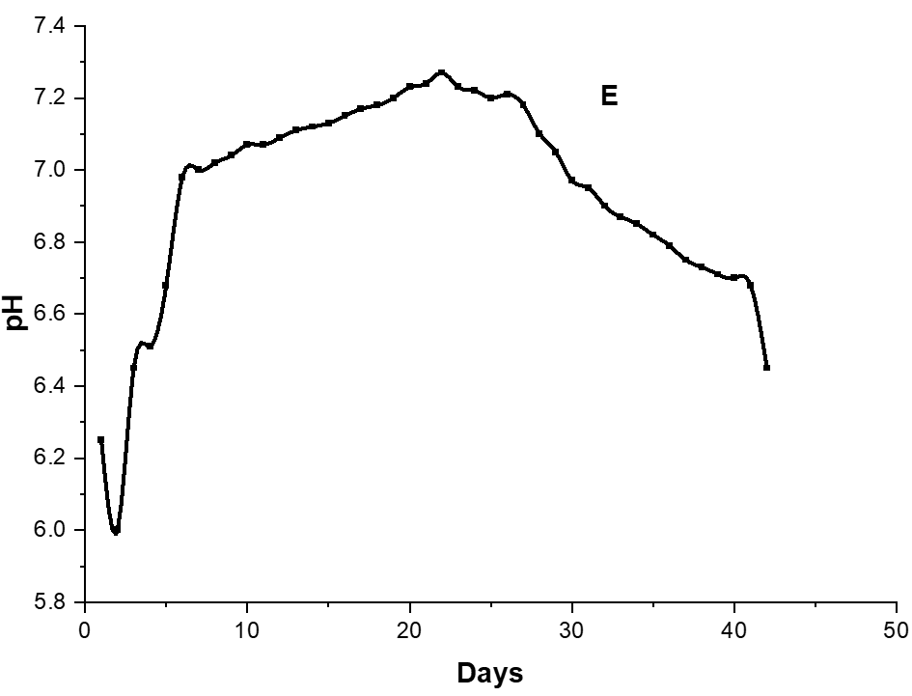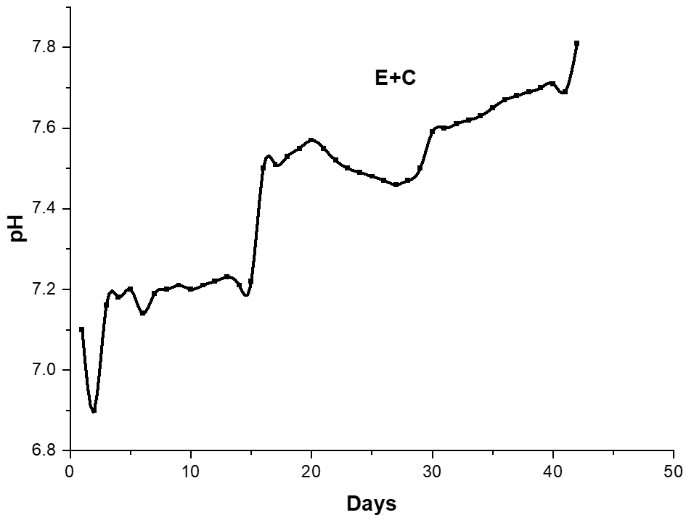
b
a
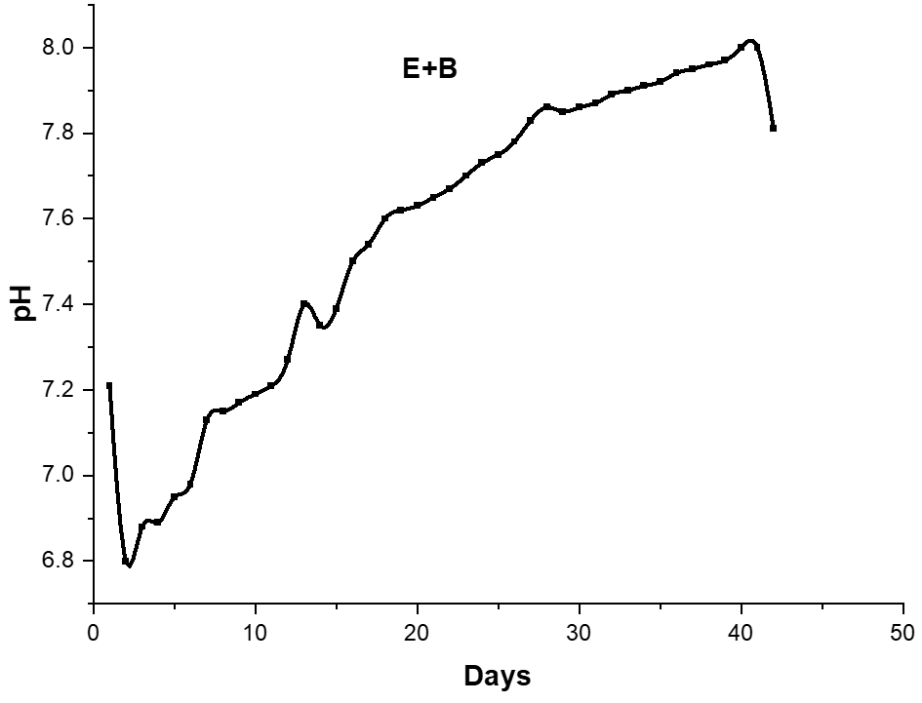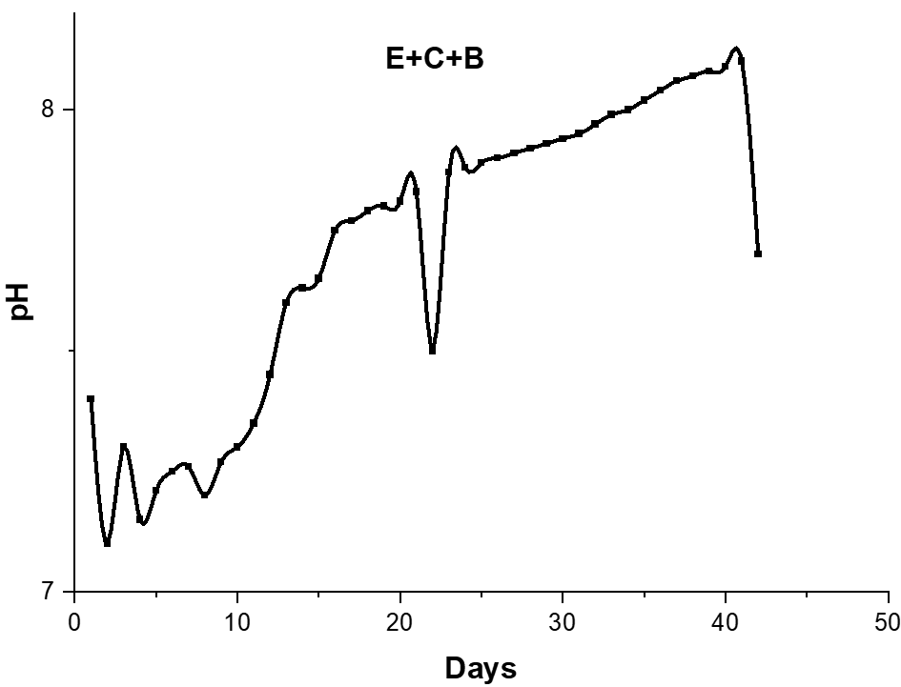
d
c
Figure 1 : pH evolution curve in the four digesters. E = sugar effluent, E+B = sugar effluent + 2 kg of cow dung, E+C = sugar effluent + ash, E+C+B = sugar effluent + ash + 2 kg of cow dung.
In digester 1 (E), the temperatures fluctuated between 27°C at the beginning of the experiment and 27.4°C at the end of the experiment with an average of 28.83±0.31°C (figure 2a). As for digester 2 (E+C), the recorded temperatures ranged from 25.5°C at the beginning of the experiment to 27.6°C at the end of the experiment with an average of 28.88±0.32°C (figure 2b). Concerning digester 3 (E+B), the recorded temperature range was from 27.9°C at the beginning of the experiment to 27.3°C at the end of the experiment with an average of 28.93±0.33°C (figure 2c). For digester 4 (E+C+B), the recorded temperatures fluctuated between 27.7°C and 28°C respectively at the beginning and end of the experiment with an average of 29.26±0.34°C (figure 2d). The minimum temperature was 25.5°C and the maximum was 35°C. There is no significant difference between the digesters (p>0.05).
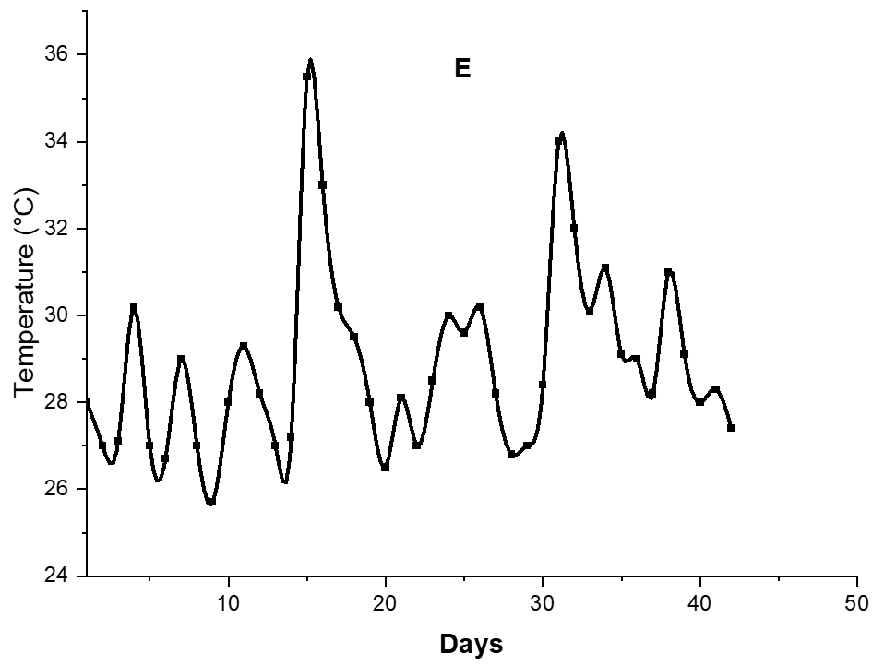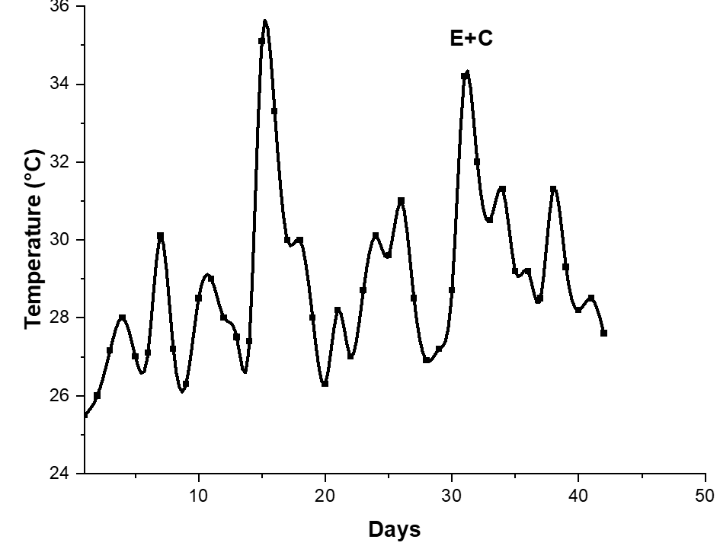
a
b
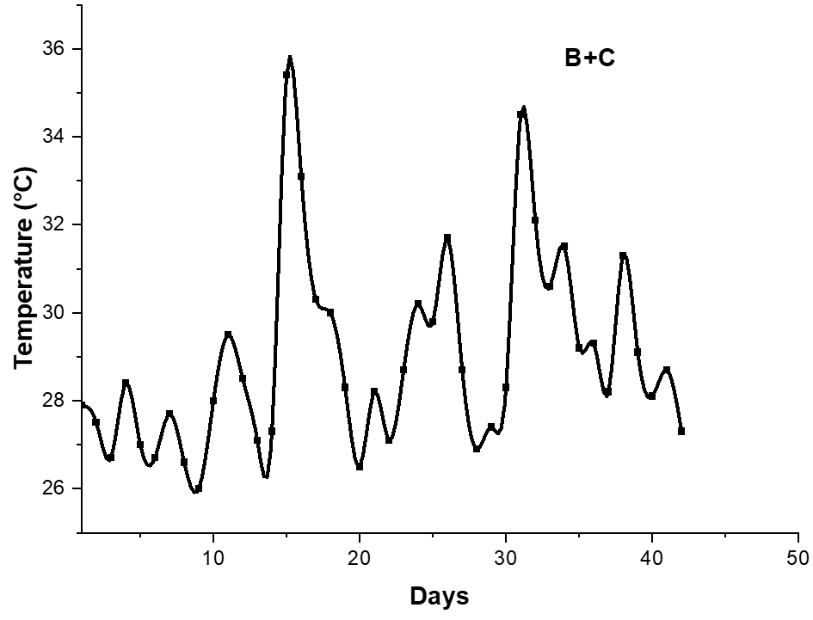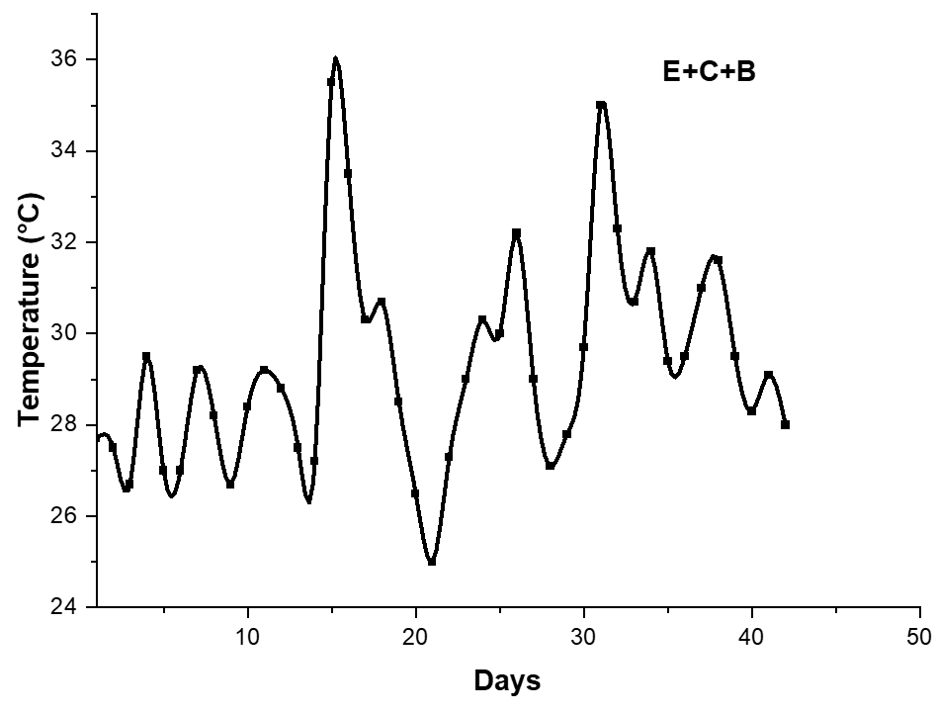
d
c
Figure 2: temperature evolution curve in the four digesters. E = sugar effluent, E+B = sugar effluent + 2 kg of cow dung, E+C = sugar effluent + ash, E+C+B = sugar effluent + ash + 2 kg of cow dung.
The chemical oxygen demand at the entrance of the different digesters was 665.7 mg/L, 670.7 mg/L, 2188.9 mg/L, and 1551.9 mg/L respectively for digester 1 (E), 2 (E+C), 3 (E+B), and 4 (E+C+B). The values of the COD gradually decreased in the 4 digesters after 5 weeks of experimentation. In digester 1 (E), the COD value decreased from 665.7 mg/L to 590.9 mg/L with a treatment efficiency of 11.23%.
Regarding digester 2 (E+B), the pollutant load decreased from 2188.9 mg/L to 801.3 mg/L, with a treatment efficiency of 63.39%.
The pollutant load in digester 3 (E+C) dropped from 670.7 mg/L to 580.4 mg/L, showing a treatment efficiency of 13.46%.
In digester 4 (E+C+B), there was a reduction in the pollutant load from 1551.9 mg/L to 890.9 mg/L, with a treatment efficiency of 42.59%.
Digesters enriched with cow dung have higher BOD levels, while digesters containing only effluent and effluent + bagasse ash have low BOD levels.
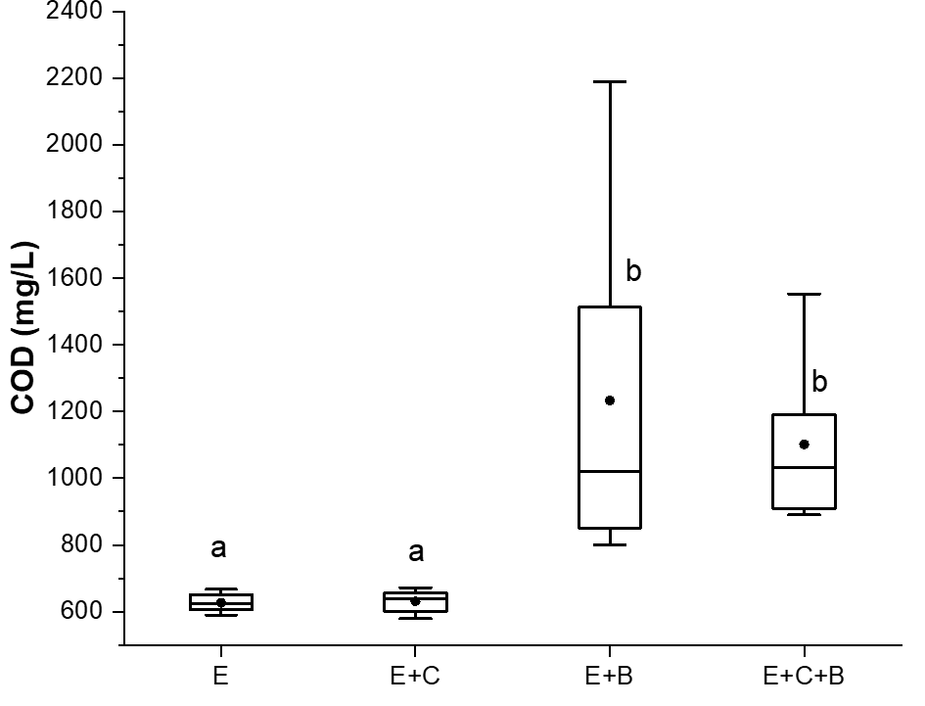
Figure 3: evolution of the COD in the four digesters. E = sugar effluent, E+B = sugar effluent + 2 kg of cow dung, E+C = sugar effluent + ash, E+C+B = sugar effluent + ash + 2 kg of cow dung. There is no significant difference between two boxes with the same letter and considerable variability between two boxes with different letters. The parametric ANOVA test followed by the Tukey HSD test for p < 0.05.
There is a slight decrease observed in all digesters in the amount of nitrogen during the experimental period. The concentrations of Total Nitrogen (TN) dropped from 79.17 mg/L to 60.45 mg/L for digester 1 (E), from 77.98 mg/L to 57.7 mg/L for digester 2 (E+C), from 558 mg/L to 220.1 mg/L for digester 3 (E+B), and from 260.12 mg/L to 190.45 mg/L for digester 4 (E+C+B). The digester (D2) containing effluent + cow dung has higher TN values, followed by digester (D4). The digesters (D1 and D3) have relatively low TN levels.
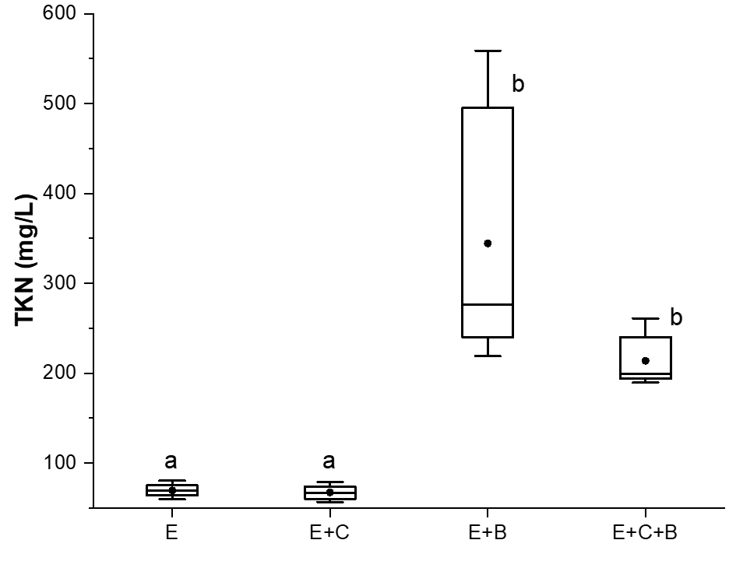
Figure 4: evolution of NTK in the four digesters. E = sugary effluent, E+B = sugary effluent + 2 kg of cow dung, E+C = sugary effluent + ash, E+C+B = sugary effluent + ash + 2 kg of cow dung. There is no significant difference between two boxes labeled with the same letter and significant variability between two boxes labeled with different letters. The parametric ANOVA test followed by the Tukey HSD test for p < 0.05.
The production of biogas is virtually zero throughout the operational period of digester 1 (E) with a total volume of 260.69 dm³ and an average of 6.20±0.15 dm3 (figure 5a). In regard to digester 2 (E+C), gas production started on the 4th day, reaching a peak of 44 dm³ on the 11th day. Then, the volume of biogas gradually decreased until it ceased on the 20th day. The total gas production in this digester is 578.62 dm³ with an average of 13.77±1.93 dm³. The flammability test of the gas produced by digester E+C was positive after 7 days of operation (figure 5b). Digester 3 (E+B) produced gas on the 3rd day of operation. The biogas production peaked on the 15th day and then gradually decreased until it stopped on the 25th day. The total volume of gas produced is 791.63 dm³, with an average of 18.84±2.58 dm³. The flammability test of the gas produced by digester 3 (E+B) was positive 6 days after the launch (figure 5c). As for digester 4 (E+C+B), gas production was recorded as early as the 2nd day of its launch. The gas production in this last digester shows two peaks. The first occurs on the 15th day with a volume of 79 dm³. The gas volume then gradually decreases to 44 dm³ on the 23rd day, before reaching the second peak which appeared on the 26th day with a value of 92 dm3. Throughout the experimental period, the total volume recorded is 2460.73 dm³, with an average of 58.58±3.08 dm³. The test The inflammability of the gas produced by digester 4 (E+C+B) was positive from the 4th until the end of the experimentation (figure 5d). The cumulative biogas production recorded at reactor 1 (E) is 0.26 m³; that of digester 2 (E+C) reached 0.57 m³. Reactor 3 (E+B) recorded a total of 0.79 m³. As for digester 4 (E+C+B), the cumulative volume of biogas after 42 days of operation is 2.46 m³.

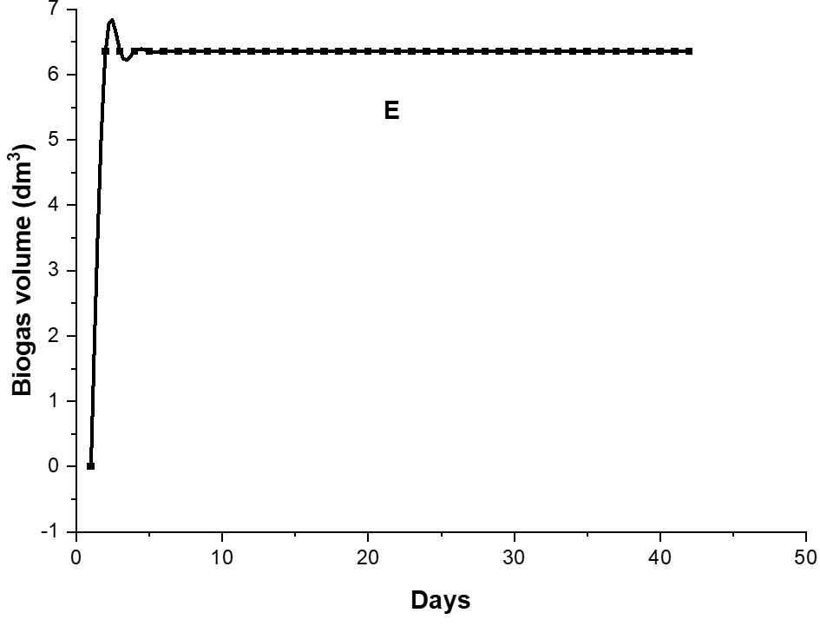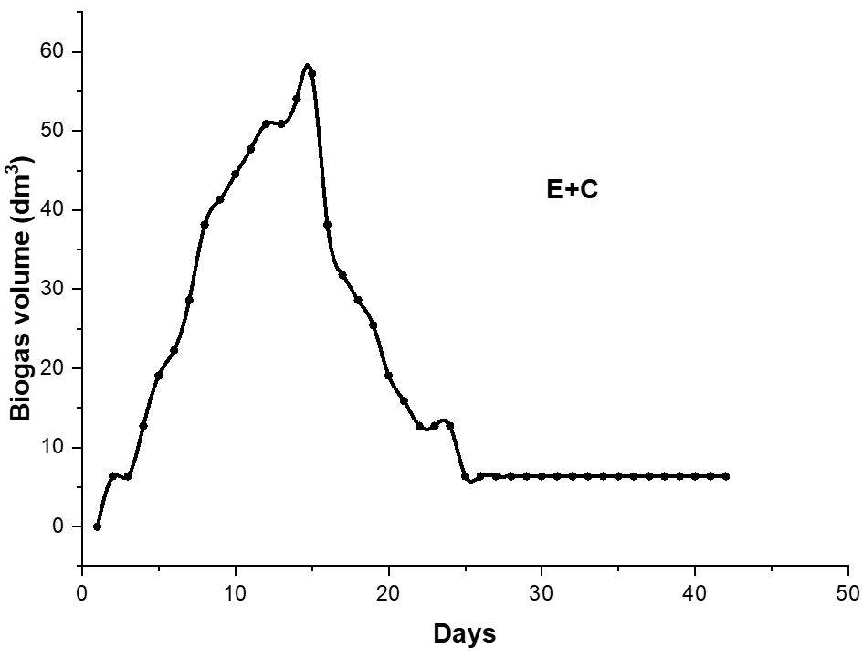
b
a

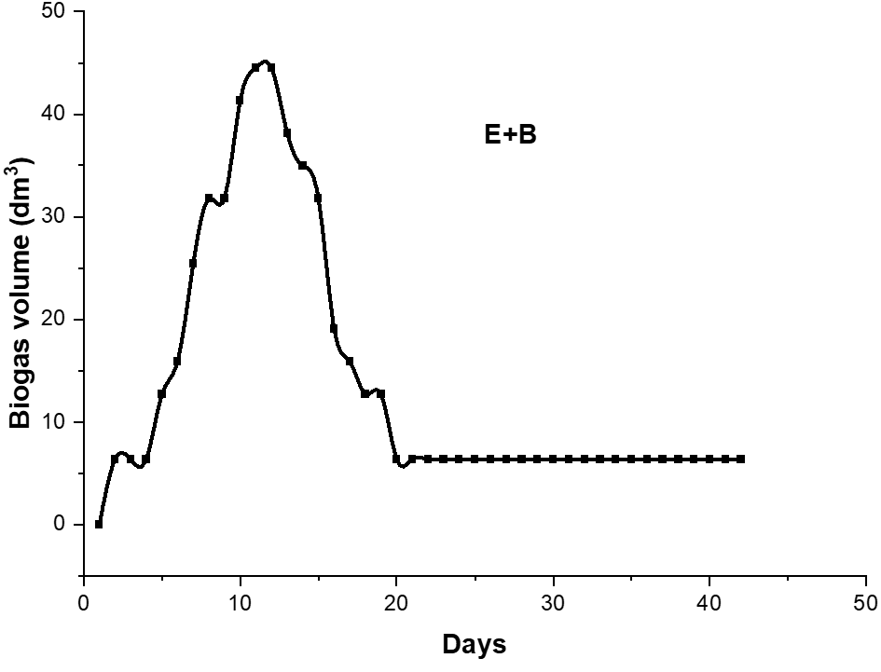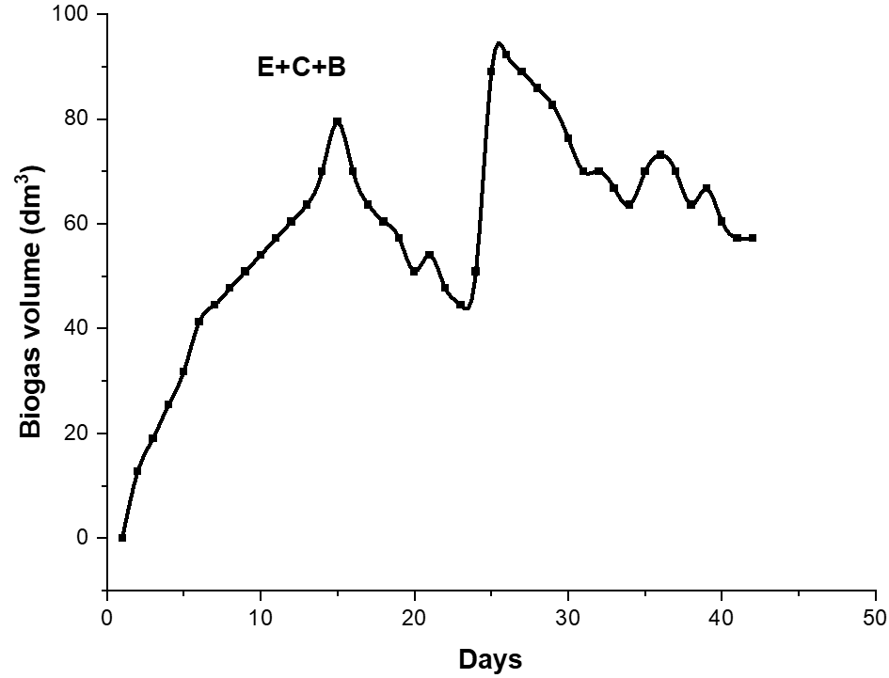
d
c
- Figure 5: evolution of biogas volume in the four digesters. E = sugar effluent, E+B = sugar effluent + 2 kg of cow dung, E+C = sugar effluent + ash, E+C+B = sugar effluent + ash + 2 kg of cow dung. The biogas volume from digester 1 is significantly different (p < 0.05) from that of digesters 2, 3, and 4.
Table 1- Analysis of temparature, pH and Biogas volume
temperature | E | E+C | E+B | E+C+B
E | - | 0.452 | 0.318 | 0.562
E+C | 0.452 | - | 0.229 | 0.365
E+B | 0.318 | 0.318 | - | 0.318
E+C+B | 0.562 | 0.365 | 0.477 | -

pH | E | E+C | E+B | E+C+B
E | - | <0.05 | <0.05 | <0.05
E+C | <0.05 | - | 0.09999 | <0.05
E+B | <0.05 | 0.09999 | - | 0.26006
E+C+B | <0.05 | 0.29135 | 0.26006 | -

Biogas volume | E | E+C | E+B | E+C+B
E | - | <0.05 | <0.05 | <0.05
E+C | <0.05 | - | 0.09999 | <0.05
E+B | <0.05 | 0.09999 | - | 0.26006
E+C+B | <0.05 | 0.29135 | 0.26006 | -
E = sugar effluent, E+B = sugar effluent + 2 kg of cow dung, E+C = sugar effluent + ash, E+C+B = sugar effluent + ash + 2 kg of cow dung.

2.2. Discussion
The results show that the pH of the digesters operated around neutrality. These pH values are favorable for optimal biogas production during anaerobic digestion (Appels et al., 2008a). However, digesters with adjusted pH before feeding are more stable. Indeed, co-digestion can provide a stable pH value by avoiding extreme acidification conditions. The change in pH value of the raw materials mixed in co-digestion is more stable and easier to maintain within the optimal pH range in the digestion process compared to single substrate digestion. These results corroborate those of (Ahou. Y. S, 2019; Kpata. N. E, 2014). There is also a sharp drop in pH in all digesters during the first five days of the experiment. This is due to the hydrolysis and acidogenic phase, which is characterized by the degradation of organic matter and the formation of volatile fatty acids and organic acids (Kalloum et al., 2007; Parawira et al., 2006).
As for the temperature, we observe from the results that the digesters operated within the mesophilic temperature range (25°C for the minimum and 35°C for the maximum). This temperature range is available due to the tropical climate of the country, characterized by warm climates where the temperature of the coldest month does not drop below 17°C, 18°C, or even 20°C (Goula et al., 2006). Indeed, according to (Appels et al., 2008b), the mesophilic process involves a diversity of microorganisms and is more stable than the thermophilic process because there are fewer varieties of active microorganisms within the ranges thermophiles. The mesophilic process allows for optimal methanogenic bacterial activity that transforms acetates into methane (Appels et al., 2008b).
Regarding chemical oxygen demand, it has gradually decreased in all digesters. This implies a reduction in pollutant load, indicating good performance overall in the digesters (Maglwa, 2019). Doré (1989) reveals that the reductions in pollutant load could be explained by the potential consumption of organic matter by the purifying microflora during its natural evolution in these digesters.
Furthermore, digesters 3 (E+B) and 4 (E+C+B) have high purification yields of 63.39% and 42% respectively, compared to digesters 1 (E) and 2 (E+C) whose purification yields are 11.23% and 24.73% respectively.
As for the total Kjeldahl nitrogen, a slight decrease is noted in all digesters. This slight reduction in nitrogen could be explained by the low volatilization of ammonia nitrogen observed in anaerobic digestion (Tugtas, 2007; Maiga et al., 2008). Indeed, Barana (2000) reported that anaerobic digestion processes conserve nitrogen. The residues from this digestion can therefore be used as fertilizer in agriculture (Kalloum et al., 2011).
Digesters enriched with cow dung have relatively higher nitrogen values than those that have not been enriched with cow dung. This large amount of nitrogen present in these digesters is due to the addition of cow dung. Indeed, cow dung added as a co-substrate to the effluent from sugar production to boost biogas production during anaerobic digestion is rich in nitrogen (Christophe, 2016; Kpera et al., 2017).
Biogas production was observed in all digesters. However, the amount of biogas produced in the digester containing only the effluent from sugar production is very low. Regarding gas quality, the digesters show differences in the flammability test. Indeed, the flammability test is positive for the digesters buffered with ash and inoculated with cow dung. In contrast, in the digester containing only the effluent from sugar production, this test is negative throughout its operation. The high production and rapid flammability of the biogas produced in the digesters neutralized with ash and inoculated with cow dung were favored by the adjustment of the pH (which remained around neutrality) of the reaction medium from the first day of the experiment. This neutral pH at startup would have allowed the onset of the methanogenesis phase in these digesters. According to Appels et al. (2008) and Kalloum et al. (2007), pH values close to neutrality are much more favorable for the development of methanogenic bacteria responsible for biogas production. Moreover, Ahou Y.S (2019) observed that this range of pH helps stabilize the reaction medium and promotes the activity of methanogenic bacteria. Thus, co-digestion can allow for a stable pH value compared to the digestion of a single substrate.
The analysis of the gas production profiles indicates that there were significant differences between the various combinations tested. Compared to the digester containing only the effluent from sugar production, the volumes of biogas produced are higher in the other digesters, namely the digesters with co-substrates. The results show that the largest volume of biogas was observed in the digester containing the substrates: effluents from sugar production + bagasse ash + cow dung.
Furthermore, outside of digester 1 (E), the flammability test of the biogas produced by the co-digestion digesters was positive for 24 days for the E+B digester, 19 days for the E+C digester, and 42 days for the E+C+B digester. Additionally, the gas produced burns with a blue flame. This indicates the presence of methane in the biogas produced by these three co-digestion systems. The observed results could be due to a positive synergy within the bioreactors, particularly in the one containing substrates composed of effluents from sugar production + bagasse ash + cow dung. Such reaction environments made up of composite substrates provide, according to Mshandete et al. (2004), the missing nutrients and manage to reduce inhibitory materials. Moreover, the higher potential of biogas recorded in mixed-substrate digesters is likely due to the increased ratio of easily degradable compounds in these reaction environments, as reported by Panichnumsin et al. (2010) and Riaño et al. (2011). The difference in the results obtained in E+B and E+C+B digesters may be attributed to the composition of the microbial communities in these co-digestion systems. Indeed, according to Fernandez et al. (2005) and Schauer-Gimenez et al. (2010), the difference between anaerobic digesters subjected to organic overloads is based on the microbial communities initially present in the reactors.

- Conclusion
This study shows that fertilization and pH adjustment before starting the treatment of effluents from sugar production is essential for optimizing the biomethanization process. The study results highlight that bagasse ash could be used as a substitute for the chemicals generally used for pH adjustment during anaerobic digestion. Furthermore, it is recommended to seed the reaction medium with cow dung to boost biogas production. Co-digestion allows for an increase in biogas yield.

Disclaimer (Artificial intelligence)

Option 1:

Author(s) hereby declare that NO generative AI technologies such as Large Language Models (ChatGPT, COPILOT, etc.) and text-to-image generators have been used during the writing or editing of this manuscript.

Option 2:

Author(s) hereby declare that generative AI technologies such as Large Language Models, etc. have been used during the writing or editing of manuscripts. This explanation will include the name, version, model, and source of the generative AI technology and as well as all input prompts provided to the generative AI technology

Details of the AI usage are given below:
1. I used AI Translator to translate the document into English. I am a French speaker.
2.
3.

- references
ADEME. 2011. Agronomic and sanitary quality of digestates. Final report by Agroenvironnement, RITTMO Uteam, FIBL, INERIS, LDAR on behalf of ADEME and the Ministry of Agriculture.
ADEME Market No. 0906C0053, p. 250.AFNOR (French Association for Standardization), 1994. Water quality. Environment. French standardization association, 2nd Edition AFNOR, Paris, 861 p.
Ahou. Y. S., 2019. Energy recovery of cassava and water hyacinth waste for biofuel production in the Republic of Benin. Doctorate thesis, University of Nantes (France), 192 p.
Appels L., Baeyens J., Degrève J. & Dewil R. (2008). Principles and potential of the anaerobic digestion of waste-activated sludge. (Progress in Energy Combustion Science), 6 (34): 755–781.
Appels, L., Baeyens, J., Degrève, J., Dewil, R., 2008a. Principles and potential of the anaerobic digestion of waste-activated sludge. Prog. Energy Combust. Sci. 34, 755–781.
Appels, L., Baeyens, J., Degrève, J., Dewil, R., 2008b. Principles and potential of the anaerobic digestion of waste-activated sludge. Prog. Energy Combust. Sci. 34, 755–781.
Asif M, Laghari M, Mukwana KC, Hussain S, Bashir I, Siddiqque M, Selele MI, Abdulrahim M, Ahmed ZD, Hasnain M, Abubakar AM. Groundwater Implications of Water Pollution in Pakistan: A Review on Sustainable Environmental Management of Solid Waste. Journal of Pollution Monitoring, Evaluation Studies and Control. 2024 Oct 16;3(1):47-58. https://doi.org/10.54117/jpmesc.v3i1.6
Barana A. C., 2000. Evaluation of the treatment of manipueira in acidogenic and methanogenic phase biodigesters. Botucatu, UNESP/FCA, PhD Thesis, 95 p.
Bouallagui H., Lahdheb H., Ben Romdan E., Rachdi B. & Hamdi M., 2009. Improvement of fruit and vegetable waste anaerobic digestion performance and stability with co-substrate addition. Journal of Environmental Management, 90: 1844 - 1849.
Bougrier C., 2005. Optimization of the methanation process through the implementation of a physicochemical co-treatment: application to the biogas resource represented by the wastewater treatment sludge. Doctoral thesis. Montpellier II (France), 276 p.
Cresson R. (2006). Study of the startup of intensive methanization processes: Impact of hydrodynamic conditions and the loading ramp strategy on the formation and activity of the biofilm. Doctoral thesis in Energetics. Process Engineering, University of Montpellier II, Montpellier, France, 272 p.
Christophe J. D. (2016). History, importance, and ecosystem. Thesis for the veterinary doctor, National Veterinary School of Toulouse, France, 82 p.
Die G.F., & Kpata-Konan N.E. 2024. Quantification and characterization of waste from Sucrivoire of Zuenoula (Central West of Ivory Coast). International Journal of Biosciences 25(6): 442-447.
Doré M., 1989. Chemistry of oxidants and water treatment. Tec et Doc, Lavoisier, Paris, 519p. Fernandez A. Sanchez A. & Font X., 2005. Anaerobic co-digestion of a simulated organic fraction of municipal solid wastes and fats of animal and vegetable origin. Biochemical Engineering Journal, 26 (1): 22 - 28.
Fountoulakis M. S., Petousi I. & Manios T., 2010. Co-digestion of sewage sludge with glycerol to boost biogas production. Waste Management, 30 (10): 1849 - 1853. Goula et al., 2006
Goula B. T. A., Savané I., Konan B., Fadika V. & Kouadio G. B., 2006. Impact of climate variability on water resources in the N’zo and N’zi basins in Ivory Coast (humid tropical Africa). VertigO, 7(1): 1-12.
Héteu T. P. & Martin J., 2003. Biochemical conversion of biomass: Technological and Environmental Aspects. TERM Unit, Catholic University of Louvain, Belgium, Working paper No. 3, 27p.
Jatoi AS, Ahmed J, Akhter F, Sultan SH, Chandio GS, Ahmed S, Hashmi Z, Usto MA, Shaikh MS, Siddique M, Maitlo G. Recent advances and treatment of emerging contaminants through the bio-assisted method: a comprehensive review. Water, Air, & Soil Pollution. 2023;234(1):49. https://doi.org/10.1007/s11270-022-06037-2
Kalloum S., Bouabdessalem H., Touzi A., Iddou A. & Ouali M. S., 2011. Biogas production from the sludge of the municipal wastewater treatment plant of Adrar city (southwest of Algeria). Biomass and Bioenergy, 35 (7): 2554-2560.
Kalloum S., Khelafi M., Djaafri M., Tahri A. & Touzi A., 2007. Study of the influence of pH on biogas production from household waste. Review of Renewable Energies, 10(4): 539 - 543.
Karina Gallardo, 2024. The Environmental Impact of Agriculture. International Review of Environmental and Resource Economics, 2024, 18 : 165-235.
Kpata, N. E, 2014. Valorization of effluents from attieke production through anaerobic digestion with human urine as a co-substrate. Doctoral thesis in food science and technology, Nangui Abrogoua University (Côte d'Ivoire), 156 p.
Maglwa T, (2019). Research for a sustainable sector for the methanization of fruit and slaughterhouse waste in Togo: Evaluation of the agronomic potential of digestates on soils in the Kara region. Doctoral thesis 614 in environmental chemistry at the University of Lomé in co-supervision with the University of Limoges, Lomé, Togo, 204 p.
Maiga A. H., Konate Y., Wethe J., Denyigba K., Zoungrana D. & Togola L., 2008. Purification performances of a series of three basins of microphyte lagoons under Sahelian climate: case of the wastewater treatment plant of 21E (EIERETSHER group). Journal of Water Science, 21 (4): 399-411.
Mshandete A., Kivaisi A., Rubindamayugi M. & Mattiasson B., 2004. Anaerobic batch co-digestion of sisal pulp and fish wastes. Bioresource Technology, 95 (1): 19 - 24. Ossepe Y.J.L.F., Koko A.C., Kpata-Konan N.E., Yao N.B., 2024. Qualitative value of digestate from a continuous cassava effluent digester. International Journal of Biological and Chemical Sciences, 18(4): 1395-1405.
Panichnumsin P., Nopharatana A., Ahring B. & Chaiprasert P., 2010. Production of methane by co-digestion of cassava pulp with various concentrations of pig manure. Biomass and Bioenergy, 34 (8): 1117-1124.
Parawira W., Murto M., Zvauya R. & Mattiasson B., 2006. Comparative Performance of a UASB Reactor and an Anaerobic Packed-Bed Reactor when treating potato waste leachate. Renewable Energy, 31 (6): 893 - 903.
Riaño B., Molinuevo B. & García-González M. C., 2011. Potential for methane production from anaerobic co-digestion of swine manure with winery wastewater. Bioresource Technology, 102 (5): 4131 – 4136.
Schauer-Gimenez E. A., Zitomer D. H., Maki J. S. & Struble C. A., 2010. Bioaugmentation for improved recovery of anaerobic digesters after toxicant exposure. Water Research, 44 (12): 3555 - 3564.
Siddique, M., Sarkinbaka, Z.M., Abdul, A.Z., Asif, M. and Elboughdiri, N., 2023. Municipal Solid Waste to Energy Strategies in Pakistan And Its Air Pollution Impacts on The Environment, Landfill Leachates: A Review. FMDB Transactions on Sustainable Energy Sequence, 1(1), pp.38-48.
Tugtas A. E., 2007. Effect of nitrate reduction on the methanogenic fermentation: process interactions and modeling. Doctoral Thesis, Georgia Institute of Technology (USA), 207 p.
Wu Changhua, Crescencia Maurer, Yi Wang, Shouzheng Xue, Devra Lee Davis., 2009. Water Pollution and Human Health in China Environmental Health 107(4): 251-56.

