Economic Viability of Nuclear Energy in Nigeria and the Need for Legislative Incentives and Risk Mitigation

ABSTRACT

Nigeria's profound energy deficit, characterized by unreliable power supply and over-dependence on fossil fuels, severely constrains its economic development and environmental sustainability. Nuclear energy presents a viable pathway to deliver reliable, low-carbon base load power, aligning with national goals for energy security and sustainable development as outlined in the Energy Transition Plan and the Nuclear Power Roadmap. However, its deployment is impeded by significant economic and institutional challenges, including exorbitant upfront capital costs, investment risks, regulatory inadequacies, and public apprehension. A critical research gap exists in the development of a holistic, Nigeria-specific framework that synergistically combines economic models, legislative incentives, and robust risk mitigation strategies to de-risk nuclear investments and ensure bankability. This study aims to bridge this gap by evaluating the economic viability of nuclear energy in Nigeria and formulating a comprehensive policy framework to facilitate its adoption. The methodology involves a systematic review of literature, comparative policy analysis, and economic modelling. Findings indicate that while nuclear energy offers substantial long-term economic and environmental benefits, its viability is contingent upon implementing targeted legislative incentives (such as tax credits, loan guarantees, and streamlined regulations) and robust risk-sharing mechanisms. The study concludes that without such a structured framework, Nigeria's nuclear ambitions will remain unrealized, perpetuating energy poverty. It advocates for urgent legislative action, international collaboration, and a phased adoption of Small Modular Reactors (SMRs) as a strategic future direction.

Keywords: Nuclear Energy, Economic Viability, Risk Mitigation, Legislative Incentives, Small Modular Reactors (SMRs), Nigeria, Energy Policy, Public-Private Partnerships.

1. Introduction

Nigeria, Africa's most populous nation and largest economy, is plagued by a chronic and debilitating energy crisis. Despite abundant natural resources, over 85 million Nigerians lack access to electricity, and those connected to the grid endure incessant blackouts and unreliable supply (World Bank, 2023). The energy mix is dominated by fossil fuels, primarily natural gas (accounting for ~80% of grid power), which is susceptible to supply disruptions due to pipeline vandalism, theft, and fluctuating global prices (IEA, 2022). This reliance exacerbates environmental degradation and conflicts with Nigeria's commitments under the Paris Agreement to reduce greenhouse gas emissions by 20% by 2030 and achieve net-zero by 2060 (Federal Ministry of Environment, 2021).

Nuclear energy emerges as a potent alternative, capable of providing dense, stable, and low-carbon baseload power. It holds the potential to bridge the energy access gap, enhance energy security, reduce the carbon footprint of the power sector, and catalyze industrial growth and technological advancement. The Nigerian government's Nuclear Power Roadmap envisions generating 4,000 MW from nuclear sources by 2035 (NAEC, 2017). However, the path to nuclear power is fraught with formidable challenges. The high capital intensity of nuclear projects, often exceeding $6 billion per reactor, presents a significant barrier in an economy grappling with fiscal constraints and competing developmental priorities (IAEA, 2022). Furthermore, perceived risks related to safety, waste management, nuclear proliferation, and political instability deter private investment.

  - The Problem and Gap
The central problem is the misalignment between Nigeria's nuclear energy aspirations and the existing economic and legislative environment, which is currently non-conducive for such high-stakes, long-term investments. Previous studies have examined the technical feasibility and safety aspects of nuclear power in Nigeria. However, a comprehensive analysis that integrates economic modelling with a prescriptive framework of legislative incentives and risk mitigation strategies tailored to the Nigerian socio-economic context is conspicuously absent. This gap leaves policymakers without a clear, actionable blueprint to navigate the complexities of nuclear power development.

  - Objective
This paper aims to critically evaluate the economic viability of nuclear energy in Nigeria and to develop an integrated framework of legislative incentives and risk mitigation strategies to lower financing costs and uncertainty, thereby making nuclear investment attractive and sustainable.

1.3. This study is guided by the following questions:
1. What are the key economic determinants (costs, benefits, comparative advantages) influencing the viability of nuclear energy in Nigeria?
2. What legislative and policy incentives are necessary to attract domestic and foreign investment into Nigeria's nuclear sector?
3. What are the predominant risks (financial, operational, safety, geopolitical) associated with nuclear power development in Nigeria, and what strategies can effectively mitigate them?
4. How can a synergistic framework between economic policy and legislation be designed to ensure the sustainable deployment of nuclear energy in Nigeria?

  - Hypothesis
It is hypothesized that nuclear energy can be economically viable in Nigeria if a synergistic framework of targeted legislative incentives (e.g., tax breaks, guaranteed power purchase agreements) and robust risk mitigation strategies (e.g., government-backed insurance pools, international partnerships) is implemented to lower the cost of capital, manage perceived risks, and create a stable investment climate.

  - Methodology
This research employs a qualitative and analytical methodology based on a systematic review of existing literature, policy documents, and economic reports. The process involves:

1. Literature Review: Comprehensive analysis of academic journals, reports from international agencies (IAEA, IEA, World Bank), and Nigerian government publications on energy economics and nuclear policy.
2. Comparative Policy Analysis: Examination of nuclear energy development models in other countries (e.g., UAE's Barakah project, US loan guarantees, French state-led model) to extract best practices and lessons applicable to Nigeria.
3. Economic Analysis: Evaluation of cost structures (LCOE), demand projections, and macroeconomic impacts (GDP, employment) using data from authoritative sources.
4. Synthesis and Framework Development: Integrating findings to formulate a novel, context-specific framework for Nigeria.

The structure of the research process is outlined in the flowchart below:
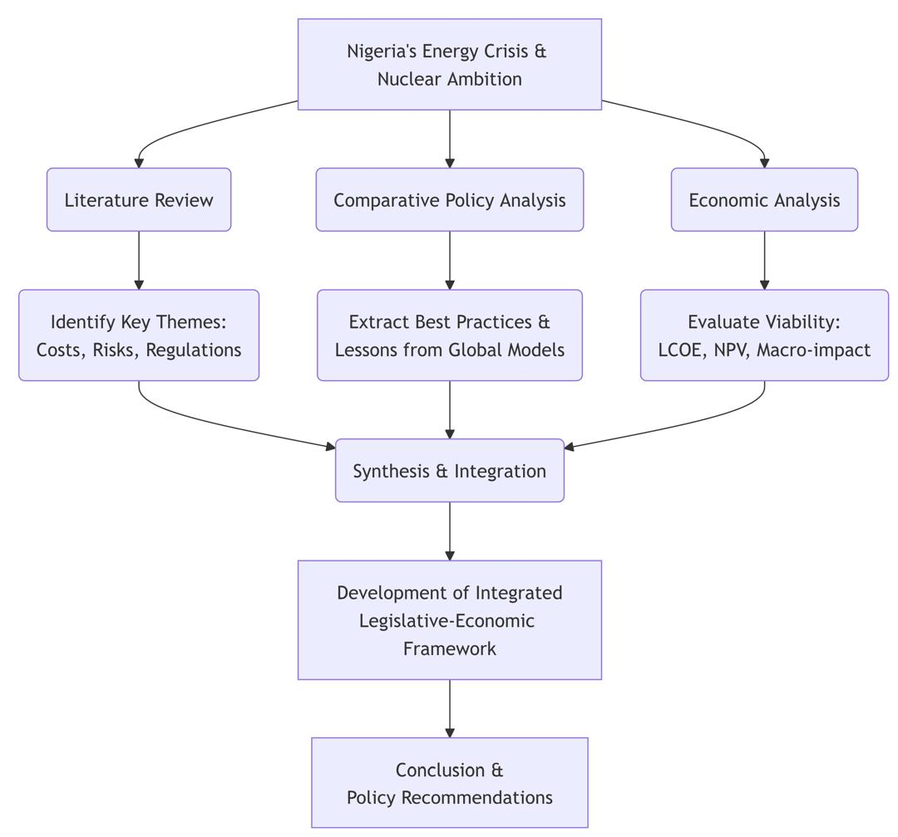

Fig 1: Flowchart showing the structure of the research process
2. Evaluation of Economic Aspects, Incentives, and Risk Mitigation

2.1 Economic Aspects of Nuclear Energy in Nigeria
The economic calculus of nuclear energy is defined by high upfront capital expenditure but low and stable operational costs over a long plant lifetime (60+ years). For Nigeria, the estimated capital cost for a large-scale reactor (1,000-1,200 MW) ranges from $5 billion to $10 billion, influenced by infrastructure deficits, need for grid upgrades, and potential cost escalations due to delays (IAEA, 2022; Rosatom, 2021). This translates to a capital cost of approximately $4,000-$6,000 per kW.

Once operational, the levelized cost of electricity (LCOE) for nuclear is estimated to be competitive. Nuclear power can generate electricity at $30-$50 per megawatt-hour (MWh), compared to $40-$60/MWh for gas-fired plants in Nigeria, which are vulnerable to fuel price volatility and supply disruptions (NERC, 2023; World Nuclear Association, 2021). The long-term economic benefits are substantial:

· Energy Security: Reduces dependence on volatile fossil fuels. The 2020 oil price crash cost Nigeria over $20 billion in lost revenues, highlighting this vulnerability (AfDB, 2021).
· Macroeconomic Stability: Reliable baseload power can boost industrial output, potentially adding 2-4% to GDP annually by mitigating the losses from power outages (World Bank, 2022).
· Job Creation: A single nuclear plant can create 10,000-15,000 jobs during construction and 1,000-2,000 permanent high-skilled positions for operations (IAEA, 2022).
· Environmental Compliance: Supports Nigeria's climate goals by providing a low-carbon power source, avoiding an estimated 6-8 million tons of CO2 emissions per year from a 1,000 MW plant (UNFCCC, 2022).

However, the initial capital outlay is prohibitively high for the Nigerian government alone to bear, given its public debt of approximately $100 billion and competing infrastructure needs (IMF, 2023). This necessitates private investment, which is currently deterred by perceived risks.

2.2 The Need for Legislative Incentives to Attract Investment
To mobilize the estimated $20-$30 billion required for its nuclear roadmap, Nigeria must enact a suite of legislative incentives to de-risk projects and improve their bankability.
· Financial Incentives: These include production tax credits (e.g., a fixed $/MWh credit for initial years), investment tax credits covering a portion of capital costs, accelerated depreciation schedules, and waivers on import duties for nuclear components. The U.S. Production Tax Credit (PTC) under 26 U.S.C. § 45 is a successful model that has spurred investment in zero-carbon energy (IRS, 2023).
· Investment Guarantees: Government-backed loan guarantees can significantly lower the cost of debt by mitigating default risk for lenders. The UAE's partnership with export credit agencies to finance the Barakah project is a prime example (ENEC, 2021). Establishing a dedicated Nuclear Energy Fund, capitalized from a portion of oil revenues, could provide concessional financing.
· Market-Based Incentives: Mandating long-term Power Purchase Agreements (PPAs) with creditworthy off-takers (e.g., the Nigerian Bulk Electricity Trading Plc) at a guaranteed tariff ensures a predictable revenue stream. Feed-in tariffs for nuclear power can also be considered.
· Regulatory Streamlining: Legislation must establish a clear, efficient, and predictable regulatory process. This involves strengthening the Nigerian Nuclear Regulatory Authority (NNRA) with adequate funding and autonomy while ensuring licensing processes are transparent and timely to avoid costly delays. A "one-stop-shop" for project approvals can enhance investor confidence.

2.3 Strategies for Mitigating Risks
A multi-layered risk mitigation strategy is essential.

· Financial Risk Mitigation: Utilize blended finance models combining public funds, private capital, and concessional loans from multilateral development banks (e.g., African Development Bank (AfDB), World Bank). Secure fixed-price, turnkey contracts with experienced vendors to cap construction cost overruns. Develop hedging mechanisms to manage currency fluctuation risks.
· Operational & Safety Risk Mitigation: Adhere strictly to IAEA safety standards and codes of conduct. Invest heavily in human capacity building through partnerships with international agencies and vendor countries. Foster a strong safety culture through independent and robust regulatory oversight.
· Environmental & Waste Management Risk: Develop a comprehensive, nationally accepted strategy for radioactive waste management from the outset, including funding plans for eventual decommissioning. Engage in international partnerships for waste solutions.
· Political & Geopolitical Risk Mitigation: Secure multi-governmental agreements with vendor countries to ensure political backing and continuity. Participate in international conventions like the Convention on Supplementary Compensation for Nuclear Damage (CSC) to create a global liability pool.
· Public Perception Risk: Implement transparent and ongoing public communication and engagement programs to build trust and social license to operate.

The following framework illustrates how economic and legislative elements must synergize to mitigate risks and ensure viability:
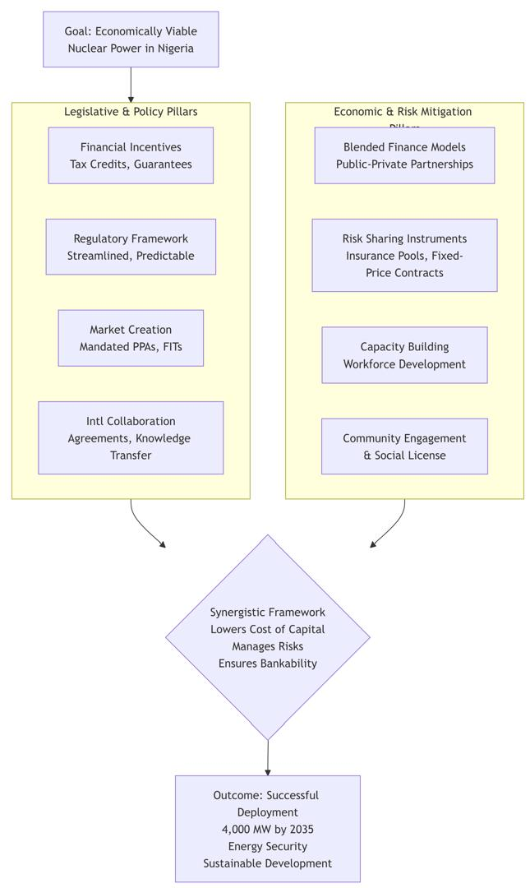

Fig 2: framework illustrates how economic and legislative elements must synergize to mitigate risks and ensure viability

3. Economic Viability: Context, Cost, and Comparison

3.1 Nigeria's Energy Context and Demand Projection
Nigeria's current electricity generation capacity is starkly insufficient. Installed capacity is about 13,000 MW, but actual generation rarely exceeds 4,500 MW for a population of over 220 million. Per capita electricity consumption is among the lowest globally at ~150 kWh/year, compared to a sub-Saharan African average of ~500 kWh/year (IEA, 2023). Demand is projected to grow exponentially due to population growth, urbanization, and industrialization, potentially exceeding 30,000 MW by 2030 (Energy Commission of Nigeria, 2021). Meeting this demand with solely renewables is challenging due to the intermittency of solar and wind, which requires costly storage solutions and grid modernization. Nuclear power offers a solution for stable, dense baseload power. Small Modular Reactors (SMRs), with their smaller footprint, passive safety features, and potential for phased investment, are increasingly seen as a suitable technology for integrating into Nigeria's grid and for potential off-grid industrial applications (NuScale Power, 2022; IAEA, 2023).

3.2 Cost Analysis and Comparative Assessment
A nuanced cost analysis is crucial. While the capital cost of nuclear is high, its LCOE over a 60-year lifespan becomes competitive, especially when externalities like carbon emissions and energy security are priced in. A comparative assessment is revealing:
Table 1: Cost Analysis and Comparative Assessment
Energy Source | Estimated Capital Cost ($/kW) | Estimated LCOE in Nigeria ($/MWh) | Key Challenges
Nuclear (Large-Scale) | 4,000 - 6,000 | 60 - 100 | High upfront cost, long lead times, need for strong grid
Natural Gas | 1,000 - 2,000 | 50 – 100 (Volatile) | Fuel price volatility, supply insecurity, emissions
Solar PV (Large-Scale) | 800 - 1,200 | 30 - 50 | Intermittency, requires storage, large land area
Wind | 1,200 - 2,000 | 40 - 60 | Intermittency, site-specific, requires storage
Hydro | 2,000 - 4,000 | 40 - 80 | Drought susceptibility, environmental/social impact

Source: Adapted from Lazard's LCOE 15.0 (2022), IEA Nigeria Outlook (2023), and NAEC projections.

The table shows that nuclear's LCOE is comparable to gas and within range of other baseload sources when considering its long-term stability. A hybrid system, where nuclear provides baseload and renewables meet peak demand, could be the most cost-effective and sustainable model for Nigeria's future grid.
3.3 Economic Potential and Challenges
The broader economic potential is significant. Beyond direct electricity generation, a nuclear program can catalyze a high-tech industrial ecosystem, create thousands of skilled jobs, and position Nigeria as a regional leader in science and technology. However, formidable challenges persist:

· Infrastructure Deficit: The national grid requires massive investment to handle large-scale nuclear power injections.
· Human Capital Gap: There is a critical shortage of specialized nuclear engineers, regulators, and technicians.
· Governance and Corruption: Perceived corruption and bureaucratic inefficiency could inflate costs and deter ethical investors.
· Fuel and Waste Management: Nigeria would initially rely on foreign fuel supply, and the long-term waste management strategy requires urgent development.

4. The Need for Legislative Incentives
The existing legal framework, primarily the Atomic Energy Act of 1964 and the Nuclear Safety and Radiation Protection Act of 1995, is outdated and inadequate for governing a modern civil nuclear power program. A new, comprehensive legislative architecture is required to provide certainty and attract investment.

4.1 Types of Incentives Needed
· A New Nuclear Energy Act: This act should establish a clear legal framework for ownership, licensing, liability, and decommissioning. It should explicitly define the role of private sector participation and provide the legal basis for the incentives listed below.
· Tax Incentives: Enact legislation for a Nuclear Investment Tax Credit (modeled on the U.S. system) and customs duty waivers on all nuclear-related equipment not available locally.
· Credit Support: Legislative backing for government loan guarantees and the creation of a sovereign-backed Nuclear Credit Guarantee Facility to insure lenders against political and regulatory risks.
· Market Support: Legislation mandating the inclusion of nuclear power in the national energy mix and authorizing long-term PPAs for nuclear generators.
· Regulatory Certainty: Amend the NNRA Act to ensure its technical and financial independence while mandating it to adopt internationally benchmarked, efficient licensing timelines.

4.2 Why Legislative Incentives are Non-Negotiable
Without these legislative interventions, the high perceived risks will translate into a high cost of capital. Investors will demand risk premiums that make the project financially unviable. Legislation signals long-term government commitment, reduces policy uncertainty, and creates a level playing field for investors. It is the foundational element upon which all other strategies are built. Lessons from the UAE's success with Barakah and the struggles of other African nations highlight that strong, clear, and investor-friendly legislation is the cornerstone of a successful nuclear program.

5. Risk Mitigation Strategies
A proactive and structured approach to risk management is paramount for public safety, investor confidence, and project success.

5.1 Key Risks in the Nigerian Context
· Financial Risks: Cost overruns, currency exchange volatility, and investor default.
· Project Risks: Construction delays and performance shortfalls.
· Safety & Operational Risks: Potential for accidents, human error, and lack of operational expertise.
· Environmental Risks: Long-term management of radioactive waste.
· Political & Geopolitical Risks: Policy reversals, regional instability, and dependence on foreign technology vendors.
· Social Risks: Public opposition due to safety fears and misinformation.

5.2 Integrated Risk Mitigation Framework
Mitigation requires a combination of technical, financial, and governance measures:
· Technical Measures: Adherence to IAEA safety standards, choice of modern Gen III+ reactor technology with passive safety features, and rigorous human capacity development programs.
· Financial Measures: As outlined in Section 4, including government credit support, fixed-price contracts, and international risk pooling through conventions like the CSC.
· Governance Measures: Establishing a strong, independent regulator (NNRA) is the single most important governance measure. Transparency in decision-making and ongoing stakeholder engagement are also critical.
· International Collaboration: Partnering with the IAEA for peer reviews and technical assistance, and with experienced vendor nations for knowledge transfer, is essential for mitigating technical and regulatory risks.

6. Conclusion, Limitations, and Future Directions
6.1 Conclusion
This study confirms the hypothesis that nuclear energy can be economically viable in Nigeria, but only if a synergistic framework of legislative incentives and risk mitigation strategies is implemented to create a conducive investment climate. The long-term benefits (energy security, economic growth, job creation, and environmental sustainability) are too significant to ignore. However, realizing these benefits requires overcoming monumental challenges related to financing, regulation, and public acceptance. The proposed integrated framework provides a roadmap for navigating these challenges, emphasizing that economic viability is inextricably linked to political will and legislative action.

6.2 Limitations of the Study
This study is subject to limitations. Firstly, it relies on projected cost and economic data, which are subject to change due to global inflation, technological advancements, and market dynamics. Secondly, the success of the proposed framework is contingent on political stability and consistent policy implementation over decades, which can be unpredictable. Thirdly, the study assumes a certain level of international cooperation and access to financing, which may be influenced by global geopolitical shifts.

6.3 Future Directions Based on the findings
The following future directions are advocated:
1. Phased Implementation with SMRs: Nigeria should strongly consider prioritizing Small Modular Reactors as a first step. Their lower capital requirements, enhanced safety features, and scalability better suit the current grid capacity and investment landscape.
2. Urgent Legislative Action: The National Assembly should prioritize the drafting and passage of a new, comprehensive Nuclear Energy Bill that incorporates the incentives and regulatory reforms discussed.
3. Enhanced International Partnerships: Nigeria should actively negotiate government-to-government agreements with vendor countries (e.g., USA, Russia, South Korea, and France) and deepen engagement with the IAEA for capacity building and technical support.
4. Public Education Campaign: A nationally coordinated, science-based public education campaign is essential to demystify nuclear energy, address safety concerns, and build broad-based social acceptance.
5. Focus on Human Capacity: Investment in nuclear science and engineering education at Nigerian universities, coupled with overseas training programs, must begin immediately to develop the necessary human capital for the long term.

By addressing these gaps and strategically pursuing these future directions, Nigeria can transform its energy landscape and harness the potential of nuclear power for sustainable development.

Disclaimer (Artificial intelligence)
Option 1:
Author(s) hereby declare that NO generative AI technologies such as Large Language Models (ChatGPT, COPILOT, etc.) and text-to-image generators have been used during the writing or editing of this manuscript.
Option 2:
Author(s) hereby declare that generative AI technologies such as Large Language Models, etc. have been used during the writing or editing of manuscripts. This explanation will include the name, version, model, and source of the generative AI technology and as well as all input prompts provided to the generative AI technology
Details of the AI usage are given below:
1.
2.
3.

References

1. African Development Bank (AfDB). (2021). African Economic Outlook 2021. https://www.afdb.org/en/documents/african-economic-outlook-2021
2. Emirates Nuclear Energy Corporation (ENEC). (2021). Barakah Nuclear Energy Plant: A Model for International Collaboration. https://www.enec.gov.ae/barakah-plant/
3. Energy Commission of Nigeria (ECN). (2021). National Energy Master Plan. Federal Government of Nigeria. https://energytransition.gov.ng/
4. Federal Ministry of Environment. (2021). Nigeria's Nationally Determined Contribution (NDC). https://unfccc.int/sites/default/files/NDC/2022-06/Revised%20Nigeria%27s%20NDC%20%202021.pdf
5. International Atomic Energy Agency (IAEA). (2022). Nuclear Power Economics and Project Structuring. IAEA Publications. https://www.iaea.org/publications/14814/nuclear-power-economics-and-project-structuring
6. International Atomic Energy Agency (IAEA). (2023). Advances in Small Modular Reactor Technology Developments. https://www.iaea.org/publications/14816/advances-in-small-modular-reactor-technology-developments
7. International Energy Agency (IEA). (2022). Nigeria Energy Outlook 2022. https://www.iea.org/reports/nigeria-energy-outlook-2022
8. International Energy Agency (IEA). (2023). World Energy Outlook 2023. https://www.iea.org/reports/world-energy-outlook-2023
9. International Monetary Fund (IMF). (2023). Nigeria: 2023 Article IV Consultation. https://www.imf.org/en/Publications/CR/Issues/2023/07/27/Nigeria-2023-Article-IV-Consultation-Press-Release-Staff-Report-and-Statement-by-the-536339
10. Lazard. (2022). Lazard's Levelized Cost of Energy Analysis - Version 15.0. https://www.lazard.com/media/2ozoovyg/lazards-levelized-cost-of-energy-version-150-vf.pdf
11. Nigerian Atomic Energy Commission (NAEC). (2017). National Nuclear Power Roadmap. Federal Government of Nigeria. https://nigatom.gov.ng/wp-content/uploads/2022/05/ACHIEVEMENTS-OF-NAEC-2019-ANNUAL-REPORT.pdf
12. Nigerian Electricity Regulatory Commission (NERC). (2023). 2022 Annual Report. https://nerc.gov.ng/index.php/library/documents/annual-reports
13. NuScale Power. (2022). Technology Overview. https://www.nuscalepower.com/
14. Rosatom. (2021). Integrated Solutions for Nuclear Power Plant Construction. https://www.rosatom.ru/en/products/nuclear-power-plants/
15. U.S. Internal Revenue Service (IRS). (2023). Production Tax Credit. https://www.irs.gov/credits-deductions/business-energy-tax-credits
16. United Nations Framework Convention on Climate Change (UNFCCC). (2022). Clean Development Mechanism (CDM): Methodology Booklet. https://cdm.unfccc.int/methodologies/documentation/meth_booklet.pdf
17. World Bank. (2022). Climate Change and Development: Nigeria. https://www.worldbank.org/en/country/nigeria/publication/climate-and-development-report-for-nigeria
18. World Bank. (2023). World Development Indicators: Nigeria. https://data.worldbank.org/country/nigeria
19. World Nuclear Association. (2021). The Economics of Nuclear Power. https://world-nuclear.org/information-library/economic-aspects/economics-of-nuclear-power.aspx
20. World Nuclear Association. (2022). Small Modular Reactors. https://world-nuclear.org/information-library/nuclear-fuel-cycle/nuclear-power-reactors/small-nuclear-power-reactors.aspx

