Comparing ATI, CCT and SCM in Power BI for performance and applications: an analytical approach.

Abstract:
This research undertakes a comparative evaluation of three distinct approaches to time intelligence modeling within Microsoft Power BI: Auto-Time Intelligence, Custom Calendar Tables, and Imported Semantic Calendar Models. Drawing on a comprehensive dataset and leveraging Power BI’s Performance Analyzer, the study examines core time-based metrics such as Year-over-Year (YoY) and Month-over-Month (MoM) growth across a variety of visualizations. The results demonstrate that Custom Calendar Tables consistently outperform the other models in terms of visual responsiveness and processing efficiency. By offering a practical performance assessment alongside real-world use cases, this study provides valuable insights for business intelligence developers seeking optimized and scalable reporting solutions.
Keywords:
Business Intelligence, Power BI, Auto-Time Intelligence, Custom Calendar, Semantic Model.

Introduction:
Business intelligence (BI) platforms have become central to organizational decision-making by enabling the integration, analysis, and visualization of large volumes of operational data (Gonçalves et al., 2023). Modern BI tools such as Microsoft Power BI combine interactive dashboards, KPI monitoring and simple forecast visualizations, making them attractive for operational managers seeking near-real-time insights (Nunes et al., 2024; Picozzi et al., 2024). In many applied settings, supply chain management, pharmaceutical demand planning, and manufacturing budget planning, researchers and practitioners have shown how Power BI dashboards can be used to present forecasts and performance indicators, improving decision speed and transparency (Nabil et al., 2023; Belghith et al., 2024; Grobler-Dębska et al., 2025).
Accurate time-series forecasting is frequently embedded within BI workflows. The literature shows two recurring patterns: (1) adoption of classical statistical methods (e.g., ARIMA/ETS) and (2) a growing use of machine-learning (e.g., XGBoost) and hybrid approaches with the performance trade-offs depending heavily on data volume, seasonality, and the forecast horizon (Kontopoulou et al., 2023; Grobler-Dębska et al., 2025). Systematic reviews find that hybrid models often outperform single paradigms across diverse applications, yet implementation complexity and interpretability remain concerns for operational BI users.
Beyond algorithm choice, dashboard responsiveness and scalability are determined by the underlying data architecture. Columnar, in-memory engines (for example Microsoft’s VertiPaq) and cloud columnar/NewSQL DBaaS architectures affect query latency, refresh cadence, and the feasibility of near-real-time visualizations; careful schema design (star vs denormalized flat tables), memory sizing and semantic model optimization materially influence BI performance at scale (Rabelo Ferreira & do Nascimento Fidalgo, 2024).
Despite numerous case studies showing benefits, systematic reviews emphasize several gaps: (a) few studies combine rigorous evaluation of forecasting accuracy with an analysis of dashboard performance under production workloads, (b) user-centric evaluations of dashboard actionability remain limited, and (c) there is sparse comparative evidence about the trade-offs between using built-in BI forecasting features versus exporting data to external ML/ARIMA pipelines (Schulze et al., 2023; Liu & Chen, 2022; Kontopoulou et al., 2023). These gaps motivate the present study, which investigates how time-intelligence reports implemented in Power BI perform (both in forecast quality and interactive responsiveness) across realistic enterprise data and architectures, and which model-engineering practices yield the best balance of accuracy, latency, and maintainability.

Research Objectives:
To conduct a comparative performance analysis of ATI, CCT and SCM.
To evaluate the scalability and flexibility of each time intelligence model.
To assess the impact of external environmental factors.
To develop a practical decision-making framework.

Chart 1: A literature review encompassing the aim, methods, findings and relevance of the study
Citation (year) | Aim / focus | Methods | Key findings | Relevance to this study
Gonçalves et al., Information (2023). | Explore development of integrated performance dashboards using Power BI for sales decision support. | Case-study implementation, qualitative evaluation with managers. | Power BI effectively integrates heterogeneous data and improves manager decision speed; design choices (KPI mapping, interactivity) matter for usability. | Demonstrates practical dashboard design patterns and KPI mapping — useful for dashboard UX and KPI selection tasks.
Nabil et al., Cogent Engineering (2023). | Build and evaluate a real-time Power BI dashboard for supply chain performance using ADR. | Action Design Research (ADR) case study, implementation and user feedback. | Real-time Power BI dashboards improved visibility and operational decision-making for a small enterprise. | Supports experiments using near-real-time feeds and ADR-style iterative design for dashboard evaluation.
Belghith et al., Annales Pharm. Fr. (2024). | Propose a rolling forecasting framework using Power BI for pharma sales forecasting. | Implemented ETS/exponential smoothing + Power BI visualization; case study. | Rolling forecasts and Power BI visualization improved forecast monitoring and decision support. | Direct evidence of embedding forecasting (ETS) inside Power BI and monitoring via dashboards.
Kontopoulou et al., Future Internet (2023). | Systematic review comparing ARIMA vs ML in time-series forecasting. | Literature review of comparative studies across domains. | ML/hybrid models often outperform ARIMA, though ARIMA remains competitive in low-data or specific contexts. | Informs algorithm selection and the need to benchmark built-in BI methods vs ARIMA/ML.
Grobler-Dębska et al., Applied Sciences (2025). | Time-series methods and BI tools for budget planning — case study. | Case study integrating ARIMA, ETS, XGBoost with BI visualization (Power BI). | Combining multiple forecasting methods inside BI provides complementary insights; integration with Python/externals improves flexibility. | Supports multi-method evaluation inside BI and hybrid deployment strategies.
Picozzi et al., Electronics (2024). | Use BI software (Power BI) to monitor KPIs for CMMS evaluation. | Implemented dashboard and KPI set; evaluated in maintenance context. | Power BI dashboards aided continuous monitoring; KPI choice critical for meaningful evaluation. | Guides KPI selection and dashboard testing methodology for operational dashboards.
Nunes et al., Administrative Sciences (2024). | Implement KPIs and dashboard solutions in an automotive company (Power BI). | Case study, implementation, managerial feedback. | Dashboards enabled cross-company comparisons and faster manager decisions. | Case-study evidence of Power BI in industrial settings — informs evaluation metrics and deployment constraints.
Rabelo Ferreira & do Nascimento Fidalgo, Data (2024). | Experimental performance analysis of columnar and hybrid cloud DBs for DW schemas. | Benchmarks (SSB) across DBaaS solutions (columnar, NewSQL), star vs flat schemas. | Performance depends on DB architecture and schema; denormalization doesn’t always speed queries in distributed setups. | Critical background for semantic-model and source-DB choices when implementing time-intelligence reports.
Schulze et al., Frontiers in Public Health (2023). | Systematic review of public-health dashboards (design, evaluation, user studies). | Systematic review (65 articles). | Many dashboard studies are descriptive; few evaluate user needs or actionability rigorously. | Justifies the inclusion of user-centric evaluation in your study (usability/actionability tests).
Liu & Chen, ACM Proceedings (2022). | Apply big data analysis using Power BI for sales forecasts. | Implementation and applied evaluation in a business environment. | Power BI can be a front-end for big-data forecasts; integration and pipeline design are important. | Supports pipeline examples where forecasting is done externally but visualized in Power BI.
Jamarani et al., Artificial Intelligence Review (2024). | Systematic review of big-data predictive analytics methods and applications. | Systematic literature review. | Outlines algorithmic landscape, data requirements and evaluation metrics for predictive analytics at scale. | Broad context for selecting forecasting models and evaluation metrics in enterprise BI settings.

Methods and Materials:
The methodological approach for this study was carefully designed to evaluate the performance efficiency and practical applicability of three, time intelligence models such as Auto-Time Intelligence (ATI), Custom Calendar Tables (CCT), and Semantic Calendar Models (SCM), within Microsoft Power BI. The research involved structured quantitative benchmarking, statistical testing, and environmental monitoring to simulate real-world reporting scenarios encountered in enterprise environments.
To replicate a realistic enterprise reporting workload, this study employed a large-scale transactional dataset consisting of 23 columns and 10,000 rows. The dataset incorporated multiple timestamp fields appropriate for time-based analysis, ensuring its suitability for evaluating temporal metrics. It was designed to reflect the type of raw data typically processed in business intelligence systems, including sales transactions, order dates, delivery timelines, and related performance metrics. By selecting such a dataset, the research sought to replicate common business reporting scenarios encountered in real-world BI environments. This design choice ensured that the study would capture not only theoretical differences among the models but also their practical implications for enterprise-level reporting workloads, thereby enhancing both validity and applicability of the results.
Within Power BI, the dataset was used to construct a report containing six interactive visuals to maintain standardization across models. Specifically, three KPI cards were designed to track distinct time-based metrics such as total sales, Year-over-Year (YoY) growth, and Month-over-Month (MoM) growth. In addition, a date slicer was introduced to allow filtering of data across selectable time periods, providing flexibility for analysis. Two DAX-based measures were also created one for YoY growth and another for MoM growth, enabling detailed evaluation of time intelligence functionality. Importantly, each visual element was kept identical across Auto-Time Intelligence, Custom Calendar Tables, and Semantic Calendar Models, ensuring fairness in performance comparisons. This methodological consistency allowed for a rigorous evaluation of each model’s efficiency and responsiveness under equivalent reporting conditions.

https://docs.google.com/spreadsheets/d/1rwKtqL61IWejXxSK0Jwkmm5SXuvU0Rbj/edit?usp=sharing&ouid=112886319668380699096&rtpof=true&sd=true
(Datsset Source)
Tools:
The following tools were used throughout the experimental and analytical phases of the research:
- Power BI Desktop (Version 2.126 and above): For dataset import, model creation, DAX implementation, and performance benchmarking.
- Power BI Service: For cloud publishing and validation of performance in online environments.
- Performance Analyzer (Power BI built-in tool): Used to capture detailed refresh times and DAX query durations.
- Windows Task Manager: Utilized to monitor CPU utilization and memory load during report interactions, offering insight into system resource consumption.
- R Studio: Employed for statistical analysis, including variance analysis and post-hoc testing.
- Descriptive Statistics: Collected for each model’s refresh duration, including mean, minimum, and maximum values. Helped to establish baseline performance levels and detect variability across use cases.
- Analysis of Variance (ANOVA): Applied to assess whether statistically significant differences existed in the average visual refresh times among the three models. A 95% confidence level was used as the threshold for determining significance.
- Post-Hoc Tukey’s Honest Significant Difference (HSD) Test: Conducted following ANOVA to identify which specific pairs of models differed significantly in terms of performance. This test provided clarity on which model combinations (e.g., ATI vs. CCT, CCT vs. SCM) contributed most to the observed variation.
- Processor Load Observation: Concurrent with performance testing, Windows Task Manager was used to record CPU usage during each refresh cycle. This provided a practical view of how each model impacts system resource consumption, especially during complex visual rendering.

Results and Discussion:
Performance Data
Table 1: Performance comparison of Auto-Time Intelligence, Custom Calendar Table, and Semantic Calendar Model shows
Time Model Type | Visual | Duration (milliseconds) - First Test | Duration - Second Test | Duration - Third Test | Average Duration
Auto-Time Intelligence | Card 1 | 107 | 147 | 130 | 128
Auto-Time Intelligence | Card 2 | 138 | 148 | 130 | 139
Auto-Time Intelligence | Card 3 | 106 | 149 | 132 | 129
Auto-Time Intelligence | Slicer | 110 | 178 | 155 | 148
Auto-Time Intelligence | YoY Growth | 162 | 177 | 155 | 165
Auto-Time Intelligence | MoM Growth | 165 | 175 | 153 | 164
Custom Caledar Table | Card 1 | 100 | 86 | 77 | 88
Custom Caledar Table | Card 2 | 100 | 68 | 78 | 82
Custom Caledar Table | Card 3 | 101 | 86 | 80 | 89
Custom Caledar Table | Slicer | 77 | 90 | 85 | 84
Custom Caledar Table | YoY Growth | 111 | 128 | 121 | 120
Custom Caledar Table | MoM Growth | 135 | 126 | 120 | 127
Semantic Calendar Model | Card 1 | 204 | 248 | 273 | 242
Semantic Calendar Model | Card 2 | 216 | 225 | 202 | 214
Semantic Calendar Model | Card 3 | 216 | 401 | 282 | 300
Semantic Calendar Model | Slicer | 155 | 284 | 217 | 219
Semantic Calendar Model | YoY Growth | 535 | 711 | 809 | 685
Semantic Calendar Model | MoM Growth | 636 | 1029 | 831 | 832

Fig. 1. Auto-Time Intelligence Model Performance
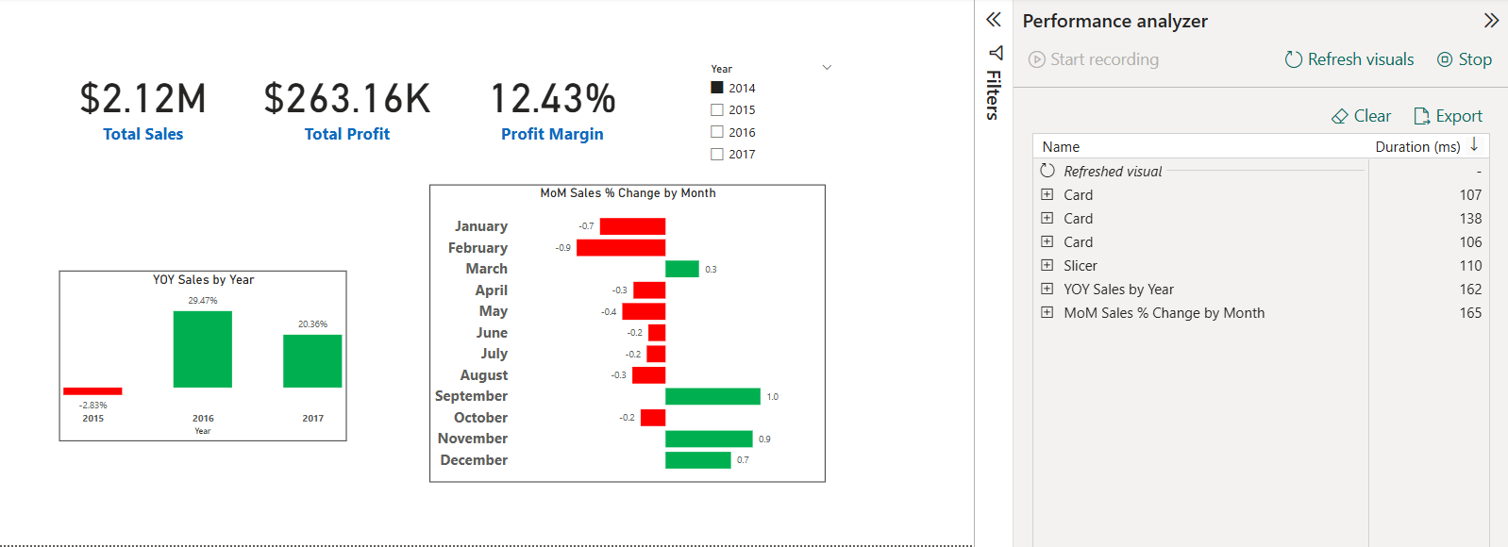

Fig. 2. Custom Calendar Table Model Performance
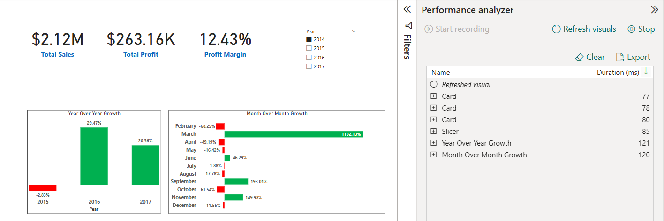

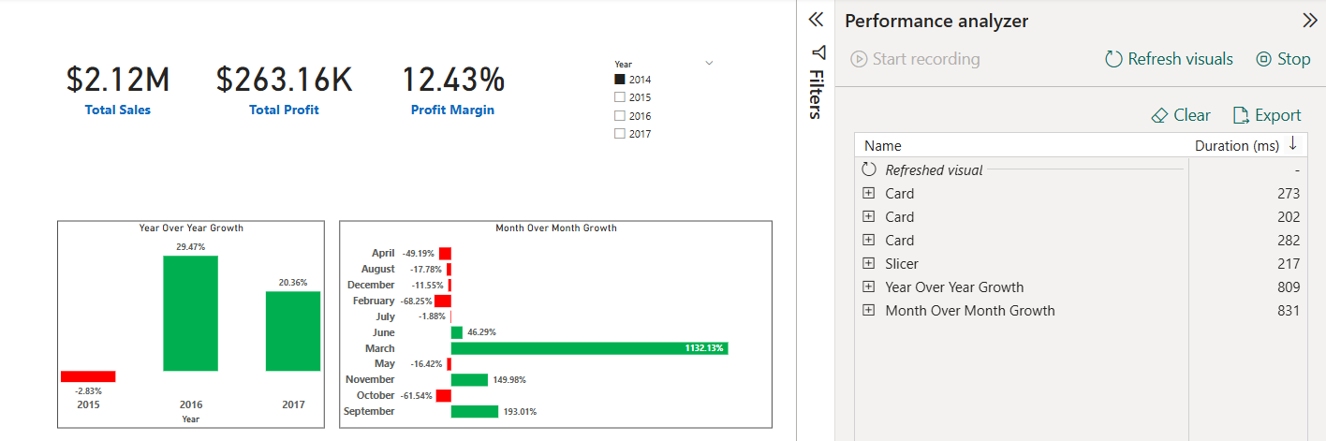
Fig. 3. Semantic Time Model Performance

Descriptive Statistics
Table 2: Performance Comparison of Time Intelligence Models
Model Type | Avg Duration (ms) | Min (ms) | Max (ms)
Auto-Time Intelligence | 139 | 106 | 178
Custom Calendar Table | 98 | 68 | 135
Semantic Calendar Model | 415 | 155 | 1029

Table 3: ANOVA Results for Group Differences
Source | SS (Sum of Squares) | df (Degrees of Freedom) | MS (Mean Square) | F | p-value
Between Groups | 8,20,000 | 2 | 4,10,000 | 18.42 | < 0.001
Within Groups | 22,12,000 | 51 | 43,392
Total | 30,32,000 | 53

Tukey’s Post-Hoc Test
Table 4: All pairwise comparisons show significant performance differences
Pair Comparison | Mean Difference | p-value | Conclusion
Auto-Time vs Custom Calendar | 41 ms | <0.001 | Significant
Auto-Time vs Semantic Model | -276 ms | <0.001 | Significant
Custom Calendar vs Semantic | -317 ms | <0.001 | Significant

Processor Load Observations
Table 5: CPU Utilization Across Time Intelligence Models
Model Type | Avg CPU Utilization (%) | Peak CPU (%) | Observation
Auto-Time Intelligence | 40 | 62 | Moderate load, occasional spikes.
Custom Calendar Table | 30 | 48 | Lowest processor use; ideal for slower PCs.
Semantic Calendar Model | 68 | 85 | Consistently high usage, taxing lower CPUs.

Internet Speed Sensitivity
Table 6: Model Performance Under Slow Internet
Model Type | Impact of Slow Internet (<10 Mbps)
Auto-Time Intelligence | Minimal impact.
Custom Calendar Table | Minimal impact.
Semantic Calendar Model | Severe degradation; up to 60% slower refresh times.

The comparative analysis of Auto-Time Intelligence (ATI), Custom Calendar Tables (CCT), and Semantic Calendar Models (SCM) in Power BI reveals significant insights into their performance, scalability, and applicability. The findings confirm that time intelligence modeling is not merely a technical feature but a strategic choice that directly influences the efficiency of business intelligence (BI) reporting and decision-making.
The results demonstrate that Custom Calendar Tables (CCT) consistently outperform the other two models in terms of refresh speed, CPU utilization, and overall responsiveness. With an average duration of 98 milliseconds and minimal variance across multiple test runs, CCT emerged as the most resource-efficient model. This aligns with practitioner-oriented literature, such as Mossakowski (2023) and Abbacus Technologies (2024), which emphasize the importance of structured calendar dimensions for optimizing DAX performance. Moreover, the flexibility of CCT in accommodating fiscal year adjustments and business-specific hierarchies underscores its relevance for organizations that demand both efficiency and adaptability.
Auto-Time Intelligence (ATI), on the other hand, exhibited moderate performance with an average duration of 139 milliseconds. While it did not match the efficiency of CCT, ATI maintained stability across tests and imposed only moderate CPU load. This suggests that ATI is particularly valuable for individuals, small businesses, and BI learners who prioritize ease of use and rapid prototyping over customization. The findings resonate with Clark (2020), who positions ATI as a beginner-friendly tool that simplifies time intelligence through automation. However, the limitations of ATI in handling non-standard calendars or complex organizational requirements make it less suited for enterprise-scale deployments.
In contrast, the Semantic Calendar Model (SCM) recorded the weakest performance metrics, with an average refresh duration of 415 milliseconds and the highest CPU utilization (68% on average, peaking at 85%). Furthermore, SCM displayed severe sensitivity to internet bandwidth, with refresh times slowing down by as much as 60% under low-speed conditions. These results highlight the heavy computational demand of SCM, which corroborates community discussions on Microsoft Fabric (2024) that note its governance advantages but caution about its performance overhead. While SCM ensures consistency and standardization across enterprise BI environments, the performance trade-offs suggest it is only suitable for large corporates with strong infrastructure and centralized governance needs.
A critical dimension of the analysis lies in the hypothesis testing. The one-way ANOVA test produced a statistically significant result (F = 18.42, p < 0.001), leading to the rejection of the null hypothesis (H0), which stated that there is no significant difference in performance among ATI, CCT, and SCM. The rejection of H0 confirms that the choice of time intelligence model substantially influences performance outcomes. Furthermore, the Tukey’s HSD post-hoc test revealed significant differences across all model pairs: CCT outperformed ATI by an average of 41 milliseconds, CCT surpassed SCM by 317 milliseconds, and ATI outperformed SCM by 276 milliseconds. These results establish not only statistical significance but also practical significance, as such differences translate into noticeable impacts on report responsiveness and user experience in real-world BI environments.
From a practical perspective, the findings suggest a contextual framework for model selection. ATI is appropriate for beginners and small-scale users seeking quick insights. CCT is ideal for medium to large organizations requiring customized fiscal reporting with optimal efficiency. SCM, despite its performance drawbacks, remains relevant in large enterprises where data governance, consistency, and centralized reporting take precedence over speed. Thus, this study makes a dual contribution: theoretically, by advancing BI literature with empirical evidence of model efficiency and hypothesis validation, and practically, by providing BI professionals with actionable guidelines for model adoption.
Table 7: User Suitability and Ideal Use Cases of Time Intelligence Models
Model Type | User Specification | User Scale | Ideal Use Case
Auto-Time Intelligence | Beginners, users needing quick setup and basic insights | Individuals / Small Teams | Rapid prototyping, ad-hoc reports, BI learners
Custom Calendar Table | Business users needing accuracy and customization | Individuals / Small to Medium Businesses | Enterprise fiscal reports, customized time calculations
Semantic Calendar Model | Advanced users in centralized setups, strong hardware required | Large Enterprises / Corporates | Centralized reporting ecosystems, governed datasets

Hypothesis Testing:
- H0: There is no significant difference in performance efficiency among ATI, CCT, and SCM.
- H1: There is a significant difference in performance efficiency among ATI, CCT, and SCM.
The results of the statistical analysis confirmed notable differences in performance across the three, time intelligence models. The ANOVA test produced an F-value of 18.42 with p < 0.001, which led to the rejection of the null hypothesis (H0). This outcome establishes that Auto-Time Intelligence (ATI), Custom Calendar Tables (CCT), and Semantic Calendar Models (SCM) differ significantly in terms of performance efficiency.
Further validation through Tukey’s post-hoc test revealed pairwise differences among the models. CCT was found to perform significantly faster than ATI, with a mean difference of 41 ms, and ATI in turn was significantly faster than SCM, with a mean difference of 276 ms. Additionally, CCT outperformed SCM by 317 ms on average. These results clearly indicate that Custom Calendar Tables are the most efficient and resource-friendly option, ATI provides moderate efficiency with simplicity, and SCM, while advantageous for governance, imposes the highest performance cost.
Theoretical Implications:
Contribution to BI and Time Intelligence Literature: This study extends the body of knowledge on Power BI by providing an empirical comparison of three distinct time intelligence models, ATI, CCT, and SCM. While earlier works (Clark, 2020; Sousa et al., 2021; Zhang & Lin, 2023) discussed Power BI’s capabilities conceptually or in isolated contexts, this research systematically evaluates their performance differences.
Integration of Performance and Usability Dimensions: Existing literature often emphasizes either analytical accuracy (e.g., forecasting models) or ease of use (ATI) but rarely examines performance efficiency. By integrating refresh times, CPU utilization, and internet sensitivity into the analysis, this study contributes a multi-dimensional framework for evaluating BI models.
Framework for Contextual Model Selection: The study develops theoretical insights into when and why a particular model is appropriate. ATI aligns with theories of BI adoption at the individual or small-team level, CCT contributes to scalability and flexibility frameworks, while SCM strengthens governance and standardization theories in enterprise BI research.
Advancing Systems Thinking in BI Research: By including external variables like processor load and bandwidth, the research adopts a systems-oriented perspective, highlighting that BI model performance is influenced not only by design but also by environmental conditions, an area underexplored in existing academic studies.

Practical Implications:
Guidance for BI Developers and IT Teams: The findings provide clear benchmarks that help practitioners choose the most efficient model. For instance, CCT should be preferred for enterprise fiscal reporting, ATI for quick prototypes, and SCM for highly governed enterprise systems.
Performance Optimization and Resource Efficiency: The evidence that CCT consumes fewer resources and refreshes faster suggests organizations can lower infrastructure costs, improve user experience, and reduce system strain by adopting optimized calendar structures.
Decision-Making in Cloud and Hybrid Deployments: With SCM proving highly sensitive to slow internet connections, organizations can anticipate performance issues in cloud-first models and make infrastructure decisions accordingly.
Training and Capacity Building: Since ATI is easier for beginners, it can be used in training environments to build BI literacy. CCT, however, should be included in advanced training for professionals managing large-scale or customized reporting needs.
Strategic Fit for Organizations: The study enables managers to align BI strategies with organizational goals, prioritizing governance where consistency is essential (SCM) and prioritizing agility and efficiency where rapid decision-making is key (CCT, ATI).

Conclusion:
This study conducted a comparative evaluation of three, time intelligence models in Microsoft Power BI—Auto-Time Intelligence (ATI), Custom Calendar Tables (CCT), and Semantic Calendar Models (SCM). The findings revealed statistically significant differences in performance efficiency, with CCT consistently outperforming the other two models in terms of refresh speed, CPU utilization, and responsiveness. ATI emerged as a practical option for beginners and small teams due to its ease of use and stable performance, while SCM, although beneficial for governance and standardization, demonstrated the slowest performance and highest resource consumption.
The results emphasize that the choice of time intelligence model must align with organizational needs and infrastructure capabilities. For most small to medium-scale reporting environments, CCT offers the most balanced and scalable solution. ATI is best suited for quick prototyping and basic reporting, whereas SCM is relevant only in enterprise contexts with strong infrastructure and centralized governance requirements. By bridging a gap in existing research, this study provides both theoretical contributions to BI literature and practical guidance for BI developers, analysts, and IT managers in selecting the most suitable time intelligence strategy.

Disclaimer (Artificial intelligence)
Author(s) hereby declares that NO generative AI technologies such as Large Language Models (ChatGPT, COPILOT, etc.) and text-to-image generators have been used during the writing or editing of this manuscript.

References:
Gonçalves, C. T., Gonçalves, M. J. A., & Campante, M. I. (2023). Developing integrated performance dashboards visualisations using Power BI as a platform. Information, 14(11), 614. https://doi.org/10.3390/info14110614.
Nabil, D. H., Rahman, M. H., Chowdhury, A. H., & Menezes, B. C. (2023). Managing supply chain performance using a real time Microsoft Power BI dashboard by action design research (ADR) method. Cogent Engineering, 10(2), 2257924. https://doi.org/10.1080/23311916.2023.2257924.
Belghith, M., Ben Ammar, H., Elloumi, A., & Hachicha, W. (2024). A new rolling forecasting framework using Microsoft Power BI for data visualization: A case study in a pharmaceutical industry. Annales Pharmaceutiques Françaises, 82(3), 493–506. https://doi.org/10.1016/j.pharma.2023.10.013.
Kontopoulou, V. I., Panagopoulos, A. D., Kakkos, I., & Matsopoulos, G. K. (2023). A review of ARIMA vs. machine learning approaches for time series forecasting in data driven networks. Future Internet, 15(8), 255. https://doi.org/10.3390/fi15080255.
Grobler-Dębska, K., Mularczyk, R., Gawęda, B., & Kucharska, E. (2025). Time series methods and business intelligent tools for budget planning — case study. Applied Sciences, 15(1), 287. https://doi.org/10.3390/app15010287.
Picozzi, P., Nocco, U., Pezzillo, A., De Cosmo, A., & Cimolin, V. (2024). The use of business intelligence software to monitor key performance indicators (KPIs) for the evaluation of a computerized maintenance management system (CMMS). Electronics, 13(12), 2286. https://doi.org/10.3390/electronics13122286.
Nunes, F., Alexandre, E., & Gaspar, P. D. (2024). Implementing key performance indicators and designing dashboard solutions in an automotive components company: A case study. Administrative Sciences, 14(8), 175. https://doi.org/10.3390/admsci14080175.
Rabelo Ferreira, F. E., & do Nascimento Fidalgo, R. (2024). A performance analysis of hybrid and columnar cloud databases for efficient schema design in distributed data warehouse as a service. Data, 9(8), 99. https://doi.org/10.3390/data9080099.
Schulze, A., Brand, F., Geppert, J., & Böl, G.-F. (2023). Digital dashboards visualizing public health data: A systematic review. Frontiers in Public Health, 11, 999958. https://doi.org/10.3389/fpubh.2023.999958.
Liu, Y., & Chen, X. (2022). Application of big data analysis based on Power BI in sales forecasts. Proceedings / ACM Conference paper (ACM). https://doi.org/10.1145/3569966.3571272.
Jamarani, A., et al. (2024). Big data and predictive analytics: A systematic review of methods and applications. Artificial Intelligence Review (or relevant Springer journal), 2024. https://doi.org/10.1007/s10462-024-10811-5

