Toxicological Impact of Cypermethrin in Common Carp (Cyprinus carpio): A study on behavior, morphology and gills

ABSTRACT
Introduction: Aquatic ecosystems are increasingly vulnerable to contamination from the agrochemicals, a consequence of expanding agricultural practices and the intensification of pest control measures.
Aim
To investigate the toxic impact of cypermethrin (CYP) in common carp (Cyprinus carpio) by assessing behavioral responses, morphological alterations and histopathological alterations in gills for 15 and 45 days.
Study Design
This was an experimental laboratory based toxicological study conducted in the Department of Zoology, Maharaja Agrasen University. The research study was carried out over a distinct duration. During the entire experimentation, controlled laboratory conditions were maintained for performing the exposure experiments, monitoring responses and evaluating the toxicological impact.
Material and Methods
Healthy Cyprinus carpio (n=15, average weight/length 12 ± 2 g/11 ± 2 cm) were acclimatized in the laboratory conditions and divided into control and exposed groups. Fish in exposed groups were administered sublethal concentration 0.41 µg/L cypermethrin for 15 and 45 days. Behavioral alterations were recorded daily and morphological changes were photographed. Gill tissues were fixed in buffered formalin and processed for histopathology using H&E staining. The statistical analysis was performed to compare results between control and exposed groups by using one way ANOVA test.
Results and Discussion:
Cypermethrin-exposure for 45 days exhibited pronounced behavioral abnormalities, such as hyperactivity, erratic swimming, excessive dorsal fin movement, frequent air gulping, and increased opercular activity as compared to 15 days exposure. Marked morphological changes were observed in 45 days group like discoloration of body color, scale erosion, caudal fin bruising and red blotches on the snout. Prolonged exposure for 45 days revealed prominent histopathological changes such as curling of secondary lamellae, epithelial lifting, lamellar fusion, hyperplasia, aneurysm formation, necrosis in the gill tissue. While, a very few behavioral, morphological and histopathological alterations were observed in fish exposed to cypermethrin (CYP) for 15 days.
Conclusion
Cypermethrin exposure induces severe behavioral, morphological and histopathological alterations in Cyprinus carpio over prolonged exposure. These findings highlight the ecological risks of cypermethrin contamination in aquatic environments and underscore the need for its regulated use to safeguard aquatic biodiversity.
Keywords: Cypermethrin, Cyprinus carpio, Behavioral and morphological alterations, gills histology

INTRODUCTION
Aquatic ecosystems are increasingly vulnerable to contamination from the agrochemicals, a consequence of expanding agricultural practices and the intensification of pest control measures (Zhou et al., 2025). Among these agrochemicals, synthetic pyrethroids particularly cypermethrin has extended widespread use due to their broad-spectrum insecticidal activity, high environmental stability, and comparatively low toxicity to mammals (Hodoșan et al., 2023). This combination of efficacy and perceived safety has led to their extensive application in agriculture and public health sectors. However, despite their targeted terrestrial use, synthetic pyrethroids frequently enter aquatic environments through agricultural runoff, leaching, spray drift, and improper disposal practices.
In recent times, Cypermethrin (CYP), a synthetic pyrethroid has been widely used to control the insect pests. It primarily enters aquatic ecosystem through agriculture runoff, seepage from treated lands, discharge from industrial processes and through leaching methods (Carriquiriborde et al., 2007).
Its environmental persistence leads to bioacccumulation in sediments and aquatic organisms, making freshwater ecosystems particularly vulnerable. Domestic use of cypermethrin-containing products in homes and gardens also contributes to its presence in wastewater treatment plant effluents, which can eventually reach natural waters. Although cypermethrin is not highly persistent in the environment and tends to bind strongly to soil and sediment, its high toxicity to aquatic life means that even small inputs can lead to severe ecological impacts. Cypermethrin tends to accumulate in aquatic organisms due to its lipophilic nature that poses a significant threat to non-target species, especially fish (Jesna et al., 2024). It majorly enters fish through absorption by gills, consumption of adulterated water and food and through dermal contact. Once it enters fish body, it exerts its toxic impact by interacting with the nervous system. Being a neurotoxin, CYP affects voltage-gated sodium channels (VGSCs) present in neuronal membranes, which led to increased influx of sodium ions (Singh et al., 2022). This increment furthermore resulted in constant nerve firing, causing hyperexcitability, deficit coordination, and lessen the neuromuscular function. Chronic esposure led to oxidative stress, metabolic disruption, antioxidants imbalance that ultimately results in structural alterations in vital organs viz. gills, liver, and kidneys (Prusty et al., 2011).
Among freshwater species, Cyprinus carpio (common carp) holds both ecological and economic significance, ranking as the third most important aquaculture species in Europe and Asia (Horvath et al., 2023). As an omnivorous benthic feeder, it plays a crucial role in nutrient cycling and sediment dynamics, earning its designation as an "ecological engineer" (Hossain et al., 2024). A decline in C. carpio populations due to pesticide exposure could disrupt trophic interactions, alter prey abundance, and destabilize freshwater ecosystems (Mutethya & Yongo, 2021). Thus, the present study investigates the impact of sublethal exposure of cypermethrin (CYP) in freshwater fish, Cyprinus carpio, with a major focus on behavioral alterations, morphological changes and histopathological damage in the gills. These findings highlight the detrimental effects of CYP on fish health, emphasizing its potential ecological consequences in contaminated aquatic environments.
MATERIALS AND METHODS
- Experimental Toxicant
Cypermethrin (CYP) 10% EC, a synthetic pyrethroid, was used as the toxicant in the present study. The formulation was procured from Shivalik Crop Sciences Pvt. Ltd., Chandigarh, India. The sublethal dose of cypermethrin (0.41 µg/L) used in the experiment was selected by reviewing the literature (Jindal and Sharma, 2019).
- Collection of Experimental Animal
Healthy fingerlings of Cyprinus carpio (Common Carp) aged 1.5 to 3 months with a mean total length 11 ± 2 cm and weight 12 ± 2 g were procured from the Government Fish Seed Farm, Nalagarh, Himachal Pradesh, India. The fish were carefully transported in aerated plastic bags to the Wet Laboratory, Department of Zoology, Maharaja Agrasen University, and treated with 0.01% potassium permanganate solution for avoiding any dermal infections.
- Acclimatization of Fish
Fish were acclimatized for 15 days in 15liter plastic tanks containing dechlorinated water, maintained at 24-25°C, with constant aeration and a pH of 7.2-7.4. One third of the water was replaced twice daily for removal fecal matter and other wastes. Fish were fed with a commercial artificial diet (Gold Toya) twice a day.
d) Experimental Design
- Grouping of Animals
The experiments were conducted to evaluate the toxic impact of CYP in common carp, in which fish were divided into three groups of 15 individuals in each (Table 1).
Table 1: Grouping of animals
Sr No. | Groups | No. of fish to be used | Treatment | Duration
1. | Control Group | 15 | Normal diet & Water | 15 & 45 days
2. | Exposed Group 1 | 15 | 0.41 µg/L of CYP | 15 days
3 | Exposed Group 2 | 15 | 0.41 µg/L of CYP | 45 days

- Control Group (15 & 45 days): Fish were kept on normal diet and dechlorinated water without any chemical exposure.
- Exposed Group 1: Fish were exposed to a sublethal dose of CYP (0.41 µg/L) for 15 days.
- Exposed Group 2: Fish were exposed to a sublethal dose of CYP (0.41 µg/L) for 45 days.
- Evaluation of Morphological and Behavioral Studies
During the whole experiment, fish were continuously monitored for detection of morphological changes viz. changes in body coloration, fin distortions and abnormal swelling in their body. In addition to this, behavioral responses were also evaluated carefully using distinct patterns involving the rate and regularity of opercular movements (as an indicator of respiratory activity), frequency and amplitude of dorsal fin movements (as a measure of locomotor activity), and incidence of surface air gulping (as a sign of respiratory distress). All observations were scientifically recorded at specific intervals following the OECD guidelines (2019).
- Histology of Gills
Gills were dissected out from both exposed groups (15 & 45 days) and were fixed in 10 % neutral buffered formaldehyde for 24 hours and washed thoroughly in running tap water. The samples were then dehydrated through a graded alcohol series (30%, 50%, 70%, 90%, and absolute alcohol), cleared in xylene and infiltered with paraffin wax. Following this, tissues were embedded in paraffin wax blocks. The tissue sections of 5 μm thickness were prepared using a rotary microtome. The sections were stained with hematoxylin-eosin (H&E) according to the protocol of Abalaka, (2015). Finally, the prepared slides were observed under a light microscope and photographed using a digital camera for histopathological evaluation.
Statistical Analysis
The experimental data was entered in MS Excel. The data were statistically analyzed by using SPSS software version 21. All behavioral parameters were expressed as mean ± standard deviation (SD). Statistical comparisons between the control and exposed groups were statistically analyzed using one way analysis of variance (ANOVA) test and validity of investigation was expressed as probability (p) values, values ≤ 0.05 were considered as statistically significant (*).

RESULTS
Behavioral Alterations
In control group, the fish showed normal behavior that include constant swimming patterns, resting at bottom occasionally, posture stability, constant schooling character and the fish moves towards upper surface of water for feeding (Fig.1A). An exposure for 15 days showed no visible alterations in their behavior. During prolonged exposure for 45 days, the fish showed different alteration in its behavior that clearly indicates neurotoxic stress. These changes include quick temperedness, continuous attempts to jump, and uncoordinated spinning movements (Fig.1B). The schooling feature was entirely disrupted among the exposed group marked by significant instability and enhanced air gulping (Fig.1C). the various symptoms of respiratory distress became more evident that includes lethargy, reduced buoyancy control and resting position at the tank’s bottom (Fig.1D). The exposed fish also showed continuous collisions against tank walls and frequent unpredictable movement (Fig.1E, F). A significant enhancement in opercular movement, dorsal fin movement, and air-gulping behavior was also observed during 15- and 45-days exposure as compared to control group (Fig.2A-C).
Morphological Abnormalities
Morphological evaluation of the control group fish demonstrated normal anatomical integrity and external features. The fish exhibited an elongated body with silvery-white pigmentation. The dorsal fin was structurally rigid with posterior serrations but not highly prominent. The operculum was located laterally near the head, positioned adjacent to the cranial region and the eyes were positioned sub orbitally. The integument was covered with large, robust scales, and the caudal fin was clearly visible at the posterior end of the body axis (Fig.3A–D). No noticeable morphological changes were detected in fish exposed to cypermethrin (CYP) for 15 days. However, after prolonged exposure extending of 45 days, clear phenotypic alterations were evident. These included marked changes in body pigmentation such as discoloration and irregular pigmentation patterns (Fig.3E) on the body surface of fish. Eye abnormalities, particularly hyphemia, characterized by intraocular hemorrhaging between the cornea and lens (Fig.3F) were also observed. Furthermore, scale loss (Fig.3G), localized bleeding in the caudal region (Fig.3H) and erythematous patches on the rostral surface (Fig.3I) were quite visible in 45 days exposed group.
Histology of gills
The gills, located in the pharyngeal region, consist of gill arches with primary and secondary lamellae that play an essential role in respiration. In the control group, the gills displayed well-structured primary lamellae, a central axis and distinct secondary lamellae. The surface of the secondary lamellae was covered with simple squamous epithelial cells and blood capillaries, providing an efficient structured and functional respiratory surface (Fig.4A–D). However, after 15 days of CYP exposure, noticeable alterations were observed in gills. These included curling and twisting of the secondary lamellae (Fig.5A), partial degeneration of the lower gill rows (Fig.5B) and fusion within the secondary gill filaments (Fig.5C).
By the 45th day of cypermethrin exposure, the gill tissues demonstrated severe histopathological damage. Entire rows of secondary lamellae were lost, with globular anomalies appearing in their place (Fig.5D). Prominent epithelial hyperplasia, extensive lamellar fusion, and aneurysm-like dilations (telangiectasis) were also observed in the gill filaments (Fig.5E). In advanced cases, the secondary lamellae were completely degenerated (Fig.5F). Ultimately, the total loss of secondary filaments explains the increased air gulping and rapid opercular movements, indicating impaired gill function and reduced respiratory efficiency in the toxic environment.
DISCUSSION
The study of behavior together with morphology links both physiological and ecological factors (Olivares et al., 2024). In the present study, morphology describes the external features of an organism, such as its shape, size, and body color. Variations in morphology can indicate stressful conditions experienced by fish in their environment (Menon et al., 2023). Similarly, locomotor responses serve as useful indicators of how animals react to external stimuli (Koprucu et al., 2006). The behavioral and morphological alterations observed in the fish linked to stress induced by CYP, which inhibits the activity of acetylcholinesterase, an enzyme essential for normal brain function (Banee et al., 2011). Similar behavioral changes have been reported in Labeo rohita, where exposure led to darting movements, rapid gill activity, lethargy, sluggishness as well as periods of immobility (Patil and Davis, 2008). Comparable abnormal behaviors were also noted in Silurus glanis fingerlings exposed to diazinon (Koprucu et al., 2006).
A study done by Marigoudar et al. (2009) in Labeo rohita, revealed that the exposure to cypermethrin has been shown to cause irregular, erratic, and darting movements. Such behavioral alterations indicate disruptions in the nervous system, leading to impaired neural transmission (Zhang et al., 2025). Furthermore, increased dorsal fin activity and frequent air gulping were also observed, likely due to cypermethrin accumulation in the gills, which interfered with normal respiration. Hemorrhaging in the eyes, tail fin and snout may have resulted from blood pooling and dilation of blood vessels, producing visible red spots on the body surface (Banee et al., 2011).
Gills are essential multifunctional organs in fish, playing an important role in both respiration and osmoregulation. Damage to the gills reduces the available respiratory surface area, lowering respiratory efficiency and potentially causing hypoxia and mortality. Because gills are in direct contact with the surrounding water and can accumulate toxic substances, they serve as reliable bioindicators of contamination. Their direct constant exposure makes them highly sensitive to waterborne pollutants, including pesticides. Therefore, alterations in water quality can directly affect the structure and function of gills (Vo and Pham, 2021).
In present research study, cypermethrin exposure caused several gill alterations, including curling and twisting of the lamellae, lamellar fusion, formation of aneurysmal (circular) structures, epithelial cell elevation and filament degeneration. Comparable effects have been reported in Oreochromis niloticus exposed to deltamethrin, where lamellar hyperplasia, aneurysm formation and fusion were observed (Yasser et al., 2024). Similarly, Oncorhynchus mykiss (Rainbow trout) exposed to sublethal concentrations of methiocarb and endosulfan for 21 days showed lamellar separation, epithelial lifting, fusion, and necrosis (Altinok and Capkin, 2007). In addition, Cyprinus carpio exposed to chlorpyrifos exhibited lamellar disorganization and telangiectasis (Majumder, 2023).
CONCLUSION
The present study demonstrates that exposure to cypermethrin induces significant adverse effects in common carp. Behavioral changes such as erratic swimming, reduced activity, and loss of balance were evident, indicating neurotoxic stress. Morphological alterations, including discoloration, excessive mucus secretion, and fin erosion, were observed, reflecting external toxicity. Histological analysis revealed pronounced gill damage, with epithelial lifting, lamellar fusion, and necrosis becoming more severe with longer exposure. Comparisons between 15 and 45 days of treatment confirmed that prolonged exposure exacerbates both structural and functional impairments. Overall, the findings highlight the toxic potential of cypermethrin and its risk to aquatic life, underscoring the need for controlled pesticide use.

ETHICAL APPROVAL
All procedures including the experimental animals were performed with ethical guidelines approved by the Ethical Committee of Maharaja Agrasen University (Approval No: IEC/MAU/2021/05).

DISCLAIMER (ARTIFICIAL INTELLIGENCE)
Author(s) hereby declare that NO generative AI technologies such as Large Language Models (ChatGPT, COPILOT, etc.) and text-to-image generators have been used during the writing or editing of this manuscript.
REFERENCES
Abalaka, S. E. (2015). Heavy metals bioaccumulation and histopathological changes in Auchenoglanis occidentalis fish from Tiga dam, Nigeria. Journal of Environmental Health Science and Engineering, 13(1), 67.
Altınok, I., & Çapkin, E. (2007). Effects of water quality and fish size on toxicity of methiocarb, a carbamate pesticide, to rainbow trout. Environmental Toxicology and Pharmacology, 24(1), 8-12.
Banaee, M., Sureda, A., Mirvaghefi, A. R., & Ahmadi, K. (2011). Effects of diazinon on biochemical parameters of blood in rainbow trout (Oncorhynchus mykiss). Pesticide biochemistry and physiology, 99(1), 1-6.
Carriquiriborde, P., Mirabella, P., Waichman, A., Solomon, K., Van den Brink, P. J., & Maund, S. (2007). Aquatic risk assessment of pesticides in Latin America. Integrated Environmental Assessment and Management, 3(4), 458-461
Hodoșan, C., Gîrd, C. E., Ghica, M. V., Dinu-Pîrvu, C. E., Nistor, L., Bărbuică, I. S., & Popa, L. (2023). Pyrethrins and pyrethroids: a comprehensive review of natural occurring compounds and their synthetic derivatives. Plants, 12(23), 4022.
Horvath, L., Hegyi, A., Lefler, K. K., Csorbai, B., Kovacs, E., Szabo, T., & Urbanyi, B. (2023). Review of central-eastern European propagation and larvae nursing method for common carp (Cyprinus carpio L.). Life, 13(12), 2334.
Hossain, M. M., Jahan, I., Dar, M. A., Dhanavade, M. J., Mamtaz, A. F. B., Maxwell, S. J., & Zhu, D. (2024). A Review of Potentially Toxic Elements in Sediment, Water, and Aquatic Species from the River Ecosystems. Toxics, 13(1), 26.
Jesna, P., Das, B. K., Sarkar, D. J., Krishnani, K. K., Chadha, N. K., & Hemaprasanth, K. (2024). Effect of nanoformulated cypermethrin, a parasiticide in Labeo rohita fingerlings: impact on biochemical, haematological, and stress response. Environmental Science and Pollution Research, 31(55), 63863-63875.
Jindal, R., & Sharma, R. (2019). Neurotoxic responses in brain of Catla catla exposed to cypermethrin: A semiquantitative multibiomarker evaluation. Ecological Indicators, 106, 105485.
Koprucu, K., Ozdemir, Y., & Ural, M. S. (2006). Acute toxicity of deltamethrin to Nile tilapia (Oreochromis niloticus L.) larvae and fingerlings. Pesticide Biochemistry and Physiology, 86(2), 82-86.
Majumder, R. (2023). Effects of chlorpyrifos on histopathological biomarkers of the freshwater teleost Oreochromis niloticus. Fisheries & Aquatic Life, 31(4), 207-214.
Marigoudar, S. R., Ahmed, R. N., & David, M. (2009). Cypermethrin induced respiratory and behavioural responses of the freshwater teleost, Labeo rohita (Hamilton). Veterinarski Arhiv, 79(6), 583-593.
Menon, S. V., Kumar, A., Middha, S. K., Paital, B., Mathur, S., Johnson, R., ... & Asthana, M. (2023). Water physicochemical factors and oxidative stress physiology in fish, a review. Frontiers in Environmental Science, 11, 1240813.
Mutethya, E., & Yongo, E. (2021). A comprehensive review of invasion and ecological impacts of introduced common carp (Cyprinus carpio) in Lake Naivasha, Kenya. Lakes & Reservoirs: Research & Management, 26(4), e12386.
OECD. (2019). Test No. 203: Fish, acute toxicity test, OECD Guidelines for the Testing of Chemicals, Section 2. Organisation for Economic Co-operation and Development
Olivares-Rubio, H. F., & Arce, E. (2023). Effects of chemical pollution on the behaviour of cichlid fish. Environmental Biology of Fishes, 106(5), 1149-1176.
Patil, V. K., & David, M. (2008). Behavioral and morphological endpoints: As an early response to sublethal malathion intoxication in the freshwater fish, Labeo rohita. Drug and Chemical Toxicology, 31(3), 367-384
Prusty, A. K., Kohli, M. P. S., Sahu, N. P., Pal, A. K., Saharan, N., Mohapatra, S., & Gupta, S. K. (2011). Effect of short term exposure of fenvalerate on biochemical and haematological responses in Labeo rohita (Hamilton) fingerlings. Pesticide biochemistry and physiology, 100(2), 124-129.
Vo, H. C., & Pham, M. H. (2021). Ecotoxicological effects of microplastics on aquatic organisms: a review. Environmental Science and Pollution Research, 28(33), 44716-44725.
Singh, A., Singh, A., Singh, P., Chakravarty, A., Singh, A., Singh, P., & Sagadevan, S. (2022). Insecticidal activity, toxicity, resistance and metabolism of pyrethroids: A review. Science and Technology Indonesia, 7(2), 238-250.
World Health Organization. (2002). The world health report 2002: Reducing risks, promoting healthy life. WHO.
Yasser, A., Al-Kaaby, I., Shabeeb, A., Naser, M., Auda, N., Ajeel, S., & Lebepe, J. (2024). Histopathology and micronuclei induction as pollution biomarkers in common carp, Cyprinus carpio from southern Iraq. Journal of Biological Studies, 7(1), 11-30.
Zhang, K., Ye, Z., Qi, M., Cai, W., Saraiva, J. L., Wen, Y., Liu, G., Zhu, Z., Zhu, S. & Zhao, J. (2025). Water quality impact on fish behavior: a review from an aquaculture perspective. Reviews in Aquaculture, 17(1), e12985.
Zhou, W., Li, M., & Achal, V. (2025). A comprehensive review on environmental and human health impacts of chemical pesticide usage. Emerging Contaminants, Article 100410.

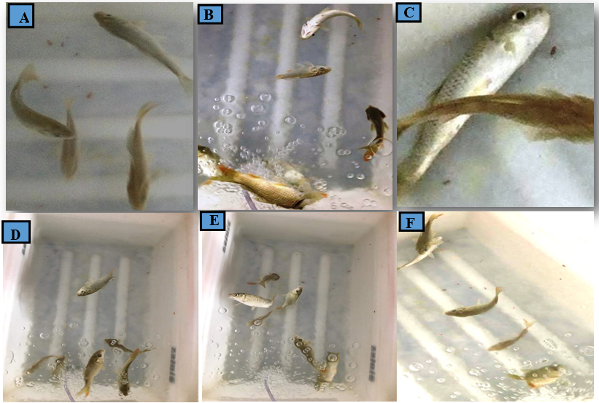

Figure 1 (A-F): Behavioral responses of Cyprinus carpio under control and cypermethrin (CYP)exposed conditions. (A) Control group displaying normal, coordinated behavior including stable equilibrium, active swimming, periodic resting at the tank bot- tom, and schooling with upward movement during feeding. (B) CYP-exposed fish showing hyperexcitability, frequent jumping attempts, and uncoordinated spinning. (C) Advanced signs of respiratory distress in exposed fish, including lethargy, buoyancy loss, and settling at the tank bottom, progressing to near-complete immobility with prolonged exposure (D) Disruption of schooling behavior, repeated collisions with tank walls, and increased air gulping (E, F) erratic swimming.

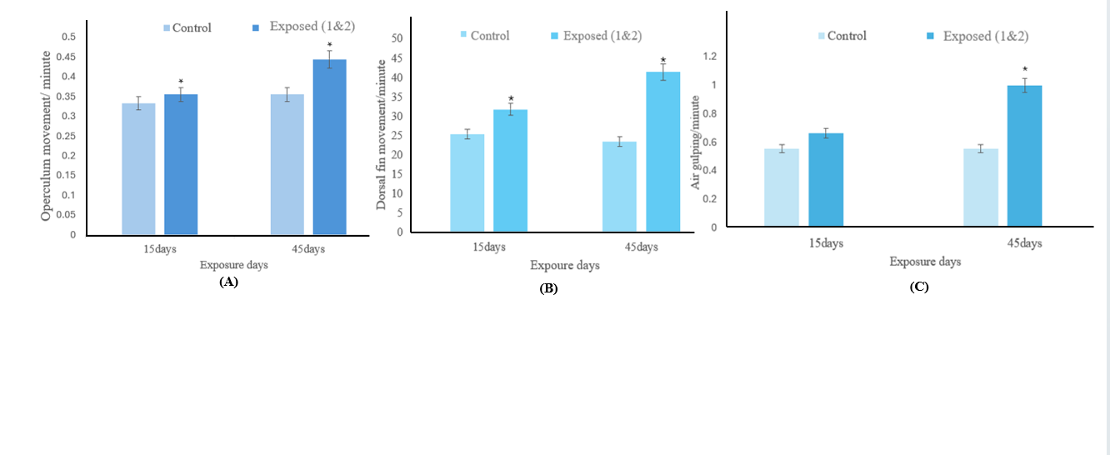
Figure 2(A-C): Comparison of behavioral responses between control and exposed groups
(Note: * represents p≤0.05)

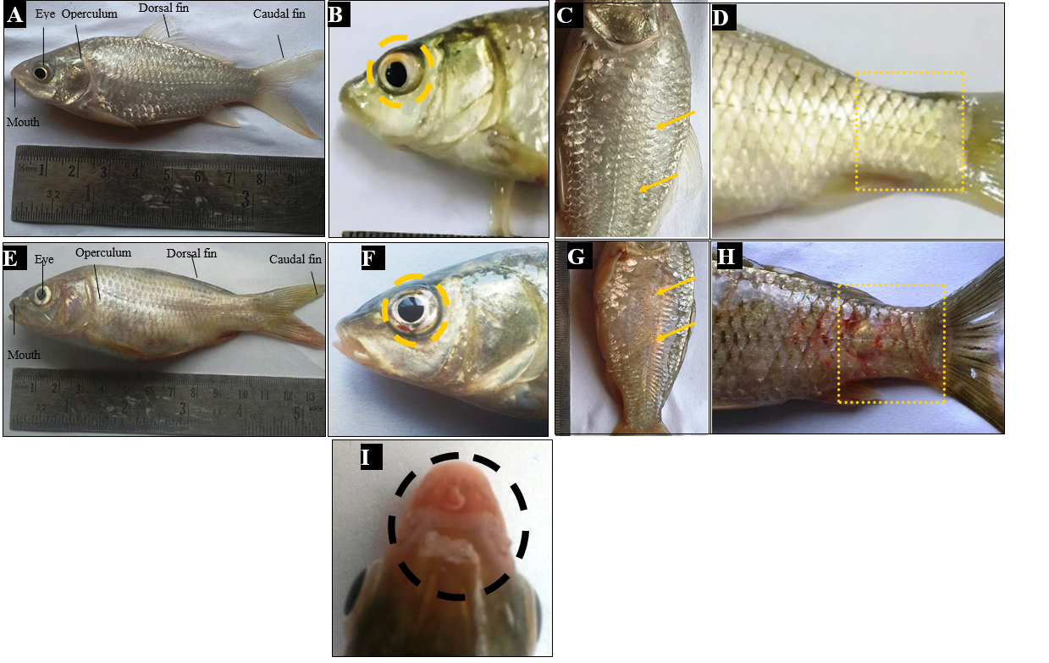
Figure3: Morphological comparison of Cyprinus carpio under control conditions and after cypermethrin (CYP) exposure. (A–D) Control fish exhibit normal external anatomy including an elongated body with characteristic silvery-white pigmentation, a firm dorsal fin with posterior serrations (A), suborbital eyes (B), laterally positioned operculum, thick and well-defined scales (C), a distinct caudal fin and clearly visible lateral line (D). (E–I) External morphological alterations observed in fish exposed to CYP for 45 days (E) body discoloration and irregular pigmentation (F) hyphemia indicating intraocular hemorrhage (G) scale erosion (H) localized hemorrhaging in the caudal region (I) erythematous

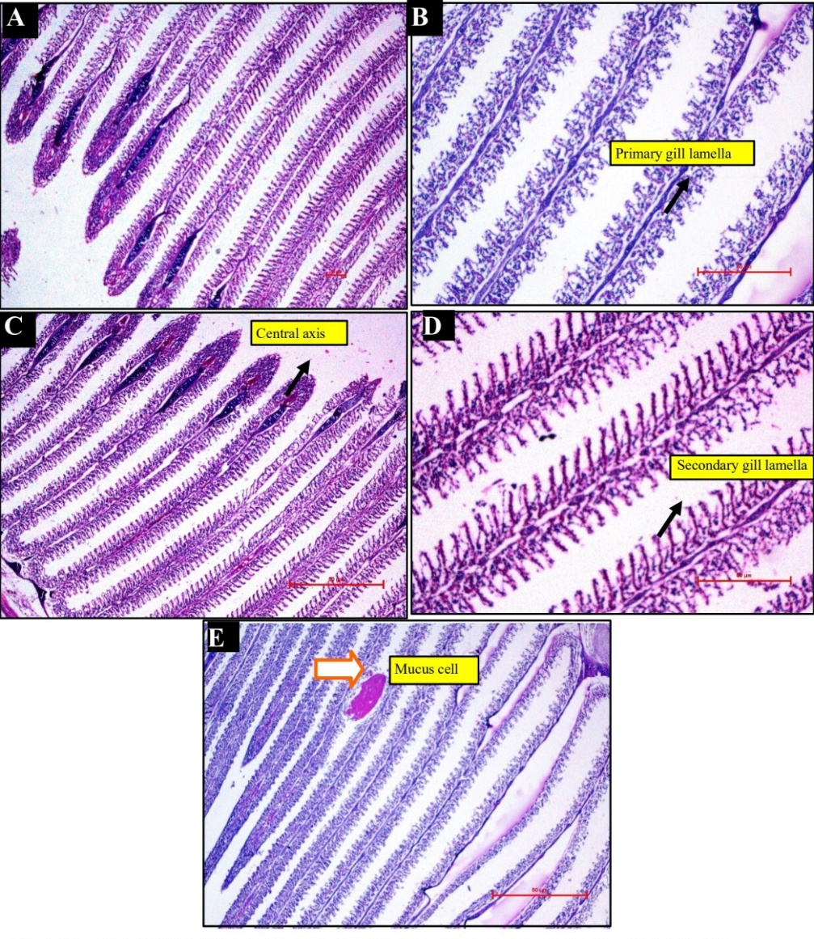
Figure4 (A-E): Light micrographs of control gill tissues of Cyprinus carpio showing normal primary gill lamella (B) (400X), central axis (C) (100X), secondary gill lamella (D) (400X) with associated mucus cell (E) (100X)
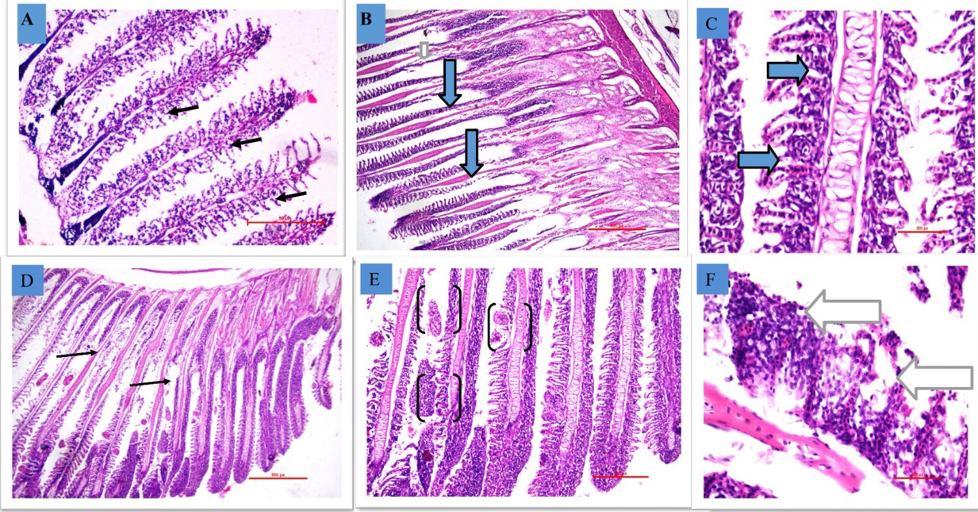
Figure 5: Histopathological alterations in the gill tissues of Cyprinus carpio following exposure to cypermethrin (CYP), (A–C) depict changes observed after 15 days of exposure (A) curling and twisting of secondary lamellae (400X) (B) partial degeneration of the lower gill rows (100X) (C) fusion of secondary filaments (400X). (D–F) show changes after 45 days of exposure, (D) complete loss of an entire row of secondary lamellae with the appearance of globular anomalies (100X) (E) epithelial hyperplasia with extensive lamellar fusion and formation of aneurysms (telangiectasis) within the gill filaments (400X) (F) complete loss of an entire row of secondary lamellae.

