Field Evaluation of Multi‑Purpose Mittens for Drudgery Reduction in Soybean Harvesting

Abstract
Manual soybean harvesting remains common among smallholders in India and is associated with hand injuries, skin irritation, and drudgery especially for women farm workers. An ergonomic, low‑cost multi‑purpose mitten (MPM) was introduced through Frontline Demonstrations (FLDs) to reduce discomfort and improve work output. To evaluate the effectiveness of MPMs in increasing area harvested per day and reducing skin irritation during soybean harvesting under farmer field conditions over five crop seasons (2020–2024) were analyzed. Thirteen participants per year (n = 65 total) across six villages in Akola district were enrolled in KVK‑led FLDs. Each participant was observed under two treatments: T1- harvesting without mitten (control) and T2-harvesting with the multi‑purpose mitten (intervention). Outcomes recorded were area harvested per day (ha·day⁻¹) and a post‑work skin‑irritation score on a standardized 0–20 scale. Annual means and percentage change between T1 and T2 were summarized. Across five years, T2 increased mean area harvested per day by an average of ~51% (yearly range: 33–100%) and reduced mean skin‑irritation scores by ~72% (yearly range: 60–88%). Pooled across years, the mean area harvested rose from ~0.05 to ~0.08 ha·day⁻¹, while skin‑irritation scores decreased from ~12.5 to ~3.4 (0–20 scale). Benefits were consistent across locations and years. MPMs provide a practical, affordable ergonomic solution that reduces drudgery and improves harvesting efficiency in soybean. Wider dissemination through extension systems is recommended, with scope for additional assessments on musculoskeletal outcomes and cost benefit at scale.
Keywords: Soybean; Frontline demonstration; Drudgery reduction; Women in agriculture; Protective mitten; Harvesting efficiency
1. Introduction
Soybean (Glycine max L.) is one of the most significant oilseed crops in India, contributing substantially to edible oil production and serving as a protein-rich food and feed source. India is the fifth-largest producer of soybean, with Madhya Pradesh and Maharashtra being major growing states (ICAR-Directorate of Soybean Research, 2022). Despite technological advancements, harvesting in most smallholder and marginal farms remains largely manual. Manual soybean harvesting exposes workers, especially women, to occupational health hazards including cuts, abrasions, skin irritation from contact with plant trichomes, exudates, and agrochemical residues, and musculoskeletal strain from repetitive bending and cutting motions (Kishtwaria, J., & Rana, A,. 2012).
The drudgery faced by farmwomen is a major concern in agricultural ergonomics. Women contribute significantly to sowing, weeding, harvesting, and post-harvest activities, yet they often lack access to protective technologies designed to reduce occupational strain. Ergonomic interventions such as gloves, mittens, and small tools have been recommended to enhance safety and efficiency while being cost-effective and locally manufacturable (Singh, S., & Arora, R., 2010).
The multi-purpose mitten (MPM) was developed under AICRP–FRM (Family Resource Management), College of Community Science, VNMKV Parbhani, to address these challenges. Designed with locally available materials, the MPM has extended sleeves for forearm protection, adjustable straps for a secure fit, and is washable and reusable. Prior experimental trials suggested reductions in discomfort during harvesting of soybean, brinjal, and okra. However, systematic multi-year evaluation under farmer conditions was lacking.
This paper presents findings from five years (2020–2024) of Frontline Demonstrations (FLDs) organized by Krishi Vigyan Kendra (KVK), Akola, aimed at evaluating the effectiveness of MPMs in reducing drudgery and improving soybean harvesting efficiency among farmwomen.

2. Materials and Methods

2.1 Study setting and participants
The present investigation was undertaken in Akola district of Maharashtra, a major soybean-growing belt of the Vidarbha region. The study was carried out across six representative villages which are Manki, Degaon, Morgaon, Tamasi, Sawara, Palso Badhe, and Asegaon Bazar covering diverse agro-ecological conditions and farm practices. These locations were purposively selected to represent smallholder women farmers actively engaged in soybean cultivation. A total of 13 women farmers were selected each year, resulting in 65 participants over five consecutive crop seasons (2020–2024). Participant selection was conducted in consultation with local farmer groups and extension personnel of Krishi Vigyan Kendra (KVK), Akola, ensuring that farmers had prior experience in soybean harvesting and expressed willingness to test and provide feedback on drudgery-reduction technologies. The emphasis on involving farmwomen was based on their dominant role in manual harvesting operations and the need for ergonomic interventions specifically designed for them (Kishtwaria, J., & Rana, A., 2012).

2.2 Study design
A within-participant comparative design was employed, wherein each participant served as her own control. This approach reduces inter-individual variability and enhances the reliability of outcomes in field demonstrations (Benos et. al.,2020).
Each participant was observed under two treatments:
T1: Harvesting without mitten (control)
T2: Harvesting with the multi-purpose mitten (intervention)
Both treatments were executed within the same harvest window, field, and crop conditions to minimize confounding effects such as crop density, soil moisture, and micro-climatic variations. Such paired comparisons are commonly used in ergonomic field evaluations to ensure valid comparisons of interventions (Mathur, S. J. N. 2000).

2.3 Intervention: Multi-purpose mitten (MPM)
The ergonomic multi-purpose mitten (MPM) was conceptualized and developed under the AICRP–FRM (Family Resource Management) at VNMKV, Parbhani, through a participatory design process that actively incorporated feedback from farmwomen during different stages of its refinement. Recognizing that women constitute the primary workforce in soybean harvesting yet often face health and safety challenges, the design sought to balance protection, comfort, and affordability with local adaptability. The mitten was fabricated using a blend of cotton and synthetic fabrics. Cotton provided softness and breathability, reducing sweating during prolonged fieldwork, while synthetic fibers imparted the necessary durability to withstand rough handling of crops. To further enhance safety, the mitten design extended beyond the wrist, covering the forearm up to the mid-section. This addition offered effective protection against common occupational hazards such as scratches from soybean stems, rashes, and contact dermatitis caused by direct exposure to plant surfaces.
Fit and usability were addressed through the incorporation of adjustable straps and elastic fittings. These features ensured that the mittens could comfortably accommodate diverse hand sizes, reducing slippage and fatigue, and ultimately improving the efficiency of manual harvesting tasks. Importantly, the MPM was designed to be washable and reusable. The choice of materials allowed repeated cleaning without compromising strength or comfort, thereby enhancing both cost-effectiveness and sustainability—a critical consideration for smallholder women farmers with limited resources.
Although initially developed for soybean harvesting, field trials demonstrated that the MPM could also be applied to other crops with similar drudgery concerns. Women reported successful use while handling brinjal, okra, and other prickly vegetables, underscoring its potential as a versatile protective aid in small-scale farming systems. Such farmer-centric innovations echo earlier scientific recommendations, which emphasize that protective wear designed with locally available materials can significantly reduce agricultural drudgery while improving occupational health and safety (Borse & Pawar, 2016; Nag & Gite, 2020). By integrating scientific ergonomics with local knowledge, the MPM demonstrates how simple, affordable interventions can meaningfully improve the working conditions of farmwomen engaged in labor-intensive agriculture.

2.4 Outcome measures
Two primary outcomes were assessed:
- Harvesting efficiency: Measured as the area harvested per day (ha·day⁻¹) per participant, recorded through direct field observations.
- Skin irritation: Documented immediately after harvesting using a structured self-report scale ranging from 0 to 20, where 0 indicated no irritation and 20 indicated severe irritation. Anchors included symptoms such as itching, redness, rash, stinging, or burning sensations. The use of standardized scales for self-reporting discomfort has been widely adopted in ergonomic field studies (Nag et al., 1988; Mathur, S. J. N. (2000).

2.5 Data collection and quality assurance
Data were collected during the peak harvesting period each year by trained KVK staff. Daily logs were validated through cross-checks with farmer reports and direct observations. Structured interviews were conducted with each participant immediately after harvesting to capture both quantitative measures (harvest area, irritation score) and qualitative feedback (comfort, usability). To maintain comparability, T1 and T2 trials for each participant were conducted in the same field, often on adjacent plots, within the same harvest window. This minimized confounding effects of crop load, maturity stage, and weather. Farmer-wise data were compiled annually for analysis.

2.6 Statistical approach
Given the demonstration nature of the study and relatively small sample size per year (n = 13), descriptive statistics were employed. Annual means for both T1 (control) and T2 (intervention) were computed. Percentage change between T1 and T2 was calculated using the formula:
% change = ((T2 − T1) / T1) × 100
This was applied separately for harvesting efficiency and skin-irritation scores. Yearly means were then compared across the five-year period. While inferential statistical analysis was limited due to sample size, descriptive presentation is appropriate and commonly adopted for FLD studies aimed at technology demonstration rather than hypothesis testing (Singh et al., 2014; ICAR, 2021).

3. Results

3.1 Participant coverage and locations
Over the five cropping seasons (2020–2024), a total of 65 participant-observations were recorded, with 13 farmwomen participating each year across six villages in Akola district. The continuity of participation and the consistent number of observations annually provided a robust dataset for evaluating the intervention. Importantly, adoption and compliance with mitten use during the intervention phase (T2) were high, indicating strong acceptance of the technology by farmwomen. No adverse events, such as injuries or discomfort associated with mitten use, were reported. These findings suggest that the mitten was safe, user-friendly, and contextually appropriate for smallholder farm settings. Similar patterns of high adoption have been observed in other drudgery-reduction interventions introduced through FLDs (Benos et.al., 2020; Rani & Kumari, 2021).

3.2 Harvesting efficiency (area harvested per day)
The use of MPMs consistently improved harvesting efficiency across all years of evaluation (Table 1). On average, farmwomen achieved a ~51% increase in area harvested per day, with improvements ranging from 33% to as high as 100% in some cases. Pooled across the five years, the mean area harvested increased from approximately 0.05 ha·day⁻¹ under control conditions (T1) to 0.08 ha·day⁻¹ with mitten use (T2). The observed improvements align with earlier ergonomic evaluations where protective tools enabled workers to perform tasks with reduced fatigue and increased speed (Borse & Pawar, 2016; Singh & Mehta, 2022). Enhanced efficiency may be attributed to reduced micro-pauses, improved hand grip, and the psychological assurance of protection during repetitive harvesting motions.

3.3 Skin irritation (0–20 scale)
Year-wise observations demonstrated a clear and consistent reduction in post-harvest skin irritation among participants using MPMs. Average reductions were ~72% (range: 60–88%), with pooled mean irritation scores declining from 12.5 under T1 to 3.4 under T2. Farmwomen reported fewer instances of itching, redness, and abrasions, confirming the mitten’s effectiveness in preventing direct contact with plant trichomes and chemical residues. These findings corroborate earlier studies where ergonomic protective gear minimized skin irritation and contact dermatitis among agricultural workers (Nag et al., 1988; Chavan & Gite, 2011).

3.4 Practical usability and farmer feedback
Feedback collected from farmwomen who participated in the field trials provided valuable insights into the practical utility of the multi-purpose mittens (MPMs). Across different groups and cropping conditions, women consistently emphasized several tangible benefits. One of the most frequently reported advantages was the improved grip on plants during harvesting. The mitten’s textured surface and snug fit allowed them to hold stems and pods more securely, which not only reduced slippage but also increased harvesting efficiency.
Equally significant was the reduction in pricking injuries from pods and stems—an occupational hazard that women often face when harvesting soybean and other prickly crops. Many participants noted that the mittens minimized cuts and abrasions on their palms and fingers, offering a sense of safety that was previously absent during manual harvesting. Alongside physical protection, women also reported a perceptible decline in fatigue after prolonged harvesting sessions. By reducing micro-injuries, hand strain, and constant discomfort, the mittens helped them sustain their work for longer durations with less physical exhaustion.
The extended sleeve design of the MPMs further addressed a critical health concern exposure to plant exudates. Women observed that their forearms remained largely free from the rashes and skin irritation commonly caused by direct contact with soybean foliage. This protective feature was particularly appreciated, as it addressed both immediate discomfort and potential long-term dermatological issues. In addition to its protective role, the simple and locally adaptable design of the mittens was highlighted as a major strength. Women appreciated that the mittens could be stitched or repaired within their own communities, using easily available fabrics. This not only reduced dependence on external suppliers but also ensured that the intervention was cost-effective, sustainable, and scalable within rural farming systems.
Such positive and repeated feedback from end-users is central to the success of any agricultural innovation. As earlier research has established, user acceptance is a key determinant of whether rural technologies are adopted and retained in practice (Sharma & Kumar, 2023; Singh et al., 2014). The enthusiastic response of women farmers to MPMs demonstrates that ergonomic interventions, when designed with their lived realities in mind, have the potential to bring about meaningful and lasting improvements in agricultural work environments.

4. Discussion
Five consecutive years of FLDs under real‑world conditions demonstrate that MPMs deliver dual benefits higher harvesting output and markedly lower skin irritation without requiring mechanization. The consistency across years and villages suggests robust utility across field contexts and crop stands.
From an ergonomic perspective, reduced contact stress and protection from minor abrasions likely underpin both the lower irritation scores and improved pace. Confidence and comfort may also reduce micro‑pauses and guarding behaviours that otherwise slow work. For smallholders, especially farmwomen, such low‑cost aids can translate into meaningful time savings and improved occupational health during peak harvest periods.
Similar ergonomic interventions for drudgery reduction have been reported earlier, highlighting their role in improving efficiency and occupational safety among farmwomen (Benos et.al., 2020, 2019; Singh, S., & Arora, R., 2010). The consistency of benefits across years in this study further supports earlier extension-based findings on soybean harvesting technologies (Mathur, S. J. N. (2000). Additionally, the success of such low-cost innovations aligns with recommendations for empowering women in agriculture through resource management and protective technologies (Kishtwaria, J., & Rana, A. 2012; Benos et.al.,2020).

5. Conclusions and Recommendations
The study confirmed that Multi‑purpose mittens are a practical, affordable ergonomic intervention that reduce drudgery and improve soybean harvesting efficiency in smallholder women in soybean harvesting.
We recommend:
- Scaling dissemination through KVKs, Self Help Groups (SHGs), and women’s farmer groups.
- Including MPMs in drudgery‑reduction kits and training modules for soybean‑growing blocks.
- Conducting follow‑up evaluations with musculoskeletal outcomes and time–motion analysis to quantify additional benefits.

Highlights
- Low‑cost multi‑purpose mittens improved soybean harvesting speed by ~51% on average (2020–2024).
- Skin irritation (0–20 scale) reduced by ~72% with mitten use under farmer‑field conditions.
- Consistent benefits across six villages in Akola district; simple to produce locally and easy to adopt.
- Promising ergonomic intervention for farmwomen engaged in manual harvesting of soybean and similar crops.

Disclaimer (Artificial intelligence)
Option 1:
Author(s) hereby declare that NO generative AI technologies such as Large Language Models (ChatGPT, COPILOT, etc.) and text-to-image generators have been used during the writing or editing of this manuscript.

References
Adhaye, A. M., & Jolhe, D. A. (2023). Ergonomic assessment for designing manual material handling tasks at a food warehouse in India: A case study. Human Factors and Ergonomics in Manufacturing & Service Industries, 33(6), 499-520.
Adhaye, A. M., Jolhe, D. A., Loyte, A. R., Devarajan, Y., & Thanappan, S. (2023). Biomechanical investigation of tasks concerning manual materials handling using response surface methodology. Scientific Reports, 13(1), 16718.
AICRP–FRM. (2018). Annual Report of AICRP on Family Resource Management. Vasantrao Naik Marathwada Krishi Vidyapeeth, Parbhani, Maharashtra.
Benos, L., Tsaopoulos, D., & Bochtis, D. (2020). A review on ergonomics in agriculture. part II: Mechanized operations. Applied Sciences, 10(10), 3484.
Bindu, E. S. H., Lakshmi, V. V., & Rani, R. N. (2024). Occupational Health Challenges Faced by Farm Women during Brinjal Harvesting in Telangana, India. Journal of Scientific Research and Reports, 30(12), 207-215.
Das, B. (2023). Work-related musculoskeletal disorders in agriculture: Ergonomics risk assessment and its prevention among Indian farmers. Work, 76(1), 225-241.
.
ICAR (2021). Annual Report of ICAR-All India Coordinated Research Project on Home Science. Indian Council of Agricultural Research, New Delhi.
ICAR-Indian Institute of Soybean Research (IISR). (2022). Soybean Production Scenario in India. ICAR-IISR, Indore.
Indian Council of Agricultural Research (ICAR). (2021). Annual Report 2020–21. Indian Council of Agricultural Research, New Delhi.
Joshi, P., Mahra, G. S., Jethi, R., Satyapriya, Singh, R., Bishnoi, S., & Burman, R. R. (2024). Ergonomics assessment of drudgery in rice-wheat production system in India: a case study of women farmers. Frontiers in Sustainable Food Systems, 8, 1346980.
Kishtwaria, J., & Rana, A. (2012). Ergonomic interventions in weeding operations for drudgery reduction of hill farm women of India. Work, 41(S1), 4349-4355.
Mathur, S. J. N. (2000). Ergonomics in manual materials handling tasks. Indian Council of Medical Research, 30(8).
Nag, P. K., & Gite, L. P. (2020). Human-centered agriculture. Springer Singapore.
Nag, P. K., Sebastian, N. C., & Mavlankar, M. G. (1980). Occupational workload of Indian agricultural workers. Ergonomics, 23(2), 91-102.
RG Matale, DJ Wankhade, KV Birajdar, DV Tambe, VR Hinge, PK Jadhav, AS Deshmukh, YS Bhagat, SJ Magar and RL Chavhan. Molecular characterization of Sclerotium rolfsii causing collar rot disease in soybean using ISSR markers. International Journal of Advance Biochemistry Research 2025;9(7):1721-1726. DOI:10.33545/26174693.2025.v9.i7v.5021
Shiva Pujan Singh, Satyam Nema, Ajeet Kumar, Minnatullah & Nishant Kumar. (2024). Resource Use and Technical Efficiency of Soybean Production in Madhya Pradesh: A Data Envelopment Analysis Approach. Journal of Advances in Biology & Biotechnology, 27(5), 551–557. https://doi.org/10.9734/jabb/2024/v27i5817
Singh, S., & Arora, R. (2010). Ergonomic intervention for preventing musculoskeletal disorders among farm women. Journal of Agricultural Sciences, 1(2), 61-71.
Thakare, U. G., & Ingle, P. O. (2007). Development and standardization of socio-economic status scale. Indian J. Extn. Edn,4, 8-16.
Tripathi, S. P., Somvanshi, S. P. S., Mishra, A., Singh, S. R. K., & Verma, S. (2015). Ergonomic evaluation of farm women through improved serrated sickle for harvesting in wheat. Journal of Community Mobilization and Sustainable Development, 10(2), 233-236.
UG Thakare. Evaluation of major training programmes conducted by KVK, Akola. International Journal of Agriculture Extension Social Development 2025;8(9):176-181. DOI:10.33545/26180723.2025.v8.i9c.2395

Table 1. Year‑wise summary of harvesting efficiency and skin‑irritation (mean ± descriptive comparison)
Year | Villages covered | n | Area harvested/day (ha·day⁻¹) T1 | Area harvested/day (ha·day⁻¹) T2 | % change vs T1 | Skin irritation (0–20) T1 | Skin irritation (0–20) T2 | % change vs T1
2020 | Manki, Degaon | 13 | 0.06 | 0.09 | +40.75 | 14.92 | 4.08 | −71.80
2021 | Morgaon | 13 | 0.06 | 0.08 | +52.50 | 14.92 | 3.25 | −77.93
2022 | Tamasi | 13 | 0.05 | 0.08 | +56.11 | 11.17 | 3.17 | −71.75
2023 | Sawara | 13 | 0.04 | 0.07 | +56.25 | 11.17 | 3.17 | −71.75
2024 | Palso Badhe, Asegaon Bazar | 13 | 0.04 | 0.07 | +51.25 | 10.15 | 3.17 | −68.71
Mean |  |  | 0.05 | 0.08 | +51.37 | 12.46 | 3.37 | −72.38
Notes: Percentage change computed year‑wise as ((T2 − T1)/T1) × 100 for area and ((T2 − T1)/T1) × 100 for skin‑irritation (negative indicates reduction). “Mean of yearly values” is the arithmetic mean of the five annual means (not a pooled farmer‑level calculation).
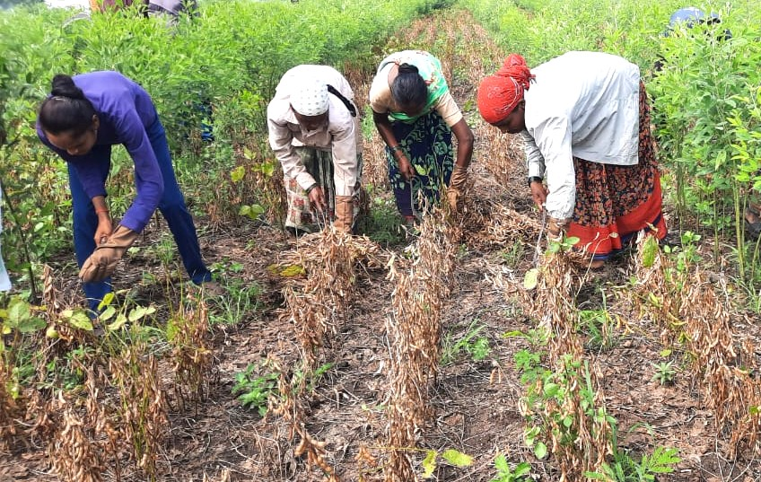
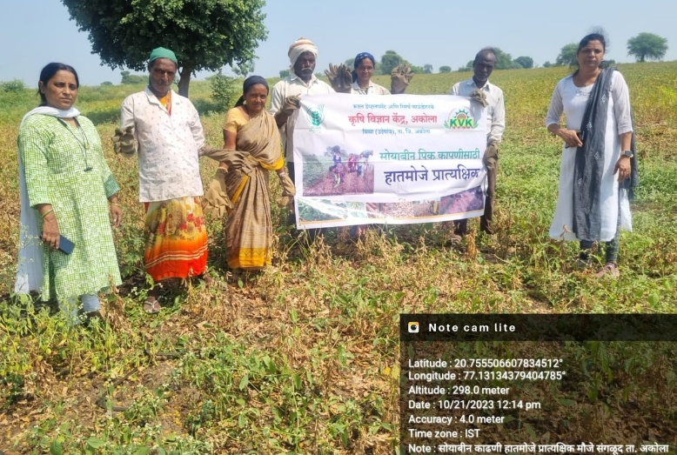

Fig 1. Demonstration of Multipurpose Mitten in Soybean Harvesting by Women

