Original Research Article

Evaluating Rain–Hose Micro-Irrigation for Improving Water Use Efficiency and Profitability in Paddy Cultivation in a district in Kerala

Abstract
Paddy cultivation in Kerala faces challenges from water scarcity, labour shortages, and declining profitability, particularly in upland areas where conventional flood irrigation is inefficient. This study evaluated the performance of rain–hose spray irrigation—a low-pressure perforated hose system—on water use efficiency (WUE), yield, and economic returns in upland paddy fields of Thiruvananthapuram district. Field demonstrations covering 3.5 ha across 28 farmers compared conventional flood irrigation with rain–hose irrigation. Irrigation was scheduled daily for 15–30 minutes according to crop growth stage, and total seasonal water use was carefully monitored. Yield, WUE, labour requirements, and economic indicators including benefit–cost ratio (BCR) were analyzed using independent t-tests.
Results showed that rain–hose irrigation increased yield by 23.0% (39.06 q/ha vs. 30.06 q/ha under flood irrigation) and improved WUE from 0.43 to 0.87 q/ha-cm. Water consumption decreased by approximately 60%, and labour requirements fell by 83% per hectare. Economic analysis indicated a BCR of 1.61 under rain–hose irrigation compared to 1.04 under conventional irrigation. These results demonstrate that rain–hose spray irrigation is a cost-effective, labour-saving, and water-efficient alternative for smallholder paddy farmers.
The findings align with prior studies in India and other South Asian contexts, highlighting rain–hose irrigation’s potential to enhance climate resilience, resource use efficiency, and profitability in paddy cultivation.

Keywords: Rain–hose irrigation; Paddy; Water use efficiency (WUE); Benefit–cost ratio; Micro-irrigation

1. INTRODUCTION

Paddy cultivation in Kerala has been steadily declining, from 8.82 lakh ha in 1974–75 to 2.03 lakh ha in 2018–19 [1], due to urbanization, labour shortages, declining profitability, and inefficient irrigation practices. One of the greatest challenges faced during paddy cultivation in Kerala is water scarcity, where traditional flood irrigation causes significant water and labour inefficiencies. Growing rice the traditional way, by keeping the fields flooded all the time, uses a huge amount of water — about 2,500 liters just to produce 1 kg of rice [2]. Percolation losses of water decreased with medium-puddling by 54–58%, but it remained unaffected by increased puddling intensity and puddling depth [3,4]. Conventional flood irrigation over the past 110 years has increased global CH₄ emissions from rice cultivation by 85%. Therefore, to address water scarcity and reduce CH₄ emissions, adopting optimized irrigation strategies is beneficial [5].

Nearly 80% of the world’s irrigated land still depends on flood or surface irrigation, which has an application efficiency of only 30–50%, whereas drip irrigation offers much higher efficiency, ranging between 70% and 90% [6]. Micro-irrigation systems, including drip and sprinkler technologies, have improved water use efficiency in high-value crops [7][8]. About 62.5% of the farmers perceived the micro irrigation system (MIS) as useful. With regard to economic and environmental benefits, 88.33% of the respondents stated that MIS helps in saving water. However, the major constraint in its adoption, reported by 81.67% of the farmers, was the non-availability of skilled labour for repairing the system when required [9].

System of Rice Intensification (SRI) under micro irrigation systems such as Low Energy Water Application (LEWA) and micro-sprinklers have shown remarkable yield advantages (128% and 123% higher, respectively) compared to conventional check basin transplanting, and recent studies further confirm that controlled irrigation strategies like Alternate Wetting & Drying (AWD) and micro-sprinklers not only sustain or enhance rice yields but also reduce water demand, improve groundwater recharge, and lower methane emissions, making them sustainable alternatives to traditional flooding practices [10][11][12]. Direct seeding of paddy in raised bed with medium duration variety at the spacing of 20x40x10 cm along with other agronomic practices is the best for getting higher yield parameters, yield, net return, higher water use efficiency and water productivity in Samba (Rabi) season under drip irrigated rice cultivation [13].

Rain–hose spray irrigation, a low-pressure perforated hose system, provides uniform water distribution at lower installation and maintenance costs compared to drip systems. Climate change has altered rainfall patterns, leading to severe water scarcity for cultivation. To address this challenge, an innovative irrigation method known as Rain Hose irrigation technology has been introduced. Also called ‘rain pipe irrigation,’ it is affordable and an efficient alternative to the conventional sprinkler irrigation system. Rain Hose is a flexible pipe designed with drip holes made using nano-punching technology, ensuring uniform water distribution. It is easy to install, simple to maintain, and highly suitable for closely spaced crops such as greengram, blackgram, groundnut, radish, onion, greens, and other vegetables [14]. It is particularly suitable for small, fragmented fields and smallholder farmers, offering labour and cost savings. Rain pipe irrigation has emerged as a promising technology that enables efficient water use and enhances crop yields, while remaining more affordable than conventional irrigation methods [15].

Rain hose irrigation at 100% of Potential Evapotranspiration (PET) enhanced groundnut profitability with a high benefit-cost ratio, while drip irrigation at 100% PET produced the highest pod yield of 3086 kg/ha [16]. Rain hose irrigation at 1.50 kg cm⁻², 30 m length, and 4 m spacing achieved high uniformity (87.83%) and distribution (76.29%), making it a cost-effective and efficient method to improve water use and crop productivity [17]. Rain hose technology for water-saving sustainable irrigation maintained the highest soil moisture (23.93% at 10 cm and 19.71% at 20 cm depth). Drip irrigation produced a higher seed yield (1363 kg ha⁻¹), but the rain hose system was more cost-effective. It reduced costs by 27.09% and achieved a 15.23% higher benefit–cost ratio. Overall, rain hose irrigation enhanced blackgram productivity in garden land [18]. The study of rain hose irrigation revealed a linear relationship between operating pressure and discharge. Specifically, at pressures of 0.5 and 1.0 kg cm- ², increased pressure correlated well with higher soil moisture content along with 20% to 23% increase in moisture with greater water-infiltration depth [19].

In Kerala, subsidies for micro-irrigation under schemes such as Pradhan Mantri Krishi Sinchayi Yojna (PMKSY) are largely directed toward horticultural crops, limiting adoption in paddy [16]. Rain–hose irrigation offers a low-cost, farmer-friendly alternative compatible with existing pump systems, requiring minimal technical expertise while improving water productivity and profitability.

1.1 Study Objectives
This study, conducted by ICAR–KVK, Mitraniketan, is aimed to:
- Compare rain–hose spray irrigation with conventional flood irrigation in terms of yield, water use efficiency (WUE), and benefit–cost ratio (BCR).
- Assess water and labour savings achieved under rain–hose irrigation.
- Analyze economic implications for smallholder farmers.

2. MATERIALS AND METHODS
2.1 Study Area and Crop
Field demonstrations were conducted by ICAR–KVK, Mitraniketan, during 2017–2018 in six panchayats of Thiruvananthapuram district: Parassala, Kunnathukal, Kazhakootam, Venganoor, Aruvikkara, and Thulicode. The upland fields selected were representative of smallholder paddy farms with limited water storage and shallow soils. The paddy variety used was ‘Uma’, known for its adaptability to Kerala’s agro-climatic conditions and is the most popular rice variety, currently occupying more than 60% of the rice area in the State of Kerala [20].
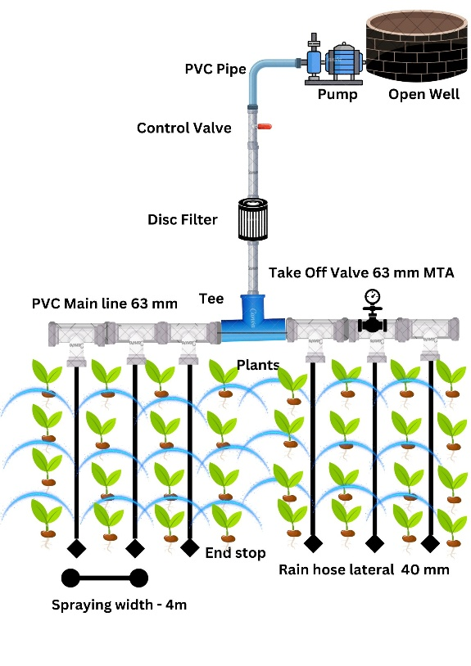
Fig. 1: Schematic of rain–hose spray irrigation system
2.2 Experimental Design
Two irrigation treatments were compared in a completely randomized block design (CRBD):
T1: Conventional flood irrigation (control)
T2: Rain–hose spray irrigation
Field demonstrations covered 3.5 ha and involved 28 farmers, with plots of 0.1–0.2 ha each. All agronomic practices, including land preparation, fertilization, and pest management, followed recommended ICAR–KVK protocols.

2.3 Rain–Hose Irrigation System
The rain–hose system consisted of 40 mm diameter perforated hoses, 100 m in length, operating at approximately 1 kg/cm², with a maximum lateral length of 50 m and spray width of 6 m. Water was pumped from a conservation pit using a 1.5 hp pump through a PVC mainline (63 mm) with a 1.5 “disc filter to prevent clogging.

2.3.1 Irrigation Scheduling for Paddy

The irrigation schedule for paddy was planned according to its growth stages to optimize water use. During the initial growth stage, the crop received 15 minutes of irrigation daily. At the critical growth stages, irrigation was increased to 30 minutes per day to meet the higher water demand. The total seasonal water requirement for paddy ranged from approximately 450 to 700 mm [21], ensuring sufficient soil moisture for growth and yield.

2.3.2 Water Management in Paddy

During transplanting, water level of approximately 1.5 cm was maintained in the field. After transplanting, water depth was gradually increased to 5 cm and maintained it until the maximum tillering stage. Proper water management during these stages ensures healthy seedling establishment, promotes tiller development, and supports optimum crop growth, leading to higher yield potential [22][23].
The rain–hose system was designed for smallholder fragmented fields, ensuring minimal labour input and compatibility with existing pump infrastructure.

2.4 Data Collection
The following parameters were measured:

2.4.1. Yield (q/ha)
Yield was determined by averaging ten 1 m² quadrat samples per plot and scaling to a hectare.

Yield (q/ha) = Average weight of sample plot (kg)​ ×10
Area of sample plot (m²)
2.4.2 Water Use Efficiency (WUE, q/ha-cm)
WUE was calculated as the ratio of yield to the seasonal water applied.

WUE = Grain yield (q/ha)
Total seasonal water applied (cm)

2.4.3. Labour Requirements (man-days/ha)
Labour was recorded for land preparation, irrigation setup, maintenance, and harvesting. Time spent on irrigation setup, water pumping, and maintenance of hoses was also recorded to assess adoption potential among smallholder farmers.
Labour Requirement=∑(Labour used for land preparation, irrigation, maintenance, harvesting (man-days))
2.4.4 Economic Indicators

Economic parameters included gross cost, gross return, net return, and benefit–cost ratio (BCR)

2.5 Statistical Analysis
Data were analyzed using independent t-tests (p < 0.05) to compare yield, WUE, and BCR between treatments. Variance homogeneity was tested prior to t-test application. All statistical analyses were performed using R software version 4.2, enabling robust comparison of treatment effects and supporting reproducibility.

2.6 Economic Analysis
Economic indicators were calculated as follows:
Gross cost (₹/ha): Land preparation, seed, fertilizers, irrigation setup, and labour costs
Gross return (₹/ha): Value of harvested paddy at prevailing market rates
Net return (₹/ha): Gross return minus gross cost.
Benefit–Cost Ratio (BCR): Gross return divided by gross cost.
Economic analysis also considered cost savings from reduced water pumping and labour, highlighting the profitability potential of rain–hose irrigation for smallholders

BCR = Gross Return (₹/ha)
Gross Cost (₹/ha)

3. RESULTS AND DISCUSSION

The performance of the rain hose spray irrigation system in paddy was evaluated, and the observed parameters are discussed here

3.1 Yield and Water Use Efficiency

Field demonstrations revealed substantial differences between rain–hose irrigation and conventional flood irrigation. The mean paddy yield under rain–hose irrigation was 39.06 q/ha, representing a 23.04% increase over the flood irrigation yield of 30.06 q/ha (Table 1). Water use efficiency (WUE) also improved markedly, rising from 0.43 q/ha-cm under flood irrigation to 0.87 q/ha-cm with rain–hose irrigation. These differences were statistically significant (p < 0.05).

The increased yield and higher WUE demonstrate that rain–hose irrigation optimizes water use, maintains adequate soil moisture, and supports better crop growth. This efficiency is particularly beneficial for small holder farmers facing limited water availability and declining productivity.

Table 1: Statistical comparison (independent t-test) between rain–hose spray irrigation and flood irrigation
Parameters | WUE (q/ha-cm) |  | Yield (q/ha) |  | BCR
Method | Flood | Rain hose | Flood | Rain hose | Flood | Rain hose
Mean | 0.430 | 0.868 | 30.061 | 39.061 | 1.034 | 1.619
Variance | 0.001 | 0.003 | 5.02 | 6.67 | 0.006 | 0.02
df | 18 |  | 18 |  | 18
t Stat | -20.944 |  | -8.324 |  | -11.426
t Critical two-tail | 2.101 |  | 2.101 |  | 2.101
Note: Significant differences (p < 0.05) observed between rain–hose (RH) and conventional (C) methods.

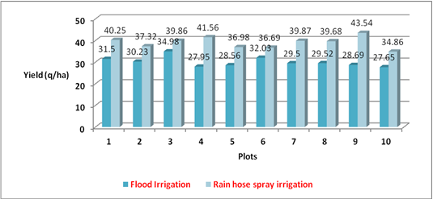
Fig. 2: Yield comparison between rain hose spray irrigation system and flood irrigation
Figure 2 illustrates the yield differences between rain–hose spray irrigation and conventional flood irrigation across ten demonstration plots. In every case, rain–hose irrigation achieved higher yields, ranging from 36.69 q/ha to 43.54 q/ha, compared to 27.95 q/ha to 32.93 q/ha under flood irrigation. This clearly shows the consistent yield advantage of the rain–hose system across varied field conditions

3.2 Water and Labour Savings
Rain–hose irrigation reduced water consumption by approximately 60%, which is critical in regions experiencing water scarcity. Labour requirements per hectare also declined dramatically, falling by ~83%. Reduced labour demand results from minimal maintenance requirements and elimination of continuous water management associated with flood irrigation.
These water and labour savings make the system highly suitable for smallholders, enabling them to allocate time and resources to other farm activities or reduce reliance on hired labour, thereby lowering production costs.

3.3 Economic Benefits
From Table 1 it can be observed that these differences were statistically significant (p < 0.05) for BCR. BCR of Rs 1.61 is obtained for rain hose irrigation against 1.04 for flood irrigation. A BCR of 1.61 indicates that every rupee invested in rain–hose irrigation returns were ₹1.61, making it a cost-effective investment for smallholder farmers. Economic performance under the two irrigation systems is summarized in Table 2.

Rain–hose irrigation achieved substantially higher profitability. Lower gross costs resulted from reduced water pumping and labour, while higher yields increased gross returns.
Table 2: Comparison of productivity between conventional and rain hose irrigation technique

Parameter | Flood Irrigation | Rain–hose Irrigation
Mean Gross Cost (₹) | 70,881 | 58,899
Mean Gross Return (₹) | 73,341 | 95,024
Mean Net Return (₹) | 2,528 | 36,125
BCR | 1.04 | 1.61

3.4 Practical Benefits
- Rain–hose spray irrigation provides multiple benefits for smallholder paddy cultivation:
- Higher Productivity: 23% increase in yield improves food security and income.
- Efficient Water Use: ~60% water savings reduces pressure on scarce water resources.
- Labour Efficiency: ~83% reduction in labour requirements lowers production costs and mitigates labour shortages.
- Economic Profitability: Increased net returns and higher BCR make cultivation more financially sustainable.
- Farmer-Friendly Technology: Easy to install, maintain, and operate without technical expertise.
- Climate-Resilient: Reduces dependence on water availability and supports stable yields under variable rainfall.

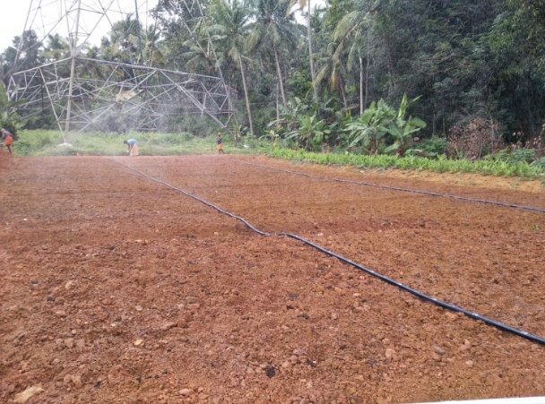 | 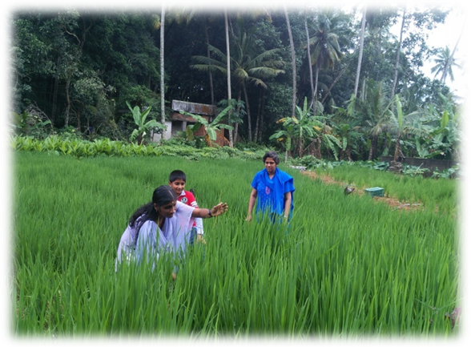
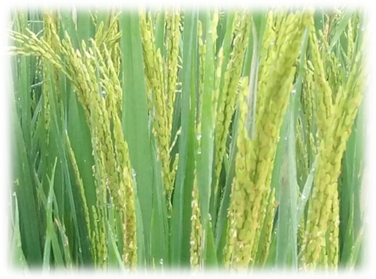 | 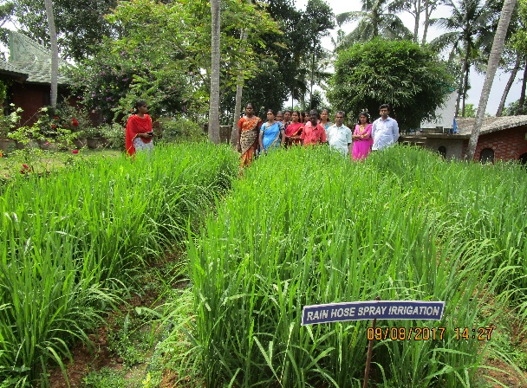
Fig. 3: Field level stages of paddy cultivation with rain hose spray irrigation system

4.Conclusion
The field demonstrations of rain–hose spray irrigation in upland paddy fields of Thiruvananthapuram district demonstrate significant improvements in productivity, resource use efficiency, and profitability. Key findings include:
- Higher yield: 23.04% increase compared to conventional flood irrigation (39.06 q/ha vs. 30.06 q/ha).
- Improved water use efficiency: WUE increased from 0.43 to 0.87 q/ha-cm, enabling optimal utilization of limited water resources.
- Substantial water savings: Approximately 60% reduction in seasonal water use, making the system suitable for water-scarce conditions.
- Labour efficiency: Labour requirements decreased by ~83%, reducing production costs and mitigating labour shortages.
- Economic benefits: Higher net returns and a benefit–cost ratio of 1.61 indicate that rain–hose irrigation is a cost-effective investment for smallholder farmers.
Overall, rain–hose spray irrigation is a farmer-friendly, low-cost, and climate-resilient technology that enhances paddy productivity while conserving water and reducing labour. Its adoption can improve the sustainability and profitability of smallholder rice systems in Kerala and similar humid tropical regions.
Disclaimer (Artificial intelligence)
Option 1:
Author(s) hereby declare that NO generative AI technologies such as Large Language Models (ChatGPT, COPILOT, etc.) and text-to-image generators have been used during the writing or editing of this manuscript.
Option 2:
Author(s) hereby declare that generative AI technologies such as Large Language Models, etc. have been used during the writing or editing of manuscripts. This explanation will include the name, version, model, and source of the generative AI technology and as well as all input prompts provided to the generative AI technology
Details of the AI usage are given below:
1.
2.
3.
References
- Department of Economics & Statistics. (2019). Agricultural Statics - Area and production statistics. Government of Kerala. https://ecostat.kerala.gov.in/storage/publications/239.pdf.
- Denis Bwire,Hirotaka Saito,Roy C. Sidle and Junko Nishiwaki. Water Management and Hydrological Characteristics of Paddy-Rice Fields under Alternate Wetting and Drying Irrigation Practice as Climate Smart Practice: A Review, Agronomy 2024;14(7):1407-1421; https://doi.org/10.3390/agronomy14071421
- Suresh, R. (2010). Textbook on Micro Irrigation. Standard Publishers. https://www.amazon.in/Micro-Irrigation-Theory-Practice-R-Suresh/dp/8180141500
- S.S Kukal and G.C Aggarwal. Percolation losses of water in relation to puddling intensity and depth in a sandy loam rice (Oryza sativa) field. Agricultural Water Management. 2022 ; 57(1):49-59. https://doi.org/10.1016/S0378-3774(02)00037-9
- Bowen Zhang, Hanqin Tian, Wei Ren, Bo Tao, Chaoqun Lu, Jia Yang, Kamaljit Banger, Shufen Pan. Methane emissions from global rice fields: Magnitude, spatiotemporal patterns, and environmental controls. 2016; https://doi.org/10.1002/2016GB005381
- Sivanappan, R. K. Prospects of micro-irrigation in India. Irrig. Drain. Syst. 1994; 8(1):49–58.
- Bansal,R., Kumar, S., &amp; Sharma, R. On-farm drip irrigation in rice. Int. J. Curr. Microbiol. Appl. Sci..2018; 7(2):506–512. https://www.ijcmas.com/7-2-2018/Rajeev%20Bansal,%20et%20al.pdf ( title properly not match)
- K.N Tiwari, P.K Mal, R.M Singh, A Chattopadhyay. Response of okra (Abelmoschus esculentus (L.) Moench.) to drip irrigation under mulch and non-mulch conditions. Agricultural Water Management.1998;38(2):91-102. https://doi.org/10.1016/S0378-3774(98)00063-8
- Patel, G. R.; Joshi, O. M.; Prajapati, M. R. and Pandya, S. P, PERCEPTION OF FARMERS ABOUT MICRO IRRIGATION SYSTEM, AGRES – An International e. Journal. 017; 6 (3):415-419. https://www.researchgate.net/publication/380006244_PERCEPTION_OF_FARMERS_ABOUT_MICRO_IRRIGATION_SYSTEM
- Giulio Luca Cristian Gilardi, Alice Mayer, Michele Rienzner, Marco Romani and Arianna Facchi. Effect of Alternate Wetting and Drying (AWD) and Other Irrigation Management Strategies on Water Resources in Rice-Producing Areas of Northern Italy. Water. 2023; 15(12):2150. https://doi.org/10.3390/w15122150
- Ajay Kumar, S K Singh, K K Kaushal and Purushottam. EFFECT OF MICRO-IRRIGATION ON WATER PRODUCTIVITY IN SYSTEM OF RICE (ORYZA SATIVA) AND WHEAT (TRITICUM AESTIVUM) INTENSIFICATION. Indian Journal of Agricultural Sciences.2015; 85 (10): 1342–8. https://doi.org/10.56093/ijas.v85i10.52300
- Ishfaq, M., Farooq, M., Zulfiqar, U., Hussain, S., Akbar, N., Nawaz, A., & Anjum, S. A. (2020). Alternate wetting and drying: A water-saving and ecofriendly rice production system. Agricultural Water Management, 241, 106363.
- S. Vallal Kannan & V. Ravikumar. (2021). Development of Crop Geometry for Drip Irrigated Rice Cultivation. International Journal of Environment and Climate Change, 11(4), 97–105. https://doi.org/10.9734/ijecc/2021/v11i430397
- P. Ayyadurai, P. S. Shanmugam and M. Sangeetha. Rain Hose Irrigation Technology in Groundnut- A New Innovation in Irrigation System. Biotica Research Today. 202; 2(8): 842 843. https://bioticapublications.com/journal-backend/articlePdf/e80a3d4a3a.pdf
- D.G. Bhadarka, S.M. Gohil, A.N. Gaadhe, D.D. Vadalia, H.H. Mashru, G.V. Prajapati, et al. Sustainable Farming Practices: A Comprehensive Study on Rain Pipe Irrigation System Performance. Research Biotica. 2023; 5(1):16-20. http://dx.doi.org/10.54083/ResBio/5.1.2023/16-20
- V. P. Harini Harishma, S. Vallal Kannan, T. Sampathkumar and S. Sheeba. Yield Enhancement through a Low-Cost Irrigation System for Groundnut. International Journal of Environment and Climate Change.2022; 12(11): 1461-1466. 10.9734/ijecc/2022/v12i1131126.
- Bhadarka, D., Gohil, S., Gaadhe, A., Vadalia, D., Mashru, H., Girish, P., Pandya, P., & Parmar, S. Sustainable farming practices: A comprehensive study on rain pipe irrigation system performance. Research Biotica. 2023;5(1), 16-20. https://doi.org/10.54083/ResBio/5.1.2023/16-20
- S. Marimuthu, S. Vallal Kannan, S. Pazhanivelan, V. Geethalakshmi, M. Raju, A. P. Sivamurugan, et al. Harnessing rain hose technology for water-saving sustainable irrigation and enhancing blackgram productivity in garden land .Scientific Reports.2024;14.Article number: 18692
- S. Sajeena, P. S. Sheeja, S. Anu Mohan, P. Hashifa, Muhammed Misbah, and K. Naja Rahman. Performance Evaluation of Rain Hose Irrigation System for Enhancing Water Productivity in Kerala, India, Journal of Agricultural Engineering (India). 2024; 61 (6): 973- 984. https://doi.org/10.52151/jae2024616.1886
- P. Sruthi, U. Surendran, Manzer H. Siddiqui, Saud Alamri. Understanding the leaf rolling of paddy and exploring its management options under aerobic rice.Scientific Reports.2024; 14, Article number: 19335. https://www.nature.com/articles/s41598-024-68244-7
- Layheang Song, Chantha Oeurng, John Hornbuckle. Assessment of Rice Water Requirement by Using CROPWAT Model. The 15th Science Council of Asia Board Meeting and International Symposium. https://www.researchgate.net/publication/303686218
- Dr. D. Alexander, Dr. S. Rajan, Dr. L. Rajamony, Dr. K. Ushakumari, Dr. Sajan Kurien. The Adhoc Package of Practices Recommendations for Organic Farming. Directorate of Research, Kerala Agricultural University. KERALA, INDIA.2009: 15. https://keralaagriculture.gov.in/wp-content/uploads/2018/12/package_2015.pdf
- Shantappa Duttarganvi, Tirupataiah K, Yella Reddy K, Sandhyrani K, Mahendra Kumar R and Kadasiddappa Malamasuri. Yield and Water Productivity of Rice under Different Cultivation Practices and Irrigation Regimes. International Symposium on Integrated Water Resources Management (IWRM).2014; 19–21. https://www.researchgate.net/publication/260427824

