Determining preferred ICT tools use among the Farmers in Kota, Rajasthan, India
ABSTRACT
The Study on Utilization of different ICT tools by the farmers for getting agricultural information in Kota District of Rajasthan was conducted on the year 2021-2022 by the department of agricultural extension and communication, Multistage sample technique was used in the selection of 399 ICT user farmers as a sample for the study. The most frequently used ICT tools for getting various agricultural information were internet and mobile. The results showed that majority of the respondents (31.25 per cent) used mobile for weather forecasting information, majority of the respondents (22.50 per cent) used internet for input specification and prices, majority of the respondents (40.85 per cent) used internet for weather based fore casting of pest and diseases. Majority of the respondents(29.25 per cent) felt that information regarding the best packages of practices for various crops cultivated in the area like cereals, pulses, fruits and vegetable and many others were perceived appropriately by using internet,majority of the respondents (29.25 per cent) used internet for value addition. It is indicated that majority of the respondents (30.12 per cent) used internet for quality standards for export, majority of the respondents (45.90 per cent) used internet for credit and finance information. It was also revealed that majority of the respondents (25.50 per cent) used mobile for getting detailed crop insurance information, majority of the respondents (25.85 per cent) used mobile for market forecasting information. It was clearly depicted that majority of the respondents (45.90 per cent) used mobile for warehouses and cold storages information; majority of the respondents used (51.45 per cent) internet for subsidies information. It was revealed that majority of the respondents (36.55 per cent) used internet for revenue aspects of land records information.

Key Words: ICT, information kiosks, input specification and prices, mobile, utilization pattern, weather information
INTRODUCTION
Information and communication technology have opened up a whole new set of options in technology transfer in agriculture to improve the speed, accuracy of the communications in relatively lower costs. Information needs of farmers are changing from information on crop technology and package of practices to market prices in national and international markets and value addition opportunities. The farmer’s concern has shifted from high production to high returns, and hence issues like quality, timeliness and post-harvest technology and storage are gaining prominence in the farmer queries. Timely access to accurate information on government schemes, input prices and availability, as well as early warnings for pest and disease outbreaks is essential for improving agricultural productivity and resilience. In recent years, the adoption of Information and Communication Technology (ICT) tools such as radio, television, video and audio conferencing, internet platforms, social media, e-mail, online expert systems, call centers, and agricultural marketing portals has greatly enhanced the reach and effectiveness of agricultural extension services.
Application of ICT in agriculture ranges from the need of each of these stakeholders who are directly or indirectly involve in agriculture. The application of emerging trends in ICT may be applied to almost all the processes involved in agriculture as well as related to it. Thus, it will always be helpful in both the product efficiency and process efficiency by means of reducing the cost and time in the functionalities involved in agriculture. The applications of ICT in agriculture development are like, Providing online technical, market and weather-related information, Global information system (Remote sensing), Expert systems (Decision support systems), Question answer service, Tele education, E-governance, Creation of databases and rural networking.
The various types of information that the ICT tools provides information related to different schemes, crops, technologies, seeds, fertilizers, pesticides, availability of fertilizers, seedlings, bio pesticides, soil fertility, pest and disease diagnosis, agricultural marketing information, weather forecast information helping farmers to take right decision at the right time. Therefore, the study aimed to focus on utilization of different ICTs by the farmers in Kota district of Rajasthan. The study on the use of ICT tools by farmers in the Kota Division of Rajasthan contributes to scientific knowledge by identifying patterns of technology adoption across socio-economic groups, assessing the effectiveness of platforms like mobile apps and expert systems, and revealing barriers such as digital illiteracy and poor connectivity. Its practical applications includes guiding targeted extension strategies, informing digital agriculture policies like NeGP-A, and designing localized training programs to enhance ICT literacy.
MATERIAL AND METHOD
The study was conducted in Kota district of Rajasthan India in the year 2021-2022 to assess the Utilization of different ICT tools by the farmers for getting agricultural information. Multistage sampling technique was used in the present study. In first stage, Kota district was selected purposively due to its active implementation of agricultural development programs and relatively high adoption of ICT-based extension services. In the second stage, Ladpura block was chosen purposively from among the five blocks of the district—Itawa, Sangod, Ladpura, Digod, and Khairabad—based on its diverse farming practices, better digital infrastructure, and strong institutional linkages with agricultural research and extension agencies. 6 villages from Ladpura block namely; Rasulpur, Bhimpura, Aarampura, Bhojpura, Jakhora, Mawasawere selected randomly since famers of these villages use different source of information technologies with good connectivity of Geographical Information System (GIS) and also connect with government and non-government institution. Finally at last stage, Cultivator Farmers who were using ICT tools were chosen for the study as they are eager to seeking farm information, advanced farming technology, proportionate number of farmers 78(Rasulpur), 137(Bhimpura), 62(Aarampura), 22(Bhojpura), 44(Jakhora), 56(Mawasa) from each selected village were selected randomly. Thus, the total sample size was 399. A proportionate random sampling method was used to select the sample of respondents by using the formulae given by Taro Yamane (1967).
$$n=\frac{N}{1+N({e)}^{2}}$$
Where;
n = sample size
N = population size (140262)
e = margin of error (5% or .05) at 95% confidence level
The data was collected by a pre-tested structured interview schedule through personal interview method and different statistical tools were used wherever required.The various dimensions regarding area of information of ICTs used by the respondents for agriculture practices and to measure the “Utilization of different ICT tools by the farmers for getting agricultural information in Kota District of Rajasthan”, it was studied on five-point continuum viz., daily, weekly, monthly, occasionally and never with scores 5,4,3,2 and 1 respectively, score obtained from each respondent was calculated and converted to number and per cent for appropriate inference.

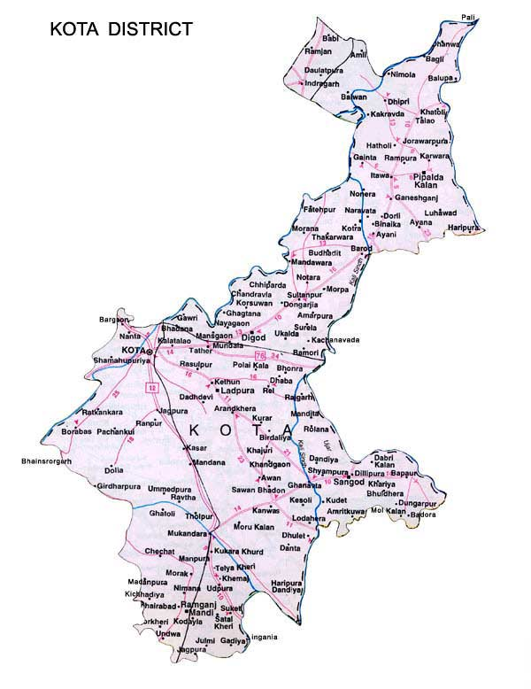
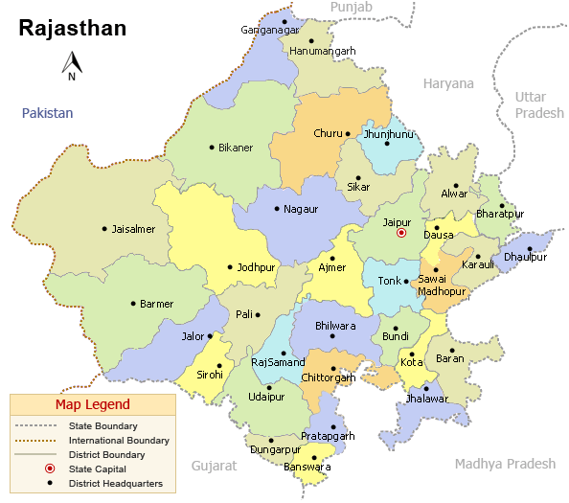

Fig 1: Study Area

RESULT AND DISCUSSION
Utilization of different ICT tools by the farmers for getting agricultural information
A clear glance at the Table 1 revealed that majority of the respondents (31.25 per cent) used mobile for weather forecasting information like rainfall, temperature and humidity etc. followed by internet (20.15 per cent), computer (15.00 per cent), CD/DVD player (10.50 per cent), information kiosks (7.75 per cent), video calling (5.25 per cent), laptop (3.75 per cent) and tablet (2.50 per cent).This might be due to that ICT tools like mobile, internet, computer is more popular and available and easier to utilize as compared to the tools like information kiosks, laptop and tablet. Video calling helps farmers get clear, real-time weather advice with visual support and expert interaction especially useful in climate-sensitive areas. The findings of the study were also supported by studies conducted by Bipinbhai (2020) who revealed in his study that the utilization level of mobile by the respondents for obtaining information about weather condition and environment was 77.92 per cent, followed by TV (71.46 per cent) and whatsapp (66.46 per cent). Similarly, Rupender et al. (2017) in their research reported that frequency of using mobile phone by farmers was found high followed by TV user, FM/Radio, followed by television, FM/Radio, internet, Whatsapp; Mobile phone camera was found, face book, YouTube, Computer, E-mail, Ebook and CD/VCD. These findings were in conformity with the findings of Kamala et al. (2019), Toluwase and Apata (2017).
The study also observed that majority of the respondents (22.50 per cent) used internet - serves as the primary gateway for input specification and prices followed by mobile (20.88 per cent), CD/DVD player (12.75 per cent), computer (10.00 per cent), video calling (7.85 per cent) enables real-time expert interaction, visual guidance, and reflects a shift toward more interactive ICT use in agriculture, laptop (5.75 per cent) and tablet (3.50 per cent) and none of the respondents used information kiosks.
It is also founded that majority of the respondents (40.85 per cent) used internet as the most used ICT tool for weather-based pest and disease forecasting, offering timely, location-specific alerts via platforms like IMD and Kisan Suvidha followed by mobile (20.88 per cent), laptop (12.75 per cent), CD/DVD player (10.85 per cent), computer (10.00 per cent), video calling (2.25 per cent) enables direct expert interaction and personalized guidance, marking a shift toward interactive advisory tools for low-literate farmers and none of the respondents used tablet and information kiosks.
Looking forward to the importance of improved field level management of pest and disease for higher crop production and also improved other agricultural management practices and due consideration to importance of early warning system about outbreaks of disease and pest infestation, and information about how to manage such outbreaks of pest and disease it is exhibited that majority (29.25 per cent) of the respondents felt that information regarding the best packages of practices for various crops cultivated in the area like cereals, pulses, fruits and vegetable and many others were perceived appropriately by using internet followed by mobile (22.50 per cent), CD/DVD player (20.50 per cent), computer (15.00 per cent), laptop (8.85 per cent), information kiosks (3.90 per cent) and none of the respondents used video calling and tablet.
It is also observed that majority of the respondents (29.25 per cent) used internet which enables farmers to access market insights, meet export requirements, and engage with platforms like e-NAM and APEDA for trade and compliance for value addition followed by computer (25.45 per cent), mobile (22.68 per cent), CD/DVD player (11.55 per cent), video calling (9.52 per cent), laptop (8.20 per cent), information kiosks (7.85 per cent) and tablet (2.00 per cent).The findings of the study were contradictory with the findings of Naik (2018) in his study entitled “A study on ICT tools usage by the farmers in Anantapur district of Andhra Pradesh” reported that majority (88.33 per cent) of the farmers have used television daily followed by CD/DVD player (24.17 per cent), mobile (8.33 per cent), computer (4.16 per cent), landline (0.83 per cent) and none of the farmers used radio.It is indicated that majority of the respondents (30.12 per cent) used internet for quality standards for export followed by mobile (18.29 per cent), CD/DVD player (15.25 per cent), laptop (12.75 per cent), computer (10.80 per cent), tablet (5.25 per cent), information kiosks (4.25 per cent) and video calling (1.75 per cent).
It is evident that majority of the respondents (45.90 per cent) used internet for enhancing their financial literacy and risk preparedness followed by mobile (12.50 per cent), CD/DVD player (11.28 per cent), laptop (9.58 per cent), computer (9.52 per cent), video calling (4.45 per cent) offers strategic benefits by enabling real-time expert consultations, visual verification during claims, and interactive training on financial and insurance literacy, tablet (4.20 per cent) and information kiosks (2.25 per cent).It is also revealed that majority of the respondents (25.50 per cent) used mobile for getting detailed crop insurance information on risk covering including crop insurance, animal insurance and insurance against property appropriately followed by (20.50 per cent) from internet, CD/DVD player (18.75 per cent), laptop (11.25 per cent), computer (8.80 per cent), information kiosks (8.00 per cent), video calling (3.75 per cent) and none of the respondents used tablet.
The findings were similar with the findings of Bipinbhai (2020) in his study revealed that utilization level of mobile by respondents for getting the information about crop insurance, loan, credit and other financial matters was (78.54 per cent) followed by WhatsApp (73.13 per cent), I-Khedut web Portal (67.08 per cent), TV (56.88 per cent) and YouTube (45.42 per cent).
It is illustrated also that majority of the respondents (25.85 per cent) used mobile for market forecasting information, including daily updates on the prices of agricultural commodities in the local markets of the surrounding district, as one of the most relevant ICT services. This was seen as most appropriately and enabling them to sell at those markets where their goods would command the best prices followed by internet (18.25 per cent), laptop (15.72 per cent), computer (12.20 per cent), CD/DVD player (9.58 per cent), video calling (7.22 per cent), tablet (6.65 per cent) and information kiosks (2.75 per cent).
The findings were in congruence with the result of Reddy (2019) who illustrated in his study that 61.50 per cent of the respondents occasionally obtained information regarding agricultural product marketing from mobile phone. Similarly, Toluwase and Apata (2017) in their study revealed that television, radio and mobile phone top the various forms of ICT usage and a high rate of competence in the use of mobile phones, radio, and television sets while respondents indicated low competence level in the use of video-conferencing and fax, the attitude of farmers has a significant level of effect on the productivity of farmers.
It is clearly depicted that majority of the respondents (45.90 per cent) used mobile for warehouses and cold storages information followed by internet (15.25 per cent), computer (9.58 per cent), laptop (9.52 per cent), information kiosks (8.80 per cent), video calling (5.25 per cent), CD/DVD player (4.25 per cent) and none of the respondents used tablet. Similar finding was also reported by Kamala et al. (2019) in their study revealed that the level of availability and accessibility of ICTs was the highest for television followed by mobile phones and radio respectively. Television and Mobile phones were also regarded as the most frequently used ICT tool as compared to other ICTs.
It is also resulted that majority of the respondents used (51.45 per cent) internet for subsidies information followed by mobile (11.85 per cent), laptop (10.59 per cent), computer (8.95 per cent), video calling (6.21 per cent), tablet (3.95 per cent), CD/DVD player (3.65 per cent) and information kiosks (3.35 per cent). It is revealed that majority of the respondents (36.55 per cent) used internet for revenue aspects of land records information followed by mobile (21.22 per cent), laptop (13.40 per cent), computer (10.15 per cent), CD/DVD player (9.78 per cent), tablet (5.45 per cent), video calling (3.45 per cent) and none of the respondents used information kiosks. The findings of the study were also supported by studies conducted by Das et al. (2020), Nikamet al. (2020) and Khan et al. (2019).

Table:1 Utilization of different ICT tools by the farmers for getting agricultural information
(n=399)
Information | Mobile |  | Computer |  | Tablet |  | Laptop |  | CD/DVD player |  | Internet |  | Information kiosks |  | Video calling
Information | No. | % | No. | % | No. | % | No. | % | No. | % | No. | % | No. | % | No. | %
Weather forecasting | 124 | 31.25 | 60 | 15.0 | 10 | 2.50 | 15 | 3.75 | 42 | 10.50 | 81 | 20.15 | 31 | 7.75 | 21 | 5.25
Input specification and Prices | 146 | 36.75 | 40 | 10.00 | 14 | 3.50 | 23 | 5.75 | 51 | 12.75 | 90 | 22.50 | 0 | 0 | 31 | 7.85
Weather based fore casting of Pest and diseases | 83 | 20.88 | 29 | 7.22 | 0 | 0 | 51 | 12.75 | 43 | 10.85 | 163 | 40.85 | 0 | 0 | 9 | 2.25
Field level Management of Pest and Disease | 90 | 22.50 | 60 | 15.00 | 0 | 0 | 35 | 8.85 | 82 | 20.50 | 117 | 29.25 | 15 | 3.90 | 0 | 0
Value addition | 90 | 22.68 | 9 | 2.25 | 9 | 2.00 | 33 | 8.20 | 46 | 11.55 | 101 | 25.45 | 31 | 7.85 | 38 | 9.52
Quality standards for export | 73 | 18.29 | 43 | 10.80 | 21 | 5.25 | 51 | 12.75 | 61 | 15.25 | 120 | 30.12 | 17 | 4.25 | 7 | 1.75
Credit and Finance Information | 50 | 12.50 | 38 | 9.52 | 17 | 4.20 | 38 | 9.58 | 45 | 11.28 | 183 | 45.90 | 9 | 2.25 | 18 | 4.45
Crop Insurance | 102 | 25.50 | 35 | 8.80 | 0 | 0 | 45 | 11.25 | 75 | 18.75 | 82 | 20.50 | 32 | 8.00 | 15 | 3.75
Market forecasting | 103 | 25.85 | 49 | 12.20 | 26 | 6.65 | 63 | 15.72 | 38 | 9.58 | 73 | 18.25 | 11 | 2.75 | 29 | 7.22
Warehouses and Cold Storages | 183 | 45.90 | 38 | 9.58 | 0 | 0 | 38 | 9.52 | 17 | 4.25 | 61 | 15.25 | 35 | 8.80 | 21 | 5.25
Subsidies | 47 | 11.85 | 36 | 8.95 | 10 | 3.95 | 42 | 10.59 | 15 | 3.65 | 205 | 51.45 | 13 | 3.35 | 25 | 6.21
Revenue aspects of land records | 85 | 21.22 | 40 | 10.15 | 14 | 5.45 | 53 | 13.40 | 39 | 9.78 | 146 | 36.55 | 0 | 0 | 14 | 3.45

CONCLUSION
The study highlights the growing adoption of ICT tools use among the Farmers in Kota, Rajasthan". The study clearly showed that the majority of the respondents used internet and mobile as ICT tools due to their accessibility, affordability, and versatility in delivering agricultural information. The use of the remaining ICT, namely computer, tablet, laptop, CD/DVD player, information kiosks and video calling should be increased by setting up a larger number of kiosks and information centers at the village level. In this way, the use of ICT can be increased by raising awareness among respondent farmers. Farmers should be trained in the effective use of tablets, video calling and kiosks. The majority of farmers had medium utilization for a number of reasons. Establishing various ICTs in each panchayat and providing proper training facilities to the respondents will bring their ICT usage to a higher level.

Disclaimer (Artificial intelligence)
Option 1:
Author(s) hereby declare that NO generative AI technologies such as Large Language Models (ChatGPT, COPILOT, etc.) and text-to-image generators have been used during the writing or editing of this manuscript.
Option 2:
Author(s) hereby declare that generative AI technologies such as Large Language Models, etc. have been used during the writing or editing of manuscripts. This explanation will include the name, version, model, and source of the generative AI technology and as well as all input prompts provided to the generative AI technology
Details of the AI usage are given below:
1. NO AI tool has been used while preparing this manuscript.
2.
3.

REFERENCES
Acharya, B., Singh, S. K., Pathak, R., & Arya, V. (2024). E-governance paradigm in the Indian agricultural sector. Discover Agriculture, 2(2). Springer.
Agri Roots e-Magazine. (2025, July). Use of ICT tools in agricultural extension: Revolutionizing farmer outreach (Vol. 3, Issue 7, Article ID: 0225). Agriculture, Technology and Sciences, Prayagraj, Uttar Pradesh, India. Retrieved from Agri Roots e-Magazine PDF
Agriculture Institute. (2024, March 11). Innovative ICT Initiatives Transforming Indian Agriculture. Agriculture Notes. Retrieved from Agriculture Institute article
Bipinbhai, R. P. 2020. Knowledge, attitude and utilization of information and communication technology services by farmers of Saurashtra region of Gujarat state. M.Sc. (Ag.) Thesis. Junagadh Agricultural University Junagadh, Gujarat.
Das, U., Goswamy, P., and Kameswari, V. L. V. 2020. Farmers’ perception on use of mobile phones for agricultural information.
E. Priyavadhana & T. Balakrishnan. (2025). A Study on Extent of Utilization of Information and Communication Technology (Ict) among Farmers in Tirupathur District, India. Archives of Current Research International, 25(8), 271–280. https://doi.org/10.9734/acri/2025/v25i81416
https://rajas.rajasthan.gov.in/PDF/11222024122534PMAgriculturalStatistics.pdf
Kamala, S., Jyothi, U., and Rani, N. 2019. ICT Availability and Usage by Farm women in Agriculture. International Journal of Current Microbiology and Applied Sciences. 8(11): 1620-1629.
Khan, N. A., Qijie, G., Ali, S., Shahbaz, B., and Shah, A. A. 2019. Farmers’ use of mobile phone for accessing agricultural information in Pakistan. Ciência Rural. 49 (10).
Naik, B. J. 2018.A study on ICT tools usage by the farmers in Anantapur district of Andhra Pradesh. M. Sc. (Ag.) Thesis. Acharya N.G. Ranga Agricultural University Lam, Guntur (ANGRAU),Hyderabad (India).
Nikam, V., Kumar, S., Kingsly, I. M., and Roy, M. 2020. Farmers mobile use pattern, information sources and perception about mobile app for grapes. Indian Journal of Extension Education. 56(1): 77-83.
Reddy, G.S. 2019.Attitude of Farmers Towards Information and Communication Technology.M.Sc. (Ag.) (Unpub.) Thesis,Dr.PanjabraoDeshmukhKrishiVidyapeeth, Krishinagar Po, Akola (Maharashtra).
Rupendar, K., Hudda, R.S., Singh, M.J., Mehta, S.K., and Gagan, M. 2017. Constraints and suggestions by farmers during accessibility of information and communication technologies (ICTS): Study in Haryana. International Journal of Agriculture Science. 9(2): 3653-3655.
Suprava Sethy & Siddhartha D. Mukhopadhyay. (2020). Use of ICTs by Farmers: A Study in Odisha. Asian Journal of Agricultural Extension, Economics & Sociology, 38(5), 74–86. https://doi.org/10.9734/ajaees/2020/v38i530349
Toluwase, S. O. W., and Apata, O. M. 2017. Use of ICTs as a Source of Information for Improving Agricultural Productivity in South-West, Nigeria. International Journal of Agricultural Economics. 2(3): 50-54.
United Nations Development Programme. Making New Technologies Work for Human Development, New York: UNDP, 2001.
Yamane, T. (1967). Statistics, An Introductory Analysis. 2nd Ed., New York: Harper and Row.

