Morphological Diversity of 23 Ecotypes of Striga Collected in the 5 Regions of Niger

Abstract
Striga hermonthica is a parasitic plant that significantly reduces millet crop yields worldwide. This species exhibits considerable genetic diversity, which contributes to its adaptability and resilience in various environments, particularly in the Sahel region. Understanding this genetic diversity is crucial for developing effective strategies to combat its impact on agriculture, as it informs breeding programs for resistant crop varieties and the design of targeted herbicides. In this study, we aimed to characterize the morphological diversity of Striga collected from five regions in the Niger Republic, where the commonly cultivated pearl millet variety serves as the host plant. We collected 23 ecotypes of Striga and conducted pot trials at the ICRISAT Sahelian Center in Niger between September and December 2022.
The study of the morphological diversity of Striga ecotypes revealed significant morphological variability, including qualitative (shape and color) and quantitative traits in the vegetative parts of Striga, suggesting strong phenotypic among ecotypes. Statistical analyses confirmed these observations, revealing significant differences in the studied traits across the regions.
These results provide valuable insights into understanding the morphological diversity of Striga originating from Niger and identifying potential targets for the development of biological control methods and their interactions with host species. The study further identified four groups of distinct morphological diversity based on the means of the 7 quantitative traits.
Keywords: Striga hermonthica, Ecotypes, diversity, agriculture, Niger.

Introduction
Striga hermonthica (Del.) Benth., commonly known as the "witchweed," is the most widespread and destructive parasitic weed affecting cereal crops in West and Central sub-Saharan Africa. Approximately 40% of cereal-producing areas in sub-Saharan Africa are severely infested by Striga (Gurney et al., 2006). Yield losses of up to 100% have been reported in susceptible cereal cultivars under high infestation levels, particularly during drought periods (Gurney et al., 2006; Ejeta, 2007; Amusan et al., 2008). As a result, Striga is considered one of the most significant biotic constraints to food production in Africa, negatively impacting the livelihoods of 300 million people—especially subsistence farmers—and exacerbating food insecurity and poverty (Pennisi, 2010).
Recommended management strategies include herbicide application, soil fertility improvement, intercropping, biological control, and the use of resistant varieties (Badu-Apraku, 2010). However, despite partial success, no method has yet provided a sustainable solution (Ransom, 2000).
In Niger, Striga poses a major agricultural challenge, with five million hectares of land infested by this parasitic plant (Gressel et al., 2004).
Recent studies conducted in six regions of the country (Dosso, Maradi, Niamey, Tillabéry, and Zinder) have highlighted the versatile uses of this species, which serves ten different purposes: as forage, soil amendment, in mystical practices, as a dyeing material, energy source, erosion control method, insecticide, dietary supplement, as well as in human and veterinary traditional medicine (Saidou et al., 2024). This multifunctionality, particularly its therapeutic applications, complicates its eradication despite its negative impacts on crops (Saidou et al., 2024).
The particular resistance of Striga hermonthica to control methods is explained by its cross-breeding reproductive system, which generates significant genetic diversity within populations (Koyama, 2000). This genetic variability, combined with the continued use of the plant and varying agroecological conditions, limits the effectiveness of conventional control strategies.
Given these findings, the present study aims to deepen the understanding of Striga's morphological variability in Niger. More specifically, it seeks to characterize the phenotypic diversity of 23 ecotypes collected from five regions of the country, with the goal of identifying characteristics that could guide the development of more effective control methods.

Materials and Methods

Plant Material
Twenty-three ecotypes of Striga, collected from the five regions of Niger (Figure 1) (Table 1), constituted the basic plant material for our study along with seeds of the local Striga-tolerant variety Zongo.

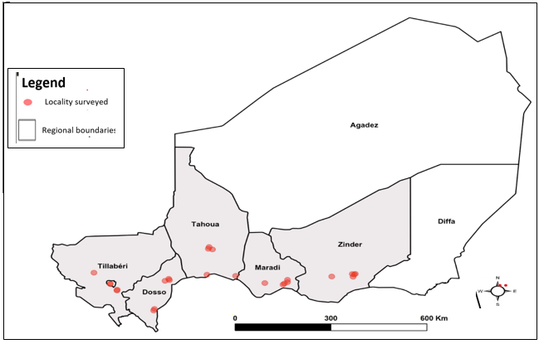

Figure 1: Striga collection sites in Niger. Red dots represent villages of collection within each region (Dosso, Maradi, Tahoua, Tillabéri, and Zinder) (Saidou et al.,2025)

Table 1: The 23 Striga hermonthica Ecotypes and Their Collection Sites
N | Regions | Department | Localities | Striga codes | Geographic coordinates
 |  |  |  |  | Latitude | Longitude
1 | Dosso | Dogondoutchi | Rahin Bozarawa | ED01 | 4.04563 | 13.64042
2 | Dosso | Dogondoutchi | Garin Sarki | ED02 | 3.9036 | 13.61412
3 | Dosso | Dioudiou | Hamdallaye | ED03 | 3.55415 | 12.55633
4 | Dosso | Dogondoutchi | Rahin Tagone | ED04 | 4.0261 | 13.68852
5 | Dosso | Dioudiou | Angoua Doka | ED05 | 3.52807 | 12.49683
6 | Maradi | Madarounfa | Galadantchi | EM06 | 7.19433 | 13.53035
7 | Maradi | Gazaoua | Doramawa | EM07 | 7.83948 | 13.51232
8 | Maradi | Tesssaoua | Kamdamka | EM08 | 7.94238 | 13.65113
9 | Maradi | Aguie | kottchi | EM09 | 7.79618 | 13.47282
10 | Maradi | Gazaoua | Dan Sa a | EM10 | 7.94472 | 13.56355
11 | Tahoua | Tahoua Commune | Kolloma | ETA11 | 14.88667 | 5.3575
12 | Tahoua | Tahoua Commune | Founkoye | ETA12 | 14.82055 | 5.33112
13 | Tahoua | Tahoua Commune | Dabagi | ETA13 | 14.79612 | 5.4675
14 | Tahoua | Birnin Konni | Terra Gonni | ETA15 | 5.2859 | 13.84453
15 | Tillabéry | Tillabéri | Lossa | ETI16 | 1.5575 | 13.91945
16 | Tillabéry | Say | Dalwel (Say) | ETI17 | 2.09695 | 13.50055
17 | Tillabéry | Kollo | Tatagounga | ETI18 | 2.09888 | 13.49945
18 | Tillabéry | Kollo | Tiaguirire | ETI19 | 2.325 | 13.27888
19 | Tillabéry | Kollo | Togal Bani zoumbou | ETI20 | 2.31667 | 13.25
20 | Zinder | Goure | Kalilla | EZ21 | 10.10725 | 13.76638
21 | Zinder | Damagaram Takaya | Dan Dania | EZ22 | 9.4023 | 13.77628
22 | Zinder | Goure | Issoufouri | EZ23 | 10.17775 | 13.87753
23 | Zinder | Goure | Magarawa | EZ25 | 10.08038 | 13.8714

Trial Conduct

Two trials were conducted at the research station of the International Crops Research Institute for the Semi-Arid Tropics (ICRISAT) Sahelian Center, Niger, in September and December 2022. This station is located in Sadoré village (13°15' N 2°18' E), 40 km southeast of Niamey, 22 km northwest of Say, and 7 km west of the Niger River.
In each trial, a randomized complete block design (RCBD) was used with 3 replications.
The trials were carried out in pots (25 cm in diameter and 45 cm deep). A mixture of sand (70%), clay (15%), and organic manure (15%) was added to half of each pot. Approximately 500 mg of Striga hermonthica seeds were mixed with sand and placed on the surface of the substrate, then covered with the remaining mixture.

A total 69 pots were used in each trial, with a spacing of 50 cm between pots. Pearl millet seeds. Two holes were sown in two holes of 10 cm spacing in each pot. Four seeds of the susceptible millet variety (Zongo) were sown at 7 cm depth, distributed in two holes separated by 10 cm.
Regular weeding of weeds other than Striga was carried out throughout the experiment, and water was supplied as needed.

Morphological Characterization
For the identification of ecotypes, virulence, and adaptability of Striga, twelve (12) descriptors were used. These are divided into 5 qualitative and 7 quantitative characteristics (Table 2).

Table 2: Qualitative and quantitative traits used for 23 Striga ecotypes characterization

Qualitative traits | Codes | Modality | Descriptions
Flower Color | CFL | 1- White  2- Pink  3- Dark Pink  4- Purple  5- Light Purple  6- Dark Purple | 90 DAS (Days After Sowing) by flower/plant observation
Corolla Shape | FC | 1- Oval  2- Elliptical  3- Pentagon  4- Variable | 90 DAS by flower/plant observation
Intensity of the White Spot on the Flower | ITBFl | 1- Weak  2- Medium  3- Strong  4- Variable | 90 DAS by flower/plant observation
Degree of Plant Pubescence | DPP | 1- None  2- Weak  3- Medium  4- Strong  5- Very Strong | 70 DAS by plant observation
Intensity of the Red Spot on the Leaf | ITRF | 1- None  2- Weak  3- Medium  4- Strong  5- Very Strong | 70 DAS by leaf/plant observation

Quantitative traits | Code | Description | Unit
Plant Height | HTR | Measured from ground level to the tip of the main tiller’s spike, averaged from 2 plants | cm
Number of Stems | NT | Number of stems per plant | -
Leaf Length | LongF | Distance between the apex and base of the leaf | cm
Leaf Width | LargF | Measurement of the widest part of the leaf | cm
Flower Length | LongFl | Distance from the petal to the peduncle (measured from the peduncle to the tip of the petal) | cm
Flower Width | LargFl | Measurement of the widest part of the flower | cm
Number of Days to First Striga Emergence | DES NJ | Number of days until Striga appears above the soil surface (days after sowing/plant) | -

Statistical Analyses
Data analysis was conducted using RStudio version 4.4.1. Normality tests were performed on quantitative variables. Due to violation of the normality assumption (p < 0.05), post-hoc comparisons were conducted using Dunn's test with Bonferroni correction for multiple comparisons following a significant Kruskal-Wallis test (p < 0.05).

Chi-square tests were also performed to assess associations between qualitative variables. Subsequently, hierarchical cluster analysis (HCA) was applied to group individuals with similar profiles based on the factorial axes derived from principal component analysis (PCA).
Results
Variability of Qualitative Traits
Morphological Characteristics of Identified Striga Ecotypes' Flowers
The morphological characterization of the flowers of each ecotype revealed a diversity of flowers, especially in size, color, and petal appearance. Based on the traits of color, shape, and intensity of the white spot at the center of the flower, we identified a total of 20 diverse Striga flower plants across the five regions of Niger. We classified the flowers in two main groups based on color and the intensity of the white spot (weak to strong intensity). The first subgroup consists of flowers with fused petals (Figure 2). The second group includes flowers with separated petals (Figure 3).

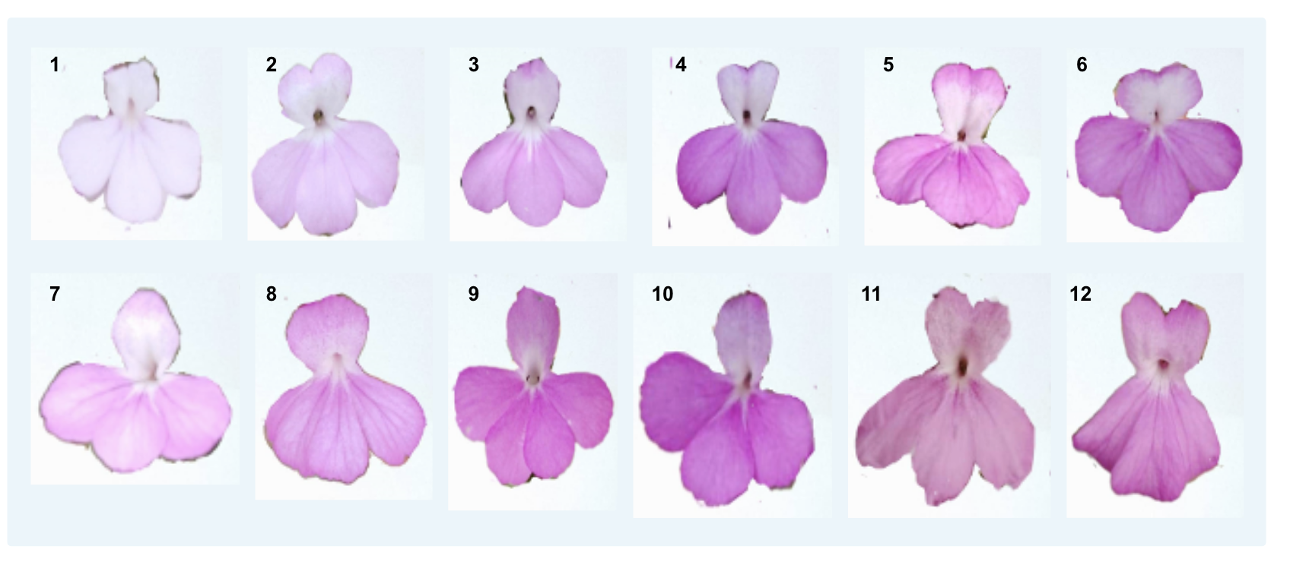
Figure 2: Different morphotypes of Striga hermonthica corollas with fused petals.
The edges of the flowers are delineated to highlight the morphotypes of the fused petals.

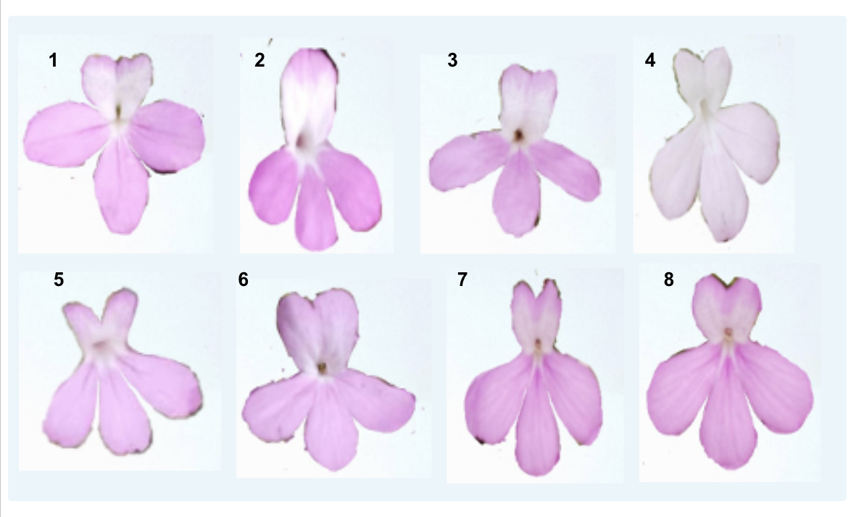
Figure 3: Different morphotypes of Striga hermonthica corollas with separated petals.
The edges of the flowers are delineated to highlight the morphotypes of the separated petals.

Distribution of phenotypic frequencies of qualitative traits
For the five qualitative traits studied, each have between four and six variables. The χ² test revealed that all phenotypic traits (p-value < 5%) have a distribution that depends on the collection region (Table 3).
Our study on Striga hermonthica revealed a remarkable diversity of calyx shapes within the Striga ecotypes from the Tahoua region. While the ecotypes from the Maradi, Tillabéry, and Zinder regions mainly exhibit oval and elliptical calyxes, those from Tahoua display a wider range, including pentagonal and variable shapes, representing 38%, 57%, 3%, and 2% of the sampled individuals, respectively.
The three phenotypes of the intensity of the white spot on the flower (ITBFL), namely weak, medium, and strong, were observed in all ecotypes from the different regions studied. The medium intensity of ITBFL was predominant among the ecotypes from the Dosso (51%), Tahoua (50%), Tillabéry (55%), and Zinder (52%) regions. In contrast, the weak intensity of ITBFL was predominant in the ecotypes from the Maradi region (55%).
The most frequently observed flower color was purple, with respective percentages of 80% for the ecotypes from the Dosso and Zinder regions, 89% for the ecotypes from the Maradi region, 72% for the ecotypes from the Tahoua region, and 87% for the ecotypes from the Tillabéry region. Dark pink flowers were observed only in the Dosso (5%) and Tillabéry (7%) regions. As for white flowers, they are exclusively present in the ecotypes from the Dosso region, with a very low percentage (3%).Leaves without red spots were observed in all the studied regions, with a particularly high frequency in the ecotypes from the Tillabéry region (87%), followed by the ecotypes from the Zinder (77%) and Tahoua (60%) regions. In contrast, very strong red spots on the leaves were observed in the four ecotypes from the Dosso, Maradi, Tillabéry, and Zinder regions with respective frequencies of 15%, 7%, 5%, and 8% (Figure 4).
The ecotypes from the Dosso and Tillabéry regions exhibit only three degrees of plant pubescence (DPP): weak (21%), medium (47%), and strong (32%). For the ecotypes from the Dosso region, and none (13%), weak (53%), and medium (33%) for the ecotypes from the Tillabéry region. In comparison, the ecotypes from the Tahoua region display greater diversity with five DPP: none (5%), weak (28%), medium (25%), strong (27%), and very strong (15%) (Figure 5).
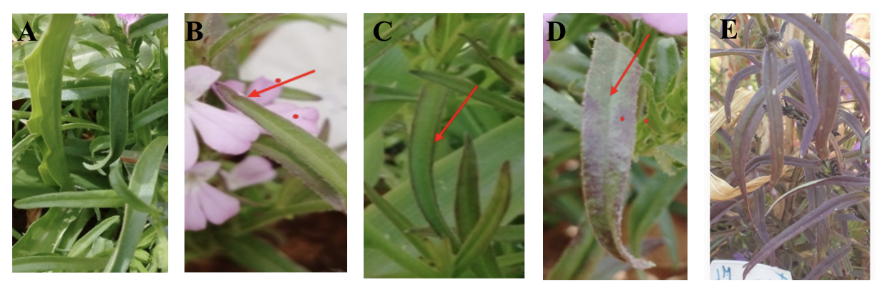
Figure 4: Intensity of the Red Spot on the Leaf (A) No pubescence. (B) Weak pubescence ;(C) Moderate pubescence and (D) Strong pubescence. And (E) Very Strong pubescence

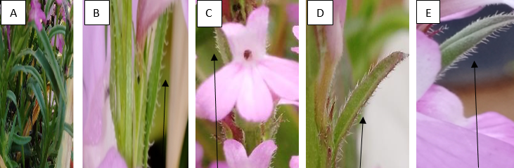
Figure 5: Plant pubescence degree (A) No pubescence degree; (B) Weak pubescence degree; (C) Medium pubescence degree; (D) Strong pubescence degree and Very Strong pubescence degree (E)

Table 3: Distribution of Phenotypic Frequencies and χ² test of the 5 qualitative traits of Striga ecotypes collected in Niger.
Trait | Modality | Dosso | Maradi | Tahoua | Tillabéry | Zinder
Corolla Shape (FC)  p-value =2.481e-10 | 1-Oval | 69 | 45 | 38 | 81 | 88
Corolla Shape (FC)  p-value =2.481e-10 | 2-Elliptical | 28 | 55 | 57 | 19 | 12
Corolla Shape (FC)  p-value =2.481e-10 | 3-Pentagonal | - | - | 3 | - | -
Corolla Shape (FC)  p-value =2.481e-10 | 4-Variable | 3 | - | 2 | - | -
Intensity of the White Spot on the Flower ITBFL  p-value = 7.025e-07 | 1-Weak | 12 | 55 | 25 | 29 | 37
 | 2-Medium | 51 | 39 | 50 | 55 | 52
 | 3-Strong | 35 | 7 | 25 | 16 | 12
 | 4-Variable | 3 | - | - | - | -
Flower Color (CFL)  p-value = 1.391e-05 | 1-White | 3 | - | - | - | -
Flower Color (CFL)  p-value = 1.391e-05 | 2-Pink | - | 3 | 12 | - | 3
Flower Color (CFL)  p-value = 1.391e-05 | 3-Dark Pink | 5 | - | - | 7 | -
Flower Color (CFL)  p-value = 1.391e-05 | 4-Purple | 80 | 89 | 72 | 87 | 80
Flower Color (CFL)  p-value = 1.391e-05 | 5-Light Purple | 3 | 4 | 5 | 7 | -
Flower Color (CFL)  p-value = 1.391e-05 | 6-Dark Purple | 9 | 4 | 12 | - | 17
Intensity of the Red Spot on the Leaf (ITRF)  p-value = 1.877e-14 | 1-None | 20 | 55 | 60 | 87 | 77
 | 2-Weak | 28 | 23 | 13 | 8 | -
 | 3-Medium | 31 | 9 | 22 | - | 15
 | 4-Strong | 7 | 7 | 5 | -
 | 5-Very Strong | 15 | 7 | - | 5 | 8
Degree of Plant Pubescence (DPP)  p-value = 2.2e-16 | 1-None | - | - | 5 | 13 | -
Degree of Plant Pubescence (DPP)  p-value = 2.2e-16 | 2-Weak | 21 | 7 | 28 | 53 | 2
Degree of Plant Pubescence (DPP)  p-value = 2.2e-16 | 3-Medium | 47 | 40 | 25 | 33 | 63
Degree of Plant Pubescence (DPP)  p-value = 2.2e-16 | 4-Strong | 32 | 33 | 27 | - | 17
Degree of Plant Pubescence (DPP)  p-value = 2.2e-16 | 5-Very Strong | - | 20 | 15 | - | 18

Analysis of Variance of the 7 Traits Studied in the 23 Ecotypes of S. hermonthica
The ecotypes of Maradi and Tahoua regions exhibit both similarities and morphological differences for the 7 traits studied. The results showed no significant differences were found for 4 traits (LongF, LargF, LongFl, and LargFl). However, significant differences were observed for number of stems (NT). For the following two traits (HTR and DES NJ), the mean values are higher in the ecotypes from the Maradi region (Table 4).
As for the ecotypes from the Tillabéry and Zinder regions, they exhibit 3 similarities for the following traits (LongFl, LargFl, and NT). The Tillabéry ecotypes are distinguished by higher mean values for the 6 traits studied (LongF, LargF, LongFl, NT, and DES NJ).

Table 4: Descriptive statistics of the 7 morphological traits evaluated in the Striga Ecotypes collected

Regions | LongF | LargF | LongFl | LargFl | HTR | NT | DES NJ
Dosso | 8.85^{c} | 0.72 ^{bc} | 2.50 ª | 1.85 ª | 67.02 ª | 11.01 ^{b} | 41.92 ^{c}
Maradi | 9.61^{bc} | 0.80 ^{ab} | 2.37 ^{b} | 1.59 ^{b} | 65.01 ^{ab} | 14.78 ª | 46.38 ^{b}
Tahoua | 8.78^{bc} | 0.66 ^{c} | 2.31 ^{b} | 1.59 ^{b} | 60 ^{b} | 10.73 ^{b} | 43.88 ^{bc}
Tilabery | 10.85ª | 0.77 ^{ab} | 2.62 ª | 1.82 ª | 61.32 ^{b} | 15.28 ª | 58.68 ª
Zinder | 9.74^{ab} | 0.81 ª | 2.51 ª | 1.87 ª | 53.68 ^{c} | 14.4 ª | 39.63 ^{d}
min | 4 | 0.4 | 2 | 1.1 | 21 | 4 | 29
max | 14.3 | 1.3 | 2.9 | 2.5 | 83 | 30 | 69
median | 9 | 0.8 | 2.5 | 1.9 | 63 | 12 | 43
mean | 9.18 | 0.74 | 2.48 | 1.84 | 60.32 | 13.30 | 43.533
SE.mean | 0.23 | 0.02 | 0.02 | 0.03 | 1.39 | 0.72 | 0.81
std.dev | 2.03 | 0.20 | 0.24 | 0.27 | 12.10 | 6.28 | 7.09
coef.var | 0.22 | 0.28 | 0.09 | 0.14 | 0.20 | 0.47 | 0.16
p-value | 5.12E-07 | 0.0001676 | 5.18E-12 | 4.93E-09 | 6.37E-09 | 4.70E-09 | 2.20E-16

LongF: leaf length; LargF: leaf width; LongFl: flower length; LargFl: flower width; HTR: plant height; NT: number of stems; DES NJ: number of days to first Striga emergence.

Hierarchical Ascending Classification of Striga Ecotypes
The hierarchical classification based on the means of the 7 quantitative traits identified four groups with distinct morphological diversity (Figure 6).
- Group 1: This group includes 3 ecotypes from the Dosso and Tillabéry regions (ED02, ED03 and ETI20). These ecotypes are distinguished by tall plants (high HTR), large flowers, and wide leaves (significant LargF). However, they exhibit a relatively low number of stems (NT).
- Group 2: The largest group, composed of 11 ecotypes mainly from the Maradi region (ED05, EM06, EM07, EM08, EM09, EM10, ETA11, ETA12, ETA13, and ETI16), is subdivided into three subgroups. The ecotypes in this group are characterized by small leaves and flowers (LonF, LarF, LonFl, and LarFl).
- Group 3: This group includes 6 ecotypes, 4 of which are from the Zinder region (ED01, ETA15, EZ21, EZ22, EZ23, and EZ25). These ecotypes are characterized by a low number of days to first Striga emergence (DES NJ) and reduced plant height (HTR).
- Group 4: The smallest group is exclusively composed of 3 ecotypes from the Tillabéry region (ETI17, ETI18, and ETI19). These ecotypes are distinguished by a high flower length (LongF), a high number of stems (NT), and a high number of days to first Striga emergence (DES NJ).
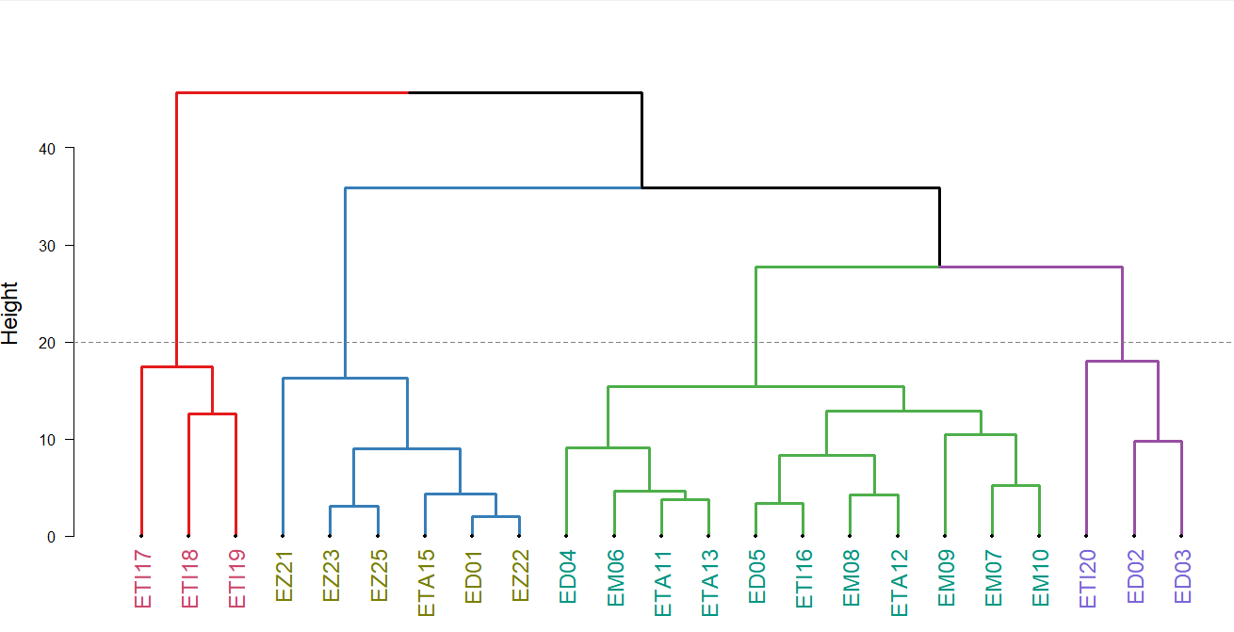

Figure 6: Classification of the 23 Striga Ecotypes Using the UPGMA Method

Discussion
The analysis of the five studied morphological traits reveals a marked phenotypic diversity among Striga hermonthica ecotypes from different regions, with highly significant differences (p-values < 0.001). These variations likely reflect local adaptations influenced by agroecological conditions, host plants, and selection pressures.
The study of qualitative traits confirms this geographical variability. The pronounced average pubescence in Zinder (63-80%), Dosso (47%), and Maradi (40%) aligns with adaptive mechanisms to reduce transpiration.
The purple flower color is predominant across all regions (72 to 89%), likely due to its adaptive role, such as protection against UV rays (Gould & Lister, 2006) or attraction of specific pollinators (Dyer et al., 2021). However, rarer colors reveal local specificities. White flowers, for example, are found exclusively among ecotypes from the Dosso region (3%), which could result from a neutral mutation (Warren & Mackenzie, 2001). These differences may require more targeted and ecotype-specific Striga control strategies to be effective (Rodenburg et al., 2022).
The high proportions of red spots observed in Dosso (15%), Maradi (7%), Tillabéry (5%), and Zinder (8%) can be explained by complex physiological mechanisms. Yoshida and Shirasu (2009) demonstrated that this characteristic coloration results from an accumulation of anthocyanins, a typical response in parasitic plants under nutritional stress.
Gurney et al. (2003) identified three interdependent processes triggered by this situation: the reduced supply of nutrients and water from a weakened host plant, the activation of oxidative stress protection systems, and the gradual replacement of chlorophyll pigments with protective compounds. These adaptations give ecotypes from these regions exceptional parasitic capabilities. Their extreme virulence is reflected in their ability to rapidly deplete their hosts, continue reproductive development under unfavorable conditions, and ensure viable seed production despite environmental constraints. Timko et al. (2012) classified this type of ecotype as "super-parasites" due to their remarkable parasitic efficiency. From a quantitative standpoint, the ecotypes from the Tillabéry region exhibit distinct morphological characteristics, including longer leaves (10.85 cm) and larger flowers (2.62 cm), coupled with a high stem count (15.28). These morphological traits—particularly flower size and stem density—could promote more abundant seed production (Ejeta & Gressel, 2007). This finding is significant, as it serves as a key indicator of these ecotypes' adaptability and their ability to spread and persist in their environment.
Moreover, their more vigorous growth, marked by increased leaf development and branching, suggests superior efficiency in extracting resources from host plants. This efficiency is directly correlated with the parasite’s virulence—that is, its capacity to weaken its host (Parker, 2013). Thus, the Tillabéry ecotypes stand out not only for their enhanced reproductive potential but also for their more effective exploitation of host resources, amplifying their parasitic impact.
Consequently, these ecotypes possess a combination of traits that enhance both their propagation and virulence, underscoring their ecological success in the Tillabéry region.
In contrast, the ecotypes from Zinder display remarkable morpho-physiological adaptations to arid conditions, with a significantly smaller stature (53.68 cm compared to 60-67 cm in other regions) and an accelerated development cycle (emergence in 39 days versus 40-60 days). As demonstrated by Mohamed et al. (2006) in their comparative study of Sahelian populations, this "dwarfed" and early-maturing phenotype represents a key adaptive strategy to escape water stress during critical phases. The development of wider flowers (0.81 cm), coupled with increased seed production, perfectly illustrates the evolutionary trade-off highlighted by Ejeta and Gressel (2007). In environments subject to severe constraints, natural selection favors preferential resource allocation toward reproductive organs at the expense of vegetative growth. This adaptive strategy relies on two particularly effective key mechanisms of virulence. First, early parasitism (initiated just 39 days after germination), which enables the parasite to capture host resources from the earliest stages of development, as clearly demonstrated by Rodenburg et al. (2010) through quantitative measurements under comparable ecological conditions. Second, a remarkable phenological flexibility allowing synchronization with various cultivated hosts (particularly pearl millet and early-maturing sorghum varieties), a sophisticated evasion mechanism thoroughly decoded by Timko et al. (2012).
However, this extreme specialization creates a significant evolutionary paradox: while it optimizes fitness in arid environments (Gurney et al., 2003), it also leads to markedly reduced phenotypic plasticity, thereby limiting adaptability to interannual fluctuations in environmental conditions.
The analysis of variance showed that the Maradi and Tahoua ecotypes share common characteristics in terms of leaves and flowers (LongF, LargF, LongFl, and LargFl). This suggests that these ecotypes have undergone similar selection pressures, leading to convergent morphological adaptations. The evolutionary principles of local selection and trade-offs described by Bellis et al. (2020) in the sorghum-Striga system support this hypothesis of adaptive convergence.
Conclusion
The study of the diversity of Striga hermonthica in Niger revealed significant morphological variability and among the first studies that cover many ecotypes from Niger. This parasitic species exhibits substantial morphological diversity, both qualitative and quantitative, reflecting adaptations to different environments. The results suggest an independent evolution of Striga hermonthica populations in the various regions of Niger, leading to the emergence and adaptation to different environments, allowing them to successfully colonize diverse habitats. This genetic diversity confers a high phenotypic plasticity to this species, explaining its persistence in the face of control strategies. A better understanding the morphological trait of the parsitic plant could shed light to the development of improved varieties resistant to striga in Africa.
Disclaimer (Artificial intelligence)
Option 1:
Author(s) hereby declare that NO generative AI technologies such as Large Language Models (ChatGPT, COPILOT, etc.) and text-to-image generators have been used during the writing or editing of this manuscript.
Option 2:
Author(s) hereby declare that generative AI technologies such as Large Language Models, etc. have been used during the writing or editing of manuscripts. This explanation will include the name, version, model, and source of the generative AI technology and as well as all input prompts provided to the generative AI technology
Details of the AI usage are given below:
1.
2.
3.

References
- Amusan, I. O., Rich, P. J., Menkir, A., Housley, T., & Ejeta, G. (2008). Resistance to Striga hermonthica in a maize inbred line derived from Zea diploperennis. New Phytologist, *178*(1), 157–166. https://doi.org/10.1111/j.1469-8137.2007.02354.x
- Badu-Apraku, B. (2010). Effects of recurrent selection for grain yield and Striga resistance in an extra-early maize population. Crop Science, *50*(5), 1735–1743. https://doi.org/10.2135/cropsci2009.11.0682
- Bellis, E. S., Kelly, E. A., Lorts, C. M., Gao, H., DeLeo, V. L., Rouhan, G., Budden, A., Bhaskara, G. B., Hu, Z., Muscarella, R., Timko, M. P., Nebie, B., Runo, S. M., Chilcoat, N. D., Juenger, T. E., Morris, G. P., dePamphilis, C. W., & Lasky, J. R. (2020). Genomics of sorghum local adaptation to a parasitic plant. Proceedings of the National Academy of Sciences (PNAS), *117*(8), 4243–4251. https://doi.org/10.1073/pnas.1908707117
- Dyer, A. G., et al. (2021). Fragmentary Blue: Resolving the Rarity Paradox in Flower Colors. Frontiers in Plant Science, *11*, 618203. https://doi.org/10.3389/fpls.2020.618203
- Ejeta, G., & Gressel, J. (2007). Integrating New Technologies for Striga Control: Towards Ending the Witch-Hunt. World Scientific Publishing. https://doi.org/10.1142/6545
- Ejeta, G. (2007). Breeding for Striga resistance in sorghum: Exploitation of an intricate host–parasite biology. Crop Science, *47*(S2), S-216–S-217. https://doi.org/10.2135/cropsci2007.04.0011IPBS
- Gressel, J., Hanafi, A., Head, G., Marasas, W., Obilana, A. B., Ochanda, J., & Tzotzos, G. (2004). Major heretofore intractable biotic constraints to African food security that may be amenable to novel biotechnological solutions. Crop Protection, *23*(8), 661–689. https://doi.org/10.1016/j.cropro.2003.11.014
- Gould, K. S., & Lister, C. (2006). Flavonoid functions in plants. In Ø. M. Andersen & K. R. Markham (Eds.), Flavonoids: Chemistry, Biochemistry and Applications (pp. 397–441). CRC Press.
- Gurney, A. L., Press, M. C., & Scholes, J. D. (2003). Can wild relatives of sorghum provide new sources of resistance or tolerance against Striga species? New Phytologist, *159*(3), 567–573. https://doi.org/10.1046/j.1469-8137.2003.00818.x
- Gurney, A. L., Slate, J., Press, M. C., & Scholes, J. D. (2006). A novel form of resistance in rice to the angiosperm parasite Striga hermonthica. New Phytologist, *169*(1), 199–208. https://doi.org/10.1111/j.1469-8137.2005.01560.x
- Koyama, M. L. (2000). Genetic variability of Striga hermonthica and effect of resistant cultivars on Striga population dynamics. In Breeding for Striga Resistance in Cereals (pp. 1–15). Margraf Verlag.
- Mohamed, K. I., Papes, M., Williams, R., Benz, B. W., & Peterson, A. T. (2006). Genetic diversity of Striga hermonthica and Striga asiatica populations in Eastern Africa. Weed Research, *46*(1), 64–73. https://doi.org/10.1111/j.1365-3180.2006.00489.x
- Parker, C. (2013). The parasitic weeds of the Orobanchaceae. In D. M. Joel, J. Gressel, & L. J. Musselman (Eds.), Parasitic Orobanchaceae (pp. 313–344). Springer. https://doi.org/10.1007/978-3-642-38146-1_18
- Pennisi, E. (2010). Armed and dangerous. Science, *327*(5967), 804–805. https://doi.org/10.1126/science.327.5967.804
- Ransom, J. K. (2000). Long-term approaches for the control of Striga in cereals: Field management options. Crop Protection, *19*(8), 759–763. https://doi.org/10.1016/S0261-2194(00)00101-0
- Rodenburg, J., Bastiaans, L., Weltzien, E., & Hess, D. E. (2005). How can field selection for Striga resistance and tolerance in sorghum be improved? Field Crops Research, *93*(1), 34–50. https://doi.org/10.1016/j.fcr.2004.09.004
- Rodenburg, J., Cissoko, M., Kayeke, J., Dieng, I., Khan, Z. R., Midega, C. A. O., & Onyuka, E. A. (2010). Field resistance to Striga hermonthica in rice. Weed Research, *50*(2), 157–166. https://doi.org/10.1111/j.1365-3180.2009.00763.x
- Rodenburg, J., Schut, M., Demont, M., & Klerkx, L. (2022). Striga ecology and management: Closing the knowledge gap. Outlook on Agriculture, *51*(1), 3–12. https://doi.org/10.1177/00307270221082113
- Saidou, S. S., Kountché, B., Amadou, H. I., Moussa, S., Laouali, A. M., Latif, H. N. A., & Yacoubou, B. (2024). Diversité d'usage de Striga hermonthica au Niger. International Journal of Innovation and Applied Studies, *42*(4), 594–605.
- Timko, M. P., Gowda, B. S., Ouedraogo, J., & Ousmane, B. (2012). Molecular markers for analysis of resistance to Striga gesnerioides in cowpea. Pest Management Science, *68*(4), 519–528. https://doi.org/10.1002/ps.2287
- Warren, J., & Mackenzie, S. (2001). Why are all colour combinations not equally represented as flower-colour polymorphisms? New Phytologist, *151*(1), 237–241. https://doi.org/10.1046/j.1469-8137.2001.00159.x
- Yoshida, S., & Shirasu, K. (2009). Multiple layers of incompatibility to the parasitic witchweed, Striga hermonthica. Plant and Cell Physiology, *50*(7), 1245–1256. https://doi.org/10.1093/pcp/pcp074

