A New Era of Precision Tumor Ablation : A Narrative Review on Laser and Plasma-Based Technologies in Oncology

Abstract
The pursuit of precision in oncologic surgery remains a critical challenge, as conventional resection techniques often face limitations in achieving tumor-free margins while minimizing collateral tissue damage. In recent years, energy-based surgical modalities such as laser and plasma technologies have emerged as promising tools to enhance oncologic resection and tumor ablation. Laser surgery, including CO₂, Nd:YAG, diode, and Er:YAG systems, offers precise tissue vaporization, improved hemostasis, and the ability to perform minimally invasive resections in various cancer types, particularly in head and neck, thoracic, and hepatobiliary oncology. Plasma-based modalities, notably argon plasma coagulation (APC) and cold atmospheric plasma (CAP), have demonstrated unique advantages. APC is widely used for intraoperative hemostasis and tumor debulking in gastrointestinal and thoracic surgery, while CAP has shown experimental efficacy in inducing apoptosis, enhancing wound healing, and eliminating microscopic residual tumor cells.
This review summarizes the fundamental principles, clinical applications, advantages, and limitations of laser and plasma technologies in surgical oncology. A narrative review was conducted by searching PubMed, Scopus, and Web of Science databases for articles published between 2000 and 2024. Search terms included “laser surgery oncology,” “argon plasma coagulation cancer,” “cold atmospheric plasma tumor ablation,” and “energy devices in cancer surgery”. Future research should focus on randomized controlled trials, optimization of surgical parameters, and integration with fluorescence-guided and robotic-assisted surgery.
Laser and plasma-based surgical technologies represent an emerging frontier in oncologic surgery, with the potential to refine tumor ablation, improve oncological safety, and reshape the paradigm of precision cancer treatment.
Keywords: laser surgery, argon plasma coagulation, cold atmospheric plasma, surgical oncology, tumor ablation

Introduction
Surgical oncology has evolved significantly over the past few decades, focusing not only on the complete excision of tumors but also on minimizing surgical morbidity, preserving vital structures, and optimizing functional outcomes. Despite advancements in surgical techniques and perioperative care, significant challenges persist in the surgical management of cancers. These challenges include achieving negative resection margins, minimizing intraoperative bleeding, and ensuring complete removal of microscopic tumor cells, which are crucial in preventing local recurrence. Moreover, the thermal damage caused by conventional surgical tools such as scalpels, electrocautery, and radiofrequency ablation, can result in injury to surrounding healthy tissues, further complicating the surgical process [1].

The need for greater precision in oncologic surgery has driven the exploration of energy-based technologies that can provide superior control over tissue excision, reduce collateral damage, and enhance hemostasis during surgery. Among the most promising of these innovations are laser surgery and plasma-based technologies, which have garnered increasing interest for their potential to address many of the limitations of conventional techniques [1].

Laser surgery, with its ability to deliver high-intensity beams of focused light, offers a means to achieve precision tissue vaporization, coagulation, and cutting with minimal thermal damage to adjacent structures. Various laser types have been explored in surgical oncology, including CO₂ lasers (10,600 nm), Nd:YAG lasers (1,064 nm), diode lasers, and Er:YAG lasers (2,940 nm). The CO₂ laser is particularly well-suited for superficial tumor excisions and soft tissue vaporization due to its high absorption by water, which ensures precise cutting with minimal thermal penetration. The Nd:YAG laser, on the other hand, is effective for deeper tissue penetration, making it valuable for coagulation and debulking of more deeply located tumors, especially in gastrointestinal and thoracic oncology [2]. In contrast, diode lasers are compact and versatile, commonly used in endoscopic procedures for tumor ablation, while the Er:YAG laser is known for its ability to achieve precise tissue removal with minimal collateral damage, primarily used in delicate and sensitive tissues like those in head and neck surgery [3, 4].

In addition to lasers, plasma-based technologies, such as argon plasma coagulation (APC) and cold atmospheric plasma (CAP), have also shown promise in oncologic applications. Argon Plasma Coagulation (APC) is a non-contact technique that uses ionized argon gas to deliver electrical current to tissues, facilitating controlled coagulation and hemostasis, particularly in gastrointestinal and thoracic surgery. APC is especially valuable in tumor debulking and for controlling bleeding in vascularized or fragile tissue structures [5].

Cold Atmospheric Plasma (CAP), a non-thermal form of plasma, operates at near-room temperatures and generates reactive oxygen and nitrogen species (ROS/RNS). These reactive species have been shown to selectively target malignant cells while sparing normal tissues, inducing processes like apoptosis, DNA damage, and disruption of tumor cell membranes. This unique mechanism of action has made CAP a potential adjunct not only in tumor ablation but also in wound healing and as a therapeutic modality to eliminate residual microscopic tumor cells, thereby reducing the risk of recurrence [6, 7].

The application of laser and plasma technologies is rapidly expanding across various types of cancer surgery, including head and neck oncology, thoracic surgery, gastrointestinal surgery, and hepatobiliary oncology, where their ability to precisely target tumor tissue while minimizing damage to surrounding healthy structures can significantly improve patient outcomes. The use of these technologies has already shown substantial clinical success in laryngeal carcinoma, esophageal cancer, pulmonary tumors, and hepatic metastases, where the precision and hemostatic benefits of lasers and plasma have been leveraged to achieve better functional outcomes and reduced recurrence rates. [1, 8, 9].

However, despite their promising potential, these technologies also present some challenges. One major concern is the cost and accessibility of high-end laser systems and CAP devices, which may limit their use in low- and middle-income settings. Moreover, the standardization of protocols for laser and plasma use remains an unresolved issue, as various studies have reported different settings for laser parameters (e.g., power, pulse width, fluence) and plasma flow rates. This variability can compromise reproducibility and outcomes, necessitating the development of standardized guidelines to optimize their use in clinical practice. Furthermore, while early clinical trials and studies have demonstrated the efficacy of these technologies, large-scale, multicenter randomized controlled trials (RCTs) are still needed to better define their long-term impact on patient survival, recurrence rates, and overall treatment costs [10, 11].

Given the current evidence and the challenges that remain, this narrative review aims to provide a comprehensive examination of laser and plasma technologies in the context of oncologic surgery. We will explore the principles behind these technologies, their current clinical applications across different cancer types, their advantages in terms of precision and safety, and the limitations that hinder their broader clinical adoption. Additionally, we will discuss the potential for integrating these technologies with emerging techniques, such as robotic-assisted surgery, fluorescence-guided surgery, and immunotherapy, which could further enhance their efficacy and establish them as key components of precision oncology.

Methods
A narrative review was conducted by searching PubMed, Scopus, and Web of Science databases for articles published between 2000 and 2024. Search terms included “laser surgery oncology,” “argon plasma coagulation cancer,” “cold atmospheric plasma tumor ablation,” and “energy devices in cancer surgery.” Both clinical studies and preclinical investigations were reviewed to provide a comprehensive overview of applications across tumor types.

Basic Principles of Laser and Plasma in Oncology Surgery

Laser Technology

Laser (Light Amplification by Stimulated Emission of Radiation) utilizes a focused beam of monochromatic light to cut, coagulate, or vaporize tissue with high precision. The interaction between laser energy and biological tissue depends on wavelength, energy density, and tissue absorption characteristics [3]. Types of Laser in Oncology include CO₂ laser (10,600 nm) has high absorption by water, excellent for superficial vaporization and precise cutting with minimal penetration; commonly used in head and neck surgery, Nd:YAG laser (1,064 nm) has deeper tissue penetration, suitable for coagulation and tumor debulking, especially in gastrointestinal and thoracic oncology, diode laser has compact and versatile, widely used in endoscopic tumor ablation, Er:YAG laser (2,940 nm) has high water absorption, effective for precise tissue removal with minimal collateral damage. Laser-based techniques operate through several mechanisms, including vaporization, coagulation, and photothermal effects [3]. Vaporization involves immediate tissue destruction by converting intracellular water into steam, whereas coagulation facilitates the sealing of blood vessels to achieve effective hemostasis. Additionally, the photothermal effect induces controlled necrosis of target tissues while preserving adjacent healthy structures. Collectively, these mechanisms allow laser technology to provide superior surgical precision, minimize intraoperative bleeding, and enhance functional preservation compared with conventional electrocautery [3, 4, 10]. The types of lasers and how they work in the field of oncology can be seen in Figure 1.

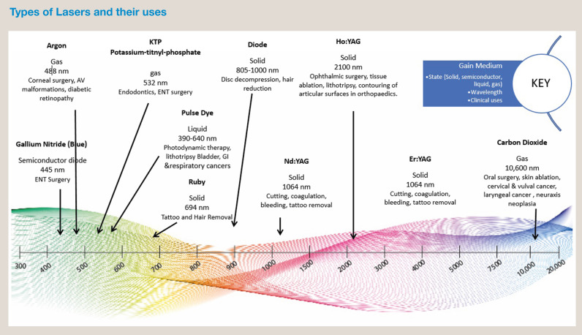
Figure 1. Types of Laser in Oncology [10]

2. Plasma-Based Technology
Plasma, often described as the “fourth state of matter,” is an ionized gas containing reactive species (ROS and RNS), charged particles, and photons [22]. Plasma in medicine is broadly classified as thermal plasma (used for coagulation) and non-thermal or cold atmospheric plasma (CAP), which exerts biological effects at near-room temperature. Argon Plasma Coagulation (APC) is a non-contact monopolar electrosurgical technique where ionized argon gas conducts current to tissue [5, 9]. APC allows controlled coagulation with shallow depth (2–3 mm) with the configuration as shown in Figur 2., making it useful in gastrointestinal tumor debulking, control of bleeding, and thoracic surgery for pleural lesions [3, 4, 5]. Cold Atmospheric Plasma (CAP) is operates at low temperatures, generating reactive oxygen and nitrogen species that selectively damage tumor cells while sparing normal tissue [13, 19]. Cold Atmospheric Plasma (CAP) has mechanisms including induction of apoptosis via oxidative stress, DNA and membrane disruption of malignant cells, possible immune modulation and sterilization of surgical margins which can be seen in Figure 3. Investigational use in breast surgery, head and neck oncology, and as an adjunct to enhance postoperative wound healing and reduce recurrence [6, 7, 8].

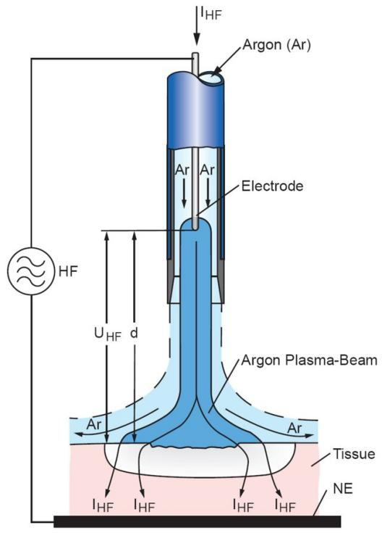

Figure 2. Simplified schematic showing the configuration of a typical APC [11].
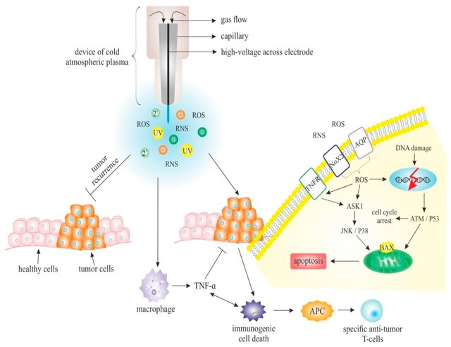

Figure 3. The underlying processes of cold atmospheric plasma (CAP) in oncologic therapy [12].

Clinical Applications
- Head and Neck Oncology
The application of CO₂ lasers has become standard in the management of early-stage laryngeal carcinoma. The high water absorption of CO₂ lasers allows precise tumor excision with minimal thermal spread, enabling preservation of vocal cord function and improved postoperative quality of life compared to conventional surgery. Furthermore, Cold Atmospheric Plasma (CAP) has emerged as a novel adjunct, showing promising results in eradicating microscopic residual disease at surgical margins [21]. This property may reduce local recurrence rates in cancers of the oral cavity and pharynx, where margin status critically determines prognosis [1, 8, 16].

- Thoracic Oncology
In thoracic surgery, laser-based bronchoscopy provides immediate palliative relief for patients with central airway obstruction due to primary or metastatic tumors. Nd:YAG and diode lasers are particularly effective in debulking intraluminal lesions. Meanwhile, argon plasma coagulation (APC) is widely used for both endobronchial and pleural diseases. Its non-contact coagulative effect ensures hemostasis and tumor devitalization while maintaining bronchial wall integrity. APC is especially useful in patients with poor cardiopulmonary reserve who are not candidates for open surgery [2, 3, 4].

- Gastrointestinal (GI) Oncology
Endoscopic laser therapy plays a significant role in the palliative and curative management of GI malignancies. For example, Nd:YAG lasers have been used to restore luminal patency in esophageal tumors and provide local control in selected colorectal cancers. Additionally, APC is highly effective for the management of GI bleeding in tumor-bearing lesions and is frequently employed for palliation, particularly in esophageal and gastric cancers. The minimally invasive nature of these approaches offers substantial quality-of-life benefits in advanced or unresectable cases [4].

- Hepato-Pancreato-Biliary (HPB) Oncology
Liver surgery has witnessed increasing adoption of laser technology, particularly for resection of hepatic metastases. Lasers, such as Nd:YAG, enable precise parenchymal transection with reduced intraoperative blood loss, facilitating safe resection even in highly vascular tumors. Furthermore, the coagulative properties of APC are valuable in achieving hemostasis across wide liver surfaces, thereby minimizing postoperative bile leakage and hemorrhagic complications. Although its role in pancreatic surgery remains investigational, laser-assisted tissue dissection and CAP are under exploration for their potential in achieving negative margins in pancreatic cancer resections [4, 5, 15].

- Breast and Soft Tissue Oncology
The role of lasers in breast surgery remains limited compared to other fields. However, CAP technology is under active investigation for intraoperative sterilization of residual tumor cells at resection margins. Preclinical studies suggest that CAP may selectively induce apoptosis in malignant cells while sparing normal tissue, potentially reducing the risk of local recurrence after breast-conserving surgery. In soft tissue oncology, such as sarcomas, lasers may serve as an adjunct to conventional resection by improving margin clearance and minimizing tumor seeding [16, 17].

Discussion
The integration of laser and plasma-based modalities into the domain of surgical oncology represents a paradigm shift in the pursuit of precision, functional preservation, and tumor control. The technologies discussed in this review offer novel biophysical mechanisms and therapeutic potentials that surpass the capabilities of traditional resection and ablation techniques.

Mechanistic Superiority and Biological Modulation
Cold Atmospheric Plasma (CAP), in particular, distinguishes itself from traditional surgical tools through its biological selectivity and immunogenic effects. CAP operates at near-room temperatures, making it suitable for use in temperature-sensitive tissues and areas where thermal injury must be minimized. Its ability to induce oxidative stress-mediated apoptosis through the generation of reactive oxygen and nitrogen species (ROS and RNS) targets tumor cells preferentially due to their disrupted redox homeostasis and altered membrane structures [6, 13].

Moreover, CAP's interaction with tumor cells extends beyond direct cytotoxicity. It has been shown to disrupt the extracellular matrix, impairing metastatic potential, and to modulate angiogenesis, thereby reducing tumor vascular support. Additionally, studies have highlighted CAP’s capacity to alter the expression of immune checkpoint molecules (e.g., PD-L1), creating a microenvironment more favorable for immune-mediated tumor clearance [6, 9]. These biological effects suggest CAP may function not just as a surgical adjunct but also as a therapeutic bridge between surgery and systemic treatments such as immunotherapy or targeted therapy [20].

Comparison with Conventional Techniques
Conventional surgical instruments scalpels, electrocautery, and ultrasonic dissectors are limited in their ability to provide simultaneous cutting, coagulation, and cellular targeting. Electrocautery, for example, is associated with wider thermal spread, increasing the risk of damage to adjacent structures, particularly in anatomically compact regions like the head and neck. Radiofrequency ablation, while useful for local tumor control, lacks the spatial precision of laser-based systems and cannot selectively preserve neurovascular bundles or functional tissue [1].

In contrast, laser systems offer tunable wavelengths and controlled penetration depths, enabling tailored resections depending on tumor location, tissue type, and oncologic goals. For example, the use of Er:YAG lasers in mucosal tumors allows for superficial vaporization with minimal thermal necrosis, which is crucial for maintaining function in the larynx, oral cavity, or anorectal sphincter complex [1, 3]. Meanwhile, Nd:YAG lasers allow for deep coagulative necrosis of bulky or vascular tumors, providing a valuable tool in palliative debulking or hemorrhage control in advanced gastrointestinal or pulmonary cancers [3, 4].

Functional and Psychosocial Outcomes
From the patient’s perspective, surgical success is not solely defined by oncological clearance but also by preservation of quality of life (QoL). Technologies that enable organ-sparing or function-preserving procedures are inherently valuable in this regard. Laser-assisted transoral resections for laryngeal carcinoma, for instance, offer equivalent oncologic control compared to total laryngectomy, but with the added benefit of voice preservation, reduced postoperative pain, and faster recovery [1].

Furthermore, the minimally invasive nature of endoscopic laser or APC interventions reduces hospitalization duration, postoperative complications, and economic burden on patients key metrics in evaluating value-based care. CAP, with its ability to be delivered topically or endoscopically, also opens the possibility for non-invasive margin sterilization, particularly useful in frail or elderly patients who are unfit for extended resections [21].

Interdisciplinary Integration and Synergistic Potential
The deployment of laser and plasma-based systems in oncology also encourages greater interdisciplinary collaboration among surgeons, oncologists, physicists, and biomedical engineers. The calibration of energy settings, design of CAP-generating nozzles, and optimization of tissue-specific protocols require integration of knowledge across disciplines. Moreover, the potential for CAP to be used in conjunction with real-time diagnostic modalities, such as intraoperative fluorescence imaging or hyperspectral analysis, could enable "see-and-treat" platforms, reducing the risk of positive margins [21].

Additionally, the combination of CAP with drug delivery systems such as nanoparticles or micelles represents a frontier in plasma-activated chemotherapy. By enhancing membrane permeability and downregulating multidrug resistance (MDR) proteins, CAP may increase intracellular drug accumulation, resensitizing tumors to standard chemotherapeutic agents [13, 14].

Ethical, Regulatory, and Safety Considerations
As with any emerging medical technology, ethical and regulatory aspects must be critically considered. The translation of CAP and laser tools from bench to bedside requires stringent safety assessments, particularly in terms of long-term tissue response, potential for DNA mutation in surrounding cells, and unintended immune effects. There remains a lack of consensus on safe exposure levels and cumulative dosing, especially in repeated CAP treatments [18, 20].
Regulatory pathways must also ensure that devices are standardized, validated, and approved by relevant health authorities (e.g., FDA, EMA) with clear clinical indications. The potential for off-label or unregulated use in cosmetic or alternative therapy contexts may undermine the credibility and safety profile of these technologies. Therefore, continued research, surveillance, and multidisciplinary oversight are essential for ethical implementation.

Challenges in Widespread Clinical Adoption
Despite their promise, barriers to widespread adoption remain significant. The high initial cost of acquisition and maintenance, particularly for high-frequency lasers and CAP generators, may limit their use to tertiary referral centers. Additionally, limited availability of training and certification can hinder safe and effective use by general surgeons or oncologists unfamiliar with these modalities [20, 21].

Moreover, clinical inertia and resistance to change from conventional surgical practices can slow integration. To overcome this, the surgical oncology community must prioritize evidence generation through multicenter trials, long-term outcomes registries, and cost-effectiveness analyses that clearly demonstrate the superiority or added value of these technologies over standard care [1, 20].

Future Perspectives
The integration of laser and plasma-based technologies into surgical oncology is promising, yet several key research directions must be pursued to establish their role as standard-of-care interventions.

- Randomized Controlled Trials (RCTs) and Multicenter Studies
Although early clinical reports and pilot studies have demonstrated encouraging outcomes, robust evidence is still lacking. Large-scale, multicenter RCTs are required to evaluate endpoints such as local tumor control, disease-free survival (DFS), overall survival (OS), quality of life (QoL), and cost-effectiveness. Such trials will be essential to validate the long-term oncological safety of these technologies and to position them relative to conventional surgical and adjuvant therapies.

- Standardization of Surgical Protocols
One of the major barriers to clinical adoption is the absence of standardized protocols. Future studies should focus on defining optimal energy parameters, exposure time, depth of penetration, and margin-sterilization protocols. Establishing consensus guidelines will not only improve reproducibility across institutions but also enhance patient safety and clinical outcomes.

- Hybrid Technological Platforms
The next era of surgical oncology may be defined by hybrid platforms combining multiple emerging technologies. Examples include the integration of robot-assisted surgery, fluorescence-guided surgery (FGS), and laser/CAP systems to enable real-time visualization and ablation of microscopic disease. Furthermore, nanocarrier-mediated delivery systems are under investigation to direct reactive oxygen and nitrogen species (ROS/RNS) specifically toward residual tumor cells. Such approaches could significantly enhance the precision of tumor eradication while minimizing collateral tissue damage.

- Global Access and Implementation
While high-income countries are pioneering clinical adoption, global equity in access remains a challenge. Strategies such as value-engineering to reduce device costs, the development of portable and modular systems, and structured training programs tailored for low- and middle-income countries (LMICs) will be critical. This ensures that the benefits of these innovative technologies extend beyond tertiary referral centers, ultimately improving cancer care worldwide.

Conclusion
Laser and energy-based plasma technologies have brought significant changes to the field of oncological surgery. Their ability to perform precise tumor ablation, provide superior hemostasis, and offer unique oncological advantages make them promising tools in the era of precision surgery. Although these technologies are still relatively new, initial results from various clinical and preclinical studies show that they can offer benefits not achievable by conventional methods, particularly in reducing damage to surrounding healthy tissue, improving hemostasis, and enhancing functional outcomes.

Lasers, with their ability to vaporize and coagulate tissue with high precision, are highly beneficial in various oncological applications, especially in the treatment of head and neck cancers, thoracic cancers, as well as gastrointestinal and hepatobiliary tumors. For example, the use of CO₂ lasers in head and neck tumor resections allows highly accurate removal of tumors with minimal damage to surrounding tissues, which is critical for preserving vital functions such as speech or breathing [2, 3]. Additionally, Nd:YAG lasers have shown benefits in thoracic and gastrointestinal surgeries, reducing operation time and minimizing blood loss, which is particularly important for patients with limited cardiopulmonary reserve [4].

Similarly, plasma technologies offer a different but highly effective mechanism in destroying cancer cells and reducing the risk of recurrence. APC has been widely used for bleeding control and tumor debulking in gastrointestinal and thoracic surgeries, while CAP shows potential as an innovative therapeutic method with the ability to induce apoptosis in tumor cells, disrupt cell membranes, and even reduce microscopic residual disease at surgical margins [5, 6]. The ability of CAP to induce immunogenic cell death and enhance dendritic cell activation opens up possibilities for combining this technology with immunological therapies, potentially transforming CAP into both a local and systemic anti-cancer modality [6, 7].

However, despite its potential, several challenges remain before these technologies can be widely adopted as standard treatments in oncological surgery. One of the major barriers is cost and accessibility. High-end laser and CAP devices remain expensive, and their availability is limited, especially in resource-poor countries. Therefore, it is essential to develop solutions that can reduce costs, such as modular and portable devices that can be used in various healthcare settings, including in developing countries [10]. Additionally, there are challenges regarding standardization of procedures for using these devices. Variability in energy settings, exposure time, penetration depth, and margin sterilization protocols needs to be standardized to ensure these technologies provide predictable and safe results across different medical centers [11].

Further research, particularly large-scale randomized controlled trials (RCTs), is urgently needed to evaluate long-term outcomes and validate the oncological safety and cost-effectiveness of laser and plasma technologies across different types of cancers. Although initial data shows promising results, only with stronger and more comprehensive evidence can we fully validate and justify the role of these technologies in the changing landscape of cancer treatment [10, 11].

Looking ahead, the integration of robot-assisted surgery, fluorescence-guided surgery (FGS), and laser/CAP systems for real-time visualization and ablation of microscopic tumors could further optimize the effectiveness of these technologies. Moreover, advances in immunomodulatory therapy, combined with these technologies, could introduce a new layer to cancer treatment, enabling more targeted and sustained therapies [12].

Nevertheless, clinical adoption of these technologies will heavily rely on standardizing protocols, reducing costs, and operator training to reduce the steep learning curve that may hinder widespread acceptance. As technology evolves, the possibility of introducing laser and plasma devices to low and middle income countries (LMICs) becomes more realistic, which would extend the benefits of these innovative tools to more cancer patients worldwide.

Overall, while challenges exist, the potential of laser and plasma energy-based devices to revolutionize oncological surgery is immense with continued research and integration into advanced surgical approaches, these technologies could become a cornerstone of future cancer care, offering greater precision, higher patient safety, and better outcomes for cancer patients worldwide.
Disclaimer (Artificial intelligence)
Option 1:
Author(s) hereby declare that NO generative AI technologies such as Large Language Models (ChatGPT, COPILOT, etc.) and text-to-image generators have been used during the writing or editing of this manuscript.
Option 2:
Author(s) hereby declare that generative AI technologies such as Large Language Models, etc. have been used during the writing or editing of manuscripts. This explanation will include the name, version, model, and source of the generative AI technology and as well as all input prompts provided to the generative AI technology
Details of the AI usage are given below:
1.
2.
3.

References
- Izzo F, Ionna F, Granata V, Albino V, Patrone R, Longo F, et al. New Deployable Expandable Electrodes in the Electroporation Treatment in a Pig Model: A Feasibility and Usability Preliminary Study. Cancers (Basel) (2020) 12(2):E515. doi: 10.3390/cancers12020515
- Ginsberg RJ, Hill LD, Eagan RT, Thomas P, Mountain CF, Deslauriers J, et al. Modern thirty-day operative mortality for surgical resections in lung cancer. J Thorac Cardiovasc Surg. 1983;86(5):654–8.
- Moghissi K, Dixon K, Thorpe JA, Oxtoby C, Stringer MR. Photodynamic therapy (PDT) for lung cancer: the Yorkshire Laser Centre experience. Photodiagnosis Photodyn Ther. 2004 Nov;1(3):253-62. doi: 10.1016/S1572-1000(04)00047-X. PMID: 25048340.
- Thosani N, Rao B, Ghouri Y, Batra S, Raju G, Shafi M, Guha S. Role of argon plasma coagulation in management of bleeding GI tumors: evaluating outcomes and survival. Turk J Gastroenterol. 2014 Dec;25 Suppl 1:38-42. doi: 10.5152/tjg.2014.4867. PMID: 25910365.
- Mateu-Sanz, M., Tornín, J., Ginebra, M.P., & Canal, C. (2021). Cold Atmospheric Plasma: A New Strategy Based Primarily on Oxidative Stress for Osteosarcoma Therapy. Journal of Clinical Medicine, 10.
- Yan D, Sherman JH, Keidar M. Cold atmospheric plasma, a novel promising anti-cancer treatment modality. Oncotarget. 2017;8(9):15977–95.
- Weltmann KD, von Woedtke T. Plasma medicine—current state of research and medical application. Plasma Phys Control Fusion. 2017;59(1):014031.
- Metelmann HR, Seebauer C, Miller V, Fridman A, Bauer G, Graves DB, et al. Clinical experience with cold plasma in the treatment of locally advanced head and neck cancer. Clin Plasma Med. 2018;9:6–13.
- Schmidt A, Bekeschus S, Jarick K, Hasse S, von Woedtke T, Wende K. Cold physical plasma modulates p53 and mitogen-activated protein kinase signaling in keratinocytes. Oxid Med Cell Longev. 2019;2019:7017363.
- Steven Stenhoff, Jane Mills. Basic principles of lasers, Anaesthesia & Intensive Care Medicine, Volume 25, Issue 2,2024,Pages 133-137.
- Cold Atmospheric Pressure Plasma (CAP) as a New Tool for the Management of Vulva Cancer and Vulvar Premalignant Lesions in Gynaecological Oncology, October 2020, International Journal of Molecular Sciences (IJMS) 21(21):7988
- Zenker M. Argon plasma coagulation. GMS Krankenhhyg Interdiszip. 2008 Nov 3;3(1):Doc15. PMID: 20204117; PMCID: PMC2831517.
- Helmke, A., Hoffmeister, D., Mertens, N., Emmert, S., Schütte, J. and Viöl, W. (2009) The Acidification of Lipid Film Surfaces by Non-Thermal DBD at Atmospheric Pressure in Air. New Journal of Physics, 11, Article ID: 115025.
- Dubuc J, Monsarrat P, Virard F, Merbahi N, Sarrette JP, Laurencin-Dalicieux S, et al. Use of cold-atmospheric plasma in oncology: a concise systematic review. Ther Adv Med Oncol. 2018;10:1758835918786475.
- Brullé L, Vandamme M, Ries D, Martel E, Robert E, Lerondel S, et al. Effects of a non-thermal plasma treatment alone or in combination with gemcitabine in a MIA PaCa2 orthotopic pancreatic carcinoma model. PLoS One. 2012;7(12):e52653.
- Schuster M, Seebauer C, Rutkowski R, Hauschild A, Podmelle F, Metelmann C, et al. Visible tumor surface response to physical plasma and apoptotic cell kill in head and neck cancer. J Craniomaxillofac Surg. 2016;44(9):1445–52.
- Zimmermann T, Staebler S, Taudte RV, Ünüvar S, Grösch S, Arndt S, Karrer S, Fromm MF, Bosserhoff AK. Cold Atmospheric Plasma Triggers Apoptosis via the Unfolded Protein Response in Melanoma Cells. Cancers (Basel). 2023 Feb 7;15(4):1064. doi: 10.3390/cancers15041064. PMID: 36831408; PMCID: PMC9954601.
- Hirst AM, Simms MS, Mann VM, Maitland NJ, O’Connell D, Frame FM. Low-temperature plasma treatment induces DNA damage leading to necrotic cell death in primary prostate epithelial cells. Br J Cancer. 2015;112(9):1536–1545. https://doi.org/10.1038/bjc.2015.102
- Keidar M. Plasma for cancer treatment. Plasma Sources Sci Technol. 2015;24(3):033001. https://doi.org/10.1088/0963-0252/24/3/033001
- Gay-Mimbrera J, García MC, Isla-Tejera B, Rodero-Serrano A, García-Nieto AV, Ruano J. Clinical and Biological Principles of Cold Atmospheric Plasma Application in Skin Cancer. Adv Ther. 2016 Jun;33(6):894-909. doi: 10.1007/s12325-016-0338-1. Epub 2016 May 3. Erratum in: Adv Ther. 2017 Jan;34(1):280. doi: 10.1007/s12325-016-0437-z. PMID: 27142848; PMCID: PMC4920838.
- Aebisher D, Rogo´ z˙ K, Mys´ liwiec A, Dynarowicz K, Wiench R, Cies´ lar G, Kawczyk-Krupka A and Bartusik-Aebisher D (2024) The use of photodynamic therapy in medical practice. Front. Oncol. 14:1373263. doi: 10.3389/fonc.2024.1373263
- Privat-Maldonado A, Schmidt A, Lin A, Bogaerts A, Bekeschus S. ROS from physical plasmas: Redox chemistry for biomedical therapy. Oxid Med Cell Longev. 2019;2019:9062098. https://doi.org/10.1155/2019/9062098

