Case report

Sinonasal Undifferentiated Carcinoma: A Surgeon’s Challenge or Simply Treatment Challenges. A Case Report.

.
ABSTRACT

A 38-year-old Chinese gentleman presented to a private healthcare facility with a chief complaint of unilateral epistaxis, persisting for 2 months. An endoscopic examination revealed a polyp-like structure in the left nasal cavity, which bled upon contact. The patient underwent endoscopic sinus surgery and biopsy. Initial histopathological examination rendered as well differentiated squamous cell carcinoma. Post operatively, despite persistent nasal symptoms, the patient defaulted on treatment. Two months later, he presented to the emergency department with painless, progressive left eye swelling, accompanied by left eye vision loss, reduced hearing, and tinnitus for 1 week. Examination revealed proptosis of the left eye, firm and non tender swelling over the left maxillary region, and a fleshy mass occupying the entire left nostril. Imaging studies showed extensive disease involving the nasal cavity, paranasal sinuses, left orbit with intracranial extension, and bony erosions. Histopathological examination from a biopsy confirmed Sinonasal Undifferentiated Carcinoma (SNUC). The patient was staged as cT4bN0M0 and planned for chemotherapy but defaulted after 2 cycles due to intolerable side effects. He succumbed to locally advanced disease a month later. SNUC is a rare and highly aggressive malignant neoplasm originating from the epithelial lining of the paranasal sinuses and nasal cavity. Its aggressive nature often results in large and extensive tumors at the time of diagnosis, with a short duration of symptoms. While initial treatment involves surgical resection, complete tumor removal is often challenging due to complex anatomy. Aggressive multimodality treatment is recommended, although SNUC carries a high rate of local recurrence and increased morbidity and mortality.

Keywords: Sinonasal undifferentiated carcinoma, painless, proptosis, aggressive.

1. INTRODUCTION

Sinonasal Undifferentiated Carcinoma (SNUC) is a rare and highly aggressive malignant tumor that originates from the epithelial lining of the paranasal sinuses and nasal cavity. Its aggressive nature often leads to large, extensive tumors by the time of diagnosis, with symptoms appearing only short duration. Other factor contributing to the late presentation of SNUC are the ample potential spaces of the sinuses which allows expansion of the tumour leading high T stage of tumour at initial presentation [9].

Although surgical resection is the primary treatment, complete removal is often difficult due to the complex anatomy involved. Aggressive multimodality treatment is recommended, as SNUC is associated with a high rate of local recurrence and significant morbidity and mortality. Yet some studes have suggested the use of single modality treatment for SNUC for early stages of the disease. However, no standardized treatment regime has been established according to the stage of the disease. This is attributed to the limited available case series of patients due to the infrequent occurrence of SNUC in the general population.

2. Case presentation

This case report describes a 38-year-old Chinese male with a 20-year history of smoking. He initially presented at a private center in July 2019 with a two-month history of left-sided nasal blockage, unilateral rhinorrhea, epistaxis, and left-sided hyposmia. At that time, he had no associated eye, ear, or throat symptoms. A rigid nasoendoscopy revealed a Grade IV nasal polyp in the left nasal cavity, which bled upon contact. A biopsy identified the mass as a well-differentiated squamous cell carcinoma arising from sinonasal papillomatosis with malignant transformation. The patient underwent left functional endoscopic sinus surgery and left inferior turbinoplasty for tumor excision but subsequently defaulted on follow-up and treatment.

In February 2020, the patient presented to our center with a five-day history of vision loss, left-sided hearing reduction, and tinnitus. He also reported a progressively enlarging, painless swelling of the left eye with yellowish discharge, intermittent epistaxis, and nasal pain since his surgery in July 2019. Physical examination revealed a firm, non-tender swelling over the left maxillary region measuring 5x6 cm, with proptosis of the left eye and a mass occupying the left nostril. A complete rigid nasoendoscopy was not feasible due to the mass and a severely deviated nasal septum, though no palpable neck lymph nodes were detected.

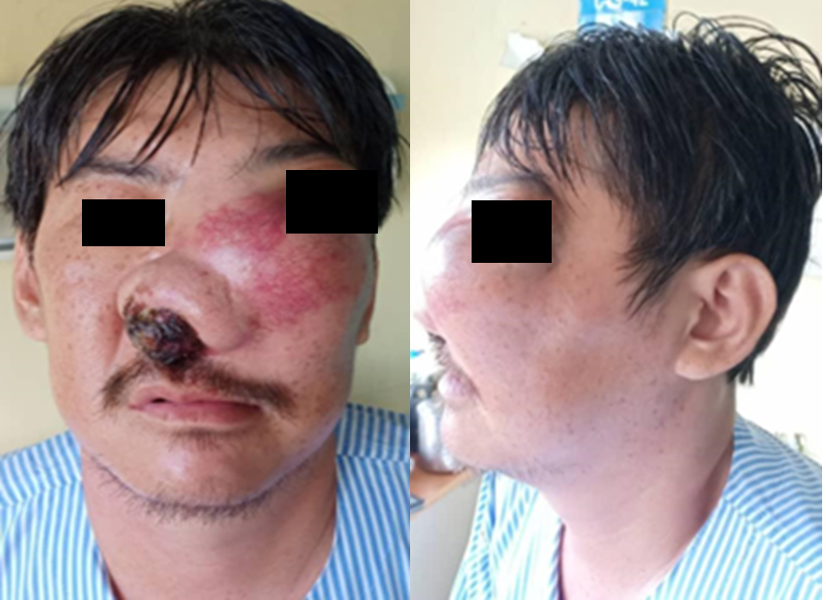

Image 1: Images were taken with consent from patient during his presentation in our centre in February 2020

A Computed Tomography (CT) imaging showed an irregular, enhancing mass centered in the nasal cavity and left maxillary sinus, with internal hyperdensities. The mass extended into the left orbit, both frontal sinuses, and posteriorly into the nasopharynx, oropharynx, and sphenoid sinus, with erosion of the nasal septum, maxillary, sphenoid, and frontal bones. The left globe was displaced anterolaterally, and multiple enlarged neck level I and II lymph nodes were noted. A tissue biopsy was performed under controlled conditions and sent for urgent histopathological examination (HPE).

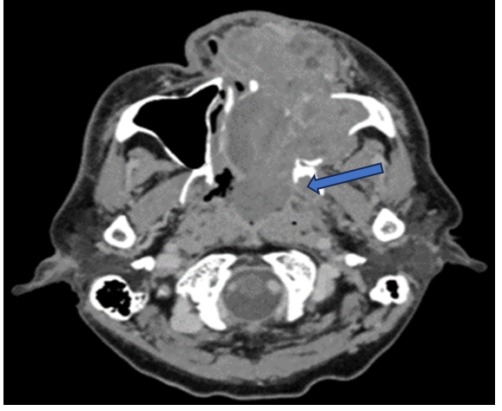
Image 2: CT axial view shows irregular enhancing mass at the nasal cavity/left maxillary sinus. Posterior extension to nasopharynx (blue arrow).

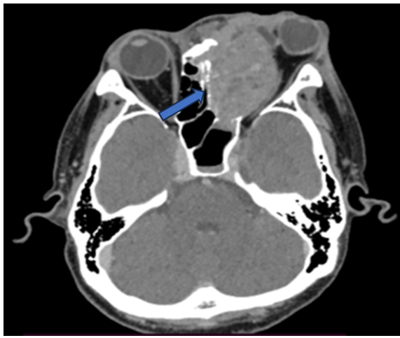

Image 3: CT axial view shows superior extension of the mass into the left orbit displacing the globe anterolaterally (blue arrow)
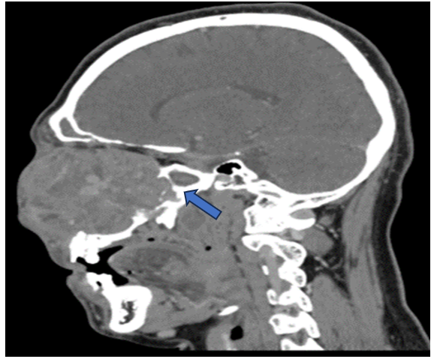

Image 4: CT sagittal view shows posterior extension into the sphenoid sinus (blue arrow)

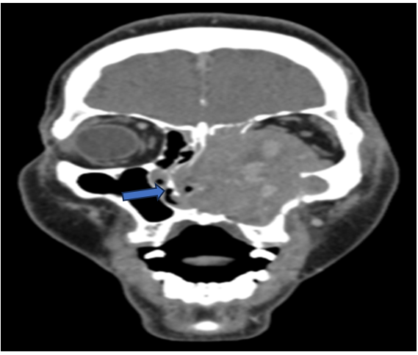

Image 5: CT coronal view shows erosion of nasal septum (blue arrow) and surrounding bony structures

Microscopically, the biopsy showed fibrous tissue infiltrated by malignant tumor cells arranged in nests, trabeculae, and sheets with pleomorphic vesicular nuclei, prominent nucleoli, and scant cytoplasm. Brisk mitosis was observed without squamous or glandular differentiation. Immunohistochemistry staining was strongly positive for AE1/AE3 and CD99, with a Ki-67 proliferation index of 88.2%. The sample was negative for CK7, S100, CK20, and other markers.

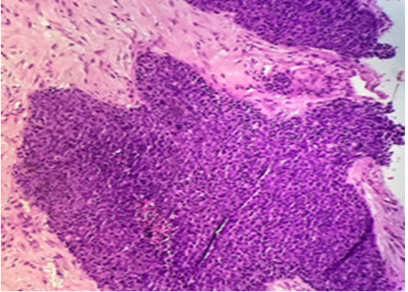

Image 6: Microcopy at 200x magnification shows malignant tumour cells in nests

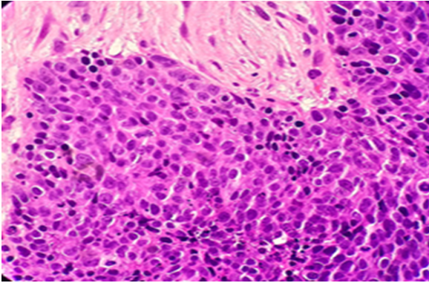

Image 7: Microscopy at 400x magnification shows malignant tumour cells with brisk mitosis

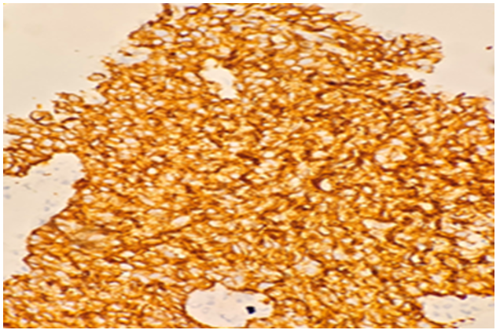

Image 8: Immuno-histochemical stain shows positive for CKAE1/AE3

The patient was diagnosed with SNUC and staged as cT4bN0M0 using the TNM staging method. He was referred for oncological intervention but was able to complete only two cycles of combination chemotherapy with cisplatin and 5-fluorouracil before defaulting due to intolerable side effects. The patient was placed under palliative care and passed away in May 2020 due to locally advanced SNUC.

3. discussion

Malignant neoplasms of the paranasal sinuses and nasal cavity are rare, accounting for only 3% of all head and neck cancers. SNUC is a particularly rare and highly aggressive malignant tumor that originates from the epithelial lining of the paranasal sinuses and nasal cavity, but lacks keratin production, distinguishing it as undifferentiated. First classified as a distinct entity in 1986 based on its unique histological, immunohistochemical, and clinical features, SNUC has an unclear etiology.

However, studies have shown that cigarette smoking and a history of radiation therapy increase the risk of developing SNUC [1]. Unlike nasopharyngeal carcinoma, no association with Epstein-Barr virus has been found [7]. SNUC was later redefined by the World Health Organization as a highly aggressive carcinoma with uncertain histogenesis that typically presents with extensive local disease. The estimated incidence is 0.02 per 100,000, with a male predominance (2:1 to 3:1) [2,6]. Patients usually range in age from their 30s to 80s, with a median age at presentation in the sixth decade.

Patients often present with symptoms such as nasal obstruction and epistaxis. Due to the tumor's invasive nature, proptosis, cranial nerve palsies, visual disturbances, and pain are also common [6]. Symptoms typically develop rapidly, in contrast to the more gradual onset seen in other sinonasal malignancies.

At diagnosis, SNUC is often large and involves adjacent structures, such as the orbit and cranial cavity. CT imaging usually shows bone erosion at the skull base and paranasal sinuses [7], while MRI helps assess soft tissue extension, typically showing heterogeneous contrast enhancement.

Microscopically, SNUC is characterized by high mitotic activity, tumor necrosis, and vascular permeation. This can make differentiation from other sinonasal malignancies, such as neuroendocrine carcinoma, mucosal melanoma, or olfactory neuroblastoma, challenging [2, 4]. Immunohistochemistry aids diagnosis, with cytokeratin staining positive in SNUC and negative for markers like leucocyte common antigen (LCA), S-100 protein, and synaptophysin.

Due to the rarity of SNUC, there is no standardized treatment regimen. Treatment generally involves surgical removal of the tumor, but complete resection with wide margins is often difficult due to the complex anatomy of the head and neck. As a result, surgery is typically combined with radiation, chemotherapy, or both. Multimodal therapy, including neoadjuvant chemotherapy followed by surgery in resectable cases, may improve prognosis, though outcomes remain poor [7]. The median survival is less than 18 months, and the 5-year survival rate is under 20%. Local recurrence is common and is the major cause of morbidity and mortality [6].

Metastasis can occur to cervical lymph nodes as well as distant sites like the liver, lungs, bone, and brain [6]. Tumors are typically advanced at presentation, with 70-100% being classified as T4 and 10-30% having neck node involvement [2]. Elective neck treatment, particularly in T3 and T4 cases, is associated with better regional control and reduced nodal relapse [8]. Therefore, ipsilateral level I-III neck treatment is recommended.

4. Conclusion

SNUC is an extremely rare and aggressive malignancy of the paranasal sinuses, primarily affecting adults. Patients often present at an advanced stage with a short clinical history. Due to its rarity, there is no established gold standard treatment. However, aggressive multimodal therapy is commonly used. Further research is needed to assess the potential benefits of neoadjuvant chemotherapy in managing SNUC.

Consent

As per international standards or university standards written consent have been obtained and preserved by author(s).

Ethical approval

As per international standards or university standards written ethical approval has been obtained and preserved by author(s).

DISCLAIMER (ARTIFICIAL INTELLIGENCE)

Author(s) hereby declare that generative AI technological tools such as Large Language Models, etc have not been used during the writing or editing of manuscripts.

References

- Edwards PC, Hess SJ, Saini T (2006). Sinonasal undifferentiated carcinoma of the maxillary sinus. PubMed, 72(2):163–7
- Barber E, Eapen A, Rupali Nabar, Wamda Goreal, Bunney J, Ritesh Parajuli (2019). Treatment of Sinonasal Undifferentiated Carcinoma with TPF and Concurrent Chemo-Radiation: Case Report and Literature Review. Case Reports in Oncology, 12(1):199–204.
- Chandala Chitguppi (2015). Sinonasal Undifferentiated Carcinoma: A Case Report and Review of Literature. Clinical Rhinology An International Journal, 8(2):60–3
- Jones AV, Robinson I, Speight PM (2005). Sinonasal undifferentiated carcinoma: Report of a case and review of literature. Oral Oncology Extra, 41(10):299–302.
- Sienna J, Nguyen NT, Arsenault J, Hodson I, Meyers B (2018). A Case of Sinonasal Undifferentiated Carcinoma with Brain Metastases. Cureus.
- Wenig BM (2009). Undifferentiated Malignant Neoplasms of the Sinonasal Tract. Archives of Pathology & Laboratory Medicine, 133(5):699–712.
- Ramalingam K, Ramani P, Chandrasekar T, Goel R (2012). Sinonasal undifferentiated carcinoma: A rare entity. Journal of Natural Science, Biology and Medicine, 3(1):101.
- Faisal M, Seemann R, Lill C, Sasan Hamzavi, Arno Wutzl, Erovic BM, et al (2020). Elective neck treatment in sinonasal undifferentiated carcinoma: Systematic review and meta‐analysis. Head & Neck, 42(5):1057–66.
- Workman AD, Brody RM, Kuan EC, Baranov E, Brooks SG, Alonso-Basanta M, et al (2019). Sinonasal Undifferentiated Carcinoma: A 15-Year Single Institution Experience. Journal of Neurological Surgery Part B, Skull Base; 80(1):88–95. https://pubmed.ncbi.nlm.nih.gov/30733906/
- Burggraf M, Schiele S, Thölken R, López FJF, Elawany N, Zenk J, et al. Contemporary treatment and outcome of sinonasal undifferentiated carcinoma: A meta‐analysis. Head & Neck. 2024 Aug 20;46(11):2890–900.
- Abbas Agaimy, Franchi A, Lund VJ, Skálová A, Bishop JA, Asterios Triantafyllou, et al (2019). Sinonasal Undifferentiated Carcinoma (SNUC): From an Entity to Morphologic Pattern and Back Again—A Historical Perspective.;27(2):51–60.
- Antoniades E, Angeliki Cheva, Jannis Constantinidis, Evangelia Kalloniati, Ioannis Patsalas (2022). Intracranially Extended Sinonasal Undifferentiated Carcinoma: A Case Report and Literature Review. American Journal of Case Reports.;23.

