Original Research Article

Maternal and Perinatal Outcomes of Preeclampsia: A Case-Control Study at a Tertiary Hospital in Lagos, Nigeria

ABSTRACT
Aim: Preeclampsia is a global burden leading to maternal and perinatal morbidity and mortality. It is peculiar to human pregnancy with adverse consequences. The study aims to compare the clinical characteristics and complications between women with preeclampsia and normotensive pregnant women
Method: A cross-sectional case-control study was conducted involving 50 pregnant women, consisting of 25 women with preeclampsia and 25 normotensive patients, after 28 weeks of gestational age. The participants attended the antenatal clinic and delivered at Lagos State University Teaching Hospital in Lagos, Nigeria, over six months. Patients were selected based on specific inclusion and exclusion criteria.
Result: The sample size of n=50 women, with 25 per group. The median age of pre-eclampsia respondents was significantly higher than the normotensive group (p=0.035). There were also significant differences across mode of delivery, with pre-eclampsia patients undergoing CS in 88% of cases compared to 56% of the control group (p=0.012 There were observed significant differences across both groups in perinatal complications (p=0.008), weight of delivered babies (p=0.005), admission to SCBU (p< 0.001), and APGAR scores (0.004).
Conclusion: Preeclampsia increases rates of cesarean delivery, prematurity, low birth weight, and a heightened requirement for maternal and neonatal intensive care. The prompt identification of preeclampsia, supported by early referral, adequate antenatal services, and effective management, is essential to mitigate its consequences, particularly in low-resource settings. It is crucial to develop healthcare policies, fund healthcare services, and educate stakeholders to mitigate the challenges of preeclampsia.

Keywords: Preeclampsia, Pregnancy, Women, Tertiary Care

Introduction
Preeclampsia is one of the leading causes of maternal morbidity and mortality and adverse fetal outcomes.^{[1]} It is a disease characterized by catastrophic progressive multisystemic changes peculiar to human gestation.^{[2]} It is associated with approximately 46,000 maternal deaths and approximately 500,000 fetal and newborn deaths annually, with a global incidence of 8%. ^{[2,3]} Preeclampsia is still a disease of theories, as a specific aetiology is still elusive. Early identification of risk factors may assist in prompt detection and clinical diagnosis ^{[4]}
Despite its global burden, many cases remain undetected due to a lack of accurate screening biomarkers, though several have been suggested ^{[4]}
Risk factors include nulliparity, maternal age, multiple pregnancy, body mass index, chronic hypertension, renal disease, Connective tissue disease and cardiac disease.^{[2-5]} The various maternal complications include abruptio placentae, HELLP, pulmonary edema, kidney failure, liver failure and stroke. Fetal complications include preterm delivery, low birth weight and perinatal death.^{[2,3,5]}
Nigeria along with three other middle and low resource countries share 50% of the global maternal mortality² Ultimately, the findings can serve as a foundation for targeted interventions and future multicenter research aimed at reducing preeclampsia-related complications and deaths. Understanding the factors associated with preeclampsia is crucial for addressing its challenges, mitigating its consequences improving overall outcomes of both mothers and their babies.
METHODOLOGY
The study was conducted at the Obstetrics and Gynaecology Department of the Lagos State University Teaching Hospital (LASUTH), Ikeja, Lagos State. The study was a cross-sectional case-control study to identify pre-eclamptic and normotensive pregnant women after 28weeks of gestation who attended the antenatal clinic and delivered in LASUTH, Lagos, Nigeria, over a 6-month period. Consecutive consenting pregnant women at the antenatal booking clinic, who met the selection criteria, were randomly selected into the study until the desired sample size was achieved.
SAMPLE SIZE ESTIMATION
The sample was calculated using the formula for sample size estimation for a study comparing two means. These figures were appropriately used in the sample size calculation.
The equation for sample size for a comparison of two mean is:
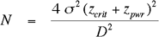

SELECTION OF PATIENTS
The total sample size calculated was 21 participants for each group (control and preeclamptic group), making a total of 42. The inclusion of 10% for attrition was added to the total sample size to make 46. However, this was approximated to 50, with both groups having 25 participants each. Consenting pre-eclamptic women aged 18 to 45 were randomly selected from 28 weeks of gestation. Consecutive consenting normotensive pregnant women were recruited as controls. Preeclampsia is defined as one measurement of systolic blood pressure SBP ≥ 160mmHg and/or diastolic blood pressure DBP ≥ 110mmHg, or SBP ≥140mmHg and/or DBP equal to or greater than 90mmHg on two consecutive measurements, 4 or more hours apart.^{[2]} The 1st and 5thKorokoff sound were used as a measure of systolic and diastolic blood pressure, respectively.^{[2,3]} Significant proteinuria is defined as one 24 hour collection with total protein excretion of 300mg or more, or two random clean catch or catheter urine specimens of 2+(1g albumin/litre)or reagent strip of 1+(0.3g albumin/litre) if specific gravity is less than 1.030 or P^{H} less than 8.^{1,2,3]} The hypertension and proteinuria should occur after 28 weeks of gestation.^{[2]} Pregnant women with chronic hypertension or cardiac pathology, pulmonary hypertension, pulmonary embolism, antiphospholipid syndrome or any connective tissue disease, multiple pregnancy and non-consenting pregnant women were excluded from the study.

STUDY PROCEDURE AND DATA COLLECTION
Data collection: Participants who gave informed consent were enrolled and matched for age with singleton pregnancies of ≥ 28 weeks gestation who are normotensive and the preeclamptic group. A 15-minute interview in which an assistant used a structured questionnaire to obtain information regarding maternal sociodemographic, obstetric and medical histories. The blood pressure using a standard sphygmomanometer (Acuson), with blood pressure measured to the nearest 10mmHg. An acid test strip combur (combes) 10 by Roche was used to test for protein. Other covariates: Covariates to be considered in the analysis include maternal age and reproductive and medical histories.
STATISTICAL ANALYSIS
The data obtained was analyzed using the Statistical Package for Social Sciences (SPSS 26.0). Demographic and baseline variables were summarized. Multivariable logistic regression was used to examine the relationship between predictor variables. sociodemographic and clinical variables). Odd ratios were calculated at a 95% confidence interval. P-values were set at <0.05.

RESULTS
Study Population.
We recruited 50 pregnant women from October 1, 2023, to 21st June, 2024; 25 with pre-eclampsia and 25 normotensive patients. There was no loss due to attrition; the final cohort included all the case and control patients. The socio-demographics of respondents are shown in Table 1. The median age of pre-eclampsia respondents was significantly higher than the normotensive group (p=0.035). Aside the significant difference across the ages of their spouses, no other demographic difference was observed across the pre-eclampsia participants and the control group.
Table 1. Sociodemographic Characteristics of Case- Control Respondents

Characteristic | Control  N = 25¹ | Pre-eclampsia  N = 25¹ | p-value²
Age | 28.0 (25.0, 33.0) | 31.0 (29.0, 34.0) | 0.035
Parity |  |  | 0.4
multiparous | 12 (48%) | 15 (60%)
nulliparous | 13 (52%) | 10 (40%)
Marital |  |  | >0.9
Married | 20 (80%) | 20 (80%)
Single | 5 (20%) | 5 (20%)
Religion |  |  | 0.7
Christian | 22 (88%) | 20 (80%)
Muslim | 3 (12%) | 5 (20%)
Education |  |  | 0.5
Secondary | 8 (32%) | 6 (24%)
Tertiary | 17 (68%) | 19 (76%)
Hubby’s age | 32.0 (30.0, 36.0) | 37.0 (34.0, 39.0) | 0.009
Tribe |  |  | 0.7
Igbo | 4 (16%) | 7 (28%)
Others | 4 (16%) | 3 (12%)
Yoruba | 17 (68%) | 15 (60%)
¹Median (Q1, Q3); n (%)
²Wilcoxon rank sum test; Pearson's Chi-squared test; Fisher's exact test

Maternal Clinical Characteristics
Differences in maternal clinical characteristics are shown in Table 2 with significant differences seen in both the systolic (p = 0.002). and diastolic pressures (p =0.003). There were also significant differences across mode of delivery (whether vaginal or caesarean surgery) with pre-eclampsia patients undergoing CS in 88% of cases compared to 56% of the control group (p=0.012). There were however no observed differences across heart rates and BMI.

Table 2. Maternal Clinical Characteristics in Case- Control Respondents
Characteristic | Control  N = 25¹ | Pre-eclampsia  N = 25¹ | p-value²
Weight | 69 (62, 76) | 65 (60, 69) | 0.2
Height | 1.62 (1.61, 1.67) | 1.61 (1.55, 1.68) | 0.4
BMI | 26.0 (24.0, 29.0) | 26.0 (24.0, 28.0) | 0.8
Systolic | 124 (120, 141) | 142 (138, 153) | 0.002
Diastolic | 75 (70, 84) | 88 (81, 97) | 0.003
Heart rate | 85 (82, 89) | 86 (80, 89) | 0.8
Delivery mode |  |  | 0.012
Caesarean | 14 (56%) | 22 (88%)
Vaginal | 11 (44%) | 3 (12%)
¹Median (Q1, Q3); n (%)
²Wilcoxon rank sum test; Pearson's Chi-squared test; Fisher's exact test

Perinatal parameters
There are observed significant differences across both groups in perinatal complications (p=0.008), weight of delivered babies (p=0.005), admission to SCBU (p< 0.001), and APGAR scores (0.004) Table 3. There were, however, no observed differences across pregnancy outcomes.
Table 3. Perinatal parameters in Case- Control Respondents
Characteristic | Control  N = 25¹ | Pre-eclampsia  N = 25¹ | p-value²
Complication |  |  | 0.008
Nil | 23 (92%) | 15 (60%)
Yes | 2 (8.0%) | 10 (40%)
Baby’s gender |  |  | 0.4
Female | 13 (52%) | 16 (64%)
Male | 12 (48%) | 9 (36%)
Birth weight | 2.86 (2.60, 3.20) | 2.40 (2.00, 2.80) | 0.005
APGAR |  |  | 0.004
Low | 0 (0%) | 6 (24%)
Moderately Abnormal | 9 (36%) | 2 (8.0%)
Reassuring | 16 (64%) | 17 (68%)
SCBU Admission | 4 (16%) | 20 (80%) | <0.001
Outcome |  |  | 0.7
Alive | 23 (92%) | 21 (84%)
Dead | 2 (8.0%) | - (16%)
²Wilcoxon rank sum test; Pearson's Chi-squared test; Fisher's exact test

Perinatal Complications and Admissions
Across both case and control patients, hypertension and eclampsia were the most common pregnancy complications with a higher proportion in the pre-eclampsia group (Figure 1). The most common indication for cesarean section in this study was severe eclampsia followed by unfavourable cervix (Figure 2), while the cause for SCBU admission in pre-eclampsia in the study was premature births, followed by fetal distress and neonatal sepsis (NNS) (Figure 3).

Figure 1. Complications in Pre-eclampsia and Control Patient

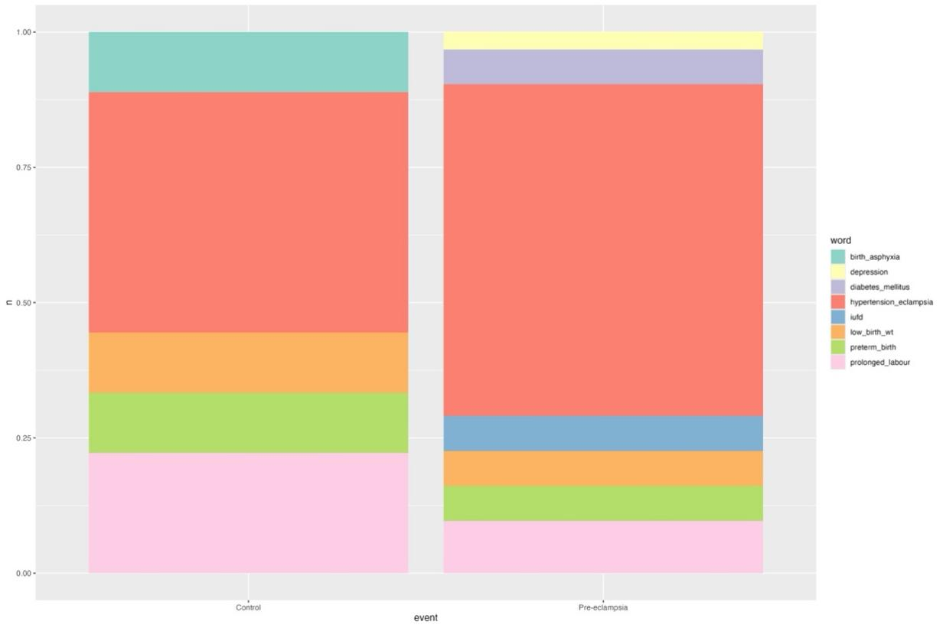

Figure 2. Indications for Caesarean Surgery.
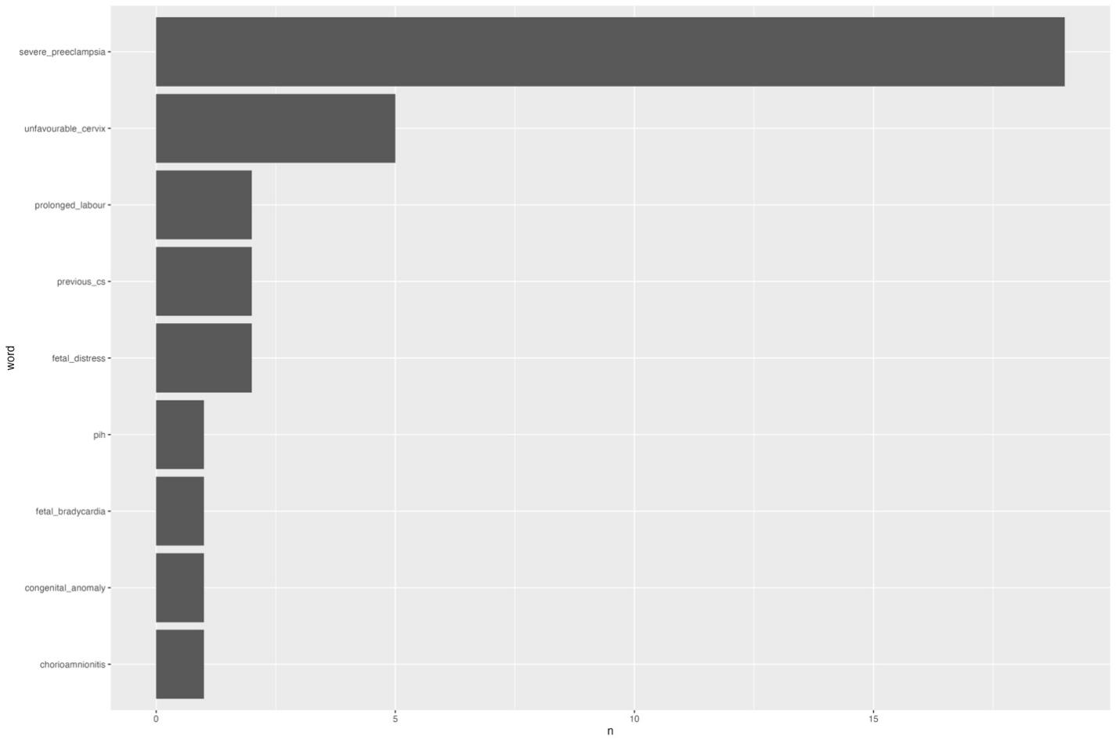

Figure 3. Indications for SCBU Admissions.

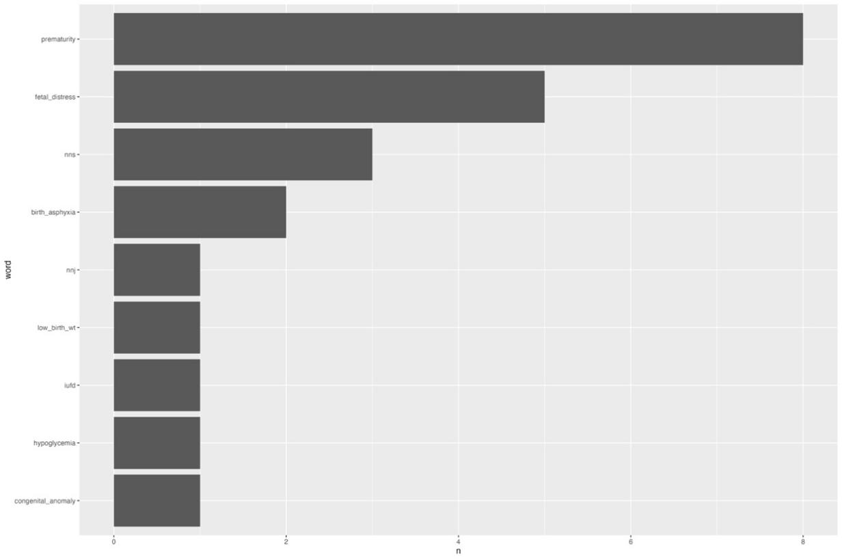

Discussion
The study showed that preeclamptic patients had more cesarean deliveries compared to normotensive patients. This is the safest and most expedited mode of delivery is carried out in the presence of fetal compromise in preeclamptic cases. This cesarean section was carried out to forestall further deterioration of the already compromised utero-fetal condition. Preterm delivery accounts significantly for the complication of prematurity as seen in the preeclamptic group, warranting more special care baby unit admission ^{[1,5,6,7,8,9.10]}
The World Health Organisation recommends a caesarean rate of 10- 15 %.^{[11]} However, in Nigeria, studies reporting delivery methods for women with pre-eclampsia/eclampsia have shown high caesarean delivery rates ranging from 48.42% to 71.2%.^{[12,13]} The result of the late referral and the presence of dire obstetrics and prenatal complications of preeclampsia. Most of the patients had no antenatal care, presenting in life-threatening conditions and on referral, necessitating abdominal delivery. As a means of prevention, early recognition of at-risk patients, timely referral to tertiary hospitals, and the antenatal use of aspirin, calcium supplements, and improved maternal and neonatal services may reduce the cesarean rate to an acceptable level.[ ^{9,10,12,14,]}
The study highlighted the risks that preeclampsia poses to fetal well-being, particularly a significant increase in low birth weight (LBW) neonates within the preeclamptic group compared to the normotensive group. This outcome is attributable to inadequate oxygenation and nutrient supply due to the chronic effects of abnormal placental flow associated with preeclampsia, which can result in intrauterine growth restriction, preterm birth, and low birth weight. The majority of the babies born to the preeclamptic group were low birthweights below 2.5kg because of premature deliveries and chronic complications of hypertension. Qaiser et al found LBW and prematurity were predominant among preeclamptic patients.^{[15]} A systematic review and meta-analysis conducted by Getaneh et al. revealed a 3.89-fold increase in low birth weight in a pregnancy induced hypertension(OR = 3.89, 95% CI: 2.66, 5.69).[^{16]} Our study mirrors these trends, showing an increase in neonatal admissions and the burden on neonatal care services.

The substantial impact of pre-eclampsia/eclampsia contributes significantly to the complications associated with stillbirths and early perinatal deaths.^{[7,8,12]} This was reflected in our study as the reasons for admission into the special baby care unit of the majority of the preeclamptic mother babies were prematurity, fetal distress and birth asphyxia, with an overall admission rate of 50%. Similar outcomes have been reported across the globe in several studies, revealing the deteriorating effect of preeclampsia and eclampsia on fetal and neonatal wellbeing ^{[3,10,12,13,14,15,17,18]} In addition, a perinatal mortality rate of 20.5% was observed in our study. A nationwide survey conducted across 42 Nigerian tertiary hospitals revealed that eclampsia accounts for one-fifth of maternal deaths, double the rate of postpartum haemorrhage (PPH).^{[13]} Our study recorded no maternal death may be a limitation of low sample size.
Several risk factors have been linked to preeclampsia in our study, including nulliparous status, lack of antenatal care, and a previous history of hypertensive disease. Faiza et al found a 70% risk of having preeclampsia among primigravida.^{[18]} Similarly, Haile et al study found that the likelihood of developing preeclampsia in primigravida is 5.41 times more than in multigravida (AOR: 5.41; 95% confidence interval [CI]: 2.85, 10.29) and is attributed to the immunological challenges that occur in first pregnancies between maternal and fetal genes^{[19]} The immune challenges during early pregnancy stem from poor immunotolerance and propose a key mechanism in the pathogenesis of preeclampsia.

Another notable finding is the husband's age. Older paternal age was predominant in the preeclampsia group.^{[13]} Abnormal placentation has been a known cause of the pathophysiology of preeclampsia. The placenta is genetically formed from both maternal and paternal origins. Abnormal placentation is the underlying cause of preeclampsia.^{[20,21]} A significant factor contributing to a proportion of preeclampsia could be the new genetic mutations that arise from advanced paternal age.
Understanding these connections underscores the importance of considering paternal age in pregnancy and maternal health.^{[21]}Preeclampsia is a significant contributor to maternal and perinatal morbidity and mortality, particularly in low and middle-income countries like Nigeria, where healthcare resources are limited, inadequate screening and antenatal care coverage are suboptimal.^{[3,4]}
Conclusion
The study reveals that preeclampsia causes increased cesarean delivery rates, preterm births, low birth weights, neonatal admissions, and perinatal mortality. Contributing factors include primigravida, inadequate antenatal care, and advanced paternal age. Early detection, antenatal care utilization and timely referrals are essential for improving outcomes.

Justification of the study
There is a critical need for local data to understand the trends, risk factors, and outcomes associated with preeclampsia in Nigerian healthcare settings. Additionally, many pregnant women in Lagos present late in pregnancy or during emergencies, complicating early diagnosis and intervention. This study is therefore justified in its aim to compare the clinical characteristics and perinatal outcomes of women with preeclampsia and those with normotensive pregnancies in a tertiary hospital setting. Findings from this study will provide insights into the burden and complications of preeclampsia in low-resource settings, help identify modifiable risk factors and support the development of targeted interventions for early detection and management. Ultimately, the findings have the potential to inform policy development, enhance clinical practice by facilitating early referral, and improve antenatal and neonatal services in Lagos and similar settings. Also used as a bedrock for other multicentre research and evidence-based management.
Limitation
The constraints of the study include a small sample size, which restricts the statistical power of the findings. In contrast, a larger sample size would provide a more accurate representation of general outcomes. Furthermore, a multicenter study would yield more comprehensive insights into comparative findings, such as variations in obstetric practices and sociodemographic factors across different health centres or geographical regions. While this study focused on the early neonatal period, it is important to acknowledge that other long-term maternal and neonatal consequences could significantly contribute to the overall burden of preeclampsia
Ethical consideration
The Ethics and Research Committee of Lagos State University Teaching Hospital (LASUTH), Ikeja, Lagos, approved the study, with the approval number LREC/06/10/2320. All participants provided their informed consent.
Consent: Oral and written consent were obtained from participants in the study

Disclaimer (Artificial intelligence)
Option 1:
Author(s) hereby declare that NO generative AI technologies such as Large Language Models (ChatGPT, COPILOT, etc.) and text-to-image generators have been used during the writing or editing of this manuscript.
Option 2:
Author(s) hereby declare that generative AI technologies such as Large Language Models, etc. have been used during the writing or editing of manuscripts. This explanation will include the name, version, model, and source of the generative AI technology and as well as all input prompts provided to the generative AI technology
Details of the AI usage are given below:
1.
2.
3.

REFERRENCE

- Kuye-Kuku TO, Ajayi G O Adegbola O Serum and red cell magnesium and calcium concentrations in normotensive and preeclamptic pregnant women in Lagos, Nigeria. Annals of Health Research. 2023,Volume 9, Issue No 1: 12-22 doi:10.30442/ahr.0901-02-186
- WHO Preeclampsia https://www.who.int/news-room/fact-sheets/detail/pre-eclampsia
- WHO 2021–2023 maternal mortality updates

- Renad Marwan Alghifari, Nuwayir Ibrahim Alhusayni, Zahrah Fuad Alyamani, Aliaa Sabban, Yousef Almoghrabi & Khalid Hussein Bakheit. (2023). The Role of Biochemical Markers in the Prediction of Preeclampsia. International Journal of Biochemistry Research & Review, 32(8), 39–47. https://doi.org/10.9734/ijbcrr/2023/v32i8833

- Abdurrahman A, Adamu AN, Ashimi A, Adekunle OO, Bature SB, Aliyu LD, Akeem O, Abdullahi H, Lavin T, Daneji S, Musa B, Muazu Z, Tukur J, Galadanci HS. Predictors, prevalence and outcome of hypertensive disorders in pregnancy in Nigerian tertiary health facilities. BJOG. 2024 Aug;131 Suppl 3:42-54. doi: 10.1111/1471-0528.17902. Epub 2024 Jul 3. PMID: 38960882.

- Kokori E, Aderinto N, Olatunji G, Komolafe R, Babalola EA, Isarinade DT, Moradeyo A, Muili AO, Yusuf IA, Omoworare OT. Prevalence and materno-fetal outcomes of preeclampsia/eclampsia among pregnant women in Nigeria: a systematic review and meta-analysis. Eur J Med Res. 2024 Oct 3;29(1):482. doi: 10.1186/s40001-024-02086-x. PMID: 39363380; PMCID: PMC11448017.
- Tunau KA, Sulaiman R, Garba JA, Aliyu FB, Panti AA,Hassan M. Presentation and outcome of preeclampsia: A five-year review in Uduth, Sokoto. Caliphate Med J 2018;6:1-4December 2018DOI: 10.47837/CMJ.19770126.20186141121

- Ugwu AO, Owie E, Oluwole AA, Soibi-HarryAP, Garba SR, Okunade KS, et al. Maternal and perinatal outcomes ofpreeclampsia at a tertiary hospital in lagos, Nigeria. Int J Med Health Dev2022;27:197-200 DOI: 10.4103/ijmh.IJMH_46_21
- Ajah LO, Ozonu NC, Ezeonu PO, Lawani LO, Obuna JA, Onwe EO. The Feto-Maternal Outcome of Preeclampsia with Severe Features and Eclampsia in Abakaliki, South-East Nigeria. J Clin Diagn Res. 2016 Sep;10(9):QC18-QC21. doi: 10.7860/JCDR/2016/21078.8499. Epub 2016 Sep 1. PMID: 27790527; PMCID: PMC5072027.
- A. Ojurongbe, M Fijabiyi, O. Tunde-Olatunji, W. Taiwo, U. Aduga, T. F. Duyile Adekunle Prevalence, Seasonal variation and Feto-Maternal outcomes of Severe Pre- Eclampsia/Eclampsia at a Tertiary Hospital in North central Nigeria. SLJM [Internet]. 2024 Oct. 14 [cited 2025 May 26];1(2):70-4. Available from: https://sljm.org/journal/index.php/sljm/article/view/49
- Angolile CM, Max BL, Mushemba J, Mashauri HL. Global increased cesarean section rates and public health implications: A call to action. Health Sci Rep. 2023 May 18;6(5):e1274. doi: 10.1002/hsr2.1274. PMID: 37216058; PMCID: PMC10196217
- Akaba, G.O., Anyang, U.I. & Ekele, B.A. Prevalence and materno-fetal outcomes of preeclampsia/eclampsia amongst pregnant women at a teaching hospital in north-central Nigeria: a retrospective cross-sectional study. Clin Hypertens 27, 20 (2021). https://doi.org/10.1186/s40885-021-00178
- Oladapo O, Adetoro O, Ekele B, Chama C, Etuk S, Aboyeji A, et al. When getting there is not enough: a nationwide cross-sectional study of 998 maternal deaths and 1451 near-misses in public tertiary hospitals in a low-income country. BJOG Int J Obstet Gynaecol. 2016;123(6):928–38. https://doi.org/10.1111/1471-0528.13450/

- Dekker G., Robillard P. Y., Roberts C. (2011). The etiology of preeclampsia: the role of the father. J. Reprod. Immunol. 89 126–132. 10.1016/j.jri.2010.12.010 [DOI]

- Qaiser Javed Iqbal, Ayesha Javed, Zafar Ali Marri and Nadia Sabeen (2020) “Feto-Maternal Outcome of Pregnancy Complicated with Preeclampsia”, Journal of Pharmaceutical Research International, 32(22), pp. 44–48. doi: 10.9734/jpri/2020/v32i2230770
- Getaneh, T., Negesse, A., Dessie, G. et al. The impact of pregnancy induced hypertension on low birth weight in Ethiopia: systematic review and meta-analysis. Ital J Pediatr 46, 174 (2020). https://doi.org/10.1186/s13052-020-00926-0
- Adeyeye OV, Ebubechukwu NV, Olanrewaju OF, Eniayewun AG, Nwuta C, Effiong FB, Unim B. Management and Prevention of Pre-Eclampsia in Nigeria. Healthcare. 2023; 11(13):1832. https://doi.org/10.3390/healthcare11131832
- Faiza, Ruqqia Sultana, Jawaris Batool, Shah Khalid, Abdul Majid Khan. Frequency of primigravida in patients with eclampsia. J Ayub Med Coll Abbottabad [Internet]. 2023 Apr. 17 [cited 2025 Aug. 21];35(2):265-8. Available from: https://jamc.ayubmed.edu.pk/index.php/jamc/article/view/11489

- Gereziher Haile, Nega Assefa , Tadesse Alemayehu, Teklewoini Mariye , Gebreamlak Gebremedhn Geberemeskel , Degena Bahrey , Guesh Mebrahtom , Biniyam Demisse , Hailemikael Gebrekidan , Tamirat Getachew. Determinants of Preeclampsia among Women Attending Delivery Services in Public Hospitals of Central Tigray, Northern Ethiopia: A Case-Control Study Journal of Pregnancy. 2021, Article ID 4654828, 8 pages https://doi.org/10.1155/2021/4654828
- Harlap Susan; Paltiel, Ora; Deutsch, Lisa; Knaanie, Ariella; Masalha, Sausan; Tiram, Efrat; Caplan, Lee S.; Malaspina, Dolores; Friedlander, Yechiel. Paternal Age and Preeclampsia EpidemiologyEpidemiology.13:p 660-667, November 2002
- Galaviz-Hernandez, C., Sosa-Macias, M., Teran, E., Garcia-Ortiz, J. E., & Lazalde-Ramos, B. P. Paternal Determinants in Preeclampsia. Frontiers in physiology, 9,2019 1870. https://doi.org/10.3389/fphys.2018.01870

