Case report

Uncommon clinical features of lower lip squamous cell carcinoma in an elderly woman

.
ABSTRACT

Introduction: Lip squamous cell carcinoma (LSCC) of the lower lip is the most common malignant neoplasm in the oral region, strongly associated with chronic sun exposure. Case Report: A 73-year-old woman presented with a persistent ulcer on the lower lip lasting two years. Clinical examination revealed a crusted nodule with discoloration and changes in the vermilion border. Histopathological analysis showed high-grade epithelial dysplasia, sunlight-induced connective tissue damage, and islands of neoplastic epithelial cells, findings consistent with LSCC. Following oncologic therapy referral, the patient remains in follow-up care with no recurrence and a favorable esthetic outcome. Conclusion: Early diagnosis and close monitoring of potentially malignant oral disorders are critical steps in reducing disease complications and improving quality of life, especially in elderly patients. This case underlines the importance of considering actinic cheilitis as a warning sign for lip cancer in elderly patients.

Keywords: Squamous Cell Carcinoma, Lower Lip, Actinic Cheilitis, Oral Cancer

1. INTRODUCTION

Lip squamous cell carcinoma (LSCC) of the lower lip is the most prevalent malignant neoplasm in the oral region, accounting for approximately 90% of oral cancers diagnosed at this site [1,2]. Its development is strongly associated with chronic ultraviolet (UV) radiation exposure, particularly among fair-skinned individuals and those with outdoor occupations [3,4].

As the population ages, it becomes increasingly important to investigate and establish care strategies for potentially malignant oral disorders (PMODs), such as leukoplakia, erythroplakia, oral lichen planus with dysplasia, and oral submucous fibrosis. Among potentially malignant disorders, actinic cheilitis is notably common in older adults. [2,5,6,12].

Actinic cheilitis results from cumulative UV-induced damage and is recognized as the primary precursor lesion for LSCC, preceding approximately 95% of cases. These lesions carry a heightened risk of malignant transformation, particularly in individuals over 60 years of age due to increased exposure to carcinogens and age-related immune changes [4,5,12].

Literature indicates that most PMODs may go unnoticed or be misdiagnosed as chronic inflammatory processes, delaying appropriate referral to specialists. In the elderly, this is exacerbated by reduced regenerative capacity and the presence of comorbidities that complicate clinical management [6,12]. While LSCC is potentially curable if diagnosed early, it can behave aggressively, with local invasion and metastatic potential in neglected or immunocompromised cases [2,5,6].

Due to its often subtle clinical presentation, early detection can be challenging, contributing to delayed diagnosis [3,9]. However, early diagnosis and complete surgical removal with clear margins are associated with excellent prognosis [7,8]. Regular screening, education on sun protection, routine dental evaluations, and timely referral to specialists are essential strategies for preventing LSCC and promoting oral health in older adults [7,11,12].

This report presents a case of lower LSCC in an elderly woman with clinical history suggestive of progression from actinic cheilitis and discusses its clinical and pathological features in the context of current literature.

2. CASE REPORT

A 73-year-old woman presented with a two-year history of a non-healing desquamative ulcer on the lower lip, which had developed nodular growth over the preceding two months. She denied smoking and alcohol consumption but reported lifelong sun exposure without the use of sunscreen. Clinical examination revealed a painless, grayish nodule on the lower lip measuring approximately 1.8 × 1.5 × 0.4 cm, with a crusted surface, discoloration, and blurring of the adjacent vermilion border.

During the interview, she revealed frequent wound manipulation through biting or peeling with her hands, which likely contributed to its persistence and progression. Despite the chronicity of the lesion, she did not seek public medical or dental until approximately nine months after noticing that the lesion was enlarging. The delay in seeking care may have been related not only to limited patient education but also to other contributing factors, such as financial constraints, possible difficulties in accessing healthcare services, and the absence of social support, as she lived and managed the condition on her own. Ultimately, it was only when the lesion reached the advanced stage illustrated in the first photograph that her employer, for whom she worked as a maid, encouraged and accompanied her to the consultation.

Following the incisional biopsy, the histopathological examination revealed a dysplastic surface epithelium, exhibiting high-grade epithelial dysplasia. The underlying stroma displayed superficial cords or islands of malignant squamous epithelial cells (Figure 2A). In other areas a mild inflammatory infiltrate, and basophilic degeneration of collagen, consistent with sunlight-induced connective tissue damage, was observed (Figure 2B). These findings were compatible with lip squamous cell carcinoma (LSCC). We referred the patient for total removal of the lesion and assessed regional lymph node screening, but the results were negative.

These findings confirmed the diagnosis of LSCC. The patient was referred for complete lesion excision and regional lymph node evaluation, which returned negative for metastasis. After confirming the diagnosis, the patient underwent oncologic treatment. At 12-month follow-up, she remains recurrence-free and in good general condition. (Figure 3)

3. discussion

The chronic ultraviolet radiation exposure, particularly in people with light skin phototypes, is the key risk factor for actinic cheilitis (AC), an oral potentially malignant disorder (OPMD) typically seen in middle-aged people with fair skin. Demographic factors such as age over 40 and male gender increase the risk. Lifestyle factors such as smoking and alcohol intake can also increase the risk of developing AC. Studies showed that the use of sunscreen creams and hats is not effective in reducing the development of AC. [13,14].

LSCC, a subtype of oral cancer, impacts the vermilion area of the lower lips. Approximately 95% of LSCC cases may be preceded by AC. The World Health Organization (WHO) indicates that LSCC is among the most prevalent malignant lesions in the head and neck area. Lower lip squamous cell carcinoma is significantly associated with environmental factors, especially prolonged sun exposure. AC is acknowledged as the principal precursor lesion [1,3,4]. Actinic cheilitis may be clinically underestimated, manifesting as atrophic, whitish, fissured, or crusted regions [4,10,13,14].

Biopsy is the gold standard for diagnosing persistent lesions [3,9]. The histopathological features observed in this case high-grade dysplasia, sunlight-induced connective tissue damage, and malignant squamous cells are classic findings in lip SCC [4,5,10]. The main treatment modalities include surgical excision, radiation, and chemotherapy. Immunotherapy and targeted molecular treatments are emerging therapeutics that show enormous promise. Early detection and treatment result in a better prognosis, whereas advanced-stage cases have poorer outcomes. [7,8,11].
The five-year survival rate exceeds 90% in early-stage cases, although local recurrence may occur, requiring long-term monitoring [6,11].

In elderly patients, such as in this case, clinical management demands extra caution. Age-related immune changes, reduced tissue repair capacity, and comorbidities may influence both disease progression and response to therapy [5,6]. Moreover, older patients may have limited risk perception or access to healthcare services, increasing the likelihood of late diagnosis. Thus, continuous clinical monitoring with periodic reassessment is essential to detect recurrence or new potentially malignant lesions [10,12].

Health education directed at the elderly population is also vital. Patients should be instructed to recognize suspicious clinical signs and understand the importance of sun protection, adequate lip hydration, and periodic evaluations of persistent lesions. Multidisciplinary care including dental surgeons, geriatricians, and dermatologists can enhance outcomes and improve patients' quality of life and cancer prognosis [6,7,12].

The prognosis is closely tied to early detection, underscoring the importance of awareness, education, and preventive measures focused on lip health and sun protection [7,12].

5. Conclusion

Lower lip squamous cell carcinoma is a potentially curable malignancy if diagnosed early. Its development from actinic cheilitis, an OPMD, requires vigilance regarding initial clinical signs, particularly in elderly patients with a history of sun exposure. Regular skin examinations and prompt attention to any changes in the lips or surrounding areas can significantly improve outcomes. Additionally, educating patients about sun protection and self-monitoring may help in early detection and prevention of progression. This case illustrates the importance of early diagnosis, accurate histopathological evaluation, and appropriate surgical management.

DISCLAIMER
The authors acknowledge that AI-assisted technologies, including QuillBot, were utilized in the writing process to assist with grammar and language refinement. These tools were employed solely to enhance clarity and readability without altering the substantive content of the work. After utilizing these technologies, the authors thoroughly reviewed and edited the content as needed to ensure accuracy, coherence, and alignment with the intended message. The authors take full responsibility for the final content of this publication.
Details of the AI usage are given below:
1. Grammar

2. Language refinement

3. Editing

Consent

"All authors declare that ‘written informed consent was obtained from the patient (or other approved parties) for publication of this case report and accompanying images. A copy of the written consent is available for review by the Editorial Board members of this journal."

References

1. Silva LVO et al. Demographic and Clinicopathologic Features of Actinic Cheilitis and Lip Squamous Cell Carcinoma: a Brazilian Multicentre Study. Head Neck Pathol. 2020 Dec;14(4):899–908. doi: 10.1007/s12105-020-01142-2. Epub 2020 Feb 2019.
2. Effiom OA, Adeyemo WL, Omitola OG, Ajayi OF, Emmanuel MM, Gbotolorun OM. Oral squamous cell carcinoma: a clinicopathologic review of 233 cases in Lagos, Nigeria. J Oral Maxillofac Surg. 2008 Aug;66(8):1595-9. doi: 10.1016/j.joms.2007.12.025. PMID: 18634945.3. Gutiérrez-Trujillo G, Delgado Ríos MA, Segura Sampedro JJ. Squamous cell carcinoma of the lip: early diagnosis and treatment. Cir Plást IberoLatinoam. 2017;43(4):425–431.
3. Miligi, L. Ultraviolet Radiation Exposure: Some Observations and Considerations, Focusing on Some Italian Experiences, on Cancer Risk, and Primary Prevention. Environments 2020, 7, 10. https://doi.org/10.3390/environments7020010
4. Rodrigues, AS et al. Actinic Cheilitis: Clinical and Histological Features Cavalcante, Journal of Oral and Maxillofacial Surgery, Volume 66, Issue 3, 498 – 503.
5. Green, Adèle C., and C. M. Olsen. "Cutaneous squamous cell carcinoma: an epidemiological review." British Journal of Dermatology 177.2 (2017): 373-381.
6. Montoro JRMC, Hicz HA, de Souza L, Livingstone D, Melo DH, Tiveron RC, Mamede RCM. Prognostic factors in squamous cell carcinoma of the oral cavity. Braz J Otorhinolaryngol. 2008 Nov-Dec;74(6):861-866. doi: 10.1016/S1808-8694(15)30146-4. Erratum in: Braz J Otorhinolaryngol. 2010 Feb;76(1):139.
7. Beltrami, Carlo Alberto, Lorenzo Desinan, and Corrado Rubini. "Prognostic factors in squamous cell carcinoma of the oral cavity: A retrospective study of 80 cases." Pathology-Research and Practice 188.4-5 (1992): 510-516.
8. dos Santos LR, Cernea CR, Kowalski LP, Carneiro PC, Soto MN, Nishio S, Hojaij FC, Dutra Júnior A, Britto e Silva Filho G, Ferraz AR. Squamous-cell carcinoma of the lower lip: a retrospective study of 58 patients. Sao Paulo Med J. 1996 Mar-Apr;114(2):1117-26.
9. Saaiq, M. (2024). Squamous Cell Carcinoma of the Lip: Clinical Presentation and Management Outcome. Journal of Pioneering Medical Sciences, 13(2), 1-4.
10. Araújo ALD, et al. Actinic queilite: literature review and clinical case report. Braz J Otorhinolaryngol. 2012;78(4):130–134.
11. D.K. Zanoni, P.H. Montero, J.C. Migliacci, J.P. Shah, R.J. Wong, I. Ganly, S.G. Patel Survival outcomes after treatment of cancer of the oral cavity (1985-2015) Oral Oncol., 90 (2019), pp. 115-121.
12. de Santana Sarmento, Dmitry José, et al. "Actinic cheilitis: clinicopathologic profile and association with degree of dysplasia." International journal of dermatology 53.4 (2014): 466-472.
13. El-Naggar AK, Chan JKC, Takata T, Grandis JR, Slootweg PJ. The fourth edition of the head and neck World Health Organization blue book: editors' perspectives. Hum Pathol. 2017 Aug;66:10-12. doi: 10.1016/j.humpath.2017.05.014. Epub 2017 Jun 2. PMID: 28583885.
14. De Oliveira Silva LV, De Arruda JAA, Abreu LG, Ferreira RC, Da Silva LP, Pelissari C, et al. Demographic and Clinicopathologic Features of Actinic Cheilitis and Lip Squamous Cell Carcinoma: a Brazilian Multicentre Study. Head and Neck Pathology [Internet]. 2020 Feb 19;14(4):899–908.

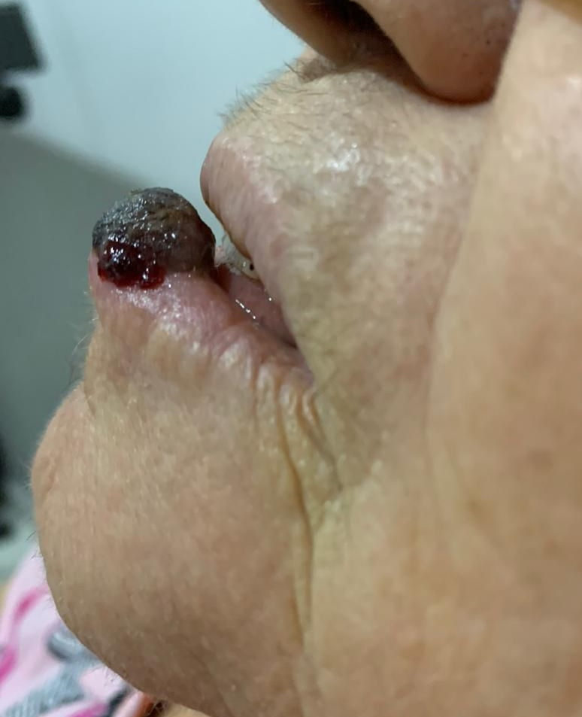

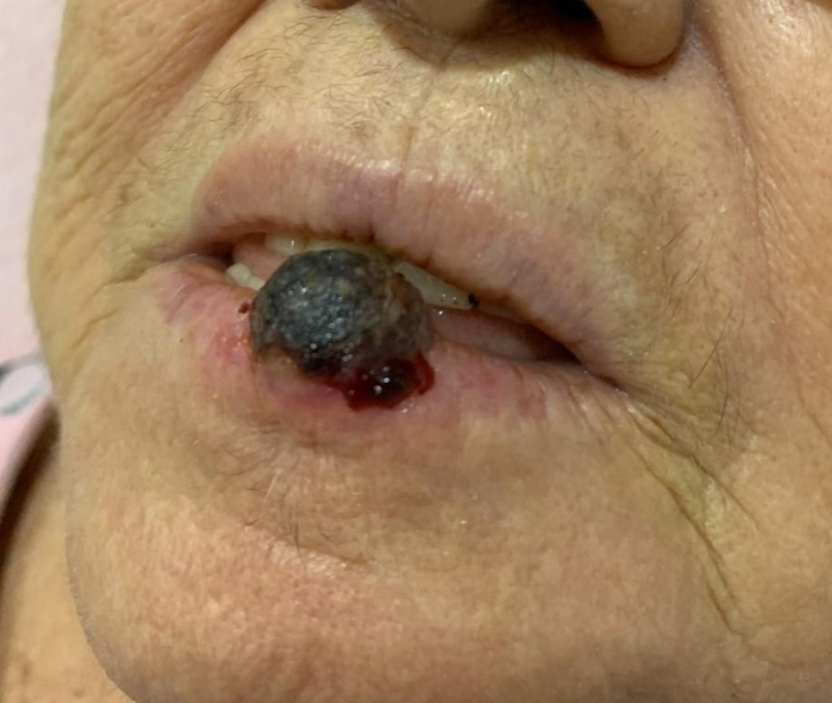
(Figure 1A: 1B)
Figure 1- lower lip squamous cell carcinoma in an elderly woman

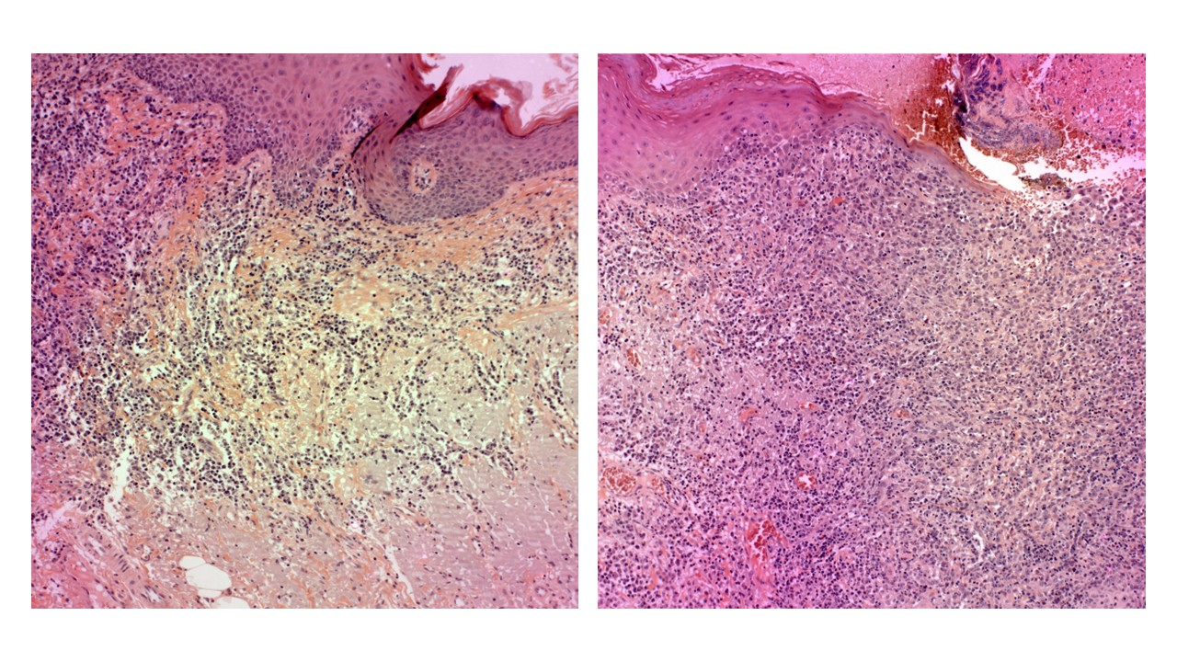(Figure 2A: 2B)
Figure 2 – 2A: The underlying stroma displayed superficial cords or islands of malignant squamous epithelial cells, 2B: along with a mild inflammatory infiltrate, and basophilic degeneration of collagen, consistent with sunlight-induced connective tissue damage, was observed.

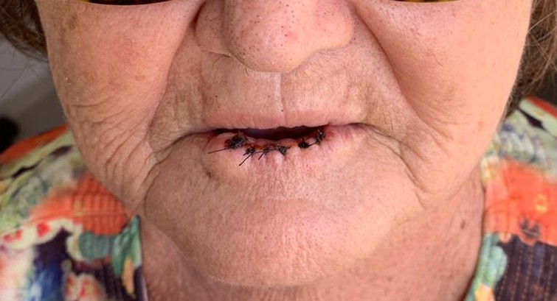
(Figure 3)- Seven days after surgery

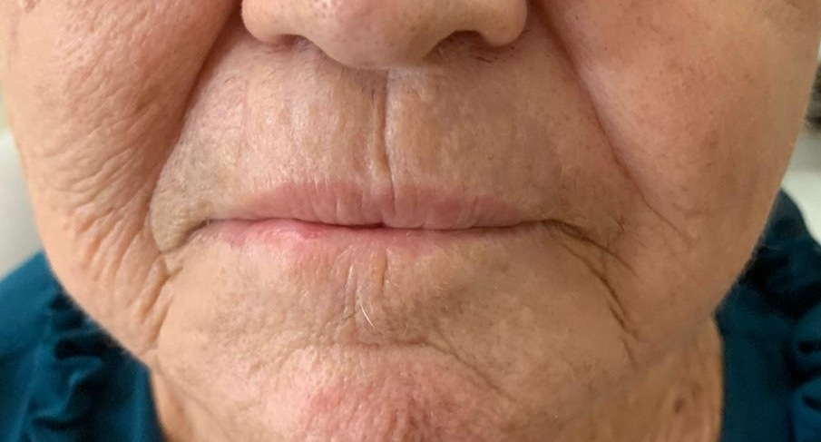
(Figure 4)- After the surgery for lower lip squamous cell carcinoma

