Original Research Article

Telehealth for Post-ED Care: A Cross sectional Analysis of University Students Preferences and Concerns

Abstract
Telehealth is carving out a vital space in modern healthcare, offering remote services that resonate well with the dynamic lives of university students. Yet, its true potential can only be unlocked if we understand the perspectives of those intended to use it. This study provides a window into how university students in Northern Cyprus view telehealth, specifically for follow up care after minor Emergency Department (ED) visits.
We surveyed 161 university students using a cross sectional approach and a structured questionnaire. We gathered insights into their demographics, prior experiences with telehealth, and preferences for future follow up care. The data was brought to life using descriptive statistics, while Chi Square tests helped us find connections, and Multiple Linear Regression (MLR) identified key factors predicting telehealth acceptance.
While nearly three quarters (74.1%) of students would prefer telehealth for its convenience and time saving nature, a striking 89.5% have never actually used it. This highlights a significant gap between interest and experience. Students' main worries centred on the 'lack of physical examination' and potential 'quality of care' (16% each). Video calls stood out as the favoured way to connect. Our MLR models strongly indicated that students who liked video calls and valued seeing their provider were much more likely to embrace telehealth (R2=0.928, p<0.001). Gender also subtly shaped views on provider visibility (p=0.020).
There is a clear, untapped enthusiasm for telehealth among Northern Cyprus university students. To bridge the gap between interest and use, we must address concerns about the remote experience, primarily by building trust and demonstrating quality, perhaps through excellent video interactions. Focused education and thoughtfully designed platforms are key to making telehealth a truly accessible and valued healthcare option for this community.
Keywords: Telehealth, Emergency Department, University Students, Telemedicine

1. Introduction
The way we access healthcare is changing. We are steadily moving away from a system solely reliant on physical clinics and hospitals towards one that embraces digital connection. Telehealth, the use of technology to deliver care remotely, is leading this charge. It holds the promise of a healthcare system that is more accessible, more convenient, and often more efficient(1), bringing benefits to both those seeking care and those providing it (1). Though not a new concept, its journey into the mainstream has been significantly spurred on by recent technological leaps and pressing global health needs (2).
University students seem almost tailor made for telehealth. They live lives packed with academic pressures, work, and social activities. For many, especially international students or those living far from home, fitting in a traditional doctor's appointment can be a real hurdle. It can mean missed classes, travel time, and added stress. Telehealth offers a way around these obstacles, allowing students to connect with healthcare professionals from their dorm room or apartment. This seems particularly useful for the kind of care needed after a minor Emergency Department (ED) visit think sprains, strains, or small cuts, common occurrences in a young, active population.
The ED is our frontline for urgent medical needs. But it's often a high-pressure environment. High patient numbers and limited resources can make arranging solid follow up care difficult. When follow up falters, patients can suffer setbacks or end up back in the ED. Telehealth appears to offer a smart way to manage this follow up, especially for less urgent cases. It can connect patients with providers quickly, regardless of distance, ensuring care continues smoothly (1). Still, we need to be cautious; some research hints that telehealth follow ups might, in certain situations, lead to more return visits than in person checks, telling us we need to be smart about how and when we use it (3).
But all the potential in the world means little if patients aren't willing to use it. Studies show a mixed picture. People love the convenience, but they also worry (4). They worry about the quality of a remote consultation, about their privacy, about whether the tech will work, and crucially, about losing that human touch, that feeling of being properly seen and heard, especially without a physical exam (5, 6). These feelings matter. In Northern Cyprus, with its large international student population and specific healthcare setup, these feelings haven't been well understood. Telehealth could be a game changer here, but only if we listen to the students.
We wanted to understand exactly what university students in Northern Cyprus think and feel about using telehealth for that crucial follow up care after a minor ED visit. Our goals were simple but important:
To see how students, feel about telehealth as an option.
To find out what they like video? phone? what features matter?
To understand their worries and what might stop them from using it.
To check their general openness to new ways of getting healthcare.
Getting answers to these questions is vital. It means we can build telehealth services that students will actually use because they meet their needs. This isn't just about convenience; it's about making healthcare more accessible, potentially cheaper, and more effective. It’s about building a system, informed by evidence, that uses technology to truly support the health of university students in Northern Cyprus and beyond.

2. Methodology
To get a clear picture of student perspectives on telehealth, we chose a cross sectional survey design. This method lets us capture a snapshot a moment in time of the attitudes, preferences, and concerns currently present within the university student community in Northern Cyprus.
2.1. Study Population and Sampling
Our focus was the diverse student body across Northern Cyprus's universities. This group numbers over 79,800, with a significant international flavour, drawing students from over 135 countries alongside those from Turkey and the local community (7).
Using the OpenEpi calculator (8), we aimed for a sample size of 383. Our recruitment drive resulted in 161 students completing the survey. While this is fewer than our initial target, it provided a strong foundation for this exploratory study and proved sufficient for building our initial predictive models.
We used a convenience sampling method, which is practical for reaching a wide, dispersed population quickly. We shared the link to our online survey through social media channels Facebook, WhatsApp, X (formerly Twitter), and Instagram known to be popular among students. This approach helped us gather responses efficiently while maintaining anonymity.
2.2. Data Collection Instrument
We built a detailed, structured questionnaire using Google Forms, ensuring it was easy to access and complete online. It was divided into six key sections:
Section 1: Demographics: We asked about age, gender, nationality, university, department (Health Related or not), year of study, and where they lived (on or off campus).
Section 2: ED Visit Experience: We inquired about their history with the ED in Northern Cyprus for minor injuries, how clear instructions were, and if they followed up when advised.
Section 3: Telehealth Experience and Attitudes: We checked if they'd used telehealth before and explored their general feelings would they prefer it? Do they think it’s suitable?
Section 4: Telehealth Preferences: We asked about how they'd like to use telehealth email, phone, video, or a mix? And importantly, how much does seeing their provider matter?
Section 5: Telehealth Concerns and Expectations: We explored what would make them choose telehealth and, conversely, what worries them. We also asked what they expect to get out of a virtual appointment.
Section 6: Technology Views & Feedback: We asked about their general comfort with new medical tech and gave them a chance to share any other thoughts.

2.3. Pre-test and Ethical Considerations
Before launching, we piloted the questionnaire with a small student group. Their feedback was invaluable for refining questions. Ethics were a top priority. We secured approval from our institutional review board. Every student saw an informed consent form first, explaining everything and stressing that participation was voluntary and anonymous. Only after giving consent could they proceed.
2.4. Data Analysis Strategy
We analysed the data using IBM SPSS Statistics (Version 28.0), taking a multi-layered approach:
Descriptive Statistics: We started by calculating frequencies and percentages. This helped us understand the basic profile of our participants and get an overview of their responses.
Inferential Statistics (Chi Square): We then used Chi Square tests. These tests help us see if there are statistically significant links between different groups of students (e.g., males vs. females, health vs. non-health students) and their views on telehealth. We set our significance level at p 0.05.
Predictive Modelling (MLR): To dig deeper, we used Multiple Linear Regression. This technique helps us understand which factors (like age or department) are strong predictors of telehealth preferences or concerns. We split our data into training (70%) and testing (30%) sets this helps ensure our models can make reliable predictions on new data. We looked at R2 (how much our model explains) and RMSE (how accurate its predictions are).
This approach allowed us to move beyond just describing what students think, towards understanding why they think it and what factors might predict their future engagement with telehealth.

3. Results
Our survey of 161 university students revealed a clear, though sometimes contradictory, set of perspectives on telehealth.
3.1. Demographic Landscape
The group was largely made up of young adults (18 to 25 years: 88.3%) and had slightly more females (53.7%) than males (46.3%). The strong international presence was evident (92.0%). A significant majority (92.0%) were studying in Health-Related fields. Students in their final years (6th year: 30.2%) and 3rd year (26.7%) were most represented. Most (61.7%) lived off campus. (See Table 1).
Table 1. Summary of Participant Demographics (N=161)
Characteristic | Category | Frequency | Percent (%)
Age Group | 18-25 | 143 | 88.3
 | 26-32 | 19 | 11.7
Gender | Female | 87 | 53.7
 | Male | 75 | 46.3
Nationality | International | 149 | 92.0
 | TRNC/Turkey | 13 | 8.0
Department | Health Related | 149 | 92.0
 | Non Health Related | 13 | 8.0
Year of Study | 1st - 3rd | 58 | 35.8
 | 4th - 6th | 104 | 64.2
Accommodation | Off Campus | 100 | 61.7
 | On Campus | 62 | 38.3
3.2. Experiences with ED and Telehealth
Fewer than half (43.2%) had ever visited an ED in Northern Cyprus for a minor injury. Most who did found instructions reasonably clear (24.8% Clear). Follow up advice wasn't consistently given. The most telling result here was the lack of telehealth experience: 89.5% had never used it (Figure 1). This is a crucial finding, indicating a wide 'experience gap'.

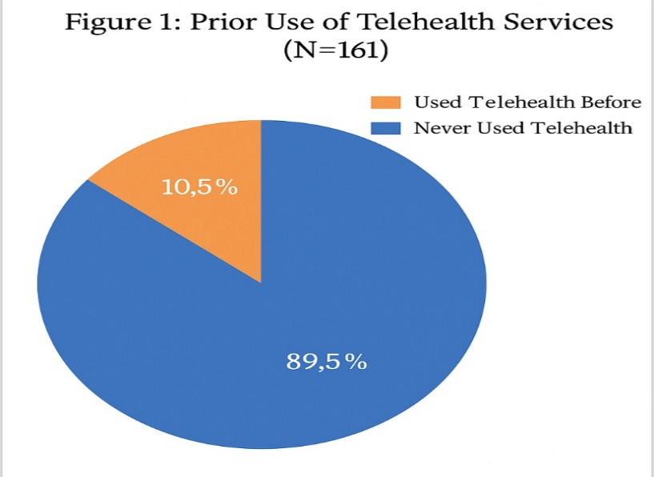

Figure 1. Prior Use of Telehealth Services (N=161)
The following pie chart, titled "Figure 1: Prior Use of Telehealth Services (N=161)," illustrates the distribution of participants based on their previous engagement with telehealth services. It shows that the majority of respondents, 89.5%, have never used telehealth, indicating limited adoption or potential accessibility barriers. In contrast, only 10.5% reported prior use of telehealth, reflecting a low uptake in this population. This visualization highlights a stark contrast in telehealth adoption, which may warrant further exploration in the research, particularly in terms of barriers to access, awareness levels, or demographic disparities in telehealth usage
3.3. Attitudes and Preferences Towards Telehealth
Despite this lack of experience, students liked the idea of telehealth. A large majority (74.1%) would prefer it for follow up, and 90.1% felt it was appropriate.
When asked how they'd like to connect, video calls came out on top. 'Video call' alone was the choice for 30.4%, and another 21.1% wanted a mix of phone and video. Clearly, seeing the provider matters 70.2% rated this as 'Important' or 'Very Important'.
3.4. Motivators, Concerns, and Expectations
What drives interest? Practicality. 'Convenience, Time saving, Accessibility, and Cost' (22%) was the top combination. What causes worry? Quality. 'Quality of care concerns & Lack of physical exam' (16%) and 'Lack of physical exam' alone (13%) were the biggest concerns. What do they expect? Primarily, 'Discussing follow up care' (24%). (See Figures 2, 3, and 4).
Figure 2. Factors Encouraging Telehealth Use (% of N=161)
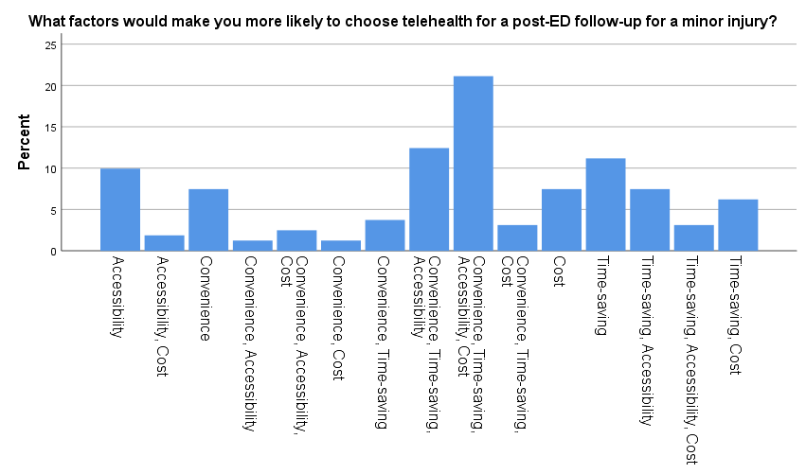
This bar chart presents data on the perceptions of 161 of our participants regarding which factors would make them most likely to choose Telehealth. The x-axis represents the number of responses, while the y-axis lists the various factors. We can see that the highest percentage of factors are (Convenience - time saving - Accessibility – Cost) with 22%, whereas the second highest percentage of factors is (Convenience - time saving - Accessibility) with 13% and the Third highest was Time Saving with 11%
Figure 3. Main Concerns About Telehealth Use (% of N=161)
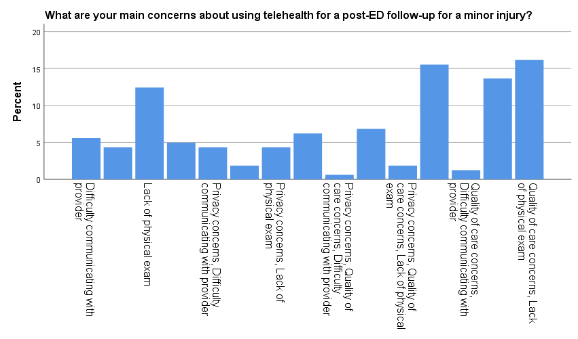
This bar chart presents data on the perceptions of 161 of our participants regarding which factors would make them concerned if they chose Telehealth. The x-axis represents the number of responses, while the y-axis lists the various concerned factors. We can observe that the highest concern was (Quality of care – lack of physical examination) with a percentage of 16% - whereas the second highest factor was Lack of physical examination with 13%, other less concerning factors presented like (Difficulty communicating with provider) with 5%
Figure 4. Expectations from Telehealth Follow Up (% of N=161)
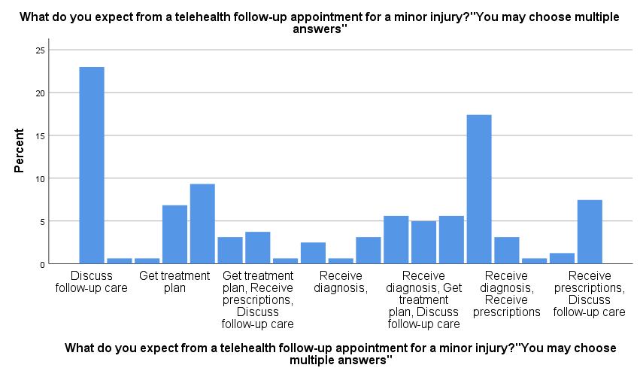
This bar chart presents data on the perceptions of 161 of our participants regarding which factors would make them most likely to choose Telehealth. The x-axis represents the number of responses, while the y-axis lists the various expected factors. It was very noticeable that the most expected factor was (Discuss follow-up care) with 24% of participants whereas the second highest expected factor was (Receive diagnosis - Receive prescription) with 17%

3.5. Key Associations (Chi Square Tests)
Our Chi Square tests showed that demographics do matter:
Age: Younger students found telehealth more appropriate (p=0.024).
Gender: Influenced how much seeing the provider mattered (p=0.020).
Nationality: Also linked to the importance of seeing the provider (p=0.020).
Department: Shaped what students expected from telehealth (p<0.001).
Year of Study: Linked to concerns (p=0.007) and seeing the provider (p=0.023).
ED Experience: Influenced expectations (p=0.038).
Follow Up History: Linked to perceived appropriateness (p=0.004).
3.6. Predictive Insights (MLR)
Our MLR models were strong. The model predicting appropriateness was particularly accurate (R2=0.935), showing that how much a student values video calls and seeing their provider strongly predicts if they think telehealth is suitable. Concerns were also predictable (R2=0.911). This tells us we can identify and potentially address the factors driving student choices.

4. Discussion
This study paints a vivid picture of university students in Northern Cyprus standing at a crossroads with telehealth. We see a strong pull towards the convenience it offers, yet a hesitant pause driven by inexperience and concerns about what virtual care might mean for quality. Let's delve deeper into these findings and what they signify for the future of healthcare in this setting.
Its undeniable students want convenience. The 74.1% preference for telehealth highlights a real demand for healthcare that fits their lives. This strongly echoes global trends where practicality often drives patient choices (9, 10). But this desire doesn't come without caveats. The shadow of concern looms large, focused squarely on the 'lack of physical examination' and 'quality of care'. Students are essentially asking: "Is this easier option as good?" This isn't a rejection of telehealth, but a call for reassurance. It tells us that simply offering a remote option isn't enough; we must prove its value and safety, and be very clear about when it is, and isn't, the right choice (4, 11).
The near 90% inexperience rate is perhaps our most significant finding. It means we are dealing with a population whose views are based on imagination, not interaction. This 'experience gap' is a major hurdle. People often fear what they don't know (12). The implication is clear: we need to create opportunities for students to try telehealth. Simple, low risk introductions perhaps through campus clinics could demystify the process. As other research suggests, a single positive experience can dramatically shift attitudes and encourage future use (13). We need to transform telehealth from an abstract idea into a familiar, trusted tool.
The strong preference for video calls and the high value placed on seeing the provider cannot be overstated. It speaks to a fundamental human need in healthcare: connection and trust. Seeing a provider's face, reading their expressions, and feeling 'seen' in return builds rapport in a way audio only cannot (14). Our MLR models confirm this isn't just a 'nice to have'; it's a predictor of whether students will accept telehealth. This is a crucial design directive: telehealth systems for students must feature high quality, reliable video as a core component. Furthermore, recognising that female students might value this visual link even more (p=0.020) allows for a more nuanced approach, perhaps ensuring providers are especially mindful of building rapport visually when consulting female students (15).
It makes sense that health students have different expectations they're learning the system from the inside. But this also flags a risk: are we leaving non-health students behind in understanding how to best use healthcare resources, including telehealth? Education about telehealth needs to be broad based. Similarly, the differences seen across nationalities and years of study remind us that students are not a monolith. They bring varied backgrounds and are at different stages of development. Our approach must be flexible and culturally sensitive (16).
What does this all mean for Northern Cyprus? It means there's a huge opportunity, but it requires thoughtful action.
Run campaigns that showcase telehealth, explain its use cases, and tackle concerns head on (17). Make it part of university orientation or health programs.
Don't cut corners on technology. Reliable, easy to use video platforms are essential (18).
Let students choose between virtual and in person, and be clear about when each is best.
Web side manner' matters. Train providers to connect and communicate effectively online (19).
Pilot programs can build confidence. Crucially, listen to student feedback and adapt.
Don't assume everyone has perfect tech. Be ready to support students facing digital hurdles (20).
By taking these steps, Northern Cyprus can build a telehealth system that truly works for its students.

5. Conclusion
University students in Northern Cyprus are clearly open, even eager, for the convenience that telehealth promises for post ED follow up. However, this interest is largely based on potential, not practice, and is held back by legitimate concerns about the quality and completeness of care without a physical presence. Our findings show that bridging this gap requires building trust in the technology, trust in the process, and trust in the remote provider relationship.
High quality video interaction emerges as a critical element in building this trust. By allowing students to see and connect with their providers, we can address some of the perceived impersonality of remote care. But beyond technology, we need focused education to demystify telehealth, set realistic expectations, and empower students to become confident users.
The path forward demands a student-centred approach. By listening to their preferences, addressing their concerns, and providing accessible, high quality platforms, Northern Cyprus can harness the power of telehealth, making healthcare more accessible and responsive for its vibrant and diverse student population. It is an investment not just in technology, but in the long-term health and success of the next generation.

6. Limitations
We believe our findings offer useful insights, but we also acknowledge some limitations:
Our 161-student sample, gathered via convenience methods and heavily weighted towards health students, might not perfectly represent all university students in Northern Cyprus. Larger, more randomized studies are needed.
This cross-sectional view tells us about now, but not how things change over time or what causes these views.
We relied on students' own reports, which can have biases.
Since most hadn't used telehealth, their views are largely hypothetical.
We looked only at minor injuries post ED; views might differ for other health needs.
We didn't measure students' access to technology or their digital skills.
Future research should aim for bigger, broader samples and follow students over time. Adding qualitative work interviews, focus groups would help us understand the 'why' behind the numbers, leading to even better telehealth solutions.
Disclaimer (Artificial intelligence)
Generative AI was used for grammer check and writing corrections
1. ChatGPT powered by OpenAI's GPT-4o model
2. Copilot powered by Microsoft's advanced large language models

7. References

- Telehealth.HHS.gov. Telehealth for follow-up care. [Online]. Available from: https://telehealth.hhs.gov/providers/best-practice-guides/telehealth-for-emergency-departments/telehealth-for-followup-care [Accessed: Aug 15, 2024].
- Harvard Business Review. The Telehealth Era Is Just Beginning. [Online]. 2022. Available from: https://hbr.org/2022/05/the-telehealth-era-is-just-beginning [Accessed: Aug 15, 2024].
- Shah VV, Villaflores CW, Chuong LH, Leuchter RK, Kilaru AS, Vangala S, et al. Association Between In-Person vs Telehealth Follow-up and Rates of Repeated Hospital Visits Among Patients Seen in the Emergency Department. JAMA Netw Open. 2022;5(10):e2237783.
- Moulaei K, Sheikhtaheri A, Fatehi F, Shanbehzadeh M, Bahaadinbeigy K. Patients’ perspectives and preferences toward telemedicine versus in-person visits: a mixed-methods study on 1226 patients. BMC Med Inform Decis Mak. 2023;23(1):248.
- Shigekawa E, Fix M, Corbett G, Roby DH, Coffman J. The Current State Of Telehealth Evidence: A Rapid Review. Health Aff (Millwood). 2018;37(12):1975–82.
- Napi NM, Zaidan AA, Zaidan BB, Albahri OS, Alsalem MA, Albahri AS. Medical emergency triage and patient prioritisation in a telemedicine environment: a systematic review. Health Technol (Berl). 2019;9(5):679–700.
- YODAK. Yükseköğretim Planlama, Denetleme, Akreditasyon ve Koordinasyon Kurulu - Home. [Online]. Available from: https://yodak.gov.ct.tr/en/ [Accessed: Aug 25, 2024].
- OpenEpi. OpenEpi - Toolkit Shell for Developing New Applications. [Online]. Available from: https://www.openepi.com/SampleSize/SSPropor.htm [Accessed: Aug 25, 2024].
- Barnett ML, et al. Trends in Telehealth Use in a Large Commercially Insured Population. Health Affairs. 2021;40(4):618-625.
- Ramaswamy A, et al. Barriers to Telehealth for Patients: A Systematic Review. BMC Health Serv Res. 2023;23(1):56.
- Toll K, Spark L, Neo B, Norman R, Elliott S, Wells L, et al. Consumer preferences, experiences, and attitudes towards telehealth: Qualitative evidence from Australia. PLoS One. 2022;17(8):e0273935.
- Almathami HKY, Win KT, Vlahu-Gjorgievska E. Barriers and Facilitators¹ That Influence Telemedicine-Based, Real-Time, Online Consultation Use at a Public Hospital: A Qualitative Study. JMIR Med Inform. 2020;8(11):e180.
- Donelan K, Barreto E, Sossong S, et al. Patient and Clinician Experiences² With Telehealth for Patient Follow-up Care. Am J Manag Care. 2019;25(1):40-4.
- Agboola S, et al. Patient Experiences of Telehealth: A Systematic Review. BMC Health Serv Res. 2020;20(1):212.
- Busey M, et al. Gender Differences in Telehealth Preferences: A Cross-Sectional Study. J Telemed Telecare. 2022;28(6):370-376.
- Hincapié MA, Gallego JC, Gempeler A, Piñeros JA, Nasiff-Hadad A, Escobar-Córdoba F. Telemedicine and telemental health in children and adolescents: a review of its effectiveness, implementation, and ethical considerations. BMC Psychiatry. 2020;20(1):358.
- Ollio J, Gyan A, Gyan E. Using Telehealth to Provide Behavioral Healthcare to Young Adults and College Students. Perspect Health Inf Manag. 2022;19(1):1e.
- Caffrey R, et al. Telehealth: A Review of Key Themes and Future Directions. J Healthc Manag. 2023;68(3):171-181.
- Sakumoto M, Jelinek R, Joshi AU. Identification of Gaps in Graduate Medical Education Telehealth Training. Telehealth Med Today. 2021;6(3).
- Phuongid J, Ordóñez P, Cao J, Moukheiber M, Moukheiber L, Caspi A, et al. Telehealth and digital health innovations:³ A mixed landscape of access. PLOS Digit Health. 2023;2(12):e0000401.
- Taylor ME, Lozy O, Conti K, Wacha-Montes A, Bentley KH, Kleiman EM. The Effectiveness of a Brief Telehealth and Smartphone Intervention for College Students Receiving Traditional Therapy: Longitudinal Study Using Ecological Momentary Assessment Data. JMIR Ment Health. 2022;9(6):e33750.
- University of Southern Queensland Repository. Understanding factors influencing adoption of mobile devices in telehealth: a quantitative study. [Online]. Available from: https://research.usq.edu.au/item/q5582/understanding-factors-influencing-adoption-of-mobile-devices-in-telehealth-a-quantitative-study [Accessed: Aug 18, 2024].
- Xu R, et al. Factors Influencing Telehealth Adoption in Rural Areas: A Literature Review. Telemed J E Health. 2022;28(5):697-707.
- Kanaziz KS, Jones HM. Assessing Acute Mild Traumatic Brain Injury via Telehealth. J Nurse Pract. 2024;20(1):104828.
- Khan MN, Altalbe A, Naseer F, Awais Q. Telehealth-Enabled In-Home Elbow Rehabilitation for Brachial Plexus Injuries Using Deep-Reinforcement-Learning-Assisted Telepresence Robots. Sensors (Basel). 2024;24(4):1273.
- Pavel M, Jimison HB, Wactlar HD, Hayes TL, Barkis W, Skapik J, et al. The role of technology and engineering models in transforming healthcare. IEEE Rev Biomed Eng. 2013;6:156–77.
- Herndon JH, Hwang R, Bozic KH. Healthcare technology and technology assessment. Eur Spine J. 2007;16(8):1293–302.
- Ye J. The role of health technology and informatics in a global public health emergency: Practices and implications from the COVID-19 pandemic. JMIR Med Inform. 2020;8(7):e19866.
- Dang A, Arora D, Rane P. Role of digital therapeutics and the changing future of healthcare. J Family Med Prim Care. 2020;9(5):2207–13.
30. Williams T, May C, Mair F, Mort M, Gask L. Normative models of health technology assessment and the social production of evidence about telehealth care. Health Policy (New York). 2003 Apr;64:39–54.

