Mathematical Modeling of HIV/AIDS Dynamics in Relation to Drug Abuse
Abstract - HIV/AIDS remains a significant public health concern, especially in regions where drug abuse is prevalent. Drug abuse facilitates HIV transmission through behaviours such as needle sharing and unsafe sexual practices. In this study, a mathematical model was formulated to investigate the co-dynamics of HIV/AIDS and drug abuse within a population. The model consists of seven compartments: susceptible individuals, protected individuals, HIV-infected individuals, drug abusers, dual-infected individuals, those under HIV treatment, and those undergoing rehabilitation. The model incorporates protection mechanisms and rehabilitation efforts aimed at controlling both epidemics. The basic reproduction numbers R₀ were derived using the Next Generation Matrix method to assess the threshold conditions for disease spread or elimination. Analytical results showed that the disease-free equilibrium is locally asymptotically stable when R_{C} < 1, indicating that both HIV and drug abuse can be controlled under appropriate interventions. Numerical simulations using Maple software further supported the analytical findings. An increase in protection and rehabilitation rates significantly reduced the number of drug abusers, HIV-infected individuals, and co-infections. These results emphasize the critical role of enhancing protection strategies and rehabilitation programs. The study highlights the importance of integrated public health interventions to effectively mitigate the dual burden of HIV/AIDS and drug abuse.
Keywords: HIV/AIDS, Drug Abuse, Rehabilitation, protection.

Introduction
HIV/AIDS is a chronic infectious disease caused by the Human Immunodeficiency Virus (HIV), which weakens the immune system and leaves individuals vulnerable to opportunistic infections and other complications [1,2]. The disease remains one of the leading global health challenges and continues to disproportionately affect sub-Saharan Africa, where it causes illness and death and places immense strain on healthcare systems [1,3]. In Kenya, the epidemic is a persistent concern, with a prevalence rate of about 4.5% [1]. The spread of HIV/AIDS is fueled by multiple factors, including unsafe sexual practices, limited access to preventive measures, stigma, and poverty [4]. One major behavioral factor that has emerged as a driver of transmission is drug abuse, particularly the misuse of substances such as alcohol, cannabis, heroin, and cocaine, which not only increase risky behavior but also directly facilitate HIV transmission through practices such as needle sharing [3,5].
According to the World Health Organization, millions of people continue to live with HIV/AIDS globally, with approximately 0.6 million deaths reported annually [6,7]. Despite advances in antiretroviral therapy (ART), which have improved life expectancy and reduced transmission in treated individuals, the epidemic persists, especially among populations with high levels of drug abuse [5,13]. Substance use is strongly associated with high-risk behaviors such as unprotected sex, multiple sexual partnerships, and non-adherence to ART, which together contribute to HIV persistence in vulnerable communities [3,8]. Over the past few years, different researchers have developed mathematical models to better understand and predict the dynamics of HIV/AIDS transmission, the impact of ART, and the role of behavioral interventions [9,10,12]. However, fewer models explicitly incorporate drug abuse dynamics despite its strong epidemiological connection with HIV transmission.
Author [6] focused on transmission networks and ART interventions, while authors [8] proposed a five-compartment drug abuse model using optimal control theory. These models provided important insights into treatment and relapse mechanisms, but they did not adequately capture the co-dynamics of HIV and drug abuse. Author [10] attempted to model the combined effects of HIV/AIDS and drug use in Turkana County, Kenya, by introducing dual-infected compartments. However, his framework lacked mechanisms to evaluate the influence of preventive protection measures and rehabilitation programs for drug abusers. Similarly, Authors [11] showed at the cellular level that chronic morphine use increases biological susceptibility to HIV infection, but their approach did not extend to population-level dynamics or intervention strategies. These limitations highlight the need for models that explicitly link HIV transmission with drug abuse and assess the potential effects of integrated control measures.
More recently, researchers have introduced fractional-order HIV models that capture memory effects and richer nonlinearity in the within-host dynamics. For instance, one study develops a fractional-order model of CD4⁺ T cells with recovery, establishing existence/uniqueness, stability, and Hopf bifurcation behavior and showing how the fractional order modulates persistence and oscillations [14]. A companion line of work extends CD4⁺ T-cell modeling by incorporating memory and external viral input from macrophages, performing sensitivity and bifurcation analyses to identify parameters that most strongly influence R0 and stability [15]. Complementing these CD4⁺ results, a macrophage-centered Caputo fractional model proves positivity/boundedness, derives R0, and demonstrates local/global stability with biologically interpretable sensitivity patterns for infection, bursting, and clearance rates [16]. Together, these studies show that fractional derivatives (memory) and cell-reservoir coupling (macrophage→T-cell transmission) materially affect stability thresholds and bifurcation structure, motivating our population-level co-dynamics model that links HIV transmission to drug abuse and integrated control.
Motivated by these gaps, the present study develops a seven-compartment deterministic model for the co-dynamics of HIV/AIDS and drug abuse. The compartments include susceptible, protected, HIV-infected, drug abusers, dual-infected, individuals under HIV treatment, and those in rehabilitation. The model incorporates both protection strategies (to reduce susceptibility and risky behaviors) and rehabilitation programs (to support recovery and reduce relapse) as explicit control measures. Analytical results establish the positivity and boundedness of solutions, derive reproduction numbers, and assess the local and global stability of both disease-free and endemic equilibria. Sensitivity analysis identifies the most influential parameters, while simulations illustrate the potential impact of increasing protection and rehabilitation on epidemic control. By integrating two interdependent epidemics within a unified framework, this study contributes to a deeper understanding of the dual burden of HIV/AIDS and drug abuse and provides insights for designing more effective, integrated public health interventions.

2 Model Formulation
The study develops a deterministic compartmental model to capture the dynamics of HIV/AIDS and drug abuse in a population. The population is divided into seven compartments. These compartments are Susceptible (S), Protected (P), Infected with HIV/AIDS(I_{H}), Drug Abuse population (I_{D}), dually infected with HIV/AIDS and also drug abusers (I_{HD}), Individuals under HIV/AIDS treatment (T_{H}), and finally individuals under rehabilitation for Drug abuse (R_{D}). The model applies some assumptions that are included in this chapter. Taking the population at time t, the total population is given by the expression.
N(t) = S + P + I_{H} + I_{D} + I_{HD} + T_{D} + R_{D}
The recruitment for the susceptible is at a rate π as a result of both birth and immigration. Those under treatment for HIV/AIDS (T_{H}) are assumed not to transmit the disease due to low viral load, while those under Rehabilitation for drug abuse can relapse at a rate α₂; those who recover from drug abuse do not leave the population but become susceptible at a rate σ₂. The susceptible are assumed to acquire drug abuse at the age of 15 due to peer influence at a rate β_{2.} At the same time, β₁ is the rate at which susceptible individuals become infected with HIV/ AIDS either by birth(children) or by sexual interaction with infected individuals. Control measures are put in place, such as sensitization and educational campaigns. The rate of susceptibility being protected is δ, and the ineffectiveness of the measures leads to individuals becoming infected with HIV/AIDS or Drug users at ω₁ and ω_{2,} respectively. The force of infection of HIV/AIDS is
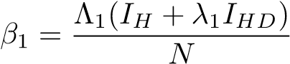
Where Λ₁ is the rate of contact of HIV/AIDS, and λ₁ accounts for the infectiousness of the infected individuals in the I_{HD} compartment. The individuals in I_{HD} have a higher viral load than those in I_{H}, hence higher infectious capabilities. Drug abuse increases at a rate.
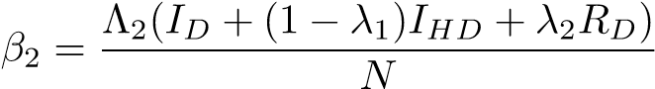
Where Λ₂ is the influence of I_{D,} I_{HD,} and R_{D} on the S, while 1 − λ₁ and λ₂ are the parameters of modification I_{HD} and R_{D,} which leads to an increase in I_{D} and I_{HD}
The natural death occurs across all the compartments at a rate µ. There is induced death due to HIV/AIDS and drug abuse at γ and ρ, respectively. Those infected with HIV/AIDS can become drug abusers as a result of stigmatization, discrimination, and depression at a rate of θ_{1.} In contrast, the drug users can get infected with HIV/AIDS as a result of factors such as reckless, immoral acts, sharing of needles, among others, at a rate θ₂ and therefore move from their respective compartment to I_{HD}. In I_{HD}, death can be a result of natural factors, drug abuse, or HIV/AIDS. Individuals infected with HIV/AIDS receive ARV and transition to treatment compartments at τ. Those infected with both HIV/AIDS and who are drug abusers can either transition to HIV/AIDS treatment or Rehabilitation (in rehabilitation, there is no treatment for HIV/AIDS) at the rates η₁ and η_{2,} respectively. The drug users transition to rehabilitation at α₁. Once those who have both infection and transition to rehabilitation are rehabilitated, they can go on with HIV/AIDS treatment at T_{H} at a rate σ₁.
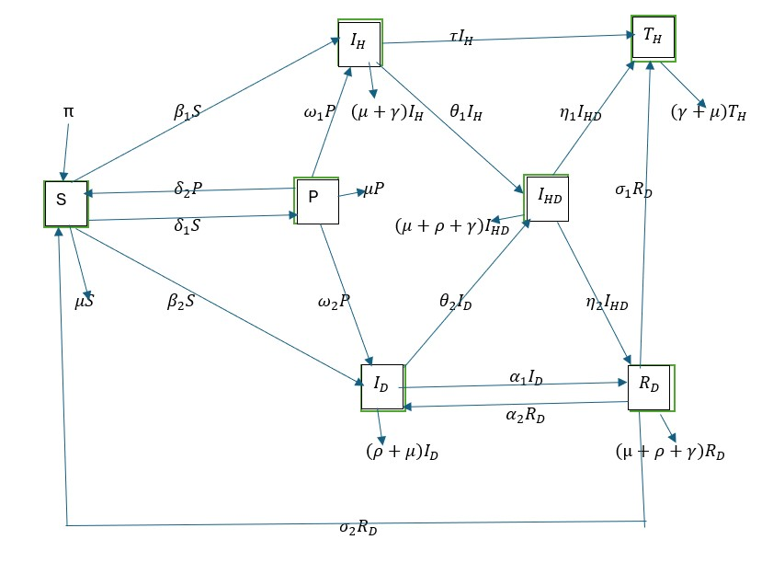
Figure 1: Flow of the model (source: Author's model)
The components used in the model are described in the table below.

VARIABLE | DESCRIPTION
S | Susceptible population
P | Protected population
I_{H} | Population infected with HIV/AIDS
I_{D} | Drug abuse population
I_{HD} | The population infected with HIV/AIDS who use drugs.
T_{H} | Population under HIV/AIDS treatment
R_{D} | Population under rehabilitation
Table 1: Description of the model Variables
The model applies the following assumptions
- The population is homogeneous.
- All individuals are susceptible to HIV/AIDS, but they become vulnerable to drug abuse from the age of 15 years due to peer influence.
- There is a possibility of being HIV/AIDS positive, but not a drug abuser or a drug abuser who is not HIV/AIDS positive.
- Those who undergo rehabilitation as a treatment method for Drug abuse can relapse.
- Since there is no permanent cure for HIV/AIDS, individuals living with HIV/AIDS may be more susceptible to drug abuse. At the same time, individuals who recover from drug abuse rehabilitation without relapse may become vulnerable to HIV/AIDS transmission..
- Those who are infected by HIV/AIDS and Drug abuse and are in rehabilitation, once they recover from Drug abuse, continue with HIV/AIDS treatment.
- Death in the model is a result of a natural course that all individuals are subject to; those with drug abuse problems can suffer Drug-attributable death, such as overdose, while those with HIV/AIDS die as a result of it. Those with both can succumb to either natural or HIV/AIDS-induced death or Drug-attributed death.
- Those under treatment for HIV/AIDS are assumed to have a low viral load and therefore do not spread the HIV/AIDS infection.
- Those infected with HIV/AIDS and are drug users, but are in denial of drug addiction, do not go for rehabilitation, but instead go for HIV/AIDS treatment only.

2.1 Model Equations
The following equations are derived from the model and used to analyses its dynamics.
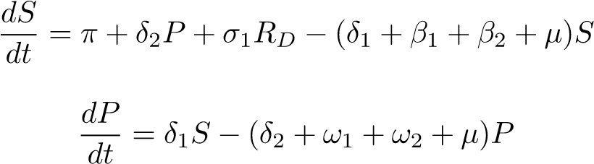
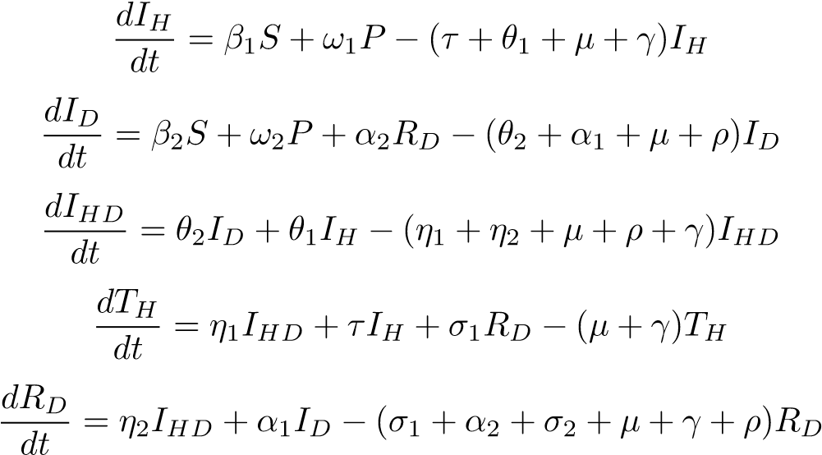

Results and Analysis

Invariant Region
Theorem: The model solutions are uniformly bounded for all time t > 0 if
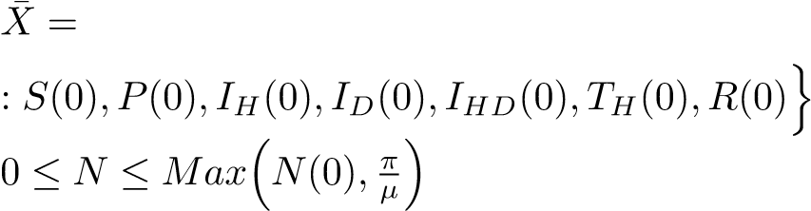
n
(S(t) + P(t) + I_{H}(t) + I_{D}(t) + I_{HD}(t) + T_{H}(t) + R_{D}(t) ∈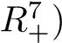
.
Proof: Taking the total population, as at time t, as
N(t) = S(t) + P(t) + I_{H}(t) + I_{D}(t) + I_{HD}(t) + T_{H}(t) + R_{D}(t)
Using the initial conditions
S (0) ≥ 0, P (0) ≥ 0, IH ≥ 0, ID (0) ≥ 0, IHD (0) ≥ 0, TH (0) ≥ 0 and R (0) ≥ 0 we Differentiate N(t) with respect to t;
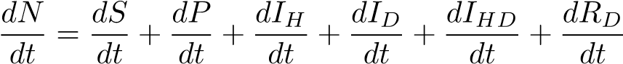 (2.1)
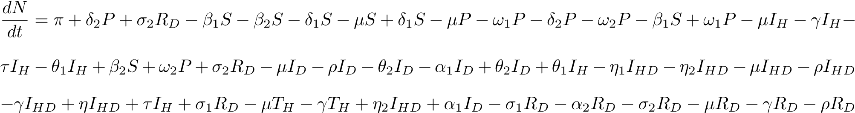
The equation can be simplified as
given that N = S + P + I_{H} + I_{D} + I_{HD} + T_{H} + R_{D} then the equation can be simplified to
(2.2)
In a state of no HIV/AIDS, then there are no HIV/AIDS-induced deaths, and therefore γ = 0, which further reduces the equation to
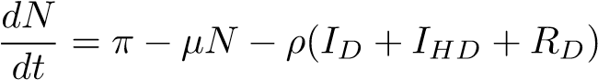
taking a situation where there is no drug abuse in the population, this translates to no drug abuse-caused deaths; therefore, ρ = 0. This further reduces the equation to
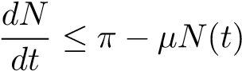 (2.3)
integrating the equation on both sides, we have
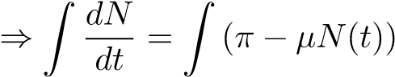 (2.4)
taking v = π − µN(t)
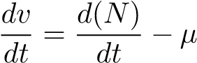
hence 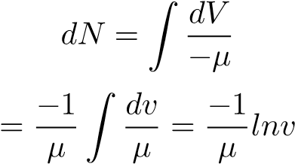
but
V = π − µ(N(t))
therefore
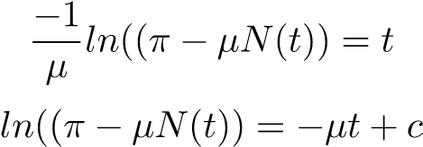
Introducing exponential on both sides, we have
_{e}(ln(π−µN)) = _{Fe}(−µt+c)
This then becomes
π − µ(N(t)) = e(−µt+c)
F = e^{c}
π − µ(N(t) = Fe^{(−µt)} (2.5)
From the equation above, we have
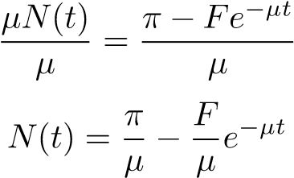
With t = 0 as the initial condition, we have t = 0 we have
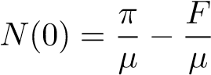
hence
F = π − µN(0)
When substituted, we have
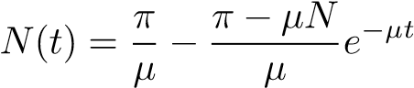
as t goes to ∞ we have t → ∞
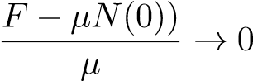
This shows that
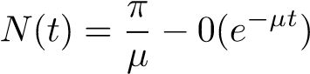
therefore
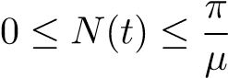 (2.6)
This proves that the model is bounded, therefore
(2.7)
therefore X¯ is invariant for all S ≥ 0, P ≥ 0, IH ≥ 0, ID ≥ 0, IHD ≥ 0, TH ≥ 0, R ≥ 0 [12]

Positivity
For a model to be epidemiologically meaningful, it must have non-negative values for all time (t).
Theorem: For all initial conditions S > 0, P > 0, IH > 0, ID > 0, IHD > 0, TH > 0, RD > 0 Then the solution
S, P, I_{H}, I_{D}, I_{HD}, T_{H}, R_{D} for all t ≥ 0 are positive.
Considering the equations of the model
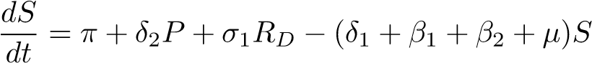
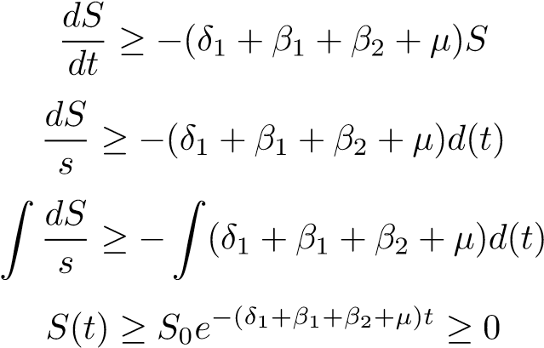 (2.8)
Applying the same method to the other equations, we have
P(t) ≥ P₀e−(δ2+ω1+ω2+µ) t ≥ 0 (2.9)
I_{D}(t) ≥ I_{D}0e−(θ2+α1+µ+ρ) t ≥ 0 (2.10)
I_{H}(t) ≥ I_{H}0e−(τ+θ1+µ+γ) t ≥ 0 (2.11)
I_{HD}(t) ≥ I_{HD}0e−(η1+η2+µ+ρ+γ) t ≥ 0 (2.12)
TH(t) ≥ TH0e−(µ+γ) t ≥ 0 (2.13)
R_{D}(t) ≥ R_{D}0e−(σ1+α2+σ2+µ+γ+ρ) t ≥ 0 (2.14)
From the equation as proven from 2.8, 2.9, 2.11, 2.10, 2.12, 2.13 and 2.14 that given the initial condition that S(T) ≥ 0, P(T) ≥ 0, I_{D}(t) ≥ 0, I_{H}(t) ≥ 0, I_{HD}(t) ≥ 0, T_{H}(t) ≥ 0 and R_{D}(t) ≥ 0 are non-negative at all t > 0 the equations system is positive

3.3 Diseases Free Equilibrium (DFE)
In the disease-free equilibrium state, the system of differential equations is evaluated at zero, reflecting a condition in which the population is entirely free from infection. Under this equilibrium, there are no individuals infected with HIV/AIDS, no cases of drug abuse, no co-infections, no individuals undergoing HIV/AIDS treatment, and no individuals recovering from drug addiction. The DFE is given by, therefore
At Disease free Equilibrium, then I_{H} = 0, I_{D} = 0, I_{HD} = 0, T_{D} = 0, RD. Therefore, the Disease Free Equilibrium is given by E∗ = (S∗, P∗, IH∗, ID∗, IHD∗, TH∗, RD∗)
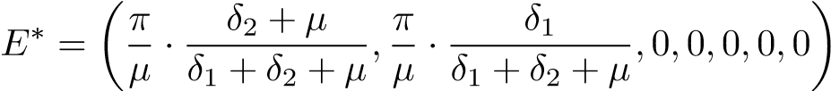

Local Stability of the Disease-Free Equilibrium
This is how the illness acts as it gets closer to the equilibrium point. The disease can be eliminated from the population if the reproduction number is less than one, R₀ < 1. Still, in a situation where the reproduction number is greater than one, the disease persists, R₀ > 1. The Jacobian matrix is used to determine the stability of the disease.
At disease-free Equilibrium
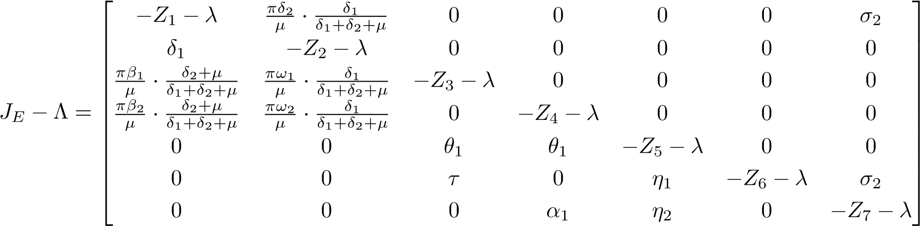
Then
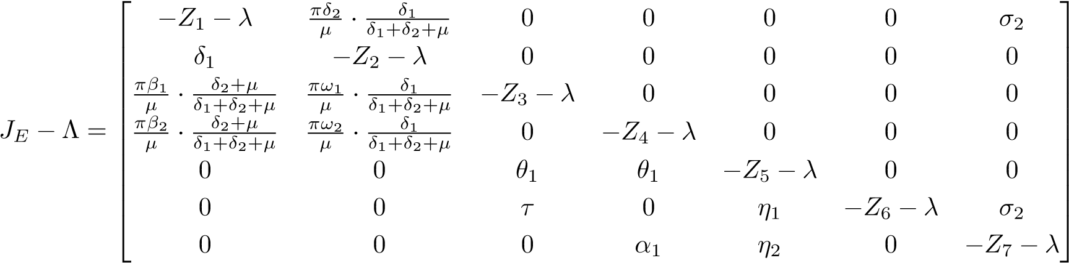
Where Z₁ = δ₁ + β₁ + β₂ + µ,Z₂ = δ₂ + ω₁ + ω₂ + µ,Z₃ = τ + θ₁ + µ + γ,Z₄ = θ₂ + α₁ + µ + ρ,Z₅ = µ + γ + ρ + η₁ + η₂,Z₆ = µ + γ and Z₇ = σ₁ + σ₂ + µ + γ + ρ
The eigenvalues of the matrix are
Λ₁ = −δ₁ − β₁ − β₂ − µ < 0
Λ₂ = −δ₂ − ω₁ − ω₂ − µ < 0
Λ₃ = −τ − θ₁ − µ − γ < 0
Λ₄ = −θ₂ − α₁ − µ − ρ < 0
Λ₅ = −µ − γ − ρ − η₁ − η₂ < 0
Λ₆ = −σ₁ − σ₂ − µ − γ − ρ < 0
Λ₇ = −µ − γ < 0
Following the principle in mathematical epidemiology,” the disease-free equilibrium is locally asymptotically stable if and only if R₀ < 1, which corresponds to all eigenvalues of the Jacobian evaluated at the DFE have negative real parts.” [13]
The system is asymptotically locally stable since the eigenvalues are negative or smaller than zero.

Global Stability of Disease-Free Equilibrium
Theorem: If the R₀ < 1, then the Disease-Free Equilibrium is globally stable asymptotically.
Proof: using the Lyapunov function technique
- Global stability of HIV/AIDS
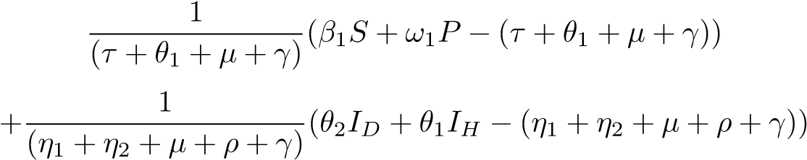
Taking the negatives on one side, we have
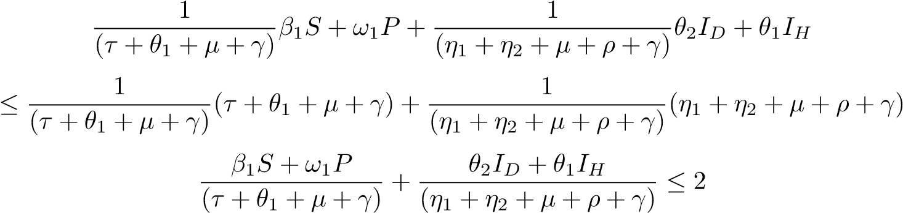
The controlled reproduction number of HIV/AIDS is 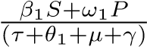 then,

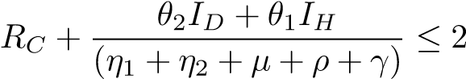
Therefore 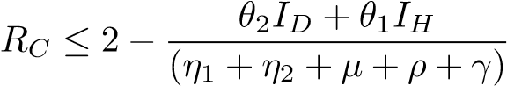

This shows that RC ≤ 1,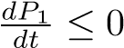 hence the disease-free equilibrium for HIV/AIDS is globally asymptotically stable.
- Global stability for Drug Abuse
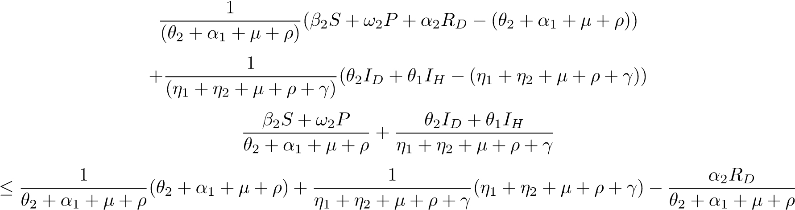
then
since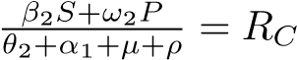 then
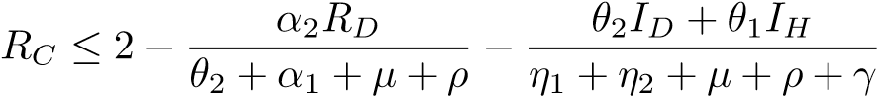
Therefore, RC ≤ 1,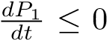 hence the disease-free equilibrium for Drug Abuse is globally asymptotically stable.

Basic Reproduction Number (R₀)
The reproduction number is the number of secondary infections originating from one primary infection. With control measures such as protection, we have control over the reproduction number. In this research, there are two control reproduction numbers for HIV and AIDS, and another for Drug Abuse. Taking the infectious compartments as I_{H}, I_{D}, and I_{HD}

Basic Reproduction Number of HIV&AIDS
Therefore, when considering HIV & AIDS, the infectious compartments are I_{H} and I_{HD}
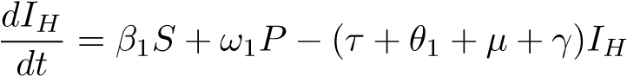
and
Taking Q to represent the new infection and L to represent the transmission of HIV &AIDS in the infectious compartment.
The reproduction number will be given by QL^{−1;} therefore, the reproduction is given byQL⁻¹ therefore
= 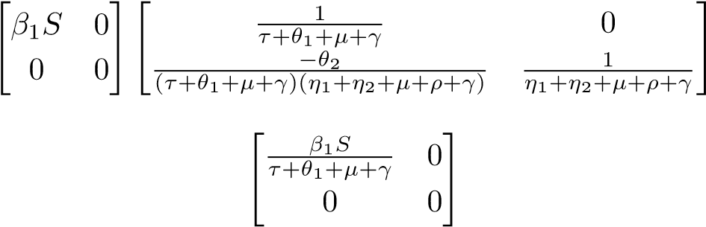
hence, the Reproduction number for HIV& AIDS is
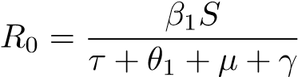 (2.15)
The reproduction is given byQL⁻¹ therefore
= 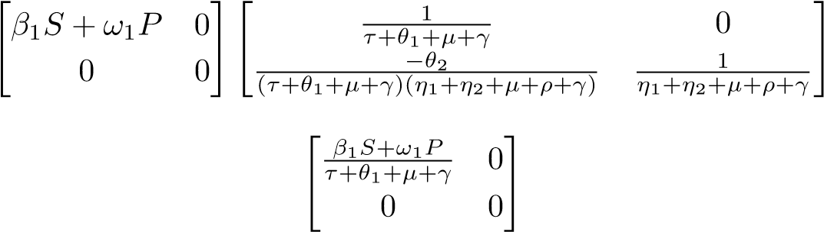
Therefore, the control reproduction number of HIV& AIDS is
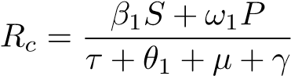 (2.16)

Basic Reproduction Number of Drug Abuse
The reproduction number of Drug abuse is calculated considering the I_{D} and I_{HD}. The equations of the compartments are
Taking Q to represent the new infection and L to represent the transmission of Drug abuse in the infectious compartment.
The reproduction number will be given by QL⁻¹ therefore Taking the inverse of R, we have QL⁻¹ is therefore given by
= 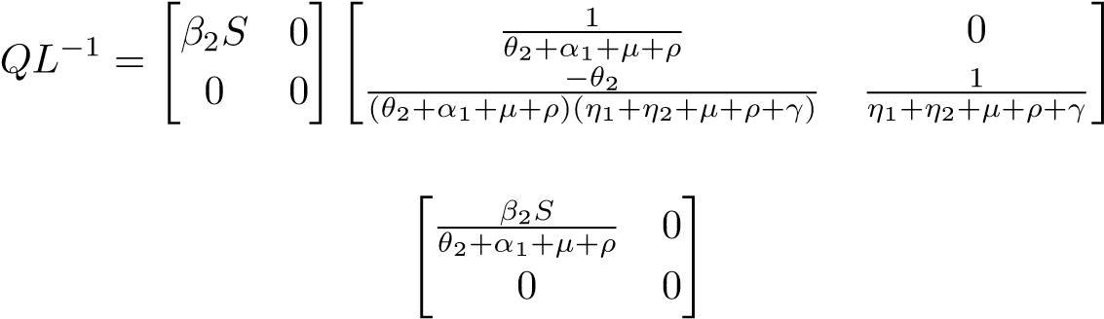
Therefore, the reproduction number of Drug Abuse is
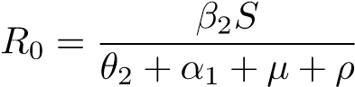 (2.17)
The control reproduction number for Drug Abuse is QL⁻¹, therefore
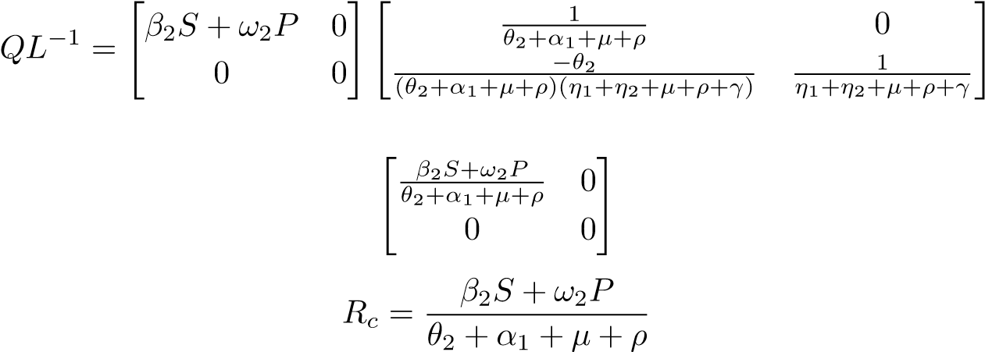
=
(2.18)

Endemic Equilibrium
When at least one of the infectious compartments is not equal to zero, the disease will persist in the population. At equilibrium, the rate of change in the compartments is Zero, and the system is written as follows. Taking the endemic equilibrium point as E₀. Then
E₀ = (S0, P0, IH0, ID0, IHD0 , TH0, RD0)
0 = π + δ₂P + σ₁R_{D} − (δ₁ + β₁ + β₂ + µ) S
0 = δ₁S − (δ₂ + ω₁ + ω₂ + µ) P
0 = β₁S + ω₁P − (τ + θ₁ + µ + γ) IH
0 = β₂S + ω₂P + α₂R_{D} − (θ₂ + α₁ + µ + ρ) ID
0 = θ₂I_{D} + θ₁I_{H} − (η₁ + η₂ + µ + ρ + γ) IHD
0 = η₁I_{HD} + τI_{H} + σ₁R_{D} − (µ + γ) TH
0 = η₂I_{HD} + α₁I_{D} − (σ₁ + α₂ + σ₂ + µ + γ + ρ) RD
Then the Endemic Equilibrium point is
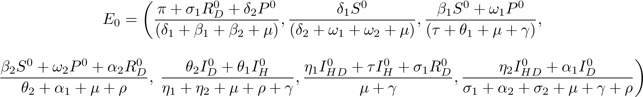

Stability of Endemic Equilibrium Point
The stability of the Endemic Equilibrium is investigated using the Lyapunov function. The choice of Lyapunov function in this study is guided by standard methods in epidemiological modeling [13]. The function is constructed as a sum of convex functions of each state variable, ensuring non-negativity and differentiability. This choice is not arbitrary, as it reflects deviations of each compartment from equilibrium values and guarantees that the Lyapunov function attains its minimum only at the equilibrium point. The function is viewed as
Q = (S∗,P∗,I_{H∗},I_{D∗},I_{HD∗},T_{H∗},R_{D∗}) = (S − S∗ − S∗lnS) + (P − P∗ − P∗lnP)
+(IH − IH∗ − IH∗lnIH) + (ID − ID∗ − ID∗lnID) + (IHD − IHD∗ − IHD∗lnIHD)
+(TH − TH∗ − TH∗lnTH + (RD − RD∗ − RD∗lnRD)
Taking the differentiation of both sides, we have
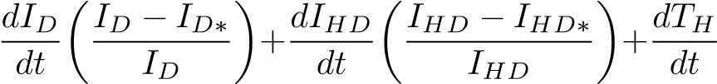
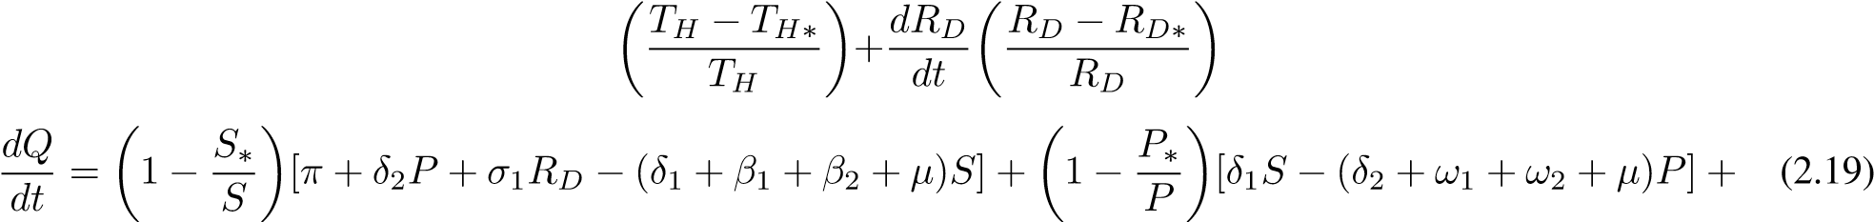
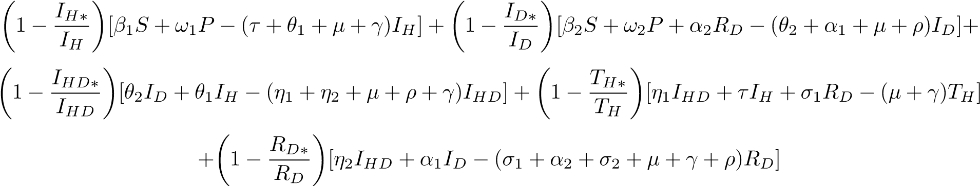
The equation 20 above can be simplified.
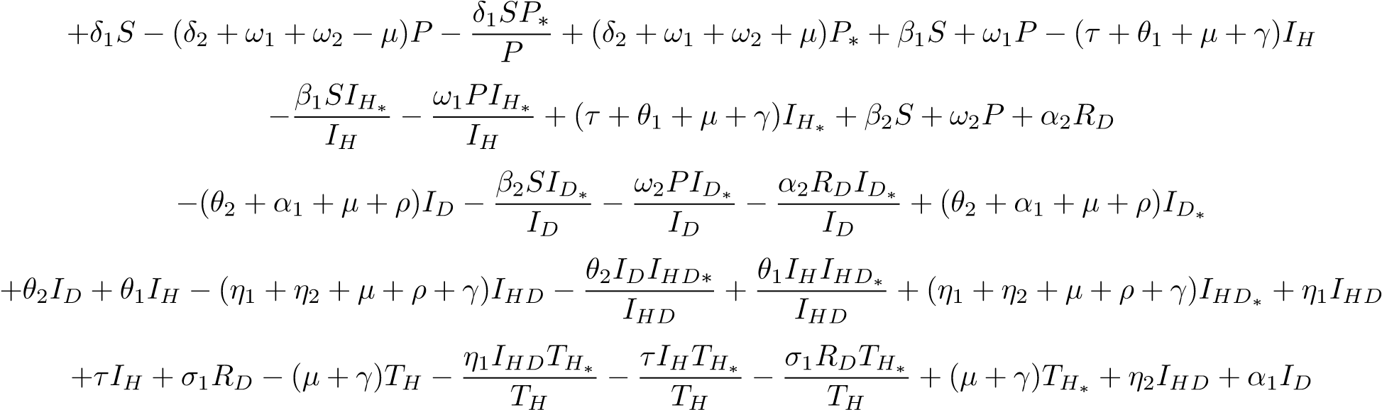
(2.20)
Rearranging the equations, we have
+β₁S + ω₁P(τ + θ₁ + µ + γ)I_{H∗} + β₂S + ω₂P + α₂R_{D}+(θ₂ + α₁ + µ + ρ)I_{D∗} + θ₂I_{D} + θ₁I_{H} + (η₁ + η₂ + µ + ρ
+γ)IHD∗ + η1IHD + τIH + σ1RD + η2IHD + α1ID + (σ1 + α2 + σ2 + µ + γ + ρ)RD∗
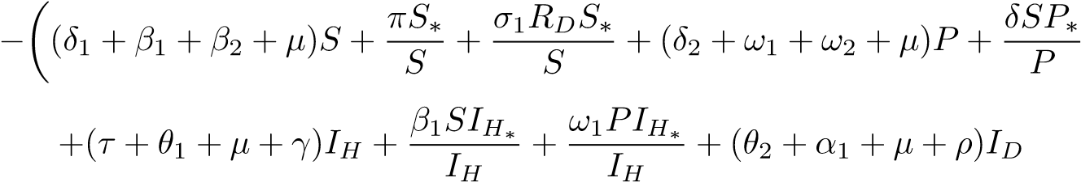
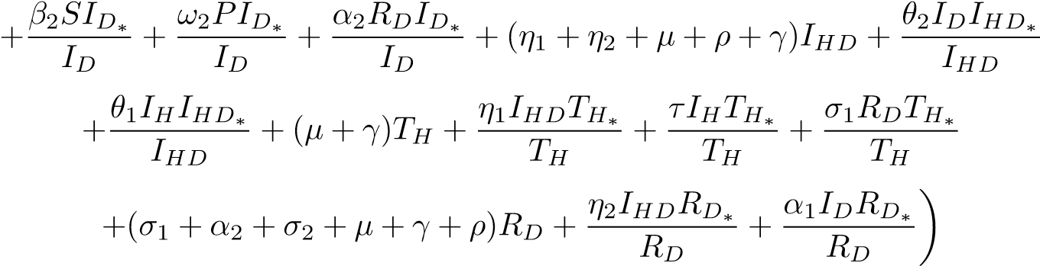 (2.21)
Using W and R to represent the positive and negative terms, respectively, we have
(δ₂ + ω₁ + ω₂ + µ)P∗ + β₁S + ω₁P(τ + θ₁ + µ + γ)I_{H∗} + β₂S + ω₂P + α₂R_{D}+
(θ2 + α1 + µ + ρ)ID∗ + θ2ID + θ1IH + (η1 + η2 + µ + ρ + γ)IHD∗ + η1IHD + τIH + σ1RD + η2IHD + α1ID+
(σ₁ + α₂ + σ₂ + µ + γ + ρ)R_{D∗}
And
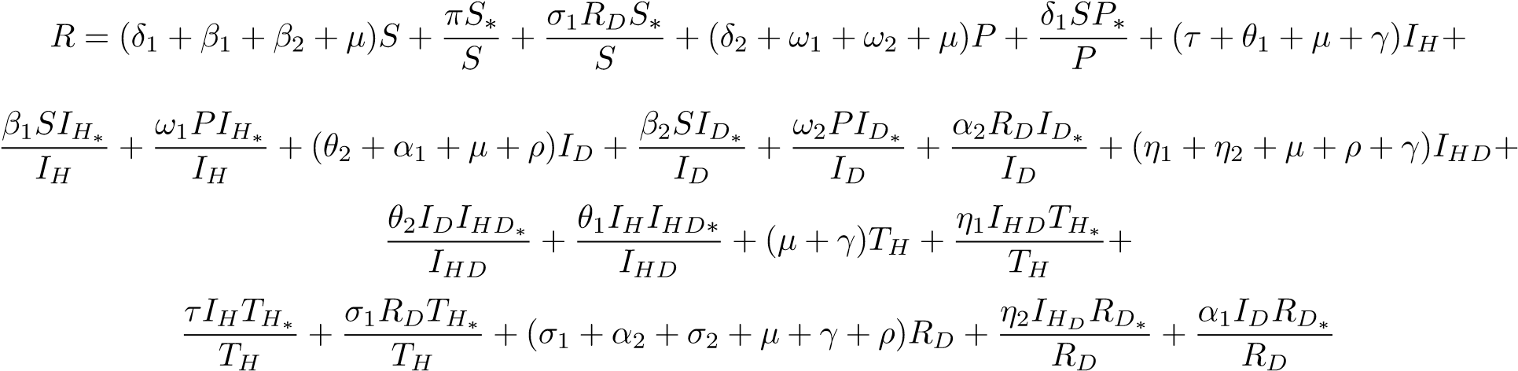
Therefore
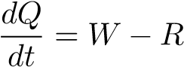
Using the conditions if W < R, then 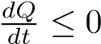 If and only if S = S∗,P = P∗,I_{H} = I_{H∗},I_{D} = I_{D∗},I_{HD} = I_{HD∗}, T_{H=} $T_{H}^{*}, R_{D}=R_{D}^{*}$ then
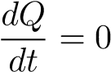
This indicates that the highest invariant set in
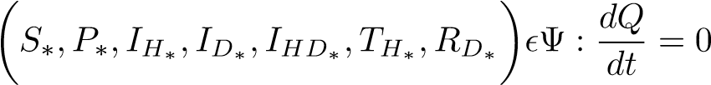
Therefore 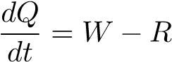
Using the conditions if W < R, then If and only if S = S∗,P = P∗,I_{H} = I_{H∗},I_{D} = I_{D∗},I_{HD} = I_{HD∗},∗, T_{H=} $T_{H}^{*}, R_{D}=R_{D}^{*}$ then
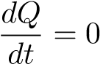
This indicates that the highest invariant set in
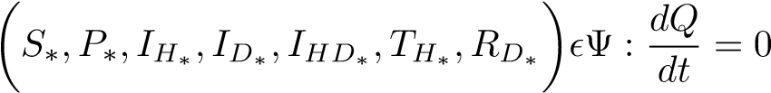
The Endemic Equilibrium Point E₀ is globally asymptotically stable in the invariant set if W < R

Sensitivity Analysis
In this subsection, we focus on the importance of each parameter on HIV/AIDS and drug abuse by looking at the effectiveness of the control reproduction number. We use the variable normalized forward sensitivity, which is differentiable and relies on parameters. The Reproduction number sensitivity analysis index,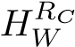, is given by
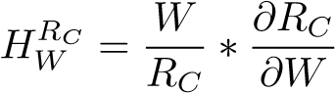 (2.22)
where W is taking the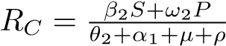 for drug Abuse and

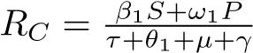 for HIV/AIDS and their respective R_{C} at DFE as
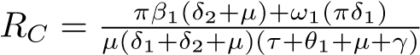 and
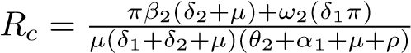
Finding the sensitivity of π we have
(2.23)
But the terms in the brackets are the same as R_{C}, then 2.23 is reduced to
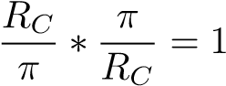
and therefore, the sensitivity of π = 1 when the other parameters are calculated, the following are their respective sensitivities.
PARAMETER | SENSITIVITY
π | + 1.00
µ | -1.145
γ | -0.252
θ₁ | -0.700
θ₂ | -0.729
τ | -0.032
α₁ | -0.1212
α₂ | -0.0285
ρ | -0.0643
ω₁ | +0.899
ω₂ | +0.996
β₁ | +0.0245
β₂ | +0.051
δ1 | +0.179
Table 2: Sensitivity indices of parameters on R_{C}
From Table 2, it can be deduced that when the infectious rate of the susceptible (β₁ and β₂) increases, the HIV/AIDS and drug abuse rates increase while other factors are held constant. When µ.γ,θ₁,θ₂,τ,α_{1,} α2, and ρ are increased, RC decreases, but when π,ω1, δ, and ω2 are increased, the RC also increases; hence, they are the most delicate parameters.

Numerical Simulation
The simulations were carried out using Maple software, which numerically solved the system of differential equations and generated the corresponding graphs. The analysis is based on the assumed initial conditions: S (0) = 800000, P(0) = 50000, $I_{D}(0)$= 30000, $I_{H}(0)$= 50000$,I_{HD}(0)$= 30000, $T_{H}(0)$= 20000, and $R_{D}(0)$= 20000. These conditions reflect the population distribution across the seven compartments at time zero and form the basis for exploring disease transmission and control strategies.
PARAMETERS | VALUE | SOURCE
π | 0.0397 | World Bank 2017
β₁ | 0.04 | Kenya HIV estimate 2015
β₂ | 0.06 | NACADA 2017
δ | 0.1200 | Estimated
ω₁ | 1.1100 | Estimated
ω₂ | 0.0800 | Estimated
θ₁ | 0.8333 | [10]
θ₂ | 0.1700 | [10]
τ | 0.0390 | [10]
η₁ | 0.9008 | [10]
η₂ | 0.0962 | [10]
σ₁ | 0.5200 | Estimated
σ₂ | 0.3142 | [14]
α₁ | 0.02827 | [14]
α₂ | 0.0005 | [10]
µ | 0.0200 | WHO 2015
γ | 0.300 | [15]
ρ | 0.015 | [10]
Table 3: Parameters, values, and source
Where parameter values were listed as estimated, they were chosen based on values used in related epidemiological models [refs] and adjusted to ensure biological plausibility within the Kenyan context.

HIV/AIDS and Drug Abuse dynamics in the population
Figure 2 presents the interrelationship among the various epidemiological compartments, namely: the susceptible population, protected individuals, those infected with HIV/AIDS (I_{H}), individuals engaged in drug abuse (I_{D}), those co-infected with both HIV/AIDS and drug abuse (I_{HD}), individuals undergoing treatment for HIV/AIDS, and those in rehabilitation for drug abuse. The graphical trends demonstrate that an increase in rehabilitation efforts is associated with a decline in the drug-abusing population. Likewise, enhanced treatment coverage for HIV/AIDS is correlated with a reduction in the HIV-infected cohort. Moreover, the size of the co-infected population (I_{HD}) exhibits a direct dependence on the magnitudes of both I_{H} and I_{D}; as the prevalence of HIV infection and drug abuse declines, the number of individuals simultaneously affected by both conditions also diminishes accordingly.
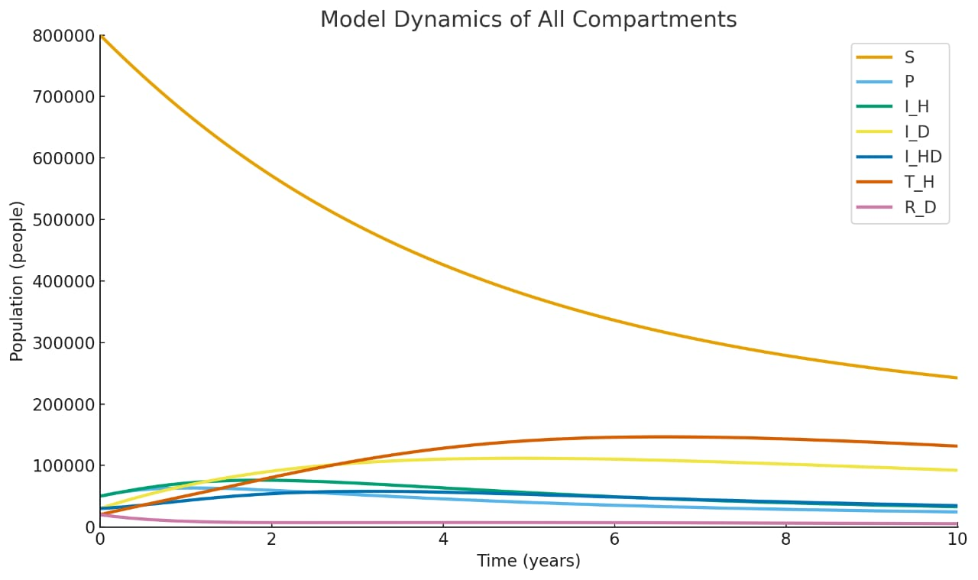
Figure 2: Graph of the model, source: Author's model

Effect of protection on HIV/AIDS and Drug abuse
Graph 3 illustrates how varying the protection rate ω₁ influences the population of HIV-infected individuals (I_{H}). As ω₁ increases from 0.5 to 1.0 and then to 1.5, the number of infected individuals decreases rapidly over time. A higher protection rate leads to a steeper decline in the I_{H} compartment, demonstrating that adequate protective measures, such as condom use and education, significantly reduce HIV/AIDS transmission. This emphasises the importance of strong preventive strategies in slowing the spread of HIV/AIDS and reducing the infected population within a short time.

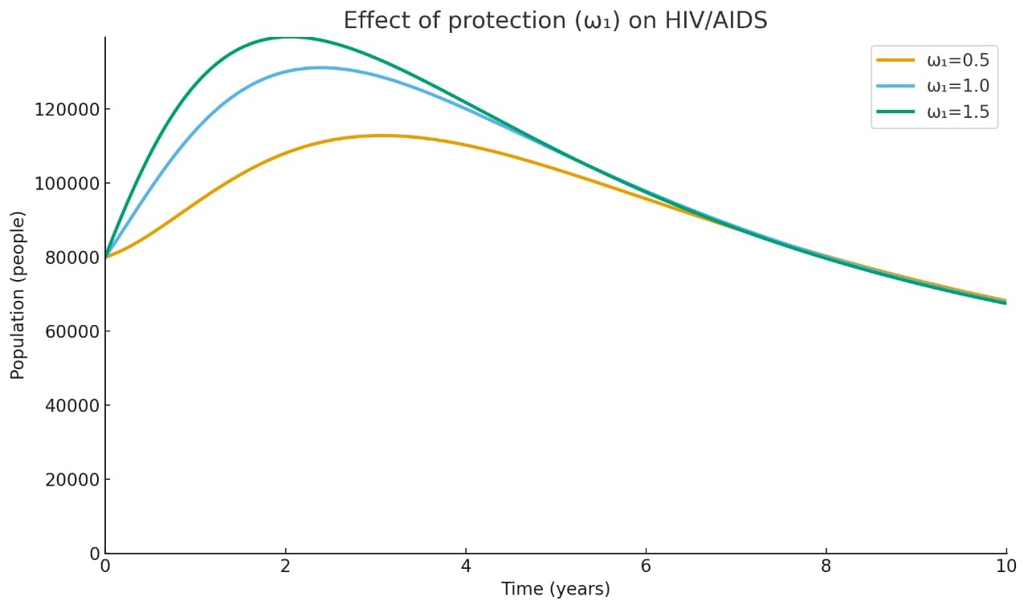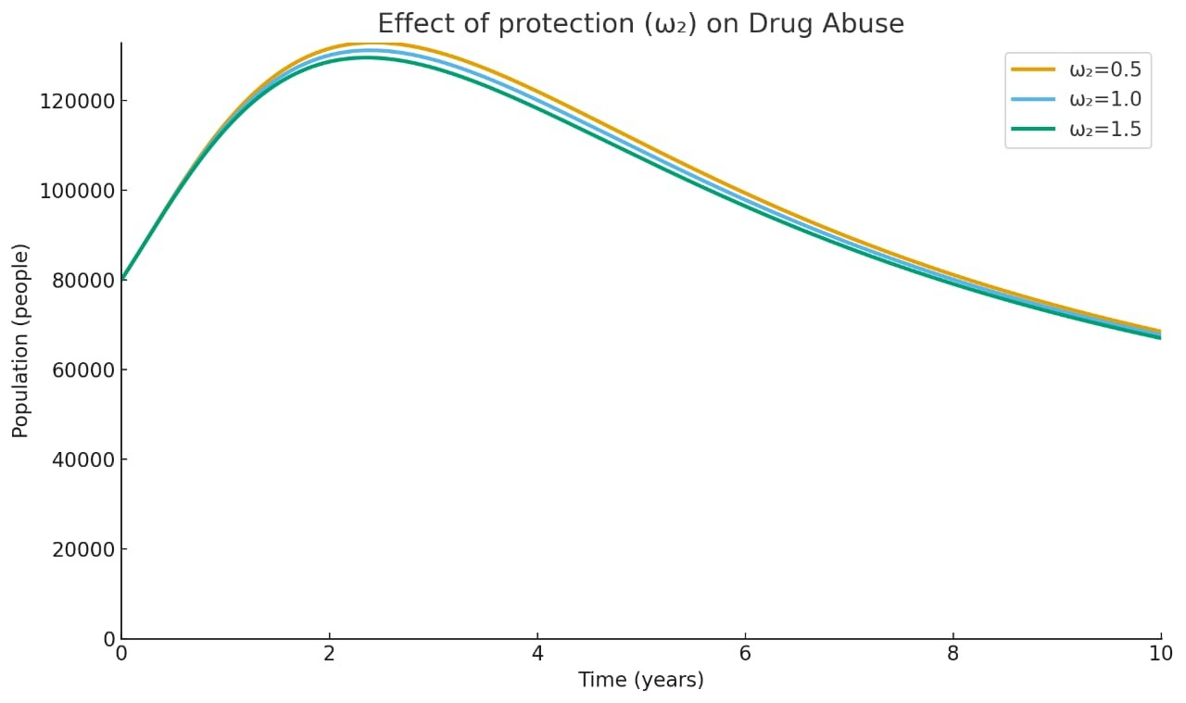
Figure 3: Effect of protection on HIV/AIDS source; Author's model | Figure 4: Effect of Protection on Drug Abuse source; Author's model
Frame.
Graph 4 shows the impact of the protection rate ω₂ on the number of drug abusers (ID). As ω₂ increases, the I_{D} population declines more quickly. The curve for ω₂ = 1.0 exhibits the steepest drop, indicating that higher protection results in faster drug abuse control. Although all curves eventually stabilise, higher protection significantly reduces peak drug abuse levels and shortens the duration of widespread use. This suggests that enhanced protective interventions, like public awareness and policy enforcement, are essential in reducing drug addiction rates and related societal impacts.

3 Effect of α₁ on Drug Abuse and Rehabilitation Compartments
Figure 5 illustrates the impact of varying the rehabilitation rate α₁ on the number of rehabilitated individuals (RD) over time. With parameters α₁ = 0.01000, 0.02827, and 0.5000, it is evident that higher rehabilitation rates lead to a sharper rise in RD, reaching higher peaks more quickly. The curve for α₁ = 0.5 shows the most significant increase, indicating
that more drug abusers are successfully transitioned into rehabilitation. This demonstrates that increasing α₁, the rate at which drug users receive help, significantly boosts the rehabilitation process and reduces prolonged addiction.
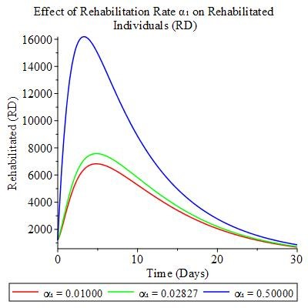
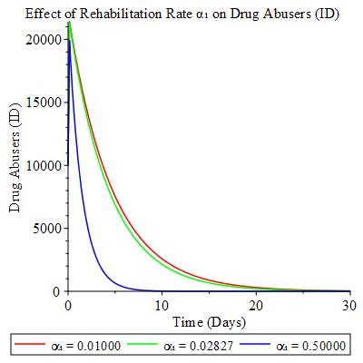
Figure 5: effect of α₁ on drug abuse, source: Author's model.
Figure 6: Effect of α₁ on Rehabilitation, source: Authors' model

Figure 6 illustrates how different rehabilitation rates (α₁ = 0.0100, 0.028270, and 0.50000) influence the decline of drug abusers (ID) over time. Higher values ofα₁ result in a faster and more pronounced reduction in the ID population. The curve for α₁ = 0.50000 shows the sharpest decline, indicating highly effective rehabilitation. This reduction in drug abuse not only curbs addiction but also significantly lowers the risk of HIV transmission via drug-related behaviors. Therefore, enhancing rehabilitation efforts plays a critical dual role in managing drug abuse and preventing HIV/AIDS.
- Discussion
The mathematical model developed in this study provides important insights into the interplay between HIV/AIDS transmission and drug abuse. By incorporating both protection strategies and rehabilitation mechanisms, the model captures key behavioral and structural factors that influence the dual epidemics. The analysis demonstrated that the model is mathematically well-posed, with solutions shown to be both positive and bounded. The equilibrium analysis revealed that when the control reproduction numbers are less than unity, the disease-free equilibrium is locally and globally asymptotically stable, indicating the potential for effective control of HIV/AIDS and drug abuse through appropriate interventions. Conversely, when reproduction numbers exceed one, the system converges to an endemic equilibrium, suggesting the persistence of the dual burden in the absence of strong interventions.
The sensitivity analysis further highlighted parameters with the greatest influence on disease dynamics. Recruitment rate (π) was positively associated with epidemic growth, while natural death rate (µ) strongly reduced transmission. Importantly, the protection parameters (ω₁ and ω₂) and the rehabilitation rate (α₁) were found to be critical levers for controlling both HIV/AIDS and drug abuse. These findings emphasize that strengthening public health measures that promote protection—such as condom use, harm-reduction strategies, and public awareness campaigns—together with scaling up rehabilitation programs, can significantly mitigate the spread of infection and drug dependence.
Numerical simulations supported the analytical findings. Increasing protection rates led to steeper declines in HIV-infected and drug-abusing populations, while higher rehabilitation rates accelerated recovery and reduced relapse, thereby lowering the number of individuals in the drug abuse compartment. These results underline the importance of integrated intervention strategies that address both epidemics simultaneously rather than in isolation.
Despite its contributions, this study is subject to several simplifying assumptions. Individuals on antiretroviral therapy (ART) were assumed not to transmit HIV, although in reality, ART substantially reduces but does not fully eliminate infectiousness. Relapse after rehabilitation was represented by a single constant rate, whereas in practice, relapse is influenced by complex social, psychological, and environmental factors. Furthermore, the model did not account for ART resistance, which is increasingly recognized as an important challenge for long-term HIV/AIDS management. These assumptions were made to preserve analytical tractability and highlight the core interactions between HIV/AIDS and drug abuse. Future research could extend the model by considering partial infectiousness under ART, more detailed relapse dynamics, and the emergence of drug resistance, thereby offering a more comprehensive understanding of the dual epidemics.

Conclusion
This study formulated and analyzed a seven-compartment deterministic model describing the co-dynamics of HIV/AIDS and drug abuse. The model incorporated protection and rehabilitation as explicit interventions and demonstrated, both analytically and numerically, that increasing these strategies can drive the system towards a disease-free equilibrium. Sensitivity analysis confirmed the pivotal role of protection and rehabilitation parameters, highlighting them as effective policy levers.
Biologically, the results suggest that integrated approaches combining preventive measures and rehabilitation programs are more effective than single interventions in reducing the dual burden of HIV/AIDS and drug abuse. By linking behavioral dynamics with disease transmission, the study provides a framework for designing targeted interventions in resource-limited settings.
While the assumptions of the model introduce certain limitations, they also lay a foundation for future refinements. Extending the model to include ART resistance, more realistic relapse processes, and partial infectiousness of treated individuals would enhance its applicability to real-world settings. Nevertheless, the present analysis contributes significantly to the growing body of mathematical epidemiology literature by offering a tractable yet informative framework for understanding and mitigating two interdependent public health crises.
- Data Availability
The article has data that were utilized to bolster these conclusions.
- Conflict of interest
The authors affirm that there is no conflict of interest with respect to the article’s publication.

Disclaimer (Artificial intelligence)
Option 1:
Author(s) hereby declare that NO generative AI technologies such as Large Language Models (ChatGPT, COPILOT, etc.) and text-to-image generators have been used during the writing or editing of this manuscript.
Option 2:
Author(s) hereby declare that generative AI technologies such as Large Language Models, etc. have been used during the writing or editing of manuscripts. This explanation will include the name, version, model, and source of the generative AI technology and as well as all input prompts provided to the generative AI technology
Details of the AI usage are given below:
1.
2.
3.

REFERENCES
- Verma A, Bhatt SM, Singh A, Dwivedi P. Hiv: An introduction. Textbook on molecular biotechnology. Delhi: IK International Publishing House Pvt. Ltd.; 2009. p. 853–878.
- Bassey E. Dynamic optimal control model for dual-pair treatment functions of dual delayed HIV-pathogen infections. Journal of Mathematical Sciences: Advances and Applications. 2018;51(1):1–50.
- World Health Organization, Substance abuse, https://www.afro.who.int/healthtopics/substance-abuse, Accessed: 2025-03-29.
- Kapila A, Chaudhary S, Sharma R, Vashist H, Sisodia S, Gupta A. A review on: HIV AIDS. Indian Journal of Pharmaceutical and Biological Research. 2016;4(3):69–73. DOI:10.30750/ijprb.4.3.11.
- Odejide A. Status of drug use/abuse in Africa: A review. International Journal of Mental Health and Addiction. 2006; 4:87–102. DOI:10.1007/s11469-006-9015-y.
- Espitia MC, de Castro A, Meyer JF. HIV/AIDS mathematical model of triangle transmission. Viruses. 2022;14(12):2749. DOI:10.3390/v14122749.
- Kariuki P, Omariba M, Motari J. Addressing the burden of alcohol and drug abuse. 2024.
- Anggriani N, Toaha S, Kasbawati K. Optimal control of mathematical models on the dynamics spread of drug abuse. Jurnal Matematika, Statistika dan Komputasi. 2021;17(3):339–348. DOI:10.20956/jmsk.v17i3.11713.
- World Health Organization, Hiv prevention, https://www.who.int/teams/global-hivhepatitis-and-stis-programmes/hiv/prevention, Accessed: 2025-03-29.
- Lokaran E. A mathematical model for the effects of drug abuse in transmission of HIV/AIDS in Turkana County. PhD Thesis, University of Nairobi; 2020.
- Bloomquist A, Vaidya NK. Modelling the risk of HIV infection for drug abusers. Journal of Biological Dynamics. 2021;15(sup1):S81–S104. DOI:10.1080/17513758.2021.1882362.
- Alfiniyah C, Puspitasari A, Fatmawati F. Mathematical modelling of drug abuse reduction strategies taking into account the treatment type and risks level. Jambura Journal of Biomathematics. 2023;4(1):23–30. DOI:10.34312/jjbm.v4i1.14263.
- Bassey BE, Henry AO. Global stability analysis of the role of antiretroviral therapy (ART) abuse in HIV/AIDS treatment dynamics. Pure and Applied Mathematics Journal. 2021;10:9–31. DOI:10.11648/j.pamj.20211001.12.
- Sardar P., Das K.P., Biswas S. Mathematical study of a fractional order HIV model of CD4⁺ T-cells with recovery. Journal of Applied Mathematics and Computing. 2025;71:1419–1457. DOI: 10.1007/s12190-024-02274-2.
- Sardar P., Biswas S., Das K.P., Sahani S.K., Gupta V. Stability, sensitivity, and bifurcation analysis of a fractional-order HIV model of CD4⁺ T cells with memory and external virus transmission from macrophages. The European Physical Journal Plus. 2025;140:160. DOI: 10.1140/epjp/s13360-025-06081-x.
- Sardar P., Biswas S., Das K.P., Gupta V., Khan I., Ismail G.M., Saleem S. Qualitative analysis of a novel HIV infection model of macrophage cells in Caputo fractional environment. International Journal of Biomathematics. 2025; Article ID 2550012 (34 pages). DOI: 10.1142/S1793524525500123.

