MATHEMATICAL MODELING OF TUBERCULOSIS DYNAMICS IN CARE INSTITUTIONS A PERSPECTIVE OF VARIANCE IN TREATMENT

Review Article

Abstract
For many years, tuberculosis has caused millions of deaths worldwide each year. Care institutions are associated with high rate of TB transmission due to the congestion nature in these institutions. The problem encountered by scientists while trying to quit this fatal bacterial disease is insufficient information about the TB dynamics. Most of the researchers provided general information on the TB dynamics mostly touching the TB transmission dynamics. More research is needed for the knowledge gap specifically on TB dynamics in care institutions a perspective of variance in treatment. The objective of the study was to develop mathematical model of tuberculosis dynamics in care institutions a perspective of variance in treatment. The model showed the influence of variance treatment in care institutions. The ordinary differential equations were used for both partial and full treatment in the care institutions. Parameters were varied in each compartment to confirm the sensitivity of the model. The basic reproduction number obtained was used to determine the stability of the model. The findings of these investigations were graphically presented. It was discovered that when full treatment is applied in care institutions, tuberculosis transmission is reduced. Full TB treatment should be done in the care institutions through provision of health care givers who will create awareness on the importance of adherence to medication by those in care institutions. The results of this study will provide valuable information to stakeholders, inform laboratory technicians and field experts by demonstrating the effects of care institutions on the spread of TB and aid in development of new intervention strategies which will help to reduce the spread of TB during outbreak that will otherwise remain unknown leading to better designs for future experiments.

Keywords: Tuberculosis, Dynamics, Care institutions, Normal environments, Partial treatment, Full treatment.

1 Introduction
Mathematical modeling is a powerful tool used in epidemiology to understand the dynamics of infectious diseases and to develop effective control strategies, Brauer et al., (2017). Mathematical models are used in understanding disease dynamics by showing disease spread within populations. Factors that influence transmission rates and disease progression are also illustrated in the models. Models are also used in predicting outcomes whereby they can be used to predict the future course of an epidemic or pandemic, helping public health officials to prepare and respond effectively. Mathematical models can be used in evaluating intervention strategies whereby models assess their potential impact on disease transmission and control which include; predicting outbreak trajectories, evaluating interventions, determining the factors that influence disease transmission and optimizing public health strategies. Key parameters such as transmission rate and recovery rate were also identified. The study did not discuss on challenge posed by TB among people living with HIV which was discussed in the Bare’s study in the year 2020.
Bares et al., (2020) discussed the significant challenge posed by tuberculosis (TB) among people living with HIV (PWH). Findings of the study were that TB was the leading cause of death in a population, and there was a high risk of developing active TB. The study underscored the need for routine latent TB screening and treatment in HIV care. Although access to antiretroviral therapy (ART) has improved, the rate at which people with HIV/AIDS complete treatment for latent tuberculosis infection (LTBI) continues to be low. The authors highlighted new clinical trials demonstrating that shorter preventive treatments are both safe and effective, and tend to have better completion rates. They advocated for further research to enhance TB-preventive therapy and antiretroviral treatment, with the goal of minimizing drug interactions, reducing the number of pills required, and limiting side effects to boost adherence and increase the likelihood of completing treatment. However, the study did not address the connection between latent infection and the immune system, a topic that was later explored in Mangione’s research.

Mangione et al. (2023) examined how latent tuberculosis (TB) infection develops when mycobacteria enter the lungs but are suppressed by the immune system, preventing them from multiplying. Individuals with latent TB do not experience symptoms and are not contagious. In many cases, the bacteria remain dormant for life without progressing to active disease. However, in people with compromised immune systems, the bacteria can reactivate, multiply, and lead to illness. At this stage, TB can be detected through blood or skin tests. Although latent TB is not infectious and causes no symptoms, treatment is crucial to prevent activation. Recommended regimens typically span 3–4 months or 6–9 months and may include medications such as Isoniazid, Rifampin, or Rifapentine. The study focused specifically on latent TB, emphasizing its non-transmissible nature, but did not address broader aspects such as TB epidemiology, transmission dynamics, risk factors, or treatment strategies key components for shaping effective public health interventions.

2.0 Model Formulation
The ${SVEI}_{e}I_{n}T_{n}T_{f}R$ model is an extension of the classical SEIR model, designed to capture tuberculosis transmission while accounting for induced risk factors and treatment. The total population (N) is divided into compartments: susceptible (S), vaccinated (V), exposed (E), infected in care institutions (I_{e}), infected in normal settings (I_{n}), full treatment (T_{f}), partial treatment (T_{n}), and recovered (R). The force of infection (λ) is driven by mass mixing and infection rate (β). Infected individuals in care (I_{e}) may receive full (T_{f}) or partial (T_{n})treatment, depending on testing and care level. Those infected in normal environments (I_{n})recover directly and move to the recovered class (R), which eventually returns to susceptible (S). The basic reproduction number is computed using the next-generation matrix method.

2.1 Model Assumptions
- People in care institutions have higher chance of being infected with TB compared to those in normal environments.
- Partial treatment increases TB infection, while efficient treatment reduces TB infection.
- The mass-mixing of population is considered uniform.

- Individuals infected with TB and are in care institutions contribute more to the force of infection than those individuals infected with TB in normal environments.
- The population is considered to be homogeneous.

Table 1: Model Variables and Descriptions
Variable | Description
S(t) | Susceptible Class
V(t) | Vaccinated Class
E(t) | Exposed
$I_{n}$(t) | Infected class in normal environmental conditions
$I_{e}$(t) | Infected class in care institutions
$T_{n}$(t) | Individuals given partial treatment
$T_{f}$(t) | Individuals given full treatment
R(t) | Recovered

Table2: Model Parameters and Descriptions
Parameter | Description
N | Total population
$λ$ | Transmission rate or force of infection
µ | Net natural death rate of humans
π | Rate of recruitment into the susceptible class
ω | Rate of recovery for the treatment class
k | Rate of exposure for the recovered individuals
α | Rate of exposure
ℤ | Death rate due to TB infection in general environment
e | Death rate of individuals with treatment
$ɣ$ | Death rate for the infected individuals in care institutions
$X$ | Rate of treatment of the infected individuals
$ε$ | Recovery rate for the infected individuals
$θ$ | Vaccination rate
R_{O} | Basic Reproduction Number

2.2 Model Equations
$\frac{dS}{dt}=π - θ S - (1 - θ)S - µS$ (1)
$\frac{dV}{dt}= θS$ − αV − µV (2)
$\frac{dE}{dt}=(1 - θ )S + αV - λE - (1 - λ)E - µE + kR$ (3)
$\frac{{dI}_{e}}{dt}=$λE − (µ + Y )I_{e}— XI_{e}— (1 − X)I_{e} (4)
$\frac{{dI}_{n}}{dt}=$(1 − λ)E − ϵI_{n}— (µ + Z)I_{n} (5)
$\frac{{dT}_{f}}{dt}=$XI_{e}$-$(µ + e)T_{f} $-$ ωT_{f} (6)
$\frac{{dT}_{n}}{dt}=$(1 − X)I_{e}$-$(1 − ω)T_{n}$-$(µ + e)T_{n} (7)
$\frac{dR}{dt}=(1 - ω)Tn + ωTf + ϵIn - µR - kR$ (8)
2.3 Positivity of solutions

Theorem 1: The solutions of the models (1-8) with positive initial data remain positive for all times t$≥0$.
Proof: Given that the initial data $S^{o},V^{o},E^{o},I_{e}^{o},I_{n}^{o},T_{n}^{o},T_{f}^{o},R^{o}$ are non-negative, it is clear from the first equation of the model (3.1) that
$\frac{ⅆs}{ⅆt}=π-θS-\left(1-θ\right)S-µS≥-\left(1+µ\right)S$
Therefore, $\frac{ⅆs}{ⅆt}≥-$ $\left(1+µ\right)S$
$\frac{dS}{S}$ $≥$ $-\left(1+µ\right)dt$
Integrating both sides of this inequality and applying the technique of separation of variables along with initial condition yield
S(t) $≥S_{o}e^{-\left(1+µ\right)t}$
Also, from the second equation of the ${SVEI}_{e}I_{n}T_{n}T_{f}R$ model we have;
$\frac{dV}{dt}=θS-αV-µV≥-(α+µ)V$
which implies that;
$\frac{dV}{V}=≥-\left(α+µ\right)dt.$ Integrating both sides, we have
$$∫\frac{dV}{V}≥-\int{\left(α+µ\right)dt}$$
Then solving by technique of separation of variables and applying the initial condition, we get
V(t) $≥V_{o }e^{-\left(α+µ\right)t}$
Applying similar steps to the third, fourth, fifth, sixth, seventh and eighth equations of the model (3-8), we obtain respectively,
E(t) $≥E^{o}e^{-\left(1+µ\right)t}$
$I_{e}$(t) $≥I_{e}^{o}e^{-\left(1+µ+γ\right)t}$
$I_{n}\left(t\right)=I_{n}^{o}e^{-\left(µ+z+∈\right)t}$
$T_{n}(t)=T_{n}^{o}e^{-\left(1+µ+e-ω\right)t}$
$T_{f}\left(t\right)=T_{f}^{o}e^{-\left(µ+e+ω\right)t}$
R(t)=$R^{o}e^{-\left(µ+k\right)t}$
This completes the proof of the theorem.
Therefore, the solution of models (1-8) is positive.
2.4 Boundedness of the system
Theorem 2: All solutions $S\left(0\right), V\left(0\right),E\left(0\right),I_{e}\left(0\right),I_{n}\left(0\right),T_{n}\left(0\right),T_{f}\left(0\right),R(0)$ of the TB dynamics model (3.1) are bounded. This means that if $\underset{t→∞}{lim sup{N_{h}(t)≤\frac{π}{θ}}}$
Then N(t)=$S\left(t\right)+V\left(t\right)+E\left(t\right)+I_{e}\left(t\right)+I_{n}\left(t\right)+T_{n}\left(t\right)+T_{f}\left(t\right)+R(t)$.
Proof: It is important to know that 0$≤N\left(t\right).$ Adding all the 8 equations of the TB dynamics models (1-8), we can say that
$\frac{dN}{dt}=π-µN-(zI_{n}+γI_{e}+eT_{n}+eT_{f})$
In the absence of infection, there are no recovery. Then, initially N (0) = S (0)
$\frac{dN}{dt}=π-µS$
solving the differential equation, by separation of variables
$\frac{dN}{π-µS}=dt$
Integrating the differential equations$\int{\frac{dN}{π-µS}≤\int{dt}}$
$\frac{-1}{µ}ln∖π-µS∖≤t+A$
$$ln∖π-µS∖≥-µ(t+A)$$
$$π-µS≥e^{-µt}e^{-µA}$$
taking,
$e^{-µA}=C$
$π-µS≥Ce^{-µt}$ at N (0) =$N_{0}$
That is, t=0, N=$N_{0}$
$$π-µN_{0}=C$$
By rearranging and simplifying,$\frac{π}{µ}-N≥\frac{π-µN_{0}}{µ}e^{-µt}$ 4.2.6
As $t→∞,$ the population size $t→\frac{π}{µ}$ and this implies that;
$0≤N<\frac{π}{µ}$ and $N≤\frac{π}{µ}$, therefore $Ω=\{S\left(t\right), V\left(t\right), E\left(t\right), I_{e}\left(t\right), I_{n}\left(t\right), T_{n}\left(t\right), T_{f}\left(t\right), R(t)∈R_{+}^{8};N≤\frac{π}{µ}\}$
This proves the boundedness of the solutions inside $Ω,$ it implies that all solutions of the system (1-8), starting in $Ω$ for all $t>0.$ Thus it is sufficient to consider the dynamics of the system in $Ω$. This completes the proof.
2.5 Disease free equilibrium point (DFE)
The disease-free equilibrium point (DFE) of the system (1-8) is obtained by setting all the infectious classes, recovered class and treatment classes to zero.
We obtain;
$\frac{dS}{dt}=π-µS-θS-(1-θ)S$
0= $π$ $-µS-θS-(1-θ)S$
$S^{o}=\frac{π}{µ}$

The DFE point for our system is given by;
$G^{o}=(S^{o},V^{o},E^{o},I_{e}^{o}{,I}_{n,}^{o},T_{n}^{o}{,T}_{f}^{o}{,R}^{o}$) = ($\frac{π}{µ},0,0,0,0,0,0,0)$
The DFE point ($E^{o})$ is the infection free equilibrium point of the system (1-8) which is numerically illustrated in the figure below.
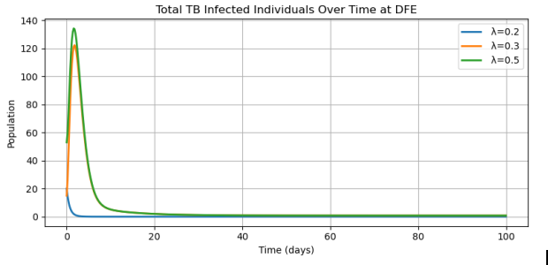

Figure 1. TB infection declines more rapidly at DFE with increasing λ values.
2.6. Computation of basic reproduction number
Using the notation f for a matrix of new infection terms and v for the matrix of the remaining transfer of infection terms. In this system, we got,
f=$\left[\begin{matrix}λE \\ (1-λ)E \\ 0 \\ 0\end{matrix}\right]$ and
v=$\left[\begin{matrix}+Ω_{1}I_{e} \\ +(e+µ+Z)I_{n} \\ -XI_{e}+{Ω_{2}T}_{f} \\ \left(1-X\right)I_{e}+{Ω_{3}T}_{n}\end{matrix}\right]$
$$Ω_{1}=-(µ+γ+1)$$
$$Ω_{2}=-(µ+e+ω)$$
$$Ω_{3}=-(µ+e+1-ω)$$

We obtain the matrices F and V by finding the Jacobian matrices of f and v evaluated at DFE respectively to obtain;
$$F=\left[\begin{matrix}β & ր_{1}β & ր_{2}β & ր_{3}β \\ \left(1-β\right) & \left(1-β\right)ր_{1} & \left(1-β\right)ր_{2} & \left(1-β\right)ր_{3} \\ 0 & 0 & 0 & 0 \\ 0 & 0 & 0 & 0\end{matrix}\right]$$
$$V=\left[\begin{matrix}Ω_{1} & 0 & 0 & 0 \\ 0 & (∈+µ+Z) & 0 & 0 \\ -X & 0 & Ω_{2} & 0 \\ 1-X & 0 & 0 & Ω_{3}\end{matrix}\right]$$
$$V^{-1}$$
$R_{o}=\frac{(\frac{Z+µ+∈-{ր_{1}}_{1}}{Z+µ+∈})}{\begin{aligned}(-\frac{{ր_{1}}_{1}}{Z+µ+∈}+\frac{Z}{\left(Z+µ+∈\right)Ω_{1}}+\frac{∈}{\left(Z+µ+∈\right)Ω_{1}}+\frac{µ}{\left(Z+µ+∈\right)Ω_{1}}+\frac{ZX{ր_{1}}_{2}}{\left(Z+µ+∈\right)Ω_{1}Ω_{2}}+\frac{∈X{ր_{1}}_{2}}{\left(Z+µ+∈\right)Ω_{1}Ω_{2}}+\frac{µX{ր_{1}}_{2}}{\left(Z+µ+∈\right)Ω_{1}Ω_{2}}-\frac{Z{ր_{1}}_{3}}{\left(Z+µ+∈\right)Ω_{1}Ω_{3}}-\frac{∈{ր_{1}}_{3}}{\left(Z+µ+∈\right)Ω_{1}Ω_{3}}-\frac{µ{ր_{1}}_{3}}{\left(Z+µ+∈\right)Ω_{1}Ω_{3}} \\ +\frac{ZX{ր_{1}}_{3}}{\left(Z+µ+∈\right)Ω_{1}Ω_{3}}+\frac{∈X{ր_{1}}_{3}}{\left(Z+µ+∈\right)Ω_{1}Ω_{3}}+\frac{µX{ր_{1}}_{3}}{\left(Z+µ+∈\right)Ω_{1}Ω_{3}})\}\}\end{aligned}}$
$$R_{o}=0.000222913$$
Which is the spectral radius/dominant eigenvalue [$R_{o}]$. In general, a value of $R_{o}<1$ implies that each individual is only able to infect less than one individual on average, so that the disease will die out hence the disease-free equilibrium will be locally and globally asymptotically stable. A value of $R_{o}>1$ implies that each individual is able to infect more than one individual on average and the disease is expected to persist in the population.
2.7. Existence of Endemic Equilibrium Point
Theorem 5: E.E.P exists whenever R_{o}>1
Proof: For E.E.P to exist, all the infectious classes must be greater than zero that is, I_{e}>0, I_{n}>0, T_{f}>0 and T_{n}>0.
$λE-(µ+γ+1)$I_{e}>0 (9)
$\left(1-λ\right)E-(∈+µ+Z)$I_{n}>0 (10)
$X$I_{e}-($µ+ε+ω)$T_{f}$⇒$T_{f}<$\frac{XI_{e}}{µ+Ɛ+ω}$ (11)
$(1-X)$I_{e}-($µ+e+1-ω)$T_{n}$⇒$T_{n}$<\frac{\left(1-x\right)I_{e}}{µ+Ɛ+1-ω}$ ₍₁₂₎
$$Using the force of infection$$
$λ=\frac{ᵦ}{N}($I_{e}+$ղ$₁ I_{n}+$ղ$₂ T_{f}+$ղ$₃ T_{n}) (13)
$\text{Solving} \text{interms} \text{of}$ (I_{e} and I_{n})
$I$_{e}<$\frac{λE}{µ+γ+1}$ ; $I$_{n}< $\frac{\left(1-λ\right)E}{∈+µ+Z}$ (14)
Now substitute the expression for T_{f} and T_{n} in terms of I_{e} , I_{n} and plug into $λ$ expression, we have;
$\frac{ᵦ}{N}($I_{e}+$ղ$₁ I_{n}+$ղ$₂ $\frac{XI_{e}}{µ+Ɛ+ω}$+$ղ$₃ $\frac{\left(1-x\right)I_{e}}{µ+Ɛ+1-ω}$) (15)
Which corresponds to the fundamental reproduction number as illustrated in the graph below.
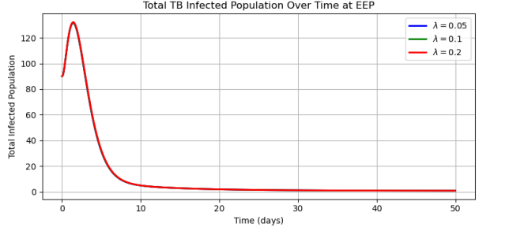

Figure 2. Effect of different λ values on TB infection dynamics over time, showing faster decline with higher λ

2.8. Local Stability of the disease-free equilibrium point (D.F.E)
Theorem 3: The DFE of model (1) is locally asymptotically stable if $R_{0}^{*}$<1
Calculating the following Jacobian matrix for our equations (4.5.1)
$$f_{1}=π - θ S - (1 - θ)S - µS$$
$f_{2}= θS$ − αV − µV
$$f_{3}=(1 - θ )S + αV - λE - (1 - λ)E - µE + kR$$
$f_{4}=$λE − (µ + Y )I_{e}— XI_{e}— (1 – X )I_{e}
(4.5.1)
$f_{5}=$(1 − λ)E − ϵI_{n}— (µ + Z)I_{n}
$f_{6}=$XI_{e}$-$(µ + e)T_{f} $-$ ωT_{f}
$f_{7}=$(1 − X)I_{e}$-$(1 − ω)T_{n}$-$(µ + e)T_{n}
$$f_{8}=(1 - ω)Tn + ωTf + ϵIn - µR - kR$$
Determining the jacobian matrix at D.F.E we obtain;
$$\left[\begin{matrix}A & 0 & 0 & 0 & 0 & 0 & 0 & 0 \\ θ & B & 0 & 0 & 0 & 0 & 0 & 0 \\ 1-θ & α & A & 0 & 0 & 0 & 0 & κ \\ 0 & 0 & 0 & C & η_{1}*β & η_{2}*β & η_{3}*β & 0 \\ 0 & 0 & 1 & -β & D & -η_{1}*β & -η_{2}*β & -η_{3}*β \\ 0 & 0 & 0 & χ & 0 & E & 0 & 0 \\ 0 & 0 & 0 & 1-χ & 0 & 0 & F & 0 \\ 0 & 0 & 0 & 0 & ϵ & ω & (1-ω) & G\end{matrix}\right]$$

Key
A=$-\left(1+μ\right)-Ψ$
B=$-\left(α+μ\right)-Ψ$
C=$\left(β-μ-γ-1\right)-Ψ$
D=$-(η_{1}*β+ϵ+μ+Ζ+η_{2}*β)-Ψ$
E=$-\left(μ+e-ω\right)-Ψ$
F=$(-1+ω-μ-e)-Ψ$
G=$(μ+κ)-Ψ$
We determine the signs of the eigenvalues using Routh-Hurwitz criterion. The characteristic function $/$A$-X_{i}I/$=0 with i=1,2,3,4,5,6,7,8.
By Routh-Hurwitz criterion for determining the negatives real signs of the eigenvalues of the cubic polynomials are;
$λ^{8}+a_{1}λ^{7}+a_{2}λ^{6}+a_{3}λ^{5}+a_{4}λ^{4}+a_{5}λ^{3}+a_{6}λ^{2}+a_{7}λ^{1}+a_{8}$ 4.5.5
with conditions:
$a_{1}>0,a_{1}a_{2}a_{3}a_{4}a_{5}a_{6}a_{7}>a_{8}>0$ 4.5.6
From the characteristic polynomial, the values of $a_{1}a_{2}a_{3}a_{4}a_{5}a_{6}a_{7} and a_{8} expressed in terms of R_{o}^{*}$ are;
$$a_{1}=1$$
$a_{2}=4+α-β+γ+ϵ+Ζ+κ+8μ+2e-2ω+βη_{1}+βη_{2}$ 4.5.7
$$a_{3}=β2 η1 - β χ η2 + \left(-1 - μ\right)\left(-1 + β - γ - ϵ - Ζ - κ - 3 μ - β η1 - β η2\right)+ \left(-1 + β - γ - μ\right)\left(-ϵ - Ζ - μ - β η1 - β η2\right)+ \left(-1 - μ - e+ ω\right)\left(-2 + β - γ - ϵ - Ζ - κ - 5 μ - e + ω - β η1 - β η2\right)+ \left(-1 - μ\right)\left(-3 - α + β - γ - ϵ - Ζ - κ - 7 μ - 2 e+ 2 ω - β η1 - β η2\right)- \left(-κ - μ\right)\left(1 - β + γ + ϵ + Ζ + 2 μ + β η1 + β η2\right)- \left(-μ - e + ω\right)\left(2 - β + γ + ϵ + Ζ + κ + 4 μ + β η1 + β η2\right)- \left(-α - μ\right)\left(3 - β + γ + ϵ + Ζ + κ + 6 μ + 2 e - 2 ω + β η1 + β η2\right)+ β ϵ η3 - β \left(1 - χ\right)η3$$

2.9. Global Stability of the disease-free equilibrium point (D.F.E)
The global stability of disease free equilibrium is investigated using Metzler matrix stability method proposed by (Catillo-chevez et al., 2002)
$\frac{ⅆQ}{ⅆt}=G(Q,M)$ (16) $\frac{ⅆM}{ⅆt}=H\left(Q,M\right),H\left(Q,0\right)=0$ (17)
Where, Q= (S,V,E R) $∈$R₊ ⁴denotes non-infectious TB compartments and M=( I_{e} , I_{n} ,T_{n} ,T_{f} )$∈$ R₊⁴ denotes the infectious TB compartment $E_{0}$= ($Q^{*}$,0) represents the disease-free equilibrium of the system if this point satisfies following condition:
- $\frac{ⅆQ}{ⅆt}=G(Q,0)$ where, Q* is globally asymptotically stable.
- $\frac{ⅆM}{ⅆt}=$P_{M}H (Q, 0) M-$H\left(Q,M\right)≥0$ for all (Q, M)$∈Ω$, then we can conclude that E₀ is locally asymptotically stable if the following theorems holds:
Theorem 4: The equilibrium points E₀(Q*, 0) of the system (16-17) is globally asymptotically stable if R₀* ≤ 1 and the conditions (i) and (ii) are satisfied, otherwise unstable.
Proof: Let Q= (S, R) and M= (S, V, E, I_{e}, I_{n}, T_{n}, T_{f},R), be the new variables and the sub-systems of the system model (1-8). From equations (1-8), two vector functions G (Q, M) and H (Q, M) are obtained, we consider reduced systems,
H(Q,0,0,0) =$\left(\begin{aligned}π - µS \\ 0\end{aligned}\right)$
It is noted that this is an asymptomatic dynamics system independent of the initial condition in Ω; therefore, the convergence of the solutions of the reduced system (1-8) is global in Ω by computing:
$\hat{H}$(Q, M) = P_{M}H (Q, 0) M-$H\left(Q,M\right)$
$\hat{H}$(Q, M)$≥0$.
Now let L= P_{M}H (Q*, 0), which is the jacobian of $\hat{H}$(Q, M) taken in (V, E, I_{e} , I_{n} ,T_{n} ,T_{f} ) and evaluated at (Q*, 0), such that the matrix L is given by;
L=$\left\lceil \begin{matrix}β-µ-γ-k & βղ1 & βղ2 & βղ3 \\ -β & -βղ1-∈-z-µ & -βղ2 & -βղ3 \\ x & 0 & 0 & -µ-e-⍵ \\ 1-x & 0 & -1+⍵-µ-e & 0\end{matrix}\right\rceil$
LH=$\left[\begin{matrix}\left(β-µ-γ-1\right)Ie & βղ1In & βղ2Tn & βղ3Tf \\ -βIe & \left(-βղ1-∈-µ-z\right)In & -βղ2Tn & -βղ3Tf \\ xIe & \left(-µ-e-⍵\right)Tf & 0 & 0 \\ \left(1-x\right)Ie & \left(-1+⍵-µ-e\right)Tn & 0 & 0\end{matrix}\right]$
$\hat{H}$(Q, M) = $\left\lceil \begin{matrix}(1-\frac{S}{N})β(Ie-Inղ1+Tnղ2+Tfղ3) \\ \left(1-\frac{S}{N}\right)-β(Ie+Inղ1+Tnղ2+Tfղ3 \\ \begin{matrix}0 \\ 0\end{matrix}\end{matrix}\right\rceil$
Therefore if $\hat{H}$(Q, M) ≥ 0, then the disease-free equilibrium, ($E_{0}$)is globally asymptotically stable otherwise its unstable. Since S ≤ N, $\frac{S}{N}$ ≤ 1, thus H (Q, M) ≥ 0 for all Q, M ∈ R₊⁴, then, the disease-free equilibrium will be globally asymptotically stable. It is clear that matrix L is an M-matrix since the off-diagonal elements of L are non-negative. Therefore, this proves that G.D.F.E is globally asymptotically stable. This completes the proof. This result shows that TB would die out whenever R₀* < 1 irrespective of the initial conditions.

2.10. Bifurcation analysis
The bifurcation analysis can be explored using center manifold theorem (Liu and Zhang, 2011). The change of variables is made first for simplicity. Let S=u_{1,} V= u_{2,} E= u_{3,} $I_{e}=u4,$ $I_{n}=$ u_{5,} $T_{n}=$ u_{6,} $T_{f}=$ u₇ and R= u₈. Further, by using vector notation, u= (u_{1,} u_{2,} u_{3,} u_{4,} u_{5,} u_{6,} u_{7,} u₈), the TB models (4.5.1) is written in the form $\frac{du}{dt}=F(u)$ ,with F= (p_{1,} p_{2,} p_{3,} p_{4,} p_{5,} p_{6,} p₇) as follows:
${\dot{y}}_{1}=p_{1}=π - θy_{1} - (1 - θ)y_{1} - µy_{1}$ (18)
${\dot{y}}_{2}=p_{2}=θy_{1}$ − α$y_{2}$ − µ$y_{2}$ (19)
${\dot{y}}_{3}=p_{3}=(1 - θ )y_{1} + αy_{2} - \frac{β(y_{4}+ղ1y_{5}+ղ2y_{7}+ղ3y_{6})}{N}y_{3} - (1 - \frac{β(y_{4}+ղ1y_{5}+ղ2y_{7}+ղ3y_{6})}{N}y_{3} - µy_{3} + ky_{8}$ (20)
${\dot{y}}_{4}=p_{4}=\frac{β(y_{4}+ղ1y_{5}+ղ2y_{7}+ղ3y_{6})}{N}y_{3} - (µ + γ )y_{4}- Xy_{4}- (1 - X)y_{4}$ (21)
${\dot{y}}_{5}=p_{5}=$(1 − $\frac{β(y_{4}+ղ1y_{5}+ղ2y_{7}+ղ3y_{6})}{N}$) $y_{3}$ − ϵ$y_{5}$— (µ + Z) $y_{5}$ (22)
${\dot{y}}_{6}=p_{6}=Xy_{4}-(µ + e) y_{7} - ω y_{7}$ (23)
${\dot{y}}_{7}=p_{7}=$(1 − X)$y_{4}-$(1 − ω) $y_{6}$ $-$(µ + e) $y_{6}$ (24)
${\dot{y}}_{8}=p_{8}=(1 - ω)y_{6}+ ωy_{7} + ϵy_{5} - µy_{8} - ky_{8}$ (25)
Where, $λ^{*}=\frac{β(y_{4}+ղ1y_{5}+ղ2y_{7}+ղ3y_{6})}{N}$. The method entails evaluating the Jacobian of the system (18-25) at D.F.E, $G_{*}^{0}=\left(S_{*}^{0}V_{*}^{0}E_{*}^{0}{Ie}_{*}^{0}{In}_{*}^{0}{Tn}_{*}^{0}{Tf}_{*}^{0}R_{*}^{0}\right)=\left(\frac{π}{µ},0,0,0,0,0,0,0\right), denoted by JE_{*}^{0}, We obtain$

$JE=\left[\begin{matrix}- ( 1+ µ) & 0 & 0 & 0 & 0 & 0 & 0 & 0 \\ θ & -( α+ µ) & 0 & 0 & 0 & 0 & 0 & 0 \\ 1-θ & α & - µ & 0 & 0 & 0 & 0 & κ \\ 0 & 0 & 0 & β*- Ω_{1} & β*η_{1} & β*η_{3} & β*η_{2} & 0 \\ 0 & 0 & 0 & -β* & -(β*η_{1}+ ϵ+ \left(µ + Z\right)) & -β*η_{3} & -β*η_{2} & 0 \\ 0 & 0 & 0 & X & 0 & 0 & -Ω_{2} & 0 \\ 0 & 0 & 0 & 1-χ & 0 & -(1 -Ω_{2} ) & 0 & 0 \\ 0 & 0 & 0 & 0 & ϵ & 1-ω & ω & -(µ+k)\end{matrix}\right]$
We consider the case where $R_{0}^{*}=1.$ Suppose $β{=β}^{*}$ chosen as a bifurcation parameter then solving for $β^{*}$from $R_{0}^{*}=1$ gives:
$$u_{1}=\frac{ɵu_{2}+(1-ɵu_{3})}{1+µ}>0$$
$$-\left(α+µ\right)u_{2}+αu_{3}=0$$

$u_{2}=\frac{αuS}{α+µ}>0$
$$-\left(1+µ\right)u_{3}+u_{5}=0$$
$$u_{3}=\frac{uS}{1+µ}>0$$
$$u_{4}\left(β-µ-γ-1\right)-βuS+XuS+\left(1-X\right)u_{7}=0$$
$$u_{4}=\frac{βuS-Xu_{6}-(1-X)u_{7}}{β-µ-γ-1}$$
$$n_{1}βu_{4}-\left(n_{1}β+∈+µ+Z+n_{2}β\right)u_{5}+∈u_{8}=0$$
$$u_{5}=\frac{n_{1}βu_{4}+∈u_{8}}{n_{1}β+∈+µ+Z+n_{2}β}>0$$
$$n_{2}βu_{4}=-n_{1}βu_{5}-\left(u+ε-ω\right)uS+ωu_{8}=0$$
$$u_{6}=\frac{n_{2}βu_{4}+ωu_{8}-n_{1}βu_{5}}{e+µ-ω}>0$$
$$n_{3}βu_{4}-n_{2}βu_{5}+u_{7}\left(-1+ω-µ-e\right)+\left(1-ω\right)u_{8}=0$$
$$u_{7}=\frac{n_{2}βu_{5}-n_{3}βu_{4}-\left(1-ω\right)u_{8}}{-1+ω-µ-e}<0$$
$$u_{5}k-{n_{3}βu}_{5}+u_{8}\left(µ+k\right)=0$$
$$u_{8}=\frac{{n_{3}βu}_{5}-u_{5}k}{µ+k}>0$$
$$-\left(1+µ\right)v_{1}=0$$
$$v_{1}=0$$
$$v_{1}ɵ-v_{2}\left(α+µ\right)=0$$
$$v_{2}=\frac{ɵ}{α+µ}$$
$$\left(1-ɵ\right)v_{1}+αv_{2}-\left(1+µ\right)v_{3}+kv_{8}=0$$
$$v_{3}=\frac{\left(1-ɵ\right)v_{1}+αv_{2}+kv_{8}}{1+µ}$$
$$v_{4}\left(β-µ-γ-1\right)+n_{1}βv_{5}+n_{2}βv_{6}+n_{2}βv_{7}=0$$
$$v_{4}=\frac{-(+n_{1}βv_{5}+n_{2}βv_{6}+n_{3}βv_{7})}{β-µ-γ-1}$$
$$v_{3}-βv_{4}-v_{5}\left(n_{1}β+∈+µ+Z+n_{2}β\right)-n_{1}βv_{6}-n_{2}βv_{7}-n_{3}βv_{8}=0$$
$$v_{5}=\frac{v_{3}-βv_{4}-n_{1}βv_{6}-n_{2}βv_{7}-n_{3}βv_{8}}{n_{1}β+∈+µ+Z+n_{2}β}$$
$$v_{4}X-v_{6}\left(u+e-ω\right)=0$$
$$v_{6}=\frac{v_{4}X}{u+e-ω}$$
$$v_{4}\left(1-X\right)+v_{7}\left(-1+ω-u-e\right)=0$$
$$v_{7}=\frac{-v_{4}X}{-1+ω-u-e}$$
$$ɵv_{5}+ωv_{6}+\left(1-ω\right)v_{7}+v_{8}\left(µ+k\right)=0$$
$$v_{8}=\frac{-(ɵv_{5}+ωv_{6}+\left(1-ω\right)v_{7})}{µ+k}$$
$$y_{4}=\frac{β(y_{4}+n_{1}y_{5}+n_{2}y_{6}+n_{3}y_{7})y_{3}}{N}-\left(u+γ\right)y_{4}-Xy_{4}-(1-X)y_{4}$$
$$y_{5}=p_{5}=(1-β\left(y_{4}+n_{1}y_{5}+n_{2}y_{6}+n_{3}y_{7}\right)y_{3}-∈y_{5}-(u+Z)y_{5}$$

$$\frac{dp_{4}}{dy_{3}}=\frac{β(y_{4}+n_{1}y_{5}+n_{2}y_{6}+n_{3}y_{7})}{N}$$
$$\frac{d^{2}p_{4}}{dy_{3}dy_{4}}=\frac{β}{N}$$
$$\frac{d^{2}p_{4}}{dy_{3}dy_{5}}=\frac{n_{1}β}{N}$$
$$\frac{d^{2}p_{4}}{dy_{3}dy_{6}}=\frac{n_{2}β}{N}$$
$$\frac{d^{2}p_{4}}{dy_{3}dy_{7}}=\frac{n_{3}β}{N}$$
$$\frac{dp_{5}}{dy_{3}}=1-\frac{β(y_{4}+n_{1}y_{5}+n_{2}y_{6}+n_{3}y_{7})}{N}$$
$$\frac{dp_{5}}{dy_{3}dy_{4}}=-\frac{β}{N}$$
$$\frac{dp_{5}}{dy_{3}dy_{5}}=-\frac{n_{1}β}{N}$$
$$\frac{dp_{5}}{dy_{3}dy_{6}}=-\frac{n_{2}β}{N}$$
$$\frac{dp_{5}}{dy_{3}dy_{7}}=-\frac{n_{3}β}{N}$$
$$a=v_{4}\left[2u_{5}u_{4}+2u_{5}u_{5}+2u_{5}u_{6}+2u_{5}u_{7}\right]+v_{5}[-2u_{5}u_{4}-2u_{5}u_{5}-2u_{5}u_{6}-2u_{5}u_{7}]$$
$$\frac{dp_{4}}{dy_{4}}=-1-\left(µ+γ\right)+\frac{β(y_{4}+n_{1}y_{5}+n_{2}y_{6}+n_{3}y_{7})}{N}y_{4}$$
$$\frac{d^{2}p_{4}}{dy_{4}dβ^{*}}=\frac{(y_{4}+n_{1}y_{5}+n_{2}y_{6}+n_{3}y_{7})}{N}y_{4}$$
At D.F.E (0,0), $y_{2}=y_{3}=y_{4}=y_{5}=y_{6}=y_{7}=y_{8}$
$$\frac{dp_{4}}{dy_{4}}=\frac{βy_{4}}{N}$$
$$\frac{d^{2}p_{4}}{dy_{4}dβ^{*}}=\frac{y_{4}}{N}$$
$$\frac{d^{2}p_{4}}{dy_{5}}=\frac{βn_{1}y_{4}}{N}$$
$$\frac{d^{2}p_{4}}{dy_{5}dβ^{*}}=\frac{n_{1}y_{4}}{N}$$
$$\frac{d^{2}p_{4}}{dy_{6}}=\frac{βn_{2}y_{4}}{N}$$
$$\frac{d^{2}p_{4}}{dy_{6}dβ^{*}}=\frac{n_{2}y_{4}}{N}$$
$$\frac{d^{2}p_{4}}{dy_{7}dβ^{*}}=\frac{n_{3}y_{4}}{N}$$
$$\frac{d^{2}p_{5}}{dy_{5}dβ^{*}}=-\frac{y_{4}}{N}$$
$$\frac{d^{2}p_{5}}{dy_{5}dβ^{*}}=-\frac{n_{1}y_{4}}{N}$$
$$\frac{d^{2}p_{5}}{dy_{6}dβ^{*}}=-\frac{n_{2}y_{4}}{N}$$
$$\frac{d^{2}p_{5}}{dy_{7}dβ^{*}}=-\frac{n_{3}y_{4}}{N}$$
$b=v_{4}\left[\frac{y_{4}}{N}+\frac{n_{1}y_{4}}{N}+\frac{n_{2}y_{4}}{N}+\frac{n_{3}y_{4}}{N}\right]+v_{5}[-\frac{y_{4}}{N}-\frac{n_{1}y_{4}}{N}$-$\frac{n_{2}y_{4}}{N}-\frac{n_{3}y_{4}}{N}]$
But$v_{4}=0, b>0$. Hence a<0 and b>0, when $β^{*}<0$ with \$β^{*}∖≪,(0,0)$ is unstable and there exists a negative and locally asymptotically stable equilibrium; when ${0<β}^{*}≪1, \left(0,0\right)$ is stable and there exists a positive unstable equilibrium. The direction of the bifurction of the system (1-8) at $R_{0}=1$ is forward. Since the bifurcation parameter changes from negative to positive and the disease-free equilibrium changes its stability from negative to positive. Therefore, absence of backward bifurcation show that it is possible to eradicate TB whenever $R_{0}<1$
2.11 Global stability analysis of the Endemic Equilibrium Point
For the system of reduced equations;
$\frac{dS}{dt}=π - θ S - (1 - θ)S - µS$ (26)
$\frac{dV}{dt}= θS$ − αV − µV (27)
$\frac{dE}{dt}=(1 - θ )S + αV - λE - (1 - λ)E - µE + kR$ (28)
$\frac{{dI}_{e}}{dt}=$λE − $Ω_{1}$I_{e} (29)
$\frac{{dI}_{n}}{dt}=$(1 − λ)E − ϵI_{n}— (µ + Z)I_{n} (30)
$\frac{{dT}_{f}}{dt}=$XI_{e}$-Ω_{2}$T_{f} (31)
$\frac{{dT}_{n}}{dt}=$(1 − X)I_{e}$-Ω_{3}$T_{n} (32)
$\frac{dR}{dt}=(1 - ω)Tn + ωTf + ϵIn - µR - kR$ (33)
The control reproduction number (R₀*), the force of infection($λ$* ), D.F.E E⁰=(S⁰ ,V⁰ ,E⁰ ,I_{e}⁰ ,I_{n}⁰ ,T_{n}⁰ ,T_{f}⁰ ,R⁰) =($\frac{π}{µ}, 0, 0,0, 0, 0, 0, 0)$and E.E.P E*=( S* ,V* ,E* ,I_{e}* ,I_{n}* ,T_{n}* ,T_{f}* ,R*) of the system (4.9.1-4.9.8) are given by;
R₀*= $\frac{(\frac{Z+µ+∈-n_{1}}{Z+µ+∈})}{\begin{aligned}(-\frac{n_{1}}{Z+µ+∈}+\frac{Z}{\left(Z+µ+∈\right)Ω_{1}}+\frac{∈}{\left(Z+µ+∈\right)Ω_{1}}+\frac{µ}{\left(Z+µ+∈\right)Ω_{1}}+\frac{ZXn_{2}}{\left(Z+µ+∈\right)Ω_{1}Ω_{2}}+\frac{∈Xn_{2}}{\left(Z+µ+∈\right)Ω_{1}Ω_{2}}+\frac{µXn_{2}}{\left(Z+µ+∈\right)Ω_{1}Ω_{2}}-\frac{Zn_{3}}{\left(Z+µ+∈\right)Ω_{1}Ω_{3}}-\frac{∈n_{3}}{\left(Z+µ+∈\right)Ω_{1}Ω_{3}}-\frac{µn_{3}}{\left(Z+µ+∈\right)Ω_{1}Ω_{3}} \\ +\frac{ZXn_{3}}{\left(Z+µ+∈\right)Ω_{1}Ω_{3}}+\frac{∈Xn_{3}}{\left(Z+µ+∈\right)Ω_{1}Ω_{3}}+\frac{µXn_{3}}{\left(Z+µ+∈\right)Ω_{1}Ω_{3}})\}\}\end{aligned}}$
And the system of equations (4.9.1-4.9.8). We propose the Lyapunov function K($S,V,E,I_{e},I_{n},T_{n},T_{f},R$)=$\left(S-S*-S*ln\frac{S}{S^{*}}\right)+y_{1}\left(V-V*-V*ln\frac{V}{V^{*}}\right)+y_{2}\left(E-E*-E*ln\frac{E}{E^{*}}\right)+y_{3}\left(I_{e}-I_{e}*-I_{e}*ln\frac{I_{e}}{{I_{e}}^{*}}\right)+y_{4}\left(I_{n}-I_{n}*-I_{n}*ln\frac{I_{n}}{{I_{n}}^{*}}\right)+y_{5}\left(T_{n}-T_{n}*-T_{n}*ln\frac{T_{n}}{{T_{n}}^{*}}\right)+y_{6}\left(T_{f}-T_{f}*-T_{f}*ln\frac{T_{f}}{{T_{f}}^{*}}\right)+y_{7}\left(R-R*-R*ln\frac{R}{R^{*}}\right)$
Where $y_{1},y_{2},y_{3},y_{4},y_{5},y_{6 }and y_{7}$are positive constants to be determined.The Lyapunov function K($S,V,E,I_{e},I_{n},T_{n},T_{f},R)$satisfies the conditions K(S* ,V* ,E* ,I_{e}* ,I_{n}* ,T_{n}* ,T_{f}* ,R*)
=0 and ($S,V,E,I_{e},I_{n},T_{n},T_{f},R)>0$ hence it is positive definite for,
$\frac{dk\left((S,V,E,I_{e},I_{n},T_{n},T_{f},R\right)}{dt}$
To be negative definite, it must satisfy,$\frac{dk\left(S* ,V* ,E* ,Ie* ,In* ,Tn* ,Tf* ,R*\right)}{dt}=0$
and $\frac{dk\left(S* ,V* ,E* ,Ie* ,In* ,Tn* ,Tf* ,R*\right)}{dt}<0$
The E.E.P E*= (S*, V*, E*, I_{e}*, I_{n}, T_{n}*, T_{f}*, R*) for the system satisfies
$π=θS** + \left(1 - θ\right)S**+ µS**$
$θS**=$ α$V**$ + µ$V**$
$αV**+\left(1 - θ \right)S**+kR**= µE**+ λ**E**+\left(1 - λ**\right)E**$
$λ**E**=XIe**$ + (µ + $γ$ )$Ie**$+ (1 − X)$Ie**$
$(1 - λ **)E ** =ϵIn**$+ (µ + Z)$In**$
$XIe**=ωTf**+$(µ + e)T_{f} $**$
$(1 - X)Ie**=$(1 − ω)T_{n} $**$+(µ + e) T_{n} $**$
$kR**µR**= \left(1 - ω\right)Tn** + ωTf** + ϵIn**$ dK($S,V,E,I_{e},I_{n},T_{n},T_{f},R)=y_{0}\left(1-\frac{S^{**}}{S}\right)\left(\frac{dS}{dt}\right)+y_{1}\left(1-\frac{V^{**}}{V}\right)\left(\frac{dV}{dt}\right)+y_{2}\left(1-\frac{E^{**}}{E}\right)\left(\frac{dE}{dt}\right)+y_{3}\left(1-\frac{{Ie}^{**}}{Ie}\right)\left(\frac{dIe}{dt}\right)+y_{4}\left(1-\frac{{In}^{**}}{In}\right)\left(\frac{dIn}{dt}\right)+y_{5}\left(1-\frac{{Tn}^{**}}{Tn}\right)\left(\frac{dTn}{dt}\right)+y_{6}\left(1-\frac{{Tf}^{**}}{Tf}\right)\left(\frac{dTf}{dt}\right)+y_{7}\left(1-\frac{R^{**}}{R}\right)\left(\frac{dR}{dt}\right)$ 4.9.21
Substituting for $\frac{dS}{dt},\frac{dv}{dt},\frac{dS}{dt},\frac{ⅆI_{e}}{ⅆt},\frac{ⅆI_{n}}{ⅆt},\frac{ⅆT_{n}}{ⅆt},\frac{ⅆT_{f}}{ⅆt} and \frac{dR}{dt}$ in the equation (4.9.21) to obtain
dK($S,V,E,I_{e},I_{n},T_{n},T_{f},R)=\left(1-\frac{S^{**}}{S}\right)\left(-θS- \left(1 - θ\right)S- µS+θS** + \left(1 - θ\right)S**+ µS**\right)+y_{1}\left(1-\frac{V^{**}}{V}\right)\left(θS-Ω_{1}V\right)+y_{2}\left(1-\frac{E^{**}}{E}\right)\left(1 - θ\right)S+α V-λE-\left(1-λE\right)-µ E+kR)+y_{3}(1-\frac{{Ie}^{**}}{Ie})(λE-Ω_{2}Ie)+y_{4}\left(1-\frac{{In}^{**}}{In}\right)(\left(1-λ\right)E-Ω_{3}In)+y_{5}(1-\frac{{Tn}^{**}}{Tn})(\left(1-X\right)Ie-Ω_{4}Tn)+y_{6}\left(1-\frac{{Tf}^{**}}{Tf}\right)(XIe-Ω_{5}Tf)+y_{7}\left(1-\frac{R^{**}}{R}\right)(1-ω)Tn+ωTf+ϵIn-Ω_{6}R$
dK($S,V,E,I_{e},I_{n},T_{n},T_{f},R)=\left(θS** + \left(1 - θ\right)S**+ µS**-θS- \left(1 - θ\right)S- µS+\frac{S^{**}}{S}θS+\frac{S^{**}}{S}\left(1 - θ\right)S+\frac{S^{**}}{S}µS-\frac{S^{**}}{S}θS**-\frac{S^{**}}{S}\left(1 - θ\right)S**-\frac{S^{**}}{S}µS**\right)+y_{1}θS-y_{1}Ω_{1}V-y_{1}\frac{V^{**}}{V}θS+y_{1}\frac{V^{**}}{V}Ω_{1}V+y_{2}\left(\left(1 - θ\right)S+y_{2}α V-y_{2}λE-y_{2}\left(1-λE\right)-y_{2}µ E+y_{2}kR\right)-y_{2}\frac{E^{**}}{E}\left(1 - θ\right)S-y_{2}\frac{E^{**}}{E}α V+y_{2}\frac{E^{**}}{E}λE+y_{2}\frac{E^{**}}{E}\left(1-λE\right)+y_{2}\frac{E^{**}}{E}µ E+y_{2}\frac{E^{**}}{E}kR+y_{3}λE-{y_{3}Ω}_{2}Ie-y_{3}\frac{{Ie}^{**}}{Ie}λE+y_{3}\frac{{Ie}^{**}}{Ie}Ω_{2}Ie+y_{4}\left(\left(1-λ\right)E-y_{4}Ω_{3}In-y_{4}\frac{{In}^{**}}{In}\left(1-λ\right)E+y_{4}\frac{{In}^{**}}{In}Ω_{3}In\right)+y_{5}\left(1-X\right)Ie-y_{5}Ω_{4}Tn-y_{5}\frac{{Tn}^{**}}{Tn}\left(1-X\right)Ie+y_{5}\frac{{Tn}^{**}}{Tn}Ω_{4}Tn+y_{6}XIe-y_{6}Ω_{5}Tf-y_{6}\frac{{Tf}^{**}}{Tf}XIe+y_{6}\frac{{Tf}^{**}}{Tf}Ω_{5}Tf+y_{7}\left(1-ω\right)Tn+y_{7}ωTf+y_{7}ϵIn-y_{7}Ω_{6}R-y_{7}\frac{R^{**}}{R}\left(1-ω\right)Tn-y_{7}\frac{R^{**}}{R}ωTf-y_{7}\frac{R^{**}}{R}ϵIn+y_{7}\frac{R^{**}}{R}Ω_{6}R$

$$λ=\frac{β(Ie+ղ1In+ղ2Tf+ղ3Tn)}{N}=\frac{βIe(s)}{N}+\frac{βղ1In(s)}{N}+\frac{βղ2Tf(s)}{N}+\frac{βղ3Tn(s)}{N}$$
$$Ie=-\frac{βIe\left(s\right)}{N}+y_{1}\frac{βIe\left(s\right)}{N}$$
$$In=-\frac{βղ1In\left(s\right)}{N}+y_{1}\frac{βղ1In\left(s\right)}{N}$$
$$Tf=-\frac{βղ2Tf\left(s\right)}{N}+y_{1}\frac{βղ2Tf\left(s\right)}{N}$$
$$Tn=-\frac{βղ3Tn\left(s\right)}{N}+y_{1}\frac{βղ3Tn\left(s\right)}{N}$$
dK($S,V,E,I_{e},I_{n},T_{n},T_{f},R)=\left(θS** + \left(1 - θ\right)S**+ µS**-θS- \left(1 - θ\right)S- µS+\frac{S^{**}}{S}θS+\frac{S^{**}}{S}\left(1 - θ\right)S+\frac{S^{**}}{S}µS-\frac{S^{**}}{S}θS**-\frac{S^{**}}{S}\left(1 - θ\right)S**-\frac{S^{**}}{S}µS**\right)+y_{1}θS-y_{1}Ω_{1}V-y_{1}\frac{V^{**}}{V}θS+y_{1}\frac{V^{**}}{V}Ω_{1}V+y_{2}\left(\left(1 - θ\right)S+y_{2}α V-y_{2}λE-y_{2}\left(1-λE\right)-y_{2}µ E+y_{2}kR\right)-y_{2}\frac{E^{**}}{E}\left(1 - θ\right)S-y_{2}\frac{E^{**}}{E}α V+y_{2}\frac{E^{**}}{E}λE+y_{2}\frac{E^{**}}{E}\left(1-λE\right)+y_{2}\frac{E^{**}}{E}µ E+y_{2}\frac{E^{**}}{E}kR+y_{3}\left(-\frac{βIe}{N}+y_{1}\frac{βIe}{N}\right)+\left(-\frac{βղ1In}{N}+y_{1}\frac{βղ1In}{N}\right)+\left(-\frac{βղ2Tf}{N}+y_{1}\frac{βղ2Tf}{N}\right)+(-\frac{βղ3Tn}{N}+y_{1}\frac{βղ3Tn}{N})-{y_{3}Ω}_{2}Ie-y_{3}\frac{{Ie}^{**}}{Ie}λE+y_{3}\frac{{Ie}^{**}}{Ie}Ω_{2}Ie+y_{4}\left(\left(1-\left(-\frac{βIe}{N}+y_{1}\frac{βIe}{N}\right)+\left(-\frac{βղ1In}{N}+y_{1}\frac{βղ1In}{N}\right)+\left(-\frac{βղ2Tf}{N}+y_{1}\frac{βղ2Tf}{N}\right)+(-\frac{βղ3Tn}{N}+y_{1}\frac{βղ3Tn}{N})\right)-y_{4}Ω_{3}In-y_{4}\frac{{In}^{**}}{In}\left(1-λ\right)E+y_{4}\frac{{In}^{**}}{In}Ω_{3}In\right)+y_{5}\left(1-X\right)Ie-y_{5}Ω_{4}Tn-y_{5}\frac{{Tn}^{**}}{Tn}\left(1-X\right)Ie+y_{5}\frac{{Tn}^{**}}{Tn}Ω_{4}Tn+y_{6}XIe-y_{6}Ω_{5}Tf-y_{6}\frac{{Tf}^{**}}{Tf}XIe+y_{6}\frac{{Tf}^{**}}{Tf}Ω_{5}Tf+y_{7}\left(1-ω\right)Tn+y_{7}ωTf+y_{7}ϵIn-y_{7}Ω_{6}R-y_{7}\frac{R^{**}}{R}\left(1-ω\right)Tn-y_{7}\frac{R^{**}}{R}ωTf-y_{7}\frac{R^{**}}{R}ϵIn+y_{7}\frac{R^{**}}{R}Ω_{6}R$

$$y_{1}θS+y_{2}\left(1 - θ\right)S$$
$$-y_{1}Ω_{1}V+y_{2}α V$$
$$-y_{2}µ E$$
$$Ie=-\frac{βIe}{N}+y_{1}\frac{βIe}{N}=0$$
$$Ie\frac{β}{N}\left(-1+y_{1}\right)=0$$
But $Ie\frac{β}{N}≠0$
$y_{1}-1=0$
$$y_{1}=1$$
$$θS+y_{2}\left(1 - θ\right)S=0$$
$$y_{2}=\frac{-θS}{\left(1 - θ\right)S}=\frac{-θ}{\left(1 - θ\right)}$$
$$Ω_{1}V=y_{2}α V$$
$$y_{2}=\frac{Ω_{1}V}{α V}=\frac{Ω_{1}}{α }$$
$$y_{2}kR-y_{7}Ω_{6}R=0$$
$$But y_{2}=\frac{Ω_{1}}{α }$$
$$\frac{Ω_{1}}{α }kR-y_{7}Ω_{6}R=0$$
$$y_{7}=\frac{Ω_{1}k}{\begin{aligned}αΩ_{6} \\ \end{aligned}}$$
$$-y_{4}Ω_{3}In+y_{7}ϵIn=0$$
$$Buty_{7}=\frac{Ω_{1}k}{\begin{aligned}αΩ_{6} \\ \end{aligned}}$$
$$-y_{4}Ω_{3}In+\frac{Ω_{1}k}{\begin{aligned}αΩ_{6} \\ \end{aligned}}ϵIn=0$$
$$In≠0$$
$$y_{4}=\frac{Ω_{1}kϵ}{\begin{aligned}αΩ_{6}Ω_{3} \\ \end{aligned}}$$
$$-y_{6}Ω_{5}Tf+y_{7}ωTf=0$$
$$But y_{7}=\frac{Ω_{1}k}{\begin{aligned}αΩ_{6} \\ \end{aligned}}$$
$$-y_{6}Ω_{5}Tf+\frac{Ω_{1}k}{\begin{aligned}αΩ_{6} \\ \end{aligned}}ωTf$$
$$y_{6}=\frac{Ω_{1}kω}{\begin{aligned}αΩ_{6}Ω_{5} \\ \end{aligned}}$$
$$y_{5}\left(1-X\right)+y_{6}X=0$$
$$But y_{6}=\frac{Ω_{1}kω}{\begin{aligned}αΩ_{6}Ω_{5} \\ \end{aligned}}$$
$$y_{5}\left(1-X\right)+\frac{Ω_{1}kω}{\begin{aligned}αΩ_{6}Ω_{5} \\ \end{aligned}}X=0$$
$$y_{5}=-\frac{Ω_{1}kωX}{\begin{aligned}αΩ_{6}Ω_{5}\left(1-X\right) \\ \end{aligned}}$$
$$-{y_{3}Ω}_{2}+y_{6}X=0$$
$$But y_{6}=\frac{Ω_{1}kω}{\begin{aligned}αΩ_{6}Ω_{5} \\ \end{aligned}}$$
$$-{y_{3}Ω}_{2}+\frac{Ω_{1}kω}{\begin{aligned}αΩ_{6}Ω_{5} \\ \end{aligned}}X=0$$
$$y_{3}=\frac{Ω_{1}kωX}{\begin{aligned}αΩ_{6}Ω_{5}Ω_{2} \\ \end{aligned}}$$
dK($S,V,E,I_{e},I_{n},T_{n},T_{f},R)=\left(θS** + \left(1 - θ\right)S**+ µS**-θS- \left(1 - θ\right)S- µS+\frac{S^{**}}{S}θS+\frac{S^{**}}{S}\left(1 - θ\right)S+\frac{S^{**}}{S}µS-\frac{S^{**}}{S}θS**-\frac{S^{**}}{S}\left(1 - θ\right)S**-\frac{S^{**}}{S}µS**\right)+θS-Ω_{1}V-\frac{V^{**}}{V}θS+\frac{V^{**}}{V}Ω_{1}V+y_{2}\left(1 - θ\right)S-y_{2}\frac{E^{**}}{E}α V+y_{2}\frac{E^{**}}{E}λE+y_{2}\frac{E^{**}}{E}\left(1-λE\right)+y_{2}\frac{E^{**}}{E}µ E+y_{2}\frac{E^{**}}{E}kR+y_{3}\left(-\frac{βIe}{N}+y_{1}\frac{βIe}{N}\right)+\left(-\frac{βղ1In}{N}+y_{1}\frac{βղ1In}{N}\right)+\left(-\frac{βղ2Tf}{N}+y_{1}\frac{βղ2Tf}{N}\right)+(-\frac{βղ3Tn}{N}+y_{1}\frac{βղ3Tn}{N})-{y_{3}Ω}_{2}Ie-y_{3}\frac{{Ie}^{**}}{Ie}λE+y_{3}\frac{{Ie}^{**}}{Ie}Ω_{2}Ie+y_{4}\left(\left(1-\left(-\frac{βIe}{N}+y_{1}\frac{βIe}{N}\right)+\left(-\frac{βղ1In}{N}+y_{1}\frac{βղ1In}{N}\right)+\left(-\frac{βղ2Tf}{N}+y_{1}\frac{βղ2Tf}{N}\right)+(-\frac{βղ3Tn}{N}+y_{1}\frac{βղ3Tn}{N})\right)-y_{4}Ω_{3}In-y_{4}\frac{{In}^{**}}{In}\left(1-λ\right)E+y_{4}\frac{{In}^{**}}{In}Ω_{3}In\right)+y_{5}\left(1-X\right)Ie-y_{5}Ω_{4}Tn-y_{5}\frac{{Tn}^{**}}{Tn}\left(1-X\right)Ie+y_{5}\frac{{Tn}^{**}}{Tn}Ω_{4}Tn+y_{6}XIe-y_{6}Ω_{5}Tf-y_{6}\frac{{Tf}^{**}}{Tf}XIe+y_{6}\frac{{Tf}^{**}}{Tf}Ω_{5}Tf+y_{7}\left(1-ω\right)Tn+y_{7}ωTf+y_{7}ϵIn-y_{7}Ω_{6}R-y_{7}\frac{R^{**}}{R}\left(1-ω\right)Tn-y_{7}\frac{R^{**}}{R}ωTf-y_{7}\frac{R^{**}}{R}ϵIn+y_{7}\frac{R^{**}}{R}Ω_{6}R$

$P=θS**+\left(1 - θ\right)S**+ µS**+\frac{S^{**}}{S}θS+\frac{S^{**}}{S}\left(1 - θ\right)S+\frac{S^{**}}{S}µS+\frac{V^{**}}{V}θS+\frac{V^{**}}{V}Ω_{1}V+\frac{E^{**}}{E}µS**+y_{2}\frac{E^{**}}{E}\left(1-λE\right)+y_{2}\frac{E^{**}}{E}µ E+y_{6}\frac{{Tf}^{**}}{Tf}$
$$Q=-θS- \left(1 - θ\right)S-\frac{S^{**}}{S}θS**-\frac{S^{**}}{S}\left(1 - θ\right)S**-\frac{S^{**}}{S}µS**-\frac{V^{**}}{V}θS-y_{2}\frac{E^{**}}{E}α V-y_{2}\frac{E^{**}}{E}kR-\frac{{In}^{**}}{In}\left(1-λ\right)E-Ω_{3}\frac{{In}^{**}}{In}-\frac{{Tn}^{**}}{Tn}\left(1-X\right)Ie-\frac{{Tn}^{**}}{Tn}Ω_{4}Tn-\frac{{Tf}^{**}}{Tf}XIe$$
This result show that TB would persist whenever P >Q irrespective of the initial conditions.
3. Simulation parameters of the model
In this section, the Runge-Kutta method is applied in the model equations and there after used to carry out numerical simulations by fourth order Runge-Kutta method in MatlabR2015a to study the dynamical behavior of the model state variables in the presence of model parameters. The Runge-Kutta method is a numerical method of solving an initial value problem of ordinary differential equations. The numerical simulations are performed using the initial conditions and and parameters in table 3 and the numerical results are presented graphically.
Table 3: Parameter values and initial conditions for the model estimated from Kenya
Parameter | Description | Parameter Value per Unit | Source
N | Total population | 10,000 | Kabunga et al (2020)
$λ$ | Transmission rate or force of infection | 0.005-0.05 | Side et al (2017)
µ | Net natural death rate of humans | 0.014 | Bhunu et al (2008)
π | Rate of recruitment into the susceptible class | 0.014 | Assumed equal to the natural death rate for population stability
ω | Rate of recovery for the treatment class | 0.90-0.95 | Ahmad et al (2017)
k | Rate of exposure for the recovered individuals | 0.0-0.1 | Ochieng et al (2025)
α | Rate of exposure | 0.2-0.5 | Lopes et al (2014)
ℤ | Death rate due to TB infection in normal environment | 0.01-0.05 | Ochieng et al (2025)
eT_{f} | Death rate of individuals in care institutions given full treatment | 0.0097per year | Adamu et al (2017)
eT_{n} | Death rate of partially treated individuals in care institutions | 0.0231 per year | WHO (2022)
$ɣ$ | Death rate for the infected individuals in care institutions | 0.07 per year | WHO (2022)
$X$ | Rate of treatment of the infected individuals | 0.5-1.0 per year | Porco et al (1998)
$ε$ | Recovery rate for the infected individuals in normal environments | 0.2-0.5 per year | Porco et al (1998)
$θ$ | Vaccination rate | 0.5-0.9 | Side et al (2017)
Table 4: Initial Conditions Table for TB Compartmental Model (Total Population = 1,000,000)
Compartment | Symbol | Value (Estimate) | Source / Reason
Susceptible | S | 800,000 | 1
Vaccinated (BCG) | V | 100,000 | 2
Exposed (Latent TB) | E | 90,000 | 1
Infected (normal) | I_{n} | 4,000 | 1
Infected (in care) | Ie | 2,000 | 3
Partially treated | Tn | 2,500 | 1
Fully treated (in care) | Tf | 500 | 3
Recovered  (Post-TB) | R | 1,000 | 3
Total Population | N | 1,000,000 | Estimated

Table 5: Sensitivity indices parameters
Parameters | Sensitivity indices parameters
Z | 0.042251
 | 0.033092
 | 0.492930
 | 0.500000
 | 0.300000
 | 0.100000
X | 0.181121
 | 0.06855
e | 0.024112
 | −0.279160
3.2.1 Susceptible population at varying force of infection.
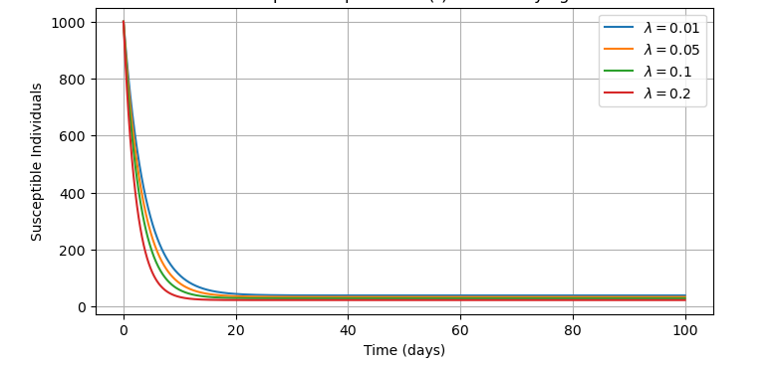

Figure 3: Population of susceptible individuals at varying force of infection with time
Figure 3: Susceptible population increases continuously as they get recruited into the population through birth rate. The population then decreases hence forth until it stabilizes due to vaccination of TB and transition of these individuals to the vaccinated class. The stabilization points vary with the varied force of infection ($λ$) whereby the lowest value of the force of infection stabilizes at higher population compared to the higher values of the force of infection. This means that if the force of infection is decreased, the stabilization level for the susceptible population increases as the rate of contracting TB decreases and if the force of infection ($λ)$ is increased, the stabilization point for the susceptible population decreases as more individual contract TB. Parameters increasing force of infection should be reduced and the parameters increasing susceptible population increased. The decrease in susceptible population is also attributed to high TB prevalence.

3.2.2 Vaccinated population at varying force of infection.

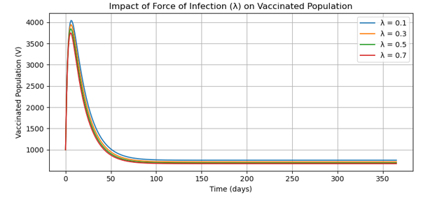
Figure 4: Population of vaccinated individuals at varying force of infection with time
Figure 4: TB vaccinated population increases due to the susceptible individuals being vaccinated. The population then decreases hence forth until it stabilizes at higher population than in susceptible population due to exposure of TB and transition of these individuals to the exposed class. If the force of infection ($λ$) is decreased, the vaccine efficacy increases as the rate of contracting TB decreases and if the force of infection ($λ)$ is increased, the vaccine efficacy decreases and more individuals will be exposed to TB. Parameters increasing force of infection should be reduced and the parameters increasing vaccinated population increased. The decrease in vaccinated population is also attributed to high TB prevalence. Strategies should be done to reduce parameters increasing the force of infection.
3.2.3 Exposed population at varying force of infection.
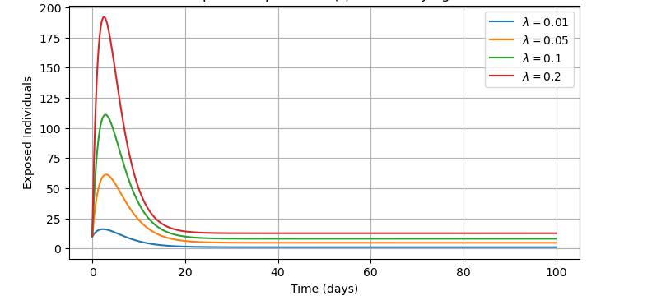
Figure 5: Population of exposed individuals at varying force of infection with time
Figure 5: TB exposed population increases due to the vaccinated individuals and also some individuals in the susceptible class being exposed. The population in the exposed class also increases as a result of the recovered individuals being exposed. The population then decreases due to individuals becoming infected either while in the care institutions or while in the normal environmental conditions. This leads to the transition of these individuals to the infected class. The force of infection ($λ$) is directly proportional to the exposure and therefore the rate at which susceptible individuals become infected depends on the exposure whereby the exposed individuals easily become infected. Thus, an increased force of infection leads to an increased population in the exposed class. The exposed population at ($λ=0.2)$ is higher than the exposed population at $(λ=0.1)$, ($λ=0.05)$ and ($λ=0.01)$ respectively as illustrated below.
3.2.4 Infected population in care institutions at varying force of infection.

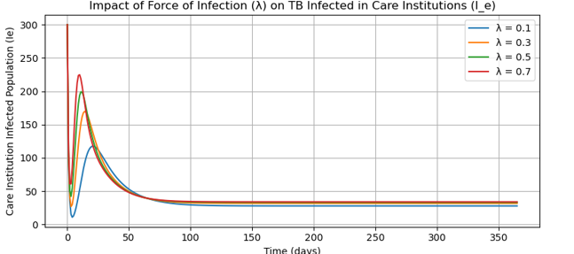

Figure 6: Population of infected individuals in care institutions at varying force of infection with time
Figure 6: TB infected individuals in the care institutions increase abruptly to the peak and reduces due to application of treatment. Transition from the exposed class to the infected populations in the care institutions leads to a decrease in infected population in care institutions. Increased force of infection in the care institutions resulted to an increased infected population in the care institutions. The highest value of the force of infection gives the highest peak compared to the lower values of the force of infection. The infected individuals in these institutions increased as it was accelerated by the congestion nature in the care institutions. To mitigate the spread of TB, strategies should focus on minimizing factors that contribute to a higher force of infection.
3.2.5 Infected population in normal environment at varying force of infection.

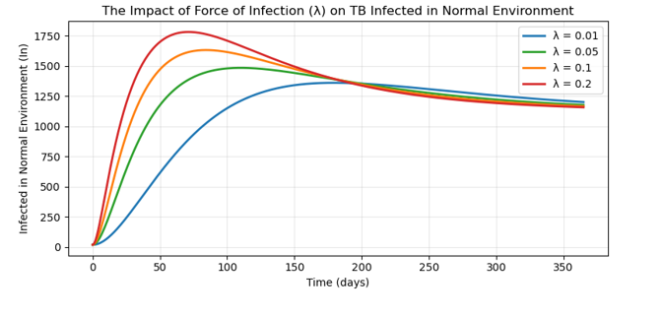
Figure 7: Population of infected individuals in normal environments at varying force of infection with time
Figure 7: TB infected population in the normal environments increased gradually until it reached the highest peak. As these individuals do not receive treatments, those with strong immunity will recover but since they are few, the reduction will be minimal as compared to the care institutions whereby treatment is applied. It is clear that the number of people recovering from TB is higher in care institutions than in normal environment due to application of treatment in the care institutions. Increased force of infection in the normal environment resulted to an increased infected population in the normal environments. A decrease in the force of infection leads to a decreased infection for the individuals in the normal environments. This is illustrated in figure 7 whereby the peak for the infected population in normal environment is higher at $(λ=0.2)$ compared to the peaks for the infected individuals in normal environment at lower values for the force of infection. Strategies should be done to reduce parameters increasing the force of infection.
3.2.6 Full treatment in care institutions at varying force of infection.

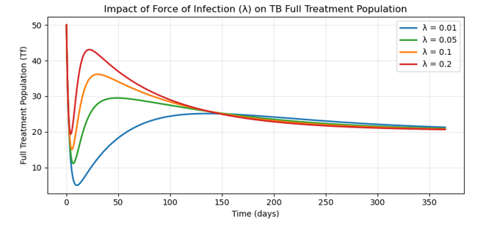
Figure 8: Population of fully treated individuals in the care institutions at varying force of infection with time
Figure 8: TB fully treated individuals in the care institutions increase through the infected individuals in the care institutions being fully treated and reduces due to the transition from the full treatment class to the recovered class. An increased force of infection leads to a decrease in the number of fully treated individuals because some individuals die as a result of TB due to re-infection. A decrease in the force of infection leads to increased fully treated individuals and as the reduction of the parameters increasing the force of infection is done, the fully treated individuals transit in to the recovered class. The effectiveness of full treatment is realized at stabilization point whereby the peak for the fully treated individuals at $(λ=0.2)$, stabilizes at lower population compared with the peaks at lower values of force of infection which stabilize higher as shown in figure 8.

3.2.7 Partial treatment in care institutions at varying force of infection.

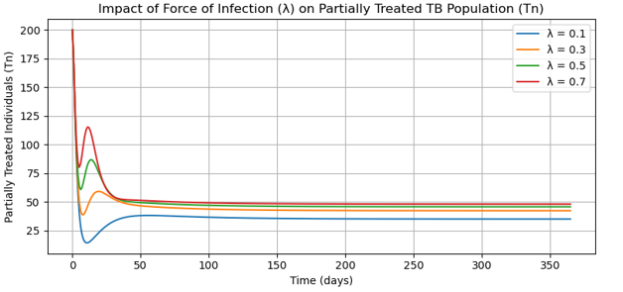
Figure 9: Population of partially treated individuals in the care institutions at varying force of infection with time
Figure 9: TB partially treated individuals in the care institutions increase through the infected individuals in the care institutions being partially treated and reduces due to the transition from the partial treatment class to the recovered class. Partial treatment is not effective in controlling TB transmission in the care institutions. It is clearly illustrated in figure 9 that an increased force of infection leads to an increase in the number of partially treated individuals because the impact of the treatment is negligible such that it is almost the same as lack of treatment in the care institutions. It is clearly seen in the graph that the individuals undergoing partial treatment are in the highest peak at the highest value of the force of infection$(λ=0.7)$, even after stabilization showing that the impact of the partial treatment in the care institutions is minimal.

3.2.8 Partial treatment in care institutions at varying force of infection.
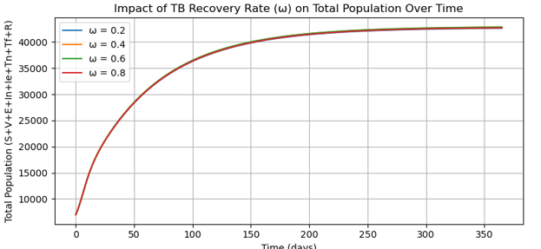
Figure 10: Population of recovered individuals with time
Figure 10: The recovered individuals increase with time as more treated individuals recover and join the class. A decrease is observed until it stabilizes as the recovered individuals gain temporal immunity to TB disease and join the exposed class and if the recovered individuals remain exposed, they can still contract TB as they don’t get permanent immunity against TB disease.

3.2.9 Relationship between Infected individuals in normal environments and Infected individuals in the care institutions given the partial and full treatments
Infected and Treated individuals over time
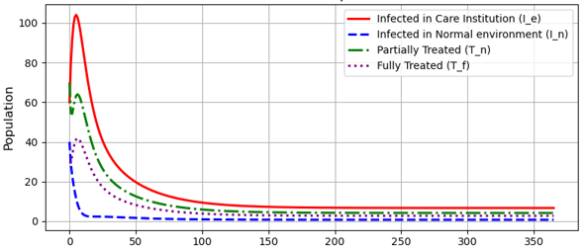
Figure 11: Population of infected and treated individuals with time
Figure 11: Care institutions are associated with high rate of TB transmission compared to the normal environmental conditions. Thus, the number of infected individuals in care institutions within a given period of time is higher than the number of infected individuals in normal environments. Variation of treatment from partial TB treatment to full TB treatment has a positive impact on TB transmission control. Full TB treatment in the care institutions resulted to reduction in TB transmission rate than the partial TB treatment in the care institutions. This resulted to many individuals transiting into the recovered class while in the care institutions compared to the number of individuals given partial treatment while in the care institutions entering the recovery class.

3.2.10 Rate of treatment on TB full treatment in care institutions

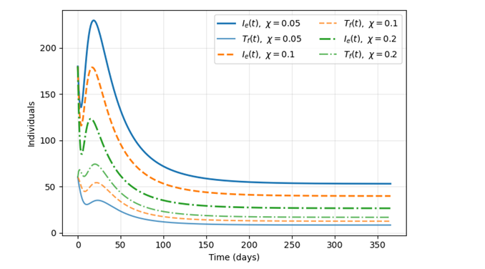
Figure 12: Population of infected and fully treated individuals with time
Figure 12: TB rate of treatment has an impact on the population in the care institutions. During TB outbreak, the rate of infection is high in care institutions. TB full treatment targets the infection in these institutions. This information is clearly illustrated in the graph below whereby the infection is higher in care institutions before application of full treatment. Infection is higher in care institutions before the application of the full treatment as it is seen when different values for the rate of treatment are used. Variation of the rate of treatment has impact on the full treatment whereby for the more infected individuals, a higher rate of treatment is required as illustrated in the graph below.

3.2.9 Rate of treatment on TB partial treatment in care institutions

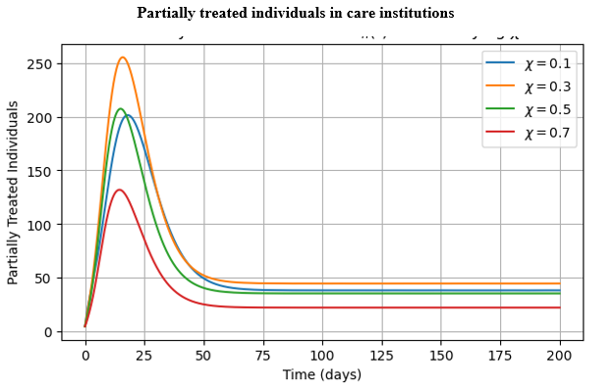
Figure 13: Population of infected and partially treated individuals with time
Figure 13: TB rate of treatment has an impact on the population in the care institutions. During TB outbreak, the rate of infection is high in care institutions. With TB partial treatment, the individuals in need of treatment reduces until stabilization occurs as seen at (χ = 0.7). This information is clearly illustrated in the graph below. Variation of the rate of treatment has impact on the partial treatment whereby many individuals are still in need of treatment at ( χ= 0.3).
3.8. Conclusion
In this paper, we developed a mathematical model for TB dynamics in care institutions perspective of variance in treatment. We analyzed the stability of both the disease-free and endemic equilibrium points. Our findings indicate that the disease-free equilibrium is locally and globally stable when the basic reproduction number (R₀), is less than one. This implies that reducing R₀ below unity can effectively control the spread of the disease. We then examined the endemic equilibrium and found it to be asymptotically stable when R₀ >1. Numerical simulations reveal that the application of treatment in care institutions hinders TB infection. However full treatment in care institutions is more effective than partial treatment.

Disclaimer (Artificial intelligence)
Option 1:
Author(s) hereby declare that NO generative AI technologies such as Large Language Models (ChatGPT, COPILOT, etc.) and text-to-image generators have been used during the writing or editing of this manuscript.
Option 2:
Author(s) hereby declare that generative AI technologies such as Large Language Models, etc. have been used during the writing or editing of manuscripts. This explanation will include the name, version, model, and source of the generative AI technology and as well as all input prompts provided to the generative AI technology
Details of the AI usage are given below:
1.
2.
3.

Acknowledgments
We sincerely appreciate the administrative staff of the Department of Physical Sciences at Tharaka University for their warm hospitality and invaluable support with our research-related activities.
References
- Ayinla, A. Y. and Othman, W. A. M. (2019). A Compartmental Model on the Effect of Quarantine on MDR-TB.
- Bares, S. H. and Swindells, S. (2020). Latent Tuberculosis and HIV Infection. Current Infectious Disease Reports, 22(7):17.
- Bhunu, C. (2011). Mathematical Analysis of a Three-Strain Tuberculosis Transmission Model. Applied Mathematical Modelling, 35(9):4647–4660.
- Bhunu, C., Garira, W., Mukandavire, Z., and Zimba, M. (2008). Tuberculosis Trans- mission Model with Chemoprophylaxis and Treatment. Bulletin of Mathematical Biology, 70:1163–1191.
- Churchyard, G., Kim, P., Shah, N. S., Rustomjee, R., Gandhi, N., Mathema, B., Dowdy, D., Kasmar, A., and Cardenas, V. (2017). What we know about Tuberculosis Transmission: An overview. The Journal of infectious diseases, 216(suppl_- 6):S629–S635.
- Dartois, V. A. and Rubin, E. J. (2022). Anti-Tuberculosis Treatment Strategies and Drug Development: Challenges and Priorities. Nature Reviews Microbiology, 20(11):685–701.
- Egonmwan, A. and Okuonghae, D. (2019). Analysis of a Mathematical Model for Tuberculosis with Diagnosis. Journal of Applied Mathematics and Computing, 59:129–162.
- Fatiregun, A. A., Ojo, A. S., and Bamgboye, A. E. (2009). Treatment Outcomes among Pulmonary Tuberculosis Patients at Treatment Centers in Ibadan, Nigeria. Annals of African Medicine, 8(2).
- Huo, H., Sun, X., and Zhang, X. (2010). The Differential Susceptibility SIR Epidemic Model with Time Delay and Pulse Vaccination. Journal of Applied Mathematics and Computing, 34:287–298.
- Jia, Z.-W., Tang, G.-Y., Jin, Z., Dye, C., Vlas, S. J., Li, X.-W., Feng, D., Fang, L.-Q.,
- Zhao, W.-J., and Cao, W.-C. (2008). Modeling the Impact of Immigration on the Epidemiology of Tuberculosis. Theoretical Population Biology, 73(3):437–448.
- Kendall, E. A., Hussain, H., Kunkel, A., Kubiak, R. W., Trajman, A., Menzies, R., and Drain, P. K. (2021). Isoniazid or Rifampicin Preventive Therapy with and without Screening for Subclinical TB: a Modeling Analysis. BMC Medicine, 19:1–16.
- Kuddus, M. A., McBryde, E. S., Adekunle, A. I., White, L. J., and Meehan, M. T. (2021). Mathematical Analysis of a Two-Strain Disease Model with Amplifi- cation. Chaos, Solitons & Fractals, 143:110594.
- Kuddus, M. A., McBryde, E. S., Adekunle, A. I., White, L. J., and Meehan, M. T. (2022). Mathematical Analysis of a Two-strain Tuberculosis Model in Bangladesh. Sci- entific Reports, 12(1):3634.
- McCluskey, C. C. and Driessche, P. v. d. (2004). Global Analysis of Two Tuberculosis Models. Journal of Dynamics and Differential Equations, 16:139–166.
- Oxlade, O., Schwartzman, K., Benedetti, A., Pai, M., Heymann, J., and Menzies,
- D. (2011). Developing a Tuberculosis Transmission Model that Accounts for Changes in Population Health. Medical Decision Making, 31(1):53–68.
- Ronoh, M., Jaroudi, R., Fotso, P., Kamdoum, V., Matendechere, N., Wairimu, J., Auma, R., and Lugoye, J. (2016). A Mathematical Model of Tuberculosis with Drug Resistance Effects. Applied Mathematics, 7(12):1303–1316.
- Seung, K. J., Keshavjee, S., and Rich, M. L. (2015). Multidrug-Resistant Tuberculosis and Extensively Drug-Resistant Tuberculosis. Cold Spring Harbor Perspectives in Medicine, 5(9):a017863.
- Sharma, V., Gupta, S. K., Shukla, K. K., et al. (2024). Deep Learning Models for Tuberculosis Detection and Infected Region Visualization in Chest X-Ray Images. Intelligent Medicine, 4(2):104–113.
- Smith, J. and Doe, A. (2019). Deterministic Mathematical Model of Tuberculosis Dis- ease with Treatment and Recovered Groups. International Journal of Mathemat- ics and Statistics Invention (IJMSI), 7(1):14–25.
- Trauer, J. M., Denholm, J. T., and McBryde, E. S. (2014). Construction of a Mathe- matical Model for Tuberculosis Transmission in Highly Endemic Regions of the Asia-Pacific. Journal of Theoretical Biology, 358:74–84.
- Yeketi, A. A., Othman, W. A. M., and Awang, M. O. (2019). The Role of Vaccination in Curbing Tuberculosis Epidemic. Modeling Earth Systems and Environment, 5:1689–1704.
- Zafar, Z. U. A., Younas, S., Zaib, S., and Tunç, C. (2022a). An Efficient Numerical Simulation and Mathematical Modeling for the Prevention of Tuberculosis. International Journal of Biomathematics, 15(04):2250015.
- Zhao, Y., Li, M., and Yuan, S. (2017). Analysis of Transmission and Control of Tuber- culosis in Mainland China, 2005–2016, Based on the Age-Structure Mathemati- cal Model. International Journal of Environmental Research and Rublic Health, 14(10):1192.
- Zhou, X., Shi, X., and Cheng, H. (2013). Modelling and Stability Analysis for a Tu- berculosis Model with Healthy Education and Treatment. Computational and Applied Mathematics, 32(2):245–260.

