Identification of microorganisms involved in cocoa fermentation in Togo and evaluation of their impact on the quality of the derived product

ABSTRACT

Aims: To identify the microorganisms involved in spontaneous cocoa fermentation in Togo and to evaluate their impact on the quality of the derived product.
Study design: Experimental study
Place and Duration of Study: Laboratory of Microbiology and Food Quality Control (LAMICODA), University of Lomé, Togo and Laboratory of Biomedical, Food and Environmental Health Sciences (LaSBASE), Higher School of Biological and Food Techniques (ESTBA), University of Lomé, Togo between January 2023 and July 2025.
Methodology: Spontaneous fermentations were carried out at two cocoa production sites in the Kloto region: Gadza-Wukpe and Tove Atsave. Characteristic colonies were isolated and subjected to standard biochemical identification tests. The selected strains were then used for controlled laboratory fermentations. The beans obtained from adding selected strains to fermentation start, were subjected to organoleptic analysis and an evaluation of their commercial quality based on international standards. Results: Microbiological analyses made it possible to isolate 27 strains among the mesophilic aerobic flora, yeasts and molds and lactic acid bacteria belonging to the genera Saccharomyces, Lactobacillus, Lactiplantibacillus, Pichia, Weisselia, Kluyveromyces, Leuconostoc, Enterococcus. Conclusion: As a perspective, the standardization of fermentation processes will allow to produce derived products, particularly chocolate and roasted cocoa beans of better and constant quality.

Keywords: Cocoa, Fermentation, Strains, Quality, Togo

1. INTRODUCTION

Cocoa is a key export crop in Togo (Guy Pontie, 2017), with production of 19476 tons in 2023. (MAHVDR, 2023). Togo aims to position itself in the cocoa market by promoting high-quality cocoa. The first cocoa plantations were established in the Kpalimé region in 1895 by German colonizers. Cocoa thrives in hot and humid forest areas, with the Plateaux region, particularly the Kloto prefecture, offering optimal conditions (Guy Pontie, 2017).
Currently, the area devoted to cocoa production in Togo is approximately 27 645 hectares in 2023 ((Rapport bilan de la campagne agro-pastorale 2023-2024 au Togo, 2024)), mainly concentrated in the Plateaux region . Although cocoa cultivation in Togo dates back to the 19th century, few studies have focused on the cocoa bean fermentation process in Togo, as highlighted by Taylor et al. Cocoa is the main raw material for chocolate and its by-products. Post-harvest practices, particularly fermentation and drying, significantly influence the quality of the by-products.
In Togolese cocoa plantations, fermentation occurs spontaneously, either on the ground, in banana leaves, baskets, or in heap, for 5 to 7 days. Fermentation primarily triggers several transformations in fresh cocoa beans:
- Removal of the mucilaginous pulp surrounding them
- Induction of embryo death, preventing the beans from germinating, which hinders their preservation
- Causes profound biochemical changes within the cotyledons.
The beans are then dried to reduce their moisture content from 60% in fermented beans to 6-7%. The dried beans are then exposed to the sun for 7 to 14 days, depending on the amount of sunlight. The fermented and dried beans are packed in 70 kg jute bags and stored in cooperative warehouses, cooperative facilities, or on farmers' premises (Pitcholo, 1990).
This study aims to :
- Research and isolate microorganisms associated with cocoa fermentation in Togo,
- Identify characteristic strains by biochemical tests,
- Analyze the impact on the organoleptic and market quality of fermented beans.
This integrated approach aims to provide scientific data to support the development of local starter crops, likely to strengthen the competitiveness of Togolese cocoa on the international market.

2. material and methods

2.1. Monitoring of on-site fermentation

The fermentations took place in two cocoa-producing localities in the Kloto region: Gadza-Wukpe and Tove Atsave. The pods were harvested from the cocoa trees and were shelled within an hour of shelling.
In Gadza-wukpe, fermentation took place in a rattan basket, the beans were previously placed in banana leaves, usually used for fermentation. In Tove - Atsave, the cocoa beans placed in banana leaves were put in a hole in the ground.
The cocoa pods are opened with a club and the fresh beans, covered with mucilage, are fermented. Fermentation lasted 7 days with manual mixing of the piles every 48 hours, particularly on days 1, 3, 5 and 7.
After the seven days of fermentation, the beans are immediately put to dry on racks for 7 to 14 days depending on the sunshine. Every 48 hours, approximately three samples of 100g each of fermented cocoa beans were taken in sterile bags. These were placed in a cooler containing cold accumulators for better conservation.
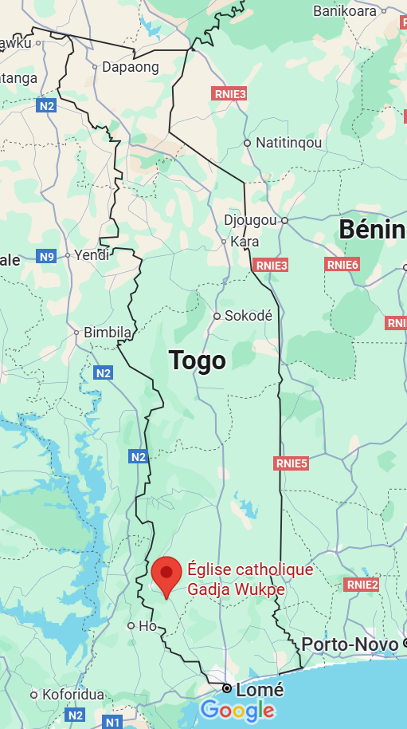
The samples were then transported to the Laboratory of Microbiology and Food Control (LAMICODA) at the University of Lome.
Fig.1: Google. (2025). Location of the village of Gadza Wukpe on Togo map. Google Maps

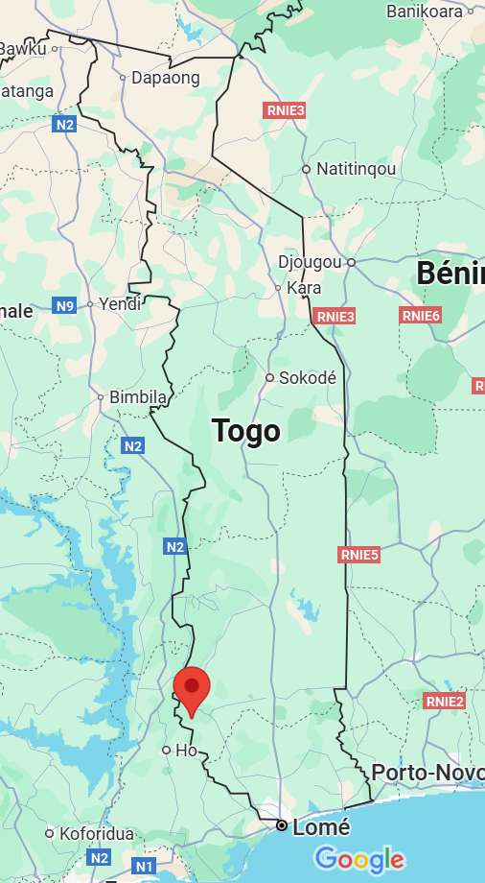

Fig.2: Google. (2025). Location of the village of Tove Atsave on Togo map. Google Maps

Table 1. Sampling schedule

Fermentation days | D1 | D2 | D3 | D4 | D5 | D6 | D7
Mixing and sampling beans | * |  | * |  | * |  | *

2.2. Isolation of microorganisms involved in the fermentation process

2.2.1. Sample preparation
For each sample, 25 g of fermented beans were aseptically collected, placed in 225 mL of sterile buffered peptone water (BPPW), and homogenized for 2 minutes using a stomacher.

2.2.2. Dilution and seeding
Successive decimal dilutions (10⁻¹ to 10⁻⁶) were carried out from the homogenate obtained. For each dilution, 100 µL were inoculated by plating on selective culture media, chosen according to the target microbial groups:

Table 2. Germs sought and culture conditions

Germs wanted | Culture medium | Growing conditions
Yeasts and molds | Sabouraud dextrose agar supplemented with 250mg/100ml chloramphenicol | The NF ISO 7954 standard: August 1988 thanks to the mass seeding technique. Incubation after homogenization and solidification is carried out at 30°C for 48 to 72 hours.
Lactic acid bacteria | De Man Rogosa Sharpe agar (MRS medium) | Incubated at 30°C for 24 to 48 hours according to the method described by Harrigan and Mc Cance in 1976.
Total mesophilic flora | PCA medium | The NF V08-051 standard : February 1999 by the mass seeding technique. The dishes are incubated at 30°C for 72 hours.

2.3. Morphological and biochemical characterization
After incubation, colonies with distinct morphology (size, shape, color, relief, opacity) were selected for each type of medium. In order to identify the microorganisms counted, identification tests were carried out, including catalase, oxidase and GRAM staining tests. 5 (Miguel et al., 2017)

2.3.1. Catalase

Catalase tests were conducted according to the protocol of Mcleod and Gordon,1936

2.3.2. Oxydase

Oxidase tests were conducted according to the protocol of Mcleod and Gordon, 1987

2.3.3. GRAM staining

GRAM staining was done according to the GRAM principle. It allowed the germs to be dissociated into Gram-positive or Gram-negative germs.

2.4. Controlled fermentation in the laboratory
A fermentation process was carried out in the laboratory, involving the inoculation of selected strains. These strains were incubated in 5 ml of Mueller Hinton broth at 30 °C for 48 hours.
Upon receipt, the cocoa pods were shelled, the fresh beans were taken out and distributed among small plastic baskets covered with banana leaves. The inoculum was then added to the fresh beans and mixed, triggering the fermentation process for 5 days, with the beans being mixed every 48 hours.
After fermentation, the beans are immediately dried on rattan racks. Drying lasts 7 to 14 days depending on the amount of sunlight during the drying period. The beans are regularly turned during the drying process to ensure a uniform drying process.

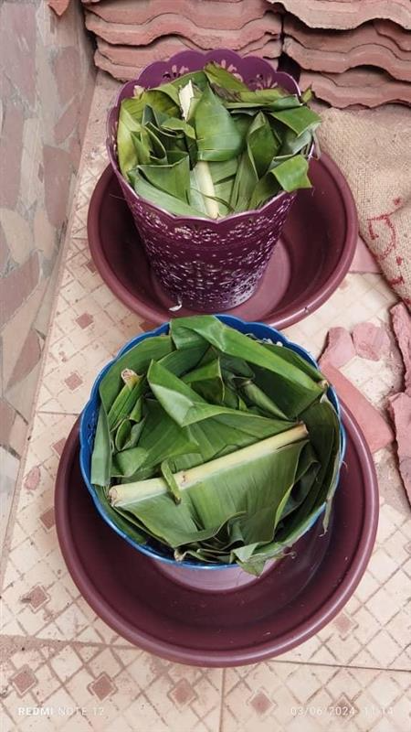
Fig.3: Controlled fermentation in small plastic baskets

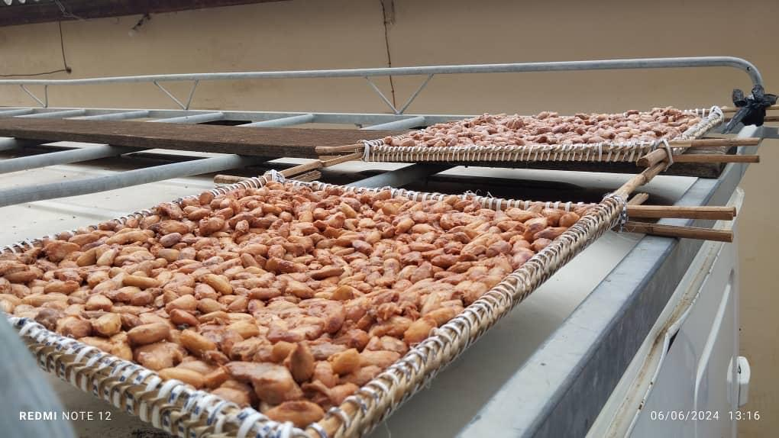

Fig.4: Cocoa beans drying on rattan racks

2.5. Sensory analysis

    - Obtaining the product derivative
Once the beans have dried, they are roasted. Roasting is an important step in cocoa processing causing water loss and generating volatile compounds responsible for chocolate aroma (R.F. Pena-Correa ˜ et al, 2022). The beans were roasted for 10 minutes over medium heat in a pan. The cocoa beans were then shelled by hand. This step removes the shells from the beans. The resulting roasted cocoa beans are then stored in airtight jars to preserve their freshness.

    - Composition of the tasting panel
To evaluate the organoleptic characteristics of the roasted cocoa beans obtained, a sensory analysis session was organized within the SATA Laboratory (Food Sciences and Agri-Food Technologies Laboratory) of ESTBA (Higher School of Biological and Food Technology) at the University of Lome.
50 panel members (of which 64% men and 36% of women) for most of them are students of the bachelor’s degree course in Food Analysis and Control participated in the session.
They were presented with five samples of roasted cocoa beans, including a sample of roasted cocoa beans from the Chocotogo brand, a control sample from the laboratory fermentation, and three samples of roasted cocoa beans from the laboratory fermentation tests. All samples were randomly coded.
Each taster had to try two beans from each sample with a mineral water mouth rinse after each sample.
A rating sheet was made available to them, on which they noted their assessment of the different samples.
The records were collected and analyzed to obtain the results of the sensory analysis.

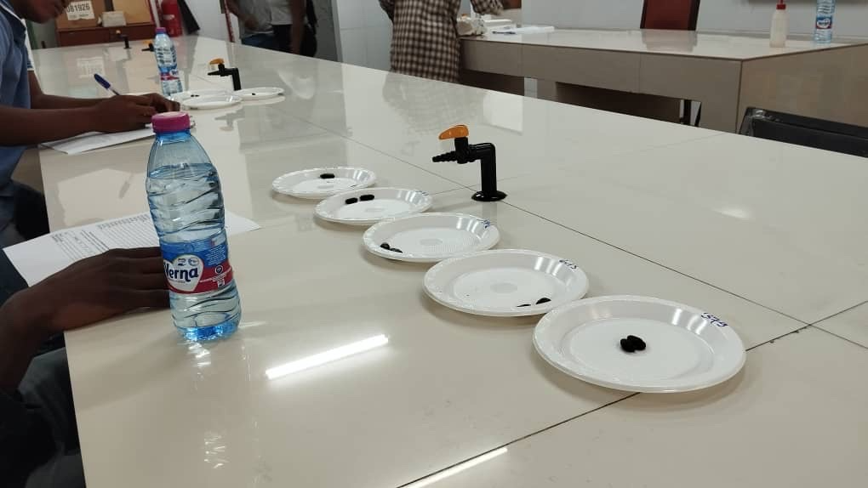

Fig.5: Sensory analysis panel

Table 3. Sampling for analysis organoleptic
Identification number | Sample tested
165 | Sample No. 20
273 | Sample No. 16
174 | Control
615 | Sample No. 6
379 | Chocotogo roasted cocoa beans

2.5.6. Assessment of merchantability
The assessment of the marketable quality of cocoa beans from each sample allows us to determine the quantity of moldy, moth-eaten, flat, sprouted beans, the fermentation rate as well as the humidity rate.
Bean count refers to the number of healthy and normal cocoa beans contained in a given mass of beans (Konan et al., 2023). In order to determine the bean count of the samples, a weighing procedure on an electronic balance is carried out to determine the average weight of a bean and the number of beans per 100 g.
The fermentation index is determined by the cut test. This test serves as a benchmark for determining cocoa quality on the world market. This method uses color as the evaluation criterion.
In practice, assessing the fermentation quality of cocoa beans involves selecting a representative sample, usually 300 beans. This analysis focuses on visually examining the cotyledons, the main part of the bean, to determine the fermentation rate. Well-fermented beans are characterized by a uniform brownish color and a uniform texture, as opposed to under-fermented beans, which may display purple or white hues and an uneven texture.

Table 4: Criteria sought during the control of marketable quality

Designation of defects/ Criteria sought
Beans moldy
Beans moths-weevil
Flat beans
Beans sprouted
Unfermented beans​
Beans insufficiently fermented
Beans insufficiently fermented
Unfermented​
Humidity
Number of beans

3. results and discussion

3.1. Results

3.1.1 Isolated microbial diversity and biochemical tests
The germ count allowed the isolation of lactic acid bacteria, yeasts and molds and a diversified total mesophilic flora. (Figures 6 and 7)

Fig. 6: Results of the Agou zone

Fig. 7: Results of Tove zone

Biochemical identification has highlighted the microbial diversity involved in cocoa fermentation. The table summarizes the results of the biochemical tests and shows the biochemical characteristics of the identified and selected germs. (Fig. 8)

Fig. 8: Results of phenotypic characterization

3.1.3. Sensory analysis of fermented beans
The results of sensory analysis show that the dominant taste characteristics are cocoa taste, bitter taste, woody taste and nutty taste. This demonstrates that the panel find that the samples given to them present mostly the taste of cocoa, nut, wood and bitterness.
The analysis also does not show that the panel did not find any significant difference between the different samples. (Fig. 9)

Fig. 9: Sensory analysis result (taste detected)

Fig. 10: Sensory analysis result

3.1.4. Marketable quality of beans
The marketable quality tests established that 84.84% of the analyzed samples are of superior quality, 12.12 are of common quality and 3.03% must be reconditioned before analysis. (Fig. 6)

Fig. 11: Result of the marketable quality control

3.2. Discussion

Although cocoa has been cultivated in Togo for over a hundred years, very few studies have been conducted on the cocoa fermentation process and the microorganisms involved in it.
As (Taylor et al., 2022) stated in their study, “there is an unfortunate lack of data from many cacao-producing countries. Colombia, Peru, Papua New Guinea, Uganda, Venezuela, Togo, India, Sierra Leone, Haiti, Guatemala, and Madagascar are all in the top twenty cacao-producing countries (Food and Agriculture Organization Statistics, 2017; International Cocoa, 2018; World Population, 2019), yet do not have a single article that meets the inclusion criteria of this review.”.
This study stands as a preliminary work for a better understanding of the fermentation of cocoa beans in cocoa-producing area in Togo.

The results of this study confirm that cocoa fermentation in Togo relies on a microbial diversity comparable to that observed in other producing regions such as Ivory Coast or Ghana. The genera Saccharomyces , Lactobacillus and Acetobacter play a central role, in agreement with the work of Ardhana and Fleet (2003) and Camu et al. (2008).
According to the study by Tovar et al., a wide diversity of microorganism species with internationally registered beneficial characteristics was discovered, including P. acidilactici, L. brevis, L. plantarum, L. farraginis, L. rhamnosus, Gluconobacter sp ., G. japonicus, A. tropicalis, A. pasteurianus/pomorum, A. malorum/tropicalis, D. hansenii, M. guillermondii , W. anomalus, B. megaterium and B. subtilis .
Nielsen, 2006 found the following germs Candida, Bacillus, Lactobacillus, Saccharomyces, Acetobacter.
(Mota-Gutierrez et al, 2018) observed that colony counts revealed the predominance of yeasts at the beginning of both fermentations, followed by acetic acid bacteria (AAB) and lactic acid bacteria (LAB). Hanseniaspora opuntiae, S. cerevisiae, Pichia pijperi, Acetobacter pasteurianus and Lactobacillus fermentum were the most abundant.
The study by Kouame et al., 2015 highlights the microbial diversity existing in cocoa fermentation in Agnéby-Tiassa .
Like all these studies, our work confirms that fermentation involves a broad microbial diversity in the cocoa fermentation process in Togo as in other producing regions in the world.

The microbial succession during cocoa beans fermentation is well documented although the fermentation is a complex phenomenon (De Vuyst & Leroy, 2020). Despite the fact that, the succession of species is well known, the cocoa fermentation process differs in microbial species and counts as well as in substrate and metabolite compounds and concentration over time, this leads to variation in cocoa fermentation quality and cocoa flavour (De Vuyst & Leroy, 2020, Adler et al., 2013)

The study focused on identifying yeasts and molds, lactic bacteria. The study did microbial count and morphological and biochemical characterisation by Gram stain, catalase and oxydase tests (Miguel et al., 2017). Numerous studies showed the implication of acetic bacteria involvement. Two main phases occurs during the cocoa fermentation process: anaerobic yeast and lactic acid bacteria phase and aerobic acetic acid bacteria phase (De Vuyst & Leroy, 2020, Hirko et al., 2023)
In the anaerobic phase yeast and acid lactic bacteria are involved. Yeast predominates this phase for the first 24 hour. Their presence is favored by the initial acidity of the cocoa pulp (pH 3.6), the concentration of citric acid, the low oxygen levels, and environmental temperature ranging from 25–35 °C (Gutiérrez-Ríos et al., 2022). The first stage of cocoa bean fermentation involves the growth of yeasts mostly belonging to the genera Hanseniaspora, Saccharomyces, Candida, Kluyveromyces, Kazachstania, Meyerozyma, Rhodotorula, Wickerhamomyces, and Pichia (Gutiérrez-Ríos et al., 2022, Mota-Gutierrez et al., 2018, Nielsen et al., 2005, Delgado-Ospina et al., 2020).These results confirm this study where Saccharomyces, Kluyveromyces and Pichia are the yeasts identified.

LAB is a group of Gram-positive bacteria whose main product of fermentable carbohydrate metabolism is lactic acid (Gänzle, M. G, 2015, Gutiérrez-Ríos et al., 2022). As Gutiérrez-Ríos et al., stated the LAB population increase when some of the pulp and lixiviate have drained mainly due to pectin degradation, and the yeast population decreases. Carbon dioxide production favors this increase in LAB populations by the yeasts and by the release of vitamins and other nutrients from the autolysis of yeast cells during cocoa fermentation Gutiérrez-Ríos et al., 2022, Agyirifo et al., 2019). The most abundant species during the LAB phase are Limosilactobacillus fermentum, Lactiplantibacillus plantarum, Leuconostoc mesenteroides, Lactococcus lactis, Lactobacillus plantarum, Lactobacillus pentosus and Lactobacillus fermentum (Gutiérrez-Ríos et al., 2022, Ho et al., 2015, Sarbu, I., & Csutak, O. (2019). These results match this study findings as it detected the presence Saccharomyces, Lactobacillus, Lactiplantibacillus, Pichia, Weisselia, Kluyveromyces, Leuconostoc, Enterococcus
Isolation and morpho-biochemical characterization revealed the predominant presence of lactic acid bacteria (Lactobacillus plantarum, L. fermentum), acetic acid bacteria (Acetobacter pasteurianus, Gluconobacter oxydans) and yeasts (Saccharomyces cerevisiae, Pichia kudriavzevii). These genera are classically reported in the literature on cocoa fermentation, particularly in West Africa (Camu et al., 2008; De Vuyst et al., 2016), confirming their central role in the metabolic transformations of cocoa mucilage.
The dominance of S. cerevisiae and L. plantarum as key species in Togolese isolates provides a relevant basis for the development of local starter cultures, adapted to the specific environmental conditions of the country.
Molecular identification validated the biochemical results and ensured essential taxonomic precision for future biotechnological exploitation of the strains.

The quality tests runned essentially by doing cut-test showed that 84.9% of the cocoa beans obtained from fermentation inoculated with the isolated strains are of superior quality. This demonstrates that the strains used for fermentation make it possible to obtain cocoa beans that can be marketed under the superior quality grade.

Treatment with the inoculated strains therefore had no significant impact on the organoleptic quality of the fermented cocoa beans. However, there are still controversies in scientific reports because some mention that there are no significant differences in the sensory characteristics of the final product (Gutiérrez-Ríos et al., 2022)
Regarding, yeast impact on cocoa sensory profile, yeast direct and indirect by-product in the fermentation process contribute fruity and floral notes to the cocoa’s profile (Campos et al., 2025). Conditions created by an acidic environment due to the metabolism of lactic acid bacteria inhibits the growth of undesirable microorganisms. This happens by metabolic process of homolactic fermentation and heterolactic fermentation. Lactic acid bacteria act to preserve the safety of cocoa fermentation products (Campos et al., 2025).

Sensory analyses conducted by Ariza Budi Tunjung Sari et al, 2023, revealed that cocoa beans from Indonesia and Ghana had cocoa notes.
This study determined that a wide variety of germs are involved in the fermentation of cocoa beans in Togo. However, the study could not show a significant impact of the strains involved individually for the improvement of the organoleptic and market quality of cocoa beans.
Finally, although this study provides a solid foundation, some limitations must be considered, including the limited number of sampling sites and the lack of metagenomic analysis of spontaneous fermentation. A more integrated approach including metabolomics could provide more detailed information on the specific contribution of each microorganism to aroma profiles.

4. Conclusion

Cocoa is an important crop in Togo both economically and agriculturally. It is therefore essential to study the stages of cocoa processing that give it its organoleptic and marketable characteristics. Fermentation is a crucial step in this process and harmonization of the products obtained is necessary. Through this study, the diversity of germs involved in fermentation was established as well as the sensory profile of the beans marked mainly by cocoa, bitter, nutty and woody tastes. However, the study could not determine a strain that significantly improves the organoleptic quality of cocoa beans. It is therefore essential to complete the analyses by studying more deeply the fermentation parameters and the design of starter for cocoa fermentation.

COMPETING INTERESTS DISCLAIMER:
Authors have declared that they have no known competing financial interests OR non-financial interests OR personal relationships that could have appeared to influence the work reported in this paper.

ACKNOWLEDGEMENTS
The author acknowledged all the authors referenced in this manuscript.

Disclaimer (Artificial intelligence)

Author(s) hereby declare that generative AI technologies such as Large Language Models, etc. have been used during the writing or editing of manuscripts. This explanation will include the name, version, model, and source of the generative AI technology and as well as all input prompts provided to the generative AI technology

Details of the AI usage are given below:
1.Assistance to refine the title of the article
2.Assistance to refine the structure of article

References

- Pontié, G. & Ruf, T. (1987). Development and Farmer Strategies: The Evolution of Coffee and Cocoa Replanting in Togo, 86-100.

- Coffee-Cocoa: Maintenance Time - Agridigitale. (n.d.). Retrieved September 4, 2025, from https://www.agridigitale.net/article/cafe-cacao-temps-dentretien

- PITCHOLO, A. E. (1990). Trial of the Use of Cocoa Pod Pericarps (THEOBROMA CACAO L.) in Broiler Chicken Feed in Togo. Inter-State School of Veterinary Sciences and Medicine (EISMV), Dakar.

- 6°49’31.6"N 0°38’44.4"E · 6.825444, 0.645667. (n.d.). 6°49’31.6"N 0°38’44.4"E · 6.825444, 0.645667. Retrieved September 11, 2025, from https://www.google.com/maps/place/6%C2%B049’31.6%22N+0%C2%B038’44.4%22E/@8.5035666,-0.4902028,7.25z/data=!4m4!3m3!8m2!3d6.8254444!4d0.6456667?hl=fr&entry=ttu&g_ep=EgoyMDI1MDkwOC4wIKXMDSoASAFQAw%3D%3D

- Église catholique gadja wukpe · gadjagan, togo. (n.d.). Église Catholique Gadja Wukpe · Gadjagan, Togo. Retrieved September 11, 2025, from https://www.google.com/maps/place/%C3%89glise+catholique+Gadja+Wukpe/@8.6589856,1.6547218,7.25z/data=!4m6!3m5!1s0x1026e77f66b3e611:0xf8e2dcc713fef998!4b1!8m2!3d6.8230436!4d0.7510031!5m1!1e4

- Miguel, M. G. D. C. P., Reis, L. V. D. C., Efraim, P., Santos, C., Lima, N., & Schwan, R. F. (2017). Cocoa fermentation: Microbial identification by MALDI-TOF MS, and sensory evaluation of produced chocolate. LWT, 77, 362–369. https://doi.org/10.1016/j.lwt.2016.11.076

- M’leod, J. W., & Gordon, J. (1923). Catalase production and sensitivity to hydrogen peroxide among bacteria: With a scheme of classification based on these properties. The Journal of Pathology and Bacteriology, 26(3), 326–331. https://doi.org/10.1002/path.1700260304

- 6. Gordon, J., & McLeod, J.W. (1928). The practical application of the direct oxidase reaction in bacteriology. The Journal of Pathology and Bacteriology, 31(2), 185–190. https://doi.org/10.1002/path.1700310206

- Taylor, A. J., Cardenas-Torres, E., Miller, M. J., Zhao, S. D., & Engeseth, N. J. (2022). Microbes associated with spontaneous cacao fermentations—A systematic review and meta-analysis. Current Research in Food Science, 5, 1452–1464. https://doi.org/10.1016/j.crfs.2022.08.008

- De Vuyst, L., & Leroy, F. (2020). Functional role of yeasts, lactic acid bacteria and acetic acid bacteria in cocoa fermentation processes. FEMS Microbiology Reviews, 44(4), 432–453. https://doi.org/10.1093/femsre/fuaa014

- Adler, P., Bolten, C. J., Dohnt, K., Hansen, C. E., & Wittmann, C. (2013). Core fluxome and metafluxome of lactic acid bacteria under simulated cocoa pulp fermentation conditions. Applied and Environmental Microbiology, 79(18), 5670–5681. https://doi.org/10.1128/AEM.01483-13

- Hirko, B., Mitiku, H., & Getu, A. (2023). Role of fermentation and microbes in cacao fermentation and their impact on cacao quality. Systems Microbiology and Biomanufacturing, 3(4), 509–520. https://doi.org/10.1007/s43393-023-00160-9

- Gutiérrez-Ríos, H. G., Suárez-Quiroz, M. L., Hernández-Estrada, Z. J., Castellanos-Onorio, O. P., Alonso-Villegas, R., Rayas-Duarte, P., et al. (2022). Yeasts as producers of flavor precursors during cocoa bean fermentation and their relevance as starter cultures: A review. Fermentation, 8(7), 331. https://doi.org/10.3390/fermentation8070331

- Mota-Gutierrez, J., Botta, C., Ferrocino, I., Giordano, M., Bertolino, M., Dolci, P., Cannoni, M., & Cocolin, L. (2018). Dynamics and biodiversity of bacterial and yeast communities during fermentation of cocoa beans. Applied and Environmental Microbiology, 84(19), e01164-18. https://doi.org/10.1128/AEM.01164-18

- Nielsen, D. S., Hønholt, S., Tano‐Debrah, K., & Jespersen, L. (2005). Yeast populations associated with Ghanaian cocoa fermentations analysed using denaturing gradient gel electrophoresis (DGGE). Yeast, 22(4), 271-284.

- Delgado-Ospina, J., Triboletti, S., Alessandria, V., Serio, A., Sergi, M., Paparella, A., ... & Chaves-López, C. (2020). Functional biodiversity of yeasts isolated from Colombian fermented and dry cocoa beans. Microorganisms, 8(7), 1086.

- Ostovar, K., & Keeney, P. G. (1973). Isolation and characterization of microorganisms involved in the fermentation of trinidad’s cacao beans. Journal of Food Science, 38(4), 611–617. https://doi.org/10.1111/j.1365-2621.1973.tb02826.x

- Gänzle, M. G. (2015). Lactic metabolism revisited: metabolism of lactic acid bacteria in food fermentations and food spoilage. Current Opinion in Food Science, 2, 106-117.

- Lima, L. J. R., Almeida, M. H., Nout, M. J. R., & Zwietering, M. H. (2011). theobroma cacao l. , “the food of the gods”: Quality determinants of commercial cocoa beans, with particular reference to the impact of fermentation. Critical Reviews in Food Science and Nutrition, 51(8), 731–761. https://doi.org/10.1080/10408391003799913

- Ho, V. T. T., Zhao, J., & Fleet, G. (2015). The effect of lactic acid bacteria on cocoa bean fermentation. International Journal of Food Microbiology, 205, 54–67. https://doi.org/10.1016/j.ijfoodmicro.2015.03.031

- Sarbu, I., & Csutak, O. (2019). The microbiology of cocoa fermentation. In Caffeinated and cocoa based beverages (pp. 423-446). Woodhead Publishing.

- Lozano Tovar, M. D., Tibasosa, G., González, C. M., Ballestas Alvarez, K., Lopez Hernandez, M. D. P., & Rodríguez Villamizar, F. (2020). Isolation and identification of microbial species found in cocoa fermentation as microbial starter culture candidates for cocoa bean fermentation in Colombia. Pelita Perkebunan (a Coffee and Cocoa Research Journal), 36(3), 236–248. https://doi.org/10.22302/iccri.jur.pelitaperkebunan.v36i3.443

- Sandris Nielsen, D. (2006). The microbiology of Ghanaian cocoa fermentations: Ph. D. thesis. Department of Food Science.

- Mota-Gutierrez, J., Botta, C., Ferrocino, I., Giordano, M., Bertolino, M., Dolci, P., et al. (2018). Dynamics and biodiversity of bacterial and yeast communities during fermentation of cocoa beans. Applied and Environmental Microbiology, 84(19), e01164-18. https://doi.org/10.1128/AEM.01164-18

- Maïmouna Kouamé, L., Koua, G. A. Y., Niamké, J. A., Goualié, B. G., & Niamké, S. L. (2015). Cocoa fermentation from agnéby-tiassa: Biochemical study of microflora. American Journal of BioScience, 3(6), 203. https://doi.org/10.11648/j.ajbio.20150306.12

- Anita Sari, I., Murti, R.H.M., Misnawi, M., Putra, E.T.S.P., & Susilo, A.W.S. (2022). Sensory profiles of cocoa genotypes in Indonesia. Biodiversitas Journal of Biological Diversity, 23(2). https://doi.org/10.13057/biodiv/d230205

- Cempaka, L., Rahmawati, E.A., Ardiansyah, A., & David, W. (2021). Sensory profiles of chocolate drinks made from commercial fermented cocoa powder and unfermented cocoa beans. Current Research in Nutrition and Food Science Journal, 9(3), 988–999. https://doi.org/10.12944/CRNFSJ.9.3.26

- Sari, A. B. T., Fahrurrozi, Marwati, T., Djaafar, T. F., Hatmi, R. U., & Purwaningsih. (2023). Chemical composition and sensory profiles of fermented cocoa beans obtained from various regions of Indonesia. International Journal of Food Science, 2023, 1–13. https://doi.org/10.1155/2023/5639081

- Campos, S. D. M., Martínez-Burgos, W. J., Dos Reis, G. A., Ocán-Torres, D. Y., Dos Santos Costa, G., Rosas Vega, F., Alvarez Badel, B., Sotelo Coronado, L., Lima Serra, J., & Soccol, C. R. (2025). The role of microbial dynamics, sensorial compounds, and producing regions in cocoa fermentation. Microbiology Research, 16(4), 75. https://doi.org/10.3390/microbiolres16040075

- Ardhana, M., & Fleet, G.H. (2003). The microbial ecology of cocoa bean fermentations in Indonesia. International Journal of Food Microbiology, 86(1–2), 87–99. https://doi.org/10.1016/S0168-1605(03)00081-3

- Bortolini, C., Patrone, V., Puglisi, E., & Morelli, L. (2016). Detailed analyzes of the bacterial populations in processed cocoa beans of different geographic origin, subject to varied fermentation conditions. International Journal of Food Microbiology, 236, 98–106. https://doi.org/10.1016/j.ijfoodmicro.2016.07.004

- Peña-Correa, R.F., Ataç Mogol, B., Van Boekel, M.A.J.S., & Fogliano, V. (2022). Fluidized bed roasting of cocoa nibs speeds up processing and favors the formation of pyrazines. Innovative Food Science & Emerging Technologies, 79, 103062. https://doi.org/10.1016/j.ifset.2022.103062

- Konan, K. A., Coulibaly, I., Kouassi, K. A., & Fauconnier, M.-L. (2023). Evaluation of the marketable, biochemical and organoleptic quality of cocoa beans (Theobroma cacao l. 1753) from new fermentation media in the De La Nawa region (Ivory Coast). 1st University Cocoa Congress. https://orbi.uliege.be/handle/2268/312527

