Case report
Successful Management of Staphylococcal Dermatitis in a Dog: A Case Report

ABSTRACT

Aims: Aim of this report is to discuss about a canine Staphylococcal dermatitis case with its symptoms, diagnosis and treatment strategies.
Presentation of case: A seven-year-old female mixed breed dog was brought with complaints of severe itching over the whole-body area for one year along with alopecia and other symptoms. The dog was examined and laboratory examinations (skin scraping examination, skin swab culture, haematology) were done for a proper diagnosis. PCR was performed to detect the presence of Staphylococcus using published primers. The management of dermatitis was done with ivermectin, and adjunct therapy using omega fatty acids to alleviate symptoms for 28 days. The case was reviewed periodically and improvements were recorded. The results were discussed with published research articles in the subject and conclusions were given
Discussion: Dermatitis is a common skin disease in dogs caused by various aetiologies. Bacteria like Staphylococcus can cause dermatitis when there is a damage of skin's protective barrier by underlying issues like allergies, wounds, external parasites, or nutritional deficiencies.
Conclusion: Ivermectin can be used for the treatment of dermatitis caused by Staphylococcus. Adjunct therapy with omega fatty acids could alleviate the symptoms (pruritus, alopecia, lichenification, erythema, excoriation, patches, crusts and foul odour) associated with dermatitis.

Keywords: Dermatitis; dog; ivermectin; skin; PCR; Staphylococcus

- INTRODUCTION

Dermatological disorders have significant impact on animals, causing distress, irritation, and unpleasant odors. They also provide a risk of zoonotic disease transmission. Bacterial dermatitis is a significant dermatological issue in dogs. Several bacterial species have been identified as primary or secondary infections, and their sensitivity varies with location. Bacterial pyoderma is a frequent dermatologic condition in dogs, however diagnosing it can be challenging even for skilled clinicians [1].
Immunoglobin E (IgE)-mediated type 1 hypersensitivity reactions are linked to skin and skin conditions that cause inflammation. These effects are brought on by varying quantities of dietary fatty acids. Dogs with inflammatory skin disease are treated with fatty acid supplements. Fatty acid supplements are used for adjunct therapy in inflammatory skin conditions in dogs. According to recent research, eating more polyunsaturated fatty acids (PUFAs) may enhance the function of the skin's epidermal barrier [2]. PUFAs mainly omega- 3 and omega-6 supplementation helps to increase the immune response, reduction of inflammatory mediators and promoting skin barrier function. In allergies and dermatitis that causes irritation and itching, omega-3 FA helps to alleviate the condition as it poses anti-inflammatory properties. Likewise, omega-6 FA is contributing the healthy skin barrier function, giving protection from pathogens and environmental allergens. Dogs with essential fatty acid (EFA) deficit have matted skin coat and unkempt appearance including delayed growth and discoloured coat. Therefore, they are highly recommended as an adjunct therapy for the effective management of bacterial dermatitis [3]. In this case report we are discussing about the management of bacterial skin infection in a 7-year-old female dog.

2. PRESENTATION OF CASE

A 7-year-old mixed breed dog weighing 7.3 kg was brought to the Veterinary Clinical Complex, Selesih, Aizawl, Mizoram with Out Patient Department (OPD) number 1729 on 24th September 2023. The dog was having a history of severe itching over the whole-body area for one year along with alopecia, lichenification of the skin, presence of fleas on the body, inappetence, erythema, excoriation, patches, crusts and foul odour. Clinical examination was conducted and observed that animal was active and alert, having rectal temperature of 101.5⁰F and with a normal mucus membrane colour.

After recording the complete case history, laboratory examinations were performed on skin scraping, skin swab accompanied by haematological examination and molecular test. Skin scraping examination revealed absence of any external parasites. Skin swabs were inoculated in the nutrient broth and then streaked on to the nutrient agar plate and kept in the incubator at 37⁰C for 24 hours for colony development. Large round golden-yellow colour colonies were observed. The colonies were identified by using Gram staining and found clusters of Gram-positive bacteria indicating of Staphylocopccus aureus (S. aureus). Polymerase Chain Reaction (PCR) was done to detect S. aureus using the standard protocol [4]. The published primers (Table 1) for nuc gene were used to detect S. aureus [5]. PCR results were found positive for S. aureus at 280 base pair (bp), as shown in fig 1. Haematological analysis showed all the parameters were within the normal range (Table 2).

Table 1. Staphylococcal nuc gene [5]

Primer Sequences (Amplicon size: 280 bp) | Phase | Cycle | PCR Components
F: 5’-GCGATTGATGGTGATACGGTT-3’ | 1. Initial denaturation at 94⸰ C for 5 min | 1 | 1. 2X PCR Master mix (5 µl)  2. Forward Primer (0.5 µl)  3. Reverse Primer (0.5 µl)  4. NFW (2 µl)  5. Template DNA (2 µl)
R: 5’- ACGCAAGCCTTGACGAACTAAAGC-3’ | 2. Denaturation: 94⸰C for half min, Annealing: 55⸰C for 30 sec  Extension: 72⸰C for 1 min | 30
R: 5’- ACGCAAGCCTTGACGAACTAAAGC-3’ | 3. Final extension at 72⸰C for 10 min | 1

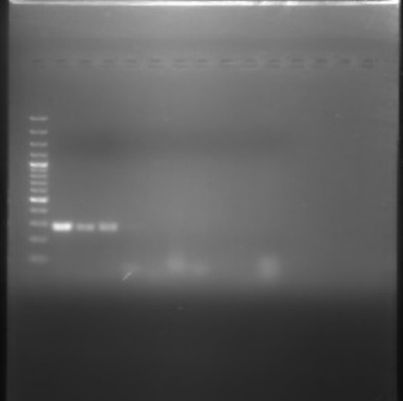  M  L1  L2  L3 | L 1: Control (Positive)  L 2: Sample (Positive)  L 3: Sample (Positive)  M: Ladder- 100bp  280 bp  L 1: Control (Positive)  L 2: Sample (Positive)  L 3: Sample (Positive)  M: Ladder- 100bp  L 1: Control (Positive)  L 2: Sample (Positive)  L 3: Sample (Positive)  M: Ladder- 100bp

Fig 1: PCR detection of nuc gene of S. aureus

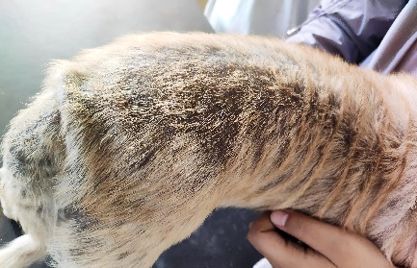 | 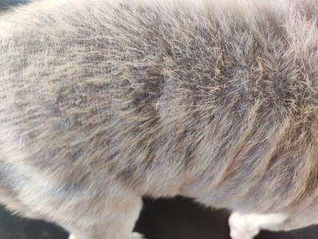 | 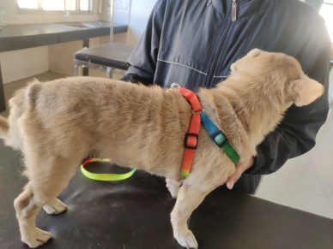
Fig 2. 0th Day | Fig 3. 14th Day | Fig 4. 28th Day

Table 2. Haematological findings
Parameters | Value | Reference Range
RBC (million/µL) | 6.43 | 5.5-8.5
WBC (x 10³/ µL) | 12.7 | 6-17
HB (g/dL) | 15.9 | 12-18
PCV (%) | 47.7 | 37-55
Neutrophil (%) | 70 | 51-84
Eosinophil (%) | 5.3 | 0-09
Lymphocyte (%) | 23.7 | 08-38
Monocyte (%) | 1 | 01-09
Platelets (x 10⁵/ µL) | 4.59 | 02-05

The case was diagnosed as bacterial skin infection. The animal was treated with Inj. Ivermectin @ 0.2 mg/Kg SC, Tablet Itraconazole 100 mg @ 5mg/Kg BID, Tablet Levocetrizine 10mg @ 1mg/Kg OD and a Tablet containing Pentoxifylline 400 mg @ 10-25 mg/Kg PO OD for 14 days. Syrup with nutritional skin and hair coat containing Omega 3 and Omega 6 was advised at the rate of 1 TSP PO OD and a shampoo with Miconazole Nitrate and Chlorhexidine Gluconate was advised for giving bath.

The evaluation of clinical sign was done on 0, 14 and 28 days of post treatment. Improvement was observed on day 14 and 28 of post treatment (Fig 2, Fig.3 and Fig 4). On 14th and 28th day of therapy, swab samples were collected and culture was done on Nutrient agar and observed no bacterial growth.

3. DISCUSSION

The higher incidence of dermatitis in adult dogs could be due to roaming outside home. Dogs with an average age more than 6 year have more chance for getting dermatitis with S. aureus infection [6]. Similar to the clinical signs in this report, it was observed that the most common clinical signs for superficial pyoderma were erythema, alopecia, collarets, pruritus, scabs, pustules, hyperkeratosis, hyper pigmentation and ulcers [7]. The common clinical signs for dermatitis due to Staphylococcus spp. were erythema, alopecia, pustules and hyperkeratosis [8]. The most common lesions in dogs with skin disorders are pruritis, acute moist dermatitis, ulcerative lesions, scaling, superficial bacterial folliculitis, and abscesses, according to Bajwa [9]. Erythema is the most common symptom in dogs with bacterial dermatitis [10]. In laboratory diagnosis of Staphylococcal infections, colonies of S. aureus were showed as large yellow to white colonies with roughly spherical to smooth surface on nutrient agar media plates [11]. Clusters of gram-positive cocci indicating S. aureus were observed in Gram staining [12]. A similar finding was also observed in other studies [13]. PCR is one of the effective molecular tests for the detection of Staphylococcus. A similar observation was recorded in molecular studies where skin samples from dog were found positive for S. aureus [14]. A comparable result in this report was obtained by collecting skin swabs from dogs with dermatoses and detecting the presence of the nuc gene [7]. Identification of nuc gene can be used as a confirmatory diagnosis for S. aureus infection [5]. Ivermectin has antibacterial effects against S. aureus infection and also against Methicillin Resistance Staphylococcus aureus (MRSA) [15]. In this case report, supplements containing omega fatty acids were used as an adjunct therapy. Omega fatty acid supplementations for the skin disorders can help to alleviate the symptoms of inflammation and improve the skin barrier function. Combination of omega-3 and omega-6 fatty acids showed more beneficial as an adjunct therapy against bacterial dermatitis [16].

4. CONCLUSION

Dermatitis is a common skin infection in dog and can cause by variety of agents. Bacterial infection is one of the most common etiologies. In this case report a female dog with dermatitis along with its clinical symptoms, diagnosis, and treatment is described. PCR results and laboratory findings were used for diagnosis and are discussed. Ivermectin can be used for the treatment of dermatitis caused by Staphylococcus. Adjunct therapy with omega fatty acids could alleviate the symptoms associated with dermatitis.

ETHICAL APPROVAL

The work was performed with permission of Institute Animal Ethics Committee of the institute vide No. CVSC/CAU/IAEC/2023-2024/P-15 (Post Graduate work of the first author).

Disclaimer (Artificial intelligence)
Author(s) hereby declares that NO generative AI technologies such as Large Language Models (ChatGPT, COPILOT, etc.) and text-to-image generators have been used during the writing or editing of this manuscript.
REFERENCES

- Logas D, Delan CY. Bacterial Infections. Small Animal Dermatology for Technicians and Nurses, 2019; 27-44.
- Macri AM, Hurley L, Matei S. The importance of dietary control in skin and hair disorders in dogs. AgriScriptum, 2017; 27-31.
- Kar P, Rajesh JB, Behera S, Konwar B, Samanta AK, Prasad H, Tolenkhomba T. Omega Fatty Acids and Its Role in Amelioration of Canine Dermatological Disorders. J Sci Res Rep. 2024; 30(11), 910-921.
- Khaleel DA, Othman RM, Khudaier BY. Plasmid transformation and curing of nalidixic acid gene in Staphylococcus aureus isolated from buffaloes mastitis and worker’s hands. Iraqi J Vet Sci. 2018; 32(2).
- Kar P, Rajesh JB, Behera SK, Konwar B, Tolenkhomba TC, Sarma K. Detection of nuc and mecA from Canine Dermatoses Cases at Aizawl. J Exp Biol Agric Sci. 2025; 13(3): 299-308.
- Punpichaya F, Pasakorn B, Pattrarat C, Nuvee P. Distribution of methicillin-resistant coagulase-positive Staphylococci (MRCoPS) in a surgical unit and cystotomy operation sites in a veterinary teaching hospital. J Vet Med Sci. 2017; 16-0146
- González-Domínguez MS, Carvajal HD, Calle-Echeverri DA, Chinchilla-Cárdenas D. Molecular detection and characterization of the mecA and nuc genes from Staphylococcus species (S. aureus, S. pseudintermedius, and S. schleiferi) isolated from dogs suffering superficial pyoderma and their antimicrobial resistance profiles. Front Vet Sci. 2020; 7: 376.
- János D, Viorel H, Ionica I, Corina P, Tiana F, Roxana D. Carriage of multidrug resistance Staphylococci in shelter dogs in Timisoara, Romania. Antibiotics, 2021; 10(7): 801.
- Bajwa J. Canine superficial pyoderma and therapeutic considerations. Can Vet J. 2016; 57(2); 204.
- Bansal A. Studies on clinico-diagnostics of canine dermatological disorders and its management [Internet]. 2022.
https://krishikosh.egranth.ac.in/items/fcf1f10a-bf0f-4367-b7dc-3f0467dd795d
Accessed on 10/09/2025
- Gnanamani A, Hariharan P, Paul-Satyaseela M. Staphylococcus aureus: Overview of bacteriology, clinical diseases, epidemiology, antibiotic resistance and therapeutic approach. Frontiers in S. aureus, 2017; 4(28): 10-5772.
- Ranzani OT, Motos A, Chiurazzi C, Ceccato A, Rinaudo M, Bassi GL, Torres A. Diagnostic accuracy of Gram staining when predicting Staphylococcal hospital-acquired pneumonia and ventilator-associated pneumonia: a systematic review and meta-analysis. Clin Microbiol Infect. 2020; 26(11): 1456-1463.
- Hadano Y, Isoda M, Ishibashi K, Kakuma T. Validation of blood culture gram staining for the detection of Staphylococcus aureus by the ‘oozing sign’surrounding clustered gram-positive cocci: a prospective observational study. BMC Infect Dis. 2018; 18(1): 490.
- Elshabrawy MA, Abouelhag HA, Khairy EA, Marie HS, Hakim AS. Molecular Divergence of Staphylococcus aureus Isolated from Dogs and Cats. Jordan J of Biol Sci. 2020; 13(2).
- Ashraf S, Chaudhry U, Raza A, Ghosh D, Zhao X. In vitro activity of ivermectin against Staphylococcus aureus clinical isolates. Antimicrob Resist Infect Control. 2018; 7(1), 27.
- Kar P, Rajesh JB, Behera SK, Konwar B, Samanta AK, Prasad H, Sarma K, Tolenkhomba TC. Alpha linolenic acid and linoleic acid and their effects on therapeutic regimen of canine dermatoses. Int J Adv Biochem. Res. 2025; 9(5): 351-360.

