Preliminary Study of Bedbug Infestation in A Hostel at Awka, Anambra State, Nigeria

ABSTRACT
Bedbugs are nocturnal obligate blood sucker that can invaded human habitation. Their bite causes sleep disturbances, skin reactions, loss of concentration and social stigmatization. Nigeria has recently experienced a high bedbug infestation rate, especially in homes, hotels, and hostels. Therefore, this preliminary investigation was primarily conducted to document bedbug infestation for the first time in a university hostel at Awka. Sensitization of hostel management personnel and four occupants of the inspected room done to obtain their consent prior to commencement of the investigation, which was allowed to take place between 5-6pm on 14th August 2024. Convenient sampling was used to collect bed bugs from beddings in the suspected room. Collected bedbugs were transferred to the Entomology Unit of the Department of Parasitology and Entomology Laboratory for identification using standard entomological keys. Blood-stained bed spreads, obnoxious odor of bed bug feces, dead shriveled bedbugs and molted skins of bedbugs were observed during the inspection, an indication of chronic bedbug infestation of the room. A total of seventy bedbugs, with a preponderance of nymphs, followed by adult females and then males were recovered within one hour allowed for the investigation. Bedbug identified belong the species Cimex lectularius. Findings from this work will help in evidence-based pest management policy on periodic fumigation of offices, lounges, rooms and conveniences in students’ hostels and other facilities in the university so as to tackle bed bug infestation on campus.
Keywords: Bedbugs, hostel, infestation, skin reaction, stigmatization.
INTRODUCTION
Bed bugs (Hemiptera: Cimicidae) are small, hematophagous insects of significant medical and veterinary importance (Mbuta et al., 2022). They are nocturnal, obligate blood feeders (Oboh et al., 2022) and have evolved to thrive in human dwellings and other protected environments. Although bedbugs were considered largely under control by the mid-20th century, their prevalence has increased dramatically since the early 2000s. This resurgence has been driven by widespread pesticide resistance, increased international travel, globalization of trade, changes in pest management practices, and increased urbanization (Doggett et al., 2012; Romero et al., 2017).
Globally, the resurgence of bedbugs has renewed public and scientific interest in their biology, ecology, and control strategies (Humphreys, 2025). Bedbugs are now reported from virtually every continent and in a wide variety of settings—including homes, hotels, dormitories, shelters, public transport, and even hospitals. In these environments, their bites cause diverse dermatological and allergic reactions ranging from mild erythema to severe hypersensitivity, with secondary infections arising from scratching (Tielemans et al., 2022; Reinhardt & Siva-Jothy, 2007). Persistent infestations are also associated with social stigma, psychological stress, and sleep disruption (Amiri et al., 2018; Susser et al., 2012). These indirect health impacts can have long-term consequences for vulnerable populations such as students, migrant workers, and low-income households.
Two species—Cimex lectularius (the common bed bug) and Cimex hemipterus (the tropical bed bug)—account for nearly all human infestations worldwide (Akhoundi et al., 2023; Hamlili et al., 2023). Although C. lectularius has a more temperate distribution, it is now frequently encountered in African cities, while C. hemipterus has expanded beyond its traditional tropical range (Deku et al., 2022; Fourie & Crafford, 2018). This overlap is creating mixed infestations in some areas and complicating control efforts because the two species may respond differently to insecticides (Dang et al., 2021). In Nigeria, both species have been recorded in urban and peri-urban settings, including student hostels, hotels, and military barracks (Oduola et al., 2017; Omudu & Kuse, 2010).
Bedbugs typically colonize mattresses, bed frames, pillows, rugs, wooden furniture, curtains, cracks, and crevices where they hide during the day and emerge at night to feed (Onah et al., 2014; WHO, 2024). Their ability to remain hidden for long periods and to survive months without a blood meal makes eradication difficult. Female bedbugs lay multiple batches of eggs, which hatch into nymphs that resemble miniature adults. Under favorable conditions of warmth and host availability, bedbugs can complete several generations per year, leading to explosive population growth (Romero et al., 2017).
Poor sanitation and inadequate housekeeping practices have been implicated as key drivers of infestations in Nigeria (Omudu, 2008). Overcrowding in hostels, use of second-hand furniture, and lack of regular fumigation further increase the risk of spread. Beyond the nuisance they cause, bedbugs are increasingly recognized as potential mechanical or biological vectors of pathogens such as Trypanosoma cruzi, Bartonella spp., and hepatitis B virus, although definitive evidence of transmission to humans remains limited (Salazar et al., 2015; Goddard & de Shazo, 2009).
In response to international outbreaks, the Nigerian Ministry of Health heightened surveillance in 2023 following reports of bedbug infestations in France and other parts of Europe. The Ministry’s alerts emphasized the risk posed by these insects in beds, sofas, luggage, and other furniture, which can facilitate their spread during travel. This mirrors recommendations from the World Health Organization (WHO, 2024), which now classifies bedbugs as a re-emerging public health pest requiring coordinated action at points of entry and in community settings. Against this background, there is a pressing need for local data on infestation patterns in student hostels and other high-density environments in Nigeria to guide evidence-based prevention and control programs.
MATERIALS AND METHODS

Study Area and Population
This preliminary survey was conducted in August 2024 in a female undergraduate hostel located within the Awka Campus of Nnamdi Azikiwe University, Nigeria. The target room, which was selected based on prior complaints of insect nuisance, accommodated four female students at the time of sampling.

Specimen Collection
Field sampling was carried out on 14th August 2024 between 17:00 and 18:00 h. The early evening period was chosen to minimise disturbance to the students and to increase the likelihood of finding bed bugs in their harbourages. Bed bugs were collected following a convenience sampling procedure adapted from Punchihewa et al. (2019). Mattresses, bedframes, pillows, and bedding were systematically inspected for live insects, exuviae, faecal spots and eggs. Live specimens were gently removed with fine forceps and transferred into clean, screw-capped, pre-labelled plastic containers to maintain sample integrity and prevent cross-contamination.
Transport and Laboratory Processing
Immediately after collection, all specimens were transported under ambient conditions to the Entomology Unit of the Department of Parasitology and Entomology Laboratory for processing and identification.
Species Identification and Morphometry
Identification was performed under a stereomicroscope using the diagnostic keys of Pratt and Smith (2005). Diagnostic characters recorded included overall reddish-brown coloration, anteriorly positioned clypeus, segmented antennae, a broad pronotum, prominent wing pads, sturdy legs and a segmented abdomen without functional wings. To determine size ranges, representative nymphal and adult specimens were placed alongside a transparent, calibrated millimetre ruler and photographed for documentation. A total of 70 bed bugs of different developmental stages—nymphs, adult females and adult males—were recovered within the one-hour sampling window.
RESULTS AND DISCUSSION
During the inspection, several unmistakable indicators of a well-established and chronic bedbug infestation were observed within the sampled room. Most striking among these were blood-stained bedspreads and pillowcases, an offensive, characteristic odour arising from accumulated bed bug faeces, the presence of dead, shrivelled adult specimens, and numerous exuviae (molted skins) scattered across bedding and furniture surfaces (Fig. 1). These visible signs are typical of long-standing infestations where successive generations of bedbugs have thrived undisturbed, resulting in large populations capable of causing sustained nuisance and health concerns.
Within the one-hour sampling period allowed for this preliminary investigation, a total of seventy individual bedbugs were successfully collected from bedding materials (Fig. 2). Analysis of their developmental composition revealed a clear dominance of immature stages (nymphs), followed in abundance by adult females and then adult males. Such a stage distribution is consistent with actively breeding populations and may also reflect the greater tendency of nymphs to remain hidden in crevices and beddings where sampling was concentrated.
Morphological examination under stereomicroscopy confirmed that all collected specimens belonged to the cosmopolitan species Cimex lectularius (Figs. 3 and 4), distinguished by its reddish-brown coloration, anteriorly placed clypeus, broad pronotum, well-developed wing pads, and segmented abdomen devoid of functional wings. Measurement of the preserved specimens further indicated that fully grown adults could attain lengths of approximately 5 mm (Fig. 5), which aligns with published descriptions of the species in the literature. This combination of field and laboratory observations underscores the severity of the infestation detected in the room and highlights the urgent need for routine surveillance and management interventions within student hostels.

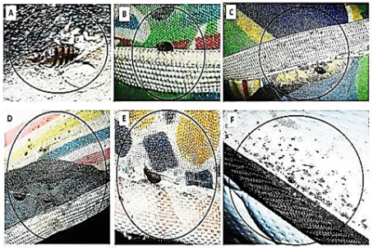
Fig. 1: Bed bugs, skin casts, feces, and blood-stains on beddings inspected
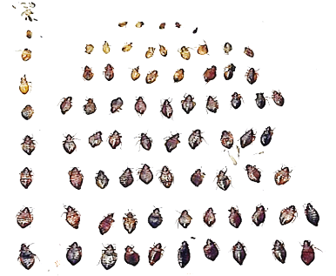
Fig. 2: Different growing phases of engorged bed bugs recovered beddings inspected

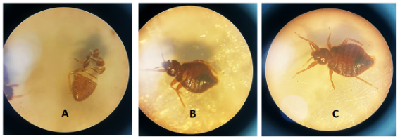
Fig. 3. Microscopic views of Engorged Bedbugs [A, B, C] at different stages of development
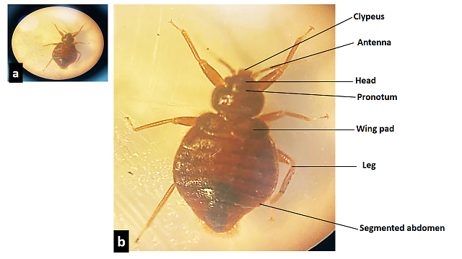
Fig. 4. Bedbug (Cimex lectularius) showing characteristic identification features

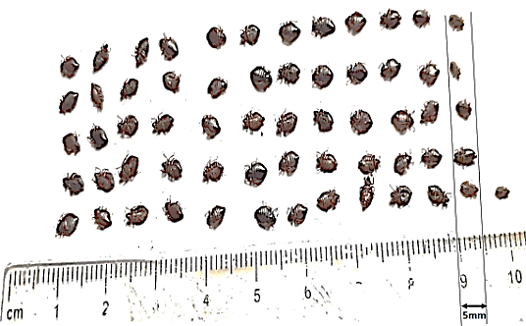
Fig. 5. Relative sizes of recovered nymphs and adults bugs (length ≡ 5mm) bedbugs
Different growth phases of engorged bed bugs, especially nymphs, were recovered from mattresses, pillows and bedspreads in the room investigated. This corroborates the findings from a similar survey of bed bug infestation in some homes and hostels Benue State Nigeria by Onah et al. (2014) who inspected bed frames, bunks, mattresses, pillows, chairs, and clothes. These authors (Onah et al., 2014) reported a preponderance of nymphs followed by males and females bedbugs and attributed the high number of infestation recorded in the hostels to poor hygiene, lack of adequate knowledge of the best control practices and the high population density. Four occupants of the room in our study constituted overcrowding, which may be a risk factor for the spread of bed bugs. Nuisance caused by bedbugs’ infestation globally (Kweka et al., 2009) may result into sleeplessness and anxiety, which, in this study could affect concentration of affected students in school work. Other authors have also associated bed bug bite with stigmatization and psychological distress (Emmanuel et al., 2014; Berenji et al., 2019). The high numbers of bed bugs recorded in this study under one hour could probably be due to observed overcrowding, improper housekeeping and poor hygiene which was also reported from other hostels investigated in Gboko, Nigeria (Omudu, 2008). The World Health Organization had earlier suggested that poor housekeeping encourages bedbug breeding (WHO, 2009).
Attendance by members of the public to major activities like matriculation, convocation and several conferences which regularly take place on campus could be a means of distribution of bed bugs in our university environment. Noticeable bustling economic activity on campus may also be a risk factor for bed bug introduction. It has been proven that tourists, travelers, and migrant workers often bring bed bugs with them inadvertently, facilitating the establishment of the pest in the local environment (Delaunay and Pharm, 2012). There is concentrated human housing in Awka, and this increases the likelihood of bed bug infestations since C. lectularius is known for its adaptability to urban environment (Fung et al., 2020).
CONCLUSION
The markedly high rate of bedbug infestation documented in the inspected room unmistakably reflects a combination of contributory factors, most notably could be a general lack of adequate knowledge regarding the biology, behaviour, and control of bed bugs among occupants. Such conditions provide ideal breeding grounds for the proliferation and persistence of Cimex species within student hostels. This observation underscores the urgent need for a comprehensive and proactive approach to address the problem.
Central to such an approach is the implementation of targeted awareness and education programmes aimed at improving students’ understanding of bed bug infestation, its public-health implications, and effective preventive measures. Empowering hostel residents with accurate information and practical skills would significantly reduce the risk of recurrent infestations.
In addition, the findings of this study provide valuable evidence to support the development and refinement of institutional pest management policies. Specifically, they highlight the necessity of establishing routine, evidence-based fumigation schedules for offices, lounges, sleeping quarters, and sanitary conveniences within students’ hostels and other university facilities. When systematically applied, such measures would not only suppress existing infestations but also prevent re-introduction and spread.
Finally, the approach adopted in this investigation can serve as a model for similar surveillance and control initiatives beyond the university setting. Property owners, hostel managers, and professional pest management outfits should be encouraged to conduct periodic inspections and preventive treatments within their facilities. By extending such integrated pest-management strategies to the larger community, stakeholders can collectively reduce the burden of bed bug infestation, thereby promoting healthier living and learning environments.

Ethical Considerations and Consent
Prior to specimen collection, a one-week sensitization and briefing exercise was undertaken with hostel management staff and the room occupants to explain the objectives and procedures of the study. Verbal informed and written consent were obtained from all participants before commencement of the investigation.

Disclaimer (Artificial intelligence)
Option 1: Author(s) hereby declare that NO generative AI technologies such as Large Language Models (ChatGPT, COPILOT, etc.) and text-to-image generators have been used during the writing or editing of this manuscript.

Option 2:
Author(s) hereby declare that generative AI technologies such as Large Language Models, etc. have been used during the writing or editing of manuscripts. This explanation will include the name, version, model, and source of the generative AI technology and as well as all input prompts provided to the generative AI technology
Details of the AI usage are given below:
1.
2.
3.

REFERENCES
Akhoundi, M.; Zumelzu, C.; Sereno, D.; Marteau, A.; Brun, S.; Jan, J.; Izri, A. Bedbugs (Hemiptera: Cimicidae): A Global challenge for public health and control management. Diagnostics 2023, 13, 2281.
Amiri, P.; Rahimi, B.; Khalkhali, H.R. Electronic physician. Electron. Physician 2018, 10, 6201–6207.
Berenji F, Moshaverinia A, Jadidoleslami A, Shamsian A, Doggett SL, Moghaddas E. Evaluation of the Common Bed Bug, Cimex lectularius (Insecta: Hemiptera: Cimicidae) Susceptibility to λ-Cyhalothrin, Malathion, and Diazinon in Northeastern Iran. J Med Entomol. 2019; 56:903– 906. https://doi.org/10.1093/jme/tjz011
Bonnefoy X, Kampen H, Sweeney K. Public Health Significance of Urban Pests. World Health Organization. 2008. https://doi.org/10.1007/978-3-319-13884-8_31
Dang, K., Doggett, S. L., Veera Singham, G., & Lee, C. Y. (2017). Insecticide resistance and resistance mechanisms in bed bugs, Cimex spp. (Hemiptera: Cimicidae). Parasites & Vectors, 10, 318. https://doi.org/10.1186/s13071-017-2232-3
Deku, G.; Combey, R.; Doggett, S.L. Morphometrics of the tropical bedbug (Hemiptera: Cimicidae) from Cape Coast, Ghana. J. Med. Entomol. 2022, 59, 1534.
Deku Godwin , Combey Rofela, Doggett Stephen L, and Mensah Benjamin A. Assessment of Tropical Bed Bug (Hemiptera: Cimicidae), Infestations in Cape Coast, Ghana: Household Control Practices and Efficacy of Commercial Insecticides and Long-Lasting Insecticidal Nets Against Field Bed Bugs. J Med Entomol. 2021, 16;58(4):1788-1797. DOI: 10.1093/jme/tjab042
Delaunay, P.; Pharm, D. Human travel and traveling bedbugs. J. Travel Med. 2012, 19, 373–379.
Doggett, S.L., Dwyer, D.E., Penas, P.F. and Russell, R.C. (2012). “Bed bugs: Clinical relevance and control options.” Clinical Microbiology Reviews. 25(1), 164 192. https://doi.org/10.1128/CMR.05015-11
Emmanuel OI, Cyprian A, and Agbo OE. A survey of bedbug (Cimex lectularius) infestation in some homes and hostels in Gboko, Benue State, Nigeria. Psyche (London). 2014. https://doi.org/10.1155/2014/762704
Fourie, J.; Crafford, D. The bed bug resurgence in Africa. In Advances in the Biology and Management of Modern Bed Bugs; Wiley: Hoboken, NJ, USA, 2018; pp. 87–94.
Fung HC, E.; Wong, H.; Chiu, S.W.; Hui JH, L.; Lam, H.M.; Chun, R.Y.; Wrong, S.Y.; Chan, S. Risk factors associated with bedbug (Cimex spp.) infestations among Hong Kong households: A cross-sectional study. J. Hous. Built. Environ. 2020, 37, 1411–1429.
Goddard, J., & de Shazo, R. (2009). Bed bugs (Cimex lectularius) and clinical consequences of their bites. JAMA, 301(13), 1358–1366.
Hamlili, F.Z.; Bérenger, J.M.; Parola, P. Cimicids of medical and veterinary importance. Insects 2023, 14, 392.
Humphreys, G. Public health round-up. Bull. World Health Organ. 2025, 103, 3–4.
Kweka E, Mwang′onde B, Kimaro E, Msangi S, Tenu F, Mahande A. Insecticides susc ceptibility status of the bedbugs ( Cimex lectularius ) in a rural area of Magugu, Northern Tanzania. J Glob Infect Dis. 2009; 1(2):102.
Mbuta, D.M. Sokame, B.M. Khamis, F.M. and Akutse, K.S. Know Where You Go: Infestation Dynamics and Potential Distribution of Two Bed Bug Species (Hemiptera: Cimicidae) in Africa. Insects 2025, 16, 395. https://doi.org/10.3390/ insects16040395
Mbuta, D.M.; Khamis, F.M.; Sokame, B.M.; Ng’ong’a, F.; Akutse, K.S. Household perception and infestation dynamics of bedbugs among residential communities and its potential distribution in Africa. Sci. Rep. 2022, 12, 19900. [CrossRef] [PubMed]
Oboh Mary Aigbiremom, Olusegun-Joseph Taiye Shade, Awoniyi Adedayo Michael, Ileaboya Maureen Ihinosen, Lawal Bukola Tawakalitu, Fagbohun Ifeoluwa Kayode. Susceptibility and fecundity of Bedbugs (Cimex hemipterus) from Yaba College of Technology Lagos exposed to Selected Classes of Insecticides: A short report Pan African Journal of Life Sciences (2022): 6(2): 472-476 DOI: 10.36108/pajols/2202/60.0250
Oduola AO, Omotayo AI, Adelaja OJ, Obembe A. Bedbug (Cimex lectularius) infestation and its control practices in two selected settlements in Ilorin, Kwara State, Nigeria. Animal Res Int. 2017; 14(3):2818-2
Okwa OO, Omoniyi AO. The prevalence of headlice (Pediculus humanus capitis) and bedbug (Cimex hemipterus) in selected human settlement areas in south-west Lagos state, Nigeria. J Parasitol Vector Biol. 2008; 2(2): 8– 13.
Omudu E.A, “A survey of bedbug (Hemiptera: Cirnicidae infestations in some homes and hostels in Makurdi and Otupkpo, Benue State, Nigeria, with notes on public health implications,” The Nigerian Journal of Pure and Applied Sciences, vol. 1, pp. 84–91, 2008.
Omudu EA, Kuse CN. Bedbug infestation and its control practices in Gbajimba: a rural settlement in Benue state, Nigeria. J Vector Borne Dis. 2010; 47(4):222.
Onah Isegbe Emmanuel, Alu Cyprian, and Omudu Edward Agbo. A Survey of Bedbug (Cimex lectularius) Infestation in Some Homes and Hostels in Gboko, Benue State, Nigeria. Psyche: Journal of Entomology Volume 2014, Article ID 762704, 5 pageshttp://dx.doi.org/10.1155/2014/762704
Pratt H.D and Smith J.W, “Arthropods of public health importance,” in Diagnostic Procedure for Mycotic and Parasitic Infections, B. B. Wentworth, Ed., American Public Health Association, Washington, Wash, USA, 2005.
Punchihewa R, de Silva WPP, Weeraratne TC, Karunaratne SP. Insecticide resistance mechanisms with novel ‘kdr’type gene mutations in the tropical bed bug Cimex hemipterus. Parasites and Vectors. 2019; 12(1): 310.
Reinhardt, K., and Siva-Jothy, M. T. (2007). Biology of the bed bugs (Cimicidae). Annual Review of Entomology, 52, 351–374.
Romero, A., Potter, M. F., Potter, D. A., & Haynes, K. F. (2017). Evaluation of piperonyl butoxide synergism in pyrethroid-resistant bed bugs. Journal of Economic Entomology, 110(3), 1233–1240.
Salazar, R., Castillo-Neyra, R., Tustin, A., Borrini-Mayorí, K., Náquira, C., & Levy, M. Z. (2015). Bed bugs (Cimex lectularius) as vectors of Trypanosoma cruzi. American Journal of Tropical Medicine and Hygiene, 92(2), 331–335. https://doi.org/10.4269/ajtmh.14-0483
Tielemans, E.; Rautenbach, C.; Besselaar, J.F.; Beugnet, F. Efficacy of a topical product combining esafoxolaner, eprinomectin and praziquantel against bedbug (Cimex lectularius) experimental infestations in cats. Parasite 2022, 29, 59. [CrossRef] [PubMed]
US Environmental Protection Agency (EPA). Bed Bugs: A Public Health Issue. 2023. Available online: https://www.epa.gov/ bedbugs/bed-bugs-public-health-issue (accessed on 22 June 2024).
World Health Organization (WHO), Public Health Significance of Urban Pests, 2009.

