Prospection and Collection OF Striga hermonthica Ecotypes and Cultivated Millet in Niger: Towards Improved Control Strategies

Abstract
Among the dominant food crops (millet, sorghum, cowpea), millet holds a prominent place in the national food security strategy. However, production remains insufficient to meet the population's needs. This productivity deficit is explained by various biotic and abiotic factors, among which Striga hermonthica represents one of the major constraints. The main objective was to study the morphological diversity of local millet varieties and Striga hermonthica ecotypes collected in different regions of Niger, and to analyse their relationship with observed infestation levels, in order to contribute to the selection of resistant cultivars and the improvement of control strategies against this parasite. Between October and November 2021, several prospection and collection missions for Striga ecotypes and the millet seeds from which they emerged were successively carried out in each of the listed regions within Niger's three main Striga infestation zones. The number of millet panicle samples collected varied according to seed availability, with a minimum of 1 to 3 panicles. A comprehensive survey of all parasite-infested areas was the first step of this work. Samples were collected based on the availability of the farmer and mature seeds (both Striga and millet). Data collected during the prospection, collection, and survey phases were entered and verified using Excel 2010. Surveys have revealed a significant morphological diversity within local Nigerien millet varieties. Millet seeds exhibit variations in colour, shape, and size depending on the region. Dosso showed the greatest diversity of shapes, while Tahoua presented 80% oval seeds. Striga infestation in the surveyed fields was widespread, with "significant" levels dominating (40-60% of fields). Maradi and Zinder experience the most severe infestations (40% "very significant" cases). PCA (Principal Component Analysis) revealed that Striga tolerance did not affect seed size/weight, but other factors, such as water stress or soil deficiencies, seem to affect grain quality. The first axis (Dim1) explains 53.4% of the total variability of the data, which is significant. These results highlight both the rich varietal diversity available and the phytosanitary challenges to be addressed. The combination of this data suggests the need for an integrated approach that values genetic diversity while strengthening cultivation practices and parasite control.
Keywords: Prospection, Collection, Striga Hermonthica, Millet, Niger

- Introduction
Millet [Cenchrus americanus (L.) Morrone, comb. nov.] (Chemisquy et al., 2010) is a staple food and essential fodder crop for millions of poor rural families in Africa and India (Hash et al., 2000; Senthilvel et al., 2008). Particularly well-suited to arid and semi-arid regions, this cereal plays a crucial role in the food security of these areas. However, its production is severely threatened by Striga spp., a formidable parasitic plant that infests over 50 million hectares of arable land in Sub-Saharan Africa. Yield losses associated with this scourge range from 40% to total crop destruction (Gressel et al., 2004; Parker, 2012; Westwood et al., 2012). The yield losses due to Striga damage can rise to 80% depending on cultivar susceptibility and the degree of the infestation. Most crop damage in Striga-infested fields occurs before Striga emergence, complicating effective parasite control (Rouamba et al., 2024). Considered one of the main biotic constraints to agricultural production in Africa, Striga affects the livelihoods of approximately 300 million people, thereby exacerbating food insecurity and poverty, particularly among subsistence farmers (Pennisi, 2010).
Niger, a Sahelian and landlocked country located in West Africa, has an annual population growth rate of 3.9% (INS, 2018; World Bank, 2020). With a predominantly rural population (85%), the country's economy relies primarily on agriculture and livestock. Among the dominant food crops (millet, sorghum, cowpea), millet holds a prominent place in the national food security strategy (FAO, 2011). However, production remains insufficient to meet the population's needs, mainly due to low yields in farmer fields (0.45 t/ha) compared to those obtained at research stations (2.5 t/ha) (M.A., 2015; JAICAF, 2009). This productivity deficit is explained by various biotic and abiotic factors, among which Striga hermonthica represents one of the major constraints. Biological control, such as the use of fungal pathogens, has been highly effective in hindering Striga’s germination, growth, and development. Selected strains of Fusarium oxysporum f.sp. Strigae (FOS) are important biological control agents. However, not all strains of FOS are effective in controlling Striga infestations (Dossa et al., 2023). Faced with this problem, a deeper understanding of both the parasite and its cultivated host is a crucial first step for developing effective and sustainable control strategies. This study is set in this context, focusing on the prospecting and collection of Striga hermonthica ecotypes and cultivated millet across different regions of Niger. The main objective was to study the morphological diversity of local millet varieties and Striga hermonthica ecotypes collected in different regions of Niger, and to analyse their relationship with observed infestation levels, in order to contribute to the selection of resistant cultivars and the improvement of control strategies against this parasite.
- Materials and Methods
  - Prospecting and collection of Striga seeds and host plant seeds
Through discussions with key informants (field supervisors, heads of agricultural districts) and document review, several prospection and collection sites were identified across the country. These sites are located in Niger's three agro-ecological zones: the Sahelian zone, the Sahelo-Saharan zone, and the Sudanian zone.
Between October and November 2021, several prospection and collection missions for Striga ecotypes and the millet seeds from which they emerged were successively carried out in each of the listed regions within Niger's three main Striga infestation zones. A comprehensive survey of all parasite-infested areas was the first step of this work. The purpose of this tour was to identify collection zones, locate and assess the degree of parasite infestation, and most importantly, meet with farmers whose fields were infested. To ensure a good representation of Striga seeds and millet varieties, five (5) regions (Dosso, Maradi, Tillabéry, and Zinder) were selected out of Niger's eight regions. The choice of these regions was made based on Niger's agricultural regions and accessibility to the area. In each region, five fields were chosen.
The plant material consists of local millet (Pennisetum glaucum (L.) R. Br) varieties found in farmers' fields and Striga hermonthica (Del.) Benthic ecotypes infesting these fields (Table 1). Within each region, sampling was carried out in a stratified manner (region, department, commune, village, and field).

Table 1: Characterisation of the Origin Sites Surveyed and the Millet Varieties and Striga Ecotypes Collected in Niger
N | Region | Climatic Zone | Sites Surveyed | Millet Varieties | Striga Ecotypes
1 | Dosso | Sahelian and Sahelo-Sudanian | 5 | 5 | 5
2 | Maradi | Sahelian | 5 | 5 | 5
3 | Tahoua | Sahelian | 5 | 5 | 5
4 | Tillabéry | Sahelian | 5 | 5 | 5
5 | Zinder | Sahelian and Sahelo-Saharan | 5 | 5 | 5
Total |  |  | 25 | 25 | 25

  - Collection and sampling of seeds
Samples were collected based on the availability of the farmer and mature seeds (both Striga and millet). Only mature floral heads (fresh or dry) with healthy, intact capsules (unbroken) (Figure 1) were harvested to reduce the amount of debris to be removed later during Striga grain cleaning. The number of millet panicle samples collected varied according to seed availability, with a minimum of 1 to 3 panicles. If it wasn't possible to obtain whole panicles due to farmer reluctance, low production, etc., a sample of half a panicle was taken from all available panicles.
For this purpose, an individual form was created for each sample (millet and Striga), with a quiz covering the farmer's name, information on the millet variety, the degree of infestation, the field's location, cultivation techniques, parasitic attacks, and so on.
The material was sieved by passing it through 300 and 250-micron opening sieves to remove plant debris from the Striga seed lot. The Striga seeds settled in a small mesh of approximately 125 µm within the sieve. After each sieving, the equipment was thoroughly cleaned to prevent contamination between different Striga ecotypes. After the millet panicles dried in the sun, each millet sample was threshed by hand, one by one, separating the larger plant parts from the grains.
    - Storage of Seeds
Once cleaned, the seed lots (Striga and millet) were labelled with the species name, collection location, date, and any other necessary observations. Each lot of clean, dry Striga seeds was isolated in an individual sachet and then placed in glass boxes. This allows for independent monitoring of their development and prevents cross-contamination. These were stored in the ICRISAT/Sadore/Niger greenhouses. The clean, dry millet seeds were placed in paper envelopes and stored at room temperature in the laboratory.
  - Statistical Analysis
Data collected during the prospection, collection, and survey phases were entered and verified using Excel 2010. This software was also used to create histograms for initial visualisation of distributions.
For more in-depth analysis, RStudio 4.2.3. Chi-squared tests were performed to evaluate associations between different variables. A Principal Component Analysis (PCA) was then conducted to explore correlations between these variables and reduce their dimensionality. The frequency of citation (FC) for each modality was calculated using the formula:
FC= $\frac{Citation frequency}{Total number of citations}$ X100
- Results
  - Surveyed zones and plant material collected
Surveys conducted in different regions across the three agro-ecological study zones allowed to visit 25 sites. A total of 25 Striga hermonthica ecotypes and 25 local millet varieties were collected.
The plant material used includes twenty-five (25) Striga hermonthica ecotypes and twenty-five (25) local millet varieties on which the parasite developed in farmers' fields. The different ecotypes and millet varieties were characterised by a unique alphanumeric code. This code, consisting of one or two letters linked to the geographical origin of the ecotype (D, M, TA, TI, and Z), followed by two digits, uniquely identifies each of the 25 Striga ecotypes and 25 millet varieties studied, originating from various regions.
Figure 1 presents the geographical distribution of the 25 Striga hermonthica ecotypes and 25 millet varieties collected in the five regions of Niger. This data, visualised using ArcGIS software, shows the distribution of samples across the country's three climatic zones.
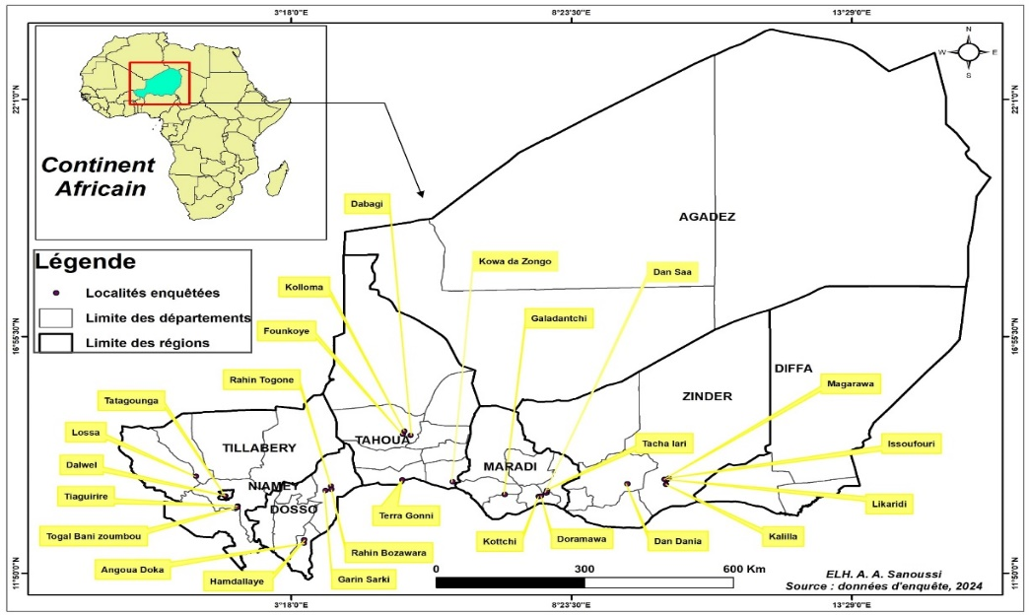

Figure 1: Collection points for 25 Striga hermonthica ecotypes and 25 millet varieties
  - Identification of producers
Table 2 indicates that 88% of the millet producers from whom samples were collected are men, compared to only 12% women.
The results revealed a generally low level of education among the millet producers sampled: a significant majority (56% are illiterate, and 24% have a very limited primary education. Only a small minority (4%) reached secondary school.
The analysis of the age distribution of millet producers showed a strong representation of the 36-50 age group (52%), followed by 20-35-year-olds (28%). Older groups (56-65 years: 12%, and 66-80 years: 8%) are less numerous.

Table 2: Sociodemographic characteristics of producers
Category | Percentage (%)
Gender
Male | 88
Female | 12
Education Level
Illiterate | 56
Quranic School | 16
Primary Level | 24
Secondary Level | 4
Age Range
20 to 35 years | 28
36 to 50 years | 52
56 to 65 years | 12
66 to 80 years | 8
  - Physical characteristics of collected seeds
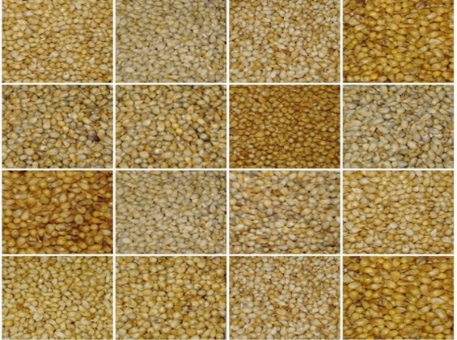  A | 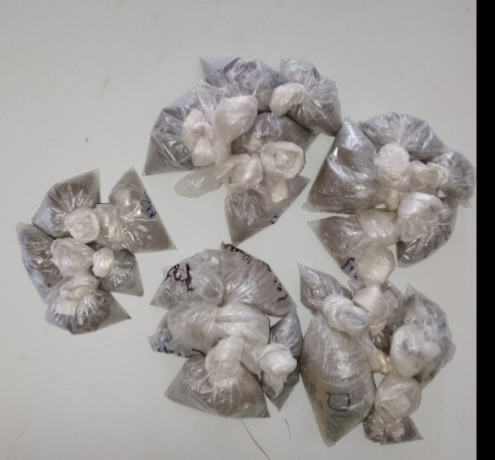  B

Figure 2: Morphological diversity of collected millet seeds (A), Seeds of collected Striga ecotypes (B)
The prospecting missions revealed significant morphological diversity among local millet varieties. The seeds varied in a range of colors, shape and sizes (Figure 2-A), whereas the seeds of the collected Striga ecotypes were all black (Figure 2-B).
  - Observed Characteristics of Millet Seeds
Table 3 presents the observed characteristics of millet seeds, described by color, shape, and size from different regions of Niger. Phenotypes vary from 4 to 10.
The yellow-orange colour is present in all regions except Zinder, with percentages of 20.0%, 40.0%, 20.0%, and 60.0% respectively. In Maradi, millet seeds show greater colour diversity, with 20% Brown, 20% grey-brown, 20% ivory-orange, and 40% yellow-orange.
The Dosso region is the most diverse, with 40% of seeds being oval and 20% each being elliptical, hexagonal, and oblanceolate. 80% of millet seeds collected in the Tahoua region are oval. The hexagonal shape is observed in all regions, with 20.0% in Dosso, 40.0% in Maradi, 20.0% in Tahoua, 40.0% in Tillabéry, and 60.0% in Zinder.
In all regions, seeds are primarily medium-sized (ranging between 40% and 80%). The regions of Dosso, Maradi, Tahoua, and Zinder recorded the same percentages for seed sizes.

Table 3: Distribution of millet Seed phenotypes collected in the 5 regions of Niger
Characteristic | Phenotype | Dosso (%) | Maradi (%) | Tahoua (%) | Tillabéry (%) | Zinder (%)
Colour (%) | Brown |  | 20
 | Grey Brown |  | 20
 | Dark Grey Brown |  |  |  |  | 20
 | Dark Grey Orange |  |  |  |  | 60
 | Grey Ivory |  |  | 20 |  | 20
 | Grey Yellow |  |  | 60
 | Ivory Orange | 20 | 20
 | Yellow | 60
 | Yellow Orange | 20 | 40 | 20 | 60
 | Orange |  |  |  | 40
Shape (%) | Elliptical | 20
 | Globular |  |  |  | 20 | 20
 | Hexagonal | 20 | 40 | 20 | 40 | 60
 | Oblanceolate | 20 |  |  | 40
 | Oval | 40 | 60 | 80 |  | 20
Size (%) | Low | 20 | 20 |  | 20
 | Significant | 20 | 20 | 20 | 20 | 20
 | Medium | 40 | 40 | 80 | 60 | 80
 | Very Low | 20 | 20
  - Infestation rates of visited fields by region
Table 4 presents the distribution of infestation levels in the surveyed fields across the five regions of Niger: Dosso, Maradi, Tahoua, Tillabéry, and Zinder. Infestation is categorised into four levels: low, significant, medium, and very significant.
The "Significant" category is the most frequent across all regions, with 60% in Dosso and Maradi, and 40% in Tahoua, Tillabéry, and Zinder. This indicates that a substantial portion of the surveyed fields experience a high level of infestation (Figure 3-A).
Some variation in the distribution of infestation levels among regions is observed. For example, the regions of Maradi and Zinder show a higher proportion of fields with "Very Significant" infestation compared to other regions, each at 40% (Figure 3-B).
The "Low" category is the least represented, suggesting that a relatively small number of fields exhibit a low infestation level. This category was observed in fields within the Tillabéry region. The chi-squared test performed showed that the distribution of categories did not depend on the regions.

Table 4: Distribution of Striga infestation categories in visited fields by region
Variable | Category | Dosso | Maradi | Tahoua | Tillabéry | Zinder
Striga Infestation Rate of Visited Fields (P-value=0.543) | Low (%) | 0 | 0 | 0 | 40 | 0
 | Significant (%) | 60 | 40 | 60 | 40 | 40
 | Medium (%) | 20 | 20 | 20 | 20 | 20
 | Very Significant (%) | 20 | 40 | 20 | 0 | 40
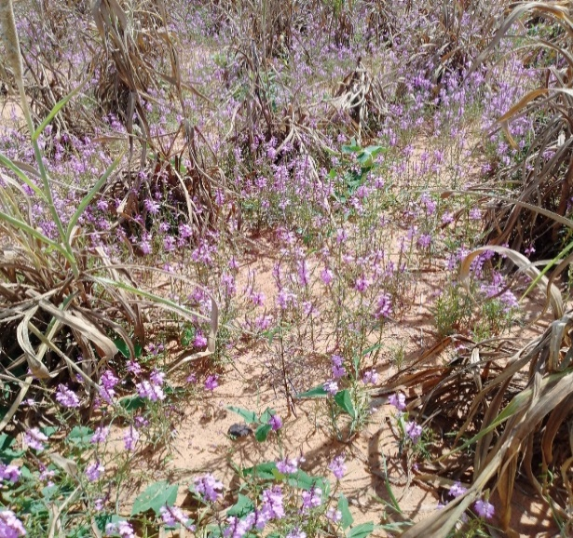  A | 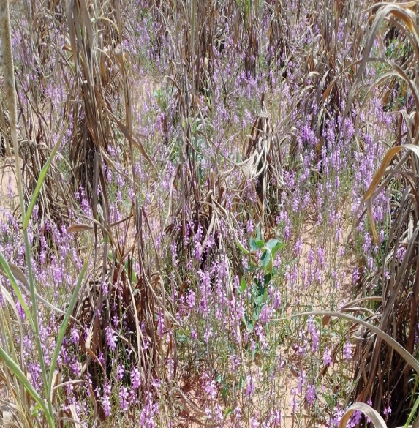  B

Figure 3: Highly infested field (A), very highly infested field (B)

  - Analysis of phenotypic characteristics of millet varieties and striga infestation rate
Figure 4 displays the projection of collected millet varieties on the planes formed by CP1 and CP2, respectively. The results of this analysis indicate that the first two principal components explain 91.5% of the total inertia of the dataset, with 58.5% and 33% respectively.
The first component (Dim1) clearly differentiates based on grain characteristics. Varieties with a high grain weight/size, such as VTI16, VD02, VTA13, and VTI17, show strongly positive coordinates on this axis. Conversely, varieties characterised by a low grain weight/size, such as VD05 and VM09, exhibit strongly negative coordinates on this same dimension.
As for the second component (Dim2) of the biplot, it reveals a clear distinction. On one side, it was observing varieties most susceptible to infestation, such as VM06, VZ24, VZ23, and VM08, which are characterised by strongly positive coordinates on this axis, thus positioning them clearly in the upper part of the graph. On the other side, the least infested varieties, such as VTI20 and VTI18, show strongly negative coordinates on the same dimension, consequently placing them in the lower part of the graph.
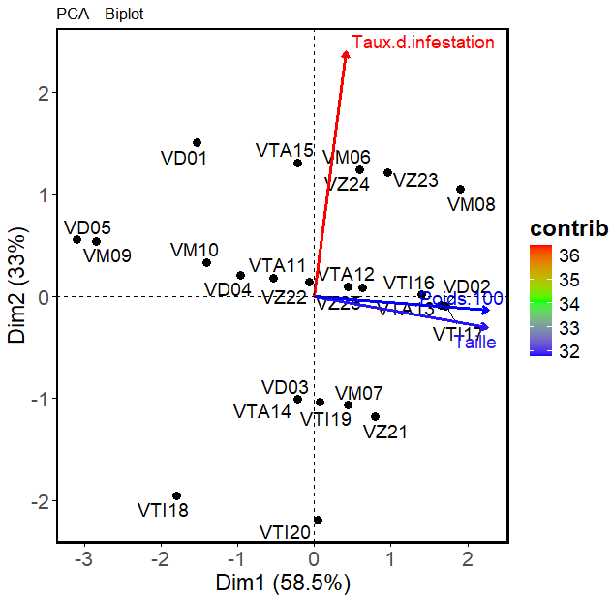

Figure 4: Projection of millet varieties and variables in the axis system formed by CP1 and CP2

Analysis of the image presenting a Principal Component Analysis (PCA) on individuals allows for several conclusions:
The first axis (Dim1) explains 53.4% of the total variability of the data, which is significant. This means that this axis captures more than half of the differences between the analysed individuals. Three distinct groups are visible (groups 1, 2, 3), separated primarily along the Dim1 axis. Group 3 showed greater dispersion, indicating internal heterogeneity (e.g., genetic variability or different responses to growth conditions). Group 2 is more compact, suggesting stronger homogeneity (Figure 5).
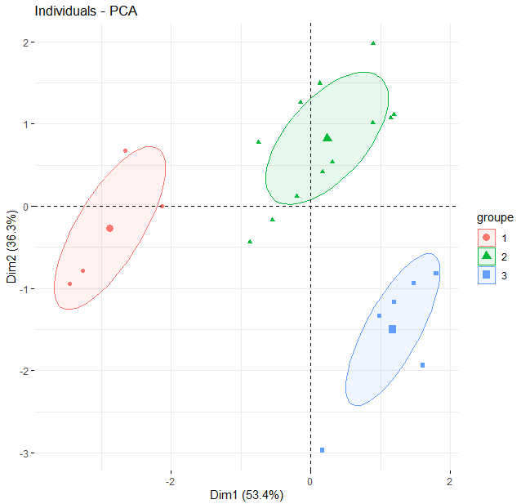

Figure 5: Principal Component Analysis (PCA) of individuals according to their groups
- Discussion

The preservation of crops necessarily involves a phase of in-depth inventory and characterisation. This work, based on field surveys, is essential for collecting plant material and gathering associated agronomic, ethnobotanical, and sociocultural knowledge (Pernès et al., 1984).
The analysis of the phenotypic characteristics of millet seeds revealed a marked diversity across Niger's regions, with interesting specificities concerning seed colour, shape, and size. The analysis of collected varieties identified 10 different colour phenotypes, a result that corroborates Haussmann's observations in 2007. However, our study did not detect the purple colour mentioned by Haussmann, which indicates an interesting divergence. The difference between the results obtained in the current study and those of Haussmann (2007) could be attributed either to differences in collection methodologies or to differences in the areas explored.
The yellow-orange colour dominates (except in Zinder, where it was completely absent, a notable exception), with the greatest variety in Maradi (4 phenotypes). This chromatic variety could reflect either greater genetic diversity in local cultivars or specific environmental conditions influencing pigment expression. Dosso exhibited the highest diversity in shapes (4 types), contrasting with Tahoua, where the oval shape largely dominated (80%), suggesting greater uniformity of cultivated varieties or stricter selection by local farmers. The hexagonal shape, present in all regions, shows variable frequencies. This uneven distribution could indicate a regional preference for certain morphological characteristics or specific adaptation to local conditions. Size remains homogeneous (40-80% medium everywhere), likely due to common selection criteria.
In parallel, the study reveals an alarming situation regarding infestations in the surveyed millet fields, with "Significant" levels dominating all regions. This indicates high and widespread parasitic pressure, posing a serious threat to agricultural productivity.
This relative uniformity of the phenomenon is confirmed by the Chi-squared test, which shows no significant difference between regions. However, regional nuances deserve attention. The particularly high proportion of "Very significant" cases in Maradi and Zinder (40% in each region) could be explained by specific factors such as favourable microclimatic conditions for parasites, particular cultivation practices, or greater susceptibility of cultivated varieties. Conversely, the notable presence of "Low" infestations in Tillabéry could indicate either more effective agricultural practices or environmental conditions less conducive to parasite development.
The study highlights a lack of significant correlation between the physical characteristics of seeds (size and weight) and the level of Striga infestation.
This observation suggests the existence of a tolerance mechanism in the studied varieties, allowing them to maintain normal seed development despite the parasite's presence. However, this tolerance has a major drawback: while it preserves quantitative yield, it paradoxically promotes the proliferation of Striga seeds in the soil, thus explaining the high infestation rates observed in the field. This situation underscores the need for in-depth research to transform these tolerant varieties into truly resistant varieties, which would significantly reduce parasitic pressure in cultivated fields.
Furthermore, the study reveals a concerning phenomenon: in some cases, poor seed quality is observed even with low Striga infestations. This finding clearly indicates the involvement of other limiting factors independent of the parasite. Several explanatory hypotheses can be put forward: severe water stress episodes, soil fertility degradation, specific nutritional deficiencies, or even unsuitable cultivation practices (such as non-optimal sowing calendars). It is also plausible that it is the combined effect of several of these environmental constraints that negatively affects the grain-filling process, thereby compromising their final quality.

Conclusion
This study highlights two fundamental aspects of millet cultivation in Niger. On one hand, it reveals significant phenotypic diversity in seeds across regions, with marked variations in colour and shape. This diversity likely reflects local adaptations and differentiated cultivation preferences. On the other hand, the study shows a concerning phytosanitary situation, with widespread significant infestations, particularly severe in Maradi and Zinder. These results call for concerted action integrating several complementary approaches. Systematically leveraging millet's genetic diversity should be combined with developing control methods adapted to local specificities. Implementing preventive cultural practices also deserves to be strengthened. The data collected during this study form a solid basis for guiding future research and control efforts against Striga hermonthica. They open promising perspectives for improving millet productivity and strengthening food security in affected areas.

Disclaimer (Artificial intelligence)
Option 1:
Author(s) hereby declare that NO generative AI technologies such as Large Language Models (ChatGPT, COPILOT, etc.) and text-to-image generators have been used during the writing or editing of this manuscript.
Option 2:
Author(s) hereby declare that generative AI technologies such as Large Language Models, etc. have been used during the writing or editing of manuscripts. This explanation will include the name, version, model, and source of the generative AI technology and as well as all input prompts provided to the generative AI technology
Details of the AI usage are given below:
1.
2.
3.

References
Chemisquy, M. A., Giussani, L. M., Scataglini, M. A., Kellogg, E. A., & Morrone, O. (2010). Phylogenetic studies favour the unification of Pennisetum, Cenchrus and Odontelytrum (Poaceae): a combined nuclear, plastid and morphological analysis, and nomenclatural combinations in Cenchrus. Annals of Botany, 106, 107–130.
FAO. (2011). Organisation des Nations Unies pour l'Alimentation et l'Agriculture. Mission conjointe d'évaluation des récoltes et de la sécurité alimentaire au Niger. Rapport spécial. 36p.
Gressel, J., Hanafi, A., Head, G., Marasas, W., Obilana, A. B., Ochanda, J., & Tzotzos, G. (2004). Major heretofore intractable biotic constraints to African food security that may be amenable to novel biotechnological solutions. Crop Protection, 23, 661–689. https://doi.org/10.1016/j.cropro.2003.11.014
Haussmann, B. I. G. (2007). Données récoltées dans la base de données du Programme de sélection du mil à l'ICRISAT.
INS. (2018). https://www.populationdata.net/pays/niger Consulté le 17/11/2018.
JAICAF. (2009). Association pour la Collaboration Internationale en matière d'Agriculture et de Forêts du Japon. Les céréales au Niger, accent sur le mil et le sorgho.
Ministère de l'Agriculture. (2015). Résultats Définitifs de la Campagne Agricole d'Hivernage 2014 et Perspectives Alimentaires 2014-2015. Direction des statistiques. 32pp. 790-791.
Parker, C. (2012). Parasitic weeds: A world challenge. Weed Science, 60(2), 269-276. https://doi.org/10.1614/WS-D-11-00068.1
Pennisi, E. (2010). Armed and dangerous. Science, 327(5967), 804-805.
Pernès, J., Charrier, A., Combes, D., Guillaumet, J. L., Leblanc, J. M., Lourd, M., & Second, G. (1984). Gestion des ressources génétiques des plantes. Tome : Manuel. Technique & Documentation-LAVOISIER, Paris. 346 pages.
Senthilvel, S., Jayashree, B., Mahalakshmi, V., Sathish, K. P., Nakka, S., Nepolean, T., & Hash, C. T. (2008). Development and mapping of simple sequence repeat markers for pearl millet from data mining of expressed sequence tags. BMC Plant Biology, 8(1), 119. http://dx.doi.org/10.1186/1471-2229-8-119
Westwood, J. H., dePamphilis, C. W., Das, M., Fernández-Aparicio, M., Honaas, L. A., Timko, M. P., & Yoder, J. I. (2012). The parasitic plant genome project: New tools for understanding the biology of Orobanche and Striga. Weed Science, 60(2), 295-306. https://doi.org/10.1614/WS-D-11-00113.1
Rouamba, A., Shimelis, H., Drabo, I., Shamuyarira, K. W., & Mrema, E. (2024). Management of the Striga epidemics in pearl millet production: a review. CABI Agriculture and Bioscience, 5(1), 11.
World Bank. (2020). Can Niger escape the demographic trap?. https://blogs.worldbank.org/en/africacan/can-niger-escape-demographic-trap#:~:text=Niger%2C%20a%20landlocked%20country%20in,reach%2070%20million%20by%202050.
Dossa, E. N., Shimelis, H., Shayanowako, A. I., & Laing, M. D. (2023). A meta‐analysis of the effects of Striga control methods on maize, sorghum, and major millets production in sub‐Saharan Africa. Crop Science, 63(2), 460-479.

