Original Research Article
EFFECTS OF SINGLE OR MIXED DIETARY SUPPLEMENTATION OF OF Α-TOCOPHEROL AND ASCORBIC ACID ON GROWTH PERFORMANCE, FLESH QUALITY, DIGESTION CAPACITY, AND PATHOGEN RESISTANCE OF GOLDEN TREVALLY (GNATHANODON SPECIOSUS)

ABSTRACT

This study aimed to investigate the effects of dietary vitamins E (VE) and vitamin C (VC) and the VE+VC mixture on growth performance, gut morphology, feed utilisation, and capacity against pathogens in golden trevally. The results indicated that supplementation with vitamins E and C had a significant growth rate of golden trevally. Fish fed a diet supplemented with VE, VC, or a mixture of VE and VC showed significantly reduced size variations compared to fish fed the basal diet. Fish receiving diets supplemented with VE or a combination of VE and VC had a larger perimeter ratio (PR) than those receiving the control diet. Feed intake was reduced in the VE + VC group. Feed conversion ratios reduced significantly in fish fed diets supplemented with vitamins E and C. Dietary vitamin supplementation significantly influences body composition of fish. In the challenge test against Photobacterium damselae, survival rates of fish in the all three dietary supplemented treatments were significantly higher than the control diet; however, the highest survival rate was recorded in fish receiving the VE + VC combination (88.57%), followed by those fed VE (62.50%) and VC (60.87%).

Keywords: golden trevally, Gnathanodon speciosus, Vitamin E, Vitamin C, growth performance, Photobacterium damselae
- INTRODUCTION
Aquaculture is regarded as the world's most rapidly growing food production industry, offering a significant source of protein for the human diet. Global aquaculture output was projected to reach 126 million tonnes in 2021, worth USD 296.5 billion (FAO, 2024). The aquaculture sector has been growing more intensely in recent years (FAO, 2024). However, illness is common during aquaculture due to unfavourable environmental conditions and nutritional imbalances that impair fish growth and immunity. Because antibiotics used to treat diseases in aquaculture are reported to harm public health, aquatic creatures, and the saltwater environment, their use is strictly controlled or prohibited in many nations (Cabello, 2006; Berendonk et al., 2015). This has led to increased research on alternative antibiotics for aquaculture (Dawood et al., 2018).

“Vitamin E (VE) is a fat-soluble compound, with α-tocopherol being the most active component, which helps protect red blood cells and fish phospholipids from damage, maintaining functional and structural integrity of cells” (El-Sayed and Izquierdo, 2022). “However, not all types of vitamin E that are biologically active can be synthesised by fish” (El-Sayed and Izquierdo, 2022). “A lack of vitamin E has been reported to harm the growth of yellow catfish, Pelteobagrus fulvidraco” (Lu et al., 2016). “Vitamin E supplements can help fish by boosting their immune systems, increasing their chances of survival, promoting growth” (Lu et al., 2016; El-Sayed and Izquierdo, 2022; Do-Huu, 2023; Do-Huu et al., 2024c).

Dietary vitamin C enhanced growth, haematological index, while reducing FCR in snubnose pompano Trachinotus blochii (Ho et al., 2024); boosted growth and body composition in golden trevally (Do-Huu et al., 2024a); enhanced growth and immunity of Waigieu seaperch, Psammoperca waigiensis (Le et al., 2021); “improved resistance of coral trout's (Plectropomus leopardus) to Vibrio harveyi” (Zhu et al., 2022), “decreased the mortality of red swamp crayfish, Procambarus clarkii from the WSSV” (Kong et al., 2021), and increased immunity and tolerance against Aeromonas hydrophila of Chinese Mitten, Eriocheir sinensis (Song et al., 2023). However, fish cannot de novo biosynthese vitamin C (Drouin et al., 2011), so they must consume VC from their diet.

Research has shown that the combining VE and VC in the diet of fish reduces FCR while improving immunological response, growth, survival rate, and haematological indices in Salmo trutta caspius juveniles (Khara et al., 2016). Our previous studies showed the benefit of vitamin C and vitamin E supplemented to the diet of golden trevally (Do-Huu, 2021; 2023); however, the combined effects of VE and VC on this species have not been examined.

“Golden trevally, Gnathanodon speciosus, is a reef-dwelling fish found in the tropical and subtropical regions of the Western Indo-Pacific, Eastern Pacific, and both the Western and Eastern Atlantic Oceans. This species has successfully induced spawning and has become a significant aquaculture species in Viet Nam, owing to its rapid development, high market value, palatable flavour, and current supply deficit” (Zhao et al., 2020; Do-Huu et al., 2022). Nevertheless, aquaculture of this species confronts significant obstacles stemming from environmental stressors in the farms.

Publications revealed that vitamin E and vitamin C boosted growth, immunity and stress resistance in number of aquaculture species and fish perform better when using the combination of the two vitamin E and C; however, the authors are not aware of any studies looking at how these two vitamins work together in the diet of golden trevally. The present study aimed to examine the benefits of including vitamins E and C in the diets of golden trevally (Gnathanodon speciosus), with an emphasis on growth, gut morphology, feed utilisation efficiency, and disease resistance.

2. MATERIALS AND METHODS
2.1. Preparation of experimental diet

The feed additives were vitamin E (VE, α-tocopherol acetate, Sigma Aldrich), and Vitamin C (VC, ROVIMIX® STAY-C® 35). Table 1 lists the ingredients of the experimental diets. The diets were prepared by supplementing the baseline diet with 50 mg VE, 200 mg VC or both to prepare experimental diets as follows: basal (control, no supplementation), VE (50 mg VE), VC (200 mg VC) and VE + VC (50 mg VE + 200 mg VC). The levels of VE and VC were referenced from previous studies on the optimal levels of VE and VC for growth of golden trevally (Do-Huu, 2021; 2023).
Table 1. Experimental diet composition (dry weight, %)

Ingredients | Percentage
Fish meal | 41.80
Gluten | 20.10
Soybean | 10.40
Fish oil | 8.40
Binder | 1.10
Corn starch | 17.70
Mineral premix | 1.50
Vitamin premix | 1.0
TOTAL | 100

2.2. Fish and culture tanks
The juvenile golden trevally, Gnathanodon speciosus, was acquired from a local hatchery in Nha Trang, Viet Nam, with an initial weight of 6.82 g ± 0.22 (SEM). The fish were transported to the wet laboratory at the Institute of Oceanography, Nha Trang, Viet Nam, where they were acclimated in a 1000 m³ tank for two weeks. During acclimatisation, the fish were provided with commercial pellets (Uni-President, 45% protein, 10% lipid) until satiation, roughly 5% of their total body weight.

2.3. Experimental design
This study aimed to examine the growth, feed efficacy, body composition, and disease tolerance of golden trevally fed a basal (control) diet compared to diets supplemented with vitamin E, vitamin C, or both. Each treatment group was randomly allocated five replicates as tank units. After acclimatisation, 22 fish were randomly allocated to each experimental tank and provided with experimental diets for 56 days. The golden trevally received three feedings per day at 8:00, 15:00, and 18:00. The pellets were placed slowly into the fish tank, and consumption was observed to adjust the feed for saturation. Gut samples were obtained for intestinal morphology, and body composition in the flesh was evaluated after the experiment. Fish were weighed and counted initially and biweekly to evaluate their growth performance. At the conclusion of the feeding trial, 20 golden trevally were randomly chosen from each treatment group to evaluate pathogen resistance.

2.4. Collection of samples and data
All the golden trevally were weighed and counted. The fish had no food supply for 24 hours prior to being weighed using a digital balance (0.01 g). At the end (day 56), 12 individuals of golden trevally from each treatment group were collected. Fish viscera and livers were weighed to calculate the VSI and HIS (n = 15). The midguts were collected from the same fish for histological analysis. The flesh was also collected and stored in a freezer for later analysis. Before tissue sampling, the fish were anaesthetised with 100 mg.L ⁻¹ tricaine methanesulfonate for 2 - 5 minutes and then cleaned by using saline water (2% NaCl).

2.5. Chemical analysis of culture fish
Dietary samples were obtained for analysing the lipid and protein compositions. Furthermore, a pooled sample of 10 golden trevally was taken at the beginning of the experiment to determine the initial proximate lipid and protein levels. Three golden trevally were taken from each tank at the end (week 8), and their muscle samples were preserved at -20 °C for carcass composition analysis. Crude protein was analysed by Kjeldahl method described by (Do-Huu et al., 2024c).

2.6. Intestinal morphology
A portion of the mid-intestine was collected and preserved in 10% formaldehyde, then samples were dehydrated in 70% ethanol and equilibrated in xylene, followed by embedding in paraffin. Eight-micron cross sections were cut, and then the sections were de-paraffinised, hydrated, and stained using the routine haematoxylin and eosin (H&E). Photos of digestive tract sections were taken by using an Olympus microscope. Images of gut sections were measured to determine the external perimeter (EP) and internal perimeter (IP) of the gut lumen (villi and mucosal folding length) by using free ImageJ software version 1.47. The perimeter ratio (PR) was calculated as PR = IP/EP in arbitrary units (AU). It is assumed that the higher the PR value, the longer the villi, the greater the increase in mucosal folding, or both (Dimitroglou et al., 2009; Do-Huu and Jones, 2014).

2.7. Calculation of feed utilisation of golden trevally fed different diets
Feed consumption (FC) was calculated by deducting uneaten feed from the amount of feed supplied. Feed conversion ratio (FCR), daily feed intake (DFI), and feed conversion efficiency (FCE) were calculated as follows: DFI (% BW. d⁻¹) = 100 × FC / [(Wt + Wo)/2]/days; FCR = FC / WG; FCE = WG / FC (Helland et al., 1996; Miliou et al., 2005). The final biomass (g) represents the total weight of fish in each tank on day 56. Biomass increase (g d⁻¹) was calculated as follows: [total final weight of fish (g) - total initial weight (g)] / day.

2.9. Statistical data analysis
Analysis of variance (ANOVA) was employed to compare growth, gut shape, and nutritional efficacy. Before analysis, the data were checked for normal distribution and converted if needed. After confirming normal distribution of the data, a parametric ANOVA was employed. A post-hoc least significant difference (LSD) test was performed when significance was observed. The non-parametric Kruskal-Wallis ANOVA was employed to compare survival rates. Kaplan-Meier and log-rank tests were employed to evaluate the cumulative survival of fish in the challenged experiments. The data are shown as the mean ± SEM (standard error of the mean). Statistical analyses were conducted using SPSS 19 for Windows (IBM SPSS, Chicago, IL, USA).

3. RESULTS

3.1. Growth and survival of golden trevally fed different diets

At the beginning of the experiment, the average weight of the fish was similar for all treatments (ANOVA, P = 0.861). At the end of the trial (day 56), the final mean weight and daily growth coefficient (DGC) were significantly higher in fish fed diets supplemented with VE and VE (P ≤ 0.034); in particular, the combination of both VE and VE was considerably higher than in fish fed the control (P = 0.001). Moreover, the growth of fish fed the supplemented combination was significantly greater than that of fish receiving only VE or VC in their diet (P ≤ 0.025) (Fig. 1). At the conclusion of the experiment, the fish survival rate ranged from 85.6% to 92.0%, exhibiting no significant difference (ANOVA, P = 0.538). (Fig. 1).

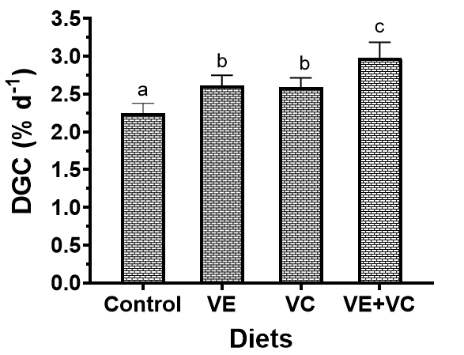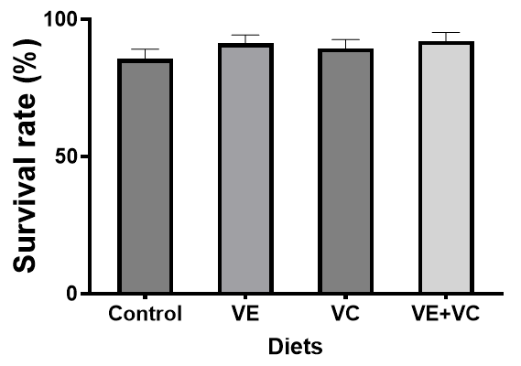

Fig. 1. Daily growth coefficient (DGC, % d⁻¹) of fish in different treatments.

3.2. Variation coefficient (CV, %) of golden trevally fed different diets
Regarding CV values, feeding juvenile golden trevally with diets supplemented with VE, VC or the mixture of VE and VC significantly reduced their size variations (P ≤ 0.005). Although a lower coefficient of variation (CV) value was observed in fish fed a combination diet of VE + VC, it was not significantly different from groups fed only VE or VC (P ≥ 0.197) (Fig. 2).

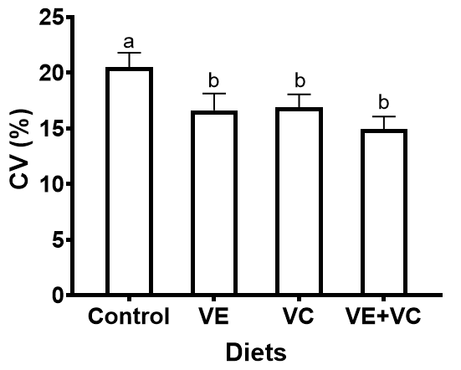
Fig. 2. Coefficient of variation in weight (CV, %) of fish.

3.3. Biometric indexes of golden trevally fed different diets

Dietary vitamin supplementation did not affect the condition factor (CF) and hepatosomatic index (HSI) of the golden trevally. Despite CF being elevated in fish fed VE, VE alone, or particularly higher in fish fed the combination of VE + VC, these values were not substantially different from those of fish in the control (P ≥ 0.485). (Fig. 3).

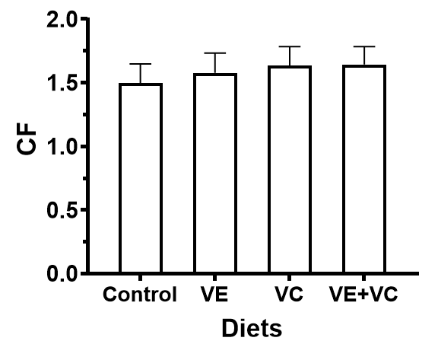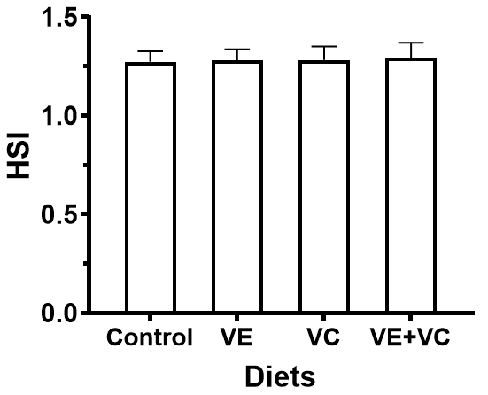

Fig. 3. Biometric indices of golden trevally fed different diets.

3.4. Feed utilisation of golden trevally fed different dietary supplementation
By the conclusion of the trial (day 56), the total feed consumption per tank varied from 488 to 537 g, without significant differences among the treatments (P = 0.211). Furthermore, there was a noticeable reduction in daily feed intake (DFI) when a combination of vitamins E and C was added to the fish feed (P = 0.037). However, compared to the control diet, dietary VE or VC by themselves did not significantly alter daily feed intake (DFI) (P = 0.053). (Table 2).

Table 2. Feed utilization of fish fed different diets supplemented with vitamins (n = 5).

 | Diets
 | Control | VE | VC | VE+VC
FC (g tank⁻¹) | 488.05 ± 11.12 | 475.46 ± 21.63 | 484.35 ± 32.55 | 537.32 ± 22.31
DFI (%BW d⁻¹) | 9.75 ± 0.24ª | 9.54 ± 0.58ª | 8.91 ± 0.63^{ab} | 7.5 ± 0.51^{b}
DBG (g d⁻¹) | 5.76 ± 0.21ª | 7.36 ± 0.43^{b} | 7.12 ± 0.40^{b} | 8.54 ± 0.28^{c}
Statistical data are presented as the mean and plus or minus standard error (SEM). Significant differences are presented by different letters. FC: feed consumption (g tank⁻¹), DFI: daily feed intake (% BW d⁻¹), DBG: daily biomass gain (g d⁻¹).

Compared to fish fed the control diet, fish fed diets containing VE, VC, and a combination of the two vitamins showed a substantial increase in daily biomass gain (DBG) (P ≤ 0.029). Fish fed the VE + VC had greater DBG values than fish fed either VE or VC alone. Fish given a diet supplemented with only VE or VC did not, however, differ significantly in DBG (P ≥ 0.326). (Table 2).

3.5. Feed conversion ratio (FCR) of golden trevally
Fig. 4 illustrates feed utilisation for fish fed different diets. Dietary vitamins E and C significantly affected feed utilisation of golden trevally after 56 days of diet feeding. Feed conversion ratios (FCR) were significantly lower for fish fed diets with added VE, VE or the combination of VE + VC (P≤0.028), and the highest FCR values were in fish fed the control diet (P ≤ 0.001). There was significantly lower FCR between fish fed a diet combination of VE + VC compared to fish fed only VE or VC alone (P ≤ 0.026), but there was no significant difference in FCR between fish fed a diet of VE and VC (P = 0.524).

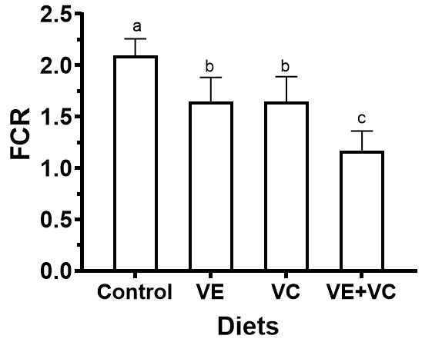

Fig. 4. Feed conversion ratio (FCR) of golden trevally fed different dietary vitamin supplementations.

3.6. Body composition of golden trevally
Fig. 5 displays the body composition of the fish fed various diets. On day 0, the average protein (CP) content were from 17.61% to 17.72% CP. Dietary supplements of vitamins E, C, and the mixture VE + VC generally had a significant effect on fish body composition by the end of the feeding trial. The muscle protein on day 56 ranged from 18.40% in the basal diet group to 19.75% in the group receiving a combination of VE and VC. A statistically significant elevation in protein content was seen in fish that received vitamin-enriched diets (P ≤ 0.039). Protein levels of fish fed VE or VC diets were not substantially different (P = 0.696).

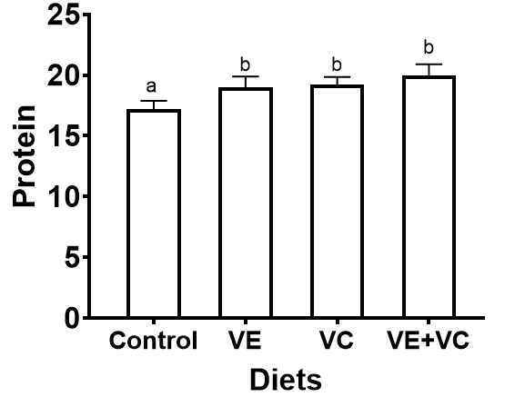

Fig. 5. Protein content in the flesh of golden trevally.

3.7. Gut morphology of golden trevally
On day 56, fish receiving diets supplemented with VE and the combination of VE + VC demonstrated a significantly larger perimeter ratio (PR) than those on the control diet (P ≤ 0.025). The highest PR value was recorded in fish given a diet enriched with a combination of VE and VE, which was considerably greater than that in fish offered VC (P = 0.046) but not different from the PR in fish fed VE (P = 0.096). The PR of fish fed the VC diet did not show any significant changes. Moreover, no significant difference in PR was observed between fish fed VE and VC diets (P = 0.729) (Fig. 6).
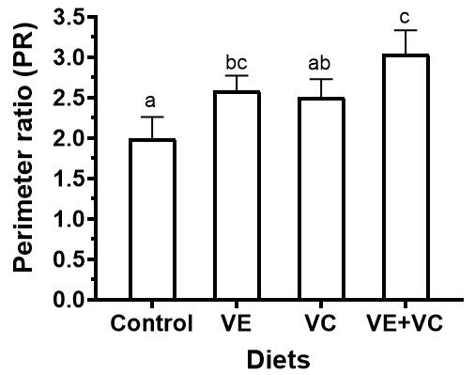

Fig. 6. Intestinal perimeter ratio (PR) of fish fed different dietary vitamins (day 56).

4. DISCUSSION and CONCLUSION
This research shows that both vitamin E and vitamin C in the diet enhance performance. However, the growth, intestinal structure, body composition, and feed use of the golden trevally (Gnathanodon speciosus) improved the most with the interaction of VE and VC.

Vitamin E is essential for the growth of numerous aquaculture species, including Gnathanodon (Do-Huu, 2023), Caspian trout (Saheli et al., 2021), Anguilla japonica (Shahkar et al., 2018), sturgeon beluga, Huso huso (Amlashi et al., 2011), hybrid snakehead, Channa argus × Channa aculate (Zhao et al., 2018), and milkfish, Chanos chanos (Sivaramakrishnan et al., 2023). In addition, dietary vitamin C boosted the growth and survival of red sea bream, Pagrus major (Dawood et al., 2017), Caspian roach, Rutilus rutilus caspicus (Roosta et al., 2014), and red sea bream, P. major (Dawood et al., 2016). However, vitamin C supplementation in the diet did not affect the growth of R. canadum (Zhou et al., 2012), and Oncorhynchus mykiss (Dabrowski et al., 2006). Our findings align with other studies that highlight the significance of dietary vitamins E and C in augmenting the growth of golden trevally when incorporated into the diet. Also, similar to the current results for golden trevally, adding vitamin E or vitamin C to the diet did not change the survival rate of discus fish, S. haraldi (Liu et al., 2019), juvenile O. niloticus × O. aureus (Huang and Huang, 2004) and yellow catfish, P. fulvidraco (Liang et al., 2017).

Furthermore, this study also highlighted the benefits of the synergistic effect of VE and VC's on golden trevally growing performance. Vitamins C and E were found to have an interactive influence on SGR in juvenile S. salar (Hamre et al., 1997), discus fish, S. haraldi (Liu et al., 2019), Japanese flounder, P. olivaceus (Gao et al., 2014), and M. chrysops♀ × M. saxatilis♂ (Sealey and Gatlin, 2002). Similarly, Nile tilapia, O. niloticus showed significant growth performance and feed utilisation after being fed dietary VC and VE at doses of 420 and 100 mg/kg fish feed (Sherif et al., 2024). It seemed that adding an extra 80 mg/kg of VE and 40 mg/kg of VC could satisfy S. haraldi requirement and enhance economic farming (Liu et al., 2019). The development and feed utilisation of hybrid male abalone (Haliotis fulgens ♂ × H. discus hannai ♀) could also be maximised by combining VC and VE (Wang et al., 2023). In accordance with the above publications, in this study, the combination of VE and VC showed an outstanding growth rate compared to supplementation with VE or VC alone.

The HSI could be used to determine the nutritional and energy status of fish because the liver is a significant repository for energy reserves (Khan et al., 2015). Additionally, researchers frequently assess fish physical health using biometric indices such as HSI, VSI, and CF in response to different nutrients. Lu et al. (2016) discovered that dietary vitamin E significantly increased the HSI of yellow catfish, P. fulvidraco. Additionally, grass carp, C. idellus given below-optimal doses of vitamin E had a reduced HSI (Li et al., 2014). Nonetheless, dietary vitamin E levels had no discernible effect on the HSI of red drum, Sciaenops ocellatus (Peng and Gatlin, 2009) and cobia, R. canadum (Zhou et al., 2013). Likewise, our findings demonstrated that the dietary VE, VC, and combination had no effect on the golden trevally's HIS, VSI, or condition factor, which was similar to study on Caspian trout, Salmo caspius done by Saheli et al. (2021).
In addition, animals ingest, absorb, and transfer nutrients via their digestive systems. Enhanced villus length and mucosal thickness may augment nutritional absorption and growth (He et al., 2017; Do-Huu et al., 2024b). Mucosal thickness and intestinal folds influence digestion and absorption in fish (Farhangi and Carter, 2001). Nutrition can also alter the gut microbiota and boost host immunity (Flint et al., 2012; Veldhoen and Brucklacher-Waldert, 2012), which potentially elucidating the results of stress exacerbation in golden trevally fed VC and VE in the present study.

The protein content of golden trevally that is fed vitamins E and C exhibits a substantial increase in the current study. Likewise, protein and lipid contents in Caspian trout, Salmo caspius, were found to increase when vitamin E was supplemented in the diet (Saheli et al., 2021). In contrast, Zhou et al. (2012) found that the protein content of juvenile cobia, R.canadum was not affected by dietary VC.

In aquaculture, feed expenses constitute 40 to 75% of the overall production costs (FAO, 2018). Identifying methods to diminish feed costs, reduce feed conversion ratio (FCR), and enhance the efficiency of feed and nutrient utilisation is crucial in aquaculture. A reduced FCR indicates the improved feed utilisation efficiency, thus increasing feed economy efficiency (Charles Bai et al., 2022). It was reported that dietary VC was found to greatly improve Nile tilapia performance and feed consumption (Rathore et al., 2019). In addition, dietary VE increased feed utilisation in O. niloticus × O. aureus (Huang and Huang, 2004) and P. fulvidraco (Lu et al., 2016). Similarly, in Caspian trout, Salmo caspius that was fed vitamin E, the amount of feed used and the efficiency of protein use improved (Saheli et al., 2021). According to Liu et al. (2019), dietary vitamins C and E may help to make S. haraldi farming more profitable.

Similar to previous results, the current study demonstrates the efficacy of VE and VC supplementation, particularly their combined effect, on feed utilisation and protein digestion in golden trevally, although a cost-benefit analysis was not conducted in this study. Our findings demonstrated that the combination of VE and VC enhanced growth, protein content, while decreasing FCR in cultured fish. These data indicate that VE + VC can decrease feed costs, enhance golden trevally production, and offer ecological benefits by reducing outflow. Furthermore, reducing FCR and expediting growth may indicate diminished waste, shorten the culture cycle, and alleviate the risk of aquaculture damage and environmental threats. The enhancement in growth may be attributed to increased feed efficiency in the diet (Dawood and Koshio, 2018; Do-Huu et al., 2018; Do-Huu et al., 2024c). Consequently, VC and VE may influence food usage due to their significance in protein metabolism and the stimulation of protein synthesis (Chatterjee, 1973).

In summary, this study demonstrates that feeding golden trevally with a combination of vitamins E and C improves growth, survival rates, feed utilization. The recommended dosage of dietary supplements for improved performance is 50 g kg-¹ VE and 200 g kg-¹ VC. However, additional research is required to explore the potential benefits of vitamin inclusion, such as boosting resistance to disease and environmental stress. Moreover, the influence of dietary vitamins at diverse life stages, such as larvae, fry and broodstock, which are not included in this study, should be experimentally assessed.

COMPETING INTERESTS DISCLAIMER:
Authors have declared that they have no known competing financial interests OR non-financial interests OR personal relationships that could have appeared to influence the work reported in this paper.

Disclaimer (Artificial intelligence)
Author(s) hereby declare that NO generative AI technologies such as Large Language Models (ChatGPT, COPILOT, etc.) and text-to-image generators have been used during the writing or editing of this manuscript.

REFERENCES

Amlashi, A.S., Falahatkar, B., Sattari, M. & Gilani, M.H.T., (2011). Effect of dietary vitamin E on growth, muscle composition, hematological and immunological parameters of sub-yearling beluga Huso huso L. Fish & shellfish immunology, 30: 807-814.
Andreoni, F. & Magnani, M., (2014). Photobacteriosis: prevention and diagnosis. Journal of Immunology Research, 2014.
Berendonk, T.U., Manaia, C.M., Merlin, C., Fatta-Kassinos, D., Cytryn, E., Walsh, F. et al., (2015). Tackling antibiotic resistance: the environmental framework. Nat. Rev. Microbiol., 13: 310-317.
Cabello, F.C., (2006). Heavy use of prophylactic antibiotics in aquaculture: a growing problem for human and animal health and for the environment. Environ. Microbiol., 8: 1137-1144.
Charles Bai, S., Hardy, R.W. & Hamidoghli, A. 2022. Chapter 10 - Diet analysis and evaluation. Pages 709-743 in R. W. Hardy, S. J. Kaushik editors. Fish Nutrition (Fourth Edition). Academic Press.
Chatterjee, I.B., (1973). Evolution and the biosynthesis of ascorbic acid. Science, 182: 1271-1272.
Clarridge, J.E. & Zighelboim-Daum, S., (1985). Isolation and characterization of two hemolytic phenotypes of Vibrio damsela associated with a fatal wound infection. J. Clin. Microbiol., 21: 302-306.
Dabrowski, K., Matusiewicz, K., Matusiewicz, M., Hoppe, P. & Ebeling, J., (2006). Bioavailability of vitamin C from two ascorbyl monophosphate esters in rainbow trout, Oncorhynchus mykiss (Walbaum). Aquac. Nutr., 2: 3-10.
Dawood, M.A., Koshio, S., Ishikawa, M. & Yokoyama, S., (2016). Immune responses and stress resistance in red sea bream, Pagrus major, after oral administration of heat-killed Lactobacillus plantarum and vitamin C. Fish Shellfish Immunol., 54: 266-275.
Dawood, M.A.O. & Koshio, S., (2018). Vitamin C supplementation to optimize growth, health and stress resistance in aquatic animals. Reviews in Aquaculture, 10: 334-350.
Dawood, M.A.O., Koshio, S., El-Sabagh, M., Billah, M.M., Zaineldin, A.I., Zayed, M.M. et al., (2017). Changes in the growth, humoral and mucosal immune responses following β-glucan and vitamin C administration in red sea bream, Pagrus major. Aquaculture, 470: 214-222.
Dawood, M.A.O., Koshio, S. & Esteban, M.Á., (2018). Beneficial roles of feed additives as immunostimulants in aquaculture: a review. Reviews in Aquaculture, 10: 950-974.
Dimitroglou, A., Merrifield, D.L., Moate, R., Davies, S.J., Spring, P., Sweetman, J. et al., (2009). Dietary mannan oligosaccharide supplementation modulates intestinal microbial ecology and improves gut morphology of rainbow trout, Oncorhynchus mykiss (Walbaum). J. Anim. Sci., 87: 3226-3234.
Do-Huu, H., (2021). Effects of dietary vitamin C supplementation on fingerling golden trevally, Gnathanodon speciosus (Carangidae). International Journal of Fisheries and Aquatic Studies, 9: 92-95.
Do-Huu, H., (2023). Effects of Dietary Vitamin E Supplementation on Growth Performance, Body Composition of Golden Trevally, Gnathanodon speciosus. Asian Journal of Fisheries and Aquatic Research, 24: 37-45.
Do-Huu, H., Ho, S.L. & Cao, V.N., (2018). Efficiency of Dietary β-glucan Supplementation on Growth, Body Composition, Feed, and Nutrient Utilization in Juveniles of Pompano Fish (Trachinotus ovatus, Linnaeus, 1758). The Israeli Journal of Aquaculture - Bamidgeh, 13.
Do-Huu, H., Huynh, S.M., Nguyen, T.N.H., Vo, H.T., Tran, T.M.H., Huynh, T.N.D. et al., (2024a). Effects of single or combination of dietary vitamin C and β-glucan supplementation on golden trevally, Gnathanodon speciosus (Carangidae). Vietnam Journal of Marine Science and Technology, 24: 73–80.
Do-Huu, H. & Jones, C.M., (2014). Effects of dietary mannan oligosaccharide supplementation on juvenile spiny lobster Panulirus homarus (Palinuridae). Aquaculture, 432: 258-264.
Do-Huu, H., Thanh Thuy, N., Thi & Ky, P.X., (2024b). A synergistic effect of dietary β-glucan and mannan oligosaccharide on growth performance, haematology, body composition, nutrient utilisation, and intestinal morphology in pompano, Trachinotus ovatus. Regional Studies in Marine Science, 73: 103494.
Do-Huu, H., Thanh Thuy, N.T. & An, H.T., (2022). Supplementing the diet of pompano Trachinotus ovatus with MacroGard® to increase innate immunity, intestinal microbes, growth and ammonia tolerance. Regional Studies in Marine Science, 55: 102621.
Do-Huu, H., Thi Thanh Thuy, N. & Ky, P.X., (2024c). The ameliorative roles of dietary mannan oligosaccharides and vitamin E on growth performance, intestinal microbes, and structure, flesh quality, nutrient efficacy and stress resistance of pompano, Trachinotus ovatus. Aquaculture Reports, 37: 102233.
Drouin, G., Godin, J.R. & Pagé, B., (2011). The genetics of vitamin C loss in vertebrates. Curr. Genomics, 12: 371-378.
El-Sayed, A.-F.M. & Izquierdo, M., (2022). The importance of vitamin E for farmed fish—A review. Reviews in Aquaculture, 14: 688-703.
FAO, (2018). The State of World Fisheries and Aquaculture 2018 - Meeting the sustainable development goals. Rome. Licence: CC BY-NC-SA 3.0 IG.
FAO, (2024). The State of World Fisheries and Aquaculture 2024. Towards Blue Transformation. Rome, FAO.
Farag, E.A.H., Baromh, M.Z., El-Kalamwi, N. & Sherif, A.H., (2024). Vitamin E nanoparticles enhance performance and immune status of Nile tilapia. BMC Vet. Res., 20: 561.
Farhangi, M. & Carter, C., (2001). Growth, physiological and immunological responses of rainbow trout (Oncorhynchus mykiss) to different dietary inclusion levels of dehulled lupin (Lupinus angustifolius). Aquac. Res., 32: 329-340.
Flint, H.J., Scott, K.P., Louis, P. & Duncan, S.H., (2012). The role of the gut microbiota in nutrition and health. Nature Reviews Gastroenterology & Hepatology, 9: 577-589.
Gao, J., Koshio, S., Ishikawa, M., Yokoyama, S. & Mamauag, R.E.P., (2014). Interactive effects of vitamin C and E supplementation on growth performance, fatty acid composition and reduction of oxidative stress in juvenile Japanese flounder Paralichthys olivaceus fed dietary oxidized fish oil. Aquaculture, 422-423: 84-90.
Hamre, K., Waagbø, R., Berge, R.K. & Lie, Ø., (1997). Vitamins C and E interact in juvenile Atlantic salmon (Salmo salar, L.). Free Radic. Biol. Med., 22: 137-149.
Hanh, P.T., Dinh, K.V., Manh, N.V., Tuan, L.A., Le, M.-H. & Hich, T.V., (2025). Dietary vitamin E enhances the growth, and immunity of snubnose pompano Trachinotus blochii juveniles. Fisheries and Aquatic Sciences, 28: 86-96.
Hardie, L.J., Fletcher, T.C. & Secombes, C.J., (1990). The effect of vitamin E on the immune response of the Atlantic salmon (Salmo salar L.). Aquaculture, 87: 1-13.
He, M., Wang, K., Liang, X., Fang, J., Geng, Y., Chen, Z., et al., (2017). Effects of dietary vitamin E on growth performance as well as intestinal structure and function of channel catfish (Ictalurus punctatus, Rafinesque 1818). Experimental and therapeutic medicine, 14: 5703-5710.
Helland, S.J., Grisdale-Helland, B. & Nerland, S., (1996). A simple method for the measurement of daily feed intake of groups of fish in tanks. Aquaculture, 139: 157-163.
Ho, L.S., Nguyen, H.T.N., Pham, K.T. & Do-Huu, H., (2024). Ameliorative effects of vitamin C (L-ascorbyl-2polyphosphate) on growth, survival rate, feed conversion ratio, coefficient of variation, and hematology of juvenile snubnose pompano Trachinotus blochii (Lacepède, 1801). AACL Bioflux, 17: 2324-2336.
Hoseinifar, S.H., Mirvaghefi, A. & Merrifield, D.L., (2011). The effects of dietary inactive brewer's yeast Saccharomyces cerevisiae var. ellipsoideus on the growth, physiological responses and gut microbiota of juvenile beluga (Huso huso). Aquaculture, 318: 90-94.
Huang, C.-H. & Huang, S.-L., (2004). Effect of dietary vitamin E on growth, tissue lipid peroxidation, and liver glutathione level of juvenile hybrid tilapia, Oreochromis niloticus×O. aureus, fed oxidized oil. Aquaculture, 237: 381-389.
Khan, K.U., Zuberi, A. & Ullah, I., (2015). Effects of Graded Level of Dietary L-Ascorbyl-2-Polyphosphate on Growth Performance and Some Hematological Indices of Juvenile Mahseer (Tor putitora). International Journal of Agriculture & Biology, 17.
Khara, H., Sayyadborani, M. & SayyadBorani, M., (2016). Effects of α-Tocopherol (vitamin E) and Ascorbic Acid (Vitamin C) and Their Combination on Growth, Survival and Some Haematological and Immunological Parameters of Caspian Brown Trout, Salmo trutta caspius juveniles. Turk. J. Fish. Aquat. Sci., 16: 385-393.
Kong, F., Zhu, Y., Yu, H., Wang, X., Abouel Azm, F.R., Yuan, J. et al., (2021). Effect of dietary vitamin C on the growth performance, nonspecific immunity and antioxidant ability of red swamp crayfish (Procambarus clarkii). Aquaculture, 541: 736785.
Lara-Flores, M., Olvera-Novoa, M.A., Guzmán-Méndez, B.z.E. & López-Madrid, W., (2003). Use of the bacteria Streptococcus faecium and Lactobacillus acidophilus, and the yeast Saccharomyces cerevisiae as growth promoters in Nile tilapia (Oreochromis niloticus). Aquaculture, 216: 193-201.
Le, M.-H., Dinh, K.V., Pham, D.H., Phan, V.U. & Tran, V.H., (2021). Extreme temperature differently alters the effects of dietary vitamin C on the growth, immunity and pathogen resistance of Waigieu seaperch, Psammoperca waigiensis. Aquac. Res., 52: 5383-5396.
Li, J., Liang, X.-F., Tan, Q., Yuan, X., Liu, L., Zhou, Y. et al., (2014). Effects of vitamin E on growth performance and antioxidant status in juvenile grass carp Ctenopharyngodon idellus. Aquaculture, 430: 21-27.
Liang, X.-P., Li, Y., Hou, Y.-M., Qiu, H. & Zhou, Q.-C., (2017). Effect of dietary vitamin C on the growth performance, antioxidant ability and innate immunity of juvenile yellow catfish (Elteobagrus fulvidraco Richardson). Aquac. Res., 48: 149-160.
Lin, M.-F. & Shiau, S.-Y., (2005). Dietary l-ascorbic acid affects growth, nonspecific immune responses and disease resistance in juvenile grouper, Epinephelus malabaricus. Aquaculture, 244: 215-221.
Liu, H.-P., Wen, B., Chen, Z.-Z., Gao, J.-Z., Liu, Y., Zhang, Y.-C. et al., (2019). Effects of dietary vitamin C and vitamin E on the growth, antioxidant defence and digestive enzyme activities of juvenile discus fish (Symphysodon haraldi). Aquac. Nutr., 25: 176-183.
Lu, Y., Liang, X.-P., Jin, M., Sun, P., Ma, H.-N., Yuan, Y. et al., (2016). Effects of dietary vitamin E on the growth performance, antioxidant status and innate immune response in juvenile yellow catfish (Pelteobagrus fulvidraco). Aquaculture, 464: 609-617.
Miliou, H., Fintikaki, M., Kountouris, T. & Verriopoulos, G., (2005). Combined effects of temperature and body weight on growth and protein utilization of the common octopus, Octopus vulgaris. Aquaculture, 249: 245-256.
Montero, D., Marrero, M., Izquierdo, M.S., Robaina, L., Vergara, J.M. & Tort, L., (1999). Effect of vitamin E and C dietary supplementation on some immune parameters of gilthead seabream (Sparus aurata) juveniles subjected to crowding stress. Aquaculture, 171: 269-278.
Ortuño, J., Cuesta, A., Angeles Esteban, M. & Meseguer, J., (2001). Effect of oral administration of high vitamin C and E dosages on the gilthead seabream (Sparus aurata L.) innate immune system. Vet. Immunol. Immunopathol., 79: 167-180.
Peng, L.I. & Gatlin, D.M., III, (2009). Dietary vitamin E requirement of the red drum Sciaenops ocellatus. Aquac. Nutr., 15: 313-319.
Pepi, M. & Focardi, S., (2021). Antibiotic-resistant bacteria in aquaculture and climate change: A challenge for health in the Mediterranean area. Int. J. Environ. Res. Public. Health, 18: 5723.
Rathore, S., Murthy, H., Nasren, S., Mamun, M. & Rakesh, K., (2019). The role of vitamin C as growth promoter and its effect on intestinal histology in monosex Nile tilapia, Oreochromis niloticus. J. Exp. Zool. India, 22.
Roosta, Z., Hajimoradloo, A., Ghorbani, R. & Hoseinifar, S.H., (2014). The effects of dietary vitamin C on mucosal immune responses and growth performance in Caspian roach (Rutilus rutilus caspicus) fry. Fish Physiol. Biochem., 40: 1601-1607.
Saheli, M., Rajabi Islami, H., Mohseni, M. & Soltani, M., (2021). Effects of dietary vitamin E on growth performance, body composition, antioxidant capacity, and some immune responses in Caspian trout (Salmo caspius). Aquaculture Reports, 21: 100857.
Sealey, W.M. & Gatlin, D.M., (2002). Dietary Vitamin C and Vitamin E Interact to Influence Growth and Tissue Composition of Juvenile Hybrid Striped Bass (Morone chrysops ♀ × M. saxatilis ♂) but Have Limited Effects on Immune Responses. The Journal of Nutrition, 132: 748-755.
Shahkar, E., Hamidoghli, A., Yun, H., Kim, D.-J. & Bai, S.C., (2018). Effects of dietary vitamin E on hematology, tissue α-tocopherol concentration and non-specific immune responses of Japanese eel, Anguilla japonica. Aquaculture, 484: 51-57.
Sherif, A.H., Khalil, R.H., Talaat, T.S., Baromh, M.Z. & Elnagar, M.A., (2024). Dietary nanocomposite of vitamin C and vitamin E enhanced the performance of Nile tilapia. Scientific Reports, 14: 15648.
Sivaramakrishnan, T., Ambasankar, K., Sathish Kumar, T., Sandeep, K.P., Bera, A., Raja, R.A., et al., (2023). Effect of dietary vitamin E supplementation on growth, fatty acid composition, intestinal histology, and haemato-immune indices of milkfish, Chanos chanos, larvae. Journal of Applied Aquaculture, 1-22.
Skjermo, J., Størseth, T.R., Hansen, K., Handå, A. & Øie, G., (2006). Evaluation of β-(1→3, 1→6)-glucans and High-M alginate used as immunostimulatory dietary supplement during first feeding and weaning of Atlantic cod (Gadus morhua L.). Aquaculture, 261: 1088-1101.
Song, Y., Cai, X., Bu, X., Liu, S., Song, M., Yang, Y., et al., (2023). Effects of Iron and Vitamin C on Growth Performance, Iron Utilization, Antioxidant Capacity, Nonspecific Immunity, and Disease Resistance to Aeromonas hydrophila in Chinese Mitten Crab (Eriocheir sinensis). Aquac. Nutr., 2023: 7228854.
Tewary, A. & Patra, B.C., (2008). Use of vitamin C as an immunostimulant. Effect on growth, nutritional quality, and immune response of Labeo rohita (Ham.). Fish Physiol. Biochem., 34: 251-259.
Vijayaram, S., Ringø, E., Zuorro, A., van Doan, H. & Sun, Y., (2023). Beneficial roles of nutrients as immunostimulants in aquaculture: A review. Aquaculture and Fisheries.
Wahli, Verlhac, Gabaudan, Schüep & Meier, (1998). Influence of combined vitamins C and E on non-specific immunity and disease resistance of rainbow trout, Oncorhynchus mykiss (Walbaum). J. Fish Dis., 21: 127-137.
Wang, L., Yao, Y., Zhao, Z., Li, L., Gan, H., Desouky, H.E., et al., (2023). Effect of dietary protein, vitamin E, and vitamin C levels on the growth and gonad development of hybrid male abalone (Haliotis fulgens ♂ × H. discus hannai ♀) by the orthogonal array design. Aquac. Int., 31: 2581-2603.
World, B., (2014). Reducing disease risks in aquaculture. World Bank Report #88257-GLB. . 485.
Yamane, K., Asato, J., Kawade, N., Takahashi, H., Kimura, B. & Arakawa, Y., (2004). Two Cases of Fatal Necrotizing Fasciitis Caused by Photobacterium damsela in Japan. J. Clin. Microbiol., 42: 1370-1372.
Zhao, H., Ma, H.-J., Gao, S.-N., Chen, X.-R., Chen, Y.-J., Zhao, P.-F. et al., (2018). Evaluation of dietary vitamin E supplementation on growth performance and antioxidant status in hybrid snakehead (Channa argus × Channa maculata). Aquac. Nutr., 24: 625-632.
Zhao, W., Fang, H.-H., Gao, B.-Y., Dai, C.-M., Liu, Z.-Z., Zhang, C.-W. et al., (2020). Dietary Tribonema sp. supplementation increased growth performance, antioxidant capacity, immunity and improved hepatic health in golden pompano (Trachinotus ovatus). Aquaculture, 529: 735667.
Zhu, X., Hao, R., Zhang, J., Tian, C., Hong, Y., Zhu, C. et al., (2022). Improved growth performance, digestive ability, antioxidant capacity, immunity and Vibrio harveyi resistance in coral trout (Plectropomus leopardus) with dietary vitamin C. Aquaculture Reports, 24: 101111.

