TEMPORAL VARIATION IN ABUNDANCE OF MICROPLASTICS IN PRAWNS (F. INDICUS) CAUGHT IN SABAKI RIVER ESTUARY, KENYA

Abstract
Plastic pollution constitutes planetary crisis which impacts negatively on ecosystems, biodiversity, climate and human health. Although presence of microplastics in prawns is well acknowledged, little has been reported on temporal variability of these contaminants, particularly in prawns caught in tropical estuaries. This study examined seasonal variations of microplastics (MPs) in prawns (F. Indicus) caught in Sabaki estuary in Kenya, during Jan-Mar-dry, Apr-June-wet, July-Oct-dry and Nov-Dec-wet seasons. Microplastics were extracted by digesting prawns’ gut using 10% KOH. Extracted MPs were manually identified and counted using a stereo microscope and, FTIR used to confirm their polymers. The results revealed prawns were contaminated at 47.5 %, 53%, 39%, and 46%, during Jan-Mar-dry, Apr-June-wet, July-Oct-dry and Nov-Dec-wet seasons, respectively. Seasons significantly (P≤0.05) influenced levels of MPs contamination in prawns with the highest level of contamination occurring during the Apr-Jun-wet season. Female prawns were more contaminated than males at 50.3% and 42.5%, respectively. White, blue, transparent and others colored MPs were observed at 68%, 19%, 11% and 2%, respectively, and two types of MPs polymers namely PE and ABS were observed at 27% and 63%. Unearthing of variations of MPs contamination in prawns from Sabaki estuary supports strategies aimed at conservation of prawns, while protecting seafood consumers.
Key words: Prawns, microplastics, wet and dry seasons, estuary
INTRODUCTION

Background information
Plastic pollution constitutes a planetary crisis which impacts negatively on ecosystems, biodiversity, climate and human health. About 400 million tons of plastics are consumed annually which is expected to quadruple by 2050 [1]. Coupling plastic waste generation, poor waste management and durability of plastics have resulted in accumulation of plastics in the environment [2][3][4]. Over 6,300 million tons of plastics ever produced, 79% are still in landfills and dumps sites, while about 12% have been incinerated, and only 9% has undergone recycling [5][6]. Exposure of plastic waste to weathering agents such as sunlight, air, heat, and moisture degrade plastics waste into microplastics (MPs) defined as plastic particles ranging from 1 micrometer (μm) to 5 millimeters (mm) in size, that have been observed to pollute all aquatic compartments including sediments, seabed, riverbanks, water columns, and surface waters [7]. Each year, over 10 million tons of plastics leak into the ocean, from inland sources and rivers are the main pathways, and this threatens aquatic life, and community livelihoods that depend on harvestable products sourced from oceans [8][9].
Aquatics organisms misperceive and ingest MPs confusing them for their natural food, causing physical abrasion or obstruction of gastrointestinal track resulting into false satiation. MPs may be attached on food for aquatic organism, therefore being ingested together with the food [10] [11] [12]. Due to MPs large surface area to volume ratio, unique size, structure and composition, MPs have been reported to adsorb toxic chemicals, equally additives used in manufacturing of plastics such as plasticizers, stabilizer fillers and flame-retardants are highly toxic. Ingestion of these toxin laden MPs leads to their bio-accumulation or biomagnification of toxins along the trophic levels including human and thus raising food safety concerns among seafood consumers [13]. Some of the additives used to enhance plastics properties have negatively affected aquatic organisms with effects such as impairing neurocognitive and cardiovascular systems, that impairs the immune system, fecundity, hormonal imbalance, memory and the animal behavior [11]. Colonization of MPs by microbes [14], and their dispersion within aquatic ecosystems disperses alien species in new areas, disrupting aquatic communities’ structure and composition [15] [16]. While threats of MPs to aquatic organisms are well documented, currently there is limited information on critical threshold of MPs in the natural environment however, laboratory experiments and simulation in microscome using organisms such as zooplankton have been generated to establish such thresh holds [17[18].
Small but highly polluted rivers such as Sabaki in Kenya that traverses regions of high plastics waste generation, conveys high loads of MPs into oceans [19]. Athi–Galana–Sabaki River is the second longest river (after the Tana River) covering a distance of 390 km, and a drainage basin of about 69,930 km² that discharges its water into the Indian. The catchment covers about 12% of the land in Kenya, and generates 4% of the country runoff (Figure 1). The river estuary is located at longitude: 3.2ºS and latitude 40.15º E, about 10 Km North of Malindi town, discharging its waters at Malindi Bay. At its estuary, the river supports commercial and artisanal fisher’s activities and among the harvestable products are Indian white prawns that prefers brackish water at their early planktonic and post larval stages, but during their adult and spawning stages they migrate into inshore marine waters of Ungwana bay. Communities living along the estuary fish and fend their families, with these harvestable products and they risk assimilating and accumulating these toxin-laden MPs in their body tissues, whose effects are not well understood [20][21] [11].
The estuary is a well-flushed ephemeral, with inter tidal zone of mangrove mudflats, that have developed over long term sedimentation [19]. Due to decreased rainfall in the East African region, and rising seawaters, seawater intrusion currently reaches about 10 km upstream. At river mouth, the estuary is about 750 to 1000m wide, but narrows to about 250 to 300m in a short distance of 2.5 Km, inland. The nutrient rich estuary is a refuge and a nursery to different marine and fresh water organisms such as Cyprinidae, Mormyridae, Mochokidae, Clariidae and Claroteidae fish families, and Macrobrachium lepidactylus, M. rude, M. scabrinsculum, Caradina nilotica and C. Africana freshwater prawns [19] [22] [23] [24].
Materials and methods

Study area
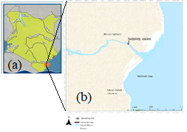

Figure 1: a) Map of Kenya, b) sampling station at Sabaki estuary
Catchment hydrology, described by river flow was used to defined the ecological seasons at the estuary. Thus, data collected from first order river gauge of Sabaki, for the year 2022 was used to categorize the dry and wet seasons (Figure 2). Two dry seasons were experienced between January-March (Jan-Mar) and July-October (July-Oct) respectively, while the long and short wet seasons experienced between April-June (Apr-June) and November- December (Nov-Dec), respectively.
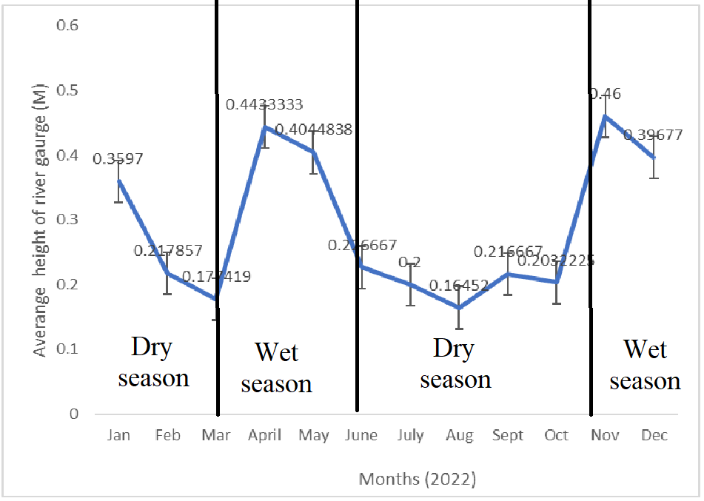
Source: Water resource authority (WRMA) (Coastal Athi Sub Station)
Figure 2: Seasonal river flow from River gauges’ height (M) at Baricho (Sabaki 3HA13)

Prawns’ species Fenneronenaeus indicus (formerly known as Penaeus indicus) were hand hauled during the Jan-Mar, Apr-June. July-Oct and Nov-Dec seasons, and from the catch a sample of n≥50 was randomly collected and immediately preserved in a glass jug containing 70% ethanol. Ethanol was preferred media for preserving prawns since it does not alter the integrity of MPs. The containerized prawns were then transferred into a cooler box and transported to Pwani University biological laboratory, where they were stored at -20° C, for further MPs analysis [25] [26]. Prawns were later thawed, and their weight and length measured, and sex established. Each prawn was then washed using ultra filtered water, dissected and the gastrointestinal tracts (GIT) extracted. Prawns’ GIT are coated with complexes of chitin and protein that inhibit MPs extraction, thus their digestion was enhanced by immersing the GIT/10% Potassium Hydroxide (KOH) containerized mixture in water bath at 50º C for 48 hours [11] [24]. The digested materials were then filtered through Whatman GF/F filter 0.7µm pore size, and the filters then oven dried at 40⁰C for 6 hours. MPs were identified and counted from the filter papers using a stereo microscope and their polymer confirmed using FTIR. Identified MPs were categorized according to their shape (i.e. fiber, film, fragment, and foam), sizes (i.e. ≥2000μm (small), 2000-3500μm (medium), and 3500-5000μm (large)) and color [11] [27].

RESULTS
The weight of prawns ranged between 2.63g and 3.53g, while the length was between 3.01 to 4.37cm. The number and weight of MPs extracted per prawns during Jan-Mar, Apr-June, July-Oct and Nov-Dec seasons were 2.63 MPs/prawn of 0.69/g wet weight (ww); 1.63MPs/prawn of 3.20g ww; 1.53MPs/prawn of 0.50g ww and 2.36MPs/prawn of 1.53g ww, respectively. The sizes of MPs extracted from prawns were 0.001-0.04 mm, 0.13-4.6 mm, 0.18-4.3 mm and 0.08-3.21 mm during Jan-Mar, Apr-June, July-Oct and Nov-Dec seasons, respectively (Table 1). The results indicated seasonal variability in MPs contamination of prawns at 47.5 %, 53%, 39%, and 46% during Jan-Mar, Apr-Jun, July-Oct and Non-Dec seasons, respectively. Seasons had significant (P ≤ 0.05) influence on MPs contamination in prawns, with the lowest contamination recorded in July-Oct-dry season, while Jan-Mar-dry, Apr-June-wet, and Nov-Dec-wet seasons recorded comparable levels of contamination (Table 2).

Table 1: Weight, size and number of MPs per individual male and female prawns, and MPs type in percentage.

Season | No. sampled | Av. Prawn wet wt (gm). | Av. Prawn length (cm) | Av. MPs/ wet wt. (#/gm) | MPs per Prawn | MPs size in Prawn (µm) | Contaminated prawns (%) |  |  | MPs shape
 |  |  |  |  |  |  |  |  |  |  | Proportion of MPs shapes
 |  |  |  |  |  |  | % Total contamination | % Sex distribution |  | MPs shape | Proportion of MPs shapes
 |  |  |  |  |  |  |  | Male | Female | MPs shape | Proportion of MPs shapes
Jan-Mar | 83 | 2.91 | 3.01 | 0.69 | 2.63 | 1-40 | 47.5 | 34 | 61 | fragments | 2
April-June | 79 | 3.19 | 4.37 | 3.20 | 1.63 | 130-4600 | 53 | 58 | 48 | fiber | 98
 |  |  |  |  |  |  |  |  |  | fragment | 1
July-Oct | 72 | 2.63 | 3.54 | 0.50 | 1.53 | 180-4300 | 39 | 37 | 41 | fiber | 99
 |  |  |  |  |  |  |  |  |  | fragment | 1
Nov-Dec | 81 | 3.53 | 3.10 | 1.53 | 2.363 | 80-3200 | 46 | 41 | 51 | fiber | 98
 |  |  |  |  |  |  |  |  |  | fragment | 2
 |  |  |  |  |  |  |  |  |  | Fiber | 98

Table 2: Seasonal variation of MPs in prawns
Seasons | Number of contaminated prawns
Jan-Mar-dry season | 47.5b*
Apr-June-wet season | 53.0a
July-Oct-dry season | 38.9c
Nov-Dec-wet season | 46.0b
P | <0.001
CV | 46.63
*Means with the same letter in the same column are not significantly different at α = 0.05

The number of microplastic contaminations in females was significantly higher than in males (P < 0.001). Females were more contaminated by microplastics than males by 15.4% (Table 3, and Figure 4).
Table 3: Comparison of MPs in male and female prawns

Sex | Mean microplastic contamination in prawns
Female | 50.25a*
Male | 42.5b
P | <0.001
CV | 46.38
*Means with the same letter in the same column are not significantly different at α = 0.05

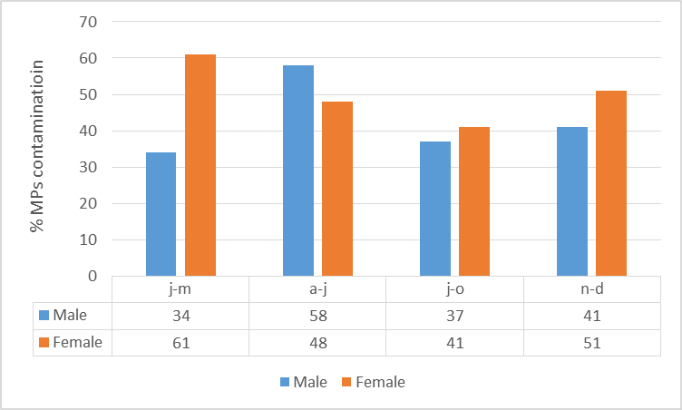
Figure 3: Comparison of MPs contamination between male and female among seasons

Color of MPs
Concerning color of MPs found in prawns, the most abundant observed color was white at 68%, followed by blue at 19%, transparent at 11% and others at 2% (Figure 2).
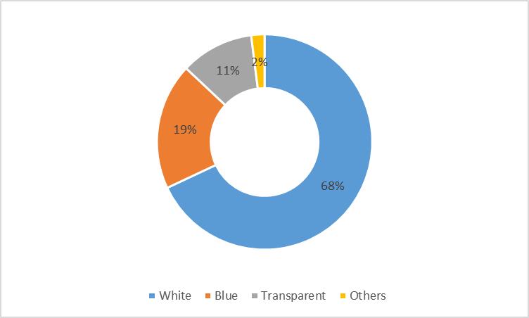
Figure 4: Percentage color of microplastics in prawns
There were two types of MPs polymers that were PE and ABS a frequency of 27%, 63% (Figure 2)

Figure 5: Percentage abundant of MPs polymers found in prawns

DISCUSSION
The study revealed 46% of Indian white prawns (Fenneropenaeus indicus) caught in Sabaki estuary were contaminated with MPs. This confirms earlier studies that reported presence of MPs in Copepoda, caught in Kenya near-shore waters [28]. However, the percentage of prawns contaminated with MPs was lower, compared to 83% of F. indicus, caught in coastal waters in Cochin, India [29], or 100 % of prawns bought in Sogkhla Province, Southern Thailand [30]. The average numbers of MPs particles/individual prawn caught in Sabaki estuary were 2 particles/individual, which was higher than 1.23 particles/individual reported in Crangon crangon reported in European [31], and Gamba shrimps (Aristues antennatus) and F. indicus caught in India that had 0.39 particles/individual [29]. On number of MPs per weight prawn caught in Sabaki estuary had 1.48 n/g ww contamination that is within the range of P. Muelleri caught in Argentina of 1.43 n/g ww [32] but lower than 14.29 n/g ww recorded in prawns found in Spain [33].
There were variations in levels of MPs contamination among seasons, in prawns caught in Sabaki estuary, with the highest levels recorded during the Apr-June-wet season. This agrees with other studies on F. indicus caught in coastal waters in Cochin, India, that reported seasonal variation of MPs contamination in prawns, with the highest levels of contamination occurred during July-August-Monsoon season. The author associated the increased level of contamination with seasonal flooding that introduced high loads of MPs in the Ocean resulting in increased ingestion of MPs by prawns. This is possible, considering prawns perceive and sort their food through smell and touch from muddy/silty substratum, and they might misperceive MPs for their natural food [29].

Various reasons have been ascribed to variations in reporting MPs in prawns such as MPs extraction methods, and depuration [34] [35], while farmed prawns have been observed to be more contaminated than wild catch, suggesting feeds are sources of MPs contamination in prawns [36] [37]. Levels of MPs in the ambient environment play a critical role with authors proposing 540 particles kg⁻¹ sediment, as potential threshold for MPs [38]. Availability of different sizes of MPs observe in this study makes all ages of prawns vulnerable, since prawns lack adaptive mechanism to digest MPs and this result into accumulation of MPs in their gut. However, MPs retained in the prawns’ gut are fragmented into smaller particles, suggesting the species could potentially be used in degradation of MPs [39]. The study reported higher loads of MPs in Sabaki estuary during the North East Monsoon (NEM) season, when prawns’ activities are high in Kenyan marine waters. This threaten prawns catch and their population structure posing a threat to the local economy. Further prawns are consumed hole in the local market, and this exposes human to MPs consumption impending community’s food security and health, especially when it is estimated human consume 1-30 MPs particle per day depending on their seafood feeding habits, and level of MPs contamination in the organism [40] [41] [42] [43].

Age and sex of prawns influences their rate of molting, where males and young prawns molt more frequent than female and adults. During molting, prawns may shed MPs and this may explain why males and smaller prawns recorded fewer MPs than females and bigger prawns in this study. Further, smaller prawns have narrower gut that restricts passage of MPs resulting into their retention, while bigger prawns may allow passage and defecation of MPs [44].
In this study, fibers-shaped MPs were most prevalent, followed by fragments, which constituted 2%. Studies have shown that fiber-shaped MPs are prevalent in estuarine environments [29], and are frequently ingested by aquatic organisms [45]. MPs of fiber-shape originates from degradation of fishing nets and effluent discharged from laundry of synthetic textiles, while fragment originates from break down of larger plastic items [46]. Aquatic organism perceives their food by feel of the shape and smell of the substrate, and they may misperceive MPs for the natural food. In addition, the shape of MPs influences the type of harm it causes in an organism, where sharp and hard MPs particles have been reported to cause physical injury or adhere inside the stomach, hindering enzymatic activities and nutrient uptake, while fiber may coil and clumps, resulting into blocking of the gut [47]. Various colored MPs were found in prawns namely; white 68%, blue 19%, transparent at 11% and others 2%, confirming other studies that have reported black, white, green, and red at frequency of 48%, 33%, 11%, 6% and 2%, respectively, in P. mondon found in Bangladesh, India [44]. Presence of different colored-MPs in prawns indicates break down and degradation of common plastics products found in the market whose particles are eroded from the river catchment into rivers. However, aging of MPs and the use acid in extraction of MPs in prawns may affects their color, leading to increased count of translucent MPs [44] [48] [31]. Polyethene (PE) and acrylonitrile-butadiene styrene (ABS) were the most prevalent type of polymers found in prawns in this study. Authors have associated end of life of common plastic polymers to contribute to MPs pollution in the environment, and thus their exposure to aquatic organisms. PE, ABS, PP, PVC, PS and PET are common plastic products found in Kenyan market meaning PE and ABS in prawn caught in Sabaki estuary are among the polymers originating from the Kenyan plastics waste or fishing gears. The type of MPs polymer in prawns is critical, since polymer-type influences adsorption and accumulation of toxins, where polymers such as PE has been observed to accumulate lipid soluble POP in aquatic organism [45] [48].

Conclusion
Levels of MPs contamination in prawns caught in Sabaki estuary varied with seasons, with the highest loads recorded during the wet season. These findings support conservation of prawn’s resources, within the wider Sabaki estuary ecosystem, considering prawns migrates to the estuaries during their young and juvenile stage of life and ingestion of MPs may affect their life cycle, population structure and the wider biodiversity. In addition, unearthing of MPs in these prawns serve in protecting the health of prawn consumers and the local economy, while advancing solid and effluent waste management policies to reduce propagation of different coloured MPs and polymers into rivers.

Disclaimer (Artificial intelligence)
Author(s) hereby declare that NO generative AI technologies such as Large Language Models (ChatGPT, COPILOT, etc.) and text-to-image generators have been used during the writing or editing of this manuscript.

REFERENCES

1. Haas, V., Wenger, J., Ranacher, L., Guigo, N., Sousa, A. F., & Stern, T. (2022). Developing future visions for bio-plastics substituting PET–A backcasting approach. Sustainable Production and Consumption, 31, 370–383.
2. Ayeleru, O. O., Dlova, S., Akinribide, O. J., Ntuli, F., Kupolati, W. K., Marina, P. F., Blencowe, A., & Olubambi, P. A. (2020). Challenges of plastic waste generation and management in sub-Saharan Africa: A review. Waste Management, 110, 24–42.
3. Lebreton, L., & Andrady, A. (2019). Future scenarios of global plastic waste generation and disposal. Palgrave Communications, 5(1), 1–11.
4. Kibria, Md. G., Masuk, N. I., Safayet, R., Nguyen, H. Q., & Mourshed, M. (2023). Plastic Waste: Challenges and Opportunities to Mitigate Pollution and Effective Management. International Journal of Environmental Research, 17(1), 20. https://doi.org/10.1007/s41742-023-00507-z
5.Geyer, R., Jambeck, J. R., & Law, K. L. (2017). Production, use, and fate of all plastics ever made. Science Advances, 3(7), e1700782. https://doi.org/10.1126/sciadv.1700782
6. Massa, G. M., & Archodoulaki, V.-M. (2024). An Imported Environmental Crisis: Plastic Mismanagement in Africa. Sustainability, 16(2), 1–20.
7. Arp, H. P. H., Kühnel, D., Rummel, C., MacLeod, M., Potthoff, A., Reichelt, S., Rojo-Nieto, E., Schmitt-Jansen, M., Sonnenberg, J., Toorman, E., & Jahnke, A. (2021). Weathering Plastics as a Planetary Boundary Threat: Exposure, Fate, and Hazards. Environmental Science & Technology, 55(11), 7246–7255. https://doi.org/10.1021/acs.est.1c01512
8.Mubin, A.-N., Arefin, S., Mia, M. S., Islam, A. R. M. T., Bari, A. M., Islam, M. S., Ali, M. M., Siddique, M. A. B., Rahman, M. S., & Senapathi, V. (2023). Managing the invisible threat of micro-plastics in marine ecosystems: Lessons from coast of the Bay of Bengal. Science of the Total Environment, 889, 164224.
9. Kumar, R., Sharma, P., Verma, A., Jha, P. K., Singh, P., Gupta, P. K., Chandra, R., & Prasad, P. V. (2021). Effect of physical characteristics and hydrodynamic conditions on transport and deposition of micro-plastics in riverine ecosystem. Water, 13(19), 2710.
10. Au, S. (2017). Toxicity of micro-plastics to aquatic organisms [PhD Thesis, Clemson University]. https://search.proquest.com/openview/d2a05cc0949cc912947e50bcfd8e4f74/1?pq-origsite=gscholar&cbl=18750
11. Lusher, A. L., Welden, N. A., Sobral, P., & Cole, M. (2020). Sampling, isolating and identifying micro-plastics ingested by fish and invertebrates. In Analysis of nanoplastics and micro-plastics in food (pp. 119–148). CRC Press. https://www.taylorfrancis.com/chapters/edit/10.1201/9780429469596-8/sampling-isolating-identifying-micro-plastics-ingested-fish-invertebrates-lusher-welden-sobral-cole
12. Grigorakis, S., Mason, S. A., & Drouillard, K. G. (2017). Determination of the gut retention of plastic microbeads and microfibers in goldfish (Carassius auratus). Chemosphere, 169, 233–238.
14. Das, R., Abd Hamid, S. B., Ali, M. E., Ismail, A. F., Annuar, M. S. M., & Ramakrishna, S. (2014). Multifunctional carbon nanotubes in water treatment: The present, past and future. Desalination, 354, 160–179.
13. Yang, H., Chen, G. and Wang, J. (2021) Microplastics in the Marine Environment: Sources, Fates, Impacts and Microbial Degradation. Toxics, 9, Article 41.
https://doi.org/10.3390/toxics9020041
15. Stabnikova, O., Stabnikov, V., Marinin, A., Klavins, M., Klavins, L., & Vaseashta, A. (2021). Microbial life on the surface of micro-plastics in natural waters. Applied Sciences, 11(24), 11692.
16. Oberbeckmann, S., Kreikemeyer, B., & Labrenz, M. (2018). Environmental Factors Support the Formation of Specific Bacterial Assemblages on Micro-plastics. Frontiers in Microbiology, 8, 2709. https://doi.org/10.3389/fmicb.2017.02709
17. Al-Thawadi, S. (2020). Micro-plastics and Nanoplastics in Aquatic Environments: Challenges and Threats to Aquatic Organisms. Arabian Journal for Science and Engineering, 45(6), 4419–4440. https://doi.org/10.1007/s13369-020-04402-z
18. Hollerová, A., Hodkovicová, N., Blahová, J., Faldyna, M., Maršálek, P., & Svobodová, Z. (2021). Micro-plastics as a potential risk for aquatic environment organisms–a review. Acta Veterinaria Brno, 90(1), 99–107.
19. Kitheka, J., & Mavuti, K. (2016). Tana Delta and Sabaki Estuaries of Kenya: Freshwater and Sediment Input, Upstream Threats and Management Challenges. In S. Diop, P. Scheren, & J. Ferdinand Machiwa (Eds.), Estuaries: A Lifeline of Ecosystem Services in the Western Indian Ocean (pp. 89–109). Springer International Publishing. https://doi.org/10.1007/978-3-319-25370-1_6
20. Mu, J., Zhang, S., Qu, L., Jin, F., Fang, C., Ma, X., Zhang, W., & Wang, J. (2019). Micro-plastics abundance and characteristics in surface waters from the Northwest Pacific, the Bering Sea, and the Chukchi Sea. Marine Pollution Bulletin, 143, 58–65.

21. Gundupalli, S. P., Hait, S., & Thakur, A. (2017). Multi-material classification of dry recyclables from municipal solid waste based on thermal imaging. Waste Management, 70, 13–21.
22. Okuku, E. O., Owato, G., Otieno, K., Kombo, M. M., Chiphatsi, M. M., Gwada, B., Chepkemboi, P., Wanjeri, V., Kiteresi, L. I., & Achieng, Q. (2022). The influence of monsoons on the spatial distribution and composition of floating marine litter. Marine Pollution Bulletin, 175, 113386.
23. Marwick, T. R., Tamooh, F., Ogwoka, B., Borges, A. V., Darchambeau, F., & Bouillon, S. (2018). A comprehensive biogeochemical record and annual flux estimates for the Sabaki River (Kenya). Biogeosciences, 15(6), 1683–1700.

24. Kaka, R. M., Jung’a, J. O., Badamana, M., Ruwa, R. K., & Karisa, H. C. (2019). Morphometric length-weight relationships of wild penaeid shrimps in Malindi-Ungwana Bay: Implications to aquaculture development in Kenya. The Egyptian Journal of Aquatic Research, 45(2), 167–173.
26. De-la-Torre, G. E., Dioses-Salinas, D. C., Pérez-Baca, B. L., & Santillán, L. (2019). Micro-plastics abundance in three commercial fish from the coast of Lima, Peru. Brazilian Journal of Natural Sciences, 2(3), 171–171.
27. Smith, T., Gupta, C., Fan, Z., Brust, G. J., Vogelsong, R., Carr, C., & Wang, S.-Q. (2022). Toughness arising from inherent strength of polymers. Extreme Mechanics Letters, 56, 101819.
28. Kosore, C., Ojwang, L., Maghanga, J., Kamau, J., Kimeli, A., Omukoto, J., Ngisiag’e, N., Mwaluma, J., Ong’ada, H., Magori, C., & Ndirui, E. (2018). Occurrence and ingestion of micro-plastics by zooplankton in Kenya’s marine environment: First documented evidence. African Journal of Marine Science, 40(3), 225–234. https://doi.org/10.2989/1814232X.2018.1492969
29. Daniel, D. B., Ashraf, P. M., & Thomas, S. N. (2020). Abundance, characteristics and seasonal variation of micro-plastics in Indian white shrimps (Fenneropenaeus indicus) from coastal waters off Cochin, Kerala, India. Science of the Total Environment, 737, 139839.
30. Goh, P. S., Kang, H. S., Ismail, A. F., Khor, W. H., Quen, L. K., & Higgins, D. (2022). Nanomaterials for micro-plastics remediation from aquatic environment: Why nano matters? Chemosphere, 299, 134418.
31. Devriese, L. I., Van der Meulen, M. D., Maes, T., Bekaert, K., Paul-Pont, I., Frère, L., Robbens, J., & Vethaak, A. D. (2015). Micro-plastics contamination in brown shrimp (Crangon crangon, Linnaeus 1758) from coastal waters of the Southern North Sea and Channel area. Marine Pollution Bulletin, 98(1–2), 179–187.
32. Senathirajah, K., Attwood, S., Bhagwat, G., Carbery, M., Wilson, S., & Palanisami, T. (2021). Estimation of the mass of micro-plastics ingested–A pivotal first step towards human health risk assessment. Journal of Hazardous Materials, 404, 124004.
33. Carreras-Colom, E., Constenla, M., Soler-Membrives, A., Cartes, J. E., Baeza, M., Padrós, F., & Carrassón, M. (2018). Spatial occurrence and effects of micro-plastics ingestion on the deep-water shrimp Aristeus antennatus. Marine Pollution Bulletin, 133, 44–52.
34. Renzi, M., Guerranti, C., & Blašković, A. (2018). Micro-plastics contents from maricultured and natural mussels. Marine Pollution Bulletin, 131, 248–251.
35. Cho, Y., Shim, W. J., Jang, M., Han, G. M., & Hong, S. H. (2019). Abundance and characteristics of micro-plastics in market bivalves from South Korea. Environmental Pollution, 245, 1107–1116.
36. Skalska, K., Ockelford, A., Ebdon, J. E., & Cundy, A. B. (2020). Riverine micro-plastics: Behaviour, spatio-temporal variability, and recommendations for standardised sampling and monitoring. Journal of Water Process Engineering, 38, 101600.
37. Kamau Moses, Tole Mwakio, Muti Simon Mbuvi, (2024), Seasonal Abundance and Types of Microplastics in Surface Waters of River Sabaki Estuary, Kenya. https://doi.org/10.9734/jaeri/2024/v25i6646;://journaljaeri.com/index.php/JAERI/index
38. Everaert, G., Vercauteren, M., Asselman, J., Bouwens, J., Catarino, A., Janssen, C., Shettigar, N. A., Teunkens, B., Toorman, E., & Van Damme, S. (2022). Plastic baseline (t0) measurement in the scope Flemish Integral Action Plan on Marine Litter: Plastic t0 study 2020-2021. Flanders Marine Institute, Ostend, Belgium. https://biblio.ugent.be/publication/8760043/file/8760044
39. Kamau, M., Tole, M., & S. Mbuvi. (2023). Micro-plastics in in Surface water of Sabaki river estuary, Kenya. International Journal of Environment and Climate Change, 13(12), 3218–3225.
40. Garrido Gamarro, E., Ryder, J., Elvevoll, E. O., & Olsen, R. L. (2020). Micro-plastics in Fish and Shellfish – A Threat to Seafood Safety? Journal of Aquatic Food Product Technology, 29(4), 417–425. https://doi.org/10.1080/10498850.2020.1739793
41. Ragusa, A., Svelato, A., Santacroce, C., Catalano, P., Notarstefano, V., Carnevali, O., Papa, F., Rongioletti, M. C. A., Baiocco, F., & Draghi, S. (2021). Plasticenta: First evidence of micro-plastics in human placenta. Environment International, 146, 106274.
42. Katzenberger, T. D. (2015). Assessing the biological effects of exposure to micro-plastics in the three-spined stickleback (Gasterosteus aculeatus) (Linnaeus 1758) [PhD Thesis, University of York]. https://etheses.whiterose.ac.uk/12579/
43. Walkinshaw, C., Lindeque, P. K., Thompson, R., Tolhurst, T., & Cole, M. (2020). Micro-plastics and seafood: Lower trophic organisms at highest risk of contamination. Ecotoxicology and Environmental Safety, 190, 110066.
44. Hossain, M. S., Rahman, M. S., Uddin, M. N., Sharifuzzaman, S. M., Chowdhury, S. R., Sarker, S., & Chowdhury, M. S. N. (2020). Micro-plastics contamination in Penaeid shrimp from the Northern Bay of Bengal. Chemosphere, 238, 124688.
46. Hanachi, P., Karbalaei, S., Walker, T. R., Cole, M., & Hosseini, S. V. (2019). Abundance and properties of micro-plastics found in commercial fish meal and cultured common carp (Cyprinus carpio). Environmental Science and Pollution Research, 26(23), 23777–23787. https://doi.org/10.1007/s11356-019-05637-6
47. Botterell, Z. L. R., Beaumont, N., Cole, M., Hopkins, F. E., Steinke, M., Thompson, R. C., & Lindeque, P. K. (2020). Bioavailability of Micro-plastics to Marine Zooplankton: Effect of Shape and Infochemicals. Environmental Science & Technology, 54(19), 12024–12033. https://doi.org/10.1021/acs.est.0c02715
48. Nan, B., Su, L., Kellar, C., Craig, N. J., Keough, M. J., & Pettigrove, V. (2020). Identification of micro-plastics in surface water and Australian freshwater shrimp Paratya australiensis in Victoria, Australia. Environmental Pollution, 259, 113865.

