Morphological Characterization of Groundnut (Arachis hypogaea L.) Accessions Using DUS Descriptors

Abstract
Groundnut (Arachis hypogaea L.) is a vital legume crop, contributing to food and oil security and supporting nutritional needs in developing regions. This study evaluated 54 groundnut germplasm accessions for genetic variability and characterization using the Distinctness, Uniformity, and Stability (DUS) framework, following National Test Guidelines and UPOV regulations. The field trial, conducted during the Kharif season of 2025 at MallaReddy University, School of Agricultural Sciences, Hyderabad, Telangana, India, employed an alpha-lattice design with two replications. Twenty-one key traits including plant morphology, pigmentation, flowering, pod structure, seed testa and kernel colour, kernel shape, and 100-kernel weight were recorded. Substantial phenotypic variation highlighted the rich genetic diversity among accessions. Hierarchical clustering based on Gower’s distance grouped the genotypes into four distinct clusters, with branches and genotype labels colour-coded for clear visualization. This clustering revealed both intra- and inter-group divergence, offering a practical guide for selecting diverse and promising parental lines. The integration of traditional DUS descriptors with multivariate clustering provides a robust framework for germplasm conservation, precise variety identification, and breeding programs aimed at improving productivity, disease resistance, and climate adaptability in groundnut.
Key words: DUS characterization, Dendrogram, Germplasm accessions
Introduction
Groundnut (Arachis hypogaea L.), commonly known as peanut, is one of the most important legume crops globally, serving as both a food and oilseed crop. The cultivated peanut is an allotetraploid (2n = 4x = 40), predominantly self-pollinated, and widely grown in the arid and semi-arid tropics, particularly by smallholder farmers due to its low input requirements. At the global level, groundnut is cultivated on approximately 32.7 million hectares, producing 31.43 million tonnes with an average productivity of 1,648 kg/ha (ANGRAU, 2023). India ranks as the second largest producer after China, with 5.97 million hectares under cultivation, a production of 10.2 million tonnes, and an average productivity of 1,716 kg/ha (Ambast et al., 2023). Owing to its high nutritional value comprising 25-30% protein, 45-50% oil, and significant amounts of vitamins and minerals, groundnut plays a crucial role in food and nutritional security, particularly in developing countries (Upadhyaya et al., 2002).
Genetic diversity forms the foundation of crop improvement, as it provides the variation necessary to develop cultivars with higher yield potential. Yield gains can be realized either through direct genetic enhancement for productivity or indirectly by breeding for resistance to biotic and abiotic stresses, thereby minimizing yield losses. In groundnut, a wide range of genetic diversity exists, broadly classified into two subspecies i.e, hypogaea and fastigiate which are further divided into botanical varieties such as var. hypogaea and var. aequatoriana (Krapovickas and Gregory, 1994). Each of these botanical groups exhibits distinct differences in plant architecture, pod morphology, and seed traits. Nevertheless, the majority of commercially cultivated groundnut varieties belong to the hypogaea (Virginia or runner type), fastigiata (Valencia type), and vulgaris (Spanish type) groups, which dominate global production.
In this context, the conservation and systematic characterization of genetic resources are vital to meet the continual demand for improved cultivars that combine high yield with resilience to biotic and abiotic stresses. Groundnut germplasm characterization provides a valuable reservoir of genetic variability, offering diverse material for breeding programs. To safeguard and promote the utilization of such diversity, the Government of India enacted the Plant Varieties and Farmers’ Rights (PPV&FR) Act, 2001, which mandates the evaluation of varieties through the Distinctness, Uniformity, and Stability (DUS) test. This test provides a structured framework to classify and differentiate accessions based on clearly observable traits, thereby fostering innovation while ensuring the preservation of genetic diversity (Krapovickas and Gregory, 1994). DUS characterization plays a critical role in variety identification, protection of breeders’ rights, effective germplasm management, and supporting crop improvement initiatives. The process typically involves the assessment of both qualitative and quantitative descriptors, including growth habit, flowering time, pod and seed morphology, and key vegetative traits.
Several studies, such as those by Sravanti et al. (2024), Karthikeyan et al. (2023), and Yasmin et al. (2025), have demonstrated the application of DUS criteria in groundnut characterization. Building on this foundation, the present study aims to characterize selected groundnut accessions using DUS guidelines, with the specific objectives of documenting morphological and agronomic descriptors, assessing variability in traits, and identifying diverse parental lines for use in future breeding programs.
Materials and Methods
Genetic Material:
The study utilized 54 groundnut germplasm accessions, obtained from the International Crops Research Institute for the Semi-Arid Tropics (ICRISAT), Hyderabad, Telangana, India (Table 1).
Experimental Details:
The field experiment was conducted during Kharif 2025 at the School of Agricultural Sciences, Malla Reddy University, Hyderabad, Telangana, India (17.54°N, 78.43°E). The experimental design followed an Alpha Lattice Design with two replications. Each entry was sown at a spacing of 40 cm between rows and 10 cm within rows. Recommended agronomic practices and fertilization schedules were strictly followed to ensure uniform crop growth and management. A total of 21 DUS traits were recorded following the National Test Guidelines and UPOV descriptors for groundnut. These included plant growth habit, leaflet shape, leaflet length, leaflet width, leaflet colour, leaflet hairiness, plant pigmentation, stem pubescence, flower colour, flower presence on main axis, flower arrangement on side branches, inflorescence type, maturity duration, peg pigmentation, pod constriction, pod reticulation, presence of beak on pod, testa colour, kernel colour of testa, kernel shape, and 100-kernel weight. For grouping of genotypes based on trait dissimilarity, cluster analysis was performed using the R version 4.5.0 statistical software (R Studio), and the results were visualized through a dendrogram to assess genetic relationships among the accessions.
Results and Discussion
In accordance with the DUS test guidelines for groundnut, 54 genotypes were evaluated for qualitative and quantitative descriptors. The assessment revealed a wide range of variability among the genotypes across these descriptors, reflecting their potential utility in distinguishing accessions. Furthermore, the frequency distribution of each trait was analysed to capture the extent and pattern of variation (Table 2).
Among the qualitative traits evaluated, plant growth habit was predominantly erect in 51 genotypes, while 3 genotypes (ICG 81, ICG 118, and ICG 11651) exhibited a semi-spreading habit; no genotypes displayed a spreading growth form (Fig 1). Analysis of leaf attributes revealed that 41 genotypes had medium leaflet lengths (4.0-6.0 cm), whereas 13 genotypes had large leaflet lengths (>6.0 cm). For leaflet width, 2 genotypes were medium (1.0-2.0 cm) and the remaining 52 were large (>2.0 cm). In terms of leaflet colour, 50 genotypes were light green and 4 were green. Regarding leaflet shape, all genotypes were elliptic except one (ICG 5236), which was obovate (Fig 2). All genotypes exhibited leaflet hairiness, with 4 genotypes having hairs only on the lower surface and the remaining 50 on both surfaces. These observations on plant growth habit, leaflet size, colour, and shape are consistent with previous reports in groundnut (Shruti, 2021; Karthikeyan et al., 2023), as well as in other legumes such as lentil (Roy et al., 2025) and soybean (Gautam et al., 2025). Traits such as plant architecture and leaf characteristics are critical not only for varietal distinction but also for influencing harvesting efficiency and crop management.
For plant pigmentation, 9 of the 54 genotypes (ICG 1415, ICG 3102, ICG 4750, ICG 4955, ICG 6263, ICG 6654, ICG 11687, ICG 12921, and ICG 15287) exhibited pigmentation, whereas the remaining 45 genotypes lacked any pigmentation. All genotypes displayed stem pubescence, with 9 genotypes (ICG 3343, ICG 6654, ICG 7969, ICG 11687, ICG 12189, ICG 12697, ICG 12921, ICG 14985, and ICG 15287) showing medium pubescence, while the remaining 45 genotypes exhibited sparse pubescence. Plant and stem pigmentation are considered important morphological markers in groundnut, as they facilitate genotype identification and differentiation. The present observations are in agreement with previous reports in groundnut (Swamy et al., 2006) and in soybean (Mishra et al., 2025), which similarly highlighted the utility of pigmentation traits in distinguishing genotypes and supporting varietal characterization.
The 54 groundnut genotypes were classified based on their flower characteristics. Among them, 14 genotypes bore flowers on the main axis, while the remaining genotypes did not. Flower arrangement on the side branches was categorized into three types: sequential, alternating, and irregular. Three genotypes exhibited a sequential arrangement, 11 were alternating, and 40 genotypes including ICG 9249, ICG 6654, and ICG 12697 showed irregular arrangements. All genotypes displayed orange-yellow flowers and possessed a simple inflorescence, with none exhibiting compound inflorescence. These observations are consistent with previous studies in groundnut (Rajgopal et al., 2004; Sravanti et al., 2024) and in lentil (Roy et al., 2025). Floral traits are critical for varietal characterization as they influence flowering time, pollination efficiency, and ultimately pod formation and yield.
For the trait days to maturity, 40 germplasm lines were classified as medium (101-110 days), 13 as late (111-120 days), and one genotype (ICG 8083) as very late (>120 days), while no genotypes fell into the very early (<90 days) or early (90–100 days) categories. With the exception of a single genotype (ICG 7190), peg pigmentation was observed in 53 genotypes. Similar patterns for maturity and peg pigmentation have been reported in soybean by Ramteke & Murlidharan (2012). While peg pigmentation serves as a useful marker for genotype identification, maturity duration is a critical trait for optimizing yield and ensuring adaptability across different growing environments.
The pod traits evaluated included pod constriction, pod reticulation, and presence of a pod beak. Pod constriction was classified into four categories: shallow, medium, deep, and absent. Five genotypes (ICG 1415, ICG 3775, ICG 4684, ICG 9249, and ICG 14118) exhibited shallow constriction, 45 genotypes were medium, and 4 genotypes (ICG 6654, ICG 7906, ICG 9418, and ICG 13491) displayed deep pod constriction. For pod reticulation, 50 genotypes showed moderate reticulation, one genotype (ICG 12921) had prominent reticulation, and three genotypes (ICG 5779, ICG 118, and ICG 6375) lacked reticulation. The presence of a pod beak was observed in 52 genotypes, while only two genotypes (ICG 1415 and ICG 118) lacked a beak (Fig 4). These pod features are critical as they influence market value, yield, and seed quality. The present findings are consistent with previous reports in groundnut by Mitra et al. (2021) and Yasmin et al. (2025).
Seed traits, including testa colour, kernel colour, kernel shape, and 100-kernel weight, which are important for assessing quality and estimating yield potential, were also evaluated. For testa colour, all genotypes except one (ICG 6654) exhibited uniform colouration, while ICG 6654 was variegated (Fig 5). Significant variation was observed for kernel colour (Fig 6), with one genotype (ICG 9418) off-white, 46 tan, one rose (ICG 1711), one purple (ICG 7190), two dark purple (ICG 6375 and ICG 15287), and four red (ICG 442, ICG 1415, ICG 377, and ICG 4955). Regarding kernel shape, 43 genotypes were spheroid, 7 fusiform, and 4 cylindrical. 100-kernel weight was classified into four categories: low (<36 g), medium (36–50 g), high (51–65 g), and very high (>65 g). No genotypes fell into the very high category; 17 genotypes were low, 32 medium, and 5 high (ICG 3102, ICG 3240, ICG 4955, ICG 7969, and ICG 13491), with ICG 7969 recording the highest weight of 60 g (Fig 1). These results are in agreement with previous studies on groundnut seed traits by Jeyaramraja and Woldesenbet (2014) and Sravanti et al. (2024), highlighting the variability in seed morphology and weight, which are key determinants of yield and quality.

Hierarchical Grouping of Germplasm Accessions via Dendrogram:
A total of 54 groundnut (Arachis hypogaea L.) germplasm accessions were evaluated for 21 DUS traits, and dissimilarity among them was estimated using Gower’s distance. Hierarchical clustering performed with Ward’s method grouped the accessions into four distinct clusters, as revealed by the dendrogram (Fig 7). This grouping highlights the efficiency of DUS traits in capturing phenotypic variability, where some accessions clustered tightly, indicating close morphological resemblance, while others showed wide separation, reflecting greater divergence.
A total of 4 clusters were formed with Cluster I (orange) represented the largest group, comprising 32 accessions, indicating a broad pool of genetically and morphologically related materials. Cluster II (Green) consisted of 11 accessions, forming a moderately sized group with intermediate levels of similarity. Cluster III (Maroon) was relatively smaller, containing 6 accessions, while Cluster IV (Red) was the smallest with only 5 accessions. The unequal distribution of accessions across clusters highlights both redundancy and diversity within the evaluated set, with Cluster I potentially representing closely related accessions, whereas Cluster IV provides unique and divergent genetic resources that can be prioritized for use in breeding and germplasm conservation.
Conclusion
The present study on 54 groundnut genotypes revealed substantial variability across 21 DUS traits, demonstrating the potential of these descriptors for genotype differentiation and germplasm characterization. The clustering pattern obtained through hierarchical analysis further confirmed the presence of distinct groups within the germplasm, reflecting both closely related and divergent accessions. Significant diversity was observed in plant architecture, leaf morphology, pigmentation, floral traits, pod characteristics, and seed features, highlighting the genetic richness of the evaluated material. Traits such as plant growth habit, leaf attributes, pod and seed morphology, and 100-kernel weight not only aid in varietal identification but also have direct implications for agronomic performance, harvesting efficiency, market value, and yield potential. The study thus provides valuable information for germplasm management, selection of superior parental lines, and future breeding programs aimed at improving yield, adaptability, and quality in groundnut.

Table 1: List of Groundnut Genotypes Assessed for DUS Trait
S. No. | Genotype | S. No. | Genotype
1 | ICG 36 | 28 | ICG 5494
2 | ICG 81 | 29 | ICG 5779
3 | ICG 118 | 30 | ICG 6263
4 | ICG 434 | 31 | ICG 6375
5 | ICG 442 | 32 | ICG 6407
6 | ICG 1137 | 33 | ICG 6654
7 | ICG 1415 | 34 | ICG 7190
8 | ICG 1519 | 35 | ICG 7906
9 | ICG 1711 | 36 | ICG 7969
10 | ICG 1973 | 37 | ICG 8083
11 | ICG 2019 | 38 | ICG 9157
12 | ICG 2106 | 39 | ICG 9249
13 | ICG 3102 | 40 | ICG 9418
14 | ICG 3240 | 41 | ICG 9507
15 | ICG 3343 | 42 | ICG 10384
16 | ICG 3421 | 43 | ICG 11249
17 | ICG 3584 | 44 | ICG 11515
18 | ICG 3746 | 45 | ICG 11651
19 | ICG 3775 | 46 | ICG 11687
20 | ICG 4543 | 47 | ICG 12189
21 | ICG 4684 | 48 | ICG 12697
22 | ICG 4729 | 49 | ICG 12879
23 | ICG 4750 | 50 | ICG 12921
24 | ICG 4911 | 51 | ICG 12988
25 | ICG 4955 | 52 | ICG 13491
26 | ICG 5195 | 53 | ICG 14118
27 | ICG 5236 | 54 | ICG 14985

Table 2. Trait-wise Frequency Distribution of Groundnut Accessions for DUS Descriptors
S. No. | Characters | States | No. of Genotypes | FD %
1 | Plant: Growth habit | Erect | 51 | 94
1 | Plant: Growth habit | Semi-spreading | 3 | 6
1 | Plant: Growth habit | Spreading | 0 | 0
2 | Leaflet: Size i.e., Length | Small (<4.0 cm) | 0 | 0
2 | Leaflet: Size i.e., Length | Medium (<4.0–6.0 cm) | 41 | 76
2 | Leaflet: Size i.e., Length | Large (>6.0 cm) | 13 | 24
3 | Leaflet: Size- width (fully developed basal leaflet) | Small (<1.0 cm) | 0 | 0
3 | Leaflet: Size- width (fully developed basal leaflet) | Medium (1.0–2.0 cm) | 2 | 4
3 | Leaflet: Size- width (fully developed basal leaflet) | Large (>2.0 cm) | 52 | 96
5 | Leaflet: Colour | Light green | 50 | 93
5 | Leaflet: Colour | Green | 4 | 7
5 | Leaflet: Colour | Dark green | 0 | 0
2 | Leaflet shape | Oblong | 0 | 0
2 | Leaflet shape | Elliptic | 53 | 98
2 | Leaflet shape | Obovate | 1 | 2
2 | Leaflet shape | Ovate | 0 | 0
6 | Leaflet hairiness | Absent | 0 | 0
6 | Leaflet hairiness | only on one side leaves | 4 | 7
6 | Leaflet hairiness | Both the side leaves | 50 | 93
7 | Plant pigmentation | Absent | 45 | 83
7 | Plant pigmentation | Present | 9 | 17
8 | Stem: Pubescence | Absent | 0 | 0
8 | Stem: Pubescence | Sparse | 45 | 83
8 | Stem: Pubescence | Medium | 9 | 17
9 | Flower Colour | Yellow | 0 | 0
9 | Flower Colour | Orange yellow | 54 | 100
9 | Flower Colour | Light Yellow | 0 | 0
10 | Flower: Presence on main axis | Absent | 40 | 74
10 | Flower: Presence on main axis | Present | 14 | 26
11 | Flower: Arrangement onside branches | Sequential | 3 | 6
11 | Flower: Arrangement onside branches | Alternate | 11 | 20
11 | Flower: Arrangement onside branches | Irregular | 40 | 74
12 | Inflorescence | Simple | 55 | 100
12 | Inflorescence | Compound | 0 | 0
13 | Time of maturity | Very early (< 90 days) | 0 | 0
13 | Time of maturity | Early (90-100 days) | 0 | 0
13 | Time of maturity | Medium (101-110 days) | 40 | 74
13 | Time of maturity | Late (111-120 days) | 13 | 24
13 | Time of maturity | Very late (>120 days) | 1 | 2
14 | Peg pigmentation | Absent | 1 | 2
14 | Peg pigmentation | Present | 53 | 98
15 | Pod: Constriction | Absent | 0 | 0
15 | Pod: Constriction | Shallow | 5 | 8
15 | Pod: Constriction | Medium | 45 | 83
15 | Pod: Constriction | Deep | 4 | 9
16 | Pod: Reticulation | Absent | 3 | 5
16 | Pod: Reticulation | Medium | 50 | 93
16 | Pod: Reticulation | Prominent | 1 | 2
17 | Pod: Presence ofbeak | Absent | 2 | 4
17 | Pod: Presence ofbeak | Present | 52 | 96
18 | Testa: Colour | Uniform | 53 | 98
18 | Testa: Colour | Variegated | 1 | 2
19 | Kernel: Colour of testa | White (1 A 1) | 0 | 0
19 | Kernel: Colour of testa | Off white (1 A 2) | 1 | 2
19 | Kernel: Colour of testa | Tan (12 E 4) | 46 | 85
19 | Kernel: Colour of testa | Rose (Grayish red 8 B3) | 1 | 2
19 | Kernel: Colour of testa | Purple (14 F 4) | 1 | 2
19 | Kernel: Colour of testa | Dark purple (14 F 7) | 1 | 2
19 | Kernel: Colour of testa | Salmon (6 A 4) | 0 | 0
19 | Kernel: Colour of testa | Red (10 B 7) | 4 | 7
19 | Kernel: Colour of testa | Dark red (11 C 8) | 0 | 0
20 | Kernel: Shape | Spheroid | 43 | 80
20 | Kernel: Shape | Cylindrical | 4 | 7
20 | Kernel: Shape | Fusiform | 7 | 13
21 | Kernel: Weight of 100 kernels | Low (<36 g) | 17 | 32
21 | Kernel: Weight of 100 kernels | Medium (36-50 g) | 32 | 59
21 | Kernel: Weight of 100 kernels | High (51-65 g) | 5 | 9
21 | Kernel: Weight of 100 kernels | Very high (>65 g) | 0 | 0

Fig. 1: Frequency Distribution of 54 groundnut genotype for different traits
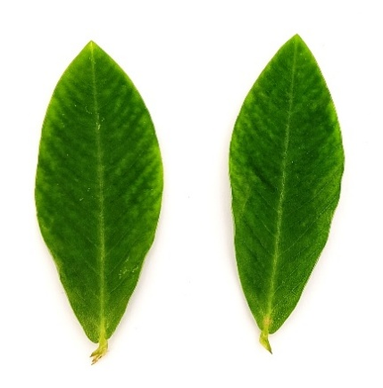
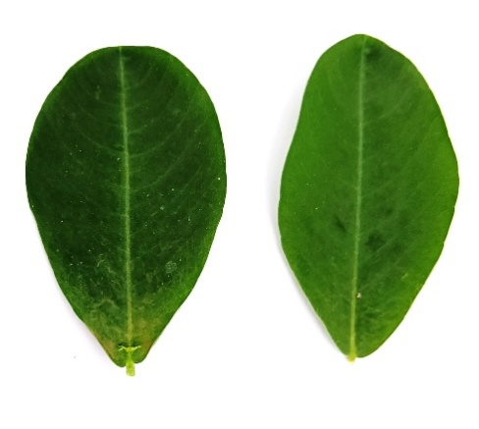

Obovate Elliptic

Fig 2: Leaflet shape

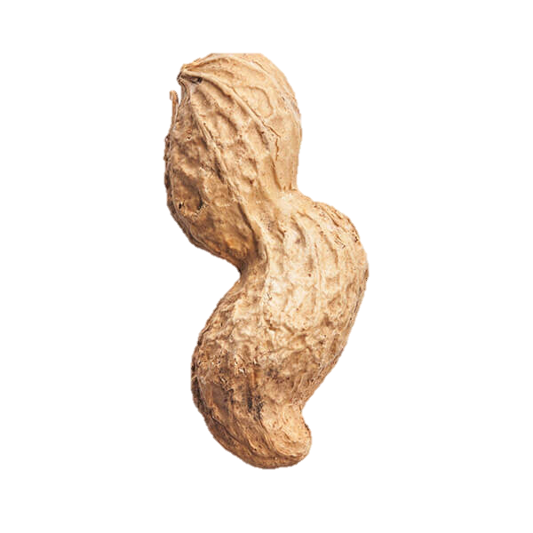
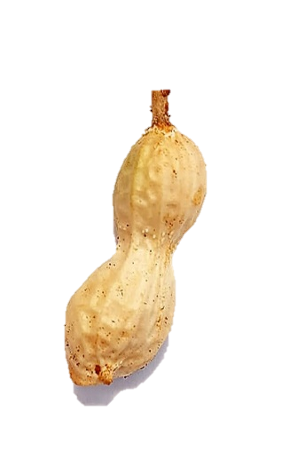
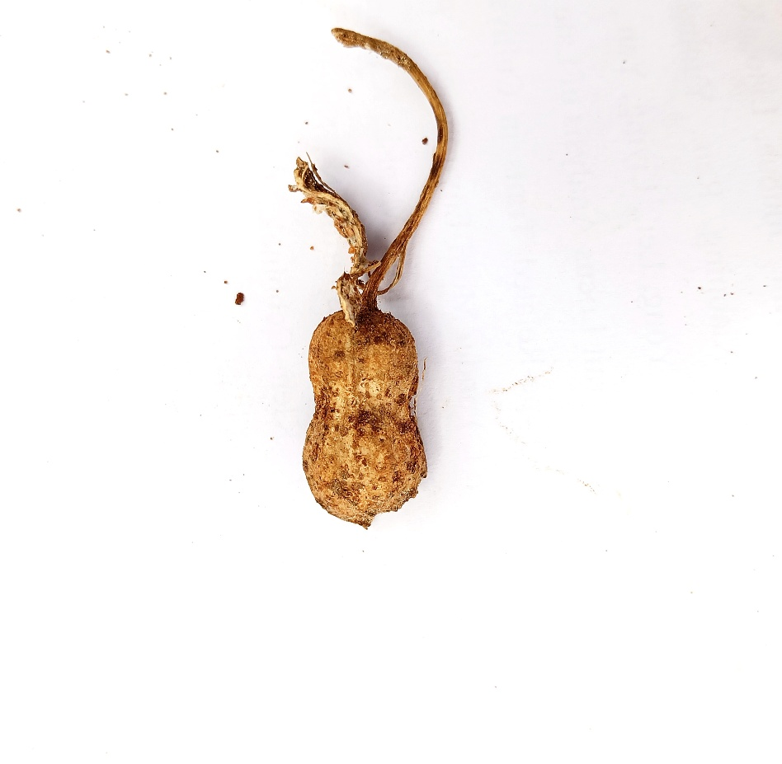
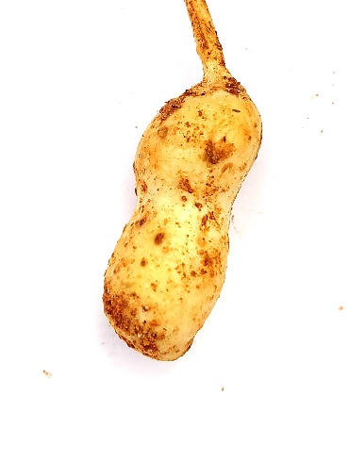
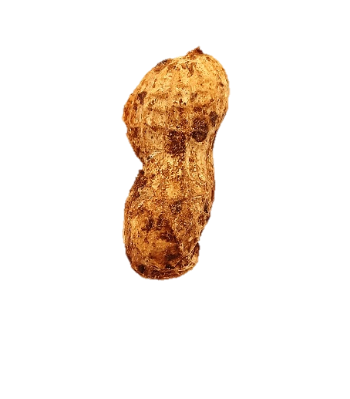
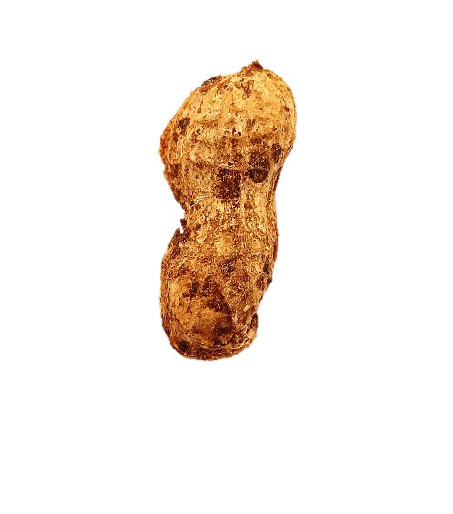

Shallow Medium Deep
Fig 3: Pod: Constriction
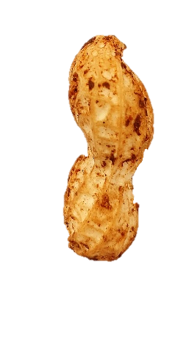
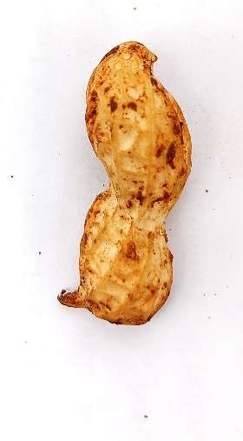
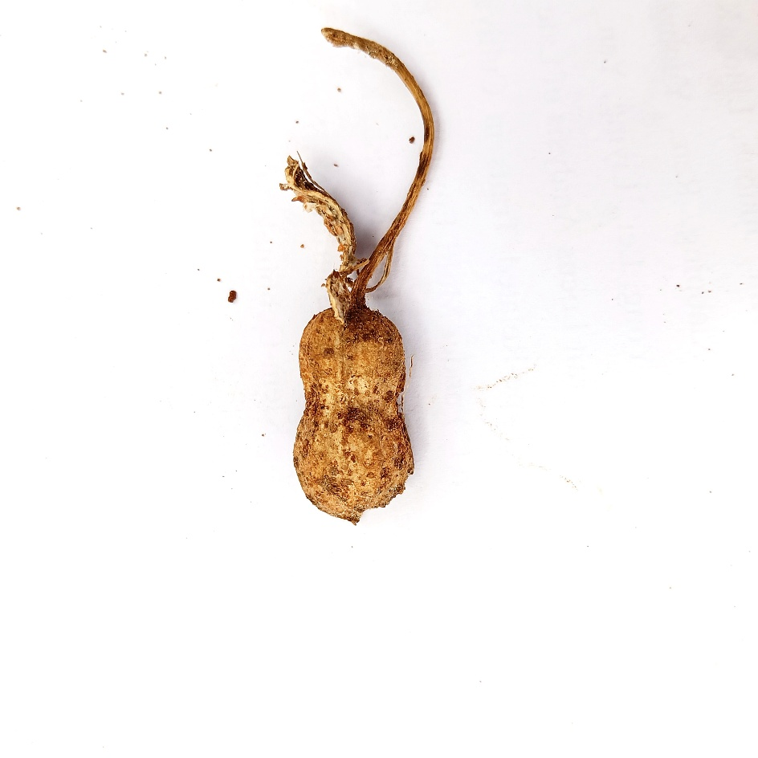

Absent Present
Fig 4: Pod: Presence of beak
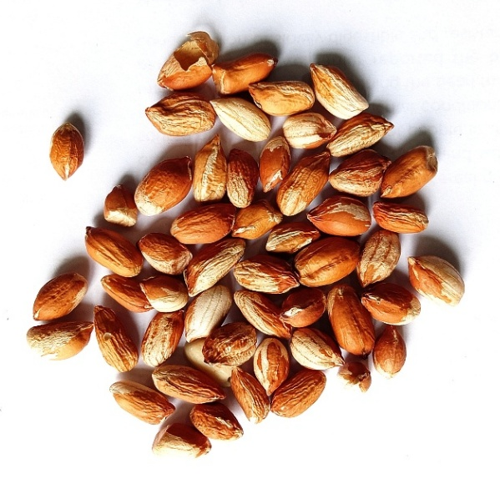
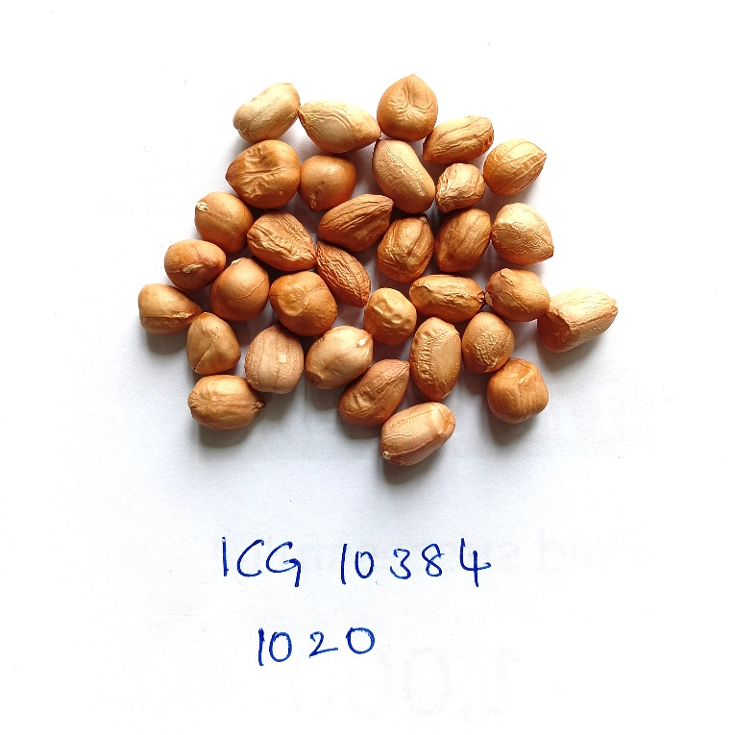
Variegated Uniform
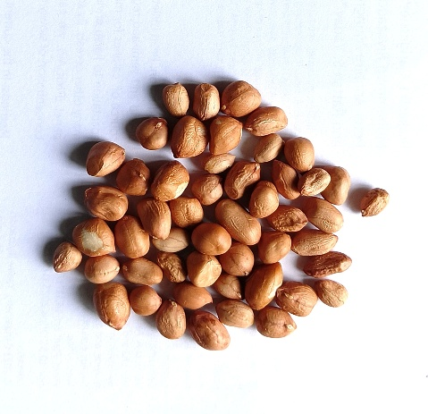
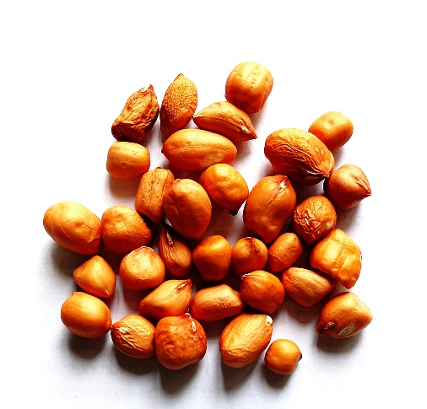
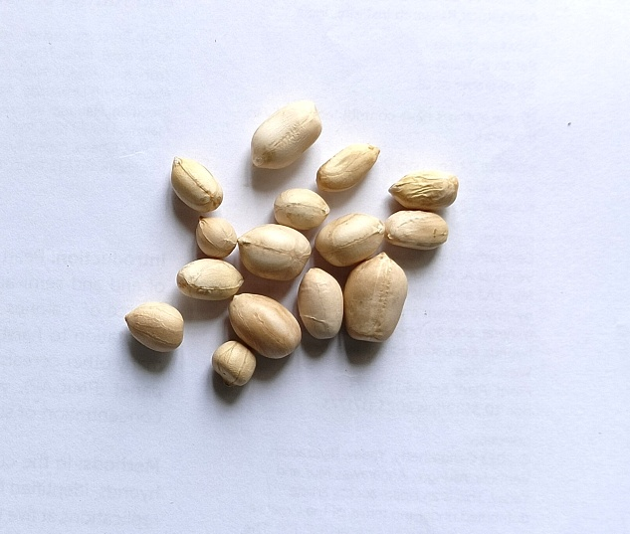
Fig 5: Testa: Colour

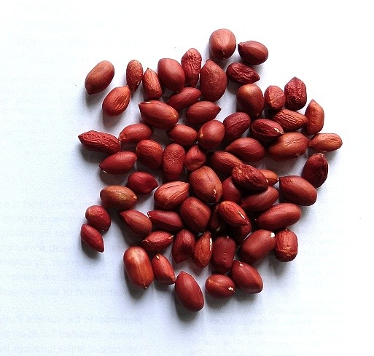
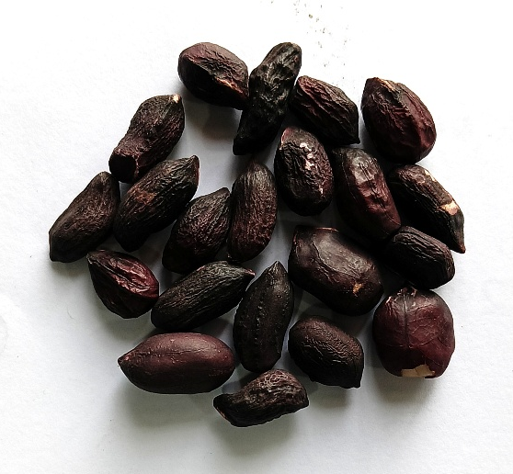
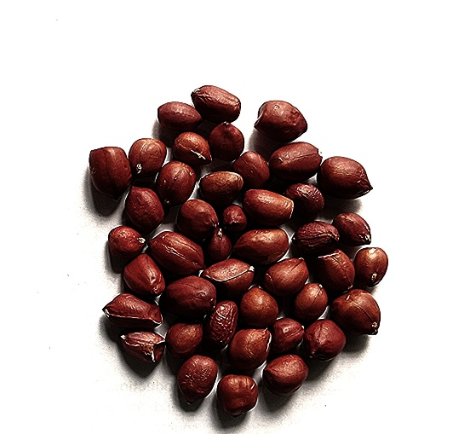
Off white Tan Rose

Purple Dark purple Red
Fig 6: Kernel: Colour of testa
Representative Images of Groundnut Germplasm Exhibiting Variation in DUS Characteristics
Fig 7: Dendrogram of 54 groundnut accessions for 21 DUS traits.

Disclaimer:
Author(s) hereby declare that NO generative AI technologies such as Large Language Models (ChatGPT, COPILOT, etc.) and text-to-image generators have been used during the writing or editing of this manuscript.
Reference
- Ambast S.K., Varatharajan G., Upadhyaya H.D., Vadez V. 2023. High-value crops’ embedded groundnut-based production systems. Front. Plant Sci. 14: 1298946. https://doi.org/10.3389/fpls.2023.1298946
- ANGRAU (2023). Groundnut Outlook Report: June to May 2023–24. Agricultural Market Intelligence Centre, Acharya N.G. Ranga Agricultural University, Guntur.
- Gautam Y., Tripathi M.K., Mishra R., Mohbe G., Sharma A., Sharma S., Singh J., Bishnoi L. 2025. Genetic evaluation and trait association analysis for yield enhancement in soybean (Glycine max L. Merrill). Arch. Curr. Res. Int. 25(6): 589-603. https://doi.org/10.9734/acri/2025/v25i6548
- Jeyaramraja P.R., Fantahun Woldesenbet F.W. 2014. Characterization of yield components in certain groundnut (Arachis hypogaea L.) varieties of Ethiopia. pp. 592-596.
- Karthikeyan A.R., Ezhilkumar S., Karthikeyan P. Characterization of groundnut (Arachis hypogaea L.) varieties as per DUS guidelines.
- Krapovickas A., Gregory W.C. 1994. Taxonomia del genero Arachis (Leguminosae). Bonplandia 8: 1–186. https://doi.org/10.30972/bon.081-2869
- Mishra R., Shrivastava M.K., Amrate P.K., Sharma S., Singh Y., Tripathi M.K. 2025. Phenotypic diversity and trait analysis of soybean recombinant inbred lines. Plant Cell Biotechnol. Mol. Biol. 26(7–8): 32–52. https://doi.org/10.5281/zenodo.10012457
- Mitra M., Gantait S., Kundu R. 2021. Genetic variability, character association and genetic divergence in groundnut (Arachis hypogaea L.) accessions. Legume Res. Int. J. 44(2): 164–169. https://doi.org/10.18805/LR-5550
- R Core Team. 2025. R: A language and environment for statistical computing. R Foundation for Statistical Computing, Vienna, Austria. Available from: https://www.R-project.org/
- Ramteke R., Murlidharan P. 2012. Characterization of soybean (Glycine max) varieties as per DUS guidelines. Indian J. Agric. Sci. 82(7): 572–577. http://epubs.icar.org.in/ejournal/index.php/IJAgS/article/view/20474
- Rajgopal K., Bandyopadhyay A., Chandran K., Lalwani H.B., Ghetia N.R., Bhalodia P.K. 2004. Morphological characterization of released groundnut (Arachis hypogaea L.) cultivars for the DUS requirement. J. Oilseeds Res. 21(1): 1–10. https://www.indianjournals.com/ijor.aspx?target=ijor:jor&volume=21&issue=1&article=001
- Roy A., Sarkar A., Sadhu S., Mondal A., Gupta V.K., Basak D., Das S. 2025. Study on lentil (Lens culinaris Medikus) genotypes for its yield and attributing characters and DUS characterization under Terai Region of West Bengal. J. Appl. Nat. Sci. 17(2). https://doi.org/10.31018/jans.v17i2.5073
- Sravanti K., Reddy V.R., Reddy M.M. 2024. Evaluation and characterization of groundnut (Arachis hypogaea L.) germplasm lines following DUS guidelines. J. Exp. Agric. Int. 46(12): 889–894. https://doi.org/10.9734/jeai/2024/v46i122091
- Shruti K. 2021. Stability analysis in groundnut (Arachis hypogaea L.). Doctoral dissertation, Acharya N.G. Ranga Agricultural University, Guntur.
- Swamy B.M., Upadhyaya H.D., Goudar P.K. 2006. Characterization of Asian core-collection of groundnut for morphological traits. Indian J. Crop Sci. 1(1-2): 129–134.
- Upadhyaya H.D., Dwivedi S.L., Vadez V., Hamidou F., Singh S., Varshney R.K., Liao B., Nigam S.N. 2012. Multiple resistant and nutritionally dense germplasm identified from mini core collection in groundnut. Crop Sci. 52(6): 2528-2537. https://doi.org/10.2135/cropsci2012.03.0170

