In silico analysis for various parameters of bHLH protein in rice (Oryza sativa indica)

Abstract
This study focuses on analyzing the basic helix-loop-helix (bHLH) protein locus WGL47969 Oryza sativa Indica Group (long-grained rice) through computational methods. bHLH proteins are known to be involved in stress responses and signalling pathways in rice. By understanding the properties and functions of the bHLH protein at the WGL47969 locus, we can potentially manipulate its activity or expression to enhance desired traits in rice, such as improved growth, development, or stress resistance. This knowledge contributes to the broader goal of developing more resilient and productive crop varieties. Through this study, we aimed to understand its properties and function, which are vital for plant growth, development, and stress responses. By conducting molecular dynamics simulations, we assessed the flexibility and stability of the bHLH protein at the WGL47969 locus, identifying important regions and residues involved in its activity. Physicochemical analyses revealed that the protein has a basic nature, biologically unstable (instability index), thermally stable (aliphatic index), and is polar/hydrophilic in nature. The study also predicted the secondary and tertiary structures of the protein, validated them using various methods, and explored their ligand binding sites. Secondary structure prediction analysis showed that this bHLH protein consisted of 138 amino acids, with a distribution of 38.41% alpha helix, 10.14% extended strands, 0.72% beta turns, and 50.72% random coils. Additionally, post-translational modifications, particularly phosphorylation, were investigated, and primers for the bHLH protein at the WGL47969 locus were designed and verified through in-silico PCR. The designed primer produced a 58-nucleotide band with a GC content of 45% and had an amplicon score of 97. "Utilizing Deeplock2.0, the sub-cellular localization of the bHLH protein was predicted to be within the nucleus, with a high probability score of 0.8757." "Protein-protein interactions are vital for understanding biological processes; STRING analysis revealed interactions of hypothetical Oryza sativa indica bHLH proteins with partners: HTH myb-type domain-containing protein associated with sodic soil tolerance, WRKY domain-containing protein involved in defense responses, and DUF4005 domain-containing protein linked to microtubule binding." The comprehensive in silico analysis provided a detailed characterisation of the bHLH protein at the WGL47969 locus in rice and serves as a foundation for further experimental investigations. These computational predictions are reliable and can guide future studies on bHLH proteins in rice and potentially other plant species as well.

The transcription factors known as basic helix-loop-helix (bHLH) proteins are essential for many biological processes in plants, including growth, development, and stress responses. Untangling bHLH proteins' intricate involvement in plant biology requires an understanding of their functional properties and regulatory processes. To evaluate the protein's flexibility and stability, molecular dynamics simulations are run, allowing the identification of crucial residues and areas involved in its functional activities. In the present work, we carried out an in silico analysis to look into various parameters and all possible aspects related to bHLH proteins in rice (Oryza sativa). A detailed in silico insight into these proteins includes physicochemical properties, secondary structure prediction, homology modeling, different models and validation of different models. Additionally, we identified possible locations for post-translational modifications, including phosphorylation, which are known to control the stability and activity of proteins. In the present study, we have characterized the bHLH protein according to different stability parameters and valid structures. A detailed in silico analysis of these proteins and prediction of their activity in different conditions can be very useful in both in vitro and in vivo experiments. Our findings shed important light on the diverse functional properties and control mechanisms of rice bHLH proteins. Understanding the precise roles and molecular mechanisms of bHLH proteins in stress responses can contribute to the development of stress-tolerant rice varieties Future experimental studies will be able to build on the integrated in silico analysis reported in this paper, which will help identify specific bHLH proteins implicated in crucial physiological processes in rice and possibly other plant species. Through the modulation of bHLH protein functions, these findings advance our understanding of plant biology and pave the path for future crop enhancement techniques. Rice bHLH proteins may take part in a variety of combinatorial interactions, according to a bioinformatics study, giving them the ability to control a wide range of transcriptional programmes. This paper is the first report on in silico analysis of various parameters and validation of the predicted models by I TASSER of bHLH protein in O. sativa indica, while Experimental validation will provide concrete evidence of the physical interactions between bHLH proteins and their binding partners in rice, confirming the reliability and accuracy of the computational predictions.
Keywords: Basic helix loop helix, Homology modeling, In silico, Phosphorylation, Transcription Factor.

1. Introduction:
Moreover, half of the world's population relies on rice (Oryza sativa), making it one of the most significant crops globally. Its importance in sustaining life, fostering economic development, and addressing issues with food security cannot be emphasized. A fuller understanding of the molecular mechanisms behind rice's growth and development is necessary as researchers work to improve rice productivity, quality, and resilience to environmental stressors. The fundamental Helix-Loop-Helix (bHLH) proteins have emerged as important regulators in several areas of rice biology among the multiple molecular actors involved in these processes. According to Sun et al., (2022)the second-largest class of plant transcription factors comprises of basic helix-loop-helix (bHLH) proteins. When compared to their animal orthologs, studies on the function of plant bHLH proteins have been very few thus far (Chen et al., 2024).
Rice grain size is a significant factor in yield and is influenced in part by the sizes of the lemma and palea. Most of the molecular processes governing these organs' sizes are yet unclear. By regulating cell length in the lemma/palea, an antagonistic pair of basic helix-loop-helix (bHLH) proteins is involved in determining rice grain length (Du et al., 2025)). The broad family of transcription factors known as the bHLH proteins is highly conserved in eukaryotic organisms. They are crucial in a variety of physiological and developmental processes, including as cell differentiation, hormone signalling, light perception, and stress reactions.
The role of bHLH proteins in critical agronomic features such as grain growth, leaf shape, panicle architecture, and tolerance to biotic and abiotic challenges in rice is an example of the functional diversity of these proteins. More than 630 bHLH proteins from a variety of photosynthetic eukaryotes have been identified as a result of analysis of Arabidopsis bHLH proteins, which has steadily increased the characterization of comparable regulators from other plant species, including significant crops (Paulet et al., 2010).
The R gene's offspring Lc, which is involved in the regulation of flavonoid/anthocyanin production in maize (Ludwig et al., 1989), was the first plant protein shown to include a bHLH domain. The R gene is a member of a small subfamily that also includes the genes R, B, and Sn. The orthologous genes in rice (Oryza sativa; OsRa-c; Hu et al., 1996; Nesi et al., 2000) and Arabidopsis (Arabidopsis thaliana; AtTT8) have been identified. The intricate regulatory networks in rice that are controlled by bHLH proteins have been the subject of extensive research. Numerous bHLH genes in rice have been discovered and characterised thanks to improvements in molecular biology methods and genome-wide research.
A lot of data has also been made available by the development of high-throughput sequencing technology and omics methods, enabling thorough analysis of gene expression patterns, protein-protein interactions, and downstream target genes. According to Li et al., 2006 there are predicted to be 177 bHLH genes in rice. Despite playing a crucial role, just 10% (19 out of 177 genes) of rice's genes have been fully characterised, demonstrating how poorly understood the function of bHLH in rice is. Positive Regulator of Grain Length 1 (PGL1), an unusual bHLH gene, was discovered in the rice lemma/palea and was linked to increases in grain length and weight.
The goal of this study is to evaluate our current understanding of the function of bHLH proteins in rice and the significance of these proteins in the control of important biological processes. We want to shed insight on the functional diversity of bHLH proteins and their complex interactions with other regulatory factors in rice by critically analysing the available literature. We will also talk about how this knowledge may be used to improve crop improvement techniques, particularly for rice varieties that aim to increase yield, quality, and stress tolerance.
Overall, research into rice bHLH proteins offers a potential path towards understanding the molecular processes regulating rice development and stress responses. It also provides valuable insights into the potential manipulation of these proteins to engineer improved rice cultivars, contributing to sustainable agriculture and global food security.

2. Material and methods-

2.1. Collection of data / Retrieval of amino acid sequences.
The National Centre for Biotechnology Information (NCBI) is one of the world’s leading networks for computational and biomedical research and was used to retrieve amino acid sequences or FASTA files for our work (https://www.ncbi.nlm.nih.gov/). A total of nine proteins and their FASTA format sequences were fetched from two different organisms, i.e., C. elegans and P. temperata (Table 1). Top of Form
The National Centre for Biotechnology Information (NCBI) is one of the world’s leading networks for computational and biomedical research and was used to retrieve amino acid sequences or FASTA files for our work (https://www.ncbi.nlm.nih.gov/). bHLH protein and their FASTA format sequences were fetched from Oryza sativa indica.

2.2. Primary structure prediction and physico-chemical characterization.

Using the web programme ProtParam (ExPASy) (Expert Protein Analysis System), predictions of the basic structure and computations of various physical and chemical properties of protein sequences were made. Included among the computed parameters are the molecular weight, theoretical pI, amino acid composition—specifically, the proportion of positively and negatively charged amino acids—instability index,Aliphatic index, Grand average of hydropathicity (GRAVY) etc. Determining the function of proteins and their molecular development requires a comparison of physical and chemical properties.

2.3. Secondary structure prediction. Self–Optimized Prediction Method with Alignment (SOPMA) was used to predict secondary features of proteins. This tool evaluates the percentage of alpha-helix, beta-sheets, turns, random coils, extended strands etc.

2.4. 3D structure prediction.

Iterative Threading Assembly Refinement (I-TASSER) is a widely used bioinformatics tool for predicting the three-dimensional structure model of protein molecules from amino acid sequences. I-TASSER is regarded as one of the best tools for structure prediction of proteins at a computerized level . It is freely accessible and generates five full-length models.

2.5. Validation of generated models.

All the five models generated via I-TASSER were validated using different computational methods such as 3D-VERIFY, ERRAT, RAMPAGE, and PROCHECK.

2.6 ERRAT
It analyzes the statistics of non-bonded interactions between different atom types and plots the value of the error function versus position of a 9-residue sliding window, calculated by comparison with statistics from highly refined structures (http://servicesn.mbi.ucla.edu/ERRAT/)

2.7Protein–protein interaction prediction

The Search Tool for the Retrieval of Interacting Genes/Proteins (STRING) version 9.1 (http://string-db.org) was used to anticipate the protein interactions. STRING is a database of 5,214,234 proteins from 1133 different organisms and known and anticipated protein interactions (Zhuang et al., 2022). The relationships come from genetic context, high-throughput tests, conserved expression, and prior knowledge and include physical and functional correlations. It transfers information across these species when necessary and quantitatively integrates interaction data from these sources for a large number of creatures. Protein values larger than 0.444 were included in the results, as were protein scores greater than 0.40 (medium confidence), 0.70 (high confidence), or 0.90 (highest confidence) (Mering et al., 2005).
2.8 Prediction of protein sub-cellular localization
Sub-cellular localization of each hypothetical and conserved protein was predicted byDeeplock2.0. It is the most precise web-based tool used for the prediction of sub-cellular localization in all protein sequences by submitting sequences in FASTA format
2.9Predction of Phosphorylation site
The process of phosphorylation is essential for the operation of signaling pathways. Protein function and localisation may change as a result of the removal or addition of phosphate groups. NetPhos server is a tool to predict phosphorylation sites at threonine, serine and tyrosine.

2.10 Primers design and in Silico PCR
Specific primers for the detection of bHLHoryza sativa indica were designed and run In silico PCR based on the sequences reported in theNCBI GenBank (OP542207.1)AmplifX 1.5.4 software was used (http://crn2m.univ-mrs.fr/pub/amplifx-dist) to design the best primer pair according to parameters such as the size of the DNA fragment, stability, high melting temperature (T _{m}), and no primer dimer in the PCR reaction.

3. Result and Discussion-

Prediction of the physicochemical properties of heat shock proteins was made using the Protparam tool from ExPASy. These analyzed properties of protein play a crucial role in determining the sustainability and stability of a protein in a biological system.

Table1 Amino Acid (%) of bHLH Protein in Oryza sativa indica.
Protein | A | R | N | D | C | Q | E | G | H | I | L | K | M | F | P | S | T | W | Y | V
bHLH | 3.6 | 7.2 | 5.1 | 2.9 | 0.7 | 3.6 | 6.5 | 6.5 | 2.9 | 5.8 | 8.0 | 8.0 | 3.6 | 2.2 | 5.8 | 10.1 | 9.4 | 0.7 | 2.9 | 4.3

A=Alanine, R=Arginine, N=Asparagine, D=Aspartic Acid, C=Cysteine, Q= Glutamine, E=Glutamic Acid, G= Glycine, H=Histidine, I=Isoleucine, L=Leucine, K=Lysine, M=Methionine, F= Phenylalanine, P=Proline, S=Serine, T=Threonine, W=Tryptophan, Y=Tyrosine, V=Valin

Table2.Physico-chemical properties of bHLHProtein inOryza sativa indica.
Protein | MW | pI | NO. OF AA | +ve AA. | -ve AA | Instability index | Aliphatic index | GRAVY
bHLH | 15563.77 | 9.83 | 138 | 21 | 13 | 64.77 | 69.93 | -0.714

3.1.1. Molecular Weight: Studies that link high molecular weight with the amino acid makeup of proteins show a correlation between high molecular weight and a high percentage of amino acids in that protein. This supports our research, in which we also pointed out that the bHLH 15563.77 molecular weight indicates that there are 138 amino acids in total. (Table2)

3.1.2. Isoelectric Point(pI): The isoelectric point (pI) is the pH value at which a molecule carries no net electrical charge. In their compact form, proteins are often found at pI. If a protein's pI value is lower than 7, it is considered acidic. A pI value greater than 7 denotes the protein's basic nature. ThebHLH protein's pI value of 9.83 (Table 2) identifies it as a basic protein. This isoelectric point is crucial to the purifying process. It identifies the range of pH where protein solubility is typically lowest.

3.1.3. Positively and negatively charged residues: The total amount of arginine (Arg) and lysine (Lys) is calculated based on the number of positively charged residues. Aspartic acid (Asp) and glutaminic acid (Glu) are added together to get the total number of negatively charged residues. This is helpful in determining the architecture of proteins (Crabtree et al., 2023).

3.1.4. Instability Index: The stability index, a property of proteins, is useful for predicting their in vivo stability (Guruprasad et al 1990). If a protein's instability index value is less than 40, it is said to be stable; if it is greater than 40, it is said to be unstable. The bHLH protein has an instability score of 64.77 in Table 2, which suggests that the protein is unstable.

3.1.5. Aliphatic index (AI)-The value of the aliphatic index is inversely correlated with a protein's structural stability. We applied the formula that was created to calculate the aliphatic index (Asad et al., 2024).
Aliphatic Index = xA+ axV + b (xI + xL)

Where the mole percents of Alanine, Valine, Isoleucine, and Leucine in a protein are denoted by xA, xV, xI, and xL. The relative volumes of aliphatic side chains to those of alanine side chains are represented, respectively, by coefficients 'a' and 'b'. Based on the volume filled by the aliphatic amino acids in a protein, these values (a = 2. 9 0. 1 and b = 3. 9 0. 1) were obtained. The aliphatic index has an impact on the protein's thermal stability. High aliphatic index proteins are more heat-stable. Aliphatic amino acids are also naturally hydrophobic. These proteins are both thermally stable and contain a large number of hydrophobic amino acids, as indicated by the aliphatic index of cytotoxins, which ranged from 66.5 to 84.33.S. (Panda et al 2012). The bHLH protein's AI of 69.93(Table2) shows that it is hydrophobic and thermally stable.
3.1.6. GRAVY (Grand average of hydropathy)-The hydropathy scale, developed in 1982 by Kyte and Doolittle, accounts for the hydrophilic and hydrophobic properties of each side chain of an amino acid in a protein. A protein's total number of residues is multiplied by the sum of the hydropathy values for each of its amino acids to produce the GRAVY score. Positive GRAVY values indicate non-polar proteins, while negative values indicate polar or hydrophilic proteins. The GRAVY values of the cyanobacterial proteins are commonly observed to range from -3 to +3. The GRAVY score of -0.714 (Table 2) for the bHLH protein indicates that it is a polar/hydrophilic protein.

Table3.Atomic composition of bHLH protein in Oryza sativa indica

Carbon | C | 677
Hydrogen | H | 1102
Nitrogen | N | 200
Oxygen | O | 208
Sulfur | S | 6

3.1.7. Formula: The formula of bHLH protein is C₆₇₇H₁₁₀₂N₂₀₀O₂₀₈S₆

3.1.8. Total number of atoms: Total number of atoms in bHLH protein are 2193.

3.1.9. Estimated half-life:

The N-terminal of the sequence considered is T (Thr).

The estimated half-life is: 7.2 hours (mammalian reticulocytes, in vitro).
>20 hours (yeast, in vivo).
>10 hours (Escherichia coli, in vivo).

Table 4. Calculated secondary structure percentages by SOPMA of bHLH of Oryza sativa indica.
Protein | Alpha helix | 310 helix | Pi helix | Beta bridge | Extended strand | Beta turn | Bend region | Random coil | Ambiguous states | Other
bHLH | 38.41% | 0.00% | 0.00% | 0.00% | 10.14% | 0.72% | 0.00% | 50.72% | 0.00% | 0.00%

3.2. Secondary structure prediction.

SOPMA was used to ascertain the secondary structure of the protein. Random coils make up the majority of the secondary structure (50.72), followed by alpha helices (38.41%) and extended strands (10.14%).”. According to the SOPMA data (Table 4), there were 138 amino acids, 38.41% alpha helix, 10.14% extended strands, 0.72% beta turns, and 50.72% random coils.

3.3Tertiary structure prediction

3.3.1Predicted solvent Accessibility: The accessible surface area (ASA) prediction, also known as the prediction of protein solvent accessibility, is a crucial step in the process of predicting tertiary structures directly from one-dimensional sequences. (Singh et al., 2022).Whether a protein is hydrophilic or hydrophobic is determined by this method.

Figure 1. Sequence Prediction by I TASSER-

Value range from 0 (buried residue) denotes hydrophobic nature to 9(highly exposed residue) denotes hydrophilic nature of protein. When bHLH protein sequence predicted it indicates majority value is ranged from 0-5 (Figure1) which indicates that bHLH protein is hydrophobic in nature.

3.3.2. Top threading Template used by I-TASSER: Major improvements in protein structure prediction based on protein threading have been made possible by the expansion of the Protein Data Bank (PDB) and improvements in prediction algorithms. Protein threading is able to predict the three-dimensional structure of the protein (i.e., target) by matching the fundamental sequence of a new protein to a relevant experimental structure (i.e., template) in the PDB. (I-TASSER modelling starts with the structure templates that LOMETS discovered in the PDB database. The multi-threading meta-server technology used by LOMETS can produce tens of thousands of template alignments from each threading programme. The Z-score, which is the difference between the raw and average scores represented in units of standard deviation, is used by I-TASSER to choose only the threading alignment templates that are of the highest importance.
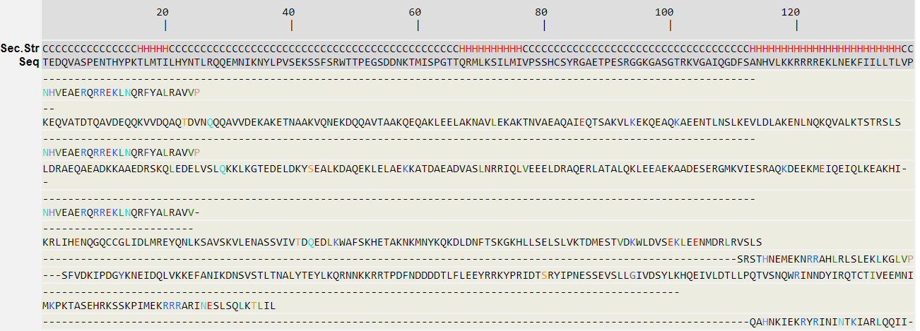
Figure2. Top threading Template used by I-TASSER

All the residues are colored in black; however, those residues in template which are identical to the residue in the query sequence are highlighted in color. Coloring scheme is based on the property of amino acids, where polar are brightly coloured while non-polar residues are colored in dark shade.

Table 5. Top 1st Threading templates used by I-TASSER the template with highest Z- score is given below

PDB ID | Iden1 | Iden2 | Cov | Z-Score | Classification | Organism | Expression
5GNJ | 0.56 | 0.12 | 0.18 | 2.34 | DNA binding protein | Arabidopsis thaliana | Escherichia coli BL21(DE3)
- Ident1 is the percentage sequence identity of the templates in the threading aligned region with the query sequence.
- Ident2 is the percentage sequence identity of the whole template chains with query sequence.
- Cov represents the coverage of the threading alignment and is equal to the number of aligned residues divided by the length of query protein.
- Norm. Z-score is the normalized Z-score of the threading alignments. Alignment with a Normalized Z-score >1 mean a good alignment and vice versa.

3.4. List of Different Biological Assemblies A functionally significant aggregate of proteins and maybe other molecules is referred to as a biological assembly. Cartesian coordinates, stoichiometry, molecular interfaces, and symmetry are all ways to define a structure. The greatest functional form found in the experimental data is referred to as the biological assembly of an experimental structure. Typically, this assembly is one of the in vivo functional forms. (Li et al., 2023).
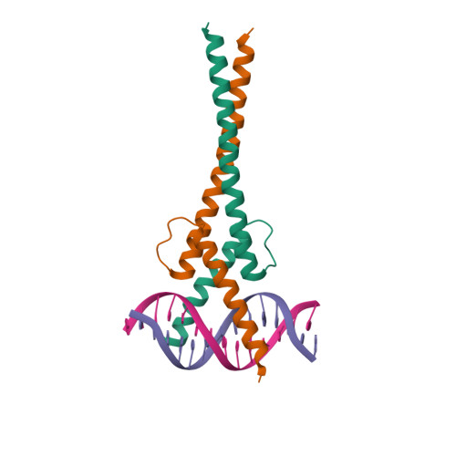 | 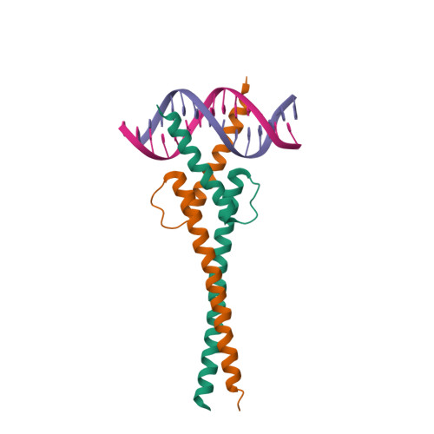 | 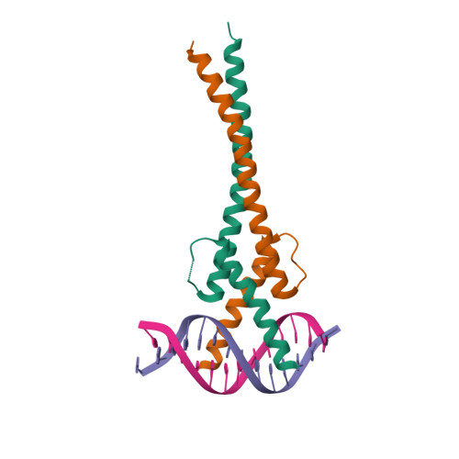 | 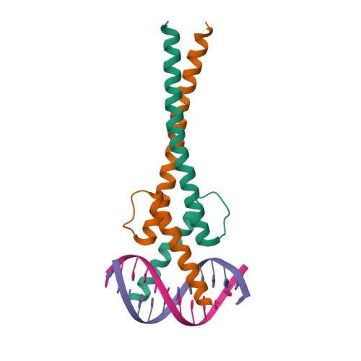 | 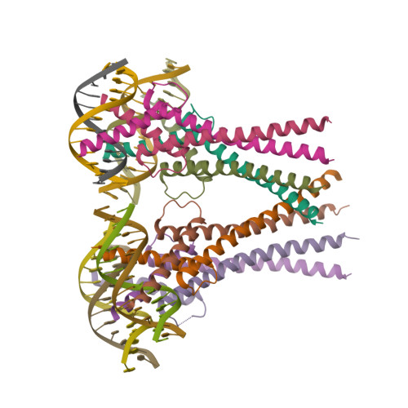
Biological Assembly1 | Biological Assembly2 | Biological Assembly3 | Biological Assembly4 | Assymetric unit

Figure 3. List of Different Biological Assemblie

3.5. Top 5 Final Models Provided by I-TASSER: I-TASSER simulations provide a sizable ensemble of structural conformations, known as decoys, for each target. I-TASSER uses the SPICKER programme to cluster all the decoys based on pair-wise structural similarity, and then reports up to five models that correspond to the five biggest structure clusters in order to choose the final models. The significance of threading template alignments and the convergence parameters of the structure assembly simulations are used to calculate the C-score, which provides a quantitative assessment of the confidence in each model. The C-score normally falls between [-5, 2], with a higher C-score denoting a more confident model and a lower C-score denoting the opposite. Since there is a link between C-score and protein length, TM-score and RMSD are computed using these metrics. Since the top 5 models are ranked by the cluster size, it is possible that the lower-rank models have a higher C-score in rare cases. Although the first model has a better quality in most cases, it is also possible that the lower-rank models have a better quality than the higher-rank model. If the I-TASSER simulations converge, it is possible to have less than 5 clusters generated; this is usually an indication that the models have a good quality because of the converged simulations (Figure 4)

Top 1st Model 2nd Model
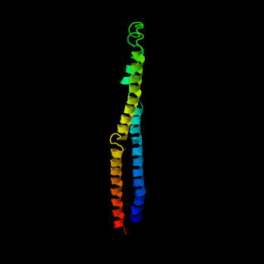 | 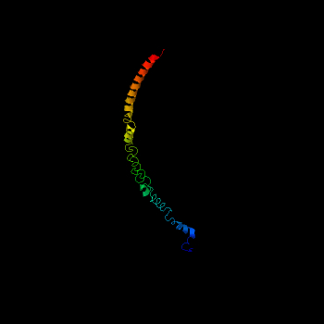
C-score=-2.04  Estimated TM-score = 0.47±0.15  Estimated RMSD = 9.0±4.6Å | C-score= -1.57C

Figure 4. Predicted Model by I TASSER

3rd Model | 4th Model | 5th Model
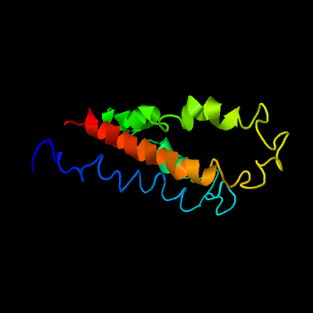 | 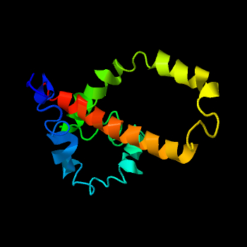 | 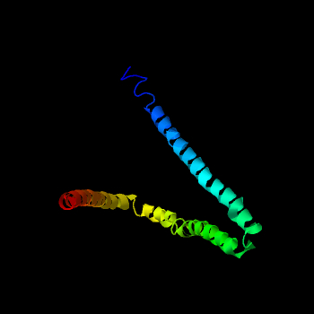
C-score = -4.03 | C-score = -4.24 | C-score = -4.38

3.6. Ligand Binding Site-This section reports biological annotations of the target protein by COFACTOR and COACH based on the I-TASSER structure prediction. While COFACTOR deduces protein functions (ligand-binding sites, EC and GO) using structure comparison and protein-protein networks, COACH is a meta-server approach that combines multiple function annotation results (on ligand-binding sites) from the COFACTOR, TM-SITE and S-SITE programs. (Figure 5).

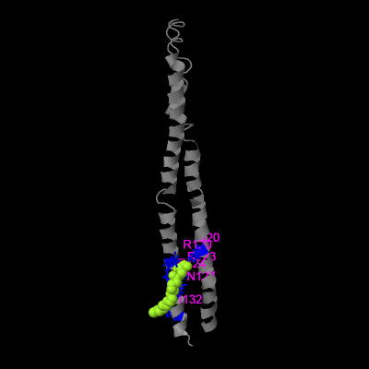
Figure 5. Ligand Binding Site

Table 6. Rank First Ligand Binding site model

C score | Cluster | PDB | Ligand Name | Ligand Binding site residues
0.16 | 7 | 5dwkA | 78N | Mult 20,120,123,124,127,132
1. C-score is the confidence score of the prediction. C-score ranges [0-1], where a higher score indicates a more reliable prediction.
2. Cluster size is the total number of templates in a cluster.
3. Lig Name is name of possible binding ligand. Click the name to view its information in the BioLiP database.

Table 7. Validation Scores of Top5 3D models of bHLH via ERRAT.
Models | C-Score | ERRAT% | Ramachandran Plot Results
 |  |  | Most favourable region, % Allowed region, % Disallowed region, %
Model 1 | -2.04 | 91.5385 | 78.3% 16.7% 3.3%
Model 2 | -1.57 | 96.1538 | 60.0% 21.7% 6.7%
Model 3 | -4.03 | 85.3846 | 47.5% 34.2% 4.2%
Model 4 | -4.24 | 68.4615 | 56.7% 27.5% 6.7%
Model 5 | -4.38 | 90 | 85.0% 12.5% 0.0%

I-TASSER was used to carry out the homology modelling in the current investigation. Five 3D models for bHLH were created. Various bioinformatic methods were used to validate the quality of these models (Table7). By statistically relating non-bonded interactions among various atom types on their distinctive atomic interactions, the bioinformatics technique known as ERRAT or "Overall Quality Factor" validated models. This tool evaluates the model's overall quality in the form of the Quality Factor, which is used to analyse the accuracy of the model that is developed. The higher the value of the Quality Factor, high will be the quality of the generated model. For a high-quality model, the generally accepted range is greater than 50. In case of bHLH the errat score of the best model was 96.1538 which is model number 2 (Table7).
According to the concept, all the models of bHLH (Oryza sativa indica) showed their quality factor above 50; hence all the generated models are good and can be used for future proteomic studies.
Ramachandran plot was generated by ERRAT for models developed using the I-TASSER in which most favourable region% allowed region&% and disallowed region % are given. (Table7)

3.7 Prediction of protein sub-cellular localization
Deeplock2.0 software was used to predict the sub-cellular localization of the proteins. bHLH protein was localized in the nucleus with probability score 0.8757 (Table8) respectively.

Table8. Prediction of protein sub-cellular localization with probability score
Localization | Cytoplasm | Nucleus | Extracellular | Cell membrane | Mitochondrion | Plastid | Endoplasmic reticulum | Lysosome | Golgi apparatus | peroxisome
Probability | 0.3568 | 0.8757 | 0.0913 | 0.0801 | 0.0334 | 0.0353 | 0.1623 | 0.1009 | 0.0540 | 0.1201

3.8 Protein–protein interaction prediction

It is possible to predict protein-protein interactions, and this knowledge is essential for comprehending biological and cellular processes. Two or more additional proteins must normally bind to a protein in order for it to fulfill a biological function. The majority of important molecular processes in the cell, including DNA replication, are carried out by large molecular machines consisting of multiple proteins organized according to their protein-protein interactions. Proteins that often interact with one another alter their function and activity, as has been demonstrated in the past. The experimental elucidation and computational analysis of the complex networks generated by individual protein-protein interactions are some of the major issues in the post-genomic era.

STRING was used to estimate how our hypothetical and conserved proteins will interact with other partners in functional protein association networks (Figure 6). Although many proteins carry out their tasks independently, the vast majority of proteins interact with other proteins for correct biological activity. Only the partner proteins with a score greater than 0.5 were included in our results. Understanding protein function and cellular biology depends on being able to describe protein-protein interactions.

First protein interacts with the oryza sativa indica bHLH protein: The transcription factor HTH myb-type domain-containing protein has been linked to tolerance on sodic-dispersive soils in wheat (Triticum aestivum L.) and has been found to be highly regulated during germination, maximum stem elongation, anthesis, and grain development stages. (Sharma et al., 2022)

Second protein interact with oryza sativa indica bHLH protein: WRKY domain-containing protein Phytohormones, phytoalexins, and other defense-related compounds are produced by WRKY proteins as part of metabolism (Saha et al., 2024; Liang et al., 2017). WRKY TFs are crucial regulators of plant growth and development. Abiotic stress responses in plants are also mediated by WRKY proteins (Guo et al., 2022; Khoso et al., 2022; Yang et al., 2025)

Third protein interact with oryza sativa indicatebHLH protein DUF4005 domain-containing protein.which is found in the C-terminal regions of many AtIQD proteins, binds directly to MTs and tubulin dimers (Liu et al., 2022).

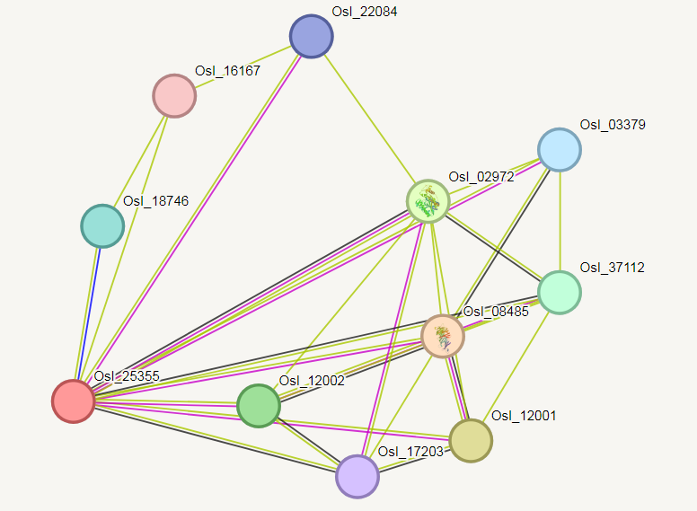

Figure6: Protein–protein interaction prediction

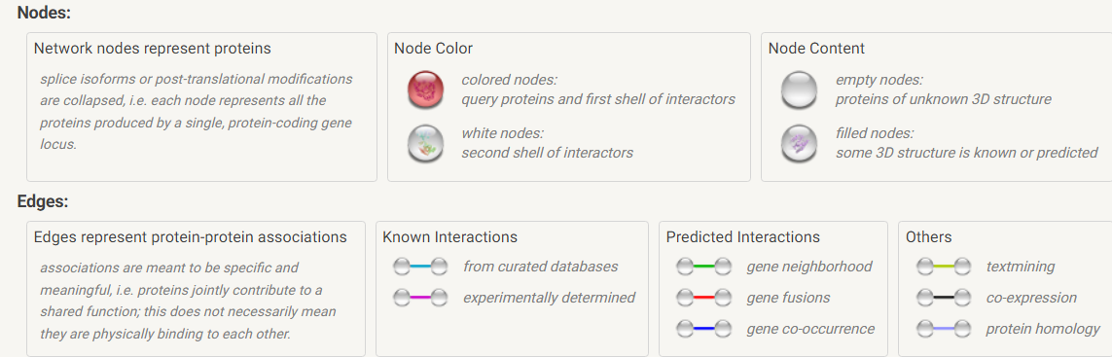

3.9 Primers design and in Silico PCR
The design and testing of specific primers for the detection of bHLH protein of oryza sativa indica AmplifX 2.1.1 software was used to design the best primer pair based on parameters like the size of the DNA fragment, stability, high melting temperature (T m), and the absence of primer dimer in the PCR reaction. This in silico PCR was based on the sequences reported in the NCBI GenBank (OP542207.1). The Forward primer (Pr0001) is written as 5' TCCATTTCCCTTCTGTCACA, and the Reverse primer (Pr0002) is 3' GCATCACCTGAAAATACCCA.were chosen, and 58 bp bHLHprotein(Rc) gene fragments were amplified in silico by AmplifXsoftware.The GC content is 45%, and the suggested annealing temperature is 50°C. These primers had an amplicon score of 97.

3.10 Predicting phosphorylation sites: Phosphorylation is a vital procedure through which signaling pathways function. The removal or addition of phosphate group may result in alteration in function of protein and its localization. Three major amino acid residues namely Serine, Threonine and Tyrosine are mostly phosphorylated, as they contain hydroxyl group in their side chain and thus are capable of binding phosphate group. NetPhos server is a tool to predict phosphorylation site at threonine, serine and tyrosine. If the amino acid residue is predicted as not phosphorylated (score is below threshold level) and if it is phosphorylated score is above threshold level (Figure7).
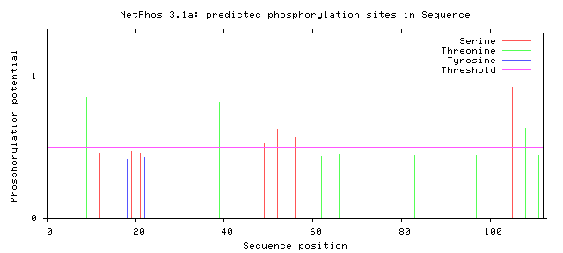

Figure 7. Prediction of Phosphorylation site

4. Conclusion
Based on the results obtained from the Protparam tool and various bioinformatics analyses, several important physicochemical properties of the bHLH protein from Oryza sativa indica have been determined. The molecular weight of the protein was found to be 15563.77 Da, and it consists of 138 amino acids. The protein was classified as basic, as its isoelectric point (pI) was calculated to be 9.83, indicating that it is most stable in a basic pH environment. The analysis of positively and negatively charged residues revealed the presence of arginine (Arg) and lysine (Lys) as positively charged residues and aspartic acid (Asp) and glutamic acid (Glu) as negatively charged residues. The instability index of the protein was found to be 64.77, suggesting that the bHLH protein is biologically unstable. However, the aliphatic index was calculated to be 69.93, indicating that the protein is thermally stable and includes a significant amount of hydrophobic amino acids. Additionally, the GRAVY score of -0.714 confirms that the bHLH protein is polar/hydrophilic in nature. The protein secondary structure prediction showed that the protein consists of 38.41% alpha helix, 10.14% extended strands, 0.72% beta turns, and 50.72% random coils. The 3D modeling using I-TASSER generated five models, and the best model exhibited an ERRAT score of 96.1538, indicating its high quality. The protein was predicted to be localized in the nucleus with a probability score of 0.8757.In terms of protein-protein interactions, the bHLH protein was found to interact with transcription factor HTH myb-type domain-containing protein and WRKY domain-containing protein, both of which are crucial regulators in various biological processes. Overall, the results suggest that the bHLH protein from Oryza sativa indica is a basic, thermally stable, and non-polar protein. It is likely to have functional significance in the nucleus and interacts with other important regulatory proteins. The information obtained from this study can provide valuable insights for further experimental and functional studies of the bHLH protein's role in various biological processes. Additionally, the identified phosphorylation sites can shed light on the protein's regulation through post-translational modifications.

COMPETING INTERESTS DISCLAIMER:
Authors have declared that they have no known competing financial interests OR non-financial interests OR personal relationships that could have appeared to influence the work reported in this paper.

Disclaimer (Artificial intelligence)
Option 1:
Author(s) hereby declare that NO generative AI technologies such as Large Language Models (ChatGPT, COPILOT, etc.) and text-to-image generators have been used during the writing or editing of this manuscript.

5. References
- Asad, M. A., Shorna, S. A., Mizan, M., Nath, R. D., Saikat, A. S. M., & Uddin, M. E. (2024). Bioinformatics approaches for the molecular characterization and structural elucidation of a hypothetical protein of Aedes albopictus. Engineering Proceedings, 67(1), 14. https://doi.org/10.3390/ecb2023-15658
- Carretero-Paulet, L., Galstyan, A., Roig-Villanova, I., Martínez-García, J. F., Bilbao-Castro, J. R., & Robertson, D. L. (2010). Genome-wide classification and evolutionary analysis of the bHLH family of transcription factors in Arabidopsis, poplar, rice, moss, and algae. Plant Physiology, 153(3), 1398–1412. https://doi.org/10.1104/pp.110.153593
- Chen, X., Li, C., Wang, H., & Guo, Z. (2019). WRKY transcription factors: Evolution, binding, and action. Phytopathology Research, 1(1), 13. https://doi.org/10.1186/s42483-019-0022-x
- Chen, X., Yao, C., Liu, J., Liu, J., Fang, J., Deng, H., ... & Guo, X. (2024). Basic helix–loop–helix (bHLH) gene family in rye (Secale cereale L.): Genome-wide identification, phylogeny, evolutionary expansion and expression analyses. BMC Genomics, 25(1), 67. https://doi.org/10.1186/s12864-024-10326-2
- Colovos, C., & Yeates, T. O. (1993). Verification of protein structures: Patterns of nonbonded atomic interactions. Protein Science, 2(9), 1511–1519. https://doi.org/10.1002/pro.5560020916
- Crabtree, M. D., Holland, J., Pillai, A. S., Kompella, P. S., Babl, L., Turner, N. N., ... & Nott, T. J. (2023). Ion binding with charge inversion combined with screening modulates DEAD box helicase phase transitions. Cell Reports, 42(11), 113368. https://doi.org/10.1016/j.celrep.2023.113368
- Dhiman, U., Parihar, R. D., Rana, S., Upadhyay, S. K., & Kumar, V. (2020). Comparative in silico analysis of randomly selected heat shock proteins in Caenorhabditis elegans and Photorhabdus temperata. Biointerface Research in Applied Chemistry, 11(1), 11418–11430. https://doi.org/10.33263/BRIAC111.1141811430
- Du, L., Ye, R., Liu, X., He, Q., Qiao, J., Charrier, L., ... & Qi, Y. (2025). The OsbHLH166–OsABCB4 module regulates grain length and weight via altering auxin efflux. Science Bulletin. Advance online publication. https://doi.org/10.1016/j.scib.2025.02.015
- Guo, X., Ullah, A., Siuta, D., Kukfisz, B., & Iqbal, S. (2022). Role of WRKY transcription factors in regulation of abiotic stress responses in cotton. Life, 12(9), 1410. https://doi.org/10.3390/life12091410
- Guruprasad, K., Reddy, B. B., & Pandit, M. W. (1990). Correlation between stability of a protein and its dipeptide composition: A novel approach for predicting in vivo stability of a protein from its primary sequence. Protein Engineering, Design & Selection, 4(2), 155–161. https://doi.org/10.1093/protein/4.2.155
- Hu, J., Anderson, B., & Wessler, S. R. (1996). Isolation and characterization of rice R genes: Evidence for distinct evolutionary paths in rice and maize. Genetics, 142(3), 1021–1031. https://doi.org/10.1093/genetics/142.3.1021
- Khoso, M. A., Hussain, A., Ritonga, F. N., Ali, Q., Channa, M. M., Alshegaihi, R. M., ... & Manghwar, H. (2022). WRKY transcription factors (TFs): Molecular switches to regulate drought, temperature, and salinity stresses in plants. Frontiers in Plant Science, 13, 1039329. https://doi.org/10.3389/fpls.2022.1039329
- Kyte, J., & Doolittle, R. F. (1982). A simple method for displaying the hydropathic character of a protein. Journal of Molecular Biology, 157(1), 105–132. https://doi.org/10.1016/0022-2836(82)90515-0
- Lee, H., Cha, J., Choi, C., Choi, N., Ji, H. S., Park, S. R., et al. (2018). Rice WRKY11 plays a role in pathogen defense and drought tolerance. Rice, 11(1), 5. https://doi.org/10.1186/s12284-018-0206-0
- Li, X., Duan, X., Jiang, H., Sun, Y., Tang, Y., Yuan, Z., … Zhang, D. (2006). Genome-wide analysis of basic/helix-loop-helix transcription factor family in rice and Arabidopsis. Plant Physiology, 141(4), 1167–1184. https://doi.org/10.1104/pp.106.080580
- Li, Y., Tian, R., Shi, H., Xu, J., Wang, T., & Liu, J. (2023). Protein assembly: Controllable design strategies and applications in biology. Aggregate, 4(3), e317. https://doi.org/10.1002/agt2.317
- Liang, X., Chen, X., Li, C., Fan, J., & Guo, Z. (2017). Metabolic and transcriptional alterations for defense by interfering OsWRKY62 and OsWRKY76 transcriptions in rice. Scientific Reports, 7, 2474. https://doi.org/10.1038/s41598-017-02454-6
- Ludwig, S. R., Habera, L. F., Dellaporta, S. L., & Wessler, S. (1989). Lc, a member of the maize R gene family responsible for tissue-specific anthocyanin production, encodes a protein similar to transcriptional activators and contains the myc-homology region. Proceedings of the National Academy of Sciences, 86(18), 7092–7096. https://doi.org/10.1073/pnas.86.18.7092
- Nesi, N., Debeaujon, I., Jond, C., Pelletier, G., Caboche, M., & Lepiniec, L. (2000). The TT8 gene encodes a basic helix-loop-helix domain protein required for expression of DFR and BAN genes in Arabidopsis siliques. The Plant Cell, 12(10), 1863–1878. https://doi.org/10.1105/tpc.12.10.1863
- Panda, S., & Chandra, G. (2012). Physicochemical characterization and functional analysis of some snake venom toxin proteins and related non-toxin proteins of other chordates. Bioinformation, 8(18), 891–896. https://doi.org/10.6026/97320630008891
- Saha, B., Nayak, J., Srivastava, R., Samal, S., Kumar, D., Chanwala, J., ... & Giri, M. K. (2024). Unraveling the involvement of WRKY TFs in regulating plant disease defense signaling. Planta, 259(1), 7. https://doi.org/10.1007/s00425-023-04262-1
- Sharma, D. L., Bhoite, R., Reeves, K., Forrest, K., Smith, R., & Dowla, M. A. (2022). Genome-wide superior alleles, haplotypes and candidate genes associated with tolerance on sodic-dispersive soils in wheat (Triticum aestivum L.). Theoretical and Applied Genetics, 135(3), 1113–1128. https://doi.org/10.1007/s00122-021-04013-8
- Singh, J., Paliwal, K., Litfin, T., Singh, J., & Zhou, Y. (2022). Reaching alignment-profile-based accuracy in predicting protein secondary and tertiary structural properties without alignment. Scientific Reports, 12(1), 7607. https://doi.org/10.1038/s41598-022-11581-3
- Singh, N., Upadhyay, S., Jaiswar, A., & Mishra, N. (2016). In silico analysis of protein. Journal of Bioinformatics, Genomics and Proteomics, 1(2), 1007.
- Sun, P. W., Gao, Z. H., Lv, F. F., Yu, C. C., Jin, Y., Xu, Y. H., & Wei, J. H. (2022). Genome-wide analysis of basic helix–loop–helix (bHLH) transcription factors in Aquilaria sinensis. Scientific Reports, 12(1), 7194. https://doi.org/10.1038/s41598-022-11302-4
- von Mering, C., Jensen, L. J., Snel, B., Hooper, S. D., Krupp, M., Foglierini, M., … Bork, P. (2005). STRING: Known and predicted protein–protein associations, integrated and transferred across organisms. Nucleic Acids Research, 33(Suppl. 1), D433–D437. https://doi.org/10.1093/nar/gki005
- Wang, H., Hao, J., Chen, X., Hao, Z., Wang, X., Lou, Y., et al. (2007). Overexpression of rice WRKY89 enhances ultraviolet B tolerance and disease resistance in rice plants. Plant Molecular Biology, 65(6), 799–815. https://doi.org/10.1007/s11103-007-9244-x
- Xu, Q., & Dunbrack, R. L., Jr. (2019). Principles and characteristics of biological assemblies in experimentally determined protein structures. Current Opinion in Structural Biology, 55, 34–49. https://doi.org/10.1016/j.sbi.2018.09.007
- Yang, J., & Zhang, Y. (2015). I-TASSER server: New development for protein structure and function predictions. Nucleic Acids Research, 43(W1), W174–W181. https://doi.org/10.1093/nar/gkv342
- Yang, L., Fang, S., Liu, L., Zhao, L., Chen, W., Li, X., ... & Yu, D. (2025). WRKY transcription factors: Hubs for regulating plant growth and stress responses. Journal of Integrative Plant Biology, 67(3), 488–509. https://doi.org/10.1111/jipb.13699
- Yokotani, N., Sato, Y., Tanabe, S., Chujo, T., Shimizu, T., Okada, K., et al. (2013). WRKY76 is a rice transcriptional repressor playing opposite roles in blast disease resistance and cold stress tolerance. Journal of Experimental Botany, 64(16), 5085–5097. https://doi.org/10.1093/jxb/ert298
- Zhang, C., Freddolino, P. L., & Zhang, Y. (2017). COFACTOR: Improved protein function prediction by combining structure, sequence and protein–protein interaction information. Nucleic Acids Research, 45(W1), W291–W299. https://doi.org/10.1093/nar/gkx366
- Zheng, W., Zhang, C., Li, Y., Pearce, R., Bell, E. W., & Zhang, Y. (2021). Folding non-homology proteins by coupling deep-learning contact maps with I-TASSER assembly simulations. Cell Reports Methods, 1(1), 100014. https://doi.org/10.1016/j.crmeth.2021.100014
34. Zhuang, Y., Xing, F., Ghosh, D., Banaei-Kashani, F., Bowler, R. P., & Kechris, K. (2022). An augmented high-dimensional graphical lasso method to incorporate prior biological knowledge for global network learning. Frontiers in Genetics, 12, 760299. https://doi.org/10.3389/fgene.2021.760299

