Assessing genetic variability in eggplant genotypes to determine their resource value and breeding potential for yield and related traits

A B S T R A C T
Eggplant is one of the most important vegetables grown in India. The present study was undertaken to study the genetic variability in eggplant for their agro-morphological traits. Sixty accessions of eggplant including released varieties, advanced breeding lines and wild relatives were assessed for 5 plant descriptors and 6 fruit descriptors. Genetic component viz., GCV, PCV, heritability and genetic advance as per cent over mean were figured out. Genetic diversity studies was carried out based on cluster analysis. Principal component analysis (PCA) and Hierarchical cluster analysis (HCA) were carried out for extracting maximum data. A majority of the characters exhibited maximum range of variation as well as many of these characters also displayed high genotypic and phenotypic variance (>20%) except for the fruit length (cm) showing modest estimates of PCV (18.73%). The total yield per plant showed positive association with leaf length (0.319), fruit length (0.447), fruit diameter (0.451), average fruits per plant (0.308) and average fruit weight (0.706) at genotypic level at p=0.01 significane. The characters which exhibited a positive correlation with yield were found to have a positive direct effect on yield. Based on D² values, 60 genotypes were assembled into 7 highly distinct clusters. The maximum intra-cluster distance was observed in cluster I (2.537) followed by IV (2.421) and the maximum inter-cluster distance was observed between clusters II and IV (7.062). The first two components of PCA depicted 50.39 per cent of the total variance and AHC categorized the germplasms into four key groups. Thus, it can be presumed by this findings that there is a broad array of variability exists in this crop for almost all the traits which will have ample scope for improvement of eggplant.
Keywords: Brinjal, Genetic diversity, Correlation, Path analysis, Mahalanobis D²statistic, PCA, AHA
1. INTRODUCTION
The genus Solanum is the largest and most economically significant among Solanaceae family, comprising approximately 1,400 species that spread all over the world (Ganaie et al., 2018; Motti 2021; Deesh et al., 2025). Eggplant (Solanum melongena; 2n =2X= 24) is one of the chief and indigenous solanaceous vegetable crop which has been cultivated in India since ancient times as well as in different continents of the world The domestication of eggplants from the wild relative Solanum incanum L. occurred 4000 years ago in South East Asia based on morphological , and molecular evidence as well as the high fertility of F₁ hybrids with S. melongena (Lester & Hasan 1991; Meyer et al., 2012). India is the land of eggplant diversity and has accumulated large genetic diversity in various parts of the country as land races, primitive cultivars and weedy forms especially in peninsular region of Western, Eastern and North Eastern parts of India (Nandi et al., 2021). Eggplant is being extensively grown in an area of approximately 6.83 lakh hectares, with a production and productivity accounting to 129.98 lakh tonnes (Pradeepkumar et al., 2022; Jadhav et al., 2025). Eggplant is well-known for its antioxidants property and its fruit extracts proved to have hepatoprotective, anti-carcinoma, anti-microbial, anti-LDL, anti-viral, anti-diabetic, anti-hyperglycemic, anti-hypertensive anti-hypercholesterolemia and cardio-protective properties (Nwanna et al., 2016; Gürbüz et al., 2018; Yarmohammadi et al., 2021).
The wild species of eggplant provide an enormous reservoir of favourable alleles against many biotic and abiotic stress and there hasn't been much progress in terms of the overall improvement of eggplant using wild resources (Dempewolf et al., 2017; Nandi et al., 2021). The success of introgression of trait from wild species to cultivated eggplant depends upon their gene pool. In order to identify the important wild species for developing crosses in eggplant improvement, it is necessary to carry out extensive morphological phenotyping of the eggplant germplasm, wild accessions, parental liness, F₁s, as well as their advancing progenies (Kaushik et al., 2016).
Morphological characterization is the most effective step in the depiction and classification of germplasm which encourages plant breeders in the better use of germplasm (Nand et al., 2018; Nandi et al., 2021). Morphological characterization is shown to be effective in assessing the genetic variability and establishing association between different eggplant varietal groups (Sulaiman and Duangjit 2021).Thus, the current research was pursued with intent of characterization of germplasm for various traits to facilitate in the effective selection of desirable lines for use in breeding program. The outcomes of this research work would help in recognizing superior accessions and support to execute the eventual breeding program to foster the varietal enrichment programs of eggplant in India.

2. MATERIALS AND METHODS
The present research study was undertaken using sixty brinjal accession, including released varieties, advanced breeding lines and wild relatives, which have been collected from different parts of the country and conserved as an active collection at Division of Vegetable Science, ICAR-Indian Agricultural Research Institute (IARI), New Delhi, (Fig. 1). Seeds were sown in raised nursery bed to raise seedlings. Four week old seedlings were transplanted to the main field at a distance of 75 × 60 cm apart. Light irrigation was given immediately after transplanting and thereafter, irrigation was given based on requirement. The plant protection chemicals were sprayed as per standard pacage of practices. The crop was fertilized with standard doses of fertilizers at 150:100:50 kg NPK/ha. Phenotypic data were recorded for 5 plant descriptors and 6 fruit descriptors on 5 randomly selected plants as per the guidelines on Distinctiveness, Uniformity, and Stability of eggplant (PPV & FRA 2001).
For each trait, the means of the estimates were used in all statistical analyses. The data set consisted of a 60 × 11 matrix, in which the rows displayed the eggplant genotypes and columns were average values of the different traits under study. Analysis of variance was performed in accordance with the framework suggested by Panse and Sukhatme (1967). The mean values were distinguished by TUKEY's Honest Significant Difference at a level of p ≤ .0001. Genetic component viz., GCV, PCV, heritability and genetic advance as per cent over mean were figured out using software SAS ver. 9.3. Correlation coefficient analysis and path coefficient analysis were performed as delineated by Al-Jibouri et al. (1958) and Wright (1921) respectively. Correlation coefficients matrix further visualized with Correlogram generated using package of "corrplot" in R package version 4.0.2. Genetic diversity studies was carried out based on cluster analysis as advocated by Mahalanobis (1936) and Rao (1952).
Chemometric data techniques viz., Principal component analysis (PCA) and Hierarchical cluster analysis (HCA) were carried out for extracting maximum data (Cruz et al. 2013). All variables were auto-scaled before deployment of the chemometrics methods. For assessing principal component we used R programme in built function prcomp provided in FactoMineR package and factoextra R package is being used to generate a ggplot2-based PCA visualization. For hierarchical cluster analysis, we followed agglomerative clustering method which is the common type of hierarchical clustering used for grouping objects on the basis of their proximity. To perform agglomerative hierarchical cluster analysis in R, we first computed the pairwise distance matrix employing the euclidean distance. The Ward’s minimum variance linkage method was used to establish clusters followed by the ggplot2-based dendrogram were produced using factoextra R package for illustration of clusters. The number of cluster formed in AHC is validated with elbow and silhouette methods.
3. RESULTS
3.1 Mean performance of eggplant accessions for various morphological characteristics
The mean performance of the eggplant accessions for 11 traits corresponding to fruit characters and yield. The characters under observation showed a wide range of variation such as plant height (cm) (27.92-145.48), plant spreading distance (cm) (52.42-169.37), leaf length (cm) (4.08-20.00), leaf width (cm) (3.37-22.87), number of primary branches (3.97-13.66), fruit length (cm) (2.53-21.80), fruit diameter (cm) (1.72-9.03), fruit index (0.82-8.00), average fruits per plant (9.02-60.12), average weight of fruit (g) (12.15-188.00), and yield per plant (kg) (0.56-2.14).
3. 2 Genetic component analysis
The estimates of genetic component were detailed in (Tables 1). High (>20%) GCV and PCV were noted in almost all the characters except for fruit length (cm), which showcases moderate PCV estimates (18.73 percent). The highest GCV (52.7) and PCV(53.73) percentage were noticed for fruit index while lowest was for fruit length [GCV (20.87); PCV(18.73)].
3.3 Correlation coefficient
Total yield per plant recorded a positive association (at p=0.01) with leaf length (0.319), fruit length (0.447), fruit diameter (0.451), average fruits per plant (0.308), and average weight of fruit (0.706) at the genotypic level ( Fig. 2).
3.4 Path coefficient analysis
In the present investigation the characters showing a positive correlation with yield also had a positive direct effect on yield itself (Table 2). Among them the average weight of fruit showed to have the highest positive effect on yield at both genotypic (0.936) and phenotypic level (0.981) which was followed by average fruits per plant (G=0.740, P=675), fruit length (G=0.324, P=0.368), fruit diameter (G=0.132 P= 0.110) and leaf length (G=0.101 P=0.133).
3.5 Genetic divergence using multivariate D² analysis
The 60 brinjal genotypes were grouped into 7 highly distinct clusters as based on the D² values (Table 3). The numbers of genotypes in each cluster are given in descending order Cluster VI (14),V (13), VII (12), III (8), I (5), II (5), and IV (3) respectively. Some of the wild species form a separate cluster such as S. integrifolium, S. xanthocarpum, S. incanum, S. insanum, S. aethiopicum in cluster I and S. khasianum, S. viarum, and S. sisymbrifolium in cluster IV. The cluster mean values are provided in Table 4 which shows that genotypes of cluster IV had the highest mean value for plant height (104.91) and average fruit per plant (53.76), Cluster VII genotypes recorded the highest mean value forplant spreading distance (127.32), leaf length (16.56), leaf width (11.07) and fruit diameter (6.54). The number of primary branches (9.69) was maximum in cluster I; and cluster II recorded highest mean values for fruit length (19.91), average weight of fruit (126.53) and yield per plant (1.68). Cluster V recorded maximum fruit index estimate (5.53).
3.6 Principal component analysis (PCA)
The first component of the PCA had the highest eigen value of 3.36 and accounted for 30.6 % of the total variability of the data set. This was followed with an eigen value of 2.17 showing 19.8 % in the second PC and 1.54 and contributing 14 % in the third PC of the variance present in the data. The eigen value in the fourth PC was 1.33 and registered 12.10% of the variance in the data. The remaining seven generated PCs (ie PC 5 to PC11) yielded successively smaller eigen value (less than 1) not explaining the significant variability in the data set (23.4% total) (Table 5). Variables that are correlated with PC1 and PC2 seem to be the most significant in illustrating the variability of set of data. The most contributing variables for each dimension explained by correlation plot (Fig. 3). The PC1 was positively correlated with variables such as fruit length, average weight of fruit, fruit diameter, yield per plant, leaf length, leaf width, plant height and plant spreading distance arranged in descending order of their contribution. The PC2 is positively correlated with variables such as fruit per plant, fruit index and number of primary branches.

3.7 Agglomerative Hierarchical Cluster Analysis (HCA)
Agglomerative Hierarchical Cluster Analysis (HCA) was carried out on the data and grouping of genotypes was done on the basis of similarities. The method of Euclidean distance and Ward Linkage method was used to perform HCA.The results acquired by implying AHC are represented in a dendrogram (Fig. 4). The dendrogarm revealed a four distinct cluster of 60 brinjal genotypes based similarities for agro morphological traits. This number of cluster generated in AHC is also validated and confirmed by elbow and silhouette methods. Cluster A constituted of 24 genotypes, which include cultivated genotypes as well their counterpart such are S. incanum, S. macrocarpum, S. integrifolium, S. aethiopicum, S. xanthocarpum, and S. insanum. Cluster B constituted of 14 genotypes. Custer C constituted 03 genotypes, S. khasianum, S. viarum, and S. sisymbrifolium. Cluster D consisted of 19 genotypes, all are cultivated types.

4. DISCUSSION
For the accomplishment of any crop breeding programs, plant genetic resources are regarded as the cornerstone Greater genetic diversity in the germplasm for different traits of interest viz., yield, quality and resistance to biotic and abiotic stress will ensure better chances of progress for these traits. A broad range of variation was ascertained, for many of the traits in the present study which attributed to the existence of adequate quantities of variation among the genotypes for the characteristics being studied.
The combination of high heritability, the intensity of selection and amount of variability exist in germplasm influences the genetic gains to be obtained from selection. The traits such as plant height, plant spreading distance, leaf length, leaf width, number of primary branches, fruit length, fruit diameter, fruit index, average fruit weight, number of fruits per plant and total yield per plant recorded significantly high heritability (>60 %) along with high GAM (>20 %). The discrepancies between PCV and GCV estimates were minimal for most of the characters considered this stipulates that the variability present in the trait are presumably due to genetic factors and are comparatively stable. However, the environment has played a minor role in the manifestation of this phenotype. Thus, these traits can be relied upon for further improvement through direct, simple selection based on phenotype. Moderate estimates of PCV were observed for fruit length and likewise for fruit diameter GCV was higher than PCV. Similar findings have been reported by Devaraju et al. (2020); Lateef et al. (2022). The results obtained from this study suggested the environment played a little role for manifestations of the results. However, a large difference existed among GCV and PCV for characters like fruit length and yield per plant indicating the role of the environment over this character.
The development in crop yield will greatly depend on the amount of variability present in the breeding materials and the extent to which the major yield contributing characters are inherited from generation to generation which gives us an option for selecting suitable parents for further crop improvement work. High heritability (>60%) estimates along with high GAM (>20%) was estimated for the most of the traits under analysis, which indicates that, additive component is predominant and hence, direct selection would be more effective in improving these traits. Our results are in accordance with reports by Jayalakshmi et al. (2020); Jyoti et al. (2025). Pearson’s correlation coefficient is a statistical approach which quantifies direction and magnitude of the association, or “coherence”, between two variables. Our results from this research work were aligned with the works reported by Onyia et al. (2020) and Kumar et al. (2020). The average fruit per plant has a positive relationship with total yield per plant in genotypic correlation, but it has shown negative association in phenotypic correlation, and this is primarily due to the interaction between the genotype and the environment.
Mahalanobis D² statistics is statistical tool based on second order statistics, appropriate for deciding biologically distinct parents in the hybridization programme. Mahalanobis D² statistics is successful in grouping 60 genotypes into 7 highly distinct clusters based on D² values. A detailed analysis suggests that neither of the clusters had all the desirable characteristics, but many important desirable traits are acquired throughout different clusters which can be assembled effectively via crossing the appropriate genotypes depending on the breeding priorities. The present study of genetic diversity provides an insight for genetic interrelationships among the genotypes of eggplant and demonstrates the presence of sufficient quantities of genetic variation in the present breeding material.
Principal Component Analysis (PCA) is a dimensionality reduction approach whichhas a profound applications to data reduction for eg.,investigative data analysis and genetic diversity of plants. The PCA showed that out of the 11 components, the first four PCs (>1 eigenvalue) explaining about 76.50% of the total variability present in the 60 brinjal germplasm collection was assessed for different morphological characters. The rest of the seven components exhibited just 23.5% of the total morphological diversity among the accessions studied. Our findings are endorsed with assertion by Nand et al. (2018). PCA recognized only a few characters played important role in classifying the variation present in the germplasm. Thus variation in the germplasm accessions cannot be explained based on only few characters hence further Agglomerative Hierarchical Cluster Analysis (HCA) were used to support the Hierarchical Clustering on Principal Components to provide a useful means for estimating morphological diversity within and between the germplasm collections. Similar finding was made by Dhatt et al. (2017).
AHC generated four cluster. Cluster A constituted of 24 genotypes, which include cultivated genotypes as well their counterpart such are S. incanum, S. macrocarpum, S. integrifolium, S. aethiopicum, S. xanthocarpum, and S. insanum. The rationale for their inclusion along with cultivated genotypes is because they are semi domesticated share most similarities with cultivated types for morphological traits and are used for culinary purposes in many other countries. Cluster B constituted of 14 genotypes. Custer C constituted 03 genotypes,S. khasianum, S. viarum, and S. sisymbrifolium, which are weedy types, morphologically contrast to cultivated forms. Cluster D consisted of 19 accessions, all are cultivated types. Genetic divergence is assessed by multivariate analysis in brinjal which helps to select superior accessions in a breeding program to breed high yielding variety.
5. CONCLUSION
The results conclude that a greater amount of genetic diversity exists among germplasm accessions for all the characters studied. For most traits, high GCV and PCV registered, and the disparities among PCV and GCV values were marginal, signaling little implications of environment on trait expression. Selecting such traits would be effective in enhancing the yieldpotential. Recombination breeding among genotypes belonging to cluster having maximum inter cluster distance are likely to achieve heterotic effect and transgressive segregations. Emphasis should be given to the yield components which showed highly significant correlation as well as direct and indirect effects on yield per plant for further improvement. Genotypes from different clusters that have been known for a particular trait may be used as a parent for breeding program with intent of enhancing the specific traits.

DISCLAIMER (ARTIFICIAL INTELLIGENCE)
Author(s) hereby declare that NO generative AI technologies such as Large Language Models (ChatGPT, COPILOT, etc) and text-to-image generators have been used during writing or editing of this manuscript.

ACKNOWLEDGEMENTS
Authors would like to express sincere gratitude to Indian Council of Agricultural Research, New Delhi and Division of Vegetable Science, ICAR-Indian Agricultural Research Institute, New Delhi for providing financial assistance and all the facilities for conducting the experiment under inhouse project (CRSCIARISIL2014017249).
.
REFERENCES
Al Jibouri, H. A., Miller, P. A. & Robinson, H. F. (1958). Genotypic and Environmental Variances and Covariances in an Upland Cotton Cross of Interspecific Origin. Agronomy Journal, 50, 633–636.
Cruz, A. G., Cadena, R. S., Alvaro, M. B., Sant'Ana, A. S., Oliveira, C. A. & Faria J. A. et al. (2013). Assessing the use of different chemometric techniques to discriminate low-fat and full-fat yogurts. LWT - Food Science and Technology, 50, 210–214.
Deesh, A. D., Ubaub, L. T., Furlong, M., & Lomavatu, M. F. (2025). Weed Population Dynamics and Composition in a Tropical Island Eggplant (Solanum melongena L.) Agroecosystem: Implications for Sustainable Weed Management. Pacific Science, 78(4), 429-443.
Dempewolf, H., Baute, G., Anderson, J., Kilian, B., Smith, C. & Guarino L. (2017). Past and future use of wild relatives in crop breeding. Crop Science, 57, 1070–1082.
Devaraju, K. M., Srinivasa, V., Lakshmana, D., Singh, T. H., Devappa, V. & Venugopalan, R. (2020). Studies on variability components for yield and its attributes in Brinjal (Solanum melongena L.) under hill zone of Karnataka. Journal of Pharmacognosy and Phytochemistry, 9, 2200-2203.
Dhatt, A. S., Kaur, G., Sidhu, M. K. & Kaur, S. (2017). Morphological and molecular characterization of Solanum melongena andrelated species. Vegetable Science, 44 (1),1-11.
Ganaie, M. M., Raja, V., Reshi, Z. A., & Verma, V. (2018). Family Solanaceae: Taxonomy and modern trends. Annals of plant science, 7(9), 2403-2414.
Gürbüz, N., Uluişik, S., Frary, A., Frary, A. & Doğanlar, S. (2018). Health benefits and bioactive compounds of eggplant. Food Chemistry, 268, 602-610.
Jadhav, V. C., Tated, R. G., Bhangale, J. H., Sancheti, S. D., & Gore, K. B. (2025). A review on vegetable seedlings transplantation systems and their importance in Indian agriculture. International Journal of Vegetable Science, 1-34.
Jayalakshmi, K., Praneetha, S. & Poobalan, V. (2020). Genetic variability studies in Tamilnadu land races of brinjal (Solanum melongena L.). Journal of Pharmacognosy and Phytochemistry, 9, 2135-2138.
Jyoti., Singh, D., Dhankhar, S.K., Saini, K. S. Arora, I., Kumar, V. & Pahal, P. (2025). Genetic Diversity Among Brinjal Genotypes Grown in North-West India. Journal of Experimental Agriculture International, 47 (5), 700- 708.
Kaushik, P., Prohens, J., Vilanova, S., Gramazio, P. & Plazas, M. (2016). Phenotyping of eggplant wild relatives and interspecific hybrids with conventional and phenomics descriptors provides insight for their potential utilization in breeding. Frontier in Plant Science, 7, 677.
Kumar, A., Kumar, R., Ansar, M., Akhtar, S., Adarsh, A. & Kumar, V. (2020). Screening against Phomopsis Blight in Brinjal (Solanum melongena L.). International Journal of Current Microbiologt and Applied Sciences, 9, 223-228.
Lateef, A., Makhdoomi, M. I., Bashir, T., Hamid, I., & Farooq, S. (2022). Cluster analysis and percent contribution of individual traits towards total genetic divergence in brinjal. The Pharma Innovation, 11(11), 231– 235.
Lester, R. N. & Hasan, S. M. Z. (1991). Origin and domestication of the brinjal eggplant, Solanum melongena, from S. incanum, in Africa and Asia. In: Hawkes JG, Lester RN, Nee M, Estrada N, editors. Solanaceae III: taxonomy, chemistry, evolution. London: The Linnean Society of London. 369–387.
Mahalanobis, P. C. (1936). On the generalized distance in statistics. Proceedings of the National Institute of Sciences (Calcutta). 2, 49-55.
Meyer, R. S, Karol, K. G, Little, D. P., Nee, M. H. & Litt, A. (2012). Phylogeographic relationships among Asian eggplants and new perspectives on eggplant domestication. Molecular Phylogenetics and Evolution, 63, 685-701.
Motti, R. (2021). The Solanaceae family: Botanical features and diversity. In The wild solanums genomes (pp. 1-9). Cham: Springer International Publishing.
Nand, N., Adarsh, A., Kumar, A., Akhtar, S., Kumar, R. & Ray, P. K. (2018). Morphological Characterization of Different Genotype of Brinjal (Solanum melongena). International Journal of Current Microbiology and Applied Sciences, 7(01), 2218-2226. doi: https://doi.org/10.20546/ijcmas.2018.701.267.
Nandi, L. L, Saha, P., Behera, T. K, Lyngdoh, Y. A, Munshi, A. D. & Saha, N. D. et al. (2021). Genetic characterisation and population structure analysis of indigenous and exotic eggplant (Solanum spp) accessions using microsatellite markers. The Journal of Horticultural Science and Biotechnology, 96, 73-86.
Nwanna, E. E., Ibukun, E. O. & Oboh, G. (2016). Effect of some tropical eggplant fruits (solanum Spp) supplemented diet on diabetic neuropathy in experimental male Wistar rats in-vivo. Functional Foods in Health and Disease, 6, 661-676.
Onyia, V. N., Chukwudi, U. P., Ezea, A. C., Atugwu, A. I. & Ene, C. O. (2020). Correlation and path coefficient analyses of yield and yield components of eggplant (Solanum melongena) in a coarse-textured Ultisol. Information Processing in Agriculture, 7, 173-181.
Panse, V. G, & Sukhatme, P.V. (1967). Statistical methods for agricultural workers ICAR Publication. New Delhi.
PPV and FR Act. (2001). Guidelines for the conduct of test for distinctiveness, uniformity and stability on Brinjal/Eggplsnt. http:/www.plant authority gov.in/pdf ingazette.pdf.
Pradeepkumar, T., Peter, K. V. & Sangeetakutty, M. (2022). Seven decades of vegetables research in India. International Journal of Innovative Horticulture, 11(2), 135-157.
Rao, C. R. (1952). Advanced statistical methods in biometric research.John Wiley and Sons Inc., New York.
Sulaiman, N. N. M. & Duangjit, J. (2021). Genetic Diversity of Eggplant Germplasm based on Agro-Morphological Traits under Open Field and Glasshouse Conditions (Doctoral dissertation, Kasetsart University).
Yarmohammadi, F., Rahbardar, M. G. & Hosseinzadeh, H. (2021). Effect of eggplant (Solanum melongena) on the metabolic syndrome: A review. Iranian Journal of Basic Medical Sciences, 24(4), 420-427. doi: 10.22038/ijbms.2021.50276.11452.
Wright, S. (1921). Systems of mating. I. The biometric relations between parent and offspring. Genetics, 6, 111.

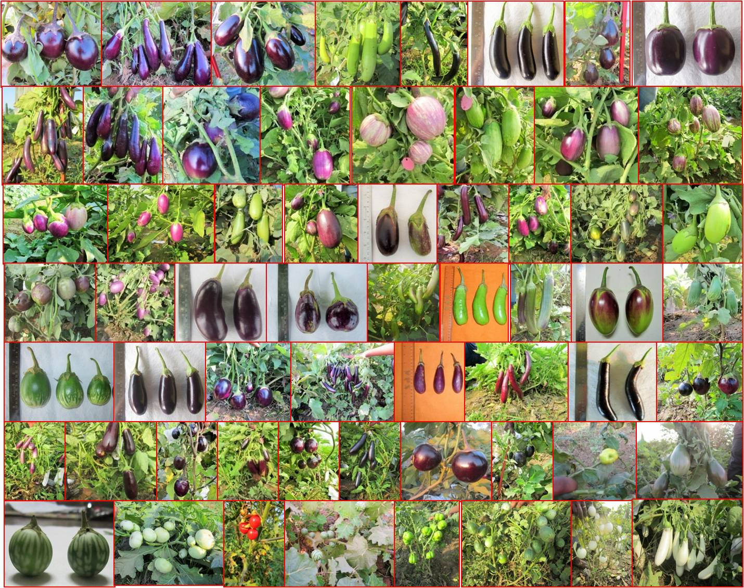
Fig 1. The morphology of eggplant accessions used in the study. 1. Sel-91-2, 2. 129-5, 3. 190-10-12, 4. Arka kusamakar, 5. Arka Neelkant, 6. Arka Nidhi, 7. BB-04, 8. BR-112, 9. DB-09, 10. Pusa Kaushal, 11.G-5, 12. G-9, 13. G-10, 14. G-17, 15. G-22, 16. G-27, 17. G-30, 18. G-29, 19. G-44, 20. G-47, 21. G-57, 22. G-60, 23. G-109, 24. G-110, 25. G-111, 26. G-128, 27. G-129, 28. G-130, 29. G-136 , 30. G-143 , 31. G-164, 32. G-188, 33. G-190, 34. G-203, 35. IC112991, 36. NDB -25, 37. Pant rituraj, 38. Pant samarat, 39. Pusa Purple Cluster, 40. Pusa Purple Long, 41. Punjab Sadabahar, 42. Pusa Ankur, 43. Pusa anupam, 44. Pusa bhairav, 45. Pusa bindu, 46. Pusa Kranti, 47. Pusa purple Round, 48. Pusa shyamala, 49. Pusa Upkar, 50. Pusa Uttam, 51. S. aethiopicum, 52 S. incanum, 53. s.khasianum, 54. S. macrocarpon, 55. S. sysimbrifolium, 56. S. viarum, 57. S. integrifolium, 58. S. insanum, 59. DBWSR-195, 60. DBWL-22 (Serial number 1 from left to right upto 60)

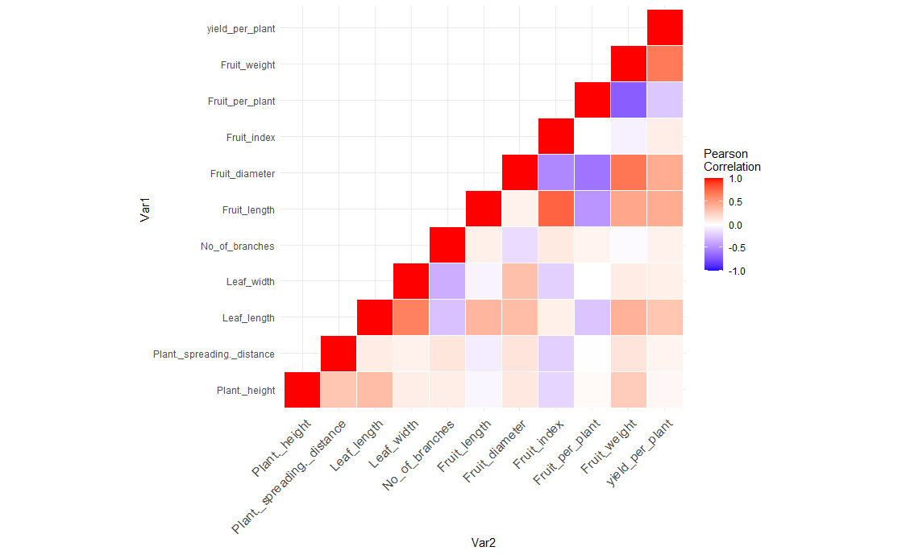
Fig 2. Heat map showing Pearson’s correlation coefficients for agro morphological traits. Self-self-correlations are identified in red. Positive correlations are displayed in red and negative correlations in blue color. The color intensity is proportional to the correlation coefficients. while correlations that were not significant are shown in white

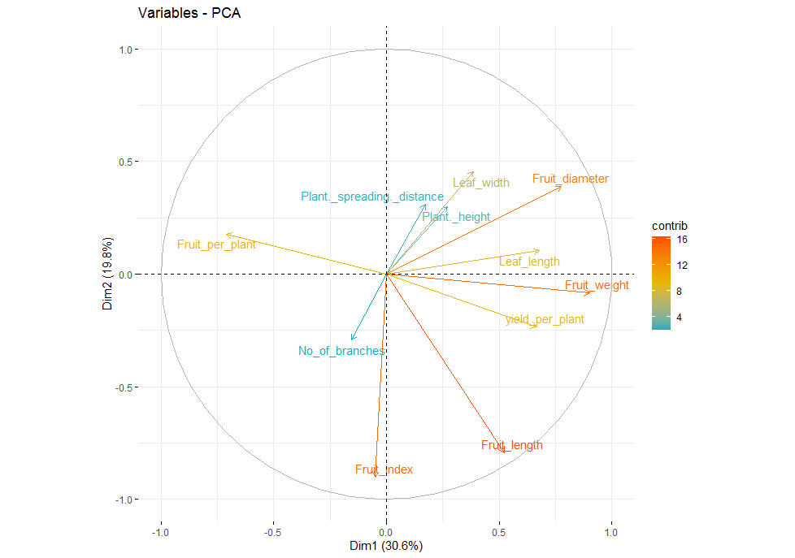
Fig 3. Variable correlation plot on the first two principal components

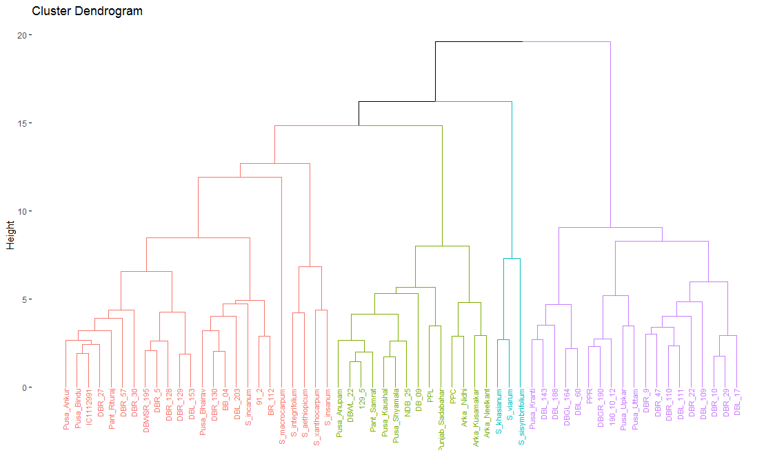Fig 4. Agglomerative hierarchical clustering of sixty brinjal genotype using euclidean distance and ward linkage method

Table 1. Estimates of variability, heritability, genetic advance and GA as per cent of mean for fruit and yield attributes in brinjal
 | Character | Range | Grand Mean | Phenotypic coefficient of variance (%) | Genotypic coefficient of variance (%) | Heritability (broad sense)  h2 (%) | Genetic advance | GA as percent mean
1 | Plant height (cm) | 27.92-145.48 | 70.23 | 31.09 | 30.63 | 97.01 | 36.78 | 52.79
2 | Plant spreading distance (cm) | 52.42-169.37 | 108.7 | 27.1 | 26.4 | 94.93 | 48.9 | 45.02
3 | Leaf length (cm) | 4.08-20.00 | 13.59 | 24.66 | 23.5 | 90.79 | 5.34 | 39.19
4 | Leaf width (cm) | 3.37-22.87 | 9.47 | 30.2 | 29.38 | 94.69 | 4.68 | 50.04
5 | Number of primary branches | 3.97-13.66 | 8.07 | 28.97 | 26.21 | 81.85 | 3.34 | 41.49
6 | Fruit length (cm) | 2.53-21.80 | 13.17 | 18.73 | 20.87 | 80.53 | 2.58 | 34.63
7 | Fruit diameter (cm) | 1.72-9.03 | 4.68 | 26.65 | 27.48 | 78.56 | 1.44 | 28.24
8 | Fruit index | 0.82-8.00 | 3.18 | 53.73 | 52.7 | 94.06 | 0.79 | 53.25
9 | Average fruits per plant | 9.02-60.12 | 21.8 | 49.32 | 47.32 | 92.06 | 16.98 | 79.45
10 | Average weight of fruit (g) | 12.15-188.00 | 79.9 | 49.93 | 49.67 | 98.99 | 68.51 | 86.49
11 | Yield per plant (kg) | 0.56-2.14 | 1.41 | 30.31 | 25.94 | 73.19 | 0.55 | 38.91

Table 2. Genotypic and phenotypic path coefficient analysis, among growth, and yield parameters in brinjal genotypes

Parameters |  | Plant height | Plant spreading distance | Leaf length | Leaf width | Number of primary branches | Fruit length | Fruit diameter | Fruit index | Average fruit/plant | Average weight /fruit | R with yield/ plant
Plant height | G | -0.288 | -0.007 | 0.034 | -0.008 | 0.005 | -0.013 | 0.014 | 0.023 | 0.018 | 0.253 | 0.043
Plant height | P | -0.323 | -0.007 | 0.047 | -0.008 | 0.009 | -0.012 | 0.013 | 0.032 | 0.022 | 0.270 | 0.031
Plant spreading distance | G | -0.083 | -0.023 | 0.010 | -0.007 | 0.007 | -0.024 | 0.018 | 0.025 | -0.002 | 0.132 | 0.057
Plant spreading distance | P | -0.097 | -0.022 | 0.013 | -0.007 | 0.013 | -0.029 | 0.016 | 0.035 | -0.006 | 0.140 | 0.053
Leaf length | G | -0.096 | -0.002 | 0.101 | -0.055 | -0.015 | 0.117 | 0.044 | -0.009 | -0.175 | 0.363 | 0. 319**
Leaf length | P | -0.114 | -0.002 | 0.133 | -0.060 | -0.028 | 0.143 | 0.040 | -0.014 | -0.178 | 0.399 | 0.272**
Leaf width | G | -0.025 | -0.002 | 0.062 | -0.090 | -0.019 | -0.015 | 0.041 | 0.024 | -0.002 | 0.094 | 0.086
Leaf width | P | -0.029 | -0.002 | 0.087 | -0.091 | -0.037 | -0.018 | 0.037 | 0.036 | -0.002 | 0.105 | 0.066
Number of primary branches | G | -0.025 | -0.003 | -0.026 | 0.029 | 0.060 | 0.022 | -0.018 | -0.014 | 0.040 | -0.019 | 0.085
Number of primary branches | P | -0.029 | -0.003 | -0.037 | 0.034 | 0.100 | 0.031 | -0.017 | -0.019 | 0.044 | -0.020 | 0.046
Fruit length | G | 0.011 | 0.002 | 0.037 | 0.004 | 0.004 | 0.324 | 0.011 | -0.098 | -0.322 | 0.418 | 0.447**
Fruit length | P | 0.011 | 0.002 | 0.052 | 0.004 | 0.009 | 0.368 | 0.007 | -0.137 | -0.320 | 0.452 | 0.391**
Fruit diameter | G | -0.031 | -0.003 | 0.034 | -0.028 | -0.008 | 0.026 | 0.132 | 0.068 | -0.421 | 0.629 | 0.451**
Fruit diameter | P | -0.039 | -0.003 | 0.048 | -0.031 | -0.015 | 0.023 | 0.110 | 0.091 | -0.418 | 0.685 | 0.398**
Fruit index | G | 0.051 | 0.004 | 0.007 | 0.017 | 0.006 | 0.245 | -0.069 | -0.130 | 0.004 | -0.059 | 0.099
Fruit index | P | 0.059 | 0.005 | 0.011 | 0.019 | 0.011 | 0.287 | -0.057 | -0.176 | 0.001 | -0.061 | 0.075
Average fruit/plant | G | -0.007 | 0.000 | -0.024 | 0.000 | 0.003 | -0.141 | -0.075 | -0.001 | 0.740 | -0.637 | 0.308**
Average fruit/plant | P | -0.011 | 0.000 | -0.035 | 0.000 | 0.007 | -0.174 | -0.068 | 0.000 | 0.675 | -0.701 | -0.141
Average weight /fruit | G | -0.078 | -0.003 | 0.039 | -0.009 | -0.001 | 0.145 | 0.089 | 0.008 | -0.504 | 0.936 | 0.706**
Average weight /fruit | P | -0.089 | -0.003 | 0.054 | -0.010 | -0.002 | 0.169 | 0.077 | 0.011 | -0.482 | 0.981 | 0.621**

Genotypic Residual effect = 0.291; Phenotypic Residual effect =0.339,** Indicates significant at p=0.01, * Indicates significant at p=0.05, Bold and diagonal values indicate direct effect

Table 3. Clustering pattern of brinjal genotypes based on fruit yield attributes using D² analysis
Clusters | No of  genotypes | Genotype name
I | 5 | S. integrifolium, S. xanthocarpum, S. incanum, S. insanum, S. aethiopicum.
II | 5 | Pusa Kranti, DBGL-164, DBL-60, DBL-143, DBL-188.
III | 8 | Pusa Ankur, Pusa Bhairav, DBL-109, DBR-130, DBL-203, Sel-91-2, BR-112, BB-04.
IV | 3 | S. khasianum, S. viarum, S. sisymbrifolium.
V | 13 | Pusa Anupam, Pusa Kaushal, Pusa Purple Long, Pusa Shyamla, DBWL-22, Pant Samrat, Arka Kusumakar, Arka Nidhi, DB-129-5, Punjab Sadabahar, NDB-25, Arka Neelkant, DB-09.
VI | 14 | Pusa Bindu, Pusa Purple Cluster, DBWSR-195, DBR-5, DBR-27, DBR-30, DBR-57, DBR-110, DBR-128, DBR-129, DBL-153, Pant Rituraj, IC1112991, S. macrocarpum.
VII | 12 | Pusa Purple Round, Pusa Upkar, Pusa Uttam, DBGR-190, DBR-9, DBR-10, DBL-17, DBR-22, DBR-29, DBR-47, DBL-111, Sel-190-10-12

Table 4. Mean values of cluster for fruit yield attributes in brinjal
Clusters |  | Plant height | Plant spreading distance | Leaf length | Leaf width | Number of primary branches | Fruit length | Fruit diameter | Fruit index | Average fruit  /plant | Average weight /fruit | Yield/ plant
I | Mean | 55.85 | 89.91 | 6.46 | 5.26 | 9.69 | 7.01 | 3.87 | 1.77 | 22.18 | 51.09 | 1.17
 | SE± | 10.75 | 36.67 | 2.1 | 1.34 | 3.1 | 4.16 | 1.29 | 0.69 | 5.68 | 9.24 | 0.48
II | Mean | 92.2 | 115.6 | 16.39 | 9.57 | 8.3 | 19.91 | 4.4 | 4.68 | 13.73 | 126.53 | 1.68
 | SE± | 14.96 | 17.29 | 2.45 | 0.25 | 1.1 | 1.42 | 0.47 | 0.82 | 1.9 | 38.74 | 0.28
III | Mean | 58.74 | 110.81 | 12.88 | 8.28 | 8.35 | 14.2 | 5.84 | 2.54 | 16.03 | 106.46 | 1.67
 | SE± | 19.06 | 27.54 | 1.41 | 1.13 | 1.99 | 1.22 | 1.07 | 0.62 | 3.62 | 23.5 | 0.35
IV | Mean | 104.91 | 125.8 | 12.41 | 10.06 | 8.75 | 3.06 | 2.13 | 1.45 | 53.76 | 13.79 | 0.75
 | SE± | 35.81 | 25.37 | 5.55 | 1.88 | 2.29 | 0.74 | 0.38 | 0.19 | 7.07 | 1.54 | 0.18
V | Mean | 55.55 | 88.73 | 13.23 | 8.39 | 8.8 | 17.18 | 3.18 | 5.53 | 25.78 | 59.12 | 1.46
 | SE± | 12.43 | 12.39 | 1.81 | 1.48 | 2.6 | 2.73 | 0.5 | 1.23 | 7.86 | 14.03 | 0.29
VI | Mean | 65.68 | 110.33 | 13.81 | 10.61 | 6.55 | 10.72 | 4.66 | 2.44 | 20.76 | 57.62 | 1.14
 | SE± | 16.42 | 30.56 | 1.29 | 3.85 | 1.78 | 2.46 | 0.9 | 0.87 | 6.1 | 13.42 | 0.27
VII | Mean | 84.54 | 127.32 | 16.56 | 11.07 | 7.79 | 13.45 | 6.54 | 2.11 | 15.61 | 116.43 | 1.67
 | SE± | 12.34 | 30.06 | 1.88 | 2.07 | 1.42 | 1.32 | 1.17 | 0.34 | 5.4 | 36.2 | 0.22

Table 5. Eigen values, % of Variance and Cumulative % of 11 for fruit yield attributes in brinjal
Principal Component | Eigen value | Variance (%) | Cumulative variance (%)
Dim.1 | 3.36980605 | 30.6346005 | 30.63460
Dim.2 | 2.17384831 | 19.7622573 | 50.39686
Dim.3 | 1.54041458 | 14.0037689 | 64.40063
Dim.4 | 1.33180026 | 12.1072751 | 76.50790
Dim.5 | 0.77105324 | 7.0095749 | 83.51748
Dim.6 | 0.72096336 | 6.5542123 | 90.07169
Dim.7 | 0.60380339 | 5.4891217 | 95.56081
Dim.8 | 0.20361721 | 1.8510656 | 97.41188
Dim.9 | 0.17004225 | 1.5458386 | 98.95771
Dim.10 | 0.08688027 | 0.7898206 | 99.74754
Dim.11 | 0.02777108 | 0.2524644 | 100.00000

